In
Internship Report
On
Financial Performance Analysis of IDLC

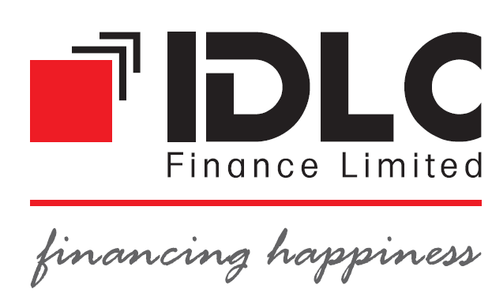


Topic: Financial Performance Analysis of IDLC
Course code: INT 4399

Submitted To
Mohammad Musa, PhD (MMs)
Professor
School of Business and Economics
United International University

Submitted By
Md. Rasheduzzaman
ID: 111-142-192
School of Business and Economics
United International University

Date of Submission: 18 september,2018
Letter of Transmittal
Date: 18, September, 2018
Mohammad Musa, PhD (MMs)
Professor
School of Business and Economics
United International University

Subject: Submission of Internship Report

Dear Sir,
It is my great pleasure to submit my internship report on “Financial Performance Analysis of IDLC” as a requirement for BBA program. I have made sincere effort to make the report. In this report I have presented the brief overview of IDLC. For getting financial analysis I have prepared horizontal analysis, trend analysis, growth analysis, financial highlights. I also arrange ratio analysis, regression analysis, and margin analysis to evaluate financial performance of IDLC. I have also identified some problems and give the solution of these problems. This opportunity enhances my knowledge about some specific operating and financial aspects of financial institutions.
I will be glad to clarify any further quarries you may have regarding this report.

Sincerely yours
………………………………
Md. Rasheduzzaman
ID: 111-142-192
School of Business and Economics
United International University

Acknowledgement

Right off the bat I need to thank to god-like Allah without his approval the report would not refined. I might want to thank to my fair chief Professor Mohammad Musa, PhD (MMs), School of Business and Economics, United International University for the majority of his help to fruitful end of the report.

I would like to thank Mr. Md.Nayem Uddin, Manager at Discretionary Portfolio Management (DPM) for letting me complete my internship at IDLC Investments Limited.

I would likewise thank to Mr. Abir Hussain Talukder (SEO), Mr. Md. Mahmudur Rahman (BDO), Mr. Ashraful Islam (help. BDO) in DPM division for their help and direction for finish my temporary position report.

At last I might want to thank to all individuals from DPM group for their help and love.

Table of contents
Content | Page Number
Executive Summary | 8
Chapter-1: Introduction | 9
1.1 Origin of the Report | 10
1.2 Objectives of Study | 10
1.3 Scope of Study | 10
1.4 Methodology of Study | 11
1.5 Limitations of the Study | 11
Chapter-2: An overview of IDLC Finance Limited | 12
2.1 Company Overview | 13
2.2 Subsidiaries | 13
- 2.2.1 IDLC Investment | 13
- 2.2.2 IDLC Securities | 14
- 2.2.3 IDLC Asset Management | 14
2.3 Our Philosophies- The Backbone of Our Enterprise | 14
- 2.3.1 Vision | 14
- 2.3.2 Mission | 14
- 2.3.3 Strategic Objective | 14,15
- 2.3.4 Core Value | 15
- 2.3.5 Code of Conduct and Ethical Guidelines | 15
2.4 Organogram | 16
2.5 Shareholders’ Structure | 17
2.6 Product and service | 18
- 2.6.1 Small and Medium Enterprise (SME) Finance | 18
- 2.6.2 Corporate Finance | 18,19
- 2.6.3 Consumer Finance | 19
- 2.6.4 Capital Market Operations | 20
Chapter-3: Internship Experience | 21
3.1 My Contribution in IDLC | 22
- 3.1.1 Training Session | 22
- 3.1.2 Exam Session | 22
- 3.1.3 Viva Session | 22
- 3.1.4 Job Under direction | 23
- 3.1.5 Job Independently | 23
3.2 Learning | 23,24
3.3 Observation | 24
3.4 Recommendation | 24
Chapter-4: Financial Analysis of IDLC | 25
4.1 Financial Highlights | 26,27
4.2 Horizontal Analysis | 27
- 4.2.1 Horizontal Analysis Balance Sheet | 27,28
- 4.2.2 Horizontal Analysis Profit and Loss Accounts | 29
4.3 Vertical Analysis | 30
- 4.3.1 Vertical Analysis Balance Sheet | 30,31
- 4.3.2 Vertical Analysis Profit and Loss Accounts | 32
4.4 Growth Analysis | 33
Financial Performance | 33
- 4.4.1 Total Asset | 33
- 4.4.2 Long Term Liabilities | 34
- 4.4.3 Term Deposit Balance | 35
Operational Performance | 36
- 4.4.4 Operating income | 36
- 4.4.5 Operating expense | 37
- 4.4.6 Financial expense | 38
- 4.4.7 Net Profit after Tax | 39
Equity Statistics | 40
- 4.4.8 Number of Share | 40
- 4.4.9 Net asset Value per Share | 41
- 4.4.10 Market Capitalization | 42
- 4.4.11 Market Value Addition | 43
- 4.4.12 Shareholder’s equity | 44
Chapter-5: Financial Performance Evaluation of IDLC | 45
5.1 Ratio Analysis | 46
Profitability’s Ratio | 46
- 5.1.1 Return on Asset | 46
- 5.1.2 Return on Equity | 47
- 5.1.3 Earning per Share | 48
- 5.1.4 Dividend Payout Ratio | 49
Solvency Ratio | 50
- 5.1.5 Debt to Total Asset | 50
- 5.1.6 Debt to Equity Ratio | 51
- 5.1.7 Financial Expense Coverage Ratio (Times) | 52
- 5.1.8 Capital Adequacy Ratio | 53
Market Ratio | 54
- 5.1.9 Price/ earnings Ratio | 54
Risk Ratio | 55
- 5.1.10 Loan to Deposit ratio | 55
- 5.1.11 Non Performing Loan Ratio | 56
Liquidity Ratio | 56
- 5.1.12 Current Ratio | 57
5.3 Margin | 59
- 5.3.1 Net Interest Margin | 59
- 5.3.2 Net Non-Interest Margin | 60
- 5.3.3 Net Operating Margin | 61
Chapter-6: Findings and Conclusions | 62
6.1 Key Findings | 63,64
6.2 Recommendation | 64
6.3 Conclusions | 65
Bibliography | 65

Executive summary
IDLC is an outstanding non-banking financial organization in Bangladesh. The examination and assessment of exhibitions cover entire IDLC. The money related and operational exhibitions of lDLC from the year 2013 to 2017 have been appeared in the report. Pattern examination predicts the future improvement of IDLC's stock in view of past data. Development rate demonstrates an expanding pattern amid the period. It builds the organization's productivity. ROA, ROE, EPS, are additionally performing admirably. The dissolvability proportion of IDLC is performing great and expands extent of obligation contrasted with its aggregate resources and aggregate value. The hazard proportions of IDLC performed better amid the period. It has possessed the capacity to diminish the non-performing credit as an extent increment the measure of advance/store proportion. The present proportion an expanding pattern over the period, additionally its development rate is expanding. The relapse investigation demonstrates that there is a solid positive connection amongst IDLC and NBFI. Edge investigation demonstrates that IDLC settles on great venture choices and end up gainful. At long last a few issues distinguished and recommendations have been given to the administration to defeat the issues. Toward the finish of the report, a conclusion has been given on the general execution of IDLC.

Chapter 1

Introduction

1.1 Origin of the Report
This report arranged to satisfy the prerequisite for fulfillment of Bachelor of Business Administration, level of United International University. The temporary position program carried on to give the understudies on a vocation presentation and coordinate the hypothetical information with corporate genuine experience.
This report named "Financial Performance Analysis of IDLC" is the result of the multi month venture work led on IDLC Investment Limited. I trust the report will give an unmistakable thought regarding the exercises and part of IDLC.

1.2 Objective of the report:
- To present an overview of IDLC.
- To apprise financial analysis of IDLC.
- To apprise financial performance of IDLC.
- To find some basic problems of IDLC.
- To give some basic solution to the problems.

1.3 Scope of study
This report covers a short diagram of IDLC Finance Ltd. what's more, portrayal about their significant exercises. This report likewise features the financial performance of IDLC for a long time. The monetary day and age under the investigation is 2013 to 2017.
At last, endeavors were given to distinguish the components that prompted the achievement or disappointment of IDLC the non-banking industry. A few recommendations to administration have additionally been given in such manner.

1.4 Methodology of study
The study is exploratory in nature. The study is covering financial performance analysis of IDLC. Ratio analysis is used in this study. In completing this report only the secondary data sources have been used. The secondary sources includes-
• Annual report of IDLC for 5 years.
• For industry average, financial information of 23 companies is used and the data are collect main of the companies.
No survey was conducted for this report. I have gone through various secondary sources in order to gather data that are related to the basics of accounting exercises and also related to the problems of accounting exercises.

1.5 Limitations of the Study:
I found some limitations when I prepared this report. The limitations are given below-
- Some information needed to develop this report is highly privileged and IDLC Finance Ltd. did not allow full announcement of those data.
- Though, there are convenient way to know about the products of IDLC Finance Ltd. but no or very few written documents are available for the operating procedures.
- There are some departments at IDLC Finance Ltd., which are regarded as intellectual asset of the organization. In those departments, proper entrance to get data about their principal activities or how they work cannot be managed.
- Limited time is another barrier to prepare quality report.
- Secret report is another barrier to prepare quality report.

Chapter2

An Overview of IDLC Finance Limited

2.1TCompanyTOverview
IDLC is one of the biggest Non-Banking Financial organizations in Bangladesh. It has three other fully owned subsidiaries. In 24 cities of the country, its serve over fifty thousand customers through 41 major touch points. More than 1,300 people put their efforts together every day in Corporate Finance, SME Finance, and Consumer Finance and Capital Market segments. From 1985, IDLC has been a story of success and growth built on the trust and respect. With IDLC, it has never been about achievement in isolation - rather its aim for inclusive growth as its make our mark in the lives of the people whom it has been privileged to come across. In certain situations, IDLC are serving them with its products & services, while in others, it has been through the initiatives it had taken to solve a few of their problems. It is this philosophy that prompted its last year to launch IDLC Khushir Kheya – a volunteering platform encompassing areas like education, fitness, environment and populations projects where volunteers from all over the country can join hands with its to build a happier tomorrow.

2.2 Subsidiaries
2.2.1 IDLC Investments Limited
IDLC Investments Limited (IDLCIL) is a merchant bank, headquartered in Dhaka, Bangladesh. The organization is a completely possessed auxiliary of IDLC Finance Limited (IDLC), the nation's biggest Non-Banking Financial Institution, which was made mutually by, International Finance Corporation, German Investment Corporation, Korea Development Bank, Aga Khan Fund for Economic Development and other nearby and worldwide establishment.

IDLCIL began as the vendor saving money division of IDLC in 1999. Later in 2010, it developed as a different organization according to the prerequisite of Bangladesh Securities and Exchange Commission. The firm gives Investment saving money, Portfolio administration, Margin advances and Securities inquire about administrations to its customers, which incorporate the two partnerships and individual IDLC Investment Limited.

2.2.2 IDLC Securities limited
IDLC Securities Limited, a completely claimed auxiliary of lDLC, offers undeniable global standard financier benefit for retail and institutional customers. It has situates on both Dhaka Stock Exchange constrained and Chittagong Stock Exchange Limited. It is additionally a Depository Participant (DP) of Central Depository Bangladesh Limited (CDBL).
2.2.3 IDLC Asset Management Limited
IDLC Asset Management Limited is an entirely claimed backup of IDLC Finance Limited. It offers resource administration administrations which at present comprise of Mutual Funds offered to people and organizations. IDLC Asset Management Limited was joined on 19 November 2015. The organization at that point connected to Bangladesh Securities and Exchange Commission (BSEC) for issuance of enlistment endorsement to work as a benefit oversees as Securities and Exchange Commission Regulation, 2001. The organization got the benefit administration permit on June 7, 2016.

2.3 Our Philosophies – The Backbone of Our Enterprise
2.3.1 Vision
Become the best financial brand in the country.

2.3.2 Mission
Focus is on quality growth, superior customer experience and substantial business practice.

2.3.3 Strategic Objective
- Grow and build up our ability pool.
- Fully use the center saving money stage.
- Optimize conveyance focuses.
- Grow and enhance subsidizing sources.
- Grow deals and administration abilities in the purchaser division.
- Sustainably develop SME portfolio.
- Focus on top-level customers in the corporate section.
- Consolidate capital market activities and improve capacities.
- Embrace globally acknowledged corporate administration and maintainable business rehearses.

2.3.4 Core Values
- Integrity
- Customer Focus
- Trust and Respect
- Equal Opportunity
- Eco-accommodating
- Passion Simplicity

2.3.5 Code of Conduct and Ethical Guidelines
- Act with trustworthiness, capability, poise and in a moral way when managing clients, prospects, associates, offices and general society.
- Act and urge others to act in an expert and moral way that will think about emphatically IDLC workers, their calling and on IDLC on the loose.
- Strive to keep up and enhance the ability of all in the business.
- Use sensible care and exercise free proficient judgment.
- Not limit others from playing out their expert commitments.
- Maintain learning of and agree to every material law, standards and controls
- Disclose all irreconcilable circumstances.
- Deliver proficient administrations as per IDLC strategies and pertinent specialized and expert measures.
- Respect the classification and protection of clients, individuals and others with whom they work together.
- Not take part in any expert direct including deceitfulness, extortion duplicity or deception or confer any demonstration that considers unfavorably genuineness, dependability or expert fitness.
2.4 organogram T22.4 organogram.4 organogram
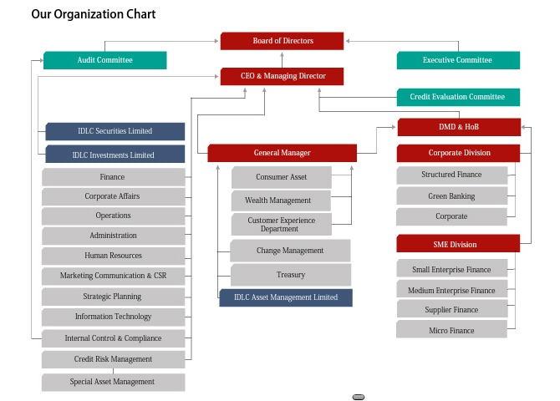

2.5 Shareholder Structure 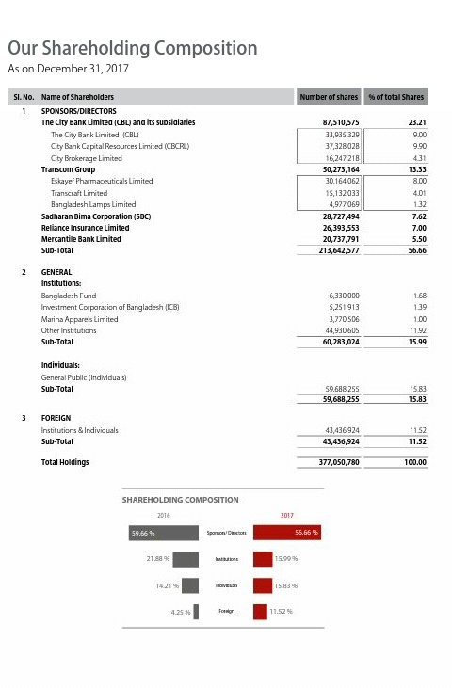

2.6 Product & Service Basket
2.6.1 Small and Medium Enterprises (SME) Finance
Small Enterprise Finance
- Small Enterprise Loan/ Lease
- Seasonal Loan
- IDLC Purnota – Women Entrepreneur Loan
- SME Shachal Loan
- Revolving Short Term Loan
- Commercial Space Loan
- Commercial Vehicle Loan
- IDLC Udbhabon
- SME Deposit
Medium Enterprise Finance
- Medium Enterprise Loan /Lease
- Commercial Vehicle Finance
- Machinery Lease
- Revolving Short Term Loan
- Commercial Space Loan
- Commercial Vehicle Loan
Supplier and Distributor Finance
- Factoring of Accounts Receivable
- Bill/ Invoice Discounting
- Work Order Financing
- Distributor Financing
2.6.2 Corporate Division
Corporate Finance
- Lease Financing
- Term Loan Financing
- Commercial Space Financing
- Project Financing
- Short Term Loans (to meet working capital requirements)
- Specialized Products (for meeting seasonal demand)
- Green Financing
Structured Finance Solutions
- Debt Syndication (Local & Foreign Currency)
- Working Capital Syndication
- Agency & Trusteeship
- Fund Raising through Zero Coupon & Coupon Bearing Bonds
- Commercial Paper
- Arrangement of Private Equity n& Preference Shares
- Corporate Advisory for Mergers& acquisitions and Joint Venture Making
- Preparation of Feasibility Study
Green Banking Solutions
- Over 50 products offered under Green Banking and Sustainable Finance department as per Bangladesh Bank Green Refinance scheme
2.6.3 Consumer Finance
Loans
- Home Loans
- Car Loans
- Personal Loans
- Loan against Deposit
Deposits
- Flexible Term Deposit Package
- Regular Earner Package

2.6.4 Capital Markets Operations
IDLC Securities Limited
Products
- Cash Account
- Margin Account through IDLCT Investments Limited and other enlisted merchant banks
- Easy IPO
- Premium Brokerage for High Net worth Individuals (HNIs) an institutional and foreign invest Services
- Trade execution through the Dhaka and Chittagong stock exchanges
- Custodial and CDBL services
- Bloomberg terminal for foreign clients
- Research and Advisory Services
IDLC Investments Limited
Products
- Margin Loan
- Discretionary Portfolio Management Services
- Corporate Advisory
- Issue Management
- Underwriting
IDLC Asset Management Limited
- Mutual Funds
- Portfolio Management

Chapter 3

Internship Experience

3.1 My Contribution in IDLC
I was allocated in IDLC Investments Limited by Discretionary Portfolio Management (DPM) division. This division fills in as wings of Portfolio Management. I was doled out in a few assignments by these divisions. I began my entry level position by here and now preparing gave by IDLC Investment Ltd. My work under DPM office is given underneath.

3.1.1 Training Session
I joined IDLC Investment Ltd. on 15 February, 2018. As I have no learning about the DPM office and their item and administrations. So they masterminded an instructional course about their item and administrations. The instructional course proceeded for initial three days and they gave me distinctive kind of preparing that was identified with their item and administrations on capital market speculation to advance their item and administrations in the corporate part. Amid the entry level position period they gave distinctive kinds of preparing identified with their item and administrations. I go to an instructional meeting on "Interest in Capital Market" which was held in Bangladesh Securities and Exchange Commission (BSEC).

3.1.2 Exam Session
After the instructional meeting, IDLCIL masterminded a short exam session. The inquiry was set by the DPM division based on their item and administrations.

3.1.3 Viva session
After the exam session, IDLCIL organized a viva session identified with their item and administrations.

3.1.4 Job under director
After viva session our fundamental employment was begun. They isolated us into three gatherings and one administrator was allocated in each gathering. We went to various corporate divisions in Dilkusha territory, motijheel, Dhaka. Around then I saw the exercises of my manager how he functions so I can apply it for next time.

3.1.5 Job independently
Subsequent to working under a chief I began work independently. In that time my boss doled out the region that I will visit. Subsequent to relegating the region I went to that region and went by to various corporate segments on that region.
I went to the general population of corporate areas and talked about with them about our item and administrations. I for the most part talked about their recently propelled riches expansion benefit called "Easy Invest".

3.2 Leanings
In my temporary job period I have learned numerous things. This are-
• How to communicate in the corporate divisions
• I have found out about the capital market of Bangladesh
• I accumulated learning how to put resources into capital market
• I have the chance to know distinctive sorts of Tax benefits that was given by our administration on the off chance that anybody put into the capital market.
• I have additionally assembled information about the ideal time to put into the capital market.
•As my activity is target situated, so now I know how to perform in an objective arranged activity.
• This work instructed me how to take weight.
• How to meet with obscure individual, speak with them, persuaded them.
• How to make association with customers.
• How to settle a gathering with customer and follow up them.

3.3 Observation
IDLCIL is a great work environment in. They regard understudies as a representative. They are particularly amicable and adaptable with assistants. They continually endeavor to inspire their assistants. They leave the work choice of understudies on themselves. They are especially useful to set up my temporary position report.

3.4 Recommendation
They generally endeavor to give an assistant the genuine experience of corporate world. So they appoint assistant in various work with the goal that they can take in more.

Chapter 4

Financial Analysis of IDLC

4.1 Financial Highlights (IDLC Finance Limited and its subsidiaries)
In BDT Million
Particulars | 2013 | 2014 | 2015 | 2016 | 2017 | Growth in 2017
Financial Performance
Lease and Term loans disburse | 16,895 | 17,473 | 22,140 | 29,807 | 35,511 | 19.14%
Housing finance disbursement | 4,421 | 5,896 | 5,954 | 5,646 | 7,893 | 39.80%
Short term finance (portfolio) | 604 | 735 | 1,079 | 1,079 | 778 | -8.01%
Lease Finance (portfolio | 6,358 | 6,282 | 6,016 | 4,950 | 4,629 | -6.49%
Real estate finance assets (portfolio) | 11,170 | 14,822 | 17,206 | 18,108 | 21,462 | 18.52%
Total assets | 48,535 | 57,160 | 71,769 | 76,505 | 92,611 | 21.05%
Long term liabilities | 42,884 | 50,471 | 63,591 | 67,446 | 80,540 | 19.41%
Term deposit balance | 29,164 | 35,241 | 46,174 | 47,564 | 60,538 | 27.28%
Net current asset | 2,682 | 2,778 | 5,924 | 5,031 | 6,580 | 30.80%
Operational Performance
Operational income | 2,573 | 3,326 | 3,961 | 4,433 | 4,801 | 8.31%
Operational expenses | 1,021 | 1,237 | 1,394 | 1,679 | 1,934 | 15.23%
Financial expenses | 4,127 | 4,530 | 4,827 | 4,625 | 4,902 | 6.00%
Profit before tax | 1,406 | 2,029 | 2,276 | 2,581 | 2,639 | 2.25%
Net profit after tax | 811 | 1,154 | 1,244 | 1,496 | 1,582 | 5.72%
Financial Ratios
Debt equity ratio (Times) | 9.50 | 9.04 | 9.65 | 9.06 | 7.76 | (1.30)
Average effective tax rate (%) | 42.32 | 43.15 | 45.34 | 42.02 | 40.05 | (1.97)
Financial expenses coverage ratio (Times) | 1.34 | 1.45 | 1.47 | 1.56 | 1.54 | (0.02)
Current ratio (Times) | 1.14:1 | 1.13:1 | 1.22:1 | 1.17:1 | 1.18:1 | 0.01
Return on total assets (%) | 1.92 | 2.18 | 1.93 | 2.02 | 1.87 | (0.15)
Non-performing loan ratio (%) | 1.63 | 2.02 | 3.06 | 2.95 | 2.77 | (0.18)
Return on shareholders’ equity (%) | 19.24 | 22.37 | 20.01 | 20.87 | 17.41 | (3.46)
Earnings per share* (BDT) | 2.50 | 3.56 | 3.84 | 4.62 | 4.26 | (0.36)
Dividend per share (BDT) | 3.00 | 3.50 | 2.50 | 3.00 | 3.00 | -
Dividend yield (%) | 4.77 | 4.69 | 3.93 | 5.26 | 3.52 | (1.75)
Dividend payout ratio (%) | 92.98 | 76.27 | 50.52 | 75.59 | 71.50 | (4.09)
Shareholders’ equity | 4,621 | 5,694 | 6,737 | 7,605 | 10,569 | 38.98%
Net interest income as a percentage (%) of working funds | 6.13 | 6.78 | 6.44 | 6.14 | 5.77 | (0.36)
Operating Profit as percentage (%) of working fund | 4.46 | 4.97 | 5.18 | 5.79 | 4.35 | (0.44)
*Earning per share is required to be calculated based on adjustment factor, as there was issuance of right shares during the year.
4.2 Horizontal Analysis
4.2.1. Horizontal Analysis of Balance Sheet
Particular | 2017 | 2016 | 2015 | 2014 | 2013
Cash | 147.23% | 131.12% | 119.80% | 98.09% | 100%
In hand | 127.91% | 124.92% | 121.59% | 114.98% | 100%
Balance with Bangladesh Bank and its agent | 147.24% | 131.12% | 119.80% | 98.10% | 100%
Balance with other banks and financial institutions | 191.69% | 145.92% | 176.38% | 102.03% | 100%
Inside Bangladesh | 191.69% | 145.92% | 176.38% | 102.03% | 100%
Outside Bangladesh | 0.00% | 0.00% | 0.00% | 0.00% | 100%
Money at call and short notice | 0.00% | 0.00% | 0.00% | 0.00% | 100%
Investments | 1007.27% | 552.83% | 431.31% | 335.14% | 100%
Government | 0.00% | 0.00% | 0.00% | 0.00% | 100%
Others | 1007.27% | 552.83% | 393.17% | 297.00% | 100%
Loans and advances | 174.64% | 151.97% | 134.86% | 114.97% | 100%
Loans, cash credit, overdraft etc. | 174.64% | 151.97% | 134.86% | 114.97% | 100%
Bills purchased and discounted | 0.00% | 0.00% | 0.00% | 0.00% | 100%
Fixed assets including land, building, furniture | 167.49% | 165.34% | 135.73% | 97.84% | 100%
Other assets | 194.47% | 164.09% | 190.67% | 190.28% | 100%
Non-banking assets | 0.00% | 0.00% | 0.00% | 0.00% | 100%
Total Assets | 189.74% | 157.27% | 145.62% | 116.85% | 100%
LIABILITIES AND CAPITAL
Liabilities
Borrowings from other banks, financial institutions | 129.14% | 142.33% | 119.91% | 104.19% | 100%
Deposits and other accounts | 205.69% | 163.39% | 157.76% | 121.23% | 100%
Current accounts and other accounts etc. | 0.00% | 0.00% | 0.00% | 0.00% | 100%
Bills payable | 0.00% | 0.00% | 0.00% | 0.00% | 100%
Savings bank deposits | 0.00% | 0.00% | 0.00% | 0.00% | 100%
Term deposits | 205.94% | 163.35% | 158.41% | 121.25% | 100%
Bearer certificate of deposits | 0.00% | 0.00% | 0.00% | 0.00% | 100%
Other deposits | 199.26% | 164.60% | 141.15% | 120.58% | 100%
Other liabilities | 158.59% | 140.21% | 122.92% | 109.16% | 100%
Total Liabilities | 184.37% | 156.15% | 145.67% | 116.27% | 100%
Capital / Shareholders’ equity
Paid-up capital | 234.37% | 156.25% | 156.25% | 125.00% | 100%
Share premium | 33616.00% | 100% | 100% | 100% | 100%
Statutory reserves | 209.16% | 177.62% | 147.79% | 123.00% | 100%
General reserves | 123.27% | 123.27% | 123.27% | 123.27% | 100%
Dividend equalization reserves | 0.00% | 0.00% | 0.00% | 0.00% | 100%
Retained earnings | 234.03% | 190.12% | 144.99% | 118.18% | 100%
Total equity attributable to equity holders of com. | 234.91% | 166.66% | 145.19% | 121.73% | 100%
Non-controlling interest | 161.87% | 128.64% | 116.77% | 105.39% | 100%
Total liabilities and Shareholders’ equity | 189.74% | 157.27% | 145.62% | 116.85% | 100%

4.2.2. Horizontal Analysis of Profit and Loss Account
Particulars | 2017 | 2016 | 2015 | 2014 | 2013
Interest income | 143.09% | 134.51% | 132.77% | 119.58% | 100.00%
Interest on deposits and borrowings etc. | 118.38% | 111.78% | 116.81% | 109.80% | 100.00%
Net interest income | 192.32% | 179.79% | 164.55% | 139.07% | 100.00%
Investment income | 2024.0% | 890.0% | 695.7% | 91.56% | 100.0%
Commission, exchange and brokerage | 260.61% | 152.31% | 123.19% | 123.92% | 100.0%
Other operating income | 131.36% | 150.10% | 129.27% | 106.00% | 100.0%
Total operating income | 227.43% | 187.00% | 166.14% | 132.46% | 100.0%
Salaries and allowances | 223.25% | 179.90% | 155.00% | 129.23% | 100.0%
Rent, taxes, insurance, electricity etc. | 207.92% | 203.85% | 128.16% | 114.95% | 100.0%
Legal expenses | 317.07% | 229.10% | 197.46% | 105.86% | 100.0%
Postage, stamp, telecommunication etc. | 116.96% | 105.22% | 108.51% | 105.73% | 100.0%
Stationery, printing, advertisements etc. | 166.91% | 122.80% | 102.50% | 137.53% | 100.0%
Managing Director’s salary and benefits | 80.06% | 68.04% | 87.99% | 100% | 100.0%
Directors’ fees | 233.73% | 191.61% | 144.26% | 115.94% | 100.0%
Auditors’ fees | 205.15% | 148.71% | 103.45% | 103.45% | 100.0%
Charges on loan losses | 0.00% | 0.00% | 0.00% | 0.00% | 0.00%
Depreciation and repair of Company’s assets | 120.85% | 125.13% | 111.59% | 102.85% | 100.0%
Other expenses | 158.44% | 128.48% | 109.77% | 98.39% | 100.0%
Total operating expenses | 187.85% | 157.56% | 132.52% | 117.71% | 100.0%
Profit before provision | 259.85% | 211.1% | 193.68% | 144.53% | 100.0%
Provision for loans and investments
General provision | -498.6% | -392.2% | -396.2% | -362.8% | 100.0%
Specific provision | 86.31% | 85.00% | 139.98% | -28.0% | 100.0%
provision for diminution in value of investments | 0% | -748.6% | -168.0% | 221.0% | 100.0%
Other provisions | 0.00% | 0.00% | 0.00% | 0.00% | 0.00%
Total provision | 120.73% | 81.22% | 161.59% | 4.09% | 100.0%
Total profit before taxation | 280.10% | 230.0% | 198.35% | 165.00% | 100.0%
Provision for taxation | 218.79% | 193.48% | 178.32% | 143.51% | 100.0%
Current tax expense | 227.33% | 199.32% | 183.92% | 150.63% | 100.0%
Deferred tax income | -71.9% | -5.6% | -12.5% | -99.2% | 100.0%

Interpretations:
- Cash is increasing from 2013 to 2017 except 2014 due to increase in Cash deposits and other accounts. There are some situations that increase the deposits. They are
- Balance with other banks is also increasing
- Investments are increasing with increasing trend
- Loans and Advances are increasing with increasing trend
- Fixed assets are also increasing from 2013 to 2017
- Overall total assets of IDLC are increasing which is good sign for the company.
- On the other hand the interest income also increased from 2013 to 2017
- Total operating income also increases that includes investments income, commission income and other operating income.
- On the other hand the total operating expenses increases that include Interest expenses, provisions against nonperforming loans, bad debts which were written off directly and administrative expenses are increasing. But the increase in income is more than increase in expenses.
- Total profit before taxations and net profit after taxations are increasing from 2013 to 2017.

4.3 Vertical Analysis
4.3.1 Vertical Analysis of Balance Sheet
Particulars | 2017 | 2016 | 2015 | 2014 | 2013
PROPERTY AND ASSETS
Cash | 1.15% | 1.23% | 1.21% | 1.24% | 1.48%
In hand | 0.00% | 0.00% | 0.00% | 0.00% | 0.00%
Balance with Bangladesh Bank and its agent | 1.15% | 1.23% | 1.21% | 1.24% | 1.48%
Balance with other banks and financial institutions | 14.25% | 13.08% | 17.08% | 12.31% | 14.10%
Inside Bangladesh | 14.25% | 13.08% | 17.08% | 12.31% | 14.10%
Outside Bangladesh | 0.00% | 0.00% | 0.00% | 0.00% | 0.00%
Money at call and short notice | 0.00% | 0.00% | 0.00% | 0.00% | 0.00%
Investments | 8.28% | 5.48% | 4.62% | 4.47% | 1.56%
Government | 0.00% | 0.00% | 0.41% | 0.51% | 0.00%
Others | 8.28% | 5.48% | 4.21% | 3.96% | 1.56%
Loans and advances | 74.72% | 78.45% | 75.19% | 79.88% | 81.19%
Loans, cash credit, overdraft etc. | 74.72% | 78.45% | 75.19% | 79.88% | 81.19%
Bills purchased and discounted | 0.00% | 0.00% | 0.00% | 0.00% | 0.00%
Fixed assets including land, building, furniture | 0.69% | 0.82% | 0.73% | 0.65% | 0.78%
Other assets | 0.91% | 0.93% | 1.17% | 1.45% | 0.89%
Non-banking assets | 0.00% | 0.00% | 0.00% | 0.00% | 0.00%
Total Assets | 100.00% | 100.00% | 100.00% | 100.00% | 100.00%
LIABILITIES AND CAPITAL
Liabilities
Borrowings from other banks, financial institution | 11.91% | 15.84% | 14.42% | 15.61% | 17.51%
Deposits and other accounts | 64.89% | 62.19% | 64.85% | 62.10% | 59.86%
Current accounts and other accounts etc. | 0.00% | 0.00% | 0.00% | 0.00% | 0.00%
Bills payable | 0.00% | 0.00% | 0.00% | 0.00% | 0.00%
Savings bank deposits | 0.00% | 0.00% | 0.00% | 0.00% | 0.00%
Term deposits | 62.55% | 59.86% | 62.69% | 59.80% | 57.63%
Bearer certificate of deposits | 0.00% | 0.00% | 0.00% | 0.00% | 0.00%
Other deposits | 2.34% | 2.33% | 2.16% | 2.30% | 2.23%
Other liabilities | 10.03% | 10.70% | 10.13% | 11.21% | 12.00%
Total Liabilities | 86.83% | 88.73% | 89.40% | 88.92% | 89.37%
Capital / Shareholders’ equity
Paid-up capital | 3.94% | 3.17% | 3.42% | 3.41% | 3.19%
Share premium | 1.32% | 0.00% | 0.01% | 0.01% | 0.01%
Statutory reserves | 2.19% | 2.25% | 2.02% | 2.09% | 1.99%
General reserves | 1.05% | 1.26% | 1.36% | 1.70% | 1.61%
Dividend equalization reserves | 0.05% | 0.06% | 0.06% | 0.08% | 0.09%
Retained earnings | 4.62% | 4.53% | 3.73% | 3.79% | 3.75%
Total equity attributable to equity holders of com. | 13.17% | 11.27% | 10.60% | 11.08% | 10.63%
Non-controlling interest | 0.00% | 0.00% | 0.00% | 0.00% | 0.00%
Total liabilities and Shareholders’ equity | 100.00% | 100.00% | 100.00% | 100.00% | 100.00%

4.3.2 Vertical Analysis of Profit and Loss Account
Particulars | 2017 | 2016 | 2015 | 2014 | 2013
Interest income | 100.00% | 100.00% | 100.00% | 100.00% | 100.00%
Interest on deposits and borrowings etc. | -55.08% | -55.33% | -58.58% | -61.13% | -66.58%
Net interest income | 44.92% | 44.67% | 41.42% | 38.87% | 33.42%
Investment income | 12.17% | 5.69% | 4.51% | 0.65% | 0.86%
Commission, exchange and brokerage | 8.49% | 5.28% | 4.33% | 4.83% | 4.66%
Other operating income | 5.04% | 6.12% | 5.34% | 4.86% | 5.49%
Total operating income | 70.62% | 61.77% | 55.60% | 49.22% | 44.43%
Salaries and allowances | 14.56% | 12.48% | 10.90% | 10.09% | 9.33%
Rent, taxes, insurance, electricity etc. | 2.48% | 2.58% | 1.64% | 1.64% | 1.70%
Legal expenses | 0.29% | 0.22% | 0.20% | 0.12% | 0.13%
Postage, stamp, telecommunication etc. | 0.42% | 0.41% | 0.42% | 0.46% | 0.52%
Stationery, printing, advertisements etc. | 1.57% | 1.23% | 1.04% | 1.55% | 1.35%
Managing Director’s salary and benefits | 0.12% | 0.11% | 0.14% | 0.18% | 0.21%
Directors’ fees | 0.03% | 0.02% | 0.02% | 0.02% | 0.02%
Auditors’ fees | 0.02% | 0.01% | 0.01% | 0.01% | 0.01%
Charges on loan losses | 0.00% | 0.00% | 0.00% | 0.00% | 0.00%
Depreciation and repair of Company’s assets | 2.17% | 2.39% | 2.16% | 2.21% | 2.57%
Other expenses | 4.61% | 3.98% | 3.44% | 3.43% | 4.17%
Total operating expenses | 26.27% | 23.43% | 19.97% | 19.69% | 20.01%
Profit before provision | 44.36% | 38.34% | 35.63% | 29.52% | 24.43%
Provision for loans and investments | 0.00% | 0.00% | 0.00% | 0.00% | 0.00%
General provision | 0.70% | 0.58% | 0.60% | 0.61% | -0.20%
Specific provision | 1.92% | 2.00% | 3.35% | -0.74% | 3.17%
provision for diminution in value of investments | 0.00% | -0.72% | -0.16% | 0.24% | 0.13%
Other provisions | 0.00% | 0.00% | 0.00% | 0.00% | 0.00%
Total provision | 2.62% | 1.86% | 3.78% | 0.10% | 3.10%
Total profit before taxation | 41.74% | 36.47% | 31.86% | 29.42% | 21.32%
Provision for taxation | 16.13% | 15.18% | 14.17% | 12.66% | 10.55%
Current tax expense | 16.28% | 15.19% | 14.20% | 12.91% | 10.25%
Deferred tax income | -0.15% | -0.01% | -0.03% | -0.25% | 0.30%
Net profit after taxation | 25.61% | 21.30% | 17.69% | 16.76% | 10.77%

Interpretations:
Vertical Analysis of Balance Sheet:
- The Balance sheet shows that the balance of IDLC is increasing from 2013 to 2017 which is a very good sign for the company.
- The percentage changes in investments are increasing from 2013 to 2017.
- The percentage changes in loans and advanced is decreasing from 2013 to 2017.
- The borrowing from financial institutions is decreasing from 17.51% to 11.92% which is very good for the company.

Vertical Analysis of Income Statement:
- The percentage change in net interest income is increasing from 2013 to 2017.
- The percentage change of total operating income is also increasing from 2013to 2017.
- The percentage change of total operating expenses is increasing but does not effect on net profit because the operating income of IDLC increasing every year.
- The percentage of total profit before taxation and net profit after taxation are increasing every year which is very good for IDLC.

4.4 Growth Analysis
FINANCIAL PERFORMANCE
4.4.1 Total Asset
Year | 2013 | 2014 | 2015 | 2016 | 2017
Total assets ( taka in million) | 50,429 | 58,927 | 73,434 | 79,311 | 95,687
growth Rate |  | 16.85% | 24.62% | 8.00% | 20.65%

From the table it is seen that in 2013 the amount of total asset was Tk. 50429 million. In 2014 it is increased to Tk. 58927 million which was about 16.85% greater from 2013. In the year 2015 it was also increased by 24.62%. In the year 2016 the amount of total asset grew at decreased rate, so that the growth rate of total asset was 8%. In 2017 total asset of IDLC grew up by 20.65%. So it indicates that IDLC will generate more cash flow in future which increases the confidence of new investors.

4.4.2 Long Term Liabilities
Year | 2013 | 2014 | 2015 | 2016 | 2017
Long term liabilities (taka in million) | 43,951 | 51,371 | 64,154 | 68,931 | 81,548
growth Rate |  | 16.88% | 24.88% | 7.45% | 18.30%

In 2013 long term liabilities of IDLC was Tk. 43951 million. From the year 2013 to 2017 IDLC increased its long term liabilities gradually. The growth rate of 2014 and 2015 were 16.88% and 24.88%. But in 2016 the amount of long term liabilities grew at decreased rate, so that the growth rate of long term liabilities was 7.45%. In 2017 IDLC total long term liabilities grew up by 18.30% and the amount reached at Tk. 81548 million. So It is indicate that IDLC may preferred more debt in their capital structure.

4.4.3 Term Deposit Balance

Year | 2013 | 2014 | 2015 | 2016 | 2017
Term deposit balance (taka in million) | 29,064 | 35,240 | 46,039 | 47,475 | 59,854
growth Rate |  | 21.25% | 30.64% | 3.12% | 26.07%

From the table it is seen that the term deposit balance was Tk. 29064 million. In the next year 2014 it increased by 21.25% and continues to increase up to 2017. In the Year 2015 it was increased by 30.64%, in 2016 it grew at decreasing rate of 3.12%. In 2017 it was increased by 26.07%. So it is indicate that IDLC has more money or funds to new investment.

OPERATIONAL PPERFORMANCE
4.4.4 Operational Income

Year | 2013 | 2014 | 2015 | 2016 | 2017
Operational income (taka in million) | 2,761 | 3,658 | 4,588 | 5,164 | 6,280
growth Rate |  | 32.49% | 25.42% | 12.55% | 21.61%

From the table we see that the operational income of the year 2013 was Tk.2761 million. In 2014 the growth rate of operational income increased by 32.49% and it increased continuously. In 2015 and 2016 the growth rate grew up at decreasing rate of 25.42% and 12.55%. In 2017 the rate is increased by 21.61%. It is indicated that IDLC has the good earning power from operations.

4.4.5 Operational Expense

Year | 2013 | 2014 | 2015 | 2016 | 2017
Operational expenses (taka in million) | 1,243 | 1,464 | 1,648 | 1,959 | 2,336
growth Rate |  | 17.78% | 12.57% | 18.87% | 19.24%

From the table we see that the operating expense of IDLC in 2013 was Tk. 1243 million. In the year of 2014 the amount is increased to Tk.1464 million and the rate increased by 17.78%. From the year 2013 to 2017 the operating expense increased gradually. In the year of 2015 the amount grew up at a decreasing rate of 12.57%. In the year of 2016 and 2017 the growth rate grew at increasing rate of 18.87% and 19.24%. Here we see that the operating expense increased regularly except the year of 2015. It is bad for IDLC because increasing operational expense reduce the profitability of IDLC.

4.4.6 Financial Expense

Year | 2013 | 2014 | 2015 | 2016 | 2017
Financial expenses (taka in million) | 4,138 | 4,543 | 4,833 | 4,625 | 4,898
growth Rate |  | 9.79% | 6.38% | -4.30% | 5.90%

In 2013 the financial expense of IDLC was Tk.4138 million. In 2014 it was increased by 9.79% from 2013 and continued to increase up the amount to 2017 except 2016. In 2016 the it sharply decreased and the growth rate fall down to -4.30%. In 2017 IDLC‘s financial expense grew up by 5.90% and reached to Tk. 4898 million. Here we see that the financial expense decreasing continuously. So it indicates that the profitability may be higher.

4.4.7 Net Profit after Tax

Year | 2013 | 2014 | 2015 | 2016 | 2017
Net profit after tax (taka in million) | 669 | 1,246 | 1,459 | 1,780 | 2,277
growth rate |  | 86.25% | 17.09% | 22.00% | 27.92%

It is seen that the net profit after tax was Tk. 699 million in 2013. In 2014 it was increased by 86.25%. In 2015 the rate grew at a decreasing rate of 17.09% which is lower from 2014. In 2016 the growth rate increased by 22%. In 2017 it was 27.925. Increasing the net profit shows good appearance of IDLC. It provides positive signal to investor to invest on IDLC.

EQUITY STATEISTICS
4.4.8 Numbers of Shares
Year | 2013 |  | 2014 | 2015 | 2016 |  |  | 2017
Number of shares | 160,875,000 | 201,093,750 |  | 251,367,187 |  | 251,367,187 | 377,050,780
growth Rate |  | 25.00% |  | 25.00% |  | 0.00% | 50.00%

In 2013 IDLC’s numbers of share was 160875000. In the next year 2014 it was increased by 25% than 2013. In 2015 it grew up by 25% but in 2016 the number of shares of IDLC was same, so that there was no change in growth rate. In 2017 it grew up by 50% and reached at 377050780. So it can clean that the number of shares of IDLC will keep increasing.

4.4.9 Net Asset Value per Share
Year | 2013 | 2014 | 2015 | 2016 | 2017
Net asset value per share | 14.22 | 17.31 | 20.65 | 23.7 | 33.41
growth Rate |  | 21.73% | 19.30% | 14.77% | 40.97%

In 2013 IDLC’s net asset value per share was 14.22%. In the next year 2014 it grew up by 21.73% from the year 2014. In 2015 the growth rate decreased by 19.30%. In 2016 it grew up at decreasing rate of 14.77%. In 2017 the growth rate grew up at an increasing rate of 40.97% and reached to Tk. 33.41. By observing the trend it is indicate that the net asset value of IDLC is slow .The higher the ratio is better for the firm. Increasing trend of net asset value per share indicates that assets of the company will increase day by day. It is a very good signal for the market.

4.4.10 Market Capitalization
Year | 2013 | 2014 | 2015 | 2016 | 2017
Market capitalization (taka in million) | 10,119 | 15,022 | 15,987 | 14,328 | 32,162
growth rate |  | 48.45% | 6.42% | -10.38% | 124.47%

From the table it can be seen that in the year 2013 market capitalization was Tk. 10119million. In 2014 it increased by 48.45% from the year 2013. In 2015 the growth rate decreased to 6.42%. In the year 2016 the growth rate become negative that was -10.38%. In the Year 2017 the growth rate grew up to 124.47% and reached to Tk. 32162 million.

4.4.11 Market Value Addition
Year | 2013 | 2014 | 2015 | 2016 | 2017
Market value addition (taka in million) | 29.57 | 42.24 | 32.63 | 21.44 | 51.89
growth Rate |  | 42.85% | -22.75% | -34.29% | 142.02%

From the table it can be seen that the market value addition in 2013 was Tk. 29.57 million. In 2014 the growth rate increased to 42.85% from the year 2013. In the year 2015 the growth rate become negative that was -22.75%. In the year 2016 the growth rate was also negative that was -34.29%. In 2017 the growth rate grew up at increasing rate of 142.02% and reached to Tk. 51.89 million. It is indicate that IDLC may create substantial wealth for the shareholder in the year of 2017. The higher MVA is better for the company.

4.4.12 Shareholders’ Equity
Year | 2013 | 2014 | 2015 | 2016 | 2017
Shareholders’ equity (taka in million) | 5,363 | 6,528 | 7,786 | 8,938 | 12,597
growth rate |  | 21.72% | 19.27% | 14.80% | 40.94%

In 2013 IDLC’s total shareholders equity was Tk.5363 million. In the year 2014 it was increased by 21.72% and continues to increasing up to 2017. In 2015 the growth rate increased at a decreasing rate of 19.27%. In 2016 it reduced to 14.80%. But in 2017 the growth rate increased by 40.94%. The increasing trend of shareholders’ equity indicates that IDLC is substantially maximizing wealth of its shareholders.

CHAPTER 5

FINANCIAL PERFORMANCE EVALUATION OF IDLC

5.1 Ratio Analysis
PROFITIBILITY RATIOS
5.1.1 Return on Asset: Net income / Total Asset

 | 2014 | 2015 | 2016 | Mean
IDLC | 2.11% | 1.99% | 2.24% | 2.11
Industry Average | 1.49% | 1.36% | 0.83% | 1.23

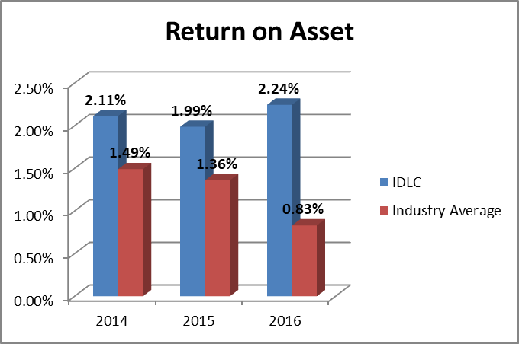
In 2014 the return on asset was 2.11%. In 2015 the rate decreased by 1.99%. In 2016 the rate grew up by 2.24%.
It is calculated for measuring how efficiency IDLC manages its asset. Here its return on asset is higher than industry average. So it clean that it is more efficient to manage the banking asset.

5.1.2 Return on Equity: Net Income / Total Equity

 | 2014 | 2015 | 2016 | Mean
IDLC | 19.08% | 18.74% | 19.92% | 19.25%
Industry Average | 4.92% | 10.28% | 7.24% | 7.48%

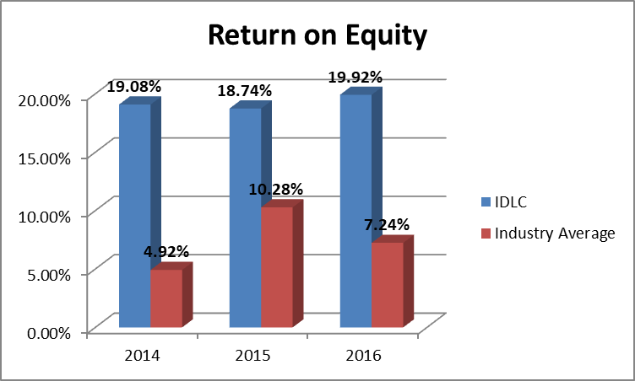
From the table we see that in 2014 Return on equity of IDLC was 19.08%. In 2015 the rate decreased by 19.74%. In the year of 2016 the rate was increased by 19.92%.
Compering with the industry average we see that IDLC’s Return on Equity is greater than industry average. It is calculated to measure how much return shareholder can get from the IDLC. So it is clean that IDLC is much attractive to its shareholder.

5.1.3 Earning per Share (taka): Net Income / Number of Share

 | 2014 | 2015 | 2016 | Mean
IDLC | 3.84 | 4.50 | 5.49 | 4.61
Industry Average | 1.56 | 1.76 | 1.72 | 1.68

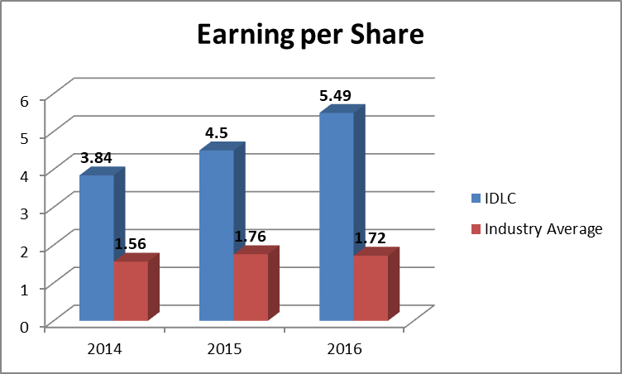

From the table we can see that the Earning per Share of IDLC’s in 2014 was 3.84 taka. From 2014 to 2016 the rate was gradually increased. In the year of 2016 the rate was 5.49 taka.
It is calculated to find out how much return IDLC can get when a shareholder can purchase single share. Here its earning per share is greater than industry average. So it is good for IDLC because it knows that high earning per share is good for the organizations.

5.1.4 Dividend payout ratio: Dividend per Share / EPS

 | 2014 | 2015 | 2016 | Mean
IDLC | 91.15% | 55.56% | 54.64% | 67.17%
Industry average | 71.57% | 59.21% | 56.37% | 62.38%

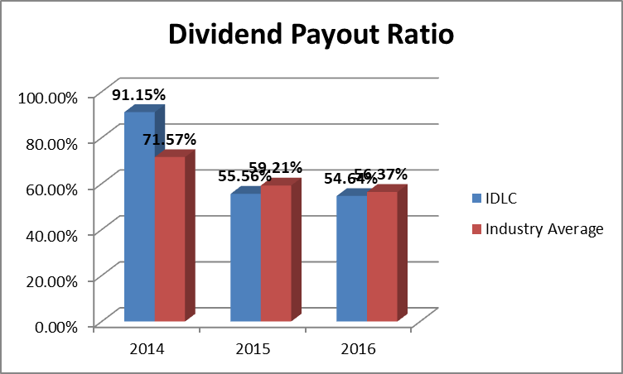

In 2014 the dividend payout ratio of IDLC was 91.15%. From year 2014 to 2016 the dividend payout ratio was gradually decreased. In 2016 it was 54.64%.
Here IDLC’s Dividend Payout ratio is less than its industry average. The decreasing trend of dividend payout ratio indicates that earning is not encouraging the dividend payment. So it is clean that it will discourage investors to invest in IDLC.

SOLVENCY RATIO
5.1.5 Debt to Total Asset: Total Liabilities / Total Asset

 | 2014 | 2015 | 2016 | Mean
IDLC | 88.92% | 89.40% | 88.73% | 89.02%
Industry Average | 81.56% | 82.88% | 86.67% | 83.70%

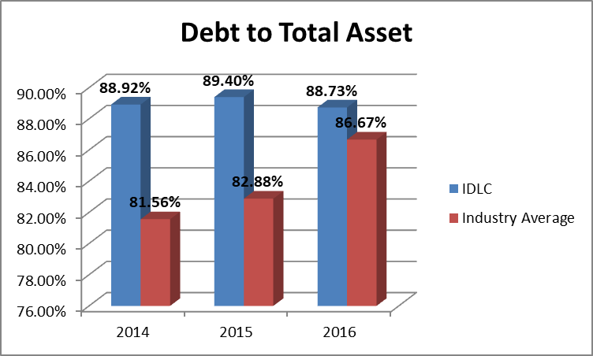
The Debt to Total asset of IDLC in 2014 was 88.92%. In 2015 it was also increased by 89.40%. In 2016 the debt to total asset of IDLC’s is 88.73%.
Comparing with the industry average it indicates that debt ratio is greater than industry average. A debt ratio compares a company’s total debt to its total assets, which is work to achieve a common plan as to amount of leverage being used by organizations. So it cleans that IDLC highly depend on leverage. Its greater part of asset is claimed by its beneficiaries. So it is risky for IDLC.

5.1.6 Debt to equity Ratio (time): Total Liabilities / Total Equity

 | 2014 | 2015 | 2016 | Mean
IDLC | 8.03 | 8.43 | 7.87 | 8.11
Industry average | 4.54 | 4.64 | 7.02 | 5.4

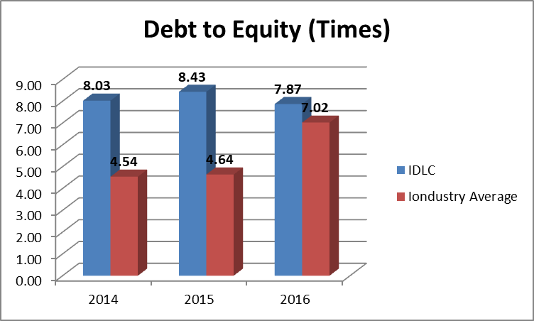

In 2014 IDLC’s Debt to equity ratio was 8.03 times. In 2015 it was 8.43 times. In the year 2016 the debt to equity ratio of IDLC is 7.87 times.
Comparing with the industry average the ratio is higher than industry average. So it clean that IDLC is more profitable, also more risky and less solvent than industry average.

5.1.7 Financial Expense coverage ratio: EBIT / Interest Expense

 | 2014 | 2015 | 2016 | Mean
IDLC | 1.48 | 1.54 | 1.66 | 1.56
Industry Average | 1.53 | 1.96 | 1.76 | 1.75

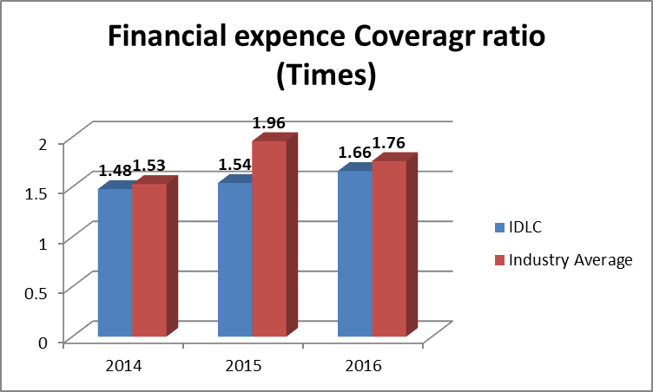

In 2014 the financial expense coverage ratio of IDLC was 1.48 times. From 2014 to 2016 this ratio was continuously increased. In 2016 the financial expense coverage ratio is 1.66 times.
Comparing with the industry average the financial expense coverage ratio of IDLC is lower than industry average. Higher the ratio is good for the company. But here the ratio is lower than industry average. So it clean that IDLC face more credit risk problem than industry.

5.1.8 Capital Adequacy Ratio: (Tier 1 Capital +Tier 2 Capital) / Risk Weighted Asset

 | 2014 | 2015 | 2016 | Mean
IDLC | 14.50% | 14.80% | 14.50% | 14.6%
Industry Average | 14.40% | 15.33% | 15% | 14.91%

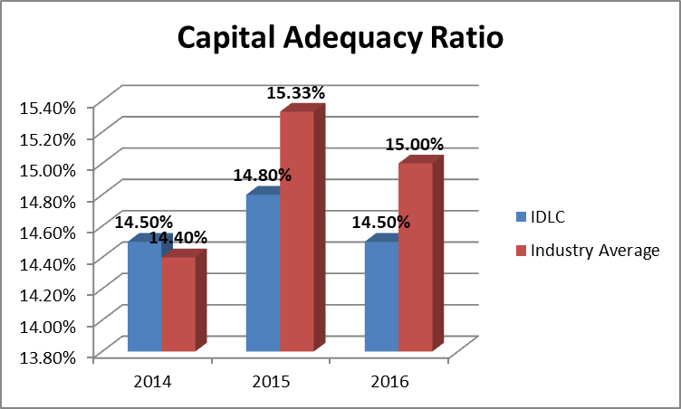

Capital Adequacy Ratio of IDLC in 2014 was 14.50%. In 2015 the rate was 14.80%. In 2015 the proportion was diminished by 14.50%

Contrasting and the business normal we see that capital adequacy ratio of IDLC is lower than industry normal. So it cleans that IDLC is less good than industry normal. Be that as it may, individually the proportion is over 10% as the requirement of Bangladesh bank that shows IDLC has enough money to support its business.

Market Ratio

5.1.9 P/E Ratio (time): Market Value per Share / EPS

 | 2014 | 2015 | 2016 | Mean
IDLC | 12.06 | 10.96 | 8.04 | 10.35
Industry Average | 16.59 | 9.37 | 12.65 | 12.87

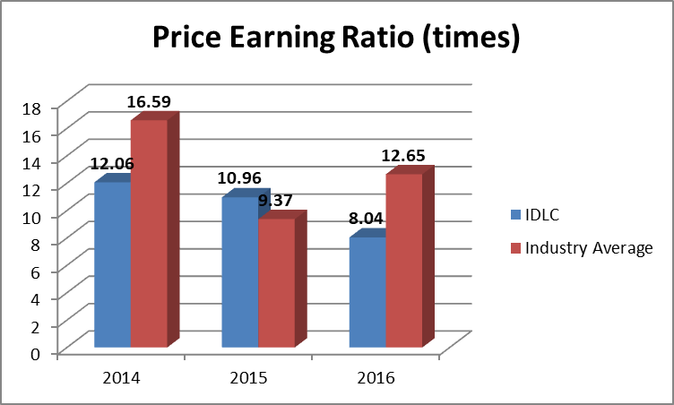

In 2014 the price earnings ratio was 12.06 times. In 2015 and 2016 it was 10.96times and 8.04 times.
Comparing with the industry average IDLC’s price earnings ratio is lower than its industry average. So it clean that IDLC is regarded more risky and their growth prospect is very poor.

Risk Ratios
5.1.10 Loan to Deposit: Total Loan / Total deposit

 | 2014 | 2015 | 2016 | Mean
IDLC | 1.29 | 1.16 | 1.26 | 1.24
Industry Average | 1.45 | 1.78 | 1.36 | 1.53

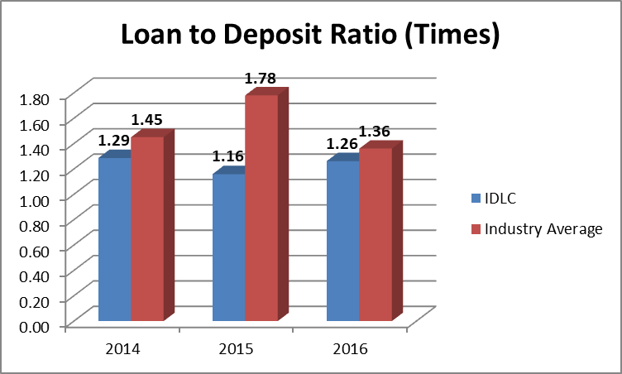

In 2014 the loan to deposit ratio of IDLC was 1.29 times. It implies that aggregate credit was 1.29 times of aggregate store. In 2015 the rate was 1.16 times. In the year 2016 the proportion grows up at expanding rate of 1.26 times. Contrasting and the business normal its credit to stores proportion was not as much as industry normal. The lower the proportion is better. Higher the proportion demonstrates that association has insufficient assets to deal with the unexpected necessities. So I can clean that the gainfulness of IDLC not as much as industry yet its liquidity was high.

5.1.11 Non-Performing loan Ratio: NPL/ Total Loan

 | 2014 | 2015 | 2016 | Mean
IDLC | 2.02% | 3.06% | 2.98% | 2.69%
Industry Average | 7.47% | 6.88% | 5.13% | 6.49%

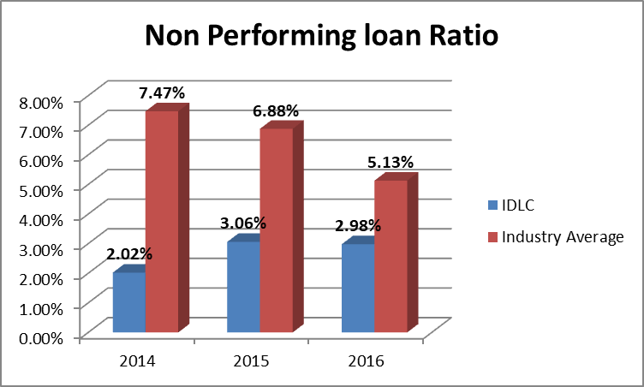

From the table we see that the non- performing ratio of IDLC in 2014 was 2.02%. In 2015 the ratio grew up by 3.06%. In the year 2016 the ratio was declined by 2.98%.
Comparing with the industry average we see that non-performing loan ratio of IDLC is lower than industry average. Lower NPL ratio is good for the company. So it cleans that IDLC is less risky and more solvent than industry average.

Liquidity Ratio

5.1.12 Current Ratio: Current Asset / Current Liabilities

 | 2014 | 2015 | 2016 | Mean
IDLC | 1.26 | 1.24 | 1.26 | 1.25
Industry Average | 1.23 | 1.16 | 1.05 | 1.15

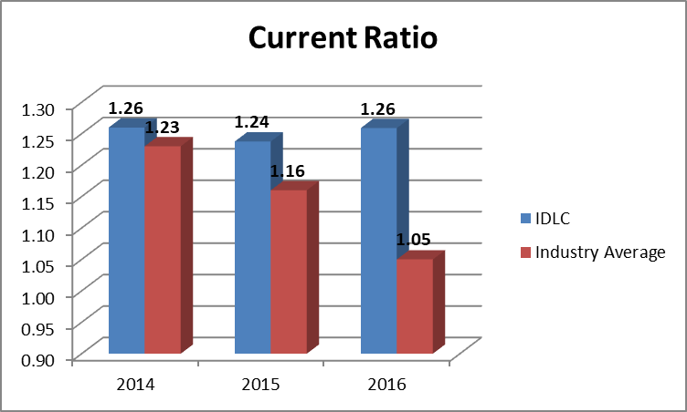

From the table current ratio of IDLC in 2014 was 1.26. In 2015 the ratio was decreased by 1.24. In 2016 the ratio was increased by 1.26.
Comparing with the industry average current ratio of IDLC is higher than industry average. So we can clean that liquidity condition of IDLC is good from the other company of the industry.

5.2 Margin
5.2.1 Net Interest Margin

 | 2014 | 2015 | 2016 | Mean
IDLC | 4.65% | 4.71% | 4.17% | 4.51%
Industry average | 5.32% | 6.13% | 4.61% | 5.35%

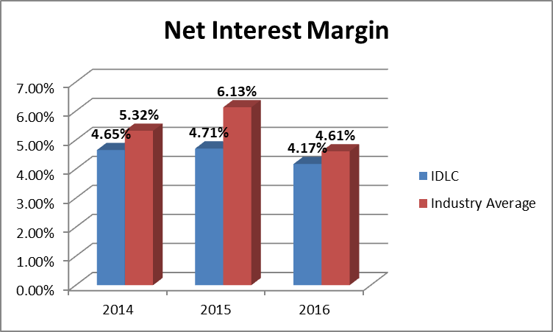

From the table and graph we see that in 2014 IDLC’s net interest margin was 4.65%. In 2015 it was 4.71%. In the year of 2016 the ratio was decreased and percentage was 4.17%. Net interest margin is fluctuating every year. Lower ratio is bad for short term. The negative figure of the ratio indicates the company cannot make effective investment decisions. So it cleans that IDLC makes good investment decisions and become profitable.

5.2.2 Net Operating Margin

 | 2014 | 2015 | 2016 | Mean
IDLC | 4% | 4.04% | 4.12% | 4.05%
Industry Average | 2.68% | 2.59% | 2.1% | 2.46%

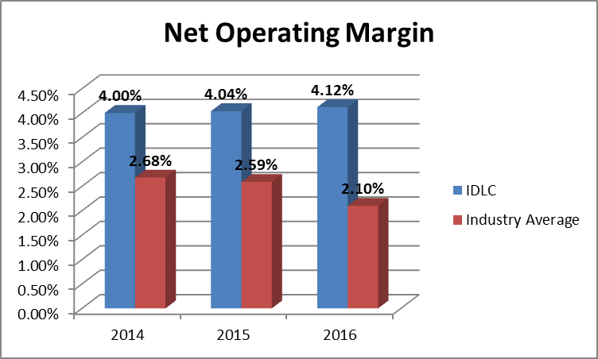

From the table and graph we see that IDLC’s net operating margin in 2014 was 4.00%. From 2014 to 2016 this margin increases continuously. In 2016 it was 4.12%. So it cleans that IDLC well in positions because net operating margin always be high for the betterment of the company.

CHAPTER 6

Findings and Conclusions

6.1 Findings
- Total asset growth rate fluctuate every year. In 2017 the rate grows up from 2016.
- Long term liabilities fluctuate during 2013 to 2017. In 2017 the rate increases than 2016.
- In case of term deposited the growth rate indicates IDLC has more money for new investment.
- IDLC’s operating income increase continuously.
- The operating expense of IDLC increase and financial expense decrease.
- Net profit after tax of IDLC increase continuously. So it provides positive signal to the investor to invest on IDLC.
- Number of shareholders of IDLC increase year by year.
- Net Asset Value per share increase every year. So it is good signal for the market.
- In case of market capitalization the growth rate increasing from previous year.
- Market value addition of IDLC becomes negative during 2015 to 2016.
- Equity of shareholders increase year by year and IDLC is substantially maximizing wealth of its shareholders.
- ROA increase during the year 2013 to 2017 and higher than industry average. So it is more efficient to manage the banking asset.
- ROE is higher than industry average. So IDLC is much more attractive to its shareholder.
- EPS of IDLC increase during 2012 to 2016. So it is good for IDLC.
- Dividend payout ratio of IDLC decreases continuously and lower than industry average. It discourages the investors to invest on IDLC.
- Debt to total asset of IDLC fluctuate every year and the ratio higher than industry average. So it is risky for IDLC because IDLC highly depends on leverage.
- Debt to Equity of IDLC also fluctuates during 2012 to 2016 and the ratio is higher than industry average. So IDLC is more profitable, also more risky and less solvent than industry average.
- Financial expense coverage ratio of IDLC lowers than industry average. So it is good signal for IDLC.
- Capital adequacy ratio of IDLC is less than industry average. So it is less favorable than other company to the shareholders.
- P/E ratio of IDLC continuously decreasing. So it is more risky and their growth prospect is very poor.
- Loan to deposit ratio of IDLC less than industry average. So the profitability of IDLC less than industry but its liquidity was high.
- NPL ratio is lower than industry average. So it is good for IDLC.
- Current ratio of IDLC is higher than industry average. So it cleans that liquidity condition of IDLC is good.
- For net interest margin IDLC makes good investment decisions and become profitable.
- Net operating margin of IDLC increase continuously. So it is good in position rather than other company.

6.2 Recommendation:
- IDLC should concentrate to increase their corporate clients because corporate clients are the main sources of earning profit.
- IDLC should control their operating and financial expense and try to maximize profitability.
- IDLC should improve their market capitalization and market value addition indicators to improve performance and concern about their shareholders.
- IDLC should increase ROA because of manage the banking asset efficiently.
- To impress shareholders IDLC should increase ROE. IDLC should careful about ROE because it I s the main indicators of companies performance.
- The bank management should be careful about EPS as it is a major indicator of the company’s performance. To increase EPS management must concentrate on increasing profitability of the company.
- IDLC should increase their P/E ratio. If the P/E ratio high it increase its shareholders confident level to invest on IDLC.
- IDLC should maintain capital adequacy ratio for unforeseen required of funds.
- IDLC should increase their dividend payout ratio. If this increases then it increases the confidence level of shareholders.
- IDLC must follow loan to deposit rules provided by Bangladesh Bank. Because of facing liquidity crisis.
- IDLC always try to keep their NPL and Financial expense coverage lower than industry for earn more profit.

6.3 Conclusions:

In conclusion it can be said that the IDLC is one of the most promising financial institution in Bangladesh. In this report overall performance of IDLC during the period 2012 to 2017 has been analyzed and evaluated. By analyzing its overall performance, various positive and negative sides of the firm have come into light. The analysis shows that IDLC performed very well. I find some problems and give necessary solution about those problems which arise in financial period and improve their future performance. It can become most preferable and leading financial institution in Bangladesh and can achieve their vision that is to be the best financial brand in Bangladesh. Besides, their core business they should perform more corporate social responsibilities that will provide them long-term sustainability.

Bibliography:
- http://idlc.com
- IDLC Annual Report 2012 to 2017.
- https://www.google.com
- http://idlc.com/idlc-investments-ltd.php
- https://www.dse.com.bd/
- www.investopedia.com

