Non-Performing Loan in City Bank
(case study)


Non-Performing Loan in City Bank
(case study)

Sumona Akter

This report is submitted to the school of Business and Economics, United International University as a partial requirement of the degree fulfillment of Bachelor of Business Administration.

Non-Performing Loan in City Bank (case study)

Submitted to:

Name: Ms. Zinnatun Nesa

Designation: Assistant professor, School Of Business and Economics, UIU

Submitted by: Name: Sumona Akter ID: 111 161 396
Major: Finance Trimester: 12th

School of Business and Economic

 United International University

Date of submission: 1st June 2020

Letter of transmittal

1st June, 2020

Ms. Zinnatun Nesa Assistant professor
School of Business and Economics United International University

Subject: Submission of Internship Report

Dear Ma’am

I would like to submit my report titled “Non-Performing Loan in City Bank (case study)” Prepared as a part of the requirement for BBA Program of United International University.
I have completed my internship program in The City Bank Limited and I worked there as an intern for three months. Working on this report was a great learning experience for me as I got to learn the differences between practical and theoretical work. I hope you will find the report to be systematic and reliable.
I would like to take this opportunity to thank you for all the support and guidelines that you have provided, which I hope to continue getting in the future.

Sincerely Yours, Sumona Akter ID: 111 161 396
School Of Business and Economics United International University

Certification of Similarity Index

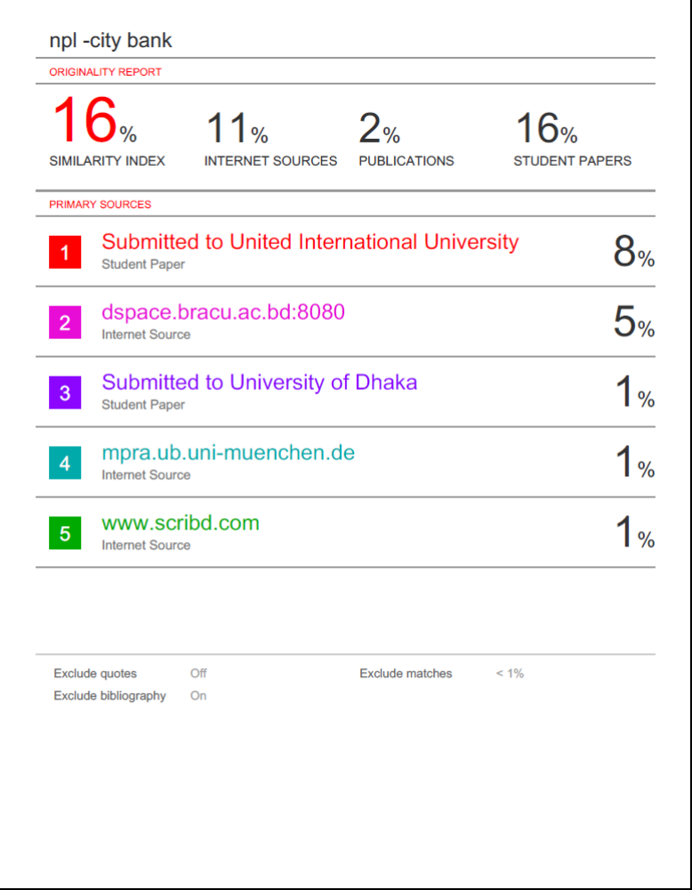

Declaration

I am Sumona Akter, student of school of Business and Economics (Finance) of United International University, Bangladesh, do hereby declare that the internship report on “ Non-Performing Loan in City Bank (case study)” is an original work and has not been previously submitted for any degree, diploma, title or recognition.

Acknowledgment

I would like to start by thanking the Almighty Allah for enabling me to prepare the report and performing the duties and responsibilities with sincerity as an intern.
I would like to express my outmost gratitude to the people by whose support I have completed this report. A special appreciation to my academic supervisor Ms. Zinnatun Nesa, for encouraged me with stimulating suggestion, instruction and guide me for completing the report. Without her help, this report would not have been completed.
Furthermore, I would like to convey my deepest thanks to Mr. Imran Hossain Pervez, my supervisor from the City Bank who permitted me to use the necessary equipment and recourses in completing the report. And I also want to thank my colleagues and staff members for providing me good working environment.
In the end, I wish to thank my University “United International University” for making me capable to take all responsibilities rationally and trying to perform on it very well. Thanks are also due to UIU Career Counseling Center for providing me with a great opportunity to work and giving me a chance to gather amazing working experience with a renowned bank, like “The City Bank Limited”.

Executive summary

The report has been prepared on “Non-Performing Loan in City Bank (case study)” based on secondary data and information. Information’s are collected from different source, such as annual reports, different websites. Non-performing loan is a common term in banking sector. There are many reasons behind non-performing loan. First reason is entrepreneurs related. Borrower need experience, need trade and organization training background or need of supporting office. At some point borrowers do it intentionally. Business people age too is a vital factor. There are certain other reasons behind this. Secondly strong competition from other firms in the same industry leads to a loan default situation. Macroeconomic factors like: Low GDP growth, increasing crimes, frequent policy change effect loan. There are some other reason like poor management, lack of knowledge, political pressure etc. Non- performing loan are reducing the profitability of banking sector. Currently non- performing loan are in alarming stage for banking sector. NPL started at the early stage of liberation. During 1980s and 1990s, Privatization and liberalization of banking sector could not control NPLs. Rate of NPLs was 41.15 in 1999. Now it is 11.90%.The amount of NPLs increased to taka 73.3 billion in 2012 from taka 47.3 billion in 2003. Effects of NPL are such as Stopping Money Cycling, Earning Reduction, Capital Erosion, Increases in Loan Piecing, Frustration etc. As a result, the value of security is increased and the risk of financial recession also see rise. Recently government is taking many steps to reduce non-performing loan.

Contents

Letter of transmittal iv
Certification of Similarity Index v
Declaration vi
Acknowledgment vii
Executive summary viii
CHAPTER 1: INTRODUCTION 1
1.1 Background 1
  - Objective 2
  - Significance 3
  - Limitations 3
1.6 Mythology of Information Collection 4
CHAPTER 2: COMPANY AND INDUSTRY PREVIEW 5
  - Company overview 5
    - Product and Services: 6
  - Organization Organogram 9
    - Board of Directors 9
    - Divisional Management 10
    - Branch Management Organogram 11
CHAPTER 3: LITERATURE REVIEW 12
CHAPTER 4: NON- PERFORMING LOAN 14
4.1. Non-performing loan: 14
  - Effect of NPL: 15
  - Reason of NPL 16
Entrepreneur Related 16
Business Related 16
Lending Related 17
Macroeconomics Factor 18
CHAPTER 5: NPL in Bangladesh 20
Trend of NPL Effect in Bangladesh 21
Emergence of Default Loan 21
Period of Post Liberation 21
Present Condition of NPL in Bangladesh: 23
Ratio of NPL According to types of Bank 23
Current Actions are Taken to Stop NPL: 26
How Successful Countries Are Dealing With NPL 30
CHAPTER 6: Nonperforming Loans in the City Bank 31
Sector Wise NPL of City Bank 33
Criteria that city bank check before giving loan to prevent NPL 35
Case study 37
Company A 37
Company B 39
Company C 41
Company D 43
Company E 44
Chapter 7: Internship experience 45
Chapter 8: Recommendation and Conclusion 48
Reference 50

CHAPTER 1: INTRODUCTION

1.1 Background

Internship is an important part for a student. In last 4 years in our BBA program we have learnt lots of theoretical knowledge. Through internship we get the opportunity of learning practically. We can say that internship helps us to know the practical version of our bookish knowledge. Only theoretical knowledge is not enough. Without internship it will be difficult to relate our bookish knowledge with the actual corporate life. Internship program is also a part of our BBA program.
I want to gather the real life work experience that’s why I choose to complete my internship program in City Bank Limited at Legal division which is situated at 10, Dhilushka Motijheel, 2nd floor of City Bank Principal office. I have learnt a lot of things from here and gathered a wonderful real life work experience. I came know about the Legal Action taken by the City Bank’s employees against their client for the default of cheque, loan, visa card, Amex card, SME loan, City Solution issue. I have worked on those files in which the case is filed by the bank against their clients. I have input all the information regarding all those cases. From my internship experience I got know the issues for which a bank can filed case against its clients on following issues (cheque, loan, visa card, Amex card, SME loan, City Solution issue).
I have also got real life experience of fast typing skill, Data Input Skill, time management. Through the internship program gain so much knowledge about corporate life and to behave in corporate life. I have got the opportunity of using my theoretical knowledge in practical life. I also get the opportunity to identify my personal skills and develop them is a proper manner. I came know that what the actual competencies that are needed in real Corporate life. I believe that the

Internship period of my life will assists me to develop a strong and good career part in my life. Now, I’m going to develop an Internship report based on my Internship Experience and overall services and operations of City Bank Limited.

Objective

There are two types of in this internship report:

Primary Objective: The primary objectives of the report are to know about the culture and environment of the city bank. This will help me in completing the BBA program. As it is a requirement of the BBA program.
Secondary Objective: secondary objective is to gather practical knowledge. Secondary objectives are given below:
    - To know how city Bank Limited deals with its customers.
    - What Kinds of services are provided by City Bank Limited
    - How Customers Power do affect the services of city bank Limited.
    - To Know the Unique services of city Bank Limited than Its competitors.

Significance

The significance of this study is, by this report anyone can get the ideas of the overall activities and services of City Bank Limited that are clearly mentioned here. And this report is made based on my whole Internship Experience so it will provide the clear knowledge of internal activities and working environment of City Bank Limited.

Limitations

From the beginning to the end, the study has been conducted with the intention of making it as complete and truthful one. However, some problems appeared in the way of conducting the study. The study consists following limitations:
    - The bank was a busy one having heavy rush people, whom officers need to deal with so, allocation of time for giving use detailed information was tough.
    - Lack of elaborate data because of Bank’s Privacy
    - There wearer not huge guidelines about Non-performing loan
    - Some employees were not interested enough to share enough information.
    - I couldn’t find all information that I planned to collect

1.6 Mythology of Information Collection

It’s very important to select the proper mythology to collect the proper information. Different mythology is required for collecting different types of information. Mythology I have selected was efficient to collect proper information what I needed to prepare the report. Most of the information that I have collected from secondary source like: website of city banks, news and article. Some information was collected through primary source also such as, direct interview of officers.

CHAPTER 2: COMPANY AND INDUSTRY PREVIEW

Company overview

City Bank is one of the most successful companies in Bangladesh. It’s established at 1983 in Bangladesh. Twelve entrepreneurs together established the City bank. It was only possible for their ability to taking risk. They started at 1983 at B.B Avenue with
1.75 capitals. At present their capital reached at 330.77 cores. Currently City Bank is one of the five successful private banks in Bangladesh.

It has its own unique strategy that doesn’t match with any other banks. This bank is successfully using online banking with by doing deferent segment. The whole business is managed from the head office. All division are regularly connecting in the head office and making the best decision for the bank. All employees and the working culture are so much suitable for working.

City Bank has 130 branches in Bangladesh. Total 3858 employees are working here. Currently they have 1700000 customers. It has 396 own ATM booth. 1068034 people are using their cards.

    - Product and Services:

City bank is working with deposit and loan. So most of their product are deposit related. They are given below:
- Credit Card:

City Bank is the franchisee of American express card. There are three types of American express card:
  - Silver
  - Gold
  - Platinum

Visa card gives both local and foreign currency. This card has tow model: .

- Gold
- Silver

- Debit Card or ATM Cards:

Any account holder can made a master card. This cards doesn’t have any classification.

- Special card:

City Max American Express Card: This card can be used as a debit card system but also an American express card. That is why it is their unique card of city bank.

- Retail Service:

Baking services like: Banking Accounts, Student Account, various types of schemes are also offered. Other services like: Saving account, deposit. Also different types of loan like: education loan, health loan, consumer loan.
- SME Service:

City Bank has Wide range of SME banking service:

  - Agro SME
  - Small Segment SME
  - Medium Segment SME

- Wholesale Banking Service:

City Bank also offers different kind of services under the wholesale service. Those are given below:

- Project Management
- Midterm Finance
- Long-term Finance
- Structures Finance
- Cash Management

There are lots of other services are offered by City Bank which can be listed as below:
  - Trade Service
  - Priority Banking Services
  - Corporate Banking Services
  - City Touch
  - Shephire Service

Organization Organogram

    - Board of Directors

Chairman
Bord
Secretary
Director
Director
Director
Director
Director
Director
Indipendant
Director
MD

    - Management Committee
MD
AMD
DMD
Head of
CRM
Head of
ICCD
CFO
Head of
Operation
Head of
Retail Banking
Head of
Commer cial Banking
Head of
IT
Head of
Wholesa le banking
Head of
Branch Banking

    - Divisional Management





















MD &
CEO
AMD &
Chief Communicat ion Officer
Chief Risk
Officer
Chief
Operating Officer
Chief
Financial officer
Head of
commercia l trade
Retail
Banking
RMD
Operation
GAD
Commercia
l Bamking
Women
Banking
CAD
Islamic
BAnking
L:egal
Finance
CRM
IT
Cards
Procuremt
SAMD
Supply
Chain Finance
C&C
Trade
Service
Small &
Micro Dinancing
FRM
Medium
Business
AMLD
Agent
Banking
Brand
Communication & Marketing

    - Branch Management Organogram

BM
CSM
RM
CT
Teller Group
CSO
BOM

CHAPTER 3: LITERATURE REVIEW

People are getting more dependable on banking survive in Bangladesh. Bank runes its operating activities by taking deposit and giving loan. Banks profitability depends on its lending decision. If loan they have given to the customers become nonperforming then the bank loses its ability to generate profit. In banking sector of our country NPL is gradually increasing. The problem of NPL has increased in last few years. Currently banks are getting more conscious about customer selection.

JOSEPH F. SINKEY, JR. & MARY BRADY GREENAWALT (1991)

NPL can arise from either external factor like economic condition or internal factor like bad investment decision. Economic condition has a strong relation with NPL. It’s found that Country in which economic condition is bad NPL rate is high. NPL also increases if the interest rate increases.

Rozina Akter & Jewel Kumar Roy (2017)

NPL affects the profitability of the banking sector because a bigger portion of profit comes from loan. Bank makes profit with depositor’s money. If banks can’t get money from depositor then there will be a vulnerable situation in the industry. Public will stop trusting bank which will make impossible for bank to run.

Rajiv Ranjan and Sarat Chandra Dhal (2003):

Terms of credit has huge effect on the banks’ non-performing loans in the presence of bank size and macroeconomic shocks. Changes in the cost of credit in terms of expectation of higher interest rate induce increase in NPL. On the other hand, factors like maturity of credit, better credit culture, and good microeconomic condition lead to lowering of NPAs.

Parven & Salena (2011):

The highest loan defaults are in the category of micro and agricultural credits, followed by term loans or large loans having maturity of 20 years and more than 20 years. To solve this problem bank should use effective financial tool. Bankers have been observed to engage in unhealthy competition in the market. Bank should use the financial technique to reduce that unhealthy competition.

CHAPTER 4: NON- PERFORMING LOAN

Non-performing loan:
A bank loan is included non-performing loan when more than 90 days pass without the borrower paying the installment that he agreed to pay or interest. Bad debt is another name of bad debt.

Definition of non-performing loan according to bank regulatory NPL consist:

    - Loan which have been placed on nonaccrual (loan for which interest is not accrued and posted to income statement.
    - Loans that are past 90 days or more due and still accruing interest.

Loan also can be default loan if it is not used in the particular source for which the loan has been it taken. According to section 5(CC) of Bank Company Act 1991, ‘defaulting debtor’ means any institution or person served with advance, loan is granted in favor of him or an institution interest or portion therefore, or any interest which has been overdue for six month according to the Bangladesh Bank’s definition. Non-performing loan are also called Non-performing Asset, that loans are classified by bank or financial institution, on which repayment are not made on schedule time. A loan is an asset of the bank as the bank invested it with a expectation of interest income. Interest that increases cash inflow is known as profit.

Effect of NPL:

A performing loan will give back interest to the bank and its will help the bank in making profit and bank will be able to create new loan. When a customer doesn’t pay interest for 90 days or more the bank assumes that there is a highest possibility that the loan will not be paid in future. That creates some bad effect on the bank.

Major effects of NPL in a bank are given below:

    - Reduce Capacity of new loan: When a bank faces highest rate of NPL it reduces the banks earning capacity. Banks create loan from its earnings and its deposit. That’s why decreasing in earning also decrease the capacity of creating loan.
    - Liquidity crisis: Banks are taking deposit from customer and paying them interest. That’s creating cash outflow. When a bank is facing NPL banks are still paying the interest to the deposit holder but not getting interest from the loan they have maid. That means banks are not generating more cash inflow accordance with the cash out flow. That is creating cash flow deficiency and that resulting liquidity crisis.
    - Reducing Profitability: Bank is reducing its earning capacity because of NPL. NPL are preventing a bent from generating more cash inflows than its cash outflows. That’s how banks are reducing its profitability.
    - Reducing capital: When bank can’t earn enough from interest because of NPL it starts paying its interest cost from its capital. That’s how banks are reducing capita.
    - Money cycling stopped: Increasing of non-performing loan can strop money cycle. Because of NPL back can’t earn profit and it can’t give loan in business. That’s how money cycle gets stopped.

  - Reason of NPL

Entrepreneur Related
    - Low business experience: Some people enter in to business without proper knowledge and experiences. Most of the time after retirement from job people suddenly wants to start a business without knowing anything about the business. When bank finance in the project the person lack of business experience id becomes risky for the bank.
    - Unwillingness to Pay: Some people thinks that default of loan will not much harm them. Some other cases people don’t want to repay loan even when they have sufficient cash inflow. It can occur sometimes that the security of backing the loan payment is low.
    - Lack of Support: every business needs some support to do its operations properly. Sometimes internal or external business creates some obstacles which hamper the business operation and it became unable to pay back loan.

Business Related

    - Non-attractive Industry: Business which is built in bad industry has higher chance of poor performance. This poor performance can affects company’s cash flows. If companies cash inflows reduce than cash outflows it can make the company unable to payback loan. Although not necessarily that all the companies no non-attractive industry perform poor.
    - Strong Competition: This reason doesn’t directly influence NPL. But it can create a strong influence when a company fails to compete with the

competitor. This can be the reason company fails to make profit and become unable to payback NPL.
    - Low Cash Flow: Cash flow that indicates that whether business is performing good or not. Because baseness that has irregular cash flow has a high eisk of getting unstable. If business can’t generate proper cash flow it won’t be able to repay loan.
    - Low Market Share: if the business has low market share that indicates it doesn’t have much influence in the market. It also indicates the company cans coupes anytime if any strong competitors come in the market.

Lending Related

    - Inappropriate Credit Risk Management (CRM): Full meaning of CRM is Credit Risk Management. It’s an important matter while giving loan. Here manager finds how much risk is involved in their investment. Proper CRM can find all kind of risk and helps a bank to avoid bad investment. If a bank doesn’t have proper CRM it will cause increasing in bad investment and also increase NPL.
    - Unskilled employee: some bankers are selecting and imposing unskilled employees. They are not able to find proper project to invest and they are investing the banks money without knowing the risk behind the investment. That is one of the reasons bad investment is increasing and increasing NPL.
    - Lack of corporate governance: Central banks create some rules and regulation for all kind of bank for reducing NPL in banking sector. But most of the bankers are not following those rules and regulations properly.
    - Delayed Disbarment of Fund: even the result that bank has done for giving the loan is positive bank don’t give the fund until all formalities are completed. For this reason business doesn’t get the fund when they actually need that.

Some defaulters complained that this was the main reason they couldn’t use the fund as they wanted to use.
    - Lack of Action: Action is taken after doing proper monitoring. Monitoring is done to identifying the differences between expectation and reality. If there are any differences between expectation and reality than actions are needed to take. The risk of NPL can be reduced id correct action is taken in correct time. Bank should visit and monitor from fist time when the borrower misses his first installment and find the actual reason of it. If the correct action is taken than there is a high chance that NPL can be reduced.

Macroeconomics Factor

    - Increase in Interest Rate: Most of the research showed that increase in interest rate has a positive relationship with NPL. Increase in interest rate will increase NPL. When the interest increases bank also increase the default risk to adjust the loan pricing. Now if the loan become none performing the rate will be greater because crease in interest rate affected the loan pricing.
    - Political Pressure: Some politician people create some pressure on the banking sector so that bank gives them loan without proper investigation. They also prevent bank from taking any action against the defaulter. They use their power so that bank becomes bias and gives loan only those people who are related to them. That’s the reason bank became unable to invest their money with proper investigation or may invest in the loss project and that’s increase the NPL.
    - Low Growth in GDP: it is proved that company that deals with consumer product that is highly influenced by the GDP growth of the economy. Because GDP growth influences customs income. When the GDP growth is positive

there will be a lower rate of NPL. But when the GDP growth is negative that indicated that people are not earring properly. That can increases NPL rate.
    - Government Changes Policies Frequently: Government can be reason for increasing loan default. Because government can influences local sale of a country. For example: if government increases tax in import then the products that are imported from foreign country price will be increased. For this reason seller of this product wont able to make much revenue that they could make before increasing tax and they can default. There are some other causes such as lack of business analysis, imperfect lending practice, lack of appropriate valuation of security and mortgage.

CHAPTER 5: NPL in Bangladesh
Nonperforming loan is not a new issue in Bangladesh. The root of NPL was started during the early stage of the liberation period, by the governments “expansion of credit” system. On the other side a feeble banking infrastructure mixes with an unskilled work force on the other side. The creation of credit policy was directed to disbursement of credit on relatively easier term, this actually expand credit in the economy on normal term during the early stage of liberation. But it’s also increased the number of willful default. This badly hampered the financial health of the bank industry by the “sick industry syndrome”.
A bored based financial measure was made in 1990s which name was FSRP with the help of World Bank to restore financial discipline to the country. At that time banking sector adopted Prudential Norms for loan classification and provision. Other regulation, law, and instrument such as loan ledger account, performance planning system, interest deregulation. Surprisingly after so many measures the banking system in Bangladesh is yet to free itself from the effect of the NPL debacle.

Trend of NPL Effect in Bangladesh

Emergence of Default Loan:

Banking sector mainly work as an intermediary of harnessing capital for increasing the growth of the productive sector in Bangladesh. The crisis of increasing non- performing loan in the banking sector has emerged as one of the most alarming problem in the way of economic development of our country. Now we will explain how the loan default problem has increased in our country by year-wise.

Period of Post Liberation:

Awani League Government made a decision to nationalize the banks and insurance companies in Bangladesh. After the liberation should be considered a logical step but the action of reorganization of the nationalized banks in the chaotic, crisis-ridden post liberation years and war-ravaged and rapid expansion of banking network in rural Bangladesh created some problems for the whole banking sector. Most corrupt, over manned, undisciplined and mismanaged concerns mired in sea of recurrent losses in backdrop of the political and administrative inexperience of the post liberation regime because there wasn’t many time.

At that time nationalized bank were imposed two types of pressure. Firstly: the almost insatiable demand of credit from the loss making state owned enterprise kept the banks under constant pressure due to a shortage of adequate liquidity and secondly the newly emerging so called “briefcase business man with connection with political parties, retired military, top bureaucrats and civil bureaucrats were constantly lobbing

for access to bank credit and in the process were vitiating the work atmosphere in the banks by alluring a sector of the banker to indulge in corruption and malpractices.

The rapid liberalization of Bangladesh’s has made sick industry syndrome in the eighties. This provided a potent excuse for some and made hardship for repayment of loans for the other. Domestic industry has been taking the brunt of this situation too rapid pace of linearization of Bangladesh’s international trade without proper policy. BNP government tried to stem the rot in this field in the year of its term in 1991 to 96. This added a high amount of flue to the fire of the default culture. The previous lending sprees continue to hampering the banking sector.

Present Condition of NPL in Bangladesh:

Ratio of NPL According to types of Bank

Banks | 2005 | 2006 | 2007 | 2008 | 2009 | 2010 | 2011 | 2012 | End June 2013
FCBs | 1.3 | 0.8 | 1.4 | 1.9 | 2.3 | 3.0 | 3.0 | 3.5 | 4.7
PSBs | 5.6 | 5.5 | 5.0 | 4.4 | 3.9 | 3.2 | 2.9 | 4.6 | 6.6
DFIs | 34.9 | 33.7 | 28.6 | 25.5 | 25.9 | 24.2 | 24.6 | 26.8 | 26.2
SCBs | 21.4 | 22.9 | 29.9 | 25.4 | 21.4 | 15.7 | 11.3 | 23.9 | 26.4
Total | 13.6 | 13.2 | 13.2 | 10.8 | 9.2 | 7.3 | 6.1 | 10.0 | 11.9

Axis Title

Indicator intended to identify the quality of the asset in the portfolio of loan is the ratio of gross NPL in total loan. Foreign Commercial Bank has the lowest and State owned Development Financial has the highest ratio of gross NPL in total loan of 23.9% where Private Commercial Banks, FCBs and DFLs had ratio of 4.6% and 26.8% at the December 2012.
Chart Title
40

35

30

25

20

15

10

5
2005
2006
2007
2008
2009
2010
2011
2012
2013
0
FCBs
PSBs
DFIS
SCBs

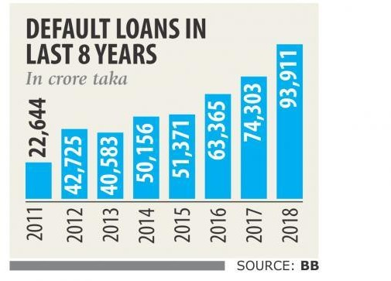

Source: The Daily Star

Current Actions are Taken to Stop NPL:

As we know that NPL has become alarming news in the banking sector of Bangladesh. Government and Bank both are taking actions to stop NPL.

Increasing Maturity: Government gave instruction to the banks to increase the maturity of the loans that are default. By doing this defaulter will be able to pay bank loan that they have taken. This will reduce the NPL rate.
Reducing Higher Interest Rate: Defaulter are facing problem in paying back the loan for the higher rate. To solve that problem government has decreased the interest rate that will help the defaulter to pay back the loan that they have taken.
This tow stapes are criticized by many specialists. They have argued that by taking those steps NPL rate can be reduced but the problem will be increased. The banks will be faced a huge deficit in future for this steps. For this steps bank will have normal cash outflows but the bank will receive slow and low cash inflows. That can bring bad times for banks and create capital shortages for the banks. These steps will also give bad motivations for the debt holder who are paying installment regularly.

There are some other steps which are taken to minimize the NPL rate:

Banks are Getting More Strict While Giving Loan: At this time banks are getting very strict so that they can invest their money in the proper sector. They are avoiding taking huge risk as they used to take before. Bank investigates and collects huge

information to find the probability of risk and return. This action can be beneficial for traducing NPL rate in the future.
Proper Security: If a person doesn’t have proper security bank are not giving any loan to the person. Because there is a huge risk that the person can default and the bank won’t be able to take back their money from them. That’s the reason banks are getting more concern about the security.

Influence Entrepreneurs: Banks are giving more facilities to the entrepreneurs. So they can increase their business. If they can increase their business their profit will also increase and that the reason bank will be able to generate proper cash flow from them.
Proper Management: Banks are trying to create the management effective. Most of the banks employees are not aware about the risk of the NPL. Currently banks are trying to collect efficient employee so they can create a strong management. That will help the bank to take proper investment decision. If the bank can invest their money in the proper sector the risk of NPL will be rescued.

Independent Management: Banks are giving more concern so that they are not getting bias while giving loan. Banks are assuring their management system is making decision independently without any bias influence. By doing this the risk of NPL can be reduced. Without biasness management will only take the decision which is good for the bank.

Giving Proper Training: Bank is giving more important to make their employee efficient. Banks are increasing their budget in training sector. Employees are getting chances for taking training from international institution. This training is helping them for identifying the risk properly and making a proper investment portfolio.

Separate Legal Department: Bangladesh banks made it mandatory for all bank for creating separate legal department. This department will help bank in finding the proper security. Deferent lower are working in the legal department. They can easily find that how strong the security is by identifying the actual owner of the collateral. Id the bank faces NPL then legal department helps the bank in collecting their money back.

Increasing Resave: Bangladesh bank has increased resave system for all banks. So that banks won’t face capital shortage in future. Banks are bound to pay a specific amount at a specific time in the Bangladesh bank. This system will help the bank from the loss of bank deficit situation.

Fix Ratio: Central bank has fixated the ratio for all kind of banks. For this reason bank won’t be able to invest more than a particular ration in a particular industry. Is a specific industry falls then the bank won’t suffer that much. For that reason now it has a verity of security in its portfolio.

Increasing Monitoring System: Banks increases their monitoring pattern. Now if borrowers miss one installment bank start their monitoring and try to identify the reason. If they find that their future risk then they initially takes steps. So they can find their easy way to collect money without any obligation. Banks also try to monitor the profitability of the business regularly to avoid any future risk.

Proper Risk Management Team: Banks are creating efficient risk management team. It’s very important to identify the risk to avoid the future risk. If the management is not efficient enough to find the proper risk they won’t be able to avoid the future risk. That’s the reason that banks are giving more concerns in creating proper risk management team.

Effective Security Market: Bank invests their money in various companies’ security. To find the proper security to invest the market need to be efficient. If the market is efficient than the bank will be able to invest in the security that are highly profitable and lower at risk this will reduce the NPL. Effective security market will help banks to avoid the companies which are performing poor.

Avoiding Risky Investment: Most of the bank wants to earn profit from higher interest rate. Bank can only increase the interest rate if they invest in the risky project. But in the reality bank can earn higher from the risky project for a short period of time. In the long run the risky project can fail anytime and the bank can faces NPL. To stop this risk of NPL banks needed to investment in any risky project. Investment in the risky project can hamper both bank and deposit holder.

Strong Probability Measurements: We can’t know the future risk. But we can measure the probability from the past performance. Banks are getting more concern about the probability measurement to avoid the future NPL rate. Banks are using diffident efficient technologies to measure proper probabilities and differentiate the companies which are performing well and the companies which are performing poor. It will make easy the investment decisions.

How Successful Countries Are Dealing With NPL

To successfully reduce the problem of NPL we need to follow the steps of successful countries how they are over coming from the problem of NPL.

Malaysia: In this country defaulters are not allowed to go out of the country. They are listed in the blacklist. This country uses non-cash format for recovering the loss of NPL. Here they have proper asset management companies which help them in collecting money back. Malaysia also sales collateral and collects money from the defaulter.

Sri Lanka: This country is also successfully able to reducing the rate of NPL. The coverage of NPL has increased from 2.5% to 63% in this country which is quite good. This become possible for correct action is taken by government and proper credit policy.

China: This country put some restriction for a defaulter that is available for general people. Defaulter is monitored strictly in china. Sometimes defaulter’s massages and calls are also recoded to monitor his action.

CHAPTER 6: Nonperforming Loans in the City Bank

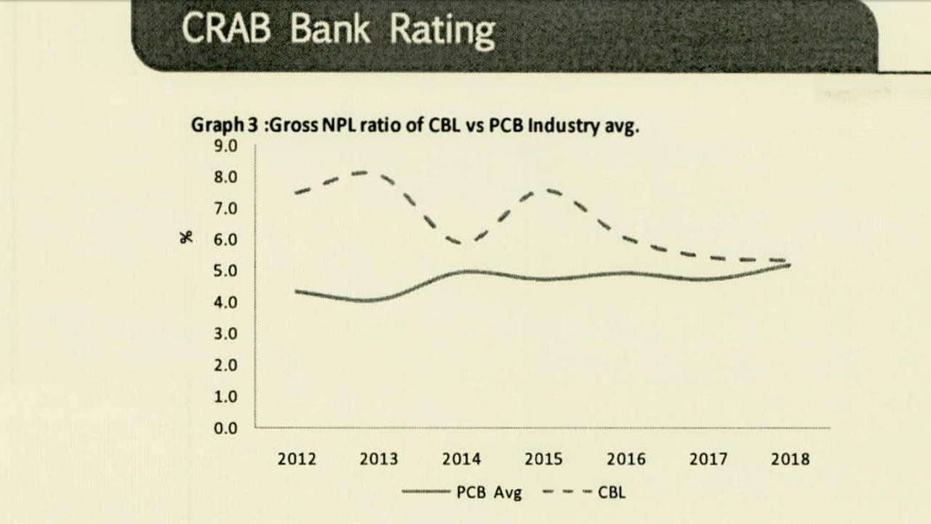

CBL’s gross NPL ratio was similar with the industry average in 2018. But the ratio was higher than the PCB industry average during last couple of years. However, the bank managed to bring down gross NPL ratio by 0.1 percentage point on the back of cash recovery and loan reschedule as well as moderate growth of loan &advance (17.7%). The Bank’s gross NPL (in absolute amount) enhanced (by 15.4%) and reached BDT 12,325.5 million in 2018. The bank had rescheduled loan BDT 3,927.7 million (1.7% of total loan) and cash recovery was BDT 2,711.2 million in 2018 (1.2% of total loan). The bank also writes off BDT 451.6 million (0.2% of total loans) non- performing loan during 2018. As an overall effect, gross NPL ratio of the bank stood at 5.3% in 2018 (2017: 5.4%) which was much alike with the PCB average.

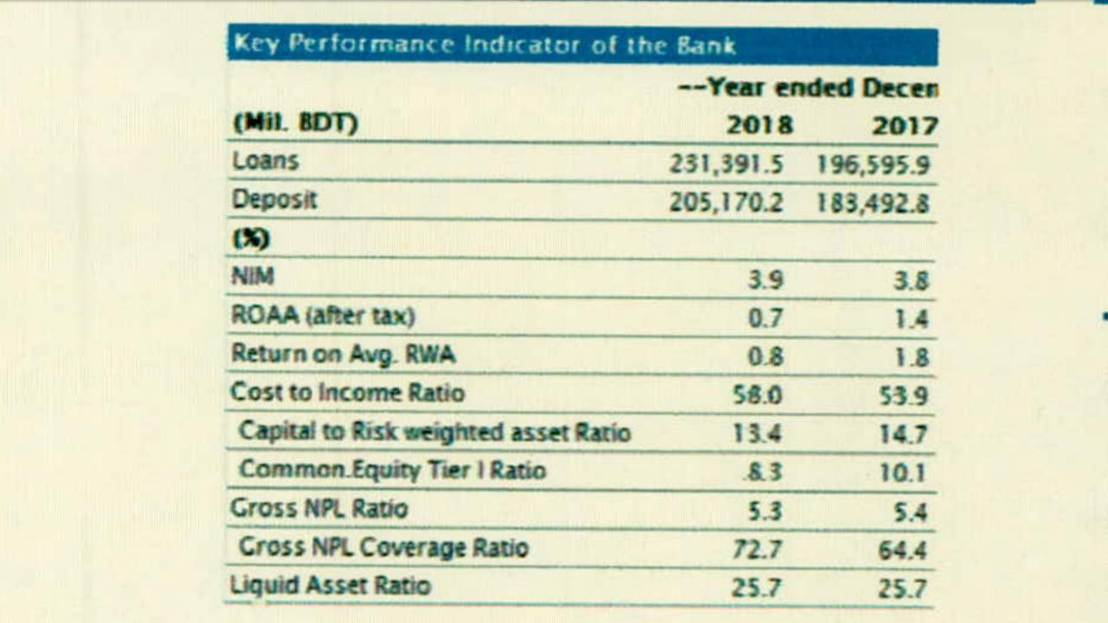

Source: CRAB Bank Rating

Sector Wise NPL of City Bank

Sales

Retail Loans Staff Loans
Off-shore Banking SME Loans Corporate loans

The Bank’s loans advance portfolio grew by 17.7% in 2018 and reached BTD 231,391.5 million. Product wise concentration shows that, corporate loans strongly dominated the loan portfolio in 2018 having 48.3% of total followed by retail loans (22.1% of total) and off shore banking (16.0% of total) and SME loan shared (12% of total). Type wide concentration shows that loans are mainly dominated by industrial credits (54.9% of total) followed by cash credit (9.5% of total).

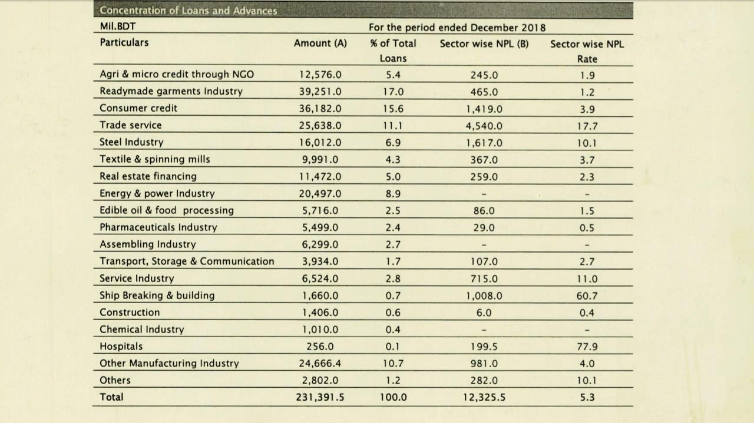

Source: CRAB Bank Rating

Criteria that city bank check before giving loan to prevent NPL

CRM manager of City bank evaluate some information about customers before giving loan so that they can avoid the risk of NPL. City Bank gathers information about some specific criteria about the customer. Those are given below:

Business: At first city bank tries to know what types of the business the customer has. Than based on types of businesses city bank try to find the validity of the business.
    - Sole Proprietorship: for this type of business the bank tries to find whether the business is situated more than two years or not, the business has proper trade license, who is the actual owner of it.
    - Partnership: Here bank properly cheeks the partnership contract and how much influence each of them has in that business.
    - Company: bank identifies whether the company is private or public, share distribution, memorandum etc.

Product: It’s important for bank to know what kind of product the customer is sailing in the business. Because if the product doesn’t have proper demand in the market than the business can collapse any time. It can increase the risk of NPL.

Relationship: City bank finds who are the suppliers and other investor in the business to know their relation with their customer. Because if the customer has a bad relationship with them than there has a high chance than customer can do this behavior with them too.
Personality: Sometimes NPL can cause because of the personality of the customer. Some person doesn’t want to pay back the loan even they have the ability to pay. To

find out their personality bank investigate customer’s family background. Here they also try to find relation among family and the customer.

Sales Validity: city bank cheeks sale invoice, bank statement and also collect information from customers of the business to find the sale was actually made by the business. And it’s also helps in finding actual profitability of the business.

Demand: it’s important for bank to know that whether the customer actually have need of loan or not. If they have need than how much the actual need is. City bank also tries to know specific what kind of loan they want and whether the demand matches with city banks products or not.
    - For Import City bank provides: LC, LTR, RSTL, Term Loan
    - For trading concern City Bank Provides: OD, RSTL
    - For export City Bank Provides: LC, Back to back Loan, PC or OD, FDP
    - For deemed export City Bank Provide: IDVP, OD, term loan.

Collateral: if the customer fails to repay the loan bank can collect the money by selling collateral. Collateral reduces the risk of NPL. Tats the reason why bank tries to find the validity of the collateral. By finding who the actual owner is or what is the market value of the collateral bank evaluate the collateral.

Market Information: Bank tries to find how much influence the customer has in the market. If the customer has weak influence in the market that indicates that in the future customer won’t be able to cope up with the market. That can increase the risk of NPL.

Industry Information: it’s also important to know the industry in which the customer is operating the business. If the industry is in downturn it increases the probability of NPL.

Case study

Company A

Industry: Garments

Product: Cotton

Types of Business: Sole Proprietorship



Company A took loan from City Bank. Company A used to sale their product seasonally. Its sales starts increase in Eid season. This types of company only sales their product in Eid season. Without that specific season the company was only producing its product. The company took loan so that it can produce its product properly. After sometimes bank started increase the loan amount according to the company’s demand. By this time the company made up some false information. It’s showed more stock than it actually has, so that it can demand for more loans. The company sold their product seasonally it starts losing its ability of paying its monthly instilment to the bank. The company starts facing shortage of working capital. Then the loan became non-performing.

Problems:

    - Company A:

This Company failed makes proper business structure. The company should make a proper plan before taking loan. If the company had a proper plan it would be able to pay the installment and it won’t face NPL.

    - City Bank:

Bank failed to do proper investigation. It couldn’t take proper information from the company. If the bank could find the actual condition of the company maybe it wouldn’t increase the loan amount.

Solution:

The bank increased the term of the loan and also decreased the interest rate. By doing that the company will be able to pay back the loan and the bank won’t face NPL.

Company B

Product: Toys

Industry: Gaming

Types of Business: Partnership


Company B had four directors, another investor and one expert. From four directors two directors had good relation with another renowned bank. That’s why city bank only cheeked whether the company has enough collator or not. Bank gave the loan without checking proper history about the company. After some times the company made a demand so the bank increases the loan amount. The company brought some defective product from the loan amount. Then they couldn’t sale that product in the market. At that point the expert starts theft and took a huge amount of money from the company and left the business. In this situation the company becomes unable to pay its monthly installment and the loan become NPL.

Problem:

In this case bank and company B both made some mistake which is given below:

Company B:

This company had management problem. Directors of the company couldn’t pay enough attention because of lack of involvement in the business. Director was fully depending on the expert that gave the expert chances for theft money from the business.

City Bank:

Bank didn’t investigate the history of the company which was a big mistake for the bank. If they investigated the company’s history properly than the bank could find out that the directors were not properly involved in the business.

Solution:

Both directors and bank agreed that directors will sale their lands which were given as collateral for thanking loan.

Company C

Product: Mobile Phone, Sim Card, Flaxy load card etc.

Industry: Telecom

Types of Business: Sole Proprietorship (Broker)


Company C was a distributor of Banglalink Company. City bank gave loan to the Company C with proper investigation. Suddenly Company C faced theft of money. Because of this reason the company couldn’t sale properly. Banglanik noticed that Company C’s sales reduced suddenly. That’s why Banglaling reduced Company C’s area limitation. Company C couldn’t increase their sales because of the area limitation. For this reason, it couldn’t earn properly to payout its fix cost. The company starts facing shortage of working capital and became unable to pay its installment. Then the Loan became NPL.

Problem:

In this case there was no mistake of the bank. Company C had some management problem. It should manage its money properly. If company c could reduce its fix cost in proper time it wouldn’t face this problem.

Solution:

Company C and bank both agreed that company c will sale its land which was given as collateral.

Company D

Product: steel

Industry: steel industry

Types of Business: Partnership


Company D had two partners. City bank give them loan as the business was doing well. In this case City bank investigated their all information. Suddenly price of steel fall down and the company faced a huge loss. As they have invested all of their money in this business after the huge loses they become unable to pay the installment and the loan become NPL.

Problem:

In this case the bank couldn’t monitor properly. If the bank could monitor properly it could identify that the price of still would fall then the bank could change its investment decision.
Solution:

Both of the partner and bank decided that the bank will sail the collateral asset.

Company E

Product: Shoe

Industry: Shoe in which industry

Types of Business: Sole Proprietorship



Owner of the business took loan from the City Bank. Company “E” used to sale shoe as their product. Suddenly the owner of the company decides to produce different types of shoe. For that reason they took more loans from the bank. After producing new product they failed to sale them for their defective design. As result they faced a huge loss and they become unable to pay the monthly installment. That’s how the loan becomes NPL.

Problem:

Company E failed to prepare proper plan. If the company could have made a proper plan it wouldn’t faced that los.
Solution:

Both of the partner and bank decided that the bank will sail the collateral asset.

Chapter 7: Internship experience

Position:

My Position was an intern of City Bank Limited. I was placed to do my internship responsibilities to Legal Division of City Bank Limited that is situated at the 2nd floor of jibon bima tower, 10, Dilkusha, Motijheel.

Responsibilities:

I was working in legal division of city bank. Here I updated the information that is related to case which is against the city banks clients. I update all information in special software named ULIS. First I needed to open page in ULIS software. After that I field up the pages by giving information about each case separately. For each case I have inputted a separate page in ULIS software. At first I needed to give the date at which I inputted the information in ULIS. Then I inputted the reference number so that anyone can easily identify the page. After that I put legal notice date and also next date on which new action will be taken for the case. And then I need to update the receiving date that is the date when the bank received the case against that client which is usually seven days before than the legal notice sent. Then I need to choose the type of notice that is legal notice. There is a list given where I selected the employee name who is dealing with the case. Till now this was all information about the file. After giving all information about the file I inputted all information about the person against whom the bank took action. In this area I have inputted the name of the person and his or her present, permanent address, and business address. Also account number, card number and client ID number were also inputted. Then I need to input the name of account if case is SME loan then the name of account will be on the name of properties for which the loan is taken and if it is visa card or AMEX card case then the name of account name will be on the name of borrower himself or herself. I also need to select the borrower status that is related to the case activity type. For example, if the activity type is charge, witness, withdrawer of suit,

transferred of suit or the suit is trial sate then the borrower status will be traceable. And if the activity type is warrant of arrest, WP&A or paper publication then the borrower status will be traceless. AND if there is a newspaper publication about this case then I need to also add the name of that newspaper. Then I gave the guarantor’s information in which the name of the guarantor, his address was inputted. There were other information about cases were also inputted about cheque like what was the date of the cheque issued and dishonored. There is a box of suit value, the suit value is equal to the cheque amount, if there is more than one cheque then the suit value will be equal to the total amount of all the cheques. Then I need to mention that this case is filling by bank from an option and input the date of filling which is mentioned in that file. I have also inputted information about lawyer like who was the lawyer working for the case and in which court. Then after completing the form fully there is a submit button where I need to click to submit all these information.

Skilled Applied:

- Using my communication skill
- Data entry
- Using the knowledge about MS excel
- Using MS word and MS excel
- Application of the option I known about MS word
- Using short cut techniques while inputting data in the software
- Fast typing speed

New skill developed:

  - Learn to be compatible in work place
  - Be punctual
  - Increase typing speed
  - Data entry
  - Learn to send mail in corporate style for corporate need
  - Learn to use more option in MS Word
  - Learn to use MS Excel more effectively
  - Increase my time management ability
  - Be more responsible to my duties
  - Learn to complete assigned work within given time period with full responsibility.
  - Increase communication skills
  - Be more presentable

Chapter 8: Recommendation and Conclusion

Recommendation:
I am recommending CBL on the basis of my personal experience. As I have worked in the Legal division of CBL I can recommend for the legal division of CBL on the following Issue:
- We were four interns in this division but there was not any separate desk or arrangement where we can sit and do our work. We have used the desks of our senior officer when they didn’t use their desktop. I will recommend to this division to arranged required number of desks to their intern before they hire new intern.
- In legal division I have faced shortage of recourse. . So I will recommend the department to give required amount of resources to their employee.
- In this division the number of scanner is less than the number of employee, I will recommend them to give extra attention on this.

- At time of taking interview of intern they make delay. This behavior makes a sense that they don’t give value of time of interns. Bank should be stricter to their interviewer on this issue.
- As a customer I will recommend CBL to make their services smarter. While using ‘’city touch’’ app sometimes the funds make withdraw but the transaction got failed.

Conclusion:

City Bank is the one of the top commercial bank in our country. It has a strong brand identity. Among those customer who are taking banking services prefer City Bank. It also can be said as one the most successful bank. That’s why the new initiatives and new offering of CBL is always highly accepted by its customers. It’s trying to fulfill its customers demand by giving different types of loan. Though in past year CBLs NPL was a little higher in past few years but in current year its managed to cope up with the industry and reduced NPL ratio. CBL already show its proactive behavior by different services, hope that it will make this continuously to stay as a strong bank in competitive industry like banking industry. Hope that CBL will able to run its banking operation by balancing with economic, political and environmental factors. After working 3 moths with this bank I have a great affection with this brand and I’m hoping continuous success for them.

Bibliography

Reference

- Akter, R. and Roy, J. (2017). The Impacts of Non-Performing Loan on Profitability: An Empirical Study on Banking Sector of Dhaka Stock. Exchange. International Journal of Economics and Finance, 9(3), p.126.
- Dhal, Sarat. (2003). Non-Performing Loans and Terms of Credit of Public Sector Banks in India. RBI Occasional Papers. 24. 2003.
- Sinkey, J.F., Greenawalt, M.B. Loan-loss experience and risk-taking behavior at large commercial banks. J Finan Serv Res 5, 43–59 (1991)
- Parven, Salena (2011): Nonperforming loans of commercial banks in Bangladesh.
- Hou, Lianhai. (2001). Mesozoic Birds of China.
- Bird, Richard & Ebel, Robert & Wallich, Christine & Bank, World. (1995). Decentralization of the Socialist State: Intergovernmental Finance in Transition Economies.
- Khemraj, Tarron & Pasha, Sukrishnalall. (2016). Determinants of Nonperforming Loans in Guyana. 10.1057/978-1-137-52246-7_9.
Online

- City bank. (2020). [online] Available at: https://www.thecitybank.com/ [Accessed 2 Jan. 2020].
- Bangladesh Bank. (2020). [online] Available at: https://www.bb.org.bd/ [Accessed 2 Jan. 2020].
- Crab.com.bd. (2020). Credit Rating Agency of Bangladesh Ltd. |. [online] Available at: https://crab.com.bd/ [Accessed 2 Jan. 2020].
- The Daily Star. (2020). The Daily Star. [online] Available at: https://www.thedailystar.net/ [Accessed 2 Jan. 2020].

