
Internship Report on
Export opportunities in RMG sector of Bangladesh.



Course Code: INT 4399
Course Title: INTERNSHIP

Submitted to
Ziaul Karim
Assistant Professor - AIS
United International University

Submitted by
Asiful Alam
ID: 111 151 259
Semester: Summer
Section: A

Date of submission: 23/10/2019

Letter of Transmittal

23rd October 2019

Ziaul Karim
Lecturer,
School of Business& Economics
United International University
United City, Madani Avenue, Dhaka 1212

Subject: Report on Export opportunities in RMG sector of Bangladesh.

Dear Sir,
I worked in a company named “Consumer Kintex Limited” in the department of Commercial as an intern and on the basis of that I prepared this report. As an intern, my job was to prepare the Generalized System of Preferences (GSP) file, some Bill of Landing adjustment related work and extra other work given by my department employee and supervisor. I have tried my best and worked with most sincerity to gather information and also put up the working experience and my company export procedure, opportunities and make it as well structured as possible.

I have tried to discuss all the relevant points and information. In writing this report, I have tried to go through your instructions and apply the concepts learned in the course. However, I will be glad to clarify any discrepancies that may arise.

Sincerely yours,
Asiful Alam
__________________

Acknowledgement

First, I would like to thank our almighty as he gives us the ability to broadly think, knowledge, strength, and patience to complete the Report.

Second, I would like to express my deep sense of gratitude to our honorable teacher Ziaul Karim, who gives me the opportunity to make this report “Export opportunities on the RMG sector of Bangladesh”. In Bangladesh, there is huge opportunities and benefits in the export sector but especially in the RMG sector, the Government gives more benefits than other company. So in this report, I am trying to find every way of how to start doing a Report, how to think while doing it, how to move forward, how to analyze and how to comprehend the total thing. I am also thankful for all the times I consulted and he answered with the utmost patience and perseverance.

Third, I offer my special thanks to my friends, relatives, classmates and senior brothers & sisters who help and support us to complete this report.

Scope & Limitation

This report is based on Export opportunities for the RMG sector has a huge scope for finding data and information. I also can provide export-related documentation based on the Bangladeshi export procedures and opportunities of the RMG sector. So, there is more scope for me of making this report.

But as I also have to make this report based on my internship in which company, I am working so it is a little bit tough to put my company all information and every stuff because that data and information of the company is confidential. So, here is some limitation in this report for providing more information about my company export sector’s information and documents which I can’t provide in this report. So this is the limitation in my report.

Executive Summery

This report does not just give a general view and prospect of Consumer Kintex Limited covering from running business forms, hierarchical structure to the customers yet, in addition, investigates the fare execution of RMG (Ready Made Garments) Sector. In spite of beginning its tasks in Bangladesh in 1986, Consumer Kintex Limited has turned out to be famous in the clothing business sector within a short period of time. Texture and sew are the essential elements of Consumer Kintex Limited. Here Consumer Knitex Ltd. provides the best quality product, better checking and better help with legitimate confirmation of 100% fare quality are what made Consumer Kintex Limited popular over the world. Then again, the remarkable exhibition of Consumer Kintex Limited displayed the RMG industry as an appealing segment to put resources into subsequent rivalry continues rising like some other division. All through this report, it is expressed how RMG division is working alongside circumstance, likely risk, this report is prepared by an industry information examination which at last expand the obstacle nation's RMG segment looking just as circumstances are accessible to reach. In this report, it is expressed about the Bangladeshi RMG sector development and progress improvement day by day and also contributing 16% in the GDP of Bangladesh according to 2019. So for the development of Bangladesh how much the RMG sector contributing and how can it increase the chances to expand its operation will be also shown in this report.

Table of Content

Contents
1.0 Introduction 1
1.1 Background of the report 1
1.2 Objective of the report 2
1.3 Methodology 2
1.4 Types of data 2
2.0 Company Profile 3
2.1 CMT Operations and Design 4
2.2 CMT and the energy behind 5
2.3 Mission Statement 5
2.4 Porter’s Five Forces analysis 5
2.5 SWOT examination of Consumer Kintex Limited (CMT) 7
2.6 PESTEL Analysis 8
2.7 My company’s export & import system 9
2.8 Job Responsibilities as an Intern 10
3.0 Literature review 11
3.1 Export condition of Readymade Garments Sector 11
3.2 Strength of RMG sector in Bangladesh 12
3.3 Key recommendations concerning worker’s welfare 12
3.4 Foreign Threats in RMG sector 14
4.0 Data Analysis 16
5.0 Findings 17
6.0 Recommendation 19
7.0 Conclusion 20
8.0 Reference 22
9.0 Appendix 23
9.1 Per Worker Productivity of Bangladesh and Its Apparel Exporting Competing Countries 23
9.2 RMG Industry Lifeline to Bangladesh Economy 23
9.3 RMG Export Growth Trend 24
9.4 Statistics Report of Workers Growth 24
9.5 Value Creation Activities by Bangladeshi Knitted Cotton T-Shirt Manufacturers FOB-2 To 25
9.6 Value Creation Activities by Bangladeshi Woven Shirt Manufacturers FOB-45 Source 25
9.7 CMT Logo 26
9.8 Compagnie Mauricienne de Textile Ltée (CMT) 26
9.9 Appointment Letter 27

Introduction

A developing economy like Bangladesh has a surplus of unproductive labor in the primitive sector. These workers are attracted to the growing manufacturing sector called RMG sector where higher wages are offered. That is why; Bangladesh becomes the Textile & Clothing (T&C) hub due to its availability of cheap labor. ‘Development with Unlimited Supplies of Labor’ model given by Sir William Arthur Lewis (23 January 1915 – 15 June 1991) is found appropriately set in the case of Bangladesh. More than 50million people out of 160 million of the country are at the age of 15 to 30 years. This part of the population is the most effective workforce in the country. They are the major player in the industrial sector of Bangladesh, particularly in the RMG sector. This is the reason to say that the demographic dividend of Bangladesh is exploited by the RMG sector only. The total economy of the country greatly depends upon this industrial sector. The role of labors is of paramount importance in this labor-intensive export-oriented industry. Proper management of labor is an essential matter for the growth of this industrial sector. But the majority of the garments workers are unhappy with their toilsome labor but the security and safety net in the working place. The recent Rana plaza catastrophe and Tazreen fire tragedy with horrendous casualties created sensation not only in the country but also in the world. These kinds of incidence show that workplace safety and security of the garments workers in the country is in very bad shape. At the cost of the sweat and blood of the poor and marginalized garment workers, the country is earning billions of dollars and garment factory owners make their fate. But these workers are facing negligence and ill-treatment both from factory owners and from the government. Gender discrimination, working environment, conspiracy, wage, owner-worker relations, life standard and socio-economic condition of the garment workers especially of women workers are the major issue in the field of the RMG industry of Bangladesh.

Background of the report

In order to complete the BBA graduation, I have to complete the internship program and work to a company as an intern. So for this, I choose “Consumer Kintex Limited” which is a renounced multinational company in Bangladesh. I worked there for 3 months and it was a great experience. I had learned a lot on the basis of the working experience and also the supervision of your I have made this report.
The report entitled “Export opportunities in RMG sector of Bangladesh” This report is submitted to Ziaul Karim, the lecturer of United International University. This report is submitted by Asiful Alam student of the Internship course, United International University. The date of submission is 23rd October 2019.

1.2 Objective of the report

The report is done for the fulfillment of the course “Internship”. The main objective of this report is to provide a comprehensive overview of the “Export opportunities on the RMG sector of Bangladesh. In this report I am going to find out:
- In Bangladesh garments how can we develop export performance and create opportunities in the international market
- To create the opportunity what will be the difficulties we have to face.
- In Bangladesh how can we develop our exporting system in the international market
- In the international market how can we increase the export volume, and what should be the measures for that.

1.3 Methodology

The task report depends mostly on secondary data and the information which is required for the report was gathered from various distributed reports, diaries and from the exercises and inquiries during my internship time and after the intern ending. Various tables and diagrams have been utilized to translate the information and draw deduction therefrom. Essential wellsprings of information during my temporary internship period and inquiries from the administrators, officials, and representatives while doing my required position in Consumer Kintex Limited.

1.4 Types of data

For this research, I used primary and secondary data.
Primary sources of data: In the time of my internship program in the Consumer Kintex Limited I have done some queries from the executives, officer, senior officer, assistant manager and also manager and from my practical experience in my short period of time.
Secondary sources of data: Secondary data include annual reports, articles, journals, and other related documents published on the internet.

2.0 Company Profile

The organization began with straightforward and humble standards in 1986 yet lived to the vision of turning into the world's head in the jersey wear business.
1986 – Founded by Louis Lai Fat Fur and Francois Woo Shing Hai,100% Mauritian,30 workers Included for the most part in cut-make-trim tasks and1 sewing production line
1990-96 – Capital venture and vertical joining and computer-aided design/CAM Technology into example making, cutting and piece of clothing produce, venture into sewing and coloring tasks and data Technology and advancement of ERP framework,2 texture plants, 3 sewing processing plants and administrator building
1997-2002 – Consolidation and broadening of administrations against the background of its statement of purpose, drafted two decades’ prior, CMT has without a doubt made some amazing progress to generously accomplish what it set out to achieve. From its modest beginnings in 1986, CMT has today developed to the biggest jersey wear maker in Mauritius and the Sub-Saharan district. Opening of a hello-tech coloring plant, making it the biggest in sub-Saharan Africa and beginning item plan and improvement administrations “Opening of new sewing plants, development of weaving and printing offices,2 texture plants, 5 sewing production lines and administrator building
2003-06 – Expansion of activities, overhauling administrations and worldwide effort and imagination and item configuration focus “Opening of world-class turning factories, opening of sewing plant, biggest in Mauritius, Union of sewing and coloring, Vertical reconciliation into trims and adornments fabricate, Venture into worth included procedures,2 texture plants, 6 sewing industrial facilities and administrator building
2007-08 – BHAG – A major bristly nervy objective set to move CMT among the world's best ten jersey wear makers by 2008
Fast development against the scenery of its statement of purpose, drafted two decades prior, CMT has to be sure made considerable progress to significantly accomplish what it set out to achieve. From its unassuming beginnings in 1986, CMT has become the biggest jersey wear producer in Mauritius and the Sub-Saharan district.

Compagnie Mauricienne de Textile Ltée (CMT), a worldwide jersey wear clothing industry pioneer, is headquartered in Mauritius with showcasing workplaces in UK, France and before long opening in New York. CMT has the biggest vertically-coordinated assembling plants in the Sub-Saharan locale and is known for its stamped interest in world-class offices and best-in-class tasks. It is represented considerable authority in the plan and generation of quick design jersey wear items for the best garments brands and quick style retailers on the high roads.

2.1 CMT Operations and Design

The organization offers a full-bundle administration to its clients, extending from plan to landed conveyance in circulation focuses in Europe and the US. Point by point tasks include:
- Product structure and advancement
- Yarn turning and coloring
- Fabric weaving, coloring and wrapping up
- Cutting and sewing
- Printing
- Embroidery
- Garment wash and coloring
- Landed conveyance into dissemination focuses

Command over the full inventory network makes CMT (Consumer Kintex Limited) situated in Bangladesh a solid all out specialist organization of a huge swath of significant worth added shirt pieces of clothing intended to meet the one of a kind and consistently changing needs of its clients.

2.2 CMT and the energy behind

At the core of the organization, a practically unmistakable enthusiasm vibrates and converts into fervor and drive. It is a promise to quality and intensity for being the best.
Sufficient isn't adequate.
What's more, simply the best exertion, consistently, is adequate to serve the absolute best apparel brands from around the globe.
More or less, CMT's corporate qualities assemble around the devotion and duty to convey Fast Fashion and meet whatever the style of the day manages.
Step by step, the CMT family lives with the vision of turning into a significant worldwide player in the style of business.
It is an enthusiasm that makes you more distant than your imagination.

2.3 Mission Statement

From where we come… to where we’re going.
We strive to be the number one world-class manufacturer of top quality garments and jersey wear, by investing in technology promoting training and development for our people.
By becoming a hub for learning, we will contribute to our country’s social and economic development.
We are the Dream Team!

2.4 Porter’s Five Forces analysis

The threat of new entrants
As Bangladesh's article of the clothing industry is encountering a decent reaction over the world and adequate modest work and credit offices are accessible to begin a business in this area, the risk of potential participants is high. This essentially clarifies Consumer Kintex Limited needs high vital stands to get by just as to have an adequate request from the developing RMG area.
The bargaining power of the firm’s suppliers
The bartering intensity of providers is moderate. Now and again the purchasers of the organization allude to certain providers. All things considered, those providers appreciate inclination.
The bargaining power of the firm’s customers
The haggling intensity of the association's clients is high. Bangladeshi makers understand that the purchaser has more power than themselves. At that point, China's lead and India's walk to the top keep the Bangladeshi makers on their toes. In this way, Consumer Kintex Limited. is giving huge space of decisions as far as quality and cost.
The threat of substitute products
In this industry, this angle isn't considered in light of the fact that there is no ideal substitute for them gave administration like manufactured items, jute or banana fiber garments and so on. In spite of the fact that the blend of various textures is being offered by the Chinese market and is getting prevalent through the span of time moreover. Be that as it may, till today the danger of substitute items is low.
Rivalry among competing for firm’s
As Government is taking enough activities to make the development of industry consistent just as an advance office is there for development more players and marketing organization is making a decent attempt to stay aware of the challenge of RMG area. Subsequently, the force of competition is very high for any working organization.

2.5 SWOT examination of Consumer Kintex Limited (CMT)

Strengths
- Having encountered the board authorities to lead the generation procedure adequately Sufficient creation limit inside the processing plant
- In house printing, weaving and washing plant office
- Usage of the accessible current gear
- CMT material has solid dependability to the customers

Weakness:
- Postponement if there should arise an occurrence of conveying test
- Troubles to adapt to upgradable new innovation
- Absence of new computerized hardware

Opportunities:
- Reliability and quality confirmation have a few remote nations enthusiasm about this organization
- Withdrawal of the portion arrangement of pieces of a clothing item from early2006 builds the interest of RMG area
- Labor cost and sound collaboration have consistently been an open door for RMG division.

Threats:
- Developing business sector of China and India
- The increased challenge with nearby pieces of clothing
- Political agitation is an obvious risk to the smooth capacity of Consumer Knitex Limited.
- Lack of power can make an issue for the business.

2.6 PESTEL Analysis

Political: From 2014 we have encountered that political instability has been minimalized and any inconsistency from the law or any aggravation which can hamper the business exercises are managed high significance. Subsequently, different segments, as well as the RMG part, got enough space to keep the development high.
Economical: As we see Bangladesh is a developing nation so it can't be said most likely whether the business will run easily or not. Since we are confronting deficiency of power and high swelling which hamper the exercises of the item of clothing area, it very well may be a downside for Consumer Kintex Limited which will hit the income cycle in the end
Social: Thirdly the social variables, as Bangladesh is a dynamic nation and our pieces of clothing are truly outstanding on the planet. A large portion of the remote nations is probably going to offer requests to our material firms. In the long run, Consumer Textile is getting a lot of requests and furthermore is contending with the material firms in Bangladesh.
Technological: As we see the cutting edge period is a time of innovations and loads of nations are embracing in present-day approach to do their capacity. They are utilizing new machines in the items of clothing area which can help in improving their quality and expanding stock amount. In any case, in Bangladesh, every one of the pieces of clothing is as yet depending on days of yore. They are utilizing the old machine which isn't abundantly tweaked to perform different undertakings. In this way, Consumer Kintex Limited should concentrate on utilizing improved hardware and advances to improve quality and to accomplish a superior position.
Environmental: To have eco-friendly factories, the government is providing loans at 9% interest, especially to the RMG sector. As a result, nowadays the RMG sector of Bangladesh is materializing its effort to build eco-friendly factories and maintaining an environmentally friendly process in the case of manufacturing. This is a challenge faced by Consumer Kintex Limited.
Legal: After the breakdown of Rana Plaza and the savage fire at Tazreen Fashions industrial facility the administration has found a way to fortify the Directorate of Inspection for Factories and Establishments, which is liable for observing workplace security and consistency and has contracted more examiners. These have a beneficial outcome with respect to the improvement of the framework of RMG division just as for Consumer Kintex Limited.

2.7 My company’s export & import system
Import:
- LC: A letter of credit is a letter from a bank guaranteeing that a buyer will pay their specific client on time and according to the contract amount in the deal. In this specific contract, if the buyer is unable to make a payment on the purchase, the bank will pay on behalf of the buyer, the bank will be required to cover the full amount of the contract. In my company for LC, HS code needed which is provided by BD govt. According to this, we have to pay duty.
- Bond Book: It is a book which is registered by the Bangladesh government if an RMG company registered under this then they have to pay less duty sometimes no duty should be given.
Export:
- First, the mother company of the CMT Bangladesh “Mauricienne” provides us the Invoice.
- Then by that Invoice, we made Exp form which is Export permission form of Bangladesh government.
- After making the Exp form we send the Invoice and Exp form to the bank for update and further procedure.
- Our bank sends the documents to the Bangladesh Bank.
- Then that Exp form send to the Chittagong port or in the Dhaka Airport
- The custom authority officer checks that and makes a pass of the document and made the Shipping bill.
- For our company, there is a Forwarding agent which is called C&F (Clear and Forwarding) for us as a middle man.
- After our custom made sure all the documents are clear then our factory which is situated in Gazipur they release the product or goods and sent them to the port of destination.
- When the goods arrived in the port of destination product buyer agent which is called buyer forwarder get the goods and our forwarder which is C&F they send us B/L (Bill of Landing)
- Then our company attached Invoice, B/L, Shipping Bill and issue GSP (Generalized System of Preferences) it is a combined declaration and certificate and it is issued under BD govt.
- After the B/L confirmation we endorsement the document to the bank
- Then the bank gives us permission to deliver the product
- Then our bank contact with buyer bank and make transaction by that B/L
- After that our mother company gives us payment, not by our buyer bank.

Job Responsibilities as an Intern

On May 12, 2019, I got the opportunity to work as an intern at Consumer Kintex Limited. I was appointed by our commercial department manager MR. Anwar Hossain and supervised by Mr. Khalid Khan. During the time my department officers and manager tried hard so that I can learn something and increase my knowledge about their most contributing sector of Bangladesh.

Commercial Department: My job responsibility while working for the Commercial Department of Consumer Kintex Limited is given below:
- Preparing the GSP file.
- Preparing the Export file and making sure of the sequence.
- Checking the Bill of Lading according to the invoice which is provided by the Mauricienne.
- Entry data to the Mauricienne website and make sure the update on time.
These were pretty much my daily job responsibilities in the commercial department as an intern.

3.0 Literature review

Preceding January 2005 there had additionally been a lot of theory about what the effects of MFA end would be on the dynamic and all the more quickly developing Asian clothing exporters including Bangladesh, India, Pakistan, Sri Lanka, Vietnam, and China. RMG is the genuine trading industry in Bangladesh. The Multi-Fiber Arrangements (MFA) became out of a progression of willful fare limitations forced by the United States and Europe on enormous Asian material and dress exporters (anger, 2005). Two overviews by the Center for Development Dialog found that laborers are frequently " glad " with extra time hours since they can procure a higher additional time rate or extra salary at a similar normal hourly rate (al., 2008). The 2007 Wage Survey by Bangladesh Bureau of Statistics (2007) proposes that the normal month to month salary of breadwinners was lower among the individuals who worked sixty hours or more for each week (contrasted with laborers who worked for at least forty and at least fifty hours out of each week), verification that laborers who work long hours do as such to make up for low compensation rates (Rodgers, 2009). The MFA arranged and controlled material and garments quantities so as to help the immature nations by giving their items a favored situation in the business sectors of the created nations and empowered the created nations to respectively arrange portions with different provider nations to ensure the residential interests from clothing imports. In view of the choices in the Uruguay Round dealings during the 1990s, the World Trade Organization’s (WTO) Agreement on Materials and Clothing (ATC) eliminated the MFA on January first, 1995, which was done in four stages, in ten years. With the fourth eliminate period finished on December 31, 2004, worldwide exchange materials and garments went into another ground. The activity of Multi-Fiber Arrangement (MFA) quantities in the process prompted sending out openings in nations where material and garments were not conventional fare things. The ascent of the RMG business in Bangladesh was the consequence of such a universal "overseen exchange" system in the attire. The Ready-Made Garments (RMG) industry in Bangladesh began its endeavor in the late 1970s propelled initially by financial specialists for the most part from Korea and Hong Kong to exploit Bangladesh’s send out quantities in limited markets just as a bounty of modest work. By the late 1980s, attire developed as the primary fare industry of Bangladesh. During the most recent two decades, the material and attire area has encountered a genuine incredible development giving it a key spot in the Bangladesh economy. In FY2008, the RMG division contributed about USD 12.35 billion out of a complete fare of USD 15.56 billion which is likeness around 79 percent of nations all-out fare. In any case, this advancement stays delicate and a tributary of inward as well as outer difficulties, for example, the eliminate of MFA in light of the fact that with the disposal of the MFA portions, taxes will turn into the essential component for outskirt security of exchange materials (WTO). In any case, regardless of the way that organized commerce improves welfare, its advantages are definitely not conveyed equally among concerned gatherings. Nations with setting up similar focal points will profit by the nullifying of the MFA, while nations that can send out in light of insurance from any source will miss out after advancement. In the short run, geographic roots and „buyer preferences‟ will stay significant in sourcing choices while in the since a long time ago run, cost elements and item separation will obtain more prominent significance (Majmudar, 1996). Be that as it may, showcase get to obstructions keep on exacting insoluble misfortunes on the South Asian nations, and non-tax boundaries winding up additional articulated as of late (Weeratunge, 2007). Considering the abovementioned issues, this paper inspects the new elements of worldwide attire exchange due to the nullification of MFA for Bangladesh opposite significant dress providers concentrating on the two significant markets - the United States and the European Union, the two of which have pursued unmistakable execution courses. (Joarder, 2010).

3.1 Export condition of Readymade Garments Sector

The Ready-Made Garments (RMG) industry possesses a novel situation in the Bangladesh economy. It is the biggest sending out the industry in Bangladesh, which experienced remarkable development during the most recent 20 years. By exploiting a protected market under the arrangement of the Multi-Fiber Agreement (MFA) of GATT, it accomplished a prominent as far as outside trade profit, fares, industrialization and commitment to GDP inside a limited ability to focus time. The business assumes a key job in the working-age and in the arrangement of salary to poor people. About 2,000,000 specialists are legitimately and in excess of ten million occupants are in a roundabout way connected with the business. In the course of recent years, the quantity of assembling units has developed from 180 to more than 3600. The segment has likewise assumed a noteworthy job in the financial improvement of the nation.

The Agreement on Textile and Clothing (ATC) presented in 1994, planned for bringing materials and attire inside the area of WTO runs by abrogating all shares before the finish of 2004. It gives an alteration time of 10 years, with the goal that nations influenced by the MFA could find a way to acclimate to the new exchanging condition. Advancement of exchange following the Uruguay Round understanding presents open doors just as difficulties for a creating nation like Bangladesh in RMG part. In the Post-Uruguay Round period, customary instruments of exchange approach, for example, levies, portions, and sponsorships will turn out to be less practical and less pertinent. In a changed exchange system, rivalry among materials and apparel sending out nations is probably going to end up extreme. The goal of this paper is to distinguish the possibilities of RMG industry after the MFA eliminate by examining the present situation alongside various strategy measures and the accessible alternatives so as to be increasingly focused in the new system.

The fare made by Garments Industries of Bangladesh is improving a seemingly endless amount of time after year with the exception of a portion of the year. Strike, design, shutdown of organization, political issue, monetary issue, swelling and so on are the prime reason for diminishing fare in this significant segment. Be that as it may, above it, Readymade Garments Industries is the main part in send out area.

3.2 Contribution of the RMG Industry

RMG business started in the late 70s as a negligible non-traditional sector with a narrow export base and by the year 1983 it emerged as a promising export earning sector; presently it contributes around 75 percent of the total export earnings. Over the past one and a half decades, RMG export earnings have increased by more than 8 times with an exceptional growth rate of 16.5 percent per annum. In FY06, earnings reached about 8 billion USD, which was only less than a billion USD in FY91. Excepting FY02, the industry registered significant positive growth throughout this period. According to GDP, RMG's commitment is profoundly surprising; it arrives at 13 percent of GDP which was uniquely around 3 percent in FY91. This is an unmistakable sign of the business' commitment to the general economy. It additionally assumes an essential job to advance the improvement of other key parts of the economy like banking, protection, shipping, lodging, the travel industry, street transportation, railroad holder administrations, and so on. A recent report found the business supporting roughly USD 2.0 billion worth of financial exercises (Bhattacharya and Rahman), when the estimation of fares remained at somewhat over USD 4.0 billion. One of the key points of interest of the RMG business is its modest work power, which gives a focused edge over its rivals. The division has made employments for around 2,000,000 individuals of which 70 percent are ladies who for the most part originate from country territories. The part opened up business open doors for some more people through immediate and roundabout monetary exercises, which in the long run helps the nation's social advancement, lady strengthening and destitution easing.

3.3 Strength of RMG sector in Bangladesh

Fundamentally the focused quality of a firm or a nation in the market relies upon its particular similar advantage(s) which its rivals don't have. If there should arise an occurrence of Bangladesh, the accessibility of abnormally modest however usable work is considered as upper hand or uniqueness for our RMG industry. The abundant stock of the nearly modest work goes about as the critical quality for the RMG part of Bangladesh. Essentially RMG industry is a low innovation yet work escalated industry. The laborers here can be utilized at extremely low wages, in correlation with other contender nations, yet in addition in examination with other local ventures in Bangladesh. In the residential market too, the wages of the laborers of the RMG business happen to be the most minimal.
Bangladesh offers the least expensive work among RMG creating nations. It has a Compact, Organized and Favorable infra-structure. It has bunches of Pre-send out Financing establishments for help. The board gives off an impression of being extremely unique and fit for improved execution. There are different affiliations like BGMEA, BKMEA, BEPZA and so on to fabricate the solid coordinated effort with different related associations.

3.4 Worker’s Condition in RMG Industry

Bangladesh faces the test of accomplishing quickened financial development and mitigating the gigantic neediness that distresses about two-fifths of its 135 million individuals. To address this difficulty, advertise arranged changing approach changes were started in the mid-1980s and were sought after substantially more vivaciously during the 1990s. These changes were specially planned for moving towards an open financial system and incorporating with the worldwide economy.
During the 1990s, striking advancement was made in monetary execution. Alongside keeping up monetary adjustment with an essentially diminished and declining reliance on remote guide, the economy seemed to start a progress from adjustment to development. The normal yearly development in per capita pay had relentlessly quickened from about 1.6 percent per annum in the principal half of the 1980s to 3.6 percent by the last 50% of the 1990s. This improved presentation owed itself both to a lull in populace development and a continued increment in the pace of GDP development, which arrived at the midpoint of 5.2 percent every year during the second 50% of the 1990s. During this time, progress in the human advancement markers was considerably progressively noteworthy. Bangladesh was in reality among the top performing nations during the 1990s, when estimated by its improvement in the Human Development Index (HDI) as assessed by the United Nations Development Project (UNDP). As far as the expansion in the estimation of HDI somewhere in the range of 1990 and 2001, Bangladesh is outperformed distinctly by China and Cape Verde.
While most low-salary nations depend generally on the fare of essential products, Bangladesh has made the change from being basically a jute-sending out nation to an article of clothing trading one. This progress has been directed by the nation's asset enrichment, described by outrageous land shortage and an exceptionally high populace thickness, making monetary development subject to the fare of work escalated produces.
In the wake of the 2001 worldwide downturn, Bangladesh's dependence on outside nations as a business opportunity for sends out and as a wellspring of settlements has turned out to be self-evident. On the off chance that Bangladesh is to turn out to be less powerless against the financial fortunes of others, it should reinforce its local economy, making occupations and markets at home. A solid household part and an improved by and large speculation condition will give a progressively steady wellspring of salary – like what the article of clothing industry has given up until now – and will revive and continue Bangladesh's financial development.

3.5 Opportunities for the RMG Industry

In spite of numerous challenges looked by the RMG business over the previous years, it kept on demonstrating its vigorous presentation and focused quality. The strength and intense pattern in this MFA eliminate period halfway mirrors the burden of 'shield shares' by the US and comparative limitations by EU organization on China up to 2008, which has been the biggest provider of materials and clothing to the USA. Different elements like cost intensity, improved GSP office, market and item expansion, modest work, expanded in reverse incorporation, an elevated level of the venture, and government backing are among the key factors that helped the nation to proceed with the force in trade income in the clothing segment. A portion of these components is assessed beneath.

3.6 Market Diversification Opportunity

Bangladeshi RMG items are predominantly bound to the US and EU. In 1996-97, Bangladesh was the seventh and fifth biggest attire exporter to the USA and European Union separately. The business was fruitful in investigating the open doors in business sectors from the EU and the US. In FY07, a fruitful turnaround was seen in fares to third nations, which have a negative development in FY06 rose three-overlap in FY07, which recorded 23.1 percent generally send out development in the RMG segment. It is foreseen that the pattern of market enhancement will proceed and this will keep up the development force of fare profit. Simultaneously an ongoing WTO audit brings up that Bangladesh has not had the option to misuse completely the obligation free access to EU that it appreciates. While this is indicated out be because of stringent standards of cause (ROO) criteria, the relative stagnation in fares to EU requires further examination.

3.7 Product Diversificaion Opportunity

The development example of RMG fares can be classified into two particular stages. During the underlying stage, it was the woven class, which contributed the most. The second stage is the rise of knitwear items that controlled the ongoing twofold digit (year-on-year) development beginning in FY04. In the globalized economy and consistently changing the design world, item expansion is the way to nonstop business achievement. Beginning with a couple of things, the business people of the RMG part have additionally had the option to differentiate the item base running from normal shirts, T-shirts, pants, shorts, night robe, women and youngsters' wear to complex high esteem things like quality suits, marked pants, coats, sweaters, weaved wear and so forth. Unmistakably esteem expansion collects generally in the planner things, and the sooner neighborhood business visionaries can get on to this pattern the more brilliant be the RMG future.

3.8 Flow of Investment Opportunity

It is conceivable that household business visionaries alone will most likely be unable to build up the material business by setting up current plants with sufficient ability to satisfy the developing RMG need. It is imperative to have a critical progression of venture both regarding funds and innovation. Figure 3 demonstrates that the speculation viewpoint in this segment is empowering, in spite of the fact that the vulnerabilities before the MFA eliminate period caused a lazy venture situation. To a limited extent, the energy in the post-MFA eliminate period is characteristic of the endeavors in progress towards limit working through in reverse mix. This is clear in the pace of loaning to the RMG division and in the rising import portion of RMG related apparatus. Anyway, further progress would be important to improve and continue intensity on a worldwide scale.

3.9 Policy Resume of Government Development

The government of Bangladesh has assumed a functioning job in planning strategy backing to the RMG segment that incorporates consecutive L/C, fortified distribution center, money motivators, send out credit assurance plot, charge occasion and related offices. At present government works a money pay plot through which local providers to send out situated RMG units get a money installment comparable to 5 percent of the net FOB estimation of sent out articles of clothing. Simultaneously, the personal expense rate for material producers was decreased to 15 percent from its previous level for the period up to June 30, 2008. The diminished assessment rates and different offices are probably going to positively affect the RMG part.

3.10 Infrastructure Development Opportunity

The presence of sound infrastructural offices is essential for monetary advancement. In Bangladesh, proceeding with the development of the RMG area is subject to the improvement of a solid in reverse linkage so as to lessen the lead time. In any case, different elements compelling intensity of Bangladesh's RMG fares incorporated the nonappearance of satisfactory physical foundation and utilities.

3.11 Research and Training Opportunity

The nation has no devoted research foundation identified with the clothing part. RMG is profoundly design situated and consistent statistical surveying is important to wind up fruitful in the business. BGMEA has just settled an organization that offers four-year college education in style structuring and BKMEA is anticipating setting up an exploration and preparing foundation. These and related activities that need support conceivably intermediated by benefactor helped innovation and learning move. An encouraging open area job can be significant here.

3.12 Labor Productivity Increase

The profitable effectiveness of work is more significant determinant for increasing near bit of leeway than the physical bounty of work. In Bangladesh, the article of clothing laborers are for the most part ladies with little instruction and preparing. The work of an uneven number of incompetent works by the article of clothing manufacturing plants brings about low profitability and relatively increasingly costly array. Bangladesh work efficiency is known to be lower when it contrasted and of Sri Lanka, South Korea and Hong Kong. Bangladesh must search for approaches to improve the profitability of its work power in the event that it needs to contend locally if not all around. As a result of modest work on the off chance that our nation makes the work profitability in the summit position, at that point we think the fate of this area is exceptionally idealistic.

3.13 Key recommendations concerning worker’s welfare

Compliance: Because the world is more centered on compliance issues, Bangladesh will carry out the solutions as per the Agreement and Alliance, ILO, U.S. government, and European Union guidelines. It is very important to improve adherence. Time isn't far from when brands and customers won't buy from us if we don't follow plant security, fire safety, the integrity of the building, etc.
Ensuring the safety of RMG factories: Together with all local and international stakeholders, the Government of Bangladesh is to incorporate RMG factories for structural, fire and electrical protection. The basic requirement for workers ' safety is to ensure the safety of RMG factories.
Strengthening the labor inspectorate: That the work inspectorate required a total redesign if it somehow managed to be successful. The Government of Bangladesh needs to reconstruct the Department of Inspections of Factories and Establishments (DIFE). Responsibility and straightforwardness of DIFE must be guaranteed. An open information base and site where examination reports can be gotten to will speak to a stage towards straightforwardness and transparency for the assessment administration.
Strengthening the fire service: The Fire Service and Civil Defense Department (FSCD) ought to fortify according to the need of the present prerequisites. Accentuation has been set on upgrading its ability to do reviews and react to episodes. This office needs to review processing plants all the more adequately, create crisis activity plans what's more, do departure drills to guarantee industrial facility tenants empty structures securely when the caution sounds.
Beyond inspections: The finishing of RMG manufacturing plant reviews is a fundamental advance towards improving security in the part. The challenge is to proceed with force previously made. Bangladesh must have prepared its institutional, administrative what's more, oversight systems worried to building and fire security to guarantee a sheltered workplace when backing from outside accomplices closes.
Enhancing occupational health and safety: To manufacture a culture of Occupational Safety and Health and the abilities to actualize it is a generally significant challenge for the RMG segment. Through preparing and instruction and the help of wide mindfulness battles and materials, laborers and businesses will profit by improved security rehearses and be better ready to satisfy the targets of the National Action Plan on Fire and Building Safety.
Launching a better work program for Bangladesh: The Better Work Program is to improve working conditions and advance aggressiveness in the worldwide piece of the clothing industry. It will advance consistency with universal work guidelines and national law in worldwide stock chains as a reason for structure socially dependable fare techniques, and by improving undertaking level monetary and social execution
Establishment of an employment injury insurance scheme: The experience of setting up a framework to convey pay in the consequence of the Rana Plaza featured the necessity for an Employment Injury Insurance (EII) Scheme to be set up. This would benefit workers, spread the budgetary hazard among bosses and upgrade the picture and notoriety of the Bangladesh RMG division according to the world.
Collaboration and coordination: Legislature of Bangladesh, Government of the USA, the EU, ILO, FBCCI, BGMEA, BKMEA, Buyers, Accord, Alliance, and NGO's, Civil Society Organizations, Collective Bargaining Organizations and different partners ought to team up one another and work with composed exertion to guarantee laborers welfare in the RMG division the nation. The administration of Bangladesh should play star dynamic and organizing jobs.
Enhancing workers’ rights: The Government of Bangladesh, other partners especially managers' and laborers' associations should make a decent attempt to fortify discourse and improve working conditions. The government should address explicit difficulties looked by laborers' and businesses' associations by structure neighborhood limit in connection to the opportunity of affiliation and aggregate bartering. Huge open support on rights and work environment collaboration expected to advance a more prominent exchange among general society. Perceiving that the larger piece of article of clothing laborers are ladies, exceptional accentuation is to be given to guarantee the privileges of ladies.

3.14 Foreign Threats in the RMG sector

- Quota System: The world’s garment trade has been governed by a system of quotas for decades which is actually imposed by the top power and top exporter country of Bangladesh. The world's piece of clothing exchange has been represented by an arrangement of quantities for a considerable length of time. The first aim of the amount framework was to ensure the piece of clothing of less created nations like Bangladeshi attire businesses in the west. Be that as it may, from 1 January 2005, Quotas were nullified. Therefore, retailers are presently allowed to purchase from any market whoever can make articles of clothing at the most minimal cost keeping up favored quality and necessities. In the end, it implied less expensive garments for buyers which by implication get the torment felt in ghettos in the creating scene. This quota system helps Bangladesh a lot to raise their garments sector and export our product in the international market in a more easy way and more efficiently.
- Competitor: At present challenge has turned out to be serious in the article of the clothing industry. Especially our main competitor is China and India as their garments sector is also raising too fast which is actually a big concern for us. The piece of the clothing industry is developing quickly in Taiwan, Hong Kong, Singapore and Korea in Asia. Thailand, Malaysia, Indonesia, Philippines, and Sri Lanka have discovered the article of clothing industry increasingly appealing to build up their economy from the 70's decade. Besides, Vietnam has turned into a potential contestant in an article of clothing industry all through the world.

- Scarcity of Raw Materials: In any industry, there is no alternative to the adequate stockpile of raw materials so as to wind up independent. The raw material of the article of the clothing industry of Bangladesh is outside the ward. Along these lines, Bangladesh needs to import crude materials of items of clothing from abroad so as to process it in Bangladesh. About 70% of the piece of clothing send out pay must be spent on the crude materials. Additionally, the fare and import approach of Bangladesh isn't so solid. Along these lines, the lack of crude materials for the piece of clothing industry' in Bangladesh is an extraordinary risk.
- Political Instability: Politically Bangladesh is certainly not an entirely steady nation. Political shakiness is an extraordinary danger for any industry of our nation. Continuous strikes and hartals are extraordinary obstructions for the development of any industry. The creation cost increments and efficiency diminishes in view of continuous hartals and strikes. Piece of clothing makers can't keep their agreement with purchasers in light of hartals and strikes.

4.0 Data Analysis

Contribution to Bangladesh GDP

Recently we have found that the commitment of fares to Gross Domestic Product (GDP) has been shrinking throughout the years as the absence of item expansion and drowsy private division interest in the assembling business keep down the energy. While the economy has been enlisting relentless development through the most recent decade, the negative commitment of contracting fares to the GDP unfavorably influenced wanted work age in the activity showcase, business analysts said. As per the most recent information of Bangladesh Bureau of Statistics (BBS), the commitment of product fares to the nation's GDP boiled down to 13.37% in the financial year 2017-18 from 13.95% in FY 2016 - 17. In 2014-15, the contributing portion of fares to the economy was 15.98%, which slid to 15.47%. Then again, Bangladesh enlisted a 7.81% GDP development in FY18, which was 7.28% the earlier year. In FY18, Bangladesh's GDP was Tk22,504,793 million at current market costs, while in general fare income from merchandise was Tk3,010,456.75 million. The RMG part, the lifesaver of the economy, has contributed to Tk2,513,471 million or 11.16% of GDP. The administration's part contributed 56% of GDP, trailed by industry at 18.99%, and 34.82% for the horticulture area.

5.0 Findings

The nation is the second biggest exporter of the RMG sector of the world for the most recent three decades. In any event, during the worldwide monetary downturn when imports by major sourcing nations dropped altogether, our piece of clothing industry remained the most loved decision for some nations. In any case, there was no enchantment wand that helped the division to go to the present position; rather different components go about as a driving force for consistent development of the RMG part in Bangladesh. By acquiring data from Consumer Kintex Limited. a few components can be recognized behind the development of fare in the RMG segment.
By obtaining information from Consumer Kintex Limited. several factors can be identified behind the growth and opportunities of export in the RMG sector:
- Offering the lowest price: prosperity. As the business is work escalated, so the nations with lower compensation rates consistently persuade the need to be the significant attire providers. Hence in a work serious industry, the wage rate ends up one of the most significant determinants of generation cost. The work cost in Bangladesh is low since it has surplus work power. Accordingly, the RMG segment of Bangladesh appreciates the capacity of keeping generally low pay rates which at last outcomes in low generation cost. In this way, Bangladesh is one of the most minimal values offering nations to both the USA and the European Union's 27 nations.

In the event that we consider Consumer Kintex Limited we can see that if for a polo shirt they just charge around $4.00 which retail cost is really $45.

- Reducing dependency on imported material: Our RMG division felt the requirement for solid help of in reverse linkages while modern specialization was occurring so as to decrease reliance on imported prompt materials. Presently the article of clothing businesses is significantly more adequate for weave texture as the majority of the knitwear texture is produced in Bangladesh. In woven texture, our articles of clothing businesses are additionally getting to have thrived. Plus, presently we have around 9 million axles introduced that can deliver up to 1.7 billion kg of yarn for each year. We are additionally practically independent for trims and frills.
- Duty –free access: Our obligation-free access to the world market is another huge bit of leeway over different contenders. As an LDC we have obligation free market access to the greater part of the created nations including EU, Norway, Switzerland, Canada, Japan, Australia and incomplete market access in India, China, South Korea, Malaysia. This exchange benefit additionally encourages us if there should be an occurrence of offering aggressive costs. It is the most beneficial factor for Bangladesh to export their garments product with duty-free access because it helps us to increase our product export and also help to create more option for us to export our product in another country. Like if European Union gives us duty-free access then if we sell a product to UK, France, Germany in this country so for expanding we can also sell our product in other European countries as they are part of the EU.
- Facilities provided by the Government: The Bangladesh government has additionally started a few help estimates explicitly focusing on this segment like giving different arrangement bolsters at each progression including reinforced distribution center offices, obligation disadvantage motivator, money remuneration plot, stable conversion scale, lower fare cost and the office of securing raw materials.

Some problems or drawback of Consumer Kintex Limited:
- Labor Issue: Work turmoil and the ensuing upward change of wages proposed is one of the fundamental issues for our piece of the clothing industry. There is no denying that the RMG business of Bangladesh has for some time been described by a wide assortment of hardships of its laborers, which incorporate, absence of appropriate foundation offices and wellbeing at work environment, and absence of arrangement of fundamental assistance advantages to the laborers. In this manner, the work issue is a factor that can be put among the issues that are looked at by the RMG area.
- Emerging competitor: At present challenge is expanding in this area. The piece of the clothing industry is rising quickly in China, India, Taiwan, and Hong Kong. Thailand, Malaysia, Indonesia, and Sri Lanka have discovered the piece of clothing industry progressively appealing to build up their economy. Along these lines, this expanding rivalry is a test for Bangladesh's piece of clothing segment.

6.0 Recommendation

- Acquisition of New technology: So as to encourage the development of fare in RMG division the utilization of different kinds of cutting edge weaving machines against the level sewing machine ought to be expanded. At that point, in sewing tasks, a few programmed sewing machines against non-programmed sewing machines ought to likewise be raised. In such a manner the administration ought to encourage the import of present-day weaving and sewing apparatus for the RMG area in Bangladesh. Simultaneously the expense and VAT on bringing in such apparatus ought to be brought down and made supple so as to advance present-day innovation use in this segment for monstrous development.
- Development of Backward Linkage Textile Sector: Fitting strategies ought to be adjusted and executed to guarantee the advancement of reverse linkage. This area is as yet reliant on the import of weave, woven and biting the dust materials which need further improvement so most extreme wellsprings of these things can be made or sourced from our very own nation.
- Research and Training: In our nation, there is no committed research foundation identified with the clothing division. As we probably are aware RMG is profoundly style arranged and steady market consequently research is important so as to end up fruitful in this segment. At present whatever plan work is done in the nation, these are for the most part done by remote specialists and specialists. BGMEA has just settled an establishment that offers four-year college education in style structuring and BGMEA is intending to arrangement an exploration and preparing foundation. Thusly, related activities ought to be taken in such a manner. An encouraging open area job can be significant here.
- Improvement of Existing Laws and Regulations: In RMG part Bangladesh requires increasingly adaptable working hours with arrangements for work during the night move, enrollment of youthful laborers as students, and so on. In such a manner, the legislature ought to be exacting on actualizing laws for the development of specialist's wellbeing and security gauges in the working environment; guidelines to change the construction standards for improving working conditions, and for guaranteeing consistency with production line laws, and so on.

7.0 Conclusion

The readymade articles of clothing industry go about as the foundation of our economy and as an enthusiasm for the advancement of our nation. As fare a profit, billions of dollars are being gotten and made employments for many individuals in the nation. The readymade articles of clothing segment have a more noteworthy potential than some other area to add to the decrease of neediness in Bangladesh. As far as work, remote trade income and its commitment to Gross Domestic Product (GDP) this division are getting to be significant. The piece of the clothing industry has assumed a spearheading job in the improvement of the mechanical segment of Bangladesh. Regardless recently start in 1976 it figured out how to set up its notoriety on the planet showcase inside a limited capacity to focus time. Resultantly piece of clothing is currently one of the fundamental fare things of the nation. In addition, enhancing the nation's economy it has assumed a significant job in reducing joblessness.

Presently Bangladesh is obviously in front of other Southeast Asian providers as far as to the limit of the instant article of the clothing industry. It additionally offers agreeable degrees of value, particularly in worth and passage level midmarket items
Taking everything into account, the RMG segment is developing, however, there is somewhat delayed down in most recent three years yet it could be upgraded to make a few strides by government and other partners. On the off chance that the nation could help to carry more speculations to the area and a solid positive transformation proceeds with the division would arrive at its normal development. Greater venture behind the human capital of the segment would be key for the coming days. To verify more worth expansion organizations must contribute to the human assets. If not full RMG segment a segment of must be changed into world-class best-performing ones. Item and procedure decent variety is the key alongside profitability and execution improvement. Simultaneously, building appropriate infra-structure all through the nation and uncommon look ought to be given to the vocations of the laborers and staffs in and around RMG plants.

8.0 Reference

About Us. (n.d.). Retrieved from http://www.cmt.mu/about-us/
Bhattacharya, D., Rahman, M., & Raihan, A. (2002). Contribution of the RMG Sector to the Bangladesh Economy. CPD Occasional Paper Series, 50(6) from https://core.ac.uk/download/pdf/9305577.pdf
Ahmed, R., Islam, M. T., & Al-Amin, M. (2013). The effects of market diversification activities on Bangladesh RMG export. International Journal of Economics and Financial Issues, 3(4), 938-948 from https://dergipark.org.tr/ijefi/issue/31960/351969
Yunus, M., & Yamagata, T. (2012). The garment industry in Bangladesh. Dynamics of the Garment Industry in Low-Income Countries: Experience of Asia and Africa (Interim Report). Chousakenkyu Houkokusho, IDE-JETRO from https://pdfs.semanticscholar.org/e77b/bea34abdf7d935a2439d4ff031cd73f8dcf3.pdf
Ahmed, N. (2009). Sustaining ready-made garment exports from Bangladesh. Journal of Contemporary Asia, 39(4), 597-618 from https://www.tandfonline.com/doi/abs/10.1080/00472330903076891
Hossain, M. S., Kabir, R., & Latifee, E. H. (2019). Export Competitiveness of Bangladesh Readymade Garments Sector. International Journal of Research in Business and Social Science (2147-4478), 8(3), 45–63. From http://www.assignmentpoint.com/science/textile/internship-report-on-export-performance-of- readymade-garments.html
An overview of Bangladesh RMG 2016. (2017, March 1). Retrieved from http://www.textiletoday.com.bd/overview-bangladesh-rmg-2016/.

9.0 Appendix

9.1 Bangladesh Export Contribution to GDP

9.2 Per Worker Productivity of Bangladesh and Its Apparel Exporting Competing Countries

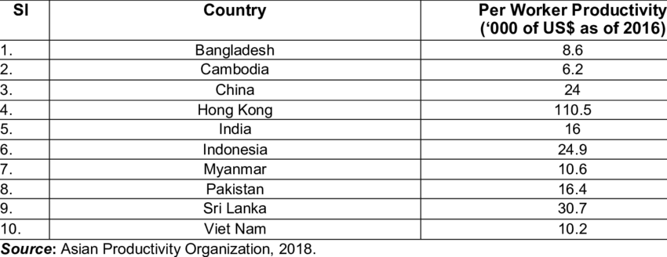

9.3 RMG Industry Lifeline to Bangladesh Economy

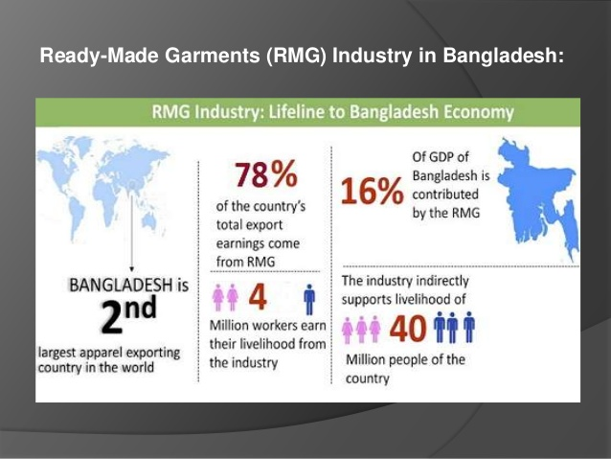

9.4 RMG Export Growth Trend

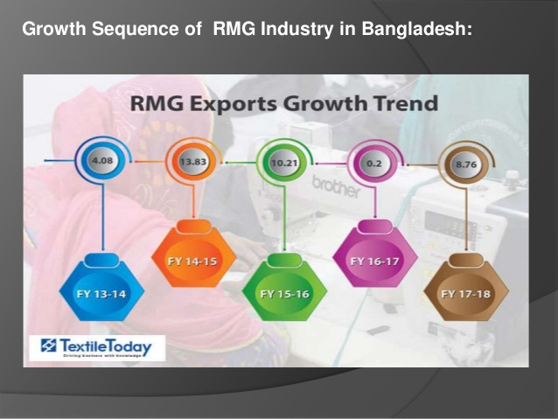

9.5 Statistics Report of Workers Growth

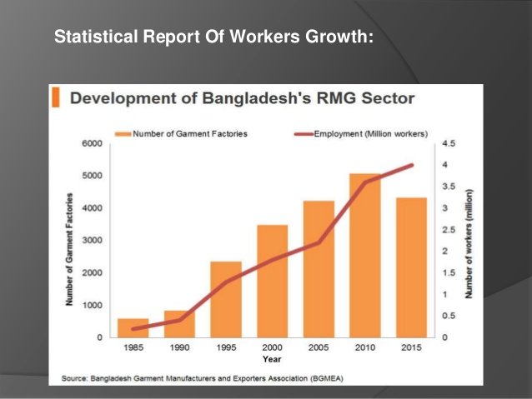

9.6 Value Creation Activities by Bangladeshi Knitted Cotton T-Shirt Manufacturers FOB-2 To
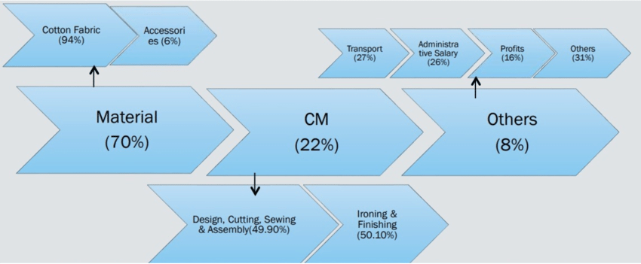

9.7 Value Creation Activities by Bangladeshi Woven Shirt Manufacturers FOB-45 Source

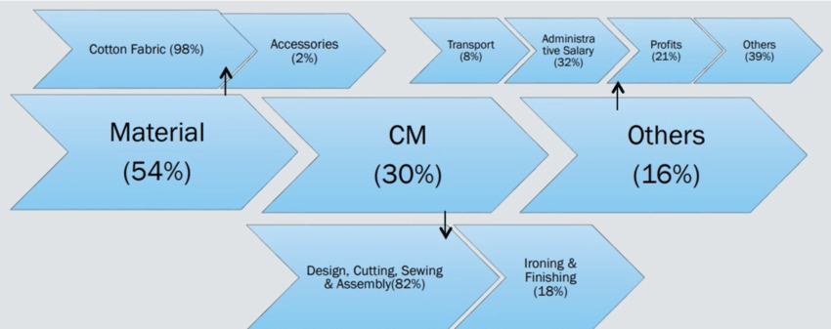

9.8 CMT Logo


9.9 Compagnie Mauricienne de Textile Ltée (CMT)



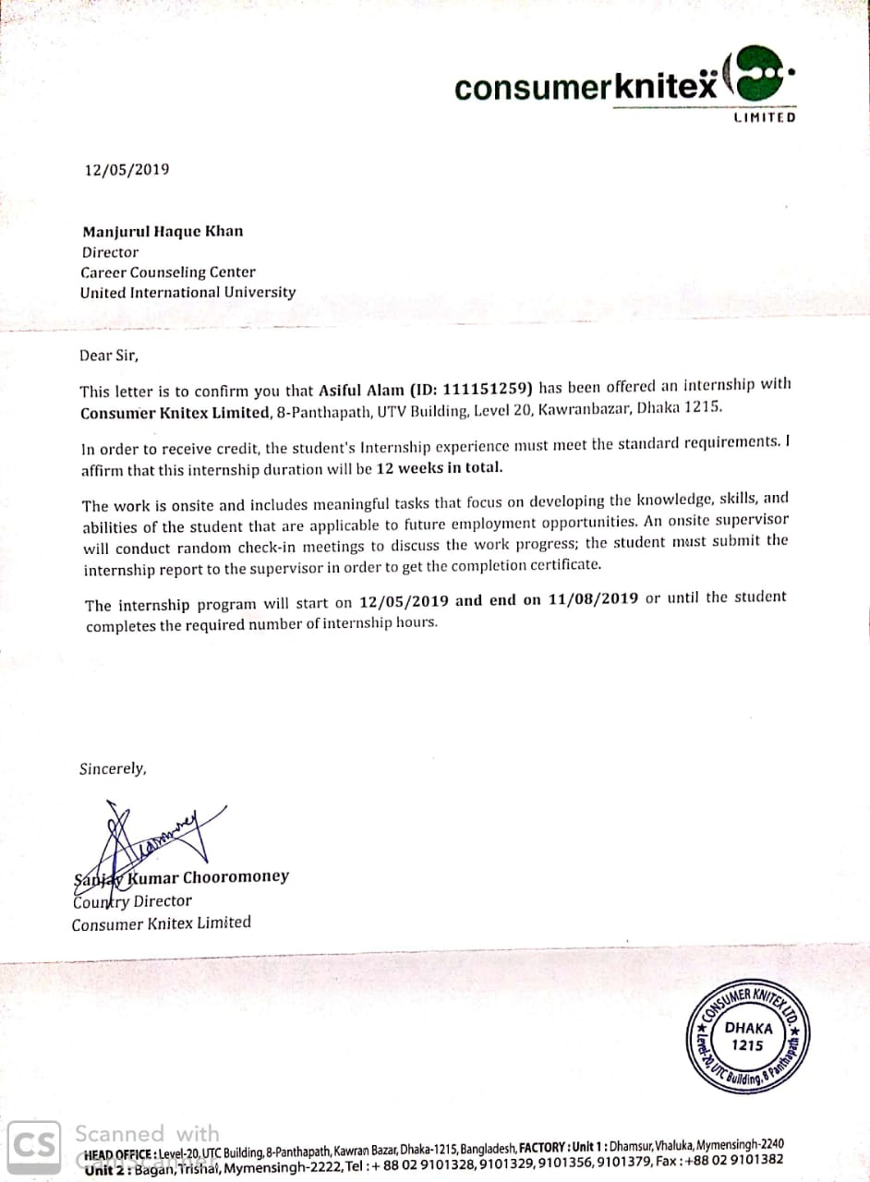
9.10 Appointment Letter

