INTERNSHIP REPORT

Prescribing E-healthcare business for better Customer service
“A study on Olwel”.





Internship report
On
Prescribing E-healthcare business for better Customer service:
A study on Olwel.

Submitted To
Mr. S.M. Asif-Ur-Rahman
Assistant Professor
School of Business & Economics
United International University
Submitted By
Hafsa Chowdhury
ID: 111 141 100
School of Business &
Economics
United International University
Date of submission: 10/03/2019

Letter of Transmittal

Date: 10/03/2019
To: The intern supervisor
Mr. S.M. Asif-Ur-Rahman
Assistant professor
School of Business and Economics
United International University
Dhaka, Bangladesh.

Subject: Submission of Internship Report.
Dear Sir,
I am so glad that I got the opportunity to submit the internship report on “Prescribing E-healthcare business for better Customer service:” A study on Olwel” . I have tried to put all the necessary information that I got permit to take. I hope this report is enlightening and additionally helpful. The report shows Internal and external data about my activity duty and entry level position result at Olwel bd.
I tried my level best to make the report a commendable one. There might be some couple of constraints because of absence of time and different reasons however I have tried to attempt my level best to influence it rightfully and also assembled related data from every single accessible sources. Maintaining my restricted learning I will attempt my level best to set up the report perfectly and advantageously.
Yours sincerely,
Hafsa Chowdhury
ID NO: 111 141 100
School of Business & Economics
United International University
Email: hafsa.bd10794@gmail.com

Declaration of Student

This is to notify that this report “Prescribing E-healthcare business for better Customer service: A study on Owlel bd.” has been prepared as a part of my internship formalities. This is a compulsory part of my Bachelor of Business Administration (BBA) program to submit an internship report.
Moreover, I was instructed and highly inspired by my Honorable supervisor Mr. S.M. Asif-Ur-Rahman, Assistant Professor, Business school and economics, United International University.

Yours sincerely,

Hafsa Chowdhury
ID. No. 111 141 100
School of Business & Economics
United International University.
Email: hafsa.bd10794@gmail.com

Acknowledgement

First of all I might want to offer my most profound thanks to the almighty Allah for whose support I was able to make ready and complete the undertaking my report on time. I am really grateful to numerous individuals for their great inspiration and support during my entire Internship period.
At first I would profoundly appreciate my honorable Supervisor Mr. S.M. Asif-Ur-Rahman, Assistant professor, Business school and economics, United International University, for his appreciable supervision to me during the entire time of my entry level position period. Without his helpful direction and motivation it was not possible for me to have possessed the capacity to finish my report effectively and efficiently.

I would also give special thanks to my supervisor, Mr. Rabiul Alam, business Development Manager, for giving me the chance to finish my temporary position at Olwel. He helped me a lot with profitable data and other important information. No doubt that their dynamic administration will help anyone to construct one's profession perfectly.

Additionally I also want to thanks to colleagues and all the person related with Olwel for their help and good behavior that helped me a lot to accommodate setting up my report.

Table of Contents
Serial No. | Subject Name | Page No
 | Executive Summary | 1
 | CHAPTER-01 INTRODUCTION
1.1 | Origin of the study | 3
1.2 | Rationality | 3
1.3 | Background of the study | 3
1.4 | Objective of the study | 4
1.5 | Methodology of the study | 4
1.6 | Limitations of the study | 5
 | CHAPTER-02 OVERVIEW OF THE COMPANY
2.1 | What is Olwel! | 7
2.2 | A brief history of Olwel. | 7
2.3 | Mission and vision of Olwel | 8
2.4 | Why Olwel? | 8
2.5 | Olwel present products and services | 8
2.6 | Primary service of Olwel | 9
2.7 | Present partners of Olwel | 10
2.8 | Other benefits of Olwel | 10-11
2.9 | Olwel service process | 12
2.10 | Company profile at a glance | 13-14
2.11 | Departments of Olwel | 14-15
2.12 | Olwel major targeted customers | 15-16
2.13 | The places where Olwel service is available | 16
2.14 | Olwel SWOT analysis | 16-17
 | CHAPTER-3: E-Healthcare service
3.1 | What is E-healthcare service | 19
3.2 | E-healthcare service in Bangladesh | 19
3.3 | Why E-healthcare? | 20
3.4 | 10 E`s of E-healthcare | 21
3.5 | Forms of E-Health | 22
3.6 | Problem of E-Healthcare service | 22-23
3.7 | Major challenges for E-Health | 23-24
3.8 | Findings | 24-25
3.9 | Opportunities | 25-26
3.10 | Recommendations for E-Health care service | 26
3.11 | Conclusion | 26-27
 | Internship Experience | 28
 | Appendix | 29

Executive Summary

Bangladesh has shown considerable progress in terms of health indicators as a nation, the utilization and access to existing healthcare system is still limited for the mass. The health sector of Bangladesh has progressed significantly since its independence. In the course of the most recent two decades its progress is strongly notifiable. Specifically, it has made strong progress in several sectors. E-health has tremendous potential to ensure healthcare quality, accessibility and affordability in developing countries like bangladesh. Developing countries gradually adopted the new technologies particularly with regards to the health care services. E health care service is a way to provide medical services at community level. Bangladesh has been identified as one of the 57 countries in world that have critical shortage in health workforce. Although, in Bangladesh there are doctors, nurses, midwives number below 2.28 per 1000 population and the number of bed 4 per 10,000 in hospitals (organization, 2012). Due to poor health care infrastructure and highly dense population it is becoming a challenge for the government to provide adequate and quality health care facilities. To overcome this challenges the government introduced ICT programs in health sector.
The main objective of this report is the Olwel established its new dimension of digital health care service. Their aim is to improve the healthcare system in developing countries. They have selected the capital of Bangladesh, Dhaka, as there first operating location. By studying the healthcare system in Bangladesh they found that the absence of general practitioners is creating a huge load on specialist doctors. They have developed an innovative service platform to tackle this problem. Their platform connects qualified and trained general practitioners with patients so the service can be delivered directly to patients home.

Chapter-1: Introduction



1.1 Origin of the study:
Running with competition has become a mandatory trend in every sector at any place. And Education is one of the most important and competitive sectors of a human life. For maintaining that standard of teaching, different universities in our country continue upgrading their procedure & teaching patterns. With respect that, internship is a mandatory part of the BBA to fulfill this program offered by University. This report is prepared as a mandatory requirement of the internship program under the Department of BBA, United International University. . The organization which this report represents is Olwel bd. My internship program started on November 12, 2018
And continued for a total of three months.

1.2 Rationality:
The main objective of BBA program is to create link between two things one is theoretical knowledge and another one is practical knowledge. Subjects finished gives us theoretical knowledge and internship is the way to gain the practical knowledge that is learned in book.
Completing this program will help me to create a pool or bridge between corporate world and academic world and be professional in the long run.

1.3 Background of the study:
In Olwel during my internship period, I got the opportunity to work with their marketing team. I was working there last three month & my work was related with the marketing activities of this company. My most of the assigned work is related with dealing with the potential customers through campaign or organization visit and also generating fresh marketing ideas for the company.

The internship program at Olwel Limited has given me the opportunity to learn about several organizational behavior through corporate environment and also gave me an insight of office environment through enhancing my practical knowledge.

1.4 Objective of the study:
The additional objectives along with the study is given below
- Primary objective:
- To completing the graduation of BBA program.
- To prepare an Internship report based on my experience gathered during internship period.
- For gathering some practical knowledge about corporate life.
- For learning corporate behavior and getting knowledge about corporate environment.

- Secondary objective:
- To know about the Olwel Environment & its operational strategy.
- To study the problems & prospects of along with the service of Olwel Bd. Limited.
- To analyze the present consumer base and accomplishment.
- To suggest some recommended ways of marketing program for Olwel.

  - Methodology of the study:
All the information used in this report are based on both primary data sources & secondary data sources.

- Primary data:
Primary data of this report are collected from face to face interactions with official persons. Their information is very important and helpful for this report.

- Secondary data:
Secondary data of this report is collected from relevant articles, official papers, website of Olwel Bd. Limited and also from relevant survey.

  - Limitations of the study:
While collecting data I have faced several constrains or obstacles such as.
- Updated information are not available.
- Restrictions in collecting some important data
- Non- Corporative behavior of some officials
- It was quite impossible to find out the implications of the findings on the whole of the industry as new competitors are only just rising.
- Unstructured company planning create several obstacle in finding needed information.
- Three month is very short time to gather all necessary data needed. Due to this short time all information couldn`t be collected.

Chapter-2: Overview of the Company

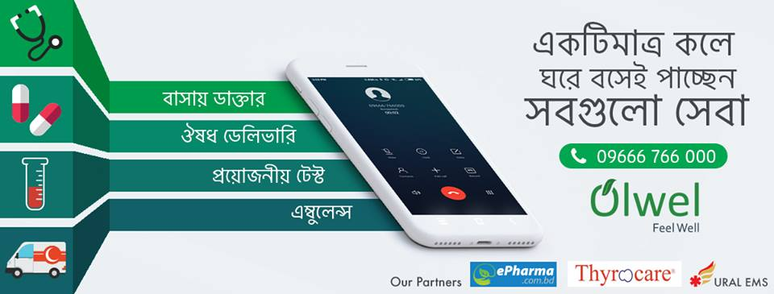

2.1 What is Olwel !
Olwel is a Finland based startup working in Bangladesh. They have came up with an essential doorstep healthcare service for patients who prefer to receive medical consultation at their home. Olwel service will be ideal for patients with movement difficulties and anyone who wants to avoid the traffic jam and the long queues at a hospital.



2.2 A brief history of Olwel :
Olwel has started his business from 17th November 2017. From the day of its inception Olwel is serving to minimize the hazard related to health problem/sickness. Olwel's service will be ideal for patients with movement difficulties and anyone who wants to avoid the traffic jam and the long queues at a doctor office. Olwel is providing its service through sending doctor to the patient doorstep on their demand. It has its own doctor panel of almost 50+ skilled GP doctors. Olwels doctors have graduated from top most medical institute/college of Bangladesh. Maximum doctors have their minimum 3 years to 18 years experiences. Doctor either have finished their post-graduation or, are in their courses from different universities. Recently Olwel is hiring doctors to make their panel of 200 doctors.
Olwel is first company in Bangladesh who brought Doctors at doorstep. They came up with a very unique idea to serve people. They assure to send doctors at home within 30/40 minutes. With their service they tried to illuminate several problems or issues that patient might face while going to hospitals. Like traffic jam, serial maintaining & many more.

2.3 Mission and vision of Olwel:
To take desire healthcare services at doorstep through our dedication, hard work and quality service. From the first day of its inception Olwel is providing its highest effort to make its beneficiaries happy with our services. We have started our journey from Mirpur, Mohammadpur and Dhanmondi zone bearing in mind to expand our services in whole Dhaka city as well as whole Bangladesh and even abroad.

2.4 Why Olwel?
- Convenience:
One can save significant amount of man-hour that is spent in traffic and long queue and get doctor`s advice in the quickest possible time.
- Care:
The experienced doctor of Olwel will always guide the patient with appropriate advice and medication and if required, they also refer to the right specialist at the right time.
- Comfort:
A dedicated account manager will always handle patients request with priority and resolve in the quickest possible time.
- Reputed and expert physicians:
Well experienced doctors listen to the situation of the patient with compassion and patience. With their caring and respectful attitude, they guide their patient with appropriate advice and medication.

2.5 Olwel present product and services:
- Doctors at home:
Olwel assure to send doctors at hoe within 30/40 minutes.
- Ambulance service on demand:
If customer want Olwel can provide them ambulance service.
- Medicine home delivery
On customer demand Olwel provide medicine home delivery service too. In that case by the reference of Olwel customer will get 5% discount too.

- Sample collection for diagnosis
Blood sample collection is also done by Olwel. Here they have partnership with Thyrocare.

2.6 Primary services of Olwel
Home Visit Doctor:
Place a request via phone or mobile app and an M.B.B.S. doctor will be there at your address in a short time or call a doctor office/ home is an essential doorstep healthcare service for non-emergency sickness.
Great Doctors:
We have locally and internally trained physician, who serves with patience and compassion.
Other services:
We collect samples for investigation, deliver reports and medicine and provide ambulance support.
Extended Support:
Call center follow-up service and dedicated account manager for our corporate client.
Customer feedback taking through rating:
After completing every visit mission the follow up doctors take feedback from the valuable customers about the service and place there rating according to the feedback taken. They also took their valuable opinion and suggestion by giving follow up calls.
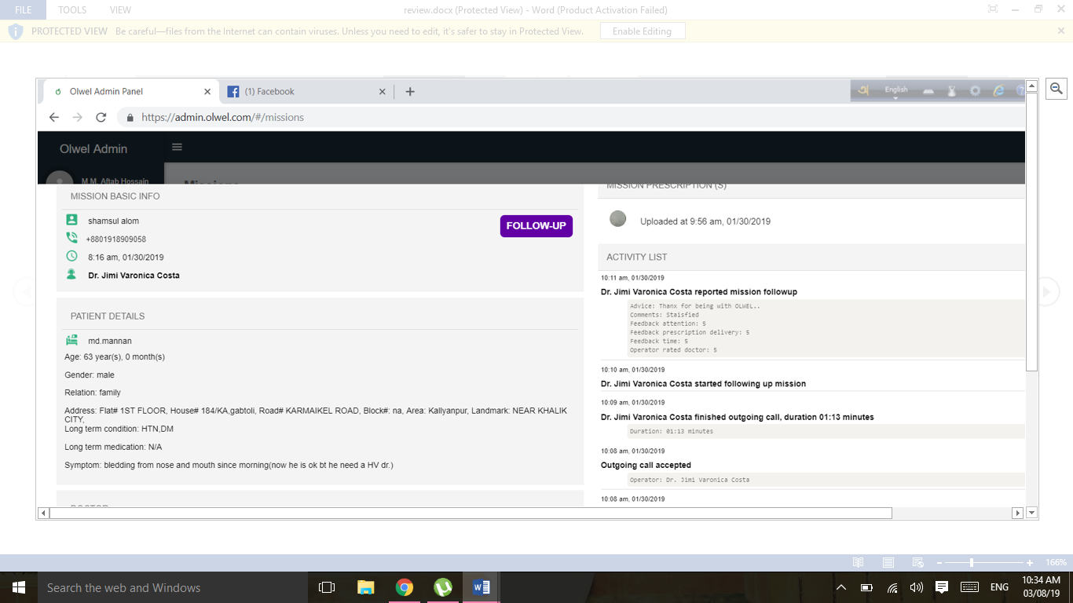
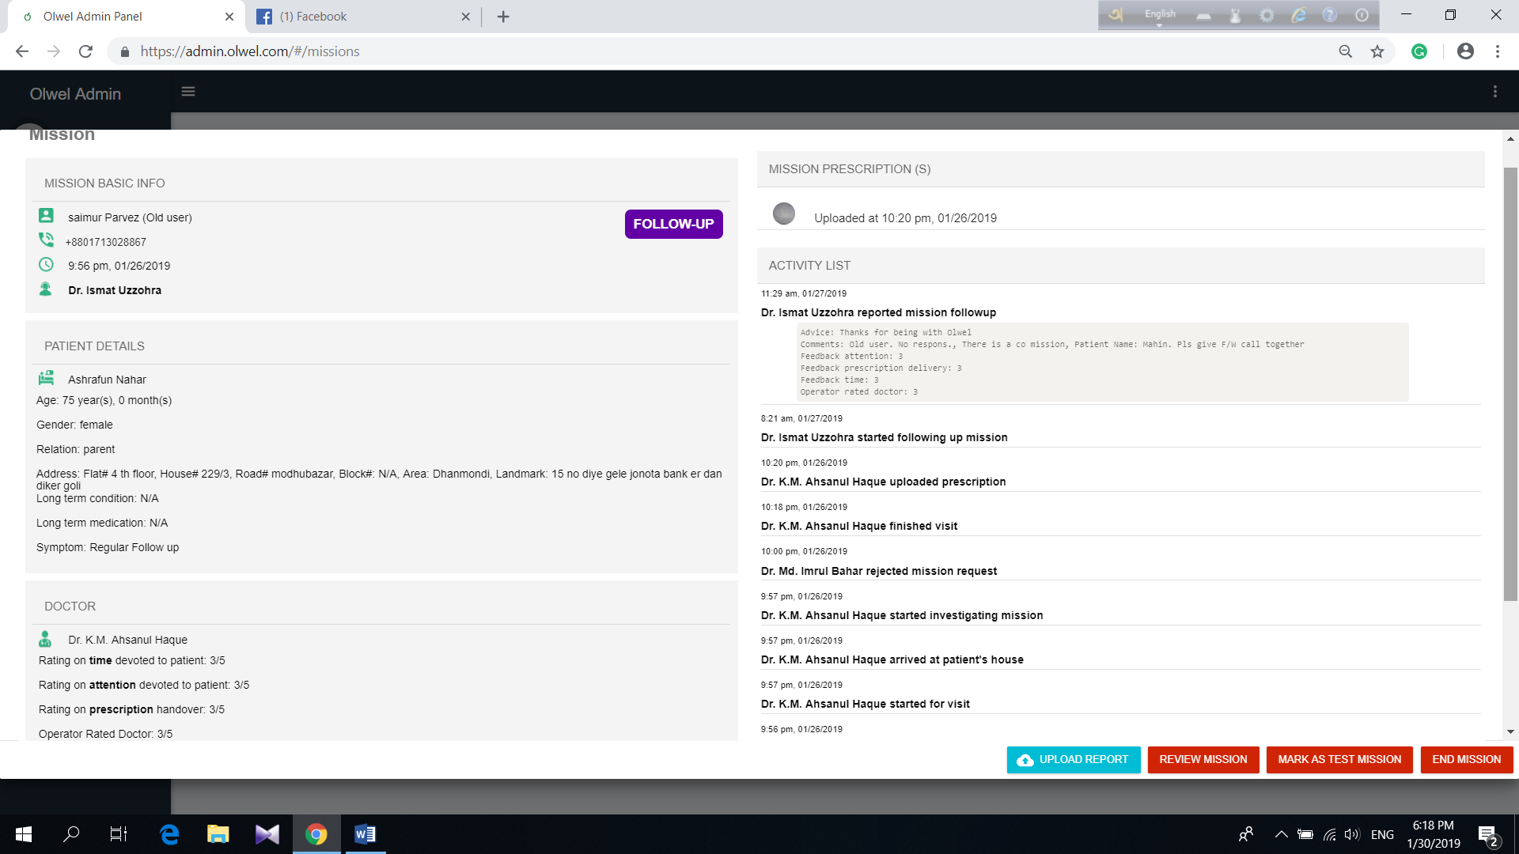
Figure-01 & 02 Customer rating about the service of Olwel

2.7 Present partners of Olwel:
- Aalto University – Accelerator.
- Ural EMS – Ambulance partner.
- ePharma – Medicine partner.
- Thyrocare – Sample collection.

2.8 Other Benefits of Olwel: Beside Doctors at home Olwel is many more benefits to their valuable customers. Such as.
- On demand doctor fee 800 taka per visit. (33% subsidized)
- 5% Discount on medicine delivery.
- Free follow-up calls, patient history database and report consultation.
- Home/Office Sample collection & medicine/report delivery.
- Unused appointments will be carried forward within contract period
- 25% discount on sample or test investigation.

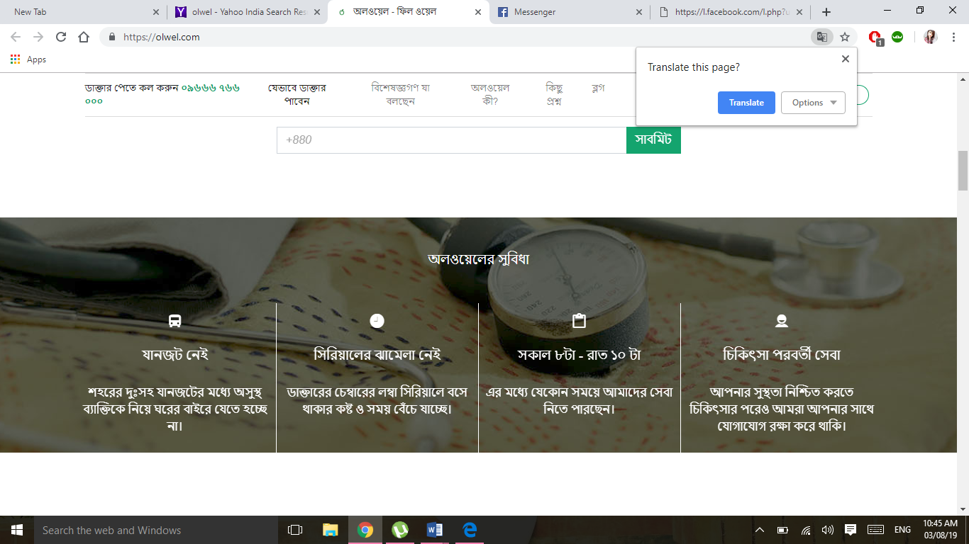

2.9 Olwel Service Process:
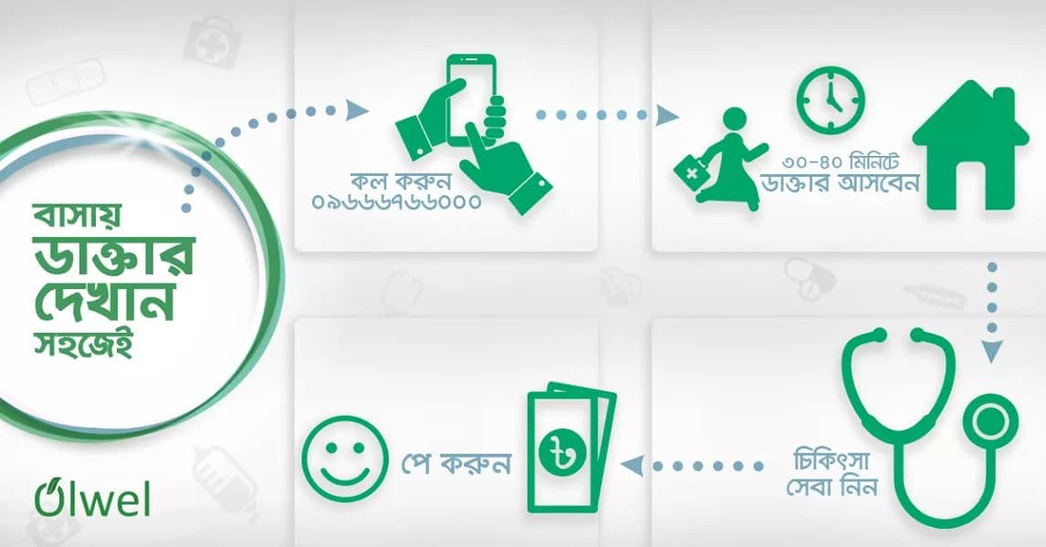
Patient:
First of all, Patient or someone who actually need to consult a doctor in a non-emergency sickness has to contact with the doctor in given possible way.
Ways of cantacting with Olwel: There are three possible ways to get connected with Olwel. Such as..
- Call:
One can call at the hotline number of Olwel to get connected directly and call doctor on the spot.
- App:
There is an online application of olwel available in app store. All you need is just to install the app, do registration for opening account and then follow the procedure of calling doctor through online.
- Web:
One can also do contact through websites and digital marketing sites available.
Select right doctor:
There are always some doctor stay available at call center. When a patient give calls they analyze the symptom of patient sickness and their problems. After talking with patient they send the right doctor at their home for giving service.

Home visit:
Olwel assured to send the assigned doctor to patient home within 30/40 minutes. The doctor try to handle there patient giving proper time.
Follow Up:
After completing a mission doctors make follow up calls for taking feedback from customer and also ask about health condition of the following customers. Moreover they also call their customers for giving medicine warning whether they are taking medicines properly on time and also make them aware when they don’t need to take any more medicines.

2.10 Company Profile at a Glance
Name | Olwel Bd. Limited
Company  establishment | 2017
Management Team | - M A Farhad, Co-founder  - M.M. Aftab Hossain, CEO, X-Post_doctoral researcher KTH Royal Institute of Technology, Sweden.  - Mojahedul Hoq, CTO, X-CTO Therap Services,LLC.  - DR. Salahuddin Feroz, Director of Medical Services , MBBS (DMC), MD (Nephrology), BSMMU  - Abdullah Faiz,, CCO Director, B2B Product & Marketing Banglalink Digital Communications Ltd.  - Aminur Rashid Khan, COO, Customer Solution Architect Nokia Network
Advisory Panel | - Khurshida Khanam, Professor and Head, Dept. Health Promotion & Health Education, Bangladesh University of health science.  - Vilho Jonsson, Founder and Principal Innovation Evangelist, Curlabs Project leader, Innovation project Tele2  - Johan Backman, Founder & Principal change Evangelist, Curlabs program Officer Tele2 Hackney Tele2  - Nima Jokilaakso, Project Manager Digital Health, Swecare Foundation CEO, Jokilaakso and Company AB Ambassador, Rockstar accelerator  - Tapio Siik, Advisor, Aalto startup centre Mentor, verticle Accelerator Angel Investor Partner, Nokia Growth Partners
Type of company | E-healthcare service company
Present Address: | Registered office: House 185, Lane 2, New DOHS, Mohakhali, Dhaka-1206  Corporate Office: House 13A/3A(2), Block B, Babor Road, Mohammadpur, Dhaka 1207  Sub-Office: Mirpur-06, Dhaka
Total employees | Approximately 70 Employees are working at present
Hotline Number | 09666 766 000
Website | olwel.com
Email | contact@olwel.com
App | Olwel  Google Play

Figure 03: showing company profile at a Glance.

2.11 Departments of Olwel:
In Olwel there have six departments. Such as;
- Marketing Department:
This department deals with all activities related to marketing such as dealing with potential customers, generating fresh marketing ideas, handling digital marketing sites, arranging campaigns and doing survey and questionnaires.
- Finance, Accounts & Audit Department:
This department deal with all financial activities of Olwel . They also audit all the activities of department every year. This department is the oxygen of this company.
- Doctors Department:
All the doctors of Olwel are registered through Bangladesh Medical & dental council. Most of the doctors are MBBS & FCPS. Very soon Olwel is going to recruit specialist doctor. There are two category doctors available at Olwel, Such as
- Home Visit Doctors: This doctors do regular mission on home visit when they got any calls from patients.
- Call center Doctors: This doctors receive calls from patients and hear from them their problems and sickness symptoms and then decide which doctor need to be send to patients place.
- Maintenance Department:
This department handle every little or big issue related with internet server in the office. As Olwel is E health care service so having uninterrupted network connection is very much important.
- Riders department:
There are always 5-8 bike riders available at Olwel for moving the doctors at patient home when they got any call from patient.
- Admin & HR Department:
This department take responsibility for providing administrative aid in information management systems, payroll, and human resource and all other activities related to Human Resource Management.

2.12 Olwel Major targeted Customers
- Would be Mother:
Would be mothers who need regular check-ups are one of the main target of Olwel . They provide different packages for different patients.
- 30+ aged people:
People whose age is more than 30 are highly in risk of Diabetes. Most of them already had diabetes. Olwel offer several packages for them as pre caution and also after Diabetes check up.
- Toddlers:
Children ages 1-3 are often need regular checkups. Precautions are needed to take so that they don’t catch bad diseases in their body.
- Corporate/Government office employees:
Many public and private Companies sometime wants fixed doctor for the regular or emergency checkups of their employee. Olwel gives several package offers for them too.

2.13 The places where Olwel service is available:
Though Olwel has started its journey by giving service in some specific area of Dhaka , such as Mohammodpur, Dhanmondi, Mirpur, Mahakhali Etc. But at resent they are providing their service in whole Dhaka. Not only that they are planning to spread their service to urban area outside Dhaka very soon. There are several freelancer doctors of different areas who are linked with Olwel so that whenever they got any call from their own area they can go there within 30/40 minutes and serve the patient.

2.14 Olwel bd Limited SWOT Analysis:
SWOT analysis are strength, weakness, opportunities & threats of a company. That`s all about company internal & external ability & lacking’s. SWOT analysis of Olwel are given below.
Strength:
  - Have first mover benefits as they brought new idea in Bangladesh.
  - Olwel is a Finland based startup company. So they got a strong back support.
  - No competitor in the market yet.
  - Have good customer feedback still now which can be used to retaining customers.
  - Huge amount of established doctor.
  - Strong relationship with present customers.
  - Strong tele communication of email, internet & cellular network.
  - Incredible marketing support provided from marketing team.
  - Good corporate relationship with corporate offices.

Weakness:
  - No stable marketing strategy.
  - No annual plan or chart are made at the beginning of the year.
  - Small number of marketing team.
  - Marketing tactics are poor.
  - Less communication of upper level workers with lower level employees.
  - Doctors list are not given anywhere.
  - Lack of investors.
  - Less focus on B2C. They mostly give afford on B2B.
  - Do not have any specialist Doctor yet.

Opportunities:
  - Huge demand in upper middle class and upper class society.
  - Have bigger opportunities to use first mover benefits.
  - There are more scopes for B2C rather than B2B. As through B2B one can reach more and more people at a time.
  - Govt. offices & schools are best place for campaigning as we can reach our target aged people more there.
  - Updated digital marketing site can attract more and more customer easily.
  - Hiring more talented employees who are ICT expert will lead the company to do better innovation.

Threats:
  - New competitor can enter the market at any time.
  - Some people has least believe in online based healthcare service. They have trust issues.
  - Rising in price so frequently can make customers dissatisfied.
  - Unplanned business model can be the reason of collapsing business any time.
  - Less employee satisfaction can be result in more talented Employee turnover.

Chapter-3

E-healthcare service



3.1 What is E-healthcare Service?
E-health broadly known as electronic health is an emerging field in the sector of medical informatics, public business and health, referred as health services and information that is delivered or enhanced through the Internet and related technologies. In a broader sense, the term characterizes not only a technical development, but also a state-of-mind, a way of thinking, an attitude, and a commitment for networked, global thinking, to improve health care locally, regionally, and worldwide by using information and communication technology.

3.2 E-healthcare Service in Bangladesh:
Bangladeshis is one of a developing country. The healthcare care facilities of Bangladesh is not adequate for its population. Because of poor health care structure and highly dense population gradually it is becoming a challenge for the government to provide good quality health care facilities. For coming out of this challenges Bangladesh Government has introduced ICT programs in health sector. Because of the Digital Bangladesh campaign of present Government more emphasize has been given to it. Along with the government also the NGOs and private organization started many projects on e-health. At present days many of the private clinics and hospitals in Dhaka city are using their own database system for recording patient’s health. Not only that many NGOs, private organization and mobile phone companies like Grameenphone are providing e-health services to their customers throughout the country.

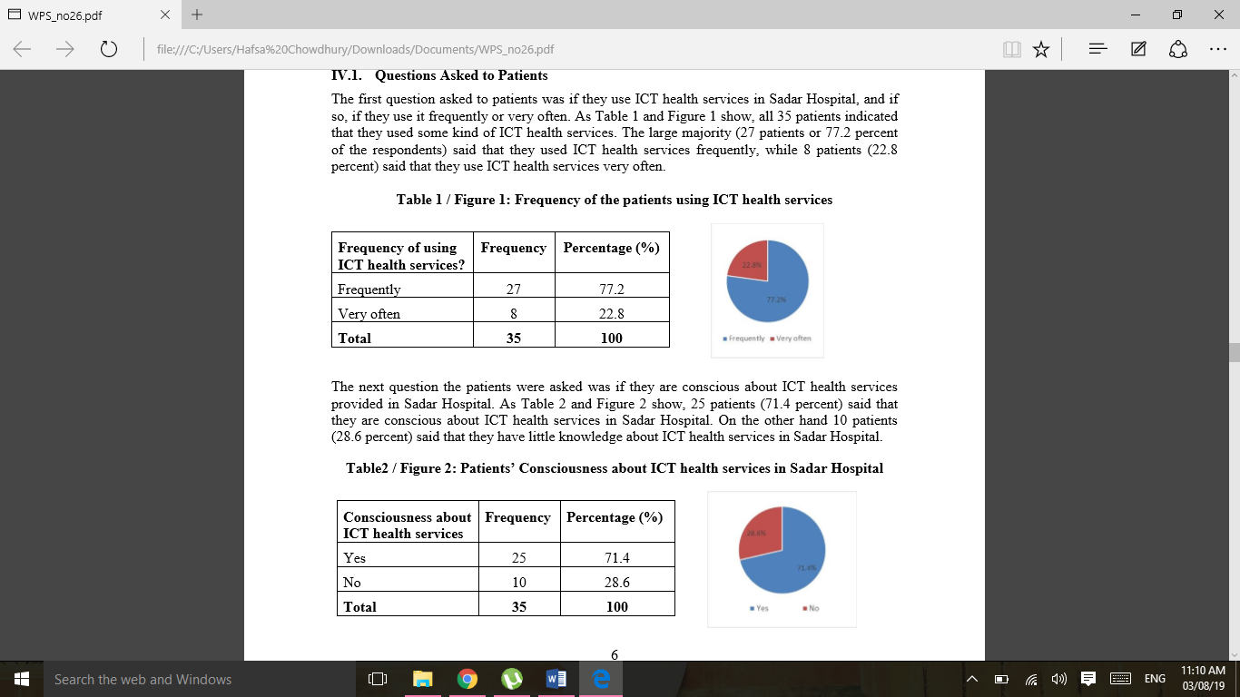
Figure 04: Showing the frequency of people using ICT/ E-healthcare service

Figure 05: Showing the frequency of people who are conscious about ICT/E-healthcare service

3.3 Why E-Health care?
- Time saving: E-health can easily save time. By online Patient can schedule their own appointment through care provider. They can do all this through online and don’t need to go to the hospitals for taking appointments. And even don`t need to wait in serial for too long.
- Insight into own health: A personal healthcare environment gives people more better insight pf their health. If they wish they can easily share their own part of data with the health care provider. Patient can gain more control over their own health and better understand their health condition.
- Lower Administrative burden: The doctors don’t need to do more and more paper works and can easily share information with their colleagues securely and easily.
- Flexibility: E-healthcare system is more flexible than traditional healthcare system. Many useless formalities and works can be omit through using E-health care system.
- Improved medication management: The management of medication system is now more improved then before. Because of less use of papers and unusual traditional formalities.
- Avoiding clinical incidents: As we know in our society so many people are victim of several clinical incidents. Even pharmacist pretend to be good doctors in several clinics. In E-health system only registered doctor can use and serve the patient thus patients can also verify their doctors so there is low chance of facing awful incidents.
- Cost effective: E-health care system is cost effective in various ways. It saves the cost of transportation as a patient have to move several time for taking appointments and other test and medicines. It also saves the cost of unusual paper-works.

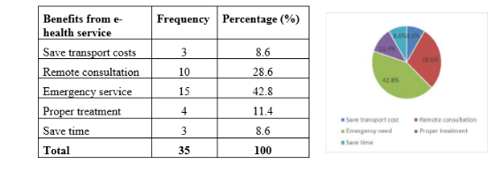
Figure 6: Showing benefit customer gets from E-Health service

3.4 10 e’s of eHealth
At the first look one may guess that the “e” in eHealth only represents the word “electronic.” But actually “electronic” is one aspect, the complete definition actually encompasses a variety of some other “e’s,” presenting the true meaning of this concept. The “10 e’s,” as spelled out that is written by Gunther Eysenbach in an article on the Journal of Medical Internet Research website, include:
- Efficiency
- Enhancing Quality
- Evidence Based
- Empowerment
- Encouragement
- Education
- Enabling
- Extending
- Equity
- Ethics

3.5 Forms of eHealth include:
- Solutions to better communicate and maintain patient data, Telemedicine, Health informatics, or which facilitates remote diagnoses and treatments and includes patient tele-monitoring.
- Electronically health recordings, or the more effective way of communication of patient data among healthcare professionals.
- Clinical decision support systems that gives healthcare professional people more easier electronic access to various protocols and standards to assist in their diagnoses and treatments
- Consumer health informatics, or electronic resources on health and medical topics that geared to individuals

3.6 Problems of E-healthcare service: In spite of having many positive sides there are also some problems there along with E-health care system. Some are given below.

- Financial Problems:
The use of e-Health systems are mostly expensive. According to world health organization having not enough funding source is one of the key obstacles that affecting e-Health adoption in developing countries. Bangladesh is not exceptional in this case. Most of the times our Government has to be dependent on well developed countries, foreign investors or World Bank for implementing large project. Researchers have come to know that fund is one of the major challenge regarding the adoption of e-Health systems in low income countries like Bangladesh.

- Usability & User Acceptance:
Service provider of Government sector in Bangladesh has better knowledge on e-Health applications. On the other hand service recipients or expected users are not well-known with e-Health. So their perception or thinking about e-Health is not in better condition. Very few Users are trusting an e-Health for documenting their patient information. This will negatively influence the will to adopt and use an e-Health service. Most of the people in Bangladesh are unaware about the e-Health service. Only few portions of the people are using the available e-Health services. Moreover, most of the people in Bangladesh do not have enough knowledge of using computers, internet or electronic service delivery.

- Lack of Policy and Regulation:
Healthcare is very sensitive domain side where people’s lives are at highly risk. While using any system proper procedures and rules are needed to be followed to ensure safe practices of healthcare services otherwise it could lead to serious consequences. Even though the Government of Bangladesh has adopted a national ICT policy in 2009, but it do not have any effect on hospitals yet.

- Interoperability of Systems:
Most of e-Health systems in Bangladesh are isolated because of the systems that are developed by different vendors of software, universities, firms and research institutions. Bangladesh government have not yet designed any central database for citizen’s access that will be used through internet. Even there is no chance of finding available information of any citizen in Government hospitals to be used in any emergency healthcare situation. For this reason health professionals in government hospital face many kind of difficulties to identify the patient and healthcare they needs.

- Safety and security:
Another problem in E-health is safety of the information of patients. As most of the patient have go through various registrations thus they have to give important information. Those information can be leaked any time. So users may face security issue in some case. Anyone can easily hack one`s personal information. That is why so many people are afraid of using E-health care service for securing their personal information.

3.7 Major challenges for E-Health:
There are so many challenges ahead for E-Health. It is not easy to establish E-health so easily in a developing country like Bangladesh. Some major challenges are given below.
- Patient acceptance:
Patient acceptance is very big challenge for E-Health service. Many people still couldn`t accept E-health normally. It seems risky for some people and hard for some people. So make it easier for them is a big challenge. The United for health project confirmed that user acceptance is the key to success for E-health.
- Complex user experience:
Health system are unable to make the best use of the opportunities afforded by E-health. Lack of transformation complicates the user experience. Making the best use of digital technology is another big challenge for E-health.
- Ensuring data security:
The security of collected data and their protection is the biggest challenge indeed. Healthcare professionals and patients feel confident about the confidentiality of digital health systems.
- Healthy investment:
As establishing E-healthcare is fully technology based so it is so much costly matter. Finding investor for this is so much tough and challenging as still very few people are aware of E-health. So at the beginning the return might not be so much profitable. But in the long run it will be so much profitable. So at present time finding healthy investor is another challenge.
- Training doctors, nurses and other healthcare professionals:
Engaging and training doctors, nurses and other healthcare professionals, in the new technologies are very much essential. If they don’t understand their own thing then how will they serve the patient! So this is another big challenge.
- Educating customer:
Educating the targeted customer is so much tough challenge. If customer do not understand the digital technology then they will not show interest in E-Health.
- Apps for healthcare:
There are more than 100,000 apps now available, need to be better absorbed into healthcare systems. They also need to be rationalized, standardized and simplified to add aid value and usability.
- Recruiting new IT talent:
It is not so easy run E-Health. Professional worker are needed to maintain several issue. For that reason talented about IT people are mandatory to run E-Health effectively and efficiently.

3.7 Findings:
In recent year there have been significant changes happened in our Healthcare sector. There have been lot of possible solution to change our healthcare sector. Some solution can take lot of time but it will be very effective for our country
- Lack of easy Understandable way:
Most of application of e-health are tough to understand. Various registrations logins and many more formalities are needed to be filled up while using. This is not easily understandable for many customers as well as staffs who are linked with the service. So the systems should be easily understandable for everyone. Tough language should be ignored.
- Less educated target customer:
One of the main targeted customer of e-healthcare is old age people. As old people often get sick. Using internet is tough for them as many of them are not familiar with internet like the young generation. Educating those customer is a big challenge that need to be accomplished.
- Give Attention:
E-healthcare sector should be given more priority and more attention. Many new and fresh ideas can be generate and used here to make peoples life more and more easy and comfortable. The idea of E-health should be spread more broadly so that no patient have to die just because of traffic jam, un-ability to go hospital and also for long serial maintain. A better E-healthcare system can eliminate all this issues from a country.
- More secure application:
Most of the application has several conditions which one just tap I Agree without even reading those. Many application users do misuse of this. Many account get hacked because of this not reading trends. This misuse of modern application should be omit. Otherwise many people will lose their trust on E-Health. The application should be made with less condition and more security of user.
- Misuse of important information:
Many important information of the users are recorded. Even many information are taken through online survey. Authority can misuse those information. For Example suppose they found 70% Diabetes effected people are using X Brand insulin. Now if they spread this information to brand owner and they raise the price of that insulin then those customer will be bound to buy in that high price. That is how information of customer can be misused. So this security of not making misuse should be assured.

3.8Opportunities:
If we are able to do than there are so many better opportunity for E–Health care sector.

- In Bangladesh no other company other than Olwel has come forward with the idea of sending doctors at home. Grameenphone is providing E-Healthcare service too but they are only giving suggestion over video calls. Without observing the patient face to face it is not possible to understand patient condition. So this idea of sending doctor home can be used broadly to represent our country worldwide.
- At present only rural people know about E-health care service. This idea can be moved to Urban areas too. Educating urban people about the benefit of E-Health can be beneficial for whole country.
- A big amount of economic revenue can be earned by making E-health well known to the people of Bangladesh.
- As there is no competitor of Olwel in the market still now, they can make the best use of marketing concept first mover benefit in Bangladesh. As we know we always remember the first brand of a product or service. No matter how many more came after that first one always get priorities.
- Several campaigns of E-Health can be held randomly in some important points of our country for letting more and more people know about the benefit of E-Health. In that way s many people together at a time will be able to know thus this will help to promote E-health around the country.
- Mostly talented people can be hired in this sector so that they will provide new and unique ideas and help our country to go one step ahead to Digital Banngladesh
- Our social media and advertisement sites can be properly used in that case for making more and more people aware about the benefit of E-Health as most of the people are deeply linked and attached with this sites.

3.9 Recommendation for E-Healthcare service

The following recommendations are given on the basis of the analysis and findings of the study.
- The Government of Bangladesh should provide specific programs on ICT or E-health services in order to create awareness among the general people around.
- Skilled manpower should be recruited and they should give proper training on E-Health service.
- The equipment facilities in E-health services should be increased for providing service effectively and efficiently.
- Technical support of ICT is very much important for ensuring a high quality health services because existing facilities cannot meet the demand of the people. The government should provide the necessary equipment and technical support to hospitals to ensure proper e-health services.
- Many people do not know how to get E-health services due to a lack of awareness. In that case the government should introduce necessary program to help the general people to get E-health services.
- The conduct of behavior of staffs, nurses and doctors should be helpful enough to the people in order to improve E-health services in hospitals.
- The accountability in E-health services of every hospital should be ensured by the Ministry of Health and Family Welfare (MoHFW).
- E-health services provided by many hospitals are not always satisfactory to their patient. An evaluation and monitoring system must be developed by the authorities to meet the expectation of the patients.

3.10 Conclusion:
E-Health care service in Bangladesh can be turned into the gold giving eggs with regards to Bangladesh. Bangladesh is one of the developing country that has not yet been prepared to properly cope up with the adoption of ICT in the health service sector. Because Bangladesh’s health policy do not have specific rules and regulations for applying ICT efficiently and effectively. But this is the time to move on. We can change that if we try.
Olwel has a very good scope as they are fully new in health care sector. By executing a good plan properly Olwel can establish themselves as milestone in this sector. During this three month internship period met so many kind of people. Most of them are positive about our service and they really appreciated our service. Now it’s a big challenge for Olwel to make the best use of those appreciation and make those positive people valuable life time customer before any other competitor enters the market. Olwel can use the benefit of first mover and fix their position in the market effectively.
Last but not the least, E-health services create a new and more effective system of service delivery which actually increases capacity of the service providers to provide rapid, safe, effective and affordable health services. So government should take all possible positive steps to remove the obstacles and to increase the benefits of general patients in E-health services all over the country, which would help the development prospects of Bangladesh.

Internship Experience

At first, I want to thanks almighty Allah & CCC of UIU who help me to find such a great organization as an intern in Olwel bd Limited. I was so lucky after Interview Olwel bd. selected me as an Intern. And I got opportunity to work with their Marketing department. My internship duration was 3 months. In this time period I have lot of experience to work with them. They are so humble and well mannered.
- Olwel head office:
Head office of Olwel is situated in Babar Road, Mohammadpur, Dhaka. Their working environment is really nice. The office is secured and well decorated. The behavior of all the staff are so humble and friendly.

- About Marketing Department:
I feel so lucky to get the chance to work with Marketing department of Olwel. In Marketing team there were 6 members. I want to thanks Mr. Rabiul Alam Rabi, Business Developer of Olwel from whom I got lots of lesson.

My working activities during the internship period was all the activities related to marketing such as face to face communication with customer, market visit, Holding campaign, doing survey, providing unique marketing ideas. Basically, I learn from there how to communicate with potential customers and doing marketing of product/service. There I have went to several corporate and Government offices and met so many corporate people and talked with them. Also did several desk job like survey entry, worked at marketing call center and digital marketing sites. The main lesson I learnt from there is corporate manner. I got a practical experience in corporate world which will help me in my future corporate life.

Appendix
References:

1 | https://www.ncbi.nlm.nih.gov/pmc/articles/PMC1761894/
2 | https://www.jacksonvilleu.com/blog/health-informatics/what-is-ehealth/
3 | https://www.usfhealthonline.com/resources/key-concepts/what-is-e-health/
4 | https://www.atlantis-press.com/journals/itmr/13590
5 | https://bmchealthservres.biomedcentral.com/articles/10.1186/1472-6963-14-260
6 | http://www.hansonzandi.com/blog/7-major-challenges-facing-ehealth/?fbclid=IwAR2or7gI9mv0p0p5FC7iOQuel1HpEyOro3YnhLVrQJrA1TWp7Ut5GuIQC10
7 | https://epha.org/key-challenges-for-ehealth/?fbclid=IwAR3Z8d_v05bR3VOMYrsy4iXKpqE8G4QmKWI0kvTeNGoyFEXV83fxw3Mr2rY

