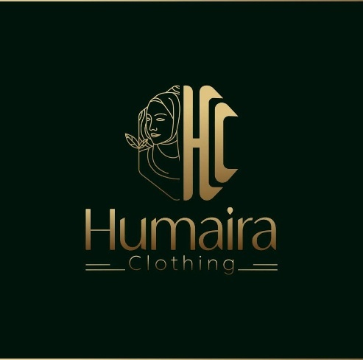
Brand, Business, and Beyond: My Journey with Humayra Clothing

This report is submitted to the school of Business and Economics, United International University as a partial requirement for the degree fulfillment of Bachelor of Business Administration
Submitted to:
Dr. Md. Shariful Alam
Professor, School of business and Economics (SoBE)

Submitted by:
Taima Rahman Moon
Id: 111211097
Major: Marketing
Trimester: Spring 2025
School of Business and Economics
United International University
Date of Submission: July 31, 2025

Letter of Transmittal
31 July,2025
Dr.Md.Shariful Alam
Professor,
School of Business and Economics
United International University.
Subject: Submission of Report on “Brand, Business, and Beyond: My Journey with Humayra Clothing”

Dear Sir,
I'm submitting this letter to formally share my in-depth assessment of the perishable commodities “Brand,Business and Beyond my journey with Humayra Clothing”Due to the fact that it satisfies a need for my BBA program, this paper is very significant.
I actively participated in the day-to-day operations of the company throughout my three-month
apprenticeship at “Humayra Clothing” head office which was situated in Mohammadpur Adabor 1. I really appreciate all of your advice and steadfast support, which have been of incomparable benefit in advancing our project.
I want to say how grateful I am for the chance to learn new things and develop my abilities. I look
forward to hearing from you and learning more about your thoughts on the report's analysis.

Sincerely yours,

ID_1111211097
School of Business and Economics
United International University
Enrolled Trimester:Spring 2025
Certification of Similarity Index
I hereby declare that the internship report titled “Brand, Business, and Beyond: My Journey with Humayra Clothing” has been checked by plagiarism detection software. The similarity index of this report is 17%, which is within the acceptable limit.

Student Name: 
Student ID: 111211097
Program: BBA
Department: School of Business and Economics
University: United International University

Declaration of Student
Signature:
Designation: Student
Department: BBA
University: United International University
Date: 22/06/25

Declaration of the Student
By signing below, I, the undersigned, certify that the project report described above was created by me independently as part of meeting the course's criteria while collaborating with Assistant Dr.Md.Shariful Alam Sir. I, the study's author, attest that all assertions stated and information provided here are the outcomes of my own independent research.I also certify that everything in this report is my original work, having worked with my academic adviser to develop the concepts and write the draughts. I further attest that I have not submitted this report to another university in order to obtain any other degree, diploma,or certificate.I adhered to all academic guidelines while I wrote this report.
Taima Rahman
ID_111211097
School of Business and Economics
United International University
Enrolled Trimester: Spring 2025

Acknowledgement
I would like to begin by expressing my sincere gratitude to the Almighty for giving me the strength and composure I needed to do the assignment in the allocated time. Because clothing brand ( Humayra Clothing) gave me the opportunity to gain practical experience by observing and participating in a company's daily activities, internships are a crucial component of the BBA curriculum. An excellent organization to intern for was clothing brand “Humayra Clothing”I would want to take this opportunity to thank “Dr.Md.Shariful Alam” Sir who served as my excellent internship supervisor and serves as an assistant professor in United International University's School of Business and Economics (SOBE). The accomplishment of this endeavor would not have been conceivable without her crucial counsel, which served as its foundation.Also deserving of praise is Mr. Shahadat Ahmed , my superior at Humayra Clothing, for his management advice and perceptive comments during the course of this project. I want to express my appreciation to all of the employees at Humayra Clothing for their unflinching support throughout this trying period. Their confidence in my competence was essential to my achievement.Last but not least, I want to thank you for giving me such a wonderful environment to work in. As a result, it was a pleasure to manage .and watch operations throughout my internship.

Executive Summary
Internship Report named "Brand, Business, and Beyond: My Experience with Humayra Clothing" outlines my twelve-month internship at Humayra Clothing, which is an online-based fashion house dedicated to producing high-quality hijabs, burkhas, and khimar sets for Muslim women in Bangladesh. The internship was conducted to fulfill the requirements of my Bachelor of Business Administration degree program at United International University. I began as a Brand Executive and subsequently moved up to the position of Brand Manager. In that position, I was engaged in various activities, which included monitoring the level of inventory, overseeing product packaging, designing content for social media sites, carrying out live promotional events, interacting with customers, facilitating brand visibility, and assisting in launching new products. Additionally, I also participated in photoshoots for models and assisted in developing new product concepts, founded on customer preferences and prevailing market trends. Humayra Clothing began operations in 2018 and has grown steadily, with over 30,000 customers presently and monthly revenue of 2 to 3 lakh BDT. Jersey material khimar dresses and burkha-hijab sets are very much in demand since no other business offers precisely the same. The company retails through Facebook as well as a Mohammadpur showroom, combining online and offline retailing. In this report, I share what I learned about the company's day-to-day operations, the items they offer, client behavior, and the hijab advertisement in Bangladesh in general. I also discuss the company's complications, strengths, and shortcomings, and potential growth opportunities. This internship allowed me to apply what I had learned in the classroom to real-world situations, particularly in branding, marketing, product management, and customer service.

Table of Contents for Internship
Table of Contents
Letter of Transmittal 2
Table of Contents for Internship 7
List of Figures 9
List of Tables 10
List of Abbreviation 11
CHAPTER I: INTRODUCTION 12
I.1 Background of the Report 12
I.2 Objectives of the Report 12
1.2.1 Primary Objective 13
1.2.2 Secondary Objectives 13
I.3 Scope and limitations of the Report 14
I .3.1 Scope of the Study 14
I .3.2 Limitation of the Study 14
I.4 Definition of Key terms 15
CHAPTER II: COMPANY AND INDUSTRY PREVIEW 17
2.1 Company Analysis 17
2.1.1 Overview of Humayra Clothing 17
2.1.2 Trend and Growth 18
2.1.3 Customer Mix 19
2.1.4 Product/Service Mix 20
2.1.5 Operations 22
2.1.6 SWOT Analysis 23
2.2 Industry Analysis 25
2.2.1 Specification of The Industry 25
2.2.2 Size, Trend, and Maturity of The Industry 26
2.2.3 External Economic Factors 26
2.2.4 Technological Factors 26
2.2.5 Barriers to Entry 26
2.2.6 Supplier Power 27
2.2.7 Buyer Power 27
2.2.8 Threat of Substitutes 27
2.2.9 Industry Rivalry 27
CHAPTER III: INTERNSHIP EXPERIECNE 29
3.1 Position, Duties, and Responsibilities 29
3.2 Training 29
3.3 Contribution to Departmental Functions 30
3.4 Evaluation 31
3.5 Skills Applied 32
3.6 New Skills Developed 32
3.7 Application of Academic Knowledge 33
CHAPTER IV: CONCLUSIONS AND KEY FACTS 34
4.1 Recommendations for Improving Departmental Operations 34
4.2 Key Understanding 35
4.3 Conclusion 36
Reference 37

List of Figures

1 Figure 1 Online Page 1 16
2 Figure 2 Online Page 2 16
3 Figure 3 Offline Store 16
4 Figure 4 Factory Product Packaging 22
5 Figure 5 Factory Product Making 22
6 Figure 6 Operational Process 28
7 Figure 7 Product Branding 31
8 Figure 8 Product Branding 31

List of Tables

1 Table 1 Monthly Sales Performance 19

List of Abbreviation

BBA | Bachelor of Business Administration
UIU | United International University
FB | Facebook
COD | Cash on Delivery
SWOT | Strengths, Weaknesses, Opportunities, Threats
P&P | Protein and Perishable
R&D | Research and Development
SME | Small and Medium Enterprises
KPI | Key Performance Indicator
HR | Human Resources

CHAPTER I: INTRODUCTION

This report is all about the time I spent working with Humayra Clothing. It’s a modest fashion brand that mainly makes burkhas and hijabs for women who follow an Islamic lifestyle. What I liked about the brand is that they really focus on comfort and style at the same time. They have different styles and colors, and the stuff they make fits women of all ages - teens, young adults, even older women. They don’t just sell online, they also have a shop in Adabor, Mohammadpur. Honestly, they’ve been growing fast and want to compete with the big names in modest fashion.

Background of the Report
So in the last trimester of my BBA program, we had to do an internship to complete the degree. That’s how I ended up at Humayra Clothing. I started off as an intern, and later they gave me a permanent role. I stayed for more than 14 months and had the opportunity to undertake a variety of tasks, including stock checking, packaging, administering their Facebook page, assisting with promotions, and even coming up with new product ideas. I also attended meetings where we discussed launch plans and how to market products more effectively.
It was a big learning curve. I saw how a small brand grows, and I picked up real skills - like how to manage customers, build a brand, and develop new items. This report talks about what I did, what the brand sells, how it works, and how it markets to people - both online and offline. Hopefully, it gives a real idea of how a modest fashion business runs and competes in today’s world.

Objectives of the Report
This part of the report is about why I wrote it in the first place. There are two main reasons behind it - one is the academic part, and the other is everything I personally learned while working at Humayra Clothing.

1.2.1 Primary Objective
The primary motive for creating this report is to meet my university's requirements. As part of my last BBA semester, I had to complete an internship and write a report on what I did and learned. So, this is that report.
But honestly, it’s not just about ticking a box. I also wanted to reflect on everything I picked up while working - like how products are developed, how a business runs from the inside, and how the modest fashion world works here in Bangladesh. These things will definitely help me later on when I start my actual career. I got to see the real-life side of things we only talk about in class.

1.2.2 Secondary Objectives
- There are also a bunch of other things I wanted to include in this report:
- To talk about how Humayra Clothing started and how the brand has grown over time.
- To show how they design products - like different styles and fabrics - and how they think about women of different age groups when creating things.
- To explain how the company works both online and offline, and how that helps them earn from two different channels.
- To look into how they talk to their customers, promote their products, and build trust with people.
- To share my own experiences - especially the work I did with stock, online promotions, and launching new products.
- To explain how a brand is introduced to people and how they position it so that customers get interested and stay connected.
- To show how the company figures out what customers are actually looking for and turns those ideas into real products.
- And lastly, I want to mention a few areas where I noticed things weren’t working as well as they could - especially when it comes to how they do their advertising and marketing. I’ve also shared some of my own suggestions on how they might improve.

Scope and limitations of the Report

I .3.1 Scope of the Study
While I was working at Humayra Clothing, I ended up learning a lot just by doing things. Not just theory like in class, but the real stuff. The brand focuses on modest wear, mainly hijabs and burkhas, and I got involved with how they run both their online page and offline store.
I helped with checking the stock, replying to customers online, packing products sometimes, and also sat in on meetings where new products were discussed. I gave ideas too. I didn’t know before how branding and customer stuff worked, but now I do. The way the team works, launches new items, and promotes them - I got to see all that. And I was part of it.

I .3.2 Limitation of the Study
Even though I was part of a lot, there were some things I didn’t get to see or do.I didn’t get to work with the design team or be involved in choosing fabrics or anything like that.And because I was still new, I didn't have access to private documents or critical corporate information.
Also, there wasn't enough time, and I had my own responsibilities, so I couldn't check into every aspect of the firm. Despite this, I learnt a lot and did my best to present the most significant information in this report based on what I did and saw.

Definition of Key terms

Key Terms | Definition
Burkha | It’s a loose outer garment that some Muslim women wear for modesty and privacy.
Hijab | A headscarf worn in public by many Muslim women to show modesty.
Khimar | A long veil that covers the hair, neck, and shoulders.
Jersey Fabric | This is a soft and stretchy kind of fabric used a lot to make comfy hijabs and burkhas.
Brand Promotion | How a company tries to make people know about its products and what it stands for.
Product Launch | When a new product is officially introduced to the market.
Content Creation | Making pictures, videos, or writing for marketing and advertising.
Live Selling | Showing and selling products online in real-time, usually on social media.
Cash on Delivery (COD) | Paying for the product only when it gets delivered to your home.
Courier Service | A delivery company that brings packages straight to customers.

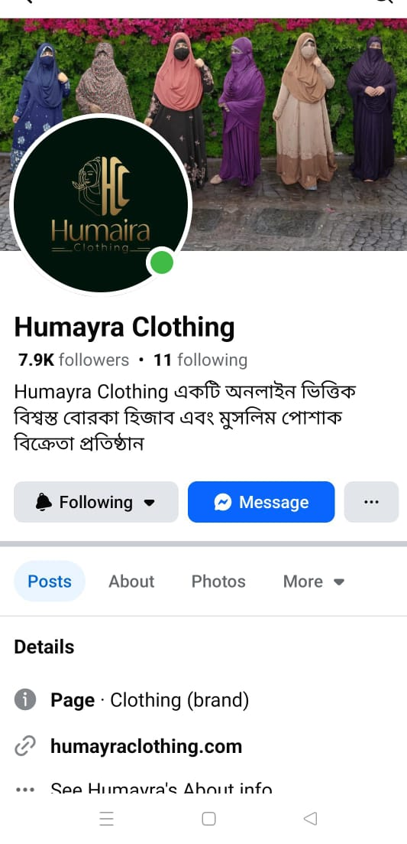
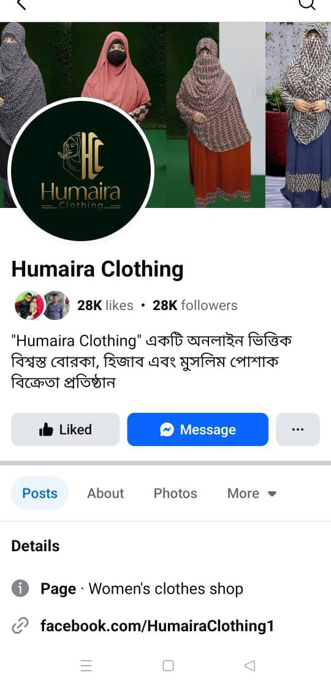

Figure 1: Online Page 1
Figure 2: Online Page 2
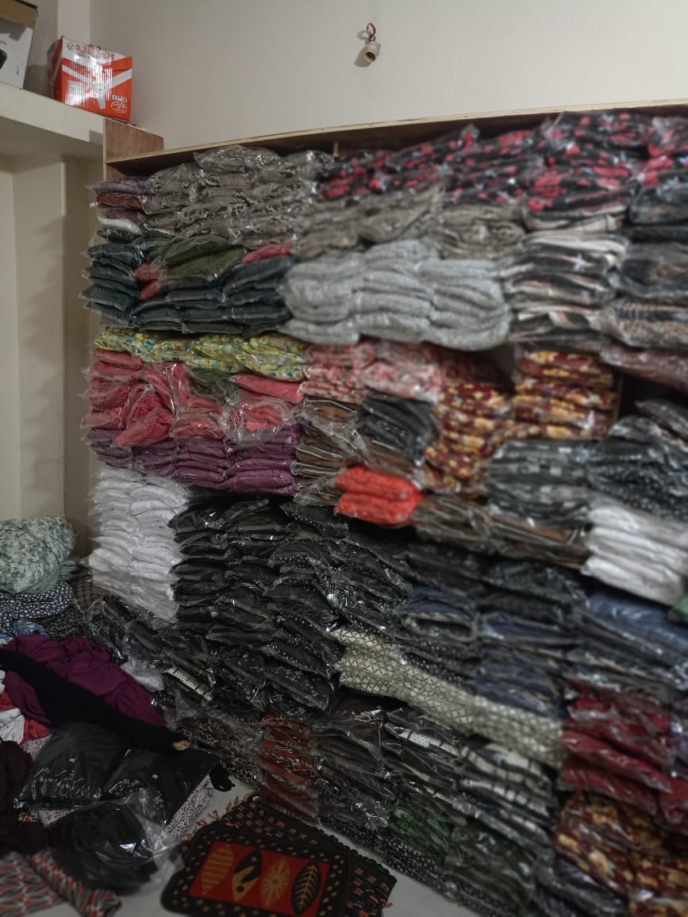

Figure 3: Offline Store

CHAPTER II: COMPANY AND INDUSTRY PREVIEW

Company Analysis

Overview of Humayra Clothing
Humayra Clothing started in July 2018, thanks to Mr. Shahadat Ahmed. At first, they made block-printed cotton salwar kameez - simple and comfy stuff. Then they added some winter things like shawls and warm clothes. But around 2020, they decided to focus more on modest fashion - mainly good quality burkhas and hijabs for women of all ages.
They offer lots of colorful and stylish modest clothes made from fabrics like jersey, georgette, linen, and cotton. The clothes cover well, are comfy, and still look modern and fashionable. They’ve got something for everybody, from teens to older ladies - everyday clothes, fancy dawat outfits, and summer-friendly pieces.
One of their bestsellers is the full burkha-hijab set with a khimar made of jersey fabric. It works for all kinds of weather, and it really helped put Humayra Clothing on the map in the modest fashion scene.
Now, they have over 300,000 to 400,000 customers, and their sales go up to around 700,000 or 800,000 BDT every month. They sell both online on Facebook and offline through their showroom in Adabor, Mohammadpur. Plus, they do cash on delivery all across Bangladesh.
Their big goal is to become one of the top modest fashion brands in Bangladesh, with great designs, good service, and products that mix faith and style. This report will dig into how they grew, what marketing and product plans they have, and why more people are loving them.

Trend and Growth
Humayra Clothing has been growing steadily since it started, both in terms of customers and how popular its products are. The brand is reaching more people every month, especially online where sales keep going up. Right now, they have close to four or five lakh customers. Most sales happen online, and their product videos sometimes get thousands or even lakhs of views. The offline showroom sales are smaller in comparison but still add to the total income.
One of their standout products is the jersey fabric burkha-hijab set with khimar - something only Humayra Clothing sells like this. These sets are popular with both younger and older women because they’re comfortable, breathable, and stylish. Each month, these sets alone bring in about 7 to 8 lakh BDT from both online and offline sales combined. In festival time the sales range of month in 10 - 12 lakh BDT No other online brand has this exact design and fabric mix, so it really gives Humayra Clothing an edge in the market.
Customers keep asking for new styles using this fabric, like two-piece khimar sets, jersey hijabs, or special burkhas with unique designs. The brand is planning to add more options soon, including burkhas decorated with karchupi and stone work.
Most of Humayra Clothing’s growth comes from its promos on social media - short videos and live selling sessions. The marketing is all handled by the team itself, and they really focus on the small details to catch the attention of the right customers. Because of this, new products usually get sold out quickly once they’re posted online.
Going forward, Humayra Clothing plans to introduce more kinds of products, open additional stores, and create their own website to make it easier for people to shop. These moves show that the brand is serious about growing bigger and becoming a strong name in Bangladesh’s modest fashion world.

Month | No. of Orders | Avg. Order Value (BDT) | Total Sales (BDT) | Top-Selling Product | Online vs Offline Sales | Returns/Exchanges
Jan-24 | 950 | 840 | 798,000 | Jersey Khimar Set | 90% / 10% | 15
Feb-24 | 980 | 860 | 842,800 | Soft Cotton Hijab | 90% / 10% | 16
Mar-24 | 1020 | 870 | 887,400 | Jersey Burkha Set | 90% / 10% | 17
Apr-24 | 1600 | 920 | 1,472,000 | Eid Special Jersey Set | 90% / 10% | 25
May-24 | 1400 | 900 | 1,260,000 | Jersey Two-Piece Khimar | 90% / 10% | 23
Jun-24 | 1200 | 880 | 1,056,000 | Lightweight Summer Set | 90% / 10% | 20
Jul-24 | 1100 | 870 | 957,000 | Cotton Khimar Set | 90% / 10% | 18
Aug-24 | 1050 | 860 | 903,000 | Dawat Collection Burkha | 90% / 10% | 17
Sep-24 | 1000 | 850 | 850,000 | Jersey Hijab Combo | 90% / 10% | 16
Oct-24 | 980 | 840 | 823,200 | Linen Hijab-Burkha Set | 90% / 10% | 16
Nov-24 | 970 | 860 | 834,200 | Winter Cotton Collection | 90% / 10% | 15
Dec-24 | 990 | 870 | 861,300 | Premium Khimar Jersey | 90% / 10% | 16
Jan-25 | 1300 | 890 | 1,157,000 | New Year Cotton Khimar | 90% / 10% | 20

Table 1: Monthly Sales Performance Summary (Jan 2024 – Jan 2025)

Customer Mix
Humayra Clothing caters to women all over Bangladesh who want modest, comfortable Islamic clothing. Their customers range from teenagers to older women, all looking for outfits that combine style with full coverage.
Most customers are from urban and semi-urban areas such as Dhaka, Narayanganj, Comilla, Chattogram, Sylhet, Barishal, Cox’s Bazar, Rajshahi, and many more. As the brand offers nationwide cash-on-delivery, it reaches customers even in remote areas.
The majority of buyers include housewives, students, and a growing number of madrasa students and teachers, who appreciate the comfort, coverage, and ease of wearing the brand’s products especially the lightweight jersey fabric burkha and khimar sets.
Humayra Clothing mainly operates online, and most orders are placed through Facebook posts, short videos, and live sessions. Offline customers also visit the showroom in Adabor, Mohammadpur, but the online sales volume remains higher.
Customer feedback highlights that the products are “easy to carry,” “comfortable,” and “suitable for regular use.” Most customers prefer affordable price ranges between BDT 500 to 10,000 making the brand accessible to the middle-income group. Products priced higher than this range are less commonly requested.
By consistently listening to customer feedback and launching variations based on their needs, Humayra Clothing has built a loyal and growing customer base, contributing to the brand's rising popularity in Bangladesh's modest fashion market.

Product/Service Mix
Humayra Clothing sells modest clothes mostly for Muslim women of all ages. Their main products are:
• Hijabs
• Burkhas
• Inner caps
• Khimar sets
They have different collections to fit various lifestyles, like:
• Everyday wear
• Dawat (party or fancy) collections
• Clothes for office and school
They use comfy, good-quality fabrics such as jersey, Dubai cherry, soft georgette, cotton, and linen. The jersey hijab-burkha sets with khimar are the most popular because they’re soft, easy to wear, and good for any season.
All items are ready to ship, so customers don’t wait long. They deliver all over Bangladesh through Steadfast Courier and offer returns and exchanges to make shopping easy.
Because of their good choices and helpful service, Humayra Clothing has become a well-known name in Bangladesh’s modest fashion scene.

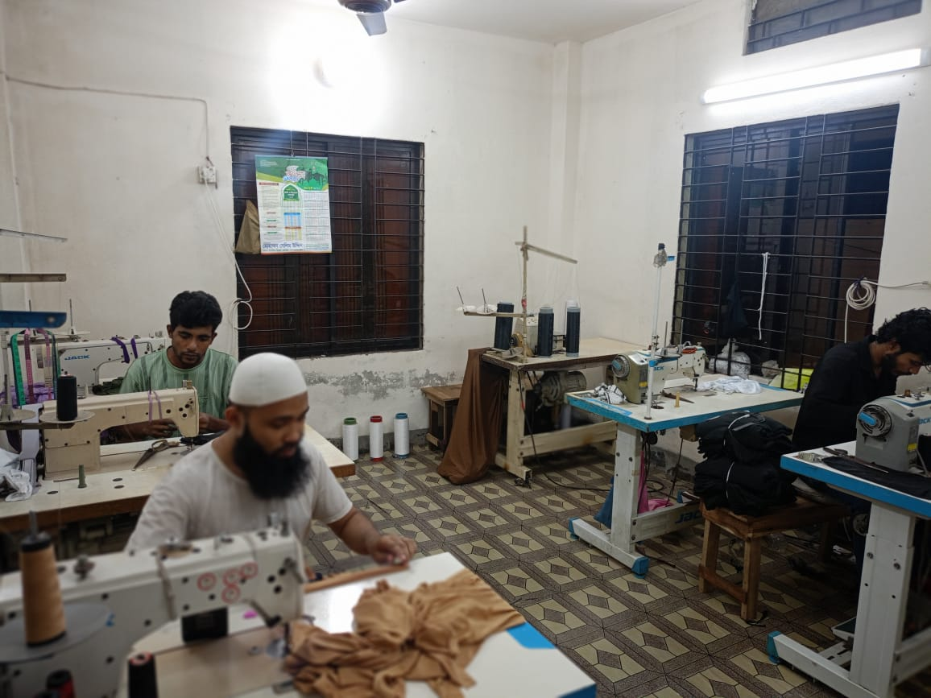
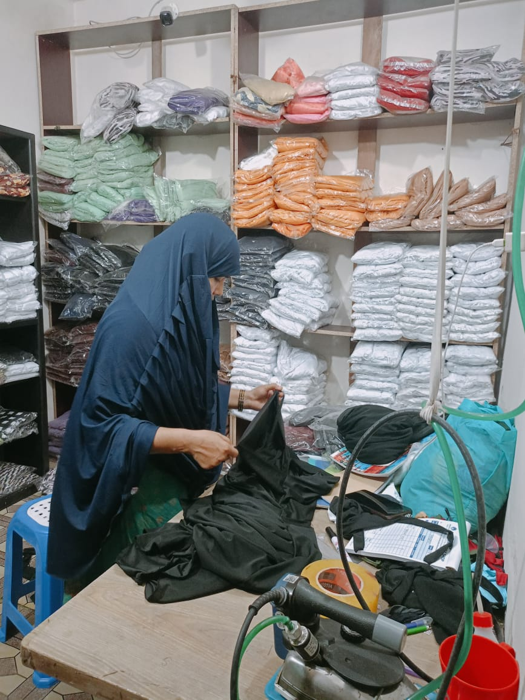

Figure 4: Factory Product Packaging Figure 5: Factory Product Making

Operations
Humayra Clothing runs its business both online and offline, with a small but hardworking team. They take care of everything -from getting fabrics to delivering finished clothes -making sure everything is done well and customers are happy.
They buy their fabrics directly from Islampur wholesale market. There, they pick good quality materials like jersey, cotton, georgette, Dubai cherry, and linen. The brand owner works closely with Ms. Taima Rahman, who started as an intern but now helps manage branding, promotion, and daily operations.
Once the fabric arrives, it goes to the in-house sewing team. Right now, there are about 8 tailors making the products. The showroom has one regular staff member, and all in all, around 10 people keep things running smoothly. Ms. Taima Rahman watches over both the factory and the showroom to make sure everything stays consistent and good quality.
Finished clothes are kept ready to ship and updated regularly for sale both online and offline. Facebook is the main online place where they show their products through short videos, photoshoots, and live selling sessions. Customers place orders by sending their name and address through Messenger, and the team confirms each order by hand.
Every order is carefully packed in plastic, with a branded thank-you card and a cash memo included. Deliveries go all over Bangladesh via Steadfast Courier, with cash on delivery and an easy return/exchange policy to make buying simple.
The showroom is at Adabor, Mohammadpur, Shahbuddin Plaza. People often drop by the showroom to browse and buy right away. The team there takes care of setting up the displays, helping customers find what they need, and keeping track of the stock.
The team meets regularly with the brand owner to review inventory, share customer feedback, brainstorm new product ideas, and plan marketing efforts. Many of the new products, like two-piece khimar sets or decorated burkhas, actually come from suggestions customers have made.
Thanks to a well-run team that really listens to its customers, Humayra Clothing has been growing steadily while keeping the quality high and building a good reputation.

SWOT Analysis
A SWOT analysis is an essential tool to evaluate the internal strengths and weaknesses of a brand, alongside the external opportunities and threats. Below is a structured SWOT analysis of Humayra Clothing:

- Strengths
- They utilize truly decent fabrics like jersey and cotton. They feel soft and look good.
- Their full hijab-burkha-khimar sets are beautiful and one of a kind. Not many brands offer that.
- Lots of clients keep coming back, so people clearly like what they get.
- They sell quite a bit online each day, which is great.
- Customers frequently send positive messages, which helps the brand’s reputation.
- The owner and Taima Rahman keep a close eye on everything, so the quality remains good.
- Returns and exchanges are easy, so customers feel secure buying from them.

- Weaknesses
- They only have one showroom, in Mohammadpur.
- Because our team is small, everyone has to handle several different tasks to keep things running smoothly.
- Our website is still under development, so most sales happen through Facebook for now.
- Occasionally, we run out of stock, but we quickly make more to meet customer demand.
- Relying heavily on Facebook can be risky since any changes to the platform could affect our business.

- Opportunities
- They want to add bridal wear and fancier burkhas with decorations.
- They have plus sizes but may include more options for different body types.
- With loyal customers and unique items, opening more stores or launching a website would be smart.
- Since modest fashion is getting more popular, maybe they’ll start offering abroad.

- Threats
- There are lots of other brands competing online.
- A few competitors have begun imitating their designs, which can be quite frustrating.
- Facebook frequently updates its advertising policies, making it harder at times to reach potential customers.
- Since the brand depends largely on social media, unexpected changes there could pose challenges.

All in all, Humayra Clothing is performing well, but they need to continue putting in effort and stay alert to any obstacles ahead.

Industry Analysis

Specification of The Industry
In Bangladesh, the modest fashion market primarily serves women who prefer Islamic clothing such as hijabs, burkhas, and khimars. This customer base includes madrasa teachers and students, working women, school teachers, and homemakers. Even women who do not wear these garments daily often use them during prayer times. The main products in this category are hijabs, burkhas, khimar sets, and inner caps.

Size, Trend, and Maturity of The Industry
The modest fashion industry in Bangladesh is now well-established and no longer in its infancy. Both online and offline sales show steady growth, with more women gradually adopting hijabs and burkhas as part of their everyday attire. Brands such as Humayra Clothing actively maintain social media accounts and regularly interact with their customers throughout the year, except for brief pauses during festivals like Eid.

External Economic Factors
Fabric prices have gone up recently, but Humayra Clothing keeps price increases minimal - usually around 400 to 800 BDT when needed. Delivery costs stay low, helping to keep the products affordable for people from various income groups.

Technological Factors
Humayra Clothing markets its products primarily on Facebook by posting real photographs, quick videos, and live sessions to communicate with consumers. Their website is at present still under construction and isn't functional yet. Orders are fulfilled manually, and there isn't a clear system for tracking deliveries, which sometimes causes holdups.

Barriers to Entry
It is not easy to start a small fashion brand. It takes time to build the trust of customers while maintaining quality products with different tailors and vendors for fabric. Delivery management is also very challenging and requires experience and investment in building a good logistics system. Moreover, setting up a garment business requires a lot of investment in materials, labor, advertising, and packaging. With no point of differentiation or identity, the majority of new brands cannot survive this competitive marketplace.

Supplier Power
To make sure she never runs out of cloth, Humayra sources it from several reliable vendors in Islampur.It might be challenging to set a fixed price at times because prices fluctuate based on the amount of supply available. Yet, the business works hard to balance quality with affordable materials.

Buyer Power
Customers particularly appreciate Humayra’s jersey fabric hijab-burkha-khimar sets because these products are unique and stand out from others available in the market. This has helped the brand acquire loyalty. Having said that, there are price-sensitive buyers who might purchase from elsewhere if prices are not competitive. Delivery cost also plays a role in their decisions.

Threat of Substitutes
Presently, Humayra mainly deals in hijabs, burkhas, and khimar sets. Yet, other modest fashion trends - including trendy hijabs, decorated abayas, and fusion wear - are becoming more popular and might attract customers away. To keep up, Humayra will diversify their product to carry more decorative and trendy products.

Industry Rivalry
The Bangladeshi modest fashion market is seriously saturated and comprises thousands of online retailers, as well as more than 25000-30000 pages and stores. However, Humayra Clothing is unique in that it sells unique jersey-fabric hijab - khimar - burkha sets which are not yet widely copied. Some similar competitors to it include Stylish Abaya, Barakah Gallery, Glam Touch, Takbir, Sunnati, Turkey Burkha Bazar, and Burkha House. Design copying is something that the brand keeps track of.
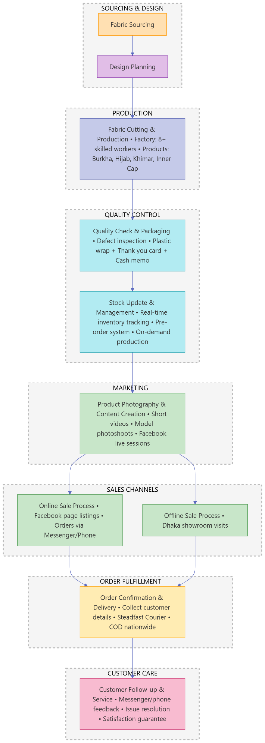
Figure 6: Operational Process

CHAPTER III: INTERNSHIP EXPERIECNE

Position, Duties, and Responsibilities
I joined Humayra Clothing as a Brand Executive during the time I was still on internship. I was then promoted to the position of Brand Manager, where I am now working full-time.
I have performed several key responsibilities in my internship as well as in my current job. I keep an eye on product packaging so that all the products are handled correctly by the employees. I regularly check the stock levels so that there is no lack of stock, and I restock when needed. I am also responsible for product shoots and video making for social media. I host live sessions regularly and interact with customers online every day.
I also take care of organizing all courier shipments and make sure customers receive their orders in good condition. If there’s any complaint, I handle it right away and keep a close record of all feedback.
A special part of my job is that I model the products myself during photoshoots and live sessions. By representing the brand personally, I help build customer trust and strengthen our brand identity.
My responsibilities also include generating new product ideas, creating brand promotion strategies, and meeting with my mentor to discuss future product launches. I directly handle content creation, including selecting models (normally myself), organizing shoots, and directing the promotion of the brand.

Training
When I joined Humayra Clothing, my training started right away under the close guidance of Mr. Shahadat Ahmed, the owner of the brand. Instead of formal sessions, he walked me through the day-to-day work - showing me how to manage product handling, courier coordination, inventory checks, customer service, and managing our online pages.
While I already had some experience in modeling and basic brand promotion and took care of that part myself, the rest of the work was completely new. His one-on-one mentoring helped me understand how the business operates and gave me the confidence to take on more responsibilities over time.

Contribution to Departmental Functions
During my internship at Humayra Clothing, I was actively involved in various departments including branding, marketing, sales, and content creation. I was directly involved in developing new product ideas and creating promotional strategies tailored to our target market. I had a major role in conceiving and developing short videos, product shoots, and social media posts.
In addition, I engaged in weekly sessions with my mentor to suggest ideas for upcoming product launches and improvements. My personal involvement in customer interactions built a positive brand image and increased credibility.
As a result of my efforts, the brand experienced more active engagement, more seamless growth in sales, and an increase in customer satisfaction and loyalty.

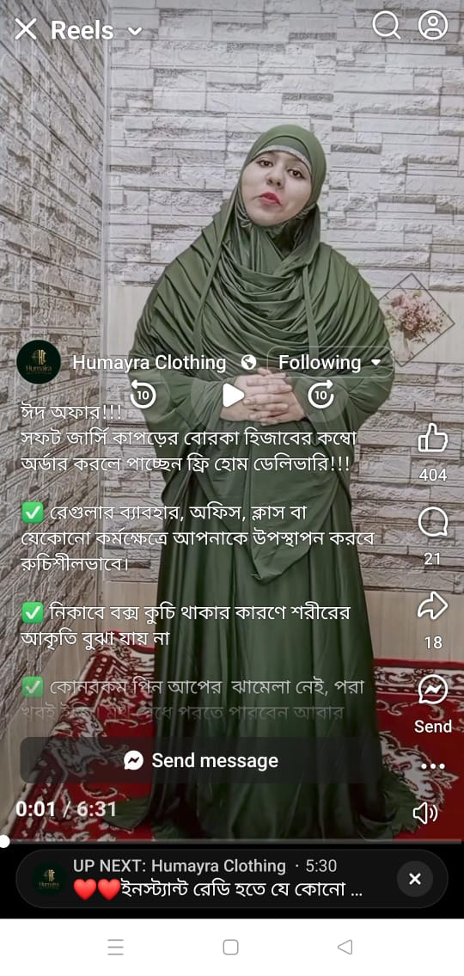
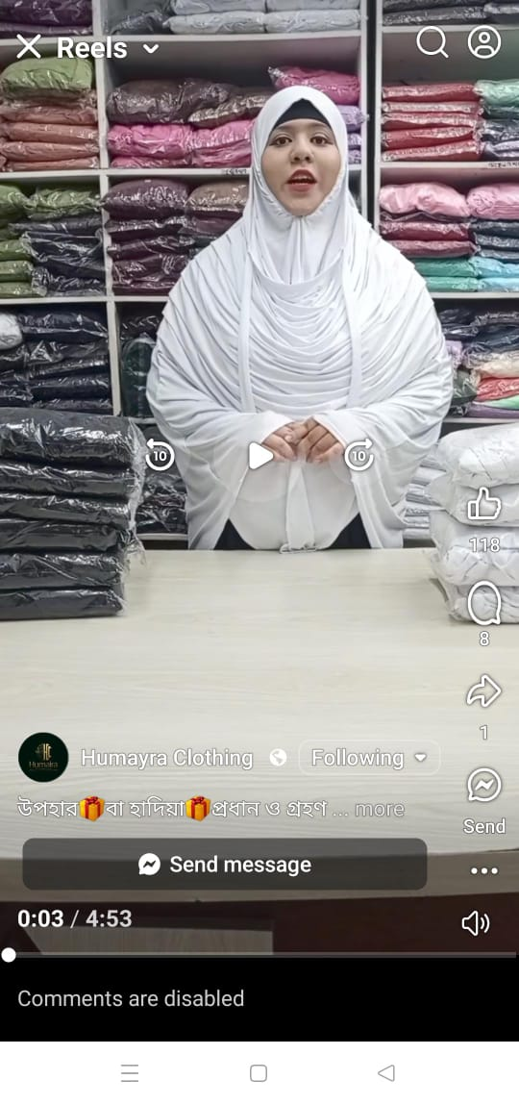

Figure 7: Product Branding Figure 8: Product Branding

Evaluation
My internship at Humayra Clothing was enriching with new experiences. I received constructive feedback and appreciation during the tenure from the brand owner and mentor, which motivated me to perform even better. This experience truly enhanced my confidence level.
I also gained useful practical experience, such as how to effectively solve customer issues, the product market insight, and a better understanding of business operations overall. The lessons have helped me lay a solid foundation for future career development.

Skills Applied
During the internship, I was able to apply many previously learned skills. Communication skills helped me in dealing with customers, solving issues, and collaborating with team members effectively. Time management skills were also applied to carry out different tasks and complete deadlines without any issue.
My creativity and experience in content creation helped me design interesting photo and video content for our online media. My brand appearance skills, especially modeling and representing the brand visually, also helped a lot in building customer trust and promoting the products efficiently.

New Skills Developed
Through the internship at Humayra Clothing, I gained several new competencies that have improved my professional skills. I gained the competency of managing stock and inventory, handling customer grievances, and coordinating with courier services for smooth delivery operations.
I also gained practical experience in product launch planning, sitting in on strategic meetings with my mentor, and helping to develop new product ideas. Further, I developed my abilities in creating brand promotion strategies, coordinating the production team, and monitoring day-to-day sales activities. All these practical skills have successfully prepared me to tackle actual business world issues.

Application of Academic Knowledge
As a Marketing major, I was able to relate and apply many of the theoretical concepts I learned during my BBA at UIU to real-life situations in my internship. I particularly found the Brand Management course very useful, especially the things I learned under Khondokar Sir. I applied concepts such as branding strategies, consumer behavior, market segmentation, and the marketing mix (4Ps) when I did product promotion, customer interaction, and new product development.
These academic lessons allowed me to better understand how to position a brand in the market, speak to the target market, and maintain customers. Applying academic learning to the field significantly enhanced my knowledge and confidence in marketing practice.

CHAPTER IV: CONCLUSIONS AND KEY FACTS

Recommendations for Improving Departmental Operations
From my internship experience with Humayra Clothing, I have realized the following areas can be improved to achieve greater operation efficiency:
1. Rise in Customer Engagement: During seasons of high demand, handling high volumes of customer correspondence presents enormous challenges. Occasionally orders are processed, yet follow-up shipment could be sluggish due to overlooked entries in the record. To combat such errors, the implementation of a methodical order tracking system or an electronic filing process may assist.
2. Better Delivery Support: In spite of the use of Steadfast Courier, there are delays from delivery staff that lead to customer complaints. Partnering with other courier companies or having better communication with current ones might help reduce this problem.
3. Fabric Stock Management: At times certain colors of the fabric may be out of stock in the market, resulting in delays in meeting the orders of customers. More developed relationships with more than one supplier or maintaining a secondary fabric stock may mitigate these delays.
4. Promotional Content Quality: Facebook content quality can be improved by using clearer, high-quality videos and images. This will attract more customers and increase page engagement.
5. Website Activation: A fully functional website installation would enable customers to place orders on their own, thereby eliminating human errors associated with the order-taking process.

Key Understanding
Through my internship at Humayra Clothing, I acquired valuable first-hand knowledge of the operational dynamics of an online fashion company in the Bangladeshi market. I have realized the dynamics of branding, product design, marketing strategy, and customer handling as essential factors in the growth of a successful business.
I now have a better idea of how to manage customer expectations, process orders, monitor stock, and help with the coordination of deliveries. I also gained insight into how visual content - images, videos, and live streaming -can have a profound influence on customer interest.
One of the key insights was the imperative contribution of product differentiation in a competitive market. The entrance of our jersey material hijab-burqa sets established a powerful brand image, which assisted in building customer loyalty. I also came to the understanding of the vital importance of customers' feedback in new product development and service enhancement.
In summary, this internship introduced me to hands-on learning that one does not typically acquire through simple academic study materials. It boosted the integration of theoretical knowledge and practice.

Conclusion
In overall, the internship experience at Humayra Clothing was enriching and enlightening. It gave me a comprehensive idea about the organizational dynamics of a niche Islamic fashion brand in online and offline markets in Bangladesh. I observed firsthand the various challenges and opportunities associated with product development, customer relationship management, and branding.
Collaborating closely with the brand owner and performing various tasks enabled me to put my theoretical learning into practice simultaneously by acquiring requisite skills in marketing, communication, and business administration. The market positioning of Humayra Clothing, particularly with its one-of-a-kind jersey fabric hijab-burqa sets, demonstrates immense potential for long-term expansion.
This internship has given me confidence and practical work realization on me for future positions in marketing and brand management. I am grateful for this opportunity to learn and assist in a business that is expanding.

Reference
- United International University. (2025). Internship report writing guidelines. Dhaka, Bangladesh.
- Kotler, P., & Keller, K. L. (2016). Marketing management (15th ed.). Pearson Education.
- Robbins, S. P., & Coulter, M. (2021). Management (15th ed.). Pearson Education.
- Steadfast Courier. (2025). Logistics and delivery policy. https://www.steadfast.com.bd
- Humayra Clothing. (n.d.). Official Facebook page 1. Retrieved June 28, 2025, from https://www.facebook.com/share/1AUBTqbtLA/
- Humayra Clothing. (n.d.). Official Facebook page 2. Retrieved June 28, 2025, from https://www.facebook.com/share/1Bpn4sc5Mm/
- The Business Standard. (2024, February 15). The rise of modest fashion and its growing market. https://www.tbsnews.net/magazine/rise-modest-fashion-and-its-growing-market-1099691
- Textile Today. (2024, March 18). Bangladesh’s strategy for expanding Middle Eastern modest fashion market. https://www.textiletoday.com.bd/bangladeshs-strategy-for-expanding-middle-eastern-modest-fashion-market
- Khondkar, M. (2021). Hijab as a Muslim attire and a fashion trend in Bangladesh. https://www.researchgate.net/publication/348998292
- Sharif, M. (n.d.). Factors behind rise of wearing ‘hijab’ among Bangladeshi urban young women. University of Liberal Arts Bangladesh. https://ulab.edu.bd/mcomn/sites/default/files/SHARIF-M-FACTORS-BEHIND-RISE-OF-WEARING-HIJAB-AMONG-BANGLADESHI-URBAN-YOUNG-WOMEN.pdf
- Islam, M. R., & Haque, A. (2014). A conceptual framework on the study of trends of Islamic fashion and clothing practices amongst young Muslim female in Bangladesh. https://www.researchgate.net/publication/263807484
- Grand View Research. (2023). Halal fashion market size, share & trends report, 2030. https://www.grandviewresearch.com/industry-analysis/halal-fashion-market-report
- Halal Research Council. (n.d.). Global development of modest fashion industry. https://www.halalrc.org/pressrelease34.php
- The Business Research Company. (2025). Islamic clothing market share and growth report 2025. https://www.thebusinessresearchcompany.com/report/islamic-clothing-global-market-report

