Internship Report
On
Developing and Managing Market Insights: A Study on Akij Food and Beverage Limited

Internship Report
On
Developing and Managing Market Insights: A Study on Akij Food and Beverage Limited

Submitted To
Muhammad Hasan Al-Mamun
Assistant Professor
School of Business & Economics
United International University

Submitted By
Md. Didarul Islam
ID Number: 111 141 345
Program: BBA
Major: Marketing
United International University

Letter of Transmittal
June 19, 2019
Muhammad Hasan Al-Mamun
Assistant Professor
School of Business & Economics
United International University
Subject: Submission of the Internship Report on “Developing and Managing Market Insights: A study on Akij food & Beverage Ltd”
Dear Sir,
It is my great pleasure to submit you my internship report on “Developing and Managing Market Insights: A Study on Akij Food & Beverage Ltd”. I have completed my internship program in Akij Food & Beverage from February 05, 2019 to May 05, 2019 as a part of my BBA Program. I have tried to explain my learning and experiences what I have gathered from my internship program briefly in this report.
I realize that this approach really contributes in giving my course learning a lasting shape in me. The whole report is based on my practical and field experience within this company. I have given my best efforts in completing the report with all the information that I have collected during my stay in Akij Food & Beverage.
I have great hope that the report will meet your expectations and my academic requirement and aid you in getting a clear idea about the subject.
Sincerely,
…………………..
Md. Didarul Islam
ID: 111 141 345
Program: BBA

Acknowledgement

At the exceedingly beginning, I would like to convey my cordial gratitude to almighty Allah for giving me the strength and the self-possession to complete the assigned job within the schedule time. I would like to reimburse my profound respect to my supervisor Muhammad Hasan Al-Mamun, Assistant Professor, School of Business & Economics, United International University, due to his generous and gracious guidance. I am also grateful to him for helping me to understand some miniature issues as well as those issues, which I have failed to understand during the preparation of the report. At the same time, I also pay my heartily gratitude to Mr. A.N.Al-Zahid (Honorable Manager,Business and development Department), Mr. Pritom Ghosh (Jr.Executive, Business and development Department) of Akij Food & Beverage who’s were extended their helping hands by showing the right and effected path to mean by motivating me to implement my theoretical knowledge of Business research and development at Akij Food & Beverage Ltd.

Finally, I humbly appreciated the endurance & assistance of the entire work force of Akij Food & Beverage, for their time in making me able to complete my Internship Report. I have tried to prepare this report accurately. However, there might be some errors or mistakes. So, I seek your kind consideration as I am in the process of learning.

Table of Content
Particular Page
Chapter-1
Introduction
- Topic in Hand……………………………………………………………………………………………………. 1
- Context of the Study…………………………………………………………………………………………1-2
Organizational Background and Industry Perspectives
- Organizational Background………………………………………………………………………………3-4
- Industry Perspectives…………………………………………………………………………………………4
Objectives and Methodology of the Study
- Objectives of the Study………………………………………………………………………………………5
- Methodology of the Study………………………………………………………………………………….5
Limitations of the Study…………………………………………………………………………………………………6

Findings of the Study…………………………………………………………………………………………………7-27

Recommendations and Conclusion
- Recommendations…………………………………………………………………………………………28
- Conclusion…………………………………………………………………………………………………….29
References………………………………………………………………………………………………………………………....30

Executive Summary
Founder and life-time Chairman Late Mr. Sheikh Akij Uddin initiated the business in 1950s with a single product of cigarette called Akij Biri. This brand is one of the biggest and well known unit of Akij Group. Akij Food & Beverage started its journey in 2006.Today AKIJ GROUP has over 18 business units in different sectors including tobacco, jute mills, cement, particle board, housing, textile, ceramics, zarda, and match. The report is prepared on "Developing and managing marketing insights: A study on Akij Food & Beverage Ltd". Akij Food & Beverage has a large products line like mineral, energy drinks, different types of juices, chips, various types of cold drinks and their latest addition is milk. To maintain this large product line, Akij built a strong network in all over this country. Every company wants to establish its new product in the market. So, they collect data from respondents through surveys like blind test, sample test, and other types of similar researches. From the blind test study, we have come to conclude that respondents like Aafi Tomato Sauce for its thickness and overall taste parameter with compared to Pran Hot Tomato Sauce. In sour-sweetness and smell parameter, respondents like Pran most. In case of hotness parameter, both are holding same position. In another study, the objective was to evaluate the preference levels of consumer perception for Mustard oil. This survey has been conducted to compare between factory provided sample product and competitors brand about smell/flavor, oil fizz, and overall taste parameters.
These insights were then incorporated in the process of new product development and the associated marketing campaign. From my internship, I have known the process of business research and development and the process of developing and managing the market insights. If the company doesn’t research in a proper way, the business development and product can’t be developed easily in a way meaningful to the target market.
Well managed market insights can be helped for the marketing managers to make the appropriate decisions in the domain of marketing. Market insights, appropriately used the organization, can create real value for the target market, and in turn can certainly one of the reasons for the creation of shareholder value.
Key Words: Market Insights, Food and Beverage Industry.

Chapter-1
Introduction
- Topic in Hand
“Companies address customer needs by putting forth a value proposition, a set of benefits that satisfy those needs. The intangible value proposition is made physical by an offering, which can be a combination of products, services, information, and experiences. At the heart of the marketing program is the product- the firm’s tangible offering to the market, which includes the product quality, design, features, and packaging. To gain competitive advantage, at last may provide services. All marketing strategy is built on segmentation, targeting, and positioning. A company discovers different needs and groups in the marketplace, target those it can satisfy in a superior way, and then positions its offerings so the market recognizes the company’s distinctive offering and images” [Marketing Management, Philip Kotler].
As a student of Marketing major under BBA Program, this study is very essential because we may acquire practical knowledge which we learn from our text book. Every company want to establish its new product in the market. So, they collect data from respondents through surveys like blind test, sample test. From my internship, I have known the process of business research and development. If the company doesn’t research in a proper way, the business development and product can’t develop easily. The report of research can be helped to take the decision of the brand and marketing manager which product sample will be developed and managed in marketing insight. So, my internship topic is very helpful in future corporate life to apply this acquiring knowledge and also establish and growth my career besides with achieving my organization’s goal.

- Context of the Study
AFBL is one of the well-equipped and country leading local manufacturers of soft drinks in FMCG sector. In the arena of globalization and free trade, it is very tough to compete in this Energy drinks and the competition style of this sector changing day by day. The AFBL is continuously upgrading itself with this changing environment of competition. My research report initially provides a nominal idea of the beverage industry in our country. Then the overview of AKIJ Group and also Akij Food & Beverage Ltd (AFBL). This is a unit of Akij group, is presented. After the company descriptive part, analysis segment is incorporated. Starting with Competitive analysis of AFBL, SWOT analysis, AFBL principles and Branding strategies. Different National and MNCs organizations are now on the field to fulfill the overall demand. AFBL requires expert Marketing and Branding which is
remarkably different from the manufacturing and other service sector companies. Because all companies of this industry need to upgrade them constantly to stay in the competition. Every day the customers’ Demands and taste are changing and the competitors are also offering customized products, which is the nature of this industry. So, the success in this industry depends largely on the continuous upgrade of Branding Activities. I have learned how to develop products and increasing demand through different kind of events. AFBL has strong presence of Digital marketing. I have gathered conceptual knowledge as well as practical knowledge.

Chapter-2
Organizational Background and Industry Perspectives

- Organizational Background
Akij Food & Beverage Ltd. (AFBL) a unit of Akij Group Started its operation in the year 2006. AFBL manufactures a wide range of Snacks and Beverage of both National & International Market alike. AFBL is a Project worth $70 million & is founded by the Parental Company Akij Group.
AFBL started its production at 400 bph in the carbonated soft drinks line and 300 bph in the juice line. In a span of one and a half years we have increased our capacity to 1800 bph. At present our capacity one is at the ground breaking rate of 1900 bph. So in approximately three years’ time our capacity has increased three folds, during this same period most of our brands became either number one or are almost on the verge of becoming number on in their respective categories. Most of our machineries have been imported from world famous brands as Crones, Tetra Pak, Alfa Laval, Spa, and Risky to achieve best quality. AFBL is one of the well-equipped and country leading local manufacturers of soft drinks in FMCG sector. In the arena of globalization and free trade, it is very tough to compete in this Energy drinks and the competition style of this sector changing day by day. The AFBL is continuously upgrading itself with this changing environment of competition.

AFBL: Mission, Vision, Goal& objective: Vision:

To be the leading food & Beverage brands excelling in product quality, social, technical & marketing creativity; and service to our customers through the skills and cordial commitment of our employees.

Mission:

To be the market leader in quality food & beverage sector discovering & satisfying the desire & need of the community working in harmony with our customers, employees and business partners.

Goal:
To achieve market leadership, profitability, good corporate citizenship and a sustainable growth.

Objectives: The main objective of the company is to increase the market share in related diversified Products in Bangladesh and to assure the potential customers of the quality and durability of the products.
- Believing in quality and excellence in service.
- Believing open communication, personal responsibilities, integrity, and active participation
- Supporting the creative diversity and share of ideas.
- Building culture of learning based on leadership, teamwork, accountability, and co-operation.

- Industry Perspectives
SWORT analysis:
Strength:
- Quick establishment of brands like MOJO,
- SPEED, FRUTIKA.
- Quality of the products.
- Availability of products through mass distribution around the country.
- Unique promotional activities.

Weakness:
- Less experience in the beverage market in terms of understanding in timely proper customer need.
- Some improper promotional activities.

Opportunity:
- There is a scope for the local companies to attaining maximum market share for the refreshing flavored CSD drink.
- Opportunity for AFBL products to be exported in the overseas Asian market.

Threat:
- Unethical practice of the competitors, for example tax violation, to reduce the price of the product.
- Companies like Coca-Cola and Pepsi to be operated as MNCs like Unilever rather than the licensing owned by the local Bangladeshi company.

Chapter-3
Objectives and Methodology of the Study
- Objectives of the Study:
The objective of the study is
- To acquire practical knowledge.
- Understanding the business research and development process.
- Understanding the target audience perception on the sample new products.
- To collect the innovative idea from the target respondents on existing product’s new product labelling survey like FGD (Focused Group Discussion).
- To evaluate the competitive industry analysis based on the SWOT analysis.
- To determine the AFBL’s brand awareness.

- Methodology of the Study:
“Along with the sources of data, a report must mention the method used for collecting data”. The possible methods of collecting primary data are observation and questioning” [Muhammad Shariat Ullah]. For this research primary approach or secondary approach is applied. The steps are:
- Primary Source
Information was collected from relevant research and development done by product labelling survey, blind test, sample product test, internal interview on seniors and different brands’ manager’s strategy and market survey on product of AFBL.
- Secondary Source
- Reports
- Journals
- Books
- Website
- Different articles
- Newspaper
- External other sources like respondent’s interview etc.

Limitations of the Study
Like any other articles and thesis, this study is not free from limitation. Highest level of efforts has been given to overcome these limitations through extensive study. The major limitations are given below:
- Company policy & secrets of not disclosing some data and information for confidential reason, which could be very much useful for the report.
- Respondents don’t share the actual information.
- Field raw data on survey were not collected properly.
- The lack of monitoring system when the outside surveys are conducted.
- The lack of information
- Lack of co-operation.
- Time limitation.

Chapter-4
Findings of the Study

- Chocolate Flavored Milk Test:
This study objective is to assert the preference level of consumer perception about Farm Fresh (Chocolate flavored milk) - 200 ml on its smell/ flavor, taste, sweetness, thickness, and mouthfeel parameters. This survey has been done over 23 AFBL in house personnel aged between 23 to 35 years old.
From this test study, a good number of respondents moderately like “Farm Fresh Chocolate Flavored Milk” of its all parameters.
Study Overview

- This survey conducts over AFBL in house personnel only.
- Age between 23 to 35 years.
Total 23 respondents are chosen for test survey:
Sample & Compare Category

SL No. | Particulars | SKU | Batch  No. | Production Date | Expire Date | Self-Life*
1 | Farm Fresh  (Chocolate Flavored Milk) | 200 ml | 002/19 | 12.04.2019 | 19.04.2109 | 11

Limitation

- Only AFBL in house personnel are chosen for test sample respondent.
- Observation cannot ensure exact hypothesis.

Analysis of Test:
Average Score –

Brand | Smell/Flavor | Taste | Sweetness | Milk Thickness | Mouthfeel
Farm fresh | 6.8 | 7.2 | 7.5 | 7.7 | 7.2

Remarks:
- From the above test survey, it is clear that- “Farm Fresh Chocolate Flavored Milk” holding moderately good position in its all parameters.
- Respondents like milk thickness most, followed by sweetness, taste, mouthfeel, smell/flavor parameters.

2. Focus Group Discussion on Product Labelling Survey:
2.1. Frutika Packaging Preference
Target Audience (Consumer) –
- Respondent Covered
- East West University (EWU)
- United International University (UIU)
- University of Liberal Arts Bangladesh (ULAB)
- Age between 20-23 years.
- Total Nos: 46 respondents (male- 19, female- 27)

University | EWU | UIU | ULAB | Total
Respondents No. | 12 | 12 | 22 | 46
Survey time period: 13th February 2019 - 16th February 2019.
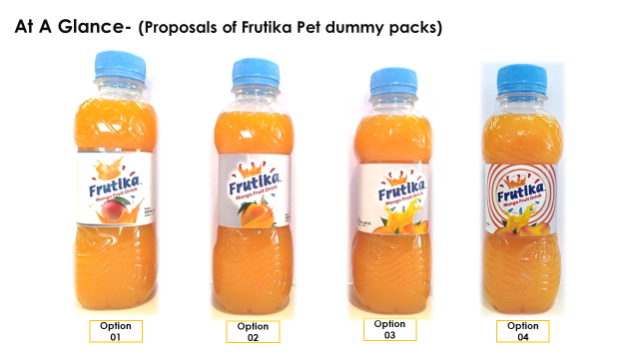

From the respondent’s perception’s rank position is determined through the survey in below:
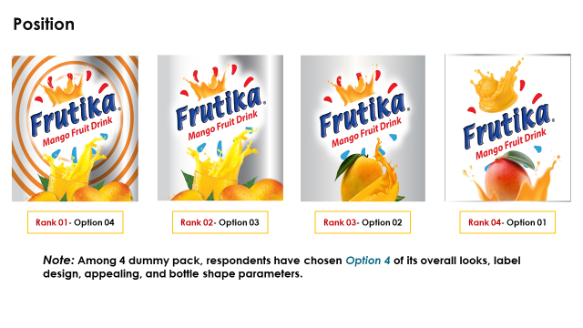Competition Race
Weighted Average
Brand | Overall looks | Label Design | Appealing | Bottle Shape
Frutika (existing) | 7.9 | 8.0 | 7.4 | 7.3
Frutika (Design 4) | 7.1 | 6.4 | 6.5 | 5.4
Frooto | 6.6 | 5.5 | 7.0 | 6.0

Remarks-
- When compare with competitors’ bottle (Frutika existing & Frooto), Frutika existing holds 1st position with compare to new dummy pack and Frooto.
- New dummy pack holds 2nd position in overall looks and label design.
- To create more appeal, need to focus on bottle cork and shape.

2.2. Speed Packaging Preference
Target Audience (Consumer) –
Respondent Covered
  - East West University (EWU)
  - United International University (UIU)
  - University of Liberal Arts Bangladesh (ULAB)
  - Northern University Bangladesh (NUB)
  - Age between 20-23 years.
  - Total Nos: 70 respondents (male- 35, female- 35)
University | EWU | UIU | ULAB | NUB | Total
Respondents No. | 12 | 18 | 22 | 18 | 70
Survey time period: 13th February 2019 - 20th February 2019.
Techniques for premium feel:
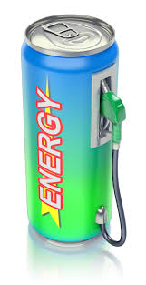
Main feature of Standard CAN-
- Shape must be unique.
- The CAN should contain with a WOW factor feel.
- Create upper class image.
- Overall CAN color should be match with drinks color.
- Use aristocrat design with color.
- Preferred color: Silver, Neon, White, Blue, Royal blue, Metal, Green, Red, Black, Red & Black combination, Black with deep gold.
- Logo concept should be match with Brand name.

Preferred Flavor-
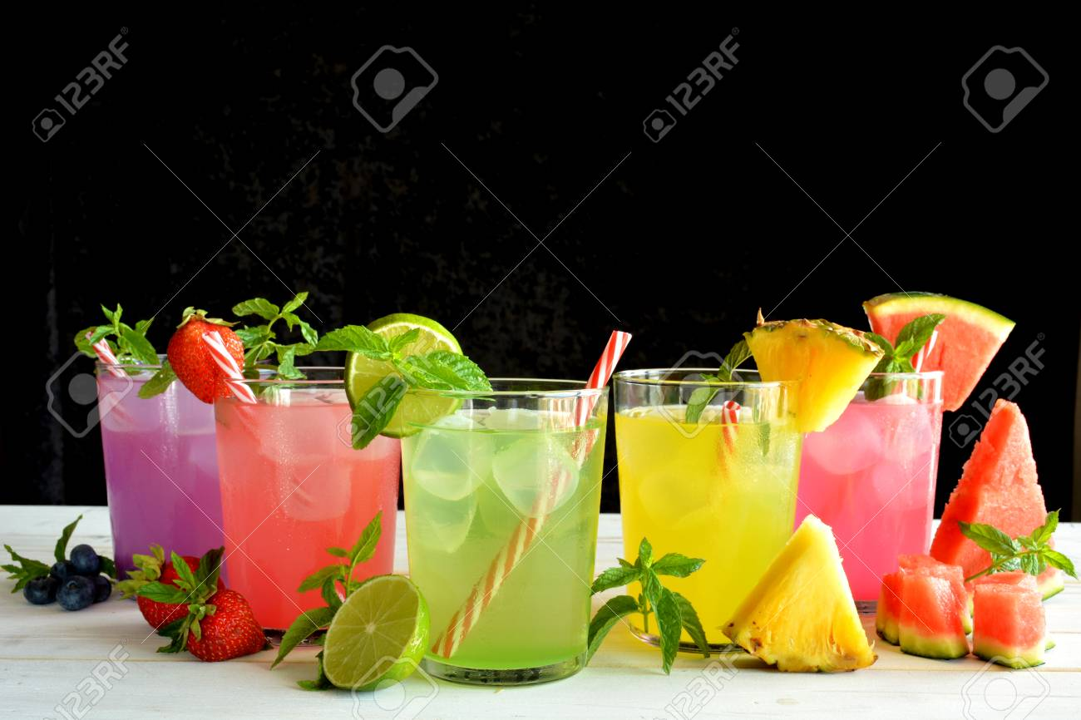
The respondents are shared their opinion about the new flavor for Speed energy drink like-
- Apple
- Grape
- Choco
- Mint
- Orange
- Lemon
- Mojito
Mostly light flavor acceptable for premium energy drink.

Packaging Preference of Speed:
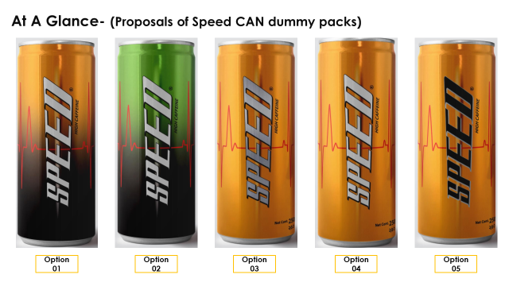

Weighted Average (Respondent category wise)

Ranking:
The ranking of Speed design is determined through the survey participants. The ranking is in the below:

Note: Among 5 dummy pack, respondents have chosen Option 1 for its overall look, followed by option 2, 5, 4, 3.
  - Laban Design Selection
Weighted Average

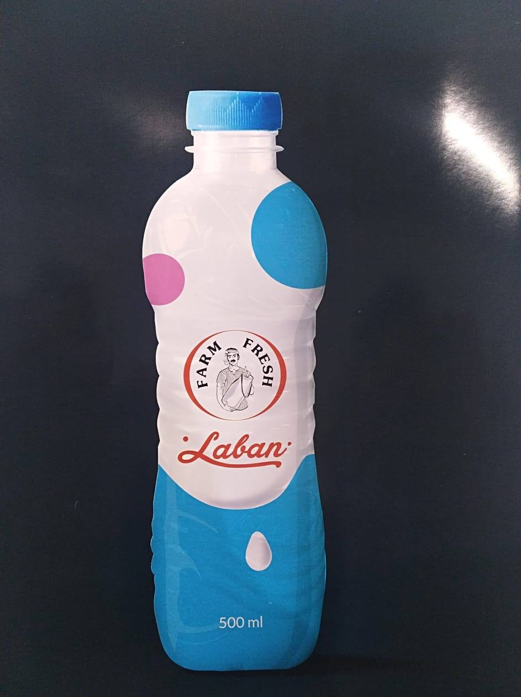
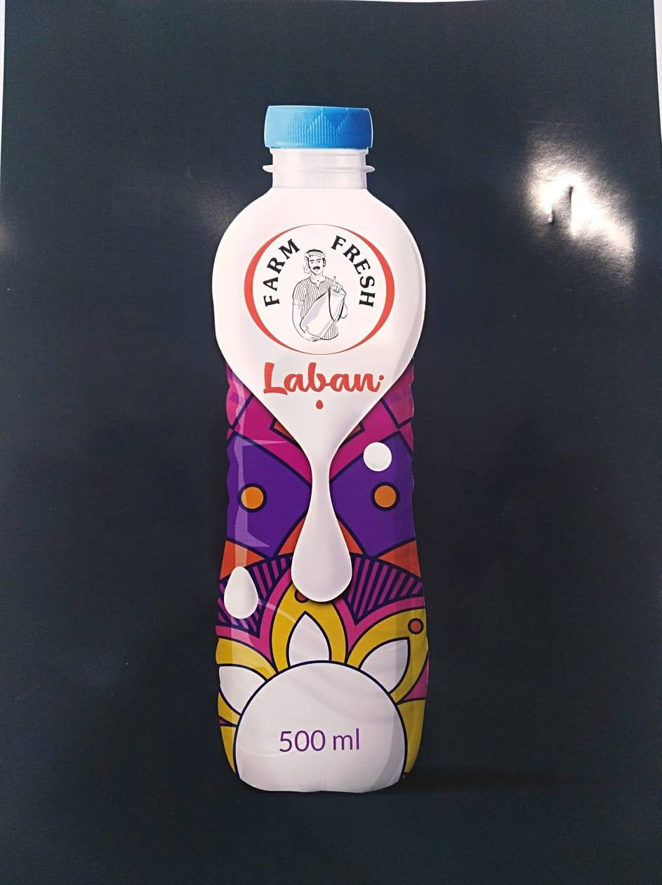
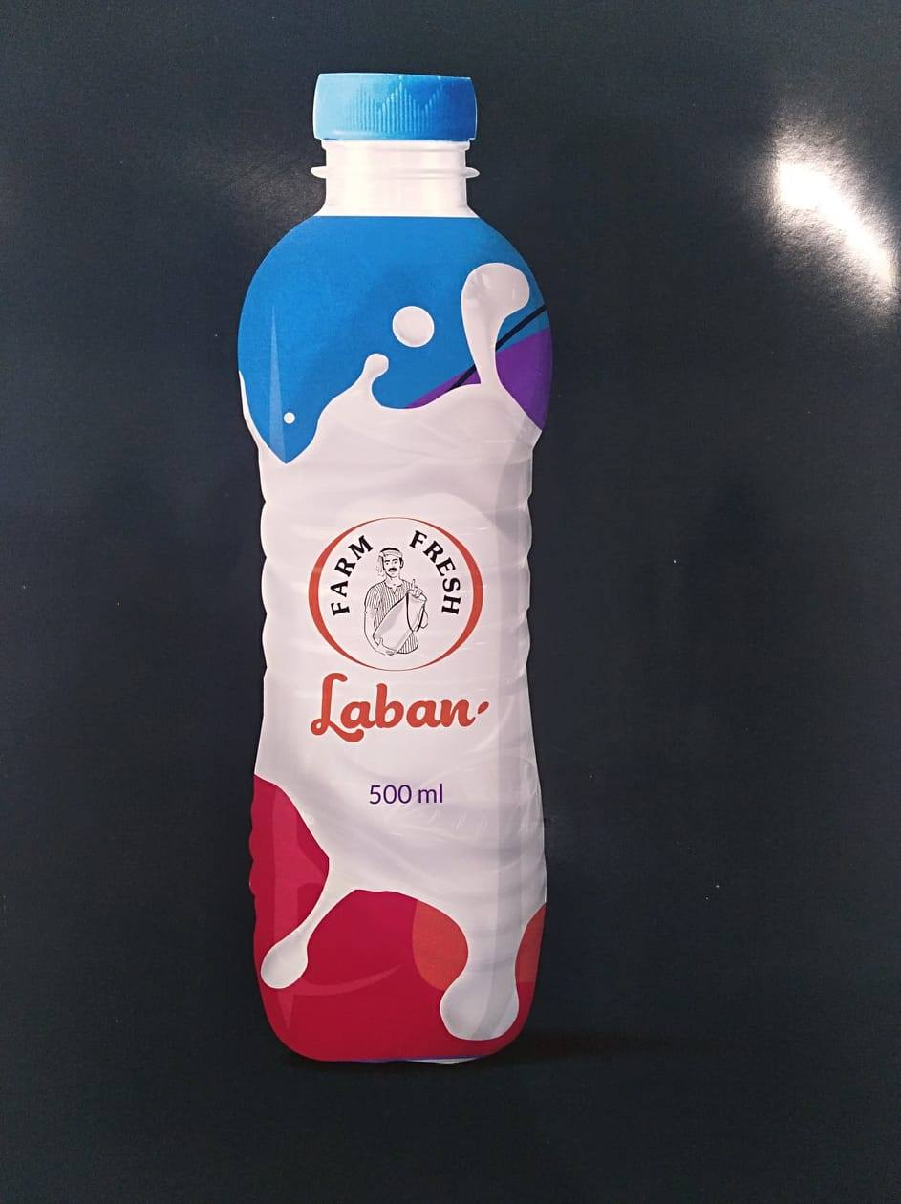

Red Blue Purple
Note: Among 3 design, respondents have chosen Red design, followed by Blue, Purple.

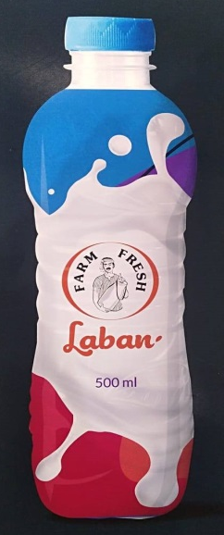
Rank-01(Red)
Average Score: 7.2
Likings:
- Eye catchy.
- Good color combination.
- Standard Design.
- Design concept is matched with dairy product.
- Milk Splash is unique.
Rank–02(Blue)
Average Score: 6.7
Likings:
- Eye catchy.
- Overall design is good.
- Customer can easily realize it’s a dairy product item.
- Blue color is matched with milk.
- Overall look is simple and good.

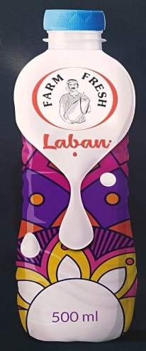
Rank–03(Purple)
Average Score: 5.9
Likings:
- Suitable for children.
- Overall design is good.
- Logo has been more focused and colorful design.

- Blind Test Survey
  - Blind test on Hot Tomato Sauce
This study objective is to assert the preference level of consumer perception about Tomato Sauce. This survey has been conducted to compare between Aafi Tomato Sauce and Pran Hot Tomato Sauce about smell/flavor, sour-sweetness combination, hotness, thickness level and overall taste parameters. This survey has been done over 18 respondents aged between 24 to 35 years old.
From this blind test study, respondents like Aafi Tomato Sauce of its thickness and overall taste parameter with compare to Pran Hot Tomato Sauce. In sour-sweetness and smell parameter, respondents like Pran most. In case of hotness parameter, both are holding same position.

Study Overview

- This survey conducts over AFBL personnel only.
- Age between 25 to 35 years.
- Total male 18 respondents are chosen for blind test survey:

Sample & Compare Category

SL No. | Particulars | Sample Code | Production Date | Batch No | Self-Life*
1 | Pran Hot Tomato Sauce | C | 07-03-2019 | 05/A R | 45
2 | Aafi Tomato Sauce  (ID: ATS-090419) | D | 08-04-2019 | --- | 13

*Blind Test Survey Date: April 21, 2019

Limitation

- Only AFBL personnel are chosen for sample respondent.
- Observation cannot ensure exact hypothesis.
Findings
Average Score (Phase -01)–
Survey Date: March 28, 2019

Brand | Smell/Flavor | Sour-Sweetness | Hotness | Thickness | Overall Taste
Pran | 6.5 | 6.4 | 6.4 | 7.0 | 7.0
Aafi | 5.9 | 6.2 | 6.2 | 5.9 | 5.8

Average Score (Phase -02)–
Survey Date: April 21, 2019

Brand | Smell/Flavor | Sour-Sweetness | Hotness | Thickness | Overall Taste
Pran | 5.9 | 6.0 | 5.3 | 5.1 | 6.3
Aafi | 4.8 | 5.5 | 5.3 | 7.1 | 6.4

Figure: Phrase-1

Figure: Phrase-2
Remarks:
- From the above blind test survey, in phase 01, Pran hot tomato sauce was holding a good position in almost all the parameters with compare to Aafi tomato sauce.
- On the basis of phase 01 result, after developing in phase 02, it’s clear that- Aafi tomato sauce holding a good position in thickness, and overall taste parameters with compare to Pran hot tomato sauce.
- In phase 02, Respondents like sour-sweetness parameter of Pran hot tomato sauce with compare to Aafi tomato sauce followed by Smell/flavor.
In case of hotness parameter, in phase 02 both are holding same position.

  - Blind test survey on Mustard Oil
This study objective is to assert the preference level of consumer perception about Mustard oil. This survey has been conducted to compare between factory provided Mustard oil and competitors brand – Radhuni about smell/flavor, oil fizz, and overall taste parameters. This survey has been done over 25 respondents aged between 25 to 35 years old.

From this blind test study, respondents like factory provided Mustard oil about its all parameters with compare to Radhuni.
Study Overview

- This survey conducts over AFBL personnel only.
- Age between 25 to 35 years.
- Total male 25 respondents are chosen for blind test survey:

SL No. | Particulars | Sample Code
1 | Factory provided Mustard Oil  (Trial) | J
2 | Radhuni | K
Sample & Compare Category
*Blind Test Survey Date: April 24, 2019
Limitation
- Only AFBL personnel are chosen for sample respondent.
- Observation cannot ensure exact hypothesis.
Analysis:
Average Score –

Particulars | Smell/Flavor | Oil Fizz | Overall Taste
Factory Provided Trial Sample | 7.3 | 7.2 | 7.4
Radhuni | 5.6 | 5.5 | 5.3

Remarks:
- From the above blind test survey, it’s clear that- factory provided trial sample holding a good position in almost all the parameters with compare to Radhuni.
- According to respondents, trial sample looks like natural mustard oil.

  - Market Visit Survey Report:
Region | Area | Territory | Point | Route
Dhaka North | Dhaka-2 | Moghbazar | Banasree | Mollabari
Findings
Need to develop:
- Need to add display program at retail shop for product presence.
- Retailers are not interested to order Farm-fresh UHT.
- As Frooto is one of the strongest competitors of Frutika, we need to balance our trade offer with Frooto.
- As we have no branded refrigerator, sometimes consumer does not get our CSD product in chill condition.
- It’s seems less interest on selling Cheese Puffs by the sales personnel but it has a huge demand.

- Firm Fresh Children Day program’s Survey
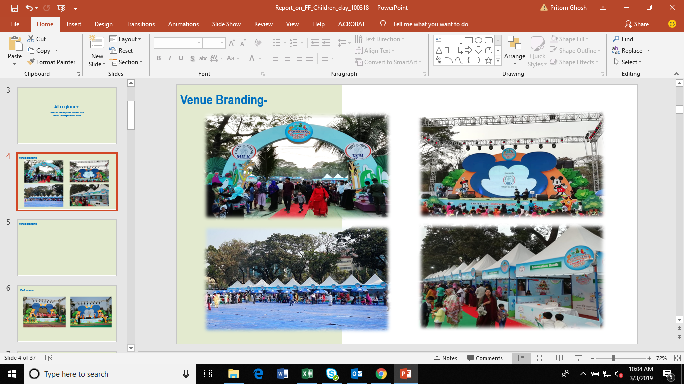
Note: Venue branding was good and field was also covered by carpet for smooth walking purpose.

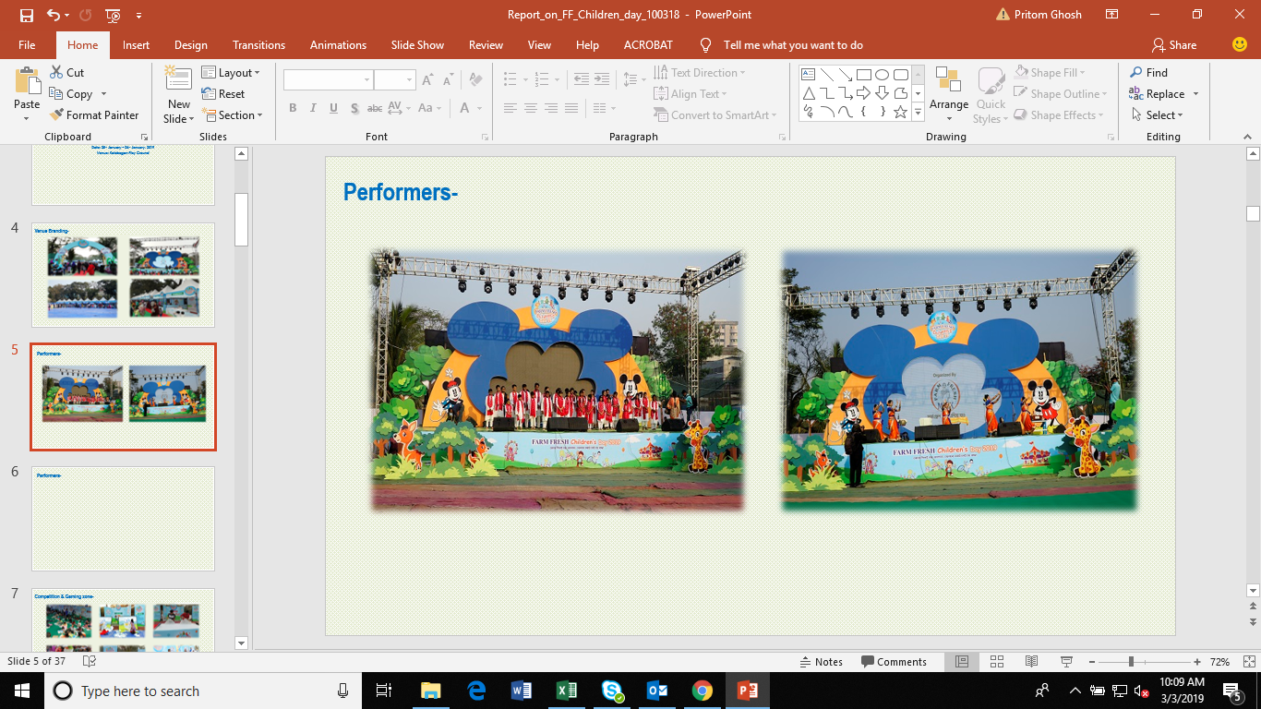
Note: Kids were very much attached with these rides.

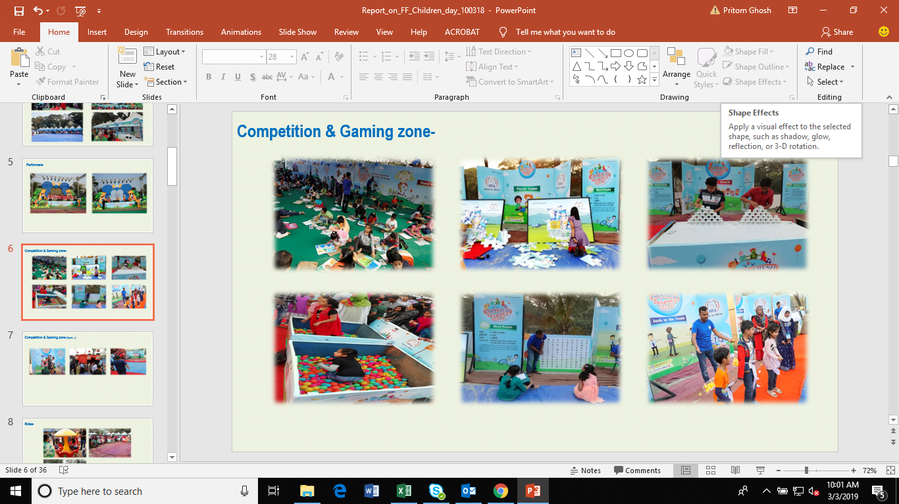
Note: All the competition and gaming zone were highly enjoyed by kids. They loved almost all gaming items.

Observation:
- Puzzle game spot was so dirty.
- Left side of the stage was not fully carpeted.
- This gaming zone was stopped due to technical issues on day 01, around 3.30 pm.
- Competitors product was found in few stalls.
- No bin was found at the right side of main stage.
Survey Analysis:
Area | Respondent Reached
Dhanmondi | 89
Mohammadpur | 47
Motijheel | 52
Mailbag | 21
Banani | 78
Mirpur | 65
Total | 352

Area | Respondent Reached | Know about Program
Area | Respondent Reached | Frequency | %
Dhanmondi | 89 | 35 | 39%
Mohammadpur | 47 | 14 | 30%
Motijheel | 52 | 4 | 8%
Mailbag | 21 | 0 | 0%
Banani | 78 | 7 | 9%
Mirpur | 65 | 9 | 14%
Total | 352 | 69 | 20%

Note: Among 352 respondents, 69 (20%) respondents know about program in Kolabagan Play Ground.

Dhanmondi & Mohammadpur:

Note: In 2016, we did survey based on Dhanmondi & Mohammadpur Area. From 2017, we try to cover several major areas in Dhaka city.

Activities | Frequency | %
Puppet Show | 12 | 17%
Cartoon | 8 | 12%
Sisimpur | 8 | 12%
Magic Show | 7 | 10%
Children Games | 6 | 9%
Varities Games | 5 | 7%
Children program | 4 | 6%
Food Stall | 3 | 4%
Sales Booth | 3 | 4%
9D Show | 3 | 4%
Poem | 2 | 3%
Circus | 1 | 1%
Art Competition | 1 | 1%
Discount on Juice's price | 1 | 1%
N/A | 5 | 7%
Total | 69

Note: Among 352 respondents, 69 respondents know about program and among 69 respondents, 64 told about program activities.
Remarks:
- To gain more awareness, on spot basis we can collect institute name and resident area from children’s who visit the program.
- Besides school, we can also provide leaf let in Art school before 7 to 10 days from the beginning of program.
- For promotional activities, we can use youtube non skippable ad.
- Pillow game competition between kids vs parents.
- Increase time duration of program.
- Increase number of kids game.
- Add additional funny games.
Chapter-5
Recommendations and Conclusion
- Recommendation:
As a part of AFBL business development and research department, I suggest that few survey matter must be developed. So, my opinion is in the below:
- Sometimes respondents are biased when they have provided the mark in house survey. So, every respondent must focus the survey based on the product comparison.
- In focused group discussion, respondents don’t share the real experience. They hide few essential information for the university and own reputation. So, I suggest that everybody should share the true information when they will participate the product labelling survey.
- In product labelling survey and sample product test survey, few respondents are biased by their friends when they provide the ranking and marking among the products. So, I think that everybody should free from biased when they will provide mark and rank among the products.
- The survey team members always must listen his participants’ discussion when they discuss about the survey topics.
- Duration of survey time must be increased.

- Conclusion
Akij Food and Beverage Ltd is the well-known name in our country. AFBL is trying to increase its business development and research its own brand for upgrading new product line. From this report we will able to know about the AFBL business research and development strategies as well as corporate & its factory task procedure to run a new product and business development of AFBL. We got the recognition from customers and respondents in a short time. We are getting careful day by day and planning for developing new product line. I wish AFBL will do better.

References:
- Marketing Management, Text Book, Philip Kotler & Pearson.
- Survey Report of Business Research and development, AFBL.
- https://www.wikipedia.org
- http://www.akijfood.com/
- http://www.akij.net/
- Personal Interviews with Employees:
1. M. Rezaul Hasan, Ex-Executive of R&D, AFBL.
2. Pritom Ghosh, Jr.Executive of R&D,AFBL.
3. A few Responsible Brand’s Assistant Managers.

