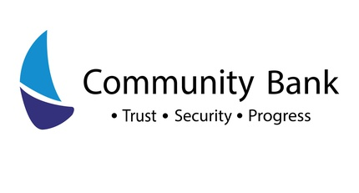


UNITED INTERNATIONAL UNIVERSITY

INTERNSHIP REPORT ON:
COMMUNITY BANK BANGLADESH LIMITED

SUBMITTED TO:
MOSABBIR UDDIN AHMAD
ASSISTANT PROFESSOR, SOBE

SUBMITTED BY:
Sadman Shabab Khan
STUDENT ID: 111 171 115
MAJOR: FINANCE

REPORT SUBMISSION DATE:
11/08/2022

Letter of Transmittal

Date: 11.08.2022
Mosabbir Ahmad
Professor
School of Business & Economics
United International University
Subject: Internship Report on Community Bank Bangladesh Limited.
Dear Sir,
I am delighted to present you with the internship report on "Community Bank Bangladesh Limited," in which I have discussed the background, working area, strategy, challenges that they face as a new entrant in the market, industry analysis, competition among rivals, and so on. I have done everything in my power to meet all of the requirements and instructions you have given me over the last three months.
I am thankful for the opportunity to create this report and learn how to understand it. I have done my best to prepare this paper to meet all of your requirements. This research has provided me with invaluable experience that will aid me in future endeavors, and I sincerely hope that your expectations are met.
I have worked hard to give this report a decent appearance and to make it as informative and trustworthy as feasible.

Sincerely yours
Sadman Sabab Khan
ID- 111 171 115

Acknowledgment
First and foremost, I am grateful to Allah for allowing me to complete the internship report on "Community Bank Bangladesh Limited" with various aspects and scenarios. My heartfelt gratitude goes to Mosabbir Ahmad, my supervisor at United International University, for his guidance and assistance in preparing and completing it.
I preferably thank my organizational supervisor, Mohammad Abdul Malek, Principal Officer (Credit analyst) Community Bank Ltd., for assisting and guiding me through the organizational procedure, as well as for providing the idea for the Comparison on Financial Analysis. I also would like to thank Mr Razee-Ul-Ameen, SAVP & Deputy Head (CRM) of Community Bank Ltd, for providing me with the relative documents and guidance to complete the report.
Thank you also to Md. Mainul huq, First Assistant Vice President, and Irin Akter keya, Senior Officer, as well as all other Community Bank Bangladesh Limited staff and workers.

Table of Content
Contents
Executive Summary 6
Introduction 7
Origin of the Report 8
Objectives 8
Broad Objective 8
Specific Objectives 8
Methodology 9
Limitations 9
Internship Roles and Responsibilities 10
Banking Industry in Bangladesh 11
Company profile 12
Management Structure 17
Strategy 17
Corporate Social Responsibility 18
Main Services of Community Bank Limited 19
General Banking Department 20
Credit Department 21
Foreign Exchange Market 23
Asset Liability Management 24
Risk Management Process 24
Ethics 26
Risk Analysis 26
Challenges Facing 27
SWOT ANALYSIS 27
Green Banking: 28
Comparison 28
Recommendation 29
Conclusion 29
References 31

Executive Summary
Community Bank Bangladesh Limited, a subsidiary of Bangladesh Police Kallyan Trust, was founded with the goal of providing communities with customized, secure solutions while upholding the highest corporate governance standards. Community Bank Bangladesh Limited was inaugurated by Bangladesh Prime Minister Sheikh Hasina on September 11, 2019. Their level of service has now surpassed that of all others. This bank is now offering all new banking services to its customers and clients, ensuring complete customer satisfaction. Despite this, they continue to improve their banking system and service quality.
In this report, I compared the performance of Community Bank Bangladesh Limited to that of three other private banks.: IFIC Bank Limited, AB Bank Ltd, and NCC Bank Ltd. I discussed the banks and my challenges, departmental work and activities, SWOT analysis, how far they've progressed in this industry, and work formation. I analyzed all of the data to better understand the concept of working progress and their methodical approach. I did some research to see if there were any similarities. I also discussed my overall findings from my internship experience.

Introduction
Banks play an important role in the financial operations of a company. The value of the bank may be viewed as the essence of the economy. Although the bank does not create money, it does facilitate the distribution and recycling of funds, as well as the transfer of wealth across national boundaries. In today's society, we cannot imagine a business transaction, a private transaction, or currency trading without the presence of a bank." According to Cairrncross, the major broker, a loan and debt broker, is a bank. A bank, as we all know, is the lifeblood of all industrial and commercial operations that help a country's economy thrive by facilitating the movement of funds and securing financial capital.
The bank, on the other hand, offers a variety of services to help its business run smoothly. Clients and customers can take advantage of the bank's various services, which include lockers, withdrawal services, credit letters, online payment systems, and performance guarantees, among others. Banks frequently warn customers about the risk. Every day, modern online banking raises our standard of living. Banks make it much easier to obtain home loans, auto loans, agricultural loans, personal loans, and other types of loans. This is how the bank enables us to improve our living conditions. There are currently 63 scheduled financial institutions throughout the country.
Nine state-owned banks (five of which are specialist banks), 38 private banks, and nine private banks exist. The remaining nine are foreign commercial banks. Despite the fact that the banking industry in Bangladesh is undergoing major changes, it remains inefficient as a result of these changes. Bank lending is the most pressing issue in Bangladesh's financial sector. This is a common issue. A number of actions have been taken to resolve the loan default.

Origin of the Report

An internship experience is required to complete the entire BBA program. After completing all academic programs, a student must be accepted into an internship training program. Each graduate is required to write a report on what they learned during their internship training and practical experience. As a result, I was grateful for the chance to take part in Community Bank's small internship program. My paper is titled "Internship Program on Community Bank," and I wrote it under the supervision of Mosabbir Ahmad of United International University.

Objectives

The primary goal of this Report is to apply the theoretical principles of Realistic Orientation in banking activities to a real-life examination, which is part of the BBA program. This report's goal, on the other hand, is much broader. I divided the objectives into two categories: broad objectives and specific objectives. The following are the broad objectives of this article:

Broad Objective

Being aware of Community Bank's progress.

The performance of Community Bank LTD in comparison to other banks of the same generation.

Pay attention to the loan sections, such as retail loan and corporate loan.

Observe Community Bank's general banking and advance operations, as well as their services.
- The manner in which bank conducts its operations across multiple fields as a unified entity.
- Growth of Bangladesh economy

- Developing a realistic understanding of banking as a financial institution.

Specific Objectives
To learn more about the banking system and its services.
• To forecast Community Banks' future position in comparison to other banks of the same generation.
• Determine the cause of progress in loan and other fields.
• Delivering an introduction to the organization.
• To gain a general understanding of Community Bank LTD's credit and general banking services.
•To identify the major areas of inefficiency.

Methodology

The report is prepared on the basis of secondary sources of information. supplementary source: These are their names:

• The annual report of the Community Banks of the Same Generation, namely IFIC Bank, AB Bank, South East Bank, Janata Bank Limited, and Eastern Bank Limited.

• Save the balance sheet and other records.

• Various textbooks and materials

• Bank websites that were used

• Reports from multiple student internships in the banking sector.

Limitations
The goal of this report's approval was to make it meaningful and widely accepted. Performed. Several issues, however, arose during the analysis's organization. All of the images and information provided are incomplete. Any and all data is kept private and confidential. It is required and only a few people are made aware of it. I discovered some flaws while studying at the bank. Now I'll go over all of the constraints I faced during my internship program—
• I was given a set amount of time to complete the report.
• In addition to that Covid-19 had a significant impact on all of the students.
• Due to privacy concerns, I have a very little knowledge about the software they used for their primary operations.
• Employees were kept busy all day because they had to perform multiple operations at the same time.
• We are not permitted to use our personal laptops or pads for any bank-related activities.
Apart from all other limitations, it was an amazing journey to gain some corporate experiences, which has given me confidence to pursue this knowledge in the future.

Internship Roles and Responsibilities
I am doing internship program in Community bank under the department of Credit Risk Management. In this division there are two allied departments which are Corporate CRM division and Retail CRM division. In my entire 2.5 months it was long commute to have a wonderful journey in this bank. Here I have learnt more or less different sorts of things which added a genuine value in my career. I want to share the things that I learnt here after taking this internship program. My learning was typically a gradual learning. First of all it was come up with filing. Filing means sorted down the legal documents in one particular section or binding up the papers serially. I have learnt how to scan and proper formal mailing. Mailing is really an important factor for the any types of corporation. Then Billing is another thing which was included in my chart of learning. Billing refers to the accumulation of the cost which is written in documented version. I am prepared a lot of bill which is conveyed the list of food related cost. I also did some requisition related work in corporate department as I am a part of it. Apart from all this learning I have learnt a how to sanction loan with different requirements for different clients. In retail section I have come up with the idea of how to service holder are taking or granted for loans. The very basic concept is their salary, life of service, how many years are left for retirement and the purpose of taking loan. Furthermore I also learnt about car loan which was like around 50% from the bank side. Apart from all these works I have also learnt another interesting relevant thing which is LDBP. It is known as Local Documentary Bill Purchase. Basically it refers to the payment documents of selling the goods of local oriented export industries. This is falls under the consideration of local currency exchange department. It is the export fund that is required by the local businessman to conduct their export import business. This was kind of an informative thing that I learnt in my internship program.

Banking Industry in Bangladesh
Bangladesh is a struggling developing country with poor banking conditions, particularly in terms of customer service at government banks. The nation's political crises are one of the most important explanations for this element. Private banks, on the other hand, came to Bangladesh and worked tirelessly to improve the financial system, but we were let down by government constraints, bureaucracy, unskilled personnel, a scarcity of technology, and so forth. Guardians Bank, on the other hand, is attempting to deal with Bangladesh Bank while also monitoring the overall banking situation.
In a nutshell, this is the history of banking. The Bank of Hindustan was Bengal's first modern bank, established in Calcutta in 1770.
Furthermore, the Bank of Calcutta was established in 1806, is the world's oldest bank. Dacca Bank, The Eastern Mercantile Bank Limited was founded in 1959.
Following the country's independence, the People's Republic of Bangladesh government nationalized the country's twelve banking institutions including Sonali Bank, Rupali Bank, Agrani Bank, Janata Bank, Uttora Bank, and Pubali Bank. The Bangladesh Bank focused on bank privatization in the late 1970s and early 1980s, and we now have private bank facilities.
In a country where a large proportion of the population lives in poverty. Five-year plans continue to govern economic policy. Nonetheless, some progress has been made over time, such as self-sufficiency in food grains, lower population growth rates, poverty alleviation, and increased export income.
Bangladesh's economic growth prospects in the near future will be determined by the speed with which economic reforms are implemented and the quality of macroeconomic management. Higher levels of investment will be required to accelerate the rate of economic growth. The vast majority of this will be accounted for by private foreign direct investment. This can be accomplished by overhauling the financial system and hastening the financial deepening process. However, because the government is frequently the bank's owner, regulator, supervisor, and client, there has been plenty of room for mismanagement over the years. The banking system is plagued by a lack of credit discipline, out-of-date loan recovery law, corruption, inefficiency, overstaffing, and other issues.
The financial industry has implemented a number of reforms to improve the situation. The previous relative stability achieved with the assistance of the central bank and the government has restored public trust in Bangladesh's banking sector. Furthermore, NCBs and old-generation Private Commercial Banks (PCBs) would be required to reduce the proportion of nonperforming assets in their portfolios (NPAs). If this is not done, the NCBs will be re-capitalized. As a result, the government's limited resources in Bangladesh may be depleted even further. This re-capitalization is not currently or in the near future feasible. With these conditions in place, the World Bank predicts that the growing burden of non-performing loans and rising debt servicing rates will strain the economy and, in the long run, lead to a recession.
Specialized banks are those that focus on specific sectors or industries of the economy. Bangladesh Kristi Bank (BKB), for example, only works in the agricultural sector; Bangladesh Shilpa Bank (BSB), in the industrial sector; and so on. Commercial banks are Scheduled Banks that operate in the country in accordance with the Central Bank's rules and regulations. Commercial banks are classified into three types: nationalized commercial banks (NCBs), foreign commercial banks (FCBs), and private commercial banks (PCBs).

Company profile
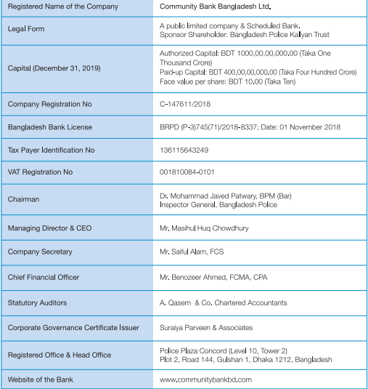
Community Bank Bangladesh Limited began operations on September 11, 2019, and was inaugurated by Bangladesh Prime Minister Sheikh Hasina. Community Bank Bangladesh Limited, a subsidiary of Bangladesh Police Kallyan Trust, was founded with the goal of providing communities with customized, secure solutions while adhering to the best standards of corporate governance. Its goal is to contribute to the country's economic progress by offering financial products and services to communities around the country. A state-of-the-art Core Banking System enables optimal centralization of operations. The three essential building blocks of Community Bank are Trust, Security, and Progress. Community Bank Bangladesh Limited. Legal Form a public limited company & Scheduled Bank. Sponsor
Shareholder: Bangladesh Police Kallyan Trust
Capital (December 31, 2020)
Authorized Capital: BDT 1000, 00, 00, 000.00 (Taka one thousand
Crore)
Paid-up Capital: BDT 4,610,000,000.00 (Taka four
Hundred and sixty one crore)
Face value per share: BDT 10.00.
Community Bank Bangladesh Limited's Treasury Division consists of a variety of activities with a growing and diverse asset base from both Police Force and General Customers. With the Bank's rapid expansion, the Treasury Division is playing an increasingly important role in its operations, taking into account both internal and external factors in a competitive market. The Treasury Division's Investment & Government Securities Desk, Money Market Operation Desk, Foreign Exchange Operation Desk, and ALM Desk are all up and running. As a result, the bank's growing portfolio includes a diverse range of products and services of varying character. This is rising and one of the most promising bank in our country. This will become one of the top most bank in our country by its determination and smooth client services. It is situated to 144, Police Plaza Concord (Level 10, Tower, 2), Plot 02, Dhaka, 1212.

Mission
- Deliver seamless services to the clients.
- Emphasize development of human capital.
- Adopt state-of-the-art technology to ensure transparency and accountability.
- Abide by the rules and regulations to establish the highest level of corporate governance.
- Offer services to the unbanked members of different communities to include them in the banking system gradually.
- We are dedicated to the welfare and economic prosperity of the people.
Vision
- Reach out to members of various communities by providing unique financial services.

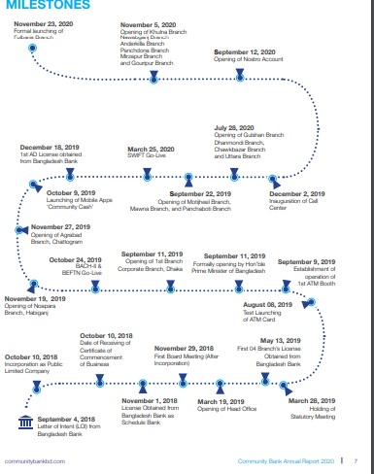

Management Structure
- The Audit and Risk Management Committee of the board supervises the activities of the board's eight members in charge of strategic planning and strategy.
- Deputy Directors is responsible for meeting the CEO's and managers' objectives.
- The management committee sees serious problems.
- There is also a Committee on Responsibility.
The Board of Directors, which consists of thirteen members, is in charge of strategic planning and overall policy direction. In addition, the Board of Directors will establish an Executive Committee.
- Deal with urgent business ideas; additionally the Board has an Oversight Committee that monitors the compliance with major regulatory regulations.
- Difficulties with operations and The Chief Executive Officer, Managing Director, and Deputy Directors are all members of the Board of Directors.
- The Managing Director and Head of Divisions are in charge of achieving company objectives and managing day-to-day operations.
- The CEO and Managing Director support a senior management department comprised of a senior management team.
- Deputy Managing Director and Department Heads in charge of specific activities Divisions coordinate branch operations and centrally coordinate divisional operations.

Major issues are handled by a Management Committee led by the CEO and Managing Director. More director, more director, more director. It encourages quick decisions.

There is an Asset Responsibility Committee, which is chaired and composed of senior executives. (2020 CBBL annual report)

Strategy
We pledge to remain flexible in order to respond to changes in the macroeconomic environment. It presents both obstacles and opportunities. The bank's three pillars are Trust, Security, and Progress. Everything we do is based on these values. Beyond the economic implications, our plan focuses on financial inclusion for the country's different communities. We have consciously invested in system, people, process, technology, and distribution to enhance our capabilities to assure the company's long-term success, in line with our strategic aim. Community Bank Investment Limited, the Bank's wholly owned subsidiary, will commence its merchant banking operation in 2021 (subject to regulatory permission). From a business standpoint, the bank plans to launch its credit card operation, expand trade and remittance-based services, and promote financial inclusion. Services for collecting utility bills by linking up with the right people authorities; and promote supply chain finance focusing on significant and well-known corporations other. The Bank will extend its distribution network. Its outreach is divided into phases in order to strike a balance between the two. Return on investment In this regard, the year was the Bank intends to build a few more branches in 2021. ATMs, service desks, and school banking are all examples of sub-branches. Booths located across the country from the standpoint of the brand and from a communication standpoint, we want to become closer to the people. Communities through various forms of marketing, communication and collaboration sponsorship and participation activities.

Corporate Social Responsibility
Community Bank Bangladesh Limited works hard to ensure the success of our customers and communities. We benefit when they do well. As per Bangladesh Bank guidelines, the bank initiated a few Corporate Social Responsibility (CSR) activities from time to time. SAJIDA HOSPITAL is located at COVID-19 patients have been able to receive services at no cost since March 2020. The SAJIDA Foundation's own funds, corporate support, and individual contributions totaled BDT 15.54 crore/BDT 155.4 million, which was used to cover treatment costs for COVID-19 patients as well as hospital operating costs. It should be noted that SAJIDA did not accept any funds from the Bangladeshi government to cover operating and patient treatment costs. Medication, oxygen, diagnostic tests, bed/cabin rental, ICU, dialysis, ambulance, food, and other expenses are all included in the treatment package. Hospital administration hired nutritionists to ensure that the diet is tailored to the patient's specific needs in order to improve a patient's overall well-being. Community Bank Bangladesh Limited, in collaboration with the SAJIDA Foundation, provided assistance to Covid-19 patients by establishing the "Community Bank Semi Critical Unit" at SAJIDA's Narayanganj Hospital. Community Bank has donated beds, oxygen concentrators, portable pulse oximeters, high flow rebreathing masks, and cardiac monitors to Covid-19 patients in semi-critical care units. The bank made a contribution of Taka 22, 98,592 to the establishment of this unit. Community Bank Bangladesh Limited paid Taka 50,000 to place an advertisement in the monthly braille newspaper "Dristy Bijoyee" in favor of Bangladesh Disable Development Trust (BDT) for the month of August 2020. (CBBL annual report 2020).

Main Services of Community Bank Limited
- Corporate Banking:
❖ Working Capital Finance.
❖ Industrial and Project Finance.
❖ Trade Finance.
❖ Lease Finance.
❖ Letter of credit and Bank Guarantee services.
- Retail Banking:
❖ Consumer Finance.
❖ Deposit Products.
❖ Credit Card.
❖ Debit Cards.
❖ Pre-paid Cards.
- SME Banking:
❖ KRISHI SILPO.
❖ Defense loan Specially Police Department Loan.
❖ Transport Loan.
❖ Commercial House Building Loan.
❖ Contractor's Loan.
- Treasury:
❖ Asset Liability Management.
❖ Capital Market / Investment Desk.
❖ Money Market.
❖ Forex Market.
- Loan:
- Retail loan
- Corporate loan
- Debit card:
Domestic debit card: The CBBL domestic debit card is issued in conjunction with a personal savings or current account. It helps to transact the amount in any place within the country.
Credit card: It provides you with a hassle-free credit facility. It charges the absolute bare minimum in interest. It includes a reasonable credit limit to assist us in meeting our regular financial obligations. It has a sufficient credit limit to meet our regular financial needs with low interest rates.
General Banking Department
This department is known as the "hub" of all banking divisions. This department handles account opening, cheque clearing, cash clearance, remittance services, bill and clearing section, account section, cheque book issues, account transfer, account closing, dispatch section, and so on. These services are provided to customers by front desk officers, clearing officers, and accounting officers. Putting Down a Deposit: You must present by yourself to the responsible official and fill out an account opening form with the following information to open an account with CBBL Bank Limited.
I. Complete the specific type of form.
II. The form should be filled out entirely by the applicant.
III. Two passport-size pictures must be added by the bank.
IV. Applicants must sign a sample signing form provided by the bank.
V. A mediator is required to open any account.
VI. An authorized officer will verify the introducer's signature and account number.
VII. An appointed official will approve the application.
IX. The authorized officer will open the account and give the registry entry.
X. The official will then hand over a cheque book to the account holder.
XI. Maintaining KYC (Knowledge of Your Client) is essential. VIII. The applicant must pay the bank the minimum balance (only cash is accepted).
Any of the following should properly introduce the account:
I. The current account holder with the bank.
II. Bank officials with a rank higher than that of assistant officer.
Documents Required for Partnership Account
• Two passport-size photos of each partner • A business license for the collaboration
• A copy of a valid passport or NID card.
• A duplicate of the alliance company's energy bill.

Credit Department
The loan department at CBBL Bank provides a variety of loan options. Loans of any length are eligible, including:
• Short Term Loan: This is the special type of loan is available from creditors for as little as a year. This loan can be used to fund tenants' working capital and production needs.
• Loans for the medium and long term: These loans can be used for a variety of purposes. Retailers, the bank provides both salary loans and home construction financing. The terms of the loan vary depending on whether it is only for corporate houses or factory.
There are two types of loans: retail loans and corporate loans. These loans are used by individuals, businesses, and corporations for their own purposes.

loan for factory construction, equipment procurement, employee wages, and so on.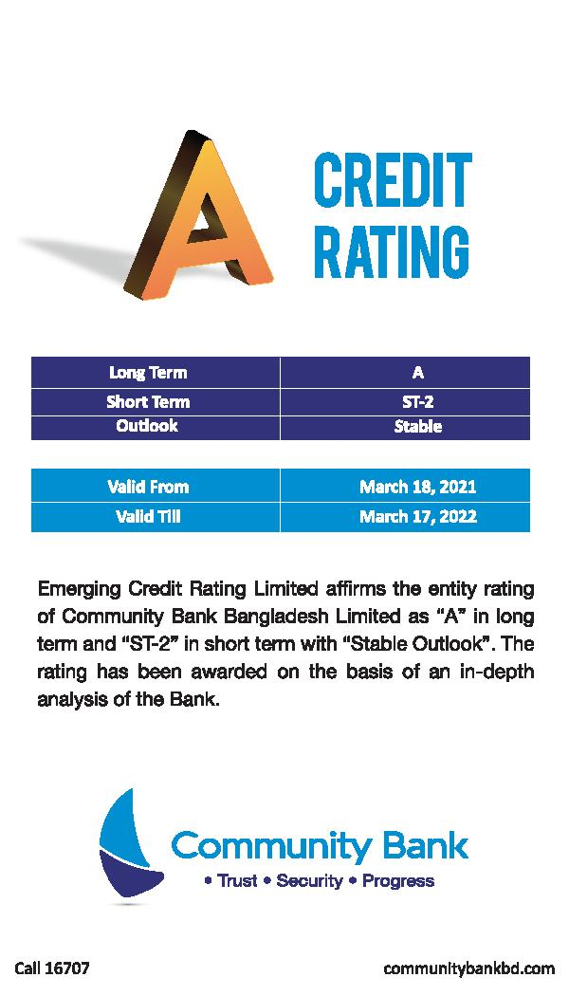

Credit Rating is very important any banks or financial institution. As this bank is new in the industry it comes up with a good ratings about credit department. It is Stable in Outlook which is very good indication of progress for any financial institution specially banks. This is after the very depth analysis of its credit policy and service rendering.

Foreign Exchange Market
The Foreign Exchange Market is the currency exchange market. The Forex Market is spreading across the country as a result of increased activity both at home and abroad. Trading takes place over the counter (OTC) (OTC). The international forex market operates 24 hours a day, five days a week, and currencies are traded between London, New York, Tokyo, Zurich, Frankfurt, Hong Kong, Singapore, Paris, and Sydney. Community Bank has entered this market and expects to expand with a diverse client base.
The following items are frequently available at this market:

Spot Transactions
Spot transitions are of
Forex, settled after two
days

Forward Transactions
Transactions beyond spot
settled after a specific
period

SWAP
Two parties transect certain
sum at a spread and
commit to reverse the
transaction at different
legs.
Industrial funding and enterprise financing: CBBL Bank offers funds in the form of a term loan for private construction, machinery and vehicle procurement, and LC for machinery imports for a variety of industrial ventures.

Asset Liability Management
One of the most important functions of Community Bank Treasury is Asset Liability Management. The ALM Desk, which is a separate section under the Treasury Department, at Community Bank is extremely efficient.
The ALM function includes liquidity management, asset and liability maturity profiles, interest rate concerns, and FX risk. ALM desk officials prepare an ALCO paper that includes a local and international economic update, market liquidity forecasts, interest rate projections, a balance sheet analysis, and recommendations for how to optimize the balance sheet, such as lowering or raising deposit and lending rates.
The ALM desk assists ALCO in adjusting lending and deposit rates by providing accurate data and superior forecasts. Based on BASEL III liquidity ratios (LCR & NSFR) and central bank policy, the ALM desk created a new ALM policy.
Taking the ALM guidelines into consideration. By changing its deposit mix and reducing its reliance on term deposits, the bank saved a significant amount of money.

Risk Management Process
Risk management is a technique that enables an organization's management to meet profit targets while avoiding the use of irrational resources. IFIC Bank's risk management strategy emphasizes a consistent approach to a wide range of risks, as well as ongoing rigorous risk monitoring, measurement, and tracking. The board of directors' approval is in jeopardy. Management policies and procedures.

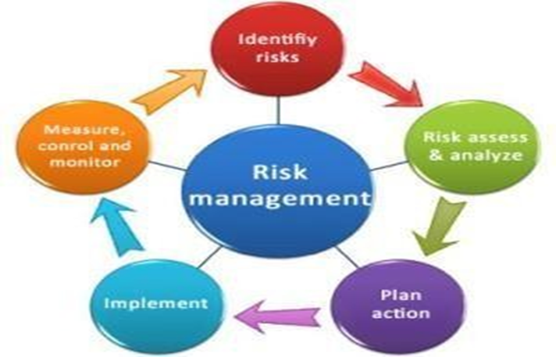
Under the Risk Management Process, there are five steps which are followed by IFIC Bank. These steps are given bellow-
•Risk Identification:
Firstly risk management is risk detection. Credit risk, international risk, anti-money laundering risk, internal control and enforcement risk etcetera.
•Risk Measurement:
Once the risk has been identified the next step is risk measurement which is the ultimate result of profit.
•Risk Aggregation:
Correlation effects should also be considered for the account.
•Planning: This is the important phase.

•Controlling and Monitoring:

Risks are properly managed in accordance with their controlling and monitoring policies in order to ensure their capabilities and capacities.

Ethics
- The Bank's reputation must be preserved.
- Concern for the interests of stakeholders.
- Standards, code, and conduct.
- Management control that is effective and efficient.

Risk Analysis
When evaluating a bank's performance, two important dimensions to consider profitability and risk.
If stock prices do not rise in line with stockholder expectations, current investors will try to sell their shares, making it difficult for the bank to raise new capital to support future growth.
Banks frequently face a variety of risks in the course of their operations, and those that can deal with these risks perform better.
•Credit Risk: The possibility where some of the bank's assets will be lost their value and become worthless.
•Liquidity Risk: The financial institution the likelihood that banks will lack sufficient cash and borrowing capacity to meet deposit withdrawals and other cash requirements.
•Market Risk: The Bank's investment portfolio's market value probability Interest rates are rising, causing the value of the currency to fall.
•Efficiency Risk: The likelihood that a bank will lose its ability to generate income from its assets.
•Earnings Risk: The Bank's Net Income After All Expenses – This is the risk to the bank's bottom line.
•Solvency Risk: Possibility that a bank's assets will be worth less than its total liabilities.
CBBL is doing well comparatively to the other new coming bank in the industry. Their ratios are promising and up to mark with other banks situated in our country. As a new ban there are lots of ways to make improve. Eventually it is currently working for that.

Challenges Facing
As an employee of a new bank, the challenges they, the new employees, are going through are:
1. They've to fuel extra energy and extra working hours to make this bank developed and grow in this banking sector.
2. There is a lack of manpower in both the divisions of head offices and in branches. So, the existing employees in branches are going through a hard time providing proper financial services to the clients. This makes the clients complaining in this market about this bank. And, this lack of manpower in branches are not letting them to provide enough information about the business clients and/or general clients that are used by employees in head office to analyze information about them. This gives them a hard time processing files and they have to squeeze officials of branches to get information.
3. Even though employees are working hard and working late hours, there is no reward as any financial incentives like increments in salary or promotions etc. This is the main reason of recent surge of resignations of many frustrated employees.

SWOT ANALYSIS
Strength:
- Transactions are completed more quickly and at a lower cost.
- Client convenience.
- Competitive advantage among the other banks
- Greater Efficiency in working
- Qualified Employees.
Weakness:
- Lack of modern internet Banking
- Target only on target customers or clients
Opportunities:
- Raising awareness of doing banking digitally and globally.
- Forex market and Asset management liability are rising.
- Better development areas in Credit management
Threats:
- Global Unstable economy.
- As it rises just before the COVID it hampered somehow and which led to rise their growth.
- Tough Competition.

Green Banking
This is the initiatives which can make them different form the competitors in the banking industry. Climate Change is deemed to be one of the major threats in today’s world. Due to unusual weather pattern and rising pollution, society demands that business also take responsibility in safeguarding the environment. Green banking, often known as socially responsible banking or sustainable banking, is a branch of the banking industry.
Green banking can be defined as financial services that are environmentally friendly to encourage activities that aren't dangerous to the community and to the environment. The Bangladesh Bank has already sent out circulars to its customers. Banks must develop their own green banking policies. Environmental and social risk management, as well as CSR policy. Policy on environmental, social, and economic risk management (ESRM) and other pertinent policies. in agreement with Community Bank provides long-term green finance solutions that are also in line Our green banking initiatives includes online and paperless banking, contributing to reduction in greenhouse gas emission, efficient energy use, environment friendly projects, tree plantation and so on with long-term societal sustainability and the country's economic development.

Comparison
As this is a new bank enlisted in our country and it had established in 2019. There annual report has analyzed and published only for that years. This bank is doing comparatively other banking in this current tenure. Their ratios and other measurement are quite good as they have started their journey newly. Their current ratios, asset turnover ratio, loan to deposit ratio, debt to equity is ration is quite well among other competitors in this industry. In 2019, the Cash Ratio of IFIC Bank was 0.219567, that of AB Bank was 0.338758, and that of CBBL was 0.1579. In 2019, IFIC Bank had a current ratio of 1.521633, AB Bank had a ratio of 1.55936, and CBBL had a ratio of 1.2357. In 2019,

Recommendation
Community Bank Limited should prioritize their interior decorations because the interior decorations in the Gulshan Branch are quite primitive and this style of décor does not fit in such a prominent location. As it the head office it can be more enlightened with the lights and other staffs. They should also update their computers which are pretty outdated. Employees suffer greatly as a result of this, and they should be provided with adequate kitchen facilities. They should also provide technical facilities to interns, because during the three months I worked there, the CBBL officials provided me with a personal computer or a desk, which greatly aided my learning of new things. The people were too friendly to teach the task as I was completely new with the environment. I had experienced a huge amount of positive learning from there as it was my first corporate professional place.

Conclusion
As a new bank in the banking industry it is becoming the most promising and well known bank in our country. From the top level to bottom level of management they are trying their level best to make this financial institution as a greater place for the transaction and other services. One of Bangladesh's new bank is CBBL Bank. This bank is consistently profitable. It is not very nice because it was established in Bangladesh through banking sector. I was also ecstatic to be given the opportunity to work for a company. The three months I worked at CBBL were extremely memorable for me and the employees were extremely friendly and helpful.
Furthermore, this report has greatly aided me in understanding the core of the banking industry, and I have done my best to demonstrate CBBL comparative performance with that of similar generation private banks. This report was written by me which is also very special. I have come up with lots of new things and ideas form making this report over this bank.
In addition, I have made some recommendations that CBBL can use to improve its performance. Mosabbir Ahmad (Professor of United International University) has been extremely helpful in completing this Internship Report despite the COVID-19 situation; without his assistance, I would not have been able to complete this report. I have a great deal of admiration and gratitude for him.

References
- Al Karim, R., & Alam, T. (2013). An evaluation of financial performance of private commercial banks in Bangladesh: Ratio analysis. Journal of Business Studies Quarterly, 5(2), 65.
- Powering Progress (2019). Annual Report. Community Bank limited. Retrieved from- https://communitybankbd.com/file/CBBL_Annual%20Report%202019.pdf
- EMBRACING AN EDGE OF DIGITALIZATION IN A TRANSFORMING WORLD (2020). Annual Report. Community Bank limited. Retrieved from- https://communitybankbd.com/file/CBBL_Annual%20Report_2020%20(3).pdf
- Community Bank. A bank with new opportunities. Retrieved from-
https://www.communitybankbd.com/
- Rafi, M. A., Ahmed, E., Natasha, M. T., Mahruf, R., & Ahmed, F. (2020). Financial Performance Analysis of Some Selected Investment Banks of Bangladesh. Journal of Internet Banking and Commerce, 25(3), 1-13.

