Marketing Strategies of Summit Communication Limited (SComm)

Afzal Ahmed

This internship report is submitted to the School of Business and Economics, United International University as a partial requirement for the degree fulfillment of Bachelor of Business Administration.

Marketing Strategies of Summit Communication Limited (SComm)

Submitted By
Afzal Ahmed
ID: 111153195
BBA, Major in Marketing
School of Business and Economics
United International University

Supervised by
Kawsar Ahmmed, PhD
Professor
School of Business and Economics
United International University

Date of Submission
March 07, 2022

Letter of Transmittal
March 07, 2022
Kawsar Ahmmed, PhD
Professor,
School of Business and Economics
United International University
Subject: Submission of Internship Report.
Dear Sir,
I am submitting my internship report, which is titled "Marketing Strategies of Summit Communication Limited," for your consideration which is a prerequisite for the Bachelor of Business Administration degree, and it contributes toward the degree completion requirement.
In this study, I attempted to assess the sales and marketing strategies of Summit Communication Limited, which I have designated on their STP process and following marketing mix strategies for their ICT business in Bangladesh."
I hope this report will meet your expectations. I would be grateful if you would accept my internship report with the utmost appreciation.

Afzal Ahmed
ID – 111 153 195
BBA Program, Major in Marketing
School of Business and Economics
United International University

Declaration of the Student
I do hereby declare that the internship report on "Marketing Strategies of Summit Communication Limited" have been prepared by my original works and efforts.
Without following any unethical ways, I have not prepared the report and this report is prepared for only academic purpose and under the supervision of Kawsar Ahmmed, PhD, Professor, Business and Economics, United International University.
Afzal Ahmed
ID – 111 153 195
BBA Program, Major in Marketing
School of Business and Economics
United International University

Acknowledgement
My sincere thanks to Allah for providing me with the strength and ability to complete my internship report and submit the report on time.
I would also like to express my gratitude to Kawsar Ahmmed, PhD, Professor, Business and Economics, United International University for all of her helpful guidance and support over my academic journey so far. Without his invaluable guidance, assistance, and participation throughout the process, I would not have been successful in completing the report on time and with accuracy. In addition, I am happy about having the opportunity to complete my report under his supervision.
Finally, I would like to thank to all employees of Summit Communication Limited for their time and effort on participating in the interview sessions

Executive Summary
Marketing strategy refers to a business's overall game plan for approaching prospective consumers and turning them into customers of their marketing offering. It contains the marketer’s value proposition, key brand messaging, data on target customer demographics, and other high-level elements. Marketing strategy allows the marketer to concentrate its limited resources on the greatest opportunities to boost-up sales and attain a sustainable competitive advantage. The main purpose of the report is to study the marketing strategies of Summit Communication Limited which is based on the STP process (segmentation, target market, and positioning strategy) as well as the application of 4Ps of marketing mix strategy on their business.

Summit Communications Limited, the largest IIG in the country, supplies 35% of the total 1,900 Gbps Internet bandwidth demand. As ITC, Summit Communications is providing 450 GBPS service out of a total of 650 GBPS in the country which is 60 percent of the total demand of the country. Besides, they are providing services across the country as an inter-connection exchange. Through public-private level internet connection services, their organization is reducing the suffering of the people by implementing the 'Info-Sarkar' project and contributing to the digital program of the government. With the policy support of the government, they have so far built more than 48,000 kilometers of optical fiber network infrastructure at the marginal level of the country.

The first chapter has an introductory section that provides information on the report's background, origin, objectives, methodology, and limitations to complete the report. Corporate Profile, vision, mission, core values, products, and services, as well as its management system and marketing department of Summit Communication Limited, are discussed in Chapter two. The literature review is included in the third chapter. This chapter's intention is to provide data that has been acquired from appropriate academic sources in relation to the study's topic. In the fourth chapter, I discussed how Summit Communication Limited utilizes the STP Process (Segmentation, Targeting, and Positioning) and the Marketing Mix approach in their International Terrestrial Cable (ITC) business. Some marketing-related obstacles are identified as a result of the study. Finally, some of the recommendations and conclusion parts are included in chapter five.

Keywords: Marketing strategy, value proposition, ITC, Scomm Limited, Bangladesh
Table of Content

Executive Summary iv
CHAPTER 01 1
Introduction 1
1.1 Background of the Report 2
1.2 Origin of the Report 2
1.3 Objectives of the Report 3
1.3.1 Primary Objective 3
1.3.2 Specific Objectives 3
1.4 Methodology of the Report 3
1.4.1 Primary Sources 3
1.4.2 Secondary Sources 3
1.5 Limitation of the Report 4
CHAPTER 02 5
Company Overview 5
2.1 Take a look at Summit Communications Limited (SComm) 6
2.2 Mission 7
2.3 Vision 7
2.4 Core Values 7
2.5 Products and Services 8
2.6 Clients 8
2.7 Management Team 11
2.8 Contribution of Marketing Team at Summit Communication Limited 11
2.9 Five Years’ Financial Data 12
CHAPTER 03 14
Literature Review 14
Definition of Key Terms 15
3.1 Marketing 15
3.2 Importance of Marketing 15
3.3 Segmentation, Target Market and Position (STP) 16
3.4 Marketing Mix Strategy (4Ps) 16
CHAPTER 04 18
Marketing Strategies and Practices of SComm: An Analysis 18
Marketing Strategies and Practices of Summit Communication Limited 19
4.1 Segmentation 19
4.1.1 Geographic Segmentation 19
4.2 Target Customers 20
4.3 Positioning 20
4.4 Application of Marketing Mix (4Ps) 21
4.4.1 Products and Services 21
4.4.2 Pricing Strategy 22
4.4.3 Places 22
4.4.4 Promotion 24
4.4.4.1 ATL Promotion (Above the Line) 24
4.4.4.2 BTL Promotion (Below the Line) 27
4.5 Findings of the Study 28
4.5.1 Lack of efficient customer management 28
4.5.2 Problems in the compliance with laws and regulation 29
4.5.3 Lack of Territory Marketing and Sales Officers/ Executive 29
CHAPTER 05 30
Recommendations and Conclusion 30
5.1 Recommendations 31
5.1.1 Developing Customers Centric Model 31
5.1.2 Providing Effective Training to the Marketing and Sales Department 31
5.2 Conclusion 32
References 33

CHAPTER 01

Introduction

Background of the Report
It is very important for any business organization to create & implement the appropriate & effective marketing strategy to increase sales & profits as well as positioning a brand. People’s perceptions about marketing have been changing day by day, especially since the Corona epidemic. People’s needs-wants, as well as the characteristics of the customers are changed. So, to adapt to this change, every business has to follow certain strategies and follow such strategies to keep their organization existence & sustainable with the future market is called marketing strategy. Much of the development of any organization or business depends on the marketing strategies and activities. So, it’s important for any business or organization to have a strong & effective marketing strategy.
I have selected Summit Communications Limited for preparing my internship report to study about their marketing strategies & activities. Summit Communications Limited is one of the largest providers of International Terrestrial Cable (ITC) services in Bangladesh, accounting for about one-fifth of the industry's total capacity. In the private sector, they have constructed the country's first tank terminal, container port, and power plant, as well as a countrywide optical fiber system. I have tried to identify about their marketing strategies on their banking services, clients’ relationship activities, sponsors, events & campaigns activities as well as changed of their marketing activities starting of the pandemic situation. And I am going to present all these things in the report.

Origin of the Report
In this report, the full marketing strategies and practices of Summit Communications Limited are detailed. This report is being prepared as part of a requirement for a Bachelor of Business Administration degree completion requirement. Through my analysis and research of the topic, I was able to attain first-hand knowledge of how Summit Communications Limited has established and positioned their International Terrestrial Cable (ITC) service business in Bangladesh, as well as how they have implemented and executed their marketing strategies and subsequent marketing activities. In addition, these concerns are a key source of information in the main study of this report, which was completed under the supervision of my internship supervisor of Kawsar Ahmmed, PhD, Professor, Business and Economics, United International University.

Objectives of the Report
In this report, the objectives are split into two sections. Following is the sequence of events:

Primary Objective
- To know about the Marketing Strategies of Summit Communications Limited.

Specific Objectives
- To have an understanding of Summit Communications Limited’s business profile, departmental operations, and activities.
- To analyze the segmentation, target market and positioning strategy of Summit Communications Limited.
- To analyze the application of 4ps of marketing mix strategy in Summit Communications Limited.
- To find out the lack of marketing strategies and activities of Summit Communications Limited.
- To provide recommendations on lack of marketing strategies and activities of Summit Communications Limited.

Methodology of the Report
Data have been used in this study and analysis came from two different sources. The following are the details:

Primary Sources
For this report, I have relied on primary sources and conducted interviews with respondents to acquire primary data for the study of this issue. Primary data may also be gathered in the following ways:
- Conversation and discussion with the employees of Summit Communication Limited.
- An in-depth observation of the development of marketing operations in Summit Communication Limited.

Secondary Sources
The following secondary data sources were used to compile the report:
- Books and Journals which are related to the concept of marketing activities of telecommunication industry in Bangladesh.
- Annual Report and website of Summit Communication Limited.

Limitation of the Report
- The Market Operation Division gave feedback and information, and the learning from the internship program over the course of these three long months was included into the report. The Market Operations Division is a very sensitive department in terms of its data. The information included below is of the utmost protecting the confidentiality.
- Only a few other divisions and personnel within Summit Communication Limited have access to this division's information. The information cannot be shared with anybody outside of the organization. The information in the study would be very beneficial to Summit Communication Limited, but it was too confidential to share with anybody outside of the company.
- Another issue was the lack of available time. The division's operations are so wide that even a 3-month study would not be sufficient to provide a comprehensive understanding of all the division does. This amount of time is insufficient for a thorough investigation. Even though there were several constraints, I made every attempt to provide the report.

CHAPTER 02

Company Overview

Take a look at Summit Communications Limited (SComm)

Summit Communications Limited is one of the largest providers of International Terrestrial Cable (ITC) services in Bangladesh, accounting for about one-fifth of the industry's total capacity. In the private sector, they have constructed the country's first tank terminal, container port, and power plant, as well as a countrywide optical fiber system. As an ITC operator, Summit Communications Limited has achieved one of the most prestigious positions in the telecommunications market of Bangladesh by achieving a 99.99 percent uptime rate.

Summit Communications Limited has established a strong relationship with Tata Communications Limited and Bharti Airtel to provide bandwidth via several submarine cables, including the IMEWE, I2I, TIC, SMW3, TGN-EA, and SMW4, as well as through other land networks. SComm - ITC maintains tertiary level redundancy in the terrestrial route in conjunction with a disaster recovery centre in order to deliver the best experience possible to its customers. Providing seamless services to its customers, SComm ITC strives to reduce latency and uptime, not only in the local NLD sector, but also in the international segment. SComm provides a 99.999% high availability for its whole network, which distinguishes it apart from other Bangladeshi service providers.
In addition, Summit will continue to develop power plants from their present production of 1941 M.W to 2500 M.W by 2021 for an electricity-starved nation. They are now constructing container terminals and ports to help Bangladesh become more integrated into global commerce. With two hotels offering over 800 five-star rooms, a conference centre accommodating 10,000 people, and 300,000 square feet of retail space, they're creating the world's biggest hospitality operation.

Mission
- To provide every family in Bangladesh with access to world-class multi-media services with the goal of assisting in the development of a Digital Bangladesh.

Vision
- Build and maintain a cutting-edge telecommunication transmission network for the benefit of the country's information and communications technology and telecommunications sectors.
- To develop and deploy cutting-edge transmission technology that is long-lasting, dependable, scalable, and cost-effective while maintaining high service quality standards.
- Build multi-operator model to explore and work toward the future possibilities of various multimedia services.

Core Values
According to Muhammed Aziz Khan, Chairman and Founder of Summit Group,
"We have worked hard to achieve the key ideals of long-term vision, forward thinking, and building a brighter future for our shareholders, our country, and the world. Summit Holdings has been setting the bar for quality, innovation, creativity, and productivity for the last 27 years."

Figure 2.2: Core Values of Summit Communication Limited

Products and Services
Summit Communications Limited, with the best-in-class ITC, IIG, and ICX services to link Bangladesh with the rest of the globe, the fastest-growing Fiber Optic Network Infrastructure in Bangladesh has emerged. The Network Operation Center (NOC) is open 24/7 to assure customer satisfaction and quality. Their providing services are:
- NTTN (Nationwide Telecommunication Transmission Network)
- ITC (International Terrestrial Cable)
- IIG (International Internet Gateway)
- ICX (Interconnection Exchange)
- NIX (Nationwide Internet Exchange)
- Summit Towers (Network Tower Sharing Services)

Clients
Internet Service Providers
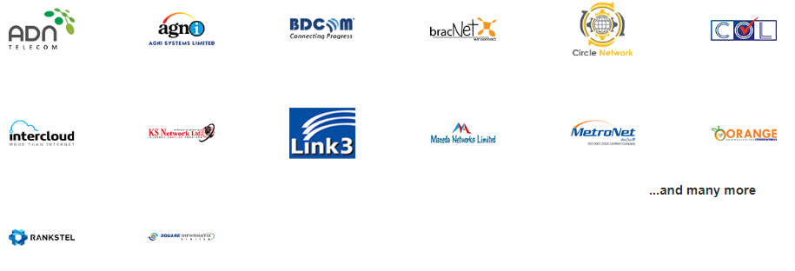
Mobile Network Operators


Government Organization
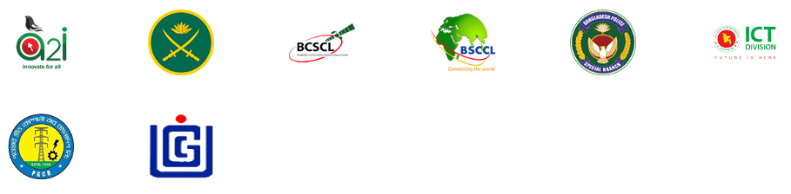
IIG (International Internet Gateway)

Digital Cable TV Operators

WIMAX Operators
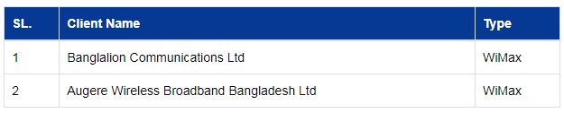

International Gateways (IGWs)
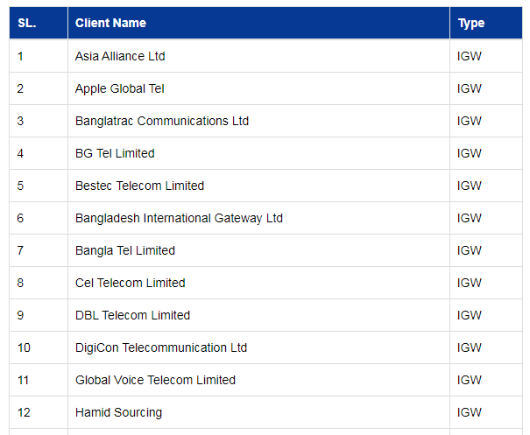
Interconnection Exchanges (ICXs)
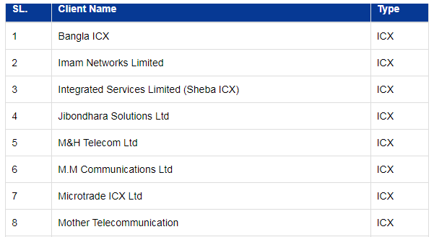

Management Team
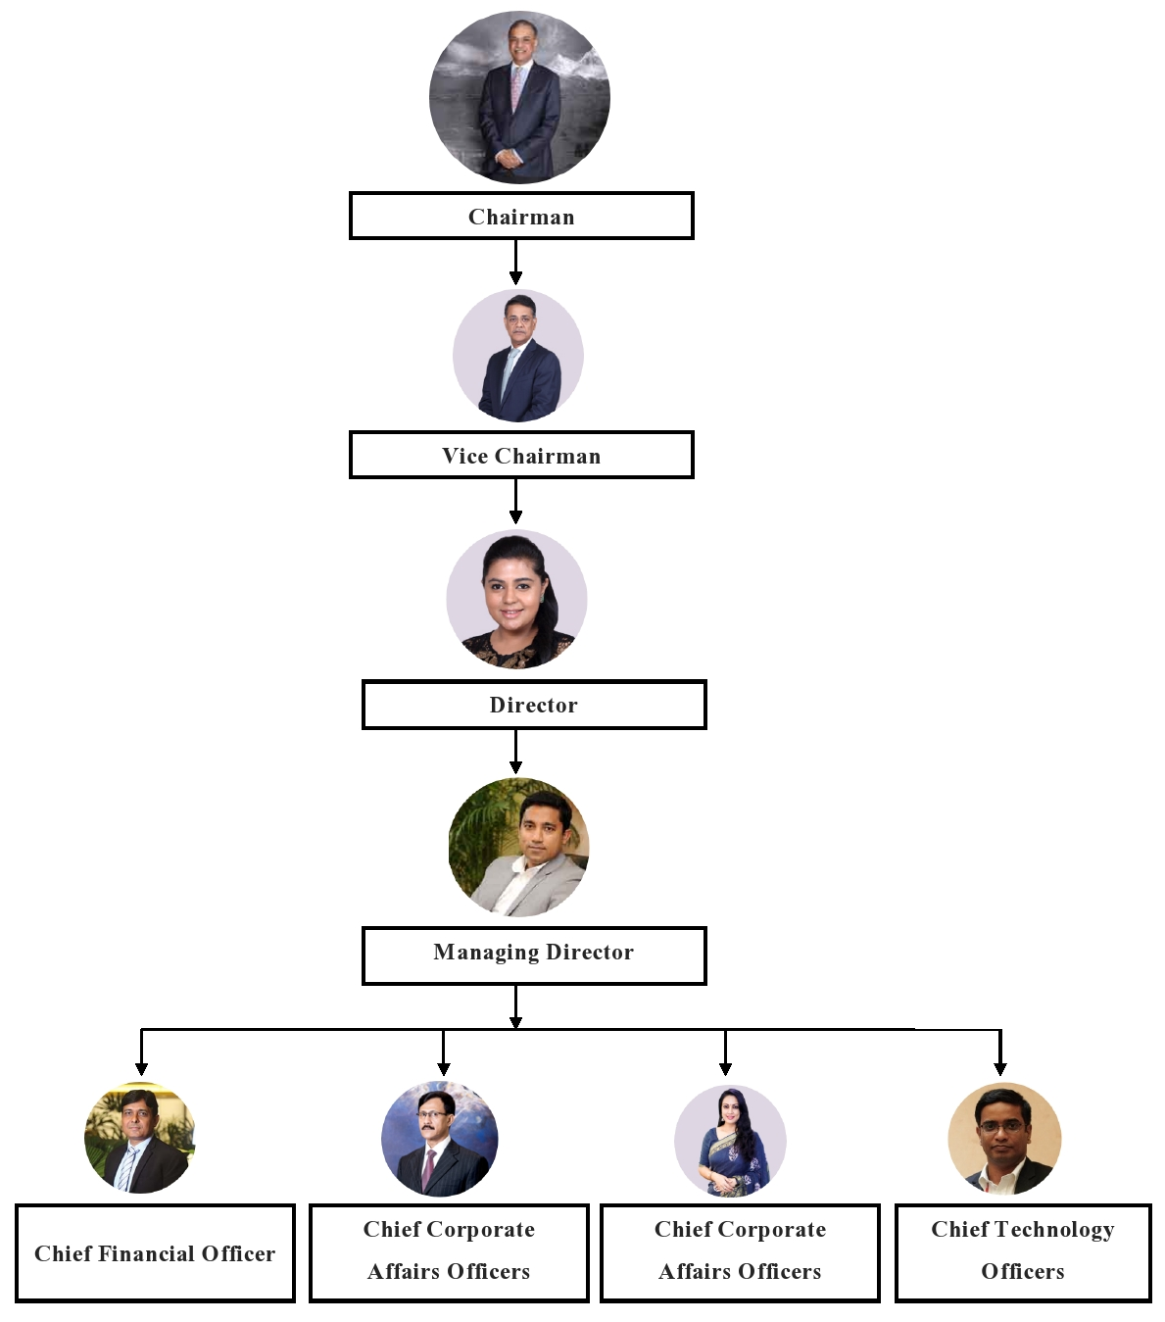
Figure 3.3: Management Team at Summit Communication Limited

Contribution of Marketing Team at Summit Communication Limited
The marketing department of SComm has played an important role in the development and promotion of the biggest fiber optic infrastructure in the country, which was built from the ground up using an entrepreneurial mindset. Among the team's many accomplishments are corporate strategy formulation, business-to-business (B2B), market segmentation, market research, and customer relationship management. The team is involved in an expert professional with an entrepreneurial mindset, strong work ethic and an unwavering dedication to commercializing the talent of the world's greatest minds. SComm, the biggest telecom and ICT infrastructure provider in the country, was built in only nine years because to their extraordinary marketing and organizational leadership skills. With the correct product and service design and target-driven mentality, the team has achieved success in developing a customer-centric culture. Throughout their journey, they has successfully negotiated and concluded multi-billion dollar partnerships with major upstream connectivity providers including Singtel, Tata, and NTT Communications.

Five Years’ Financial Data
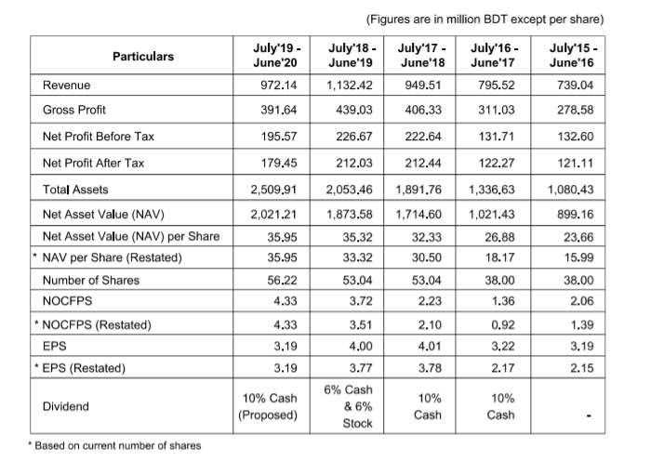
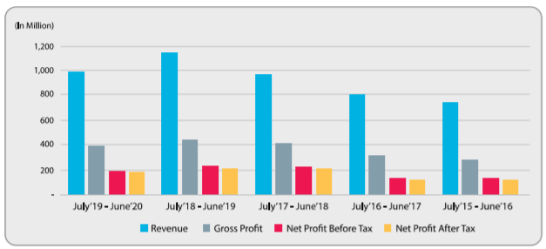
Figure 4.4: Financial Data of Summit Communication Limited (2015-2020)

CHAPTER 03

Literature Review

Definition of Key Terms

Marketing
Marketing is a set of acts that are used to direct the flow of goods and services from producers to consumers (Kotler, 2018).
To be successful in marketing, you must be able to manage profitable client relationships and both recruit and retain and grow your current customer base. A marketing strategy is a plan for maximizing the value of a customer's relationship with a company (Armstrong, 2007).

Importance of Marketing
In light of the enormous shifts in corporate culture, marketing terminology and practices have undergone significant evolution. In the past, the marketing and sales departments were independent entities, but nowadays, they are frequently one and the same (Why Marketing is SO Important, 2020).
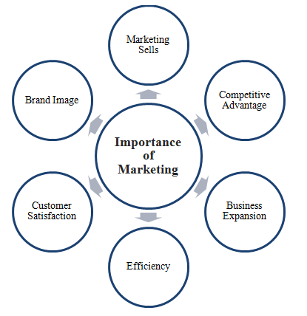
Figure 1.1: Importance of Marketing Mix
No longer is "collaborating with sales teams" the exclusive definition of marketing. For many businesses, sales are synonymous with marketing in today's society. Social media is no longer as effective as it once was in attracting new consumers or persuading them to choose one company over another. This is the only way to accomplish growth and sales. Marketing, sales, and distribution are all terms that may be used to describe what you do.

Segmentation, Target Market and Position (STP)
It's a well-known technique in today's world: Segmentation, Targeting, and Positioning (STP). As one of the most extensively utilized marketing strategies, many marketing professionals have praised its capacity to streamline their interactions with customers.
When a corporation employs STP marketing, it may determine its most lucrative market segments, and then design an individual marketing strategy for each one.
Since STP is a great way to connect, engage, and convert customers, whether you're just starting started or have been using STP for years, it's worth taking a step back to make sure you're making the most of every chance (Hanlon, 2022).

Marketing Mix Strategy (4Ps)
Product, pricing, place, and promotion are all tactical marketing components that a firm may manage and employ to get the desired results in the target market by combining them correctly (Kotler and Armstrong, 2010).

CHAPTER 04

Marketing Strategies and Practices of SComm: An Analysis

Marketing Strategies and Practices of Summit Communication Limited
Throughout this part, I've covered over the fundamental marketing strategies and practices of Summit Communication Limited, such as the STP Process (Segmentation, Targeting, and Positioning), as well as the 4ps of Marketing Mix strategy.

Segmentation
Marketing's term for the process of dividing a huge population into smaller ones with similar wants and needs is segmentation. Companies use market segmentation as a strategy to get an edge over their rivals, improve performance, and increase profit. A company's strategy should include the following steps:
- To better understand the needs and wants of clients, market segmentation and customer profiling are necessary.
- Concentrate your efforts on subgroups of people who have specific needs, wants, and preferences.
- Based on market research, create and execute effective ‘marketing mixes' for each target market group.
Market variety allows for different future demand functions to be predicted, which is why segmentation makes economic sense. The market may be divided into four main categories, each of which has a unique implementation. From Summit Communication Limited's point of view, they only segmented their market on geographical basis:

Geographic Segmentation
It's the technique of separating the market depending on its location. It's very common for markets to be segmented down to the level of regional or even city-level detail.
Summit Communication Limited has opted to segment its market by Bangladesh and overseas despite the fact that is to provide every family in Bangladesh with access to world-class multi-media services with the goal of assisting in the development of a Digital Bangladesh.

Target Customers
Targeting is a marketing term that refers to a market that has been segmented based on criteria such as age, gender, income, education, lifestyle, social standing, social class, and other factors, amongst other reasons. The identification of segmentation results in the selection of a limited number of segments for the purpose of contacting prospective customers. When it comes to marketing, market targeting refers to the process of first identifying, then assessing, and lastly choosing target market segments.
For the most part, a corporation's target market is made up of customers who share similar characteristics (such as age, geography, money, or way of life) and who are considered the most likely to purchase a company's market offerings or to represent the most lucrative segments for the business to serve.
Summit Communication Limited is focusing on 4 distinct groups of customers that have the spending capacity on International Terrestrial Cable (ITC) services and optical fiber connections internet services. These are listed below:
Target Customers
01 | Internet Service Provider | 03 | Cable Operators
02 | Mobile Network Operators | 04 | Call Centers
Table 1.1: Target Customers of Summit Communication Limited

Positioning
In the context of marketing and business strategy, "market positioning" refers to how a consumer views a brand or product in relation to those of its competitors. A brand's or product's image or identity is built up in order for others to see it in a specific light, and this is known as market positioning.
Summit Communication Limited has a distinct value approach at the following points:
- Summit Communications aims to build a digital Bangladesh: They are doing fiber optic network all over Bangladesh. Through which ISP and telecom operators will get the benefit of transmission backbone. They have 40 thousand kilometers of fiber optic network all over Bangladesh. Is made, it is not possible to carry it wirelessly. In terms of providing easy access to internet to the customers, the internet cost has come down a lot now as compared to five-six years ago.

Application of Marketing Mix (4Ps)
In the context of marketing strategy, the marketing mix refers to the tactical or operational aspects of that approach. The 4Ps, 7Ps, and even 9Ps are all terms used to describe the marketing mix. The four pillars of the marketing mix: product, pricing, location, and promotion.
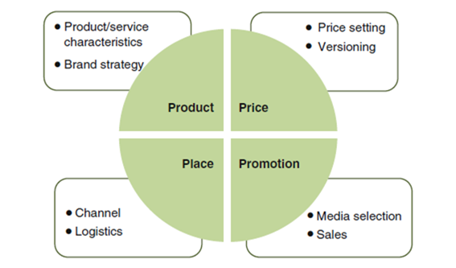
Product, pricing, location, and promotion are all tactical marketing components that a firm may manage and employ to get the desired results in the target market by combining them correctly (Kotler and Armstrong, 2010).

Products and Services
There are many different types of products a company may provide its customers. When it comes to many individuals, a product is just a thing that we buy or sell. In the case of services, the product may also be seen as intangible. Design, color, size, shape, and visibility of the product are all examples of product features.
Summit Communications Limited, with the best-in-class ITC, IIG, and ICX services to link Bangladesh with the rest of the globe, the fastest-growing Fiber Optic Network Infrastructure in Bangladesh has emerged. The Network Operation Center (NOC) is open 24/7 to assure customer satisfaction and quality. Their providing services are:

NIX
Nationwide Internet Exchange
Summit Towers
Network Tower Sharing Services
IIG
International Internet Gateway
ICX
Interconnection Exchange
ITC
International Terrestrial Cable
NTTN
Nationwide Telecommunication Transmission Network

Figure 5.5: Products and Services of Summit Communication Limited

Pricing Strategy
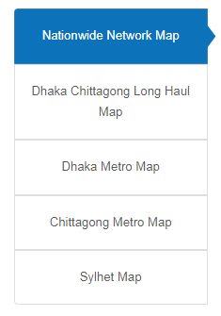
The price of a product is typically defined by the amount of money a customer must fork over in order to use it. Price is a critical consideration in marketing mix tactics. A marketing plan's profitability and long-term viability are directly linked to this component. Prices may have an enormous influence on the whole marketing strategy, sales, and demand for a product within a certain product range.
Summit Communication Limited sets its prices based on a balance of value, speed of ITC, IIG, and ICX services, operating cost and the government policy.

Places
Where a product may be found by a target audience is considered part of a company's place strategy (Kotler and Armstrong, 2010). Wherever our target client prefers to buy, the product should be available for purchase. Product and service mix description is inadequate if distribution and placement are not included. Consumers and potential buyers must be able to easily reach the spot where the product is being positioned and distributed.
Summit Communication Limited spends a lot of money in this area to ensure seamless strong network all over the Bangladesh and maximize return on investment. Throughout Bangladesh, they established a network of distribution centers.
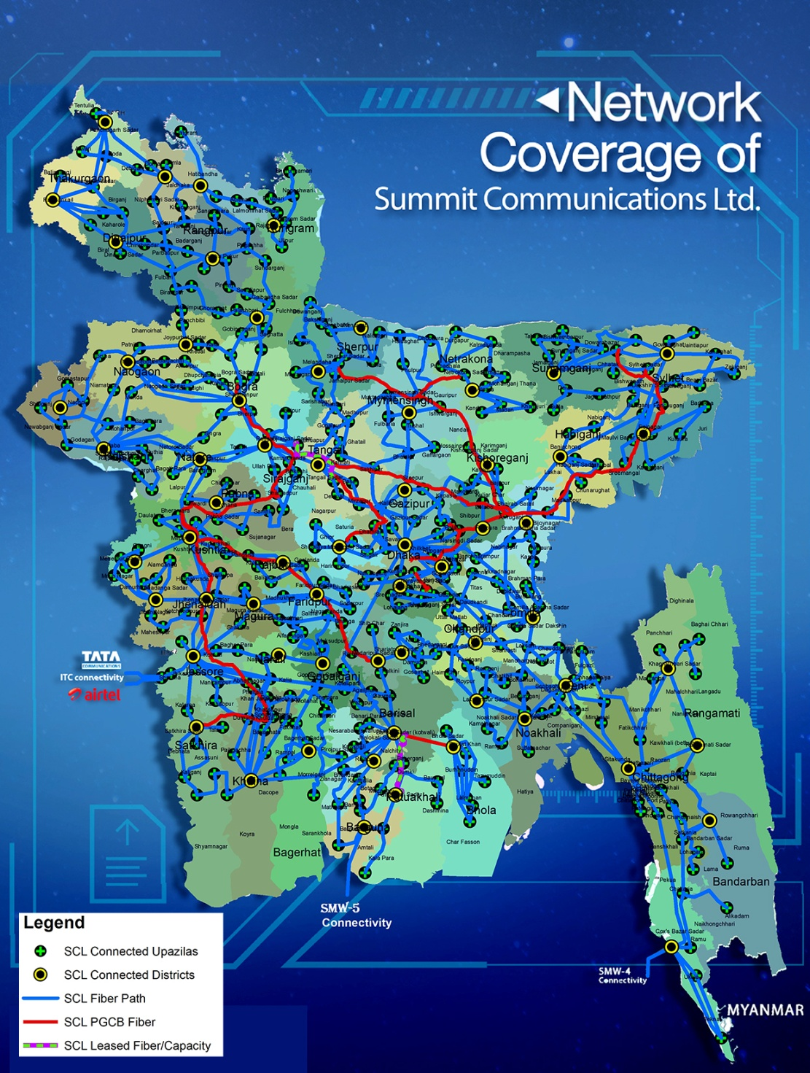
Figure 6.6: Network Coverage of Summit Communication Limited

Promotion
According to the definition of promotion, all of the actions marketers do to educate consumers about their products and persuade them to make purchases, are included in the term (Solomon et al, 2009).
A marketer's promotional arsenal includes all of the tools at their disposal for reaching out to clients through different marketing channels. Successful marketing is one that persuades customers to buy our products while at the same time boosting revenue. Advertising, sales promotion, public relations, direct marketing, online communications and personal selling are just a few of the ways firms employ to promote themselves.
Summit Communication Limited has a number of Add Agency-created marketing initiatives and campaigns. Summit Communication Limited’s marketing and promotional efforts are handled by "FCB BITOPI and Grey Advertising Limited."
A number of advertising agencies manage posters, advertisements, slogans for T-shirts, and festoons, to highlight a few. Summit Communication Limited uses both BTL and ATL marketing tactics in their promotional and campaign activities.

ATL Promotion (Above the Line)
ATL promotional and campaign activities are being carried out by Summit Communication Limited in the following ways:
TV
Advertising
Magazine/ Newspaper
Radio
Advertising
Social Media Marketing
Brand
Activation

TVC

Figure 7.7: ATL Promotional Tools of Summit Communication Limited

- Social Media Marketing
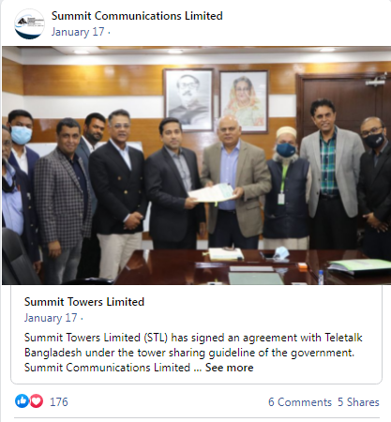
As people enter the digital age, Summit Communication Limited is keeping up with the latest trends in social media marketing on a daily basis. Their Face Book page is used to market their company by posting promotional campaigns, updating their ongoing projects, client feedback, and videos, among other things. Examples of such campaigns include:
- It is their policy to publish on Face book whenever they launch new innovative technologies, services in order to ensure that people are aware of the new stuff.
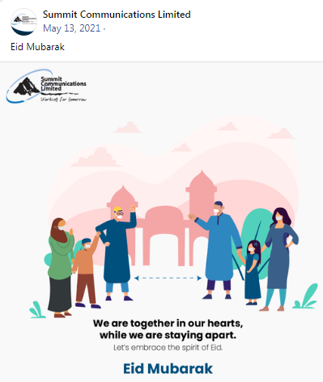
- By developing and sharing information about the advantages of their services, or how to utilizing their products, for example, they may increase their exposure.
- These forms of social media marketing assist them in polishing their brand by posting on key occasions such as Eid-Ul-Fitr and Eid-Ul-Aadha and greeting all of their Face book followers, which in turn assists them in polishing their brand even further.
- Creation and publication of many pieces of material in conjunction with major celebrations such as Mother's Day, Father's Day, Friendship Day, and so on.
- Summit Communication Limited provides customer care and customer support capabilities via its Face book page, which includes online chatting and commenting platforms, among other things.

- Radio Marketing
Radio platforms like Radio Foorti 88.00fm and Radio Vhumi 99.00fm are used by Summit Communication Limited to promote its products. Major events like as the Cricket World Cup, Eid, and other government holidays are when RDC is distributed to the public. Their goal is to make their products and/or brands more familiar to radio listeners.
- Brand Activation
New and existing services from Summit Communication Limited are often introduced to the market through free service testing. So that clients may have a firsthand look at their new products and get a good impression of them.
- Advertisement on Newspaper
Among the many publications that Summit Communication Limited advertises in are Dainik Ittefaq, The Daily Star, Business Times, Banki Barta’s monthly online newspapers, among many others. Ads are placed in the newspaper whenever a new product, technology is available.
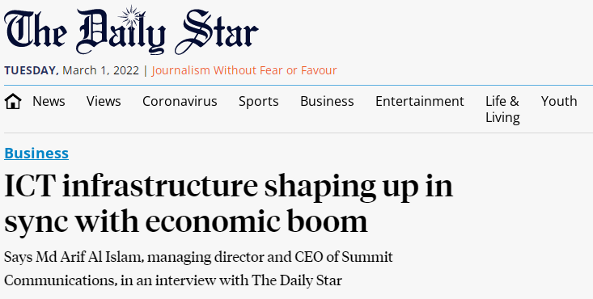
- Advertisement on Television
Television is an excellent medium for promoting a company's name and logo. Summit Communication Limited will run commercials on television if it becomes required.
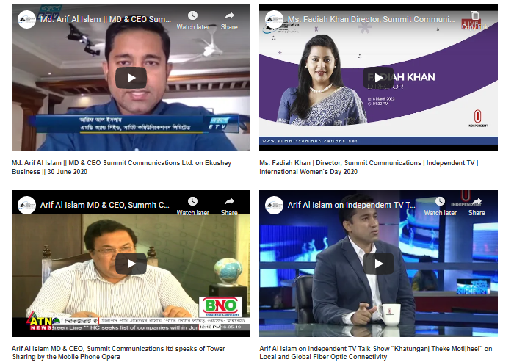
- TVC Advertising
Summit Communication Limited created more TVC about their brands, services. The appearance of a brand on television may help establish trust. It reaches a far broader audience than internet advertising at the outset. All other types of advertising are influenced by television advertising's success. Despite the fact that viewers may be using numerous gadgets while watching television, they are far from disinterested.


BTL Promotion (Below the Line)
In BTL marketing, Summit Communication Limited is doing the following:
Direct Marketing
Sponsorship
PR
Tele Marketing

Figure 8.8: ATL Promotional Tools of Summit Communication Limited
- Direct Marketing/ Direct Mail
Customers may be informed and reminded by direct mail of Summit Communication Limited that they can upgrade from 4G, get a new modem or router to enable better internet speeds, or change service providers by combining it with other channels. They have developed a plan that incorporates mail, online, and television commercials in order to engage consumers and non-customers.
- Sponsorship
Summit Communication Limited provides sponsorship for a number of the well-attended events in our country. The corporation sponsors social and environmental activities.
- Public Relationship (PR)
The establishment of a favorable image and goodwill in the community via efficient public relations is one of the most powerful instruments available to a firm. The explanation for its significance may be boiled down to a single action: it shapes people's perceptions of the world. If we take a glance around, we will see that there are several firms that provide identical items, but just a few of them are drawing more clients. Summit Communication Limited, they have selected more PR agency for it. Impact PR agency of Bangladesh is one of them. This agency is publishing the news, events, winning awards’ news to the online newspaper portal and social media sites.
- Tele Marketing
Communication with telephone from Summit Communication Limited may notify and remind customers that they may upgrade from 4G, buy a new modem or router to allow improved internet speeds, or switch service providers by combining it with other channels.

Findings of the Study
According to Summit Communication Limited’s current condition and marketing operations, there are many impediments to the company's International Terrestrial Cable (ITC) business growth. Summit Communication Limited serves customers throughout Bangladesh. The development of Telecommunication Company of Summit Communication Limited faces several obstacles, such as the existence of large corporations in Telecommunication industry.
Summit Communication Limited’s telecommunication and International Terrestrial Cable (ITC) business is affected by the following factors:

Lack of efficient customer management

New customers are often overlooked by Summit Communication Limited’s business development team when formulating sales and growth strategies for their telecommunication and International Terrestrial Cable services’ company.
Sales and business growth are dependent on customer loyalty and commitment as well as customer referrals and complimentary sales activities, but it is equally important to raise brand awareness, find new customers, and engage both new and existing customers by offering competitive rates and discounting.
When it comes to engaging existing customers and clients, they aren't making any effort in the areas of R& D or marketing.

Problems in the compliance with laws and regulation
Even though Bangladesh's business standards are always changing, if any company is proven to be involved in unethical practices, the company may be shut down or rejected under its Consumers Right Act. For Summit Communication Limited, retaining consumers is difficult since it is difficult to provide high-quality internet services at fixed prices by providing the government.
A government official's approval was often required for the importation of technology for commercial telecommunication and International Terrestrial Cable (ITC) business. Summit Communication Limited finds it difficult to expand their operations in all around the Bangladesh because of the prevalence of corruption and other types of unaccounted for funds.

Lack of Territory Marketing and Sales Officers/ Executive
The territory marketing and sales department of Summit Communication Limited is understaffed with qualified territory sales executives. The territory sales department's salary structure is often criticized for not attracting highly educated workers. In order to avoid this, the company often hires people based on personal recommendations, which lead in the hiring of unproductive employees.
Consequently, the territory sales department's direct marketing plans have been pushed back owing to a lack of recruiting prospective people and a lack of effort to adapt new technology.

CHAPTER 05

Recommendations and Conclusion

Recommendations
STP and marketing mix strategies of Summit Communication Limited have identified several obstacles and a lack of marketing activities that might have a negative influence on the company's development and competitiveness.
These observations may help Summit Communication Limit evaluate the present issues confronting their telecommunication and International Terrestrial Cable (ITC) business, and many recommendations are developed based on study and findings in order to support the firm in attaining and sustaining company growth in this competitive market.

Developing Customers Centric Model
Summit Communication Limited should priorities both present and potential consumers equally in order to preserve a competitive edge. That being said, it is important to remember that even if the fish company has concentrated on serving present customers, new consumers and clients must be brought in if the business is to continue to grow and thrive.
- In addition, websites and web pages should be regularly updated to ensure that they are current and relevant, as well as optimized to make browsing easier for customers and consumers.
- In order to increase their customer base, they should focus more on their marketing and promotional efforts on online platforms as well as direct marketing to corporate and government organization, authorized ISP companies, call centers’ company.

Providing Effective Training to the Marketing and Sales Department
Summit Communication Limited’s operational methods, relationships, and cross-departmental communication all have an influence on the company's efficiency and growth. The capacity of an organization's employees to work together successfully is critical to its success. Exhaustion and lower output may result if an organization's leaders try to be in charge of every area of its operations. Having the right management in control of a company's personnel is also crucial to its growth and productivity. So, Summit Communication Limited, they should arrange more training sessions for their marketing teams about the presentation skills on their innovative technologies and services.

Conclusion
The purpose of the study is to understand about the Summit Communication Limited’s marketing strategies that might have a negative influence on the company's development and telecommunication and International Terrestrial Cable (ITC) business in Bangladesh. Many factors are at play in the development of Summit Communication Limited, according to a study's findings. Summit Communication Limited’s Segmentation, Targeting, and Positioning strategy and marketing mix suggest that the telecommunication and International Terrestrial Cable (ITC) business development is impacted by a lack of marketing activity. In order to survive, Summit Communication Limited should invest more resources for marketing development. This means that Summit Communication Limited needs to invest in training to find potential territorial marketing and sales executives in order to acquire new consumers, maintain current customers, and expand the company.

References

About Organization. (n.d.). Retrieved from Summit Communications Limited: http://www.summitcommunications.net/
Armstrong, P. K. (2007). Principles of Marketing . South Asia: Manipal Press Pvt Ltd.
Hanlon, A. (2022). The segmentation, targeting, positioning (STP) marketing model. Retrieved from Smart Insights: https://www.smartinsights.com/digital-marketing-strategy/customer-segmentation-targeting/segmentation-targeting-and-positioning/
Keller, K. (2018-2019). Marketing Management (15e). Global Edition: Pearson Education Limited.
Kotler, P. (2018). Principles of Marketing. South Asia: Manipal Press Pvt Ltd.
Philip Kotler, G. A. (2017-2018). Principles of Marketing (13th Edition). South Asia: Manipal Press Pvt Ltd.
Why Marketing is SO Important. (2020). Retrieved from Animas Marketing: https://animasmarketing.com/importance-of-marketing/

Barone, A. (December 12, 2021). Marketing Strategy. Retrieved on 02 March, 2022 from
https://www.investopedia.com/terms/m/marketing-strategy.asp#:~:text=A%20marketing%20strategy%20refers%20to,and%20other%20high%2Dlevel%20elements.
…….Marketing Strategy. Retrieved on 02 March, 2022 from Wikipedia
https://en.wikipedia.org/wiki/Marketing_strategy

