A project on “Pharmaceutical industries &Transition Economy: Evidence from Bangladesh”


United International University
Submitted to:
Mofijul-Hoq Masum
Assistant Professor
School of Business and Economics
Submitted by:
Atundrila Chowdhury
ID: 111 122 199
B.B.A Program
School of Business and Economics
Submission date:
16 Oct. 2019
Letter of Acknowledgment

This project is the outcome of contribution and involvement of an individual student (Atundrila Chowdhury), and all information are used in this project is full authentic and relevant. My course supervisor, Mofijul-Hoq Masum, assistant Professor supervised me for making this project successful submitting.

First of all, I would like to thank my honorable academic supervisor Mofijul-Hoq Masum Sir, Assistant Professor of School of Business & Economics, United International University. I am thankful to him for his constant support and supervision, recommendations and delivering me with valued information that was very much desired for the completion of this presentation.
Letter of Transmittal

January 3, 2019
Mofijul-Hoq Masum,
Assistant Professor,
School of business and economics,
United International University
Subject: Submission of Project.
Dear Sir,
I am very pleased and delighted to submit this project, as it is a valued project for my BBA Program. I have attached the files and documents as per the requirements of the project. You have given me this opportunity under your guidance and support. Without your help, this project would have been impossible to complete.
To prepare this project I have collected maximum percent of information from different sources and add that information from my point of view. I have used all information in this project is fully authentic and most relevant with the project topic. All of that information, which is added in this report, is potentially in my corporate life and professional life.
I am really thankful to you that, your guidance has enriched my knowledge and experience for preparing this report. You can also make a wish to enquire of this project; I will happily repose to your quarries. Thank you for your supervision and feedback.

You’re sincerely,
Atundrila Chowdhury
ID: 111 122 199
B.B.A Program
School of Business and Economics

Table of Contents
Chapter 1: Introduction: 1
1.1 Bangladesh overview for “Transition Economy”: 2
1.2 Rationale of the study: 2
1.3 Background of the study: 3
1.4 Limitation of the study: 3
1.5 Objectives of the study: 4
Broad objective: Economic Transition and Pharmaceutical industries at Bangladesh Transition 4
Specific objectives: 4
Chapter 2: Methodology 5
2.0 Methodology of the study: 6
2.1 Data design: 6
2.1.1 Data type: 6
2.2 Analytical Tools 6
Chapter 3.0 Literature Review: 7
3.1 History of “Transition Economy”: 8
3.2 Challenges of “Transition Economy”: 9
3.3 Challenges of modern economy of Bangladesh: 10
3.4 Bangladesh Growth: 10
3.5 Transition economy Problems: 11
Chapter 4: Findings and Analysis 18
4.0 Findings and Analysis: 19
4.1 Least Development countries in Transition Economy: 19
4.2 Developed Countries in Transition Economy: 20
4.3 Developing Countries: 21
4.4 Pharmaceuticals industries of Bangladesh Transition Economy: 23
4.4.1 OVERVIEW OF PHARMACEUTICAL INDUSTRY OF BANGLADESH 23
4.4.2 Key drivers for growth of Pharmaceuticals Company in Bangladesh 24
4.4.3 MARKET POSITION OF DIFFERENT COMPANIES 24
4.4.4 EXPORTS OF PHARMACEUTICALS PRODUCT 25
4.4.5 Opportunities in Global Generic Drugs Market for Bangladesh 25
4.4.5 Trade Related Aspect of Intellectual Property Rights (TRIPS): 26
4.4.6 TOTAL HEALTH CARE EXPENDITURE 26
4.5 PESTLE analysis: 33
Table: PESTLE Analysis 34
Chapter 5: Recommendation and Conclusion 35
5.0 Conclusion: 36
5.1 Recommendation: 36
6.0 References: 38
Abstract

The entire world is moving on for better development of their individual economy. As the economy is growing and the demand of the market is also changing day by day. Required practical knowledge in this report will help a student to understand about the practical world and its activities. The most important issues in this report are covered about transition economy and its effect over the country. In this project there are five chapters and these are introduction part, objectives part, methodology part, literature review part, findings and analysis part and conclusion part. In this report some information is collected from secondary data source and some information is collected from primary data source. Bangladesh economic growth rate is registered with average GDP growth rate 7.3 percent. Bangladesh is also registered as middle economic development country over the years. Notwithstanding of this inspiring development through decades, per capital income of Bangladesh is the lowest among the countries of south Asia and it also under the per capital revenue of the smallest industrialized nations. In the SWOT and PESTLE analysis Bangladesh economic condition is analyzed.
Key word: Transition economy, Pharmaceutical Industry, Drug Industry

Chapter 1: Introduction:

1.1 Bangladesh overview for “Transition Economy”:

In most recent days Bangladesh is practicing the powerful economic growth and macro-economic stability for massive economic transition to a democratic rule in the early of 1990s. In the macro economic disaster of former 1990s, different types of steadiness actions are announced as the economic condition of Bangladesh. Bangladesh economic growth rate is registered with average GDP growth rate 7.3 percent. Bangladesh is also registered as middle economic development country over the years. Notwithstanding of this inspiring development through decades, per capital income of Bangladesh is the lowest among those countries, which are in south Asia and their per capital revenue of the smallest industrial nations. After the time of 1990s, Bangladesh has established excellent performance growth over the years. This macro-economic development started from the early 1990s until to current period, which is characterized by a record of low inflation rate and an unparalleled accumulation of outside assets and the better stand-in situation of government. Some evidence of different macro-economic stabilization and indications of monetary stagnation have translated the development of Bangladesh. Macro-economic movements are changed in the 1990s and its changeover of independent law by flinging of an inclusive suite of marketplace concerned with relaxing strategy improvements. Many foreign companies are investing in Bangladesh and Bangladeshi government also taking different approaches to follow the economic transition.

1.2 Rationale of the study:

This report is on “Transition Economy” and most of the economic sector in Bangladesh is developing and it is transferring from product economy to service economy. In this study the main focus is concerned about “how an economy is transferred to a transition economy”. There are several aspects in transition economy. There are many foreign direct investments are coming in Bangladesh and it has a multiplier effect on economy. This study describes about transition economy effect on Bangladesh growth and investment rate and different analysis is done in the findings and analysis part to show Bangladesh’s economic situation in terms of macro-economic aspects.

1.3 Background of the study:
Economic situation of Bangladesh is increasing day by day. Without practical experience any business cannot survive in the economy. The entire world is moving on for better development of their individual economy. As the economy is growing and the demand of the market is also changing day by day. Mandatory practical knowledge in this report will help a student to understand about the practical world and its activities. The most important issues in this report are covered about transition economy and its effect over the country. I am very thankful to my course instruction that supervises me to complete this report with his guidance. The theoretical knowledge in this project is very helpful for understanding the necessary issues of this study.

1.4 Limitation of the study:
There are several limitations of this project. To make this project understanding about the Bangladesh economic condition and analysis of economic position in Bangladesh and its changes are concerned here. In this study several limitations are showed and these are:
- To collect all information about Bangladesh transition economy.
- To know about actual economic situation about transition economy of Bangladesh.
- To analyze economic situation of Bangladesh over the year.
- To relate full of theoretical knowledge with lack of practical knowledge.
- Lack of information in the Internet about transition economy.

1.5 Objectives of the study:
There are several objectives in this project about “Transition economy”. Normally there are two types of objectives and these are broad objective and specific objectives. At the bellow broad objectives and specific objectives of this project are given:

Broad objective:

The most important objective of a project is to perform the functions for which it was initiated. If it doesn't fulfill its purpose, the project has failed. Companies undertake projects to address the needs of project users or to solve particular problems. Within the broad objective of fulfilling its purpose, it has to meet actual needs and carry out specific operations.

Specific objectives:
There are several specific object of this report and at the bellow those are given
- To see history of transition economy
- To point out the challenges of modern economy of Bangladesh
- To identify transition economy Problems
- To understand transition economy in developed countries
- To see the overview of pharmaceutical industry of Bangladesh
- To see exports of pharmaceuticals product
- To identify opportunities in global generic drugs market for Bangladesh

Chapter 2: Methodology

2.0 Methodology of the study:
In the methodology of this project is guided on different methods and techniques to make this report successful. Data methodology is designed and projected on the basis of transition economy. At the bellow the methodology of this project are given shortly:

2.1 Data design:
Data collection play a vital role in researches. Using different methods for gather information ,all information are fall into two categories primary data ,and secondary data. For making this project’s requirement fruitful data is designed based on primary and secondary data sources.

2.1.1 Data type:
Primary data: Primary data is first hand data which collected by the researcher for personal use by using methods like surveys , observations ,questionnaires,interviews or experiments etc.
Examples- A students collected data for his/her project report. If you took a trip to a trauma unit and interviewed burn survivors, the data collected in that phase of your research would be primary data.
Secondary data : data collected by someone else for other purpose. Government publications, websites, books, journal articles, internal records etc are the source of data.
Examples- If one of your interviewees puts you in touch with a burn survivor support group, and you are given access to a database of information about the psychological state of a large group of survivors in the years following the burn incident, that would also be secondary, not primary, data.

2.2 Analytical Tools
As this project is the use of secondary and primary data so that, data is presented by using Microsoft word. In the Microsoft word application different techniques and functions are used for presenting data. Different charts, tables, organizing tools are also used for making this project.
In this project different analysis in done according to the project requirements and different tables and graph picture is been attached according to the growth of transition economy. According to the project outline and project requirements different findings is been given for understanding the aspects of transition economy.

Chapter 3.0 Literature Review:

3.1 History of “Transition Economy”:

At the end of the twenty first century the transition economy transferred to socialism to capitalism and it make a significant effect over the economic industrialization. Generally fundamental institutional change creates effect over the world population. Normally historical period has many involvements over the period of time. The massive experiment of economic and political situation is covered over the transition economy. The economic model of socialism with the central planning promoted as the alternative to the capitalism. Through from chief periods of collectivism, these experiments lived occupied actual extremely, but by the late-night 1980s insufficient misgivings continued that the communist financial scheme was in the extended track animatedly fewer well-organized than entrepreneurship. Over the course of several decades, growth gradually came to a halt. However, most of the experts believe that, transition economy always comes with surprise. In the early few years, USA and CIA accumulated some of the best economist to make discussion over the prospects of soviet economic system. In the year of 1983 US based economist published a book named “The Soviet Economy over the years”. Exclusive of initial party-political revolutions started by Mikhail Gorbachev, mainly activated, the weakening popular incomes after lubricant transfers, and the still have existed over the years. Normally, the transition procession system covers the procedures of China, which is the world most popular country in transition. Inadequate remunerated contemplation of Chinese conversion at the time, partially by the perseverance of the Stalinist governmental administration. When the Soviet Union was unexpectedly collapsed, some communist political party regime and made refreshment of democracy that opened so many possibilities of economic transition from the socialism. Transition is the challenge for transferring a socialism economy to the capitalism economy. Changeover of transition was the great experiment in the moneys livelihood for the complete. There are different countries who critically use the transition economy over the main aspect. In general, economists were not well prepared. In this project the main aim is depend on understanding of capitalism over the transition economy and aspects of transition economy over the years in the world population. Nevertheless no guideline occurred, the philosophies of finances remained to deliver a scope, and changeover was to disclose the accurateness of that scope. Eventually, the transition process was executed to provide about the understanding of capitalism of US based economy.

3.2 Challenges of “Transition Economy”:

There are several challenges over transition economy and its aspects to make challenges of transition period. There are some early policies in the transition economy, which describe about strategies of transition economy. There are some steps in the transition economy, which describe about the determining the policy in the transition economy of Poland and it is used as the reference of transition economy. At the bellow the challenges of transition economy are given:
- Stabilize policy and monetary policy: The general strategy used in the transition economy is “shock therapy or cold turkey” for stopping the hyperinflation in the transition economy. The reduction of money supply in the economy could provide the necessary backup in the hyperinflation.
- Alternatives in the economy: The use of single system in the economy can lead the positive effect or negative effect in the economy and the positive thing can influence the reform introduction in the economy such as, denationalization and independence perceptibly counterpart all. The concept of denationalization refers to comparative analysis of economic system of the economy between two countries. The most negative effect of this denationalization is augmentation between two countries.
- The emerging market of “Washington consensus” makes a durable positive importance on industrialization, denationalization and economic chastisement as the prevention of international financial institution. The most unsatisfactory involvements in the growth assistance for the year of 1960s and 1970s made a lead conclusion that provides good situations in international policies, which is needed for better development of markets and competitive environment. In this type of economic transition countries structural reform are generated for example liberalization and privatization.

3.3 Challenges of modern economy of Bangladesh:

Now a day’s Bangladesh is most emerging country in the world and it is most challenge for policy makers and consultants of growth. Though the earning development, mortal growth and susceptibility lower labors to date must stayed unexpected. Bangladesh faces different dares by about 24 million public’s motionless alive underneath the deficiency track. Bangladesh is at a significant stage, when with the correct strategies and appropriate act and it container transfer awake inside the middle-income support. The World Bank has recognized job formation as the nation's top expansion importance. Bangladesh wants to generate more and healthier jobs to achieve the glitches connected to increasing childhood joblessness and relaxed countryside of the occupations. To do so, Bangladesh will essential to eliminate the fences to advanced speculation modeled by low admission to dependable and reasonable control, lowly transport substructure, incomplete attainability of repaired plot, indeterminate and multifaceted commercial directive, among others. Encounters related to fast development and weather change wants to get lectured through lasting groundwork.

While all sectors in the economy of Bangladesh is knowledge based. To remain competent and skilled in the economy Bangladesh government is facing many challenges and getting many opportunities for making the transition economy more competent. In this large population of Bangladesh and it has facing many challenges. As Bangladesh government is building many economic zones in the hundred regions so that much skilled labor force is required for maintaining the economic growth. Bangladesh GDP rate is 39th according to its nominal GDP rate and the GDP of Bangladesh is 314.656 billion. There are different trade organization and these are SAFTA, SAARC, AIB, IMF, Common wealth of nation, ADB and World Bank. In 2018 the GDP nominal rank is 144th per capital and it is also facing the extreme poverty line.

3.4 Bangladesh Growth:
Bangladesh economic susceptibility is intended by reflecting several factors and these are populace position, Lower coastal zones of the populace, detachment, agriculture position of the area, forest position and festering, exporting ability, distribute attentiveness, and capabilities of prevent natural disasters. For maintaining the economic growth and strong economic transition Bangladesh is recently launched a satellite and the announcing settlement name “ The Bangabondhu Satellite” is incorporated by the American satellite manufactured company “Space X” in the year of 2018. For accelerating the strong telecommunication development of the economy, “Bangladesh Space Research” and Remote Sensing Organization has lunched a strong remote technology for better economic transition in the global world. The remote connection of satellite has enabled the technology to generate more economic advantage, identifying threats of natural disasters in the Bangladesh. This kind of advantages will help Bangladesh economic status to grow more.
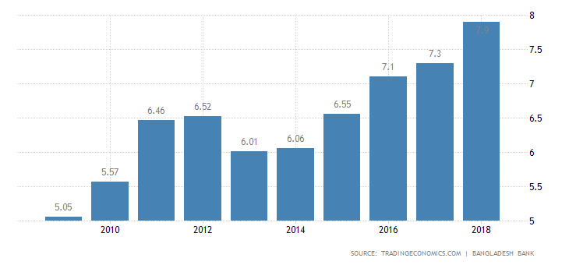
Graph 3.2.2: Economic growth of Bangladesh
Bangladesh textile industries are tremendously growing day by day and it is growing as the 80 percent export base economy and its position rated as fifty seventh in the world exporting position. There are only two countries that topped Bangladesh in the export of cloths in 2015 and these two countries are China and European Union. The clothing industry of Bangladesh is increased by 14 percent of gross domestic product (GDP) in the year of 2015. Now a days Bangladesh is experiencing a super GDP growth from the year of 2011 and Bangladesh is the second most exporting country in the Asia. For maintaining a good reputation in the economic transition requires the sustainable growth in educational and health sector. The asset of human index is accumulated by maternal and under gross literacy and gross secondary school enrollment.

3.5 Transition economy Problems:

A transition economy refers to changing from planned market to free economical market. From the negative outcome of collectivism in the year of 1980s, nations of the previous Russian union, and its satellite states, counting Poland, Hungary, and Bulgaria, sought to encirclement market entrepreneurship and abandon dominant development. Though, several term of economic transition has faced shorter-term problems of transition, and long term limits on growth. At the bellow problems of transition economy is given:

Raising unemployment: Many transition markets knowledgeable increasing joblessness as afresh-privatized organizations strained to develop better organized. Under collectivism, state possessed industries managed to employ additional individuals than was severely wanted, and with the private businesspersons inserted to the economic market and the labor cost is lower in an effort to improve competence. In the recently recognized sequestered organizations developed topic to greater opposition some were ambitious out of the market, which created job fatalities. In accumulation, a decrease of size in the market, the government also destined those several staffs of the national are looted their jobs from the market.

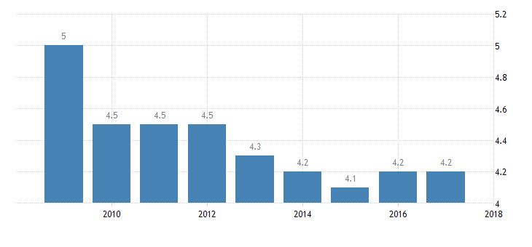
Graph 3.5.3: Unemployment rate of Bangladesh from 2010-2018
The rising unemployment rate of Bangladesh is increasing day by day. Now a day’s most of the employees in the country are also facing about job insecurity. It is happening in the private jobs because employees in the private jobs have lack of job security because of huge number of unemployment workforce. In the opposite side government jobs have very strong job security for some political and legal issues. In the developed countries especially in America, Australia, Canada, Europe has less job security in the government and private job sector. According to their point of view, performance is required for better job security. Bangladesh government is also taking many initiatives to resolve this problem because if public sector jobs have strong job security then employees will not provide appropriate service to the local people.

Raising Increase: The transition economics is also knowledgeable price rise as an outcome of the elimination of value panels executed by authorities. When this is occurred, the fresh-private firms instigated to custody values that reproduced the true costs of manufacture. In addition, some organizations are browbeaten their situation and elevated values in an effort to revenue from the position. In Bangladesh most of the youth labor force is facing the unemployment issues and Bangladeshi government is providing many circular for government jobs. There are many procedures that unemployment rate can be reduced. If government want to make the economy to the knowledge economy than all the skilled labor force should be employed. Every year Bangladeshi government is exporting much skilled labor force in different countries. In the early there was many people, who work at home such as housewife, female teenagers but know different garments hire them into the production unit for utilizing them appropriately. At the bellow the chart of raising increase are given and there are the chart of four years.

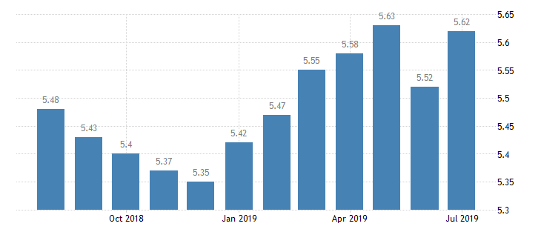
Graph 3.5.4: Inflation rate of Bangladesh from Oct.-2018 to July-2019
Moral Hazard: The situation of ethical danger suggests the mediocre presentation sack ascend when the dangers related through deprived presentation remain protected alongside. As the example of persons protect the fillings of their household in contradiction of robbery and they will are more willingly to leave their opportunities open for the better economic position. In this context of transition economics, below collectivism persons touched the national will protect those in contradiction of the hazards related beside the worldwide rivalry, counting as the hazard of misplacing their works. The importance is that many work forces continued incompetent and infertile, expressive that service scenarios would not be condensed. The moral hazard of Bangladesh is also very low because the corruption rate of Bangladesh is not good. In the year of 2018 Bangladeshi corruption rate according to the world economic index was very high. Bangladesh government also notices that, all the government sector are corrupted and the system of public service in bad. From the Independence war to now Bangladesh economic position was not good but in most recent years Bangladesh economic sector is developing day by day.

Corruption: There are many transition economies that suffered from corruption and they extensive throughout the initial ages of change in numerous previous collectivist republics, and this self-conscious the real outline of marketplace improvements. Many products were unwell made and sold in free and unlawful markets, and numerous needs demanded the illegal possess and extensive illegal process occupied the void leftward by the overview of collectivist governments. This is the biggest factor that can be considered as the barrier to the transition economy. In the eight listed south Asian countries including Bangladesh are considered as the list of developing countries and Bangladesh is considered as high corruption effected country. Now a days Bangladesh government is undertaking many essential steps in reducing the corruption rate. There are many people in the public sector who are taking dowry for satisfying their personal need and takes some illegal procedure. In the government sector maximum portion of employees are not showing their honesty in their service time and for this reason values and beliefs of general public are reducing in the public sector service. In Asia pacific region is the lowest corruption rate country in terms of the list of developing countries list. In corruption rate of Bangladesh is reducing day by day and Bangladesh government is taking many steps to reducing the corruption from the public sector services. At the bellow the chart shows about the Bangladesh corruption index:
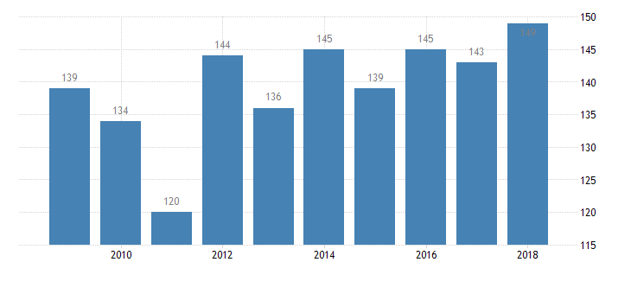
Graph 3.3.5: Corruption index of Bangladesh from 2010 to 2018
Lack of infrastructure: The changeover humanities too agonized after an absence of actual wealth, such as newfangled knowledge, which is obligatory to harvest professionally. This is incompletely since of the partial evolution of monetary marketplaces, and since here was petite innermost speculation after external stakeholders. Undoubtedly, this has transformed as the changeover parsimony obligate changed, and amalgamated the comprehensive bazaar, which has invigorated private outlay after nearby the biosphere. The lack of infrastructure in the economy will provide lack of output to the overall growth of the economy. There are different infrastructures in the economy, which provides better economic growth sustainability in the every sector of any country. According to the data of Bangladesh economic intelligence unit, Bangladesh had gained a lowest score of economic growth over the years of 2001-2005 and its capital per income also very low. Bangladesh’s government is taking many initiative to improve country’s infrastructure in resources building, unplanned use of natural resources, developing skilled labor force, applying laws and regulation successfully, managing change in strategic or aggregate level, balance exporting and importing, understanding generation changes and so many. As there many infrastructure belongs to economic growth so that Bangladesh’s government is implementing many approaches and strategies for developing infrastructure system.

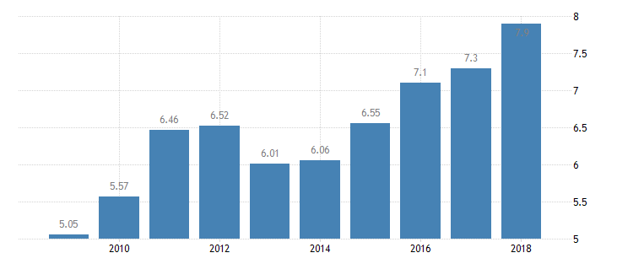
Chart: Bangladesh GDP rate over the years.

Lack of entrepreneurship and skills: Countless change humanities agonized from an absence of businesspersons and free enterprise, which type it additional problematic to improvement their humanities and endorse marketplace entrepreneurship. In calculation, there is also a skills opening with insufficient work forces consuming the indispensable services compulsory by companies in the afresh-transferred corporations. In the Bangladesh there are many people who cannot star up a new business as an entrepreneur for the lack of financial capability. In these days Bangladeshi government are undertaking many initiatives for providing sufficient financial resources to young entrepreneurs for maximizing economic growth of Bangladesh.

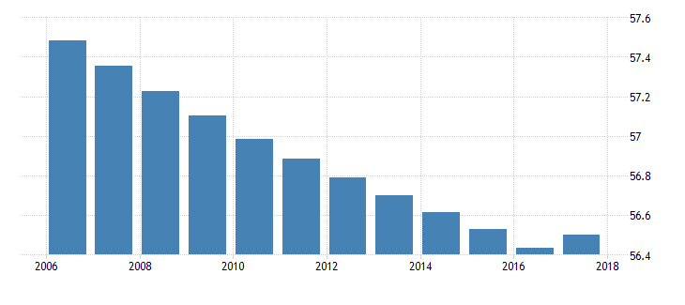
Graph 3.3.6: Bangladesh labor participation rate

Lack of sophisticated legal system: Below collectivism, the national possessed all the key creative possessions, and here was minute inducement to mature a urbane permissible organization that threatened the privileges of regulars, and delimited the actions of creators. Market-driven parsimony resolve first progress when countries are arranged extensive stuff truths, and container defend these entitlements complete the aboveboard procedure. This was out sized absent-minded in the previous Marxist changeover humanities. There are different lacking in the implementation of laws and regulation in different sectors.
Inequality: Financial changeover too led to quickly snowballing unevenly as particular browbeaten their situation as businesspersons and dealers in merchandises, although others agonized after joblessness and intensifying increase.

Chapter 4: Findings and Analysis

4.0 Findings and Analysis:

There are different analysis and findings for measuring effect of transition economy over macro-environment of any country. In this project different analysis and findings are observed for knowing the market potentiality of Bangladesh in terms of global world. In this part SWOT analysis and PESTLE analysis are done analyzing the market of Bangladesh economy and at the bellow those are given by using different graphs and tables:

4.1 Least Development countries in Transition Economy:

Subjects nearby worldwide business guidelines and least development countries need grown many communication and attention for recent economic collapse in the world trade of organization and many negotiations are developed for increasing growth of transition economy. During most of world trade organizations made an agreement for 100 percent duty free and quota free access to US market. But there are several analyses, which are conducted in the context of least developing countries position in the transition economy. In this project there are one analysis is been conducted which is PESTLE analysis. At the bellows table is showing about the position of transition economic countries in terms of their continent and their 48 least developed countries:
.
Africa | Asia | Oceania
Angola | Afghanistan | Kiribati
Benin | Bangladesh | Solomon Islands
Burkina Fa so | Bhutan | Tuvalu
Burundi | Cambodia | Vanuatu
Central African Republic | East Timor | South Africa
Chad | Lagos | Niger
Comoros | Myanmar | Mail
Niger | Nepal | Madagascar
Domestic Republic of Congo | Yemen | Ethiopia
Guinea | America | Togo
Somalia | Haiti | Zambia
Sudan | Slovenia | Senegal
Liberia |  | Mauritians

In the context of the table the World Bank listed some countries, which are Bosnia and Herzegovina and the Federal Republic of Yugoslavia. According to the World Bank information: Kosovo also included in the transition economy list and Mongolia is also added in this list. In the year of 2009 Iran is growing as the transition economy and it has passed the early stage of transition economy. There are also eight European countries, which are added in the transition economy and these are Czech Republic, Estonia, Hungary, Latvia, Lithuania, and Poland Slovakia These countries are fallen into the category of early stage of transition economy. There are also two countries, which are fallen into the second stage of transition economy and these are Romania and Bulgaria. In the year of 2007 10 countries transition period is over in the European Union.

4.2 Developed Countries in Transition Economy:

The developed reflects about some factors and these are advanced infrastructure, skilled resources, and better technology. The developed countries in the transition are advanced in some factors and these are skilled manpower, better technological development, advance infrastructure and use of competitive resources. There are other factors by which developed countries in the transition economy are designed and these are gross national product, income per capital, population standard of living. There are other developed countries, which are contributing more, in the industrial sector. The World Bank published that there are some countries which are known as first world countries for their high national income, strong economic position, skilled labor force, stabilize political condition and high income off general citizen.

Developed countries | Human Development Index
Australia, Austria | 0.953
Switzerland | 0.944
Ireland | 0.938
Germany | 0.936
Iceland | 0.935
Sweden | 0.933
Netherlands | 0.931
Denmark | 0.929
Canada | 0.926
United States | 0.924
United Kingdom | 0.922
Finland | 0.92
New Zealand | 0.917
Belgium | 0.916
Japan | 0.909
Austria | 0.908
Israel | 0.903
France | 0.901
Spain | 0.891
Italy | 0.88
Estonia | 0.871

4.3 Developing Countries:

In the United Nations System there are no designation for “develop” and “developing” countries. There are several countries like Canada, United stated in North America, Japan in Asia, New Zealand in Oceania, Europe are considered as the developed countries. According to the statistics of international trade South African customs union are considered as developing union. Now a day Israel is considered as most developing country in the transition economy. There are also some emerging countries like Yugoslavia are considered as developing countries. Normally in the eastern Europe and some of independent state in the united states including soviet union is not considered as either developed or developing countries.

Comoros | Myanmar | Mail
Niger | Nepal | Madagascar
Domestic Republic of Congo | Yemen | Ethiopia
Guinea | America | Togo
Somalia | Haiti | Zambia
Sudan | Slovenia | Senegal
Liberia | Kuwait | Mauritians
Libya | Laos | Pakistan
Bangladesh | India | Nauru
Georgia | Panama | Nepal
Dominican Republic | Gabon | Mail
Tajikistan | Jordan | Mauritania
Tonga | Jamaica | Moldova
Turkey | Bhutan | Costa Rica
Uganda | Brazil | Iran
Morocco | Palau | Oman
Mexico | Namibia | Poland

4.4 Pharmaceuticals industries of Bangladesh Transition Economy:

4.4.1 OVERVIEW OF PHARMACEUTICAL INDUSTRY OF BANGLADESH
According to Bangladesh Association of Pharmaceutical Industries (BAPI) and Directorate General of Drug Administration (DGDA), approximately 257 licensed pharmaceutical manufacturers are operating in Bangladesh and about 150 are functional1. These manufacturing companies meet around 97% of local demand. Specialized products like vaccines, anti-cancer products and hormone drugs are imported to meet the remaining 3% of the demand. 80% of the drugs produced in Bangladesh are generic drugs, rest 20% are patented drugs. According to Director General of Drug Administration (DGDA), the industry has 3,534 generics of allopathic medicine, 2,313 registered Homeopathic drugs, 5,771 registered Unani Drugs and 3,899 registered Ayurvedic drugs.

Domestic market of Pharmaceutical products in Bangladesh has shown an increasing trend over the past few years and the market size is BDT 187,566 million as on 2017 Q2 (Source: IMS Health Report Q2). However, this number does not reflect total market size because IMS report does not include homeopathic, unani, ayurvedic or herbal medicine information.

According to Bangladesh Bureau of Statistics, the industry has contributed 1.85% to the GDP in 2016-173. Pharmaceutical industry of Bangladesh is largely protected from external competition, as there is a restriction regarding import of similar drugs that is manufactured locally. This industry is the second largest contributor to national exchequer. At the same time, the industry provides the largest white collar (note) intensive employment.
Pharmaceuticals industry of Bangladesh has grown significantly over the last five years. From 2012 to 2017, historical five years CAGR was 15% and from 2014 to 2017, historical three years CAGR was 21%. According to industry experts, market size of pharmaceuticals may reach about BDT 330,000 million by 20204. The table in the below shows year on year size and growth of GDP and size and growth of Pharmaceuticals Industry of Bangladesh. This shows that from 2013-14 to 2016-17. The growth of Pharmaceuticals industry of Bangladesh exceeds the GDP growth of Bangladesh.
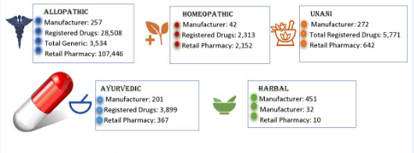

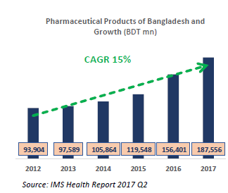
 |  |  |  |  | 2013-14 |  |  | 2014-15 |  |  |  | 2015-16 |  |  |  |  | 2016-17
GDP (BDT Million) |  |  |  | 7,741,361 |  |  | 8,248,624 |  |  |  | 8,835,389 |  |  |  |  | 9,478,975
YOY GDP Growth |  |  |  | 6.06% |  |  |  |  | 6.55% |  |  |  | 7.11% |  |  |  |  | 7.28%
Pharma Market (BDT Million) |  |  |  | 105,864 |  |  |  |  | 119,548 |  |  |  | 156,401 |  |  |  |  | 187,556
YoY Pharma Market Growth |  |  |  | 8.48% |  |  |  |  | 12.93% |  |  |  | 30.83% |  |  |  |  | 19.92%
 |  |  | Source: Bangladesh Bureau of Statistics, IMS Health and EBLSL Research

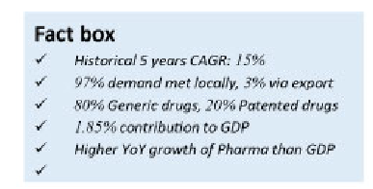

4.4.2 Key drivers for growth of Pharmaceuticals Company in Bangladesh

Economic Growth: The country’s growth has been healthy and growing by 6-7% each year. This has contributed to higher per capital income and growing middle and affluent class population. With growing industrialization over the next decade, income level is expected to increase further leading to higher consumer spending. Demand for consumables like medicines would also increase in tandem with rising disposable income.
Population Growth: Although Bangladesh’s population is growing at a steady pace of 1.2%, total population is already around 166 million, with population expected to reach 250 million within 2025. (Source: WB) Higher population will increase demand for essentials like medicine.
Healthcare and Life Expectancy: Bangladesh’s population life expectancy has increased to 71 years, which is particularly due to better access to healthcare and increased awareness of health issues. With rising average age of the population, demand for healthcare products and services would increase at a significant pace.
Environmental Issues: Bangladesh’s urban population is particularly exposed to adverse environmental impact, which includes- pollution and contaminated food, which have resulted in increased risk of chronic non-communicable diseases. As a result, increasing number of people would require rigorous healthcare services.
Changing Life Style: Life of city dwellers and urban people is changing rapidly. They lack proper nutrition and rest. At the same time they take adulterate food and face different pollution. To keep healthy, they have to rely on advice of physician and medicine heavily.
High Life Expectancy: Life expectancy among the people has significantly increased. In 2015, life expectancy at birth is 72.2 years where it was only 66.4 years in 2002. To achieve a longer life, people use to consult with physician regularly and take different medicine according to the prescription of doctor.

4.4.3 MARKET POSITION OF DIFFERENT COMPANIES
Bangladesh has a well developed pharmaceutical industry. It is enhancing the country’s economic growth greatly. According the report of the year 2000, there have been 210 certified allopathic drug manufacturing companies in the country, from which only 173 were activated production. Others units were either shut down by themselves or hanging by the certification authority for drugs because of noncompliance to good production practices as well as drug regulations.
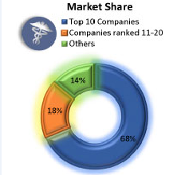
The Pharmaceuticals market is concentrated among few local companies only and entry barrier is higher due to large capital investment and legislative bindings. Square Pharmaceutical is the market leader having 17.73% market share followed by Incepta, Beximco, Opsonin and Renata. Multinational companies hold only 9.39% of market shares. The table below shows the current market share hold by leading pharmaceutical companies as per IMS health report Q2, 2017 and comparison against 2016.
.

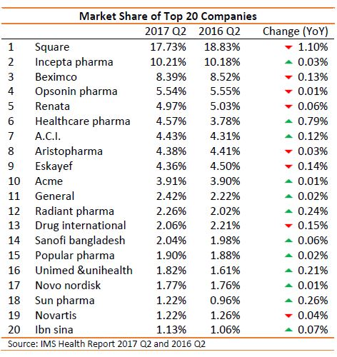

4.4.4 EXPORTS OF PHARMACEUTICALS PRODUCT
The sector is emerging as an emerging export destination as a number of top local Pharmaceutical companies- Beximco, Square, Incepta- have received FDA approvals for exporting to developed markets. Alongside, pharmaceutical players are targeting to capture a significant market share in price sensitive African markets. Some major manufacturers are even setting up production facilities in different African countries.
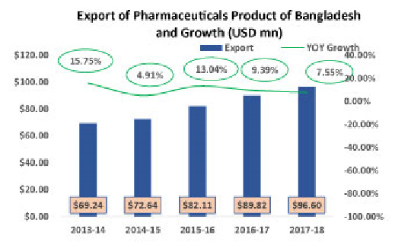

Considering Bangladesh’s export potential, government has been supporting the sector through policy support and incentives like tax holidays, priority in getting lands and allocation of dedicated economic zones. Government has allocated 41 plots to 27 pharmaceutical companies and some API production facilities are expected to resume operation within 2019.

4.4.5 Opportunities in Global Generic Drugs Market for Bangladesh
- Opportunities in Global Generics▪Currently valued at ~ $350 b
- Generic drugs will continue to grow maintaining healthy rate
- Drugs worth more than $150b coming off patent by 2020
- Rising healthcare cost, particularly cost of medicine has become a global concern
- Developed countries are increasingly promoting access to generic drugs
- MNCs are outsourcing their production from cost-effective destinations
- Major generic hubs India and China are losing cost advantages

4.4.5 Trade Related Aspect of Intellectual Property Rights (TRIPS):
TRIPS Advantage Bangladesh and other LDCs are exempted from patent protection for an extended period until 2033 (from original 2016). Bangladesh is allowed to produce any patented medicines without taking prior permission from innovator.

4.4.6 TOTAL HEALTH CARE EXPENDITURE

Health expenditure, total (% of GDP) in Bangladesh was reported at 45.1 % in 2014, according to the World Bank collection of development indicators, compiled from officially recognized sources. Total health expenditure is the sum of public and private health expenditure. It covers the provision of health services (preventive and curative), family planning activities, nutrition activities, and emergency aid designated for health but does not include provision of water and sanitation.
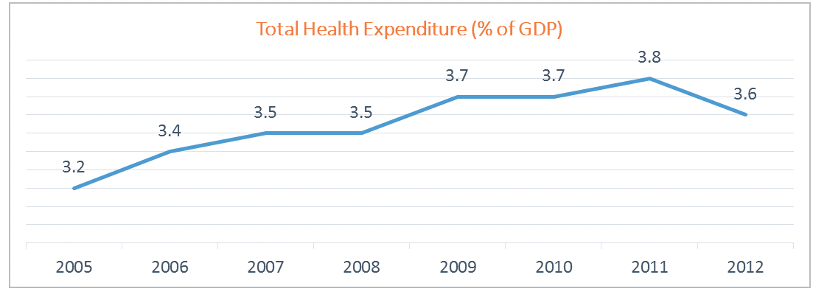

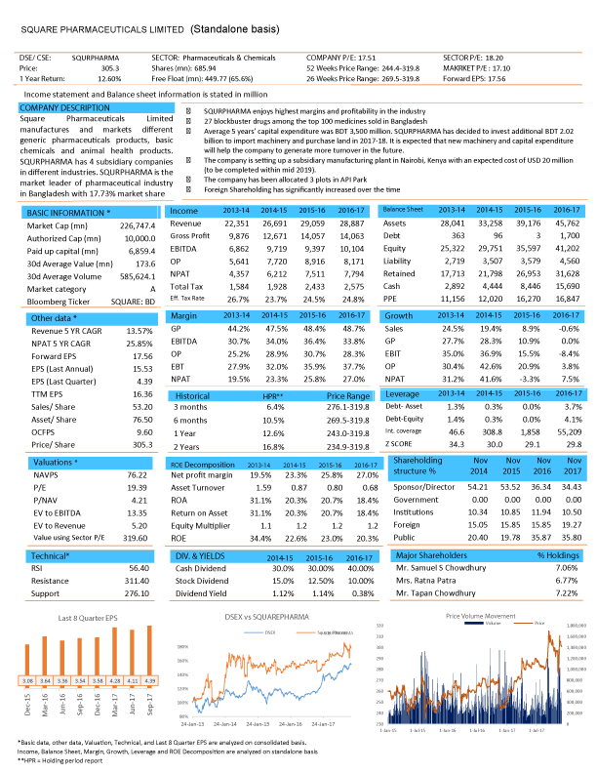
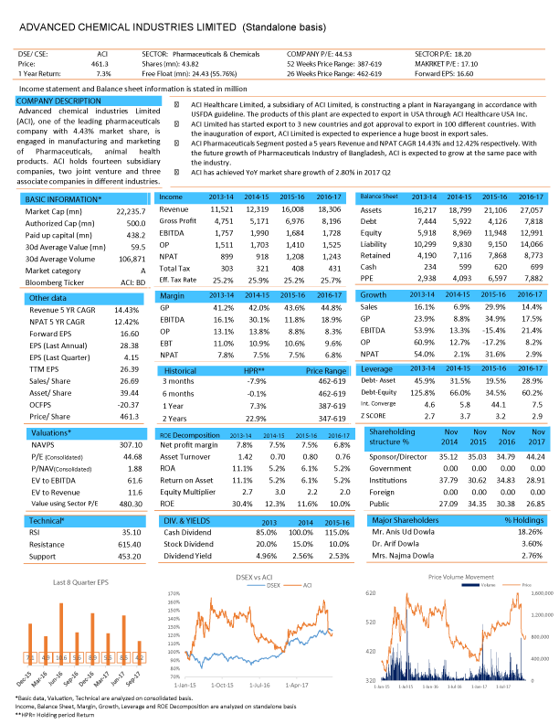
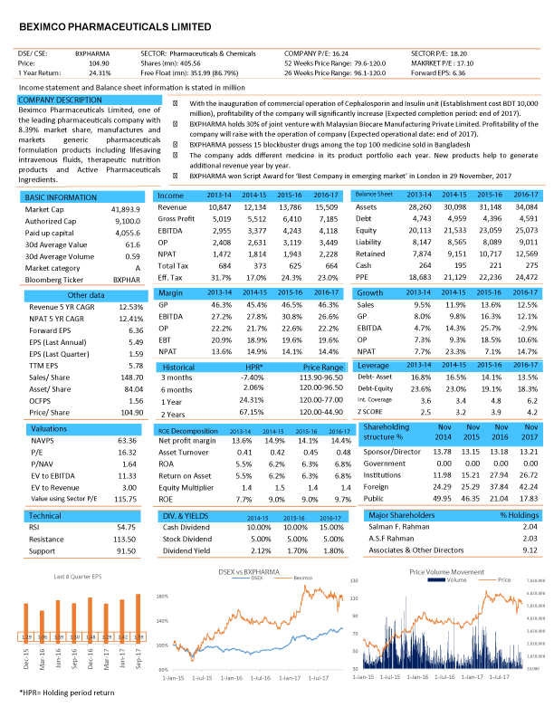
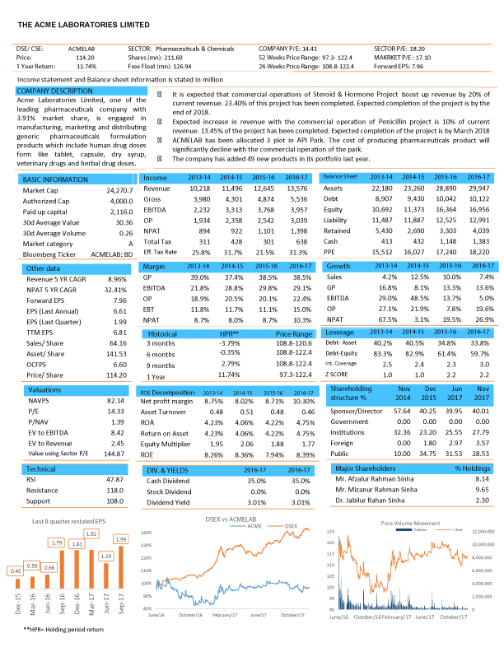
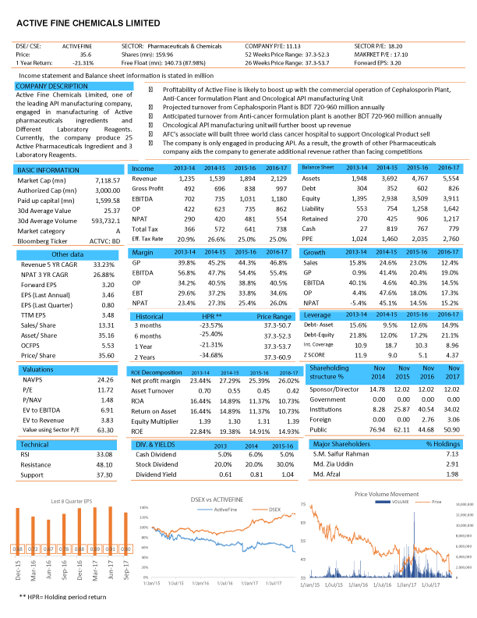

4.5 PESTLE analysis:
Political:
- Low political stability.
- High corruption by political party.
Environmental issues:
- Poor environmental condition in the urban sector.
- Poor maintenance of water, soil and other natural resources.
- Prevention of different natural disaster like flood, cyclone and other socio economic damage.

Legal:
- Poor stated policies in the foreign direct investment
- Low implementation of legal activity.
- Less difference in domestic and foreign investors in terms of investments or exports or imports.

Economic
- High corporate taxes.
- Low rate of using wide range of water transportation.
- Poor rules and regulation on public based transport.

Social
- Export sector is changing in terms of globalization affect.
- Low social awareness in the social contribution.
- Integrated social responsibility for strategic investments as the core business strategy.

Technological:
- Better technology used in different industrial sector.
- Strong emphasis on technological development and telecommunication issues.
- Proper planning in the technological adaptation.
- Government involvement in the formulated and adopted technology.

Table: PESTLE Analysis

At the above the PESTLE analysis in given from the perspective of Bangladesh economy. Bangladesh is increasing day by day and its economic growth also converting its traditional economy to transition economy. Now a day’s government also planning to make 100s economic zones in Bangladesh and most of the economic zones are covered different areas of Bangladesh. Bangladesh government also is planning to increase the average income rate of persons. The main reason of Bangladesh poverty line is corruption because some group of people illegal amount of money by making corruption. Government also is taking different types of initiatives for reducing corruption. Most of the people in our country are illiterate and they are no understanding the skilled labor force benefits.

Chapter 5: Recommendation and Conclusion

5.0 Conclusion:

The economic condition of Bangladesh is table and it is capturing a sustainable growth over the years. In the most recent years Bangladesh position transition economy in term of least develop countries is second. The external environment of Bangladesh like political and legal factors are getting strong day by day and many more foreign investors are making investment in different sectors of industries of Bangladesh. Bangladesh exporting sector of garment is in better position and Bangladesh is shifting from agricultural based economy to industrial based economy. The technological and globalization affect also increasing day by day and it is creating a multiplier effect for economic sustainability. Bangladeshi government “Shekh Hasina” is trying to improve the educational sector with the aspect of technology. According to the result of Bangladesh BSTI educational sector is not improving day by because the quality education is not supplied. In the terms of transition economy educational sector must need to improve for further development in the economy and stable political condition in the country also refers a strong economic transition.

5.1 Recommendation:

- For better economic transition political stability is required because foreign investors will not invest without good political stability.
- The strong political leadership is required and Bangladesh government should motivate social workers, civil society and media personalities for creating strong morality in the civil society.
- Minimizing the corruption rate in all sectors is required for sustainable economic development.
- There must need three phase planning and these will be on short term, midterm and long term. The government should take major step for minimizing the unemployment rate.
- Longer kind of strategy should need to implement for making people life more secure and better quality should need to imply for maintaining better from educational sector.
- Better infrastructure should build for making appropriate economic transition. Regulate the entire sector directly by the law force.
- The women empowerment is necessary for further development in the economy and every nation in the world ensure women empowerment for sustainable growth in the economy.
- Fix a perfect and appropriate salary scale for low level workers because most of labor force are not getting sufficient payment form many organization for poor law implementation policy.

6.0 References:

Reference:

World, B. (2019, March 27). The World Bank of Bangladesh. Retrieved 9 2019, 23, from World Bank: https://www.worldbank.org/en/country/bangladesh/overview

Bangladesh Bank. (1991-2003). Economic Trends. [Monthly issues from 06/1991 to 07/2003].Dhaka: Bangladesh Bank.
Bangladesh Bank. (2002-2003). Annual Balance of Payments 2002-2003. Dhaka: Bangladesh Bank.
Bangladesh Bureau of Statistics. (1997). Summary Report of the Household Expenditure Survey 1995-96, August 1997, Dhaka: Government of Bangladesh.
Bangladesh Bureau of Statistics. (2000). 2000 Statistical Year Book of Bangladesh, Dhaka: Government of Bangladesh.
Bangladesh Bureau of Statistics. (2003). Report of the Household Income & Expenditure Survey 2000, March 2003, Dhaka: Government of Bangladesh.
Bhattacharaya, D. (2002). Bangladesh Economy in FY2001: Macroeconomic Performance. In Centre for Policy Dialogue. Bangladesh Facing the Challenges of globalization: A Review of Bangladesh's Development 2001. Dhaka: University Press Limited.
Bhattacharya, D. (2003). State of the Bangladesh Economy in FY2002: Fiscal Consolidation, Balance of Payment Improvement and Investment Stagnation. In Centre for Policy Dialogue.Employment and Labor Market Dynamics: A Review of Bangladesh’s Development 2002. Dhaka: University Press Limited.
http://www.bapi-bd.com/bangladesh-pharma-industry/overview
http://www.dgda.gov.bd/index.php/registration-dashboard
http://www.bbs.gov.bd/site/page/dc2bc6ce-7080-48b3-9a04-73cec782d0df/
http://acmeglobal.com/acme/investors/financial-reports/annual-reports/
http://www.worldbank.org/en/publication/global-economic-prospects#data

