INTERNSHIP REPORT
ON
Asset Management Procedure of IDLC (Industrial Development & Leasing Company) Asset Management Limited.



UNITED INTERNATIONAL UNIVERSITY
Prepared For:
Mosabbir Uddin Ahmad
Assistant Professor
School of Business & Economics
UNITED INTERNATIONAL UNIVERSITY
Prepared By:
Ikbal Hossain
ID: 111 151 004
Date of Submission: 18th June, 2019
Asset Management Procedure of IDLC (Industrial Development & Leasing Company) Asset Management Limited.

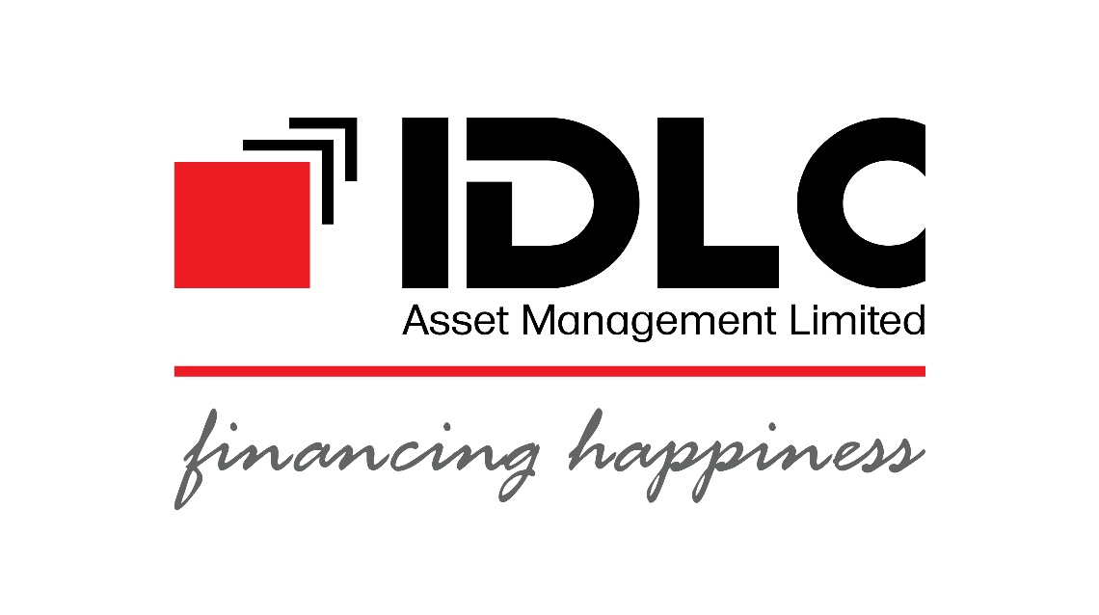

Letter of Transmittal
18th June, 2019
Mosabbir Uddin Ahmad
Assistant Professor
School of Business & Economics
United International University
Subject: Submission of Internship Report on “Asset Management Procedure of IDLC Asset Management Limited”
Dear Sir,
It’s my pleasure to submit my internship report. The topic of my report that you were chosen to me is “Asset Management Procedure of IDLC Asset Management Limited”. This was assigned to me as a partial requirement for the completion of my BBA program. I have given my full efforts to make my report successful.
You will be glad to hear that this report has been prepared under your effective guideline. I tried to prepare that report as much as informative and resourceful based on the topic. From different sources as well as my intern working place “Gulshan Branch” of IDLC Asset Management Limited, the data that I collected which helps me to acquire different knowledge. That knowledge may help me in my real life.
I am really thankful to you for providing me such an exciting opportunity to give you the report. I appreciate the report topic by me heart. It will be my privilege if you provide me the feedback.
Sincerely Yours,
………………………………..
Ikbal Hossain
ID: 111-151-004
BBA in Finance
United International University

Acknowledgement
Thanks to my Allah, the merciful, for giving me all the blessings. I want to give thanking to my parents also. It was a long journey duration of three months that I have finished my intern successfully at IDLC Asset Management Limited. Internship is a part of my BBA Course. So, the completed report is prepared now.
The gratefulness that I have to talk about to Mr. Mosabbir Uddin Ahmed, Assistant Professor, honorable faculty member, United International University, School of Business & Economics. Under his supervision as well as guideline, I was inspired while doing internship. I am very much grateful to him for assessing and evaluating the course, the report is finally ready.
It’s my pleasure to say the gratefulness of the Managing director, IDLC AML, Rajib Kumar Dey. He was much supportive to do my internship. I also thanks to all the other employees of IDLC AML for welcoming me. Specially, I must say thanks to Itrat Hossain, CFA, and Investment Analyst. All of their kind support I successfully have completed my internship. I have gathered lot of practical knowledge working in there.
Finally, I am very much delighted to express my gratefulness to United International University for giving me the opportunity to acquire my BBA degree.

Executive Summary
My internship paper is prepared to make an overview about the asset management procedure of IDLC Asset Management Limited. Industrial development and leasing company abbreviated as IDLC is the leading company in the financial industry in Bangladesh. IDLC group has been operating in Bangladesh successfully since many years. IDLC is contributing a great role to the financial industry in our country. The details about IDLC group is also included to that report. The asset management which is called the fund management is the important activities of IDLC group. The company name is IDLC Asset Management Limited which is the subsidiaries of IDLC Group. There are many highly qualified as well as very experienced employees working together. They have a great knowledge about the financial industry. As an intern student, I have got an opportunity to work at IDLC AML with those highly qualified Portfolio Management Team. I worked in different areas. Every week I have to assign the net asset value of the different mutual fund companies operating in Bangladesh. These NAV report is published to the daily news of “Financial Express”. I had to read the daily news to find out the foreign development funds or donor money which would impact to the stock market of Bangladesh. Again, I had to analyze the different sectors like Pharmaceuticals, Fuel & Power, Cement and Engineering industry. These industries annual report analyzing and find out the efficient company where the high return will get if invested to the fund. Moreover, I had to work in different research activities of investments and investment criteria. This report helps to understand what I learned in the three months period. It will overview the company profile. Then introduce the different funds. After that to focus the process of investment systems as well as many more in details. Also include my references what will be the helpful the organizations. Despite of different obligations, I tried to give in depth information as I can.

Contents
Particulars
- Directory Fund
- Abbreviation
- Risk Factors of The Fund
Chapter 1: Introduction 4
1.1 Origin of the Report 5
1.2 Objective of the Report 5
1.3 Limitation 6
Chapter 2: 7
Overview of IDLC Asset Management Limited 7
2.1 Introduction 8
2.2 History of IDLC AML 9
2.3 Product and Service 9
2.4 Sister Concerns 9
2.5 Philosophy 10
2.6 Journey 10
Chapter 3: Management Procedure of Funds 12
3.1 About Mutual Fund 13
3.2 IDLC SIP 14
3.2.1 HOW IDLC SIP SERVICES 14
3.2.2 Steps of SIP 14
3.2.3 ADVANTAGES OF SIP 15
3.3 IDLC GROWTH FUND 18
3.3.1 Origination 18
3.3.2 Viability 18
3.3.3 Market Price, Size, Branch 18
3.3.4 Purpose- Investment 18
3.3.5 Assessment policy 18
3.3.6 Calculation Price of Asset: 19
3.3.7 Purchase & Surrender Procedure 19
3.3.8 The Dividend Process 19
Chapter 4: Process of Investment Management 21
4.1 Allocation of Asset 22
4.2 Various Type of Assets: 22
4.3 Analysis Investment: 23
4.4 Philosophy of Investment 23
4.5 Selection Process of Asset 24
Chapter 5: Administration, Formation and Management 26
5.1 Sponsorship 27
5.2 Trustee of the Fund 27
5.3 The Fund Custodian 27
5.4 Management 27
5.5 IDLC AML Concern Persons 27
5.6 IDLC AML Senior Management of 28
5.7 The Fund Auditor 28
5.8 Formation Costs and Issue 28
5.9 Size of Issue 29
5.10 Selling Author 30
Chapter 6: Findings, Recommendation and Conclusion 31
6.1 Findings and Recommendations for Portfolio Team: 32
6.2 Conclusion 33
References: 34
Appendix 35

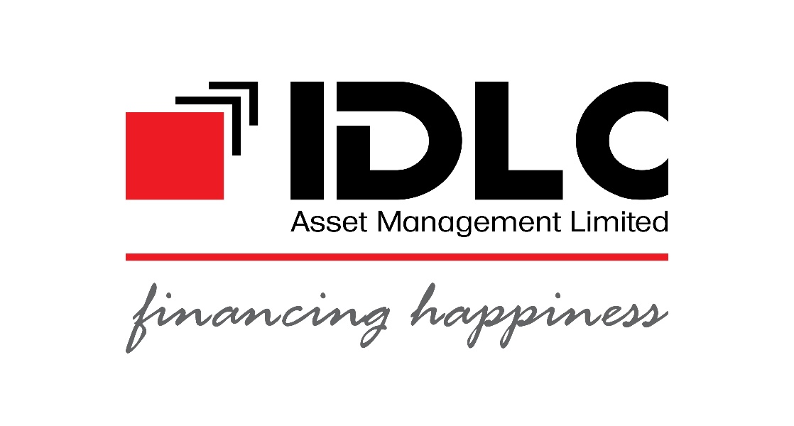

Particulars

Directory of Fund
Sponsor | IDLC Finance Limited
Trustee | Bangladesh General Insurance Company Ltd.
Custodian | BRAC Bank Limited
Asset Manager | IDLC Asset Management Limited
Auditor | Malek Siddiqui Wali, Chartered Accountants
Banker | BRAC Bank Limited
Selling Agent | IDLC Group

Abbreviation
Rule | Securities & Exchange Commission (Mutual Fund) Rules.
Asset Manager  Fund Manager  Investment Manager/AMC | The Asset Management Company (AMC) refers to “IDLC Asset Management Limited”
BB | Bangladesh Bank
BDT | Bangladeshi Taka
BEFTN | Bangladesh Electronic Fund Transfer Network
BGIC | Bangladesh General Insurance Company Ltd.
BO A/C | Beneﬁcial Owner Account or Depository Account
BSEC / Commission | Bangladesh Securities & Exchange Commission
CAGR | Compound Annual Growth Rate
CDBL | Central Depository Bangladesh Ltd.
CEO/MD | Chief Executive Oﬃcer/Managing Director
Companies Act | Company Act, 1994
Fund / Scheme | IDLC Growth Fund
Unit Holder | Individual or institution holding of IDLC Growth Fund oﬀered under this oﬀer document

RISK FACTORS
There are some risk factors of IDLC Growth Asset:
Ordinary Risk:
- Different issues may affect the capital market and money market in Bangladesh. So investing these funds to different sectors may go up or down the price or values of the fund.
- Sometimes government may imposed any kind of obligations like tax. This is the crucial part of the investing to invest.
- Different policy can be generated by the policy makers and thus may affect the funds.
- Moreover, in different situations, fund manager may undertake quicker decision to buy or sale the funds. That may lead the funds price movement.
- Disposal problem of the funds can affect to the mismatching of the funds.

Chapter 1: Introduction

1.1 Origin of the Report
It is my great pleasure to prepare the report. This report is chosen by Mosabbir Uddin Ahmad, honorable course director. I tried to prepare this report according to the Asset Management Activities of IDLC Asset Management. I added to this report in various topic wise. These are formation of the fund, investment management process, risk factors management process, formation, management, size of the fund and another area includes unit subscription, sales agent. This report includes how the funds are used to investment and I learned the real life activities of the mutual funds.

1.2 Objective of the Report

Broad Objective:
Getting an idea about activities of IDLC Asset Management Company.
Principal Objective:
- To know the overall activities of fund
- To know about the risk factors
- To know the whole operation process of growth fund
- To know the decision making process of the fund
- To know the present situation and growth of the fund
- To know the investment legitimacy
- To know the funds size, tax rights of unit holders
- To know the formation, management, and administration
- To know the NAV
- To know the investment management process
- To get an in-depth view of the fund

1.3 Limitation
I worked hard to prepare this report. I tried to give my highest efforts to make this report relevant and informative. But still there are some limitations while preparing this. These are as follows:
- The first limitation that I faced most is proper time. Many things I missed because there was not enough time. But this intern period is very much effective to learn the practical knowledge but I could learn deeply of the management of assets giving much time.
- While doing intern at this company I had to face such situation like some information which is not disclosed to the external people because of the confidentiality rules. Although all organizations have some secret information or policy that they do not want to disclose.
- Again, job replacement is another issue. Many employees come and go if they get another better opportunity. So, the relationship sometimes is very tough to become intimate for knowing much more information.
1.4 Methodology
I have collected data from different sources. Actually primary data collections is helps most. Again secondary data has the details. My data collections was two different sources. These are as follows:
Primary Sources:
Most of the data I collected from the internal sources of the company. Talking directly with the employees, talking with the existing intern students of different universities. That primary data helps me most to get depth information.
Secondary Sources:
The secondary data method collected from various sources. These are:
- Internet Web Browsing
- Annual Report and Prospectus of IDLC AML

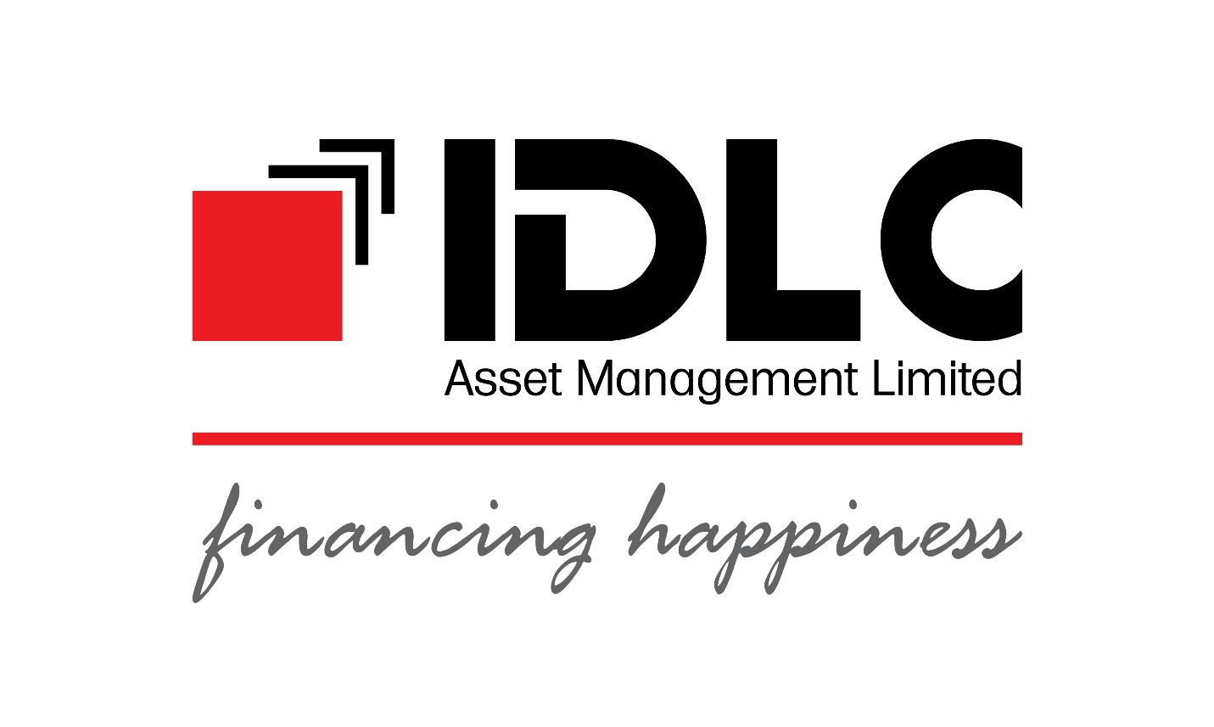

Chapter 2:

Overview of IDLC Asset Management Limited

2.1 Introduction
IDLC is a renowned financial institutions in Bangladesh. It has a long journey operating in our country. It has been almost 3 era that they are doing business in financial industry. IDLC group is offering many financial products. They are operating in investment areas, stock market areas, consumer loan, home loan, car loan, SME loan, different mutual funds and many more upcoming products they are developing. It is a diversified company. More than thousands of employees are working in there. IDLC has many branches in different remote areas of the country.
I worked three months long intern in IDLC AML. Based on my working experiences and real life experience, I have prepared this report. This report is necessary for completion my BBA program in the School of Business & Economics at United International University. I have prepared this report based on gathering the information during the whole intern period. From the beginning I started to collect the information. In this report I tried to focus on different areas of managing the asset of different mutual funds. I was assigned to the portfolio management team of IDLC AML. So, I tried to focus the investing activities, how investment run, how the funds are managed. I tried to give in details. I worked in various diversified sectors like pharmaceuticals, power and fuel, cement and many more industries annual report analysis and viewing the overall conditions of the micro and macro environment of the sectors. Evaluating the business context of these industry. Finally, which industry would be greater value to maximize the investors?
Under the asset management IDLC AML, I knew about the products of that company. IDLC AML mainly offers to the investors are growth and balance fund. Other product is Systematic Investment Plan which is called SIP for the employees of medium and small earnings. IDLC AML upcoming products will be Sharia Fund. This fund is for the Islamic minded people. That fund will be invested under maintaining the Islamic law and rules of conduct. Again, there are Private Capital and Venture Capital products for the entrepreneurs which is under launch. These different funds are offered by IDLC AML for the investors. Thus IDLC AML is contributing to develop three country’s economy.

2.2 History of IDLC AML
IDLC Asset Management Limited which was incorporated on date of the 19th November 2015 with an authorized capital of BDT 250 million. This company operating asset managing tasks since 2016. Their capital was 100 million Tk. It has started it’s alternative investment process in 2018. It is the first Bangladeshi asset managing company which offers to insurance as well to it’s investors. It was a great initiatives for this industry. The parent company of IDLC AML is IDLC Finance. This parent company is monitoring all the activities of the company.

2.3 Product and Service
Mutual Fund
IDLC AML offers different mutual fund products to their investors. It offers to the targeted individual as well as organizations or institutions to invest. This company has mainly two products. These are as follows:
- Growth Mutual Fund &
- Balanced Mutual Fund
Alternative Mutual Fund
IDLC AML provides other services for institutional investors of different institutions. Which are:
- Venture Capital
- Private Equity

2.4 Sister Concerns
IDLC AML has various sister concerns operating in financial industry. They are as follows:
- IDLC Finance Ltd.
- IDLC Investments Ltd.
- IDLC Securities Ltd.

2.5 Philosophy
IDL AML believes in using genuine financial knowledge and satisfactory investment conveyance for maximizing the growth of people’s wealth. With a view to accomplishing that, the objective are as follows -
- Making the general people to make aware about the knowledge of financing and to make proper planning of money.
- Aiding people helping their plans by providing proper investment vehicles
- Helping people to feel financially secure and feel confident of a brighter and flourishing future.
VISION
IDL AML wants to be Bangladesh’s best one institution to the context of the phrases to investors’ relines as well as wants to best company of managing asset.
MISSION
IDL AML wants to be the most-preferred terminus for investment knowledge, investment products and investment return in Bangladesh for individuals as well as institutions.

2.6 Journey

Spectator of the key milestones it has achieved over the years
2018
- On the 22nd February 2018permission for Prospectus of IDLC Growth Fund
- On the 27th February 2018, IDLC Growth Fund was launched
- On the 27th February 2018, Launching of IDLC Systematic Investment Plan (SIP)
2017
- On the 27th April 2017 Permitted for Prospectus of IDLC Balanced Fund
- On 22nd May 2017 it was launched of IDLC Balanced Fund
2016
- On the 7th June 2016, It Was granted the asset management license to IDLC Asset Management Ltd. (AML)
2015
- In 19th Nov 2015, it was started as a private limited company and a subsidiary of IDLC Finance Ltd.

Chapter 3: Management Procedure of Funds

3.1 About Mutual Fund
The dreams are what people live for. And life flows better when people making plan to gain the desire dreams. IDLC AML dream for a better future for the family, better education for the children. In order to make planning for dreams, one critical portion is money and it grasps active efforts for really grow money. There is a way which is Investment to really grow money. While to save to keep money safe, investment uses people’s money producing value and that comes back to people as more money.
Worldwide, it is a most useful way of conveyance in growing money. A mutual fund is managed under professionally where investment conveyance that pools money from many investors for investing in securities for example as bonds, stocks and money market instruments. Mutual funds which are managed by professional asset managers to achieve the investment goals of the investors of the fund.
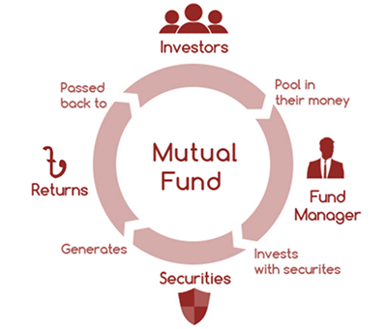
Figure: Management of Mutual Fund

3.2 IDLC SIP
It is an easy, suitable and highly furnished system for making investment for fulfilling people’s financial objectives. Under the SIP, usually investors invest a fixed amount of money per month during a specific period in a proper mutual fund accessible for them. Mutual funds are managed by professional asset managers to achieve the investment goals of the fund.

3.2.1 HOW IDLC SIP SERVICES
Investors can open SIP account in any mutual fund managed under the IDLC Asset management Limited (IDLC AML) always for a period of three years or more, to submit the necessary legal papers with the IDLC SIP form. The minimum per month installment size is Tk. 3,000 or any multiple of Tk. 1,000 more Tk. 3,000 for single investors and Tk. 10,000 or any multiple of Tk. 000 for more Tk. 10,000 for institutional investors.
Per month IDLC SIP installments are invested in certain IDLC mutual funds, which is selected under the investors at the time of opening IDLC SIP account. The buying units of mutual funds that are transferred to the particular BO accounts of investors.
On the maturity of the IDLC SIP period, investors can completely liquidate to their investments to sell the units to IDLC AML at the current surrender price at that tenure.
Again, Investors can anytime extract their investments, completely or partially, without any penalty or price.

3.2.2 Steps of SIP
Step 1
Firstly, Investors open SIP account to a secured amount of money every month that is for a fixed period.
Step 2
Secondly, Every month IDLC SIP part payment are pooled from investors' bank account.
Step 3
Thirdly, Per month SIP installments that are invested in IDLC mutual fund units choosen by investors.
Step 4
Fourthly, The purchased mutual fund units which are transferred to Investors account.
Step 5
Finally, At the time of maturity, investors withdraw/sell the units at the current surrender price

3.2.3 ADVANTAGES OF SIP


Figure: Make a Habit of Savings


Figure: Elasticity


Figure: Secure Life Goals During Someone’s Absence


Figure: There is a Power of Compounding Return


Figure: Break Market unpredictability


Figure: Tax Under Managed

3.2.4 Purchase and Sale in SIP Procedure:
It is very easy to invest in SIP. There different ways to purchase and sell the units. Every investor has their own BO Account. Investor can use automatic card system under the BO Account to the given bank. Investor can use cheque as well. Again there are selling agent also thus they can buy and sell the units of funds.
There is no any obligation for selling the SIP. Those investors who have the long time period investment, if they want to surrender then they can easily do it. Always they can reduce their plans. But in this situations, Agents or authority might have reduction some cost. It is very low which is one percent. Because the fund management has a maintenance cost.

3.3 IDLC GROWTH FUND

3.3.1 Origination
The Trust Deed action of the Fund was registered on the 11th September 2017, under the trust law, 1882, 1908 Registration Act, By a Trust Deed came to between Bangladesh General Insurance Company Limited (BGIC) and IDLC Finance Ltd. That was authorized under the BSEC on date of the 29th October 2017, under the rules of SEC (Mutual Fund), 2001.

3.3.2 Viability
- Type: Open-end fund
- Duration: Perpetual
- Investor: Individual, Institutions as well as any global investor.

3.3.3 Market Price, Size, Branch
- Primary size: Tk. 500.00 million.
- Units Tk. 10.00 each.
- The Size of the Mutual Fund that will be increased over time to time through the Asset Manager subject to permitted of the Trustee and in order to indication of the BSEC.
- The Face value of per Unit will be Tk.10.00
- For institutions: 5000 units, for individual: 500 units minimum.

3.3.4 Purpose- Investment
Main Purpose of the IDLC Growth Fund is to bring about longer period capital valuing from a portfolio of mostly equity & equity associated instruments.

3.3.5 Assessment policy
The investment pricing procedure are as following:
For Listing Share | - On that time when quoting the value of shares during valuation will be the base of assessing NAV in that particular share.  - Not traded to the Stock Exchanges during the specific pricing period, instant last quoted of closing value, where one is closer but that is maximum 30 days of pricing tenure, then it will be counted.
Shares Which Not Listing | - According to the process of the commission, both management and trustee have to follow the rules and guidelines for not listing shares.  - Asset Management Company and the Trustee shall price the non-listed securities at least one at per 3 months.

3.3.6 Calculation Price of Asset:
To get the asset value (Net) of fund, management operates some process. The per unit asset pricing are:

Total Net Asset Value = Value of all securities – Liability or Payable of securities.

Net Asset Value each shares = Sum of Net Asset Value ÷ Number of shares.

3.3.7 Purchase & Surrender Procedure
- The Units Growth Fund might buy / sell under the company and their surrendered concern people those are legitimate by the AML over period to period as well as other ways that are set through the Asset Manager. Selling of units is admitted exclusively by IDLC Asset Management Limited or the selling agents where the units are actually bought.
- Minimum buying amount at the time of public subscription are as follows :
- Individual: For individual might buy minimum 500 shares and price of 5000 taka.
- Institution: For the institution might buy at least 5000 shares the price of 50000 taka.

3.3.8 The Dividend Process
- Management might allocate at least 50 percent or above might be set on by the rules during period.
- Time starts according to the company’s fiscal year.
- The Fund can make equal reserve of satisfactory through revenue for ensuring stability to provide earnings disbursement for every year.
- Before declaring the dividend, company can make supply in negotiate, it depends on the situation of the investment market.

Chapter 4: Process of Investment Management

4.1 Allocation of Asset
All the company have the goal is to maximize the value to their shareholders. Because company runs the business to the help of the shareholders. Basically shareholders are the owners of the company. IDLC AML also wants to maximize the value of the shareholders. They want to generate the high return from the market and try to become the market leader and capital acquiring.
Assets generating Income: Assets which causing income on structured basis example as debt instruments, fixed deposits, and high dividend yielding stocks.
Allocation of Asset of that asset’s portfolio are given below:
Instruments | Distribution | Movement
Income Generating | 20% | ±20%
Growth Assets | 80.0% | ±20.0%
.

4.2 Various Type of Assets:
There are many asses are performing in Bangladesh. Assets which are in our investment market are as follows:
- Equity: The shares act for a right of possession interest is called equity. There are different types of equity. They are:
- Equity under listed: Authority who has shares that operates in investment or stock market. It has quicker liquidation.
- IPOs: Which distributes a particular percentage. It usually 10%.

- Shares which earning is fixed: Those shares provide the fix return. For example:
- Term Deposits It can make in the phase of term deposits in NBFIs and Banks.
- Shares provide Government: Treasury Bonds, Treasury Bills.

4.3 Analysis Investment:
The following analysis are taken:
A. Technical Analysis:
It means value to the shares which has available information publicly. Moreover. It depends on the supply and demand of the market. The historical value and volume of the stock also specifying the market trend
B. Fundamental Analysis:
- Industrial Analysis- It means country’s particular business sector. The growth of the sector according to the social, political and other factors.
- Economic Analysis- Country’s GDP, expenditure, revenues and others.
- Company Analysis- Net revenue, liability, and many more instruments are analyzed

4.4 Philosophy of Investment

Figure: Investment Philosophy

4.5 Selection Process of Asset
Investment Style:
IDLC Asset Management Limited follows the fundamental and tactical analysis

Figure: Style of Investment
Procedure followed for Investment Decision:
- IDLC AML has occupied specific sector of fund managers
- The investment committee decide the recommendation of fund manager.
- IDLC AML has its own investments committee where directors, portfolio managers, and analyst are included.
- The managing director guided the investment committee.
- The director presented the sectors.

Figure: Investment procedure
Who to take in Investment:
- Person who has the knowledge about the capital market
- Individual investor who is looking for long time investment.
- Determining the other factors, individual can invest.
- Individual who finally decided to invest of these funds.

Chapter 5: Administration, Formation and Management

5.1 Sponsorship
IDLC Finance Company who takes sponsorship of that fund

5.2 Trustee of the Fund
The trustee of the fund is “Bangladesh General Insurance Company”

5.3 The Fund Custodian
BRAC Bank acts as fund custody.

5.4 Management
Company Itself acts as the Asset Manager of that fund.

5.5 IDLC AML Concern Persons
Chairman
Matiul Islam
Chartered Fellow, FCMI
Director
Arif Khan
Director
Mir Tariquzzaman
Shareholding Director
Akhteruddin Mahmood
Director
Md. Masud K Majumder, ACA
(Ex-officio)
Rajib Kumar Dey, Director

5.6 IDLC AML Senior Management of
Managing Director
Rajib Kumar Dey
Chief Operating Officer
Kazi Mashook ul Haq
Sales & Marketing Head
Ahmed Tamjeed
Investment Analyst
Md Itrat Hossain, CFA
Investment Analyst
Md. Arman Chy. Nayan
Investment Analyst
Kazi Umme Sumaiya

5.7 The Fund Auditor
Chartered Accountants
Malek Siddiqui Wali,

5.8 Formation Costs and Issue
The approximate costs for the issue and starting of the Fund are as given below:

Yearly Cost
Managerial Fees: Under the Securities Authorization Act, that asset will give the management cost through the concerns managerial are following:
- Each annum 2.50 % weekly average NAV up to Tk. 5.00 crore.
- Each annum 2.00 % with extra amount of NAV up to Tk. 25.00 crore
- Each Annum1.50 % with additional value of the weekly NAV upto Tk.50.00 crore.
- 1.00% each annum with extra value of the weekly NAV up to Tk.50.00 crore (
Fee of Trustee
They have to give Tk. 4,00,000 or .15% of total price.
Fee of Custodian
Custodian Services shall be 0.05 percent
Fee of CDBL
CDBL Fixed Annual Fee shall be Tk. 40,000.
Registration and Annual Fee of Fund
The Fund has to give Tk.1 million through BSEC under the SEC (Mutual Fund) Rules.
Fee of Audit
The audit fee shall be Tk. 30,000 for the 1st fiscal year and the trustee shall ﬁx the audit fees for the next years.
Broker Cost
This asset shall give commission as 0.30 percent of total transaction for broker cost.

5.9 Size of Issue
Primary asset length will be five hundred million which is divided into fifty million units of Tk. 10. The primary allocation of the Fund’s holding of units will be as:

Users | Size | Market Price  (BDT/Unit) | yearly
Parent Company | Ten Million | Ten | One Hundred Million
Common People | Forty Million | Ten | Four Hundred
Accumulate | Fifty Million | Ten | Five Hundred Million

5.10 Selling Author
These company are specified for selling author to the asset under asset manager:
Serial | Seller | Form of Company
 | IDLC Finance | NBFI
 | IDLC Securities | Broker Firm
 | IDLC Investments | Investment Bank

Chapter 6: Findings, Recommendation and Conclusion

6.1 Findings and Recommendations for Portfolio Team:
According to analyze all the aspects of IDLC Asset Management Limited Company, this is a very much employee friendly organizations. It maintains all the aspects of employee benefits, working environment, investor relation, corporate good governance, shareholders profit maximization, good policy for the asset managing company. Doing all that tasks, it is one of the best asset management company in Bangladesh. I had a great experience to do intern here. According to me, still there are some things that should to be developed:
- It is democratic organization, though there are many decision come from the mother company as centralized organization. The parent company decision will be the final decision for the asset management company.
- The company sometimes fail to send any agent to the investor in time.
- The sales team sometimes call the investor off-hour, it may causes disturbance to investors.
- The portfolio team member is very low as number. Member should be recruited more to do well.
- Due to lack of employee, or number off employee job switching rate still so high, sometimes intern student full-fill their tasks. This might be brought extra burden to intern student.
- Conference room is very small. That room should be increased enough to ensure the sit for all meeting attendance pupils.
- Branches are very limited number. It should expands through-out the remote areas of Bangladesh.
- They can bring more products for the rural people.
- They can create awareness about mutual funds in the medium earning generates people to invest to the capital market.
- Portfolio team needs to a separate board room because they needs a calm and quite room which is free of noise.

6.2 Conclusion
Being the largest NBFI of the country IDLC Asset Management Limited is setting remarkable footprints in the economic development of the country. The company’s business is experiencing growth in every year. Among many other factors the increasing mutual fund applications from investors segment is also contributing in this growth. Highly skilled, experienced, and competent employees of the portfolio management department ensure quick and proper delivery of information. Due to this the company is competing head to head with local mutual funds company. Simultaneously this team is very strict in complying with the rules and regulations set by Securities & Exchange Commission. For contributing country economic development and other factors, this team of IDLC AML is a very good place for a Finance, Accounting & Economics graduate to do his/her intern. One will get precious opportunity to real life issues dealt by a financial institution by doing internship here. Also this provides a very good networking opportunity. Therefore, I suggest fresh graduates to do his/her internship in this department of IDLC Asset Management Limited.

References:
- Annual Report of IDLC AML
- Web Address: www.idlc.com
- Web Address: https://www.lankabangla.com/
- Daily News: The financial express.
- Different Working experience.
- Various Training materials of IDLC AML
- Discussion with the head and members of various departments of AML

Appendix
Form of IDLC Growth Fund
