Project Report On
The Impact of Covid-19 on Human Resource Management in the Organisations of Bangladesh


Report on
The Impact of Covid-19 on Human Resource Management in the Organisations of Bangladesh

Submitted To
Yeasmin Islam,
Assistant Professor,
School of Business & Economics,

United International University.

Submitted By
Sadia Islam
ID: 111 161 085
Major in Human Resources Management (HRM)
Minor in Accounting.

United International University.

Date of submission: 5/12/20

Letter of Transmittal,

20th November,
Yeasmin Islam,
Assistant Professor,
School of Business & Economics United International University
Subject: Submitting project article on “The Impact of Covid-19 on Human Resource Management in the Organisations of Bangladesh”.

Dear Ma’am,,
I am Sadia Islam, bearing ID 111161085, is a usual Pupil of United international University, School of Business and Economics, would like to deliver my project report on The Impact of Covid-19 on Human Resource Management in the Organisations of Bangladesh for the fulfilment of the prerequisite of my BBA degree.
I have tried my best for furnish all the aspects what I have found during the project program. I will be highly encouraged if you are considerate enough to receive this Project.

Thank you.

Sincerely Yours,

........................
Sadia Islam,
ID: 111 161 085

Student Declaration:

I am Sadia Islam bearing ID 111 161 085, a Student of School of Business and Economics, Major in Human Resource Management from United international University do hereby declare that the project article on “The Impact of Covid-19 on Human Resource Management in the Organisations of Bangladesh” is wholly formulated by me and it has not been delivered by me or anyone before for any Degree.

Acknowledgement:

I would like to mention my enormous appreciation to those who assisted me a lot to complete this report.

First of all, I would like to thank Almighty Allah for the successful completion of this report and I would like to utter my gratefulness to Allah for giving me adequate toleration and strength to work for the completion this report.

Additionally, I also would like to express my great-fullness the momentous role of all the people who supported me to assemble all the data regarding my project.

Finally, I would like to give Special and generous thanks to my Supervisor Yeasmin Islam, Assistant Professor, School of Business & Economics, United International University for tutoring me towards successful preparation and completion of this report, who helped me from the beginning to end of completing this project. Because of her immense support, guidance and valuable advices, I became eligible to made this project report complete.

Executive Summary:

The COVID-19 pandemic in Bangladesh is component of the worldwide pandemic of (COVID-19) caused by corona virus. The virus was verified to spread to Bangladesh in March 2020. From March 2020 to December 2020 this pandemic has influenced the whole business world. This article is written on the impact of COVID-19 on HR department in the organisations of Bangladesh. Same as all the further departments, HR department has also had a vast impact of this pandemic. Almost every action of Human Resource Department has changed due to this pandemic. Employees, Executives, companies had also handled a huge consequence of COVID-19. From the procedure of every work to the outcome of every work has changed due to this pandemic situation. During assembling this report, we found that COVID-19 has impacted in all the districts of organisations. Among of these HRM has been affected directly, cause this department deals with the Human Resources (workers ) of a company . Numerous activities of HR department has been confronting the impact of COVID-19, such as recruitment,, training process, interview process ,compensation process, evaluation process, Employees Safety and security procedures e.t.c everything has differed because of this pandemic situation.

Table of content

SL. |  | Page.Number
1. | Chapter 01 – Introduction | 10-12
1.1  1.2  1.2 | Background of Study:  Scope of the study:  Objective of the Study: | 11
1.3 | Methodology: | 11-12
1.4 | Limitation: | 12
2. | Chapter Two: Literature Review | 13-15
2.1  2.2 | Dealing with increased anxiety at work  Dealing with increased anxiety at work | 13  13-14
2.3  2.4 | Skill based hiring will be new normal  Disproportionate work-family effects | 15
3. | Chapter Three: Description Of Human Resource Management and it’s Process | 16-21
3.1 | Human Resource Management | 17
3.2 | Objectives of human resource management | 17-18
3.3 | Process of Human Resource Management:  3.3.1 Human Resource Planning (HRP)  3.3.2 Performance management  3.3.3 Remuneration to employees and benefits  3.3.4 Employee Relations | 18  19  20  20  20  20
3.4 | Importance of Human Resource Management: | 21
4. | Chapter Four: The Impact of Covid-19 In the organisations of Bangladesh | 22-24
4.1 | COVID -19 | 23
4.2  4.3 | The Impact of COVID 19 in the Economy of Bangladesh:  The Impact of COVID-19 in Health Care Industry of Bangladesh | 23
4.4  4.5  4.6 | The Impact of COVID-19 in E-commerce Industry of Bangladesh  The Impact of Covid-19 in Pharma Sector of Bangladesh  The Impact of COVID-19 in Banking Industry of Bangladesh: | 23-24  24  24
5. | Chapter Four: Data Analysis | 25-50
6. | Chapter Five: Findings and Recommendations | 51-56
6.1 | Findings | 52
6.2 | Recommendations | 53
 | Conclusion | 54
 | Biography | 55
 | Appendix | 56

Chapter 1: Introduction

1.1 Background of Study:
This report is submitted to United International University as a part of a project program of BBA. This is required for Bachelor of Business Administration. As a portion of this program, a thesis report has to be prepared by every project. The project is established on the information which is collected during this project program. The theme of this report has been chosen on the basis of the current situation of the whole world, because of a pandemic called COVID-19. In this report, I aimed to overview the impact of this pandemic on HRM in Bangladesh.

1.2 Scope of the study:
The project will focus on the The Impact of Covid-19 on Human Resource Management in the Organisations of Bangladesh.

1.2 Objective of the Study:
Main Objective: Main Objective of This project is to analyse The Impact of Covid-19 on Human Resource Management in the Organisations of Bangladesh .

Certain Objective:
- To analyse the impact of Covid 19 in HRM
- To find out the direct damage that COVID-19 caused in business world.
- To find out how companies survived during this pandemic by the help of it’s HRM department.
- To meet BBA degree requirement.

1.3 Methodology:
I have designated some organisations of Bangladesh and it’s employees as the sample of my project. In our region there is numerous kind of organisations with various kind of employees. Those who are presently employed in different organisations and had gone through this pandemic, I’ve selected them as my respondents.

- Topic Selection: Project topic have chosen by me and Confirmed by my Supervisor Yeasmin Islam, Assistant professor, School of Business and Economics, United International University.

- Sample size: 50 Respondents.

- Target Organisation: 360 degree investigation of all organisations which has gone through this pandemic.

- Data Collection Method: To complete this program I collected both primary data and secondary Data
- Primary Data: primary data is obtained throughout the questionnaire. The questionnaire is distributed by google form. Because of this pandemic, direct distribution was tough to be done.
- Secondary Data: Some sources are listed below-
- Official websites of Organisations characterising the impact of COVID 19
- Internet
- Different survey report
- Suitable Articles

1.4 Limitation:
To accomplish any good action there will be an unusual limitations. and I had also few limitations to assemble my project effectively. The crucial limitations that I’ve dealt during this project is being listed below
- Inadequate source of secondary data.
- Inadequate articles associated with the topic.
- Not all employees were willing to provide the authentic information.
- During this pandemic direct distribution of questionnaire was not probable.
- In google form, respondents delayed to answer.
- During this pandemic, me and my family was also affected. So, it became a huge barrier to do my project effectively and efficiently.

Chapter 2: Literature Review

2.1 Work from home is being new normal:

Covid 19 is making organisations, employees and their managers more comfortable with working from home. Covid 19 changed everything overnight, the lockdown was implemented, and social distancing became the new rule which is must to follow for the welfare of all. Companies around the world have no other option rather than providing flexible working conditions containing work from home. Work from home is becoming current normal term for todays world.

“Building Back better, before and after this pandemic, with fast broadbandin” .

Many employees are performing their duties by remaining at home for the sake of safety of all human being.Work from home can assure employees security and social distancing. Some vitality is needed to do the works effectively and efficiently. In this pandemic situation, the world have no other choices rather than doing work from home. So, people are being used to with this phrase and coping up with these organisational alterations. “Remote working is here to remain. But it doesn’t mean that this is the stop of offices”.
“Jane pary”. Work from home is the recent normal term that we have to follow. For instance, all the universities are physically shut down during this pandemic situation. But the actions had never stopped for long. Semesters are going on. Exams and classes, everything is occurring via online. Faculties are doing their work from home and now it’s been a familiar term for them. So, for the safety and security of everyone, working from home is the new usual thing in current world.

2.2 Dealing with increased anxiety at work:

“Companies are attempting to assemble remote workers with “virtual water coolers”- but it’s tough than it sounds”
“Paul Lavy” In this pandemic situation, as the root of the work has changed, it has become tough for employees to harmonise with the new changes. Employees are performing their works staying at home through online. The method of working and everything connected to do their job has been changed so instantly. So, it has become a challenge to do work properly with the new environment of work. Shifting to remote work atmospheres or new workplace isn’t that much easy to adapt overnight. The radical modifications in the working method and working environment is boosting the pressure of employees. The rates of loosing job in this pandemic situation is highly increasing. And employees are getting anxious while accomplishing their work. As the procedure of completing their work has entirely been modified so it’s tough to do work correctly. Employees aren’t being able to be trained as the got trained before. Coping up with these differences of work and working environment isn’t so easy. So, the anxiety of work is being increased. And employees are facing tough situations at work. For this virus the economy of whole world is being affected. Loosing job is a common term. For example, we can notice in Bangladesh many people are quitting Dhaka. Because they lost their job during this pandemic situation. And now not being able to adjust with the cost of living here. Because of all these unfavourable affects of this circumstance and the altering environment and procedure at work the stress at work is being expanded.

2.3 Skill based hiring will be new normal:

In this pandemic situation everything has been altered drastically. Process of recruitment, interview, selection everything has altered. In this emergency situation practical implementation of knowledge is more vital than the academic one. “Skills-based hiring can help fill jobs instantly, conserve talent, diversify an organization’s mastery channel and provide a greater awareness of skill success and significant upskilling needs. By Danielle Perimeter ( A Critical Response During COVID 19)”
So, skill-based hiring will be most appreciative element while recruiting anyone for job. For instance, currently in hospitals there’s need of skilled and trained doctors. Who can serve the best treatments to patient with their hard work. Rather than the doctors who had many international degrees from numerous countries. So we can easily understand that instantly all we need is the emergency implementation of our skill and knowledge. Cause the current situation is never like before. Here skill-based hiring is more required rather than the theoretical one. And these things will go on for some following days in IHRM.

2.4 Disproportionate work-family effects:

The earlier few years sustained the raised interest and applications regarding family-friendly workplace practices such as flexible working arrangements, services containing on-site childcare, and benefits that include childcare.. These strategies have been found to be vital for lessening family to work-life conflict. But as the current pandemic situation is continuing to unfold, the probable conflict between the work and family conflicts may be greater than ever. Because employees are doing their work from home. “Forget work life balance. It’s all about integration in the duration of Covid-19.”
Melissa.
But in this pandemic, by being accountable and by using time effectively employees can preserve their work life balance this pandemic situation.

Chapter Three: Description of Human Resource Management and it’s Process

3.1 Human Resource Management:

According to Decenz and Robbins, “Human Resource Management is interested with the people dimension in management”
According to to Gray Dessler, “The procedure and practice one predicts to carry out the people or human resource aspects of a management position comprising recruiting, screening, training, awarding, and assessing employees “

So, Human resource management (HRM) is the technique of recruiting, hiring, deploying and supervising a company’s employees.
Human Resource Management can be interpreted as :
Human: which relates to the skilled workforce in a company.
Resource:which refers to restricted availability or scarce.
Management: Which refers how to optimise and earn best use of such limited and scarce resource to fulfil the organisation goals and objectives.

3.2 Objectives of human resource management
Human resource management (HRM) is the procedure of recruiting, hiring, selecting, deploying, motivating and managing an organization's employees. HRM can be quoted to clearly as human resources (HR).
The objectives of HRM is being written into four classifications below:
- Societal objectives: Measures put into spot which respond to the genuine and social desires or challenges of the organisation and its employees. This involves legal issues such as balanced opportunity and balanced compensation for equal kind of work.
- Organizational objectives: Actions taken that help to assure the efficiency and effectivity of the business. This includes furnishing training, hiring and selecting the right portion of employees for an allotted task and preserving high employee retention ratios.
- Functional objectives: Techniques used to keep the human resource management functioning accurately within the organization as a total. This make sure that all of HR’s resources are being disseminated to its entire capacity.
- Personal objectives: Resources which are manipulated to support the personal goals of each individual. This involves offering the chance for education or career development as well as strengthening employee satisfaction properly.

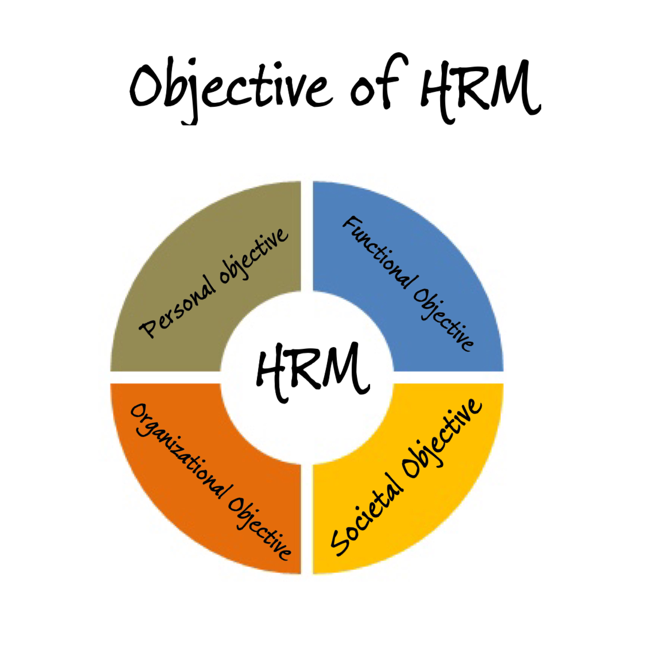

3.3 Processes of Human Resource Management:
Human Resource Management is the procedure of recruiting, selecting,inducting human resources, facilitating orientation , training and development , apprising performance of employees , deciding payment and facilitating other benefits , encouraging employees with employees and trade unions , ensuring employee safety and interest.

The numerous process of HRM are stated below:
- Human resource planning (Recruitment, Selecting, Hiring, Training).
- Compensation of employees and further benefits
- Performance management and performance Appraisal
- Employee connections.

3.3.1 Human Resource Planning (HRP)
This is the most significant and fundamental method for formulating an adequate strategy for the company. This comprises putting the right person in the right place according to their skills and achievements. It begins with the recruitment and goes until the adequate training of the employee so that he/she becomes an asset for the company.
The common HRM processes are as follows:

i) Recruitment
It is a procedure of broadcasting job openings and attracting prospective employees to apply for their desired job in an organisation so that the eligible candidate can be assigned.

ii) Selection
Selection is a fundamental process in HRM. It involves removing the unsuitable candidates through the procedure of investigations or interviews and comprehending the eligible ones, which are the nicest fit for the desired job.

iii) Hiring
This is the procedure of officially proposing the job to the assigned ideal candidate and offering them the period of joining.

iv) Training and development
The hired candidates are delivered training and their skills are brushed and nourished so that they become more efficient in their task to handle with future challenges.

3.3.2 Performance management
There should be adequate management of work and the future goals. Performance management refers to appraising the performance of employees and enhancing it. For such a management, it is essential to motivate the employees so as to raise their confidence levels. This can be done by furnishing them with fair rewards so that they work in optimum productivity levels.

3.3.3 Remuneration to employees and benefits
Fair compensation or remuneration plays a significant role in motivating an employee to accomplish organisational goals. If employees get rewards for their adequate performance, they will get their job satisfaction. The rewards not just contains compensations, but it also contains incentives and other financial and non financial benefits.

3.3.4 Employee Relations
There should be a sound and healthy harmony between the employees and the organisation. There are several factors which motivate and demotivate the employees to stick with organisation. These characteristics include working atmosphere, labour law and relations, compensations. The employer must secure all these factors to assemble employee relationships.

3.4 Importance of Human Resource Management:
The function of HRM is to manage the employee within a workplace to accomplish the organization’s mission and vision. When done effectively, HR executives can assist to recruit new experts that have skills necessary to further the company’s objectives as well as aid with the training and development of new employees to attain objectives and goals.
A company is only as reasonable to its employees, making HRM a vital part of maintaining and enhancing the health of the business. Besides, HR managers can regulate the state of the job market to help the organization to stay competitive. This could involve making sure compensation and benefits are fair, events are planned to keep employees from burning out and job roles are adapted based on market demand.

Chapter Four: The Impact of Covid-19 In the Organisations of Bangladesh

4.1 COVID-19:
Coronavirus disease (COVID-19) is a contagious disease caused by the newly discovered coronavirus.
COVID-19 pandemic in Bangladesh is part of the worldwide pandemic of (COVID-19) caused Coronavirus . The virus was verified to spread to Bangladesh in March 2020. The first three known outbreaks were reported on 8th March 2020.

4.2 The Impact of COVID 19 in the Economy of Bangladesh:

The COVID-19 pandemic had encompassed household and individual level earnings in Bangladesh heavily with around 13 percent of people have become unemployed; lower and middle-income classes have been undergoing a significant decrease in income for the past few months. Consequently, the disposable income of the nation people is following a declining trend. the national poverty gained by 25.13 percent, declared by Bangladesh Institute of Development Studies.

4.3 The Impact of COVID-19 in Health Care Industry of Bangladesh:

The COVID-19 pandemic had an enormous impact worldwide. Developed countries, such as the United States, United Kingdom, Italy, and Spain, had their highly efficient medical infrastructure greatly stressed and suffered from a high death rates. Furthermore, Bangladesh, a poverty-stricken South Asian country, is losing its battle against this pandemic, but mainly because of its incompetent poor healthcare system.
After investigating the first COVID-19 case on 8 March, in the following 2 weeks, more than 0.63 million overseas employees immigrated the country without appropriate screening, facilitating community transmission. the government has recruited 2,000 doctors and 5,000 nurses to fight against the this pandemic.The health directorate administrator said indicating the development "the biggest recruitment drive Bangladesh has ever seen”.

4.4 The Impact of COVID-19 in E-commerce Industry of Bangladesh:

E-commerce firms are a silver lining from the Covid-19 shutdown as a significant number of clients are now more eager towards ordering online than ever before, which might improve this industry in the post-pandemic time.

4.5 The Impact of Covid-19 in Pharma Sector of Bangladesh:

Although all the medication stores were open by following the government's directive, sales of most shops have decreased at this period of coronavirus shutdown. The allotment of drugs had also dropped during the period.

4.6 The Impact of COVID-19 in Banking Industry of Bangladesh:

The economy and local businesses began to suffer the pinch of the pandemic even before its outbreak in the country and so did the banking sector. To cope with this situation, several banks have moved to cut employee remuneration while others went for manpower deduction.
As per the Bangladesh Bank data, the amount of employees at 59 scheduled banks was 1,78,515 at the end of last June against 1,78,430 six months earlier.

Chapter Five: Data Analysis

4.1 Descriptive Analysis:
The study attempts to trace the “Impact of Covid-19 on HRM”. To accomplish the project primary and secondary sources of data is used. Primary data are collected using questionnaire. 25 Question were prepared and several employees from various organizations were assigned as respondent..The table below, has been formulated on the basis of the responses of the survey..
The questionnaire comes with a five-point scale ranging from 1 to 5 with 1 indicating strongly disagree and 5 demonstrating strongly agree was used in this regard.
However, the table is not very informational so, to come up with an adequate conclusion, some pie chart has been Developed.

Result and Discussion:

Question no. | Particulars | Strongly disagree |  | Disagree |  | Neutral |  | Agree |  | Strongly Agree
Question no. | Particulars |  | % |  | % |  | % |  | % |  | %
1 | Companies are recruiting new employees during this pandemic | 0 | 0 | 0 | 0 | 0 | 0 | 9 | 10.9 | 46 | 83.6
2 | Recruitment process is same as before | 45 | 81.5 | 8 | 9.3 | 1 | 0.5 | 1 | 0.5 | 0 | 0
3 | Skill based hiring is more preferable rather than academic during this pandemic. | 0 | 0 | 1 | 1 | 3 | 2.7 | 4 | 9.3 | 47 | 87
4 | Interviews are being taken through online. | 0 | 0 | 2 | 1 | 2 | 1.7 | 4 | 9.3 | 47 | 87
5 | Experienced employees are new demand during this pandemic. | 0 | 0 | 1 | 0.4 | 5 | 7.6 | 3 | 7.4 | 46 | 85.2
6 | Company provides full salary to employees | 0 | 0 | 2 | 1 | 3 | 6.6 | 4 | 7.4 | 46 | 85.2
7 | Companies recruitment process create limitation (hidden aspect) | 2 | 7.7 | 7 | 26.9 | 4 | 15.4 | 11 | 42.3 | 2 | 7.7
8 | Company provided Festival bonus during this pandemic. | 1 | 0.5 | 1 | 0.5 | 40 | 74.1 | 10 | 18.5 | 3 | 6.4
9 | Company gives remuneration at the specific day of the month during this pandemic. | 2 | 1 | 3 | 6.7 | 4 | 7.1 | 40 | 74.1 | 6 | 11.1
10 | Company facilitate any kind of advance payment to employees in financial crisis during this pandemic | 0 | 0 | 2 | 4 | 3 | 5.2 | 6 | 9.3 | 44 | 81.5
11 | company evaluate employees on a regular basis. | 2 | 2.5 | 5 | 6.5 | 8 | 14.1 | 2 | 2.5 | 38 | 70.4
12 | Evaluation process is different during this pandemic | 1 | 1 | 4 | 5.4 | 1 | 2 | 7 | 13 | 43 | 79.6
13 | Performance is being judged on the basis of productivity. | 0 | 0 | 0 | 0 | 2 | 1.8 | 9 | 16.7 | 44 | 81.5
14 | Evaluating employees through online is complex for company | 0 | 0.0 | 0 | 0 | 2 | 1.8 | 9 | 16.7 | 44 | 81.5
15 | Performance bonus is being paid during this pandemic | 1 | 1 | 3 | 3.6 | 4 | 7.4 | 10 | 18.5 | 37 | 69.5
16 | The company should calculate cost per recruitment to reduce limitation | 1 | 0.2 | 2 | 0.4 | 42 | 77.8 | 7 | 13 | 3 | 8.6
17 | Online training is being fruitful. | 0 | 0 | 3 | 3.7 | 43 | 79.6 | 5 | 9.3 | 4 | 7.4
18 | Company is facing difficulties in online training. | 0 | 0 | 3 | 5.7 | 0 | 0 | 10 | 18.5 | 42 | 77.8
19 | Employees are being trained regarding the term “working from home” | 0 | 0 | 3 | 5.7 | 0 | 0 | 10 | 18.5 | 42 | 77.8
20 | Online training is being financially efficient for company. | 0 | 0 | 3 | 5.7 | 0 | 0 | 10 | 18.5 | 42 | 77.8
21 | Company is Providing enough safety measures during this pandemic | 1 | 0.8 | 0 | 0 | 4 | 7.4 | 47 | 87 | 3 | 4.8
22 | Workplace is cleaned and sanitise | 0 | 0 | 2 | 1.9 | 4 | 7.4 | 43 | 79.6 | 4 | 11.1
23 | Employees are getting leaves and considerations in case of illnes | 0 | 0 | 2 | 2.8 | 7 | 13 | 9 | 16.7 | 37 | 68.5
24 | company is providing any additional medical support and benefits during this pandemic | 2 | 2.4 | 1 | 0.4 | 37 | 68.5 | 10 | 18.5 | 5 | 9.3
25 | Meeting and events are happening by maintaining all protocols for safety during this pandemic | 0 | 0 | 0 | 0 | 0 | 0 | 49 | 90.7 | 6 | 9.3

- Companies are recruiting new employees during this pandemic
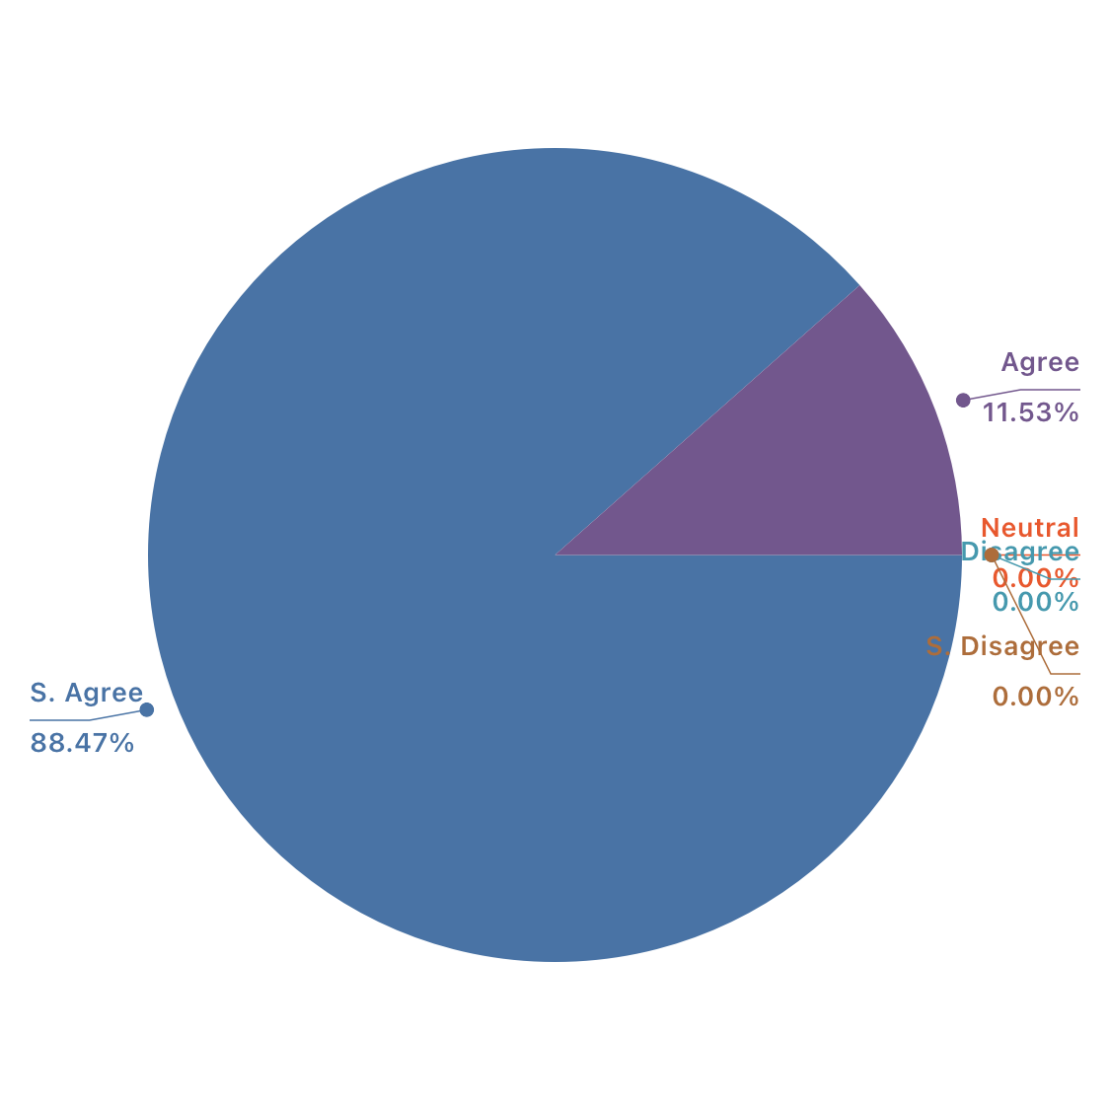

According to the responses that we got, we can easily say that most of the companies are recruiting employees during this pandemic situation. For example, the worldwide renowned firms like Amazon, Facebook, Microsoft any many others are hiring employees.

2. Recruitment process is same as before

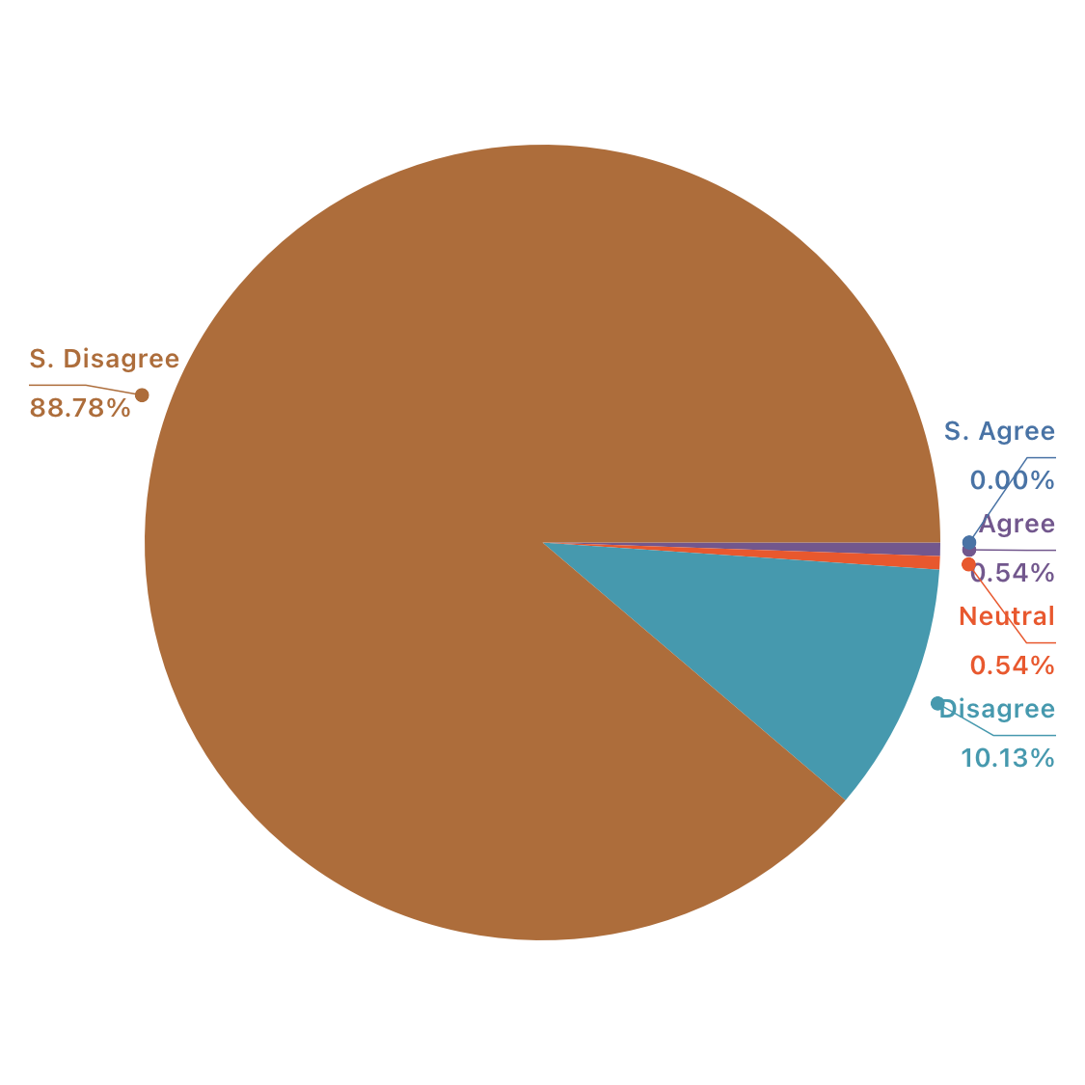

According to the average response that we got, we can easily say that the process of recruitment has been changed during this pandemic. Safety and security is must during this pandemic. So many companies are recruiting employees through online interviews. From first to last, every action related to recruitment is being taken via online. For example, now Job Interviews Cannot Be Handled Face-to-Face, Onboarding New Employees Must Happen Remotely. Employees are being appointed via Live Video Interviews or Recorded Video Interviews. During this pandemic, to assure safety almost every organisation has changed their recruitment process. They moved in online interviews from traditional face to face interviews.

3. Skill based hiring is more preferable rather than academic during this pandemic.

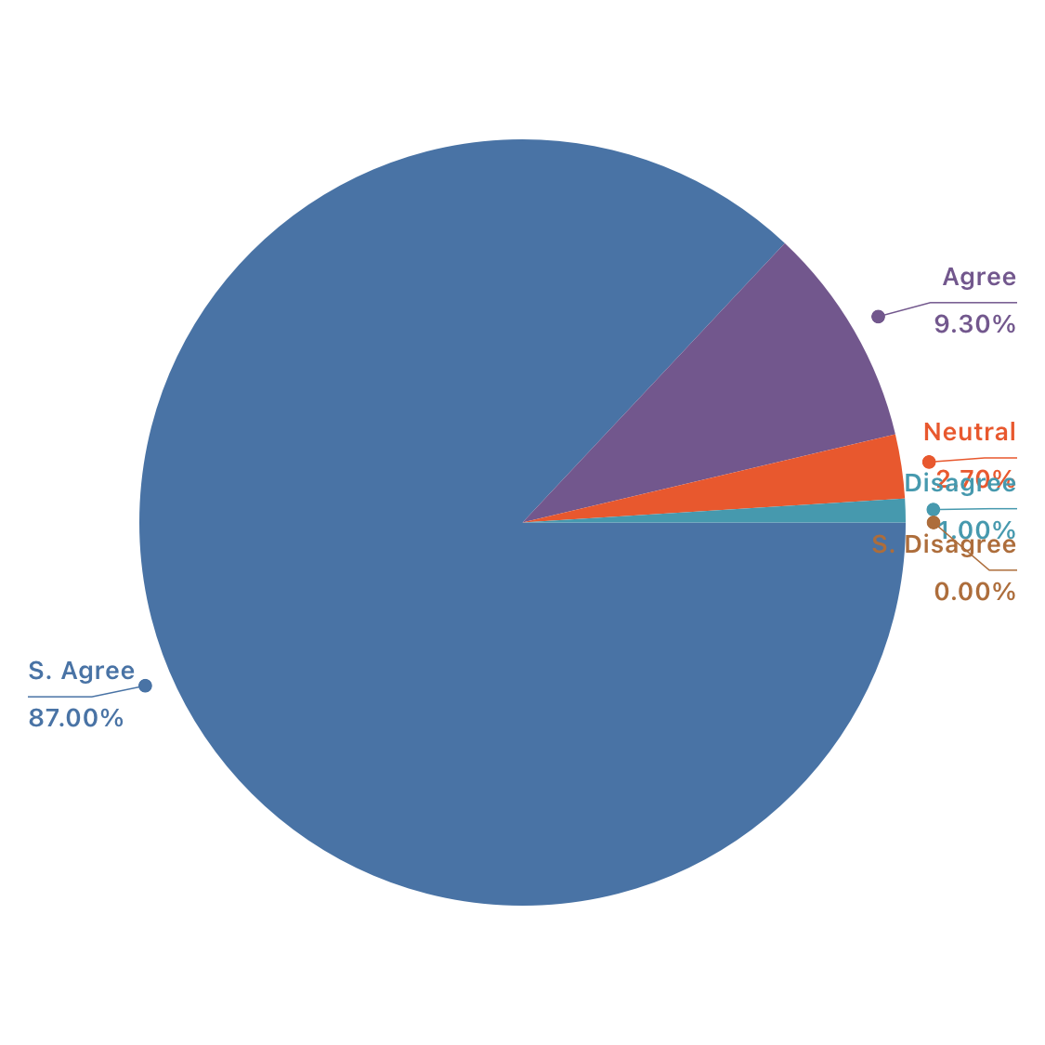

During this pandemic situation, every organisation needs efficiency in work. So many companies choose to hire skilled and experienced employees rather than depending on the academic degrees. Cause skilled and experienced workers will understand how to accomplish the work with effectivity and efficiency. Academic degrees can’t provide skilled workers always. During this pandemic, Companies has chosen to remain efficient while selecting employees. So, in our survey we can see the results. 87% of respondents strongly agreed that companies are choosing skill based workers. And rest 9.3% agreed with the term that companies are preferring skilled and experienced employees rather than preferring candidates with heavier academic accompaniments.

4. Interviews are being taken through online.

During this pandemic all over the world, people are staying at home, no matter what. All the necessary works are even being done even at home. In this period of working from home, almost every organisation is hiring employees in online interviews. It can be live or recorded. In our survey 87% respondents said that they are strongly agreed with the statement that interviews are occurring through online. And the rest of the respondents are agreed with the term.

5.Experienced workers are new demand during this pandemic.

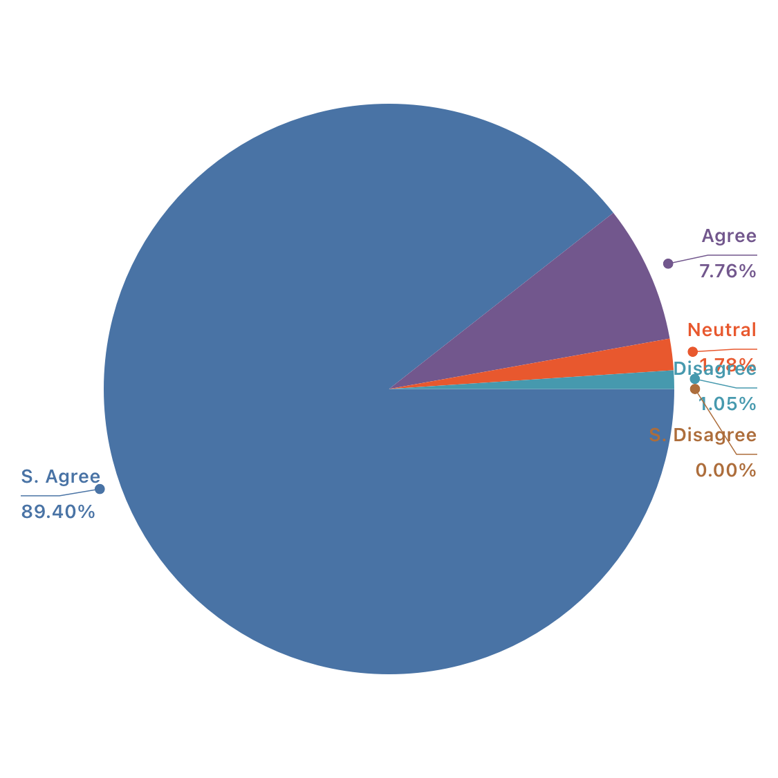

In this pandemic situation, Experienced employees are the new demand in job market. Companies are seeking experienced employees to make their job done efficiently which will increase the profitability in their business.

6. Company gives full salary to employees.

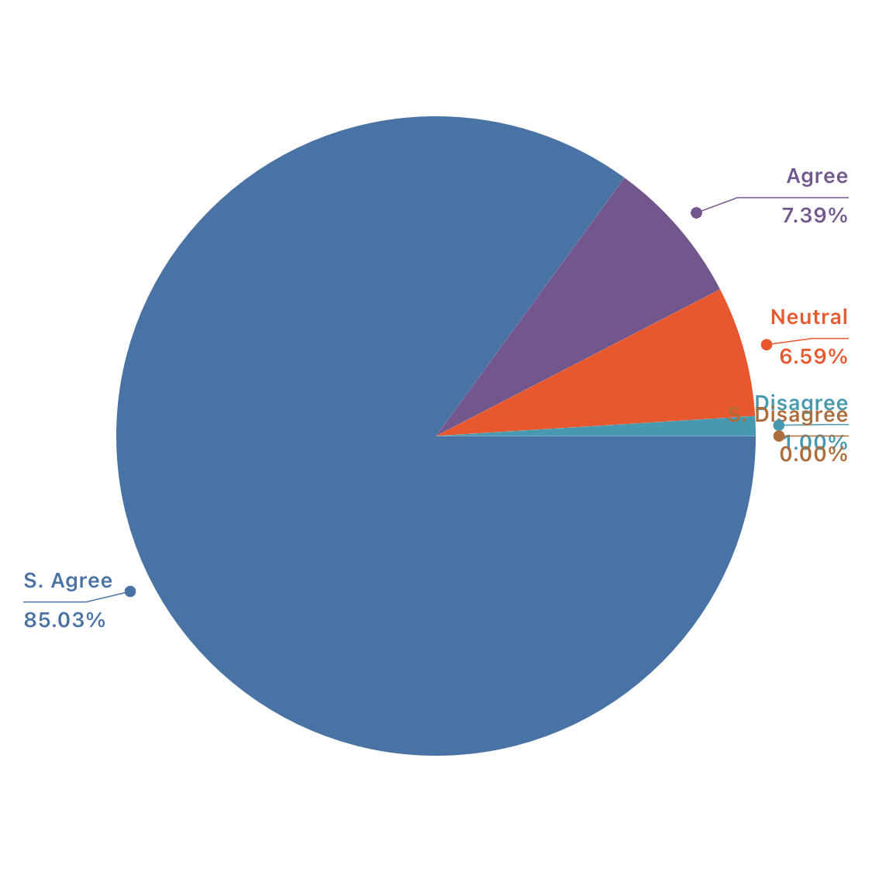

According to the respondent statements, I can say most of the organisation provided full salary to employees. But In our country the banking organisations has decided to reduce a specific percentage of salary of their employees. Most of the respondents of my survey are from e-commercial and multinational organisation such as Daraz, Advanced IT, ACI, Robi etc. The salary of these organisation hadn’t decreased during this covid 19 period. So, they are agreed with this statement mostly.

7. Company gives other financial benefits except for salary during this pandemic.

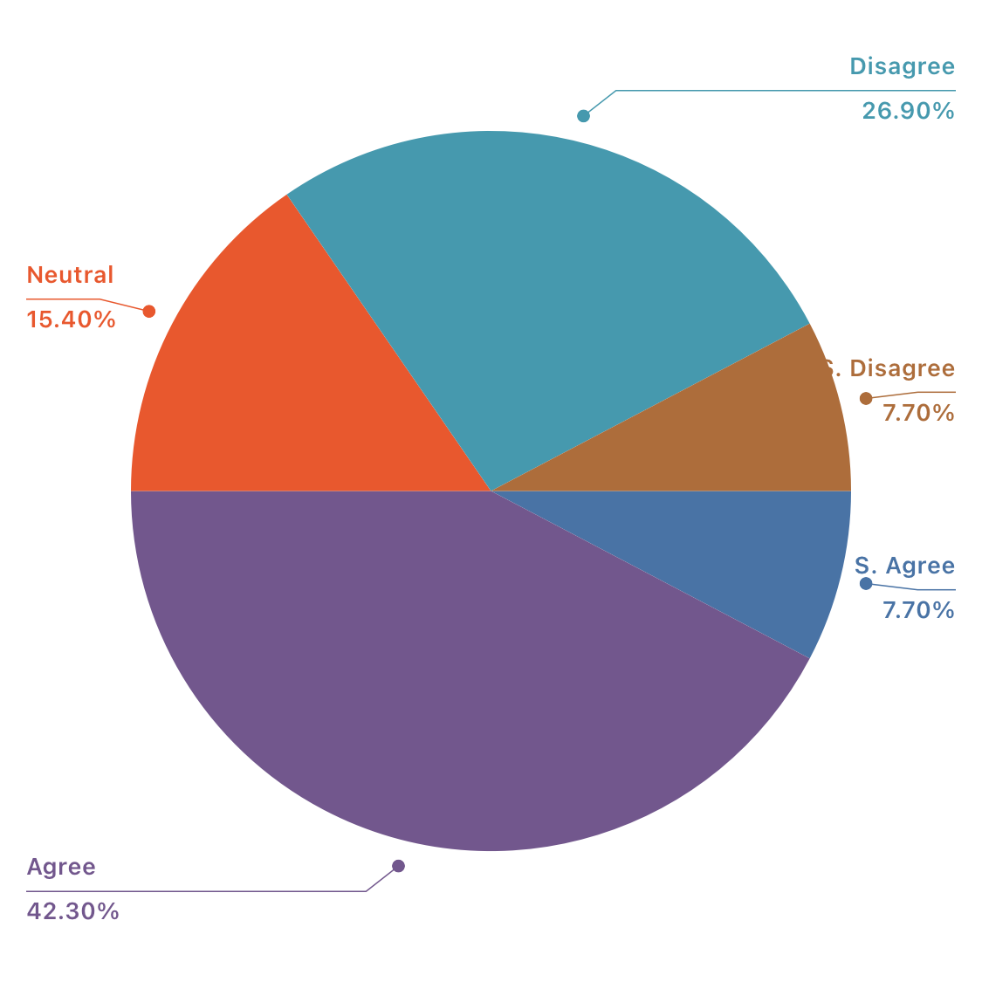

According to the response, 70.4% respondents agreed that their company provided extra benefits except salaries in this pandemic. According to other sources, I assumed that many organisations provided extra financial benefits to their employees in this pandemic. But still there are a few organisations which didn’t.

8. Company gave Festival bonus during this pandemic.

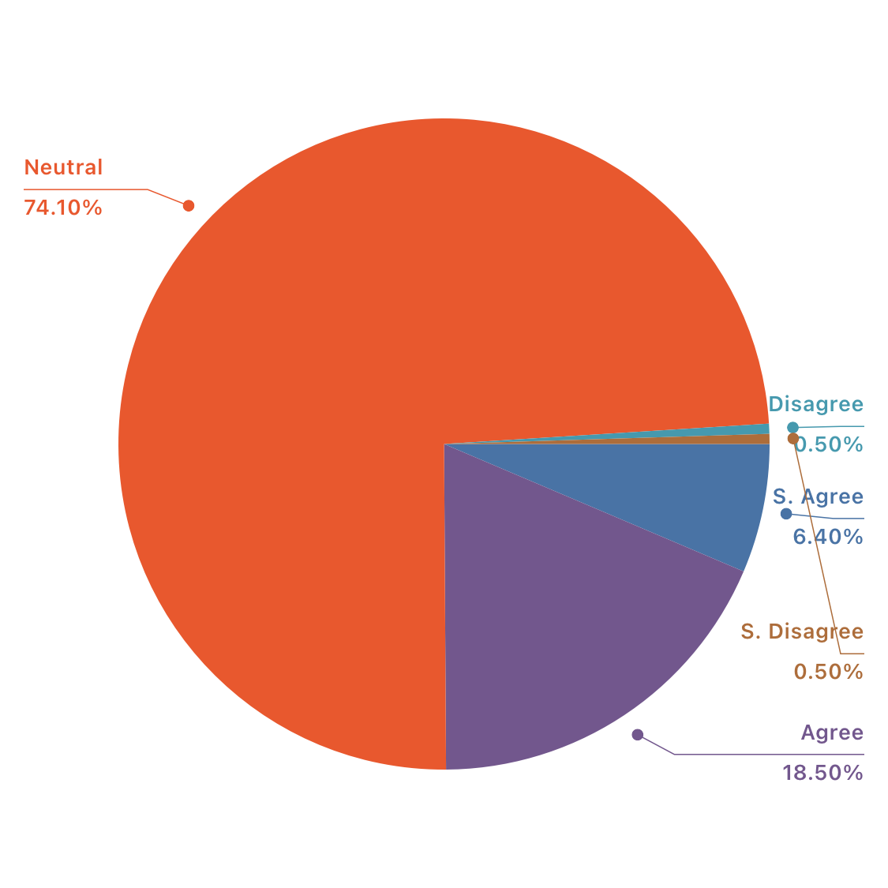

According to the response 74.1% of respondents remain neutral in this term. But according to the information from some other sources I assumed that most of the companies didn’t provide any festival bonuses in this pandemic situation. As it’s staying for a year long almost, Two festivals already passed during this pandemic. But according to my knowledge most of the companies didn’t pay any kind of festival bonuses during this pandemic. But still 18.5% respondents said that some companies provided festival bonus.

9. Company provides remuneration at the certain day of the month during this pandemic.

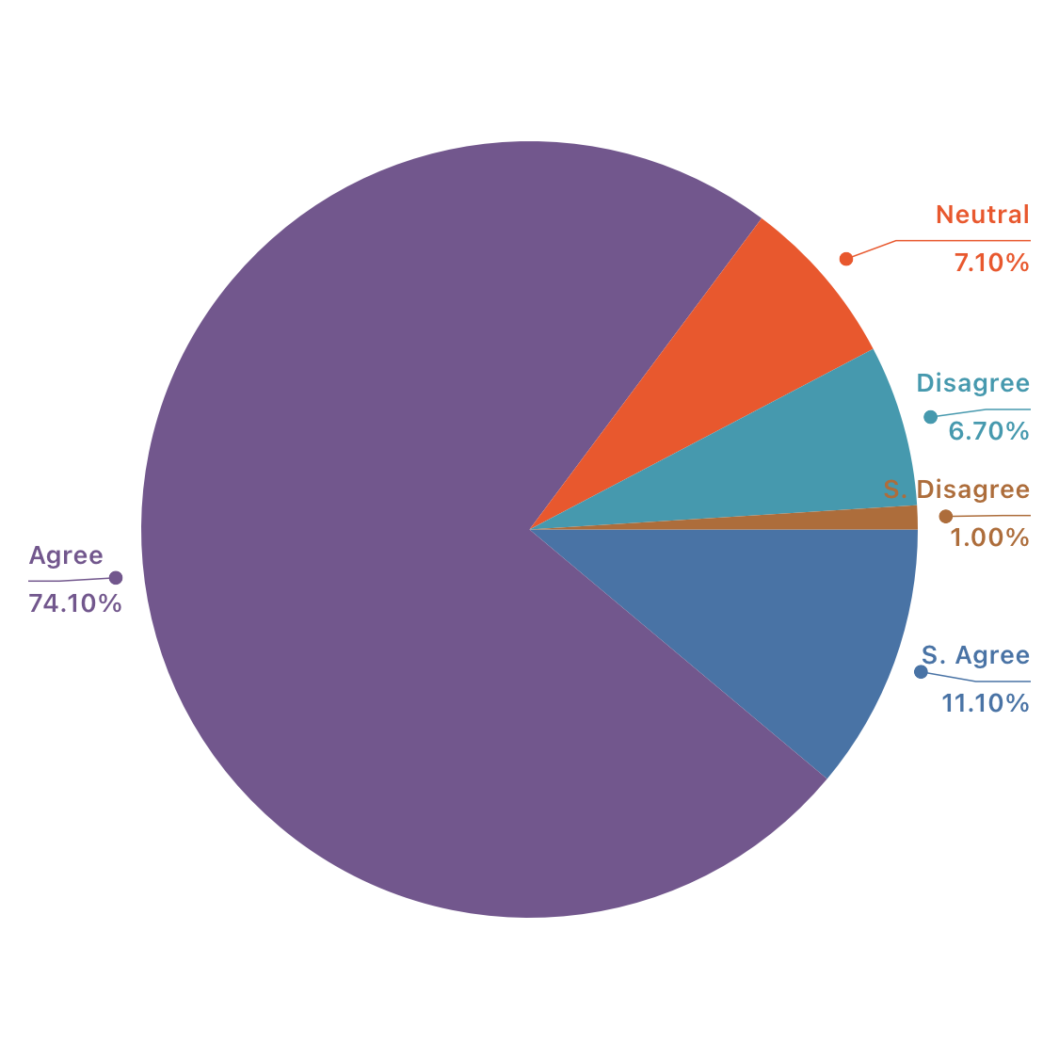

According to the responses, 74.1% employees agreed with the term that their organisations provided remuneration at the certain date of the month. 11.1% respondents strongly agreed. So, we can say that, on average, companies give remuneration to employees in the specific date of the month.

10. Company facilitate any kind of advance payment to employees in financial crisis during this pandemic

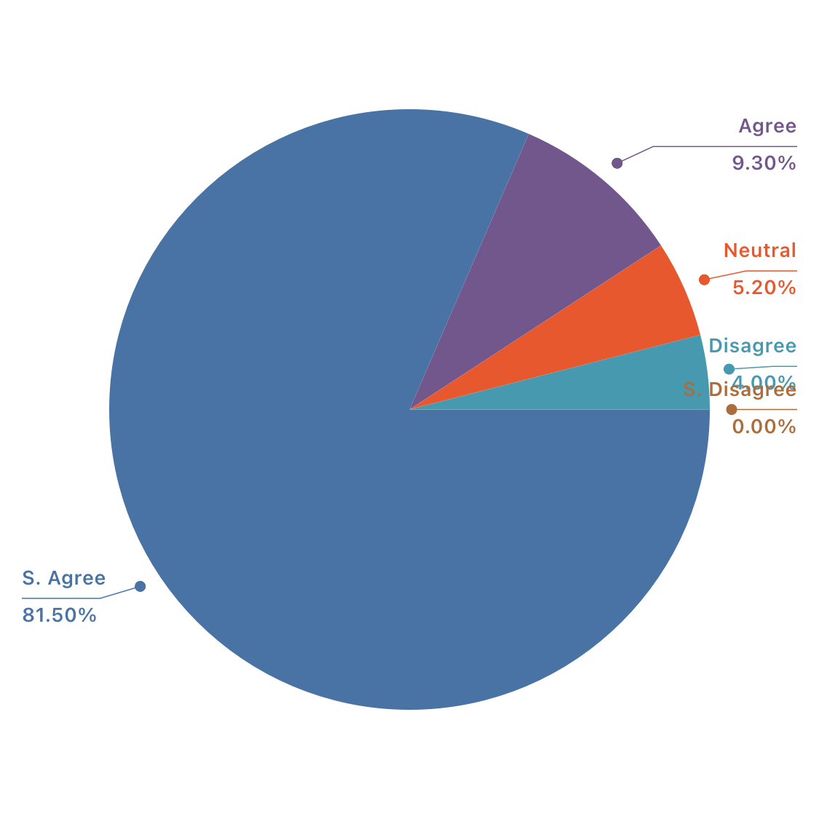

In this term, 81% of respondents strongly agreed that their companies are providing advance payment in case of any emergencies in this pandemic. And the rest of the respondents remain agreed too.

11. company evaluate employees on a regular basis.

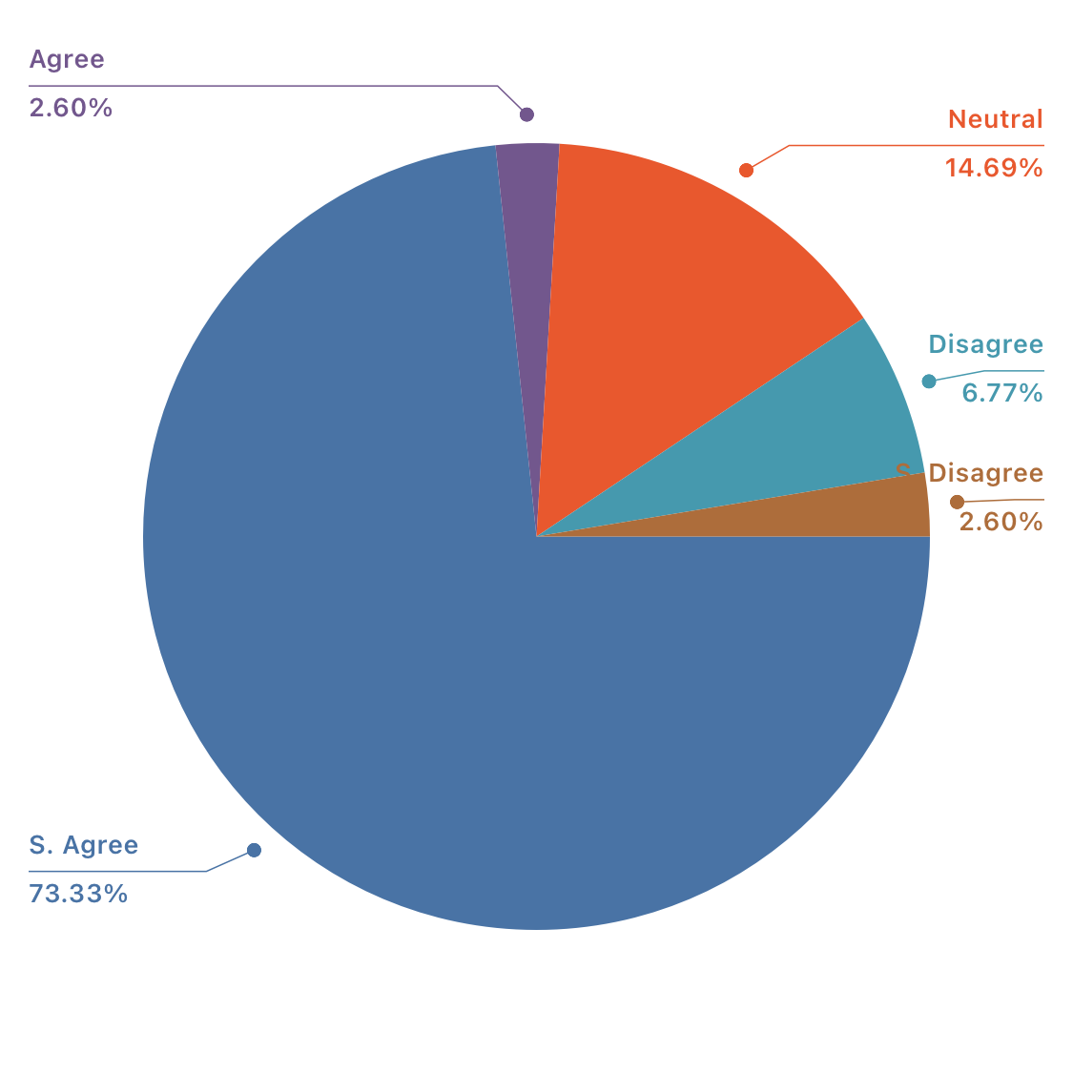

In this regard 70.4% respondents stay strongly agreed. And the response is practical. Because while working from home, evaluation of works will be maintained regularly otherwise employees wouldn’t be encouraged to work hard with proper attention.

12. Evaluation method is different during this pandemic

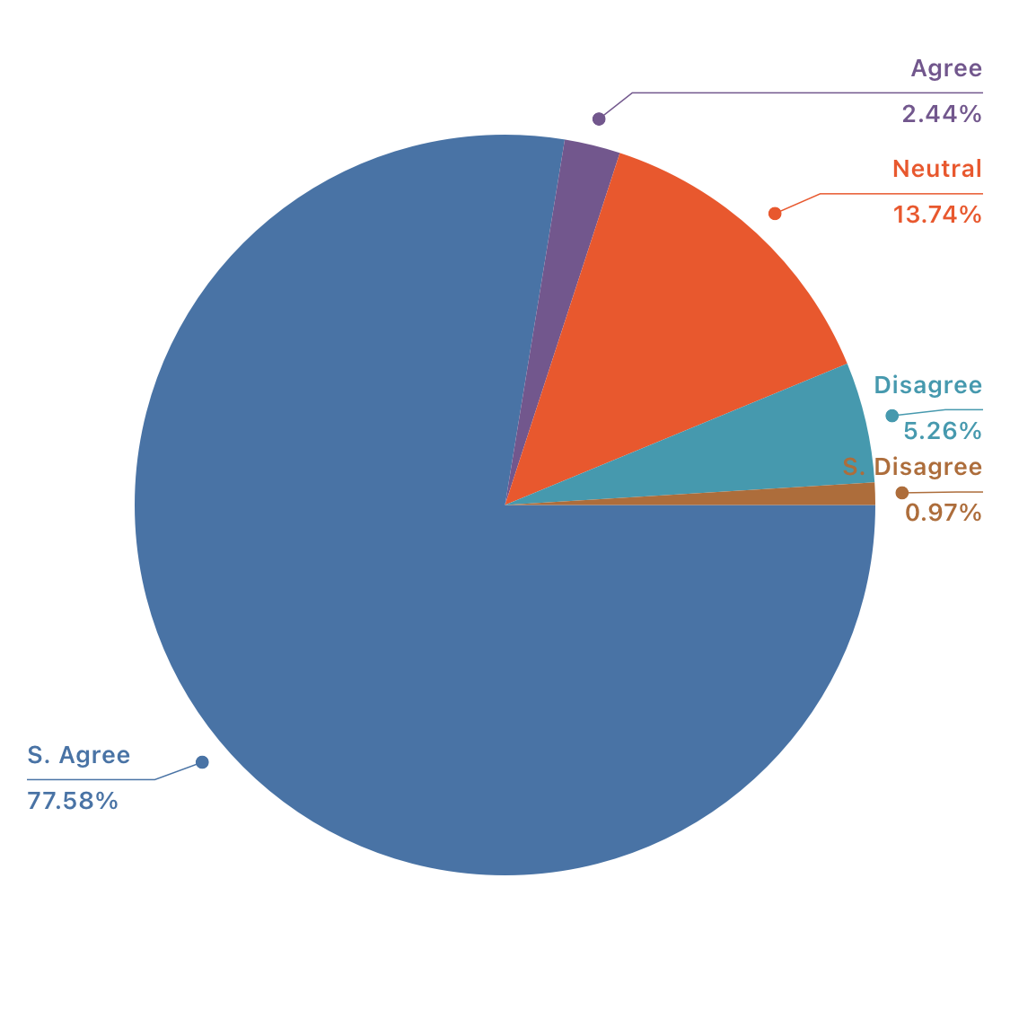

During this pandemic, almost every employee worked at home by retaining all protocols. Employees are working through online, they are getting evaluating through online too. So, the evaluation process is obviously different now. Here, 79.6% of respondents agreed with the term that evaluation process is different during this pandemic.

13. Performance is being assessed on the basis of productivity.

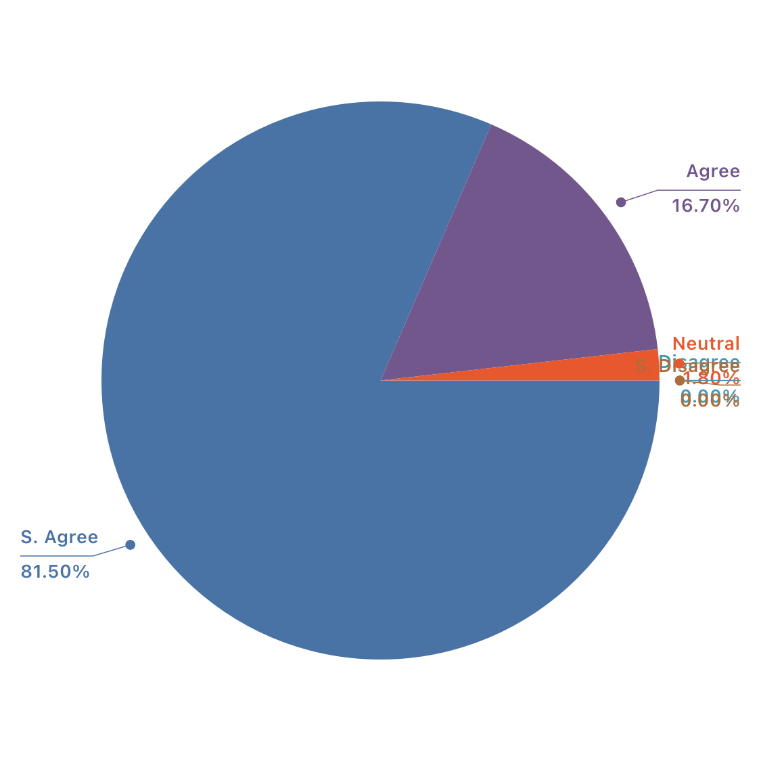

In this term, 81.5% respondents agreed with the term that the performance is being judged on the basis of productivity of organisation. As, workers are working through online evaluation can be complex. So, it’s wise to evaluate that whether employees are increasing the productivity or not.

14. Evaluating employees through online is complex for company

During this pandemic, almost every employee worked from home for a specific period. At that period evaluating the performance of employees for a regular basis was a tough job. Cause evaluating through online is a quite impossible job to be done. So here we can see, most of our respondents strongly agreed with our given term.

15. Performance bonus is being compensated during this pandemic

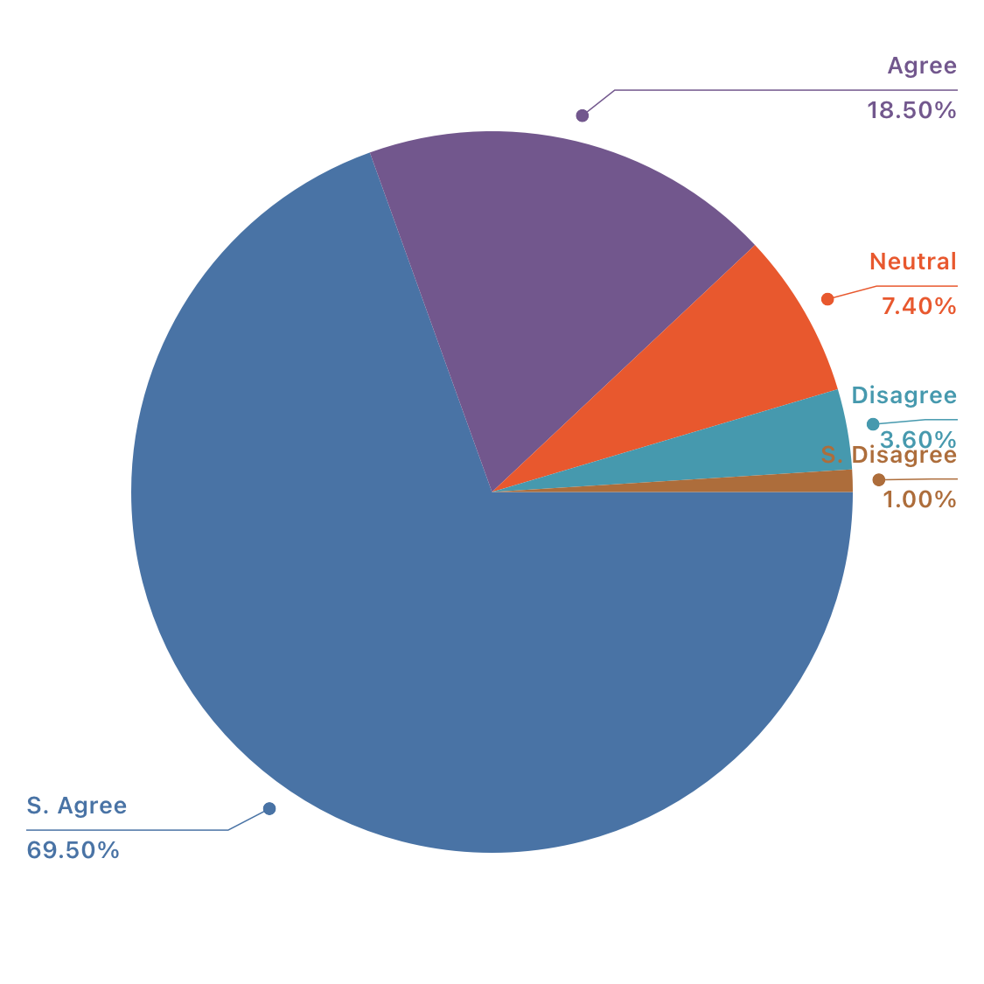

During this pandemic, every organisation is going through a bit financial ups and downs. So the incentive and performance bonuses for employees can be a question mark. This thing is completely dependent on the financial health of the company. So, here we can say various kind of responses. Cause the respondents are from different organisations.68.5 % of respondents strongly agreed with the term.

16. Company is providing the training facilities to it's employees in this pandemic

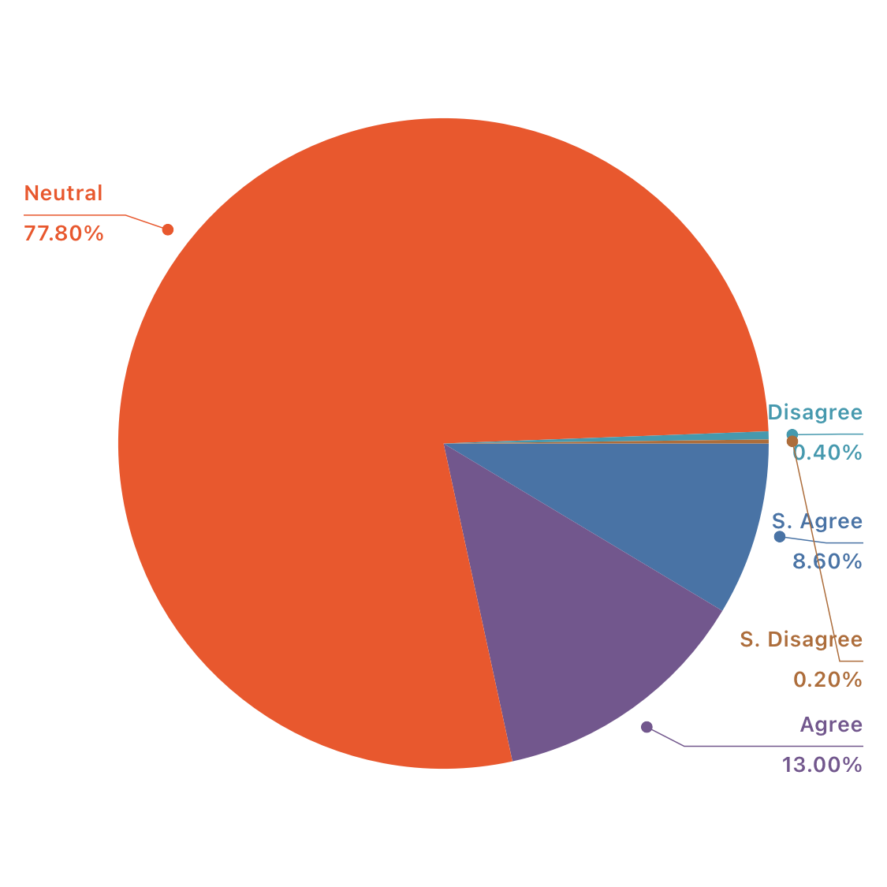

During this pandemic, every work is being done through online. Nothing is being stopped. So, nor the training. In the response we can see that our respondents remain neutral about getting training facilities. And other 13% and 5.6% are agreed and strongly agreed respectively with this term.

17. Online training is being productive.

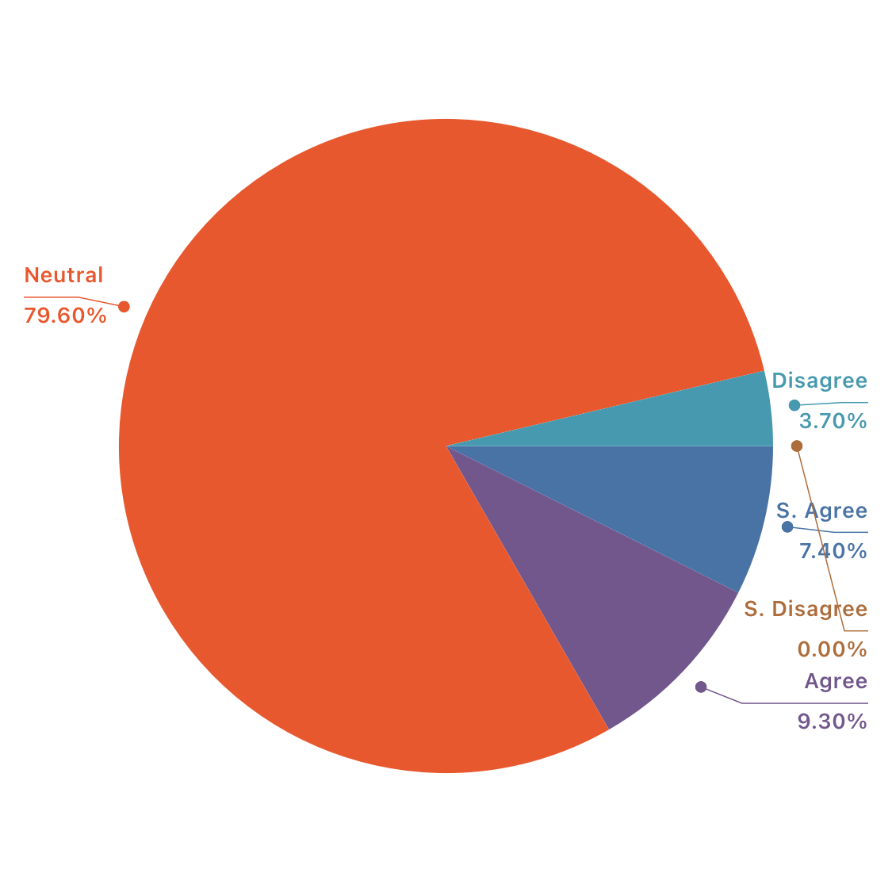

During this pandemic situation training is occurring through online process. In this term, most of the respondents persist neutral. Other 9.3% and 7.4% agreed and strongly agreed with the term. Probably every respondents are not familiar with the term of training. It can be the reason of remaining neutral of the most of the respondents.

18. Company is facing difficulties in online training

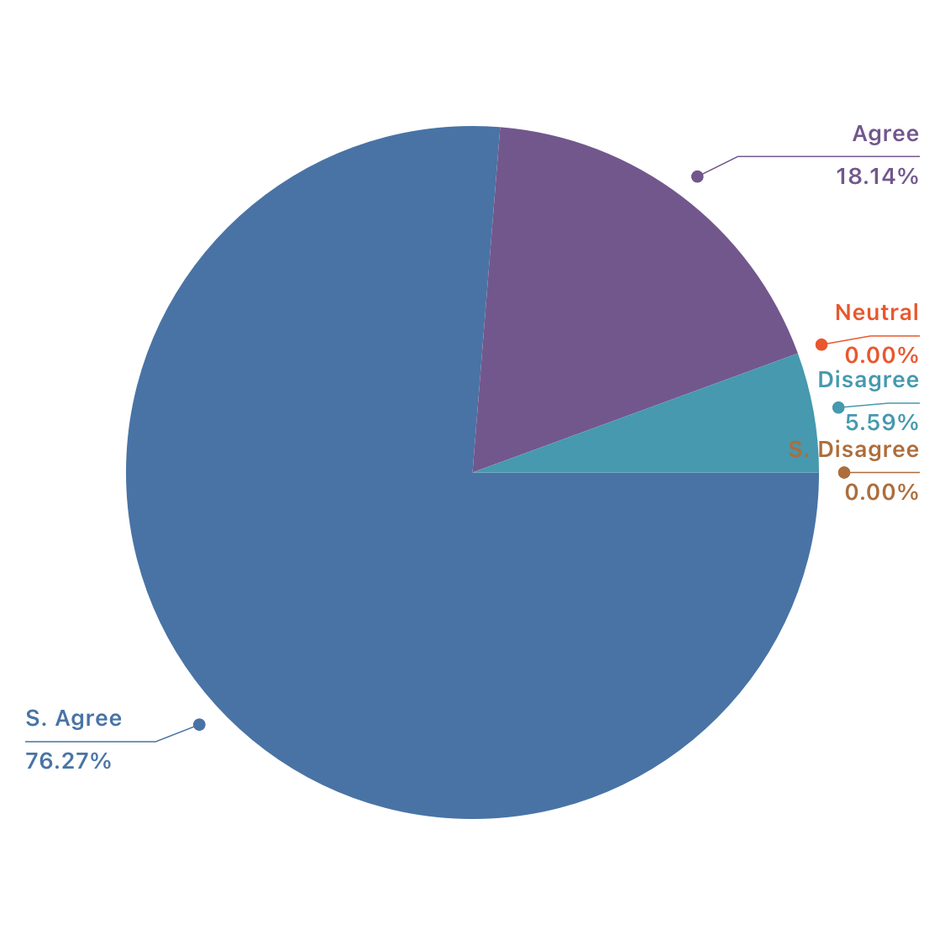

Every employee doesn’t have the efficiency of working online. During this pandemic, everyone is working from home through online. But it’s not an easy task for everyone. To train employees through online can be very difficult. Training process needs a lot of interaction between trainee and trainer. Through online it became tough task to train employees properly. So here, 77.8% of respondents remain strongly agreed with the term. Other remain agreed. And a few of respondents remain disagreed with the term.

19. Employees are being trained considering the term “working from home”

During this pandemic, the mostly known term in Job life is Working from Home. This has become the base of the work. Employees would have to learn how to work from home. Otherwise they will not be able to do their works. As we know through zoom app, any desk app, google meet app people are doing there works from home. The use of these things have been learnt from a short training given by many organisations to their own employees. So here, 77.8% employees agreed with this term. 18.5% strongly agreed. And a few remain disagreed. Their organisation didn’t facilitate any training about how to accomplish their work from home.

20. Online training is being financially efficient for company.

In this term 77.8% of respondents strongly agreed that online training is veiny financially efficient. As we know, incase of training there will be the need of equipments regarding training, a platform to train employees, a specific time within the office hour. But when employees are getting trained through online none of these things are needed. It’s a cost cutting and cost-effective term for the organisation. So, online training is financially effective for an organisation. But this is not a long-term effectivity.

21. Company is Providing enough safety measures during this pandemic

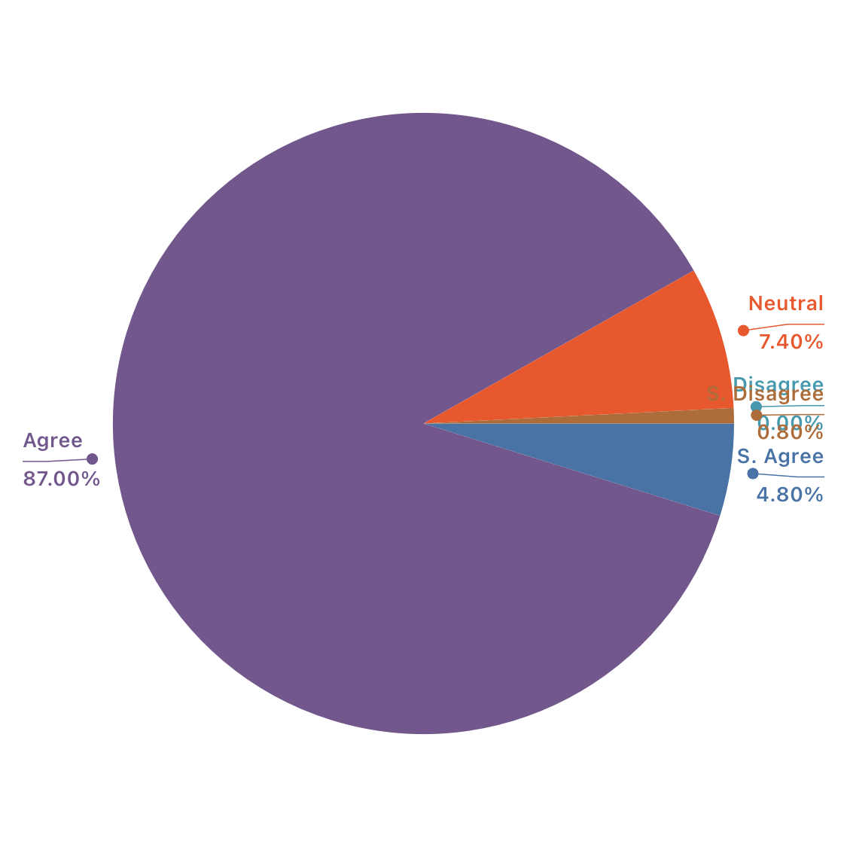

During this pandemic situation, some safety measures became must . Such as wearing masks, maintaining safe distance of at least 6 feet, using hand sanitisers for a regular basis e.t.c. As per my knowledge, almost every organisation is providing safety measures such as masks, sanitisers while entering or exiting, thermometer to measure temperature. So, the responses of the survey says that too. 87% respondents agreed that companies are
providing safety measures to employees.

22. Workplace is cleaned and sanitised.

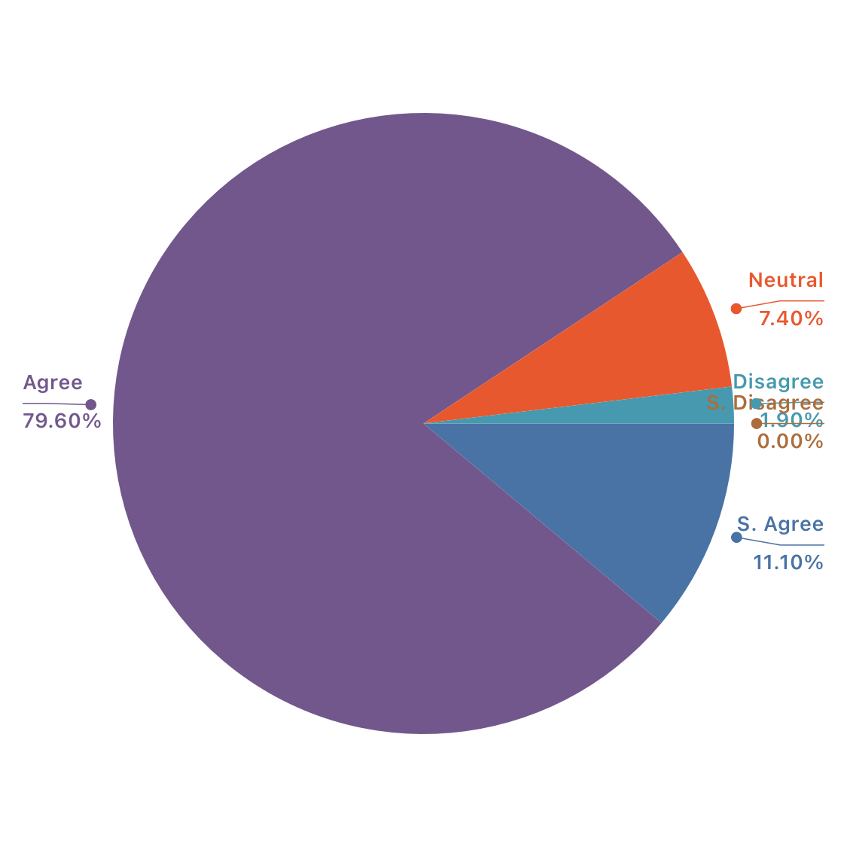

According to our labour law, it’s a must for organisations to keep the working place clean enough. And now in this pandemic it became a must. Cleaned and properly sanitised place is must for an employee now to ensure his/ her safety. Every organisation would have ti maintain it, not only now but always. In the responses we can see most of the respondents are agreed and strongly agreed with this term. But still a few people are neutral and disagreed. Those organisations which are not maintaining their cleanliness would have to be careful about this issue now.

23. Employees are getting leaves and concerns in case of illness

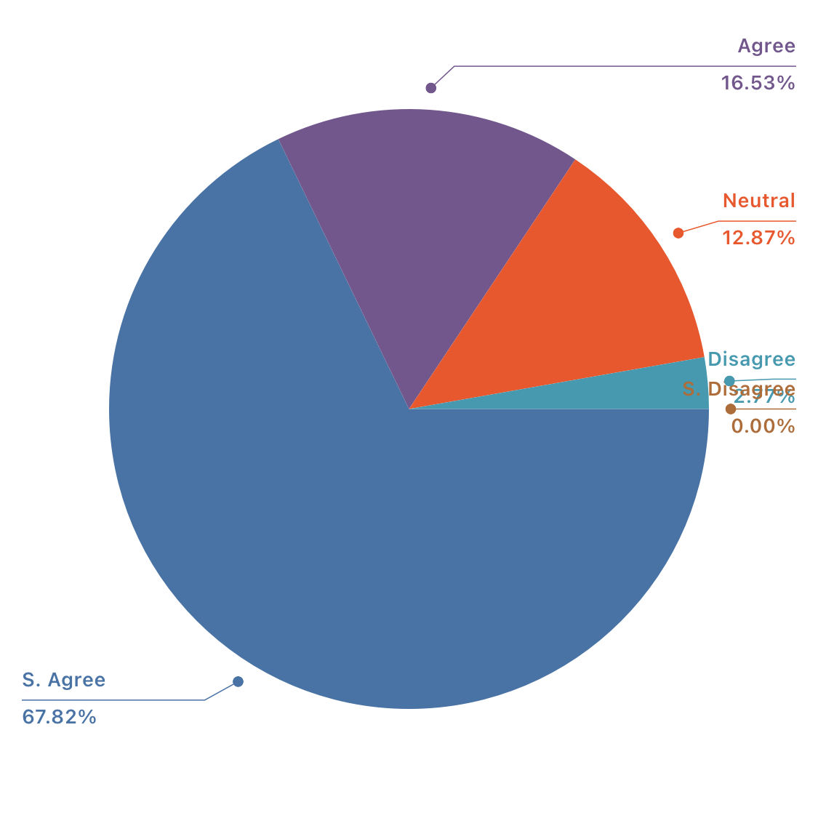

During this pandemic, people are getting ill frequently. The affect of this pandemic can be noticed in everyone’s family. So, it should be considered. Organisations should give employees leaves in case of emergencies. In the responses, we can see most of the respondents agreed that their company is considering their illness but still a small percentage of respondents remain neutral and disagreed. Which should be corrected in any organisation.

24. company is furnishing any additional medical support and benefits during this pandemic

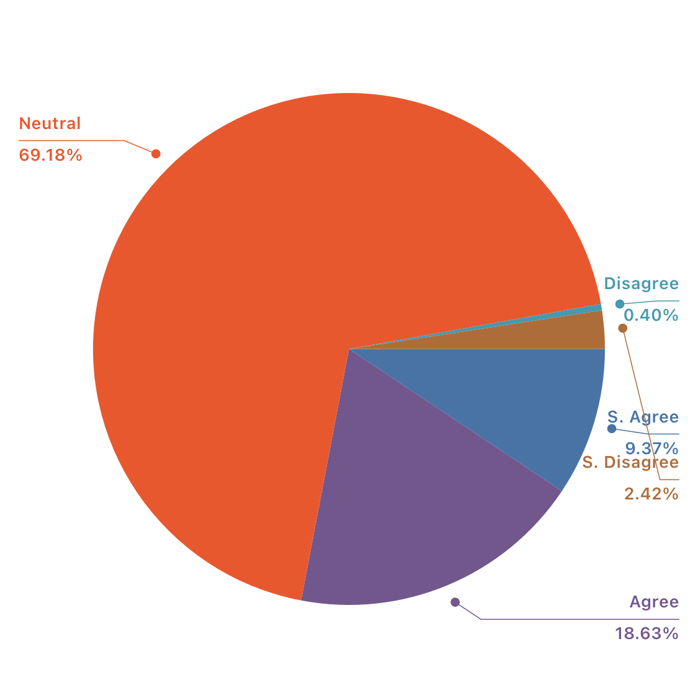

In our country, here is a question mark in this term. As per my knowledge, most of the companies are not facilitating any kind of medical benefits in this pandemic. Employees are doing their own COVID-19 test by their own to ensure safety. But in other countries, organisations are providing the facility of COVID-19 test. So, we can say in our country maximum organisations are not providing any kind of medical benefits during this pandemic. Our responses are also saying something negative. Most of the respondents remain neutral in this term. A few persisted disagreed too.

25. Meeting and events are happening by maintaining all protocols for safety during this pandemic

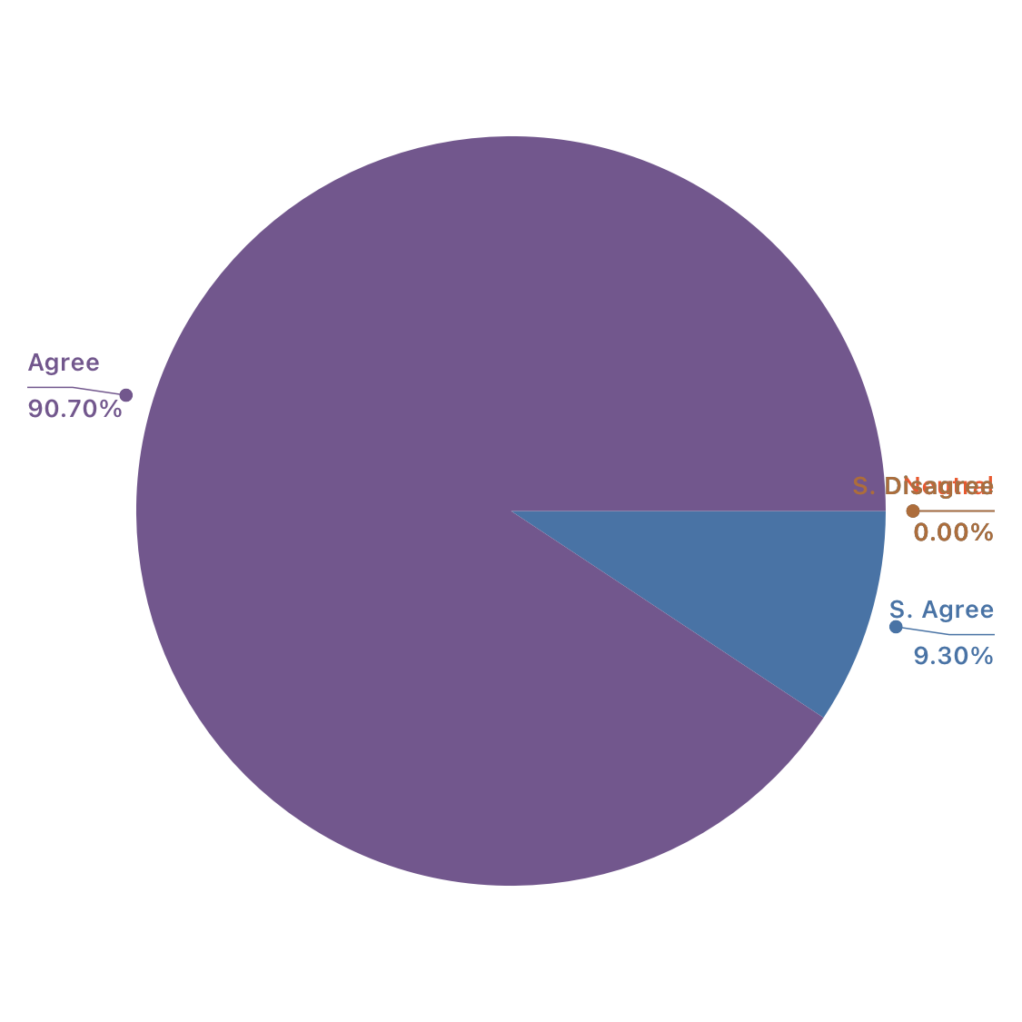

In this term, almost every respondents agreed and strongly agreed. Meetings are happening by maintaining all protocols for safety. Such as zoom meeting through online, or a meeting by maintaining proper distance, a meeting on a safe and well sanitised place having all the safety equipments such as face masks and sanitisers. Here, 90.7% respondents agreed that meetings are happening my maintaining all protocols for safety.

Chapter Five : Findings and Recommendations

5.1. Findings:

- Long term impact: Covid-19 has influenced almost all sectors of an organisation. This pandemic may last for a specific period but its impact will remain for a long time. Such as the procedures of work, the altering nature of the training process, the profitability ratio of a company. These things will bring a long-term impact on an organisation.
- Changing Policy:Because of COVID-19 pandemic nearly every action of an organisation has altered. Every work is being accomplished via online.
- Evaluation process: Evaluation process has changed into online action. Employees are being evaluated through online in many organisations. They are being regulated via online. But in many organisations evaluation is not being practiced regularly.
- Recruitment process: Recruitment and selection process has altered in this pandemic. Recruitment is being done through online.
- Training process: During this pandemic, both on the job and off the job training is happening through online. But still there are a limited organisations which are not practicing training process during this pandemic .
- Remuneration: Remuneration ratio has been changed during this pandemic. Many organisations has lessened employees compensations, many organisations has stopped providing incentives.
- Safety and security issues: Every organisations is reviewing more and more regarding this issue during this pandemic. Organisations are providing masks, sanitisers and all the necessary equipment to ensure employees safety and security.
- Cleanliness: During this pandemic, cleanliness has became a huge concern. Work place needs to remain clean and well sanitised to ensure employees safety.
- Performance appraisal: During this pandemic, most of the organisations aren’t rehearsing this term.
- Internal Communication: Because of this pandemic situation, internal communication of organisations has reduced.
- Compensation:. Compensation management has also changed during this pandemic situation.
- Employee’s health issues: Employees health issues became a huge concern during this pandemic. Some organisations are providing medical benefits during the pandemic.
- Dependancy on online work: During this pandemic , the word “ Online” has became the most important term. Most of the works are being done through online.
- Actions are being complex: In this pandemic, the procedure of every work is being changed. So it’s being problematic to cope up with those modifications and work appropriately.
- Work from home: During this pandemic, many organisations have moved to work from home. Organisations are facilitating every work through online. So employees can do their task by staying at home.
- Overall Impact of COVID-19: Covid-19 has a huge consequence on the HRM department of organisations. Every work has altered due to this pandemic.

5.2 Recommendation:

- Companies should be more conscious regarding employees health issues.
- Safety measures should be furnished regularly.
- Medical assistance and benefits should be given to employees.
- Organisations should train workers to work through online properly.
- Employees should be evaluated on the basis of productivity of their work.
- Employees should get evaluated regularly through online.
- Online training should be given to have adequate output
- HR department should persist aware of the affect of this pandemic
- Incentive and bonuses should be regularly provided to encourage employees.
- Employees should operate effectively during this pandemic situation.

Conclusion:

The findings simply demonstrates that Human Resource Department ( HR Department) has faced a huge impact of COVID-19 in the organisations of Bangladesh. Practically every activity of HR department has fluctuated due to this pandemic situation. From Recruiting employees to performance appraisal every activity has changed. Every work is being done through online. Interaction has lessened. Numerous employees, executive is handling difficulties to work online. Recruitment, training, evaluation, remuneration every thing is being done through online. Safe distance is being retained. Organisations is delivering safety measures such as mask, sanitisers. Organisations are maintaining cleanliness highly because of this pandemic situation. Sanitising everything has became a mandatory action now. All-around, I can say that COVID-19 has a huge impact on HR Department of every organisations of Bangladesh. This pandemic has caused change in every movement that HR department takes.

Bibliography

- https://www.dhakatribune.com/opinion/op-ed/2020/06/04/human-resource-management-during
- https://www.thefinancialexpress.com.bd/views/opinions/covid-19-and-its-impact-on-bangladesh-economy-1592580397?amp=true
- https://reliefweb.int/sites/reliefweb.int/files/resources/COVID_NAWG%20Anticipatory%20Impacts%20and%20Needs%20Analysis.pdf
- https://www.frontiersin.org/articles/10.3389/fpubh.2020.00154/full
- https://tbsnews.net/economy/here-comes-pay-chop-78145
- http://www.mohfw.gov.bd/index.php?option=com_docman&task=doc_download&gid=23359&lang=en
- https://www.who.int/docs/default-source/searo/bangladesh/covid-19-who-bangladesh-situation-reports/who-ban-covid-19-sitrep-06.pdf?sfvrsn=36254da0_6

Appendix:

Questionnaire on the Impact of Covid 19 on Human Resource Management in an organisation:

Dear respected respondents,
The following questionnaire is to collect information from the employees who are working in HR department in an organisation . It’s about the impact of covid 19 in HR department of an organisation. The information of this survey will be kept private and be used just for research purpose.

Name: |  | Age:
Gender: |  | Resignation:
Firm name: |  | Date:

Particulars | Strongly Disagree  1 | Disagree  2 | Neutral  3 |  | Agree  4 |  | Strongly Agree  5
Recruitment and selection
1)Companies are recruiting new workers during this pandemic

2)Recruitment process is same as before.

3) Skill based hiring is more preferable rather than academic during this pandemic

4)Experienced employees are new demand during this pandemic.

5) Interviews are being obtained via online.
Compensation
6) company provides full salary to employees.

7) company provides other financial benefits except salary during this pandemic.

8) company furnished Festival bonus during this pandemic.

9) company gives remuneration at the specific day of the month during this pandemic.
10)company facilitate any kind of advance payment to employees in financial crisis during this pandemic..
Performance Management
11) company evaluate employees on a regular basis.

12) Evaluation process is different during this pandemic

13) performance is being judged on the basis of productivity.

14) Evaluating employees through online is complex for company
15) performance bonus is being paid during this pandemic .

Training and development
16) Company is providing the training facilities to it's employees in this pandemic
17) Online training is being fruitful.
18) Company is facing difficulties in online training
19) Employees are being trained regarding the term “working from home”
20) Online training is being financially efficient for company.
Employee Health and Safety
21) Company is Providing enough safety measures during this pandemic
22) Workplace is cleaned and sanitised.

23) Employees are getting leaves and considerations in case of illness .

24) company is providing any additional medical support and benefits during this pandemic .

25)Meeting and events are happening by maintaining all protocols for safety during this pandemic

