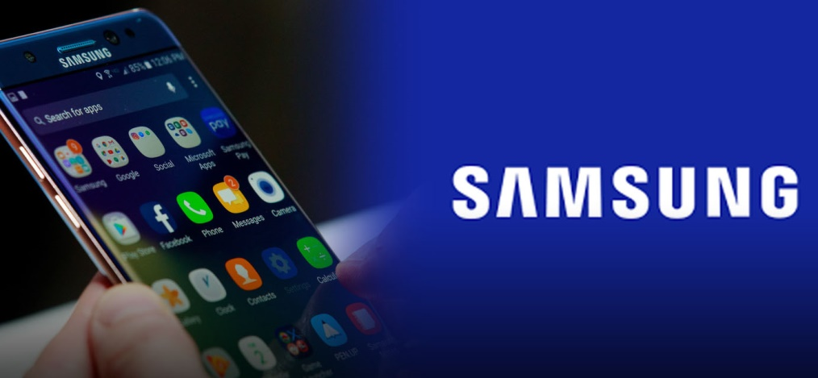
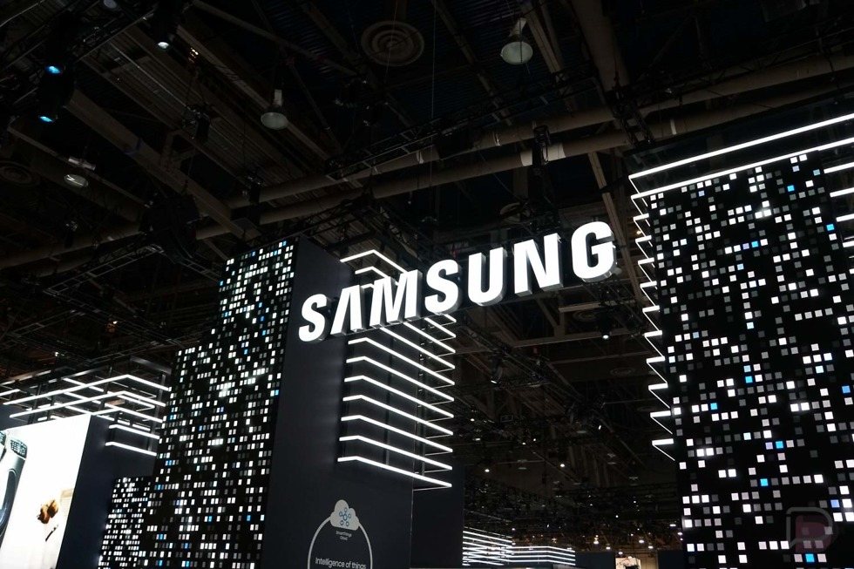
STRATEGIC BRAND PLANNING
OF
SAMSUNG MOBILE

Strategic Brand Planning of Samsung Mobile
[THE REPORT IS SUBMITTED FOR THE REQUIREMENT OF THE BACHELOR OF
BUSINESS ADMINSTRATION DEGREE SPECIALIZATION IN MARKETING]


SUBMITTED BY
Md. Ashikur Rahaman
ID: 111151547
Major: Marketing
School of business and economics
United International University

SUBMITTED TO
Dr. Md. Shariful Alam
Assistant professor
School of business and economics
United International University

Date of submission: 24th December 2019

LETTER OF TRANSMITAL
30th December 2019
Dr Md Shariful Alam
Assistant professor
School of business of economics
United international university
Subject: Submitting a project report on "Samsung Mobile's strategic business plan"
Dear Sir,
I have been very pleased to submit this project report on Samsung Mobile's strategic business plan. Yet I am a continuing student at UIU and this is my last semester. So I decided to report on a marketing related project because my major is marketing. I did my best to meet the University requirements and also followed your instructions when preparing the report. This report especially helped to understand the different concepts of marketing for branding.
If the report can achieve its purpose, it would be a pleasure for me. So I would like to request you to accept my report and be compelled by it. If any questions seem to be needed I will be available at any time.

Thank you
Sincerely yours

Md Ashikur Rahman
ID 111 151 547
Major: marketing
School of business and economics
United international university
ACKNOWLEDGEMENT

At first, I want to thank my almighty God, whose invisible guidance helped me complete the report. I would like to express my gratitude to my esteemed supervisor Dr Md. Shariful Alam, Assistant Professor of the School of Economics at the International University, who helped me to select this report. He helped me with the report from the very beginning. He helped me from time to time and gave me instructions on the report. He advised me on assignments and the creation of accurate reports which ultimately enabled me to complete well which is a partial requirement of the BBA program. I would like to extend my sincere love and thanks to all those who provided me with information and expressed their personal opinions. The information they provided helped me as the primary information in my report. Finally the silent stream of gratitude is for my mother, whose blessings are always with me in this world.

EXECUTIVE SUMMARY

Fair Group is one of the fastest growing business organizations in Bangladesh established by the Fair Group Samsung. With the cooperation of Samsung, Fair Group reached the milestone of the first Samsung manufacturing plant in Shivpur, Narsingdi, Bangladesh. Fair Group launches Samsung Executive Briefing Center (EBC) in Dhaka's Banani, Asia's second largest EBC.
My report is about "Samsung's strategic business plan" so I mentioned the company that launched Samsung. This report consists of five separate sections. In the first chapter I discussed the background of the report. I also explained the purpose, scope, limitations and secondary information of the report for my study and the methodology used to prepare this report. Like all reports, it also has some limitations that were inevitable in some cases. The second section deals with all company information and attempts to focus and focus on fair groups and companies in Samsung. In the third chapter I have given an overview of the current market of the mobile phone industry in Bangladesh. The next section deals with Samsung's business model and its one-year brand plan, as well as Samsung's SWOT analysis. Finally in the last chapter of this report SWT and the people describe some of the recommendations based on the information that I asked when creating this report.
This is about my project report which mainly focuses on "Samsung Mobile's strategic brand planning". The limitation of reporting is the short time of the semester, poor research experience and poor confidential information. While this report has some limitations, it did help me complete my undergraduate degree; this will help other people and students generate final reports. Samsung can find positive and negative aspects of their activities in this report.

TABLE OF CONTENTS
CONTENTS | PAGE
Acknowledgement | ii
Executive summary | iii
Chapter 1: background of the study | 1
Introduction | 2
Origin of the report | 3
Objectives | 3
Scope of the study | 3
Methodology | 4
Limitations | 5
Chapter 2: organizational overview | 6
Fair group | 7
Samsung | 8-9
Chapter 3: mobile phone industry in Bangladesh | 10-11
Sales growth of mobile phone | 11-12
Growth of mobile handset market | 13
Samsung and Huawei continue to rule handset market | 14
Smartphone continues growth | 15
Major players | 16
Chapter 4: business model and brand plan | 17-21
Distribution network and channel | 21
Advertising and promotion | 22
After sales service and care | 22-23
SWOT analysis | 24-26
Brand plan | 27
Timeline | 27
Objectives | 27
Target audience | 27
Segmentation | 27
Positioning | 27
4PS | 29-31
Main message | 31
Chapter 5: recommendations and conclusions | 32-34
Reference | 35

CHAPTER 1

STUDY
OF THE
BACKGROUND

INTRODUCTION
Mobile phones have become an important part of our daily life. Due to technological and innovation advances, it is no longer about luxury products. Mobile phones are showing positive growth in the telecommunications industry in Bangladesh. Apart from the international brand, various local and China brands are performing well in the market. Local mobile brands are slowly conquering the minds of people due to their low cost, amazing features and improved performance.
FAIR Group is a renowned encouraging and evolving business group aimed at enhancing all aspects of life for customers with strong brands, trusted products and services. On 27, the Fair Group took over the national distribution of Samsung Mobile Bangladesh. In recent years, Fair Group has made various investments in mobile devices, consumer electronics, FMCG contracts, logistics, pumps and foundry manufacturing and distribution, IT Solutions, Food and Beverage, Retail and Café.
Samsung has been working in Bangladesh for a long time, for 8-9 years. It entered the market at a time when major international companies such as Nokia, Motorola, Sony etc were ruling the mobile phone industry alongside global companies. But in this tough time, Samsung managed to grab the most customers of our country, which is 40-50% of all mobile users. Samsung has able to capture the big portion of market by providing feature phone at lower cost and also providing the smart phone with amazing feature at lower price. When people realize that a global brand that they provide smart phone at a lower price they eagerly buy the product. And this was their strategic plan to capture a big portion of market. They were able to enhancing sales growth in telecommunication industry. At a beginning of 2010 Samsung were continuing growths by providing smartphone at lower price with amazing feature. They were able to attract people by their strategic plan to increase their sales and capture the market.
“Strategic Brand Planning of Samsung Mobile” Subject to my project report. The survey helped me about a mobile company like Samsung Mobile, as well as learns practical knowledge about the branding strategy of Bangladesh's mobile industry. Not only the mobile phone it helped me to know about the branding and sales strategy any product and service.

ORIGIN OF THE REPORT
This report is prepared as the part of complete my bachelor degree. It is an educational requirement of my bachelor program. This report helped me to enhance my practical knowledge on product and service. I have known the strategy of branding, sales and capturing market. The most important origin of the report is to fulfill my degree.

OBJECTIVES OF THE REPORT
BROAD OBJECTIVES
To determine the strategic brand plan of Samsung mobile for one year. What is their plan about their product and service to consumer, what is their branding strategy, how they implement their strategy, this all about my broad objectives of my report.
OTHER OBJECTIVES
- Offers an overview of FIR Group, Market Access and Samsung Mobile
- Analyze the performance of the mobile industry in Bangladesh
- Study the current branding strategies of SAMSUNG Mobile
- analyze SWOT
- An strategic brand plan of SAMSUNG Mobile
- Finally, to suggest some recommendations to overcome the shortcomings of SAMSUNG Mobile branding
SCOPE OF THE STUDY
The study is conducted on academic need and its territorial boundaries are restricted to Bangladesh where Samsung operates its activities. The main objective of the report is to "Samsung Brand Strategic Brand Plan". At present, the mobile phone brand's operational strategies are considered. Global brands such as Apple, Huawei, MI, OnePlus, Realme etc. are considered and this study is limited to FAIR group providing mobile phone. They are also not considered in other product lines. The strategies outlined are related to the mobile phone industry, not just other products and electronics devices. The survey highlights the market situation of the mobile phone industry and aspects of the upcoming market growth of Bangladesh.
METHODOLOGY OF THE STUDY
Some information is used to generate reports and data is collected from two sources, one primary and the other secondary. On the face of the people, some information is collected from personal interviews of the mass people. Secondary non-secondary information, on the other hand, is the analysis described in the report. This report uses some graphical tools to more accurately describe the data. There are also some suggestions for the branding strategy of Samsung mobile phones.
SOURCES OF INFORMATION
Primary source:
- Personal interview of mass people
- Personal observation
- Practical work in field
- Regular briefing is such a great supervisor's office
Secondary source:
- Various publications regarding mobile phone industry
- News letters
- Official website
- Different business report
- Different book and journal
Research instruments: the information has gathered that are mentioned those were the research instruments of the report. Some questionnaire was also used to prepare the report.
Software instrument: Microsoft word is used to making the report.

LIMITATIONS OF THE STUDY:
Research is a daunting task for preparing a report. A lot of consideration is needed to prepare the research. Different tools and techniques are needed for accurate analysis techniques .There are several limitations to creating this report which are outlined below:
Hidden information: There are some secrets that are usually not provided.
Short time: Time-dependent is the avoidance of reporting. The allotted time is not enough to know the branding strategies.
Limited information: The reports were made for academic purposes only. So, it is very difficult to gather all the information.
Insufficient data: The report that the data appears to be insufficient
Extract Information: Some information is collected from public opinion based on their experience. Because of this, there was very little problem with extracting information.
Study and personal business: still I am a running student and I have other academic study. For this reason I can afford more time to prepare the report.

CHAPTER 2
ORGANIZATIONAL
OVERVIEW

FAIR GROUP
FAIR Group Business FAIR Group's story is set up to enhance all the aspects of life for customers with strong brands, trusted products and services:
Fair Group is one of the fastest growing business associations in Bangladesh established in the 21st. Fair Group has embarked on a journey of excellence, representing the world's top five edible oil brand OLITALIA, as a marketer in Bangladesh. Later, in the 21st, the Fair Group took over the national distribution of Samsung Mobile Bangladesh. In recent years, Fair Group has made various investments in mobile devices, consumer electronics, FMCG contracts, logistics, pumps and foundries, manufacturing and distribution, IT Solutions, Food and Beverage Retail and Café.

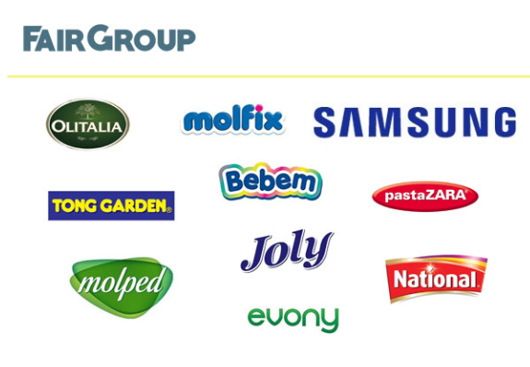

- To be the Leader of Tech-entrepreneurship in Bangladesh.


- Improve people's lives through technology, quality and convenience.

SAMSUNG:
In 2000 Samsung introduce its new Samsung's Galaxy Smartphone Series, which quickly became not only the company's most acclaimed product but has repeatedly topped the annual list of the world's best-selling smartphones. The company has been the top-selling international producer of television ever since. At the beginning of the 21st, the Galaxy series was expanded to tablet computers by introducing the Galaxy Tab. Shortly after the end of the 20, Samsung brand has emerged as the fastest growing and leading the mobile handset brand in Bangladesh market. Samsung is proud to enjoy a leading position in the mobile handset industry of one brand; Samsung has become the market leader in the mobile phone segment in the 21st. The low price strategy, amazing features and style, quality of international construction And has contributed to the creation of a strong distribution network Samsung Mobile the choice of Bangladeshi customers. The company's main goal as it continues to provide outstanding customer service; it continues to explore new horizons in order to provide its most valuable premium assets, new and better solutions to its customers.
- Dedicate human resources and technology to create better products and services
- To inspire the world with innovative technologies, products, and design that enrich people’s lives and creating a new future.
PRODUCTS
HANDSET | ACCESSORIES
Classic | Battery
Feature | Charger
Smartphone | Headphone
Tablet | Pen drive
Style | Power bank
Robust | Speaker

CHAPTER 3

MOBILE PHONE
INDUSTRY
IN
BANGLADESH

CELL PHONE INDUSTRIES IN BANGLADESH
In recent years, the mobile phone industry has grown unexpectedly, according to Bangladesh BTRC, there are now more than 120 million mobile phone subscribers in the country. Bangladesh is a truly mobile-first country, according to Stat Counter Global Status data in February 2018, over 25% of internet users came via mobile where the number for desktop was only 30%. Despite affecting overall usage of feature-phone, the country is also seeing incredible smartphone growth for cheap Chinese handsets. China brand bring a huge change in mobile market industry. They provide smartphone and feature phone at a lower price. Beside as a global brand Samsung capture a huge market by providing excellent pricing strategy and branding strategy. Their market plan was successfully implementation. As a global brand Samsung has able to understand the demand the local people and that way they were marketing and implementation their strategy. They have able to increase the sales growth in mobile market industry.

HANDSET SALES GROWTH IN 2018:
Currently, there are five local and global brands that are integrating smart devices into the country. Local assembly is now about 14 percent of total device service. Mohammad Mesbah Uddin, chief marketing officer at Fair Electronics, said collectors will be able to meet one-third of the country's demand for handsets by the end of the year. From Samsung's point of view, we are happy with the growth of our merger, but the overall industry has not been able to keep up with us, "said Mesbah, joint secretary of the BMPIA. He said there is still huge potential in the market, but the volume of business is not growing exponentially." One problem is if people don't get the expected speed on their device By smart devices will be the key? "29% of handset sales are smartphones, which is 24.2 percent higher than the first quarter of 2018 if the government encourages Ha Haq, the industry will help the market grow. Transient's plant in Gazipur consolidates 3.5 million units of handsets a month, the highest among rallies. According to the BMPIA, the handset was sold in Bangladesh last year for Tk.
The feature phone category is still in the dominant category with a 76% share, but its shipments have shrunk to 25.5 million units in 20 shipments, up from 26.5 million in the year before. Mobile phone vendors also fought against the tariff structure in the country to manage their pricing strategy. Impact of increased tariffs was seen in the Customs Phone segment, where smaller local vendors were unable to absorb higher prices. The Smartphone segment ends 2% quarter-over-quarter growth In 2018 ended Android Go smartphone share increased from 8% in 2012 to 12%, an impressive 12% increase in 20in. HMD launched the first version Go smartphone in the country.
.

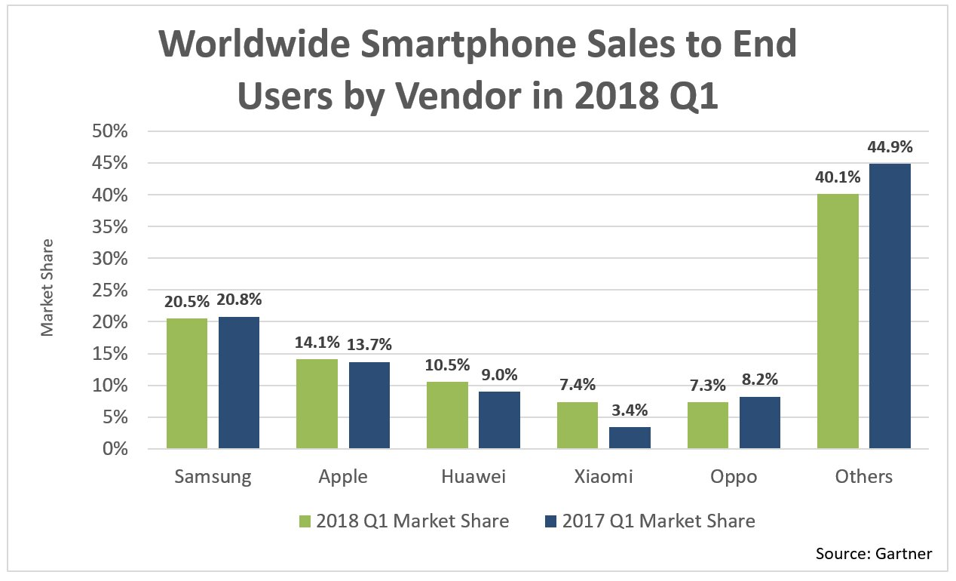

HANDSET GROWTH:
The mobile is one of the fastest growing markets in BD but one of the key differences is that, around the year 2012, it was a feature phone that came in large numbers and today it is a smartphone. Importers Company of Mobile phone, estimate that the value of legally imported handsets is expected to reach $ 1 million by 2020. The increasing number of smart phone access will affect business, payments, lifestyle, content usage and more.
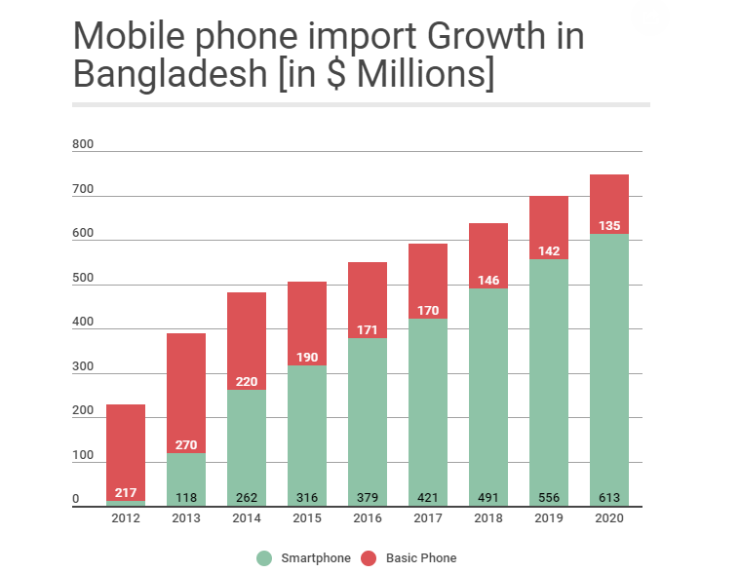

SAMSUNG AND HUAWEI RULE THE MARKET
Samsung and Huawei are continuing ruling the mobile phone market in Bangladesh. Their market share is more than other brand. Samsung is the world's No. 1 smartphone brand. For the last 4 years they have been in the first position in the smartphone market in the world. Samsung occupies 24% of the smartphone market worldwide. However, Samsung is able to capture only 5% of the market in Bangladesh. Samsung annually releases a lot of new model smartphones. This is the name of the smartphone series Samsung Galaxy. Currently Samsung's market cap is increasing day by day. Huawei is the world's leading smartphone brand. It is a chain smartphone brand. Huawei is the number one smartphone brand in China. Huawei has been able to capture 9% of the global smartphone market and it is growing day by day. Its market position is close to 5%. Huawei was the top profitable market after Samsung. However, the situation is different in the smartphone market segment. Although Huawei imports more smartphones, Samsung topped the total revenue from smartphone sales.
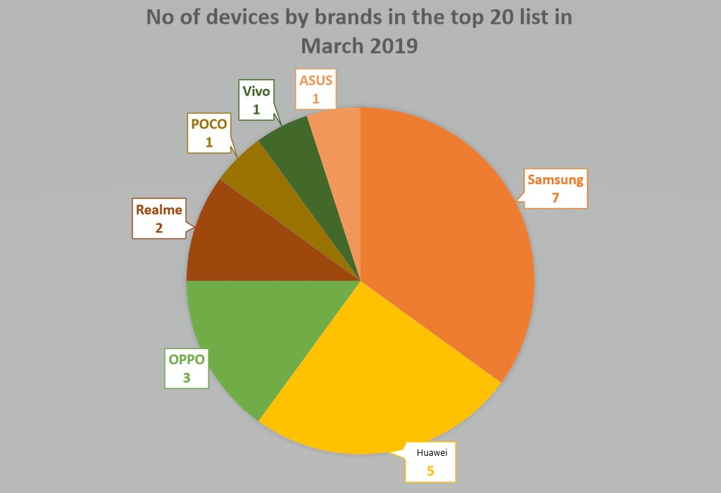

SMARTPHONE GROWTH
The smartphone import of Bangladesh is gradually growing, accordingly the market research. Mobile handset is one of the fastest growing markets in the country. In past few years the big portion of market captured by feature phone, but after 2015 smartphones ready to capture its market hugely. And it brings a significant change in mobile market.
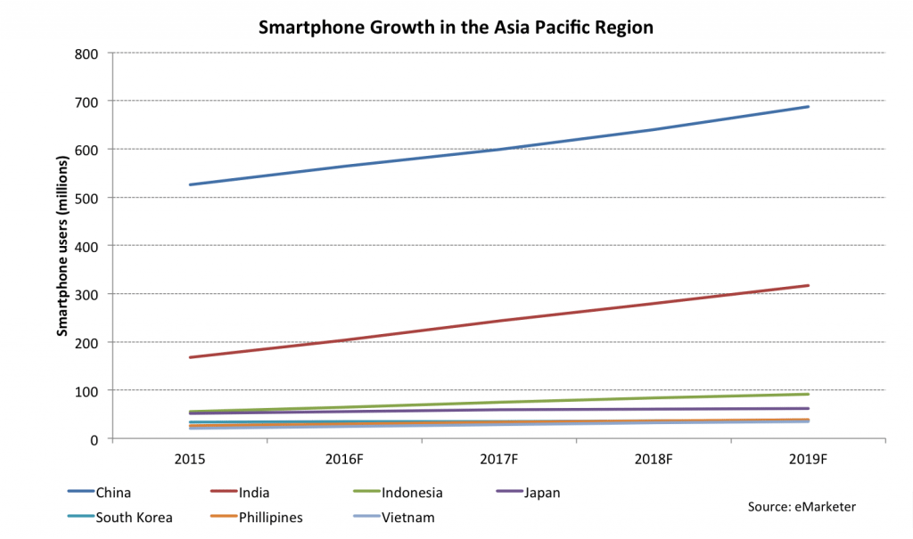

According to Bangladeshi mobile importers, smartphone imports increased significantly in the first half of January 20, compared to the same period last year. This is an increase of about 58.45%. About 36.71% of the smartphones were imported during this time. Smartphone growth in Asia about 150m in 2015 and in 2019 it has increased about 320m. It is a significant change in mobile market growth. The largest change has come in china. Their smartphone growth from 2015 to 2019 is all about 500-700m.

MAJOR PLAYERS
Samsung:
The leading smartphone company. Samsung has held the largest share of the global smartphone industry for the past eight years. Handset is the main contributors to division sales, accounted for about 95% of department sales in the first half of the year, 40% of total mobile phone company sales 2018, and their contribution increased 46% in the first half of 2019.
Huawei:
Chinese smartphone leader. According to Gartner, the market share of China smartphone maker Huawei was 16% in the second quarter. Huawei is the world's second-largest smartphone company in sales, and it has sold 206 million smartphones in 2018. Huawei sold 117 million smartphones in the first half of 2019. The company earned $ 105 million in revenue and $ 5 billion in net profit.
I-phone:
The leader in profit. I-phone made a net profit of $ 59 billion in 2018, making it the world's top tech company in terms of profitability. I-phone’s 2018 revenue stood at $ 266 billion, and the company sold 218 million iPhones in 2018, however, the company's iPhone sales declined in the fiscal year 20.
Xiaomi:
Unlike Huawei, Xiaomi is listed on the Hong Kong Stock Exchange. Founded in 27, xiaomi was the fourth largest smartphone company in the second quarter by unit sales. The company sold nearly 60 million smartphones in the first half of 2019 During this period, xiaomi smartphone revenue increased by 9.8%. Xiaomi made around $ 25 billion and its profit for the year was about $ 2 billion in 2018.
Oppo and Vivo:
Oppo launched their phone in 2008 and vivo 2009. Oppo sells in around 39 countries and has more than 41k employees. According to IDC, they captured 7.4% of the global smartphone market in the first quarter of 2019.

CHAPTER 4
BRAND PLANNING
AND
BUSINESS MODEL

BUSINESS MODEL OF SAMSUNG
Samsung has started in a new age in Bangladesh handset industry; They make a history of selling 6.5 million mobile sets all over Bangladesh in one year. Their business strategies were very successful and effective in gaining the share of Bangladesh's mobile phone market over the years. A brand name is Samsung run their operations under a company called FAIR Group. In the year 2014, they first launched the brand name Samsung. Their primary business was later mobile phones; they launched mobile accessories and mobile applications under the Samsung brand as a subsidiary business.
Public made Samsung is a wealthy leading brand of Bangladesh.
The 5 major reasons of Samsung success:
1. Providing high quality in mobile handsets
2. After-sales service like, guarantee-warranty and customer care service
3. Offering low prices in the market
4. Providing ancillary products for mobile
5. Providing feature phones to the public
Following the Samsung management system, Employees have the right to participate in the decision-making process, but at the manager's suggestion. The marketing manager informs and describes it as a "new generation" execution system. Manager thinks that in today's world management should be more based on team work and that work should be done collectively. Now employees have the freedom to interact more freely with their immediate careers and managers. When making decisions, employees are notified and are asked to express themselves freely if they have any objections or opinions. He believes authorize the staff ultimately leads to the welfare of the organization.
Samsung's research and development department is just as powerful and successful. For this; they are not only available to provide mobile-handsets, but also to mobile accessories and mobile applications. They are the first global brand in Bangladesh to develop mobile applications. They believed that this division made them strong and successful in maintaining the Bangladesh mobile industry and furthermore it made their operations smooth and flexible. Their strategies and decisions depend on the research and development department, and they emphasize the importance of maintaining Bangladesh's market. Samsung's Start Year 2014 by FIR Group in Bangladesh; Samsung has been a successful brand in Bangladesh since its first year. Samsung started to make a profit by surpassing the break-even point in a year. Bangladesh Telecom Association has said that Samsung is the highest selling mobile brand. Samsung faced the challenge of Nokia as a feature phone in the 21st. Because then people like the brand for their strong phone service and strong brand. This time, people understand the brand as Nokia. However, the 25 made a significant breakthrough to Samsung, the first mobile brand in Bangladesh to sell 5 million mobile handsets all over Bangladesh and earn tens of thousands of dollars.
Over the past few years, the mobile industry has grown to a level that has never been before. Millions of people are now using mobile phones. It is also an arm's reach for poor people. Demand for cell phones to them is enhancing day by day. Just as people have the ability to buy cell phones, they also have different demands from cellphone companies. They have the flexibility to switch from one brand to another. Therefore, mobile companies are in a difficult situation to meet all consumer needs. They have to serve their entire consumer to sell their cellphone to the customer as much as possible and maximize their profit. This will help them gain competitive advantage over their competing companies. So every cell phone company including Samsung should meet consumer demand, they must listen to what the customer wants, what their problem is, and they should work on that and solve the problems. Samsung has several problems ahead of them; one of the major problems is their phone's Face Hang problem. Long-term use or other applications running Samsung phones do not perform well. Some customers are switching to another brand for this problem.

BUSINESS STRATEGY
The strategy that our chosen company Samsung is using is a limited growth strategy. This is the kind of strategy a company focuses on its current products that are being produced and the potential market. There are ways to grow the product to be more innovative. Samsung basically depends on various growth strategies. They are
- Market Penetration
- Market Development
- Product development and
- Innovation.
- Diversification
Market penetration:
Samsung has maintained its market share. The company develops its product as their valuable customers are not bothered with the product and can attract new customers. That way their customers will be pleased with the product and it could be a better shareholder for Samsung.
Product Development:
Samsung targets the same consumer with new products. By introducing a new product, they will attract more customers to their product and enhancing their market share. They advertise on TV, newspapers and pamphlets and billboards for product awareness.
Ex: Samsung is launching the Galaxy S series mobile phone every year.
Market Development:
As Samsung enters new markets, market growth and market share will increase. Using this strategy, they enter a new market targeting new customers in other regions. The new market for Samsung may be a new country or it may be a new city within the same country operated in the previous country.
Ex: Samsung is launching its product in a rural area or a new country.
Innovative:
Samsung are leading company in case of innovativeness. They bring something new and exciting in handset market every year. First they bring an innovation in display, like curve display that redefine immersion. They show that software and camera innovations that continue to push the limits of what mobile devices can do. They bring innovation on some area like display, pro grade camera, pen, Knox, biometric authentication, wireless charger, Samsung pay and so on.
Diversification:
Apart from Samsung's electronics, Samsung also produces unrelated products. Samsung has the Samsung heavy industry, which is the second largest shipbuilder. Samsung has two construction companies which are the 13th largest and the 36th largest companies are Samsung Engineering and Samsung C&T. Samsung also offers services such as Samsung Life Insurance and is the 14 largest companies in the world. They are operating much division in widely different business areas.

DISTRIBUTION NETWORKS AND CHANNELS
Samsung currently has about 722 distributors and more than 266 dealers all over Bangladesh. Further, Samsung has 5,000 employees all over Bangladesh and some are permanent and some are contract based. Their employees are divided into three groups - Engineer Employees, Management Employees and Marketing Employees. There are two types of engineer workers - the first type who develops mobile hardware systems and the second develops mobile software or application systems. Management staff to manage their offices, call centers, customer care and delivery management systems. Marketing staff to manage sales and manage promotions. Samsung has an existing distribution network and channels from existing businesses. Samsung's resources aren't much needed for new phones and, more importantly, their phones and tablets. These distribution channels will be available for promotion of other Samsung products in the future. That means it's easier for them to market more than just electronics if they want to.

Additional distribution channels come in 3 different sizes
1. The product is sold directly to the consumer
2. The products are sold to retailers and then to retailers
3. The product is sold to wholesalers who sell to retailers who then sell to buyers

ADVERTISING AND PROMOTION
Marketing and promotional strategies are created to attract the public to buy something. So, Samsung is centered on price sensitive issues because Bangladesh is a middle-level income country and most people are below the income of 20,000. Later they also offer premium mobile. Their main goal was to provide mobile at a low cost with quality and features. Samsung, the best global mobile brand that offers mobile phones with cameras at a lower cost, is incredible. They used RDC, TVC, print advertising and sponsorships as their promotional strategies. All their strategies, they described their quality and low prices. Moreover they do CSR. The pricing strategy, channel marketing, sponsorship etc. are the advertising method of Samsung.
AFTER SALES SERVICE
One Year Warranty Service
Samsung will provide a one-year warranty service if any instrument defects or any functional defect develops for one year from the date of purchase of the phone. The date will be calculated by automatic warranty activation via SMS. For batteries and chargers, customers will enjoy a six-month warranty from the original purchase date. It does not place any accidental loss or damage on any kind due to the use of unauthorized accessories. There is no need to pay a service charge on that warranty service period.
7 Days Replacement Support
If a functional error develops on the handset, the customer will have the benefit of replacing them within days by purchasing their newly purchased handsets.
Customer care:
Currently, Samsung has a total of 37 customer care points in various cities. There are 11 customer care points in the Dhaka area. And other points are located in major cities of Bangladesh. It also has 26 collection points. People go to the care if they face any problem after buying the mobile phone.

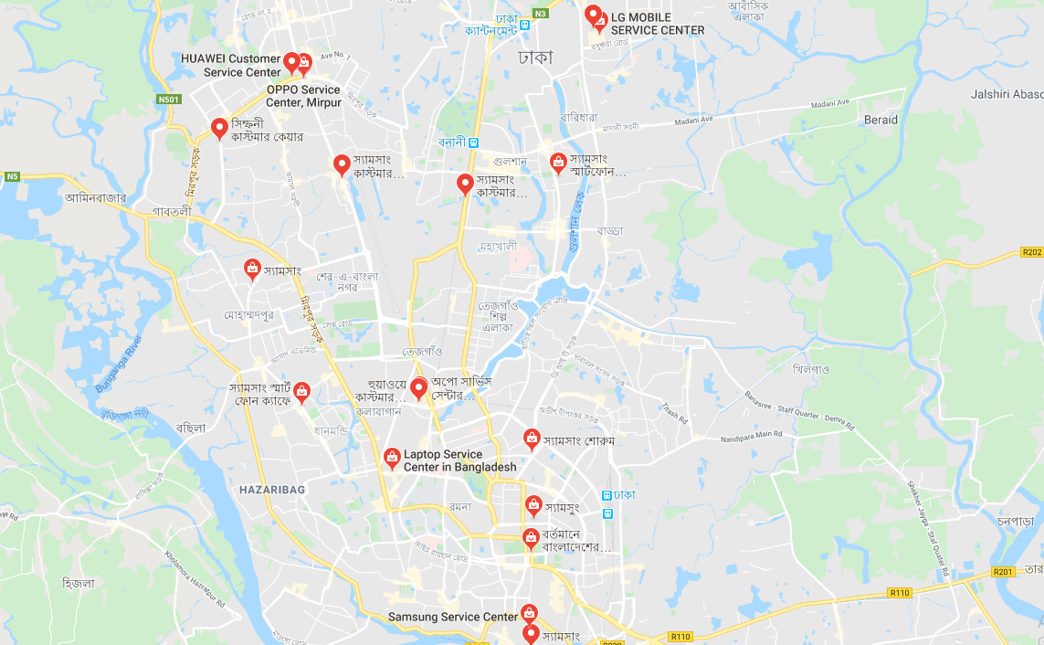

SWOT ANALYSIS
STRENGTH
Innovative
Samsung Mobile has a superior innovative touch screen and exclusive design. Attractive build quality. It has launched a global brand in Bangladesh. It offers a lot of mobile with different design. It gives customers reliability, value for money and choice.
Market leader
Samsung mobile is the recent market leader of mobile phone industry in Bangladesh. From the market research it has been said that now they are leading the market and now they are the popular brand. Their market share is higher than any other brand.
Strong brand
Samsung has a strong brand image and it is trusted by its millions of people for their quality products and there have global presence that is very strong.
Price
The issue of price is important in Bangladesh because of our income. The price of Samsung mobile is low to medium which is affordable for the people of Bangladesh. This is why people love the brand most.
Quality and cost
Samsung production cost is low. They produce their production in various countries and it is their competitive advantage.
Strong R&D
Samsung has a very strong R&D department to evaluate their product and develop it.

WEAKNESS
Low profit
Samsung profit market is low. For getting competitive advantage they offer different promotion and provide products at a lower cost.
Image damage
For some incident like battery backup and hang problem their reputation has decreased les from before.
Large product diversity
Samsung launch a huge model, that’s why they can’t concentrate on a specific product.to develop it. For this reason they are losing the public trust.
Dependency on other software
Samsung has no own operating system like apple. If their software want run they cannot run without the third party.

OPPORTUNITY
Growing smartphone market
People are becoming more technology dependent and for this smartphone is the most suitable device. That’s why demand of smartphones is increasing. Smartphone is using alternative as computer or tablet. So demand of smartphone is increasing.
Switch to smartphone
In past recent year people are switching to smartphone from feature phone.

Strong financial position
Samsung has been run their business for a longer period of time so they are able to secure their position in mobile market.
Tablet market growth
The tablet market growth is less slow and that has negative impact. In this place smartphone take a strong position.
New company
Recently Samsung bought the audio giant, VIV, Al platform that completed the acquisition of new net communication technologies.
THREAT

Competitor
There are lots of competitors in mobile market place. Huawei, MI, Oppo and beside the local brand are competing with Samsung. The number is increasing day by day.
China competitor
China companies are providing phone at a lower price than Samsung and they also give the latest technology and feature in their phone. People are accepting those brands in case of Samsung.
Large number of product
Samsung produce a huge product portfolio that has high risk. If any product fails to satisfy the customers the entire product will suffer for this.

SWOT analysis of Samsung proves that it has huge strength opposite of weakness. They also have so many opportunities beside as threats. If they provide good quality and decreasing their product portfolio they will be the number one brand in Bangladesh.
BRAND PLAN

Time period
The brand plan is ready for the January 2019 to December 31 periods.
Objectives
- Expand the Samsung brand name.
- Hold on to the market leader and gain more market share.
- Expand the Samsung image of innovation, and quality.
- Measure awareness and responsiveness to adjust to marketing promotion as needed.
Segmentation
Samsung follow the two types of segmentation. One is geographic and another is demographic. Geographic segmentation focus on country, region, state, nation, city. Samsung reach their product in rural area and country. And for this reason this brand has become popular to customers.
The other segmentation Samsung follow that is demographic segmentation. Demographic segmentation follows the consumer want, age, demand and so on. Samsung produce many product portfolios for their different choices of people. They focus on teenager, college student and produce their product. Foe senior citizen they also produce the feature phone.

Target audience
Samsung has two main categories and it targets the multi-segment. Samsung targets upper middle and lower middle class professionals. It usually has a busy schedule and therefore needs to communicate with colleagues and family.
Secondary goals are high school colleges and graduate people who need devices that are multifunctional and portable. In that case, Samsung manufactures their products to the needs of the people. The second goal includes advertising for medium-sized corporations that they aim to help directors and employees access important data on the go.
Senior citizens who are not very well known with new technology and a simple need the solution for connecting is targeted. Beside they produce the feature phone for them. Recently it has become more use beside the smartphone. Because people want to use a simple phone to communicate.
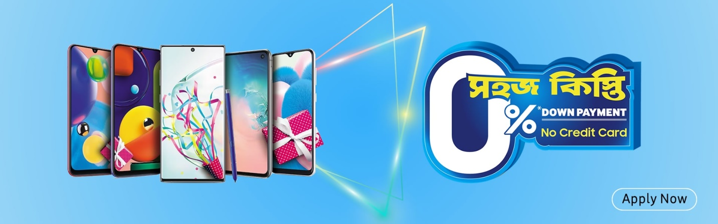
Samsung also target the lower income people whose income is low. They provide the EMI system to buy their phone. They provide 0% interest. They provide this service through a third party.

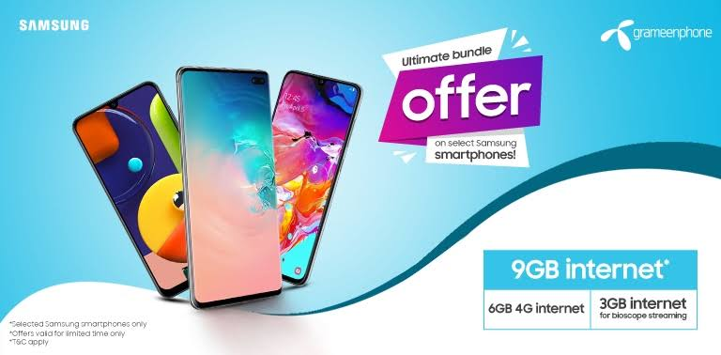
Business target
The biggest cell phone service provider, Grameen phone. They provide different offer to buy Samsung mobile.

Positioning
Samsung position its brand by following the blue ocean strategy. They produce and provide product at a lower cost but their product performance is good than any other local brand. They get a competitive advantage from it. By following blue ocean strategy Samsung become the market leader in smartphone market in Bangladesh.

THE 4PS OF SAMSUNG
Product
- The special edition version will be launched like the Samsung S series. The S series is the flagship phone in Samsung.
- A cheaper version is being launched, with less advanced features, including a more advanced version for professional use, such as the Samsung J series, a series smartphone.
- Adding the following features to Samsung (large disk storage, low weight, slim device, long battery life, 3G, Wi-Fi, EDGE, GPS and advanced cameras like vertical and more than 2 cameras)
- The new smart watch (Samsung gear) has launched.
- They provide the camera and Bluetooth in their feature phone. For this reason the feature phone demand is increasing.
- Samsung provide the finger print sensor and face lock in their smartphone.
- Wireless charger, portable SSD, pen drive.

Price
- Affordable price.
- Attractive and exciting Offer.
- Samsung provide their product at a lower price because their production cost is low.
- Samsung can beat their competitor for special prices of their feature phone.
- They can take a competitive advantage in case of their pricing system.
- Samsung provide EMI system to customer to buy their product.
- Samsung use the Skimming Price Policy. When Samsung launches new products with different variants of storage capacity, the price of the product goes even higher. But when other competitors launch a smartphone with similar features, Samsung decrease the older price.

Place
Samsung sells their product directly to retailers and service merchants. And because of this strategy, only service traders are responsible for corporate sales. Because the brand is world-renowned, retailers who transact in technology usually have to include Samsung in their offerings. Distribution is the power for Samsung. Samsung distributes its products at a specific location using a single distribution company that distributes the products to other locations. E-commerce channels like Facebook Marketplace Samsung use their products to their maximum potential.

Promotion
Promotions are not necessarily only mentioned in the media for advertising. In a highly competitive business world, an organization must go beyond the usual promotional strategies and find new ways to attract customers. Samsung believes in such specifications; For promotional activities it has created some promotional alliance promotional activities Three more groups have been appointed for ATL campaign which means all advertising activities.
ATL Promotions: Promotions under BTL or more commonly known as promotions and advertisements. Adcom Ltd: In most cases, it produces posters, leaflets, brochures and other printable advertisements as well as media ads.
BTL Promotions: Windmill Advertising Limited was recruited for ATL promotion and hired a project called SPC (Samsung Product Consultants) to generate sales by providing brand awareness, customer conversion, feature display, customer service, survey management, market intelligence information about related brand. Was done and all necessary. o A new idea in the field of propaganda propagated through BTL. The introduction of SPC has proven to be very successful and is now being implemented in other countries as well. Acting as the eyes of the SPC company, a mobile surveillance and brand awareness process was integrated into all single entities to generate sales.
Helpline: The Helpline provides 24 hours. Customer service over the phone. A dedicated call center is equipped with extensive product knowledge with trained people to serve customers with the information they seek. For this customer get a satisfaction from the company.
Email: Samsung do customer satisfaction by providing email service. When people want to know about new product of Samsung and user guidelines about the product they immediate response them. This can help to promote the brand. Because this can help to customer as a trusted brand.
Print add
Samsung promote their new product by giving add on newspaper. This concept help to attract the product in customers mind.
TVC
Samsung also promotion their product through TVC, that means doing promotional add campaign on television media. In lazy time people watch TV, and if the promotional campaign give on TV that can able to attract the customer mind about the product.

MESSAGE FOR CUSTOMERS
Since Samsung is a low-income mobile handset aimed at low-income and low-education people, our message should be concise, simple and clear to understand. On the other hand, middle-class people, along with senior citizens, college and university students, are our target customers. So, the message should be clear to them. Although handsets have different benefits such as battery, loud voice or hardy, we need to focus on something that will keep a satisfaction level of the customers mind.

CHAPTER 5
CONCLUSION
AND
RECOMMENDATI0N

CONCLUSION
FAIR Group started a mobile handset business called Samsung brand. From the very beginning they are able to understand human needs and human potential. Offering all the latest features at a very low cost, they are able to enter the market very efficiently. They are offering both smart phones and feature phones. It is noteworthy that the growth of mobile industry in Bangladesh is increasing. Samsung also received the best brand awards and maintained the highest market share by becoming an international brand in Bangladesh. As many local and chain brands are now competing with Samsung, it will be a challenge for them to maintain their brand today and gain more shares. For this, they need to build a strong brand and create the necessary strategies and execute them properly. In terms of the above, Samsung can implement 4PS, STP, blue ocean strategy, advertising strategy to implement their brand plan, so that customers will keep Samsung brand name and reputation in mind. However, they should focus on other rivals so that they do not have better service or products than Samsung. They have provided competitive advantage to the customers.

RECOMMENDATION
Improve product quality
Samsung provides better quality handset but they should focus on improving their product quality if they want to catch larger market. Because most of the big problem is, their phone do hang that are so irritating for user. For this reason customer don’t want to buy the Samsung mobile. So they should solve this hang problem. Besides they also have provided more MAh battery in their mobile.
More business target
Samsung now runs their promotion through Grameenphone, the most popular telecommunications service provider. Besides, they should focus on Banglalink and Robi like other telecom companies. So that users of those operators will be impressed to buy the product. This will help increase their publicity.
More billboards in rural area
Samsung should increase the number of billboards in rural area. So can people know about the product benefit, price and become encourage to buy the product. This will be very effective promotion for them.

More TVC
If they want to make promotional activity more effective, they should focus more on TVC. They should provide ad on their local TV channel. Their local and china competitors already have several TV ads and are still launching new ones to connect with consumers. So, they should focus more on their TV ads to shift their competitors.
Proper training and coordination
Proper training is needed to make marketing staff efficient. On the other hand, coordination between departments is also necessary to increase sales and market share.
CSR activity
They should also do some CSR activities. This will help them create positive ideas Which is really important for branding.

REFFERENCE
- Kotler, P., & Keller, K. (2016). Marketing Management 15th edition. Prentice HallBook
- Strategic Marketing (David W . Cravens & Nigel F . Piercy)

- https://bangladeshbusinessdir.com/fair-group/
- https://fairgroup-bd.com/web_admin/page/Mission-&-Vision
- http://www.theindependentbd.com/printversion/details/210448
- https://futurestartup.com/2019/03/30/bangladesh-mobile-handset-market-updates/
- https://www.thedailystar.net/frontpage/samsung-mobile-locally-made-sets-hit-market-soon-1557781#:~:targetText=Samsung%20entered%20Bangladesh%20in%202009.
- https://www.britannica.com/topic/Samsung-Electronics#:~:targetText=Samsung%2C%20South%20Korean%20company%20that,memory%20chips%2C%20and%20integrated%20systems.
- https://en.wikipedia.org/wiki/Category:Samsung_Electronics
- https://www.idc.com/getdoc.jsp?containerId=prAP44948519
- https://www.thedailystar.net/business/news/bangladesh-made-smartphone-sales-rise-1753246
- https://gs.statcounter.com/vendor-market-share/mobile/bangladesh
- https://www.ukessays.com/essays/business/business-strategy-samsung.php
- https://research-methodology.net/samsung-business-strategy-competitive-advantage-effective-exploitation-market-readership/
- https://www.slideshare.net/mehrabmoho/an-evaluation-of-samsungs-marketing-strategy-in-bangladesh-43216125

