Internship Report
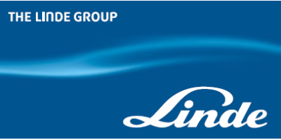

Safety & Maintenance Policy on Linde Bangladesh


‘United-International-University’
Prepared For:
Nasrin-Akhter
Assistant-Professor
School-of-Business-and Economics
‘United International University’
Prepared By:
Sayra Begum
ID-No. 111152266
School of Business and Economics
United-International-University
Submission date: 1st March, 2020

Letter of Transmittal’
1st March, 2020
Nasrin Akhter
Assistant Professor
School of Business and Economics
United International University

Subject: Report on “Safety and Maintenance Policy at Linde Bangladesh”
Respected Ma’am,
Here is the assigned report on “Linde Bangladesh Ltd.”. In this report I try to show the existing usage of the safety rules & how they are maintain this policy. I have enclosed all the necessary- elements-that must be-included in this-report.-Besides, this is a process of developing my skills. So, I hope that you will be kind enough to consider the limitations of this report.
Thank you for giving us such an opportunity to work with something new. I-will be grateful to provide-you any-additional-information, if necessary.
Sincerely yours –


Sayra Begum-(111-152-266)

Acknowledgementt
“First of all, I would like to convey my warmest thanks to the Almighty-Allah for fruitfully completing the internship report. I want to evolve my deepest sense of gratitude and healthy respect of “Nasrin Akhter, Assistant-Professor-of-BBA-program-United International University”, whom.I got as my honorable supervisor and from whom I received all the valuable suggestion and instructions for completing this internship report also very thankful to all my faculty members who helped a lots to complete BBA program. Most thanks to the organization’s supervisor of Fuad Ahmed of Linde Bangladesh Ltd giving me the authority to work with the team in to the organization.
Also thanks to my colleagues and HR team those who helped me to figure out all of the given tusks and provided me all of the regarding information which I had needed to completed the daily tasks and or preparing this whole report.
Lastly I really would express my gratitude to all of the employees and management team for their great support of whole entire Internship journey to make it success one.

Executive Summary
Now-a-days the world became more advanced and comprehensive. So, as a business student we are the future of the business market near future and an internship is the best time to acknowledge to learned corporate knowledge. I got a chance to work in the Human Resources Department at Linde Bangladesh for 3 months. This report is going on the Linde Bangladesh LTD that is one of the most leading gas companies in Bangladesh. They have different sectors for their products and services. This report is totally based on “The Safety And Maintenance Policy at Linde Bangladesh”
Here I have included the overall safety and maintenance policy that are followed by the company. And the employees and workers are must allowed maintain. I have worked in corporate office along with in factory. So, here I monitor at every where they highly concerned about safety. Because, they are manufacture risky products. I also tried to mention all the safety policy applied here according to Labor law of Bangladesh.
Being an intern in HR department, I got the opportunity to do the employee performance evaluation survey of performance management. Moreover, it also gives a picture of individual workers minds. They are very happy that Linde concern about their safety and they love to work at Linde.
Last, but not to the least with a fulfill recommendation that could be further increased the capabilities of Linde Bangladesh to a new & level also have been recognized. Despite the challenges that I have tried to make this report with as much informative as I could assure.

Contents
Letter of Transmittal’ ii
Acknowledgementt iii
Executive Summary iv
“Chapter -1” 1
Introduction of the Report 2
Background of the Report 2
Objective of the Report 2
Main-Objectives: 2
Other-objectives: 3
Specific-Objective 3
Scope & Limitation of the Report 3
Scope to the study 3
Limitation to the study 3
Methods and Sources of Data Collection 3
Methodologyp 3
Sources-of-Data 4
Primary source 4
Secondary-source 4
Data Processing and Analysis Method 4
Data-Processing: 4
Data-Analysis: 4
“Chapter-2” 5
(Literature Review on existing Safety & Maintenance) 5
Safety Management 6
Safety First - Linde’s Safety Principles 7
Existing Safety & Maintenance at Linde Bangladesh 7
Maintenance management 8
Maintenance rules 8
Benefits of Employee Safety and their Maintenances in an Organization 9
Importance of Safety & Maintenance 10
“Chapter-3” 11
(Company Overview) 11
History of Linde Group Limited 12
Linde Bangladesh Ltd. 13
Organ gram of HRD 14
Location 15
Nature of the business 15
Vision 16
Mission 16
The Linde Spirit 16
Values 17
Behaviors 17
Products 17
Gases Business -a Wide Range of Products 18
Functional department of Linde BD. 19
Finance 19
Human Resource /Admin 19
Sales & Marketing 20
Distribution 20
Operation Department 21
Procurement 21
Information System 21
Hospital Care 22
“Chapter -4” 23
(Overall Safety Practice & Maintenance) 23
The Concept of Employee’s Safety 24
Laws regarding occupational employees health & safety 25
Health & Hygiene 26
Section 51.Cleanliness 27
Section 52: proper ventilation system and keep the temperature low 27
Section 53.Removal of dust and control excess fume 28
Section 59: Toilets &-washrooms 30
Section 61: Buildings and machineries safety 30
Section 62: Protect from fire 31
Section 69: Hoists-and-Lifts 34
Sec.72-Floors, stairs passage 34
Sec.74-Excessive-weights 36
Sec.75- Eye protection 36
Sec.78.a - Requirement to used personal safety equipments 37
“Chapter-5” 44
(Findings, Recommendation & 44
Conclusion) 44
Findings of the study 45
Recommendation 46
Conclusion: 47
Reference v

“Chapter -1”

(Introduction of the Report)

Introduction of the Report
An internship is a great opportunity to meet and know an organizational behavior also considered as most integral part to understand and compare any organization by its activities, cultural norms, values and behavioral practices of individuals of that organization. It’s also a pre-session for business background students. It can help to improve skills, knowledge and train up to corporate field in near future. In my whole internship period I have experienced get things from my supervisors and teams. I have learned the actual corporate work. I worked under HR department so got the opportunity to observe the organizational policy and rules as they followed. Within my internship I visited the Linde’s factory several times for the purpose of doing employee performance survey. At this time I look after their how much they followed the safety rules and policy. Though it’s hard to maintain all things properly but they tried to their 99.9percent to maintain their rules properly.

Background of the Report
It’s no doubt that it’s very thought for all organization to sustain in the competitive market. If is there no identically differentiation, scope of showing the core product and service that are provided by them , higher market gaining opportunity so none of the organization can bring them up in this market. For getting higher customer satisfaction and employee and work team engagement differentiation strategy plays an important role to achieve success.
Linde Bangladesh Ltd conducts its activities and maintains a proper working environment so that they can serve best to its customers or clients. Human Recourse management plays a particulate part to make it success. Employees are highly satisfied working with this organization. Organizational and their employee safety is the core issue and their HR activities are highly appreciated by all employees. This report has been made based on how Linde Bangladesh ensures their employees and workers safety and how to maintain all the policy.

Objective of the Report

Main-Objectives:
To analyze any significant difference that exists in terms of safety policy practice in Linde Bangladesh by the law mentioned in the acts given by the government of Bangladesh.

Other-objectives:
- To comprehend the safety and maintenance policy practice in organization
- To enhance my practical observation
- Employee’s perceptions regarding the safety policy practice in respective organization
- To know about good labor law practice in real world

Specific-Objective
- To analyze the internal working environment and organizational,
- To know HR practices and effect on overall activates,
- To find and recommend the overall analysis.

Scope & Limitation of the Report

Scope to the study
This report has been prepared through widespread discussion with the respected faculty, and the organization that I have completed my Internship Program. Here, safety maintained that government of Bangladesh imposed. At the time of internship, I got the opportunity to visited factory to enlighten ourselves.

Limitation to the study
The findings of this study have to be seen in light of some limitations and they are:
- Limitation of data collection,
- Access to information, access to resources, access to experts for editing, proofreading, and guidance support from existing organizations and participants
- Not all rules are known and well implemented
- One organization doesn’t show the full scenario

Methods and Sources of Data Collection

Methodologyp
Methodology is the systematic, theoretical analysis of the methods applied to a field of study. It comprises the theoretical analysis of the body of methods and principles associated with a branch of knowledge.

Sources-of-Data
Usually i can collect data from two sources which are primary and secondary.

Primary source
Data collected by perception or questionnaire is a characteristic of data obtained in an uncontrolled situation.

Secondary-source
Data collected from optional sources like magazines, books, documents, journals, reports, the web and more.
I mainly collected data from secondary data sources which were through internet. I collected the data about law from different government websites, different online books and other online sites which are basically written about industrial laws in Bangladesh. i also used questionnaire to gain an insight of organization which is a primary source of data collection.

Data Processing and Analysis Method

Data-Processing:
A series of steps performed on data to verify, organize, transform, integrate, and extract data in an appropriate output form for subsequent use. Methods of processing must be rigorously documented to ensure the utility and integrity of the data.

Data-Analysis:
It involves actions and methods performed on data that help describe facts, detect patterns, develop explanations and test hypotheses. This includes data quality assurance, statistical data analysis, modeling, and interpretation of analysis results.
After collection of all the data it ensured that it is correct and used properly in our report in specified headings.

“Chapter-2”

(Literature Review on existing Safety & Maintenance)

There have many researchers are investigating that the Bangladeshi’s working conditions in factory and industry. In fact, the working environment is lowering typical and that do not reach the ILO standards in the industrial factory sector. Labor standards and rights are usually ignored-in the factories in Bangladesh: poor practice includes the deficiency of trade unions, CBA, and mismanagement of safety policy or rules, excessive work in unsafe zone, and labor law. Due to unsafe or unhygienic conditions, many workers have been suffered in various types of accidents or incidents and many workers have been faced in workplace accidents, fires and panic stampede. The lack of proper procedures to protect the rights of workers and ensure the applicability of laws available to maintain workplace safety continues to be a concern in the factory sector. As such, the sector is the main revenue element, some changes are needed.
Labor law has traditionally encompassed the relationships among unions, employers, and employees. Labor laws grant employees in certain sectors the right to unionize and allow employers and employees to engage in certain workplace-related activities (for example, strikes and lockouts) in order to further their demands for changes in the employer-employee relationship. There are two broad categories of labor law.
First, collective labor law relates to the tripartite relationship between employee, employer and union.
Second, individual labor law concerns employees’ rights at work and through the contract for work. The labor movement has been instrumental in the enacting of laws protecting labor rights in the 19th and 20th centuries. Labor rights have been integral to the social and economic development since the industrial revolution.

Safety Management
Safety management is managing business activities and applying principles, framework, processes to help prevent accidents, injuries and to minimize other risk.
Safety refers to the absence of harmful incidents. Stated differently, safely means to the protection of employees and workers from the danger of incidents or any kind of accidents. Safety is simple terms that mean freedom from the occurrence or risk of injuries or losses of human resources. Industrial safety or employee safety refers to the protection of workers from the danger of industrial accidents. An accident, then is an unplanned and uncontrolled event in which an action or reaction of an object, a substance, a person, or a radiation results in personal injury.

Safety First - Linde’s Safety Principles
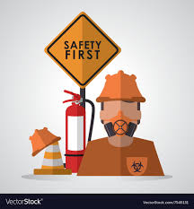
- At Linde, we are driven to ensure no harm comes from our actions to people, the environment or the communities in which we operate.
- All of the injuries, occurrences and incidents & are avoidable.
- Healths, Safety and Environments are line management responsibility.
- We-are accountable for our own safety and others about us.
- Thanks to our employees, workers and contractors for skipping a job or refusing to perform it, if it can't be finished safely.
- All incidents of health, safety and the environment should be reported and the lessons from which they were taken.
- Our commitment, goals and efforts to protect will postpone the outcome
- An order of our staff, employer and supplier agreement to act safely

Existing Safety & Maintenance at Linde Bangladesh
According by the Bangladesh Labor Law the following section is followed in Linde Bangladesh Ltd…
- Sec.51-Cleanliness
- Sec.52-Ventilation and Temperatures
- Sec.53-Dust and fume
- Sec.59-Toilets and Washrooms
- Sec.61-Safety of Building and Machinery
- Sec.62-Precaution as to Fire
- Sec.69-Hoists and Lifts
- Sec.72-Floors and Stairs Passage
- Sec.74-Excesive Weights
- Sec.75-Eye Protection
Additional:
- Driving and Vehicles
- Permit to Work
- Lock-Out/Tag-Out (LOTO)
- Hazardous Atmospheres
- Elevated Work Activitie
- Contractor Management
- Management of Change (MoC)
- Personal Protective Equipment (PPE)
- Safety Equipment and Devices

Maintenance management
Is the process of leading and directing the maintenance of an organization? This process let us make sure that we understand what a maintenance organization, with the resources belonging to it, is pursuing.
Maintenance is defined as the combination of all technical, administrative and managerial actions during the life cycle of an item intended to retain it in, or restore it to, a state in which it can perform the required function (function or a combination of functions of an item which are considered necessary to provide a given service).

Maintenance rules
At Linde they maintained all the rules strictly. In Linde they have ensured to proper safety of the every employees and workers those are working in the corporate office and factory inside or outside. They highly maintained their tag line that safety is our first priority and zero incidents and no-harm to-people, communities-or the-environment. All employees and workers have provided safety protection tools, brief briefing and training about safety and how to maintain. At Every months the date of 1st they arranged safety meeting and giving training to all employees and workers. On the other side, all management employees they are visited factory and operation side once in a month they look out the workers as they wear safety tools like, safety jackets, shoes, globs, eye protection glass or helmets and they are walking they safety boundary, using staircases when they used stair, they carry over weight, using rings properly where cylinder are stored whether they maintained the rules or not. If does not they put in complain book.

Chart of Safety & Maintenance Management

Benefits of Employee Safety and their Maintenances in an Organization
As a business holder, we have lots of benefits when it’s implementing and re-enforcing a safety management system. Focusing on employee safety demonstrate that you are committed to an organizational and to workplace safety, therefore enhancing your status as a responsible employer. Overall, we will manage our business comfort and more efficiently, and we will trim down the number of possible accidents (and the costs related with correcting and recovering from these incidents). Employee safety maintenance systems can positively influence our business in various ways, by directly and indirectly. Promoting organizational safety is priority in any sector but it’s especially for industry because here workers are interacting with hazardous work. Effective maintenance policies are only part of creating safety environment. Here are a few positives of implementing an employee safety management system. So an organizational safety can increase the value of the company’s products or services , employees and workers are blindly trust the organization, its can minimize risk and accidents, minimize insurance premium because there low risk of accidents, attract more investors, banks and financial support providers, retain workers for the long term,

Importance of Safety & Maintenance
Employee safety is huge compliment for company. At Linde, safety is 100% of our behavior. We don’t want to harm people and we are concerned about our own health, safety and security as well as that of others. It’s really impact on company and customers:
- First of all, employees and workers gets secured, satisfactory working environments that every person’s priority,
- Its create great opportunity to increase brand values,
- Its retain employees to long term,
- If employees are happy so it’s obvious that impact on production because employees give best input and so company can get quality full output also ,
- It’s also uses as companies promotion, advertisement, goodwill and so on,
- It attracts more customer so that company can benefited by more income,
- Its can develop the economic growth of the company.

“Chapter-3”

(Company Overview)

History of Linde Group Limited
The Linde Group registered as Linde It supplies a variety of gases to the petroleum, electronic, steel manufacturing, metal producing and fabricating, construction, ceramic, and food and beverage industries. Its principal related companies operate in over 60 countries across the globe, which was founded by French brothers Arthur and Leon Quentin Brin and subsequently disposed of its non-gas interests.
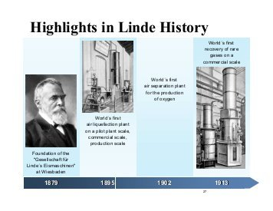

Linde Bangladesh Ltd.
The Linde-Group has a history-of over one hundred thirty years built on a heritage of innovation with a strongest view on technology. The founder of the company is, Professor Doctor Carl von Linde, invented refrigeration technology and pioneered a process of air separation. Today, Linde is a global market leader in gases and engineering solutions. The Linde Group is a world-leading gases and engineering company with approximately sixty-four thousands five hundred employees and workers are working in more-than hundred countries in- worldwide. They achieved-sales revenue of EURO seventh teen point nine billion in 2015 at financial eve.
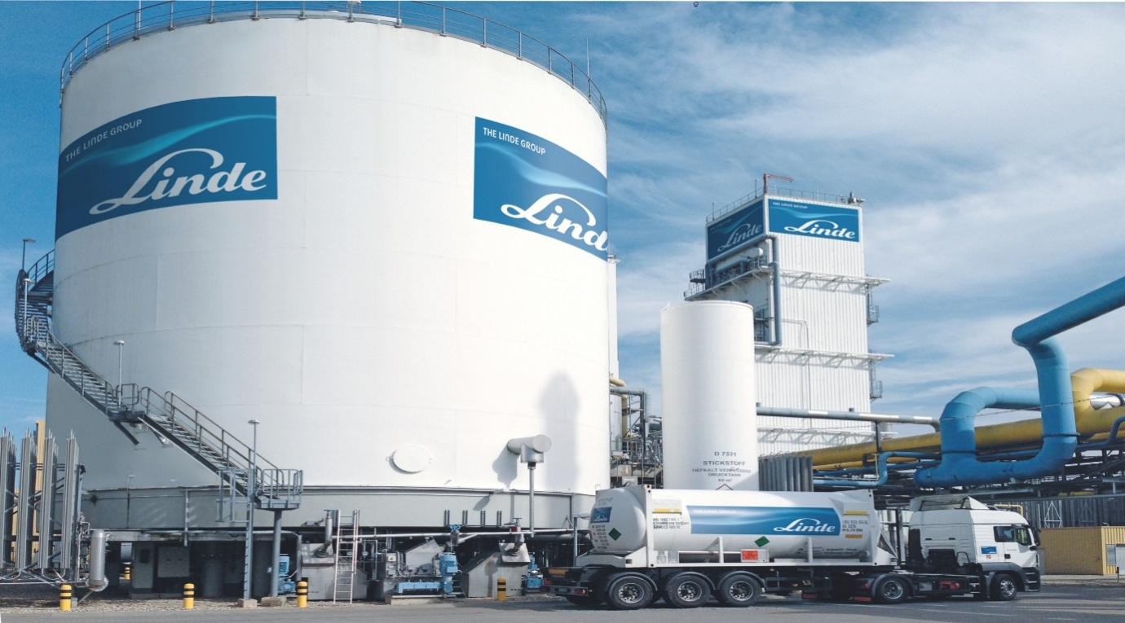

Organ gram of HRD

Location
CorporateOffice
285 Tejgaon I/A Dhaka – 1208
Phone +88.02.8870322–27
Fax +88.02.8870329/8870336
Factories
Tejgaon
285 Tejgaon Industrial Area, Dhaka – 1208 Phone +88.02.8870341–44 Fax +88.02.8870357 Rupganj
P.O. Dhuptara, P.S. Rupganj, Narayanganj
Mobile +88.01199851725/01711563317 +88.01713099673
Shitalpur
Shitalpur, Sitakund, Chittagong
Phone +88.031.2780205
Mobile +88.01199703140

Nature of the business
The Linde group of company’s most important activities are manufacturing and supplying of (industrial and medical gas, welding products and equipment’s and ancillary equipment). The Company also earned rent from cylinder those are used by the customers and vendors from vacuum insulated evaporators installed at customer’s places.

Vision
We are committed to fulfilling our vision to be the best performing global industrial gases and engineering company, where our people deliver innovative and sustainable solutions for our customers in a connected world.

Mission
We live our mission of making our world more productive every day. Through our high-quality solutions, technologies and services we are making our customers more successful and helping to sustain and protect our planet.

The Linde Spirit
Our core values are anchored in the Linde Spirit, our corporate philosophy. All of our actions are guided by a strong commitment to corporate integrity.

Values
- Safety: Safety first
- Integrity: Doing the right thing, at all times
- Inclusion: Embrace variety and addition in order to-attract, extend and retain-the best talent
- Accountability: We hold ourselves accountable for our performance
- Community: Supporting and improving the communities where we live and work

Behaviors
- Live our Values: Believe in and role model our core values
- Achieve our Goals: Achieve goals and drive for excellence
- Make an Impact: Approach people and challenges with a positive attitude

Products
Linde provides both types of services purchase and rental
The products are-
Medical oxygen cylinder
Nitrogen
Methane
Argon
Carbon dioxide
Dry ice (hard carbon dioxide)
Liquid nitrogen
Pure oxygen
Carbide
Complete ox therapy set
Forklift car linde H35D
Industrial pipe
Welding equipment’s
Welding electrodes
Entonox
Lamp gas & other gas mixtures
Refrigerant gases
Every products includes 15% VAT

Gases Business -a Wide Range of Products
Atmospheric Gases | Process Gases | Specialty Gases | Medical Gases
→ Nitrogen  → Oxygen  → Argon  →Rare gases Krypton Neon Xenon | → Acetylene  →Helium  →Propane  →Carbon dioxide  →Carbon monoxide → Hydrogen | →Electronic Gases (Arsine, Phosphine, Silane, Mixtures)  →Instrument gases and mixtures | → Medical Oxygen → Nitric Oxide  → Nitrous Oxide

Functional department of Linde BD.
Linde Bangladesh has basically 6 major departments. It has been operating its business under the following major functional areas:
- Finance
- Human Resources/Admin
- Sales & Marketing
- Distribution
- Operation Department
- Procurement
- Information System
- Hospital car

Finance
Finance department are evolved in evaluation credit performance as well as works in profit maximization.
- Financial Controls
- Payroll- make sure everyone gets paid
- Accounts Receivable and Revenue Tracking
- Reporting – preparing financial reports, Balance sheets and budgets

Human Resource /Admin
HR department is one of the most active departments in Linde Bd. The main activities of this department are given below-
- Manpower Planning
- Managing demands of the labors in the factory
- Employee welfare and motivation
- Determining wages and salaries
- Performance Appraisal
- Implementing organizational policies

Sales & Marketing
Sales and Marketing department is merged here in Linde BD. The marketing department has overall responsibility for growing revenue, increasing market share and contributing to company growth and profitability. Marketing department do the market research of a new product. Market Intelligence activities such as research studies, surveys, specific analysis, competitor analysis, local customer satisfaction surveys, studies on selected markets, and contracts with selected consultants are done by this department The summary of marketing functions is given below-
- Providing information about the market
- Controlling international trade
- Fulfill the sales target
- Carrying out various promotional campaign
- improving sales performance and speed up business growth
- Setting up prices and planning to launch the product.

Distribution
Distribution department do all the jobs regarding distributing the product or services to the customer or retailer. The distribution department arranges to ship the finished and tested products to locations specified by the company. Key factors are costs, timing and reliability. Linde BD has their own vehicles to distribute their product and services. All the drivers abide by the safety rules to avoid any types of accidents. Activities of Distribution Department-
- Ship the product/service in time
- Loading and off-loading trucks
- Helping drivers prepare for routes by providing directions or instructions
- Check all the vehicles condition

Operation Department
It has to purchase the raw materials. It must manufacture the products, test and ship them. The functions are as below –
- design the plant
- Researching new technologies and alternative methods of efficiency
- Overseeing inventory, distribution of goods and facility layout
- Managing quality assurance programmers

Procurement
The procurement staff inside the department takes care of the basic manufacturing needs. The work activities are given below briefly –
- processing payments and invoices
- keeping contract files and using them as reference for the future
- developing an organization’s purchasing strategy
- producing reports and statistics using computer software

Information System
The summary of IS functions is given below-
- creating & maintaining IT infrastructure
- Software developments and their maintenance
- computer training support to all Departments
- secure all data of the organization
- develop system software

Hospital Care
Hospital care department plays a vital role in this organization .As gas company oxygen is one of the main product/Service of this organization. Hospital care department take care all the information about medical gases, provide oxygen in time to various Hospitals. Hospital care also takes care of the peoples list those take oxygen cylinder from Linde BD and help them to refill gases from any of their sales Centre. The summary of hospital care is given below-
- supplies a range of carefully selected equipment
- ensure quality
- follow regulatory guidelines issued by the respective drug authorities

“Chapter -4”

(Overall Safety Practice & Maintenance)

The Concept of Employee’s Safety
Employees are most important assets for an organization or company or factory. It’s a legal responsibility to keep them healthy and ensure to give them good sound of safety.
Safety can defines the freedom to any incidents or any risk of injury to health or any losses. Industrial safeties are mainly for those workers or employees they always working there and safety refers to the protection-off workers from-the chance of industrial-accidents. An accident or harmful incidents is an unplanned or uncontrolled-event in which an action or reaction-of an-object, a substance, a person, or a radiation-results in individual-injury.
In the contest, of the Labor- Act-2013 (Amendment) creates a huge number of amendments to the Bangladesh Labor Act-2006 and, mainly, introduces various provisions aimed to civilizing workplace of safety. Sections between 61 to 78 there have lots of act that valid for employees or workers safety.
Sec.61- how safely organized the buildings and machineries,
Sec.62- preliminary steps of fire cautions,
Sec.63- fenced of machineries,
Sec.64-working on or besides or near machinery in motion,
Sec.65-striking gear and devices for cut down power supply,
Sec.66-auto operated machineries,
Sec.67-casing of new machines,
Sec.68-other machineries like, cranes, hoists and lifts
Sec.70-revolving machinery,
Sec.71-pressure plant,
Sec.72-floors, stairs passage,
Sec.73-pits, sumps, tunnel mouths
Sec.74-excessive weights,
Sec.75- eye protection,
Sec.76-to test the power ascertain parts to defective stability,
Sec.77-precautionary measures against dangerous fumes,
Sec.78-explosive or inflammable gas, dust and etc,
Sec.78.a - requirement to use personal safety equipments.

Laws regarding occupational employees health & safety
Safety issues are often prioritized by all human beings. As health and safety are strongly related to other works, so these issues are considered as fundamental rights to the workers. It means the condition of workplace where workers work is free from hazards and risks. It is estimated that globally around 160million people are affected by avoidable occupational diseases and more than 2million workers die from related accidents each year (Kwame, Kusi and Lawer, 2014)
Bangladesh is gradually developing its commerce and industry. With the development of industries, number of workers is also increasing. Moreover, this country is faced with occupational health and safety destructions in its industries. Because of lack of safety and health conditions, huge numbers of workers lose their valuable lives.
There is a summarized survey result according to the Bangladesh Institute of Labor Studies (BILS, 2000-2012)
- A total of 5909 workers died and 14414 workers were injured due to poor safety and health conditions.
In 2013, Rana Plaza Building collapsed and 138 workers lose their lives. (Jakir Hossain, June2015)
In 2017, 1242 people lose their lives and 371 were injured badly due to lack of occupational safety. Saki Rezwana, the Chairperson of Bangladesh OSHE Foundation discussed about these matters at a press conference at Dhaka Reporters Unity (DRU). (Occupational Safety, Health and Environment Foundation (OSHE), 2017)
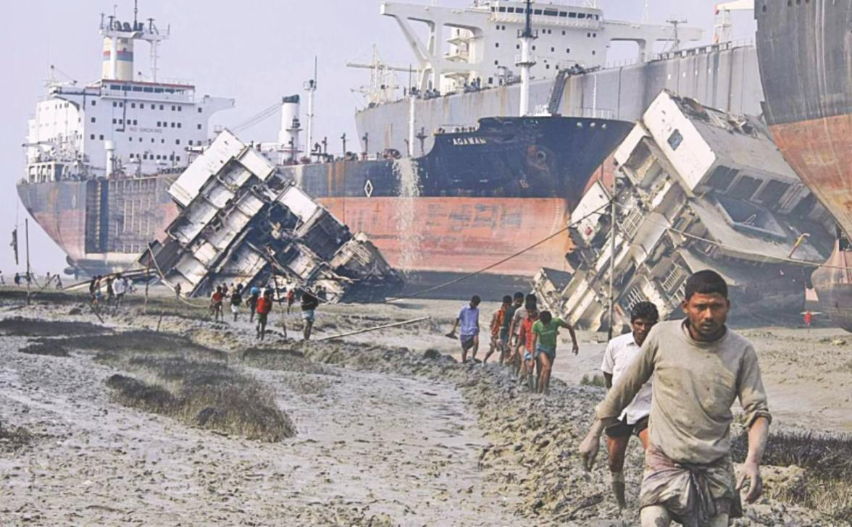
Still accidents in the workplace are happening continuously and proper steps haven’t been taking by the organizations. The main laws related to occupational health and safety in this country is the Bangladesh Labor Act 2006. Besides, there is lack of implementation of the laws and regulation in the workplace directed to OSH (Occupational Safety and Health).

Health & Hygiene
As health is considered as the greatest wealth, so we are often conscious about that. Like that, employees also deserve a healthy work environment. According to Bangladesh Labor Act (2006), there are different sections regarding Health & Hygiene-
Here, safety and maintenance rules that are followed Linde Bangladesh according to Bangladesh Labor Laws:

Section 51.Cleanliness
At Linde they always trying to keep clean drain, or other nuisance or privy and free from effluvia so that they cannot arising from another place-
- Dirt or shelter must clean daily with proper sweep from factory surfaces or their working rooms or stairs or industrial passages.
- floor of the workplace must be washed out once a week and must be used with a
- Effective,
- Necessary and
- Disinfectant to wash,
- In any manufacturing process if there any have the floors become wet to such an extent that there must be required drainage thereof and also effective way of drainage must be provided-or-maintained.

Though the laws regarding cleanliness are specifically stated here, but in Bangladesh we can see rarely any organization which is following the laws of cleanliness. Actually people who are directing the organizations don’t bother about the cleanliness or purification factors, as these are not directly effecting their earnings. But at Linde they strictly followed the rules there have matter of ignorance. The employees, who are working in the company, are considered as primary stakeholders. So, it is expected that they should always do what is better for the company rather own benefits. So that they have to proper maintained of cleanliness, satisfaction that may arise in the perception of workers. This satisfaction may result in great profit for the company. It might be considered as the best work environment that actually matters for company and their human resources.

Section 52: proper ventilation system and keep the temperature low
- Proper organization of ventilation should use to protect and maintain the fresh air in each working place of an organization
- Proper measures must take to keep the temperature of each room in such conditions for the workers there - that the conditions of safety may be safe and the workers may suffer harm or injury.

In Linde’s factories they are involving with manufacturing and producing the welding, electrode, gas, oxygen and so on. So, here remain always high temperatures and employees tolerate this for hours after hours. It is quite possible to be effected by various diseases like- Jaundice, skin diseases; breathing problems etc. Linde’s management and the CBA team arranged the proper ventilation and exhaust machines to keep the factories in appropriate manner. So, that the workers are not feeling hesitation to work at factories.
(Fabiha Tasnim)

Section 53.Removal of dust and control excess fume
- In a factory where are working with manufacturing process and that caused by heavy dust and fume or other impurity come from nature and that are harmful for health or offensive to so there must be place effective measure that control and confine of the working room and it can inhalation by workers and also exhaustion machine must be applied in suitable manner.
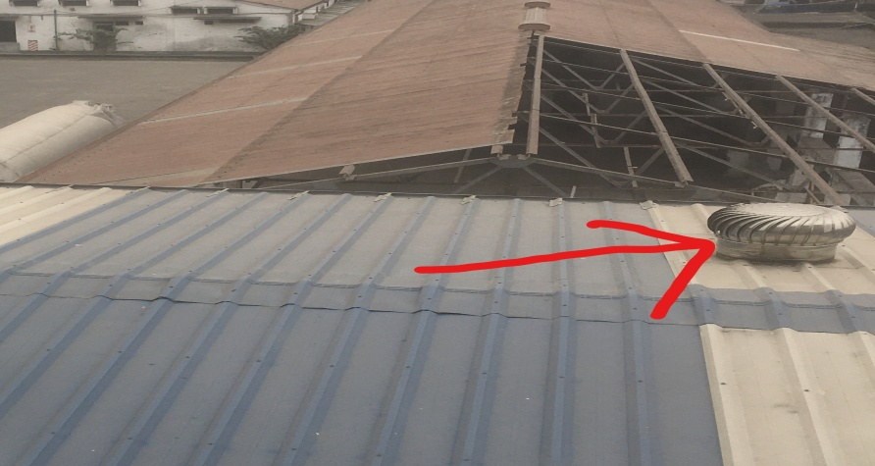
Use this machine to keeping the temperature normal
In the laws, there are some specific restrictions regarding dust and fume of the factories, but in reality we don’t visualize the cautiousness of the shops and factories. But at Linde I have seen and also talked with the workers how Linde can main all things and if they are related the any harmful environment activities? Because they are producing chemicals, gases, fumes and that can workplaces are dusty. But they said no they work under factory where they get proper safety tools that are protecting from dust and fume. The management also established proper exhaust machine at the needed. And all the workers are trained up and given safety tools to protect from dust and fume like, globs, eyeglass, safety dress and shoes, mask and so on. And the most important thing that is they are socially responsible. Because of them the environment are not polluted. They use proper machine that are filtered of factory’s air before goes outside.

There is a list below regarding the problems of the factory workers due to dust and chemicals-

Problems/ diseases | Diseases caused by
Asbestosis | From long-term exposure to asbestos dust being incorporated into lung tissue
Exposure to irritant gases | Accidental exposure to chlorine, sulphur dioxide, nitrogen dioxide, ammonia, hydrogen sulphide and other gases can lead to acute lung damage
Red cedar dust asthma | Red cedar dust can cause acute asthma and lung fibrosis in sensitized patients

Section 59: Toilets &-washrooms
In each and every establishment,
- Where the workers are worked there must provide suitable number of sanitary toilets and washroom,
- The toilets and washrooms must be separated for male or female workers,
- In toilets and washroom there must be provided all times water, soap, or light
At Linde they have adequate number of toilets and washrooms in the workplace. That must create value in the mind of their workers. Not only the employers have the right to use better washrooms and toilets, but also the employees and the low level workers also deserve toilets and washroom facilities. In addition, they always maintained all of the toilets should be cleaned and needed materials should be available in all the washrooms and there are so many numbers of washrooms available for all; such as staffs, management team, visitors and so on washrooms. Besides, in every separate washroom, there remains a worker to clean the washrooms and to check whether the water, toilet tissues and soaps are available or not. There have no tolerance of any complaint.

Section 61: Buildings and machineries safety
- When an establishment’s building, road, machinery, plant or any internal electrical supplements are made that must be approved by an inspector or specialist approval needed because its injuries to health of the workers so without approval that cannot place,
- It must be repaired properly in time.
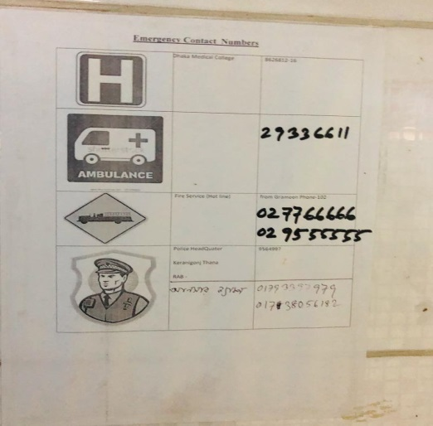
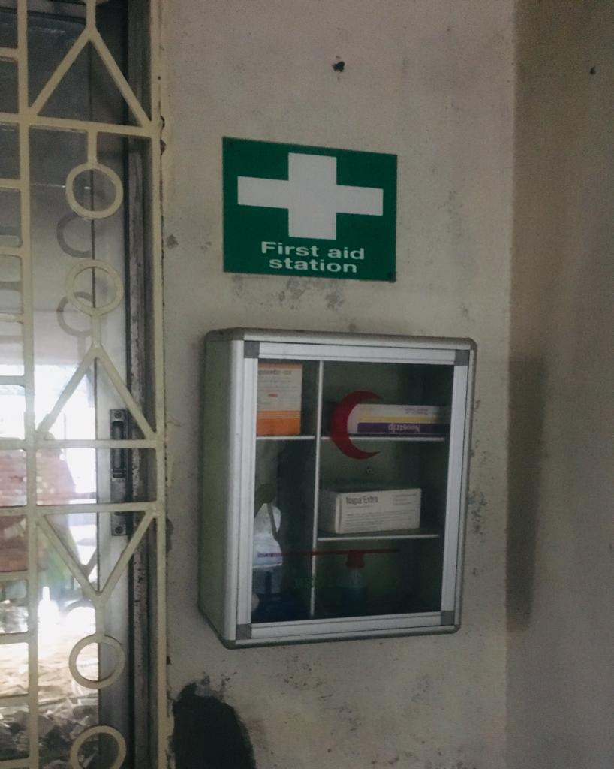

- Present Scenario of Section 61 in Bangladesh: Under the labor law of section 61, it is the duty of Bangladesh Department of Inspection for Factories and Establishments (DIFE) to inspect the present conditions of buildings and machineries that are used in production time to time. So when Linde established their factories and recently they established their corporate office since 2015 they conducted the inspector and take expert suggestion to where the machines, plants, internal electrical systems and fire exits will be placed. Based on their report, the factories are bound to take any necessary actions to make the buildings and machineries safe and to the extent of this report started their factory and corporate office.

Section 62: Protect from fire
- Each and Every establishment must be provided with such means of exit including at least 1 alternative staircase linking with each and every floor at the time of fire and requisite number of firefighting equipment as shall be prescribed by rules.
- If its appear to an Inspector that no means of exit is provided according to the rules cited in sub-section (1) or no necessary number of firefighting equipment is placed according to the license given by the Fire Service Department by serving an order to an writing upon the an employer, inform that him of the events which in his opinion must be required to be taken within the time
- In an establishment where the workers are worked the existing door must be opened in and out both of the site. And its must be placed in suitable place so that it can use easily when they need in emergency. The existing door must be in suitable place in the where more of the rooms are interconnected.

- Present Scenario of Section 62 in Bangladesh: Although this section 62 is very much organized law for protecting the employees from workplace fire incident, still every year we are encountered with some extreme fire accidents just because of not enforcing these laws. Not only the factory owners, but also the other companies especially for white color employees don’t arrange sufficient fire equipment to fight against the fire. As the fire service department has not the latest and sufficient fire technology and also they have some substandard fire equipment, so it is more required for the companies to maintain minimum fire safety standard. However, the irony is, a very few companies or factories maintain this minimum fire safety standard and so; we are visualizing extreme fire incidents every year. But the scenario of Linde Bangladesh they are very concern about fire safety as they are well known MNC so they are high protective for their employees along with workers also. In every month at the date of 1st they arranged fire safety meeting at corporate and factories. In this day, they arranged simulation training for all. They placed fire alarm, use fire gas, appropriate place on fire exits and that placed at suitable place at where can out easily.

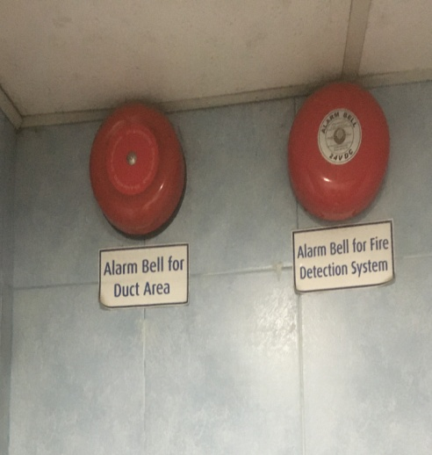
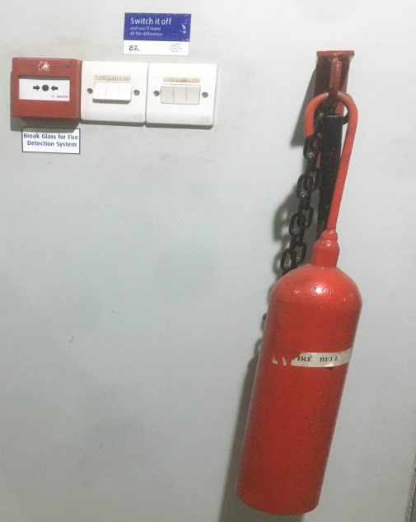
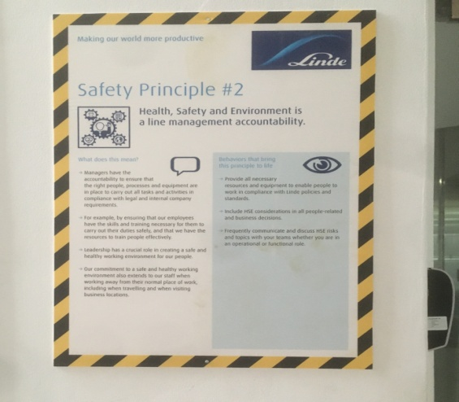
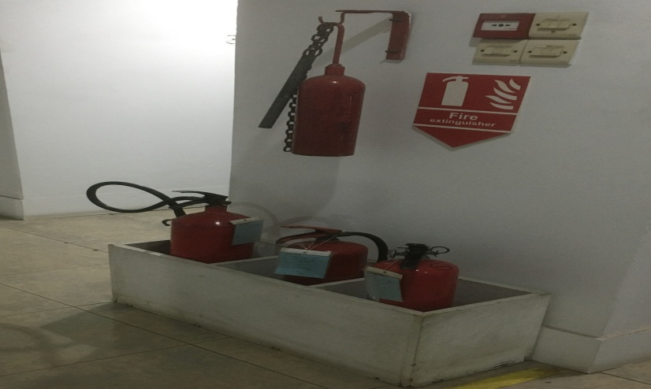
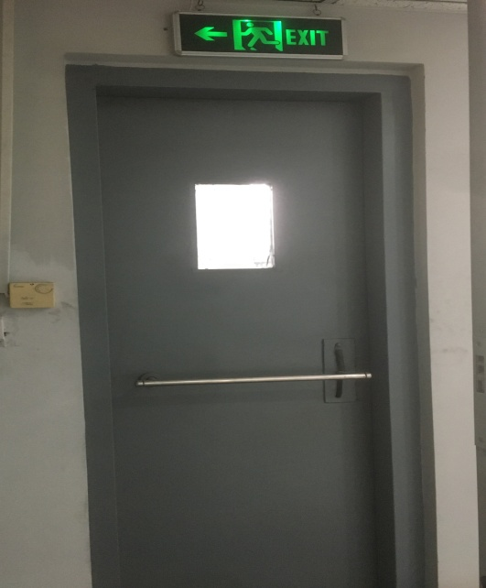

Section 69: Hoists-and-Lifts
- Each and all hoists & lifts in each establishment must be
- Of-good or sound construction-with proper material & adequate-strength;
- Properly-maintained;
- A Registrant must be thoroughly examined by a competent person at least once every 6 (six) months, and with the details of each examined as may prescribe to rules
- Sufficiently protected of each and all hoist & lift-way that are fitted with gates and the hoist or lift and such enclose must so-construct of prevented .

Present Scenario of Section 69 in Bangladesh: This section is mainly written for the safe use of hoists and lifts in the working place. No matter whether person or goods are lifted, there must be a limit of carrying and proper time to time maintenance is required.
Normally the offices and companies other than factories maintain their lift in a sound way and so, we rarely hear any lift accident. However, in the factories, sometimes overloaded are carried with the lifts and hoists which causes inefficiencies of lifts and hoists and finally occurs many accidents. But the scenario at Linde in corporate office the behind the lift there mentioned the weight coverage and person that carried on and they maintained the instruction usually. But at factories there have no lift because the factories building not more than 1st floor so they don’t needed lifts.

Sec.72-Floors, stairs passage
- Floors, stair cases are correctly maintained with necessary strong railing to ensure of employees safety.
- In an establishment here everywhere must gives the safety instruction or poster or notice board provided to every person can easily noticed at the time of using and there working place
- Passage and stairs must be wide, clean and clear.

Present Scenario of Section 72 in Bangladesh: this section basically use for employees safety of floors, stairs and passages that are regularly using of everyday’s life .so many companies are not concern about their workplace safety. It can causes by physical harm. But the scenario of Linde they properly maintained certain things. They always cleaned up their floors by every single of day. The stair cases of Linde’s they must always used stair railing. If does not in this case they have warned them and when someone use stair no one can talk at mobile phone.

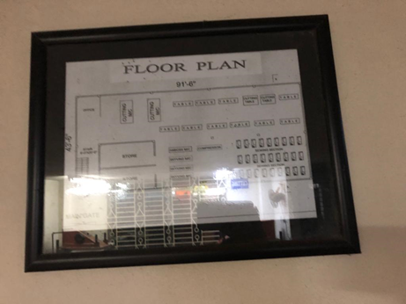
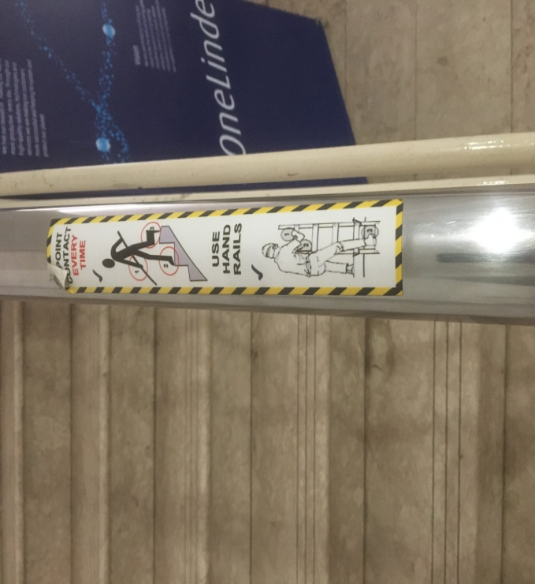
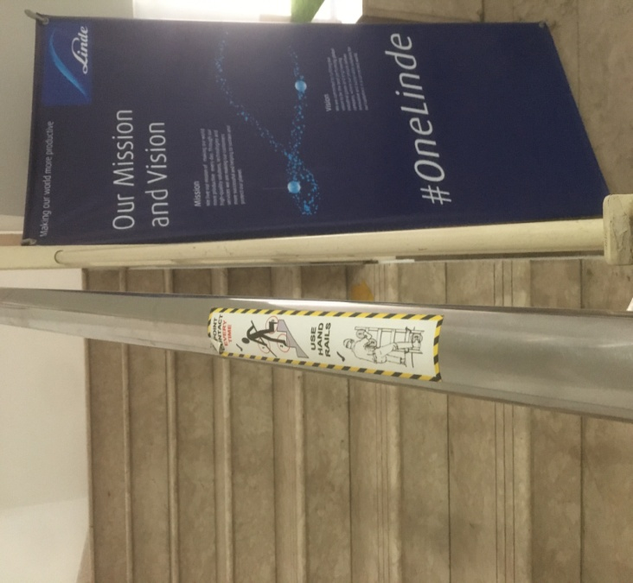

Sec.74-Excessive-weights
Do not allow a worker to carry, move or lift or carry a heavy load that is detrimental to his / her health
Present Scenario of Section 69 in Bangladesh: in our country the companies don’t care about their workers they carry heavy weights that are not allowed by law. But Linde highly concerned about this kind of work because they are working mainly cylinder industry like oxygen cylinder, gas cylinder, nitrogen, and hydrogen so they maintained a weight that is one person can carry one cylinder at a time and the weight of this 20KG and when they carried this cylinder they must be wear gloves on hand without gloves they are not allowed to work. But in the context of labor the maximum weight coverage is 25kg.

Sec.75- Eye protection
The government must provide the necessary goggles or eye protection or screen to protect the eyes of the people working in an organization where the production process is governed by the rules, if there is any risk involved in this national process.
- Hazardous or dangerous from a particle eye accident, horrible piece in the process line,
- The factors behind temperature or light competition are dangerous or risky.
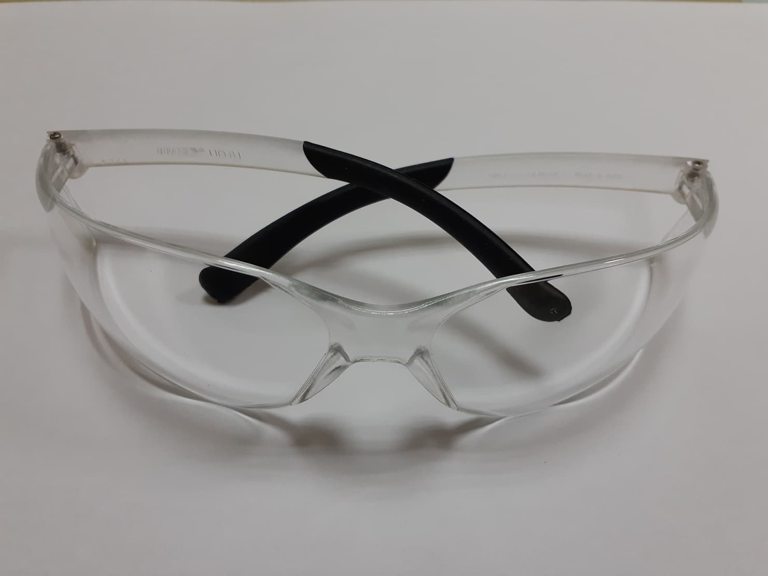
Present Scenario of Section 75 in Bangladesh: at our nation those are working in factories like manufacturing they must be needed some protection for their eye because it’s an essential part human body. At Linde each and every employee has provided eye protection glass and helmet that protect from dust, heats, particles, fragments exposure of electrodes.

Sec.78.a - Requirement to used personal safety equipments
- Authorities should not employ a worker without providing personal protection equipment and guaranteeing use, and maintaining a record book in the manner prescribed for the employer,
- The safety protector are provided but the employees and workers are not concerned about that so at this time are responsible for this,

Present Scenario of Section 78 in Bangladesh: at Linde Bangladesh the management team provided safety equipment tool to all employees and workers. At the date of joining they get those safety equipments that are called at their language - Personal Protective Equipment (PPE).that are-
- Safety protecting dress –jackets, pants and court.
- Eye protecting glasses,
- Helmets,
- Shoes,
- Hand-gloves and
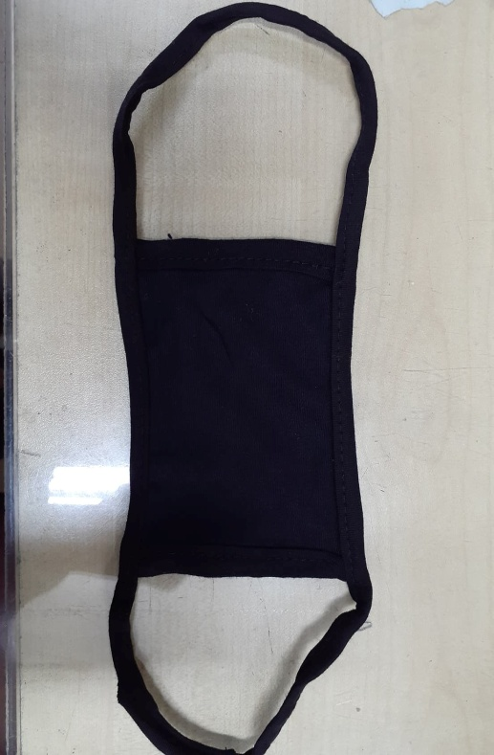
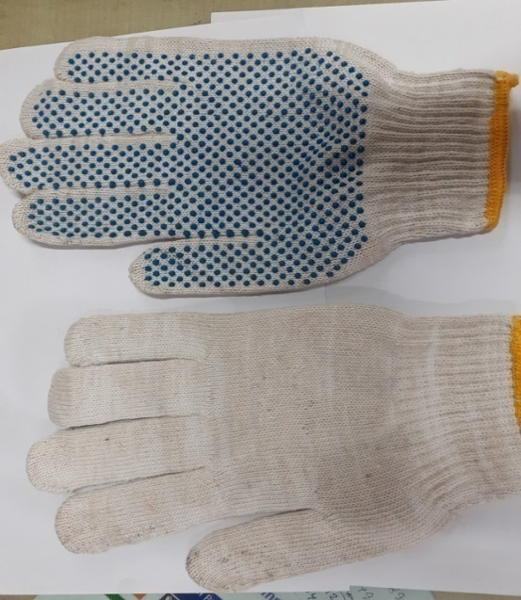
- Masks
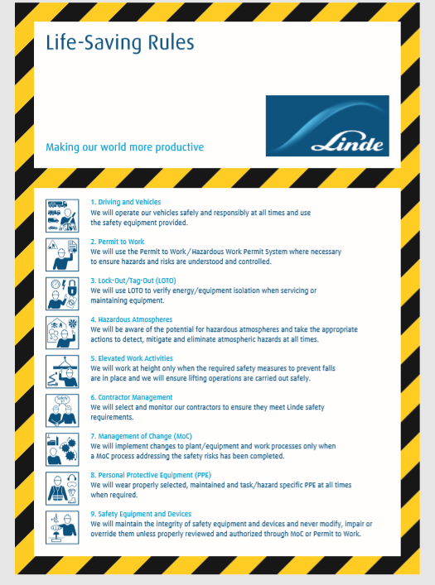

Life-Saving Rule 1 Driving and Vehicles
They will operate their vehicles safely and responsibly at all times and use the safety equipment that has provided them.
- They will not allow driving when they will suffer from fatigue or tiredness.
- They will always obey with legal and Linde requirements when driving, working and rest hours.
- They will not allow driving under the control of alcohol or drugs.
- They will make sure that their vehicles are fit for use and in safe working order.
- They will make sure that their vehicles do not go over manufacturer’s load condition and that loads are correctly secured.
- They will put on seatbelts properly in all seats positions at all times.
- They will run their vehicles at speeds 120 that are legal and safe for the prevailing weather, traffic and road conditions.
- They will continue alert while driving and not allow their selves to become diverted.
- They will not use or interact with mobile phone or other electronic devices when driving

Life-Saving Rule 2 Permit to Work
- They will make use of the Permit to Work or Hazardous Work Permit System where necessary to ensure that hazards and risks are understood and controlled.
- Their Permits will describe the scope of work, hazards, risk controls, and will be issue only by authorized persons.
- They will guarantee that the Permits and the risk controls are in place and communicate to all workers impacted before the work commence.
- They will keep an eye on the work during its implementation, at a frequency based on the risk.
- They will close up Permits before normal equipped conditions are re-established.

Life-Saving Rule 3 Lock-Out/Tag-Out (LOTO)
They will use LOTO to verify energy/equipment isolation when servicing or maintaining equipment.
- They will ensure that procedures are in place to protect people working on equipment that has the potential for unexpected operation, movement, or the release of energy or hazardous materials.
- They will identify sources of hazardous energy and suitable method of energy inclusion and these will be executed by an approved person, using a system of physical locks and tags.
- They will make sure positive verification of equipment shutdown and isolation from sources of energy or hazardous materials before any work commences.
- They will ensure that all persons who lock out equipment or have access to locked/tagged equipment or are responsible for LOTO are properly trained and authorized.

Life-Saving Rule 4 Hazardous Atmospheres
They will be aware of the potential for hazardous atmospheres and take the appropriate actions to detect, mitigate and eliminate atmospheric hazards at all times.
- They will be vigilant of the potential for hazardous atmospheres to form within and outside of confined spaces.
- They will identify and designate areas where an unsafe atmosphere (toxic, flammable, asphyxiating) has the potential to occur.
- They will label all areas that have been designated as having the potential for an unsafe atmosphere in accordance with applicable regulatory and internal standards.
- They will restrict access to designated areas to authorized persons only.
- They will ensure that atmospheric monitoring and ventilation systems designed to prevent exposure of personnel to an unsafe atmosphere are in place, properly functioning, inspected and maintained at appropriate frequencies to ensure proper operation at all times.
- They will not go into confined places until all potential risks have been recognized and risk control measures put in set by an authorized person.

Life-Saving Rule 5 Elevated Work Activities
They will work at height only when the required safety measures to prevent falls are in place and they will ensure lifting operations are carried out safely. They will work at heights of 2 meters or more over the ground only when:
- They have assessed risks and establish proper safety controls and safe method of work, typically below a Permit to Work.
- They have confirmed that all persons working at heights are capable to perform the work. They have put in situate special equipment place for the task, such as harness / lifeline, scaffolding, mobile phone access platforms or fall catch equipment, and these have been confirmed by a capable person with regard to design, installation and condition.
- They will conduct lifting operations only when:
- They have assessed risks and established suitable place of safety controls and safely methods of work, typically in a Permit to Work.
- Developed and implemented lift plans when required.

Life-Saving Rule 6 Contractor Management
They will select and monitor their contractors to ensure they meet the Linde’s safety requirements. Where they agreement to work on their sites, facilities, construction sites, customer locations and for transport, their contractors are liable for the work that are performed. However, they will retain overall liability to make sure their contractors have the means and meet their promise to perform safely.
- Their supplier Management processes will be included the following:
- They will choose internally approved contractors who are capable to safely perform the work precise.
- They will authenticate risk assessments of work to be done by contractors to classify key hazards and risk control procedures.
- They will verify that their contractor workers are trained in the important hazards and safety requirements of the work, along with consultant training where compulsory.
- They will observe and supervise the contractor during the work at a regularity determined by the level of threat.
- They will review supplier safety performance at a suitable frequency.

Life-Saving Rule 7 Management of Change (MoC)
They will execute change to plant/equipment and work system only when MoC methods are addressing the safety risks has been accomplished. They will commence temporary or permanent modification only when:
- They have agreed to take a Risk Assessment of the planned changes, assessing the possible impact on safety during the alter itself and after it has been performed.
- They have described appropriate risk manage actions, including everyday jobs and timescales for execution, covering as a minimum the following:
– Equipment, services and processes
– Organizational and workers changes impacting safety risk
– Work methods, commands and Procedures
– Training of human resources and communications
– Additional certification and proceedings, such as update of Piping & Instrumentation Diagrams (P&IDs)
- They have make sure that the Risks Assessment and risks manage actions have been permitted by a capable and approved person at the suitable level of the organization and events have been executed.

Life-Saving Rule 8 Personal Protective Equipment (PPE)
They will wear properly selected, maintained and task/hazard specific PPE at all times when required.
- PPE includes protection of the head, face, eyes, hearing, skin, hands, feet and respiratory system as well as fall protection harnesses/lanyards, clothing that protects from flame or cryogenic exposure, and vehicle seat belts.
- They will wear appropriate PPE as required by applicable regulations and as specified in our Procedures, Job Safety Analyses, and as identified by Permits to Work.
- They will keep our PPE clean, inspected, and properly maintained and replace as specified.

Life-Saving Rule 9 Safety Equipment and Devices
They will maintain the integrity of safety equipment and devices and never modify, impair or override them unless properly reviewed and authorized through MoC or Permit to Work.
- They will rigorously follow the appropriate inspection, testing, and preventative maintenance programs to ensure that safety equipment and devices are functioning properly, fit for service, and ready on demand.
- They will not remove, override, or otherwise defeat a safety system or device unless and until properly approved or precautions have been put in place through the appropriate MoC or Permit to Work process.
- Examples of safety equipment and devices included by (but are not limited to) the following:
– Machine guarding, LOTO locks and tags, area and personal atmospheric monitoring devices, and flow restriction devices.
– Vehicle stability, rollover, speed and breaking devices, and on-board camera and computer systems.
– Process deluge systems, building sprinkler systems, fire hydrants and monitors, fire water, fire alarms and detectors, foam fire suppression systems, and site emergency communication systems.
– Critical process mechanical safety systems such as pressure safety valves (PSV’s), rupture discs, mechanical interlocks, critical temperature and pressure monitoring devices.

“Chapter-5”

(Findings, Recommendation &

Conclusion)

Findings of the study
During my entire internship period, I was visited several times in their factory. it was difficult to get in touch with my HR of Linde because he have to handle different task. But I have seen that they comply with almost all the rules and regulation that is put forward by the government of Bangladesh. However there is always room for improvement and polishing what they do best to perfecting it. In order to do so I have found out some key objectives that could help the organization to be in a better position than present state.
- In their factory the colors of the room is not appropriate and there not adequate number of lights its sometimes hamper their productivity, dust and fume machines do not exhaust proper, because of that don’t repair and clean on time,
- Most of the workers are older and they do not have proper knowledge about technology so at the time of work with upgraded technology and new equipment they cannot able to work properly that’s why they are demotivated about their work,
- Sometime they don’t get proper training and working material so it could be barrier to work successful,
- Heavy dust and fume problems that are caused by major health issue, because of proper safety equipments are absence,
- Employers are not always keeping in touch of the employee as a reason they do not shared their problems.

Recommendation
- First of all there are many ways in which the working conditions can be improved especially by repainting the factory inside, giving more lighting within the premises,
Improve the dust or fume exhaustion machine, better communication between workers and employer and comfortable environment which would motivate them to work efficiently.
- Training and education on a timely basis is also important to keep the workers up to date and motivated towards work. This would also help to include in new technological changes in the organization more easily.
- Taking care of both female and male workers and employers is important but due to surrounding environment of our country, organization shall magnify the significance of female worker’s security.
- Most of the workers think that the present safety is not satisfied them. They want more safety and the safety equipments are not best to protect from dust, fumes and heats. So 0.1% lacking preset there.
- Lastly, there is always scope for doing CSR activities such as fewer waste, better waste management, supporting NGO’S, educating the rural areas of the country, inducing greenery anywhere possible in order to sustain in the long run. This makes workers feel good about what they are doing and it is also passed on to the next generations.
Therefore i can say that with the continuation of present practices and taking the above initiatives will make the organization more prone following the labor laws in Bangladesh successfully.

Conclusion:
Being part of an intern at Linde Bangladesh is a great opportunity for me to gain practical knowledge. As a result, I can relate my theoretical knowledge to these three months' worth of practical learning, and we all know that without real experience, it is like walking a blind road. The report reveals the safety and maintenance policy taken by Linde Bangladesh Ltd. We know safety is our one of the basic need so without safety and employee cannot work freely. According to the provisions of the labor law Act, the workers are provided. It reveals that workers' awareness of safety in the workplace is inadequate. Also frequent accidents such as electric shock, finger injury, breathing problem, eye fragmentation and dust problem that happened at workplace. The role of management is very effective in implementing safety and maintenance in the organization. Most of the workers are employed in the organization with health and safety measures. If the agency executes effective disciplinary procedures; This will help the organization to adhere to their policies and maintain employee safety in the organization.

Reference
https://www.safeopedia.com/definition/1104/safety-occupational-health-and-safety
https://www.ilo.org/dyn/travail/docs/352/A%20Handbook%20on%20the%20Bangladesh%20Labour%20Act%202006.pdf
https://iclg.com/practice-areas/employment-and-labour-laws-and-regulations/bangladesh
https://www.nibusinessinfo.co.uk/content/benefits-health-and-safety-management-systems
https://www.sciencedirect.com/science/article/pii/S0925753512001580
https://www.hsa.ie/eng/Your_Industry/Quarrying/Maintenance_Operations/Workshop_Safety/
https://mail.google.com/mail/u/0/#search/ahmed.fuad%40linde.com?projector=1
https://mail.google.com/mail/u/0/#search/ahmed.fuad%40linde.com?projector=1
https://mail.google.com/mail/u/0/#search/ahmed.fuad%40linde.com?projector=1
https://mail.google.com/mail/u/0/#search/ahmed.fuad%40linde.com/FMfcgxwGBwQNCZTtgCJWSBcmLpmxTlbZ?projector=1&messagePartId=0.4
http://www.linde-gas.com.bd/en/products_and_supply/welding_safety_products/index.html
https://www.the-linde-group.com/en/corporate_responsibility/environment_and_safety/index.html

