
United International University
School of Business & Economics

A Study on the
Performance Evaluation System at Fortis Group

Prepared by
Md. Raihan Uddin Evon
Student ID: 115183017
Masters in International Human Resources Management (MIHRM)
United International University

Submission on: 10th February, 2020
[Declaration]

Project Report
A Study on Performance Evaluation System at Fortis Group

Submission Date: 10th February, 2020

[This is a project report prepared on Fortis Group and this is an original work done by Md. Raihan Uddin Evon. All rights reserved. So, photocopying, rearranging, reproducing or, transmitting in any form or by any means strongly prohibited. No one is allowed to use this report paper without prior permission from Md. Raihan Uddin Evon – ID: 115183017; Student of MIHRM Program in United International University.]

For farther information please Contact:
Md. Raihan Uddin Evon
Cell no: +8801707542642
Email: raihan.evon@yahoo.com, or
United International University

Acknowledgements

With cordial honor I would like to express my gratitude to the Almighty of Allah for giving me strength to prepare this report successfully. Without his mercy it would never be possible to complete this project report.
Secondly, I would like to express my gratitude and honor to our honorable Vice Chancellor sir, Musharrof Hossain Sir and DR. F.A. Sobhani sir and all other faculties of MIHRM program for designing and serving the wonderful and most needed international program for the students HR professionals of this country. I pray to almighty Allah for blessing peace upon them.
My special thanks to my practicum supervisor Mohd. Hasanur Raihan Joarder Sir for providing me such valuable suggestions and guidelines to make this report from the very beginning to the end with a friendly behavior. It’s really a big pleasure for me to get him as my supervisor. Without his proper guideline and direction, I would not be able to prepare this report in the required format. I wish him a very successful and peaceful entire life.
I also would like to thank Nusrat Chowdhury, CHRO at Fortis Group and all the wonderful people working in Fortis Group for guiding me and providing all the necessary information through this entire project.
At last but not the least with utmost sincerely; I would like to thank the entire team of wonderful good number of experienced persons, employees, workers, my peers who have made significant contribution in preparing this report. Their advices and suggestions helped me a lot. Also my each of the peers with those peoples I have worked. It is they who have made it easy for me to understand the real practices. Without their help and continuous guidance this report might have not been possible.
We also pay our indebtedness to those websites that helped us by providing lots of information. Without those help & support we could not be able to complete the report successfully.
Moreover, we would like to thank all the participants for their co-operation and support in Question Survey.

Letter of Transmittal
10th February, 2020
To
Prof. Dr. Mohd. Hasanur Raihan Joarder (HRj)
Director – IBER
Project Supervisor
UIU- United International University
United City, Madani Ave, Dhaka 1212

Subject: Submission of Project Report on Performance Evaluation System at Fortis Group

Dear Sir,
With due respect & humble submission, i've got the consideration to state that i'm Md. Raihan Uddin Evon is submitting my project report on “A study on Performance Evaluation System at ‘Fortis Group” for your kind consideration as an element of requirement in completing my MIHRM program. During this report I’ve got analyzed the performance management system that's being employed by Fortis Group in Bangladesh.
I would wish to express my heartiest gratitude for your kind cooperation and guidance in making this project paper informative and time oriented. There may have some unintentional mistakes and lapses. I hope you may be gracious enough to think about those mistakes.

Therefore, I hope that you simply will appreciate my effort and that i are going to be very grateful if our report is accepted for the suitable purpose.

Thanking you
_____________________
Md. Raihan Uddin Evon
ID: 115 183 017
Student of MIHRM Program
United International University
Table of Contents
Letter of Transmittal 4
1.1 Introduction: 3
1.2 Objectives of the study: 4
1.3 The Scope of the Study: 5
1.4 Limitations of the study: 5
1.5 Methodology: 5
1.6 Source of Data: 5
1.6.1 Primary Data: 6
1.6.2 Secondary data: 6
2.1 RMG sector of Bangladesh: 7
2.1.1 BGMEA: 8
Table 2.1: Growth of the industry and Employment 10
2.1.2 FBCCI: 10
2.1.3 BKMEA: 11
3.1 Organizational overview: 13
3.2 DEPARTMENT: 14
3.3 OBJECTIVE: 15
3.4 TARGET MARKET: 15
4.1 Literature Review (HRM): 17
4.1.1 Human Resource Management: Evolution 18
4.1.2 Human Resource Management: Nature 18
4.1.3 Human Resource Management: Scope 18
4.1.4 Human Resource Management: Beliefs 19
4.1.5 Human Resource Management: Objectives 19
4.1.6 Human Resource Management: Activities 19
4.2 Functions of Human Resource Management: 20
4.2.1 Acquisition: 20
4.2.2 Selection: 22
4.2.3 Induction : 23
4.2.4 Compensation: 24
Table 4.1: HR Metrics for Compensation 26
4.2.5 Performance Appraisal: 26
4.2.6 Training and Development: 26
5.1 History of performance appraisal: 29
5.2 WHAT IS “Performance Appraisal”? 29
5.3 Why Appraise Performance? 29
5.4 Objectives of Performance Appraisal: 29
5.5 SCOPE: 29
5.6 Characteristics: 30
5.7 Benefits of Performance Appraisal: 30
5.8 Limitations: 30
5.9 Modern Appraisal: 31
5.10 Controversy: 31
5.11 Process: 31
5.12 Techniques in performance appraisal: 32
5.13 Methods of Performance appraisal: 32
5.13.1 Essay appraisal: 32
5.13.2 Graphic rating scale: 33
5.13.3 Management by objectives (MBO): 33
5.13.4 Field review: 33
5.13.5 Forced-choice rating: 33
5.13.6 Ranking methods: 33
5.13.7 Assessment centers: 34
5.13.8 360 Degree Feedback: 34
Figure-5.2: 360 Degree Feedback. 35
5.14 Benefits of Performance Appraisals: 35
5.15 Problems in Performance Appraisals: 36
6.1 Performance Appraisal Systems of Fortis Group: 38
6.2 HR Plan of Fortis Group: 39
6.2.1 Appraisal System of Fortis Group : (For office) 39
6.2.2 The pay structure of Fortis Group: (For the factory) 43
6.3 Benefits: 44
Strengths of the Fortis Group: 44
7.1 Recommendation 47
7.2 Conclusion 47

Chapter: 01
Introduction

1.1 Introduction:
Background: Business is such is thing where there are only a few similarities or sometimes contradictions between theories and practices and Human Resource Management is that the most important a part of a business. But actually a business organization there's the very best contradiction and conflict between theories and actual life practices. Management, particularly human resource, in real world isn't that easy just like the theories. The intention of this report is to seek out the particular picture within the growing business organizations of Bangladesh.
Particularly within the private sector (We exclude public sector, because the bureaucrats of the country, where the human resource management practice is incredibly poor, run this sector). in line with the direction in fact instructor, I selected single organization each without overlapping and surveyed on the Human Resource Department of the organization. i select the Fortis Group, one in all the well reputed group in garments sectors in our country to figure on.
My research consists with “Performance Evaluation System of Fortis Group.” during this project, i've got studied the performance appraisal process because it is dole out within the company.
The second & third chapter of my report deals with a close profile of RMG sector of Bangladesh with detailed information about the corporate and therefore the nature of it’s functioning.
The fourth chapter deals with performance appraisal. during this section, i've got given a short conceptual explanation to performance appraisal. It contains the definition, process and significance of performance appraisal.
In the remainder of my report, I’ve got conducted a research study to guage the method of performance appraisal at Fortis Group.; this section also contains my findings, conclusions, suggestions and feedback.

1.2 Objectives of the study:
This study has been conducted to specialize in the subsequent key objectives and their relevant facts:
- to investigate and explain performance appraisal process of Fortis Group.
- To asses and evaluate the present performance appraisal Practice and identify strengthens and weaknesses of existing performance appraisal Practice of Fortis Group.
- To summarize and know the performance appraisal process and practice are conducting now in Bangladeshi Garments.
- To gauge performance management system within the organization.
- To live the compensation management practice.

1.3 The Scope of the Study:
The scope of the study is incredibly bright, because to prepare this report about the performance appraisal system I got the possibility to speak with CHRO of the organization, and might observe what performance appraisal systems they're follow and the way they implement. it's an enormous opportunity on behalf of me to develop my skill during this sector, and also to create them an entire report of the clothes.
To make this report i take advantage of both primary and therefore the secondary data. the first data is collected from both CHRO and therefore the HR officer by asking question once I got any problem within the time of research and also to create this report.
The secondary data is collected from their all kinds of rules, policies and also from their various reports.
By this report I try and know what quite theoretical procedure are implied within the practical life to run this type of organization.

1.4 Limitations of the study:
Some limitations or barriers were faced while conducting the study, among which is making textbook knowledge compatible with real world scenario while reprehension the organization, which was sometimes disappointing. Again, this report is that the first of its kind prepared by me. This also proved to be a limitation. These limitations were:-
There is no previous study and written information on such topic was available.
Getting relevant papers and documents were strictly prohibited.
The human resources department was reluctant to supply information thanks to confidentiality.
In many cases the newest information wasn't available.

1.5 Methodology:
The company provides readymade garments and for the aim they need differing types of employees in line with the position order. The authority has assigned the HR department, which is liable for the recruitment, training, position assigning, promotion, performance appraisal, motivation, monitoring employees’ performance etc. the target of this report back to know the performance appraisal process and its implementation in a corporation like garments sector.
Here i take advantage of both primary and therefore the secondary data to create this report.

1.6 Source of Data:
Collection of facts (raw facts) is thought as data. There are two styles of data are available supported source. There are-
1. Primary source of information.
2. Secondary source of information.

1.6.1 Primary Data:
The data collected for a purpose or when the researcher investigates a specific problem at hand is thought as primary data.
• Sources of primary data: the first data for this study collected through surveys and private interview, just like the CHRO, HR officer of Fortis Group. and personal interview, like the CHRO, HR officer of Fortis Group.

1.6.2 Secondary data:
When an investigator uses data, which have already been collected by others for an additional purpose, such data is named the secondary data. this kind of information is primary data for the agency who collected them for the primary time, and become secondary data for a few else who uses these data for his own purpose.
• Source of Secondary data: the most important data are employed in this study are of primary data. Secondary data for this study was collected from the Fortis Group several reports, their policies.

Chapter: 02
RMG Sector of Bangladesh

2.1 RMG sector of Bangladesh:
Globalization provides the backdrop for drama, then the achievements of the rag trade in Bangladesh are indeed dramatic. Within the short space of 15 years, Bangladesh emerged because the eighth largest garment exporter to the us by 1991. Approximately 100 differing kinds are now exported to fifty countries round the globes.
In 1999, over 1.4 million employees were employed directly by the sector, about 80% of whom were female. The expansion of the RMG industry has also expanded the connecting industries that supply fabric, yarns, accessories, packaging materials etc. In addition, demand for services such as transport, banking, shipping, and insurance has increased. Further employment has been created of these.
The RMG industry relies heavily on imported raw materials and accessories, because Bangladesh has insufficient capacity to supply fabrics and accessories of export quality. Approximately 90% of woven fabrics and 60% of knit fabric are imported to produce export clothing. The industry is entirely based on subcontracting, under which Bangladeshi owner work as foreign buyers ' subcontractors.

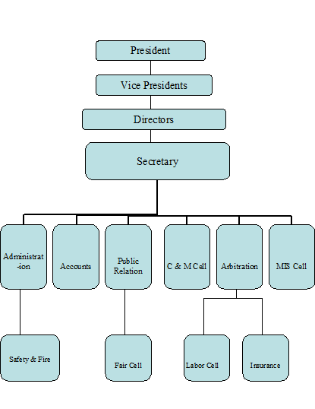
2.1.1 BGMEA:

Chart 2.1: BGMEA organogram.

2.1.1.1 Introduction:
The Bangladesh Apparel Manufacture and Exporters Association (BGMEA) is the main trade body representing the country's producers and exporters of export-oriented woven knit and sweater garment. Readymade clothing (RMG) alone won about 78 per cent. About 3.5 million employees are employed within the garment –manufacturing sector. the expansion rate of RMG export was over 20% per over the last twenty years

2.1.1.2 A Success Story of RMG Sector:
The industry's expansion in terms of number of units and job creation is shown in the table- 1 below:
YEAR | NO. OF GARMENTS | EMPLOYMENT IN MILLION WORKERS
1983-1984 | 134 | 0.040
1984-1985 | 384 | 0.115
1985-1986 | 594 | 0.198
1986-1987 | 629 | 0.283
1987-1988 | 685 | 0.306
1988-1989 | 725 | 0.317
1989-1990 | 759 | 0.335
1990-1991 | 834 | 0.402
1991-1992 | 1163 | 0.582
1992-1993 | 1537 | 0.804
1993-1994 | 1839 | 0.827
1994-1995 | 2182 | 1.200
1995-1996 | 2353 | 1.290
1996-1997 | 2503 | 1.300
1997-1998 | 2726 | 1.500
1998-1999 | 2963 | 1.500
1999-2000 | 3200 | 1.600
2000-2001 | 3480 | 1.800
2001-2002 | 3618 | 1.800
2002-2003 | 3760 | 2.000
2003-2004 | 3957 | 2.000
2004-2005 | 4107 | 2.000
2005-2006 | 4220 | 2.200
2006-2007 | 4490 | 2.400
2007-2008 | 4743 | 2.800
2008-2009 | 4825 | 3.100

Table 2.1: Growth of the industry and Employment
Of the 3.1 million manpower working in BGMEA member industries, 2.38 million are women (85 percent), the bulk are poor, and women who are economically poverty-stricken.

2.1.1.3 Main Functions of BGMEA:
BGMEA is passed by an elected board of directors comprising 27 members. Four vice-presidents with significant portfolios, along with a secretariat of experienced officials, assist the board in formulating and implementing the organization's vital policies and programmes. The President is that the BGMEA's highest executive authority.
- Protecting and upholding the industry's interest by helping to formulate presidential policies in line with the arena's congenial growth.
- Committed to safeguarding the interests of its members and their staff by implementing legitimate rights and privileges for the workers in the garments.
- Negotiate and converse with international and indigenous agencies to move the clothing sector in every possible areaTo maintain liaisons with foreign buyers, business associations and chambers.
- To provide foreign buyers with all necessary information about all RMG-related issues.
- BGMEA provides local manufacturers with opportunities to connect with foreign buyers and forge new partnerships by organizing various apparel fairs for reception and for the international market.
- To keep child labour free in the BGMEA factories by ongoing surveillance.

2.1.2 FBCCI:
The Bangladesh Chambers of Commerce and Industry Association, the Bangladesh umbrella body for trade and industry. It was established by the Trade Organizations Ordinance of 1961 (amended in 1994) in 1973 and by the Corporations Act of 1913 (amended in 1994). The FBCCI's most important objective is to safeguard the interests of Bangladesh's personal-sector trade bodies and industry.
There are actually 234 members, 67 of whom belong to the previous group and the remainder to the latter. The FBCCI's operations are carried out by a 32-member executive committee or board of directors, chosen by direct vote of members of both groups for a term of two years.

2.1.3 BKMEA:
The Bangladesh Knitwear Manufacturers & Exporters Association was founded in 1996 through the concerted efforts of a few knitwear producers. Shortly after the establishment it conducted activities to appear after the interest of the country's knitwear industry. Today it's a group of about 1700 knitwear producers and exporters representing the country's most important export earning market.
BKMEA Was Formed to handle the subsequent Agenda:
1. Secure the World's Interest
2. Promoting & Developing the World's Business
3. Global Resource Building
4. Enhancing legal enforcement status
5. Raising education and awareness of fundamental rights

Chapter: 03
Organizational overview

3.1 Organizational overview:
Fortis Group ventured in to the realm of garment industry as an export oriented knit, oven, and outwear apparel manufacturer in Bangladesh since 2005. Over the years the group has diversified its business from mainstream garments industry to sectors that has more direct impact on social development such as real estate, hotel & resort, sports complex, infrastructure and power sector. With a vision of sustainable development in the society, Fortis intends to become a revolutionist in promoting healthier life style by offering services that enhances physical and mental development of the society.
As a Bangladesh-German joint venture, it has deliberately identified some of the complementary advantages from both these countries to flock together to accumulate one of its major organizational strengths in order to infuse the mainstream lifeline in its entire corporate initiative. And it is unique combination of Bangladesh’s history-old industrial legacy and renewed pursuit for export-led and labor intensive industrial growth with the proven leadership of Germany and the West for their appropriate technological prowess and international market experience in the related field. Currently the group employs a workforce of 8051 and an export value of about USD 105 Million.



3.2 DEPARTMENT:
Account:
There are six employees in the account department including 2 DGM, 3 Asst. Manager, 3 Sr. Executive and 5 Executive.
Commercial:
There are five employees in the commercial department including 1 DGM, 2 Manager, 2 Asst. Manager, 1 Sr. Executive and 1 Jr. Executive.
Merchandising:
There are five employees in the merchandising department including 2GM, 1 DGM, 6 Asst. Manager, 25 Merchandiser, 8 Asst. Merchandiser, and 1 Jr. Merchandiser.
IT: There are three employees in the IT department including, 1 Asst. IT Manager, 1 Sr. IT officer and 1 Jr. IT officer.
Compliance:
There are four employees in the compliance department including 2 Asst. Manager, 1 Sr. Executive and 1 Jr. Executive.
HRM/ADMIN:
There are six employees in the HRM department including CHRO, 1 Asst. Manager, 1 Sr. Executive and 1 Jr. Executive. This department controls personnel documentation and filling, Time section, cleaning and mechanical maintenance, Security and Store etc with their scheduled HR activities.

3.3 OBJECTIVE:
Fortis Group. situated near to Boro Beraid, Notun Bazar, Dhaka. The capacity of the said project is 2, 00,000 Dozen per month. The sponsors by this time have gathered sufficient experience in production, management and marketing. Being inspired by excellent production and financial performance, this will not only increase profitability, but also enable to add more value, considering the growing worldwide market for its product. The excellence of the technology, the genius of company’s personnel, clear vision and commitment of management in the garments arena is the stronghold of this bold initiative.

3.4 TARGET MARKET:
Fortis Group. generally, does not directly sale its product because they receive order from foreign buyer and buying house etc. Their important buyers are TARGET, WALLMART, JORDUS, KOLS and GAP which are the well-known brand in USA, CANADA as well as the whole world.
Corporate Headquarter:
Brooberaid, Notunbazar, Dhaka 1212.
Factory:
Gozaiapara, Bhawal, Mirzapur, Gazipur.
Date of Incorporation:
Fortis Group. Established in 2005.
Listing status:
Private Limited Company.
Production Capacity:
Its production capacity is 2, 00,000 dozen per month.
Number of Employees:
The total numbers of employees are 6,500.
Product of RababFashion Ind. Ltd:
PANT, TROUSER (Short/Long).

Chapter: 04
Literature Review

4.1 Literature Review (HRM):
Human Resource Management is that the function within a corporation that focuses on recruitment of, management of, and providing direction for the people that add the organization. Human Resource Management can even be performed by line managers. Human Resource Management is that the organizational function that deals with issues associated with people like compensation, hiring, performance management, organization development, safety, wellness, benefits, employee motivation, communication, administration, and training.
"People are our most valued asset" could be a cliché that would not trouble any member of any senior management team. Yet, for several organizations, the fact remains that their people are undervalued, under-trained and under-used. It's a competitive and expensive market place for talented, skilled people. New hiring is often detrimental to existing staff.
Management of human resources has come to be known as an intrinsic part of management, which is worried about a corporation's human resources. The goal is to maintain higher human relations within the company through a case, implementation and review of human resources policies, procedures and programmers to maximize their contribution towards the conclusion of organizational goals.

4.1.1 Human Resource Management: Evolution
The early part of a century saw priority being given to improved efficiency by careful labor design. A part of the century emphasis shifted to the productivity of the employee during the centre. Recent decades have focused on increasing concern about the standard of working life, total quality management and the involvement of the worker in management. Those three phases are also called welfare, development and Autonomy.

4.1.2 Human Resource Management: Nature
HRM could be a process of bringing together people and organizations so that everybody's goals are met. HRM's assorted functions include:

• It is omnipresent in nature since companies are present altogether.
• The emphasis is not on rules but on performance.
• It attempts to help the workers fully develop their abilities.
• Workers are motivated to bestow their best upon the company.
• It's all about working people, both as individuals and in communities.
• It attempts to put people into assigned jobs to deliver good results.

4.1.3 Human Resource Management: Scope
The scope of HRM is incredibly wide:
- Staffing aspect-This concerns manpower strategies, recruitment, selection, placement, reallocate, promotion, learning and development, retirement and layoff, remuneration, subsidies, productivity etc..
- Government assistance element-it deals with workplace conditions and services such as canteens, kindergartens, rest and meal rooms, accommodation, transportation, medical assistance, schooling, health and safety, recreational facilities etc.
- Element of Industrial Relations-This includes partnerships between employer and management, joint negotiation, mediation, grievance and disciplinary proceedings, dispute resolution, etc.

4.1.4 Human Resource Management: Beliefs
The Human Resource Management philosophy is predicated on the subsequent beliefs:
- Human resource is that the organization's most valuable asset could be created and extended to a large extent;
- The creation of human resources depends on a stable environment with principles of transparency, creativity, confidence, mutuality and collaboration.
- HRM is often designed and managed in ways that benefit people as well as the organization.
- Employees feel highly motivated if the organization’s basic and better level needs are met.
- Employee motivation is improved with the opportunity to find and leverage one's skills and talents in the job.
- It is the responsibility of each manager to confirm the event and exploit subordinate capabilities

Human Resource Management: Objectives
- Increasing the job satisfaction and self-actualisation of the employee to the fullest.
- To develop and maintain a high standard of work life.
- To be ethically and socially attuned to society's needs.
- To develop every employee's overall personality in its multidimensional aspects.
- To boost the capacity of workers to perform their current job.To equip the staff with precision and clarity in transaction of business.

Human Resource Management: Activities
In order to attain the above objectives, Human Resource Management undertakes the subsequent activities:
- The intending of human resources or of manpower.
- Personnel training, selection, and deployment.
- Employee training, and development.
- Appraisal of employee performance.
- Taking corrective actions such as moving from one task to another.
- Employee Compensation.
- Employee Welfare and Social Security.
- Setting of a general and specific organizational relationship management policy.
- Collective bargaining, contract negotiations and the handling of grievances.
- Organizational staffing.

4.2 Functions of Human Resource Management:
Following are the varied functions of Human Resource Management that are essential for the effective functioning of the organization:
- Acquisition
- Selection
- Orientation
- Performance Evaluation
- Compensation
- Learning & Development

4.2.1 Acquisition:
The recruitment process starts after the qualitative workforce requirements are determined through work analysis and quantity by forecasting and planning. The hiring and selection is that the main function of the human resource department and hiring process is the effort to establish the competitive strength and also the organizations ' strategic advantage. A general acquisition process is as follows:
Identifying the vacancy
The recruitment process begins with the human resource department receiving requisitions for recruitment from any department of the corporate. These contain:
- Posts to be stuffed
- Amount of persons
- Execution duties
- Requirements required

Recruitment process:

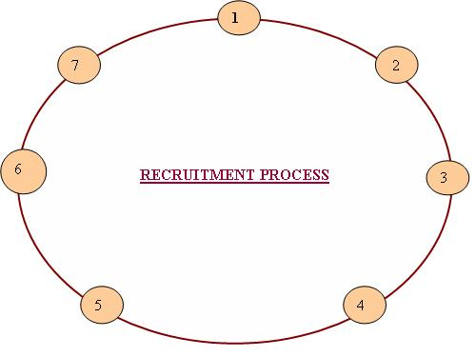

Figure 4.1: Recruitment Process

- Identify Jobs
- Prepare job description and criteria for person
- Advertisement for vacancy
- Manage Reaction
- Shortlist
- Have interviews arranged
- Interviews and decision-making
The process is followed immediately by the recruitment process, i.e. the final interviews and decision making, conveying the formalities for the decision and the appointment.

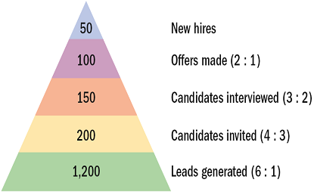

Figure 4.2: Recruiting Yield Pyramid
Recruiting yield pyramid:
The historical arithmetic relationships between recruitment leads and invitees, invitees and interviews, interviews and offers made, and offers made and offers accepted.
Recruitment process importance:
Each organization needs the members to be the live organism. The recruitment process is the main process to bring new members to the organization. Each Human Resources Department has some kind of the support for the recruitment process.
The method of recruiting involves a lot of steps and optimisation. The recruitment process includes quite heavy HR marketing because from the external labor market the organization can attract enough job applicants.
Currently, We're sleeping for the skills at present in the days of war. Workers are one of the organization's most valuable assets, and recruiting is also one of the easiest tools in the talent battle. The organization can't survive without the recruitment process, because it can't find new members and can't rent them on board.

Selection:
The selection is that the process of ascertaining whether or not candidates possess the requisite qualifications, training and skill required. The steps in Selection process in human resource management are:
1. Initial screening interview
2. Completion of the appliance form
3. Employment tests
4. Comprehensive interview
5. Background investigation
6. Conditional job offer
7. Medical/physical exam
8. Permanent job offer
Selection Process in HRM:
He selection process is made up of varied phases. Facts may come to light at each stage which can cause the applicant to be rejected. The selection steps involved are :

- Preliminary interview: Initial screening is done at the beginning to remove completely undesirable / unqualified candidates.
- Application blank: Form could be a traditional and widely used device for gathering candidate information.
- Selection test: In the selection of workers psychological is gradually working. A check is a sample of certain aspects of a person's attitude.
- Jobs interview: An interview could be a two-person conversation. This requires a private, analytical and face-to-face assessment of job candidates in selection.
- Medical examination: Applicants who have passed the above stages are sent either to the physician of the company or to a medic accredited for the reason for a physical examination.
- Reference checks: In its form, the applicant is asked to state the names and addresses of two or three people who know him well.
- Final approval: Department's short-listed applicants are eventually accepted by the department's executives.

4.2.3 Induction :
Induction is that the method by which a brand new employee is removed from society into the changed environment and introduced to the organization's practices, policies, and purposes. Once an employee has been selected and placed on a suitable job, the method of familiarizing him with the duty and also the organization is considered to be inductive.
Objectives of induction:
Induction is meant to attain following objectives:
- Helping the newcomer beat his shyness and overcome his nervous shyness in meeting new people in a new setting.
- Giving new comer necessary information, such as restaurant location, relief etc. • Building new employee trust within the organization.
- It helps to reduce employment turnover and absenteeism.
- Reduces uncertainty and creates healthy relationships within the organization organization.
Advantages of formal induction:
The advantages of formal induction are:
- Induction helps create a two-way communication channel between managers and employees.
- Proper induction encourages casual relations between workers and team work.
- Effective induction helps to integrate the new employee and develop a way of belonging in the organization.
- Induction helps build good relationships.
- Proper induction reduces grievances amongst employees, absenteeism & turnover.

4.2.4 Compensation:
Compensation refers to the actual, albeit nominal, exchange rate. Compensation is that input from the employer for the work of an employee. It is simply that the expense one would give reciprocally of their services to his / her employees.
Types of Compensation:
One of the distinctions is that rewards may be both intrinsic and extrinsic. Intrinsic rewards may include praise for completing a project or meeting performance objectives. Other psychological and social varieties of compensation also reflect intrinsic variety of rewards.
Variable Pay:
A further variety of direct pay is variable pay, which is also an person, team, or organizational performance-related compensation. Bonuses and scheme rewards are the most popular variable purchase forms for most workers. Also, managers earn long term bonuses such as share options.
Benefits:
Most businesses are implicitly offering multiple extrinsic rewards. Employees receive the tangible value of the bonuses with indirect benefits, without receiving actual cash. A gain is an indirect compensation as an example, insurance, vacation pay, or a pension for corporate membership offered to an employee or a bunch of employees, regardless of the results.
HR Metrics and Compensation:
Employers spend huge amounts of cash for employee compensation. a bit like the other area of expenditures, compensation expenditures should be evaluated to see their effectiveness. Many measures may be used for this evaluation. Employee turnover/retention is one widely used factor. Often the importance of using these numbers isn't a priority for managers or CFOs. Ideally, compensation metrics should be computed annually, so compared with the rate of changes in the organization overall (revenues, expenses, etc.)

HR Performance Area | Method of Calculation
1. Pay and benefits as percentage of operating expense. | Total pay and benefits expenditures ÷ Total operating expenses.
2. Human value added. | Revenue – Operating expense – Pay and benefits = Adjusted profit ÷ Full time equivalent employees (FTEs).
3. Return on human capital
Invested. Revenue – Operating expense – Pay and benefits = Adjusted profit ÷ Pay and benefits.4. Employee cost factor. Total compensation and benefits ÷ FTEs.

Table 4.1: HR Metrics for Compensation

4.2.5 Performance Appraisal:
A performance evaluation may be an analysis and review of the performance of delegated roles and responsibilities by an employee. The appraisal is based on the results the worker obtains in his / her job, not on the personality characteristics of the employee. The evaluation tests competencies and accomplishments with reasonable accuracy and uniformity.
Steps in performance evaluation:

- Defining the task
- Making sure that you just and your subordinate agree on his or her duties and job standards.
- Appraising performance
- Comparing your subordinate’s actual performance to the standards that are set; this usually involves some sort of rating form.
- Providing feedback
- Discussing the subordinate’s performance and progress, and preparing for any development required.

4.2.6 Training and Development:
Education and growth in the field of human resource management is the discipline that is concerned with organizational behavior aimed at improving the performance of individuals and groups in organizational settings. Many titles were recognized, including workforce growth, human resources development, and learning and development.
Training and Development Objectives:
The principal objective of coaching and development division is to form sure the supply of a talented and willing workforce to a company. additionally to it, there are four other objectives: Individual, Organizational, Functional, and Societal.
Personal Objectives–Helping workers achieve their personal goals, which in effect increases the individual contribution to a company.
Organizational Objectives–Helping the organization achieve its primary goal by bringing individual effectiveness.
Functional Objectives–sustain the commitment of the department at a rate relevant to the needs of the company.
Societal Objectives– ensure an organization is morally and socially accountable for society's wishes and obstacles.

Chapter: 05
Performance Appraisal

5.1 History of performance appraisal:
The performance appraisal history is kind of a brief one. Its roots are traced back to Taylor's pioneering studies of Time and Motion in the early 20th century. Yet this may not be very helpful, for in the area of recent human resource management, the same could also be said about almost everything. As a definite and systematic management method used in the assessment of labor performance, the evaluation actually dates back to the time of World War II, not 60 years ago.

5.2 WHAT IS “Performance Appraisal”?
Performance assessment is defined as the process of assessing an employee's performance and progress or a gaggle of employees on a given job, and their potential for future development. It consists of all formal procedures used in the work organizations and employee potential. According to Flippo, "The performance evaluation is systematic, routine and very relevant to the job.

5.3 Why Appraise Performance?
Periodic evaluations help managers gain a better understanding of the capabilities of each employee. The review process aims at recognizing success, assessing job development, and thus styling preparation to further develop skills and abilities. A careful review will increase the interest of workers and will improve the performance of jobs. The examination gives the job, the overseer. Such debates must not, however, be limited solely to a reasonable annual review.

5.4 Objectives of Performance Appraisal:
Performance Appraisal may be finished following objectives in mind:
- Taking care of records in order to draw up compensation packages, salary structure, wage increases, etc.
- To identify workers ' strengths and weaknesses in putting right men on the right job.
- Take care of and evaluate the potential for further growth and development present in the very individual.
- It is a foundation on which to manipulate the workers ' working habits.
- Reviewing and preserving promo and other training programs.

5.5 SCOPE:
The scope of any performance evaluation should include: providing workers with a far greater understanding of their position and responsibilities; raising satisfaction by recognizing abilities while recognizing training to strengthen weaknesses; enhancing working relationships and cooperation between superiors and subordinates.

Characteristics:
- Performance Appraisal could be a process.
- it's the systematic examination of the strengths and weakness of an employee in terms of his job.
- it's scientific and objective study. Formal procedures are employed in the study.
- it's an ongoing and continuous process wherein the evaluations are arranged periodically in keeping with a certain plan.
- the most purpose of Performance Appraisal is to secure information necessary for creating objective and proper decision an employee.

5.7 Benefits of Performance Appraisal:
Performance evaluation is said to be a business investment that can be justified by the below advantages::
- Incentive: Performance evaluation aids managers in drawing up incentive plans for successful workers.
- Compensation: Performance Assessment helps with the chalking out of workers compensation packages. Rating of merits is feasible through assessment of results. Performance Analysis tries to convey a performance worthwhile..
- Employee development: The structured performance evaluation method supports border management policies and programs with the managers.
- Selection Validation: Performance Evaluation helps managers understand the value and significance of the method of preference.
- Communication: Effective communication between employees and employers is critically important for a company.
- Motivation: Appraisal of success is an instrument of motivation. Through measuring employee performance, an individual's productivity can be measured if the goals are met..

5.8 Limitations:
- Errors in Note
- Missing Reliability
- Negative approximation
- Multiple Goals
- Data shortage.

5.9 Modern Appraisal:
Performance assessment could also be determined as a defined formal interaction between a submissive and supervisor, typically taking the form of a periodic (annual interview in which the subordinate's work performance is reviewed and discussed in order to identify strength and weaknesses as areas of improvement and growth of skills.
In many organizations-but not all-evaluation results are used, either directly or indirectly, to help determine outcomes of reward. That is, the appraisal results will usually identify the higher-performing workers who are expected to receive the majority of usable raises in remuneration, rewards and promotions.

5.10 Controversy:
Few issues in management awaken more controversy than performance appraisal.
There are many reputable sources – researchers, management commentators, and psychometricians – who have expressed doubts about the validity and reliability of the performance appraisal process. Some have even suggested that the method is so inherently flawed that it's going to be impossible to perfect it. At the opposite extreme, there are many strong advocates of performance appraisal.
For example, what number of people would gladly admit their work problems if they realized at the same time that their next pay rise or a much sought-after promotion was riding on an appraisal result? Very definitely, a lot of us would dismiss or downplay their shortcomings in that case. Neither is the will to distort or deny the reality confined to the appraised person.

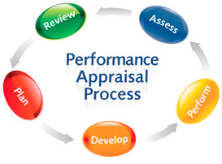
5.11 Process:
The process of performance appraisal:
- Establishing performance standards
- Communicating the Standards
- Measuring Performance
- Comparing the actual with the standards
- Discussing the appraisal
- Taking Corrective Action

5.12 Techniques in performance appraisal:
Certain techniques in performance appraisal are thoroughly investigated, and a few are found to yield better results than others. Encourage Discussion:
Research studies suggest that, if they need the opportunity to speak freely and analyze their results, workers are likely to feel more pleased with their evaluation outcome. It is also more likely that those employees will be better prepared to meet future performance targets.
Employees are also more likely to feel the assessment process is rational if they have a chance to talk about it their performance.
It is critical that the evaluator (normally the boss of the employee) is well educated and reliable. Appraisers can feel comfortable with assessment methods, and can understand the job and success of the employee.

5.13 Methods of Performance appraisal:
The above list of major pitfalls in the program represents a formidable challenge, even considering the battery of assessment techniques available. But trying to avoid these pitfalls by doing away with appraisals itself is like trying to solve life's problems by committing suicide. The more logical task is to identify those assessment practices.

5.13.1 Essay appraisal:
This method asks the rater in its simplest form to write down a paragraph or more covering the strengths, weaknesses, potential and so on of a person. Essay appraisals from former employers, instructors, or associates carry significant weight in most selection circumstances, especially those involving technical, sales, or managerial positions.

5.13.2 Graphic rating scale:
The rating scale approach allows for evaluations with a high degree of consistency. - employee characteristic or feature is graded on a bipolar scale, sometimes with several points starting from "poor" to "excellent" (or some similar arrangement)

5.13.3 Management by objectives (MBO):
The use of management objectives was first widely proposed by the noted management theorist Peter Drucker within the 1950s. MBO (Management by Objectives) performance evaluation approaches are outcomes-oriented..

5.13.4 Field review:
One among several techniques for doing this is the field review. A staff member or central administrative staff works with small groups of raters from each supervisory unit and goes beyond the rating of each employee with them to
(1) define areas of inter-rater conflict,
(2) help the community reach consensus, and
(3) decide that each rater equally conceives the criteria..

5.13.5 Forced-choice rating:
Like the field analysis, this approach has been designed to minimize bias and set objective reference criteria between individuals, but it does not require a third party interference.

5.13.6 Ranking methods:
For comparative purposes, especially when it is necessary to match those that work for different supervisors, it is not particularly useful to make individual statements, ratings or evaluation forms..
- "Alternation ranking": Another approach for assessing workers is to rate employees from best to worst on a function or characteristics.
- Paired-comparison ranking": this approach is perhaps as reliable as, and could be more accurate than, alternation ranking. But it gets extremely time-consuming and frustrating with large numbers of workers.

5.13.7 Assessment centers:
So far, we have been discussing analyzing past performance. What about future performance / potential assessment? Some prediction of future performance is critical in any placing decision, and even more so in advancement decisions.

5.13.8 360 Degree Feedback:
Many companies have expanded the concept of upward feedback into what the 360-degree decision feedback was about. Usually the feedback is used for training and development, rather than for pay increases.
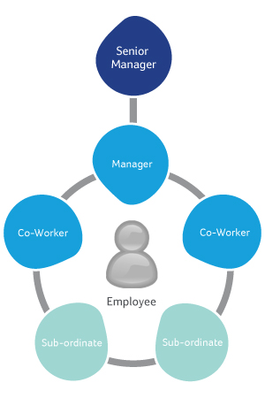

Figure-5.2: 360 Degree Feedback.
There are several common traits in Most 360 Degree Feedback system. As an example, appropriate sides – peers, supervisors, superiors and clients – total survey, private questionnaire.

5.14 Benefits of Performance Appraisals:
• Tests the success of an employee;
• Helps explain, identify, redefine expectations and goals;
• Motivates workers by achieving and providing feedback.
• Plays a major role in identifying and evaluating needs of organizational preparation.
• Assists with counselling and feedback.

5.15 Problems in Performance Appraisals:
A wide variety of errors and biases referred to as ' rating errors ' are willing to submit to performance assessments. These mistakes can seriously affect the results of the evaluation. Some of the most common mistakes in the rating are:-–
Leniency or severity: Rater leniency or severity makes the evaluation subjective. Subjective evaluation defeats the very purpose of assessing performance.
Central tendency: This happens when employees are wrongly rated close to the average or middle of the scale. The rater's mentality is to be playing safe.
Halo error: A halo error occurs when one aspect of the performance of an individual influences assessment of the individual's entire performance.
Rater effect: It involves stereotyping, favoritism and animosity.
Order of performance dimensions: Two or more dimensions follow one another on a performance instrument and both describe or rotate to a similar

Chapter: 06
Performance Appraisal Systems of Fortis Group

6.1 Performance Appraisal Systems of Fortis Group:
Today every organization is interested – in doing better performance appraisals-
For the organization, Performance Appraisals provide the mechanism to cascade Organizational strategies, goals and core values all the way down to each employee. This ensures that their efforts are coordinated and their combined effort moves the organization within the right direction.
For Managers, the Performance Appraisal will be a practical and versatile management tool that helps them focus their employees’ activities, monitor their progress, and encourage their development
For Employees, effective Performance Appraisals can have a positive effect on morale. Employees who know what's expected of them and the way they're going to be evaluated will approach their work with a more robust attitude and better sense of responsibility.
Reasons for an Appraisal:
Reasons for introducing performance appraisal in Rabab Fashion explaining below: -
- To identify any training that, could also be needed
- To make personal / business objectives clear
- To identify employees that are potential for promotion
- To review salaries or payment methods
- To identify individual strengths of employees
- To increase motivation
- To improve performance
- To update job descriptions
The main benefits for using an appraisal system are as follows:
- Gives you a concept of what you must expect from your employees
- Develops further yourself as a manager (or supervisor)
- The supervisors develop a more robust relationship with the workers by reaching to know them better and what their job consists of more precisely
- Improves communication within the business

6.2 HR Plan of Fortis Group:
In the Fortis Group. Fair labor standard Act 1938 and therefore the Equal Pay Act: passed in 1963 are both are followed and comments of the compensation system; Job Descriptions, Job Analysis, Evaluation, Pay Structures also are followed for the compensation.

6.2.1 Appraisal System of Fortis Group : (For office)
Fortis Group generally used Performance evaluation to hold based on Departmental KPI, Values and Competencies. Departmental KPI will be the 5 core Job areas of an individual as per his/her JD acknowledge by line manager and verified by HR
Methodology: Performance evaluation to held based on Departmental KPI, values and competencies (for annual appraisal reference documents- FG/HR/APEF/V_1.0, for probation period - Doc #FG/HR/PEF/V_1.0).

Ratings or performance categories

SL | Grade | Score Achievement | Performance Rating | Next Action
1 | O | 91-100 | Outstanding Performer | Future Leader & Reward proposal (role modeling)
2 | A | 81-90 | Excellent Performer | Fast Tracker & Future Leader
3 | B | 71-80 | Superior Performer | Core Performer & Individual development Plan (IDP)
4 | C | 60-70 | Marginal Performer | Average Performer
5 | D | 0-59 | Unsatisfactory | Performance Improvement Plan (PIP)

Performance Evaluation Form:
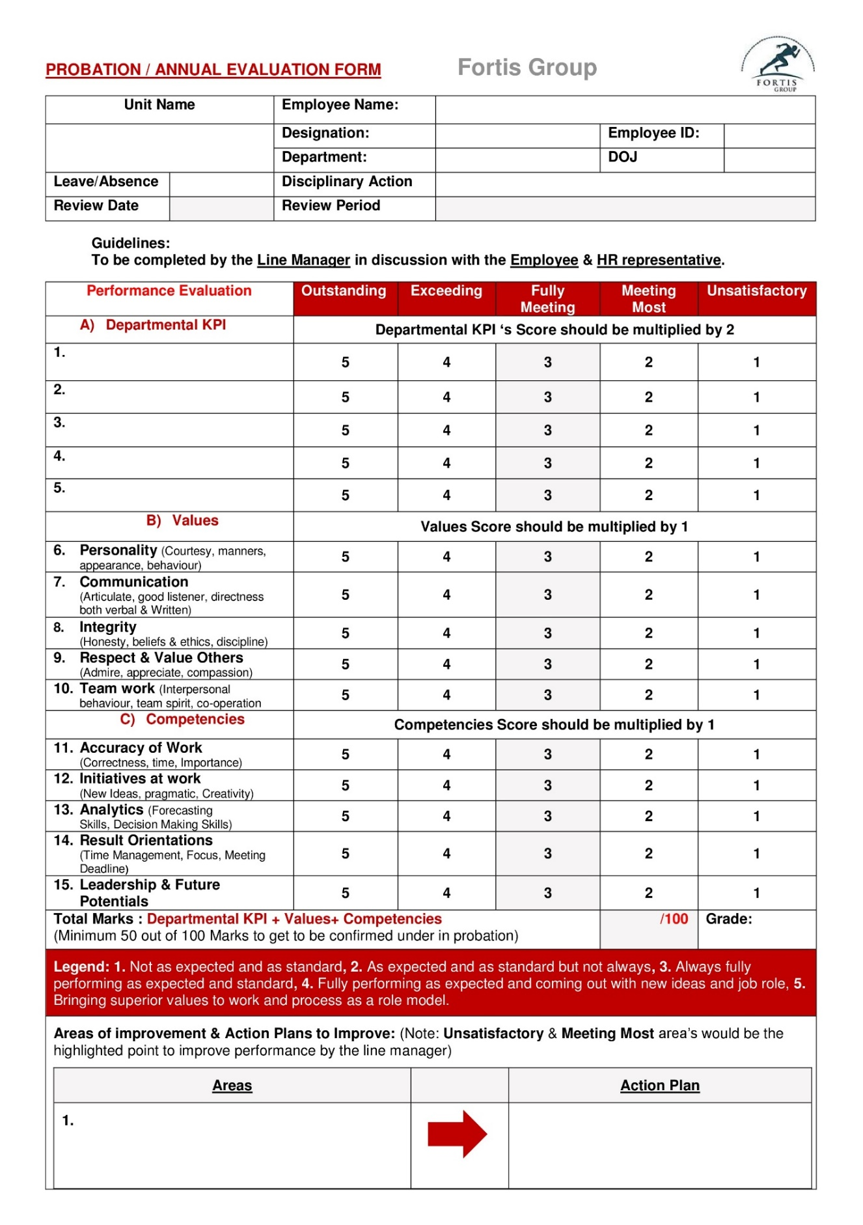
Performance Evaluation Form
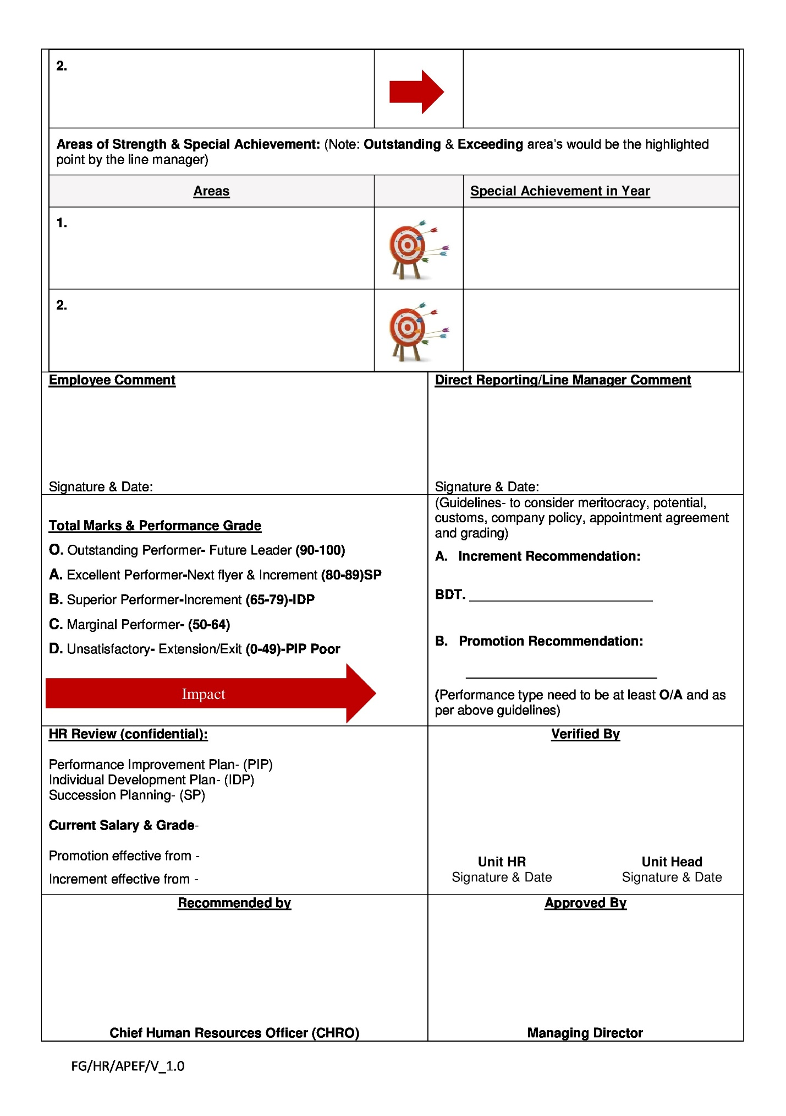

Increment Guidelines:
- Increment will be based on performance score.
- In case management may increase or decrease on the basis of business needs.
- Employee completed 1 full year (from DOJ) shall be eligible for 5% annual increment on gross. However, there may be some special adjustments subject to performance ratings and approval from MD.
- Special Increment will be applicable only based on special recommendations by concern HOD, CHRO and approval of MD.

Promotions Guidelines
- Performance and availability of higher position being the main factors for promotion, it is not mandatory that all employees eligible for promotion will be promoted.
- For Assistant manager & Above: Promotion of an individual will be based on the availability of a position, succession pipeline, career path of the individuals and key success activities; if the position is a key position. Emphasize would be on both the Potential and performance evaluation.
- For Sr. Executive and below, the performance of an individual needs to be at least fully meeting.

Exception:
Any exception shall be implemented subject to permission of CHRO & MD.

6.2.2 The pay structure of Fortis Group: (For the factory)
In the Fortis Group. There are 4000 -worker work for them they need their pay structure in keeping with the govt. rules, and therefore the labor wages law. and therefore the wages laws are describing bellow.
Wages: every worker for 8-hour work, 6 days per week in a very month should work, and it call the fundamental work and that they will get for the fundamental salary Tk.4000/-
Compensation of Over time: over 8-hour add working day is looking the overtime work. And for that they're going to get Tk. 26.10/- per hour. If any worker does the beat 12 hours, then he will get 400/-taka. But no worker can work over 54 hours in a very week as overtime.
The total wage: Every worker will get 14% of his base salary as a house rent, and medical allowance (fixed) 200/- taka. So as a complete he will get 5800/- taka.
Time card: for each worker they need their own time card. In these card workers arrivals and point in time from the work is recorded. and therefore the organization timekeeper will give his sign to the time card in keeping with the time. And thus way workers’ wages are calculated by their time card.

6.3 Benefits:
Employee benefit: Every organization try and give their employee or the worker benefit. this sort of benefit will be the financial or might be the non-financial. But during this benefit part would really like to explain the non-financial benefit part, which are given by Fortis Group. to their workers and therefore the employees.
Medical allowance: The Fortis Group has their own medical team for the emergence. each week the organization fixed doctor checkup the complete worker and if he got any disturbances then he takes the action. and each 9.00am to5.00pm the doctor stays within the organization, and from the organization the free medicine also provided to the ill workers. and therefore the organization also give the power to the worker with minimum charge they'll do the pathological test. If any quite accident happens within the organization, then they're able to give the medical service. And also the workers have gotten the fixed medical allowance (taka-200) with their total salary. And also for the main accident happen to doing the work, then organization takes the entire responsibility for the expense. Health Insurance: For the security of each worker the organization has taken the group health and accident policy. Holiday & vacation leave: The Fortis Group gives their workers the several styles of vacation to take care of the labor law for the leave and also the govt. rules.
Findings of the Study: Human resource function within the organization makes the organization smoother and simple to control. Many HR professionals believe their function has become more involved in business decision, more strategically oriented and more practical as a business partner. The HR function is adding more value to the fashionable organization day by day. The changing HR profession makes this profession more difficult & responsible. At the time of my survey at Fortis Group, I found the strengths and also the weaknesses within the present HRM practice of Fortis Group.

Strengths of the Fortis Group:
- They really follow the govt. labor law and international labor act and other terms that I found within the HRM theory.
- Their environment of the work is extremely neat and clean, and healthy for the worker health.
- The performance appraisal process is extremely modern, and provides reward within the basis of fine performance.
- The officers of the Fortis Group are considerably friendly with their worker.
- All labor is extremely much friendly with their superior, and may raise their logical demand, which is additionally an honest sign for the HR practice
- In case of getting unutilized Earned Leave employees get additional payment that Keeps employees motivated.
- In the time of my research, I noticed that there's no office politics in this organization which may be a positive sign of fair employee evaluation.
- No violence has been happened till now during this organization which represents a robust HR activity within the organization.

Weakness of the Fortis Group:
If organization is extremely much protecting by the organizational rules and also implement the principles perfectly then there aren't any chance for error. But some points are always missed thought they're carefully observing.
So like there are some slight weaknesses i've got found and that they are:
- There are only two junior HR officers, which is a few time insufficient to regulate such an oversized number of workers.
- this can be very difficult for those two HR officers to assess subordinates fairly.
- Maximum recruitment is appointed internally who are inexperienced. So there's an opportunity to affect in overall performance of the organization.
- Appraisal system is just supported performance basis which limits the world of employee evaluation.
- there's no training or counseling facilities for the poor performers within the organization.
- The organizations don't have any lady doctor or lady medical representative for the lady worker.
- The Fortis Group, computing device remains under construction, which isn't good for the competitive market, to spread their information about their organization.

Chapter: 07
Recommendation & Conclusion

7.1 Recommendation
I have completed my dissertation program within the Fortis Group. During now, i've got found some scope for the event of the Fortis Group. There are some opinions for the further development of the Fortis Group.
- They will hire more HR officer for better HR practice and done them in perfect time.
- They'll implement other performance appraisal methods to judge their employees.
- Reward system is taken into account united of the foremost important motivational factors in any organization. so that they should implement this method for better outcome.
- They will include giving certificates and regeneration towards their employees which enables the workers to realize more self-esteem and trust to them, which reciprocally will reflect to their individual performances.
- They ought to not west time to develop their computing device for meet the challenge of latest marketing strategy within the information world.

7.2 Conclusion
Today’s organization demand that the HR function delivers value added service. this needs a pointy business focus from HR professional and therefore the delivery of prime quality HR systems that are integrated into the organization’s strategy and operations.
The study “Performance Appraisal System of Fortis Group” under HRD revealed that the people are the foremost valuable resource of the progress of the organization like garments sector. Here within the garments human or the worker are the first resource to form the merchandise, the worker should execute the entire operation. And to extend the productivity of a company effective, dynamic HRM practice of Fortis Group is important.
Thus, watching the strengths and weaknesses of annual performance appraisals, and these research findings, it will be concluded, that though there are both advantages moreover as disadvantages of conducting an appraisal, it's a necessary employee motivation tool without which organizations cannot function properly.
The practice of Performance Appraisal in Fortis Group is extremely much satisfactory, and therefore the truth of this word proved by my report, that make Fortis Group. The ruling garments within the garments industry.

Appendix-A
Questionnaire
Evaluation of Performance Appraisal System at "Fortis Group"

Dear Respondent, I’m a student of United International University with major in HR.
I'm conducting this survey for the aim of fulfilling my Study report supported “Evaluation of Performance Appraisal System at "Fortis Group”
This questionnaire is an integral part of my prerequisite and can be used for educational purposes only. So, my request is to induce all of your help in arranging my report. I promise you that the information and input you receive can be kept completely confidential and can only be used for the purpose of this study. No information will be disclosed / published without your information .
1) Is your performance assessed using a formal performance assessment instrument?

• Yes • No

2) A program of performance evaluation goals. You're going to be able to put tick marks on quite one selection.

• Allocation of rewards
• Identification of coaching and development needs
• Facilitation of promotion, transfer and termination
• Quality improvement of the employees
• Motivation strategy
3) Who's judging your performance?

• Peer
• Rating Committee
• Self• Subordinates
• 360-Degree Feedback (supervisor, peer, clients)
• Others

4) How often are you assessed?

• Weekly
• Quarterly
• Twice in an extraordinarily long year
5) How could you solve those problems?

• Knowing future problems and trying to solve them through dialogue with staff
• Having proper preparation • Using the right tool • Others

6) "My manager can give me whatever ranking he / she likes and there's hardly anything I can do"
• Heavy disagreement
• Disagreement
• Undecided
• Strong agreement
7)' The performance appraisal method motivates people to work hard?
• Strongly disagree or disagree
• Undecided or agreed
• Strongly agreed

8) does one think that performance evaluation plays an effective role in improving the performance of your company's employees?

• Heavy disagreement or conflict
• Undecided or unagreed

