f

UNITED INTERNATIONAL UNIVERSITY



INTERNSHIP REPORT
ON
HUMAN RESOURCE MANAGEMENT PRACTICES OF SUPER STAR GROUP



UNITED INTERNATIONAL UNIVERSITY
United City, Madani Ave, Dhaka 1212

e

United International University

Internship Report
On
Human Resource Management Practices of Super Star Group

Submitted to
Farhana Rashid
Assistant Professor
School of Business & Economics

Submitted by
Shakib Quraishy
ID: 111 142 190

Date of Submission: July 3rd, 2019

Letter of Transmittal

July 3rd, 2019

To
Farhana Rashid
Assistant Professor
United International University

Dear mam,
With full of respect and gratification I am hereby submitting my Internship report on “The four different functions of Human Resource policies of Super Star Group” that you have assigned me with as an obligatory requirement of the Internship program. It is truly a great opportunity for me to work on the report where I’ve gotten to learn how to represent all my learnings that I’ve done practically, I’ve learned how to gather information about something while doing it & also how nicely I am doing the tasks while being with the team. I’ve found some drawbacks during my employment there & I’ve also found the probable solutions for those problems that can help overcome the difficulties. I genuinely have found my time there as an Intern very spellbinding, useful, effectual & full of positive intuition.
I’ve attempted my level best to make this report fruitful, instructive & reliable. This report will unfold useful insights about the overall functions of Human Resource Department’s operations of the organization. For providing me with this opportunity to work practically alongside what I’ve learned theoretically I am thankful to you. I wish you will overlook my mistakes that I’ve made in this report in spite of giving my best effort.
Sincerely yours

Shakib Quraishy
ID: 111 142 190
United International University

Acknowledgement

I would like to recognize the support, direction & inspiration that I’ve got from a number of helpful & friendly persons. First of all, I’m very much thankful to my academic Internship supervisor- Farhana Rashid mam for providing me with massive support and useful feedbacks all through the trimester on this report.

I am also willing to convey my gratitude to my colleague and seniors of my department, especially my organizational supervisors- Sabbir Rahman Joy (Executive) & Mohammad Tanim Rahman (Manager) & I am also thankful to MR Moinul Islam (Assistant General Manager) MR Augustin Mondol (Assistant Manager); MR Mashfiqur Rahman (Senior Executive) & MR Salman Kabir Abid (Senior Executive) from Human Resources department of Super Star Group for assisting me with the important aspects of HR policies like- Operations, Recruitment & other policies that I needed to prepare this report. Alongside all this thanks & gratitude, I would like to thank the Honorable Chief Human Resource Officer, MR Afsar Uddin and all the employees of SSG for assisting me with the necessary support whenever required. Finally & most importantly I have to recognize the contribution of the above mentioned Staffs without which this report work would not have been possible to complete.

Executive Summary
Having worked as an Intern in Super Star Group (SSG) I have got so many practical ideas & knowledge about how to run & coordinate an organization smoothly with the help of the human resource management by placing the right person in a right a position in a right time & to perform a right job. I have also come to learn about the environment, culture & values of the Super Star Group, besides this I have also learned how the organization handles its employees & brings out the best from each employee by providing them the deserved valuation & motivation.
In this report I have started with the organization overview, the mission & vision of the organization, the values of the organization, the factory overview of the organization & along with this the overview of the Human Resource department and its mission & vision.
In the next part of the report, I have described about the internship program & the internal and external recruitment process of SSG along with the Flow chart.
The next part covers the wings of Human Resource department & the policies of Human Resource department and also my responsibilities there as an Intern.
In the next part I have covered my learnings during the internship along with the findings & constraints that I have found while being the part of the SSG HR department.
The analysis of strengths, weaknesses, opportunities & threats are put up in the next part of this report.
The report gets ended with the overall idea of my internship program & future potentialities.
Table of Contents

Chapter 1: Introduction
1.1 Objective of the report
1.2 Methodology
1.3 Scope of the report
1.4 Limitation of the report
Chapter 2: Organization overview
2.1 Company profile
2.2 Products of the company
2.3 Vision, Mission & Values
2.4 Awards & achievements
2.5 Factory overview
2.6 Organizational Chart
2.7 Human resource department of SSG
2.8 Vision of HR department
2.9 Mission of HR department
2.10 Wings of SSG HR
2.11 The functional chart of HR department
Chapter 3: Literature review
Chapter 4: Analysis part

4.1 Recruitment & selection process of SSG
4.2 Training & development process of SSG
4.3 Performance appraisal management of SSG
4.4 Compensation & benefit system of SSG
4.5 HR operational activities of SSG
4.6 Human Resource Planning of SSG
4.7 HR policies of SSG
4.8 Grievance handling process of SSG
4.9 SWOT analysis
Chapter 5: Learnings from the internship program
Chapter 6: Constraints & findings
Recommendations
Conclusion
Reference
Annexure

(Chapter 01)
Introduction

1.1 Objective of the report
Broad objective: To provide an idea of the internship program of SSG HR and the learning of an intern by doing the things practically in a corporate field at the end of the academic curriculum is the main objective of this report. This report will provide the overall idea about the Human Resource department of Super Star Group & how the HR team implements its policies by being aligned with the organizations mission & vision.
Specific Objectives:
- To introduce the importance of HR operational functions for the organization.

- To bring out ideas regarding the operational functions of the HR team & how efficiently they are being done.
- To find out the contribution of the HR team in the overall growth of the organization.

- To find out how the HR team implements & maintains the Quality management system & Environment management system to achieve international standards.
- To find out the problems of SSG HR & the probable solutions to mitigate them.
- To provide logics why Super Star Group will be a better choice for internship for the future interns.
1.2 Methodology: This report work is solely produced by me which was not at all easy, so I had to take some helps from different sources. The sources I went through for seeking help are- Primary sources & Secondary sources.
- Primary sources: The consultation with my supervisor, my colleague & other members of the HR team.
- Secondary sources: SSG website & web portal, HR policies, Human Resource Information System (HRIS) software.

1.3 Scope of the report:
This report work is the best possible way to find out the lacking in my performance & how and where should I improve. It is also an assistance tool for me to increase my writing abilities. It’ll also help me to improve my analytical & critical thinking ability. This report can also act as a useful tool for the future Interns who will be looking for doing internship in similar type of organization. This report may come useful for SSG as they can use this as a feedback for the overall working environment & their areas of strengths & weaknesses. Ultimately, this project will be helpful for both the Interns & the organization to improve their areas of lacking.

1.4 Limitation of the report:
I have tried my level best to create a useful, informational & effective report, however there were limitations that I had to go through while making this report. Those limitations are-

- Getting data regarding the functions of HR team was not at all that easy, so I had to be very alert whenever any information came towards me in any confidential way.
- Making of the report while being responsible for the tasks assigned to me was a difficult task for me as the work load was huge.
- During the first month of my internship I fell sick several times so that was one reason I couldn’t give much time in the making of this report.

(Chapter 02)
Organization overview

2.1 Company Profile
Super Star Group is the leading & most successful manufacturer, Importer & distributor of electrical accessories & electrical equipment for more than two decades & it has a brand name “Super Star”. Super Star Group started its journey way back in 1994 by setting up its first move through an Incandescent lamp plant founded at the Narayangonj. Super Star Group provides a wide variety of lighting and other electrical solutions for residential, commercial, and other special needs. SSG offers high quality lighting solution to its numerous customers that made the group number one conglomerate in lighting sector of Bangladesh. SSG has a wide range of products namely- Compact Fluorescent Lamp, incandescent lamp, Light Emitting Diode, fluorescent tube light, switches & sockets, fan, fluorescent lighting fixture, PVC Insulating tape, electronic ballast, and distribution board.
Super Star Group is the prominent distributor of Kawamura Electric Inc. of Japan and Federal Electric of Turkey for marketing their Circuit Breaker and other electrical safety related products in Bangladesh. In addition to that, having their own fan production house with brand name “Super Star Fan”, they are the exclusive distributor of Khaitan Fan of India in Bangladesh. The quality of these products is guaranteed and its durability is unquestionable. All these products have got both intrinsic and aesthetic value for which SSG is proud of and find itself really satisfied in supplying the quality goods to their valued and prospective buyers and consumers.
SSG started a new project named Super Star Engineering Ltd. in 2012 and proved its ability to manufacture, supply, installation, testing and commissioning of electrical sub-stations, elevator & generator as well as complete electrical solutions on turnkey basis as one of the leading and popular brand in Bangladesh. SSG entered into renewable energy business under the name of Super Star Renewable Energy Ltd. in 2013. Using the brand name “Super Star Solar” this company designs and develops innovative renewable energy related products that are best suited for customer needs. To meet the increasing demand of city people, SSG expanded its activities in real estate sector under the name of Super Star Properties Ltd. In 2011, to provide high quality comfortable living and commercial space that will deliver the highest value for money of the customers.

Besides the above mentioned things, SSG is looking forward to adding few more new products which will add value to the image of SSG in many ways and establish as a diversified conglomerate.
A team of experienced and highly skilled professionals having good corporate culture are keeping contributions in the growth of the organization. All the products that are manufactured by SSG are mostly designed by their own professionals and all the product designs are kept under copyright law so that no one can copy their product design. SSG has a reputation of being involved in a good number of Corporate Social Responsibility (CSR) activities and maintains a very good credit rating with banks and other financial institutions.

2.2 Products of Super Star Group

Fans
Lightings
Professional Lighting

Energy Meter
Switch Socket
Accessories

Solar
Generator
Engineering
Tissue
Circuit Breaker

Super Fone

2.3 Vision, Mission & Values

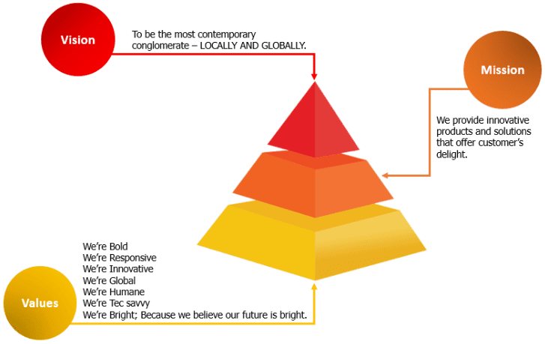

2.4 Awards & achievements

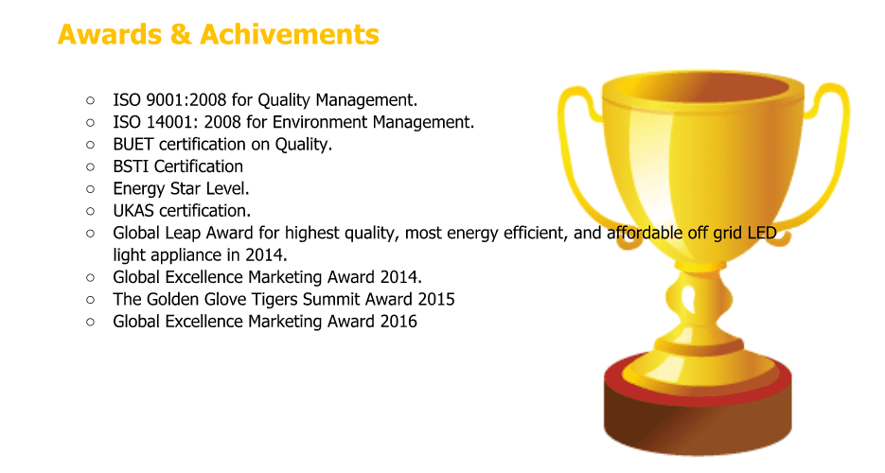

2.5 Factory Overview: Super Star Group has six factories thus far for the production & assembling of its products for different product lines. Their factories and the locations of the factories are:-
I.R. Bulb Factory
Bhuighor Narayanganj

SSEAL factory
Fatullah Narayanganj

CFL factory
Siddhirganj Narayanganj

Fan factory
Kachpur

SSEngl factory
Munshiganj

Supreme Electronic Ltd
Savar

2.6 Organizational Chart

2.7 The Human Resource Department of SSG:
The Human Resource Department of SSG believes that it is the most important resource amidst all. And, on the basis of this belief they are relentlessly trying to keep their employees motivated and charged to bring the best from each employee and they always look for different ways to empower their employees in order to provide the best return on Investment for the overall profitability of the organization.
2.8 Vision of Human Resource Department:
Human Resource department’s vision is to increase the competitive gain by streamlining the strategies with a view to maximizing the employee capability & productivity.
2.9 Mission of Human Resource Department:
- Human Resource department’s mission is to unlocked doors, to discover ways of getting things done by working together to set up KAIZEN.
- To ensure alliance & to ease the achievement of the organization’s mission by providing leadership and guidance in the development process
- To fortify the execution of equitable administration of policies and procedures & thus strengthening a positive work environment.
2.10 Wings of SSG Human Resource Department:
The HR department of Super Star Group consists of 10 staunch and stalwart members who are to assist the human resources and to accomplish all the related tasks of the whole organization & factories. SSG HR has 4 wings to correlate the whole department and they are as mentioned below-
- Recruitment, placement & employer branding
- Compensation, benefits & HRIS
- Training, development & employee engagement
- QMS & HR operational excellence

2.11 The Functional Organogram of HR department:
The approved & the most accurate hierarchical chart of the Human Resource department is given below-

(Chapter 03)
Literature review

Literature Review

Literature review is the total history of the report like what critical points I find out and how they do that, what are the main functions of HRM and how the organization use it according to our author. I am dealing with HR activities that Tory Fashion Wear Ltd uses their company according to my findings. I have given a detail view about the whole topic.
Human Resource Management:

HRM is a process of acquiring, training, appraising and compensating employees and of attending to their labor relations, health and safety and fairness concerns. Human Resource Management establish in the organization so that they can manage all the human related responsibilities. Now I can say that human resource manager fall into three major areas: staffing, employee compensation and benefits, and defining/designing work. Essentially, the purpose of HRM is to maximize the productivity of an organization by optimizing the effectiveness of its employees.

Functions of HRM:

- Conducting job analysis (what qualities they have).
- Planning labor needs for organizations (how many employees need).
- Recruitment and selection employee (how many employees are attracted and select through some test).
- Orienting & training new member of staffs (inform about organization’s rules and regulations and also give them training).
- Provide proper incentives and benefits.
- Managing ways and salaries.
- Appraising performance.
- Building up employee relations and engagement.
- Communicating.

Importance of HRM:
- To select the right employees for the organization.
- To reduce employee turnover.
- To ensure sound organizational environment.
- To increase quality of work.
- To motivate employees.
- Managing any kind of conflicts.

HR manager’s responsibility:
- Placing the right person in the right job.
- Starting new member of staffs in the business.
- Training employees for the job that are new to them.
- Improving the job performance of each person.
- Interpreting the companies’ policies and procedures.
- Controlling labor costs.
- Developing the abilities of each person.
- Protecting employees’ health and physical condition.

HR arrangement and Forecasting:
If I say very simply, human resource always plan according to base on past but do this for future by forecasting. Human Resource Management is running all the community of the organization in such a way that a correlation could be maintain between top level – mid level and lower levels of an institute. This is the main work as a HR. According to Mr. Jack Welch, “Every person who leaves goes on to represent your company. They can either bad – mouth or praise.” Organization desires employee or worker to fulfill their mission and vision or company’s purpose according to company. For this reason, HR specialized use an unusual technique that starts with the very first method ‘Man Power Planning and Forecasting’. To get a job done and to get the job flawlessly done are 2 different things. All companies at all times seek out for the 2nd one for the reason that they know that by taking 2nd one organization can get their desire outcome.
Moreover, for this reason, experienced HR specialized hire so that they can find the exact candidates for the exact post and fill the existing place for the organization. However, manpower planning and forecasting help us out to find what arrangements the firm will have to block, and how to fill them. Manpower planning covers up all future position from preservation clerk to CEO. In case of filling human resource officials also call for to be very anxiety about overstaffed or understaffed issue. Every accomplishment leads to a feedback, so HR officials also need to be concerned about the existing employee satisfaction while employing. It is going to be easy for them to get the potential employee by taking interior recruitment.
The most common Manpower planning approaches occupy the use of straightforward procedure like ratio analysis or trend analysis to estimation staffing needs foundation on sales protuberance and historical sales to Manpower relationships. The usual procedure is to anticipate revenues first and then calculate approximately the size of the staff required to accomplish the sales volume.
An organization should always be prepared for any unanticipated intimidation. Human Resource Inventory provides the idea about the organization’s present capacity for a proper response of any unexpected intimidation.

Recruitment & Selection:
Recruitment is the process of recruit people so that organization can get necessitate people. Over the past decade, researchers have stressed the fact that the recruiters should be more observant towards the first phase of the recruitment process as it can prove to be very crucial in terms of selecting the right people to do the job (Barber, 1998;Rynes, 1991). Barber (1998) argued that the initial phase of recruitment may be the most critical stage since individuals that do not apply are rarely exposed to the later, more interpersonally intensive, phases. Further, Boudreau and Rynes (1985) argued that if a firm can handle the pre-interview information then it can increase applicant awareness and interest in learning more about organizational offerings and can turn out to be a positive point to the economic utility of recruiting efforts.
Recruitment is a continuous process of hire the employee/staff/worker to fill the vacancy as and when needed in a proper way within cost effective manner. Through recruitment process organization can identify the right person for the right position which is very important for any kind of business, organization. According to Edwin B. Flippo, “Recruitment is the process of searching the candidates for employment and stimulating them to apply for jobs in the organization”. So the authority simultaneously searches the candidate so that no vacant posts are fallen idle.
Selection
Tory Fashion maintains two way selection process; worker selection and staff, officer’s selection, both are different from each other. Worker selection is a continuous process, each and every worker those who are looking for job appear before the factory gate, after physical verification who are deserving among them are choose for final selection. Staff and officer are being selected through strong reference or any reliable source which to be most acceptable and much effective. Although most employees do not use such an elaborate screening device, all employees put applicants through a selection process. The selection process is a series of specific steps used to decide which recruits should be hired. The process begins when recruits apply for employment and ends with the hiring decision. Recruiting and selection are combined and called the employment function in many HR departments. In a large HR department, the employment function is the responsibility of the employment manager. In a smaller department, the HR manager handles these duties. Employment is recurrently the primary reason for the department’s existence, since the selection process is central to the HR function.
Training
Training is the procedure of acquiring people about the job. There are some writer’s opinions about training. According to Clinton O. Longenecker, “Training demonstrates the ways to better performance; unsuccessful training generates problems; training must be managerial priority; managers have to create a system for training that is tied to actions that make sure valuable outcomes and educating workers to see the big picture in paramount” (Longenecker and Fink, 2005). He mentioned that in all the organizations, the people in charge of employees is very enthusiastic to make training accessible to their people and construct it an unconditional requirement. By doing so, the company can accomplish great results and thus boost competitive advantage over the challenger firms.
There is no doubt that managers at all levels of organizations roughly the world are under increasing stress to produce better results more rapidly than later. In this flash to increase performance, many business leaders their organizations habitually overlook the competitive advantage to be gained by properly training and educating their workforces that they need to compete in global market. And because of downsizing the significance of helpful training is increasing every day. As the recession has damaged almost all the country’s economy in the world the companies are looking to have fewer but resourceful employees. The explosion of the technology in the workplace, empowerment, work teams, tight labor market and often times, the lack of high quality graduates are ready to fill entry-level positions. Thus proving the fact Is that training can come to use in a very crucial manner. Yet the high level managers have to go through a lot of hurdles to keep the training programs active.
Staff and worker development is the key function of Tory Fashion as a specious garment group, no alternative but training and development process, not only that from buyer side also very much conscious about worker and staff development. Every now and then buyer arranged training program in collaboration with Tory HR and Admin department.
Training refers to a planned effort of a company to facilitate employees the learning of job related knowledge, skills, or behavior or can say competencies. The goal of training efforts is for employees to master the knowledge, skills or ability emphasized by training programs and to apply it in organization day to day activities.
In garments sector training is very crucial issue as the whole industry is very labor oriented. In Tory there is training centre where new recruits are trained and given proper instructions of how to carry out the operations and complete the orders. It requires a lot of skills to carry out the operations and has to be fast to meet the deadlines.
Good training always lessens boredom and frustration between supervisor and worker. Sometimes good training contributes to improved human relations and raise morale. The improvement in skills increase productivity and minimize turnover rate and employee get the chances for their own betterment. Through training Tory try to make employees more loyal towards the company. In market to much competition we see nowadays so, to make own place training is one of the strongest tool through which a person can be specialize.
Workplace learning and its benefits
An employee always learns from workplace and the benefits of learning they can use always. A firm owner of a clothing enterprise commented, they manufacture very good quality of garments products both for the domestic market and the international market and it is important that their employees have to acquire advanced technical skills so that they can operate all the machinery they have. Unluckily, the quality of vocational education and training in India is not up to the mark, so to avoid any skill shortages the worker is trained at the workplace. Of the small firm owners, 19 further argued that workplace training is crucial to the competitiveness of their firms most of their machine operators carry out inspections to check whether their machines need repairs or adjustments. Workplace training plays a role to educate them to adapt to new ideas in their work, which in turn gives them the opportunity to invest in advanced equipment. Moreover, in order to stay productive and efficient, workers must be kept motivated. Noe (1986) described motivation as a transfer of trainee’s desire to use the knowledge and skills mastered in the training and development program on the job. Below, five critical elements are identified which persuade the transfer of training process by moving the employee’s motivation to transfer the newly acquired skills and knowledge to the actual job setting.
Benefit and compensation
As an organization always tries to increase the earning, the employees also want to earn benefit. This particular aspect of a job probably holds more appeal than anything else, and has the greatest impact on whether employees stay or leave. All over the world, majority of the employees work for the purpose of supporting themselves and their family financially. Therefore, this is undoubtedly the most important factor affecting job satisfaction. Benefits are always a great way to motivate the employees. In terms of HR it actually means to pay the job holders for doing their job. Compensation also covers the aspects of intangible benefits such as holiday benefits, payment appraisals, bonuses etc. Compensation works as an antidote because it is employee right they try hard for this.
Succession Planning
- Try to categorize key positions and also consider the size of business, growth of potential, complexity of the organization etc.
- For selected positions have to construct success profile.
- Appraise succession planning process in terms of readiness, individual competences versus success profile, prioritization and examine the gap.
- Have to classify and originate action plan to shut the gap.
Retention
Organizations have to retain their existing employee because through this they can reduce the cost. We can see already labor markets have tightening over the past decade, and replacement costs connected with filling vacancies have been escalation upward for years. It can turn out to be expensive if there are high rates of turnover as recruitment is very costly and time consuming.
The turnover rates of any company can be taken into account to compare the progress in the future performance with the past performance. In Tory Fashion the turnover rate isn’t that high and it is not a matter of concern. Retention problems can affect the financial status of a company if goes unnoticed. It’s good that Tory Fashion does not have to face the problem.
Performance Appraisal
Performance management is a process for establishing a shared understanding about what is to be achieved and how it is to be achieved. An approach to managing people which increases the probability of job related success. Organizations have to measure performance of employee so that they can identify which employee is doing well and which is doing badly. Performance Appraisal information is used to find out whether an employee requires additional training and development. Deficiencies in performance may be due to inadequate knowledge or skills. Performance appraisal helps a manager to find out whether he needs additional training for improving his current job performance.
Similarly, if the performance appraisal results show that one can perform well in a higher position, then he got the training for the higher level performance. Most employees are very interested in knowing how they are doing at present and how they can do better in future. They want this information to improve their performance in order to get promotions and merit pay. Proper performance feedback can improve the employee’s future performance. It also gives them satisfaction and at a time gets motivation which is very vital for employees and workers.
Compensation System
There is an obvious relationship between performance measurement and compensation system. Compensation is a key factor in attracting and keeping best employees and ensuring that organization has the competitive edge in an increasingly competitive world. When compensation and reward system managed correctly, it helps the organization achieve its objective and obtain, maintain and retain a productive workplace. Because of performance management system practices properly an employee can get incentives rewards on a fair and equal basis. Compensation and reward decisions are likely to be arbitrary in the absence of good performance management system. So to get a proper compensation an employee has to prove his performance in the workplace. Proper compensation always works as a motivation but for these, employee have to work hard otherwise organization will not provide proper compensation.
Change Management
Organizations rules and procedures have to change according to the goal. So when they make any kind of new changes they always give training to adapt with the changes otherwise employee face problems.
Our surrounding is changing always because of political effects, technological effects, so change is inevitable. When any new rules and regulation come organization culture have to change, when any new machinery came some changes always came, and technology always changing so organizations have keep pace with these changes otherwise can’t survive with competitors. When any new changes come then definitely some development will occur. Like when new software Tory brings then employees have to take training their development is certain. Every organization when brings any changes employee become frustrated but after getting the training they will understand that the changes is for their betterment.
An organizational change is very essential to survive in this competent market otherwise company can’t compete with the competitors. With the flow of time, organizations are required to acquire new strategies based on demand of the market. Usually employee does not like any changes some tries to cope up with the changes but some wants to avoid the changes. Employee needs time to understand the changes to understand the benefit of changes then they will accept the changes. To initiate any change a responsible leader will be needed for 3 reasons-
- A leader will tell everybody why the changes are essential.
- The changes will be articulate by leader.
- Implementation of changes should be linked by means of the vision.

Employee development and training
Staff and worker progress is the key purpose of Tory Fashion as a specious garment group, no alternative but training and development process, not only that from buyer side also very much conscious about worker and staff development. Every now and then buyer arranged training program in collaboration with Tory HR and Admin department.
Training refers to a planned effort of a company to facilitate employees the learning of job related knowledge, skills, or behavior or can say competencies. The goal of training efforts is for employees to master the knowledge, skills or ability emphasized by training programs and to apply it in organization day to day activities.
In garments sector training is a very crucial issue as the whole industry is very labor oriented. In Tory there is training centre where new recruits are trained and given proper instructions of how to carry out the operations and complete the order. It requires a lot of skill to carry out the operations and has to be fast to meet the deadlines.
In TFWL, HRD is vigorously working on the uninterrupted training; improvement and comforts of its member. Both in house and outside business training of employees are associated and ongoing process.
For continuous monitoring and development, a highly scientific participatory, Performance Management System (PMS), in use for assessing employee need and apprising them once in each quarter of the year.
Good training all the time lessens boredom and frustration stuck between supervisor and worker. Sometimes good training contributes to improved human relationships and lift up self-esteem. The improvement in skills increase productivity and minimize turnover rate and employee get the chances for their own betterment. Through training Tory try to make employees more loyal towards the company. In market to much competition we see nowadays so, to make own place training is one of the strongest tool through which a person can be specialize.
Training also helps ambitious employees to build their own career. Training is a leadership activity, which prepare individuals for their own future opportunities and on the other hand, it increase customer satisfaction.
Work Environment
Work environment is a vital issue for employee and also for workers because if the environment is not suitable with that individual person then they cannot work. Work environment is the key aspect of Tory Fashion and they always try to keep attention to maintain the utmost friendly being here work together with both male and female worker, staff and officer. All kinds of compliance related issues Tory Fashion strictly follow, such as amiable relationship of the employee to each other, they always do the job with satisfaction, and try to communicate top to bottom of workforce and make available them motivation for smooth operation. In this era of globalization where there can be mixed culture in a company the work environment is quite important. The employee relationship can affect the company’s performance. As most people spend a significant part of their day working, the environment of their workplace is also a very important factor affecting their job satisfaction. Job environment includes physical aspects of the workplace like working conditions, availability of resources as well as coworker’s behavior, politics etc.
Some changes patterns have been witnessed during the research in this direction due to the major upheavals during the crucial steps of downsizing. Dougherty & Bowman (1995) said that during such periods organizations appear to experience lack of communication in many levels (even though communication appears to be particularly important at these times. Similarly, downsizing organizations appear to suffer a deterioration of trust (Buch & Aldrige, 1991) and an increase in uncertainty.
Work environment is always a major in terms of labor intensive industries as there are lots of workers working together in a single unit. If the working environment is not properly handled then it can lead to chaos and cause a lot of problems for the company.

(Chapter 04)
Analysis part

4.1 The Recruitment process of Super Star Group
The Human Resource Department of Super Star Group follows different recruitment processes for their sales employees & corporate employees. For their sales employee’s recruitment they have an established process of hiring the Divisional sales managers, Regional sales managers, Territory sales managers & the Field officers. And, for their corporate employees they have a different kind of an established process of hiring- Executive, senior executive, Assistant manager, Manager, Assistant General Manager & Head of the Departments.
For recruiting the sales the personnel they’ve two processes; for the field officers there is one process & for the divisional sales managers, regional sales managers & territory sales managers there is another process.
Process for recruiting field officers:

Process for Recruiting Divisional/Regional/Territory sales managers:
For recruiting the corporate personnel the HR team follows a different process than what they follows for the sales personnel. The process for recruiting a corporate personnel is being given below.

Process for recruiting the corporate personnel:

Internal Transfer or Recruitment: Super Star Group allows the internal transfer of employees to fill up the vacant positions among different departments. The process for internal transfers is not that complicated, all it is needed to be done is to fill in an internal transfer form and signature from the head of the department from where the employee will be transferred & signature of the head of the department in which the employee will be transferred. The transfer form looks like this-


Form no. SOP-HR-005-F002 Revision no. 01
Super Star Group
Human Resources Department
Job Transfer Request Form (to be filled up by incumbent)
Employee Information :

Name: | Designation:
Employee ID : | Department:
Cell Phone No: | E-Mail :
Date of Joining at SSG : | Date of Joining at current location:
Reports to: MD & CEO

Details of Transfer Request :

Current working location and designation | Requested/preferred transfer location | Probable Effective Date of Transfer | Remarks (if any)
 | One Thousand One hundred

Reasons for Transfer Request (to be filled up by incumbent):

Signature of Employee | Supervisor/Channel Head | Departmental Head | MD/DMD
Received by HR:
Intern recruitment & selection process:

Super Star Group is extremely focused in younger generation to lead & carry young leadership to match with the trend & to run with the tide. SSG is looking forward to getting young bloods in its business operations to run the organization in a sound manner & it is also looking forward to grabbing every success by the strong and active hands and brains of the young talents of this generation. To extend help to the young guns who are about to start their career, SSG offers Internship program to the students who have successfully completed their academic procedures. This Internship offer is open to all the Government university students alongside the approved private university students. Generally, Super Star Group hires Interns for their different departments to aid the organizational activities. SSG recruits Interns to make them knowledgeable & to make them getting used to the corporate culture and day to day activities. In the Human Resource department, Interns are hired usually in quarterly basis which is a 3 month long internship program. I, along with another intern from a top university were recruited by SSG for 3 months in the Human Resource Department.
Interns are usually recruited externally & SSG follows a systematic process to hire the best candidate for its Internship program. While recruiting interns for different departments, the HR team goes through a series of steps. The Human Resource Department tries it heart out to hire someone who will have the ability to work under pressure, can adapt to the environment, can be of positive attitude, and can be goal oriented and who will have some other special qualities as well. I have tried to explain the steps of recruiting interns in Super Star Group here through a diagram.

And, the whole process of recruiting Interns externally is being put up in the following chart-

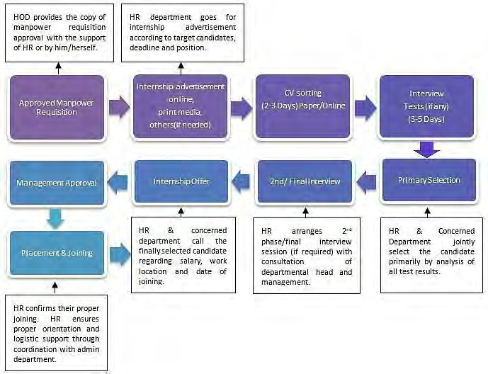

4.2 Training & Development process of Super Star Group
Super Star Group always believes that employee training & development is very important for the overall growth of the organization. Based on this belief of the management, the Human Resource team is working relentlessly on providing appropriate training to the employees & also working to develop the employees in every possible way.
The Human Resource department sits with the heads of the other department in the beginning of every year to conduct an analysis, which is called the Training Need Analysis. The purpose of this analysis is to find out the areas where the employees need training & to find out the employees who need training; this is applicable for all the departments.
Based on the Training Need Analysis, the HR team provides four different types of training namely-
- Basic Training
- Functional/Technical Training
- Supervisor/Managerial Training
- Leadership Training
The Human Resource team of Super Star Group develops ADDIE Model before going for the planning of employee training & development. Based on the model, they look forward to the process of training & developing the employees.
Here, I am going to describe shortly about the ADDIE Model with a diagram & its uses in the Super Star Group-
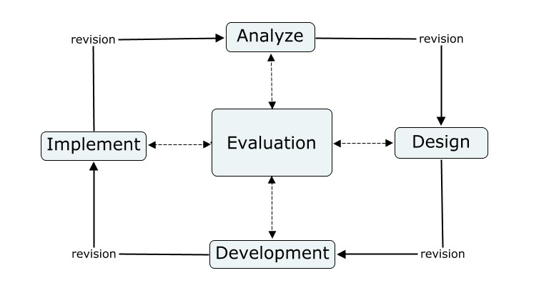

ADDIE is an acronym of the five stages of employee training & development process: Analysis, Design, Development, Implementation, and Evaluation. The ADDIE model relies on each stage being done in the given order but with a focus on reflection and iteration. The model gives you a streamlined, focused approach that provides feedback for continuous improvement.
Analysis: The HR team of SSG analyses the current situation in terms of training & knowledge gaps before going for developing any content or training strategies. The HR team goes through a series of questions to understand the current situation & to bring out the purpose of the training itself. The questions can be like this: What is the point of the training? Why are we doing it? What type of behavioral change is desired? Will training actually help? These questions should be answered with a full focus of the audience, organization goal, training methodologies used, media types used, etc. Once this part is being done, the HR team addresses the following issues:
- Who? What? When? Why? Where? How?
The main theme of the training plan will be "How can we ameliorate the situation & achieve business goals through training?” The HR team uses this question as the basis for the rest of the process.
Design: As the training plan & the analysis part done, the HR team then go to the design phase of the whole process. This is the phase where the HR team takes all the learnings from the previous phase along with them & uses the learnings to make real & practical decisions. The design phase includes a presentation, simulation, role-play, strategy, delivery methods, structure, duration, assessment, and feedback. The next step of the HR team is to create a prototype & to storyboard their ideas. By creating the prototype they can easily communicate with the other stakeholders about the value of the training.
Development: In the development stage, they go for the creation of the courses. At this stage the HR team gets help or guidance from the prototype that they previously created. They match all the elements of the courses with their design phase. As the basis of the content has already been developed all they need to do is to add a level of detail and polish to the courses. They add graphics, colors & different fonts to their course contents. However this effort may seem of little value or importance to some but this added effort has a huge relevance on how engaging the content of the course is. By carefully selecting the elements, the HR team becomes able to present the courses to the audiences in an attractive manner. Navigation is the prime concern at this stage. The problems here for the trainer are that that the learners/employees try to match how the developed courses will help them to develop & they ask many irrelevant things which are hard to deal with. So, what is important here for the trainer is- to ensure the accuracy of the training & to ensure the quality with which the development process is supposed to be dealt with.

Implementation: When the content of the training & the testing of the content is being done then they go for sharing the content with the trainees. The decisions that the HR team made in the design phase will influence how those decisions are going to be carried out here. The HR team makes a table consisting of- who are the participants of the training program, how much time they are to be given, what is the passing mark for the successful assessment of the training & how they’ll collect feedbacks. Once they are done with the table making and other issues, they go for the implementation of the whole content of the training & start training the trainees on the basis of the made content.
Evaluation: After completing the previous four parts of the model successfully, the HR team evaluates the success of the training & the extent to which the employees are trained & developed. As ADDIE Model’s purpose is to- provide a structured method of creating training programs, so the HR team of SSG focuses on the model very carefully and especially in the evaluation part because the HR team can find out the overall success of the training program from evaluating the whole process of training. While evaluating the learnings of the trainees from the training they focus on the following things-
- Are the goals being met as set out in the analysis phase?
- Is there any area left where further training is needed?
- Do they need to change their approach while giving training to the trainees?
- Is every one of the training program given feedback or not?
- How much satisfied the trainees are after being trained?
As the model is developed for creating training programs now let’s talk about their different types of training that they provide to their employees. The trainings provided by the Super Star Group’s HR team to it’s employees are-
Basic Training: This is the most fundamental type of training that SSG HR provides to its employees. The contents of this training are- orientation, values of the organization, culture of the organization etc. This training is being provided all through the year, as they recruit employees all year round. This training is done simply to make the novices introduced with the organization. Whenever new employees join the organization the HR manager of SSG provides training to them on how they should behave in the organization, how they should talk in the organization, what are the values of the organization, what is culture of the organization and everything related to the organization & its whole body. As I mentioned this training is for the newcomers however this training sometimes is also provided to the existing employees when they are about to violate the regulations of the organization & when they have done something that doesn’t go well with the values of the organization. So, the main purpose of this training regardless of the employee being new or existing- is to educate the employees about the organization & its culture.

Functional/Technical training: This training is being provided for enhancing the performance of the employees of different departments. This training is mainly given to the employees department wise. Different departments time to time needs this kind of training for increasing the level of their performance. It is really important that the employees are doing great to add value to the overall growth of the organization but sometimes unwillingly they fail to maintain their level of performance due to many reasons (the reasons can be- employee burnout, demotivated, less appreciated & so on), so this training brings out the reasons for why the employees are not doing up to the mark and then the trainer provides them the accurate training that they needed to cheer up & to start performing like never before. For instance, the sales admin department’s overall performance is below-par may be because some of the employees are underperforming and that impacts the total performance of the department. So, the job is to find out that underperformer & then provide him the necessary training so that the scenario will be changed.
Supervisor/Managerial training: This training is for the newly appointed managers and supervisors. The purpose of this training is to make the new managers & supervisors capable of handling their subordinates in a perfect manner. It is very important for any manager or supervisor to marshal his troops accurately otherwise he’ll not be able to bring out the best from his subordinates and the overall performance will not be that fruitful for him & for his subordinates. A direct supervision is very much important for any employee because if the employee works under the supervision of his manager/supervisor then that employee will be able to grow as perfect doer of his assigned jobs, and the Super Star Group highly believes this philosophy and so the HR team always arranges this kind of training for their new managers & supervisors. In this training, the managers & the supervisors are being taught about how they should handle their subordinates, how they should provide feedback to their subordinates, how they should motivate their subordinates to work productively & how they should control & supervise the overall performance of their subordinates.
Leadership training: This training is for the existing managers/supervisors/assistant general managers/general managers of the corporate office & also for the sales personnel who are in leadership positions. This training is similar to the managerial or supervisor training discussed above, the only difference in between these two training is- one is for new employees & another is for existing employees, managers or leaders to be specific. This training is of different types and different levels. For any particular quality of a leader, this training is being provided. For example, this training can be based on the decision making abilities of the leaders or strategy making abilities or any other thing. If the training is based on the decision making abilities then the leaders are taught how they can take decisions promptly & efficiently. If the training is based on some other abilities then the leaders are taught about grabbing that ability more efficiently & effectively.

4.3 Performance appraisal management of Super Star Group

Performance appraisal management is the process of appraising the employees for their tremendous performances throughout the year and rewarding them according to their annual achievements; contrary to this, it is also the process for identifying the employees who have not been performing up to the mark throughout the year and motivating them to become more productive. Performance appraisal management system is very useful for the organizations and helps them to grow smoothly. Likewise every organization, the Super Star Group is also very much focused on the performance appraisals of its employees. Super Star Group’s human resource department has the responsibility to appraise the performances of the employees through the support of the employee’s supervisor.
Performance appraisal system of Super Star Group is mainly done based on the Key Performance Indicator (KPI). The management set their objective for the year and then share those objectives with the different heads and then the department heads along with the Chief Human Resource Officer set their department wise KPI’s. However, this KPI based performance appraisal system is being followed for the employees who hold the designation assistant manager & above. For the employees who hold the designation below the assistant manager, this KPI based performance appraisal is not applicable for them; their appraisal is done by their supervisors through a printed performance appraisal form. The performance appraisal form has five dimensions each carries a particular weight and the supervisor rate the employee out of five. Below I’ll attach a sample form of performance appraisal system of Super Star Group.
Based on the appraisal, the management can find out the employees who are doing great and can reward them to keep them motivated to perform exactly how they have been performing for the last one year or so. Employees get promotion as well based on their performances. Every year numerous promotions happen and employees get increments in their salary as well with the promotion. Not all employees are eligible to be appraised when the performance appraisal happens. Employees who finish their probation periods successfully and get confirmation of employment, fall in the process of performance appraisal system. The employees have to work a minimum of one year to get into the process of performance appraisal management.

Purpose of performance appraisal system of Super Star Group:

- To evaluate the yearly performance of the employees.
- To find out the good and poor performer of the organization.
- To develop the areas of weakness of the poor performers.
- To give increments & promotions to the best performers.
- To find out potential candidates for future top-level positions.
- To get the overall performance overview of each departments.

Process of performance appraisal of Super Star Group:
Key Performance Indicator: KPI based performance appraisal system is followed in the Super Star Group. In the beginning of every year, the management sits with the department heads to set KPI for each department; this is also called MBO- management by objective. Management set their objectives with the department heads. The heads of the departments then break the objective to impose them onto their concerned team members which is called the KPI of the employees.
Every employee gets their own KPI in this way and then they starts performing on that. On the successful achievement of the KPI, the employees get the positive evaluation which brings them the promotions and salary increments. Just like the positive evaluation, if the employee gets negative evaluations for his overall performance throughout the year then they have to justify to their concerned bosses why their performance has come below the set standard.
The HR team of SSG does the KPI based performance appraisal by first setting the KRA (Key Result Area), then KPI (Key performance indicator) & then measure of success. Below I am going to show an example of the KPI of Super Star Group looks like-
Part A:

KRA | KPI | Measure of Success
Revenue | HR Headcount Rationalization: Review of each department Org Chart and rationalize the Head count based on business requirement for 2019 | All Organogram (Total 18 dep) along with proper Job Description will be vetted & agreed by respective department head and HR. (All over the year)
Revenue | Streamline efficient Recruitment Process with clear roles and ensure specific time frame to close each vacant position | Average recruitment lead time to close positions as per policy with required competency level (All over the year)
Revenue | Mastering on HR Policies & Processes that will support to attract and retain employees. | Policies & Processes (at least 8) will be reviewed/ introduced by May, 2019 and get approval from the management accordingly.
EBITA/ Financial optimization | Improve employee attrition Rate | Improve attrition rate from the year 2018 (7%) to the year 2019 (6%)
HSE management | To maintain the world class safety advocate and enforce compliance with the H&S legislation to reduce incident. | Create awareness and learning session program to Reduce 3% incidents than the year 2018 (Accident Frequency Rate)
Comply with legislative requirements | Maintain ISO Standard & requirements in required aspects | Review & Audit all ISO parameter that is directly related with Business Operation and identify the Core HR action area and Submit report to the management with other recommendation.
HR Administration | Performance appraisal process | Ensure on time completion of performance appraisal process and distribute benefits as per their performance evaluations. Dec 2019
Enhance productivity & efficiency | Achieve benchmark of Employee Productivity | # Set target on employee productivity to 0.15 million taka/employee (All over the year)  # Identify the barriers to productivity  # Considering barriers, provide awareness & training program to improve the productivity (at least 5 session)
 | Implement Job Class KPIs for non-officers | Set KPI for non-officers (Such as Product quantity, Waste control, Attendance) along with reward offer and implement it during Appraisal. Dec-19
Organizational Development | Implement 5S, KAIZEN in all factories | # Design and implement the process & procedure by December 2019  # Conduct at least 1 Learning session in every Factory/BUs
Customer & Employee satisfaction | Employee Engagement Program to motivate | Organize at least 4 employee engagement program throughout the year (Ex: Picnic)
Customer & Employee satisfaction | Employee Satisfaction Survey | # Conduct Employee Satisfaction Survey/ year  # Identify the requirements from the employees’  # Full filling the requirements as per Mgt approval. Dec 2019

Part B:
KRA / KPA | KPI | Measure of Success
Competency Development | Develop competency framework for different department in line to business demand | Analyze and set competency dictionary in all level at least for 6 departments by July 2019
Create Coaching Culture | Develop Coaching culture in SSG to reduce learning cost | Increase in no. of Coach-trainees Relationship through coaching session (at least 3) by May 2019
Development of learning culture | Drive learning culture & employee development initiatives | # To create internal resource poll as a facilitator arrange TOT program (2 program) for selective people from different dept.  # Conduct leadership development program (4 programs) for senior & mid-level employees to enhance the leadership skills. By Aug 2019

Part C:

KRA | KPI
Implement SSG values within the organization | Organize SSG value based awareness program/ workshop (at least 4 program)
Implement Common role behavior within SSG | Organize training program on "The 7 Habits of Highly Effective People",(at least 6 program)

These are the KPI’s set by the management for the year however each year these KPI’s become change. Based on the performances related with this KPI’s and based on the rate of achievement of this KPI’s, an employee gets promotions and increments and overall department wise performance is being justified.

However this KPI based performance appraisal system is not applicable for the entire organization’s employees as I already mentioned above that this KPI based performance appraisal is being done for the employees who hold the designation assistant manager and above. And for those employees who are below the designation of assistant manager there is performance appraisal form which I will attach here. The performance appraisal form has five different dimensions on which the supervisor of the employee rate the employee and there is a weight associated with each dimension. The performance appraisal form of the Super Star Group looks like this-

Annual Performance Appraisal
General Information: Date:
Appraisal Period : |  | 2018
Name of Employee |  |  |  |  |  | Employee ID No.
Designation |  |  |  |  |  | Department
Date of Joining |  |  |  |  |  | Working Place/Area
Last Increment |  |  |  |  |  | Current Salary
Name of Supervisor |  |  |  |  |  | Job Title of Supervisor
PART-A- Performance Appraisal
Sl | Criteria | Score Recommended |  |  |  |  |  |  |  | Overall Performance Rating
Sl | Criteria | Weightage | Outstanding | Very Good | Good | Average | Poor | Weightage X point |  | Outstanding | 4.51-5.00
Sl | Criteria | Weightage | 5 | 4 | 3 | 2 | 1 |  |  | Very Good | 3.51-4.50
1 | Achievement of Assigned Job | 70% |  |  |  |  |  |  |  | Good | 2.51-3.50
2 | Attendance | 10% |  |  |  |  |  |  |  | Average | 1.51-2.50
3 | Integrity | 5% |  |  |  |  |  |  |  | Poor | 1.00-1.50
4 | Drive & Initiative | 5%
5 | Communication | 10%
 | Total Score | 100% | Total Performance Score Achieved for reward
PART B- Observations on Marking
Comments/Observations
 |  |  |  |  |  |  |  |  |  | Signature of the Apprise
Signature of Appraiser/Supervisor |  |  | HOD's Comments & Signature |  |  |  |  | CHRO’s Comments & Signature

4.4 Compensation & benefits system of Super Star Group

This is the most complicated and most needed part of the human resource activities. Compensation is very important for driving any employee towards their goals however setting perfect compensation for a particular designation is a big challenge for any organization. For getting good employee the compensation package has to be smart enough to attract the productive type of employee to join the organization. A poor compensation package shall never attract new and capable employees so organizations have to be very careful in designing the compensation packages of the employees. The HR team of Super Star Group deals this issue very nicely which I have to admit because their total employee turnover rate is low which means their employees are satisfied with what they are getting as compensation & benefit.
Super Star Group provides monetary and non-monetary compensation to their employees. In the monetary package the employees get their basic salary with the house allowance, medical allowance, transportation allowance & daily allowance. Employees also receive two festival bonuses each year which is also under the monetary compensation package. Employee increments of salary and promotions are also considered to be as monetary compensation packages. In the non-monetary package they have- praise, working condition & job security.
Monetary
Monthly salary- Different designation’s employee gets different salary. The salaries are usually disbursed to the bank accounts of the employees within first three to four days of the month.
Bonus- Every year the employees get two bonuses, one is in Eid Ul Fitr & another is in Eid Ul Adha.
Increments- After the performance appraisal of the employees, there comes an increment for the employees who have done their task perfectly throughput the year.
Promotion- By working sincerely and being dedicated to the organization the employees receive promotions at the end of the annual performance appraisal.

Non-monetary
Praise- Meeting the deadlines of the assigned tasks perfectly, the employees receive appreciations from their supervisors & they are told to keep up the good work.
Working condition- The overall working condition is genuinely very good at Super Star Group which acts as an extra source of motivation for the employees.
Job security-There are very incidents when the company has fired employees, so if the employees are doing well they are always being motivated by the management and if they don’t want to continue their work with SSG then they are never being restricted.
Benefits
Provident fund: After getting the confirmation as a permanent worker of SSG which is after the completion of the probationary period, every employee is offered the provident fund scheme. Provident fund is definitely a good option for those employees who want to continue with the organization for a long period of time. And, there is no forceful deduction from salary of the employees in the name of provident fund.
Lunch: The organization provides free lunch to their employees which is an extra benefit.
Medical facility: Every employee can avail the health insurance policy of Super Star Group through which they can be assured to have the financial support in time of any serious physical issues.
Life insurance: Super Star Group also provides life insurance policy to their employees. The employees can be satisfied with this sort of benefit that the organization offers to them and they can be more dedicated to their responsibilities.
Apart from what I have mentioned in the above description there are many other facilities that the employees of the SSG enjoy. For example, two time free snacks on each working day is a big facility which the organization is providing to their employees. So, I can say that the employees working in SSG are very happy with the way they are being treated by the management however there might be some exceptional cases where some employees may be not satisfied with what they are getting but exceptional cannot be example.
4.5 HR operational activities of Super Star Group

Quality Management System & Human Resource operational brilliance is a disparate & well designed wing of SSG HR. It has a short name which is called- “HR operation”. The operation team consists of two members- one is the QMS & operations manager & another one is an executive. HR operations focus on two very pivotal systems for making the Human Resource activities run smoothly and keeping things updated with the changing HR world & to gain the global excellence by working on Human Resource aspects successfully & productively. The particulars are- Quality Management System & Environment Management System. The policies for QMS and EMS of Super Star Group are given below:
SSG integrated policy (QMS & EMS)
- SSG strives to manage customer happiness via ultra-modern production facilities for fortifying top quality environment friendly products & dynamic services.
- Being the leading Electrical accessories and equipment manufacturing company, SSG is dedicated to-

- Increase productivity
- Prevention of pollution & ensure energy conservation
- Ensure continual improvement
- Minimize the adverse impact of its activities on the environment
- Improve work force capability through proper development initiatives
- Increase organizational growth

- Super Star Group is strived to achieve excellence by streamlining with-

- ISO 9001:2008 standard
- ISO 14001:2004 standard
- Applicable & subscribed legal requirement

Functions of HR operational wing:
Working on the implementation of various Human Resource policies to tackle the human resource related issues is the main activity of HR operation. Having been an Intern out there I used to help my supervisor on different organizational activities & I also used to help the other members of the whole HR team. My supervisor was responsible for issues like- job confirmation, transfer, updating daily attendance, employee clearance & settlement and I was used to helping him on the related tasks. Sometimes I had to take the role of my supervisor & had to do his duties partially. So the responsibilities with which I was assigned to will give a glimpse of the overall HR operation related functions. I am now going to explain that-
Being updated with organizational affairs and operations: During my initial days as an intern at SSG, my main tasks were to know the organization & its mission, vision & values. I was also told to know the names of the department heads & their office locations. How SSG runs its administrative tasks, how it focuses on the HR policies and how HR operations team is working to fortify the proper implementation of the policies. I had to be updated about the changing issues in the administrative & human resource activities, & how they deal with the changing issues, where the team couldn’t perform well and what are the ways to eliminate the pitfalls.
Maintaining employee personal files: The HR operation wing maintains personal files of each employee with extreme privacy creating liaison with the company policy. All the necessary documents of each employee are kept in his/her personal files. A personal file of an employee contains his/her educational certificates, national ID cards photocopy, curriculum vitae and his/her parents national id card’s photocopy and names of nominees, previous work experience certificate and salary certificates, copy of any disciplinary decision taken against him/her & documents related salary adjustment, increment, promotion, hand-set allowance, appointment, transfer and so on. Personal files are being maintained for three types of employees:-
- Corporate employees
- Factory employees
- Resigned employees
Three different excel files are being maintained for these three types of employees. When new employees were recruited, I had to set up a whole new personal file for that employee. I had to write the name, id, designation, area in the cover page of the personal file, and also had to write the ID number of the employees in the top right corner of the file. Whenever new documents of the employees would come, I had to open the personal file of that employee and had to attach the document there. I also had to bring folders & had to place 20/22 personal files in that folder, and I had to mark the folder with a folder number (like- 250/251/252) and had to give entry of all the 20/22 files in the database in excel under the folder number of that folder. Whenever anyone would ask me for an employee’s personal file, I had to search in the database with the employee’s ID number and then I had to bring the file from the shown folder off the rack, which hardly would take 1 to 2 minutes.
Keeping updates of each employee’s personal files: I was used to updating the employee personal files when needed & in case of arrival of any new document. I also had to update information about the employees in the database of the excel files accordingly. Sometimes, other department’s employees would come and ask me to keep some documents in their respective files & I had to do that. For example, documents regarding the purchase of a car/bike, tax papers, and other certificates of achievements; I was being responsible for the keeping of these documents in the accurate files.
Automation of employee personal files: To get the information about a particular employee without opening his/her file, I had to scan the personal files of the employees & had to upload it in the HRIS software so that anyone in the team could get easy access to the information needed about an employee. Once, I was assigned with a task of scanning 3 months employees’ documents & also was assigned with keeping those documents in the respective files and for doing this I was given a time of 2 days. And, Alhamdulillah I was able to meet my target within the deadline which brought lots of appreciation & small reward. (Annexure-3)
Scanning, printing and updating necessary documents: One very important task during my internship was to scan and print documents. Many a time, I had to scan a lot of documents such as- leave application form, resign letters, job transfer forms, vehicle policy manual, papers of car loan, confirmation of service & many more. I had to scan these documents to keep a copy save in the computer for any period of necessity. I also would receive mails from employees of their scan documents and then I had to print those documents and had to attach those in their personal files.

Employee attendance record management: Creating liaison with the policy, employee attendance system were needed to be updated for the salary purpose and overstay allowance. Super Star Group has a very organized kind of an attendance system. Each of the corporate offices has an attendance record device in which employees punch two times a day through ID cards or finger to record their in and out time in the office. Every day my supervisor was used to connecting all the devices from the head office to download all the program files for the purpose of uploading them to the HRMS software for daily attendance report & for creating overstay and salary adjustment report.
Preparing overstay report: Employees who overstayed the last day used to come to my supervisor to adjust their attendance and to get a copy of that overstay period to have them approved by our AGM. 5/8 reports were been created by my supervisor. Being aligned with the policy, an employee only becomes eligible for the overstay allowance if he or she works a minimum of two hours exceeding the official end hour.
Managing & updating leave of the employees: Among the operation activities of HR operation team the most common activity was to manage & update leave of the employees. Super Star Group has a software named- Time attendance software to manage & update leave and attendance stuffs. Whenever any employee came to my supervisor for any sick, casual, annual or compensatory leave, he then checked whether that employee is eligible for that leave or not. Then my supervisor filled in the part of the leave form to write the left over leave and once get approved by the department head my supervisor then update that leave in the time attendance software.
Procedure of leave management:
- Individual will fill in a leave application form.
- The HR operation team will fill in the necessary leave update.
- Immediate supervisor will recommend or reject.
- HR operation team will update the leave in the Time attendance software.
- In case of the leave be rejected the application will be handed over to the HR team.
- The HR team will update that in the software and keep the record.

SSG has a systematic leave policy according to which the employees get leave, the leave policies (Annexure 6) are as follows-
- Casual Leave- 10 days
- Sick Leave- 14 days
- Annual Leave- 20 days
- Hajj Leave- 30 days
- Maternity Leave- 112 days
- Paternity Leave- 3 days
- Compensatory leave- 10 days
- Leave without pay- 30 days
- Other leave- 30 days

Preparing attendance report for the purpose of salary adjustment: SSG HR has a very systematic process of salary adjustments. Since the management of Super Star Group always tends to prioritize the employee compensation and benefits, it provides the order to process and disburse the salaries within first five days of the following month. The compensation and benefits team accomplishes the entire task with the help of HR operations team. As per the policy, attendance reports of the corporate officers were needed to be prepared based on the individual’s attendance record starting from 21st of the previous month to 20th of the current month & for the factory personnel it is 26th to 25th respectively.
In case of any employee’s late entry and early exit violating the official working hour two times a week is considerable but when it is three times a week then a day’s salary will be deducted from the gross salary. I had to check each and every active officer’s attendance report for the whole of the month of all the 14 departments and SBUs and 6 factories and had to make salary adjustment report of the whole organization to submit to the compensation and benefits team. In times of checking the attendance report I had to be very careful as my one silly mistake can cause a top level employee loose around a big amount for one single day, so my full concentration & dedication was a pivotal issue while checking & deducting salaries from the attendance report.

Final settlement of the resigned employees:
My main task was doing the final settlement of the employees who would resign. Employees who are to give resign have to give resign letter, distributor clearance in case of a sales personnel then I had to print a top sheet containing the employee name, id, designation, department, phone number, resign date, effective date and there were 8 rows for taking the signatures or approval from 8 departments. When I got a resign letter, I attach a top sheet upon that and went to the eight different departments to take signatures; and once I was done taking the signatures then I had to give it to the compensation & benefit officer, he then wrote the salary and provident funds amount in a printed a top sheet and used to give a signature in the bottom. After getting that from him, I then went to the audit officer for his signature and then I had to take the signatures of Chief human resource officer & finance officer and in the cases of the total amount went pass twenty thousand I needed to take the signature of the deputy managing director sir. After the approval from the management, if the total amount is fourteen thousand or less then I would give it to the cash counter and if the amount is more than fourteen thousand then I would give to the cheque officer to manage the cheque for that resigned employee.
ID card & business card requisitions: I was used to receiving ID & business card requisitions from employees. Sometimes I had to download the requisition forms from the web portal and had to give the employees to fill in. After taking the ID card & business card requisitions, I used to keep them separately and in a nice way. When I would find that I had 8/10 or more than that requisitions in my hand then I called the vendor and asked him to come. In a week, the vendor came two times and I handed over the requisitions to him. He used to take the requisition forms and came back to me after 2 days or so for proof checking. After checking I used to give him back the proof copies and taking those he used to go. And, finally after 4/5 days the ID & business cards would come.
Processing vendor’s bills: Once I got the ID & business cards from the vendor, I would ask him for the invoices and then I used to accumulate all the invoices right through the month. Then I checked & calculated the invoice amount & I had to keep a copy of that for further issues if come. If I found everything perfectly okay, I then went to the chief human resource officer to take the approval and then I processed the bill with the support of supply chain management, this is where I got the chance to work cross-functionally.
ID card & Business cards distribution: Once the Id cards & Business cards were done then I used to create a list of the employees to whom the ID & business cards were supposed to send. In case of the field officers, I used to call the field officer and asked him his supervisors name and then I print the address of his supervisor’s territory and attach that address onto the envelope in which the ID card & business card were being kept by me. I then used to take the envelope to the reception and asked them to send to the courier office via our sales admin department. In case of our other corporate office’s employees, I just took the envelope of the ID card & business card to the reception and they sent those ID cards & business cards to the said offices through our service assistants.
Making & providing NOC, experience certificate and other letters: One of my responsibility was to prepare No offence clearance (NOC), experience certificate, resignation acceptance letter and clearance letters for any employee’s visa processing issue. This certificates or letters were prepared by me on demand of any employee. There were different formats for different certificates & letters but sometimes I could bring changes in the formats with the approval of my supervisor. For my creative & useful changes, I received appreciations from my supervisor when he really felt that the change in the format is actually good.
Issuance of various other letters: The HR operation team had to prepare & disburse various type of letters on demand or on the basis of the necessity of the employees, and to prepare this sort of letters I was responsible there. The letters that I was used to preparing were:-
- Job confirmation rating forms
- Show cause letters
- Salary increment letters
- Disciplinary action related letters
- Performance appraisal related forms & letters
Just like the way I used to disburse the ID cards & business cards, I had to disburse these sort of letters in the same manner too.
Preparing welcome mails: The Human Resource Department’s operation team was always being very much active in welcoming new comers. The recruitment team of SSG HR, managed a beautiful flower bouquet for the new employees on their first in the office, and the flower bouquet was handed over the new comers by their respective department heads however other senior members & the chief human resource officer were also used to being there. I used to take photographs of those Induction moments & afterwards I had to select the best pictures from among the pictures that were being taken by me and then I had to attach the best picture in the word as a template for creating the welcome mail. I had to write other useful information about the new employee in the welcome mail and for that I had to go through the personal file of the new employee for bringing out the education qualification, experiences & other relevant information. Then I used to send the draft to the employee & once he/she confirmed the draft by a proof read then I used to attach the welcome note to our official outlook email and sent to the head of the department & also to the other department heads and the management in order to make the new employee introduced to everyone.
Photography: It was an extra thing that I had to do there. After few days of my joining as an intern, my boss and other seniors got to know about my passion for photography as they saw some of my taken photographs. And, after couple of days I got the responsibility to take pictures of some important events. Having got the responsibility of photography I had to take pictures of the Annual Business Conference held in Fantasy Kingdom. For taking pictures of the mega event I was praised a lot by the seniors.
Adjustment of manual attendance summary: Though there was the time attendance software to record the attendance of the employees but sometimes the operation team of Human Resource department had to adjust the attendance summary manually. Example for this sort of cases could be the failure to punch or late in punching or if the employee was out of the office for official purpose with the acknowledgement of his/her department head. To get this sort of issues adjusted by me the person had to go through a formal procedure, starting from sending me a mail containing the reason for the adjustment; after getting the mail I then supposed to check the approval of the mail by the employee’s boss & the employee had to keep his boss in the CC of the sent mail to me. For the Informed leaves I had to follow the same procedure as well. I had to go through bulk of emails and had to adjust them manually in the time attendance software for each employee to avoid the deduction from their salary for those acknowledged leave, late and other issues regarding the adjustment. (Annexure-8)

4.6 Human Resource Planning of Super Star Group

Human Resource Planning is the process by which an organization can identify and analyze the availability of human resources in the organization. A good planning means half of the job done and having trust on this the HR team is very much accurate in their human resource planning in the beginning of each year. A proper plan is the one through which it can be ensured that the right person is in the right position in the right time and in the right place. Let’s show this process through a short diagram-

Right place
Right Person
Right time
Right quality
Effective HR planning

Super Star Group has HR team for planning its human resources of the corporate body and they also have HR teams for their factory personnel. Every year the corporate HR team does the human resource planning and in efficient manner. The Chief Human Resource Officer along with the HR manager and assistant general manager makes a plan of how much manpower they are going to need throughout the year and for which locations they will need most human resources to meet the organizational need. While making the plan, they ensure the proper support from each department because without talking to the concerned department heads the proper planning of human resources is not possible.
The HR team follows the following steps in Human Resource Planning-

The HR team after making the human resource plan starts implementing the processes set for each area. They first set a goal for the year and starts working on that goal desperately. They work on the requirements of human resources in different departments & different sales teams by providing human resources to the vacant positions. Besides, the HR team also develops the organizational structures by modifying it. The HR team also makes the job descriptions & job specifications for different jobs. Finally, by aligning the previous four targets the HR team becomes able to develop a proper human resource planning.
4.7 The HR policies of Super Star Group
The HR team of Super Star Group has developed a comprehensive Human Resource policy handbook which envelope each & every practices that are followed regarding the smooth running of the HR functions. The intention of the handbook is to fortify familiarization of Human Resource practices amidst the employees. The HR policy handbook showcases that how employees should perform while being in the organization during their work tenure with SSG. The handbook keeps the details of different policies with the target to obtain stability, equilibrium & fair interpretation of different practices every time. Employees shall also find the high-level of guiding principles and values simultaneously in which all the staffs of SSG shall have faith & the intention to agree with & to gain the respect of their fellow worker, consumers and contender. The policy titles given in the handbook are-
Office hour, holidays, attendance and leave policy: The daily office hour of SSG is 9 A.M to 6 P.M & weekly holiday is Friday. However sometimes the employees have to work or attend meetings on Friday. For recording the attendance, the employees have to punch their fingers on the machine; if any employee punches after 9:20 A.M that will be counted as late similarly if any employee punches before 5:40 P.M that will be counted as early out. Two days of late come or early out are considered okay but when it is more than two late or early out then one day’s salary will be deducted from the monthly salary of the employees.
Probation & confirmation policy: Any employee who joins the organization usually being kept in a probation period of six months. If it is found that the employee has done well in the probation period then a confirmation letter is being issued to the name of the concerned employee after the successful completion of the probation period. However, if the employee’s performance is found not up to the mark during the probation period then the probation period of the concerned employee will be extended by three months.
Code of conduct policy: There is a well described code of conduct for the employee of Super Star Group. No employee is being allowed to go anywhere during the office hour without letting his supervisor know. If any employee needs to go out early then he has to let his supervisor know and only if the supervisor permits him to go then the employee can go otherwise he cannot. All the employees have to be in formal dress throughout the week except Saturday, which is a casual day for the employees. If any employee needs a leave, he first has to get the permission from his boss then he can go to the HR and can fill in a leave form. More or less these are the code of conducts I have got to observe during my internship there however there might be some more thing in the code of conduct list.
Increment & promotion policy: Every employee usually gets an increment after the successful completion of the probation period. However, this policy of increment is applicable for senior executive and above in case of corporate personnel and for regional sales manager & divisional sales manager in case of sales personnel. And, employees who are able to meet assigned duties or KPI throughout the year along with other areas of measurement such as- attendance, integrity, communication, drive & initiative get promotion after the annual performance appraisal. With the promotion a handsome amount of money is being added to their salaries.
Workplace etiquette and behavior policy: Every employee is ordered to follow the workplace etiquette and the violation of workplace etiquette causes the employee or employees to have negative appraisal in the annual performance appraisal. Everyone is told to behave nicely with seniors, juniors & guests of the organization. No employee is allowed to browse Facebook or YouTube during the office hour unless or until it is for official purpose. Being impatient and behave roughly with anyone in the office is highly prohibited and such behaviors may bring punishments for the employees. Employees are highly ordered to perform the assigned responsibilities by his boss and no employee can refuse doing the given tasks even if it causes him to stay at office after the regular office hour.
Recruitment & selection policy: The recruitment & selection policy of SSG HR covers various steps and processes. Walk-in interviews, advertisements in the social media or local newspapers, BdJobs & LinkedIn these are the platforms from where the HR team recruits perfect match for the organization. Through screening of the CV’s and taking two three interviews the selection of the employees gets done. However, the process for recruitment & selection for corporate personnel, sales personnel & interns are different and the various processes of hiring various personnel from different departments are nicely shown via diagrams in the recruitment process of the Super Star Group.

Transportation & vehicle policy: Super Star Group provides cars to its General Managers. In case of a general manager who has his own vehicle then he’ll be given additional salary. For the sales personnel, the company offers cars to its divisional sales managers but not to every divisional sales manager; if the divisional sales manager has to cover a lot of area to supervise on day to day basis then the company gives him the car facility. For the Territory sales manager whose territory is quite big, they are given motor bike facilities and the regional sales managers also get the motor bike facility. The corporate personnel also get the transportation facilities but not individually, for example the company has a mini bus for its employees who come from Narayanganj or from Mirpur. And, every employee gets a transportation allowance which is included to his gross salary.
Foreign travel policy: Generally, this policy is for the sales team of the company. The sales managers, national sales managers, divisional sales managers, regional sales managers and in some exceptional cases the territory sales managers and the field officers get the opportunity to go on a trip outside the country. This policy is for the Super Star Renewable Energy’s sales team and for the normal products sales team. The company offers tour to- Nepal, Bhutan, Singapore, Thailand & Malaysia. Last year, the SSREL’s sales team had the luck to tour these countries for its amazing achievement in terms of sales obtaining the given target and in addition achieving more than what was set as target.
Mobile phone policy: The Company provides hand set allowance to its each and every employee. The amount of the allowance varies with the designation of the employees. Below I’ll show the amount of the allowance for different designations via a table-
Designation | Amount | Designation | Amount
General Manager | 10,000 | National sales manager | 7,000
AGM/DGM | 7,500 | Divisional sales manager | 6,000
Manager | 6,500 | Regional sales manager | 5,500
Asst. Manager | 5,500 | Territory sales manager | 4,500
Sr executive/executive | 4,500 | Field officer | N/A

TA/DA policy: Every employee of the organization gets the allowance named TA/DA however this allowance is basically for the field officers as they have to take a house on rent and travel different places for selling the products. The minimum TA/DA for the field officers is 6000 BDT. The amount of the TA/DA may be increased if the area of the field officer is found to be bigger. The DSM/RSM/TSM get different amount as TA/DA which is around 8000 for the TSM, 10000 for the RSM & 12000 for the DSM. However the corporate employee gets absolutely a different amount for their TA/DA package and the amount of their house rent, medical allowance is very confidential so the exact amount is difficult to describe.
Policy for overstay & holiday work allowance: Employees become eligible for the overstay allowance if they work no less than two hours after their official work hour. The amount for the overstay allowance is calculated in relation to the daily salary of different designation’s employees and so different designation has different amount for overstay. For example, a service assistant’s overstay allowance will be different from than that of an executive. If any employee works on a holiday then that employee will get a substitute leave on any other working day as per policy, however if the employee doesn’t get the substitute leave then that employee will get allowance for working on an holiday and the allowance’s amount will be double of the one day’s salary amount of that employee.
Health insurance & life insurance: Super Star Group offers health insurance & life insurance to its employees. This insurance policy works as a key to attract employees to join the organization because very few organizations in our country offer this kind of benefits to the employees. There is a HR policy relating to this insurances. The employees have to submit the detail of the beneficiary in case of a life insurance scheme. In case of the demise of an employee, the beneficiary will get the whole amount of the insurance. When any employee is badly sick and hospitalized for at least three days then the organization will bear the cost of the medical expenditures of that employee which will be covered by the health insurance. Failure to prove the sickness and hospitalization issue will not be entertained by the organization and no allowance will be provided to such employees. So, it is more than necessary to show the documents and other appropriate prescriptions related to the sickness and hospitalization to have the allowance from the health insurance scheme.

Festival bonus policy: The employees of the Super Star Group get two festival bonuses, one during the Eid-Ul-Fitr & the other during the Eid-Ul-Adha. Employees get some huge amount of money as festival bonuses starting from 10,000 BDT to 50,000 BDT. The amount of the bonus depends on the designation of the employees. Though the range of the bonus is given but the exact amount for particular designations is confidential.
IT policy: The information technology department of the Super Star Group has their own policy for aiding the organizational tasks. The IT team helps the corporate personnel by providing them with the laptop, mouse and other accessories. The employees have to give requisitions for the laptop when they join the organization, after getting the requisition from the employee the IT team will give laptop to the employee for official purpose. There is an IT policy for providing mouse to the employees for example, assistant manager and above designations employees will get wireless mouse. When employees find problems with their laptop or mouse, they have to send a short mail to the executive who deals with this sort of issues keeping the head of the department in the CC of that mail. After getting the mail, the problems are sorted out as early as possible by the physical visit of that executive to the concerned employee’s desk for fixing the problem or by replacing the laptop or mouse with a new one.
Hotel stay policy for the corporate personnel: Many times the HR team’s members have to go to different places out of the town for walk-in interviews or for any other official purposes, similarly the marketing team’s members also have to go for market visits outside the town or in other cities or districts. So there is a policy set by the human resource department for this type of visits or tours. The policy for hotel stay of the corporate personnel is- the employees get 450 BDT for their meal and they get 1200 for each day’s hotel stay.
Incentive policy: Super Star Group has a policy set by the human resource department for its sales personnel which is called the Incentive policy. SSG provides good amount of incentives to its sales personnel to motivate them or to make them driven towards the set target by the organization which will bring personal & organizational growth. Field officers get 1% incentive of the target if they successfully achieve the assigned target and if they achieve not less than 90% of the assigned target then they get .75% incentive of the target. There is incentive for the TSM, RSM & DSM also and their incentive policy is same as the field officers, 1% incentive for 100% target achievement & .75% incentive for minimum 90% achievement of the target. There is incentive for the professional lighting sales team, institutional sales department and component & project sales team & for the clients who introduce new customers or dealers to the organization. The amount of these incentives vary department to department and achievement of the target.
Car loan entitlement policy: This loan is being provided to the employees who hold the designation manager or above. Likewise other policies of HR, there is also a very smooth policy for giving car loans to the employees. The amount given to the employees as car loans varies between five lac taka to ten lac taka. And, the employee who takes this loan has to be very prompt in paying back the money to the organization because failure to repay the loan amount on the given time period will bring lots of trouble for the employee. Disciplinary actions are taken against the employee who fails to repay even after deducting his salary amount.
Transfer policy: Employee transfer policy is less complicated in Super Star Group. The HR department has a very simple policy for employee transfers related issues. The Human Resource Department of SSG provides a form to the employee who is to transfer from one department to another. The employee after getting the form has to fill in the form and has to take signatures from his current department head and from his to be department head. But before filling in the form, a requisition relating to the transfer has to be sent to the HR from the current department head of the concerned employee and after processing the requisition the HR executive will provide the employee a transfer form. For the field officer’s transfers, a mail from his territory sales manager is needed to be sent to the HR and the HR personnel then adjust the details about the employee in the system and then the employee is all set to join the new point.
Phone allowance, internet & modem policy: There is phone allowance for the corporate personnel, the limit of the phone allowance varies in between five hundred taka to three thousand taka. For example, the executive or senior executive gets 500 taka as phone allowance per month whereas the manager gets 1000 taka & the assistant general manager or deputy general manager gets 2000 taka and lastly the department head & general manager gets 2500/3000 taka as phone allowance per month. There is a modem policy for the general managers which is- general managers are given a modem that has a limit of 10 GB or more for doing the official work smoothly and briskly. On the time of resignation, the GM has to submit the modem back to the deputy manager of administration.
The policies that are discussed above are the core policies of the Super Star Group’s human resource department. Apart from the mentioned and described policies, there are some other policies as well in the list of HR policies of SSG. Those policies that are not shown above are-

- Amendment of laptop policy
- Disciplinary action policy
- Separation & settlement policy
- I-Pad/Tab policy
- Internet modem ceiling issue, Modem limit increase, approval for increasing the mobile phone allowance & internet package
- Attendance bonus policy
- Salary approval, OT, tax, absent & approval of several HR policies
- Internal memo
- Policy for acceptable internet usage
- Policy for data usage, laptop usage, & information privacy
- Policy for archiving & email preservation

More or less, these are the total policies that SSG HR has in their policy list. Each and every employee of the organization is requested to follow these policies for the better establishment of the HR policies of the Super Star Group. The organization’s HR team keeps a close eye to the implementation of these policies and also to the occasions when these policies are breached by any employee. Violation of these policies causes great difficulties to the employees as they have to accountable to the Chief Human Resource Officer for disrespecting or violating the any of the policies. And the actions taken against the employee who disobey any policy are- facing the CHRO, justification for violating the policy, firing the employee from the organization (in some exceptional cases).

4.8 Grievance handling system of Super Star Group

Any kind of dissatisfaction among the employees relating to their employment which is brought in the concern of the management is called grievance. Grievances have legal certification. Employees have the legal right to show their grievance relating to their employment. As grievances can be brought in the concern of the management however the employee has to be very careful about his grievance because if the grievance is found to be illogical or illegal then disciplinary actions can be taken against such employee or employees.
Super Star Group has a grievance handling policy in connection with their HR team. The HR manager takes care of the employee grievances and provides the best solutions to the employee grievances. While providing the grievance solutions to the employee, the HR manager follows a sequential process through which the grievance is being settled down & the employee who show his grievance becomes satisfied. The grievance handling process looks like the following diagram-

Disciplinary actions in relation with the grievance:

After identifying the grievances of the employees the HR manager has two paths in front of him. One path is the path that will lead to the solution of the grievance positively and with very polite way and will also lead to a fair redressal of the grievance of the employee. And the other path will lead to the solution of the grievance negatively & with very tough way which will lead to punishment for the employees.

If the grievance of the employee is found to be fair and legal then the HR manager sits with the employee in one of the conference room and tries to motivate the employee that this type of dissatisfaction will be blown away by the organization from the next time and then the manager starts to take necessary steps needed to make the employee’s redressal happen as soon as possible and to make the employee happy and satisfied and loyal to the organization.

In other case, if the grievance of the employee is found to be illegal and not appropriate then serious disciplinary actions is being taken against the employee by the organization. The HR manager after finding the grievance illegal, starts matching the principles of the legal actions for an illegal grievance and once the manager is done with his legal actions principles then the manager holds up the salary of the employee with the concern of the management, takes other necessary actions against the employee and in some cases when the employee is found absolutely violating all the principles of the workplace by making a grievance then such employee is fired by the management.

These are the actions that are taken against a grievance being exposed. Even though grievances do not sound good to hear but the human resource department of Super Star Group always inspires employees to raise their voices against anything that they feel is hurting them or when they feel less cared by the organization or when they feel they are not treated equally and appropriately according to their performances. Grievances are actually good because through grievances the HR team can identify the areas of the organization or the areas of injustice happening in the organization and so they can take immediate actions against such issues.

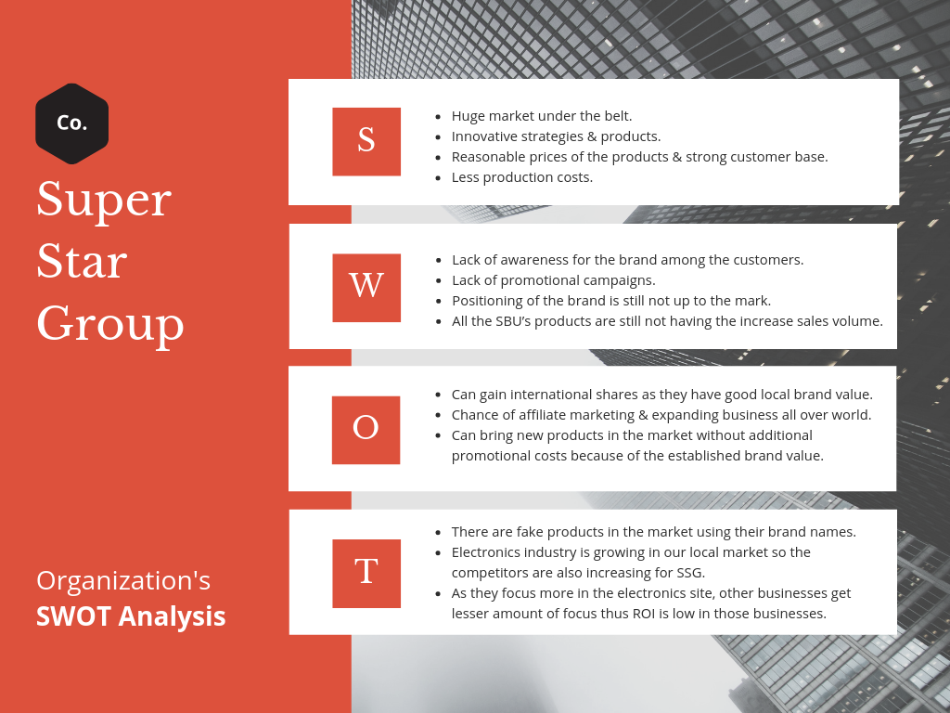
4.9 SWOT Analysis

(Chapter 05)
Learnings from the Internship program

My Internship in SSG was an advanced Internship program so the responsibilities were huge on my shoulders as compared to the traditional Internship programs. As I was never afraid of taking responsibilities, so I happily undertook the responsibilities assigned to me & I tried my best to give the best out of me. During my tenure in SSG, I got to learn a lot in terms of practical issues which I learned theoretically back in University. In this chapter, I’ll be describing about my learnings from the Internship.
Responsiveness: As I got the opportunity to work in a corporate sector for the very first time I found that really challenging & new. My responsiveness which was in the university is completely different from my responsiveness while working in the corporate sector. Responsiveness is the most important thing for working in a corporate sector anywhere in the world. As I was working there, after few days I got to realize that I have to change my behavior, attitude, habits & working styles. While being an Intern in SSG, I learned how to deal with the changes in the workplace or in the working environment, how to work with people who have different mentality and how to be responsive to the given duties and responsibilities.
Multitasking: Multitasking has always been a known and matter of curiosity to me. More or less every Internship program or the Job offers have this word attached with them. All I know about multitasking before my internship was doing more than one thing at the same time but my whole concept got changed as soon as I came to learn through my Internship that multitasking is more than just doing two/three tasks at the same time, it is about doing more than one task with high efficiency and proper management of confidentiality. And, in my internship program I got the opportunity to learn how to do multitasking with accuracy and in given time.
Self-motivation: Self-motivation is the thing that can drive a person towards the highest level of accuracy & efficiency. Self-motivation can come from getting monetary or non-monetary rewards or through inside. As an Intern, I didn’t get any monetary or non-monetary rewards so I had to be self-motivated. As I am already a self-driven person so I didn’t need any extra motivation to work from others. I used to motivate myself by my own self. Through my Internship I got the chance to develop this skill further more. Even though there were nothing for me to do sometimes but I never sat empty handed, I used to at least something from the work of others & tried to help the members of HR team as much as I could.
Managing Clients: My one of the major reasons to take HR as my major in the university came from my willingness to serve people. The Human Resource department believes that serving employees is the most pivotal thing. Human Resource Management is much more than just taking care of disciplinary actions, attendance, training programs & so on. The HR team has to be very active when it comes to serving the employees. In my case, I would say every day lot of people used to come to me for different reasons like- attendance problem, ID card & business cards, settlement issues, experience certificates & many more so by doing all these things I got to learn how to deal with the clients, how to talk with them, how to behave with them, how to give the priority to them, I learned all these things. Besides, I had to meet new people every day & had to talk with them, had to listen to their problems, had to make them understand that the solution for their problems will be provided as soon as possible; so all these activities made me much more polite and customer-centric. I believe, that experience in SSG that I had, will assist me a lot in the near future when I will be dealing lot more clients.
Corporate culture: Being an intern in the Super Star Group I found that the culture that I got to see in my university is far different from the culture of the corporate sector. I started realizing that I need to change the way I used to talk because talking with my university mates & talking with my colleagues & bosses are completely a different thing, so I started shaping myself in terms of talking, doing things with other members in the department, dealing different people having different mindset & behaving in front of the senior officers . The culture that I had found in Super Star Group I believe has made me more professional in terms of behaving officially and has made me more efficient as an employee to be.
Working under pressure & managing efficiency: Before starting my internship program I heard & saw a lot that most of the job offerings were asking for the ability to work under pressure but I didn’t have any idea about what it exactly means, as soon as I started my internship I got to understand what working under pressure actually is. By doing my internship in Super Star Group, I had got the clear idea about the term under pressure. Though I had some assigned duties to do every day, but I never knew how much work would come on my shoulder & when can I go to home. I used to have very little time to sit workless, since HR operations is a very dynamic process so I had to be very prompt to meet the pace of the dynamic work flow.
I had to work promptly and with full of efficiency. There were lots & lots of tasks to do and in a limited time period, so I had to be very quick and at the same time very accurate to finish things off timely & effectively.
Getting used to different types of software & devices: During my internship in SSG, I got myself accustomed to various software and devices, such as- Human Resource Information System (HRIS), Human Resource Management System (HRMS), Time Attendance Software (TAS) & ZKTeco devices. As I learned to operate the devices & software, I had become able to solve employee’s attendance related issues, attendance adjustment related issues, making reports for employee’s overstay & making salary adjustment reports. By getting ideas on the HRIS software I came to learn how to input employee information in the HRIS software & I also learned to make salary account profile & I also became able to connect HRIS to payroll management. I can now say working with those software & devices I have become experienced in the related tasks & more of a complete performer than I ever was.

(Chapter 06)
Constraints & findings

Problems of HRIS software: Human Resource Information System is a very useful tool for daily activities of the HR team & it is also a very important software for managing employee information & other important issues. The HRIS software is supposed to be a very prompt and up to date software but in SSG the software was slow. The software used to take a lot of time to upload and save documents. Sometimes the software used to give invalid or blank details even though the details were saved accurately. Malfunction was very common in the software. Even though the software was supposed to be worked from anywhere, anytime & by multiple users but there in SSG it never worked that well for example- when one employee is using the software, another employee couldn’t get access to the software & even if in cases of getting access the software didn’t function that well and used to be very slow. The software is developed by the external vendor but the much needed service & support never used to come in time. The problems in the software caused a lot of difficulties in day to day HR activities. An example can be given like this that, had the software worked smoothly, it would have been possible for multiple interns to scan & upload files in the HRIS.
Insufficient working space: The Human Resource Department is very congested in nature. The workspace is not very huge. In a very limited space, ten personnel has to sit and work. To work with a lot of space is not possible there and in case of yearly performance appraisal based increment & promotion letters need to be scanned & enveloped in the conference room as a big space is needed for this sort of tasks. Moreover, I had to sit in front of the AGM sir as there was lack of space and sometimes while working sitting there my laptop & AGM sir’s laptop got scratched hitting each other. There were also lack of space for keeping the employee personal files and the folders containing the files of the employees had to be kept under my table and I got no space to keep my legs easily. In addition to all these, there was also another issue that when the business cards of the employees would come there were no real spaces to keep them nicely and as a result to walk around the department was used to be a very difficult thing.
Poor technical support: It was altogether a very bad experience when it comes to the technical support. The attendance software had issues, even the attendance devices didn’t work properly sometimes. The internet speed was also very slow time to time, and sometimes the server got down. There were problems in the software so sometimes while updating a leave in the system, It Would bring troubles and problems to update the leave. One day I myself uploaded daily attendance records in the system but I couldn’t find the records on the next day. If I hadn’t noticed the record missing in the system, it would have been resulted in the salary deduction of the employees. There were also problems in the devices which caused the failure of the machine in recognizing the employee fingerprints or ID cards. So, a lot of time was wasted in fixing these problems of the devices & software. One bigger problem was with the photocopier machine as it went out of toner & necessary documents which were to be photocopied but couldn’t be done. The support system never had been satisfactory and never on time.
Lack of proper flow of information: What I observed during my internship was, people weren’t communicated nicely & weren’t provided with proper information. The new employees were used to being in a confusion regarding what to do & what not to. For example, a new employee didn’t know why he is needed to punch the card or finger In the device, and whom to go to adjust the late attendance & early leave; as a result of this problems sometimes deductions were made from their salaries as they don’t know that two days late or early leave will cause them one day’s salary. So, these things are needed to be communicated more accurately besides other disciplinary issues shall also communicated to them.
Inadequate weekly and other holidays: Being a temporary employee there in SSG, I got to have some ideas about how employees feel for the organization and how much satisfied they are with SSG. I had good relations with so many employees of different departments, so I felt that all of them were tired of working six days a week. And even in the Industrial law of Bangladesh, it is clearly mentioned that for any type of organization one and a half day’s holiday is a must but in SSG one cannot see this practice. Working six days a week is a great reason for getting bored with the tasks for the employees. This reason can also be the cause of employee turnover.
Split departments & SBU’s: All the departments of Super Star Group are not in under one roof. The admin office, audit office, engineering office, renewable energy office, properties office are situated in different places. Because of this diverse locations of different offices, there were lots of problems in communication. Besides, employees of other offices felt less privileged than the employees of the Head Office as the head office employees have the opportunity to drink espresso coffee, being in the touch of the management more closely and there were also many issues that made the employees of other offices felt jealous & less motivated.

Recommendations
From all my observations whatever problem I have found or whatever changes are needed to be done, should be fixed as soon as possible. Every problem has got a solution, we just need to identify the correct solution for each particular problem. The problem that SSG has, also has solutions so the management should try to mitigate the indicated problems. From my point of view, I have some recommendations for the problems. And those recommendations are:-
Make HRIS error free: HRIS software is a very pivotal thing in terms of keeping employee’s details and documents confidential & safe, thus keeping this software error free is a must. I think the management and the HR team should take this issue in their concern and sort the problems related to Human Resource Information System out as early as possible. In order to ensure the correct gathering of the scan documents the HRIS software needs to work accurately & fast at the same time. And, also HRIS is a very important thing from one more perspective and that is, the HRIS software helps the company to accelerate their functions towards the set vision and mission by creating liaison with the company policy and the HRIS software.
Sitting arrangements & working space should be Re-structured: As there were scarcity of space in the HR department, the sitting arrangements were looked very congested in nature. There were not enough space to sit spaciously and work in team. As I mentioned earlier, I had to sit in the desk of the AGM sir due to shortage of space, so I think there should be a place for the Interns to sit and work comfortably. One more thing is the lack of space to keep the folders containing the personal files of the employees. Since personal files are very important thing to take care of by the HR team, so I strongly believe they should fix this problem of keeping the personal files out as soon as possible. Moreover, if the management think that they need one more person to join the HR team then that will be very difficult to execute as there was no space left in the department to keep a new table and chair for another employee to work. So, these above mentioned issues should be taken care of by the Chief of Human Resource department & by the management.
Have to ensure timely IT & other technical supports: To work smoothly and in an uninterrupted manner the most important thing is the proper support from different sources such as the- Information Technology team, technical support team etc. Many a time there raised one problem or two in the HRIS, HRMS, and TAS software. These software are very
Vital for the HR team as well as for the overall organization as the documents, personal information of the employees, keeping records of the employee attendance are done by these software. During my tenure in SSG, I saw that many times the software had issues and my supervisor had to wait for the IT team to fix the problem out and only after fixing the problem he was become able to update the attendance records of the employees. So, as this software are very important and highly needed to operate day to day activities, the problem related to these software & devices need to be sorted out as early as possible.
Making sure of the correct flow of communication: Whenever a new employee joins the organization, he should be communicated properly in terms of the important issues that he needs to know and for which he might get himself in trouble due to the lack of knowledge regarding that issue. The new employee should know how to punch and whom to report the attendance related issues. And, they also should know about the salary deduction process related to the early leave & late attendance.
Providing weekly two days & other holidays: From my perspective, I believe that weekly two days of holiday would be a very good thing to motivate and happy the employees. Employees would be more focused and would be more dedicated to their works if they get two days of holiday and other holidays timely. Weekly two holidays will make them feel that they will be able to give their family more time & they will be able to manage the work life balance. However, the management may feel that giving the employees two days of holiday harm the functions of organization, so in that case the management should increase the salary range of the employees to keep the employees loyal to the organization.
Bringing all departments and SBUs under one roof: All the departments, corporate offices & SBU’s should be brought under one roof. When all the corporate offices will come under one roof then the communication will be even more effective and work flow will be even more dynamic. In addition to that, the employees will feel equally treated and will feel that everyone is getting equal benefits & opportunities and the employees will become less jealous and work their best to achieve the goal of the organization. One more advantage will be that the management can easily look after all the departments & teams.

Conclusion
At last, I have to say that doing internship in an organization like the “Super Star Group” was a real honor for me. The internship of SSG has make me learned so many things on so many aspects which will help me in my future career. I believe, starting my career with an organization like SSG will help me in obtaining good jobs ahead & will enable me to work appropriately. Besides, I believe the contribution that I had there in SSG were remarkable. There were so many problems that I found there in SSG but the good thing is SSG is looking forward to eliminating those problems. Human Resource Management is the most important department to run the organization smoothly and without the proper flow activities of the HR team, no other activities will help in the growth of the whole organization. And, here SSG is number one because they know the importance of the Human Resource team and that’s why they have hired the best HR professional from across the country to run the HR team effectively & accurately leading towards the achievement of the organization’s mission & vision.
Lastly, I would like to say that whatever learnings I had during my internship I will be looking forward to implementing those in my next organization. The experience that I had there in SSG will enlighten my future just like the mantra of the Super Star Group- “Future is bright”. The work loads, pressures, behavioral attitude, corporate culture everything that I have learned there, I believe I will be able to capitalize those in my next practical journey.

Reference

- http://portal.ssgbd.com/
- https://www.ssgbd.com/
- HR Policy handbook of SSG
- Time attendance software
- Human Resource Information System (HRIS)
- Monthly newsletters of SSG

Annexure
Annexure: 1 (The Logo)


Annexure: 2 (Pictures from the advertisements)
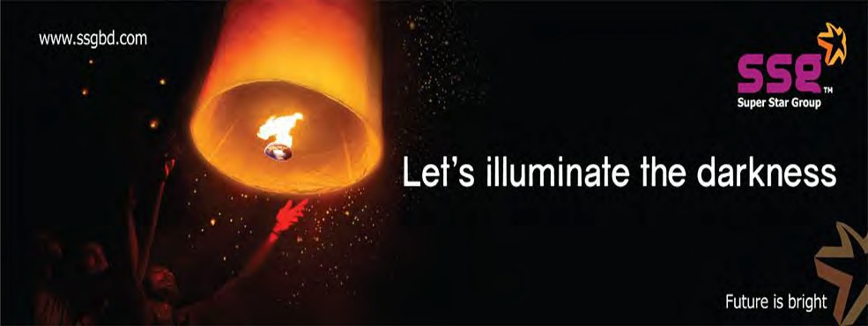



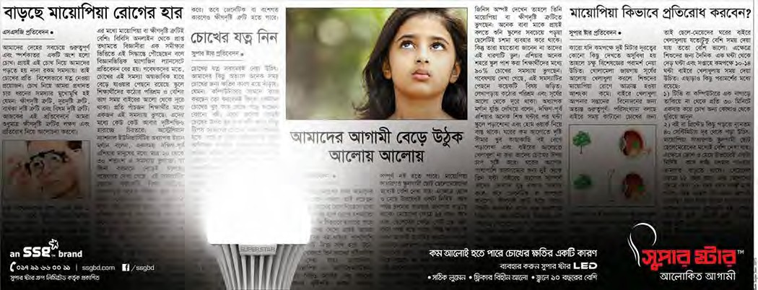


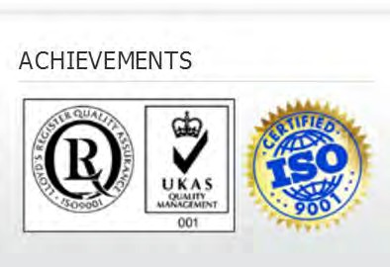

Annexure: 3 (HRIS & HRMS Software)
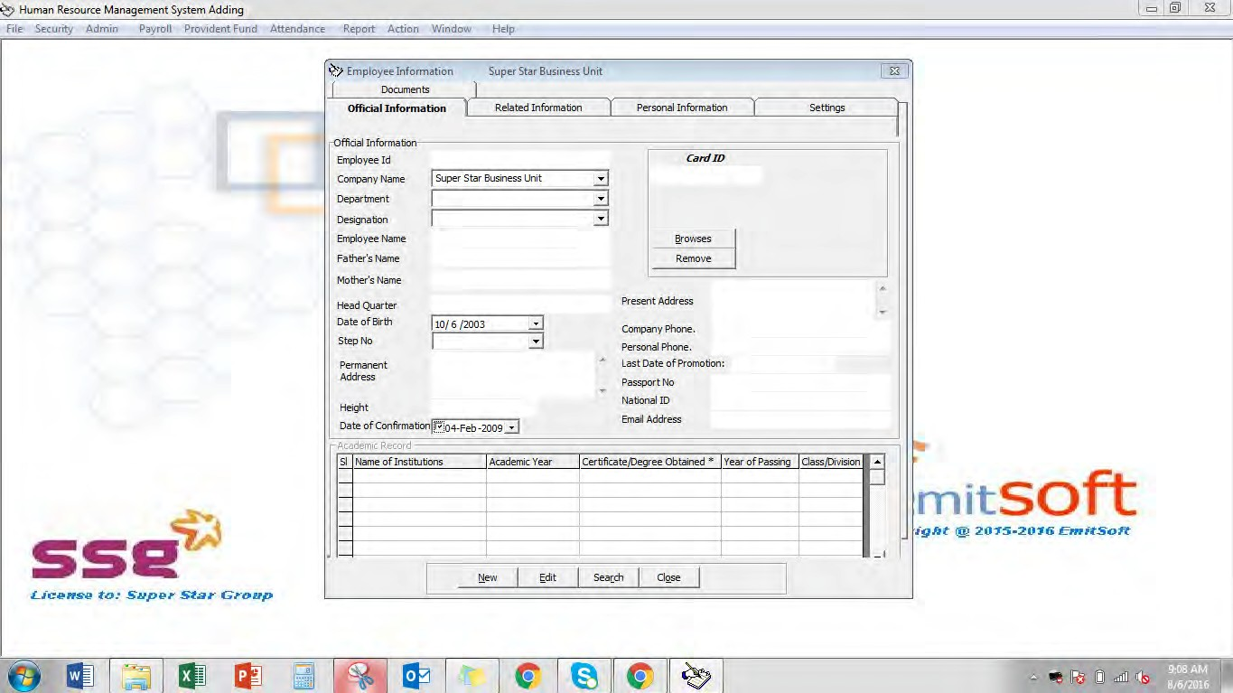

Annexure: 4 (Employee leave application form)
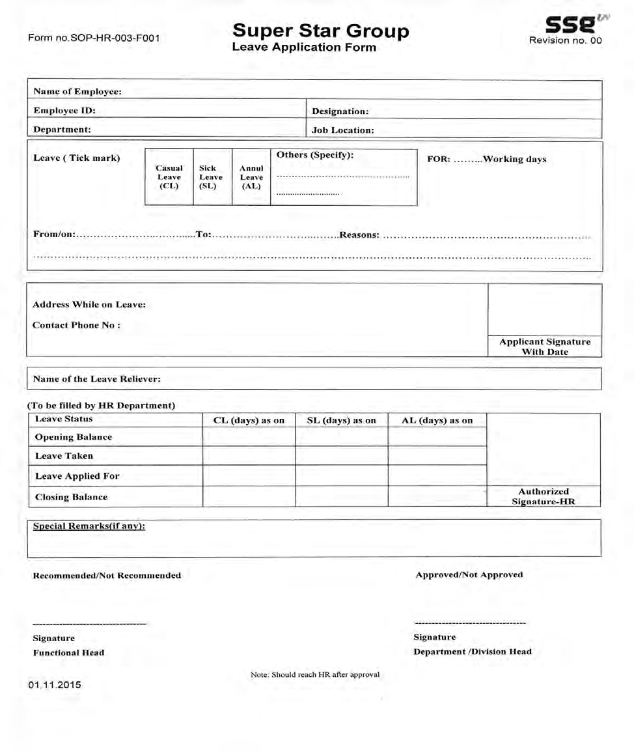

Annexure: 5 (Employee clearance form)
Name of Employee |  |  |  | Designation
Employee ID |  | Department |  |  | Area/Division
Date of joining |  |  | E. D of Resignation
This is to inform you that, the above-mentioned employee is going to be resigned. Your observation is expected on the following issues for clearance.
SL | Department |  | Observation |  |  |  |  |  | SIGNATURE
1 | Concerned  Department |  | Responsibilities
1 |  |  | Files/ Documents
2 | HR Related Issue |  | Salary |  |  |  | Month/S
2 |  |  | PF |  |  |  | Duration
2 |  |  | Mobile Set |  |  |  | ID Card
2 |  |  | Loan
3 | Admin Related  Issue |  | Mobile SIM/Bill
3 |  |  | Int. Modem
3 |  |  | Transport/Vehicle
4 | IT Department |  | Laptop |  |  |  | PC Set
4 |  |  | Pen drive |  |  |  | P.HDD/Other
5 | Accounts | Advance
5 | Accounts | Other Due
5 | Accounts | Bill
5 | Accounts | Incentive
5 | Accounts | Cash
6 | Sales  Admin | TA/DA
7 | Audit

Annexure: 6 (Time attendance software)
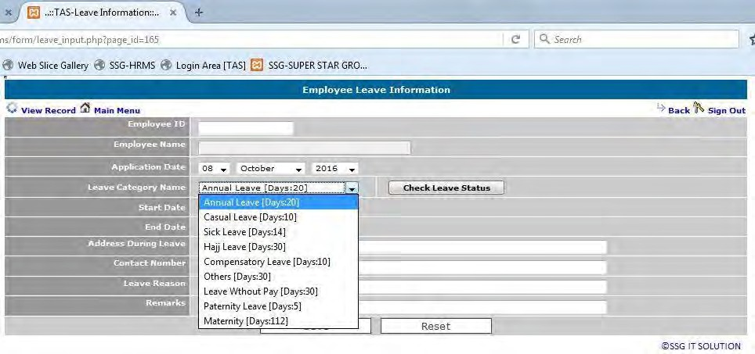
Annexure: 7 (ZKTeco attendance management software)
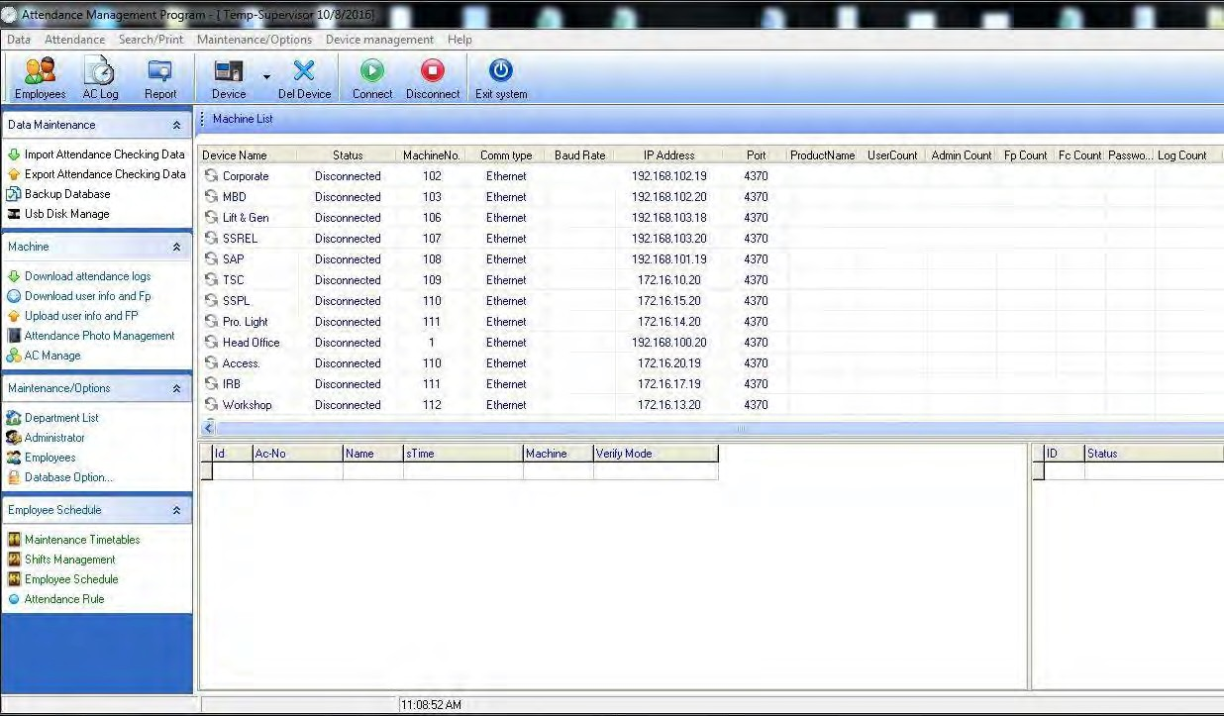

Annexure: 8 (Employee’s manual attendance record)
