Internship Report

on
“Human Resource Management Practices and Policies followed and applied by
The City Bank Limited”

Internship Report
on

“Human Resource Management Practices and Policies followed and applied by The City Bank Limited”

Submitted to:

Md. Abul Mohaimen
Assistant professor of
School of Business & Economics
United International University

Submitted By:

Sarmin Saila Huq
ID: 111 131 206
Major in Human Resource Management
United International University

Date of Submission
22th July 2018

LETTER OF TRANSMITTAL

July 22, 2018

To,
Md. Abul Mohaimen
Assistant professor,
School of Business & Economics
United International University

Subject: Submission of Internship Report.

Dear sir,
This is to express that, I am presenting my internship report on "Human Resource Management Practices and Policies followed and applied by The City Bank Limited." with due thankfulness and reverence. According to the necessity of the BBA degree, I have finished my internship from "The City Bank Limited" which is a famous Bank in Bangladesh. It is my pleasure that I have finished the internship report under your kind supervision.

According to the prerequisite of preparing an internship report with practical situation in a Bank, I have chosen HRM practices and policies followed by the City Bank as my main concentration alongside couple of other HRM techniques that I have gone over to amid my internship program.

However, I have completed the internship report on "Human Resource Management Practices and Policies followed and applied by The City Bank Limited." and I trust this report reflects the bank's HRM exercises that are being performed in realities.

I therefore, pray and hope that your honor would be great enough to accept my internship report for further assessment.

Thanking You
Sincerely Yours,

Sarmin Saila Huq
ID: 111 131 206
United International University.

ACKNOWLEDGEMENT

First of all, I want to offer my thanks to Allah to give me the strength to finish the report within the given time. This report is a summary of my ongoing learning from the internship program at The City Bank Ltd.

At very beginning, my ardent appreciation goes to Md. Abul Mohaimen ,Assistant professor, United International University for his kind guidance and valuable advice all throughout the program.

I also acknowledge with thanks the contribution of Mr. Ashutosh Debnath, HR Training and Development Manager, The CITY Bank Ltd. for his valuable recommendations in this Internship program and for helping me to complete this report in a proper way.

I also want to thanks to all the staff of Human resource department who share their important time and shared their experiences to me which enlightened me highly to allow me to achieve all the vital Data that helped me a lot to finish my report.

Table of Content
Chapter 1  Introduction ……………………………………………………….. 11  Origin of the Report ……………………………………………...12  Objectives of the Study…………………………………………12  Methodology…………………………………………………………..12  Nature of Study………………………………………………13  Sources of Data Collection……………………………………..13  Data Process and Analysis…………………………………….13  Limitation of the Study…………………………………………13 | Page no.
Chapter 2
Introduction
The City Bank Limited………………………………………..16
Mission ………………………………………………………………17
Vision:…………………………………………………………………17
Product Line of City Bank Limited………………………17
Management Overview………………………………………..18

Chapter 3  Human Resource Management of City Bank Limited  - Recruitment & Selection Process  - Testing Process  - Training  - Performance Appraisal  Development  Importance of Training & Development  Training and Development program of The City Bank Limited  On - the - Job Training  Off-the-Job - Training  The City Bank Ltd. Training Institute offers these courses  Executive Courses  General Courses  Computer Course  Short Courses  Remuneration Strategy  Sorts of Terminal Advantages  Festival Bonus  Execution Reward  Cash award  Rewards for Passing Banking Diploma Examination  Annual Increment  Travel allowance and Daily Allowance  Leave Policy  Earn Leave  Disability Leave  Maternity Leave  Casual Leave | 25  27  29  30  31  33  35  35  36  36  37  37  37  37  38  38  40  42  42  42  42  43  43  43  44  44  44  44  44  44

Chapter 4  Findings of the study | 48
Chapter 5  Recommendation  Conclusion  Reference | 51  52  53

Executive Summary

This is the report on the internship program at The City Bank Limited. This report has covered a variety of areas on the practices of human resources management and all the related policies The City bank follows.

To prepare the report, secondary data are used. From the study, it is found that the City Bank Limited is a standout amongst the best banks among the third-age private banks. The bank has effectively entered its tenth year of activities. With a proficient and committed group of administration having long understanding, admirable learning and involvement in customary and current banking, the bank has made progress among its companion bunch inside a limited capacity to focus time. The City bank ltd has set equivalent emphasis on all the four major elements of the procedure of HRM-acquisition, development, motivation, and retention.

Declaration

I beg to state that the report named by ‘Internship Report on ― “Human Resource Management Practices and Policies followed and applied by The City Bank Limited” presented as a prerequisite for the completion of B.B.A program of United International University, was prepared by me. I worked so hard to collect essential info to make this report unique and realistic.

Sarmin Saila Huq
ID-111131206
Major in Human Resource Management (HRM)
United International University (UIU)

Chapter 1
Background of the Report
Introduction
Human Resource management practice is in the increasing trend in Bangladesh. The potential for Human Resource Management is superior in Developed countries. In every department, the human is a very vital part if we consider operating the organization properly. With the dynamic condition in the business world, the correct administration of HR ended up must. Organizations are creating techniques to adapt to new patterns of HRM.

The idea is moderately new in this region. In late 90's couple of remote organizations working in here presented HRM practices. Prime and new organizations never again think of HRM as an auxiliary piece of the organizations. Presently the practices of HRM are being well known among all kind of organization. In this report, I will talk about HRM practices in Bangladesh under the light of City Bank Limited, which will give us a reasonable situation of HRM practices in Bangladesh.

The City Bank Limited is a scheduled commercial bank in the private division built up under the Banking Company Act 1991 and incorporated in Bangladesh as an open limited organization under the Companies Act 1994 to complete banking business in Bangladesh. In Bangladesh, the HRM practices are well known in banking areas. In this pattern, City Bank Limited is one of the main HRM rehearsing organizations in Bangladesh.

Origin of the Report:
As requirements of BBA program, I have prepared this report on “Human Resource Management Practices and Policies followed and applied by The City Bank Limited”My hoarier supervising Md. Abul Mohaimen, Assistant professor, United International University assigned me this topic.

Objectives of the Study:
The objectives of this report are to provide an overall Human Resource Management Practices and all the related policy followed by the City Bank Limited.
General Objective –
- To fulfill the requirements of the BBA degree.

Specific objectives -
- To describe the HRM Practices by the City Bank Limited.
- To describe the policies that are followed by the City bank ltd.
- To find-out strengths and weaknesses occupied in HRM Practices bythe City Bank Limited.
- To propose necessary steps to overcome the Problems and make possible improvement in the future.

Methodology:
The report is created by using a lots of descriptive info. To meet the objectives of the investigation, I understood that a solitary method would not be effective. Formal and oral communication, coordinate observation, and annual reports of the Bank were so helpful. Both primary and secondary sources were also used here.

Nature of Study:
This is the exploratory type of research. Information has collected and finished the report from Primary and Secondary sources.

Sources of Data Collection
The data are collected from two sources --
I. Primary sources:

- Discussion with the employees of the City Bank limited.
- Personal Observation.
II. Secondary sources:

  - Annual report, publications, training materials
  - Periodical statements of the bank, brochures, booklets etc.
  - Official Website of the City Bank Ltd.
  - Documentary file of the City Bank Ltd.

Data Process and Analysis:
- Collected information has processed through data processing software.
- Detailed analysis, working variable future projection and working definitions are incorporated in the report.

Limitation of the Study:
HRD is a very secret department for any bank. Here I am permitted to get limited information for my report. I’m restricted to get the information that is very much confidential for the City Bank Ltd. So in this report I have presented all the info that I learnt from my internship work and found from their annual report.

The main limitation encountered in producing this report is as follows:
- Lack of adequate practical knowledge about modern HRM practice.
- In many cases up to date information is not published.
- The unwillingness of the busy key persons, necessary data collection becomes hard.
- Unavailability of sufficient documents as required making a comprehensive study.
- Time constraints were a major drawback of this study, three months not sufficient.
- Bank policy should not disclose the confidential matters for many reasons.
- Only limited excess to human resource policy. Top personnel is allowed.

Chapter 2
The Profile of the City Bank LTD
- The City Bank Limited
“Making sense of money” with this mission City Bank Limited operates as a commercial bank in Bangladesh and internationally. The Bank began commercial banking operations effective from November 27, 1999. It was the time when a fast financial advancement in the nation simultaneous with urbanization and way of life change made requests for new items and administrations. The City Bank Ltd has been propelled by a gathering of effective business visionaries with perceived remaining in the general public.

The City Bank Limited is a standout amongst the best financial institution among the 3rd age private banks. It has effectively started its 10th year of activities. With a proficient and committed group of administration having long understanding, admirable learning and involvement in customary. It has made progress with its companion bunch inside a limited capacity to focus time.

With all resources, the management of the bank assumes that it is proficient to experience inconveniences which may happen both at miniaturized scale and macroeconomic stages. Inside a little traverse of time City Bank has perceived itself as one of the principal developing neighborhood private banks. It has at display a system of Fifty-three branches serving a large number of the main corporate houses and is bit by bit moving towards retail banking. Its other critical delivery channel is the common ATM frameworks and The City Bank has 52 ATM corners.

The City Bank is keeping up its intensity by utilizing on its Online Banking Software and present-day IT foundation. It is the founder among the neighborhood banks in showing imaginative staffs like SMS banking. The Online Banking programming empowers coordinate connecting of a client's record under the ATM Network,, exclusive of the need for another record. With the assistance of this Software, every last sort of posting is being finished.

The City Bank has successfully settled a direct strategy of enlistment searching for the best capacity. In its undertakings towards the steady progression of the HR of the Bank, it coordinates getting ready programs reliably.

Mission: The Mission statement of City Bank Limited is - To assist in bringing high-quality service to our customers and to participate in the growth and expansion of our national economy. To set high standards of integrity and bring total satisfaction to our clients, shareholders, and employees.

Vision: The Vision Statement of City Bank Limited is to have a poverty-free Bangladesh in course of a generation in the new millennium, reflecting the national dream. Our vision is to build a society where human dignity and human rights receive the highest consideration along with the reduction of poverty.

Management Overview
The management of the Bank comprises a group driven by senior bankers with many years of involvement in national and foreign markets. The senior management group is capably upheld by a gathering of experts a considerable lot of whom have an introduction to the universal market.
Here is the Organogram for City Bank Limited-
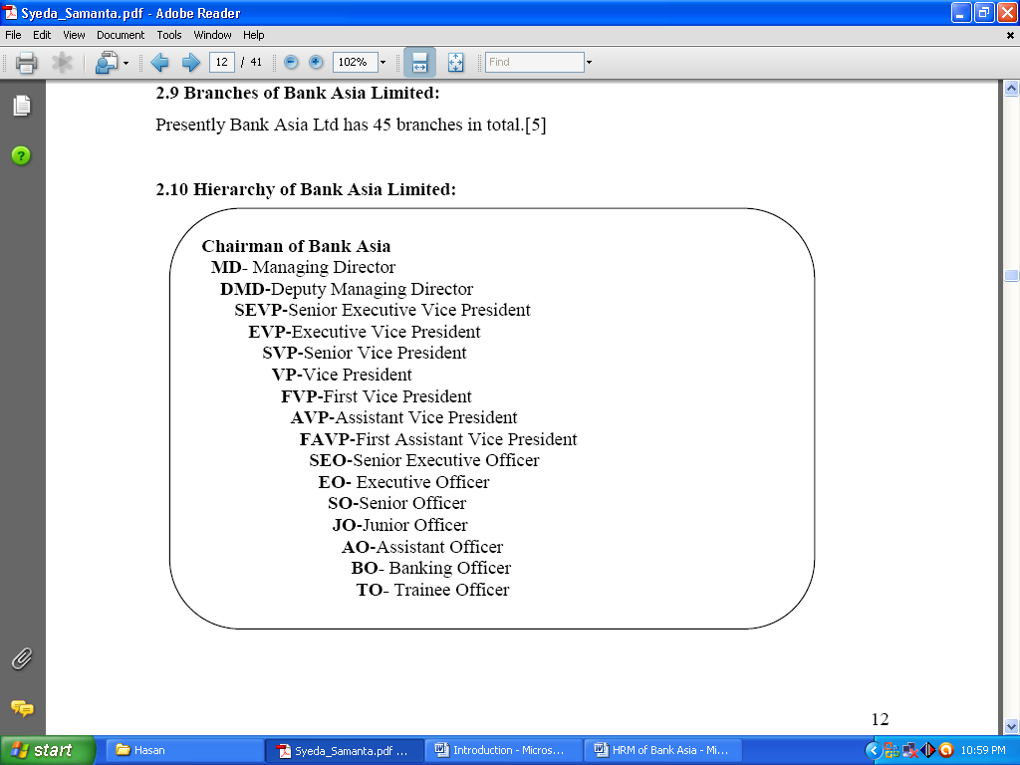
Figure: management team of The City Bank Ltd.

The Management team of THE CITY Bank Ltd includes the following positions and each position contains one member.
- Managing Director & CEO
- Deputy Managing Director
- Chief Information Officer
- Head of Credit
- Head of Regulatory & Internal Control
- Head of Probashi Banking
- Head of Human Resource Management
- Head of Treasury &Financial Institution
- Head of Marketing & Corporate Affairs
- Head of Corporate Banking
- Head of Impaired Asset Management
- Head of Enterprise Risk Management
- Chief Financial Officer
- Head of Technology
- Head of Retail Banking

Products & Services of The City Bank Ltd.
The City Bank Limited provides the following products and services to their customers-

- General Products
- Current Deposit
- Savings Deposit
- Short Term Deposit
- Fixed Deposit

- Consumer Banking Products
- City Bank DPS Plus
- City Bank Multi-Millionaire
- City Bank Money Maximized
- City Bank Earning Plus
- Online Service
- Credit Card
- Features of City Bank Credit Card
- Product type & Annual Fees
- ATM Services
- Foreign Currency Account
- SMS Banking
- SME Banking
- Mobile Banking & KIOSK (proposed)

The City Bank Ltd. provides its clients with three main kinds of services comprising various kinds of products, these services are:
Products & services

Corporate banking
Retail banking

SME Banking

Corporate loan products,
Trade finance,
Corporate cash management.
Loan products,
Cards,
Deposit products.
SME network coverage,
SME Products.

Figure: 2.4 Products & services of The City Bank Ltd.
- SME Banking:
The City Bank is the marketplace leader in providing loans to small and medium entrepreneurs. They are doing it for the previous5 years. SME Banking contains:
- SME Network Coverage
- SME products
II. Retail banking:
Retail banking contains car loan, deposit product, and card.
Loan Products: doctors’ loan, salary loan, secured loan, NOW loan, high Flyer loan, Top Up loan, car loan, teachers’ loan, study loan, travel loan, credit card loan etc.

Deposit products: set up a fixed deposit, fixed deposit, and interest first, salary account, current account, savings account.
Cards:
- American Express Card
- Nexus Pro
- City Credit Card
ATM/ Debit Card:
- ATM Debit Card
- ATM Locations
- POS Outlet
- Lost card/ card replacement
III. Corporate Banking:
- Corporate loan products:
- Trade Finance:
- Corporate cash management:
The advantage of employees/employer:
For the member of staff:
- 24/7 hours banking
- comprehensive banking hours
- Online banking
- Payday overdraft
- Salary loan

For employer:
- Salary upload
- Multi-location remuneration
- Affordability
- Secrecy
- Professionalism
Cash management services:
The City Bank's national Collection Services (NCS) is planned to assist corporate with countrywide collection requirements by providing quicker funds availability in a cost-effective manner.
- Cash collection services.
- Drop box facility

Chapter 3
Human Resource Management of City Bank Limited
Human Resource Management of The City Bank Limited

The City Bank Limited, from the beginning, has set equivalent importance on its four major elements of the procedure of HRM. All the different projects attempted by the City Bank to advance the nature of human asset are for the most part gone for expanding proficient information and aptitude levels of representatives through preparing and improvement, keeping in mind the end goal to shape an all-around prepared work drive for giving great administrations to the clients.

Moreover, the top executive of the Bank is frequently sent abroad for enabling them to know the functions and mechanisms of financial, money and security market of the developed countries and also to exploring business opportunities. A significant expansive quantities of officials and officers of the Bank have so far been prepared at Bangladesh Institute of Bank Management (BIBM), Bangladesh Bank Training Academy (BBTA) and so forth covering jumpers zones of the money related framework including business banking as precisely chose are to a great extent focused around center banking issues like credit management, global exchange, treasury management, review and assessment, advanced survey and observing and venture management.

Human Resource Management includes the following aspects:

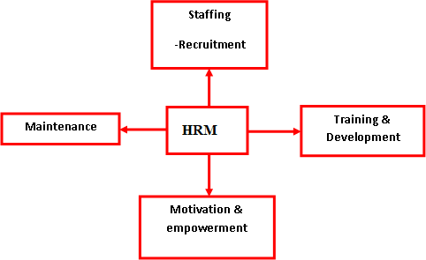

Figure: Aspects of HRM

All the steps showing below to demonstrate HRM practices of The City Bank Limited: -
- Recruitment& Selection Process
Recruitment is the procedure of finding the accurate people to the accurate job or function, generally undertaken via the HRD. For successful recruitment and selection, HR personnel of City Bank does job requirement analysis at first. In which post they need how many employee(s), what should be the qualification of that employee(s), in which time they need the employee(s), for rural branch or outside of Dhaka branches from where they need to enroll employee(s) and so forth. Without this prerequisite investigation, an organization can't remunerate viably and productively.

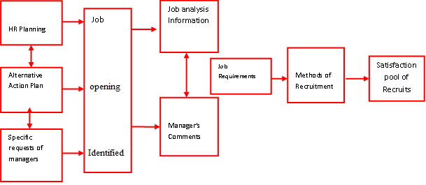

Figure: Recruitment Process

After Job examination, the Bank goes for recruitment notice. In day by day daily papers and online job sites, they, for the most part, post their commercials. Management Trainee recruitment process is not the same as other representatives. In the event of Management Trainee City Bank takes the composed examination. Other worker's recruitment processes are as per the following.

In the wake of advertising the daily paper, the Banking Officers and Trainee Officers of the Human Resource Department gather the CVs from the front counter. CVs are posted by hand or by post. HR worker primer screen the CV by coordinating the post they need for. With the direction of First Assistant Vice President (FAVP) of HRD Banking Officers and Trainee Officers begin to section the CVs in the software. The software likewise screens the by coordinating the criteria, since software is composed as the criteria set up. In the event that the criteria don't coordinate the software won't permit to section the CV.

After entering the CV in the software, they print out the CV statement in test format, six CVs are on one page. With the announcement, the Banking Officers go to the Head of the HRD. The Head of the HRD, Senior Executive Vice President (SEVP), Executive Vice President (EVP) complete a casual talk and screen the CV. Then these best level supervisors give a timetable for the meeting. To begin with, Assistant Vice President (FAVP) of HRD set the scene for meeting and calls the best level management to lead the meeting. Banking Officers call the possibility to go to the meeting.

The continuous process of recruitment and determination is demonstrated as follows: -
- Job Analysis
- Advertisement
- Written Examination (Management Trainee)
- Collecting CV
- Preliminary CV Screening by entering Software
- CV Screening by the Head of the HRD
- Preliminary Interview Selected Candidates
- Interview of Selected Candidates from Preliminary Interview
- Final Interview

If the preliminary interview is effective, the candidate will be welcome to another interview. Then the selected competitors need to confront the last interview. It isn't set that, there will be three interviews. It could be at least four, relies upon circumstance and post. All interviews are board interview and the survey of the interview could be immediate or non-coordinate.

After choosing from the recruitment process the bank offers the contender to join the bank. An example of Offer of Appointment Letter is joined in Appendix E. if applicant consent to join the bank then gives him/her appointment letter. In appointment letter the date of joining, which archive ought to be connected, compensation parameters are said. With the reference of arrangement letter inside the joining date, the applicant needs to come to the HRD.

The selection process typically contains eight (8) steps or stages:
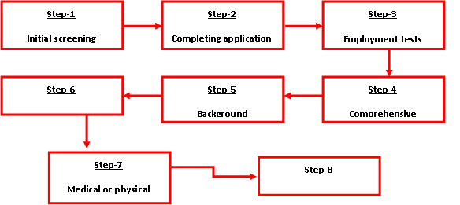

Figure: the Selection process

The Banking officer of the Human Resource Department (HRD) processes the joining. The hopeful need to top off a joining structure, in which there are close to home data, references, candidates name and level of the given intensity of provident store and so on. S/he needs to sign the Code of Conduct and present a joining letter and an affirmation letter. Banking Officer confirms his\her endorsements, and gather nationality and medicinal testaments. Regarding some representative like Management Trainee, they need to sign cling to join the administration. These all archives will encase in his/her own document. In the wake of gathering every one of the records Banking Officer makes the applicant's close to home document and go to the Head of the HRD and DMD to acknowledge his/her joining. In the wake of tolerating his/her joining, now the applicant turns into a worker and Human Resource Department (HRD) gives him/her a posting request. In that posting request, the branch and date of joining are said. With the reference of that presenting the representative have on the report the specified Branch Manager inside the said date.

- Testing Process
The City Bank Limited takes written exams usually to choose Management Trainees. The purpose of this test is to justify the candidate's cognitive, professional and basic knowledge. The candidate who passes in written examination gets a call for an interview. First Assistant Vice President (FAVP) of HRD set a place for the interview and calls the higher level executives to direct the interview. Banking Officers call the candidates to go to the interview. It isn't set that, there will be three interviews. It could be at least four, relies upon circumstance and post. All interviews are board interview and the poll of the interview could be immediate or non-coordinate.

- Training
Training is the procedures of educating the employee the aptitude for their better follow up on at work. Training is exceptionally useful for the employees for their better execution. There are numerous techniques for training, yet in the banks of Bangladesh, two strategies are usually utilized, address and at work training. Numerous organizations and banks like 'BIBM', 'IBA', and 'World Bank', Asian Development Bank, Bangladesh Bank, City Bank and so on orchestrate different sort of training. A Lot of banks of Bangladesh have their own particular training establishment and different banks employee can partake in that training. City Bank's employees additionally participate in some different banks training moreover.

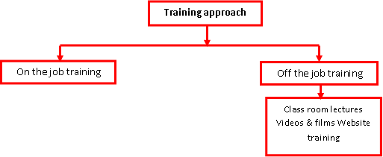

Figure: Training Process

The City Bank have no self training institute but this bank managed a lot of training in its corporate office. Various training in particular for the particular department like Attention to counterfeit cash, illegal tax avoidance, Q-money check card are obligatory for money department workers. Other pieces of training resemble Client Credit Plan and Rent Fund Plan, Credit Risk Reviewing, Credit risk Management, Loan Order, and Provisioning, Loan Documentation, Exercises Learnt from Credit Highlight, Organized back for Vast Activities in Bangladesh, Conversion standard Management and so on. The employee can't take part in any in-house training from their own advantage, the Human Resource Department will choose the employee to take part in the training. Human Resource Department sends office notice to those employees to go to the training. In the wake of going to their training, the employee needs to present a write about that training to the Human Resource Department. Now and then Human Resource Department sends the employee to go to the training outside of Bangladesh.

- Performance Appraisal
In City Bank Limited Performance Appraisal is preparedby ACR (Annual Confidential Report. ACR is the evaluation report on the work performance and personal skills. In an ACR report there will be the essential data like worker's faculty data, time of assessment begin to end, comments (assuming any), rater name and so on. This assessment in light of five-liar scale (Underneath normal 1, normal 2, good 3, good 4 and exceptional 5). City Bank assesses two components, one is close to home characteristics and other is execution factors.
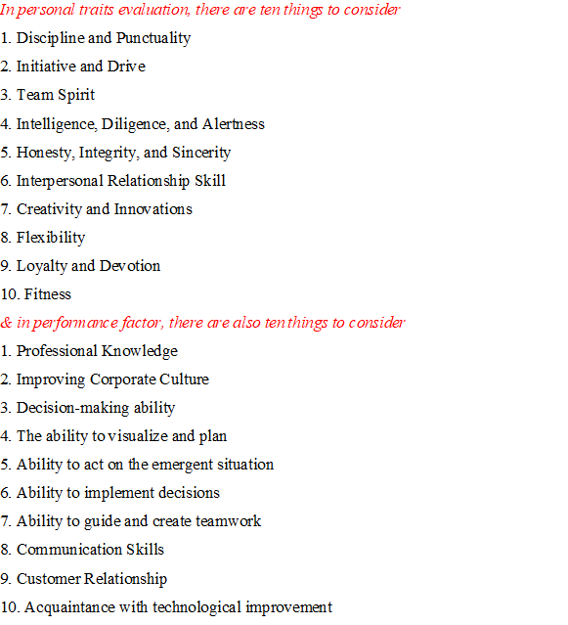

An employee has not any correct access to his/her ACR, but rather s/he will be educated; with the goal that s/he jars remedy/enhance/amend himself/herself from his/her shortcomings if s/he has any. Subsequent to completing the Yearly Secret Report (ACR) in paper HR department enter those reports in the database.

Development:
Employee development, by configuration, is more future situated and more worried about instruction than employee job particular training. As indicated by Griffen, "development alludes to showing managers and experts the ability required for both present and future jobs."

Employee developments techniques are:

- Job rotation
- Assistant- to positions
- Committee assignment
- Lecture courses & seminars

Importance of Training & Development:

Training | Development
- Development of skill  - Development of attitude  - Improved performance  - Reduce wastage & accident  - Employee job satisfaction | - Competitive advantages  - Decision making  - Innovation & improvement in management  - Organizational effectiveness.

Training and Development program of The City Bank Limited:
HRD is a fundamental pre-imperative to accomplishing authoritative objectives. Nonstop training of the employees and administrators is gone for limit and expert aptitude working consistently. The City Bank Limited has a built-up resourceful training organization. Encountered broker's effort as employees under the immediate direction of an executive.

Training is a learning knowledge in that it looks for a moderately perpetual change in a person that will enhance his/her capacity to perform at work. We regularly say training can include the changing of expertise, learning, mentalities or social behavior. It is the application of knowledge.

Development is a related methodology. It covers those activities which improve work execution and in addition those which bring development of the personality; push individuals to the progress toward development and acknowledgment of their potential cutoff points with the objective that they end up extraordinary employees and additionally better individuals. The most conspicuous training methods used by The City Bank Restricted can be named either at work or off the activity training.

On - the - Job Training:
On - the - job training places the employees in a genuine work situation and influences them to have all the earmarks of being quickly beneficial. It is learning by doing. The most generally utilized strategies for training happen on the job. This can be ascribed to the effortlessness of such techniques and the impressions that attempt are less expensive to work.

One of the downsides to on-the-job training can be low efficiency while the employees put up their capabilities.

Off-the-Job - Training:
Off - the - job training spread different systems classroom addresses, films exhibits, relevant examinations and other reenactment works out, and adjusted direction. The office's prerequisites for each one of these strategies change for a little stopgap classroom to a mind boggling development center with enormous address passageways, supplemented by little gathering rooms with current shifting media adapt, two various mirrors, and each one of the decorations.

The City Bank Ltd. Training Institute offers these courses:
Executive Courses:
- Risk-Based Capital Adequacy under Basel –II
- Executive Development Course
General Courses:
- Foundation Course for Executive officers
- Foundation Course for Assistant Executive officers
- Foundation Course for Assistant Executive officers-Teller
- Industrial Credit & Project Financing Course
- International Trade Finance & Foreign Exchange
- English Language Course (Evening)

Computer Course :
- Basic Computer Training
- Hardware Maintenance, Trouble Shooting &Networking (For Officer)
- User Training on New Salary Software
- Computer Course for Executives (Outside Dhaka)
- Computer Course for Executives (Dhaka-Evening)
- Banking Application Software, LAN and Software Maintenance
- Networking & System Administrating with MS Windows 2000 Server
Short Courses:
- Managing Core Risks in Banking

The Course Contents of the Executive course:
I. Executive Courses:
- Title of the course: Risk-Based Capital Adequacy Under Basel- Ii
- Duration: 2 (Two) Working Days
- Frequency & Date: 2 (Two)
- Level of Participants: Executives from Corporate Branches/RO/AO/DO/HO
- Number of participants: 25 (Twenty-five) Participants
- Methodology: Lecture, Discussion, Exercise & Case Study
- Coordination & Resource Person: JBTI Faculty, Resource Speakers from Bangladesh Bank, BIBM & Credit Rating Agency
- Course-Direction: Director & DGM and Assistant General Manager
- Risks: Definition, Types & Risk Management
- Introduction to Basel I, 1988 Capital Adequacy Accord and Capital Banking Company
- Implementation of Basel I Capital Adequacy Accord in Bangladesh:
- Basel II – Introduction, Objectives, and Scope of the New Capital Accord and three Pillars.
- First Pillar: Calculation of Minimum Capital Requirements- three Approaches.
- Determination of Capital Requirements under Standardized Approach.
- Determination of Capital Requirements under the Internal Rating Based Approach
- Operational Risks and Trading Bank Issues
- Second Pillar- Supervisions Review Process: Four Key Principles

II General Courses content:
- Title of the course: foundation course for executive officers
- Duration: 20 (Twenty) Working Days
- Level of Participants: Executive Officers (SO) joined in 2008 & 2009
- Number of participants: 25 (Twenty-five) Participants
- Methodology: Lecture, Discussion, Case Study, Test, Evaluation, Field Visit.
- Coordination & Resource Person: JBTI Faculty, Guest Speakers from H.O., BIBM, Bangladesh Bank & Other Banks.
- Course-Direction: Director & DGM and Assistant General Manager, JBTI.

Remuneration Strategy
The size of salaries and other remittances of employees and representatives are recommended by the Skilled Expert every now and then. The underlying pays of a worker selected or elevated to the superior position are customarily settled at the underlying phase of the size of salaries of the position to that they advanced or delegated.

Vice President as well as Overseeing Chief to Bank officials, the pay separates are Fundamental pay, House Lease Roof, Movement Remittance, Medicinal Stipend and Amusement Recompense. Here House Lease Roof is 54%, Transport Stipend is 26%

Remittance is ten percent and Excitement expense is ten percent of essential compensation. Bank employees are got United Compensation just, in light of the fact that all of them are on arrangement phase. Top level Officers from President as well as Overseeing Chief to 1st Colleague VP (FAVP) get additional charges like House Support, Auto Upkeep. Agent Overseeing Chief (DMD) and Senior Official VP (SEVP) get Electricity, Gas, Phone as well as Household holds expenses too.

President and Overseeing Chief to Official VP (EVP) get an immediate auto-car from the bank. From Senior VP (SVP) to First Aide VP (FAVP) get Auto Loan for office. What's more, President and Overseeing Executive to First Right-hand VP (FAVP) got House Loan moreover.

Free Group Insurance Services will get the whole bank’s employee. This protection essentially medical coverage and will get offices on just hospitalization. In this protection officers and administrators will get the advantage of one mate and two kids.

Sorts of Terminal Advantages
The accompanying sorts of terminal advantages are passable to a general and full-time employee of the bank.
- Gratuity
- Contributory Provident Fund
- Benevolent Fund

Festival Bonus
A standard employee will get the bill as Celebration Rewards payable on the occasion of Eidul-Azha and Eid-ul-Fitr. The reward entirety will be the half of his/her compensation.

Execution Reward
In case the bank makes an advantage, the employees will be met all requirements for 3% of pre-survey advantage as execution reward. 50% of such reward dispersed based on fundamental pay of an employee, and adjust 50% based on execution of individual employees. Performance examination for the reason made on the paradigm set by the management every now and then.

Cash award
The Competent Authority May stupendous cash reward to any of its employee for execution of a work which is intermittent in character and imaginative or innovative work situated justifying uncommon legitimacy as to legitimize the installment of the same.

Rewards for Passing Banking Diploma Examination
The employee of the bank who will pass Banking Diploma Part-I Examination in the main Possibility will get money reward of TK.25, 000 and the individuals who will pass Banking Recognition Part-II Examination in the primary shot will get money reward of TK.50, 000. The individuals who will pass Banking Certificate Part-I Examination in the principal chance anchoring most astounding imprint will get an extra money reward of TK.25, 000 and the individuals who will pass Banking Recognition Part-II Examination in the main shot anchoring most noteworthy check will get an extra money reward of TK.50, 000. The money rewards for Banking Recognition Part-I and Part-II Examination in one in excess of one set will be TK. 10,000 and TK. 20,000 separately.

Annual Increment
If the employee's administrative records and annual confidential Report (ACR) are pleasing, at that point the Skillful Specialist embraces the expansion on the compensation. The level of pay expansion isn't settled; it varies on Skilled Specialist decision. If the administrative records and annual confidential Report (ACR) are not classy of an employee then the Capable Expert put him/her on excellent report for a period not outperforming a half year interminable supply of such report may approve the growth either from display or from speedy effect or may surrender it for the whole year.
If an employee saw of his/her phenomenal and praiseworthy execution, at that point the Load up may give him/her another excellent expansion in multi-year time period.

Travel allowance and Daily Allowance
At the point when the bank sends any employee for preparing and call any employee for the interview then the bank will give him/her movement remittance and day by day recompense. For this situation, the employee needs to guarantee his/her recompense with transport/prepare/plane tickets. Human Resource Department will confirm the claim and pay the employee.

Administration of the city bank ltd
The Administration is the wing that preserves and controls the employees of The City Bank Limited. The administration has to perform the following duties.
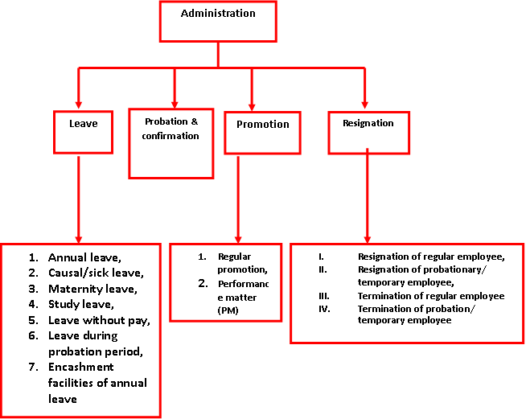
Figure: Administration wings of the city Bank Ltd.

Leave Policy
Following kinds of leave allowable to employees of the bank

Earn Leave
On finish of time of 1 year of ceaseless administration in the Bank, all employees get earned leave on full pay. The most extreme measures of such leave that might be aggregate four months.

Annual Leave
All officers will become eligible for an annual leave of 24 working days after completion of the one-calendar-year. Of these 24 days, 15 days must be taken as consecutive leave each year. Any pending leave may be carried forward to the next year.

Disability Leave
Disability leave might be conceded by the Load up to an employee who is handicapped by damage incurred or caused in a mishap.

Maternity Leave
Maternity leave might be conceded by the equipped specialist to an employee for a greatest three months term at once.

Casual Leave
Casual leave implies a leave of nonattendance for a brief time of days, conceded to an employee who might be not able to go to obligation because of sudden sickness or pressing private/family issues.

On finish of time of three long periods of persistent administration employee may get casual leave with no compensation as well as stipends, for a period not surpassing 2 years might be conceded by the Load up to an employee to empower themselves to contemplate thought about helpful for his/her administrations under the Bank.

Probation and Confirmation
The terms of probation are as per the following:

- A person selected for the appointment with under 3years job experience will be on probation time or multi-year.

- An employee with a job experience of 3 years or more will be on probation for 6 months.

In case of the probationer's inability to demonstrate agreeable advance and gain required proficiency amid employee's probationary period, the designating expert may, at its discretion, expand his probationary period by a greatest of additional 6 (six) months, or get rid of his administration by giving one month see or by paying a total equivalent to one month's compensation without doling out any reason. An officer will end up qualified for confirmation in the predefined present subject on employee's fruitful completion of the time of probation.

Promotion
Promotion is a continuous procedure by which the employee propels for player work; get the cost for employee's better work. In The City Bank, there are two kinds of promotions-

Regular Promotion: Regular promotion is offered by the employee's regular performance. At the point when the administrator or division leader of the employee assess that his employee is turned into a benefit for the bank and merit promotion then the chief or the office head take a promotion appraisal form from HRD and suggested the employee for promotion.

PM Promotion: Performance Matter (PM) is the annual performance report of an individual employee of The City Bank Constrained. As per Performance Matter positioning scale, the employee can land promotion in the position review of their own.

Chapter 4
Findings of the study
Findings of the study:

- The Manager of HRD is not proficient enough to apply the various HRM Activities such as the job investigation, human resource scheduling, Recruitment, and Selection policy of The City Bank Limited.

- The City bank Ltd show they follow performance appraisal, but in realities they don’t. There is occurring some discrimination, nepotism is exercised. As a result, employees with the same effect are given different score by a different author.

- The salary packages of the City Bank is not attractive in comparing to most other Bank in Bangladesh.

- Employees training program is not given regularly basis.

- Though the bank don’t facing employee lacking , I think there is lacking of well trained employees- that means "lack of right people in right place".

- Succession Planning includes having senior executives intermittently audit their best executives and those in the following lower level to decide a few reinforcements for every senior position. This is critical in light of the fact that it frequently takes long times for preparing to create compelling senior managers. But, the bank has not concentrate yet such a succession planning.

- Only the head office contains HR division and all the HR exercises are controlled from the head office. Thus, when once in a while any HR issues raised representatives need to sit tight for quite a while to explain it. In addition, this office isn't excessively organized.

- Employees reported that superfluous workload on a daily working hour is a common problems of the bank. For this causes, the City bank sometimes loss employees attractiveness.

- Training assessments are not correctly used or monitored.

Chapter 4
Recommendation and Conclusion
Recommendations

As a rising pattern, HRM in the bank division has done entirely well. To help up, later on, we could take after cases of western banks and other organizations. In enrolling in an organization choosing by various criteria ought to be rehearsed. Human resources are the most vital and complex resource of an organization. So actualizing any arrangement that influences employee ought to be reexamined and examined before execution. These days HRM turned into a critical department which contributes a great deal to make the system in an organization. A good HRM department could be the greatest center capability for an organization if employees are dealt with legitimately. The main recommendations are shown below:

- City Bank should change their existing PE process cause in modern times it’s not enough to judge employee performance like this.

- Compensation and benefit package must match with industry standard.

- Recruitment and selection system needs to be updated.

- There is no proper HR planning system followed by the bank which needs to be introduced.

- Finally, HR benchmarking system with similar industry must be introduced.

Conclusion

Banks are among the most vital money related establishments in the economy. They are the vital wellspring of loan capable assets for many people, firms and families and furthermore for some units of government segment. So as to monetary part banking assumes a critical part in the fast development of any country. Banks in this way assume a functioning part in the financial improvement of any nation. Not at all like other organization banks utilize most Human resources and a good employee can be an essential resource for an organization. In this way, making HR procedure and execution of The city bank ltd require serious supervision. In spite of the fact that numerous organizations are following HR patterns, still, the HRM rehearse in Bangladesh did not flourish as it ought to be. It is an expectation that the organization will be more mindful and intrigued by legitimate HRM practices.

Reference

Books:
- Alan Price, Human resource Management , Cengage Learning, 2011
- Mathis L Robert L. , John H. Jackson, Sean R. Valentine, Patricia Meglich Cengage Learning, Jan 22, 2016 - Business & Economics
Websites:

- https://www.thecitybank.com/annual_reports.php (Accessed at July 1,2018)
- https://www.thecitybank.com/career/ (Accessed at July 9,2018)
- https://www.thecitybank.com/financial_performance.php (Accessed at July 9,2018)
- https://bdresults24.com › Latest Job Circular in Bangladesh (Accessed at July 4,2018)
- www.academia.edu/.../Employee_Job_Satisfaction_of_The_City_Bank_Limited (Accessed at July 1,2018)

