

United international University

Internship Report
on
Impact of Recruitment and Selection in the Achievement of Organizational and Societal Goal in icddr,b.

Submitted to:

Ishrat Sultana
Assistant Professor
School of Business and Economics.
United international University

Submitted by:

Sarzin Sultana
ID: 111 142 252
BBA Program
United international University

Date of Submission: 14th September, 2019.

Letter of Transmittal
Date:
Ishrat Sultana
Assistant Professor
School of Business and Economics.
United International University
United City, Madani Avenue, Badda, Dhaka 1212, Bangladesh.

Subject: Submission of Internship Report.

Dear Ma’am,
It is an honor and pleasure for me to present you the internship report on “Impact of Recruitment and Selection Process in the Achievement of Organizational and Societal goal in icddr,b. ” as a prerequisite for the competition of the BBA program. The report has been made during my internship period at icddr,b on the basis of my practical knowledge and the information collected from my supervisor, colleagues, staffs, Websites, articles and newspaper.
This report aims to demonstrate how the Recruitment and selection process conducted by the Human Resource Department of icddr,b has an impact in the organization and on the society. It was a great pleasure as well as a challenge to work in such an international health research organization and prepare this report which has helped me significantly to enhance my knowledge and skills.
I, therefore, express my profound gratitude to you for the kind cooperation, supervision and guidance in successfully preparing this report. I hope you will consider this report and oblige me thereby. I shall be happy to provide any clarification on any relevant matter.

Sincerely yours,

------------------
Sarzin Sultana
ID: 111 142 252
BBA Department.
School of Business and Economics.
United International University.

Acknowledgement
The internship opportunity I had at icddr,b was a great chance of learning and professional development. Therefore I consider myself a very lucky individual as I was provided with an opportunity to do my internship in such organization. I got the chance to meet so many wonderful people and professionals who guided me through the internship period.

I express my deepest thanks to Ms. Ishrat Sultana, Assistant Professor, School of Business and Economics, United International University for taking part in useful decision & giving necessary advices and guidance and arranged all facilities to make life easier. I choose this moment to acknowledge his/her contribution gratefully.

It is my radiant sentiment to place on record my best regards, deepest sense of gratitude to Mr. Hasanul Islam, Senior manager, Talent and acquisition, Human Resources, icddr,b. I am highly indebted for his guidance and constant supervision as well as for providing necessary information regarding the project & also for their support in completing the project.

Bearing in mind previous I am using this opportunity to express my deepest gratitude and special thanks Mr. Musharrof Hosain, the Head of Human Resource, icddr,b who in spite of being extraordinarily busy with his duties, took time out to hear, guide and keep me on the correct path and allowing me to carry out my project at their esteemed organization and extending during the training.

Thanks to Mr. Mohammad Mazharul Islam, Manager, Human Resources, icddr,b for his careful and precious guidance which were extremely valuable for my study both theoretically and practically.

I perceive as this opportunity as a big milestone in my career development. I will strive to use gained skills and knowledge in the best possible way, and I will continue to work on their improvement, in order to attain desired career objectives. Hope to continue cooperation with all of you in the future.

Table of Contents
Origin of the report: 2
Objective of the Report 2
Scope of the Report 3
Methodology 3
Limitations 3
Literature Review: 6
Overview of the Organization 15
History of icddr,b: 15
Vision, mission and values 16
Approach: 17
Products and services: 17
Organization Structure: 19
Management Team and Board of Trustees: 20
Donor Organizations: 20
Major Achievements 21
HR department Organizational Structure: 23
Units of HR Department: 24
Talent Acquisition Unit: 24
Talent Development Unit: 25
Talent Reward and Recognition Unit: 25
Gender and Diversity Unit: 25
International Staff Management Unit: 25
Recruitment and Selection Process in icddr,b 27
Recruitment Process (National) 28
Organizational Strategic Plan: 33
Indicators for HR Departments Successful Recruitment and Selection in Terms of Organizational Goals: 36
Indicators for HR Departments Successful Recruitment and Selection in Terms of Societal Goals: 38
Achievements of the Human Resource Department in Terms of Recruitment and Selection, icddr,b: 40
Impacts of Recruitment and Selection on Achieving the Organizational Goal: 41
Impacts of Recruitment and Selection on Achieving the Societal Goal: 43
Some Other Findings: 45
Conclusion: 47
Recommendations: 48
Reference: 49

Introduction

Origin of the report:

Internship program is the prerequisite of completing the curriculum of Bachelor of Business Administration in United International University. Every student of BBA program must go through this program. The main reason of this program is to provide a practical knowledge for the undergrad students.
The report is a outcome of my internship as a requirement of the internship program, titled “Impact of Recruitment and Selection Process in the Achievement of Organizational and Societal goal in icddr,b”. The topic was chosen by me with the Supervision of Ms. Ishrat Sultana, Assistant Professor, School of Business and Economics, United International University. The Report includes Organization profile, Overview of the Recruitment and Selection process, analysis of the impact of the process, Major findings, Recommendation and Conclusion.

Objective of the Report

There are two kinds of objectives in this report; one is the Broad Objective another is Specific Objective.

Broad Objective: The broad objective of the report is to get the experience of the actual recruitment and selection process of the organization and learning through the regular activities of the office.

Specific Objective:
- To gather knowledge of recruitment and selection process and its impact on the organization and the society.
- To create analysis of Human Resource Department of icddr,b.
- To complete the requirement of submitting internship report.

Scope of the Report

The report has been prepared through extensive discussion with the HR department of icddr,b employees, management and supervisor. While preparing this report I had the honor to get some in depth knowledge about the recruitment and selection process of icddr,b and its impact on the whole organization and the society.

Methodology

Two methods were followed to gather the data:
Primary Sources:
- Practical Deskwork at the office
- Practical Observations
- Regular HR Activities
- Interviewing the Supervisor
- Interviewing the managers
Secondary Sources:
- Annual Reports
- icddr,b Website
- News paper
- Manuals, Journal, Articles, Books.

Limitations

There were some limitations of the report. Those are described below:

Confidentiality of the data: The availability of the information were also difficult because of the confidentiality.
Time Limitation: 3 month is not enough time to know about the recruitment and selection process and its impact on the organizational and societal goals.
Lack of Experience: This was my first time of doing an internship and writing a report on it so the lack of experience in this particular area took more time than it should be.

Literature Review:

Literature Review:

Internship program is a mandatory for the Bachelor of Business Administration- BBA students of United International University. The target is to make the students familiar with the corporate culture. As a BBA student I had the opportunity to conduct my internship in the Human Resource Department Talent Acquisition Unit of International Center for Diarrhoeal Disease Research, Bangladesh – icddr,b.
My topic for the internship report is “Impact of Recruitment and Selection in the Achievement of organizational and Societal goal in icddr,b.” Recruitment and selection has an impact on the achievement of both organizational and societal goals. The connection between them is very relevant. The impacts are direct and indirect both.
International Center for Diarrhoeal Disease Research, Bangladesh – icddr,b is a international health research institute based in Mahakhali, Dhaka. The organization is dedicated to serve people through their research and hospital services. With the help of the donors the organization has been able to do its research. The donors are mainly from foreign country. There is a board of trustee who regulates the activities of icddr,b.
Human Resource Department is a very crucial supporting departments of icddr,b. The department has five units to operate the activities; the units are Talent Acquisition, Talent Development, Talent Reward and Recognition, Gender and diversity, International Staff Management.
The Talent acquisition unit is responsible for the recruitment and selection of the employees.
The process of is receiving requisition, Prepare role certification document, post classification and establishment, preparing and publishing the ad, sorting out the CV, issuing the selection test notice, communication with the candidates, taking the test and evaluation, issuing interview notice, selecting and informing panel member, interview, preparing matrix and minutes, checking reference, informing the selected candidates, necessary documents verification, then providing the offer, contract and the joining letter.
From my internship I have learned various aspects of recruitment and selection in icddr,b and the impacts of the process has on the organization and the society.

Muhammad Anosh et.al on their article “Impact of Recruitment and selection of HR Department Practices” recruitment and selection is the basic role in HRM that people do regularly as a practices. This article help to try to find out what happened or is the truth in the recruitment and selection process that people do it regularly honest with their particular area of labor or activity that during which the aim is to create a profit with completely different levels which are presence on the structure task with different organizations. Through form we have a tendency to analyze the data through the SPSS that offer the results of this analysis. In organization development it,s most significant to better HRM performance.
In this different literature are selected that is improve and consider the important or significance areas. Fajana (2002) HR plan that need fixed plan and great changes to check the human resource wants, demands that develop the number of people of who are employed by a particular company procedures that effect the organization in long-term. British psychological Society (2007) they measure the ability of test with different reason that is mechanical (naturally good at understanding) verbal (something is connected with words) numerical (expressed in the numbers) spatial (to describe the things that is related to that areas). Ulrich and Brockbank (2005) a plan or an idea you suggest it for people to think about and to decide the decision about what is going to be done in the future hour HR organization that alter to line managers.
- Concept of Recruitment and Selection:
To hire and select the employee that is most important for the Human Resource Management and effect the success of the organization. The organization that are with success relay upon the plan how to do one thing before you begin to try to do it. This organization selects the most qualified person with their own interest that is short and long term. Person or employee selected at the right place and also at the right time.
- Recruitment and Selection Process and Development of the Organization:
Recruitment and selection are central part of HRM such as a skill or a particular type of knowledge is the process of learning or develop it, gradually growth and also the work benefit that benefit as a result of doing that issue. That is a basic role to ensure the performance of the workers who are employed in industry or business and that are not the managers. Selection of the employee person they no do replace to one thing or person with another to leave it and start a journey to another place of employees but aim is to induce or select the staff that perform the work with success.
- Process of Recruitment:
In any vacancy the organization take the decision to fill the vacancy with the process of recruitment than it involves the activity or task that organization job analysis that conduct the process of human resource planning. If organization has the job explanation or description that result from considering something carefully organization structure fit that job than they want to process of hiring to select the candidate which is suitable for that job.
- Selection Design:
When the candidate standard of their ability is shown the hiring process the decision to select the candidate is always difficult. Some of the faults are affected that a person who is responsible for whole of a business or organization they think the extremely most important character to choose what should be done. When in the selection person is not choosing than the employers are unexpected. The basic origin of weakness is that the call of human manufacturers.
- Recruitment Sources:
The researcher use the different ways through which they select that include the telephone, direct mail and also the advertising. Advertising is that the activity of making advertisements and ensuring people see them. One of the advantages of advertising and recruitment is the low money and easily convince to do something they persuade you to do it. But on other hand the sampling way is the non-random and motivate to do something that’s why all of the young generation people considered this way. Mail and recruitment is also the low money and persuade to do something but the young people are feel difficulty to arrive this email.
- Internal Recruitment:
That depends upon internally which check the person for job within the organization. External Recruitment: That depends upon externally which check the person for job outside the organization.
- Challenges of Recruitment and Selection:
The basic purpose of this study is that the planning of human resource they select the person with the right training and knowledge, experience with that particular job. In this department the human resource managers have basic effect on hiring and selecting and HR person who is very skilled at doing something or who knows a lot about a particular subject they not only shorten the position which has not filled but they also improve the skills of the applicants. Recruitment and selection is finished whenever there’s presence of most effective HR team.
- Recruitment and Selection Practices and Performance:
To hire the employee is the basic role in the human resource management that effect the company or organization performance. But on the other hand we tend to settle for that the choice to employee performance is poor than that poor performance cause the organizational performance. It is believable that efficiency and effectiveness is important to hire and selection procedures.
- Human Resource Development:
When the organization hire and motivate the person to do something that person give their response and accept the difficulties which requires great effort and determination than the organization are succeeded for a long time in the future. Every employee that do their work they have the ability to compete with each other and show the different ways of market change with the help of consumer, customer and the supplier needs, wants and demands that have the capacity to join things together and effect the long time and best relationship in which two or more people of organization work together as a partners.
- Recruitment and Attraction:
Recruitment and attraction represent important stages within the determination of which employees will be able to benefit from integrated HRM of policies. There is the need to attract people and this implies that people have a choice about which organizations they wish to work for the contribution that people will make to an organization is not totally predictable.

Academic knowledge about recruitment and selection:

Recruitment:
Recruitment is the process of finding and attracting candidates for employment. Dale Yoder (1986) defines recruitment as a process of searching for prospective staff and stimulating and inspiring them to apply for jobs in a company. Flippo (1990) views recruitment is positive activity. He says, it positive because it stimulates people to apply for jobs to increase the hiring ratio. The process begins once new recruits are sought and ends when their applications are submitted. The result is pool of qualified candidates from that new employees are selected. The purpose of recruitment is to find sources of manpower to fulfill job requirements and job specifications. Recruitment is two way street. Both recruiter and the recruiter have a right to choose each other.
Recruitment Functions-
- Assessing recruitment – HR department identifies vacant positions
  - Internal employee
  - External source
- Fixing standards-
- Educational knowledge, technical and behavioral skills
- Relevant experience
- Advertising and publicity-
- Newspaper
- Social media
- Online media
- Television
- Making initial contact with prospective candidates-
- A visit to the personnel office
- A written request for an application
- Preliminary perusal and assessment of applicant-
- Written examination
- Short listing of probable candidates for selection-
- Scoring in the written exam
- Grade in the previous educational institutions
- Selecting process-
- Viva
- Presentation
- Recording and documentation-
- References check
- Medical evaluation
- Information, certificates of the selecting candidate.
- Offer
- Negotiation
Sources of recruitment-
- Internal Recruitment: Internal sources indicate recruiting qualified people from within the organization itself (from the present working force). When reference is made to the number of employees already employed by the organization we have a tendency to speak of the internal supply. Whenever any vacancy happens, someone from within the organization is upgraded, promoted or transferred to another department.
- External Recruitment: Recruitment from outside the organization is known as external source. All organizations more or less rely on external sources.

Methods of Recruitment-

- Walk-ins and write-ins- Walk-ins are job seekers who arrive at the personnel department in search of a job. Write-ins are those who send a written inquiry.
- Employee referrals- Refer job seekers to the personnel department.
- Advertising- Most used method as it reach a wider audience.
- Educational Institutions- Schools or vocational training institutes are common source of recruits of many organizations.
- Professional associations- Associates conduct placement activity to help new and experienced professionals get jobs, especially at job fairs.
- Labor unions- Labor unions are a source of certain types of workers. Recruiters want people with trade skills can contact with local labor organizations which maintain rosters of members who are looking for employment.
- Internet recruiting- Some employers are conducting employment interviews on-line for reaching more applicant, having lower costs and faster response time frame.
Selection :
Selection means choosing from those applicants who are most likely to succeed in the new job. The selection process is a series of steps accustomed to decide which recruits should be hired. Dale Yoder (1972) defines selection as a process by which candidates are divided into class- those who will be offered employment and people who will not. The process beings when recruits apply for employment and ends with the hiring decision.

Selection Process:

These steps are briefly discussed in subsequent paragraphs.
- Preliminary Reception of Applicant: The selection process id a two way street. The organization selects employees and the applicants select employers. Selection starts with a visit to the personnel office or with a written request for an application.
- Screening: This step may involve two activities : screening applications and screening interviews. Screening applications is the verification of applications against the planed needss of job given in job description and job specification. Based on such comparison, many applicants can be screened out for their inability to meet the criteria specified in job specification. Screening interviews is conducted during which the candidate is asked to present himself for clarifying certain points, which are not explicit from him application.
- Job Application Blank: The job application blank collects information about recruits in a uniform manner. The application blank typically contains such information as :
- Personal data (name, address, phone number, place of birth, sex, race, religion, national origin, health, height, weight).
- Employment status (type of employment sought, position sought, data available for work, salary desired).
- Education qualification and training.
- Work history or past experience, ability, skill and personality attributes.
- Expectation of salary.
- Memberships.
- Awards and hobbies.
- References.
- Signature line.

- Employment Tests: These tests are devices that assess the probable match between applicants and job requirements. These tests are conducted in order to improve the selection decisions. Tests are screening device, some are paper and pencil tests, others are exercises that stimulate work conditions.
- Selection Interview: There are different interview formats. Following are the types :
- Structured (questions are predetermined and sequenced).
- Unstructured (non-planned and non-formatted).
- Mixed (a combination of structured and unstructured)
- Problem solving or stress producing.
- Reference and Background Check: Reference checking involves obtaining information about applicants from pervious employers. Reference checks can supply important information about personality and character and may ever provide some legal protection.
- Medical Evaluation: The selection process may include a medical evaluation of the applicant before the hiring decision is made. The criteria for medical examination vary with the nature of job and type of organization. Normally the evaluation is a health checklist that asks the applicant to indicate the health and accident information.
- Hiring Decision: The final hiring decision marks the end of the selection process, assuming that the candidate accepts the job offer. Candidate who has successfully completed the various hurdles of selection process id offered the job. Employment is complete when the successful candidate accepts the offer and joins the firm.

Difference between recruitment and selection
Recruitment is the search the candidate and motivates to do something to get job in the company. On the other hand selection is defined choose the person which are most applicable out of others which are job interested and qualified.

Importance of recruitment and selection
Recruitment that increases the candidate job that is possible allowed and required amount of money. They tell as the time that we are in now and the things that are happening now also the period of time that will come after the present or the things that will happen then these define the job description and specification, deciding terms and conditions of employment in the organization. With the process of deciding in detail how to do something before you actually start to do it and consider something carefully and using statistical methods in order to understand and explain the job activities.

Company Profile:

Overview of the Organization

Icddr,b is one of the world’s leading health institute based in Dhaka, Bangladesh. The institute is committed to solving public health problems facing low and middle income countries through innovative scientific research including labrotary based, clinical, epidemiological, and health system research. By Developing, testing, assessing the implementation of interventions specifically designed for resource poor settings, icddr,b aims to improve the health and wellbeing of people living in world’s poorest nations. For more than fifty years they have been caring out high quality research and promoting the uptake of evidence based interventions. Their initial focus was on diarrhoeal diseases, now they study multiple infectious diseases, other threats to public health, and methods of healthcare delivery. Their work has had been a profound impact on health policy and practice both locally and globally and this remains their key objective for future.

History of icddr,b:

The institute was established in Dhaka in 1960s as South East Asia Treaty Organization (SEATO) Cholera Research Laboratory (CRL).
The CRL- Cholera Research Laboratory soon developed an international reputation in diarrhoeal disease research. Among their notable early achievements was the key role in the development, testing and implementation of Oral Rehydration Solution- ORS, a treatment estimated to saved 10 million of lives worldwide.
In 1960 CRL established a large scale health and demographic surveillance site at Matlab. Now it is the longest running site in the global south and inspiration for many similar sites worldwide.
During 1962, CRL established the Dhaka Hospital. Which is still run by icddr,b, to meet the urgent need to treat patients, particularly young children, with severe diarrhoeal diseases. The Dhaka hospital is now a nationally important treatment center and provides an infrastructure for an extensive program of clinical research. Matlab hospital was also introduced by the clinical services.
From CRL to icddr,b:
In 1978, the CRL got a new name icddr,b- International Center for Diarrhoeal Disease Research, Bangladesh. In recent years they have been known simply as icddr,b.
Their research continued to expand, to address the major public health threats facing Bangladesh and other countries of the global south. The institute is recognized as national asset and has contributed to the significant improvements in health achieved by Bangladesh in past decades.

Vision, mission and values:

Vision:

A world in which more people survive and enjoy healthy lives

Mission:

To solve public health problems through innovative scientific research

Values:

- Excellence:
We are single-minded in our pursuit of scientific rigour and operational efficiency

- Integrity:
We are a responsible and accountable organisation, committed to the highest standards of behaviour

- Inclusivity:
We collaborate effectively throughout the organisation and with our partners

Approach:
They aim to carry out high quality research that addresses health priorities and ultimately influences practices and policy. To achieve the aims they follow a set of key policies:
- Understanding local context
- Developing practical solutions
- Generating evidence to support wider use
- Focusing on translation
- Networking globally
- Building an infrastructure for world-class research
- Liaising with Government

Products and services:
There are three main areas if activities in icddr,b, those are Research, Service and Training.
Research:
Their Research addresses some of the world’s most pressing health challenge. The research is focused on seven areas of unmet need of particular relevance to low and middle income countries. Their studies in Bangladesh take advantage of an extensive research infrastructure, including high quality laboratory facilities, a major hospital and other clinical facilities and multiple well established field sites. icddr,b also maintain multiple collaborations with research groups and implementing partners in both global and the global south. The research theme of icddr,b are:
- Maternal and neonatal health
- Maternal and childhood malnutrition
- Enteric and respiratory infections
- Emerging and re-emerging infections
- Universal health coverage
- Health consequences of climate change
- Non-communicable diseases

Clinical Services:
Dhaka Hospital and their other clinical facilities provide a platform for clinical research, as well as delivering much needed services to local populations. Dhaka hospital has grown into a nationally important center treating more than 140000 patients a year. It provides an infrastructure for a wide range of clinical research projects.
Matlab Hospital provides free clinical care for diarrhoeal disease, maternal and child health care services. The 120 bed icddr,b Matlab hospital plays a key role in community trials of ORS and early cholera vaccine studies.
Mirpur Treatment Center is a 50 bed facility hospital was set up to treat patient with serious diarrhoeal diseases. It treats some 20000 patients every year.
Training:
Training is a big part of icddr,b. It is also a source of generating revenue. They have more than fifty years of research experience which helped them becoming a leading provider of epidemic information world. They offer flagship training courses in epidemiology and fresh research. Their training is famous all over the continent.

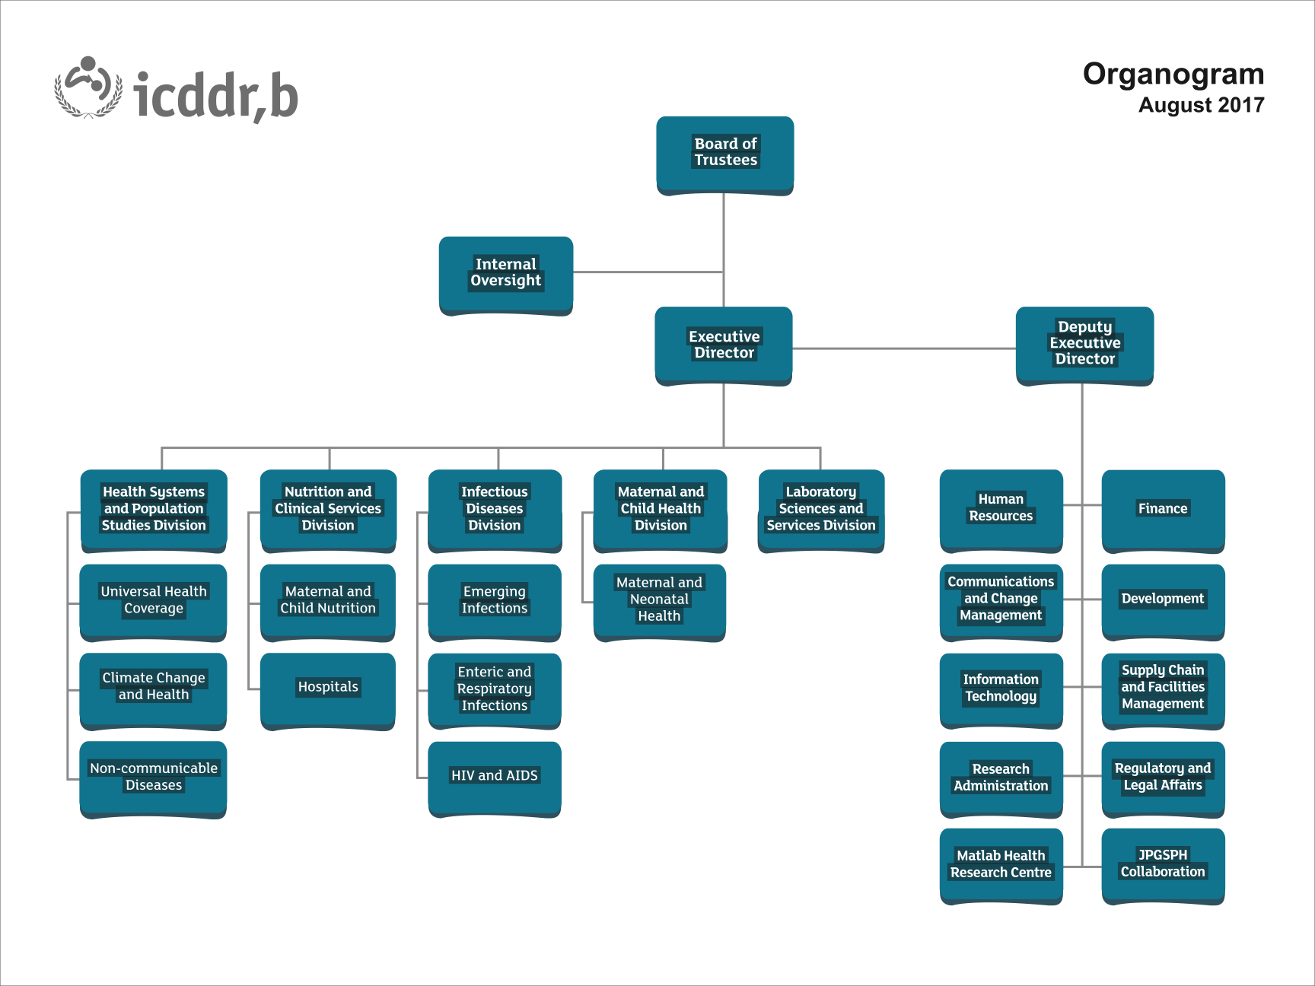
Organization Structure:

Figure 1 Organogram of icddr,b

Management Team and Board of Trustees:
An experienced team of experts management team led icddr,b.
- Board of trustees: 17 members of Board of trustees are responsible for governing icddr,b. The board is created by an ordinance of the Government of People Republic of Bangladesh. Three members are nominated by Government. The WHO- World Health Organization and UNICEF nominate one member each. icddr,b’s Executive Director serves as the Member-Secretary.
- Senior Leadership Team: Senior Leadership Team is led by the executive director who is responsible for everyday activities of the organization. They also implements the strategy and are accountable to board of trustees.
- Scientific Advisory Group: In June 2014, icddr,b’s Board of Trustees convened a world-class Scientific Advisory Group (SAG). The purpose of SAG is to built capacity in the training and mentorship for the young scientist, increase partnership opportunity internationally, increase the ability of research to undertake the research outside of Bangladesh.

Donor Organizations:
icddr,b research is supported by a combination of core support from bilateral donors and grant income. In 2017, the top 10 revenue sources for restricted and unrestricted grants were:

- Bill & Melinda Gates Foundation, USA
- UKAID: Department for International Development (DFID)
- Centers for Disease Control and Prevention (CDC), USA
- United States Agency for International Development (USAID)
- The Global Fund to Fight AIDS, Tuberculosis and Malaria
- National Institutes of Health (NIH), USA
- Government of the People's Republic of Bangladesh
- Swedish International Development Cooperation Agency (SIDA)
- Commission of the European Communities
- Global Affairs Canada (GAC), Government of Canada
Bangladesh Government is also a big source of icddr,b’s funding

Major Achievements
The work of icddr,b has had a major impact on the health of people in Bangladesh – and in other countries of the global South. Throughout its history, it has developed innovative products and generated rigorous evidence that has influenced health policy and practice in Bangladesh globally.
- Oral Rehydration Solution
- Zinc Treatment for Diarrhoea
- Tetunus Toxoid Vaccine for Mothers
- Guidelines for Treating Severe Malnutrition
- Testing Vaccines
- Family Planning Solutions
- Domestic Violence Legislation
- Continuing innovation
- Mat for Measuring Maternal Blood Loss
- Ultra Low-cost CPAP Device for severe pneumonia
- Supplementary and therapeutic foodstuffs to prevent and treat malnutrition

HR Department:

HR department Organizational Structure:
The policies and practices involved in carrying out the “people” or human resources aspect of a management position, including recruiting, screening, training, rewarding and appraising is Human Resource Management.
Human Resource Department does the recruitment, screening, training, rewarding and appraising for the organization. They play a key role in helping the business units for fast changing environment and the greater demand of quality employee.
Figure 2 Organogram of Human Resource Department of icddr,b.

The human Resource Department is one of the most important supporting department in icddr,b. The primary focus of the department is staffing as well as compensating and developing them through training, and maintaining a healthy work environment and solving the problems of the workforce. The department hierarchy includes the Director of HR, Head of HR, Senior managers, HR managers and HR personnel.

Units of HR Department:

There are 5 units works in HR department of icddr,b:
- Talent Acquisition Unit
- Talent Development Unit
- Talent Reward Recognition Unit
- Gender and Diversity Unit
- International Staff Management Unit
Every unit has a senior HR manager and some HR managers with some personnel. The senior manager reports to the head of the department.

Talent Acquisition Unit:

The main function of this unit are recruitment and selection, staff transition, coordination and maintaining document management system, audit response and job evaluation.
Recruitment and selection is the most important among all of them. To fulfill this the unit receives job requisition, prepare role clarification documents, classify and establish new posts, makes and publishes advertisements in different media, short list the CVs, prepare and issue selection notice test notice, communicate with the shortlisted candidates through phone call or email, fixes a time and venue for the preliminary test, takes the tests, code and decode the scripts for transparency, Select the panel members for the interview, inform the panel members to join the interview, prepare interview sheets, preapare munits and matrix based on the dision taken after taking the interview, cross check the reference of the selected candidats, inform them about their selection for the job, issue offer letter, verify the documents, complete the recruitment file and sends them to HRIS to onboard the new employee.

Talent Development Unit:

Main function of Talent Development unit is staff development, on boarding and new facilitation, higher studies of the current employees. They arrange orientation programs for the new employees, they identify the training needs of the employees, identify feasible training programs and the resources personnel and institution that are appropriate for those programs. They also provides necessary logistics support and provides reports on the training activities then they selects employees for higher studies abroad based on their performance on the training program.

Talent Reward and Recognition Unit:

The main function of this unit is overseeing the issues regarding performance management and the compensation issues.
They mainly focus on the performance management, allowance for the employees, HRIS, separation process and payroll.
The unit sets a standard of performance to measure the expected performance and the actual performance. The deferens between actual and expected performance determines the performance benefits.
They also operate the Human Resource Information System- HRIS where information of every employee is stored. This unit also handles the termination of the employees.

Gender and Diversity Unit:

This unit works on the implementation of the gender and the diversification policy in icddr,b. They arrange training for diversity awareness and gender equality. They also facilitate the day care named “Shishu Aloy” for the working parents in the organization.
They also deal with the equal right for the different religion, race and gender.

International Staff Management Unit:

This unit is interlinked with the other four units. As the hiring policy of national and international employees are different so there is a different unit in the department works for the international hiring.

Recruitment And Selection Process

Recruitment and Selection Process in icddr,b

Talent acquisition aims to find suitably qualified persons for posts that are vacant or that will shortly become vacant and to create a reserve list of equally qualified persons who can be called upon to fill future vacancies. The Talent Acquisition Policy of icddr,b is set to ensure that the best people are recruited on merit and the recruitment process is transparent, free from biasness and discrimination and is in accordance with its equal opportunity policy.
icddr,b follows two types of recruitment and selection process there are:

- Recruitment of employees (national)
- Recruitment of employees (international)

- Nationally and internationally the process covers the hiring of personnel.
- The sub processes are the same, the activities within the sub processes are different between national and international recruiting.
- The recruitment and selection process in the same for all kind of contract types which are – Daily Wagers, CSA and Fixed term.
- Recruitment process starts when an HRR requisition is received by HR-BP’s.

Recruitment Process (National)
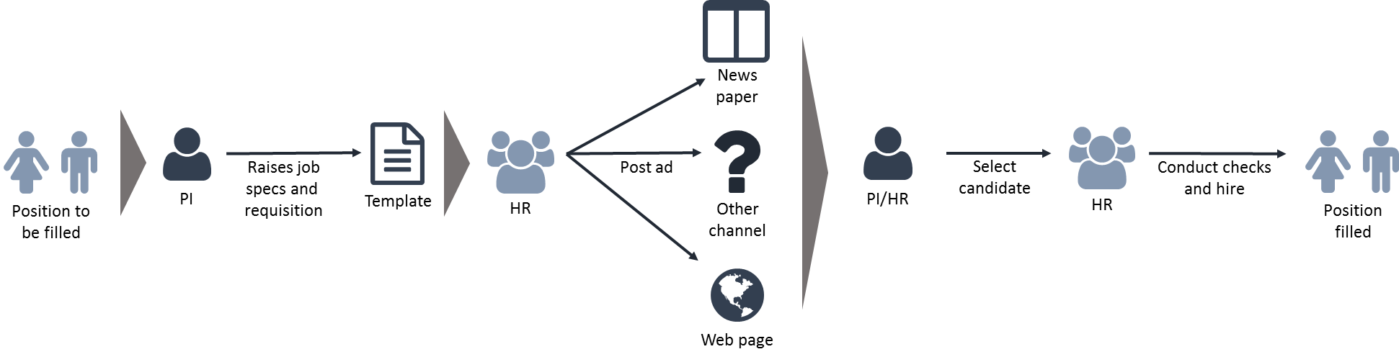
Figure 3: Recruitment and Selection Process

Requisition :

Requisition is a document used to request a hire, explain why it is needed, and determine the budget available for the role. PI or hiring - manager fill up a job requisition when they wish to create a new position or refill an existing, vacated position.

In this requisition step whenever the hiring manager identifies a position or vacancy to be filled he/she needs to document the specifications which is known RC template.
If the RC required is not reflected in the ERP system than the hiring manager goes through the HR-BP to initiate the needed steps. The HR-BP is consulting with the hiring manager if required when customizing the RC template.
The hiring manager has to consult with the HR-BP if the open position should be filled with a-
- Re-hire: person has been employed by icddr,b within the last 6 months but not currently employee of the organization.
- Conversion: employee move from one contract type to another contract type.
- Transfer: employee move from one to another project where employee maintaining same grade and status.

- If HR takes the decision to recruit from the internal resource, the HR-BP will consult with the PI/hiring manager about the requirements to identify the right candidate.
- HR is responsible for the internal resource pool database as they are controlling internal resource pool.
- The HR-BP informs the hiring manager in new hire or any of the cases that it is possible to raise the requisition in the ERP system.
- Start the recruiting without delay, the PI/hiring manager raises an online HRP requisition and submits to the approval workflow in the ERP.
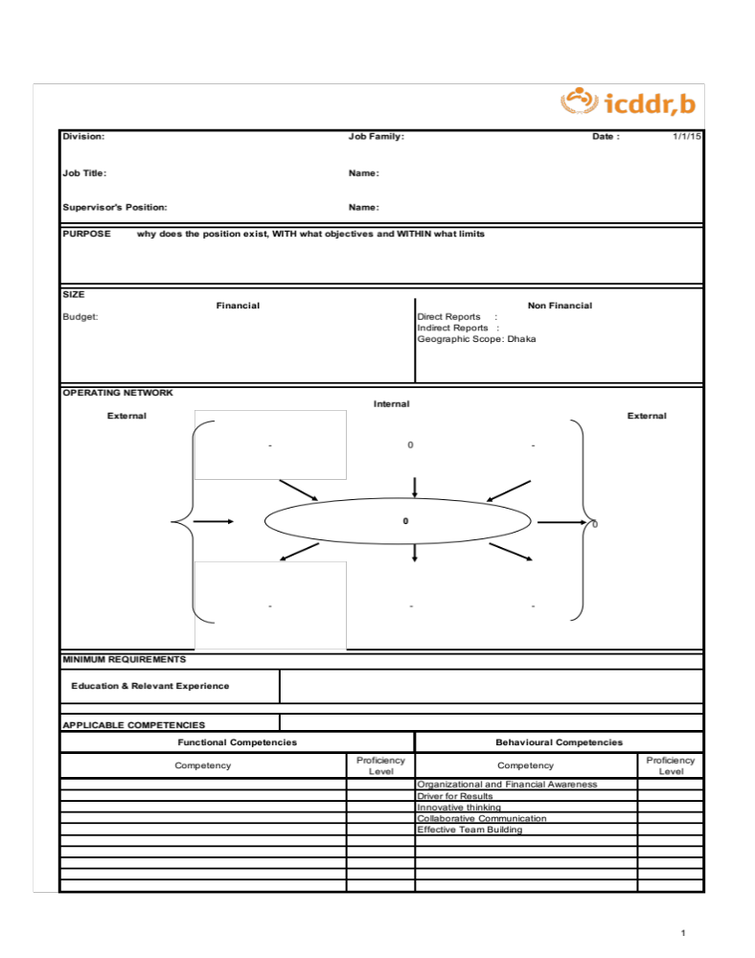
Figure 4: RC Template

Sourcing:

Sourcing is the act of perusing resumes and applications of prospective candidates received in response to an online or offline job requirement. It also includes evaluating the applicant in terms of their skills and experience.

- HR prepares the advertisement for the vacancy position based on the information in the RC and posts it to the defined channels like- online media, newspaper.
- Incomings CVs are screened and a short list is prepared by the system named “Suchona”.
- Questionnaires for tests are prepared by the recruit area.
- HR conducts the test, analyzes the results and select five interviewees together with the PI/hiring manager.
- Tests are required in any case for –
- All positions regardless of grades expect otherwise waived by the management.

Selection:

The Selection is the process of choosing the most suitable candidate for the vacant position in the organization.

- HR invite the selected candidates to the interviews and forms the interview panel-
- In the interview panel arranged by PI/hiring manager and “not interested” person. “Not interested” person refers who is not working in the same area of the interview.
- Interview taken by additionally-
- For GS/NOA – HR-BP
- For NOA/NOB – Senior Manager of Talent Acquisition
- For NOC and above – Head of HRM
- Summaries of the scoring from the interviews to be prepared indicated the best fitting candidate following the test and interview.
- HR-BP performed reference check.
- Candidates who passing the reference checks, the offer letters will be prepared and signed following the guideline –
- GS: HRBP
- NOA/NOB : Senior Manager of Talent Acquisition
- NOC and above : Head of HRM
- The HR- BP takes a decision if a background check is required.
- The HR- BP invites the candidate to hand over the offer letter.
- HR to renegotiate offer within the defined boundaries if not accepted.
- If background check is required, HR to initiate background check with the respective agency.
- After background check HR- BP inform the candidate who passed and initiate the HRIS setup and sign the contract with the candidate on the first working day, HR perform the HRIS setup.
- If any candidate not accepted the offer, the second candidate following the interview scoring is considered for recruiting.
- In case of re-hire/ conversion / transfer, HR has taken the decision to go through internal pool database, issues the offer/ conversion letter / transfer letter which as well results in signing a contract with the candidate.
- To ensure a standardized and efficient interview process with candidates, the company- based interview approach is used. HR is responsible to provide a competency based interview question bank to the interview panel.
- In case of an emergency/ short term recruiting is required, the HR-BP reviews the criteria-
- Only daily wagers who employment for less than 3 months
- Required start less than 15 days from identification to the need
- Extraordinary situation like- real emergency situation, no candidate for open identified than PI/hiring manager and HR jointly decided what they can do.
- The HR-BP collects CVs according to the requirements, supports the PI/ hiring manager in screening those and selecting the candidate and informs the candidate.

Findings and Analysis

Organizational Strategic Plan:

The strategic plan of 2015-2018 was successful for icddr,b. They came up with another plan for 2019-2022 as they continue to align and encourage implementation of research to address the world’s most pressing public health challenges; they are guided by sustainable development goals:

Goal One: Maintain a Focused Research Strategy:
They will continue to focus their research on areas of unmet need, developing high quality research programs addressing the key health challenges of Bangladesh and the global South.
- To reduce maternal neonatal, and child mortality and improving the condition of the women and children.
- Prevention and treatment of childhood malnutrition.
- Enteric and respiratory infection control.
- Reemerging and emerging infection detection and control.
- Universal health coverage achievement.
- Gender equality and sexual and reproductive health rights achievement.
- Inspection the health consequences and adaptation to climate change.
- Non-communicable diseases prevention and treatment.

Goal Two: Devolve and Promote Use of Innovations for Bangladesh and the Global South:

They will develop, evaluate and promote the implementation of innovations- product, tools and innovative models of service delivery tailored to the needs of Bangladesh and other low resource settings.

Goal Three: Clinical and Humanitarian Service and Response:

Through the hospital they will continue to provide high quality clinical services in diarrhoeal disease and malnutrition. They will also provide advice and training in humanitarian emergency response situations.

Goal Four: Invest in Research Platform and Field Studies:

They will continue to develop their research infrastructure for population based, clinical and laboratory based research to ensure it is aligned with our research objectives, remains internationally competitive and financially sustainable.

Goal Five: Increase Visibility and Impact of Their Research Evidence:

They will build skills and partnership to ensure that their research evidence has impact in national and international policies, programs, and practices.

Goal Six: Invest in Their People:

They will continue to build the skills and competence of all their people with a special focus on scientific staff, specially developing young and mid career researchers and supporting female researchers.

Goal Seven: Improve Organizational Efficiency and Cost Effectiveness:

They will continue to update and improve their business processes and governance regularly and modernize their operations to maximize efficiency and cost effectiveness.

Goal Eight: Ensure Financial Sustainability:

As well as carefully controlling expenditure, they will strengthen their fundraising strategy and maximize opportunities for income generation.
In the past three years, one of the biggest achievements has been the deployment of oral cholera vaccines to over one million Forcibly Displaces Myanmar Nationals in Cox’s Bazar, which averted a cholera epidemic – a testament of the implementation of innovative science. Capitalizing their expertise, they have established “Humanitarian and Clinical Services” as an individual goal, strengthen their responsibility to aid the vulnerable during times of crisis and recognize their enduring humanitarian response in Dhaka, through their diarrhoeal diseases hospital – the world’s largest specialist facility.
In their continual commitment to attending the sustainable Development Goals, they have included gender related research theme, addressing key issues which affect girls and women in Bangladesh.
They will continue to develop, evaluate and promote the uptake of low cost, life saving innovative situations. The new strategic plan highlights their focus on knowledge transfer and implementation of their innovation that can make a difference to people in Bangladesh and other low and middle income countries.

They have produced life saving science for over sixty years and they look forward to continue this tradition through with their 2019-2022 plans and beyond helping them to achieve their vision of world where more people survive and live healthy lives.

Indicators for HR Departments Successful Recruitment and Selection in Terms of Organizational Goals:
There are some indicators to measure if the recruitment and selection process is successful to fulfill the goal:
- Recruitment Plan:
icddr,b talent requisition department posts different advertisements on their website for different kind of job vacancy. First they see how many responses the get from the potential candidates. The main goal here is to get the best candidates for the job as many as possible. Because the more talented people will apply for the job increases the possibility of getting the best human recourses from the job market. If people do not apply for the job it is impossible to get the best workforce and ultimately achieving the organizational goal.
There is a comparison between the amount of recruitment plans are made and based on that how many requisitions are made. This comparison defines whether the target has been fulfilled or not. The fulfillment of the target determines further success of the organization and the future of the organization.
So HR department makes sure from the very beginning that the organization gets the right people for the right job.
- Probationary Period:
Another important indicator for the achievement of the goal is how many candidates are successfully passing the probation period. Not passing the probation period means that the employee is not capable of doing the work he is expected to do. So the success rate of the employees passing the probation period means the organization has efficient employees. Which means the goal achievement would be easier for the organization. Recruitment and selection has a major roll here. The impact is long term, so that it is important.
“Turn around time to fill vacancy” is the term the use to for to determine the how many candidates join on the fixed time.
Two elements are important here, first is targeted joining date and second is when the employee is joining in that position.
- Targeted joining date: They give a certain date to join a certain position. After that date the candidate cannot join for that post. Dateline plays a very crucial character here.
- When the employee is joining in that position: It is important when and how many employees join in the position.

- Cost per hire:
The cost per hire is the cost that the organization has to spend for per position of hiring. The average cost per hire in the market according to society of human resource management is $4000.
icddr,b cost per hire is below the average cost. If this cost is more than the standard then the organization has to face difficult situation.

Indicators for HR Departments Successful Recruitment and Selection in Terms of Societal Goals:
icddr,b works in different societal sectors. So there are different goals for different sectors. Recruitment and selection helps the organization to achieve those goals. The sectors can be divided in three,
- Field
- Hospital
- Libratory

- Field:
icddr,b hires local peoples for the field job. They have a better idea of the area and the people who live there. The field sites provide a platform for high quality population based research in urban and rural areas. In the field sector different kind of peoples work in icddr,b. Most of them are from poor financial background. The primary goal is to solve their financial problems by giving them job.
To help the female workers by prioritizing women while recruitment and selection in field sector. So the women can contribute in the society as equal as men.
Members from minority groups such as different tribes and religions get priority in the selection process.

- Laboratory:
The laboratory of icddr,b is well equipped to do the research. Recruiting the best scientist help the society in various way. The research they have done has a direct and indirect impact on the society. Not only the scientists get hired but also a huge number of lab assistants and other technicians helping hands are hired in the process.
Microbiological, immunological, genetic and other research helps the society to disease control. One of their important aims is to integrate field-based surveillance and intervention studies with detailed molecular and cellular analyses at their central laboratory facilities.
They have a high throughput genome sequencing and bioinformatics facility which helps them collaborate with the research outside the country. The genomic facility can be used by the institutions within and outside of the country.
They also provides diagnostic and laboratory services which requires a huge number of skilled staffs and experts. The goal is to serve the people as more as possible with better quality.

- Hospital:
They have three hospitals. One is Dhaka hospital which treats more than 140000 patients every year. Matlab Hospital treats 30000 people every year, Mirpur Treatment Center treats 20000 people every year. To treat this number of people icddr,b needs doctors, nurse, ward boys, cleaners, technicians, etc. Not hiring the right people can cause peoples life. So the goal is here to hire the best people in this field so that they can save as many lives as possible.
They also have community health services which can help the people with cholera, rehydration, and maternal issue. Recruiting and selecting the health workers and training them with appropriate knowledge play a very important role.

Achievements of the Human Resource Department in Terms of Recruitment and Selection, icddr,b:

HR department is has been able to achieve many goals for icddr,b. Some of them are described below:

Transparency in the Recruitment Process:
The recruitment and selection process in icddr,b is very transparent and fair. They don’t let the any kind of biasness come when it comes to recruitment and selection.
For example the coding and decoding of the answer scripts is to make sure the examiner cannot identify who the examinee is. Possibility of any kind of biasness is very low.

Equality:
Equality in gender, race and religion is important. Recruitment and Selection is very diverse, so everyone who has knowledge, skills and ability to do the job the gets chance. Their gender or religion does not come in the way of their success. They have a very strict policy against discrimination. So the organization gets benefitted from all kind of people from our society.

Consistency in Talent Development:
The training of the employee plays an important role. It helps the employees to work better and develop their skills.

There are many other achievements which were not possible if the recruitment and selection was not good. The organization is doing so good is because of its skilled employees. The consistency of the developments is also the result of proper recruitment and selection.

Impacts of Recruitment and Selection on Achieving the Organizational Goal:
Impacts of proper recruitment and selection in organization of the indicators have a long term and short term effect. It effects the organization in various ways.
Selecting and recruiting the right employee is important because of three reasons:

- First,
The performance of superiors always depends on the people working under him. Employees with better skills and attributes are able to do a better job for the superior and for the organization. Employee without skills will not do the work effectively so the performance of the employer and the organization will suffer. Selecting the correct employee will screen out undesirables before, not after. So the organization can do its best with the best employee.
On the other hand when the skillful employees work very hard the superior as well as the organization gets benefited. The superiors give positive motivation to the employees. The work environment does not give stress to the employees. As a result they work harder. Both employer and the employee are satisfied with each other. Which leads them to achieve the goals.
Icddr,b selects the employee very impartially so the skillful employees helps the employers to do their best as a result the organization does its best automatically.

- Second,
It is important to select and recruiting the correct employee because it is costly to recruit and hire new employees. With the cost per hire and the supervisory period the cost is a lot. When the hiring is not right the turnover rate will be high. The hiring of a crucial post can be 10 times higher with the search fees, interviewing time, travel expenses, reference checking, etc.
If the recruitment and selection is right at the first place then the organization does not have to deal with these extra expenses.
Icddr,b Human Resource Department tries to make the recruitment and selection process error free so that the turnover rate is low. They do the background check very carefully from the very beginning. From sorting out the applicants CVs to reporting date they observe every aspects of the employee. This has an impact on the turnover rate and eventually on the budget.
This means when the recruitment and selection process is more error free the possibility of spending extra money is less.

- Third,
The selection and recruitment is important because of legal implication of incompetent hiring. Court will find employer liable when the employee with criminal history or other problems use the sensitive information of the clients and the patients to commit any crime. The lawyers will contact the organization first, especially the Human Resource Department. Hiring employees with such background without proper safeguard is called Negligent Hiring.
Negligent hiring underscores the need to think through what the job’s human requirements are.
When the recruitment and selection process is transparent the possibility of hiring such employees with criminal record is very low. So the possibility of facing unnecessary law suits is also very low. As a result the reputation and the expanses both are safe. Most importantly the law suits bring a lot of controversies, negative marketing damages the organization.
The main source of icddr,b funding comes from the foreign donors. These lawsuits can make the donors make feel uncomfortable. They would lose interest on further donation. Without the donors money it will be impossible manage the organization. The whole organization will be damaged including the employees and the people who get the benefit of the medical services. In the long run the impacts are very harsh.
The importance of recruiting and selecting the right employee not only keeps the goodwill intact but also increases the positive reputation with their service.

Impacts of Recruitment and Selection on Achieving the Societal Goal:

The impact of recruitment and selection in achievement of the societal goals of icddr,b are discussed below:

- Unemployment:
Unemployment is one of the biggest problems in Bangladesh. The unemployment rate of Bangladesh is 4.30 percent which is a threat for development. A big institute like icddr,b needs a huge number of manpower to operate. They are contributing in reducing the unemployment rate and making a difference in the society.

- Solvency:
The range of the employees in icddr,b is very wide. They have their own rickshaw puller, boat men, technicians etc. who comes from very poor family. They have education from class eight to H.S.C. By hiring from the lower class of the society the organization solves the financial problems of those people.
They have more than 20,833 employees in those entry level which is a lot compared to others. This huge number of people are directly benefitted from the recruitment and selection in icddr,b.

- Women Empowerment:
For a long period the women in our society were neglected. They were not able to work outside their house. The scenario has changed now days. Recruiting and selecting the women from rural areas has made the women more empowered. They are earning now which they are not financially dependent anymore. It leads to having a voice in society. Icddr,b gives emphasis on hiring more women, they always encourage the women to apply.

- Brain Drain:
Bangladeshi students have a tendency of going abroad and not returning back in the country. It is because they don’t have the facility to research and gaining some positive result to do well in the future. They don’t have the resources and funding for their research. In icddr,b the researchers gets everything they needs for their research.
They can keep their employment active when they go for higher studies in abroad. Most of the employees comes back to icddr,b after finishing their study.
In this case icddr,b keeps the inelegant people in the country. The whole nation gets benefitted by them and the world acknowledges the research as Bangladeshi research.

- Skilled Manpower:
Because of the recruitment and selection of the right employee the organization makes some skilled and efficient manpower. The skilled people are asset for the society.

- Urbanization:
The tendency of moving in the big cities for better life reduces if the people from rural area has job. It is not so beneficial for populated cities like Dhaka. Because of the hiring the locals icddr,b preventing the locals from migrating to big cities.

- Hospital:
Hospital serves the biggest social goal of icddr,b. The treatment of the people needs the services to be good. Recruiting and selecting the right employee keeps the hospital services moving.

- Other Benefit:
Not only externally but also internally icddr,b gives the employees some hospital benefit, Day Care facility and others so the employees also gets benefited.

Their research in Maternal and childhood malnutrition, Non communicable disease, Enteric and respiratory infections, Universal health coverage, Emerging and re- emerging infections, health consequences of climate change, Maternal and neonatal health is helping the society and also the Government of Bangladesh.

Some Other Findings:

Following are the findings that can be found on the basis completing the tasks on daily basis:

- The recruitment and selection process in icddr,b is very structured. It makes the whole process more efficient and effective.
- The cost per hire is low because of the use of website and social media for posting the advertisements.
- Coding and decoding makes the answer scripts scoring bias free.
- They have their own format of online application.
- Sometimes the managers have to go through thousand of application for a particular post.
- The internal applicants get priority in terms of CV sorting out.
- The under qualified and over Qualified candidates gets rejected after participating the interview session.
- The HR managers has to go through a lot of paper work which is time consuming and monotonous.
- The female candidates get priority in selection for the job.
- They have a very strict policy in terms of their confidentiality violation.
- Very few people knows about icddr,b.
- The corporate part of icddr,b does not have any visibility in their website.

Conclusion and Recommendations:

Conclusion:

In the sector of research icddr,b is one of the pioneer in Bangladesh. Working in such organization as a HR Intern in Talent Requisition Unit was a great opportunity and honor.
This opportunity able to use my theoretical knowledge in the practical life, able to know about the organizational culture, by getting involved in the recruitment and selection step by step helps to understand the real life HR application.
Recruitment and Selection works and has an impact on the fulfillment of the organizational and societal goal. The research shows that the success of a big organization like icddr,b rely on the Human Resource Department.
The fulfillment of their social goals like women empowerment, preventing brain drain, contributing in lowering the unemployment rate, etc are gained by the Human Resource Department.
Skillful employees are the biggest resource of an organization, through the proper recruitment and selection the organization gets the most effective and efficient employees. In terms of skillful employees icddr,b is very rich, and the reason behind this is their effective Human Resource Department.
So the success of icddr,b has and will always be an impact of proper Recruitment and Selection.

Recommendations:

Although icddr,b is a very successful organization but there are some scopes of improvements. Here some recommendation for icddr,b which can be useful for their future growth of the Human Resource Department:

- Minimize the paper work for HR managers to save more time: The paper works takes a lot of time from the managers working hour.
- By giving same priority to both external and internal candidates: They prioritize the internal candidates in terms of hiring than the external candidates. The priority should be same.
- Giving more emphasis on the reference check: The reference check does not get the importance like the other steps does, which can cause lawsuits.
- Making the application process less complicated: They have their own process of application which can be complicated for some people, so they do not get proper applications sometimes.
- The corporate part of icddr,b should be more visible in their website: There is huge scope of career development in their admin level, but the website only shows the field research opportunities. A lot of people has no idea that icddr,b offers job in different sectors like IT, Finance, Human Resources, etc.

Reference:

- icddr,b website: https://www.icddrb.org/

- Dessler, Gray. (2014). Human Resource Management.

- Bhuiya, Abbas & Chowdhury, Ahmed. (1995). The impact of social and economic development programmes on health and well-being: a BRAC-ICDDR,B collaborative project in Matlab. https://www.researchgate.net/profile/Abbas_Bhuiya/publication/242249678_The_impact_of_social_and_economic_development_programmes_on_health_and_well-being_a_BRAC-ICDDRB_collaborative_project_in_Matlab/links/00b7d539f116c9788c000000.pdf

- Anosh,Muhammad, Hamad,Naqvi and Batool Anam. (2014). Impact of Recruitment and selection of HR Department Practices.
www.iiste.org

- https://www.icddrb.org/about-us/strategy

- https://www.jstor.org/stable/2939243?seq=1#page_scan_tab_contents

- https://www.sciencedirect.com/science/article/abs/pii/S027795369900461X

- https://www.scielosp.org/scielo.php?pid=S0042-96862001000600006&script=sci_arttext&tlng=pt

