Service Encounter at the Front Office of Hyatt Place Dhaka: A Perception

Fatema Jur Ferdous

The Report is submitted to the School of Business and Economics, United International University as a partial requirement for the degree fulfillment of Bachelor of Business Administration

Service Encounter at the Front Office of Hyatt Place Dhaka: A Perception

Submitted by
Fatema Jur Ferdous
Student ID.111122304
United International University

Supervised by
Prof. Dr. Kawsar Ahmmed
School of Business & Economics
United International University

Date Of Submission: July 25, 2026

Letter of Transmittal

Date: July 25, 2026

Dr. Kawsar Ahmmed
Professor of Marketing
School of Business & Economics
United International University

Dear Sir,
It is a pleasure to present this report entitled “Service Encounter at the Front Office of Hyatt Place Dhaka: A Perception.” This report provides a thorough evaluation of the hospitality industry in Bangladesh, an introduction to Hyatt Place Dhaka Uttara, and a detailed explanation of my Work experience at the hotel’s Front Office Department. It has been prepared for the academic purpose of the Tourism and Hospitality Management course I really think the information and the recommendations in this report will help the department.
Thank you for helping me and working with me all the way through this course. I will really appreciate it if you give me your thoughts, on this report.

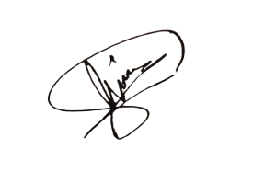
Yours faithfully,

Fatema Jur Ferdous
Student ID.111122304
United International University

Declaration

I, Fatema Jur Ferdous, hereby declare that the material contained in this report entitled “Service Encounter at the Front Office of Hyatt Place Dhaka: A Perception” is original. Sources of all information used have been appropriately cited. Assistance rendered in the preparation of this report has been appropriately credited.

This report has not been submitted for the award of any other degree or diploma in any other university or institution. All sources used have been properly acknowledged and referenced in accordance with the guidelines provided by United International University.

Yours faithfully,

Fatema Jur Ferdous
Student ID.111122304
United International University

Acknowledgement

I would like to express gratitude for all the help and assistance I have been getting throughout my internship from my workplace supervisors and staff at Hyatt Place Dhaka Uttara, in particular from Mr. Gautam Sarkar, Assistant Front Office Manager, who has given me much needed insight in preparing this report. I am grateful to my academic supervisor, Prof. Dr. Kawsar Ahmmed, for his guidance regarding this report's preparation.

Job Certificate
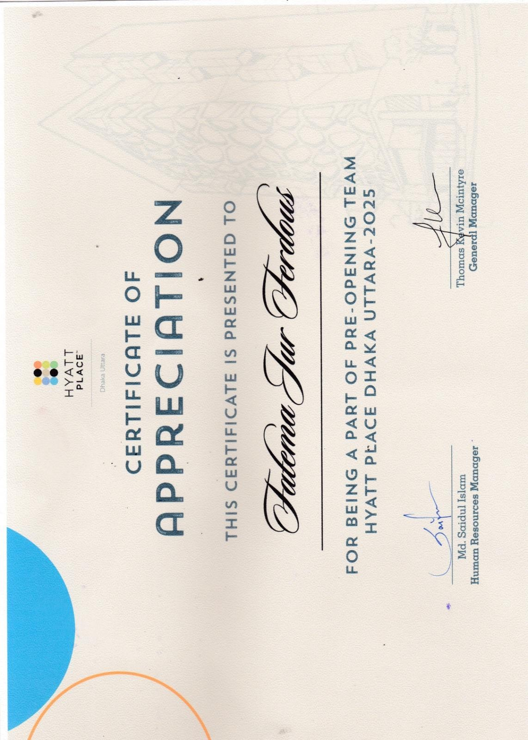

Executive Summery

The front office service encounter is critically important because it creates the guest’s first impression, which sets the tone for their entire stay. It ensures smooth check-in and check-out processes, reducing stress and enhancing convenience. The encounter also provides opportunities for personalized service, such as offering tailored recommendations or addressing special requests. Ultimately, it strengthens guest satisfaction and loyalty, making them more likely to return and recommend the hotel to others.

This report analyzes the hospitality industry in Bangladesh, with a focus on front office operations, through the lens of a job experience at Hyatt Place Dhaka Uttara. A service encounter shapes how guests perceive the quality of hospitality, as every interaction influences their overall impression of the hotel. Positive encounters build trust and satisfaction, while negative ones can quickly damage the guest’s perception of service excellence.

The whole report is divided into five chapters. In the initial chapter introduction is given with an inclusion of the study’s objectives and significance and basic knowledge about hospitality Industries. Chapter Two introduces Hyatt Place Dhaka Uttara, Where I describe all details of Hyatt Place Dhaka Uttara: its opening in November 2025 as the first Hyatt in Bangladesh, facilities (85 rooms, rooftop pool/bar, meeting space), Major Departments in Hyatt Place Dhaka Uttara and Organization Chart. Chapter Three details of Service Encounter at the Front Office of Hyatt Place Dhaka (guest check- in/out, reservations, duty schedule, relationship with others department and total front office operation). Chapter Four introduces of my Work Experience where I describe of my Position, Duties and Responsibilities, Training Received, Contribution and performance. Chapter Five offers recommendations for Improving Front Office Operations at Hyatt Place Dhaka. Throughout, the report integrates industry data and literature to contextualize observations, citing sources from tourism reports and hospitality news. Based on the findings several recommendations were forwarded.

Keywords: Service Encounter, Perception, Front Office, Hyatt Place, Bangladesh

Table of Contents
Letter of Transmittal 3
Declaration 4
Acknowledgement 5
Job Certificate 6
Executive Summery 7
Chapter 1: Introduction 10
1.1 Overview 11
1.2 History: 13
1.3 Present State of the Hospitality Industry in Bangladesh: 14
1.4 Importance of Hospitality Industry: 15
1.5 Front Office Department in Hospitality Industry: 16
1.6 Objective of the Report: 16
1.7 Background of the Report 17
1.8 Methodology: 17
Chapter 2: Overview of Hyatt Palace Dhaka Uttara 18
2.1 Introduction 20
2.2 Background of Hyatt Place Dhaka Uttara 20
2.3 Organization Details: 21
2.4 The House of Hyatt 21
2.5 Type of Rooms in Hyatt Place Dhaka Uttara: 23
2.6 In-Room Facilities 24
2.7 Dining in Hyatt Place Dhaka Uttara 25
2.8 Major Departments in Hyatt Place Dhaka Uttara: 27
2.9 Organization Chart in Hyatt Place Dhaka Uttara: 28
2.10 Hyatt Place Dhaka Uttara Policies 29
2.11 SWOT Analysis of Hyatt Place Dhaka Uttara: 32
Chapter 3: Service Encounter at the Front Office of Hyatt Place Dhaka 34
3.1 Introduction of the Front office Department 35
3.2 Objective of Front Office 36
3.3 Organizational Chart for Front Office Department of Hyatt Place Dhaka Uttara: 37
3.4 Front Office Interaction with Departments: 37
3.5 Relationship between Front Office and other departments of Hyatt Place Dhaka Uttara 38
3.6 Duty Schedule: 42
3.7 Front Office Duty Checklist: 42
3.8 Front Office Terms 48
3.9 Check in and Reservation Process: 49
3.10 Payment Methods: 50
3.11 Front Office Team Member Should Know: 50
Chapter 4: Work Experience 52
4.1 Introduction 53
4.2 Position, Duties and Responsibilities 53
4.3 Training Received 53
4.4 Contribution to Departmental Functions 53
4.5 Evaluation of Working Performance 54
4.6 Application of Academic Knowledge 54
4.7 New Skills Developed 54
Chapter 5: Recommendations and Conclusion 55
5.1 Introduction 56
5.2 Recommendations for Improving Front Office Operations at Hyatt Place Dhaka 56
5.3 Recommendations for Improving Personal/Professional Performance 57
5.4 Conclusion 58
References 59

Chapter 1: Introduction

1.1 Overview
Hospitality and tourism is a multi-billion dollar service industry that caters people from all walks of human life. It is much more than just the fundamental purpose of creating lodging for tourists and people coming home by themselves.
The hotel industry provides travel, meals, entertainment and even business activities for patrons of all walks of life globally. The Customer Experience is Everything for the Players
Furthermore, the hotel sector is considered the bellwether of other sectors because it attracts job and leisure travel. Every year millions of tourists come to Bangladesh from all parts of the world. The region is of great importance due to its booming tourism sector and prosperous economies.

Bangladesh hotel industry growth is being propelled by growth of middle class, demographic strength and travel demand. For many, the hospitality industry holds a certain glamour and sophistication. This is partly due to the image most hotels choose, refine, and project to the public. Much of this image is created through architecture and design. In 2019, before the pandemic, Travel & Tourism (including its direct, indirect, and induced impacts) accounted for 10.5% of all jobs (334 million) and 10.4% of world GDP (US$ 10.3 trillion). In 2019 before the pandemic happened the Travel & Tourism industry was really big. It included all the indirect and induced impacts. The Travel & Tourism industry had a lot of jobs 334 million to be exact which was 10.5 percent of all the jobs in the world. The Travel & Tourism industry also had an impact on the world economy it was 10.4 percent of the world GDP, which was US$ 10.3 trillion. People from countries spent a lot of money when they visited, US$ 1.91 trillion in total.

The World Travel & Tourism Council did some research and here is what they found:
* In 2023 the Travel & Tourism sector was 9.1 percent of the GDP.
This is an increase, 23.2 percent more than in 2022. It is also very close to what it was in 2019, 4.1 percent less.
* The Travel & Tourism industry also created a lot of jobs in 2023, 27 million to be exact. This is 9.1 percent jobs than in 2022. The Travel & Tourism industry is back to what it was in 2019 only 1.4 percent less jobs. The Travel & Tourism industry is really important for the world economy and for people who need jobs. The Travel & Tourism industry is getting better, after the pandemic.
Domestic travelers in 2023 spent about 18.1% more compared to the year before, actually managing to surpass what they shelled out back in 2019—a bit of a surprise for many industry watchers who'd braced themselves for a slower recovery. Meanwhile, folks visiting from abroad ramped up their spending by 33.1% over the previous year; still, their wallets didn’t quite open as wide as pre-pandemic days, falling short of 2019’s numbers by roughly 14.4%—I remember reading an article last December where hoteliers hoped foreign guests would return sooner. (https://wttc.org/research/economic)

The travel and tourism world packed quite a punch in 2023, pouring nearly 9.1% into the global GDP bucket—a jump of about 23.2% over the previous twelve months. If you look back at those bustling days just before COVID hit, it’s still missing about 4.1%, but optimism seems to be creeping back into boardrooms (or maybe that's just wishful thinking on my part). This whole hospitality sector pulls more weight than most people realize—it doesn't just serve food or make beds; it’s sort of like a giant magnet for jobs, pulling in new workers and powering economic engines everywhere. Imagine this: in 2023 alone, nearly 320 million people earned their paychecks thanks to travel and tourism gigs around the globe.
The US stood out with roughly 16.5 million hospitality employees, painting a picture of hotels buzzing with activity again—though I suspect not every pancake breakfast went off without a hitch.

Tucked away just about a kilometer from Hazarat Shahjalal International Airport sits Hyatt Place Dhaka Uttara, which opened its doors as Dhaka’s first modern hotel crafted especially for multitasking globetrotters (I can almost hear suitcase wheels clattering across its lobby floors). King Rooms overlook runways; Twin Rooms offer cozy quarters; Suites give travelers some much-needed breathing room after long flights—each space seems built with jet lag in mind.
Hungry guests find plenty at Zing’s all-day buffet or grab-and-go snacks at The Market downstairs; rooftop cocktails at Zing Sky bar come with sunsets that seem straight out of watercolor paintings.
More than two hundred seats fill meeting halls and banquet spaces—a magnet for business visitors tied to Dhaka's bustling apparel supply chain. That said, I’d bet even leisure seekers peek inside now and then—drawn not just by convenience but maybe also curiosity or simply good coffee.

It will also generate demand from international sourcing firms, RMG buying houses, infrastructure consultants, airline crews, and technical teams.
(https://bangladeshmonitor.com)
In this report I have discuss about overall Service Encounter at the Front Office of Hyatt Place Dhaka. This Report mainly focused on to know about Service Encounter at the Front Office Department and discuss about different methods and techniques of Front Office Department. Other objectives are to know how Front Office Department provide services, guest satisfaction, and to create a positive brand image of a hotel in the minds of the guest.

1.2 History:
The First Hotels- During Ancient times people started to see places like modern hotels. These were called 'hospitals because they were about being friendly to guests. They were rooms that you could rent in people’s homes. As time went on these places started to make money by offering them. Over time they began to offer more. They served food and drinks. Had places to stay. These places became where people went to relax. The idea of hospitality was key. It was about making guests feel welcome.

The history of hotels: In the Middle Ages, inns and staging posts were established to offer travelers a place to rest. Abbeys and Cloisters also provided places for tired travelers to stay the night. Inns cropped up around Europe and the rest of the world, but travelling during this time wasn’t particularly safe and/or common. Pilgrims, couriers and government workers were most likely to use these services.

Wealthy people were starting to travel more and they wanted to stay in nice places. So hotels had to get better and offer things to their guests. One of the really good hotels was in Exeter and it opened in 1768. Then the City Hotel in NYC opened. It was not until the 1800s that people really started to like the idea of ​​staying in hotels. Mivarts Hotel in London opened in 1812. It later became Clarridges. A years later Tremont House in Boston USA opened in 1829. Tremont House was special because it was the hotel to have toilets and baths inside and it also gave guests free soap. It had a nice reception area where guests could check in and get help.As time went on more hotels opened. This was because people were working hours and had more money so they could travel more. The industrial revolution helped make travel easier and more fun. With the invention of trains and cars people could go on trips without spending all their money. Hotels became very popular. By the 1900s there were hotels all over the world.

The history of hotels: in the century is really interesting. As it got easier to travel more people wanted to stay in hotels. The economy was doing well in the second half of the 20th century. This meant that more people had money to travel and stay in hotels. So hotels started to cater to kinds of people. We got beach resorts, motels, golf resorts and budget hostels. This was great because people could choose where they wanted to stay based on what they liked. Hotels could charge prices depending on what they offered. This made the hotel industry very exciting. It kept growing.

1.3 Present State of the Hospitality Industry in Bangladesh:
Hospitality has traditionally been regarded as a practice of welcoming people with warmth wherever they have gone as guests, both within households and within the burgeoning hospitality industry which aims at making the guests happy. There are quite a few hotels and resorts in various parts of the world that offer great facilities and services to their guests. The hotels are highly competitive, trying to outperform other hotels with unique features of theirs in terms of modern architectural and interior designs. Today, there are quite a few firms operating in Bangladesh that offer high-quality hospitality services in many different ways, whether they run hotels and resorts or arrange trips and events for their clients. (https://businessinspection.com.bd)

The hospitality sector of Bangladesh has really taken off in the few years. This is happening in Bangladesh. Also, in other countries. As the economy of Bangladesh gets bigger and more people visit the country more and more people need places to stay things to do and food to eat. The hospitality sector of Bangladesh is getting more popular every day. Various major cities of Bangladesh such as Dhaka, Chittagong, and Cox’s Bazar, among others, have experienced many new investments being made in the sector. Moreover, various initiatives by the government of Bangladesh have also helped this sector to grow tremendously. However, despite all these positive factors, there are some other challenges as well that hinder its growth. (https://bwhotelier.com)

1.4 Importance of Hospitality Industry:
The hospitality industry is a key driver of the global economy, which also provides a good source of employment, tourism, and economic development. The main factors highlighting the importance of the hospitality industry include the following:
- Economic contribution: The hospitality industry offers employment opportunities at various levels including vocational and management level and also provides a lot of income to the economy due to hotel operations, food and beverage, entertainments, and tourism related activities.
- Tourism development: The hospitality industry is very important for the tourism industry and both have a strong connection with each other. Hotels, restaurants, and entertainments all add towards attracting tourists and supporting businesses and diverse cultures.
- Cultural Exchange: Hotels welcome guests from countries and cultures with a friendly attitude. This helps people learn about and experience cultures, foods and traditions from, around the world through hotels, restaurants and other places.
- Global Interconnections: With global connections the hospitality industry helps people connect with each other. Hotels, airlines and travel services make it easy for people to meet for work or other reasons making the world a connected and diverse place.
- Local Community Development: The hospitality sector helps local communities grow by supporting businesses investing in community projects and hosting local events. Successful hotels and restaurants may serve as the focal point of both social and economic life within their communities.

1.5 Front Office Department in Hospitality Industry:
The most crucial department in the hotel industry and can also be called the face of the hotel will be the Front Office Department. In the hospitality industry, the Front Office Department is referred to as the “face of the hotel”. This is primarily due to the fact that the Front Office Department acts as the first point of contact for the guests, and also serves a significant purpose regarding guests' overall experience in a hotel. Whatever services guests need in terms of getting checked-in, information or any sort of help; they come to the Front Office Department. For a 5-star hotel, the importance of this department is even higher as it becomes responsible for maintaining the high standards of hospitality at such hotels. As explained above, this department is the first thing that a guest sees upon entering a hotel. The behavior, efficiency and professionalism of its employees serve as the first impression of the hotel to guests. In case of a 5-star hotel, it is extremely important for the first impression to be impressive and warm.

1.6 Objective of the Report:
As already stated above, the main goal of this report is to give a detailed account of the Front Office process and activities at Hyatt Place Dhaka. This paper will make an attempt to elaborate the major functions and processes performed by Front Office Department at Hyatt Place Dhaka, particularly pertaining to guest services, booking, correspondence and sales processes. By analyzing the process, the researcher hopes to clarify the way Hyatt Place Dhaka works with respect to its guests and how successful it is in its Front Office activities. A number of objectives of this paper are stated below.

General Objective
The main objective of the report is to explore about front office operational process in Hyatt Place Dhaka and sharing existing experience in the relevant issues.
Specific Objectives
  - Provide an overview of Hyatt Place Dhaka.
  - Provide information about the way front office department operates.
  - Provide details about Job responsibilities of front office staff members.
  - Summarize existing issues with Hyatt Place Dhaka and suggest solutions.
  - Explore factors related to Hotel Industry.

1.7 Background of the Report
In this report, I have highlighted the impact of Front Office Department in Hyatt Place Dhaka Uttara and how the revenue targets can be achieved. In hospitality industry, the most critical department is front office. It is so as it plays a very crucial role in customer satisfaction since it is the first point of contact for guests. Whether customers seek information or need any help, Front Office becomes the go-to place.
The author's work experience at the front office department of the Hyatt Place Dhaka Uttara forms the basis of this study. The report presents an analysis of the hospitality sector in Bangladesh and explains how front office operations facilitate effective hotel management and customer satisfaction. The report further reflects skills gained from practical experience in a hotel setting.

1.8 Methodology:
In this report, I tried to explain the general workings of the Front Office department of Hyatt Place Dhaka and in general hospitality sectors.
Sources and Collection of Data:
Both primary sources and secondary sources were considered while preparing this report.
Primary Sources: Primary sources of data collection were my practical experience and face-to-face discussion with employees of Front Office Department at Hyatt Place Dhaka.
Secondary Sources:
  - Articles available online
  - Journals and newspaper
  - Official website of Hyatt Place Dhaka.

Scope and Limitation of the Report:
The scope of this report is the hospitality industry in Bangladesh specifically Hotel Industry with special reference to the front office functions at Hyatt Place Dhaka Uttara. Data for this report is gathered from published articles, government regulation, industry reports, and the author’s professional job experience.
There are certain limitations of this report. Personal professional job experience is the main source for this report. Sensitive internal data is not considered for this report and the confidentiality of the hotel has been maintained.

Chapter 2: Overview of Hyatt Palace Dhaka Uttara

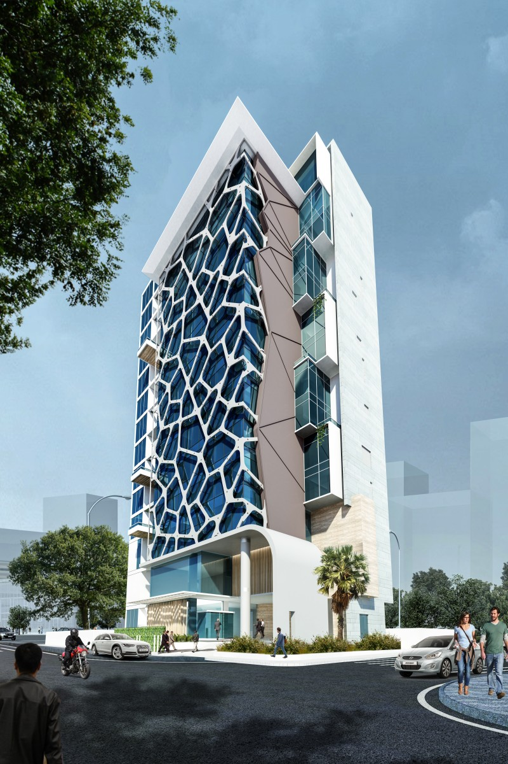

2.1 Introduction
Hyatt Place Dhaka Uttara is the hotel from Hyatt in Bangladesh. The Hyatt Hotels Corporation has come to Bangladesh by opening a Hyatt Place in Uttara which's, in the capital city. The hotel is just one kilometer away from Hasrat Shahjalal International Airport. This hotel offers different choices for its visitors – they could stay in King, Twin and Runway View rooms, dine throughout the day at the hotel restaurant Zing, have fast food at 'The Market' or enjoy the cocktails in Zing Sky, the hotel's rooftop bar, and watch planes taking off into a setting sun, said a news release.
As it has been designed with business travelers in mind, especially from the garments and import/export businesses, the hotel has a ballroom as well as meeting rooms that can accommodate up to 200 Guest.

2.2 Background of Hyatt Place Dhaka Uttara
While the hotel was planned to open its doors in late 2024, Hyatt Place Dhaka Uttara actually opened for business in November 2025. This hotel was developed with the intention of helping Hyatt Hotels Corporation achieve its strategy of entering emerging markets. The launch of the hotel is highly relevant as it comes to solve the increasing demand for good-quality lodging, especially from businessmen traveling to the northern areas of Dhaka.

The hotel maintains the Hyatt Place global standards by providing guests with comfortable accommodation and advanced amenities and services available 24/7. Due to this aspect, Hyatt Place hotels are very popular among business travelers who need convenient check-in, business facilities, and round-the-clock assistance.

Being the first Hyatt-branded hotel in Bangladesh, it is an important move towards improving the country's global hospitality standards. According to the hotel's general manager Kevin McIntyre, the hotel works hard to provide excellent services for visitors from the Uttara area.

2.3 Organization Details:
Short View of Organizational Demography:
Name | Details
Property Name | Hyatt Place Dhaka Uttara
Owned by
Address | Plot 2 & 4, Jashimuddin Rd, Dhaka 1230
Telephone | 09606-771234
Mobile
Fax
Website | www.hyatt.com/hyatt-place
Location | Uttara
Year Hotel Opened | 2025
Opening Date | November 2025
Hotel Category | 5 Star
Number Of Rooms | 85

2.4 The House of Hyatt
Vision: A world of understanding and care
Mission: We deliver distinctive experiences for our guests
Values: Empathy, Experimentation, Inclusion, Integrity, Respect, Wellbeing
Strategy
- Maximize our core business
- Integrate new growth platforms
- Optimize capital & resource deployment
Plan
- Cultivate the best people & evolve the culture
- Drive guest & customer personalization
- Operate with excellence
- Grow with intent
Purpose: We care for people so they can be their best
Values: Guide our behaviors to bring our purpose to life

Empathy
- Truly Listen
- Walk in the shoes of others
- Respond With Compassion
Experimentation
- Be curious and continuously learn
- Experiment & generate new ideas
- Make things happen
Inclusion
- Seek to understand
- Encourage different viewpoints
- Support each other to thrive
Integrity
- Tell and accept the truth
- Honor your commitments
- Take ownership and act with pride
Respect
- Be Open and honest
- Treat others with appreciation
- Collaborate and work as a team
Wellbeing
- Prioritize self-care
- Use fun as fuel
- Build connections within your community

2.5 Type of Rooms in Hyatt Place Dhaka Uttara:
Hyatt Place Dhaka Uttara comprises 85 guestrooms with 16 suites that have been designed keeping in mind the requirements of today’s travelers. Guests can enjoy magnificent views of the city skyline from floor-to-ceiling windows either while working or unwinding on their sofa beds. Every room is equipped with a 55-inch smart television, whereas suites come with a spa shower.
- King bed Room-269 sq ft
Take some time off and relax in our 25-square-meter room that comes equipped with a king-size bed, cozy corner, and 55-inch smart TV. Relax in a beautifully designed bathroom complete with bath amenities and receive complimentary buffet breakfast at Zing during your stay.
- Twin Bed Room-269 sq ft
Get away from it all and enjoy some peace and quiet in our 25-square-meter room with twin beds, cozy corner, and 55-inch smart TV. Have access to a beautifully designed bathroom complete with bath amenities and get complimentary buffet breakfast at Zing during your stay.
- King bed Room, Runway view-269 sq ft
Feel at home in our 25-square-meter room that offers you a king-size bed along with the breathtaking views of the runway. Get access to a cozy corner, 55-inch smart TV, and a beautifully designed bathroom with bath amenities and have complimentary buffet breakfast at Zing.2 Twin Beds, Runway View-269 sq ft
Relax with peace of mind in our luxurious guest room with 2 single beds that have an impressive view of the runway. The room includes a corner couch area, 55-inch smart television, and a beautiful bathroom complete with bath amenities. Buffet breakfast is available complimentary at Zing.
- Suite, 1 King Bed – 398 sq ft
Experience luxury in our relaxing 37-square-meter one-bedroom suite. Our suite features a king-size bed, living room with a sofa, spa shower, and 55-inch smart television. Buffet breakfast complimentary at Zing.

2.6 In-Room Facilities
- Free buffet breakfast available in Zing
- Free wireless internet
- Smart TV with screen size 55 inches
- Charging Station
- Mini bar
- Iron & Ironing Board
- Hair dryer
- Coffee and tea facilities
- Refrigerator with in-room safe
- Music docking station including charging and other features
- Wake up services
- Non-smoking rooms are available.
- The baths are really
- Bathrooms have four fixtures
- There is a desk chair for comfortable sitting
- You will find an iron and ironing board
- Bath robes are provided
- We have phones with direct dialing
- All rooms are air-conditioned
- There is a refrigerator and a safe in the room
- Smoking is allowed in some rooms
- You get free newspapers every day
- We have rooms that are easy to use for people with disabilities
- There are two bathroom and shower facilities
- The bath and shower are, in separate stalls
- There are two phone lines
- We have a fridge in the room
- Some rooms have a refreshment center
- You can use high-speed internet for free

2.7 Dining in Hyatt Place Dhaka Uttara
Diners can enjoy a range of dishes from various cuisines at Hyatt Place Dhaka Uttara. Whether you’re in the mood for a quick bite, a full meal or just a cup of coffee or a cocktail, Hyatt Place Dhaka Uttara is ready to take care of you. Come and visit our multi-cuisine restaurant, Zing, to have a great dining experience in a very lively environment, which is suitable for your family visits or even business dinners. There’s also an exciting roof top bar, plus 24 hours grab 'n go.
- Zing
Zing is our all-day dining multicuisine restaurant located on the first floor of the hotel. Zing provides a very casual dining experience where our open kitchen serves cuisine ranging from local, Indian, Bangladeshi, Asian to continental cuisines. It’s a perfect place for either your family or business meetings.
- Zing Sky Bar
Situated on the rooftop near the Swimming Pool, Zing Sky Bar provides panoramic views of the runway and cityscapes. It's the best location for you to unwind and enjoy the rest of your day. As the sun sets, indulge in the beautiful sunset of Dhaka and witness its transformation from a serene place into an exciting nightlife destination, providing interesting drinks (non-alcoholic beverages) and tasty snacks.
- Market
The Market is available 24 hours a day and provides a convenient shopping place with ready-made retail items. Have a coffee or a snack while leaving for an important business day or an exciting adventurous day.
- In-Room Dining
We will provide the most luxurious service for your lazy morning by serving breakfast in bed and satisfy your nighttime food cravings with some tasty treats. In-Room dining services are available all day and night. Experience a specially designed in-room dining menu.
- Meetings & Events
Hyatt Place Dhaka Uttara provides 144 square meters of flexible meeting and event spaces for hosting special celebrations, business meetings, training sessions, conferences, small weddings, and group events. Our experienced meeting host will manage all the details and arrangements for your upcoming event.

- Meeting Room 1
Area: 1,076 sq ft | Guest Capacity: 90
The Hyatt Place Dhaka Uttara offers meeting and event spaces that are perfect for special occasions, business meetings, training, conferences, Small Wedding and group gatherings. Our event spaces can be customized according to your needs.
- Meeting Room 2
Area: 484 sq ft | Guest Capacity: 30
Hyatt Place Dhaka Uttara is a great place to organize corporate executive meetings, training sessions or group events.
- Roof Top Swimming Pool
Dive into our temperature-controlled infinity edge swimming pool with an amazing view of the runway, the skyline, and sunset views. Relax in a comfortable lounger with a drink from the bar and unwind.
- Gym
24 hours gym on the 3rd floor is perfect for all those who are committed to their health regime. It is fully equipped with state-of-the-art machinery and free weights and receives plenty of sunlight.

2.8 Major Departments in Hyatt Place Dhaka Uttara:


Hyatt Place Dhaka

Front
Office

Housekeeping

Food
Production

F&B

Sales

&
Marketing

Human
Resource

Security

2.9 Organization Chart in Hyatt Place Dhaka Uttara:

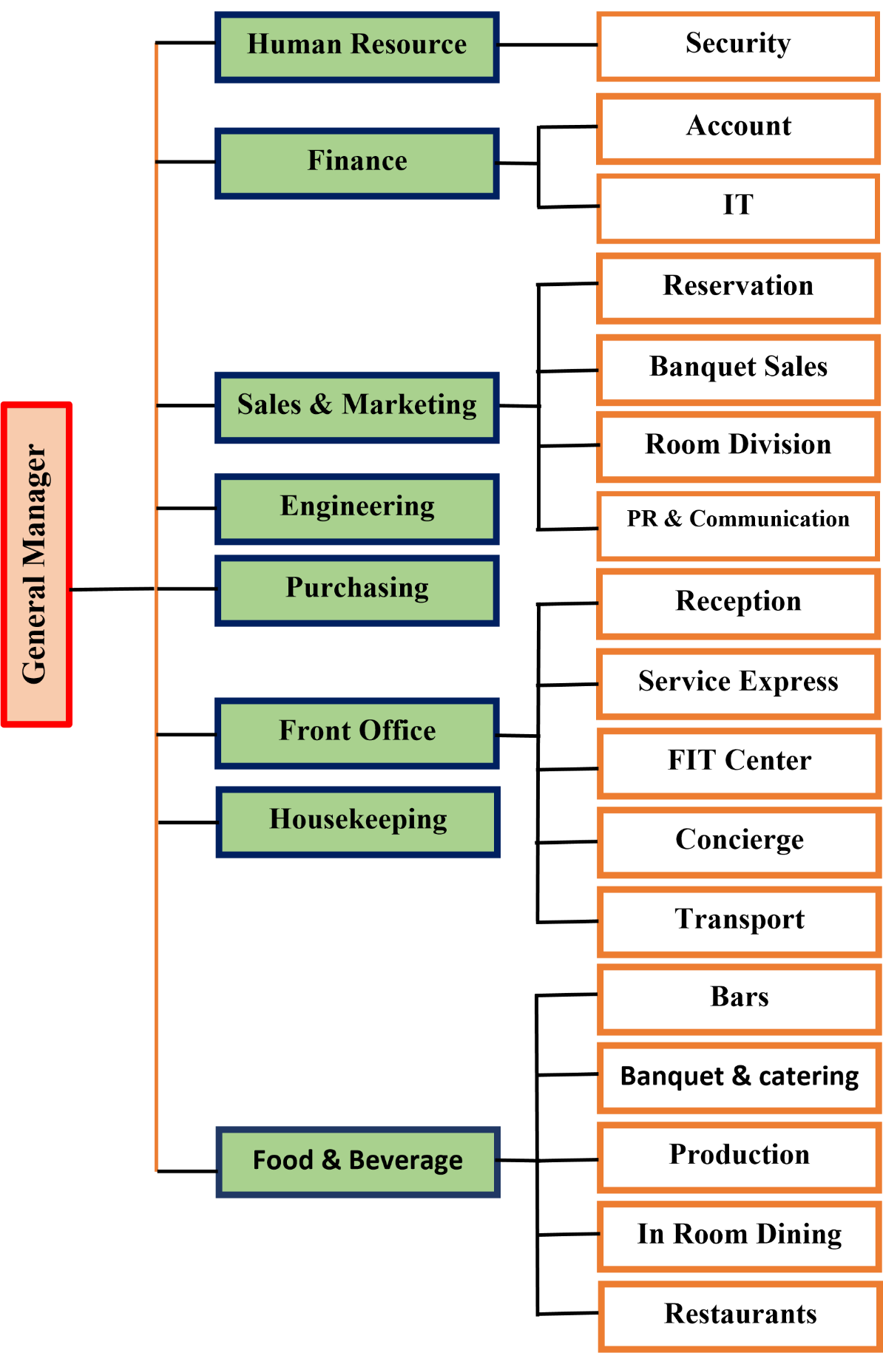

2.10 Hyatt Place Dhaka Uttara Policies
- Early Arrivals
If you check in between 3 PM and before 9 AM you will have to pay for one night’s room rate. If you arrive after 9 AM but before 3 PM you will have to pay 50 percent of the room rate.
- Late Checkout
Check-outs after 12 noon till before 6 PM will have to pay 50% of one night's room rate charge. Those checking out after 6 PM will have to pay full room rate charge for the additional night.
- Family Room Policy
Children up to 12 years of age stay free without any charge for accommodation when using existing bedding facilities in the room. Use of other types of beds like Rollaway, child rollaway and cribs, may carry some extra charge.
- Identification Card
The hotel needs to make sure that all guests are safe. So when you check in you will have to show your identity and a valid address card that the government approves. This can be a driver’s license, passport, citizenship certificate or voter ID card. The hotel will take a copy of your address proof when you check in. If you are a foreigner you will have to show your visa before you can check in.
- Rec Facility Usage Policy
There is minimum age limit set for using the facility like pool and fitness gym. As a general rule of thumb, such services can be used and accessed only by those guests who are 16 years and above in age. Children below 16 will require adult escort. The hotel assumes no responsibility or liability towards providing safety and security to its guest while using hotel facilities.
- Security Policy
The hotel checks all rooms every 24 hours to see if they are being used. The hotel will not give you a duplicate key to your room unless you are the registered guest and you show a photo identification. The hotel has CCTV cameras and only the hotel staff can see what is on them.
- Smoking Policy
There will be no smoking/vaping in any hotel rooms and common places except for the designated smoking areas. The sale of tobacco products is not allowed for people younger than 18 years old. Smoking in the room that does not allow smoking will lead to a USD 200 fine.
- Connecting Room
Hyatt Place Dhaka Uttara provides connecting rooms upon request during booking. The allocation of connecting rooms depends on the availability of the room on the date of arrival.
- Cancellation and Deposit Policy
Reservation at Hyatt Place Dhaka Uttara is guaranteed either with credit card, prepayment, or company deposit. In case the guest does not arrive, the hotel reserves the right to make non-arrival charges according to the standard reservation confirmation voucher. The cancellation policy requires guests to cancel their booking 24 hours before the check-in date; otherwise, there will be some penalties. There will be no refunds or cancellations on some reservations, which will be mentioned in the standard reservation confirmation voucher. For late cancellations and non-arrival cases, the full amount will be deducted from the credit card.
- Payment Policy
The hotel collects the total cost of accommodation and other charges with the help of an approved credit card on the day of check-in. Besides, the hotel also takes some incidental charges on the first day of check-in.
- Credit Card Policy
You have to be there in person to use your credit card at the hotel. The hotel does not accept cheques. When you give the hotel your credit card information when you make a reservation you are giving them permission to take money from your card if you do not show up or cancel at the minute.
- Pet Policy:
you cannot bring pets to the hotel.
- Bed or Extra person Policy:
if you have a child or an adult who is over 12 years old and they need an extra bed you will have to pay US$15 plus taxes per person, per night. Only some rooms can have a bed and only one extra bed can be provided per room. The cost of a person does not include any extras.

- Outside food and Beverage’s policy
At Hyatt Place Dhaka Uttara, outside foods & beverages cannot be brought into the hotel unless written consent is obtained separately. Consumption of outside food & beverages is at guest's own risk.
- Visitor Policy
Outside visitor is strictly prohibited to enter into guest room corridors or guest rooms except those being registered as occupant. Guest can meet or entertain others in public areas and restaurants. Registration of additional guest requires photo ID proof and extra occupancy charges.
- Guest Room Usage
We do not allow things that can catch fire or put people in danger in the guest room. This is a serious rule. We also do not allow people to use banned products or drugs in the guest room. People need to know that guest rooms are for safe and legal activities. We follow the laws of Bangladesh.
We do not allow poker chips or cards, hookah, guns or other weapons and things that can catch fire in the hotel.
Guests know that they cannot do anything in the guest room like gambling. Guests must also make sure that they do not let anyone else do anything in the guest room.
- Camera and Photography/Videography equipment
We do not allow people to use cameras or drone cameras in the hotel. People cannot take pictures without asking us. If people want to take pictures or videos in the hotel they need to ask us for permission. We also need to give people permission to use the pictures or videos they take in the hotel, for business.
- Guest Conduct
Hyatt Place Dhaka Uttara gets to decide who can come into the hotel. If a guest is being very bad or making other people uncomfortable, we can ask them to leave the hotel. We want to make sure that all our guests and staff are safe and happy.
- Disclaimer of Contact Information
It might become necessary for Hyatt Place Dhaka Uttara to get in touch with you regarding your application for a reservation and/or in connection with any other transactions made with Hyatt Place Dhaka Uttara for confirmation of your reservation as well as provision of information required by you on services available at Hyatt Place Dhaka Uttara. Such communications might take place through a telephone call or an SMS sent to the contact number provided by you along with emails sent by Hyatt Place Dhaka Uttara to you. We really care about keeping your information private and confidential. So we will use your information according to our rules which are explained in the Global Privacy Policy for Guests. You can find this policy at privacy.hyatt.com. If you have any questions about the policies at our hotel you can send a message to xxxxxx@hyatt.com. This is how you can talk to someone from Hyatt Place Dhaka Uttara who is allowed to help you.It is also important to remember that according to the Global Privacy Policy for Guests you have the right to see your information make corrections and say no to us using your information if you have a reason, for doing so.
- Sustainability Policies
A healthy environment is essential for everyone to perform at their best. Hyatt is dedicated to promoting actions to benefit the environment in order to make destinations thrive for guests, colleagues, and local communities worldwide.

2.11 SWOT Analysis of Hyatt Place Dhaka Uttara:
All organizations have strengths, weaknesses, opportunities, and threats.
Strengths:
- Situated within business premises.
- Professional management team.
- Harmonious staff.
- Part of an international hotel chain.
- A branded spa.
- Traditional buffet restaurant featuring Asian cuisine.
- Service available around-the-clock.
- Transportation services.
- High security management.
- Good reviews from customers.
Weaknesses:
- Scarcity of labor.
- No resident doctor.
- Limited parking space.
- Inadequate cost management.
- Delayed hiring process.
- Inefficient maintenance.
Opportunities:
- Established corporate relationships with domestic and foreign firms.
- International property management.
- Trusted employees.
- High-profile guests regularly visit the establishment.
- Low cost of labor.
Threats:
- Competing international hotel nearby.
- Gradually increasing competition in the vicinity.
- Motor vehicle noise pollution.
- Proximity to highways.

Chapter 3: Service Encounter at the Front Office of Hyatt Place Dhaka

3.1 Introduction of the Front office Department
The main thing about a hotel is the desk. This is the place where the front office's it deals with all the other parts of the hotel. The front desk is where the hotel staff meet the guests. The front desk does a lot of work. They check people in and out. They answer phones and book rooms. They also handle money. Sort out bills.

The front desk is very important. It has to take care of all the guests needs. The front office is where guests and hotel staff work together. This is where they keep the guests information. This is also where guests can get help when they need it.
The front office staff has a job. They have to make sure the hotel is running smoothly. The front office staff has to tell people about the hotel and what the hotel can do for them. The front desk and the front office staff are very important, to the hotel. They have to work to make sure the guests are happy and the hotel is running well.

The Front Office Department is a part of a hotel. Guests only deal with this department when they arrive and when they leave. The front office team makes sure guests know about our hotel and what we offer. They also answer any questions guests might have and solve their problems.

The front office and other hotel teams work together to keep guests The front office is key to understanding what guests need and want. All hotel teams must work together for operations. Front office staff must be good, at communicating with guests and helping them with issues.

When guests arrive at the hotel the first place they go is the office. This department is in charge of lots of things like booking rooms sorting out events and dealing with bills. Guests often go back to the office if they need help or have any questions. That is why the Front Office is so important. It is the center of the hotel. It has to make sure that everything is running smoothly.
The front office does lots of things including:

  - Checking people in
  - Checking people
  - Giving them a room
  - Booking rooms
  - Sorting out bills
  - Dealing with money
  - Doing night audits
  - Answering phone calls
  - Dealing with people who just walk in
  - Giving people information about the hotel
  - Sorting out transport, for guests
  - Getting feedback from guest

3.2 Objective of Front Office
The front desk at Hyatt Place Dhaka Uttara is where all the action happens. This is where the hotel staff and guests interact with each other. The people working at the desk do many tasks that shape what guests think of the hotel. They are like the point of contact for guests.
The front desk staff at Hyatt Place Dhaka Uttara play a role because they are always dealing with guests. They make sure guests have a time at Hyatt Place Dhaka Uttara. The front desk staff are very important, to Hyatt Place Dhaka Uttara. They are the ones who help make guests stay enjoyable.
.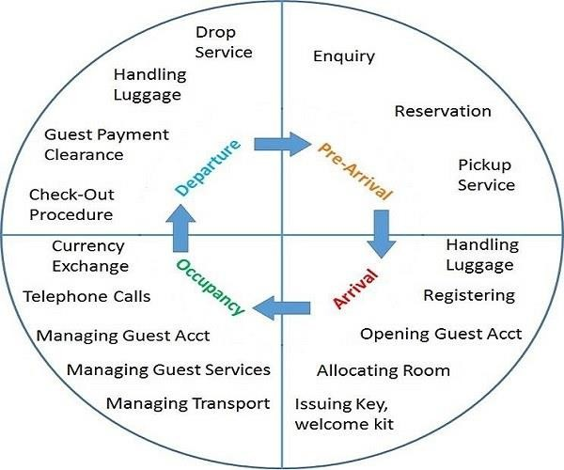

3.3 Organizational Chart for Front Office Department of Hyatt Place Dhaka Uttara:


FO Manager

Lead Host

Driver

Bell Boy

Door Man

Concierge

Female Host

Male Host

3.4 Front Office Interaction with Departments:
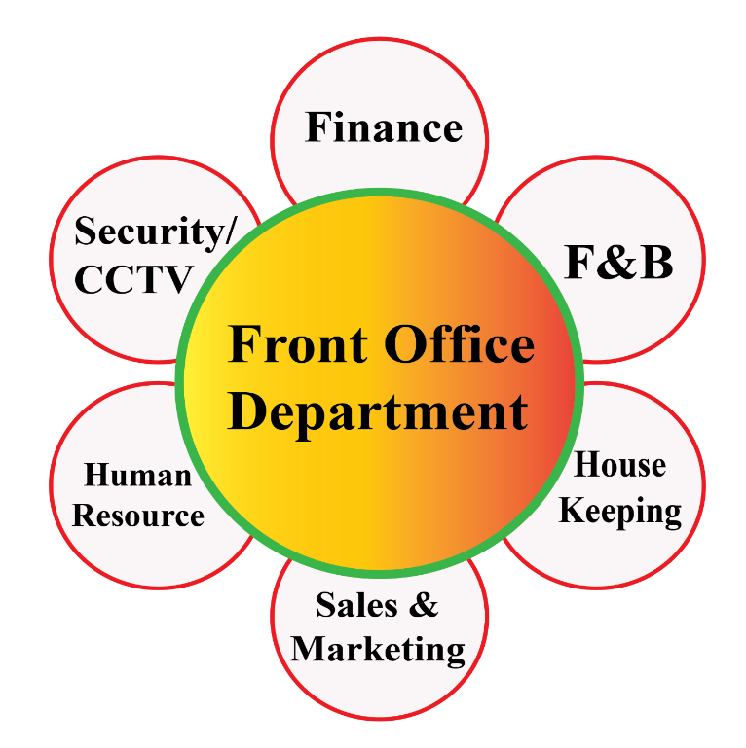
The front desk is like the heart of the Hyatt Place Dhaka Uttara. It has to talk to all the departments. The front desk is very important because it helps the hotel run smoothly. The front desk at the Hyatt Place Dhaka Uttara is in charge of making sure everything works well. The main job of the desk, at the Hyatt Place Dhaka Uttara is to help organize the hotel.

3.5 Relationship between Front Office and other departments of Hyatt Place Dhaka Uttara
- Housekeeping Department
The office and housekeeping team are always in touch about room status and making rooms available for guests right away. They talk about things like:
- Available Clean or Ready. The room is clean and ready for guests
- Occupied. Guests are already staying in the room
- Stay over. Guests will not be checking out today
- On-Change. Guests have checked out but the room is not cleaned yet
- Out-of-Order. The room cannot be used because it’s not working properly
They also talk about reports on how many roomers’ available security issues and requests for extra things like towels or toiletries.
In hotels that don't use a computer system the housekeeping and front office teams meet every hour or two to discuss room status. They also do a report at the end of the day to see which rooms are occupied, vacant or not working.
The housekeeping team uses a report from the office to plan their work and schedule staff. This report shows how many guests are arriving and leaving and helps the housekeeping team plan ahead.
The front office also relies on housekeeping to report any security issues, like doors or extra guests in a room.
When guests request things like towels or toiletries the front office team sends the request to housekeeping right away.
- Food and Beverage Department
The office and food and beverage team also work together. They use forms to communicate, like transfer slips to charge things to a guests account.
They also talk about forecasts of how many guests will be in the hotel and fill out forms for payments made.
The front office team helps the food and beverage team by receiving messages from vendors and industry representatives.
When there are computer systems charges are automatically posted to a guests account. If not, the front office team has to make sure charges are posted correctly.
The food and beverage team relies on the office team for estimates of how many guests will be in the hotel so they can schedule staff and plan sales.
Sometimes the food and beverage team needs to request money from the office team to buy last-minute items for events.
- Marketing and Sales Department
The marketing and sales department at the hotel needs the office to give them information about the guests who stay at the hotel. This includes things like where the guestsre from, how often they visit and if they have any special needs. The front office is also in charge of making an impression on the guests when they first arrive. They have to make sure the guests are happy and that their needs are met when they are at meetings, seminars and banquets at the hotel.

The marketing and sales department uses the guest history to plan their marketing campaigns send out mail and pick the way to advertise. The front office employees have to make sure the database is updated all the time. When the hotel is getting ready for an event they have to make sure there are enough rooms for the guests. The marketing and sales department has to check the list of rooms to make sure they will have enough for the guests.

The hotel uses a system to manage the rooms. The first time a guest talks to the marketing and sales department is usually through the hotel switchboard. The person who answers the phone has to be friendly and know what is going on at the hotel. They have to make an impression so the guest thinks the hotel is well organized. When the guest arrives at the hotel they will usually talk to the staff at the office first.
It is very important that the messages the front office gives to the marketing and sales department are clear and get to them on time. The person who answers the phone is very important for making sure the guest and the sales person can communicate. The front office manager has to make sure all the new employees know who does what in the marketing and sales department.

The front office employees should be able to say the names of all the people who work in marketing and sales. The manager should introduce the employees to the department directors and supervisors and show them pictures so they know who they are. Sometimes guests will ask for things like an extension cord. Help with a broken socket during meetings and banquets.
The front office manager has to make rules for how the employees can talk to departments like maintenance, housekeeping, marketing and sales and food and beverage. This way they can help the guests with their requests. It will save a lot of time if the employees know where to find things like tools, adapters and cleaning supplies. The marketing and sales department needs the office to help them with these things.
The front office is very important for the marketing and sales department. They have to work to make sure the guests are happy and that the hotel runs smoothly. The marketing and sales department uses the information from the office to plan their events and make sure they have enough rooms for the guests. The front office employees have to be friendly and helpful so the guests have an experience at the hotel.

The marketing and sales department and the front office have to communicate and work together. This is the key to making sure the guests are happy and that the hotel is successful. The front office employees have to know how to talk to the marketing and sales department and how to help the guests with their requests. The marketing and sales department needs the office to give them the information they need to do their job.
The front office and the marketing and sales department are a team. They have to work to make sure the hotel is running smoothly and that the guests are happy. The front office employees have to be able to say the names of all the people who work in marketing and sales. They have to know who to talk to and how to get the things the guests need. The marketing and sales department needs the office to help them with their events and to make sure they have enough rooms for the guests.

The hotel switchboard is the point of contact for the guests. The person who answers the phone has to be friendly and know what is going on at the hotel. They have to make an impression so the guest thinks the hotel is well organized. The front office manager has to make sure all the new employees know who does what in the marketing and sales department. The front office employees have to be able to communicate with the marketing and sales department.

The front office and the marketing and sales department have to work to make sure the guests are happy. They have to communicate and make sure they have enough rooms for the guests. The front office employees have to be friendly and helpful so the guests have an experience at the hotel. The marketing and sales department needs the office to help them with their events and to make sure they have enough rooms for the guests.
The front office is very important for the marketing and sales department. They have to work to make sure the hotel runs smoothly and that the guests are happy. The marketing and sales department uses the information from the office to plan their events and make sure they have enough rooms for the guests. The front office employees have to be friendly and helpful so the guests have an experience at the hotel. The marketing and sales department needs the office to give them the information they need to do their job.

The marketing and sales department and the front office are a team. They have to work to make sure the hotel is running smoothly and that the guests are happy. The front office employees have to know how to talk to the marketing and sales department and how to help the guests with their requests. The marketing and sales department needs the office to help them with their events and to make sure they have enough rooms, for the guests. The front office and the marketing and sales department have to communicate and work together
- Banquet Department
The marketing and sales departments and the food and beverages department usually work together in the banqueting department. However, the front office is in charge of talking to the guests about events and making sure they pay for them.
The front office helps plan out the day by making a schedule of activities. This schedule shows what is happening in each room at the hotel and what time it is happening. The same people who make the schedule also put up a sign called the Marquee, outside the hotel. The Marquee has the hotels logo on it and a message.
A lot of times guests who come to banquets are not staying at the hotel. So the front office is a place for them to get information.
In some hotels one person at the office talks to the Marketing and Sales Department to figure out what message to put on the Marquee.
When a guest arrives from outside the hotel they will ask the office where to go. This might seem like a thing but it is really important for the guest who does not know where they are going. The staff at the office needs to be able to tell the guest where to go and what is happening in each room.
The front desk clerk needs to be ready to answer questions, about all the activities happening in the hotel.
The person who is paying for a function will come to the office to take care of the bill. If the banquet captain is not available the front desk clerk will need to know all about the bill, including the cost of food and beverages tips and rental fees. They will also need to know how the person wants to pay.

3.6 Duty Schedule:
The Hotel that works round the clock is Hyatt Place Dhaka Uttara. The duty shift of the employee in Hyatt Place Dhaka Uttara will be 9 hours. I have worked during both morning and evening shifts.

Duty Schedule of Hyatt Place Dhaka Uttara for the Employee:
- Morning Shift: Duty Hours: 07:00 am – 04:00 pm
- Evening Shift: Duty Hours: 02:00 pm – 11:00 pm
- Night Shift: Duty Hours: 11:00 pm – 07:00 am

3.7 Front Office Duty Checklist:
Front office team member must follow the shift duty checklist.
Morning Shift Checklist:
No | Task List | Time
01 | Briefing:  We need to talk about what happened during the shift and the tasks that are still pending. The previous shift is something we should go over. Then we will look at the pending task. This way we can figure out what to do with the pending task, from the shift.  The previous shift and the pending task are the two things we have to discuss. | 07:00 AM
02 | Read the log book and the night shift report. Then do what is necessary to follow up and sign them.  Make sure to check the log book.  Also review the night shift report.  Follow up on any issues. Sign the documents. | 07:10 AM
03 | I need to check what events are happening today. I also have to look at the Group Arrivals and see what is going on with the food and beverage promotions. Then I will share all of this information with the office team so everyone knows what is going on with the events and the Group Arrivals and the food and beverage promotions. | 07:15 AM
04 | . Clean up the desk, for the morning shift.  * Clean the desk.  * Refile the Electronic Data Capture Machine Roll.  * Refile the printers with paper.  * Make sure there is enough room cards and key jackets.  * Have departure envelopes ready. | 07:30 AM
05 | I need to print and save the file for the morning shift. This file includes the same day arrival list and the downtown reports. | 07:30 AM
06 | Check Arrival Today Remarks:  - Arrivals, Individual/ Company/ Group  - Special Guest (VIP, Single Leady Traveler, Honeymooners, Set Weekend).  - Group Arrivals (Print the Registration card in advance, Prepare the room keys, Also Assigned Group Coordinator). | 07:45 AM
07 | Please print Trace report and take necessary actions. | 08:00 AM
08 | Departure Control:  - Control to due outs.  - Approved Late Check out (Complimentary, Chargeable & Extension).  - Communicate with transport for Guest Airport pickup & drop up service.  - Docket Check (Registration Card, CC Slip, Paid out, Pre-auth Cancellation, Transport Bills, F&B Bills. | 12:00 PM
09 | All Host must update the Guest Profile According the Procedure:  ✓ Nationality, Passport/NID/DL Update, Update the Pre-Auth, Address Update according to the Business Card, Any Special Requirements, Background Profile Notes, Trace, Alert, Comments & Preference. | 02:00 PM
10 | Briefing & Training  ✓ Briefing the team for the pending arrivals, Due outs, Any Guest Issues, VIP Arrivals, Event in House. | 02:30 PM
11 | Make Sure there are sufficient collaterals available for the next shift  ✓ Pen, Remittance Envelop, Regular Envelop, New key jacket, Recycle key jacket, Room key, A4 papers, Stapler Pin and Others. | 02:45 PM
12 | Cashier Closing:  - Print out the shift report & do audit properly with POS details, Process cash drop & write down the cashier log book, Fill Remittance envelop with proper Denominations, Drop Foreign Currency If any.  - Follow up with the due backs, drop the cash envelop with the proper witness and must take the signature. | 03:30 PM
13 | Write down all Information to Log Book and Hand Over the next shift | 04:00 PM
Evening Shift Checklist:

No | Task List | Time
01 | Read the Log Book & Morning shift Report and do necessary to follow up & Sign | 02:00 PM
02 | Print and save back up file for evening shift:  - Same day arrival details (All Host must go through the report to meet the guest expectations).  - Downtime reports (Downtime reports must need to be saved in front desk PC in Down time folder). | 02:15 PM
03 | Briefing & Training  ✓ Briefing the team for the pending arrivals, Due outs, Any Guest Issues, VIP Arrivals, Event in House. | 02:30 PM
04 | Organize & clean up the desk for morning shift  ✓ Clean the desk, Refile the EDC (Electronic Data Capture) Machine Roll, Refile the printers with papers, Sufficient room key card and key jacket, Departure envelope. | 03:00 PM
05 | Check Arrival Today Remarks:  - Arrivals, Individual/ Company/ Group  - Special Guest (VIP, Single Leady Traveler, Honeymooners, Set Weekend).  - Group Arrivals (Print the Registration card in advance, Prepare the room keys, Also Assigned Group Coordinator). | 03:15 PM
06 | Follow up if there have any departure left in the system. | 03:30 PM
07 | - Check high balance report and communicate with guest if there have any high balance room.  - Cross check all transactions and posting in the system. | 04:00 PM
08 | All Host must update the Guest Profile According the Procedure:  ✓ Nationality, Passport/NID/DL Update, Update the Pre-Auth, Address Update according to the Business Card, Any Special Requirements, Background Profile Notes, Trace, Alert, Comments & Preference. | 04:30 PM
09 | Taking Signature in all Registration card By DM or other Host who will be available on that time. | 05:30 PM
10 | Make Sure there are sufficient collaterals available for the next shift  ✓ Pen, Remittance Envelop, Regular Envelop, New key jacket, Recycle key jacket, Room key, A4 papers, Stapler Pin and Others. | 09:45 PM
11 | Cashier Closing:  - Print out the shift report & do audit properly with POS details, Process cash drop & write down the cashier log book, Fill Remittance envelop with proper Denominations, Drop Foreign Currency If any.  - Follow up with the due backs, drop the cash envelop with the proper witness and must take the signature. | 10:00 PM
12 | Write down all Information to Log Book and Hand Over the next shift | 10:30 PM

Night Shift Checklist:

No | Task List | Time
01 | Read the Log Book & Morning shift Report and do necessary to follow up & Sign | 10:35 PM
02 | Takeover the cash Float properly from evening shift and sign at cash handover. | 10:45 PM
03 | Print and save back up file for evening shift:  - Same day arrival details (All Host must go through the report to meet the guest expectations).  - Downtime reports (Downtime reports must need to be saved in front desk PC in Down time folder). | 10:55 PM
04 | Organize & clean up the desk for Night shift  ✓ Clean the desk, Refile the EDC (Electronic Data Capture) Machine Roll, Refile the printers with papers, Sufficient room key card and key jacket, Departure envelope. | 11:15 PM
05 | Settle all POS machine. | 11:30 PM
06 | - Check the in-house guest list with rates.  - Check all Guest profile is properly update or not.  - Check all the supporting is attach with folio or not. | 00:00 AM
07 | - Check high balance report and communicate with guest if there have any high balance room.  - Cross check all transactions and posting in the system. | 01:15 AM
08 | Complete the Day End Process. | 03:00 AM
09 | Prepare The Night Manager Report and Send all report to concern Person. | 03:15 AM
10 | - Check Following days Arrival and Departure List.  - Assign Room.  - Check the bills of Departure room. Moreover, make it ready for smooth departure. | 04:15 AM
11 | Make Sure there are sufficient collaterals available for the next shift  ✓ Pen, Remittance Envelop, Regular Envelop, New key jacket, Recycle key jacket, Room key, A4 papers, Stapler Pin and Others. | 05:00 AM
12 | Cashier Closing:  - Print out the shift report & do audit properly with POS details, Process cash drop & write down the cashier log book, Fill Remittance envelop with proper Denominations, Drop Foreign Currency If any.  - Follow up with the due backs, drop the cash envelop with the proper witness and must take the signature. | 06:30 AM
13 | Write down all Information to Log Book and Hand Over the next shift | 07:00 AM

3.8 Front Office Terms
Front Office Terminologies
In order to be effective as a Host in the front desk, it is essential to understand all terminologies related to the hotel industry. In virtually all the hotels and motels in the whole world, these terms are used.
Complimentary: A guest uses a good or service without making any payment for it; hence the term is used.
Do Not Disturb (DND): The visitor asks not to disturb him; he can show that by placing an appropriate sign outside the hotel room. Alternatively, it is denoted by a flashing red light just before entering the room.
Due Out: The Visitor anticipates leaving the next day.
Late Check Out: This is when a visitor stays longer and leaves after the check-out time of 12:00 pm.
Occupied: This means there is a guest, in the house.
Out of Order (OOO): This means that due to some maintenance problem, it cannot be sold.
Sleep Out: It is a visitor staying in the room but not using the bed.
Stay Over: Both residents and prospective visitors are planning to spend one additional night.
Inspected: The room has passed the test of inspection and is clean for reuse.
ADR: The daily rate is calculated based on the total amount of revenue earned.3.8

3.9 Check in and Reservation Process:
Hyatt Place Dhaka Uttara utilizes Opera PMS system for daily transactions. Input the information of the guest in the reservation system. Three minutes on average are needed for the completion of the check-in process. The normal check-in process follows below:
1. Greetings:
Good. Morning or Afternoon or evening.
Welcome, to Hyatt Place Dhaka Uttara. If you have been here before then welcome back to Hyatt Place Dhaka Uttara it is good to see you at Hyatt Place Dhaka Uttara.
We need to see your NID or your passport so we are requesting that you show us your NID or your passport.

2. Acknowledge:
- Check all the alerts.
- Notify visitor of his/her reservation.
- Double-check guest's room number, room type, and departure date.
3. Register Guest to Card:
- Request confirmation of reservations' details.
- The guest needs to sign their registration card. We have to make sure the guest has filled out and signed the guest registration card.
4. Collect Payments:
- Follow the billing instructions that we have. The billing instructions are very important. We need to follow the billing instructions.
- Inform them about our policy when they ask for pre-authorization for something. Our policy is in place for a reason. We have to inform them of our policy when they are requesting pre-authorization.
- When they only want to pay for the room charges, we need to lock the folio. We have to put up a no post flag. This is what we do when they only want to pay for the room charges. We lock the folio. Put up a no post flag, for room charges.
5. Give Guest Key Card:
- Wishing them a pleasant stay.
- Tell them about the facilities available like discounts, stores, and promotions.

Guest Reservation Data:
  - Complete name of guest.
  - Address.
  - Date of arrival.
  - Phone numbers.
  - Room price.
  - Code of room price.
  - Preference of the customer.
  - Payment methods.
  - Rules and regulation of the hotel.
  - Time to check out.
  - Details of the company.
  - Copy of the passport and visa/National Identity card.

3.10 Payment Methods:
Guest has some payment methods to pay for services. The payment methods have been discussed below:
  - Cash.
  - Online/ offline card payment.
  - Bank transaction.
  - Mobile transaction.
  - Payment from city ledger/ company.

3.11 Front Office Team Member Should Know:
These are the basics of the roles that one must know being a front office team member.
  - These are the basics of the responsibilities of a member of the front office department.
  - The ability to use the PMS-software effectively.
  - The use of the color and system printer.
  - The proper usage of the extension and telephone.
  - The use of photocopiers and replacement of toner.
  - The knowledge of SOPs (Standard Operating Procedures).
  - The ability to make elevator keys and room keys.
  - The process of pre-registration and scanning of passports into the database.
  - The use of POS (Point of Sale) systems for making payments.
  - The handling of groups during check-in.
  - The help provided to guests with special needs regarding transport and flights.
  - The answers to visitors' queries.
  - The handling of agitated, intoxicated, and ill-mannered guests.
  - The provision of security and privacy to visitors.
  - The knowledge of terminology for courtesy call, wake-up calls, and answering phone calls.
  - The receipt of housekeeping updates regarding the condition of your room.

Chapter 4: Work Experience

4.1 Introduction
I worked at Hyatt Place Dhaka Uttara in the Front Office Department. This department is where guests first interact with the hotel. I helped guests. Performed daily tasks. I learned how to handle guest requests, check-ins and check-outs.

4.2 Position, Duties and Responsibilities
My boss was Assistant Front Office Manager Mr. Gautam Sarkar. My main job was to welcome guests. I helped with check-ins and check-outs. I also answered questions from guests.
I used the hotels computer system to manage reservations. The hotels computer system was really helpful for this task. I worked with hotel departments like housekeeping and concierge. This was part of my job, at the hotel.
I helped with luggage. Made sure guest information was correct. I focused on being friendly and efficient. I followed hotel rules like answering phones and knowing what to do in an emergency.

4.3 Training Received
I got training on the job and in a classroom. I learned about Hyatt Place, the hotel layout and front office tasks. I learned how to use the Opera computer system to make reservations and manage guest bills.
I learned how to upsell, like offering room upgrades. This means I can give people a room. My supervisors gave me feedback, which helped me get better at upselling and offering room upgrades. The feedback, from my supervisors was really helpful. I kept working on upselling and offering room upgrades.

4.4 Contribution to Departmental Functions
I helped the team by doing tasks. I checked in guests quickly which reduced waiting times. I helped prepare reports on room occupancy and reservations.
I organized reservation documents and paperwork. I shared guest feedback with the team. This helped us improve our service.

4.5 Evaluation of Working Performance
My supervisors reviewed my performance regularly. They liked my efficiency and accuracy. They said I was polite and professional.
They suggested I improve my communication with guests who speak languages. I became more confident in using the computer system. I became more confident in handling guest requests at the same time.I used the things I learned in school. I applied the things I learned in school to my job.
The computer system and the things I learned in school really helped me. I saw how the room rates for the hotel change when the demand for rooms is high or low. The room rates change based on demand, for the rooms and the computer system helps with this.

4.6 Application of Academic Knowledge
I applied what I learned in school to my job. I saw how room rates change based on demand. I learned about customer relationship management.
Communication skills I learned in school helped me interact with guests and colleagues. My knowledge of office operations helped me perform tasks effectively.

4.7 New Skills Developed
I developed interpersonal skills. I became confident in using the Opera computer system. I improved my communication skills.
I learned hospitality phrases in Bengali and Hindi. I improved my ability to multitask and handle guest requests. I became more culturally aware and patient.
I developed problem-solving skills like finding a room for a guest. I improved my time-management skills during periods. These experiences increased my confidence. Prepared me for a career, in hospitality.

Chapter 5: Recommendations and Conclusion

5.1 Introduction
I have been working at Hyatt Place Dhaka Uttara for a while now. The front office operations at Hyatt Place Dhaka can be improved in a way. First Hyatt Place Dhaka should have training programs all the time. This way the staff at Hyatt Place Dhaka can get better at talking to guests and providing service. They can also learn how to use the hotel systems at Hyatt Place Dhaka.
If the front office and housekeeping and other departments at Hyatt Place Dhaka work together closely we can get rooms ready for guests faster. This will make the guest service at Hyatt Place Dhaka better.

Using tools can make things easier at Hyatt Place Dhaka. For example, automated reporting systems can make managing reservations and daily reports at Hyatt Place Dhaka faster and more accurate.
We should. Analyze guest feedback at Hyatt Place Dhaka regularly. This will help us find out what we are doing wrong at Hyatt Place Dhaka. Then we can make the guest experience, at Hyatt Place Dhaka better.

5.2 Recommendations for Improving Front Office Operations at Hyatt Place Dhaka
To make the front office operations at Hyatt Place Dhaka Uttara even better we need to help the staff get better at working with departments and using technology. Training programs will help the front office staff at Hyatt Place Dhaka get better at talking to guests providing service and using hotel systems.
The staff at Hyatt Place Dhaka will be able to help guests in a way. If the front office, housekeeping and other departments work together closely we can reduce delays in getting rooms ready and make the guest service better. This will make guests at Hyatt Place Dhaka very happy.
The Hyatt Place Dhaka can really improve by using some tools to manage reservations and daily work. This will help them get things right. The management team at the Hyatt Place Dhaka should also collect feedback from guests. They need to look at this feedback and figure out what the Hyatt Place Dhaka is doing wrong. Then the Hyatt Place Dhaka can make some changes to make the experience better, for guests.
Here are some ideas to improve things:
- We should use Digital Check-In at Hyatt Place Dhaka. This means using a contactless or mobile check-in system and keyless entry. Guests want a tech-driven experience. This will reduce crowds at the desk. Make guests happier.
- We should give staff training on how to talk to guests, sell services and be sensitive to cultures. We can use tools to teach them about hospitality. For example, we can teach them how to sell services to increase revenue and how to be kind on the phone.
- We should teach staff languages like Urdu and Arabic to serve guests from India and the Middle East. We should also make sure the concierge and front desk staff know about attractions and transportation.
- We should monitor the office performance. We can use metrics like check-in time number of services sold and guest happiness. This will help us see how efficient and good the front office is.
- We should always look for ways to improve office processes. For example, we can make the shift change procedure better. We should also have plans; in case something goes wrong.
- We should use technology to make the guest experience personal.

5.3 Recommendations for Improving Personal/Professional Performance
I want to be good at my job at Hyatt Place Dhaka. So I need to keep learning. I want to get better at talking to people using computers and solving problems. This will help me at Hyatt Place Dhaka. I also want to improve my English and learn languages. This way I can talk to guests from countries when they come to Hyatt Place Dhaka. I am interested in learning more about the systems we use to manage the hotel and the technology we use at the office. This will help me do my job faster and better at Hyatt Place Dhaka. When it gets busy at Hyatt Place Dhaka, I will try to do things at the same time and manage my time well. My goal is to keep learning and getting better at my job at Hyatt Place Dhaka. I know I can do my job well at Hyatt Place Dhaka. I want to make the service better at Hyatt Place Dhaka and become a hospitality person. I will do this by taking training asking for feedback, from others and working on myself. Here are some ways I can do this:
- Continuous Learning: I want to get better at my job so I will take some hospitality courses. Get certified. I can do this by taking classes or workshops. This will help me learn things like how to use the property management system and sell upgrades to guests.
- Skill Development: I will work on speaking and listening in languages. I can use apps to learn at home. This way I can talk to guests from countries. I will also ask my coworkers for feedback. This will help me give service.
- Professional Networking: I will attend hospitality events. These can be trade fairs or seminars. I want to meet people, in the industry and learn what is new.
- Time Management: I need to get better at doing things at once. I will focus on what guests need. When I have a moment, I will do tasks like logging feedback and updating guest info. This will help me work efficiently.

5.4 Conclusion
This report looked at the hospitality sector in Bangladesh, what Hyatt Place Dhaka Uttara does. My experience working at the front office in detail the hotel business is really going to grow a lot. There are some problems with rules and buildings. Hyatt Place Dhaka Uttara is a spot for business travelers. It has everything you need.

I learned at my office job that having skills like computer communication and adaptability is crucial. These skills help when things change suddenly. The hotels’ location is convenient. It offers amenities for work travelers. Being able to adjust plans quickly is important. Computer skills are also essential. Hyatt Place Dhaka Uttara has a location. It is suitable, for people who travel for work. Hyatt Place Dhaka Uttara has a lot of things that business travelers need. I think that the front office, at Hyatt Place Dhaka Uttara is a place to work on these skills. By using technology to improve service and training staff Hyatt Place can make the front desk operations better. For me this job helped me connect what I learned in school to life which was very valuable, for my professional development. Overall being committed to providing service and always learning will help both Hyatt Place and me succeed in the competitive hospitality industry.

References
- Upturn, Insights on the Hotels & Accommodations Industry (Bangladesh) (2024) – projected industry revenue and growth.
- The Daily Star, “Tourism picks up as hotels, resorts report 60% occupancy” (14 Dec 2025) – hospitality statistics, GDP and employment share
- Sabbir Ahmad, “Our tourism needs a policy reset” – commentary on Bangladesh tourism’s economic impact and challenges.
- Mahfuz Hosen, Tourism Reports in Bangladesh 2025 (Jan 2026) – tourism contributions to GDP and government initiatives.
- OGR Legal, “Bangladesh introduced new law for hotel and restaurant” (Nov 2014) – details of the Bangladesh Hotels & Restaurants Act 2014.
- Tahmidur Rahman Law Firm, Hotel and Tourism Business in Bangladesh – overview of licensing and regulatory requirements (e.g. hotel licensing by MoCAT/DC).
- Sourav Bin Hussain, The Future of Bangladesh’s Hospitality Industry: Promise, Challenges & Opportunities (2025) – LinkedIn post on market size and workforce challenges.
- TravelPress (Mar 2024), “Hyatt adds 8 new hotels in India & Southwest Asia” – announcement of Hyatt Place Dhaka Uttara, first Hyatt in Bangladesh, 85 rooms.
- Alan Woinski, Skift: Hyatt Opens First Bangladesh Hotel in Dhaka (Nov 2025) – details of the hotel’s opening, room types, and amenities.
- Bangladesh Monitor, “Hyatt opens first hotel in Bangladesh” (Nov 20, 2025) – target markets (business/leisure), location and features of Hyatt Place Dhaka Uttara.
- Hospitality Career Profile, “India, UK and USA Tourists Flock to Bangladesh” (Feb 17, 2026) – trend of rising international arrivals and opportunities for hotels.
- SafetyCulture Training, “12 Essential Front Office Training Topics for 2025” (Jan 2025) – recommended skills such as customer service, upselling, and safety protocols.
- Lynx (Aug 2025), “Hotel Contactless Check-In: Eliminate Front Desk Delays” – discusses the necessity of digital check-in and mobile access for guest satisfaction.
- Business Inspection BD. (2023, January 25). Top 7 hospitality management company in Bangladesh. https://businessinspection.com.bd/top-hospitality-management-company-in-bd/ (Accessed On- 29/08/2024)
- Tourism and hospitality management education in ... (n.d.-c). https://pust.ac.bd/uploads/pust-journals/pdf/1676916166.pdf (Accessed On- 30/08/2024)
- Colcol, S. (2024, May 23). Hotel strategies to effectively increase revenue. SiteMinder. https://www.siteminder.com/r/hotel-distribution/hotel-revenue-management/strategies-increase-hotel-room-sale (Accessed On- 31/08/2024)

