The Impact of HRM Practices on Bank Performance in some Selected Commercial Banks in Mogadishu, Somalia
This report is submitted as partial fulfillment of the degree of
MBA & MIHRM Programs, UIU

Submitted To
Piana Monsur Mindia
Assistant Professor
School of Business & Economics

Submitted By
Name: Hassan Mohamed Hassan
ID No 115202015



School of Business & Economics
United International University

Date of Submission
January 2022

STUDENT DECLARATION

I declare that my dissertation submitted to the United International University entitled (the impact of hrm practices on bank performance) is the result of my own research except as cited in the references for the Degree of Master in IHRM. I also declare that this is my original work and has never been presented in any other degree for other universities or for any other reward.

Name of the candidate:
Signature: ……………………………..

Date:…………../…………/…………../

SUPERVISOR APPROVAL

I hereby declare that I have read this thesis and in my opinion, this senior project is sufficient in terms of scope and quality for the awarding department of (School of Business & Economics) master in international human resource management and I accepted for the submission to the examining panel.

Name:

Signature: ____________________________________ ____
Date: _________/__________/__________

DEDICATION

I dedicate this thesis to my beloved Mother and father for love, my wife’s encouragement, and support throughout my life during my study. I also dedicate it to all my family members who encouraged me in my studies and enriched my knowledge during the education field. My Love my sister who supported me in my education until when I was young thank you so much. Specially thank my beloved classmates for their encouragement and support in my way of data analysis.

ACKNOWLEDGMENTS

First of all, I would like to express my gratitude to ALLAH who provides me great health, strong and emotional self-support, knowledge, the financial and moral integrity of competing for the first degree that could not be reached without Allah’s Almighty.
It is with great appreciation for me that I have knowledge of the contribution and the support in the completing of this dissertation to my Supervisor Ms. Piana Mansour Mindia Assistant Professor, whose time, effort, and support guidance were highly beneficial during my long journey to the dissertation completion.
I would like to pass a special thanks to my beloved parents who have sacrificed for me with their encouragement and emotional self-support that could not be fulfilled without their encouragement pressure behind my success.
I also would like to thank here gratefully my fellow friends who sacrificed their time and assisted me to reach and prepare this thesis. I also thank all my friends and my classmates for their encouragement and cooperation during my long journey to prepare a research topic.
Finally I thank all the respondents for their sacrifice for me to allow them to distribute and fill the questionnaire I distributed, their time, and emotional voluntary fulfillment of the questionnaire.

ABSTRACT

The study's major goal is to In a few selected commercial banks in Mogadishu, Somalia, assessing to obtain a practical grasp of HRM practices and their impact on bank performance. Three main objectives guided this: to determine the impact of hiring on the success of a few selected banks commercial banks in Mogadishu, Somalia; to assess the effect of recruitment on bank performance of some selected commercial banks in Mogadishu, Somalia; and to assess the effect of recruitment on bank performance of some selected commercial banks in Mogadishu, Somalia. The goal of this research was to see how the impact of training studies on the operation of a few commercial retail banks in the United States in Mogadishu, Somalia. The purpose of this study was to look at the impact of compensation on the performance of a few Mogadishu, Somalia: selected banking sector.

To characterize the features of the survey, this research utilized a descriptive design and a key here is to make to measure the central tendency of the questions. The study has a population of 100 intellectuals in Mogadishu City as a case study. The study included an 80-person sample size that was chosen from the target demographic. The aims of the study, as well as the study's dependent variable, were used to support the argument. This demonstrated the impact of HRM practices on bank performance. The findings revealed that assessing the economic determinants linked to the impact of the judgment on bank profitability is significant. The researcher recommended service providers ta great responsibility in the improvement of the public finance relations and banking performance welcoming. Economic status management should also research the system of the banking needs and the make best possible economic determinants improvement. It also recommended to economic sectors combat the household financial factors in order to be capable of providing effective HRM on banking Performance. The equilibriums how to fight with the challenges and management depressions and quality performance and even supporting with incentives and other facilities to the employees. This will create an opportunity to develop banking system promotion. All these were aimed at meeting the basics of the societal conditions and other means of life and bank performance.

Contents
STUDENT DECLARATION I
SUPERVISOR APPROVAL II
EXAMINING PANEL APPROVAL III
DEDICATION IV
AKNOWLEDGEMENTS V
ABSTRACT VI
CHAPTER ONE-Introduction of the report 1
1.1 Origin/ Background 1
1.2 Scope of the report 2
1.3 Objectives of the report 2
1.4 Methodology and Material of the Report 2
1.4.1 Type of data: 2
1.4.2 Data Collection Process: 3
1.4.3 Sample Size 3
1.4.4 Sampling Techniques: 4
1.4.5 Area and Time of Research 4
1.5 Limitations of the Desertion Report 4
CHAPTER TWO 5
LITERATURE REVIEW 5
2.0 Introduction 5
2.1 Concept of Human Resource Management practice 5
2.1.1 Recruitment 8
2.1.2 Training 10
2.1.3 Compensation 11
.2.2 Bank Performance 13
2.3 Empirical Review 14
2.4 Research Gap 17
CHAPTER THREE 18
AN OVERVIEW OF SEVERAL PRIVATE BANKS OF SOAMLIA 18
3.1 Dahabshiil: 18
3.2 INTERNATIONAL BANK OF SOMALIA (IBS): 20
3.3 SALAAM SOMALI BANK: 22
3.4 PREMIER BANK: 23
3.5 AMAL BANK: 24
Chapter 4 27
HRM practice Bank performance of Mogadishu Banking Sector 27
4.1 Training and Development Function 27
4.2 HR Policy and Planning Function 27
4.3 HR Payroll and Benefits 27
4.4 Creating a planning for HRM practice 28
4.5 Setting HRM practice standard 29
4.6 Carrying out HRM practice 29
4.7 Measure and compare HRM practice with standard 30
CHAPTER FIVE 31
ANALYSIS AND FINDIGIS 31
5.0 INTRODUCTION 31
5.1 DEMOGRAPHIC INFORMATION OF THE RESPONDENTS 31
Table 5.1.1 GENDER OF THE RESPONDENTS 32
Table 5.1.2 AGE OF RESPONDENTS 33
Table 5.1.3 MARITAL STATUS OF RESPONDENTS 34
Table 5.1.4 EDUCATIONAL LEVELS OF RESPONDENTS 35
Table 5.1. 5 EXPERIENCES OF RESPONDENTS 36
5.2 DATA PRESENTATION AND ANALYSIS 38
5.2.1 OBJECTIVE ONE: RECRUITMENT 38
Table 5.2.1.2 Showing summary statistics results on Respondents Ratings of recruitment 39
Figure 5.2.1: Histogram showing normal distribution of respondents’ rating on Recruitment 40
5.2.2 OBJECTIVE TWO: Training Programs 41
Table 5.2.2.2: Showing summary statistics results on Respondents Ratings of Training Programs 42
Figure 5.2.2.1: Histogram showing normal distribution of respondents’ rating on Training Programs 43
5.2.3 OBJECTIVE THREE: 44
Table 5.2.3.2: Showing summary statistics results on Compensation 45
Figure 5.2.3.1: Histogram showing normal distribution of respondents’ rating on Compensation. 46
4.2.4 DEPENDENT VARIABLE: BANK PERFORMANCE 47
Table 5.2.3.2: Showing summary statistics results on Bank Performance 48
Figure 5.2.3.1: Histogram showing normal distribution of respondents’ rating on Bank performance. 49
5.3 REGRESSION MODELS 50
5.4 CORRELATION ANALYSIS 51
CHAPTER SIX 53
CONCLUSION AND RECOMMENDATIONS 53
6.0 Introduction 53
6.2 Conclusions 53
6.3 Recommendations 53
6.4. Further Research 54
REFFERENCES 55
QUESTIONAIRE 60

CHAPTER ONE-INTRODUCTION OF THE REPORT

1.1 Origin/ Background
All managerial functions involved in planning for recruiting, selecting, developing, utilizing, rewarding, and maximizing the potential of human resources in a business are referred to as human resource management (Franklin and Byrd, 1995). Selection, job definition, training, performance appraisal, compensation, career planning, and fostering employee engagement in decision-making are all examples of human resources management (HRM). Human resources, as both a labor force and a corporate function, have long been regarded as a cost to be cut and a potential source of efficiency benefits. HR choices are rarely viewed as a source of value creation, or what Hamel and Praha lad (1994) referred to as "numerator management." Labor expenditures continue to be the single highest operational cost in many firms (Saratoga Institute, 1994), and job cuts are a key component of restructured operations and cost-cutting measures (e.g., Uchitelle&Kleinfield, 1996).
Do these choices add value or just save money? The challenge, empirically, is to discern between staffing reductions that are strictly cost-cutting measures and restructurings that require fewer employees but create value because the new structures are better suited to the firms' specific strategy.
According to research, HR systems offer significant economic potential, but there is no agreement on how to realize that potential. Apart from strategically designing a company's HR system, there appears to be no best practice magic bullet. As a result, a set of properly aligned HR policies that solve business challenges and support the firm's operating and strategic ambitions must be the primary emphasis of both the HR system and the HR function.
Unfortunately, there is no industry HRM guideline in Somali banks that directs the human resource practices and policies that they use. As a result, each Somali bank has established its own set of HRM procedures. Policies. This indicates that there is a strong desire to continue re-examining the best HR practices in terms of their impact on Bank performance. As a result, the purpose of this study is to look into the impact of HRM practices on bank performance in Mogadishu, Somalia, namely in the areas of recruitment, compensation, and training. In United International University students of BBA program has to submit Desertion report for the completion of their graduation program. It is a mandatory requirement and also contains three hours’ credit course. Thereafter, for the submission of the Desertion report I have selected the topic titled “The impact of HRM practices on Bank performance in some selected commercial banks in Mogadishu Somali”.

1.2 Scope of the report
The purpose of this study is to learn more about a practical understanding of HRM practices and their impact on bank performance in a few selected commercial banks in Mogadishu, Somalia. I was able to learn about the human resources management and procedures of numerous banks as a result of performing this research. This research aids me in deepening my knowledge and connecting the theoretical and practical aspects of the Performance Appraisal System.

1.3 Objectives of the report
The report's main goals are to learn more about the impact of HRM practices on Bank performance in some selected commercial banks. Other specific objectives are as follows:
- To determine the impact of Recruitment on Bank performance of some selected commercial banks in Mogadishu Somalia.
- To identify the effect of Training programs on Bank performance of some selected commercial banks in Mogadishu Somalia.
- To investigate the effect of Compensation on Bank performance of some selected commercial banks in Mogadishu Somalia

1.4 Methodology and Material of the Report
To develop this Desertion, I have collected data from two sources such as:

1.4.1 Type of data:
- Primary sources of data: I went to many commercial banks and had a facial expression meeting with the industry of the Human Resources Managers, as well as junior and senior workers. These forms of information were gathered through a survey questionnaire.
- Secondary sources of data: I collected information for the study's continued development from the banks' websites, past research articles, journals, books, and lecture notes.

1.4.2 Data Collection Process:
The research efforts in any Desertion become increasingly focused - in terms of data needed to answer the research questions - as they progress from broad to specific research inquiries. As a result, data gathering questions are among the most crucial in any study project.
The researcher was following particular processes when collecting data. To begin, the researcher was write an application letter to all of the respondents in the target sample, explaining the aim of the study and gently requesting that they spend their period of time to honestly answering the questionnaire.
The investigator would next contact the participants and give them the survey questionnaires. The study next gave the respondents extra time to thoroughly read and complete the questionnaire. Lastly, the study began collecting questionnaires distributed from them as soon as they were finished.

A survey questionnaire was having been created for the preparation of the Desertion report, with all of the questions being relevant and structured. Only the questionnaire was be used. This well-structured questionnaire made it easier for respondents to react swiftly. Total respondents were recruited from several banks in order to collect data.

1.4.3 Sample Size
In order to determine the require sample size, Slovenes’ formula was be used.
N
n =
1+ N (e) ²
Where
n = required sample size
N = target population
e = standard error
100
n =
1+ 100(0.05)²

n = 80

1.4.4 Sampling Techniques:
During sampling, the research was use non probability sampling which means to select study participants intentionally. In this type of sampling, the researcher is the one to decide who was participating the study and who was not. The target population was not having an equal chance to participate the study.

1.4.5 Area and Time of Research

- Geographical scope
This study was be conducted in Salam bank, Dahabshiil, International Bank of Somalia (IBS), Amal bank and Premier bank in Mogadishu Somalia.
- Time Scope
The study was be conducted from Sep 2021 to Jan – 2022

1.5 Limitations of the Desertion Report
This study has a number of flaws that may have an impact on researchers working on it. These flaws include: This study's research instrument was a questionnaire solely, rather than a questionnaire plus an interview, and another drawback of this study is that it employed a questionnaire that took time to modify. The study's geographical scope was limited to Mogadishu. Future research should encompass a broad geographical reach, according to potential researchers.
Additionally, the researcher encountered linguistic barriers because some of the respondents were unfamiliar with the thesis written language, which required the researcher to spend time translating the phrases into their native tongue.

CHAPTER TWO

LITERATURE REVIEW

2.0 Introduction
This section summarizes the research that has been done on the topic HRM practice on Bank performance. It then reviews previews empirical studies on the subject. The final part provides a Research Gap.

2.1 Concept of Human Resource Management practice
Despite the fact that it is often used considered that human resource management (HRM) approaches emerged with the fact is that the industrial revolution HRM techniques have been around for a long time. Its roots in the past. People Work was distributed throughout ancient cultures within the equal manner that personnel in the tasks that required to be completed in modern businesses were shared As a consequence, work division is thought to be have existed before the dawn of time. Despite the fact that jobs were assigned based on skills like gathering food or greenery, tuning livestock, or cooking (price, 2007), the industrial revolution in the 1800s had the largest impact on the creation of HRM systems.
Depending on how you define human resource management, your dreams may differ. HRM aims may vary based on the study's perspective, as the definition of HRM differs from one to the next. The overall purpose of management of human resources.
"It is to ensure that the firm is able to achieve success via people," writes Armstrong (2009, p.8). "HRM techniques try to help programs increase organizational effectiveness by introducing policies in areas like knowledge management, talent management, and generally providing a 'great place to work,'" he noted.
“Hr. department are something that can be specified. as "the people a corporation hire to do various jobs, obligations, and responsibilities in exchange for pay and other benefits. (DeNisi and colleagues, 2005). Administration of Hr Department is defined as "the process of acquiring, training, evaluating, and rewarding people, as well as attending to their labor relations, health and safety, and justice concerns" by the American Society for Human Resource Management (Dessler 2013, P.3).
Human resource planning (HRM) has been widely used as a technical word, in seminars courses, business manuals at universities and colleges, and as the title of faculty positions, ever since mid-1970s (Huselid, 1995). HRM is seen as a strategic asset, and studies demonstrate that HR policies and procedures are a key source of a company's competitive edge because they are difficult to reproduce.
Management of human resources, according to experts, is the most important managerial role in any firm, regardless of the industry (Batti, 2014). It has much to offer conducive environment for business success. "A method that enables organizations to recruit, choose, and develop employees within the business agency," describes human resource management.
People management management (HRM) is a method to human employment and development that is comprehensive and well-coordinated. Human resource management (HRM) is a philosophy determined by a variety of attitudes on how people should be managed in individual and material behavior It is concerned with both the moral dimension – how people should be treated per a range of moral rules – and the role it can play in improving organizational success through people. Taylor and Armstrong are two of the most well-known musicians in (Armstrong & Taylor, 2014).
(Vincent & Joseph 2013) define human capital administration as a "control position within organizations concerned with individuals and their work relationships." Human aid management refers to the management of an agency's group of personnel, or human resources (O'Brien, 2011). (HRM). It's in charge of attracting, recruiting, educating, comparing, and paying personnel, as well as overseeing organization strategy and cultures and ensuring labor law compliance.
HRM is also defined as management's use of human beings' efforts, knowledge, abilities, and dedicated behaviors to perform work duties in a way that allows the company to keep workers in the future holds of an authoritatively organized human labor market employer (or extra transient contractual arrangement). Watson and his associates (2010).
Actions taken by an organization to deal with a stock of people projects and improve that those assets are used to achieve organizational objectives Human resource planning (HRM) is described as "the management of human resources" (Tiwari & Saxon, 2012, p. 671). According to (even as & Ling, 2012), human resource methods may be classified into numerous categories, including recruiting, selection, training and improvement, motivation, and renovation. And they're in charge of duties such as recruitment, interview, hiring, and training, all executives are human capital managers in some sense. Regardless, the majority of companies have HR departments with their own top executives (Dressler, 2013).
The organization can employ a number of different HR procedures. Recruiting, selection, education, development, and performance evaluation are all HR procedures that contribute to the bottom line of a So that firms may make long-term commitments to keep their people, they ought to be consistent, unified, and competitively driven the year 2013 (Choudhary & Lamba).
Academic institutions in HR use the phrase "strategic HRM" to emphasize their conviction that effective HRM is important for an organization's growth. HR professionals who collaborate closely with line managers and have a say in business policies have the best chance of succeeding. Many HRM researchers agree on the basic truths of "strategic HRM." Despite the fact that the definition of strategic HRM has evolved over time, across cultures, and as a reflection of strategic HRM educators' different disciplinary identities, the sector is united by the belief that study that treats the different activities involved as an integrated Approach device that generates good outcomes once designed properly and connected to the larger context can yield new insights into managing people at work.
Diverse human assistance strategies, whether employed in my opinion or as a tool, have been shown in various research to have an immediate and direct effect on the firm's male or female and group results, either used during mine view or as an instrument (Becker & Gerhart, 1996 and Jiang et al., 2013).
As a result, empirical research has attempted to link human resource strategies to corporate goals such as improved overall performance and satisfaction (Becker & Huselid, 1998, Delaney & Huselid, 1996 and Huselid, 1995). According to several studies, hr. policies may have a positive impact on organizational success through influencing employee behavior.
As a result of these workers' improved performance, satisfaction, and drive, individual and/or group larger firms (Becker & Huselid, 1998 and Guest, D. E., 2011).
Although some research (Guest, et al., 2003) did not fully support these positive associations, their results are consistent with the broader premise that human resource exercises improve staff performance and have good benefits on both individual and collaborative performance measurement (Jackson et al., 2014).
"A comprehensive set of managerial activities and duties connected to the growth and safeguarding of a competent workforce" is how strategic human resource management (SHRM) is described. This group of people contributes to the organization's strategic goals, which define its success. “Strategic human resource management takes place within the organization in a complicated and changing environment. Human resource managers are gradually taking a thoughtful plan to their employment, recognizing important connections among administrative and institutional resource objectives (Fettle et al., 2010)
Again for reasons outlined above, personal assistance control mechanisms are projected to be consciously tuned for tremendous work practices in the future (selective staffing, in depth education, energetic employee involvement, a complete overall performance assessment, and overall performance-related incentive systems). Personnel could be motivated to involve in attitudes and behaviors that promote higher total personal and collective achievement (preferential staffing, in-depth education, active worker involvement, a comprehensive performance assessment, and performance-linked incentive structures), and members of staff might be encouraged to participate in attitudes and behaviors that promote higher overall personal and collective achievement (selective staffing, in-depth education, active worker involvement, a comprehensive performance evaluation, and performance-linked incentive structures) (selective staffing, in-depth education, active worker involvement, a comprehensive performance assessment, and performance-linked incentive structures).

2.1.1 Recruitment
Human resources planning is the relationship between a strategic direction of the organization and the role of human resources planning within it. The strategic plan can be used by human resource management to recruit, attract, train, and retain employees. Al Salem, 2010. The establishment of a very well strategic policy that includes operations and other administrative responsibilities handled by the hr department, such as employee recruiting, training, and development, is required for strategic planning. This entails gathering exact, accurate, and sufficient information in order to make informed decisions. Take into account the company's long-term performance. (P. 48 in Joudeh et al., 2010).
Recruiting is defined by (Umpires et al., 2007) as the procedure through which candidates choose their positions. Organizational aspects such as rank, work atmosphere, and prestige, and also compensation such as performance-based salary, benefits, and incentives, all attract friends to participate a company.
According to this, every company's primary goal in human resource planning is to build a specific human capital development strategy that is connected with the firm's economic growth goals. HR planning lays out the goals and strategies for attaining an organization's goals, such as attracting the right amount of people with the right skills, expertise, and talents.
The worker picks the firm in 2 methods, while the business chooses the worker in the other. It's a process that connects job seekers with employers. It's a method of ensuring that the appropriate individuals are present at the right time. Recruiting and selection costs are always a factor to consider in any company. 2011 (Fening and Amara).
According to the definition of recruiting, "the process of building a pool of capable applicants to apply for employment with a corporation" (Bratton & Gold, 2012). Another definition of recruiting is "candidate pools that provide sources of candidates as well as information on the job's criteria and incentives to applicants." (Photo courtesy of Heneman and Malinowski) (200) Social resource planning is the process of integrating a group's human resource needs into its strategic plan in order to ensure that personnel are adequate, qualified, and competent to meet the goals and overall mission of the business. It was a critical organizational component for maintaining a competitive edge in a rapidly changing environment while also reducing employee attrition. One of the most important jobs for a group's survival and growth is planning staff succession to assure the availability of the right number and type of employees at the appropriate right time in the right position.
Planning is the process of identifying potential successors for certain roles as well as relevant prospects for individuals currently employed in the company. 2014, Bhagul Once a year, planning was done. Senior management routinely does this to meet their commitments to shareholders without involving intermediate management or the board of directors.
Recognizing their requirements Planning, on the other hand, must be more than a list of who will succeed who; it should be first and foremost define the outside context within which future staffing and selection will take place. It should include details about the company's future architecture and scale, as well as any potential job positions. 2014, Bhagul International competition in terms of corporate size and complexity, changing attitudes, career concerns, and workforce structure—all of these, as well as a variety of other factors—have rendered the previous approach to human resource management obsolete
A more comprehensive, strategy is an approach to recruiting, acquiring, and maintaining skilled human capital is essential to keep up with current trend. Management of human resources isn't any more a job that can be assigned. HR should be incorporated into a competitive strategy because it involves long-term investment decisions. Employees are important stakeholders, and management must provide for them.
That year 2005, there were (Pattanayak). The nature of the work and how managers arrange it have an impact on human resource operations. As a result, task analysis is required in order to fully appreciate the task (Aswathappa, 2008). There are two types of data generated by the job analysis procedure.
1. A position a summary of outlines the position's duties and responsibilities (tasks and responsibilities, job title, duties, and machines).
2. Job qualifications; the knowledge, qualities and abilities that the job holder should possess (education, experience, training, judgment, skills, communication skills and the like). Aswathappa.

2.1.2 Training
Workers' behaviors and feelings are changed through training in order to increase overall effectiveness and performance. Employee development, often known as training, is a company's systematic and purposeful effort to offer specific information to employees, improve their skills and talents, and change their attitudes (Al Salem 2010: 271).
Organizations can benefit from the on training because it enhances performance and productivity, putting people in the best possible position to compete and stay on top. Today, almost everyone recognizes the value of education in a company's success and development. Workers, on the other hand, are a company's most valuable and costly resource. In recent times, there have been significant variations in terms of employee value. Education is required to increase workers' information, abilities, and attitudes. Workers will also find it easier to gain extra required knowledge on the training's foundation and to influence their teammates. On-the-job training is required for almost all positions, and having a well-trained workforce benefits both employees and businesses. New employees are typically given training to familiarize them with the tasks and responsibilities of their positions, as well as company policies. People may, for example, customize their skills to the job. According to the poll, many firms offer additional training opportunities for employees, focusing on skills that could improve productivity. Because they believe the firm has invested in their skills and growth, well-trained employees have higher up the morale, resulting in reduced turnover rates. (Innovation, 2016)

Despite the expanding impact of corporations on staff training, there is still a dearth of literature on hotel employees development in developing countries. It's also worth noting that, while the economics of training are well understood in wealthier countries, research on the effects of training on hotel personnel in underdeveloped countries is scarce. The findings of this study disclose hotel training methodologies, as well as several employee performance indicators and the impact of training on staff performance.
According to the data, the three most popular methods of training in the study region were orienting, presentation and examples, and mentorship. The majority of participants say that hotel employees must be able to effectively connect with customers or clients, demonstrate the services provided to visitors or clients, and keep a record as to how their assets are used. Hotel training, according to respondents, increases their skills as well as their interactions with clients. (Department of Population and Health, Armah-Ansah* and Quartey Rita, 2019)
Learning is the process of enhancing one's knowledge and abilities in preparation to do a given activity. Training is increasingly recognized as a means not only of promoting employee personal growth, but also as a vital part of company progress in today's environment. Employees that work for businesses that invest in education feel valued and become less likely to leave. According to existing research, employees may view professional development as an indicator that their employer desires to engage in socialization with them. As a consequence, they and their boss develop a strong psychological bond.
People management training programs are mainly designed to motivate less skilled individuals by equipping them with the necessary skills and information to allow them to effectively performing its duties and obligations while also enhancing productivity. The connection among economic wellbeing and efficiency has been obvious in the last decade, addition to higher productivity and the development of a strategic objective for many organizations. The need for production skills has been significantly impacted by the rapid evolution of manufacturing technologies and procedures. As a result, employees must constantly improve their skills and knowledge, as well as cultivate a mindset that eventually contributes to change. The adoption of effective and efficient training can improve worker productivity and individual stats. (Mesfin Lemma (PhD) is an associate professor at the International Institute.)

2.1.3 Compensation
Employee satisfaction and productivity have become more dependent on remuneration, commonly known as compensation packages (Curran & Walsworth, 2014) and performance bonuses (Green & Heywood, 2008). Pendleton and colleagues (Pendleton and colleagues, 2009). It's one of the most crucial parts of any HRM strategy aimed at providing a long-term competitive edge to a company. Stock purchase ownership, reward systems, and profit-related remuneration are all mentioned as ways to encourage positive employee attitudes including work satisfaction (Heywood & Wei, 2006), commitment to the organization, and management trust (Moriones et al., 2009). Individuals are rewarded for spreading discretionary effort among these compensation schemes, which leads to increased levels of success and achievement of important work-related goals.
The majority of managers and academics believe that happy, skilled workers are essential to the performance of a firm, irrespective of company size, industry, or corporate strategy How and when to excite them has been thoroughly investigated. Workers can be paid in one of two ways based on performance: compensation is granted to people performance based evaluations, or compensation is given to the organization as a whole, including such profit-related pay or stock ownership. the current calendar year (Ogbonnaya and colleagues).
Many studies have found that remuneration has a positive impact on employee attitudes, and evidence suggests that alternate compensation programs may boost productivity levels (Green, 2004). As a consequence of performance and target-based remuneration, employees may work too hard and too intensively, resulting in job-related stress or poor health.
So date, statistical evidence on whether salary is related to the notion of more intensive work and how this might affect employees ’ attitudes like workplace satisfaction has been difficult to come by (Ogbonnaya et al., 2017).
Remuneration all monetary prizes, incentives, and non-monetary perks provided to workers in order to recruit competent human resources and retain what is already on hand. Compensation is one of the most important factors influencing people's motivation for learning, grow, and maintain their skills, boost productivity, and enhance the company's overall success (Casio, 2013).
Employee satisfaction is a critical significant strategy of a firm's ability to hire and maintain its most valuable long-term competitive asset: its workers. The year 2011 is drawing to a close (Kang & Yanadori).

The converting of pensions into causal pensions, the transmission of livable wage entitlements in to the basic salary, the trying to split of previously paid semi-annual bonus payments into the more adaptable components, the linking of benefits to employee performance, and the conversion of pension plans into contributory pension plans were some of the major global compensation trends (Conrad, 2009).

Moreover, over the last quarter-century, use of variable pay schemes has changed dramatically, with a greater chance of group compensation systems, meaning that all these schemes can be employed in a number of ways. This could be related to changes in the nature of employment and workplace interactions in general and also new technological advancements.

.2.2 Bank Performance
In the economic literature, banking results in terms of competition, consolidation, effectiveness, output, and profit has gotten a lot of attention. The main reason for this is that banks are hazardous by nature. They're one-of-a-kind in that they play such a significant part in company lending. Because information on output prices (or credit rates) is scarce and figures on the costs of banking products are unavailable, banks and other financial institutions are seen as difficult, if not inconceivable, to observe directly, particularly in relation to the aforementioned occurrences, particularly competition and efficiency.
They're one-of-a-kind in because companies play such a significant part in company lending. Because information on output prices (or credit rates) is scarce and figures on the costs of banking products are unavailable, financial institutions are seen as tough, if not impossible, to observe directly, particularly in relation to the aforementioned occurrences, particularly competition and efficiency.
The book reviews a large amount of research by offering a general framework for identifying an income bank and showing how a variety of regularly used types of models may be fitted into it, centered on Bikker and Bos (2005). The assumptions that support various competitiveness and efficiency measurement approaches are highlighted in this framework.
This goes some way to explaining (at least some of) the theoretical faults in many techniques, and the broad range of real-world outcomes. Following that, we offer a summary of recent significant banking developments and link them to each model's assumptions, illustrating the models' relevance, timeliness, and longevity. As a result, we've prepared a list of possible future research subjects. Production pricing should be given more weight, and the intermediation approach should be altered, according to our proposal. We also illustrate how to more clearly distinguish between market power and efficiency, as well as why time-dependent models are required.
Finally, latest models should be applied to a variety of market groups and size classes. Throughout the study, we stress the need of to use a variety of complementary models to address the identification challenges that we uncover in individual models.
The work is significant for its application of all of the many methodologies for evaluating efficiency and competitiveness, along with all of the banks ’ performance interpretations, to a single data set encompassing 46 nations from 1996 to 2005. This allows for a comprehensive comparison of empirical approaches across methods that is unaffected by changes in the data set.
If effectiveness earnings benefits are directed into improved capital adequacy positions, efficiency can be supposed to lead to enhanced financial products, a high amount of funds arbitrated, larger and more suitable innovative ideas, a normally extra sensitive monetary sector, and improved risk-taking capabilities, according to Monteux et al (1997). (See page 9) To put it another way, understanding and analyzing bank performance necessitates knowledge of bank efficiency. As according Berg and Humphreys (1992) and Avkiran (1999), the only way major bank mergers benefit customers is through increased efficiency, which leads to lower prices and improved service.
Roses (1995), Altunbas et al. (1997), and Akhavein et al. (1997) investigated whether merged banks are more efficient than non-merged banks of equal size. Baker and Brenham (1985) look into whether more product differentiation might help enhance efficiency after a merger.

Harrison and Thompson (1999) look at the similar issue for English credit unions. 12 These studies' findings emphasize the need of determining if inefficiency is a role in bank performance. There is only a sprinkling of evidence showing efficiency benefits as a result of mergers in the last case. Other studies have found either no evidence (e.g., Rose, 1987) or evidence that mergers diminish efficiency (e.g., Rose, 1987). (e.g., Rose, 1987). (See, for example, Altoona’s et al., 1997).

2.3 Empirical Review
“"According to a study by Koys, "The Impacts of Job Satisfaction, Positive Organizational Behavior, and Departure on Organization Performance: A Unit-Level, Longitudinal Study" (2001).
The goal of this study is to determine if good staff attitudes and behaviors impact corporate outcomes or whether favorable economic outcomes encourage positive employee attitudes and behaviors. Employee satisfaction, corporate citizenship, and staff turnover are regarded to influence profitability and consumer satisfaction.
Data collected from of the locations of a regional restaurant chain using worker surveys, manager questionnaires, consumer surveys, and organizational records. According to cross-lagged regression models, employees ’ perceptions and actions at Time 1 are linked to organizational success at Time 2. Further cross-lagged regression analysis demonstrates that there is no link between organizational success at Time 1 and employee attitudes and behaviors at Time 2. These findings contribute to the growing body of evidence that HR outcome, rather than the other way around, drive business outcomes.
"As according Altarawneh, "training and development effectiveness: methodologies, roles, and consequences for success in Jordanian banking businesses" (2005). It examined Jordanian financial firms' training & development (T&D) methodologies, policies, and functions. It looks at how the training and development work is carried out (how training needs are assessed, how training is delivered, and how T&D programs are evaluated), as well as top management, T&D, and HRM professionals' attitudes regarding the importance of T&D. Employee and organizational performance, as well as T&D's strategic location and functions in their enterprises.
The study looks at all of the obstacles and obstacles that T&D activities face, and also practical ideas for making them more effective. It also attempted to aid people in comprehending HRD in various cultural situations. Best managers' attitudes and views (perceptions) just on research goals, as well as T&D and HRM, will be the focus of this study. The study employed an inter approach.
The data came from a mix of semi-structured conversations involving 15 chief execs and a poll of T&D executives at the organizations in question. The majority of businesses, according to the survey, lack a comprehensive evaluation of employee training needs as well as proper evaluation mechanisms.
Banks are likely to transfer employees to outside training providers rather than teach them in-house. The most common delivery method is just off education, which comprises presentations, seminars, and case studies. T&D is much less active than proactive in these firms, and it is not characterized by strategic hr requires action. T&D improves workers' skills, knowledge, attitudes, and conduct, but not their commitment or satisfaction. T&D has little influence on profit, innovation, or change in their businesses, as well as revenue, absenteeism, turnover, job satisfaction, or cost savings; nevertheless, it does enhance customer satisfaction, quality service, and productivity.
"As according Shay, "a universalistic framework for identifying the link among HRM practices and firm success at various points in time" (2006). It looked at companies that used a set of diverse human resource management approaches across a wide range of industries, regions, and time periods (HRMP). The study's main purpose is to see if the relationship among HRMPs and organization effectiveness changes with time (stable or not). The data for this study originates from two cross-sectional surveys.
All 230 enterprises in this research were picked from the list of state and nongovernmental sector entities in Dun's Guide, with 102 of them completing surveys. The 275 companies will provide 104 valid responses using the same sampling process and questionnaire.
Per the findings both from time periods, specific HRMPs help organizations operate better. Businesses that considered its employees as an asset and invested in existing talents, increased their judgment authority, and used them as the major flow of new hiring had superior organizational performance.
Scientists and HR managers were asked to examine the context of each country when conducting research.
“Permeates every aspect and Simmons claim that "human resource management methods and worker satisfaction" are linked (2008). Its purpose was to investigate the link among Practices and employee job and pay satisfaction. Data from two independent pass data from of the United Kingdom were used in the study. Total job satisfaction and pay satisfaction were added to probity models as subjective dependent variables.
According to the study, several HRM practices were revealed to boost employees' total job satisfaction and pay satisfaction. The only people who suffer the consequences are non-union members. Nonunion members' overall job enjoyment and pay satisfaction suffer as a result of their view of an unfair pay structure. Despite the fact that HRM policies might improve worker happiness, nonunion members may feel poorer job satisfaction as a result of growing wage gaps in the workplace.
Per an AL-Nofal (2010) study, "Human Resource Empowering Plan and Its Effect on Achieving Objectives in Kuwait Banking Institutions." Its purpose was to see how data participation, independence and freedom, ego teamwork, and organizational authority could help Kuwait Commercial Banks meet its strategic goals of creativity, efficiency, and social responsibility.
The sample population, which included (273) people from Kuwait Commerce Banks' Middle Management Level, was given a 35-paragraph questionnaire to collect primary data. Statistical methods used in the study included mean, variance, and regression model. The following are the study's findings: The Human Capital Empowering Approach (Knowledge Involvement; Independence and Freedom; Ego Teamwork, Organization Authority) has a statistically significant impact on Strategic Goal attainment.
Alam et al. published "The Impact of Human Resource Practices on Business Performance among Private Companies in Malaysia" in 2015. The impact of human resource management methods on the performance of Malaysian private enterprises is the topic of this study. The study revealed a correlation between human resources management practice and firm success based on responses from 153 managers from Selangor-based private enterprises in Malaysia. Education and development, cooperation, remuneration, HR planning, performance assessment, and employee security, apart from compensation/incentives and employee security, all seem to have a positive and significant impact on corporate performance.
As according Koon's study, "The Impact of Human Resources Management on Work Outcomes in Privat and Limited Company Companies in Malaysia" (2015). The study's goal was to see how various Strategic hr procedures (recruitment, training & development, compensation, performance management, job security, and work–life balance) influenced employee results (commitment, turnover intention, employee involvement, and job satisfaction). These links were used to assess the overall amount of differences among formal and informal limited companies in Malaysia. According to the study, HRM practices have had an effect on the connection among corporate strategy and employee outcomes.
Furthermore, the effects of corporate strategy and human resource management practices on employee outcomes differ very little across public and private limited enterprises.
Marn et al. published "Exploring the mediation influence of strategic hr policies on quality management and firm performance" in 2015.

Human capital strategies' involvement in bridging the gap among information management or business outcomes According to prior research findings, information management and organizational strategies interact to improve business performance.

The purpose of this study is to develop and test an integrative model that takes planned human resource management practices into consideration as a driver for improving information management efficiency.

The findings imply the adopting high-performance work practices such as selective recruiting, rigorous training, constructive participation, thorough performance evaluations, and performance-based pay into knowledge management systems improves corporate performance. Human resources, as a result, functions as a link between these two realms.

2.4 Research Gap
Per the research review, talent management and organization effectiveness have a good link. (Shay (2006), Alam et al. (2015), AL-Nofal, AL-No (2010). Because no prior research examined the effects of human resource practices on banks profitability in Mogadishu, Somalia, has been done, the current study will concentrate on the impact of HRM practices on banks profitability in a few selected banks in Mogadishu.

CHAPTER THREE

AN OVERVIEW OF SEVERAL PRIVATE BANKS OF SOAMLIA

Questionnaire data was obtained from five private banks in order to compile this project report. The following is each bank's bio:
Private Banks: Dahabshiil bank, Salaam Somali bank, International Bank of Somalia, and Premier bank, Amal bank.

Company background

3.1 Dahabshiil
The company was formed in 1970 by an indigenous African business. It was designed as just a novel repatriation service for East African migrants can transfer money to their families and friends. Dahabshiil has expanded to become Africa's largest money transfer company, with operations in 126 countries worldwide, including 40 in Africa. It is still a company built on the values of trust, dependability, honesty, and exceptional customer service.
Mr. Mohamed Saeed Duale, the company's founder, launched Dahabshiil in 1970. He began his career Purchasing Arab goods on account of migrants and transferring the earnings home to the families as a remittance broker.
This was formed in 1970 by an indigenous African enterprise It began as a new transfer business that allowed migrants in Africa to transmit money to family and friends. With operations in 126 nations worldwide, including 40 in Africa, Dahabshiil has grown to become Africa's biggest money transfer provider It is still a company built on the principles of trust, dependability, honesty, and excellent customer service.
Dahabshiil the Company was founded in 1970 by Mr. Mohamed Saeed Duale. He started off as a remittances trader, buying Arab goods in account the migrants and remitting the earnings to their families.
Mr. Duale used his knowledge and large network of business contacts to launch a new remittance company that allows Somali refugees to transfer goods to their displaced family despite the fact that they are in a foreign country. Our In reaction to an inflow of Somali migrants, the clan launched an office in London.
Dahabshiil grew in lockstep with the Somali community in the United Kingdom.Dahabshiil created financial history in 2009 when he launched Somaliland's first debit card. Dahabshiil established an Islamic bank in Djibouti in 2010. Dahabshiil's essential concepts about trust and accountability haven't changed in forty years. The company is debt-free, family-owned, and operates on a plan for a reasonable service charge. Dahabshiil remains committed to the Somali community in Africa around the world by donating 5% of its income to community development projects like schools, clinics, agriculture, and sanitation.
Including over 5,000 employees in 150 countries and hundreds of locations, Dahabshiil is Africa's largest money transfer organization. In addition to its major remittance services, Dahabshiil Bank provides financial services to international organizations, large and small businesses, and private individuals. Telecommunications services are provided through the company's subsidiary, Somtel. Dahabshiil is committed to giving back to the community, allocating a significant portion of its annual revenue to projects such as school restorations, hospital renovations and construction, agricultural and sanitation services, and so on. Dahabshiil's money transfer and banking services are used by corporations and international organizations such as the United Nations, World Bank, Oxfam, and Save the Children, as well as private consumers. They use Dahabshiil to pay their employees, contractors, government agencies, and non-governmental organizations. Dahabshiil's services are described by the UN as "the sole secure and efficient solution for transmitting cash to projects."
So according various international organizations, remittances are critical in both humanitarian and development crises. The United Nations, the World Bank, Oxfam, and other organizations routinely mention solutions for transfer of funds. They see them as a lifeline to millions around the world, especially in rural areas who lack access to traditional financial institutions such as banks. Dahabshill has a considerable presence in rural areas. Dahabshiil not only helps the continent's poorest residents survive, but it also allows others to invest and generate jobs, boosting the continent's economic progress.
Dahabshiil is also a safer and more preferred option than unregulated methods, which aren't really responsible for where their money originates from or goes. Organizations like Dahabshiil are thought to be required for a healthy competitive environment to exist. As a result, we can keep our prices affordable while yet offering exceptional service. Dahabshiil boasts some of the most cost-effective lodging in the region.
Dahabshiil has a strong history of supporting the communities where it operates. It donates 5% of its income to charitable and community development organizations. It has contributed millions of dollars to projects such as hospitals, schools, and community centers.
Dahabshiil's global network employs comprehensive and sophisticated compliance, anti-money laundering, and counter-terrorism funding systems to ensure full compliance with all relevant regulations. The necessary authorities in each country where it operates have properly licensed, regulated, and overseen its network and partners. The majority of African and among them are European countries, and the United States, Russia, Japan, and the Arab World. Dahabshiil was Kenya's first regulated money transfer company, and it has always followed all relevant rules and regulations.
Dahabshiil has created regulations and processes in Kenya to ensure that both senders and recipients of remittances are subjected to a thorough set of checks and controls.
The Monitoring Department of the Central Bank of Kenya conducted a two-week in-depth audit of Dahabshiil's activities in February 2015, concluding that the company conformed fully to all applicable legislation and procedures. This was the first money transfer company to be audited by the Central Bank.
Dahabshiil helps Kenya's economy by employing Kenyans, creating hard cash, and paying significant taxes and other contributions.
In Kenya, Dahabshiil places a great importance on its civic responsibilities. It was a gold sponsor of the Kenya Diaspora Forum, which His Excellency the President of the Republic of Kenya attended.
Dahabshiil tells the rags-to-riches narrative of an African businessman whose operations were impeded by the Somali civil war. He rebuilt the company It is presently one biggest global payment business in the African continent, despite having low assets and a solid network of connections, two decades later.
Dahabshiil marked its tenth anniversary in 2010. its 40th anniversary. Dahabshiil is still a family firm, with CEO Abdirashid Duale and Chairman Mohamed Duale, the company's founder. Dahabshiil has offices in London, Hargeisa, Mogadishu, and Dubai, and employs 5,000 people in 126 countries. It works with a number of well-known humanitarian organizations around the world, Ilo Unicef, Save all the Child, and Care Worldwide are just a few examples. Dahabshiil is without a doubt one of Africa's most important multinational corporations, providing a crucial money transfer lifeline to people all around the continent and beyond.

3.2 INTERNATIONAL BANK OF SOMALIA (IBS)
IBS Bank was established in July 2013 and is regulated by the Somali Central Bank (CBS). The first international bank to be registered, adhering to international standards.
In October of 2014, the bank held its official opening ceremony. The bank has followed a thorough and rigorous biometric KYC methodology since its start.
With the formation of correspondent banks around the world, IBS became the first bank in Somalia to offer international SWIFT transfers.

Launched Microfinance Program
A Microcredit program for small enterprises was developed by the bank. Over 1,000 applications have been handled so far. The initiative had a significant, beneficial, and measurable impact on the recipients, allowing them to expand their businesses and improve their quality of life.
IBS and the International Labor Organization (ILO) collaborated on financial services and banking products for women entrepreneurs, and were named best emerging bank of the year. Following the program's successful implementation, the ILO committed more cash to expand the project to other regions of Somalia.
In 2017, IBS won the SABA award for the second time. The Somali Investor Magazine consortium created this award to encourage Somali enterprises to reach their full potential.
IBS Bank has introduced a corporate and retail online banking platform with world-class security standards and innovative features such as automated SWIFT transfers. IBS Bank, headquartered in Mogadishu, Somalia's capital city, is the country's leading worldwide commercial and investment bank. IBS was established in July 2013 and granted a license by the Somali Central Bank (CBS).
We are Somalia's leading global investment and commercial a company that provides a comprehensive range of services Shari'ah- goods and services that are suitable. IBS Bank provides a broad range of financial services to its customers, including retail, private, corporate, and investment banking. IBS has followed international standards for all of its product offerings since its start in order to get the Somali banking method in route with the international banking system.
IBS Bank would like to extend a warm welcome to you. Here you can find an overview of our principles, mission, and vision, the Bank's brand promise to you, our client, the bank's values, and our dedication to best practice and governance. We share your dedication to risk management in order to build a strong, reliable banking basis.
We inform you about how we anticipate and meet your demands through continual innovation. We highlight how we engage in activities of giving back to society through our CSR initiatives and the IBS Foundation because our business is very much about people and planet.
We presently operate ten (10) branches both inside and outside Mogadishu, and we are working to expand our reach in order to achieve financial deepening and play a key role in Somalia's and the region's growth.
The Union of Arab Banks is a member of IBS Bank. The bank was the first to use the SWIFT code in conjunction with an IBAN number, which is recognized all over the world, and so became a member of the International Banking System. The Bank can conduct banking transactions with any other bank in the world.
Introduction The International Bank of Somalia (IBS Bank) is the country's leading international commercial and investment bank, with headquarters in Mogadishu, Somalia's capital. IBS was established in July 2013 and granted a license by the Somali Central Bank (CBS). The bank now operates eight (8) branches both inside and outside Mogadishu, and is working to expand its reach in order to achieve financial deepening and play a vital role in Somalia's and the region's growth.
IBS Bank was the first Somali bank to offer a comprehensive range of banking products and services for both domestic and international transactions (provide link). The Union of Arab Banks has accepted IBS Bank as a member.

3.3 SALAAM SOMALI BANK
Salaam Somali Bank opened its doors in October of 2009. Since 1991, it has been the first global bank to operate in Somalia. Mudharabah, Murabahah, and Musharakah are examples of Islamic banking services and amenities. Debit cards, internet banking, and mobile banking are also available from the bank.
The first privately owned bank in Somalia is Salaam Somali Bank (SSB). We launched our company in October of 2009. The bank's operations are overseen by the Somalia Central Bank. SSB is managed by a dedicated group of professionals with more than 20 years of experience in banking and financial management. It is owned by reputable Somali businesspeople.
Salaam Somali Bank is Somalia's largest privately held bank in terms of branch network and client base. We have roughly 15 locations in Mogadishu and 8 branches across southern and central Somalia.
Salaam Somali Bank first opened its doors in October of 2009. Since 1991, it has been the first global Somalia will be served by a bank.
Salaam Somali Bank (SSB) is an Islamic financial institution that serves both people and businesses. The bank provides personal, business, and non-profit financial services.
Mudharabah, Murabahah, and Musharakah are examples of Islamic banking services and amenities.
Debit cards, internet banking, and mobile banking are also available from the bank.
Inside the previous three years, SSB has extended its branch network. In compared to 2012, the bank has doubled in size. In Mogadishu, the institution started providing automated teller machine (ATM) services in 2014.
The technologies were the first of their sort in Somalia when they were first launched, and they are managed in English. Salaam Bank, a different company based in Bosaso, has been providing ATM services for quite some time.
Salaam Somali Bank Personal banking services include banking (Dalmar diaspora savings accounts, Hajj-Umra accounts, and student savings account).
Company Certificates of Deposit, Term Loans, and Checking Accounts are among the commercial banking services offered by the company.
As part of its non-profit banking services, it provides a Family Trust for quasi organizations, organizations, societies, and charities.

3.4 PREMIER BANK
Premier Bank is a specialized financial institution with a wide range of services. Premier Bank is a Somalia-based, religious law financial institution that is fully owned that was founded in 2013 and acquired its license from the Somali Central Bank in 2014. It is a Visa partner and Somalia's first bank to issue Master Card credit cards.
Premier Bank was founded on May 21, 2015, both Somali bankers and private Somali entrepreneurs in South Sudan, Djibouti, and Kenya, in accordance with Sharia law. Past Leader of Somalia Hassan Sheikh Mohamud officiated at the bank's inaugural event. There are offices of the company in Somaliland's Mogadishu and Hargeysa.
Premier Bank, in collaboration MasterCard and SWIFT are two of the most used payment methods, offers local consumers worldwide online banking services. During the Mogadishu Tech Summit 2018, Premier Bank CEO Jibril Hassan Mohammed announced a one-million-dollar grant for Somali digital businesses.
According to the Premier Bank, a fresh Somalia is possible. In Somalia's future, you each have a part to play reconstruction. We have the power to change things if we work together. This principle guides our efforts to restore Somalia and promote economic and communal progress (in our own tiny manner).
We can fulfill and meet the needs of Somalia's burgeoning industry by implementing contemporary banking techniques, thanks to our thorough knowledge of local financial requirements. In Somalia, they offer complete one-stop financial solutions to corporate and industrial organizations, corporate and SME enterprises, and also private citizens.
A fresh Somalia, according to the Premier Bank, is possible. In the reconstruction of Somalia, you each have a part to play. If we work together, you can create a change this principle guides our efforts to restore Somalia and promote economic and communal progress (in our own tiny manner).

Because of our in-depth understanding of local financial requirements, you can meet and service the expectations of Somalia's vibrant economy by providing modern banking procedures to the nation. In Somalia, we offer complete one-stop financial solutions to corporate and industrial organizations, corporate and SME enterprises, and also individual citizens.

3.5 AMAL BANK
Amana was the bank's initial product when it first opened its doors in 1998. (Only a limited number of deposits and withdrawals are permitted.) Amal Bank is today a very well Banking institution with contemporary and convenient facilities in both wealthy and poor Somalia, allowing our customers easy access to financial services. Our team is made up of nice, professional, responsive, and trustworthy personnel, as well as a knowledgeable and experienced Board of Directors and seasoned management.
Amal Bank provides financial solutions and services that improve our customers' lives. To put it another way, we wish to assist our customers in achieving their financial goals, no matter how large or small. Our financial products and services are cutting-edge and customer-centric, allowing us to offer a diverse choice of solutions that respond to our clients' evolving needs. Through in-person delivery methods, we offer a wide range of Islamic financial goods and services (Wide Branch and Agent Networks, ATMs, Call Centers) as well as complementing digital channels (Online, Mobile, and SMS).
Every successful collaboration begins with a solid foundation based on mutual trust, shared values, and goals. We believe in the following as a local Islamic bank:
- Understanding and fulfilling the requirements and aspirations of our clients
- Time the bank for individuals and businesses—tailored economic goods and services to satisfy our customers' financial needs
- Unique client services include financial institutions and extraordinary experiences per each customer, each day.
- Shariah compliance is an Islamic-based banking paradigm and collection of goods.
- Integrity and openness are described as doing things the way we agreed to do them, when we agreed to do them, and how we promised.
- It is mutually advantageous to create value for our shareholders, consumers, and local community.
- Amal Microfinance is a socially focused core banking service that complements the Bank's broader commitment to CSR.
We at Amal Bank believe that the poor may contribute to the growth of Somalia's larger financial industry. In reality, Amal Bank's strategic aim is to meet unmet demand by combining the Islamic social ideal of caring for the less fortunate with microfinance to give the disadvantaged financial access.
Furthermore, we take pleasure in being the only bank in Somalia dedicated on improving lives and communities while delivering visible and accessible programs to help economically active individuals work their way up the economic ladder, as reflected in our tagline, 'Your Future. Our Mission.'
As a result, we launched Amal Microfinance in Somalia in July 2015 in partnership with the International Labor Organization (ILO) and Local Economic Forums (LED) to promote financial inclusion, financial literacy/education, and micro-entrepreneurship.
Following a strategic engagement with the Central Bank of Somalia (CBS) in 2017, we created a $400,000 microfinance program based on family empowerment targeted at women who are economically engaged in Somalia.
Since the pilot phase in 2015, Amal Bank has disbursed or plans to disburse about $670,000 in interest-free loans to Somalia's economically active people (women, men, and youth).
Amal Microfinance's mission is to complement Amal Bank's impact-oriented goals and savings-led approach by providing complementary services. We believe that successfully integrating a poverty-alleviation platform into regular banking operations and remittance services will provide us with access to a rising market of unbanked, under banked and unbanked people. This would allow Somalia's poor to gain access to financial products and services that are compliant with Islamic financial principles, allowing them to better their lives and communities.
Because Amal Bank values social duties as well as profit possibilities, our concern for society's bottom half does not conflict with our bottom line. Financial inclusion (access to savings and credit), financial literacy/education, and entrepreneurship activity are the three bottom lines that drive microfinance. It is not a mission drift to run a financially profitable financial organization that also serves as a social and economic change agent. We believe that making money while also providing critical financial services to low-income households and microenterprises is possible—doing well while doing well.
In comparison to other countries, Somalia's microfinance sector is still in its infancy, with no financial institutions reaching a regional, much alone national, level. Due to a lack of a financial track record, collateral, or affordable financial goods and services, the majority of Somali MSMEs struggle to obtain affordable funding. As a result, better access to and utilization of financial services to achieve what we aspire for or believe in and h ave a substantial positive development impact:
We see government and donor aid as a supplement to market-oriented imitation rather than a replacement.
The cost of providing microfinance services is covered by contributions from our partners and Amal Bank subsidies. We’ve invested in a branch network to expand our geographic footprint and assist more micro-entrepreneurs in Somalia's cities and rural areas.
We've fine-tuned our lending strategies to match the specific needs of microbusinesses and low-income households.
To diversify our loanable funds, we have increased and broadened our strategic partners, and we have doubled our fund creation initiatives.
To attain the goal of scalability and sustainability in serving the financial needs of the unbanked poor, we use business discipline and financial strategies.

Chapter 4

HRM practice Bank performance of Mogadishu Banking Sector
Banking sector make an effort to adhere to a decent HRM practice framework. Banks design many techniques for implementing HRM practice Performance of commercial banks management so the HRM practices Banks ’ performance system becomes more organized and provides a logical and ratiocinate result to the workers. The following are the steps in HRM practice for Bank performance:

4.1 Training and Development Function
The learning and development division is in charge of increasing an organization's staff productivity. It creates, coordinates, and delivers effective training and development programs for all employees; assesses bank-wide developmental requirements to guide training activities; and finds and arranges relevant training solutions for employees. This sector is dedicated to identifying, developing, and implementing effective instructional, performance-enhancing, and performance-recognition strategies.

4.2 HR Policy and Planning Function

The Policy and the planning section is in responsible for supervising and coordinating all aspects of the project. The Bank's performance management policies and procedures, in addition to having a successful employee relations program and providing useful venues for staff interactions. The Division also provides planning and advises on management challenges as they arise, as well as ensuring that the bank's HR functions are managed professionally, successfully, and ethically.

4.3 HR Payroll and Benefits
The Payroll and Benefits branch of HR Operation is in charge of monitoring and organizing the Bank's HR operations in the areas of compensation and benefits, HR policy, and employee records. Maintains an HRIS system that is fully automated (HR Information System). It also creates and implements a strategy for performance management, employee relations, and staff communications.

4.4 Creating a planning for HRM practice
The collaborative attitude of management and staff is exemplified at this phase.
The preparation is done in accordance with the abilities behavior, results, and developmental plan of the employees. This serves as a foundation for HRM practice at the Bank. It is the supervisor's responsibility to define a realistic, relevant, and feasible HRM practice aim in order for employees to perform a proper range of duties.

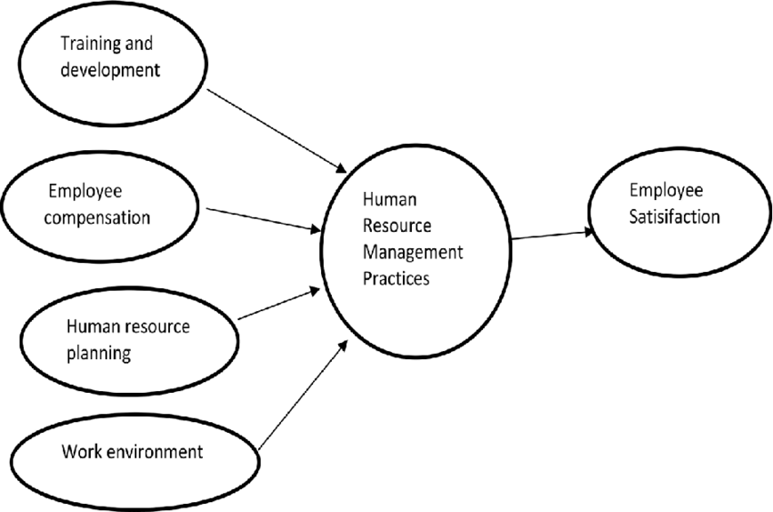

4.5 Setting HRM practice standard
In the second step, management must identify the important areas of aim, or objectives, which must be properly delineated so that employees may remain on path to complete the specified goals. During this time, employees decide on the goals and major areas of HRM practice that they will pursue throughout the year, before reporting to the officer and reaching a mutual agreement. It is necessary to have a well-thought-out goal in this situation.

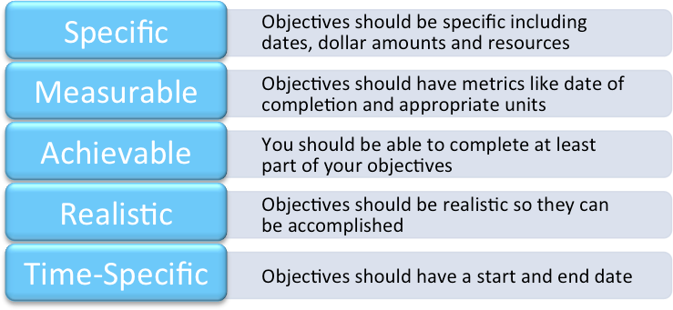

4.6 Carrying out HRM practice
This is the stage at which the HRM practice is put into action. This establishes two different responsibilities, such as,
Responsibility of manager: This involves things like keeping personnel records, training team, giving feedback and suggestions, and changing aims and priorities as appropriate.
Responsibility of employees: This involves things like keeping personnel records, training team, giving feedback and suggestions, and changing aims and priorities as appropriate.

4.7 Measure and compare HRM practice with standard
Workers ' HRM practices are reviewed, and then this HRM practice is compared to a set standard. This allows for a comparison of real results to the benchmark. This procedure aids management in determining which employees have met or exceeded the standard and which have not.

Employees are given feedback (rewards or penalties) and suggestions.

Workers who meet the standard and provide the intended outcomes are rewarded, but those who do not fit the criteria are relegated to a down the hierarchy position and are not eligible for promotions or raises, among other things. Employees that are rewarded have a positive effect on the self, are more driven, and are much more loyal and ethical to the firm, resulting in a significant win for the organization.





Reward

Motivation

HRM practice

Success

CHAPTER FIVE

ANALYSIS AND FINDINGS

5.0 INTRODUCTION
This section is about highlights the researcher's main contribution during his field study, in which he picked an expert target audience from the four Banks community in order to acquire valid data from a sample of 75 respondents in Mogadishu, Somalia. The chapter is broken down into three books. The very first portion is made up of information about the interviewees' backgrounds. The remaining half is made up of descriptive data on the independent and dependent variables, while the third section deals with the testing of study hypotheses.
The researcher first distributed written questionnaires relating to the variables of the effect of HRM practices on bank performance in a few selected commercial banks in Mogadishu, Somalia, in general and particularly the research objectives. Second, the researcher used SPSS to organize and combine the results in order to provide the data as collated and analyzed data in a precise manner.

5.1 DEMOGRAPHIC INFORMATION OF THE RESPONDENTS
The population or historical participants' data is described in this section took parts the research. This information has been given to enable the reader authenticate whether data were collected from the appropriate groups of respondents or not. Specifically, the description of the backgrounds of respondents has been given covering respondents of the questionnaire, sex, age, academic qualifications. Below table of the gender respondents of the population or historical information of respondents is described in this section.

Table 5.1.1 GENDER OF THE RESPONDENTS
Gender Respondents | Frequency | Percentage
Male | 49 | 65.3
Female | 26 | 34.7
Total | 75 | 100.0
Source: primary data, 2022
Table 5.1.1: demonstrates that the characteristics of those who replied by gender and the questionnaire consisted of 36 and the most respondents were male of 49 and their percentage was 65.3%. The female respondents were 26 and their percentage of 34.7%. The most number Males made up the majority of the responders. Below of the gage is the graph of the gender respondents of the study.
The above table indicate the level respondents of gender by the target population those around at the area of the study. The majority of the respondents were male since the gargets were major effective performance concerned conditions and the teacher performance importance for them.
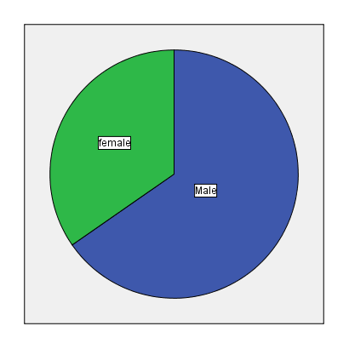
Figure 5.1.1 Gender Respondents

Table 5.1.2 AGE OF RESPONDENTS
Age of Respondents |  | Frequency | Percentage
 | 20-29 | 60 | 80.0
 | 30-39 | 14 | 18.7
 | 40 and above | 1 | 1.3
 | Total | 75 | 100.0
Source: primary data, 2022
Table 5.1.2: shows the respondents by Age, the questionnaire consisted of 80 respondents. The age between 20 and 29 years of respondents were 60 and their percentage 80.0%, the age between 30 and 39 years were 14 and their percentage 18.7%, the age between 40 and above were only 1 respondents and their percentage was 1.3%.
The most of the research participants were young age, of between twenty to twenty-nine in the study; this because of the Somali population are said to be young, middle and young adulthood and almost seventy-five percent are said to be young that why the research participants age was early ages of the lifespan.
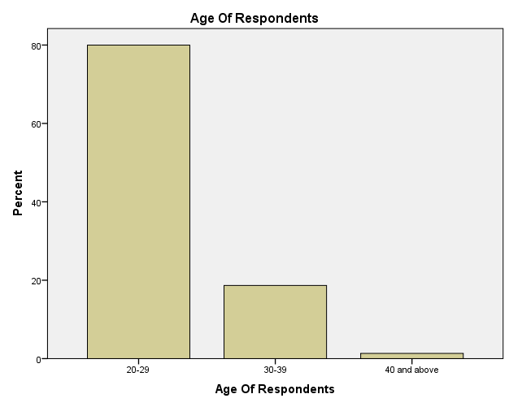
Figure 5.1.2: Age of Respondents

Table 5.1.3 MARITAL STATUS OF RESPONDENTS
Marital Status |  | Frequency | Percentage
 | Single | 56 | 74.7
 | Married | 19 | 25.3
 | Total | 75 | 100.0
Source: primary data, 2022
Table 5.1.3 shows that 56 (74.7%) of the respondents were Single, 19 (25.3%) of the respondents of the selected sample were married. Based on the data gathered, the majority of the respondents of the selected bank Respondents in Mogadishu were Single.

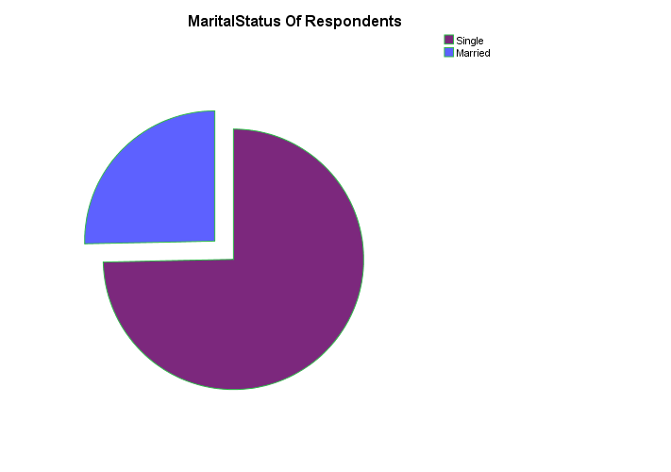Figure 5.1.3: Marital Status

Table 5.1.4 EDUCATIONAL LEVELS OF RESPONDENTS
Educational Level of respondent’s |  | Frequency | Percentage
 | Bachelor’s degree | 50 | 66.7
 | Master degree | 25 | 33.3
 | Total | 75 | 100.0
Source: primary data, 2022
Table 5.1.4: reveals the participants' attributes by level of education. The questionnaire consisted of 75. The respondents with Bachelor degrees were 50 with their percentage of 66.7% and those of Masters were 25 and their percentage of 33.3 %.
The majority of the respondents were having of bachelor degree. This indicates that the participants of the research questions were an educated populations and this helped to the performance of right screening.
The above table accurately describes and explains the level characteristics, frequencies and percentages of the respondents who took part the research study. For instance the data presentations in the series one explains and the total amount of who participated in the research, while the series in two indicates the percentages of participants and their levels of educational percentages.
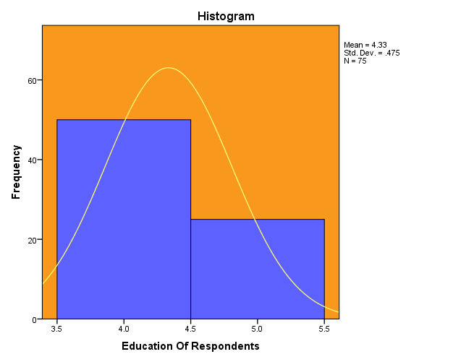
Figure 5.1.4: Educational Level of Respondents

Table 5.1. 5 EXPERIENCES OF RESPONDENTS
Experience of respondents |  | Frequency | Percentage
 | Less than 1 year | 2 | 2.7
 | 1-2 Years | 32 | 42.7
 | 3-4 Years | 23 | 30.7
 | Above 4 Years | 18 | 24.0
 | Total | 75 | 100.0
Source: primary data, 2022
Table 5.1.5 shows the characteristics of the respondents by work experience. The questionnaire was consisting of 75. The respondents having less than 1 year experiences were 2 and their percentage of 2.7%. The respondents having between 1 and 2 years’ experience were 32 and their percentage of 42.7%. The respondents of the work experience of 3 and 4 years were 23 and their percentage was 30.7%. And lastly those having more than four years work experience were eighteen with the percentage of 24.0%.
Most of the respondents were having one and two decades of practical experience. The above table shows the levels of the work experience within the respondents’ participants who are taking part the study.
The above table illustrates the work experience others who answered and the most popular number of work experience indicates the one and five years of work experience in this in field of research study.
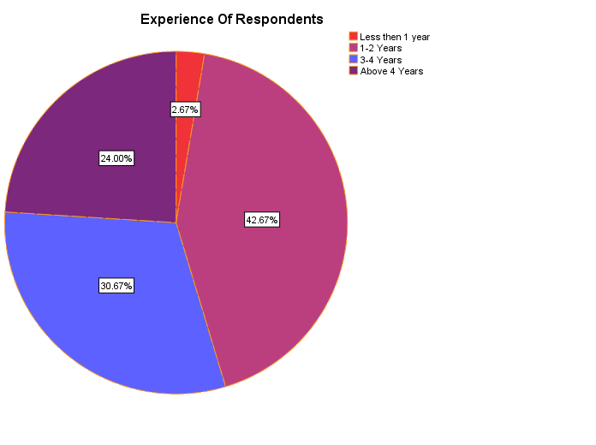
Figure 5.2.5 Experience of Respondents

5.2 DATA PRESENTATION AND ANALYSIS

5.2.1 OBJECTIVE ONE: RECRUITMENT
Conceptualized using four quantitative questions. And used the four quantitative items, recruits After that, they were required to determine oneself on a scale of one to ten. on a Liker-scale ranging from one to ten, with ten representing highly. Two people said they agreed, three said they were neutral, four said they disagreed, and five said they strongly disagreed. Disagree. Table 5.2.1.1 gives the results therefrom.
No. |  | Statements |  | Mean |  | Std. Deviation |  | Interpretation
 | 1 |  | The company attracts and retains high quality employees. |  | 1.35 |  | .479 |  | Strongly  Agree
 | 2 |  | The company’s recruitment and selection process are fair and transparent |  | 1.69 |  | .838 |  | Strongly  Agree
 | 3 |  | The company’s recruitment and selection process are structured and formalized |  | 2.45 |  | 1.189 |  | Agree
 | 4 |  | The company uses interview and other testing methods to select an employee. |  | 2.20 |  | 1.174 |  | Agree
 | 5 |  | The company forecasts the human resource requirements. |  | 2.11 |  | .994 |  | Agree
 |  |  | Total Mean & Std. Deviation Index |  | 2.06 |  | 0.988 |  | Agree
Source: Primary Data, 2022
The table's overall mean index of 4.2.1 denudates and suggests that The large bulk of those polled agree that the goal is to establish the effect of HRM practices on Bank performance in some selected commercial banks in Mogadishu –Somalia has high response rates with the main mean is 2.06.
These displays because the large bulk of interviewees respondents agree that the effect of HRM practices on Bank performance in some selected commercial banks in Mogadishu –Somalia market and also serious effects to the community after the alternative factors which indicates high response rate.

Table 5.2.1.2 Showing summary statistics results on Respondents Ratings of recruitment
Statistics |  | Value
Mean |  | 2.20
95% Confidence interval | Lower | 2.05
 | Upper | 2.35
Median |  | 2.20
Minimum |  | 1
Maximum |  | 4
Range |  | 3
Source: Primary data, 2022
Summary of results from Table 4.2.1.2 show that the mean value was 2.20 with confidence interval of 2.05 to 2.35 at the 95% level corresponding to a relatively moderate (or fair) rating regarding to recruitment as internal quality assurance mechanisms by respondents. Although the rating was relatively moderate, Table 4.2.1.2 reflects that some respondents scored recruitment levels lower than the minimum score of 3 while others tallied it relatively higher; that is, maximum of 4. This slight disparity was reflected by a range of 3 Table 4.2.1.2 also showed that the respondents fairly rated recruitment. This view was supported by the fact that the median (2.20) was equal to the mean (2.20). The histogram in Figure 5.2.1.1 suggests respondents’ rating on recruitments was normally distributed. 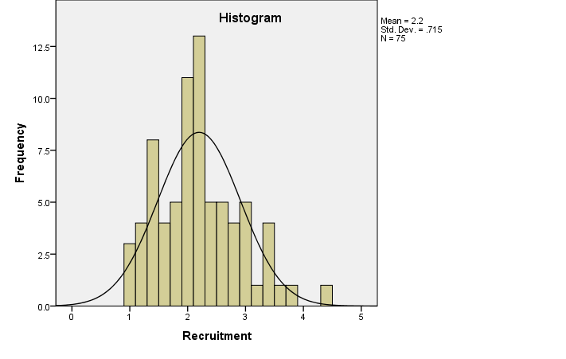

Figure 5.2.1: Histogram showing normal distribution of respondents’ rating on Recruitment
Figure 5.2.1: shows that responses were centered in the high of the histogram curve. This suggested that the Recruitment practices were given due consideration by the concerned stakeholders in the banks.

5.2.2 OBJECTIVE TWO: Training Programs
Conceptualized using four quantitative questions. Bank employees people required to rate oneself on a Liker scale of one to 5, with one being the worst and five representing the best highly Agree, two representing Agree, three representing neutral, four representing disagree, and five indicating strongly Disagree. Table 5.2.2.1 gives the results therefrom.
No. | Statements | Mean | Std. Deviation | Interpretation
1 | The company provides new employees with an orientation. | 1.72 | .952 | Strongly Agree
2 | The company adopts continuous training to improve performance. | 1.97 | 1.046 | Agree
3 | The training need analysis is done before the training program | 2.08 | .866 | Agree
4 | The company uses advanced technology in training Programs. | 2.13 | .963 | Agree
5 | The employee performance is increased after any training program | 2.21 | 1.266 | Agree
 | Total Index Of The Respondents | 2.02 | 1.019 | Agree
Source: Primary Data, 2022
The table 5.2.2.2 showed that all the respondents agreed with the questions those were asked for them with a total mean Index of 2.02 and an Average index of 1.019. The results also showed that the study hypothesis was confirmed with the responses and also this study was playing a very important role in developing the recommendations and conclusion. As it prosed earlier these questions in the table above was reacted in chapter five in order to discuss the challenges, result from the questions these were asked the research participants, and lastly the total mean index of the table above was explain the objective of the question in the table above.

Table 5.2.2.2: Showing summary statistics results on Respondents Ratings of Training Programs
Statistics |  | Value
Mean |  | 2.03
95% Confidence interval | Lower | 1.92
 | Upper | 2.15
Median |  | 2.00
Minimum |  | 1
Maximum |  | 4
Range |  | 3
Source: Primary Data, 20222
Summary of results from Table 5.2.2.2 show that the mean value was 2.03 with confidence interval of 2.15 to 2.15 at the 95% level corresponding to a relatively moderate (or fair) rating regarding to Training Programs as internal quality assurance mechanisms by respondents. Although the rating was relatively moderate, Table 5.2.2.2 reflects that some respondents scored Training Programs lower than the minimum score of 1 while others tallied it relatively higher; that is, maximum of 4. This slight disparity was reflected by a range of 3. Table 5.2.2.2 also showed that the respondents fairly rated Training Programs. This view was supported by the fact that the median (2.00) was slightly lower than the mean (2.03). The histogram in Figure 5.2.2.1 suggests respondents’ rating on Training Programs was normally distributed.

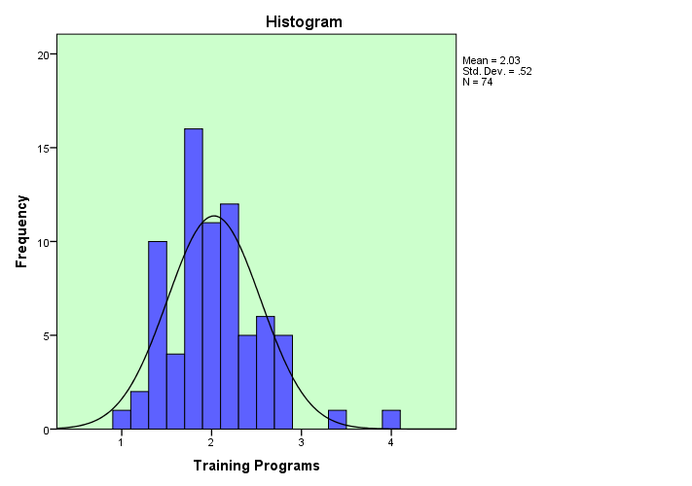

Figure 5.2.2.1: Histogram showing normal distribution of respondents’ rating on Training Programs

Figure 5.2.2.1 shows that responses were centered in the middle of the histogram curve. This suggested that the Training Programs practices were given due consideration by the concerned stakeholders in the Banks.

5.2.3 OBJECTIVE THREE:
Compensation conceptualized using five quantitative questions. Bank employees On a Liker-scale, individuals was required to determine themselves ranging from one, which signified strongly, to five, which represented weakly. Two people said they agreed, three said they were neutral, four said they disagreed, and five said they strongly Disagree. Table 5.2.3.1 gives the results therefrom.
No. | Statements | Mean | Std. Deviation | Interpretation
1 | The compensation package is motivational for the employees | 1.65 | .993 | Strongly  Agree
2 | The company provides employees with different types of benefit they need. | 2.35 | 1.059 | Agree
3 | The company uses compensation programs based on performance. | 2.51 | 1.267 | Agree
4 | The company uses fair compensation system. | 2.77 | 1.269 | Agree
5 | The company’s compensation system is reviewed regularly. | 3.08 | 1.440 | Neutral
 | Total Index of the Respondents | 2.47 | 2.206 | Agree
Source: Primary data, 2022
The table's overall mean index of 4.2.3.1 denudates and reveals that the large bulk of those polled agreed with goal. To learn more the effect of HRM practices on functioning of a chosen group of commercial banks in Mogadishu –Somalia has high response rates with the main mean average is 2.47.
The Table 5.2.3.1 showed that all the topics were approved by the participants those were asked for them. The results also showed that the study hypothesis was confirmed with the responses and also this study was playing a very important role in developing the recommendations and conclusion. As it prosed earlier these questions in the table above was reacted in chapter five in order to discuss the challenges, result from the questions these were asked the research participants, and lastly the total mean index of the table above was explain the objective of the question in the table above.

To get the overall picture of the respondents rating of Compensation as an internal quality assurance mechanism using the five questions, an average index was calculated. The relevant descriptive data are included in Table 4. 2.3.2. Gives the relevant descriptive statistics.

Table 5.2.3.2: Showing summary statistics results on Compensation
Statistics |  | Value
Mean |  | 2.47
95% Confidence interval | Lower | 2.29
 | Upper | 2.65
Median |  | 2.40
Minimum |  | 1
Maximum |  | 4
Range |  | 3

Summary of results from Table 5.2.3.2 show that the mean value was 2.47 with confidence interval of 2.29 to 2.65 at the 95% level corresponding to a relatively moderate (or fair) rating regarding to on compensation as internal quality assurance mechanisms by respondents.

Although the rating was relatively moderate, Table 5.2.3.2 reflects that some respondents scored compensation lower than the minimum score of 1 while others tallied it relatively higher; that is, maximum of 4. This slight disparity was reflected by a range of 3. Table 5.2.3.2 also showed that the respondents fairly rated compensation. This view was supported by the fact that the median (2.40) was slightly less than the mean (2.47). The histogram in Figure 5.2.3.1 suggests respondents’ rating on compensation was normally distributed.

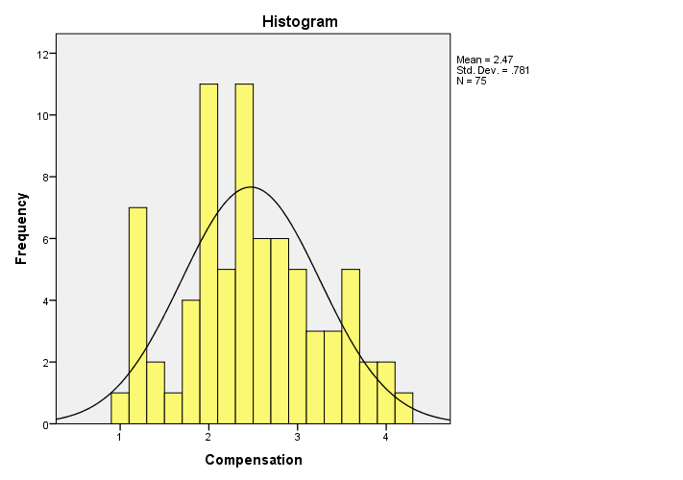

Figure 5.2.3.1: Histogram showing normal distribution of respondents’ rating on Compensation.
Figure 5.2.3.1 shows that responses were centered in the middle of the histogram curve. This suggested that the Compensation practices were given due consideration by the concerned stakeholders in the banks.

4.2.4 DEPENDENT VARIABLE: BANK PERFORMANCE

No. | Statements | Mean | Std. Deviation | Interpretation
1 | The bank performance has improved after they have formalized their HR practices | 1.77 | .994 | Strongly  Agree
2 | The Bank Service range has increased in the last five years as a result of use HRM practice. | 2.25 | .974 | Agree
3 | The organization cost of service delivery has reduced as a result of the HRM practice. | 2.60 | 1.065 | Agree
4 | Our Bank has increased market share as a result of the use HRM practice. | 2.44 | 1.093 | Agree
5 | The bank’s employees are better motivated after the implementation of HR practices. | 2.47 | 1.427 | Agree
 | Total Index Of The Respondents | 2.31 | 1.111 | Agree
Source: Primary Data, 2022
The total mean index of the table of 5.2.3.1 denudates and indicates that The large bulk of those polled agreed that object which is To find out the impact of teachers in service training on teacher performance In Mogadishu, Somalia has high response rates with the main mean average is 2.31.
The table 5.2.3.1 showed that all the respondents agreed with the questions those were asked for them. The results also showed that the study hypothesis was confirmed with the responses and also this study was playing a very important role in developing the recommendations and conclusion. As it prosed earlier these questions in the table above was reacted in chapter five in order to discuss the challenges, result from the questions these were asked the research participants, and lastly the total mean index of the table above was explain the objective of the question in the table above.

To get the overall guidance of the respondents rating of teacher performance as an internal quality assurance mechanism using the five questions, an average index was calculated. The relevant descriptive data are included in Table 4.3.1.

Table 5.2.3.2: Showing summary statistics results on Bank Performance
Statistics |  | Value
Mean |  | 2.31
95% Confidence interval | Lower | 2.15
 | Upper | 2.46
Median |  | 2.20
Minimum |  | 1
Maximum |  | 4
Range |  | 3
Source: Primary Data, 2022
Summary of results from Table 5.2.3.3 show that the mean value was 2.31 with confidence interval of 2.15 to 2.46 at the 95% level corresponding to a relatively moderate (or fair) rating regarding to Bank performance as internal quality assurance mechanisms by respondents. Although the rating was relatively moderate, Table 5.2.3.3 reflects that some respondents scored Bank performance lower than the minimum score of 1; while others tallied it relatively higher; that is, maximum of 4. This slight disparity was reflected by a range of 3. Table 5.2.3.3 also showed that the respondents fairly rated Bank performance. The histogram in Figure 5.2.3.1 suggests respondents’ rating on Bank performance was normally distributed.

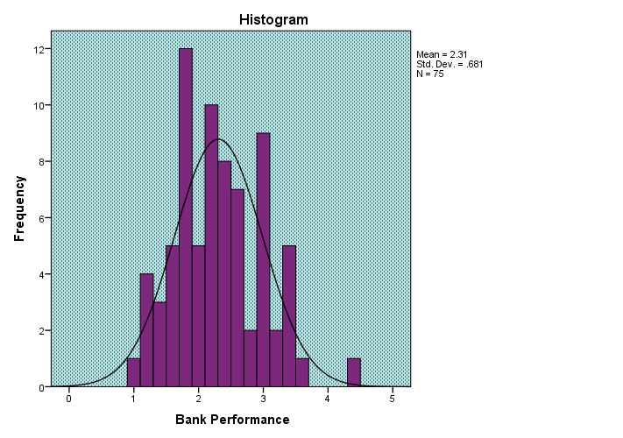

Figure 5.2.3.1: Histogram showing normal distribution of respondents’ rating on Bank performance.
Figure 5.2.3.1 Shows those responses were centered in the upper of the histogram curve. This suggested that the Bank performance practices were given due consideration by the concerned stakeholders in the Bank.

5.3 REGRESSION MODELS
5.3.1 Summary Model

Model | R | R Square | Adjusted R Square | Std. Error of the Estimate
1 | .594ª | .353 | .325 | .563
Source: Primary Data, 2022
As shown above, the determination factor R is .594, and R-squared is about .353. While adjusted R Square is .325. Standard of the study is also .563.
Table 5.3.1: Summary ANOVA

Model | Sum of Squares | df | Mean Square | F | Sig.
Regression  Residual  Total | 12.088 | 3 | 4.030 | 12.727 | .000^{b}
Regression  Residual  Total | 22.163 | 70 | .317
Regression  Residual  Total | 34.251 | 73
Source: Primary Data, 2022

The results in Table 5.3.1 The F-ratio of 12.727 is given, along with the significance of p = 0.000. At the 5% level of significance, this meant that the factor (F) was small. Significance. This indicates that the respondents’ concept was regarded to support of the questions asked by the researcher.

Coefficients
Model |  | Unstandardized Coefficients |  | Standardized Coefficients | t | Sig.
 |  | B | Std. Error | Beta | t | Sig.
 | Recruitment | .205 | .097 | .211 | 2.099 | .039
 | Training Programs | .351 | .130 | .267 | 2.704 | .009
 | Compensation | .333 | .088 | .379 | 3.785 | .000
Source: Primary Data, 2022

This table summarizes the result that was obtained from Recruitment, teacher quality training, and Training Programs and Compensation regression analysis and it reveals that banks conditions develop a meaningful and good rapport in Bank performance.
However, the t-statistics shows that the coefficients of Recruitment, quality training, and Training Programs and Compensation were significant in explaining variation in Bank performance.

5.4 CORRELATION ANALYSIS
 | Table 5.4.1 Correlation Analysis
 |  |  | Recruitment | Training  Programs | Compensation | Bank Performance
Recruitment |  | Pearson Correlation | 1 | .186 | .270** | .359**
 |  | Sig. (1-tailed) |  | .057 | .009 | .001
Training Programs |  | Pearson Correlation | .186 | 1 | .162 | .367**
 |  | Sig. (1-tailed) | .057 |  | .084 | .001
Compensation |  | Pearson Correlation | .270** | .162 | 1 | .477**
 |  | Sig. (1-tailed) | .009 | .084 |  | .000
**. Correlation is significant at the 0.01 level (1-tailed).
Table 5.4.1 demonstrates a somewhat positive link between recruitment and bank performance, as demonstrated by a revalue of (0.359**) and a significant p-value of (0.001).

Furthermore, there is a substantial positive association link Learning and Skills Programs and Bank Performance, as seen by the correlation between Training Programs and Bank Performance. (.367**and p-value of (0.001) which is significant.

Furthermore, there is a strong positive link between compensation and financial leverage, as evidenced by a value of (0.731) and a significant p-value of (0.000). As a result, HRM practice has a substantial positive correlation with bank performance.

CHAPTER SIX

CONCLUSION AND RECOMMENDATIONS

6.0 Introduction
The primary findings of the study are the subject of this section which were given in Chapter 5. This even includes the study's conclusions as well as suggestions; this Chapter is divided into three pieces. Key findings are presented in the first section, conclusions are presented in the second part, recommendations are shown in the third section, and further research is presented in the fifth section.

6.2 Conclusions
The goal of this research would have been to investigate the impact of utilization of resources techniques on banks profitability at a few selected commercial banks in Mogadishu, Somalia, using a questionnaire that 75 persons completed. Per the correlation study's findings there is indeed a strong positive connection between the two HRM practice and conduct of the bank per the findings.
6.3 Recommendations
- The following conclusions are proposed based on the investigation's findings. In order to boost the bank's efficiency.
- Upper executives in commercial banks should improve the quality of HRM dimensions, according to the current study, in order to promote the team's growth.
- According to the survey, commercial banks need to be more transparent with current and prospective employees during the recruitment process.
- The study stressed the importance of commercial banks improving the quality of training they provide their workers and integrating trainees in the creation of these projects so that courses that improve their thinking and analytical skills can be developed.

- Commercial bank executives, according to the current study, should build a much more equitable incentive system that provides employees with perks beyond the fundamentals, such as medical services, remuneration, as well as other non-cash advantages.

. According to the study, commercial banks should be more aware of their workers' perspectives through establishing a "open door" policy for lesser employees and providing frequent feedback, resulting in a much more honest and fair evaluation process that requires actual performance from the employees.

Chief execs at commercial banks, according to the research, must create a clear and proper advancement structure that distributes income evenly and in accordance with their employees' degree of experience and education.

6.4. Further Research
The study's general purpose was to look on how HRM procedures affect bank profitability in Mogadishu, Somalia, with a special focus on a few selected commercial banks. In Mogadishu, Somalia, this study looked into the effects of recruiting, education, and compensation on banks profitability. HRM practices and other elements such as work description, performance appraisal, career planning system, and employee engagement should all be thoroughly studied, according to the study.
Second, the sample is limited to a specific geographic area and a specific type of responder. It's possible that the findings aren't applicable to different user groups or locations. Future studies should cover various geographical areas and groups of In terms of developing a more robust finding which can be applicable to a broader spectrum of customers, respondents were polled.
Third, while this study utilized a questioner, the researcher suggests employing additional instruments such as an interview to predict if the outcome will be the same or not.

REFFERENCES

- Armah-Ansah* and Quartey Rita-Department of Population and Heath, U. o. (2019).
Effects of Training on Employee Performance in Ga East Hotels. DOI: 10.31080/ASPE.2019.02.0091, 1-6.
- Al Salem, M. (2010). Human Resources Management Integrated Strategic Approach. (Unpublished doctoral thesis).University Library, Sharjah UAE.
- Altarawneh, A. (2005). Training and development effectiveness: practices, roles and impacts on performance in Jordanian banking organisations (Unpublished doctoral thesis) The University of Huddersfield, West Yorkshire, England.
- Armstrong, M. (2009). Performance Management: Key Strategies and Practical Guidelines. London, United Kingdom: Kogan Page.
- Armstrong, M., & Taylor S. (2014). Armstrong's Handbook of Human Resource Management Practice. London, United Kingdom: Kogan Page.
- Aswathappa, K. (2008). Human resource and personnel management text and cases. New York City, USA: McGraw-hill publishing company.
- Batti R. (2014). Human Resource Management Challenges Facing Local NGOs. Humanities and Social Sciences, 2(4), 87-95.
- Becker, B., & Gerhart, B. (1996). The Impact of Human Resource Management on Organizational Performance: Progress and Prospects. Academy of Management Journal, 39(4), 779-801.
- Becker, B., & Huselid, M. (1998). High Performance Work Systems and Firm Performance: A Synthesis Of Research And Managerial Implications. Personnel and Human Resources Management, 16, 53-101.
- Bhagul, D. (2014). GLIMPSES OF HRD PRACTICES IN PHARMACEUTICALS COMPANIES IN PUNE. Solapur, India: Laxmi Book Publication.
- Bosninih, S., & Al-Farsi A. (2003). Human Resources: relevance, organization, responsibilities and functions, Tripoli, Libya: graduate Academy.
- Bratton, J., & Gold, J. (2012). Human Resource Management: Theory and Practice. London, United Kingdom: Palgrave Macmillan.
- Bratton, J., & Gold, J. (2012). Human Resource Management: Theory and Practice. London, United Kingdom: Palgrave Macmillan.
- Bryson, A., Pendleton, A., & Whitfield, K. (2008). The changing use of contingent pay at the modern British workplace. (Discussion Paper No. 319). National Institute of Economic and Social Research.
- Casio, W. F. (2013). Managing Human Resources: Productivity, Quality of Work Life, Profits. New York,USA: McGraw-Hill Irwin.
- Choudhary, N., & Lamba, S. (2013). Impact of HRM Practices on Organizational Commitment Of Employees. International Journal of Advancements in Research & Technology, 2(4), 407-422.
- Conrad, H. (2009). From Seniority To Performance Principle: The Evolution Of Pay Practices In Japanese Firms Since 1990‘s. Social Science Japan Journal, 13(1), 115-135.
- Curran, B., & Walsworth, S. (2014). Can you Pay Employees to Innovate? Evidence from the Canadian Private Sector. Human Resource Management Journal, 24(3), 290–306.
- Delaney, J., & Huselid, M. (1996). The impact of human resource management practices on perceptions of organizational performance. Academy of Management Journal, 39(4), 949-969.
- Denisi, A., & Griffin R. (2005). Human Resource Management, New York, USA: Houghton Mifflin Company.
- Dessler, G. (2013). Human Resource Management. New Jersey, USA: Pearson Education.
- Fening, F., & Amaria, P. (2011). Impact of human resource management practices on small firm performance in a country in recession. American Journal of Business Research, 4(1), 23-54.
- Fottler, M., & Khatri, N. (2010). Strategic Human Resource Management in Health Care. Bingley, United Kingdom: Emerald Group Publishing.
- Green, C., & Heywood, J. (2008). Does performance pay increase job satisfaction? Economica from London School of Economics and Political Science, 75(300), 710–728.
- Green, F. (2004). Why has work effort become more intense?, Industrial Relations A Journal of Economy and Society, 43(4), 709–741.
- Guest, D. E. (2011). Human resource management and performance: a review and research agenda. The International Journal of Human Resource Management, 8(3) 263- 276.
- Guest, D., Michie, J., Conway, N., & Sheehan, M. (2003). Human Resource Management and Corporate Performance in the UK. International Journal of Employment Relations, 41(2), 291-314.
- Heneman, H, & Milanowski, A., (2007). Assessing Human Resource Alignment: The Foundation for Building Total Teacher Quality Improvement. Madison: University of Wisconsin, Wisconsin Center for Education Research, Consortium for Policy Research in Education.
- Heywood, J., & Wei, X. (2006). Performance pay and job satisfaction. Journal of Industrial Relations, 48(4), 523–540.
- Huselid, M. (1995).The impact of Human Resource Management practices on turnover, and Productivity and corporate financial performance. Academy of Management Journal, 38(3), 635-872.
- Huselid, M. (1995).The impact of Human Resource Management practices on turnover, Productivity and corporate financial performance. Academy of Management Journal, 38(3), 635-872.
- Jackson, S.E., Schuler, R.S. & Jiang, K., (2014). Strategic HRM: a review and framework, Academy of Management Annuals, 8(5), 1-56.
- Jiang, K., Takeuchi, R., & Lepak D. P. (2013). Where do we go from here? New perspectives on the black box in strategic human resource management research. Journal of Management Studies, 50(8), 1448-1480.
- Joudeh, M. (2010). Human Resources Management. , Amman, Jordan: Weal Publishing.
- Kang, S., & Yanadori, Y. (2011). Adoption and coverage of performance related-pay during institutional change: An integration of institutional and agency theories. Journal of Management Studies. 48(8), 1837-1865.
- Koys, D. J., (2001). The effects of employee satisfaction, organizational citizenship behaviour, and turnover on organizational effectiveness: A unit-level, longitudinal study. Personnel Psychology, 54(1), 101-114.
- Moriones, B. A., & Larraza-Kintana, M. (2009). Profit-sharing plans and affective commitment: does the context matter?. Human Resource Management, 48(2), 207–226.
- O'Brien, M., (2011). HR's Take on the Office. Human Resource Executive Online.
- Ogbonnaya, C., Daniels, K., & Nielsen, K. (2017). Does contingent pay encourage positive employee attitudes and intensify work?. Human Resource Management Journal, 27(1) 94–112.
- Pattanayak, B. (2005). Human resource management, New Delhi, India: prentice hall of India publishing company.
- Pendleton, A., Whitfield, K. & Bryson, A. (2009). The changing use of contingent pay at the modern British workplace’, in W. Brown, A. Bryson, J. Forth and K. Whitfield (eds), The Evolution of the Modern Workplace, Cambridge: Cambridge University Press.
- Petrescu, A., & Simmons, R. (2008). Human resource management practices and workers' job satisfaction. International Journal of Manpower, 29(7), 651-667.
- Price, A. (2007). Human Resource Management in a Business Context. (3th Ed.). London: Thomson Business Press.
- Sels L (2003). How HRM affects corporate financial performance: Evidence from Belgian
- Shay, S. T. (2006). A universalistic perspective for explaining the relationship between HRM practices and firm performance at different points in time. Journal of Managerial Psychology, 21(2), 109-130.
- Tiwari, P., & Saxena, K. (2012). Human resource management practices: A comprehensive review. Pakistan Business Review, 669–705.
- Umphress, E. E., K, Smith-Crowe., AP, B., J, D., & M. B. Watkins. (2007). When Birds of a Feather Flock Together and When They Do Not: Status Composition, Social Dominance Orientation, and Organizational Attractiveness. Journal of Applied Psychology, 92(2), 396-409.
- Vincent, S., & Joseph A. (2013). Challenges for human resource experts in Global scenerio. International Journal of advancement in Research and Technology, 2(4) 209-214.
- Watson, T. J. (2010). Critical social science, pragmatism and the realities of HRM. The International Journal of Human Resource Management, 21(6), 915–31.
- Wright, A. (2013). Reward systems and organisation culture: an analysis drawing on three perspectives of culture (Unpublished doctoral thesis). University of Greenwich, London, United Kingdom.
- Zuelv, M. (2003). People management. Amman, Jordan: Dar Al-Safa for publication and distribution.
- DAUD, N. B. (2006). HUMAN RESOURCE MANAGEMENT PRACTICESAND FIRM PERFORMANCE:THE MODERATING. MALAYSIA: UNIVERSITI SAINS MALAYSIA.
- Dessler, G. (2004). Human Resource Management in China: Past, Present, and Future. Florida: Florida International University.
- Mesfin Lemma (PhD)-Associate professor at International Leadership Institute, E. a. ( 2016 ). Effects of Training Practices on Employees’ Performance in East AddisAbaba District of Commercial Bank of Ethiopia . journal of business and administrative studies , 1-29.
- TECHNOLOGY, J. T.-J. (2016). Effect of On-The-Job Training on Employee Performance in Kenya: Case of Mumias SugarCompany Limited. International Journal of Recent Research in Commerce Economics and Management (IJRRCEM), 7-24.
- WARSAME, A. S. (2015). HUMAN RESOURCE MANAGEMENT PRACTICES AND ORGANIZATIONAL COMMITMENT. International Journal.

QUESTIONAIRE
(ACADEMIC QUESTIONNAIRE)
Dear respondent,
I am a student of (U I U) carrying out academic research on THE EFFECT OF HRM PRACTICES ON BANK PERFORMANCE: A CASE STUDY OF SELECTED COMMERCIAL BANKS IN MOGADISHU-SOMALIA I was specifically chosen to participate in the study, and I respectfully request that you provide an adequate response by carefully completing out the questionnaires. The responses you provide will only be used for academic purposes and will be kept in strict confidence.
NB: Do not write your name anywhere on this paper.
Part (I): Profile of the respondents or Demographic Data
Dear sir/madam,
Please tick in the blanks in front of your appropriate response
1- Gender:
1) Male 2) female

2- Age Group

a) 20-29 | b) 30-39 | c) 40 and above

3- Marital Status:

a) Single b) Married
4- Level of Education
1)No education | 2)Primary | 3)Secondary | 4)Bachelor‘s degree | 5)Master degree
5- Experience:
1)Less than 1year | 2)1-2 years | 3) 3-4 years | 4)Above 4 years

Part (II): Independent Variables
Direction: Please Use the rating where 1 = Strongly Agree, 2 = Agree, 3 = Neutral, 4 = Disagree, 5 = Strongly Disagree.
NO: | OBJECTIVE ONE: RECRUITMENT & SELECTION | SA | A | N | D | SD
1 | High-quality employees are attracted to and retained by the organization.
2 | The recruitment and selection process at the organization is transparent and fair.
3 | The recruitment and selection process at the organization is well-structured and established.
4 | The company uses interview and other testing methods to select an employee.
5 | The company forecasts the human resource requirements.

NO: | OBJECTIVE TWO: TRAINING PROGRAMS | SA | A | N | D | SD
1 | An orientation is provided to new employees by the company.
2 | To boost performance, the organization uses continual training.
3 | Before beginning a training program, it is necessary to conduct a training need analysis.
4 | In its training programs, the business employs cutting-edge technologies.
5 | The employee performance is increased after any training program

NO: | OBJECTIVE THREE: COMPENSATION | SA | A | N | D | SD
1 | The compensation package is motivational for the employees
2 | Employees can choose from a variety of benefits provided by the company.
3 | Performance-based remuneration is used by the company.
4 | The firm employs a system of equitable pay..
5 | The remuneration system at the company is examined on a regular basis.

Part (III): Dependent Variable (Bank performance)
Direction: Please Use the rating where 1 = Strongly Agree, 2 = Agree, 3 = Neutral, 4 = Disagree, 5 = Strongly Disagree.
NO: | BANK PERFORMANCE | SA | A | N | D | SD
1 | The bank performance has improved after they have formalized their HR practices
2 | As a result of HRM practice, the Bank Service offering has expanded in the last 5 years.
3 | As a result of the HRM practice, the organization's customer service costs have decreased.
4 | Our Bank has increased market share as a result of the use HRM practice.
5 | Employees at the bank are more motivated now that HR policies have been introduced.
END
Thank you for your cooperation

