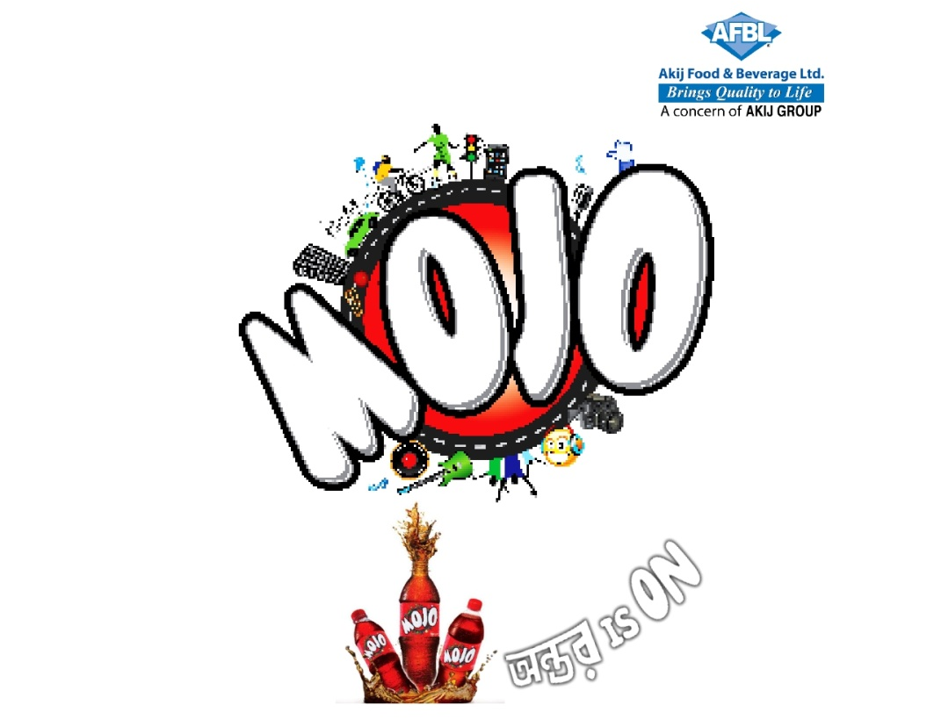
Building Brand Equity of MOJO through Promotional Campaign – A Study of AFBL
Name of the student
Nazmul Haque

This report is submitted to the school of Business and Economics, United International University as a partial requirement for the degree fulfillment of Bachelor of Business Administration.

Internship Report
On
Building Brand Equity of MOJO through Promotional Campaign – A Study of AFBL
Course code: INT 4399
Submitted To
Dr. Md. Shariful Alam
Associate Professor & Deputy Director
BBA Program
School of Business and Economics
United International University
Submitted By
Nazmul Haque
ID: 111 172 016
School of Business and Economics
United International University
Date of Submission: September 19, 2022

Letter of Transmittal
September 19, 2022
Dr. Md. Shariful Alam
Associate professor
School of Business and Economics
United International University
Subject: Submission of Internship Report.
Dear Sir,
It is my great pleasure to complete the internship report under your instruction and supervision. I have conducted the report on MOJO Brand- AKIJ Food and Beverage Limited, where I summarized my entire study which is part of the Bachelor of Business Administration degree and the INT course 4399.
The report is based on the real life experience in the marketing and brand department on the FMCG Company, which is AKIJ Food & Beverage Limited. The report outlines are followed as per the guidelines and instruction provided by the university BBA Program.
However, I hope that you would be kind enough to accept my internship report on MOJO Brand, and oblige thereby. It would be a great honor if I get the opportunity to explain any query of yours and receive your valuable suggestion regarding this report.
Thanking you in anticipation.
Sincerely Yours,
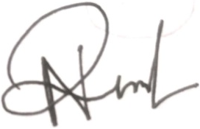
Nazmul Haque
ID: 111 172 016
School of Business and Economics
United International University

Declaration of the Student
I, Nazmul Haque, a student of Bachelor of Business Administration (BBA), Department of Marketing, School of Business and Economics of United International University, declaring that my this particular project report has only been prepared and conducted for my university course purpose. I prepared this report for the particular INT course 4399, as the requirement of the university.
I also declare that all the resources used in this report are collected by me and is completed all by me. It does not contain any materials or contents that are published before or written by any other person, which have been accepted for the degree of United International University, or any other institution. The information, which is used in the report, related to the organization that has been acknowledged properly with the source. It has been prepared for any academic purpose.
Sincerely Yours,
Nazmul Haque
ID: 111 172 016
School of Business and Economics
United International University

Acknowledgment
At first, I would like to thank almighty Allah for blessing me. I am very lucky and proud to complete this important part of my life in this pandemic. I will not be possible without almighty Allah “Alhamdulillah”.
However, I would like to express my gratitude towards some people, without their support, it would be impossible to complete this internship program and complete this report.
I would like to thank my honorable faculty Dr. Md. Shariful Alam, Associate Professor, School of Business and Economics, United International University. Without his instruction and guidance, it would not be possible to complete this report on my own. I am very grateful and thankful to this special kind human being. He provided me, supported me through thick, and thin and always encouraged me to relax and work. Without his instruction and guidance, it would not be possible to complete this report on my own. I am very inspired by his words and working method and will be forever grateful to him.
In conclusion, I would like to extend my gratitude to all of the employees of the AKIJ Food and Beverage Limited (Head Office), particularly those in the marketing and brand department, for the time and effort they put into participating in the interview sessions.

Table of Contents

Executive Summary vi
Chapter 01: Introduction
1.1 Introduction of the Report 2
1.2 Origin of the Report 3
1.3 Objectives of the Report 3
1.3.1 Broad Objective 3
1.3.2 Specific Objectives 3
1.4 Methodology of the Report 3
1.4.1 Primary Sources 3
1.4.2 Secondary Sources 3
1.5 Scope of the Report 4
1.6 Limitation of the Report 4
Chapter 02: Overview of the Company
PART A: COMPANY ANALYSIS 6
2.1 AKIJ Food and Beverage Limited – At a Glance 6
2.2 Vision 7
2.3 Mission 7
2.4 Core Values 7
2.5 Business Strategy 8
2.6 Main Products and Services of AFBL 9
2.7 Competitors of AKIJ Food and Beverage Limited 11
2.8 SWOT Analysis 12
PART B: OVERVIEW OF MOJO BRAND 14
2.9 MOJO – A Product of CSD in the Product Lines of AFBL 14
2.10 Segmentation, Targeting and Positioning of MOJO 15
2.10.1 Segmentation 15
2.10.2 Target Market 17
2.10.3 Positioning 17
Chapter 03: Analysis and Findings
3.1 Brand Equity MOJO 20
3.2 Factors of Brand Equity In terms of MOJO 20
a) Brand Awareness 20
b) Recognition 20
c) Recall 20
d) Trial 20
e) Preference 21
f) Customer Loyalty 21
3.3 Competitive Brand Analysis 21
3.4 Linking Brand Equity and Promotional Campaigns of MOJO 23
3.5 Brand Equity Performance of MOJO 27
3.6 Findings of the Study 29
3.6.1 SWOT Analysis of MOJO 29
Chapter 04: Recommendations and Conclusion
4.1 Recommendations 32
4.2 Conclusion 33
References 34
Appendix 35
Some Promotional Activities of MOJO 35

Executive Summary
The purpose of this report is threefold: first, to conduct an analysis of AKIJ Food and Beverage Limited's MOJO carbonated soft drinks positioning strategy; second, to conduct an analysis of this unit's promotional strategy and their effectiveness; and third, to conduct an analysis of MOJO's brand equity's effectiveness.
The goal of the fast-moving consumer goods (FMCG) sector has always been to provide ultimate customers with a wide variety of products at reasonable prices. If you're looking for a well-known FMCG company in Bangladesh, go no further than AKIJ Food and Beverage Limited (AFBL). AFBL offers a wide range of products suitable for their customer base. In addition to its many other great products, AFBL's MOJO carbonated soft drink, introduced on April 14, 2006, stands out as particularly noteworthy. Market share is very important to AFBL, and MOJO has helped the company gain a substantial amount of market share. MOJO's brand value has skyrocketed because of the success of the slogans "ONTOR IS ON" and "MY LIFE MY MOJO." MOJO uses many different positioning strategies, such as "big ideas" like "engage individual part of life," "unique selling propositions" like "bearing local heritage and culture with fusion," and "elements like culture, heritage, and life style," to guarantee that it has a distinct impact on the minds of consumers. MOJO has a broad promotional approach to reach its target audience. MOJO Pitha Uthsob, MOJO Pohela Boishak, MOJO Ontorer Dak, MOJO Ticket Is On, MOJO Humba Is ON, MOJO Jhal Fest, etc., are among the most well-known of MOJO's many promotional events. AFBL goes live on Facebook to reach existing and future customers by showcasing daily activities of PithaUtsob, MOJO PohelaBoishak, etc. The value of the MOJO brand was calculated by taking into account not just its positioning and marketing tactics, but also consumer opinions on the product's quality, appearance, flavor, associations, and loyalty. Several suggestions with real-world ramifications are put up on the basis of the results.

CHAPTER 01
INTRODUCTION

Introduction of the Report

The value of a product or service is affected by several factors, including the reputation, quality, and popularity of the brand name and associated logo. It is the interactions between a brand and its consumers that contribute to the brand's growth and development throughout time. Brand strength is the outcome of high levels of consumer awareness and positive perception of the brand. Therefore, there are more parts to brand equity: Consumer perception, the effect this perception has on the company, the value of this effect, quantitative values-revenue, profit or loss and sales numbers, qualitative values-consumer awareness of the brand, and goodwill. Professor of marketing Kevin Lane Keller says that in order to increase brand loyalty, businesses must influence customers' perceptions of the product (Kevin, 2013). The four questions below illustrate the unspoken concerns that customers have about your brand. Thus, there are essentially four dimensions or components that make up brand equity. The first is something called "brand awareness," which is a method for raising a product's profile via increased recognition and exorability. The second building block of "brand association" refers to any mental picture or performance associated with a brand. Perceived quality, or how consumers rate a product's quality and experience, is stored in the third block and is used to set individual brands apart from one another. Lastly, the resonance building block conveys loyalty and connection as an essential aspect of brand equity (Brand Equity, 2010)

Brand equity may be understood from two vantage points: the financial, which evaluates the worth of the brand to the company, and the consumer, who considers the worth of the brand in terms of its perceived value to them. A promotional campaign is a coordinated effort to raise awareness about a product, service, or event by a series of ads distributed through several marketing channels that all have a similar theme and tone. It may help in establishing a positive brand identity and spreading the word about your business. You may run these campaigns completely offline if you want to. The ultimate goal of every marketing campaign is to increase sales, customer engagement, and repeat business by getting the word out to as many people as possible and inspiring them to take action in response to the campaign's message. The main purpose of preparing this report to study on building brand equity of MOJO which is 1st brand item of AKIJ Food and Beverage Limited.

Origin of the Report
Incorporating both theory and practice into one's education and training yields optimal results. To graduate from a Bachelor of Business Administration (BBA) degree, students must participate in an internship at a company since classroom learning alone cannot prepare them for the rigors of the business world.
During my time as an intern at AKIJ Food and Beverage Ltd, I was exposed to the company's inner workings (AFBL). My faculty advisor, Dr. Md. Shariful Alam, Associate Professor in the School of Business and Economics at United International University, gave me the assignment to write a paper with the title Building Brand Equity of MOJO via Promotional Campaign: A Study of AKIJ Food and Beverage Limited. He gave me the official okay to write the report and gave me certain guidelines to follow. Based on my internship experience, I have done my best to describe AFBL in practice.

Objectives of the Report

Broad Objective

The primary objective of this study is to provide an overview of how Akij Food & Beverage Ltd. promotes its Mojo brand of beverages.

Specific Objectives
- In order to get more information on AFBL and its carbonated soft drink MOJO.
- To analyze the brand equity of MOJO.
- To provide some recommendations on potential solutions to the current issues.

Methodology of the Report
The information used in this study and research came from two different kinds of sources. The particulars are as follows:

Primary Sources
- Communication and discussion with employees employed in FMCG corporations via the use of the social media.

Secondary Sources
- Newspapers, articles and journals that is associated with the idea of the food and beverage industry.
- Annual Reports of AKIJ Group, AKIJ Food and Beverage Limited and MOJO.
- Website of AKIJ Food and Beverage Limited and MOJO.

Scope of the Report
The purpose of this study is to present a more in-depth examination of MOJO Brand - AKIJ Food & Beverage Limited's brand equity activities and also advertising approaches utilized to expand the company and organizational performance, with prospective profits and income. The purpose of this research was to uncover the logic for the firm's engagement in the various measures it takes to manage its customers. Not only that, but the study tries to provide light on the subject of how effective the company is in retaining its clients. In our study, we set out to catalog every role that marketing and branding performs, as well as any possibilities for expansion. In addition, the study examines competitors from the point of view of consumers and how those customers see the competitors.

Limitation of the Report
This report was compiled using comments from the marketing and brand teams. Some employees may feel that the data linked to them is not private enough to keep from the public eye. As a corollary, time constraints were an issue. Due to time constraints, it was not feasible to study a sizable sample in the course of the analysis and research. My contract was limited for three months. However, a thorough and unambiguous investigation cannot be conducted in such a short time frame. The lack of details necessitated the adoption of some educated guesses. Accordingly, the report might have a few scribbled-on typos. Despite several constraints, I did my best to provide the report.
.

CHAPTER 02
OVERVIEW OF THE ORGANIZATION

PART A: COMPANY ANALYSIS

AKIJ Food and Beverage Limited – At a Glance
The AKIJ food and beverage is a subsidiaries business of AKIJ Group. Akij Food & Beverage Ltd. has just been founded in Dhaka's Dhamrai neighborhood, which is known for its physical surroundings. It comes with the highest quality cuisine and drink that Bangladesh has to offer.
There is more than one kind of beverage available. Soft drink is known by its brand name Mojo, lemonade is known by its brand name Lemu, and energy drink is known by its brand name Speed. Instantaneously after the launch of the brand, it rapidly rose to the top of its category in terms of customer demand due to the product's superior quality as well as its extensive distribution over the whole of the nation.
The banana chips that are made at this plant are marketed under the brand name Checky Monkey. Additionally, it is becoming popularity in Bangladesh as chips.
AFBL's long-term goal is to become a financially stable company by producing high-quality goods with the help of an inspired and motivated staff and state-of-the-art equipment. By facilitating contract farming for goods like milk from Pabna and Rajshahi and mango from Rajshahi and Chapainawabganj, AFBL assists small and medium-sized farmers in the area.
A number of distinctions and accreditations have been bestowed to AFBL throughout the years. It's the four-time winner of the Best Brand Award. The company's commitment to quality is shown in its many accreditations, including those from ISO, HALAL, BSTI, and HACCP. Since AFBL uses local and international sources for its raw ingredients and the most advanced technology available, the resulting food products are of the highest quality. To realize its vision of being "Bangladesh's most famous food and Beverage Company," AFBL is governed by a set of core principles that includes creativity, teamwork, honesty, dedication to the client, and a healthy dose of respect and trust. AFBL has worked hard to build a positive reputation as a leader in a wide range of Corporate Social Responsibility (CSR) initiatives among banks, other financial institutions, and government agencies.

Vision
Through dedication and unrelenting work, we will become the industry standard bearer for leading brands in the food and beverage sector in terms of quality, excellence, marketing inventiveness, honesty, and excellent service to customers.

Mission
- To discover new things while maintaining the level of customer satisfaction.
- In order to establish effective lines of communication among clients, personnel, and individuals involved in business partnerships.
- Through the cultivation of innovative organizational practices and increased organizational prowess, ensure the company's continued growth and profitability over the long run.
- Supplying Food Products that are both fresh and healthy, while also meeting International Quality Standards.
- To build and maintain a team that is committed and devoted to their work.
- Always stay one step ahead of the competitors technically, and go on doing business as normal.
- Providing a service to the community by increasing the number of well-paying employment, boosting the nutritional value of large populations, and contributing to the expansion of the national economy.

Core Values
Established in 2006, AKIJ Food & Beverage Limited has been recognized for its dedication to quality by earning ISO 9001 accreditation. The company has a food safety management system that has been certified to ISO 22000 standards. Because of the company's dedication to quality, use of cutting-edge technology, emphasis on human resource development, commitment to continuous improvement, and introduction of new goods to meet the needs of expanding markets, it has risen to the top in its field. In order to satisfy the needs of both domestic and international consumers,
AKIJ Food & Beverage Limited is dedicated to manufacturing and packaging its goods in accordance with HACCP, CODEX, and FDA regulations. The company is particularly concerned with the following:

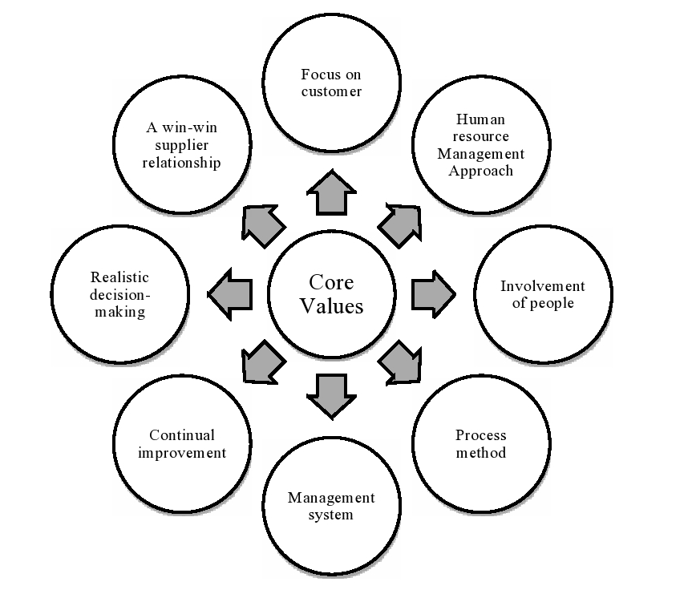
Figure 2.1: Core Values of AFBL

Business Strategy
The organization of AFBL has traditionally relied more on pull than push strategies. Before offering any kind of product or service, they do extensive market research to determine what exactly consumers are looking for. Then, they tailor when and where they provide their services to meet the needs of their customers. The objective of AKIJ food & beverage is to provide its target market with foods of the highest possible quality. The food and beverage industry is served by a number of businesses, both domestic and foreign, who operate in the space. AKIJ has the ambition of being a one-of-a-kind local food and beverage goods manufacturer that can compete with the quality of an international company. Producing chips aimed at a younger demographic that appreciates living a trendy lifestyle helps to achieve this goal. "Brings Quality in Life" is the primary slogan that AFBL operates by.

Main Products and Services of AFBL
Table 2.1: Product Listing of AFBL
Product | Segmentation | Size | Price (BDT)
Frutika Juice  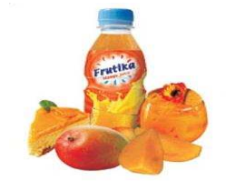 | Mango | 250 ml | 25
 | Mango | 1lt | 80
 | Grapes | 250 ml | 30
 | Grapes | 1lt | 80
 | Orange | 250 ml | 25
 | Orange | 1lt | 80
Speed  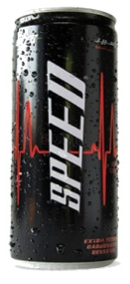 | Energy Drink | Bottle | 25
 | Energy Drink | Can | 35
Mojo  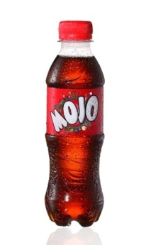 | Soft Drink | 250 ml | 15
 | Soft Drink | 500 ml/ 1lt / 2lt | 28/45/80
 | Soft Drink | MOJO Can / Naga MOJO Can – 250 ml | 30
Clemon & Lemu  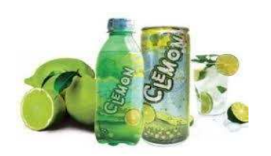 | Soft Drink | 250 ml | 30
 | Soft Drink | 1lt / 2lt | 45 / 80
Checky Monkey  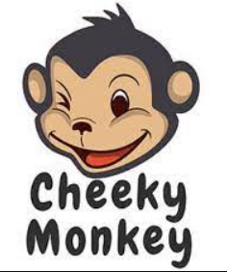 | Chips | 100gm | 10
Spa  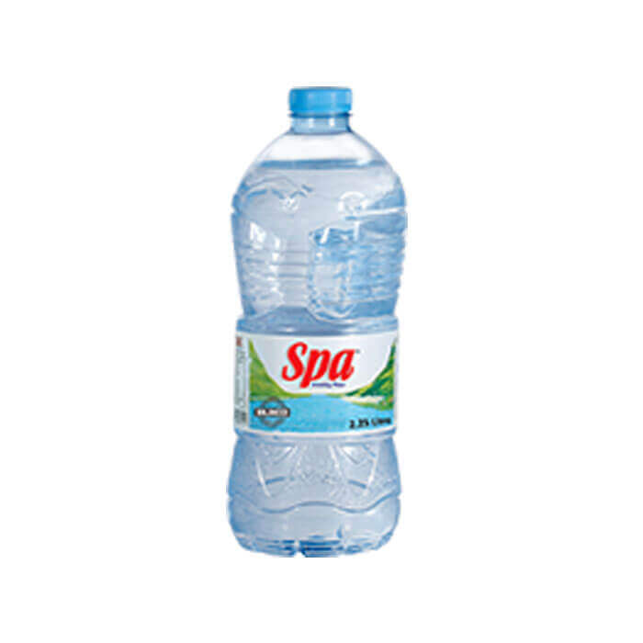 | Drinking Water | 500 ml | 15
 | Drinking Water | 1 liter | 20
 | Drinking Water | 2 liter | 30
 | Drinking Water | 5 liter | 70

Aladdin (Services of AFBL): Call Aladdin is the brand name of Akij Food and Beverage Ltd's home delivery service, which provides delivery of all of the company's products as well as everyday necessities to customers' homes. However, the percentage of people who really use this service is shockingly low.
Channel Message: You may now place orders for all of your favorite Akij Food and Beverage items directly from the comfort of your own home or place of business. Simply dial 16609 or 08 0000 16609 to place an order, and you will have access to a wide variety of food, beverage, and dairy goods to choose from (Toll Free).

Competitors of AKIJ Food and Beverage Limited
Brand Name: MOJO (CSD Drinks)
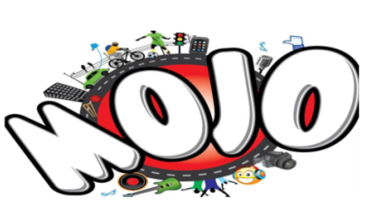
International Giants in CSD Drinks
- Coca Cola
- PEPSI
Local Brands in CSD Drinks
- Royal Crown Cola (Partex Beverage)
- Pran Cola (Pran Foods)

Brand Name: SPA Mineral Water
International Giants in Mineral Water (Bottle)
- Aquafina
Local Brands in CSD Drinks
- Jibon
- Mum
- Fresh
Brand Name: Clemon
International Brands
- Sprite
- 7up
Local Brands
- RC Lemon
- Pran Up

Brand Name: Frutika
International Brand
- Slice
Local Brand
- Pran
- Fruto
- Shezan Mango Juice
Brand Name: SPEED Energy Drinks
Local Brand
- Shark
- Tiger
- Dark House

SWOT Analysis
The SWOT analysis of AKIJ Food and Beverage Limited are listed below:

- Strengths of AFBL
- Establishment of brands such as SPA water drink, Frutika, Speed in a short amount of time.
- The high standard quality maintains on every items.
- They are regarded as the pioneers of the market by all of its rivals.
- Achieving and maintaining a dominant standing in the market of drinking water bottle, energy drinks, chips and fruits juice.
- A pricing and packaging approach that is effective.
- Support from Government and AKIJ Group.
- Produce an efficient capacity for production by making sure there are economies of scale in the manufacturing process.

- Weakness of AFBL

- High levels of competition prohibit AKIJ Foods and Beverage from increasing its market share.
- Depending on outbound sources for its basic raw materials.
- However, while holding the leading position in terms of market share, AKIJ Food and Beverage limited does not collect customer feedback, which is a factor that might be essential in increasing product demand among consumers.
- Sometimes, irregularity in supply of items occurs as a result of manufacturing inefficiencies, and as a consequence, manufacturers are unable to timely offer such products to retailers.

- Opportunities of AFBL

- Increasing the product's distribution is the most effective method, as well as the only one, for consumer goods firms to sell more units. A delay in distribution is also caused by issues with production and storage stability.
- Regulatory power that is friendly to the interests of domestic producers.
- AFBL has a growing opportunity to export items to new markets that they haven't yet been able to reach.
- Increased consumer awareness about health and regulatory backing are driving this industry's rapid expansion growth.

- Threats of AFBL

- Threats on a social, political, and economic level are instances of unpredictability.
- There is intense rivalry from multinational corporations, and process licenses are increasingly being converted into product patents.
- More foreign firms investing in Bangladesh's food and beverage industry might lead to a saturation of the present market.

PART B: OVERVIEW OF MOJO BRAND

MOJO – A Product of CSD in the Product Lines of AFBL
The carbonated soft drink (CSD) with a cola taste that goes by the brand name MOJO is the one that is favored and has the highest consumption rate among all eight AFBL products. It was first introduced on April 14 (Pohela Boishakh), with the intention of promoting a sense of merriment and amusement among the younger demographic. Since that time, MOJO has been successful in winning the affection of thousands of consumers by skillfully fusing local tradition and culture.
Table 2.2: Take a Look of MOJO
Initiation | 14th April, 2006
Ranking | 3rd Position in terms of Brand awareness  2nd Position in terms of Sales volume
Vision | By volume, MOJO will dominate the cola market ten years from now, and during the following two years, it will move into second place in the TOMA (Top of Mind Awareness) rankings.
Objective | Top of Mind Awareness, often known as TOMA Awareness of the brand, significant brand value, and sustained growth.
Tagline | ONTORE ONTORE– IT’S INSIDE U” (1st)  “ONTOR IS ON” (2nd)  “MY LIFE MY MOJO” (Present)
Big Idea | Participate actively in the many aspects of life.
USP | Bringing together local traditions and culture via a mix of styles.

Segmentation, Targeting and Positioning of MOJO

Segmentation
From the perspective of MOJO, a product AKIJ Food and Beverage Limited, the following are crucial things to take into consideration:
- Demographic Segmentation
Market segmentation is referred to as demographic segmentation when it is based on demographic data such as age, gender, income, and other similar factors. When doing research related to marketing, demographic data like gender, race, and education level are quite important.
Under this categorization, MOJO are generally suitable for a number of different functions. The following is a list of some of the available features and benefits:
Gender | Male and Female
Age | Basically 15 – 30, below 40
Income | Minimum 5000 BDT
Occupation | Mainly Students and other Businessman & Professionals
- Geographic Segmentation
Geographic segmentation refers to the practice of splitting a market into various subsets based on their physical locations. Submarkets may be as broad as geographic areas or as narrow as individual cities in the real world.
Although MOJO is primarily an open and market-based firm, they have made the decision to segment their respective markets.
Continent | Asia
Country | Bangladesh
City | Dhaka (Main Focus)
Size/Population | Approximately 16 cores
- Psychographic Segmentation
Customers' and clients' habits may be quantified via psychographic segmentation by understanding about their hobbies, passions, and worldviews. It has to do with people's habits and the kinds of information they take in. Marketers may better identify market groupings and comprehend consumer product and brand preferences with the aid of psychographics.
Although MOJO does directly follow this section, it has had an impact on some of the duties that they do. Example:
Social Class | Middle class, Upper middle class
Life style | Preferring Trendy, fusion, Fun, Fashionable, Choosey, Always Foorti, General and tip top

- Behavioral Segmentation
In this kind of market segmentation, the population is split into subsets defined by their shared characteristics, such as their interests, preferences, and buying habits. Young ladies may like Sandelina Sandal soap, but sports fans will always go for Lifeboy.
This method is not being used by MOJO to segment their food and beverage industry. They're merely following:
- Loyalty and Commitment Customers: Groups of consumers are based on how much money they spend with MOJO so that they may increase the quantity of favorable word-of-mouth about their product by keeping their clients as repeat customers.
- Purchasing Items on occasions: Consumers' propensity to buy or consume a product at different times of the day or week is the primary focus of purchase or use occasion segmentation. The use of segmentation models built at both the customer and occasion levels allows for a more nuanced comprehension of individual customers' demands, behavior, and value over a broad range of use and time. MOJO divides its offerings into specific groups for the many holidays and celebrations that take place throughout the year, including Eid Ul Fitr, Azha, Pohela Baishak, weekends, and weddings.

Target Market
MOJO Brand is targeted two distinct demographics, both of which will have the ability to make purchases and have a strong preference for MOJO from AKIJ branded products.
MOJO adhere to a number of functions because it takes into account the different types of customers it serves. The following are some of the functions that are:
Target  Customers  MOJO  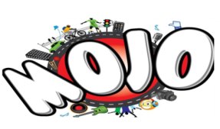 | Gen Z - those born between 1997 and 1996 | Urban and Semi Urban Area of Bangladesh
 | Middle and Upper class segment of society | Urban and Semi Urban Area of Bangladesh
 | Individuals, Corporate, Family Occasions | Urban and Semi Urban Area of Bangladesh
Table 2.3: Target Customers of AFBL

Positioning
MOJO for the long term establishes a particular place in the mind of the customer via its fundamental attractiveness, as well as its ability to inspire fun, foorti, fusion, and fashionable. It has always positioned itself in the market as a refreshing cola drink aimed at young people who are motivated by their own personal goals. It cultivates a culture while valuing uniqueness and displaying POD and POP, as well as the brand slogan and benefit, all in relation to its brand image.
- Brand Mantra: Heritage, Culture and Life style
- Point of Difference (POD)
- Attractive brand name & easy to pronounce
- Priority on local heritage
- Packaging and style
- Points of Parity (POP):
- Consistency in taste
- Properly delivered
- Strong brand image

- Benefit: The benefits that consumers perceive are-
- Functional: High quality sound
- Emotional: feel like rock star

CHAPTER 03
ANALYSIS AND FINDINGS

Brand Equity MOJO
When individuals discuss about "brand equity," they are referring to the value that consumers place on a particular brand. It serves as a framework for understanding the strength of emotions held by consumers in connection to the positioning of a firm (Kevin, 2013).
The marketing benefit of setting MOJO apart from competing products is reflected in the company's brand equity. What the company promises in its ads is something the brand strives to deliver on. Although it first appeared on store shelves in 2006, it wasn't until 2008 that people started recognizing it as a household name. It has been constantly communicating with customers for the last 13 years to keep the brand fresh in their minds. During the same period, RC Cola attempted to get into the same market, but MOJO has been more successful because its brand equity has made it more memorable, more widely recognized, and more trustworthy.

Factors of Brand Equity In terms of MOJO

Brand Awareness
The appealing jingle "Asmane Pakha Melo-Antore Antore" was MOJO's first introduction to its core demographic. That anthem gave the MOJO brand instant recognition and energized the target demographic.

Recognition
People of all ages in Bangladesh can now easily associate positive attributes with the MOJO brand, and consumers are increasingly able to spot and purchase MOJO products on store shelves and elsewhere.

Recall
Through annual publication, MOJO strengthens consumer recognition of the brand. MOJO's standard method of determining which brand enjoys Top of Mind Awareness is to have customers name some alternative carbonated soft drinks (TOMA).

Trial
Almost all advertising attempts are made with the goal of gaining new clients. Example: MOJO Pitha Uthsob is aimed at both the local youth and the local families. The vast majorities of guests tries out or just prefer MOJO.

Preference
An individual's preference for MOJO increases after a positive interaction with the brand. Most of the younger generation swears by MOJO 250ml. internal source investigation of the cola market revealed that MOJO has dropped to third place.

Customer Loyalty
After a string of positive interactions with the brand, consumers not only sing the brand's praises but also stop considering any alternatives. Since MOJO often provides free merchandise, many shops choose it over Pepsi and Coke. Some consumers may associate the positive feelings they have for a regional brand with a connection to the history and traditions of that area.

Competitive Brand Analysis
Mojo is in competition with two well-known worldwide brands, Coca-Cola and Pepsi, as well as a number of well-known regional brands, including Pran Maxx Cola, RC Cola, Uro Cola, and Color Cola. Let's look at it in comparison to its two major competitors.

Figure 3.1: 250 ml contribution of CSD Products in Bangladesh
Source: Research &Development Dept. of AFBL
Coca-Cola has successfully expanded into the liter package and is now appealing to the urban luxury customer category thanks to its extensive history and well-established brand image. The introduction of a 250-milliliter pack as a competitor to MOJO posed the greatest challenge to MOJO's ability to compete, particularly given the extensive consumer advertising, store branding, and sticker posting that CNG does, among other things.
Pepsi is making an effort to expand its business and is developing a plan to compete with Coca-Cola. It also launched PACK (250 ml) to compete with MOJO 250 ml using an aggressive price approach of Tk 16. It, too, makes substantial investments in extended advertising, such as placement in refrigerators, hop branding, sales promotion, and so on.

Figure 3.2: Market Share of CSD Products in Bangladesh
Table 3.1: Brand Analysis (CSD Sector)
 | MOJO | Coca Cola | Pepsi | Max cola
Brand Positioning | Antor is on | Taste the Feeling | Live for Now | Masti Sarabela
Communication Objectives | Follow the trend, fusion own style | Follow the brand reputation | Follow the brand reputation | Follow the brand promise
Communication Agenda | Cultural occasion | Sports & occasional communication | Promotes occasion | Promotes occasion
Engagement | High | Moderate | Moderate | Average
Followers | 39k | 100k | 21k | 93k

Source: Research and Development Dept. of AFBL

Linking Brand Equity and Promotional Campaigns of MOJO
Brand equity is not simply recognized or measured. It narrows down on the brand's function in marketing campaigns. For example, MOJO has been advertising heavily to young people in the nation since its creation, and as a consequence, in 2014, it had the greatest brand equity of any domestic CSD product. MOJO's marketing efforts are broken down into three distinct campaigns as opposed to the more traditional six.
Advertising firms handle a wide variety of promotional materials, including banners, posters, T-shirt logos, and festoons. At AKIJ Food and Beverage Limited for MOJO Brand, their marketing strategies and promotional events include elements of both above-the-line (ATL) and below-the-line (BTL) marketing.
Above the Line (ATL) Marketing
The following are some of the activities that MOJO Brand is participating in as part of its ATL promotion:
Radio Advertising
Brand Activation
TV Advertising
News Paper
Social Media/ YouTube Marketing
In Store Marketing

Figure 3.3: ATL Marketing Methods of MOJO Brand
- Brand Activation
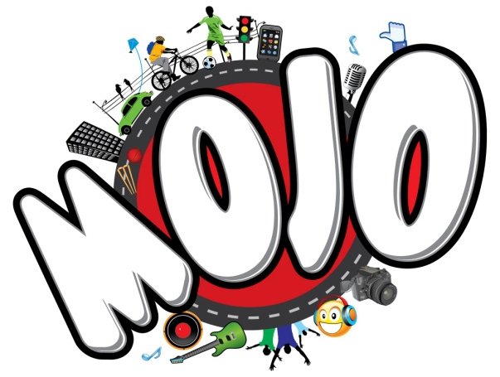
Akij Food and Beverage launched its first brand, Mojo, with this product. It was a cola-flavored carbonated soft drink. It was marketed as a "fusion" brand, combining elements of a traditional design with those of a more contemporary style. That's why the product's packaging and messaging are so on point. "Antore Antore" was the original slogan; however it has now been modified to "Antore is on." From the start, Mojo was a very popular brand. Because of the two current international giants, Coca Cola and Pepsi, breaking into this market has always been difficult. In spite of this, it was able to maintain its position in the marketplace and even gain some market share. Mojo now has 35 percent of the cola market, 20 percent of the entire CSD market, and over 80 percent of the 250ml SKU category. In addition, it came in second place in the minds of consumers. AFBL's recent MOJO-related events have received a lot of positive reaction from the public. This year's taglines are "ONTORER DAAK" and "MY LIFE, MY MOJO." In 2018, "ONTORER DAAK" was released on Valentine's Day to commemorate the holiday.
- TV Advertising
In 2015, during the Bangladesh vs. India One Day Cricket Series, MOJO cola ran a humorous commercial (Bamboo is on) on almost every Bangladeshi station.
In order to attract viewers, MOJO aired commercials and displayed its emblem during the broadcast of the drama shohore notun premik, choto chele, on the RTV channel.
DJ Bravo, a renowned cricket player, appears in a TV commercial for a thematic campaign called "My Life, My MOJO," which has recently incurred tremendous costs. With the slogan as inspiration, it has aired commercials with catchphrases like "my life, my click," "my life, my music," etc.
- Newspaper and Magazine
Advertisements for MOJO Brand may be seen in a wide variety of newspapers and magazines, including the monthly magazine that is published by “Daily Sun.” They will run an advertisement in the newspaper whenever a new product or a promotion is made available.
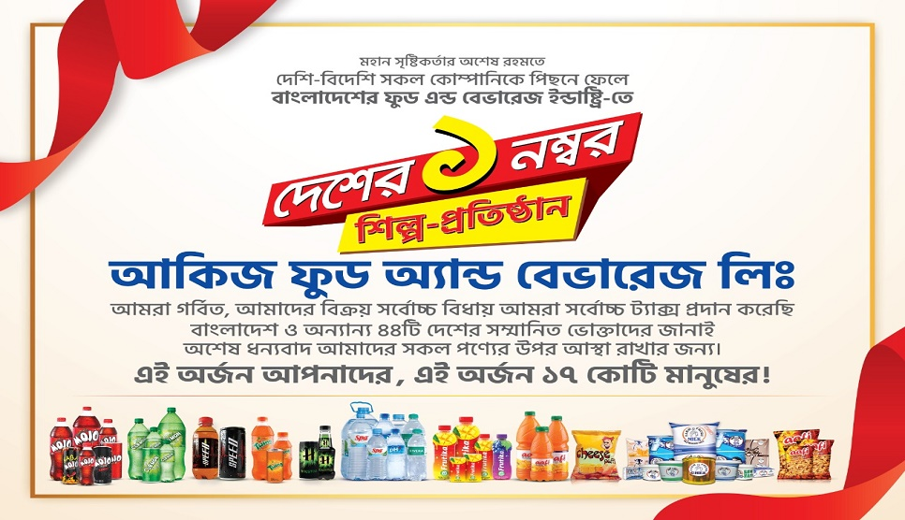

- Social Media and YouTube Marketing
In today's digital world, MOJO Brand keeps up with social media and YouTube marketing on a regular basis. On Face book, YouTube they publish promotional efforts, such as updates on the pricing of their goods and commodities; offers; discount coupons; customer reviews; as well as video testimonials from satisfied consumers. On YouTube and Face book pages, their marketing teams involved the digital marketing activities such as:
They are able to polish their brand further with the use of this social media marketing by posting on key events like Eid-Ul-Fitr and Eid-Ul-Aadha and greeting all of their Face book fans, which helps them, polish their brand even more.
  - Developing and publishing a variety of content in conjunction with key days like Mother's Day, Father's Day, and Friendship Day, amongst others, is a good strategy.
  - By use of online chatting and commenting systems, MOJO Brand provides customer care and support capabilities for customers through their Face book page like: Masti package Mojo 1 liter, twin 500 ml.
- Radio Marketing
MOJO Brand uses radio platforms like Radio Vhumi 99.00 Fm and Radio Foorti 88.00 Fm to market their goods. Public distribution of RDC occurs at major occasions like the Cricket World Cup, the Islamic festival of Eid, and other official celebrations. They are attempting to get radio listeners to learn more about their products or companies by promoting them over the airwaves.
- In Store Marketing
MOJO Brand visits supermarkets including Meena Bazar, Aagora, KB Square and Swapno. On important occasions, they provide a 10% discount on all of their products.
Below the Line (BTL) Marketing
The following are some of the activities that MOJO Brand is participating in as part of its BTL promotion:
Sales Promotion
Sponsorship
Events
Brand Promotion

Figure 3.4: BTL Marketing Methods of MOJO Brand
- Sales Promotion
The organization MOJO Brand intends to sell more of its products, therefore it is increasing the commissions that retailers get for selling those products. They estimate a rise in sales as a direct consequence of this, as well as a large increase in return on their investment. On the other side, they offer their customers promotional prices and other gifts and presents.
- To advertise their "MOJO UTVOT OFFER" campaign, MOJO rode three camels around Bangladesh's key thoroughfares and presented them as prizes to three fortunate merchants in honor of Ed-Ul-Ajha.
- You may get 10 airline, AC bus, and Ramadan launch tickets for every hour of the day by sending a Unicode message to the MOJO Ticket website.
- Notun Jama MOJO One hundred customers were offered the deal by text message.
- MOJO Automobile Tumi Kar gave away a beautiful car to the fortunate person who found the bottle cap for a 500 ml, 1 liter, or 2-liter bottle of MOJO pet juice.
- Sponsorship
MOJO Brand is a major sponsor of a significant number of our country's most well-attended events. The organization provides financial support for a variety of scholastic competitions and activities, including business case competitions; annual sports competitions, and various cultural celebrations such as Pohela Baishakh.
- With the theme "My result, my MOJO," the Mojo team honored the HSC results of students from a wide variety of schools in and around Dhaka, honoring those who have shown such dedication to their academic and professional pursuits.
- MOJO decorates their sales stand at the annual Dhaka International Trade Fair (DITF) with an animated floor design, games, discount coupons, free samples, and swag like pen-drives, caps, wrist bands, etc.
- Brand Promoter
MOJO often receives requests to be a sponsor for a wide variety of university-affiliated activities, including events, campaigns, and sports. Therefore, MOJO gains promotional benefits such as-
- Promotional Banner Ads
- Publicity drive in the cyber world (promotional videos, links)
- Online and offline promotion (a road show approach, volunteer T-shirts, ID cards, etc.)
They've broken down the whole sponsorship package's advantages into three primary categories.
Title | *****
Platinum or powered by | ****
Gold or co-branding | ***
Here are just a few examples of the amazing events that MOJO has sponsored: Folk Fest 2017 as beverage partner
- Welcome to the 2018 Daffodil International University Alumni Program!
- Professor Pitha Uthsob of the University of Dhaka's School of Business Studies
- Dhaka, Bangladesh, Intra-University Football Championship
- United International University hosts the first-ever national stand-up comedy festival..
- Events
- Each year, MOJO members all around the nation celebrate the MOJO Pitha Uthsob. Over the course of two days, attendees may enjoy a kids' play area, a Shahi Bari attraction, a photo booth, a band performance, and a plethora of game shows like pitha khadok, pitha chor, etc., all while learning about local tradition and culture.
- To mark its 12th anniversary and 1stera, MOJO held its trademark campaign and birthday on the holiday of Pohela Boisakh. Three days were dedicated to the event, the culmination of which was a performance at the Uttora Friends Club. Tanjib Sarawar, Warfaze, Fusion, Hrydoy khan, Mila, Daag, Light, and Inside u, to name a few, performed at the event to raise awareness of their "Ek Jug Eksathe Boishakhi MOJO hatred" campaign.

Brand Equity Performance of MOJO
MOJO gives fast, accurate, and actionable data to the Brand Department so that they can assess the brand's health and make both tactical and strategic decisions, all of which are important for the company's future success. Typically, Mojo uses these four metrics to evaluate the strength of its brand:
Examining the Target Market The research and development team at Mojo conducts surveys with around 1,500 students, faculty members, and staff members at educational institutions located all across the United States to find out which Mojo brand is their favorite. The following described of the brand equity as measured by the number of times consumers can remember competing brands in a row:
According to Retailer Survey, The primary function of the Panthopath office's business developer is to conduct a survey of retailers in order to learn information such as product availability, sales volume, customer demand, market position, etc. Even as an internship, I was tasked with making a market tour to the Puran Dhaka neighborhood, where, out of a total of 32 stores, 88% carried Coca-Cola and 84% carried MOJO.
According to Post Evaluation Campaign, Mojo's event management team conducts the assessment using an outside party to see whether the campaign will have a lasting impact on the minds of its target audience. In addition, it tracks digital metrics such as views, likes, impressions, and reaches on a monthly basis.
MOJO contacts the qualitative research firm to conduct a focused group conversation in which customers honestly rate their satisfaction with the product and share their opinions on whether or not they would recommend it to others. Mojo's Branding staff is also there and is secretly listening in on the conversation. Teens (mainly those still in school or college) aged 15 to 20 choose MOJO because to its lower pricing and greater fuzziness compared to other brands. Coke is the most popular multinational brand among those aged 20 to 30. Therefore, the FGD approach allows for a higher degree of in-depth analysis. All of this data demonstrates how brand equity is evaluated from the perspective of customers' perceptions and the company's bottom line. According to the Neilsen Company Bangladesh, Mojo is now placed third in customer perception but second in sales volume.

Findings of the Study

SWOT Analysis of MOJO
Conducting a SWOT analysis on your company is easier than you would think. It won't take long, but doing so will force you to reconsider your company in a new perspective. A SWOT analysis may help you craft a solid business strategy by making sure you've thought through your firm's advantages and disadvantages, as well as the possibilities and dangers it faces in the market. A SWOT analysis may be useful for businesses since it can reveal both threats and opportunities. Using SWOT analysis has several benefits, especially in fields like healthcare, where it may help professionals better understand the dangers they face and the opportunities they have to provide their patients with better, more effective treatment. By analyzing their strengths, weaknesses, opportunities, and threats, firms may improve their competitiveness in their industries and ultimately benefit their customers via lower costs and better service (Berry, 2020).
Summing up the advantages and disadvantages of FMGC Company to break down each component in minute detail, during which time we will analyze the internal strengths and weaknesses, as well as the external opportunities and threats. A strategy for how businesses of MOJO providing takeout and its’ services may use their strengths and chances to overcome their shortcomings and threats. The SWOT analysis of MOJO is shown here:
- Strengths  - The MOJO 250 ml pet bottle is quite popular.  - A price that is both fair and competitive from other competitors.  - A respectable percentage of the market share and brand equity.  - Communication that is both attractive and innovative, together with the most recent technology.  - Reputable and effective advertising and branding campaign. | - Weakness  - The store doesn't have a refrigerator for drinks.  - No use of bottles made of glass.  - Acceptance of the brand is more difficult to get.  - In comparison to Coca-Cola and Pepsi, its advertising is less prominent.
- Opportunities  - Interaction with the Hotel's Dining Facilities (HORECA).  - Improve the public's impression and brand image of the company by conducting PR campaigns.  - Develop a consumer appetite for greater SKUs.  - Export products in foreign countries. | - Threats  - The extensive activation that the competitor is doing with the store.  - A strategic collaboration between rival brands and other names in the industry  - A growing competition from alternative products such as juice, energy drinks, and sports drinks.  - A market leader with a strong brand image.

Figure 3.5: SWOT Analysis of MOJO Cola

CHAPTER 04
RECOMMENDATIONS AND CONCLUSION

Recommendations
The food and beverage business in Bangladesh is one of the countries most dynamic. Increasingly, businesses see the need to boost their brand equity via various forms of advertising to stay competitive in today's market. MOJO has been giving its patrons a taste of culture, tradition, pleasure, and fusion for the last 13 years. However, there are also some negative aspects to consider. This study's results and recommendations may be used to narrow the equity gap and trigger impulse purchases from consumers.
- In addition to the MOJO 250 ml bottle size, additional SKUs should be the focus of the promotional effort.
- The R&D department should conduct the poll by first having users try the newly upgraded MOJO, and only then should they ask for reviews. This possible hazardous characteristic of perception may be improved, allowing for the creation of advantageous brand equity.
- The introduction of an increasing number of entrances via HORECA equipped with vending machines or ice coolers will encourage customers to purchase MOJO while providing them with an exceptional tasting experience.
- MOJO need to be highlighted as a star in the BCG Product category and more investment ought to be put into creative features for the purpose of maintaining brand loyalty.
- Mojo may provide a small percentage off on online delivery through Aladdin if the buyer agrees to upload their bought images to their Face book page and review their taste.
- Promote product and service bundling, such as by giving a discounted bundle of items.
- For a blind test of three competing brands and rating those on several factors including fuzziness, sugar quantity, and taste, and flavor, FGD survey may be the best option. Brand equity may be evaluated more precisely via their participation.
- In order to get more clients and useful data for the research and development department, a closed-ended survey through Google form or a specialized brand booster might be a great help. By incorporating "voice of customer," MOJO is able to take into account both the overt and covert demands of its clientele.

Conclusion
It has been noted that people's impressions of MOJO-Cola are highly favorable, which is consistent with what has been predicted. People are familiar with the brand, and MOJO-profile MOJO's in the public consciousness is rather high in the industry. When a new product from MOJO-Cola is introduced to the market, loyal customers are more likely to purchase it than any other offering simply because they have come to trust the brand.
The purpose of this report is to find out any gaps in MOJO's brand equity performance that might hinder the company's growth and success in the highly competitive food and beverage industry in Bangladesh. The study shows that many different things may affect MOJO's development. Certain marketing activities done by MOJO have a positive impact on the expansion of their brand equity and brand image to their targeted customers, as determined by brand equity, SWOT analysis, and positioning strategy. MOJO-Cola has not a designated cooler in contemporary grocery shops and convenience stores where only their goods are kept. But public relations and the company's public image make up for the lack of direct sales. MOJO-Cola is a big supporter of many different kinds of events, from sports to festivals to concerts. So it can be said that, MOJO- Coke consumers aren't simply purchasing a drink, they're buying into a certain personality, therefore charging a premium for the brand sends a message that they see the product as superior to competitors and that they are willing to pay more for it.

References

Berry, T. (2020, September 14). How to Do a SWOT Analysis for Better Strategic Planning. Retrieved from Bplans: https://articles.bplans.com/how-to-perform-swot-analysis/
Brand Equity. (2010). Retrieved from Shopify: https://www.shopify.com/encyclopedia/brand-equity
Kevin, K. L. (2013). Strategic Brand Management.4th ed. United States: Pearson.
Kibriya, M. G. (2018). Success through Social Media Promotion: A Study on Akij Food and Beverage Ltd.
MD. MONOAR HOSSAIN, M. S. (2014). Market Structure of Akij Food & Beverage Ltd. Bangladesh: Jagannath University.

Appendix

Some Promotional Activities of MOJO
