Internship Report
On

Rubber Industry: Bangladesh Perspective
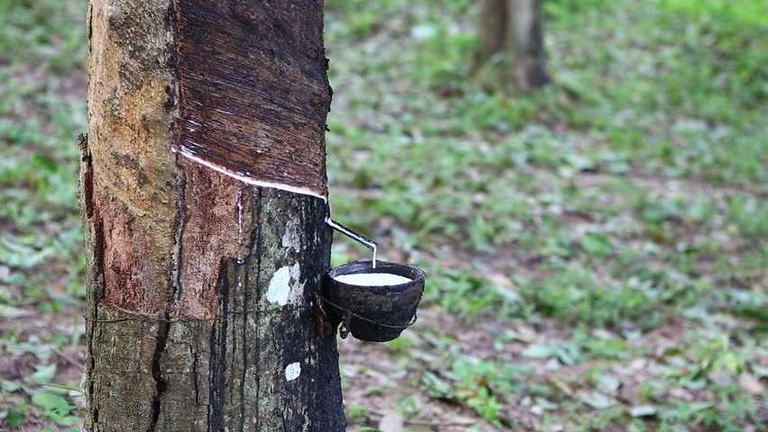

Rubber Industry: Bangladesh Perspective

Prepared For
Nusrat Farzana
Assistant Professor
School of Business & Economics
United International University (UIU)

Prepared By
Abdullah Rakibul Hasan
ID- 111 142 262
School of Business & Economics
United International University

April 17, 2019
Letter of Transmittal

18th April, 2019

Nusrat Farzana
Assistant Professor
School of Business and Economics
United International University

Subject: Submission of the Internship Report

Dear Madam,

I am pleased to submit the internship report titled “Rubber Industry: Bangladesh Perspective” as a part of the completion of BBA program. I have learn from Global World Ltd. which was established as a limited company in 2011 and engaged Export-Import, Trading, Supplying, Real Estate, Marketing, Tourism etc. It is basically a customer oriented service organization.
According to your suggestion and direction, I have tried to complete this report carefully. It was really great experience for me and I enjoyed my internship period at Global World Limited.

Sincerely,
Abdullah Rakibul Hasan
ID No: 111 142 262
Acknowledgement
I am thankful to internship supervisor, Nusrat Farzana. She has supported me to complete my internship report. I am very much thankful to Mr. Aygun Akgun and Mr. Robin Mahmud for giving me the opportunity to complete my internship at Global World Limited. I got the inspiration and suggestion from them, which will be helpful to shine my career.
I also would like to thank Md. Sakhawat Hossain (Managing Director) for his support that I have been provided for preparing my internship report. I directly work with him and I learned so many things from him. Finally I would like to thanks the others persons who help me to prepare my report properly as well as I want to provide thanks who will read my report, I hope this report will be to develop themselves.

Declaration

I am Abdullah Rakibul Hasan of the student of school of Business and Economics of United International University, Bangladesh. My internship report on “Rubber Industry: Bangladesh Perspective” is a real report which is not submitted previously anywhere.

________________
Abdullah Rakibul Hasan
ID No: 111 142 262
School of Business and Economics
United International University

Table of Contents
Executive Summary…………………………………………………………………………………………………………………… 1
Chapter 1 2
1.1 Introduction 2
1.2 Topic of the report 2
1.3 Origin of the report 2
1.4 Background of the Report 3
1.5 Objective of the Report 3
1.5.1 General objective 3
1.5.2 Broad Objective 3
1.5.3 Specific Objective 4
1.6 Scope of the report 4
1.7 Methodology of the report 4
1.7.1 Primary sources 4
1.7.2 Secondary sources 5
1.8 Limitation 5
2. Organization Part 6
2.1 Overview of the Organization 6
ii) Foil Paper 11
3. World Scenario of Rubber Industry 12
3.1 Rubber 12
3.2 Global Rubber Industry 12
3.3 Malaysia scenario for Rubber Industry 14
3.4 Vietnam scenario for Rubber Industry 15
3.5 Thailand scenario for Rubber Industry 16
3.6 Indian Rubber Industry 17
Chapter 4 18
4.1 History 18
4.2 Socio-economic Impact of this sector: 19
4.3 Consumption of domestic Rubber Production: 19
4.4 Constraints to the Industry 20
Chapter 5 20
5.1 Player in Industry 20
5.2 Opportunities of Rubber Industry 21
5.3 Problem of this Industry 22
5.3.1 Global Shortage 22
5.3.2 Raw Material Cost 22
5.3.3 Product Recalls 22
5.3.4 Erosion and degradation of soil 22
5.3.5 Scarcity of skilled tappers 23
5.4 Recommendations 23
Conclusion 23
Reference ……………………………………………………………………………………………………………………………….25

Executive Summary

Global World Ltd. has been established in 2011 as a limited company. It specially focuses on Export-Import, Trading, Supplying, Real State, Tourism and Marketing. Their imported products are Natural Rubber, Leather, Leather goods, Jute, Wooden Furniture, Garments stock lot, Fabrics, Sea Food, Potato, Vegetable, Garments Accessories, Tea, Rice Bran oil, Aromatic Rice etc.

The fast growing industry is the rubber industry in the world. There are mainly three categories of rubber such as natural rubber, synthetic rubber and reclaimed rubber. 9.67 million Metric tons production of global natural rubber was stood in 2006 and grew at a CAGR of 7.68 percent during 2004-06.

In constructing this paper, a review of relevant journal, newspaper, academic publications, and online resources were used. I have focused the not only world scenario but also the scenario of nearest country India as well as our country. Then the worldwide demand of rubber industry with consumption pattern, SWOT analysis, recommendation
And conclusion is properly described in this paper.

Chapter 1

- Background of the Problem

Introduction

Modern business is highly complex due to ever changing market and customers demand, strength of competitors, advanced technology etc. After becoming the globalization marketers also can get benefits as well as they face more challenge. Operation, marketing, distribution and all others activities become more important of firm.
Global World Limited is one of most reputable international trading company. This company represents leading manufacturer as well as supplier on international scale. It has the innate capability to execute orders of all sizes. Latex, RSS, Bangladesh standard natural rubber etc. are special products of this organization. This company more focuses the rubber related product because now a days rubber industry is growing up so fast and it is a hot item in the world.

Topic of the report

According to my internship activities, one topic is selected which is World Scenario of Rubber Industry.

Origin of the report

Now a days today’s world is not only based on academic knowledge but also practical knowledge. By doing this report it was a great opportunity how a company formulate Marketing Strategies, Business policies and so on.

Background of the Report

Internship report has a significant impact to fill up the learning level of a student. During internship period, a student works with the corporate people in an organization which can develop himself/herself by it. This report would be based on the world scenario Rubber Industry.

Objective of the Report

For the purpose of understanding real scenery nearly and then it was focused in this report details so that it can develop the career building. There are some objectives-

General objective
Completing properly is the general objective of this report and it should be the information oriented.

- After visiting the factory and trying to understand the main fact of the products and services.
- Finding out the relationship between academic knowledge and practical field.
- Knowing how to work in the practical field and how to manage in a new environment.

Broad Objective
To find out and analyze the current market scenario and marketing plan of the portfolio “Rubber Industry”.

Specific Objective
There are some specific objectives-
- To analyze the current market and compare the market shares.
- Find out comparative position of the company.
- Finding out about pricing policy and distribution strategy.
- Identifying the standardization of the product.

Scope of the report

After discussing with clients, honorable supervisor and employees, this report is prepared. While preparing it, I have learned so many things about export-import business and specially rubber industry.

Methodology of the report

For preparing it I have followed two types of methodology-

Primary sources
- Practical Brand development
- Face to face conversation with the Project Supervisor
- Direct observations
- Face to face conversation with the client/ employee

Secondary sources
- Articles
- Websites of Global World Ltd.

Limitation
There are some limitations in preparing this report-
- Lack of sufficient sources prevented verification of information.
- The analysis presented here may vary with opinions of experts in this field.
- Some aspects of the report may be considered confidential by the organization.
Chapter 2

Organization Part


Overview of the Organization

This section includes the overview of Global World Ltd.
Global World Ltd. has been established in 2011 as a limited company. It specially focuses on Export-Import, Trading, Supplying, Real State, Tourism and Marketing. Their imported products are Natural Rubber, Leather, Leather goods, Jute, Wooden Furniture, Garments stock lot, Fabrics, Fish, Potato, Vegetable, Garments Accessories, Tea, Rice Bran oil, Aromatic Rice etc. Global World Ltd. is a service organization and focused on quality work. Their vision is to maintain standard as well as excellence service. The location of the head office is plot# 1/3, Road # 21C, Nikunja-2, Khilkhet, Dhaka-1212, Bangladesh. The nature of business is showing by following figure-
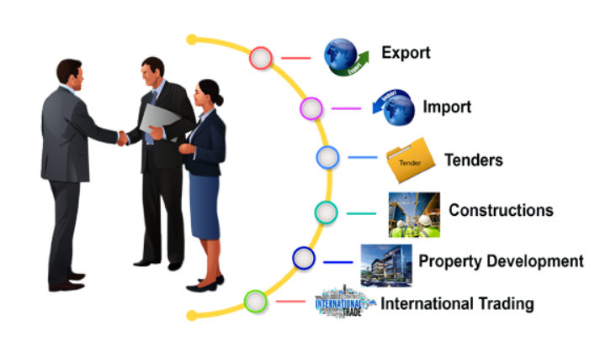

Board of directors:

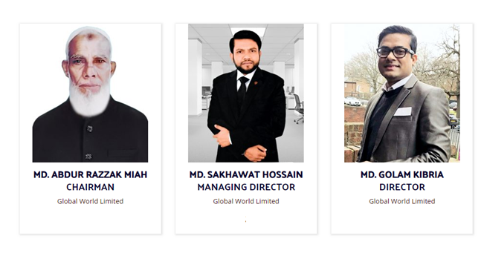
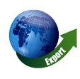
  - Services
    - Export
Global World Ltd. exports a lot of products from different countries. The briefly discussion of exported items is given below-

Rubber

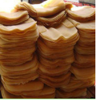
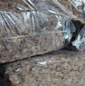
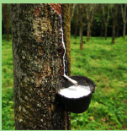

  - Latex
A natural latex emulsion which will air dry rapidly and can be used to make mold for casting the wax, plaster or resin parts.

  - RSS
RSS refers Ribbed Smoked Sheet Rubber which is made directly from latex and it is treated and then made to coagulate. The coagulate latex sheets are air dried or smoked in ovens.

  - Bangladesh Standard Natural Rubber (BSNR)

Bangladesh Standard Natural Rubber (BSNR) is acquired from three Hevea brasiliensis. There are some rubber gardens in Sylhet, Chittagong, Chittagong Hill Tracts and Modhpur zones under Bangladesh Forest Industries Development Corporation.
Leather
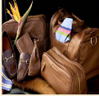
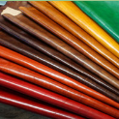
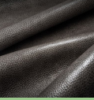

- Finished Leather
Over the surface the leather has a PIGMENTED COLOUR as well as it is finished with a clear sealer.
  - Crest Leather
The Crest Leather focuses the exceptionally soft hand.

  - Leather

There are different types of leather-
- Belt
- Watch Bands
- Portfolio case
- Ladies handbags
- Footwear
- Pet accessories
- Camera & Guitar Straps
- Men and Women accessories and so on.
Without Rubber and Leather, there are several products such as-
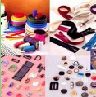
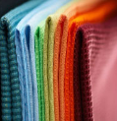
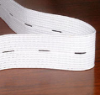

Cotton Fabrics Garments Accessories Elastic
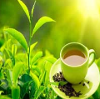
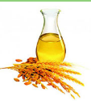
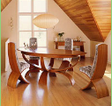

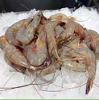
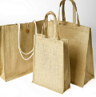
Wood Furniture Rice Bran Oil Tea
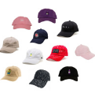

Cap Jute Product Shrimp Fish

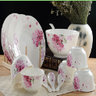

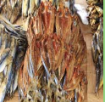

Dry Fish Vegetable Ceramic
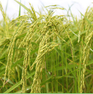

Aromatic Rice

    - Import
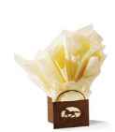
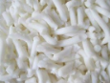

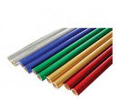

- lldiz Baby Diaper
For meeting the Bangladeshi market demand, Global World Ltd. import baby accessories specially IIdiz Baby Diaper.

Foil Paper

Foil Paper is almost like aluminum foil crossed with a paper. The quality of it is nice. It does not wrinkle as easy as foil.
- Weight Tissue
Global World Ltd. imports Heavy Weight Tissue Paper with 100% guarantee.
- Soap Noodles
For making Soap noodles, vegetable oils are main ingredient and vegetable oils include palm oil, coconut oil, olive oil, and/or animal fats.
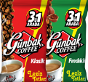

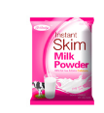
Without these products, there are also some products which Global World Ltd. imports such as-

Gunbak Coffee Skim Milk Macaroni Power
Chapter 3

World Scenario of Rubber Industry

Rubber

The fast growing industry is the rubber industry in the world. Now a day’s rubber plantation is more population in various countries than tea plantation. There are mainly three categories of rubber such as natural rubber, synthetic rubber and reclaimed rubber. From the sap of rubber tree, natural rubber is produced. Synthetic rubber is called artificial rubber which is made from raw materials. For example isoprene, chloroprene, butadiene etc. Reclaimed rubber is made from the tubes and miscellaneous waste rubbers and the treatment of ground vulcanized scrap of rubber trees.

Global Rubber Industry
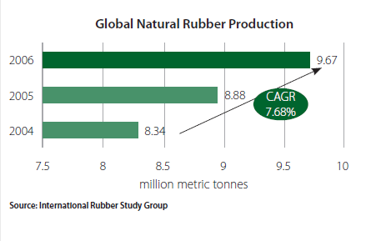
In 2006, 9.67 million Metric tons production of global natural rubber was stood and increased to CAGR of 7.68% during 2004 to 2006. The biggest source of natural rubber is Asia, almost 94 percent of the whole world input. Indonesia, Malaysia and Thailand are three largest major rubbers producing countries. Around 72% of all natural rubber production is collected from these three countries.

Top 5 Rubber Producing Countries
 | Country | Percent Change
1 | Thailand | 9.73%
2 | Indonesia | 12.92%
3 | Malaysia | 10.86%
4 | India | 3.40%
5 | Viet Nam | 5.04%

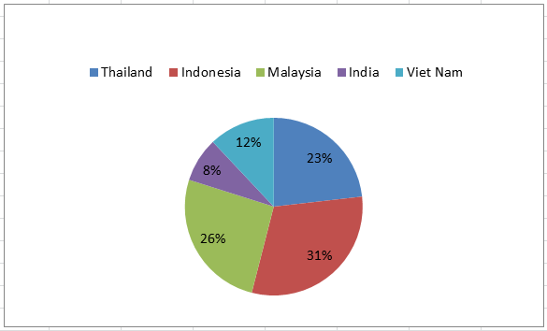
There are two factors of global consumption of natural rubber-
- The growth of economy which is major natural rubber consuming countries.
- Relative to synthetic rubber’s price
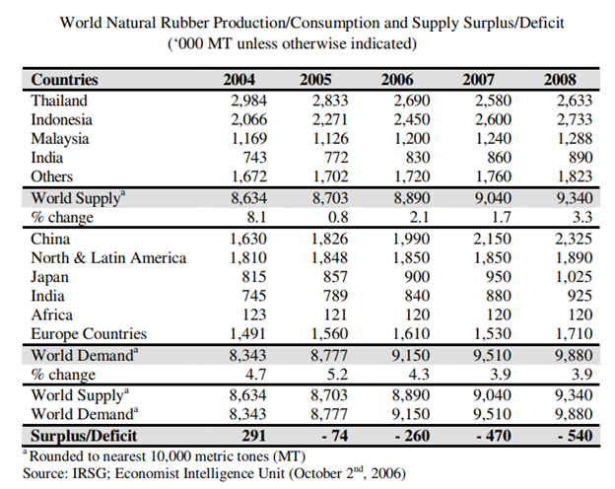

Malaysia scenario for Rubber Industry

Once a main source of income for the country, the manufacturing of rubber used to be reportedly declining and some investors even labeled it as a sundown industry. However, the healing in the international economic system and the shortage of natural rubber have since greater potentialities for the industry this 12 months and there are fine signs and symptoms for the future.
As of 2017, one of the biggest producers is Malesia as well as exporter of natural rubber whose position is 5th and it is the chief in the production, export of rubber products. It is additionally the greatest shopper of natural rubber.
They contribute to 46% of whole rubber manufacturing in the global and produces almost 1 to 5 million a lot of rubber annually. The manufacturing of rubber has declined from the Nineties which used to be 615222 tones. The International Monetary Fund (IMF), in its World Economic Outlook October 2016, said based totally on the world monetary scenario, which was estimated to grow at a faster fee of 3.4% this year, the shortage will be at 350,000 tons this year.
According to The Malaysian Rubber Export Promotion Council, Malaysia is nonetheless an appreciated rubber exporter as the rubber produced is of excessive quality, whilst the costs are aggressive in the international market. Ninety percentage of production is accounted through smallholders who normally maintain tons much less than forty acres of agricultural land. This data remains a fundamental problem for the organization as these smallholders have a tendency to go to different economic things to do when the rubber price goes down.
In fact, the MREPC is assured that no matter stiff competition from Thailand, Indonesia and China, Malaysia is anticipated to stay a major provider of rubber gloves. This is supported by using the reality that Malaysian glove producers are superior in terms of technological know-how as the necessities for clinical grade gloves become increasingly more stringent. Another motive the future of rubber enterprise looks bright is due to the fact of the healing of the automation area where rubber is one of the main substances needed in car manufacturing such as tires, piping and tubing.

Vietnam scenario for Rubber Industry
Synthetic rubbers are essential input materials for many industries as it affords intermediate items and introduced values for different industries, specifically plastics and automobile industry. The inputs for artificial rubber (polymer, plastic) are products from oil industry, mainly naphtha from oil refineries or propane, ethane from processing factories, processing fuel from crude oil and gas cracking.
Vietnam plastics industry is nevertheless a new region compared to others such as mechanical, chemical or textile industry; however, it has experienced wonderful boom in both revenue and profitability, with annual estimated increase rate of 16 to 18 per cent. There are currently more than 2,200 plastics companies running in Vietnam with the quantity of home corporations accounting for 85 per cent. This has resulted from an ever-increasing consumption of plastic merchandise which is widely used in numerous industries and financial sectors such as: power, electronics, telecommunication, conversation and transportation, aquatic products, agriculture, etc. Forecasting to 2020, home plastic producers will need about 5 million heaps of enter raw substances for production flows and activities.
Positive increase prospects for Vietnam’s plastics and rubber sectors have now attracted strong attention of overseas investors, particularly from Thailand. This further creates a slew of enterprise opportunities as properly as challenges for home groups in the face of improved worldwide competition. In fact, due to the lack of capital, technical equipment and superior technology, many small and medium home firms have been mired in difficulties, discovering it difficult to compete with foreign counterparts.
Based on the Ministry of Agriculture and Rural Development, Vietnam exported about 184,000 tons in the first two months of 2018 which total price of USD 217 million, an enlarge of 0.4% in terms of extent but a reduce of 27% in terms of value compared to the identical duration in 2017.
Meanwhile, Vietnam imported 96,000 tons of rubber in the first two months of this year with a whole price of US$166 million, up 20.8% in terms of volume and 1.9% in phrases of price in contrast to 2017.

Thailand scenario for Rubber Industry

One of the dynamics sectors in Thailand is Rubber Industry as well as there are key challenges in this sector. Thailand’s production and export of rubber are highly increased now a day but due to fall in demand from China, Rubber prices have fallen approximately 30% in 2014.

About 35 percent of world natural rubber supply and the value of market is USD 25 billion per year has been accounted by Thailand. Till 2011, the price of natural rubber increased, while the farmers expanded production but finally which indicates to the current situation of oversupply in the market.
Over 50% of the natural rubber produced in the country has been consumed by the tyre industry in Thailand and it is estimated to grow at a CAGR of 12% from 2014 to 2019. Bridgestone, Michelin and Goodyear etc. are main tyre brands which are operating in the country.
In 2016, Thailand exported over USD 4.4 billion tons of natural rubber to global market according to the latest trading statistics from ITC and 36.6% of the world’s total rubber has been exported by Thailand. China (Maximum portion importer), Malaysia, Japan, and USA import from Thailand.

Indian Rubber Industry

The rubber sector is one of the major sectors in the economy of India and it is 3rd largest producer and 4th largest consumer of natural rubber in the whole world. India started commercially of rubber plantation in1902. Some of the key factors that highlight the criticality of this sector in the Indian economy are:

- Top ranked nation globally based on productivity.
- 2nd ranked in terms of consumption of natural rubber, similar to China.
- 6th ranked based on rubber plantation globally.
- 4th ranked in terms of world natural rubber production.
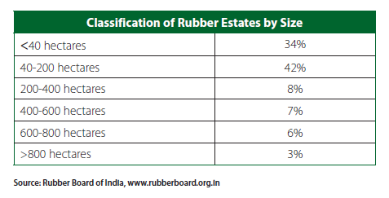

Chapter 4

- Bangladeshi scenario for Rubber Industry

History
In 1952 from Malaysia and Sri Lanka the Department of Forest in Bangladesh bought several thousand rubber seeds and some budded saplings. The rubber expert of the UN and Agriculture Organization (FAO) conducted a research about potentiality of rubber plantation in Bangladesh. After that the government of Bangladesh wanted to launch commercial rubber plantation in this country. A pilot project was conducted by Department of Forest in 1960 on 710 acres of land. In that period, the 5-year long project was amended for commercialization.
The Forest Industries Development Corporation made the implementing agency for the project in 1962. Finally the project was successfully done. From 1980 to 1981, BFIDC started to play much yielding types of rubber saplings and by 1997 it nurtured 16 rubber gardens in Chittagong, Sylhet and Madhupur regions. A total of 7,700 acres of forest land of Chittagong and Sylhet are earmarked by BFIDC during 1960-1973 to develop rubber gardens there.

Socio-economic Impact of this sector:
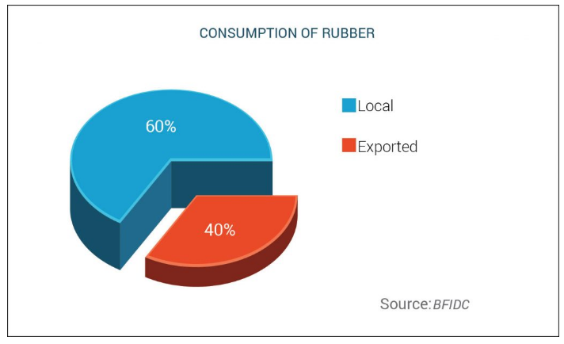
In 2012, our country produced 24,000 tons of rubber (out of that 60%) which was consumed by the local market as well as rest of the rubber (9600 tons) were exported and earned BDT 220 crore. Because of creating this sector in our country, the employment opportunity is also created. According to industry experts, in every 25 acres of rubber land, as many as 10 people are employed.

Consumption of domestic Rubber Production:
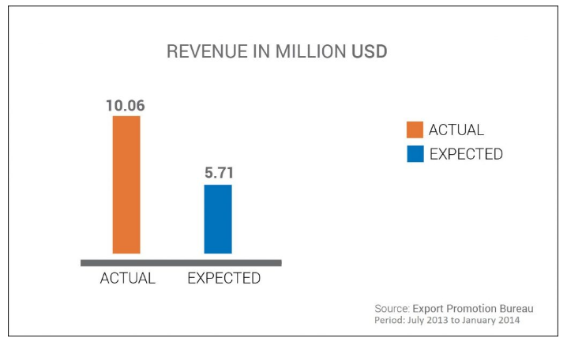
According to the president of BRGOA (Bangladesh Rubber Garden Owners Association), India, China, Malaysia, Turkey and Pakistan show much penchant to the raw and processed rubber of Bangladesh because of its esteemed quality.

From July 2013 to January 2014, the expected figure of the rubber export revenue was USD 5.71 million but the actual revenue was USD 10.06 million. It was unbelievable.

Constraints to the Industry
It is one type of barrier the imposition of 15% VAT by the government for growing this sector, although all VAT has been withdrawn from agro-based products. During the last 33 years, 12% interest rate was on BDT 162.82 million, have been invested by our government. Lacking of expertise in this field is another constrains to this industry as well as the scope of soft loans and other financial opportunities are very low according to Bangladesh Rubber Garden Owners Association (BRGOA).

Chapter 5

- Analysis & Demand of Rubber Industry
Although the huge demand of natural rubber in the world, it showed the low demand through 2016 as consumption growth in China (the biggest importer) and then expansion would moderate to 3.5 percent in 2016 from 3.9 percent the previous year.

Player in Industry

Market share of the rubber industry leaders (Market Capital)
There are 6 big giant in this industry, they lead in this sector.
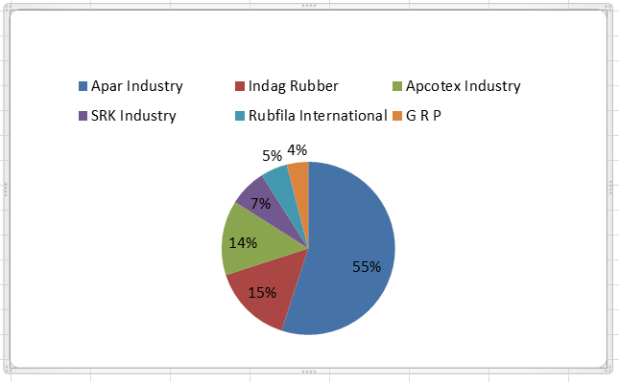

Opportunities of Rubber Industry

Growing Economy
- Growing Automobile Industry

The growing rate of Automobile Industry is an opportunity for rubber industry although during the initial stages of auto industry was overlooked by the Government which was not favorable

- Growing OEM demand
Belts and hoses, latex foam, battery boxes, cables and wires, tyres and tubes of automobiles, balloons and toys etc. are made from raw materials as natural rubber as well as it is also essential for processing synthetic rubber. Finally, the future rubber industry is very bright.

Problem of this Industry

Increasing price of natural rubber which becomes major threats of this industry.
Cheaper imports of Rubbers, especially from China, selling a very low price, have been a challenge. The increase in import of cheap Chinese Rubbers last quarter has resulted in the fall of Rubber prices by over 25% in the market. Finally, local Rubber producers face the threat of cheaper imports. There are several limitations of this industry-

Global Shortage
There is a deficit of 449.000 tons this year and the widest since 2000, which decreased the investments (247 million tons) according to Prachaya a London based industry advisor and he has knowledge about it from 30 years.

Raw Material Cost
About 70 percent of rubber industry’s income comes from raw materials. Labor cost is very important part here. For the last 3 years, the raw materials cost is increasing constantly and especially crude oil-linked raw materials.

Product Recalls
By allowing for back tracking on any items, the manufactures managers of rubber recall the product. If customers have any complaint about product, the ERP system indicates for recalling the products. It allows for easy recalls as well as less uncertainty which affects the main rubber industry.

Erosion and degradation of soil
As a monocrop, rubber planted in large area. Due to use of pesticides, organic, herbicides and inorganic fertilizers natural flora and fauna were disturbed. For establishing plantation, the growth of the plants becomes retarded and the ground covering plants were killed or perished. As a result, heavy erosion of the topsoil occurs.

Scarcity of skilled tappers
A common standard for payment of wages still cannot be achieved because of uneven distribution of crop and it is done in the core counties like Thailand, Sri Lanka and Malaysia of the traditional zone. Here, there are very limited training facilities for the tappers.

Recommendations
Within 2020, 150,000 acres of land will be bought under cultivation for facing world demand of rubber according to the Food and Agriculture Organization of the UN (FAO). The target is to reach 0.1 million metric tons of rubber production within 2020 as well as 0.2 million metric tons of rubber production within 2050. So, now Bangladesh needs a proper infrastructure to reach the target and Bangladesh should concern from key supplier to ultimate production to meet the global demand. The rubber production in our country can reach its vastly anticipated statures, Saied by BRGOA. Here public and private both sectors have their own responsibilities.

Conclusion

Rubber has been used for centuries as the favored material for the manufacturing of many products. Manufacturing methods have evolved considerably towards achieving a greater efficiency, as well as overall volume of rubber. For the purpose of fulfilling the shortage of the demand of world, private and public sectors should take proper steps. In this report the overall global scenario of rubber industry is focused with details. Finally, in near future, the scenario of rubber industry will be brighter.

Reference
http://www.globalworld.com.bd/
http://www.atmaindia.org/Export.htm
http://www.mindbranch.com/catalog/find.jsp
http://www.atmaindia.org/Radialisation.htm
https://feppcar.org/9/problems-of-rubber-production-in-bangladesh-and-their-solutions/
http://www.theshillongtimes.com/2013/04/19/low-productivity-still-a-problem-in-rubber-cultivation/
https://businessimpactenvironment.wordpress.com/2011/10/03/environmental-issues-caused-by-rubber-industry/
http://e2btek.com/top-5-challenges-rubber-plastics-manufacturers-solved/
https://www.rubberasia.com/2017/11/27/indian-rubber-industry-opportunities-challenges/
http://www.dailymirror.lk/30772/natural-rubber-industry-challenges

