Promoting Door to door health care services: A Study on Olwel BD Ltd.

Md. Mifthahul Baki

This internship report is submitted to School of Businesses & Economics, United International University as a partial requirement for the fulfillment of Bachelor of Business Administration Degree requirement

Promoting Door to door health care services: A Study on Olwel BD Ltd.

Submitted by
Md. Mifthahul Baki
ID: 111 142 221
School of Business & Economics
United International University

Supervised by
Kawsar Ahmmed, PhD
Associate Professor
School of Business & Economics

Date of Submission: October 22, 2020

Letter of Transmittal

October 22, 2020

Kawsar Ahmmed, PhD
Professor
School of Business & Economics
United International University
United City, Madani Avenue, Badda
Dhaka,

Subject: Submission of Project Report

Dear Sir,
With due respect, I am really pleased to inform you that this is a great pleasure for me to submit the internship report on “Promoting Door to door health care services: A Study on Olwel BD Ltd."

In this report you have found what I have actually assigned as my learning perspective. I have included all the elements that help me to learn something different. I try my best to make it as attractive as possible.
Finally, I am really grateful to you for giving me this opportunity to work on this report which I have taken this as a great opportunity for me to develop the practical and professional skills through the Internship program.

Thank you.

Yours Sincerely,

……………………………
Md. Mifthahul Baki
ID: 111 142 221
United International University

Executive Summary

The internship report is based on the three months internship program that I had successfully completed on “Promoting door to door health care services: A Study on Olwel BD Ltd”. This study has tried to focus on the real marketplace and intellectual work on promotional activities. I focused on how customers are being influenced, how they interact with their desire and services. It was such a good experience to work on this topic. To inform the customer, to remind them and to persuade them, promotional activities essential for a marketer. Accordingly, as a marketing student, working on this topic is really helpful and provide the scope of utilizing the theoretical knowledge in the practical arena. All information collected in this study is from the experience of designated area and practical work. It gives a great opportunity at the same time to work on this. In this report, readers can see how different variables impact promotional activities related to door-to-door health care service. Every possible discussion related to promotional activities has been discussed in this study. Readers can easily get the idea how customers are being influenced, how they react towards the door-to-door health care service, how they became familiar with the service, why they ignore or not buying service. After all, it will provide a strong summarization of promotional activities on door-to-door health care activities.

Keywords: Service promotion, health care services, mobility problems, Olwel, Bangladesh

Contents
Executive Summary 4
Introduction: 8
Motivation of the Study 8
Objectives and limitations of the report 9
Limitation of the Report: 9
Chapter 2: Company Overview and Literature Review 10
Background of the Organization: 11
Corporate Information of the organization at a glance: 11
Management Team 12
Partners 13
Mission and vision of Olwel: 13
What does door to door promotion means? 14
Why analyzing door to door promotion is important? 15
Offers an impressive return on your investment 15
Great way to get customer feedback 15
What factors impact on door to door promotion? 16
Interactions 16
Use of remuneration as sales leader: 16
Use redemption as sale 17
Continuity / commitment 17
Use commitment as sales leader: 17
Use the promise as a sales representative: 17
Social proof 18
Use social proofs as sales leader: 18
Use of social proof as sale 18
Authority 18
Use authority as sales leader: 18
Use of authority as sales representative: 19
Likes 19
Using choice as a sales leader: 19
Use choice as sales choice: 20
Deficit 20
Use deficiencies as sales leader: 20
Lack of use as sales representative: 20
Chapter – 3: Job Responsibilities 21
Experience at the OlWEL BD LTD: 22
Actual Task: 22
Intern KPI: 22
The most potential place for campaign: 24
Institutions: 24
Government office: 24
Achievement: 24
Customer Satisfaction 25
Reasons Why Customer Satisfaction Is Important: 25
Services Marketing: 26
Olwel Expanded mix for services marketing: 27
Customer satisfaction: 27
Factors impact on customer satisfaction: Loyalty programs: 27
Olwel follows these strategy for employee engagement by this model: 30
Olwel follows these techniques for increasing trust of customer: 31
Relationship between Service Quality and Patient/Customer Satisfaction: 34
The Customer GAP 35
The Provider Gap 35
Gap 1: The listening gap: 35
Gap 2: The design and standard gap: 36
Gap 3: The service performance gap 36
Gap 4: Communication Gap: 37
Implementation of Service Gap Model in Olwel: 37
Five Dimension of service Quality of Olwel 40
Recommendations 45
Conclusion: 46

Chapter 1: Introduction

Introduction:

This study is an internship document that has been created as a requirement for performing the BBA program of the United International University Bachelor of Business Administration (BBA). The key area of the internship is to provide students with a job experience and an opportunity to turn academic starting into real-life situations. Through innovation, companies, research institutions and development projects, undergraduates are put. I was based on the internship program in Olwel Bd Ltd, Dhaka. I need to submit a report as a requirement to complete the program, which includes "Promoting Door to Door Health Care Services: A Study on Olwel BD Ltd." The report is based primarily on preliminary information, secondary information and company information. Study methods and searches basically show my volume for some creative and original methods to solve practical problems in today’s market.
Olwel is a Bangladesh-based startup based in Finland. Olwel is developing door-to-door healthcare services for patients who prefer to seek medical advice at home.
Olwel service is suitable for people with mobility problems and anyone in the doctor's office who wants to avoid traffic jams and long queues. Door-to-door is a screening method that is usually used for sales, promotions, advertisement or lobbying, where the person or persons walk from one house's door to another's door trying to sell or promote a product or service to the general public or collect information.

Motivation of the Study
Just like I did my internship at Olwel BD Ltd. where I learned how to sell door-to-door health care. It makes me interested in writing a report on how a service door to door can be promoted and sold. I've inspired a few things that made me hypersensitive. I just found out that I love direct marketing and door-to-door sales. It's mostly about different experiences in interaction. Studies have shown that more than 90 percent of human communication is made up of body language. One of the advantages of live input and facial expressions expressed in body language is face-to-face interaction. The advantage of face-to-face interaction is that it helps to expand the network and improve communication in the future. It provides a feeling of friendship that virtually enhances the success of the relationship, be it personal or business relationships. Door-to-door marketing is more natural and effective from all other communication tools. That's why I was inspired to write a report on door-to-door health care service promotion.

Objectives and limitations of the report

Research Objectives:
The Research objective of the report can be viewed in two forms:
- General or Broad Objective
- Specific Objective

Broad Objective:
The Broad objective of this report is "Promoting Door to Door Health Care Services: A Study on Olwel BD Ltd."

Specific Objective:
The specific purpose is to gather information from potential sources and analyze the selected scopes under the following directions:
- To analyze the promotional strategies of Olwel.
- To analyze the promotional performance of Olwel.
- To analyze the promotion related activities.
- To find out the communication strategy.
- To know the Customer Satisfaction of Olwel Bd Ltd.

Limitation of the Report:

Olwel is really a great place to gain practical knowledge. Although I tried my best to make this report, I had some problems with my report. As they follow -

- The main problem I found in doing this report is accessibility of information because a lot of information is confidential.
- As we know, the duration of internship is only 3 months. This is a very short time for any kind of study, which was not enough.
- While doing the internship, in many parts of my investigation, my acting got stuck due to some lack of experience.
- Since this is the first time I have done such a report, it was difficult to organize the report in a general manner.

Chapter 2: Company Overview and Literature Review

Background of the Organization:
Olwel is a Finland based startup working in Bangladesh. We are bringing a necessary service for their patients who prefer to receive treatment advice at their home prefer it started its business on 17th November 2017 due to its movement difficulties and Olwel's service would be ideal for anyone who wants to avoid traffic jams and long queues at the doctor's office. Olwel is providing its service through sending doctors to the patient’s doorstep on their demand. It has its own doctor panel of almost 50 skilled GP doctors. Olwel’s doctors have graduated from the top most medical institute/college of Bangladesh. Maximum doctors have their minimum 3 years to 18 years’ experience. Doctors either have finished their post-graduation or are in their courses from different universities. Recently Olwel is hiring doctors to make their panel of 200 doctors.

Logo:

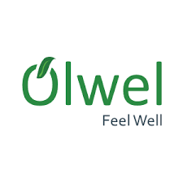

Corporate Information of the organization at a glance:

Company Name: Olwel BD LTD.
Nature of business: Service
Founded: 2017
Location Registered Office: House 185, Lane 2, New DOHS,
Mohakhali, Dhaka - 1206.
Corporate office: House#13A/3A(2), (Beside Panam Resident School),Block#B, Babor Road, Mohammadpur, Dhaka-1207.
Sub office: Mirpur 6, Dhaka
Headquarters: Dhaka
Phone: 9887041
Hotline number: 09666766000
Facebook Page: www.facebook.com/olwel.feelwell
Website: www.olwel.com
E-mail: contact@olwel.com

Management Team

- M.M Aftab Hossain (CEO)
- X-Post-Doctoral Researcher (KTH Royal Institute of Technology, Sweden)
- Mojahedul Hoq. Abul Hasnat ( X-CTO Therap Services, LLC)
- Dr. Salahuddin Feroz (Director of Medical Services MBBS(DMC),MD(Nephrology), BSMMU)
- Abdullah Faiz (CCO, Director,B2B Product & Marketing Banglalink Digital Communications Ltd.)
- Aminur Rashed Khan (COO, Customer Solution Architect Nokia Network)
- M W A Farhad (Co-founder)
- Advisory Panel Vilho Jonsson (Founder & Principal Innovation Evangelist, Curlabs Project Leader, Innovation project)

Johan Backman
Founder & Principal
Change Evangelist, Curlabs Program Officer Tele2 Hackney

Khurshida Khanom
Professor and Head, Dept.Health Promotion & Health Education, Bangladesh University of Health science.

Nima Jokilaakso
Project Manager Digital Health, Swecare Foundation CEO, Jokiaakao and Company AB Ambassador, Rockstar Accelerator.

Tapio Siik
Advisor,Aalto start-up centre Mentor, Vertical Accelerator Angel Investor Partner,Nokia Growth Partners.

Partners

- Thyrocare
- URAL EMS
- ePharma
- Aaito University
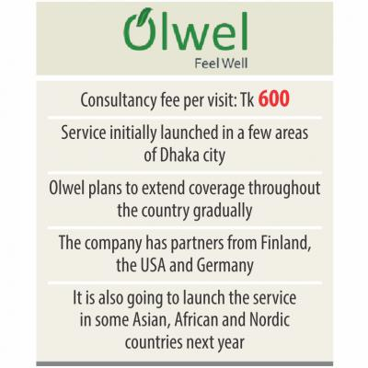
Table 2.1: Corporate Information of Olwel

Mission and vision of Olwel:
To take desire healthcare services at doorstep through our dedication, hard work and quality service. From the first day of its inception Olwel is providing its highest effort to make its beneficiaries happy with our services. We have started our journey from Mirpur, Mohammadpur and Dhanmondi zone bearing in mind to expand our services in whole Dhaka city as well as whole Bangladesh and even abroad.

Fundamental Departments of Olwel:
- Administration Department
- Financing and Planning
- Commercial Department
- MIS
- Training and Development
- HR

Olwels present product and services:

- Physicians at home: throws a request by phone or mobile application and an MBBS. The doctor will be present at the patients address in a very short time.
- Medicine Home Delivery: Patients need to show a prescription for delivery of medicine at home.
- Sample collection for diagnosis: The patient has to call Olwel for sample collection or small test and Olwel will send a lab technician to the patient's home.
- Ambulance service as per demand: In case of emergency anyone can request to move from home for ambulance.
Primary services:

- Home Visit Doctor: Place a request via phone or mobile app and send an MBBS. The doctor will be present at your address shortly or call the doctor's office / home for door-to-door healthcare services for non-emergency illnesses.
- Great Doctor: We have local and internally trained physicians who work with patience and empathy.
- Other services: We collect samples for investigation, provide reports and medicines, and provide ambulance assistance.
- Extended Support: Call Corporate Followup Service and Dedicated Account Manager for our corporate clients.

What does door to door promotion means?
Door-to-door is a common technique commonly used for sales, marketing, advertising or promotion, where a person or individuals walk from door to door trying to sell or advertise a product or collect services or information from the general public.

Why analyzing door to door promotion is important?
Analyzing door to door promotion is important because it has lots of benefits and future market potentials. Door-to-door sales may not be new, but this tried and tested marketing method can still bring great benefits to companies that use it. As well as being an effective way to increase sales levels, this strategy offers more or less well-known benefits - and here are a few to consider.

Offers an impressive return on your investment
Spending money on marketing campaigns is easy, but making sure you get a good return on your investment is not always so straightforward. For example, you can raise enough money for anything from direct mail promotions to web-based promotions and TV and radio ads, but you fail to achieve the results you are aiming for. One of the great things about home sales is that it enables you to have complete control over your spending. The easiest way to do this is to find a direct sales specialist who will only charge you for the results they provide. For example, the Apco Group operates a performance-based model that helps it deliver the highest quality to its clients. By choosing a service like this, you can be confident that your money will work well.

Great way to get customer feedback
Not all successful businesses understand the importance of conducting market research, but many companies have helped their product promotions as well as the fact that door-to-door sales campaigns provide the perfect opportunity to gain important information about them. Brand ambassadors who present companies at the doorstep can gather a broad range of information about people's perceptions of brands and what they like or dislike about specific products. These can be fed back to businesses to enable them to hypnotize their products and make them useful for their images and marketing messages.

Helps you create end-to-end customer connections
With plenty of choices now available to them, it's no surprise that customers can be restless. Even if they purchase a product or service from you, there is no guarantee that customers will repeat that purchase in the future. Another little-known advantage of door-to-door sales is the fact that, unlike many other marketing strategies, it can be extremely effective in establishing lasting relationships between businesses and customers. Skilled brand ambassadors can help build relationships with customers at the doorstep, build trust and instill a sense of loyalty.

What factors impact on door to door promotion?

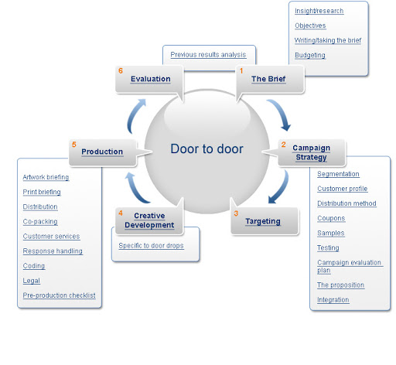

Interactions

The first principle is reciprocal behavior, which says that people are more obliged to return grace to those who have done something for them. This does not mean that you should expect or need something instead, but that they expect them to do something; This is not a quid-pro-co-exchange. Sealdini demonstrated this during his three-year research where he documented the effect of giving a gift with restaurant waiters and waitress bills. He noted that if diners were given a single mint or luck cookie but something along that line, they increased their tips by an average of 3%. If given a couple of minutes instead of dinner, they have a 14% increase in tips.

Use of remuneration as sales leader:
Leaders are always supposed to lead by example, right? You have to thank them for their hard work while delivering them in person in a personal conversation on how your competitor brings a few qualities to work once in an hour of your day. What you are most likely to get if you don't just find some worthy leadership for them is a one-stop shop thanking them in a 1-on-1 conversation, more improved work ethic, and much more from them on a daily basis.

Use redemption as sale
When a sales representative is talking to a current or potential customer they need to be able to offer something of value. Being able to solve an immediate problem with a potential person's home or offering a free visit is a good start. If a sales representative sees a leak they can resolve quickly, they should at least take the opportunity to ask and offer to do so. Even offering a piece of mint or candy during a conversation or visit.

Continuity / commitment
This principle says that people want to be consistent with their behavior and be committed to it. You’re initially looking for smaller promises and over time these will get bigger because research has shown that people are already committed to doing something bigger with the person they once committed to.

Use commitment as sales leader:
One of the best ways for owners or managers to get consistency from their sales staff is to write down their important information. If a sales manager talks to each representative and asks how many doors they are knocking on each day, they must track these metrics. However, instead of using your sales tracking app to pull these numbers, write down their names at the end of each day and turn it on before they leave. Use your dashboard now to verify that the information is correct.

Use the promise as a sales representative:
This example is the same as the one above. When a sales representative makes an appointment with an expectation, instead of the usual natural way of sending a reminder via text or email, as is the case with many expectations, ask the sales representative to write the appointment information in front of them while they are at the door. This will ensure higher rates.

Social proof
Whether consciously or unconsciously, social evidence says that people pay attention to what other people in the neighborhood are doing. People basically do things because someone else did it before. That’s why you have startups or preachers and you need to cross these wrinkles to reach your early majority.

Use social proofs as sales leader:
Think about making such a change anywhere near being controversial, you definitely have a pushback. Those of you who support the change and your highly productive sales representative should use it to support your change. As others see that the company’s best sales representatives are in favor of change, they will eventually expect the same on board. Try dragging them out before major changes are revealed, pick them up on the board, and then ask the rest of the team for help. Boom! Everyone is on board.

Use of social proof as sale
One simple principle of persuasion to use sales proofs is social proof. All they have to do is throw away your most well-known clients as references during their pitch or use your company's social media influence. This is probably more used than you understand. I've seen reps go around with a layered template with 6 to 8 images - either with the customer before / after or below a quote from the customer to check out why you're proposing. It's great to be able to hand over to the customer.

Authority
The fourth principle of persuasion, authority, follows the concept where people believe who are credible and knowledgeable in a particular field. In very simple language, people follow positions such as doctors, lawyers and officials in terms of skills and competencies.

Use authority as sales leader:
People in the leadership position of your organization can always use the owner for reference as a person of authority when talking to the customer or they can use the closed national client as brand recognition. On the other hand, if you have experience selling your product, you can drive with your representatives and occasionally show them how it happens. If you can get in there and close a deal while they are fighting it will show them and the team will think you are the authority here.

Use of authority as sales representative:
Delegates have a much easier time exercising authority because of their position. Let’s say any customer has asked a question that the sales representative doesn’t know. Sales representatives can do two things to establish authority instead of making noise by trying to swing instead of answering. First, they need to be humble themselves. Second, they need to mention someone in authority. They should tell their clients that they are not sure about the answer and that they have more than 15 years to call the National Vice President for their "Central Time Sales Region Regional Director for the Midwestern Region of the Central Time Zone."

Likes
Simon Sinek taught us a lot about the fifth principle of understanding his TED talk. He talked a lot about how people like to buy and do business. Sealdini’s choice of study led him to do research at two well-known business schools so that students could come to an agreement and fully discuss the negotiations. The first group was told that time was money and that they needed to get the right to work. They managed to reach an agreement at a rate of 55%. The second group was asked to trade information about each other and found a match they shared before they started. This group comes to an agreement 90% of the time and delivers 18% more valuable results to both parties.

Using choice as a sales leader:
Leaders need to find some similarities to express their team likes and dislikes. Some easy ways to do this are to take the team out for a drink or play games in the office. I played a game there very early in my time at Spotio where everyone had already filled out a questionnaire, then each person had another interesting answer used to the game and everyone had to guess who it was. Then we saw Glengari Glen Ross and the winner got a Cadillac Eldorado and the second place one got a set of steak knives. I brought it up because it was fun and I learned a lot about our executive team that I respect,

In addition, we learned that one of our team members is Kooray, the top author of 201 & 2017, with over 5 million views. How cool to know it!

Use choice as sales choice:
It is a critical policy to choose your salespeople to make sense of the use. The easiest way to do this is to have an outgoing personality in an effort to become representative and find something that can be related to expectations. Building Rapaport will help the customer to stay comfortable and exchange more information. For example, do they have a beautiful yard or car that they are definitely proud of and you can bring it. Or if you live inside their house and you see a guitar on the wall, I play the guitar so I can instantly present it and enjoy the conversation.

Deficit
Wrapping up our time when we’ve made it to # 6 with the scarcity of scarcity. This means that people want more than they can afford (like our blog post). This is still another principle that is often used without realizing it. The important thing to remember with lack is to stick to your word. If I get an email from a company offering a 50% discount that ends at midnight, I don’t take it and decide to call to try the next day, they better not give it to me. If they do, I'm probably not taking it yet because now I know I can get it whenever I want.

Use deficiencies as sales leader:
Managers can use deficits during any competition. A representative who knocks on 100 doors at 12 o'clock at night gets a $ 25 gift card instead of saying, change it and say the first two reps that hit the two doors during that first time received the $ 75 gift card.

Lack of use as sales representative:
Like the story above, it can be rather easy to use when closing sales deals. Offer a special promotion to buy at a place that will only be valid at the end of the day to generate scarcity and urgency. However, just like the one mentioned above, you will not be able to make the same deal over time.

Chapter – 3: Job Responsibilities

Experience at the OlWEL BD LTD:

Actual Task:
This report has done based on the requirement for competing the internship program. The primary objective of this report is getting the real life practical knowledge. For completing internship three credit course fulfillment I joined Olwel BD Ltd as an internee. I worked here for three months in marketing department. In this time I have learn lots of things. They were very helpful and friendly.

Intern KPI:
I have done my Internship program at Olwel Bd Limited which is situated at Corporate office: House#13A/3A(2), (Beside Panam Residant School),Block#B, Babor Road, Mohammadpur, Dhaka-1207, Bangladesh from 12th June to 31st August 2019. I worked in sales and marketing department. During internship, I worked both in office and went to field work under the supervision of Md Rabiul Alam Rabi, Business developer. They have opportunities for internship students for working. So my principle object was to comprehend there arrangement of working in the marketing division.
The place we have covered during field work:
- University
- College
- School
- Private Company
- Public Company
- Did activation on several place
- Did fair on "Bangabandhu International Conference Center"

Guideline of 3 month work

Primary learning:
In primary learning I learn some basic things like:
- Know how to communicate face-to-face
- Know about culture of organization
- How to behave with Colleagues, Customers and others.
- How to make a good relationship with another.
- How to manage time
- In Business conference how to deal with clients
- Contact with company’s employees and others
- Know about rules & regulations of company and law.
- What the sales department does.

Secondary learning:
- Collected information of the offices located in Agargaon office area.
- Introduced our services to the staffs employed by those Gov. Offices.
- Collect some data from those employees in details.
- Tried to convert those offices as our valued customer.
- Found some opportunities to work as a partner.
- Found some places to arrange any awareness program.
- Contact with the main person of IDB (special desk) and shop owner association. Try to convince them regarding our services and collect permission so that we can arrange some awareness campaign in this premise.

- Bangla Academy: Met with the DG of bangla academy and convey services. Know the procedure in details if we want to take part in the "ekushe boi mela".
- National Museum: Meet with the concern (DG) and convey our services. And to let them know we want to arrange a awareness program.
- Rest: to know the details if we want arrange fair or other campaigning.
- Took necessary action to organize activation program.
- Collected information of the offices/school/colleges and universities
- Introduced our services to those organizations and their staffs.
- Collected some data from those organizations in details.
- Tried to convert those offices as our valued customer.
- Contact with the targeted distribution channels.

Main Objective:
- To build a business relation with some corporate offices.
- To build a business relation with some institution (School, college, university etc)
- To build awareness to targeted distribution channels.
- To build awareness among the mass people through some events, activations.
- To create some business campaigning ideas as well as to convert those ideas in business.
- Propose some business model which will be helpful for olwel.
- To create some promo campaign model based on the practical experiences gather from field work.
- To know how a call center executive does their daily jobs. And find some tricks to improve our services.
- To know how our CC colleagues are working.
- To know how a corporate presentation can be prepared for jobs done in internship period.

The most potential place for campaign:

Institutions:
As my perception I think institutions are most effective place for getting new customer. Because there are so
many scope for doing campaign by which thousands of people can know about Olwel. By giving 10-15 minute speech on any meeting of any institute can give us potential customer as well as we can educate our customer about Olwel.
Second most potential place for activation:

Government office:
Government offices are second most potential place for activation. Because by doing activation in government offices we can get some upper class customer for long time.

Achievement:
• Feedback about Olwel: We have got some important information by which we can identify the needs and wants of our customer.

Potential customer: By doing the activation and market visit we have got some loyal customer.

Creative idea: By going lots of places we have gather lots of creative ideas for improving our services. By doing the activation we could knew about the customers’ perception about Olwel.

- Important data from people: We have collected data from potential customer which data will help us for future development.

Customer Satisfaction
Customer satisfaction is a term which mainly uses in advertising. It is a proportion of how things and administrations provided by an organization meet or outperform client need. Consumer loyalty is characterized as "the quantity of clients, or level of complete clients, whose revealed involvement with a business, its administrations (evaluations) surpasses indicated fulfillment of needs and wants." As per Hansemark and Albinsson (2004) "fulfillment is a general disposition towards an item supplier or a passionate response to the contrast between what clients expect and what they really get with respect to the
satisfaction of a need".

Reasons Why Customer Satisfaction Is Important:
We can never ignore the importance of customer satisfaction. There are so many reasons for business success, customer satisfaction is one of them. Identifying this component and functionality is essential to improve the intent to make our customers more loyal and to transform them into brand ambassadors. If we don't care about customer satisfaction, we can't expect them to care about our products or services. It is true that the sooner we face it, the better we will perform.

1. Loyal customers are a treasure we should keep hidden from the world
According to the research client that loyal he is ten times more valuable than their first purchase. Even some studies say it is six to seven times more expensive than the current customer. Service companies know it better than other so they don't face extra problem for going far for customer who is not more satisfied. It can be more expensive but also difficult to retain the existing customer. 2. They can stop being our clients in a heartbeat:

2. It is not impossible that clients easily switch their favorite brands. It happens for customer service. If customers don't get feedback they can be dissatisfy. And gaining customers trust takes a business up to many
positive experience. 3. Also, It is all about the money:

3. Customer satisfaction is affected with revenue. A brand can be affected by customers’ feedback in both positive and negative way. They can create us customer value. Satisfy customers won't focus on our competitor service or product. They will also recommends our product. If we can fulfill their requirement and deliver high quality service they will be loyal customer. It will increase the revenue.

4. Customer satisfaction is a factor that helps us stand out of the competition:
In spite of the fact that our clients won't like us on the off chance that we give terrible product or service, our
rivals will. Competitor always waits for our one wrong move. Being set up for their incitements isn't sufficient on the off chance that we don't have the foggiest idea how to manage the negative kickback.

5. Extraordinary client experience can take our image places:
We can't ignore the customer satisfaction. We should keep it mind while planning our targeting and positioning activations. Satisfied customer always share those things more on social media. They will comment with our post and will leave some beautiful ideas.

Services Marketing:
In the marketing field service marketing, most of concept came from service industries like, transportation, banking, health care & hospitality. As this traditional services have involved & became more competition so
online Medicare service is so much effective for customer.
Olwel Traditional services marketing:
- Olwel follows traditional marketing mix which is composed of the four Ps: product, price, place (distribution), and promotion. There are main variables for decision making any marketing plan.

Olwel Expanded mix for services marketing:
As service is intangible sometime customer wants to find tangible cue for helping them to know about the nature of the service. Example: The appearance of treatment. There are 8 PS: Product, place, promotion, price, people, physical evidence, process.

Customer satisfaction:
Customer satisfaction is the thing by which we can measure customers’ attitude towards product or service or brand. Success is depend on customer link to business. Customer satisfaction and quality management should be incorporated in long run goal of any business. A business can creat plan for customer satisfaction. An easy way to know about customers is survey on customer satisfaction and do what they want makes customer satisfaction.

Factors impact on customer satisfaction: Loyalty programs:
The paradox of customer loyalty shows the phenomenon of an attitude that can be influenced by customer relationship management as popular loyalty grows. But research says that repeat purchase loyalty is possible through passive recognition of the brand. Demand for this approach is more limited than trustworthiness. Surveys three alternative perspectives on consistency and these relate to a framework for understanding the client that includes client brand liability, client brand recognition, and client brand purchasing. Uses this framework to isolate demand - side capabilities of reliability programs. Olwel always strives to maintain customer relationship management through this kind of loyalty program. By loyal to their customer they increase their customer satisfaction. Olwel does programs so that customers get our services they need. These programs help new customers to understand the service.

Commitment:
Client commitment is currently seen as a key variable in connection promotion. The article explores the different types of responsibilities that govern the connection between customers and their service providers. It was discovered that while customer commitment depends on shared qualities, it consistently has a positive effect on client reliability. At this point when the client’s liability depends on the cost and the exchange of dependencies, it affects the client’s dedication. Moreover, it was found that there is a critique between these two types of responsibilities regarding client dedication. In the off-chance of us realizing the client's work of responsibility, we should have a strong sense of duty in our relationship. There is important interaction for the executives of these discoveries and administrative connections because it is not the real situation that more client tariffs are better for the expert agency or the client Olwel always tries to fulfill their promise. They promise to serve their patient within 30-40 minutes of the appointment. They always observe their patients for at least 20 minutes because they are committed to the customer. They always follow after 3-7 days of any treatment. With Olwel, three things are guaranteed - patient comfort, care and comfort. Olwel always brings comfort to patients by promising experience with doctors because they truly care for the patient.

Perceived switching cost:
It is a commercial center reality that marketing manager now and then incur exchanging costs or switching cost on Olwels clients, to restrain them from abandoning to new supply. To address that issue, some study analyzes the directing impacts of switching costs on customer faithfulness through both fulfillment and saw esteem measures. The directing impacts of switching costs on the relationship of client reliability and consumer loyalty and saw esteem are noteworthy just when the dimension of consumer loyalty or saw esteem is better than expected. Olwel always tries to retain their customer by making their customer understand about Olwel so that customer don't switch to other service company.

Customer Engagement:
By customer engagement Olwel increases customer’s encouragement and interaction and create their business by shearing their experience. And by this Olwel gets customer satisfaction. By strong strategy of customer engagement Olwel creates customer satisfaction with loyalty and brand growth. Value creation happens for customer engagement and for this satisfaction of customer is increasing. Olwel follows three customer strangers by which they make loyal customer for customer satisfaction. Following:
1. Customer experience: It has importance for Olwel because customer experience gives business & markets a path for increasing satisfaction. Olwels patient experience makes patient involvement in different level like emotional, physical, sensorial, and spiritual. Response of customer or patient conducts direct, indicate contact of a customer. By customer direct interaction occurs when purchase is initiated. Advertisement, news reports, word of mouth or criticism etc. is defend indirect contact.
2. Humanize brand: it's significant that Olwels customers want to inform about their needs and wants. Within this concept for creating customer acknowledgement of Olwel with human and ground level of understanding. It’s a matter by which customer can trust Olwel. It's a way by which Olwel can get success of brand and get the satisfaction of customer.
3. Social Media: It's a platform where Olwel is able to help the customers on level of customer satisfaction & many ways for engagement. It's the reason to become popular around the Bangladesh among business. Social media is a popular platform for customer engagement. It is included in Instagram, Twitter, and Facebook etc. which are most popular stage. Olwel uses all social media by which they get customer and they also use combination media. It’s a best idea to use different ones so that they can get the success. They also invest on which media is more benefited for them.

Employee Engagement:

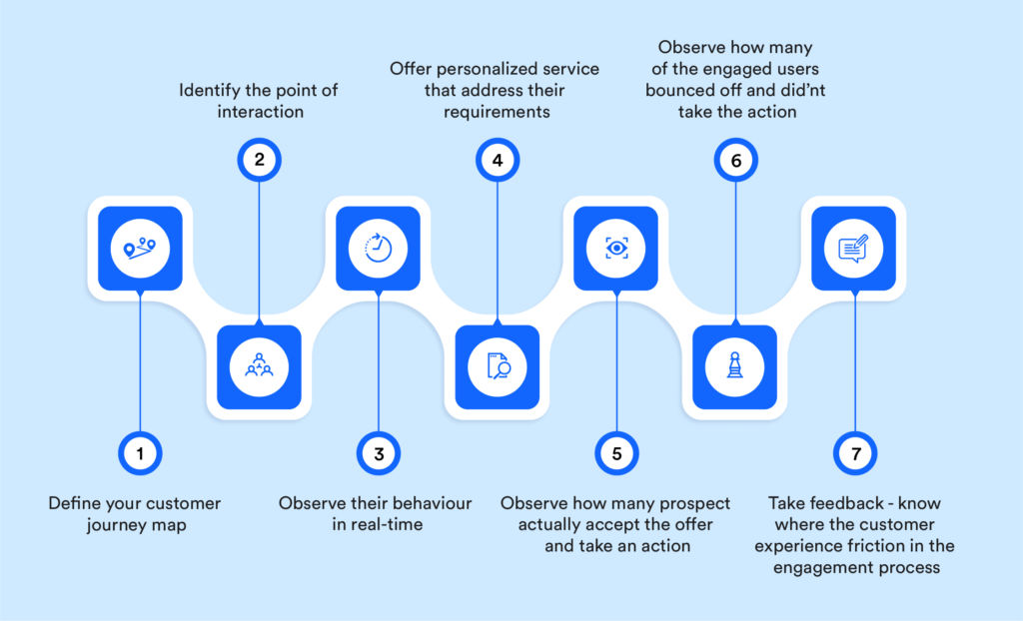

A company does right when company’s customer and employees both are happy. Olwel knows the importance of customer satisfaction and employee engagement. And it can be happed when both has strong connection. By the customer experience delivery a business can get 80% of customers and their customer will pay for service more and more and will create superior customer value. Doctors' activity fulfillment is essential in conveying fantastic therapeutic administrations to patients. As employee engagement influences customer satisfaction so we can say that positive customer experience equal to employee engagement. Olwel always tries to make their employee happy so that customer can be satisfied. Olwel makes the employees satisfy so that they can give the best service to the patient. Employee engagement always affects Olwels bottom line. Customers who are satisfied can increase engagement also. It makes olwels employee motivated. Olwel also get negative experience of customer and they also learn from the failure. So in this case manager and supervisor recognize stories of customer satisfaction.

Olwel follows these strategy for employee engagement by this model:
1. Unify the Experiences: Olwel does survey for knowing the customer experience which is affecting by employee engagement or not.
2. Evolving through open communication: Open communication or face to face communication is followed in the office of Olwel in any meeting so that they know about the main problems of organization. In this meeting every employee can share their idea and experience for developing their service. Often olwel gives reword who gives best idea.
3. Providing Proper Communication Channels: Some employee wants to give their feedback by face to face communication and some employee wants to give their opinion in written. So for this Olwel available some channels by which employee can share their ideas or opinion.
4. Enabling Conversation Fluidity: Whichever channel employees choose, they have to ensure about the fluidity. The opinion must be non-frustrating for another employee of Olwel. It will have to be ensured that there are no barriers.
5. Manage Communication: It's the most important step in this process. Managers check the all entire process that this process is correctly working or not. They should ensure that it serves the ideal reason and isn't being utilized adversely.

Customer trust:

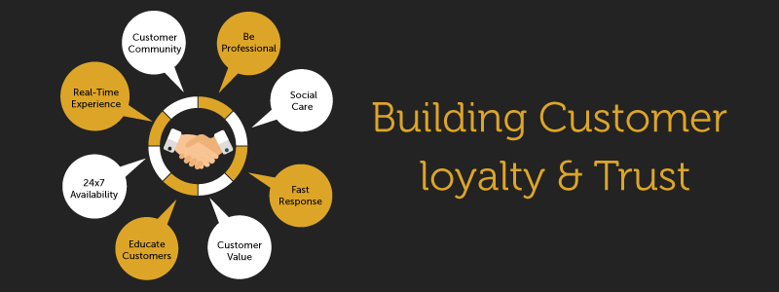

What a positive behavior a company gets is the customer truth. It comes from when customer understand that we will fulfill their needs and respect them and offer best service. Customer trust not only make a customer loyal but also make highest satisfaction.

Olwel follows these techniques for increasing trust of customer:

1. Provide an amazing customer experience:
A good experience of customer makes them to repeat consumption of service. So Olwel always makes contact with customer by SMS, phone calls, website, Facebook page, Instagram and face to face visit in several campaign. They train their team for making some decision for customer needs & make a positive relation with them.

2. Invite customers to review:
Olwel always focuses on existing customers and future potential customer also and let them leave feedback by phone call and they do calls to customer after received olwels service. They always do follow up calls, message and by online also.

3. Use interactive content:
It's a new model of marketing. By this Olwel builds a phenomenon for customers for participating in learning information on attractive form. They gain trust in message, and believe are able to help them.

4. Respond to negative reviews:
Olwel takes the time for responding to online review, even negative responses also. It is also an activity about experience of customer and makes the negative one to positive.

5. Deliver quality:
Olwel never delivers less which they promised to the customer. For long term trust they always try to maintain the quality of service. Once customers trust the service and company they reach the high level of trust and be a loyal customer. Best quality makes the trust strong. It increases loyalty, trust, sales and customers recommend other for our service. So Olwel has to ensure the trust by maintaining quality and make customer satisfaction.

Post Purchase Behavior:

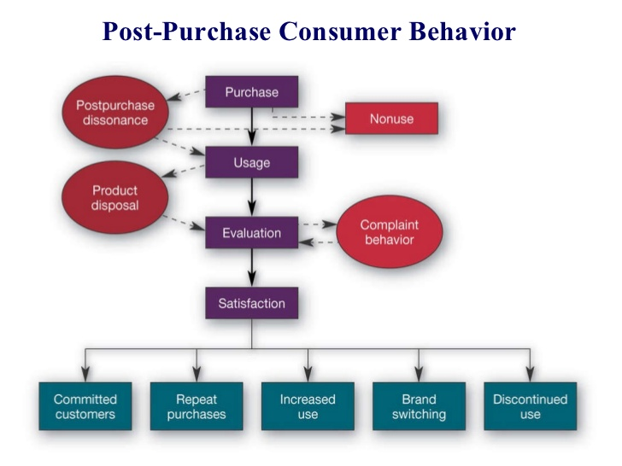

Post purchase behavior means the final stage of process of customer decision when we can identify whether customer is satisfied or not satisfied. How customers feel about the service always influences whether he/she will take the service again or not. Olwel always focus on this because a customer always influences other people to get the service. So Olwel make follow up message and follow up calls after any patient take service from us. It can be 3-7 days and sometimes the calls are done after 1-2 months and by this Olwel make satisfaction of customer.

Payment option:
Olwels customers have the right to choose payment agency option. By paying Bkash customer can get 10% discount on total payment. They can pay by cash also. By this option customer can pay by cheques or credit cards by doing contact in the office. By this Olwel manages this payment system for the benefit of customer and they for this they will become more satisfied.

Word of mouth:
Passing a information to one to another person by oral communication means Word of mouth. Olwel always tries to make their customer satisfied so that if they will be happy for our service, they will talk about this to another person and will recommend other to get the service when they want. Story telling is one of common form now a days for word of mouth communication where one person tells a story to other about a real phenomenon which was happened. A company is valueless where word of mouth is absent. When a customer become fully satisfied and get the full superior customer value they will always recommend the service.

Product & Place:
Product and place are the two variables of Olwel which have very big influence on satisfaction of the customers. If the quality of their service is not up to mark and the price of the product is not match with the quality of their service then the customers become dissatisfied. As well as if the service is not convenient then customers will also be dissatisfied. So from that we can say both have very big influence on satisfaction of the customers of
Olwel.

Take Customer Advice (and Credit Them for It):
Always improve to keep the customer loyal to the image. Instead of just passing numbers or our guts, give customers a shot of what they need instantly. They surveyed some of the thoughts we had about the Olwels blog, web-based social networking records and sending them via email. Always leave space for customers to recommend that they are not listed at all and they constantly provide some kind of motivation to take part in the survey. Whether it’s just the opportunity to acquire something as small as a gift voucher or the initial access to a new item, it will actually have a huge impact on the amount of people interested. Allow customers to give their consent to any improvements or refreshments based on criticism. Olwel announces it through most of its advertising channels and sends them something to show us our appreciation.

Customer Satisfaction:
Customer satisfaction is a felling which is internal feeling of individual. The feelings provide dissatisfaction or satisfaction result from assessment by any organization to customer anticipation. Company tries to improve service just for satisfying their customer for higher satisfaction of customer which will lead to the customer loyalty.

Service quality:
The quality of a service business has become a proportion of the degree to which the service was given to meet the aspirations of the customers. Companies have discovered that in order to create the benefits and part of the overall industry, they should consider enough to support their standards. Companies use service quality as a way to evaluate their customers. Service quality has become an important factor in differentiating their items and services from different competitors. Numerous experts recommend that clients survey the quality of service by looking at what a seller should offer them and think about it against the merchant's actual service. The impact on customer satisfaction is built by different fields of service quality. Studies have shown that the relationship between service quality and customer or patient satisfaction is positively related. Satisfied with the patient's healing benefits when their wishes are fulfilled.

Relationship between Service Quality and Patient/Customer Satisfaction:
Customer satisfaction & service quality is the relation of cause and effect for each other and maintain a role of decisive for existence and in competitive market technology leads a high role for gaining success. If the perceived quality of service is high than that can increase consumer satisfaction. In Olwel they make customer satisfaction by improving quality of their service. For this reason they follow the service quality gap model to remove the gap for getting the higher satisfaction. The Gap model consists of two parts:-
1. The customer gap
2. The provider gap

The Customer GAP

The gap between a customer's expectations and a customer's perception of an organization's service is called the customer gap. Customer expectation means what the customer expects from the service they are getting according to the resources available. And they are influenced by experience with family, personality, cultural background, advertising, demographics, similar products and information available online. Customer perception refers to thematic issues that are based on customer interaction with the service. The goal is to understand the market, the strategy for a particular product or service, the quality of the service should be clear. To close this gap, Oloh tries to understand the needs and expectations of the customer. Expected service customer expectations.

The Provider Gap

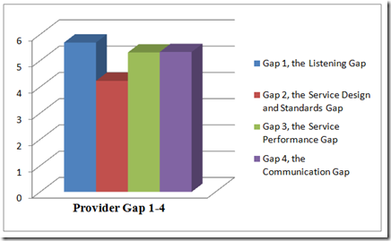

Gap 1: The listening gap:

The listening gap refers to the gap between the customer’s expectations and the company’s understanding of those expectations of the service. A primary factor in many companies is the customer gap which does not meet customer expectations. Always follow strategies to close the auditory gap:

- They listen to their customer in multiple ways, customer research and employee interaction.
- They meet customer needs over time and maintain relationships through understanding.
- Olwel works and knows what the customer expects from the experience of a service failure.

Gap 2: The design and standard gap:

The design and standard gap means concentrated with forming
customer expectation into actual designs. And they developing the standard for measuring service operations for customer expectation.

Strategies which olwel follows for closing the design and standards gap:
- Olwel introduces new service development which is well defined practices with innovation.
- Through service Olwel understand their total customer experience.
- Service operation by customer is measured - defined rather than olwel’s pre-defined standards.
- In providing service of olwel they incorporate physical evidence.

Gap 3: The service performance gap

If the discrepancy is exist between actual service delivery & customer driven service design then the service
performance gap can be closed. Even when guideline is present to perform service well and treat customer high quality performance of service is not called as certainty. By using appropriate resources like system, people and technology the standard must be maintain.

Strategies which olwel follows for closing the service performance gap:
- Olwel maintain this by aligning their resources like training, hiring and rewords for delivering excellence service.
- By make customer understand and perform effective way olwel define roles of customer
- Olwel uses effective technology and appropriate aid for performance of service.
- They maintain fluctuation in demand & supply.

Gap 4: Communication Gap:

If any firm done everything for closing the three gaps for ensuring service quality but there is still be a failure to meet the expectation of customer because if communication is not exist service will not meet with what will be delivered. So the final communication gap has to be closed. Communication gap focuses contrast on service delivery and external communication through pricing, advertisement or other forms of promotion.

Strategies which olwel follows for closing the communication gap:
- Olwel develops converting strategies for service marketing, competitive price, quality service and sends those message to the consumer.
- Olwel maintain effectively the customer expectation by the experience.
- For the communication which is internal they develop mechanisms for avoiding over promising. And they ensure delivery successful.
- They manage their brand image.
- Communicate with customer by giving regular follow up calls.

Implementation of Service Gap Model in Olwel:

The Customer Gap
Olwels patients are considered as customers and providing satisfactory services are major concerns.

Customer Expectations: Some of the factors that affect customer expectations:

1) Word of mouth: Word of mouth is the main form of sharing information with the person through verbal communication in the text. Allways patients are satisfied and they spread good things about the service. Patients share information with close people such as colleagues, friends, family, etc.
2) Personal needs: Patients will be happy if they get the desired level of service. However some amount of department is available, so the patient may be dissatisfied. So some patients complain of getting the right amount of attention.
3) Past experience: An important part of the patient's past experience is service. Most Oval patients compare recent service with past service which creates customer satisfaction. Main customer expectations:

1) Physicians pay full attention to complaints: Olwel patients expect full attention so that physicians listen to their problem with empathy. They believe that if the doctors listen carefully, they will recover.
2) Patients expect proper treatment: Olwel patients expect proper checkups for all types of illnesses. Proper treatment makes for a better and healthier future.
3) Caring Attitude: Patients always expect from a caring attitude physician and they only expect all the levels of benefits by which they will feel better. A caring attitude makes the patient comfortable, reliant and confident. So that the patient can be satisfied.
4) Economic Charge: Olwel expects financial charge for visiting the patient physician. They want a fair rate of philosophy. Therefore, Olwel gives a discount card for regular patients through which the patient will get 10% discount per visit. So that they can bear all the cost of treatment.

Customer Perception:
1) Moderate health care: Olwel gives their patients a good level of service. This service will touch the marginal level of satisfaction. Very few patients are not completely satisfied.
2) Expensive investigations: Clinics are more after some investigations like blood tests. Some patients cannot afford it.

Supplier Gap

Gap 1: Hearing gap: There is a gap between patient expectations about services on Olwel and the services provided by Olwel.
1. Lack of adequate, formal and friendly behavior: Patients are so sensitive that they should be treated with care. But sometimes they can be busy and they miss the right advice and attention from them. For this patient may be hesitant to share their problems. The friendly attitude makes the patient comfortable.
2. Lack of female doctors: Women in Bangladesh are very conservative and shy. Patients want female doctors for female patients for checkups. The number of female doctors in Olwel is low.
3. No Emergency: No Emergency has been conducted on the railway. Olwel does not operate for emergency work such as trauma, accidents, etc.

Gap 2: Service design and quality gap: Customer-driven standards differ from the conventional performance standards established by an organization. These issues are reflected in Interval 2, the difference between the company’s understanding of patient expectations and the development of patient-driven service designs and standards.
1. No ambulance of their own: They have no ambulance of their own. So it may make the customer feel less confident in Olwel.
2. They have no pharmacy of their own: they only supply drugs from third parties. So the patient feels dissatisfied.
3. There are several departments for the service: Olwel has several departments as they only have medicine and gynecology specialists. However, the absence of other departments such as surgery, eyes, etc.

Gap 3: Gap between service performance: This is the difference between customer-driven service quality development and actual service delivery by company employees. Arrangements can be balanced by appropriate resources such as systems, people and technology.
1. Lack of modern technology: There is less technology in disease investigation to report them.
2. There is no doctor for all time: Olwel said that their doctors are always available but often doctors are appointed for other patients at the same time.

Gap 4: Communication gap: Communication gap means the difference between service delivery and external communication of the provider. The difference between real and committed service can widen the customer gap.
1. Delay in report delivery: Sometimes they provide report delay. As a result customers become dissatisfied and annoyed for delays and they lose their patience.
2. Long wait at the reception area: Time is of the essence. When the patient has to wait more than 30-40 minutes for the doctor to reach home, they get upset.
By removing these gaps in Olwel they ensure quality and close the gap in creating customer satisfaction in this market.

Five Dimension of service Quality of Olwel

Service Quality
It is most important to focus on service quality in order to gain competitive advantage, because customer awareness about quality is therefore necessary to provide higher quality of service than the competitor. The service provider can differentiate itself by delivering superior service than its competitors as the capability of the service organization depends on the fact that it gives some benefits to its customers, but the best strategy to retain the customer depends on their quality. Service quality is identified as the difference between customer desire and their recognition about the service experience. At the end of the day, if suppliers get these measurements correctly, customers will hand over the keys for their fidelity. As they will attain the glory of service. Guided by what they need?

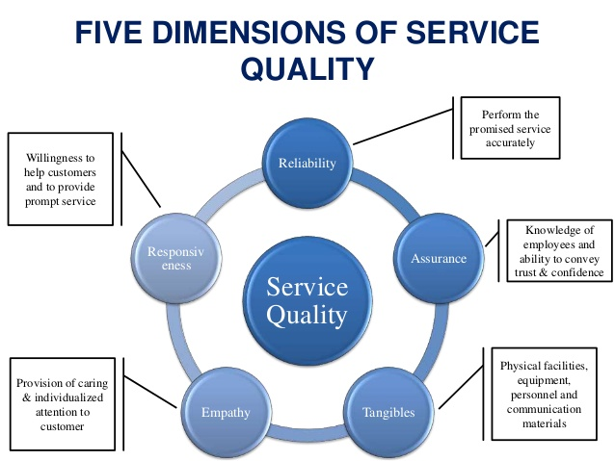

The five SERVQUAL dimensions are:
- TANGIBLES- Appearance of equipment, personnel, physical facilities, communication materials etc.
- RELIABILITY- Ability to do the task what company has promised for service accurately and dependably
- RESPONSIVENESS-Willingness for helping consumer and provide quick service.
- ASSURANCE- Courtesy and Knowledge of employees & their ability for convening belief and confidence.
- EMPATHY-Caring, individualized attention that company provides its customers.

5 dimensions for customer care for customer satisfaction:

Reliability:
Reliability is most significant factor which is directly related to provide service problems of customer, Delivering services at the right time what was promised and keeping blunder free records of every action. Besides, unwavering quality is about precise request satisfaction as exact statement, exact record, precise in charging, and keep up their guarantee. In Bangladesh, reliability of the supplier is frequently seen as low for different reasons, as like many doctors recommend various types of unnecessary medical tests, not only that but also there is irregular supply of drugs for hospitals.

- Olwels doctors don't recommend any unnecessary medical test as they promise to their customer.
- Olwel always provide regular supervision.
- They always provide correct treatment at the first time.
- They always keep in mind what they were promised to serve their customer like they promise their customer to do treatment after 30-40 minutes after getting calls of patient.
- They promise to give respectful attitude and guide patient with appropriate advice and medication.

The patient needs to rely on Olwel’s services. They respect that reliability. This is. Being reliable is many times more critical than having a gorgeous new uniform. This does not mean that we can wear ragged uniforms and only be reliable. Service providers have to do both. But the first and best effort of the supplier is better spent to make the service reliable.

Responsiveness
Responsiveness is another dimension of service quality to exceed customers’ expectation. It’s the willingness and readiness of employees to serve timeliness. It also includes knowing the attention OD safety and individual attention to customer given by employee. It’s a vital term of satisfying customer’s expectation which will make customers delight and increase their trust for the organization.

- Olwel respond promptly when patient need or expect as a customer.
- Olwel always available equipment what patient required.
- They diagnose of diseases quick as customer need.
- Olwels doctors prescribe drugs which will be easier to find.
- This company does work with the responsiveness of doctors, the greater the satisfaction of patient.
- Arrive doctor to the spot on time
- Olwels call center track wait times of patient. They track the response time of responsiveness
- Service the patient without serial

Holding up multi day to restore a call or email doesn't make it. Regardless of whether patients are incessantly moderate in returning to olwel, responsiveness is multiple/fifth of their administration quality evaluation.

Assurance
Assurance is the ability of employees to have knowledge and inspiration, confidence and self-confidence. Assurance in healthcare organizations refers to friendly and polite staff / physicians / nurses, internal comfort, financial advice and knowledge management team in the information related account. Physicians ’knowledge, skills, and courtesy can realize this assurance that they have the best interests of the patient in them and that they will provide services with dedication, fairness, and benefit. For a service that is largely based on reliability, where customers are unable to evaluate the quality of service after purchase and consumption, a sense of reassurance can anxiously affect patient satisfaction. In the healthcare system, reassurance includes service providers who accurately interpret laboratory reports, diagnose efficiently, provide appropriate explanations in investigations, and create a sense of security. Nurses also play an important role in providing additional support to patients ’feelings of reassurance by being trained and efficiently addressing their needs. Thus, the greater the assurance received from healthcare providers, the greater the patient satisfaction.

- Olwels doctors knowledge and skill can provide assurance that they know patients interest
- Olwel deliver service with integrity beneficence and fairness.
- This company correctly diagnoses medical test reports, diagnose the disease fully, provide exactly explanations of queries & generate a sense of safety.
- Olwel expected to be expert of the service they’re delivering.

Research says it's significant to communicate the customer or patient. If company is highly skilled but customer doesn't see this, their confidence as a service provider is lower.

- Olwel does awareness by free treatment in some organization.
- They make campaign for create awareness
- They create awareness by giving small statement in any school meeting.
- They make activation in several public place.
- They do fair for health awareness.

Since company should communicate with their expertise & rivals before they do the work. It can be done in various way that are repeatedly watch by customer, Such as:
- Show industry certificates on badges, patches or catches worn by representatives.
- On letters, emails & reports include certification logos.
- Into newsletters, posters & handouts put certifications.

Company can help to manage customer expectations by communicating competencies & influence service quality assessment in advance.

Tangibles
Tangibles means the appearance of physical facilities, equipment, personnel, written materials which are also major dimension to make customer delight and ownership of the company's brand image. For satisfaction of patient Olwel provides satisfactory service. Generally good tangibility like equipment, physical facilities, personnel etc. create positive impression. It influences olwels customer. In Bangladesh most of health care services ignore the attribute for patient satisfaction. So olwel always focus that which elements affect to customer behavior for attenuating customer satisfaction because better tangibility provides greater patient satisfaction.

Though it is less important than other dimensions but sometime appearance make patient trust. Olwel wants to make employee uniforms, appearance, equipment, work areas like service officers, closets etc look good. Olwel keep it mind that tangibles makes reliability and responsiveness also.

Empathy
The attention of individual, caring which is given to the patient of olwel refers empathy. It means keeping self on another shoe. This determine is fully dependable on the emotional view for making customer that we care our patient or customer. This term provides quality service on customer expectation which a patient want and their perception toward service which they receive. SERVQUAL is being applied by some researcher for measuring quality of service of Olwel. Olwel provides empathy and understand their patients’ problem & their need are being influenced for patient. Like this Olwels patient wants to olwel that the doctor will be attentive and doctor will understand patient’s problem. Olwel gives patient personal care and not only has that also provided mental support to patient. By this olwel shows empathy to patient. More empathy makes the patient more satisfied. Patient may not feel that service providers care about them. Then it hurts customer behavior of service quality.
For example:
- Olwel doctors provide treatment and listen patients’ problem carefully.
- Doctors keep a smile during checkup.
- Gives mental support.
- Gives more time to patient so that patient feels good
- Ask to patient if they can do anything else for patient
- They provide comfort by handling patient request with priority and resolve as soon as possible.
- The patient doctor relationship will not end with one visit. They do follow up calls from olwels call center and ensure the effectiveness of advice and imitation further action if necessary.
- Gives treatment with patience and compassion.
- Gives respectful attitude with caring.
Customer evaluations include desire and perception for each of the five server measurements. Olwe needs to work on all five, yet their seriously sorted pressure. We need to follow the levels that work again.

Recommendations
- Olwel should improve quality of their services for customer satisfaction.
- Olwel should increase the number of doctors and staff for providing adequate services for customer or patient.
- For many diseases are increasing so the departments should be extended.
- Fees must be charged reasonable and economical.
- Specialist doctor should be hired.
- In the community survey of patient satisfaction should be studied for effective way to know the patient satisfaction level.
- For the stability of olwel in competitive market for both patient satisfaction and service quality must be considered together.
- An annual planning schedule can be created for determining the whole year work plan.
- Olwel should do campaign for educating their customer and more people know about Olwel.
- Schools and Government offices are the best places for campaigning because we can reach our targeted customer.
- They should give discount several discount on several occasion to regular customer.
- They will have to focus on promoting their apps along with hotline numbers. As very few people know about our apps.
- Package making (baby, old people, and pregnant woman) can be easier for getting segmented customer base.

Conclusion:
At the end of our internship as a Marketing intern I think Olwel is giving a unique service in Asian culture. If they can go in a good strategy door to promotion they can achieve the goal and can make a brand position in the market place. They can get first mover advantage by proper marketing. The purpose of the report was to identify the factors, dimension, and services quality of the services by which olwel can do the best marketing through door to door promotions. At the end of the report I tried to conduct the administration which olwel does for their patient satisfaction.

References

Ali, M. (2014). Factors Affecting Medical Service Quality. Tehran University of Medical Sciences, School of Public Health. Tehran: Iranian Journal of Public Health. Retrieved February 2014, from https://www.ncbi.nlm.nih.gov/pmc/articles/PMC4450689/?fbclid=IwAR0NZkz-CkueJ5mW2HDbJ4jyvdch1g1nD9cDWZlWoij1pXhuJp_SdG4Au7c

Andaleeb, S. S. (2019). Patient satisfaction with health services in Bangladesh. Oxford Academic, 22(4), 263- 273. doi:10.1093/heapol/czm017

Australian Government Department of Human Services. (2018). Customer Satisfaction. Retrieved November 2, 2018, from Australian Government Department of Human Services: https://www.humanservices.gov.au/organisations/about-us/annual-reports/annual-report-2017-18-html/part-4-customer-engagement-and-feedback/customer-satisfaction?fbclid=IwAR26cWOt0NSV_ZCbGXlbutWWDYsv8Mp96sj71JsmHMk14ZBSrEM_EWST EQU

Hussain, M. M., & Raihan, M. M. (2015). Patients’ Satisfaction with Public Health Care Services in Bangladesh: Some Critical Issues. ABC research house, 2(5), 126. doi:10.18034/mjmbr

Islam, M. Z. (2019). Doctors waiting to see you. Retrieved March 18, 2018, from The Daily Star: https://www.thedailystar.net/business/olwel-doorstep-healthcare-service-in-bangladesh-doctors-waiting-to-see-patients-1549807

Kabir, F. R. (2018). New Era of Digital Health Service in Bangladesh. BRAC University, BRAC Businesss
School. Dhaka: Telenor Health. Retrieved September 3, 2018, from http://dspace.bracu.ac.bd/xmlui/bitstream/handle/10361/10690/13204075_BBA.pdf?sequence=1&isAll owed=y Nohr, L. E. (2007).

Croatian Island Telemedicine System Project: Public Health and Technical Evaluation. Norwegian Centre for Telemedicine University Hospital of North Norway. Retrieved March 29, 2007, from https://ehealthresearch.no/files/documents/Prosjektrapporter/NST-rapport_2007- 08_Croatian_Island_Telemedicine.pdf

Oxford Academic. (2019). Health Policy and Planning. Retrieved March 11, 2019, from academic:
https://academic.oup.com/heapol/article/22/4/263/620111?fbclid=IwAR0lz_vpKal8ADZ6vjP_eV_- UmCwkHhax4LjltrH4emrw74Y-Fywm4marbM

Sanjeewa, G. &. (2017). Patient Satisfaction with Health Care Services Delivered at the Out Patients Department-Case Study-at Teaching Hospital Karapitiya Sri Lanka. Health Care: Current Reviews, 5(2). doi:10.4172/2375-4273.1000193 Satisfaction With Medicare Advantage Plans Remains Stable, but Opportunities Remain. (2006-2018). Retrieved june 22, 2018, from AJMC: https://www.ajmc.com/focus-of-the-week/satisfaction-with- medicare-advantage-plans-remains-stable-but-opportunities- remain?fbclid=IwAR39kVuLg87zthkGCZmPxcER6YwvMem6HO3yvJnWOe_wt2JZMohcLNHuY0E 40

