Internship Report on
Job Analysis of
SGS Bangladesh Limited”


United International University

Course code: INT 4399
Internship Report on
Job Analysis of
SGS Bangladesh Limited

Submitted To:
Shayla Khanam
Assistant Professor,
School Of Business and Economics,
United International University.

Submitted By:
Shamima Akter Sova
United International University
ID:111151042
Bachelor of Business
Administration

Letter of Transmittal
20st January, 2020
To
Shayla Khanam
Assistant Professor,
School Of Business and Economics,
United International University.
Subject: Internship report on Job analysis of SGS Bangladesh Ltd.
Dear Mam,
With due respect and immense gratification, I am submitting my internship report on “The Job analysis of SGS Bangladesh Ltd.” that you have assigned me as an essential requirement of the internship program. It is really an enormous prospect for me to gather vast information and grasp the subject matter in an appropriate way. I have found the study is quite attention-grabbing, beneficial & Insightful.
I tried my level best to prepare an effective & creditable report. The report will provide clear concept about the overall functions of Job analysis in SGS Bangladesh Ltd. I welcome your query & criticism on the report, as it will give me the opportunity to learn more and enrich my knowledge. I hope you will consider the mistakes that may take place in the report in the spite of my best.

Sincerely,

Shamima Akter Sova
ID: 111 151 042
United International University
BBA

Student’s Declaration

I hereby declare that the internship work entitled “Job Analysis of SGS Bangladesh Ltd” is an original work done by me under the guidance of Shayla Khanam, Assistant Professor, School of Business and economics, United International University this report work is submitted in the partial fulfillment of the requirements for the internship program. This report is submitted in United International University and the SGS Bangladesh Ltd Not any other Institute or University.

Shamima Akter Sova
ID: 111 151 042
Major: Human resource management
United International University.

Acknowledgement

First of all, I would like to thank Almighty Allah for granting me with constant patience and strength to complete this internship report on time.
I would like to take this opportunity to convey my heartfelt appreciation to those, whose blessing and cooperation was important to bring this report in light.
I want to show my gratitude to:

Ms. Shayla Khanam
Assistant Professor,
School Of Business and Economics,
United International University.
Mr. Azharul Islam
Senior Executive
Human Resource
SGS Bangladesh Limited
Mr. Mohammad Masud Karim
Senior Assistant Manager
Human Resources
SGS Bangladesh Limited

Last but not the least, I also acknowledge the Human Resource Management team and employees of SGS Bangladesh Limited for their great support for making this report a successful and comprehensive one.

Executive summary

Here I have obtained knowledge on how Human Resource Management department collect information for the purpose of analyze specific position in the organization. SGS started their journey officially 1919, July 19 which is the world leading inspection, certification, testing company in Bangladesh.
The report consists of four chapters. First chapter, named Introduction is the discussion of the study that includes background, scope, objectives, methodology and limitations of the study. The second chapter is about the Organizational Overview which consists of a discussion based on SGS Bangladesh Limited. The third chapter is Analysis and Findings chapter what discussed job analysis of SGS Bangladesh Limited.
The final fourth chapter is Recommendation and Conclusion, where I tried to provide some suggestion based on my theoretical learning for the betterment of the SGS Bangladesh Limited.
The entire report is about how SGS is doing their job analysis which is position analysis they called and how does it impact on different field of position. And also from this analysis describe the process how they recruited the right candidate for different field. There are also several outcomes from job analysis. Each of them is very important for SGS Bangladesh Limited.

Table of content
Topics | Page Number
Chapter 1- Introduction of the study  Introduction  1.1 Background of the study  1.2 Scope of the study  1.3 Objectives of the study  1.4 Methodology of the study  1.5 Limitation of the study | 1-4
Chapter 2- Organization Overview of SGS Bangladesh Limited  Background of SGS Bangladesh Limited  2.1 Company profile  2.2 History  2.3 Core service categories  2.4 Company Vision & Values  2.5 Business principle  2.6 SGS establish In Bangladesh  2.7 Organization network hierarchy  2.8 Expertise service provided at SGS  2.9 Board of Directors | 5-15
Chapter 3- Analysis and findings of SGS Bangladesh Limited  3.1 Job analysis in SGS Bangladesh Limited  3.2 Sample form required information of Job analysis in SGS  3.3 Describe process of Job analysis in SGS  3.4 Job analysis outcome Job description on SGS Bangladesh Limited  3.5 The impact on talent management through job analysis process  3.6 Flow chart of Job analysis process that manage talent Acquisition at the SGS Bangladesh  3.7 The impact on organizational development through job analysis process by talent management  3.8 | 16-29
Chapter 4- Recommendation & conclusion  4.1 Recommendation  4.2 Conclusion | 30-32
Reference | 33

Chapter 1

Introduction
Of
The study

Introduction
This Internship report is a part of my BBA Program. The duration of my internship was three month where I learned the practical information. This report topic is “Job analysis of SGS Bangladesh Limited”. SGS Bangladesh limited is the multinational world leading company.

1.1 Background of the Study
This report is based on Job analysis process of employees of SGS and its impact on the organization mainly the benefits that SGS Bangladesh Limited gain. This is a service oriented multinational company. It covers the purpose of completion of my Undergraduate studies in business at United International University. SGS is the world leading, inspection, verification, testing and certified Multinational Service Company. When it comes to the trust issue SGS can be one of them. Job analysis is essential part to follow up the whole process in the organization, so it is an important factor.

1.2 Scope of the study
The scope of the report is to provide the general overview of SGS Bangladesh Limited and the job analysis process the organization is maintaining for their development to acquire the talent management. A reader can easily understand about the job analysis, process, and usefulness and organization development if they go through the point of the report properly. As a university student I could understand how a job analysis is performed in a real organization so that compare them with them theoretical knowledge.

1.3 Objectives of the study
The main objectives of this report is to investigate the job analysis process of SGS Bangladesh Limited and understanding the job analysis related factors on the basis of Interviewing and observing of the employee of this organization. I am trying to specify the objectives into two sectors-
Primary objectives:
- How the job analysis is useful at SGS Bangladesh Limited.
- Impact of Job analysis for managing the resources
Secondary objectives:
- An analysis of SGS Bangladesh Limited
- To analyze the job analysis process.
- To show how job analysis of SGS Bangladesh Limited impacts on the organizational development.

1.4 Methodology of the study

Methods of data collection: The sources are:

Primary Sources:
- . From current employees through formal communication.
- . From my office Supervisor.
- . From my practical work experiences in the organization.
- . From the websites of SGS Bangladesh Limited.

Secondary Sources:
From online blogs and websites.
Data presentation: The report information are used qualitatively investigating in a nature.

1.5 Limitations of the study
During the internship period, I have to face a lot of task orientated responsibilities and pressures. During such a hard time preparing the report was difficult. At this part I am going to provide some limitation. Given below-
- Short Duration: I have to work in office and as well as have to prepare my Internship report as well as.
- Confidentiality: As a leading company of service sector SGS maintain a lot of security in their business and do not allow me to discover few information.

As, they are already an establish company so this topic they have done long time. So, now in this time they just focus on updating so the root could not be explored.

Chapter 2
Organization Overview of SGS Bangladesh limited



Background of SGS Bangladesh Limited
2.1 Company profile
“The full form of SGS is Société Générale de Surveillance (French which mean for general society for surveillance). It is a multinational company. The Headquarter of the Organization situated in Geneva, Switzerland.
SGS is the world leading, inspection, verification, testing and certified Service Company. SGS recognized for the quality and the integrity as global benchmark. It has more than 94000 employees and operators over 2600 offices and laboratories fully in worldwide give their hard work to build the SGS Bangladesh. It has position and ranked on Forbes global 2000 in 2015, 2016 and last of all 2017.
The core and main service provide in SGS include the inspection and verification of the quantity, weight and quality of the traded goods, quality and performance testing product against various health, safety and regulatory standard, and to make sure the product, standard set by the government meet the requirement or not, standardization bodies or by SGS customers. When, It is comes to the trust or any kind of compliance issue SGS is gaining the market.”1
2.2 History
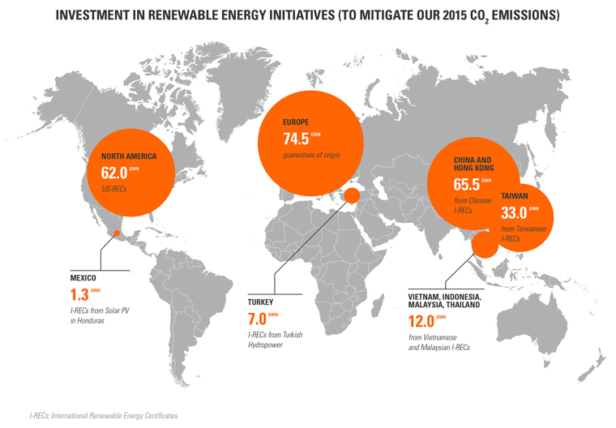
As, we can see the company it is not stand up in a one day. Every success required time and to stand up SGS in this position there is a history related with a lot of things.
“Established in 1878, SGS transformed grain trading in Europe by offering innovative agricultural inspection services. From those early beginnings, SGS steadily grew in size and scope as their agricultural inspection services spread around the world.
During the mid-20th century, It was began to diversify and started offering inspection, testing and verification services across a variety of sectors, including industrial, minerals, oil, gas, and chemicals.
- https://www.sgsgroup.com.bd
In 1981, SGS was listed on the Swiss Stock Exchange and forged an unrivaled reputation as the industry leader in finding solutions to the complex challenges faced every day by organizations. Consultancy, outsourcing and training services complement SGS core inspection, verification, and testing and certification services in delivering these solutions across all industries. Through Their unique global network, SGS deliver independent results tailored to the precise needs of each industry or sector. SGS customers trust in their expertise, experience and resources to support them in achieving outstanding performance in everything they do.

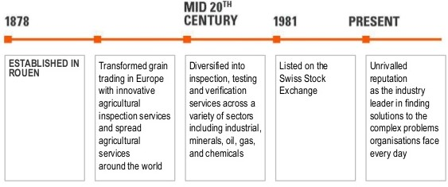
Today, SGS focus is on innovative ways to deliver business benefits. This enables them to help their customers improve quality, safety, efficiency, productivity and speed to market while reducing risk and building trust in sustainable operations.”2

- (https://www.sgsgroup.com.bd/-/media/global/documents/brochures/group-profiles/sgs-group-profile)
SGS operate in Bangladesh mainly Dhaka, Chittagong, Khulna since 1974.

2.3 Core Service categories Overview
SGS Bangladesh Limited core service divided into four categories. They are given below in a diagram-

  - Company vision and values
Vision
“SGS company Ltd aim to be the most competitive and the most productive service organization in the world. Our core competencies in inspection, verification, testing and certification are being continuously improved to be best-in-class. Our chosen markets will be solely determined by our ability to be the most competitive and to consistently deliver unequalled service to the customers all over the world.”(3)
Value
“Everything on SGS seek to be characterized by our passion, integrity, entrepreneurialism and our innovative spirit, as we continually strive to fulfill our vision. These values guide us in all that we do and are the bedrock upon which our organization is built.”(4)

  - Business principle
- “Integrity
Integrity is at the heart of SGS. The trust that SGS inspire in their customers and stakeholders is the key to their success. As leaders in our industry we hold themselves to the highest standard of professional behavior as embedded in our Code of Integrity.

- Health, Safety, and Environment
SGS’s long term success and sustainable business depends on its ability to remain a recognized leader and a reference for all Health, Safety and Environmental (HSE) matters. We ensure that all their services and operations are performed and managed in such a way as to protect the environment.
- (https://www.sgsgroup.com.bd/en/our-company/about-sgs/sgs-in-brief)
- https://www.sgsgroup.com.bd/en/our-company/about-sgs/sgs-in-brief)

- Quality and Professionalism
Quality and Professionalism are core parts of SGS’s Business Principles and are a cornerstone of ensuring high levels of customer satisfaction. By maintaining
Operational excellence we ensure the long-term sustainability of our business.

- Respect
SGS provides an environment where its employees can thrive. As a fundamental part of this we must ensure that we treat people fairly. SGS provides an environment where its employees can thrive. As a fundamental part of this we must ensure we treat people fairly.

- Sustainability
SGS provide scale and expertise to enable more sustainable future. SGS are good corporate citizen and invest in the communities in which operate

- Leadership
SGS make sure that work together and think ahead. SGS work in an open culture where smart work are recognized and awarded.”5
2.6 SGS establish in Bangladesh
In 1974, SGS established in Bangladesh. Now mainly operate in Dhaka, Chittagong and Khulna division. SGS deals the business consumer testing textile, garments and food testing laboratory in Dhaka head office. It range 28,000 square feet and also several lab floor in Noor Tower and also staffed with 650 highly qualified personnel. Every instrumentation of the laboratories calibrated to national standards also approved by NABL. NABL approved with ISO/IEC 17025. In Dhaka there are two office. One office in Kawran Bazar another office which is in Gulsan because of expanding the lab.
They also provide certification service including ISO 9001, ISO14000, and ISO22000.

- (https://www.sgsgroup.com.bd/-/media/global/documents/brochures/business-principles/sgs-corporation)
Address
Dhaka Division
SGS Bangladesh Limited
Office 1 | Office 2
Noor Tower 9th Floor, Kawran Bazar.  Dhaka-1205. | House 37, Road 24, Gulsan 1, Dhaka-1212.
Khulna Division
SGS Bangladesh Limited
Office
Shilpa Bank Bhaban (6th floor)
25-26 KDA Commercial Area
Khan-A-Sabur Road
Khulna, 9100
Bangladesh.
Chittagong Division
SGS Bangladesh Limited
Office
IIUC Tower (7th Floor)
Plot No. 9, SK. Mujib Road,
Agrabad Commercial Area
Chittagong, 4100
Bangladesh.

- https://www.sgsgroup.com.bd/en/office-directory

2.7 Organizational Network Hierarchy

Country Manager
Country Manager Personal Assistant

Human Recourses
OGC

Information & Technology
AFL

Operational Integrity& QHSE
EHS

Finance
GIS

Admin & procurement
CBE

Finance - Credit & Account Management
RBS

CRS

Laboratory
Business Development
Inspection

Figure- Organization chart

2.8 Expertise service provided at SGS Bangladesh Limited

  - Board of directors

- “Peter Kalantzis (1945) nationality is Greek. Dr. Peter Kalantzis was appointed to the board in March 2009 and named Acting Chairman in July 2018.
- Paul Desmarais, jr (1954) nationality is Canadian. Paul Desmarais, Jr. has been a member of the SGS Board of Directors since 2013.
- August François von Finck (1968) nationality is Swiss. Appointed to the Board in May 2002, August François von Finck is a member of the SGS Board of Directors and the Audit Committee.
- Luitpold von Finck (1971) nationality is German and Swiss.
- Ian Gallienne (1971) nationality is French. Appointed to the board in July 2013, Ian Gallienne is a member of the SGS Board of Directors and the Nomination and Remuneration Committee.
- Calvin Grieder (1955) nationality is Swiss.
- Cornelius Grupp (1947) nationality is Austrian.
- Gérard Lamarche (1961) nationality is Belgian. Appointed to the board in July 2013, Gérard Lamarche is a member of the SGS Board of Directors and Audit Committee.
- Shelby R. du Pasquier (1960) nationality is Swiss.Shelby R. du Pasquier has been a member of the SGS Board of Directors since March 2006.
- Kory Sorenson (1968) nationality is British”(6)
- (https://www.sgs.com/en/our-company/about-sgs/board-and-committees)

Chapter- 3

Analysis and Findings

3.1 Job analysis of SGS Bangladesh limited
As, the basic things of job analysis is collecting several Job related data to perform the designated job.
SGS Bangladesh Limited through analysis the job their aim is to use the information to fit the employee in right fit for the job and also impact talent management and the whole organization though the job analysis. So, for the betterment of the organization SGS focus on job analysis.
The Job analysis at SGS Bangladesh Limited starts with the assumption of Candidate require for the vacant position. And the whole journey starts from here. In the job analysis the SGS named it position analysis. The form is created 2008 in December and the author is here SEAP HR.
3.2 Sample form required information of Job analysis in SGS
Job Analysis sample format in SGS of is given below-
Supervisor Job tittle-……………………………………………………………………………...
Your Job tittle-………………………………………………………………...............................
Job titles reporting to you, if applicable
………………………………………………………………………………………………………
Primary responsibilities
………………………………………………………………………………………………………………………………………………………………………………………………………………
Duties and Responsibilities the most important major area list down
………………………………………………………………………………………………………………………………………………………………………………………………………………………………………………………………………………………………………………………
Any External contact required regarding the job purpose
………………………………………………………………………………………………………………………………………………………………………………………………………………
What task should be completed first?
………………………………………………………………………………………………………………………………………………………………………………………………………………

How can improved the workflow efficiency and quality?
………………………………………………………………………………………………………………………………………………………………………………………………………………
What should be major challenges in these positions?
………………………………………………………………………………………………………………………………………………………………………………………………………………
Specific Knowledge, Skill, Abilities job task require
- Knowledge
………………………………………………………………………………………………………………………………………………………………………………………………
- Skills
………………………………………………………………………………………………………………………………………………………………………………………………
- Abilities
………………………………………………………………………………………………………………………………………………………………………………………………
If any previous work experience required
………………………………………………………………………………………………………………………………………………………………………………………………………………

Approved by the Department Supervisor
………………………………………………………
Approved by the HR Regional
…………………………………………………………………..

3.3 Describe Process of Job Analysis in SGS Bangladesh
The first requirement in the form is dimensions which is basically describe any specific measures of the particular job responsibilities such as what are the specific areas are covering within the job reporting, customer care etc. Second, there is a chart box of the supervisor job title that specific employee job title and if anyone is going to report that specific person than who will be that and his job title. These sequences are only applicable when there is group or team. It will be making in a chart. Then there is some primary function that employee has to be perform. Third comes Duties and responsibilities, for that specific position which duties and responsibilities have to perform clearly mentioned above description and the weight or percentage of the single work actually what time required also describe them. Attach any additional information if it is required. And also to complete this task if any other department has to connect them then their name designation has to be in the analysis form. How frequently contact with them and also for which purpose clearly mentioned it. As job analysis is a detail about the job so it is necessary. And if the specific job task person needs to contact with the other outside external employee for work related purpose then it must need to mention.
And after that the main concern also from where the task is given and whom to send it has to be counted. Then fifth there is some related task like how much efficiency and quality full work accelerated to do the job like as- what task should be completed before the works come to the person, how the workflow can be balanced or improved.
Before, took any action to any kind of work refer to the boss if necessary then there should be mentioned which type task. And what type of major challenge engage during the work. These parts will go to the decision-making portion.
There should be specific work like specific skills abilities and experience that job will require to perform the particular job. In here, the main focus is the KSA of the particular employee. And last of all from these positions which objective should be fulfill make in a short note.
Then at the end, it will be approved by the supervisor or the line manager and also approved by the HR regional head. In this process they do the job analysis. Job analysis is a collecting a huge information. Sometime the employee feels bias or not enough idea about to do so job analysis information will help them to achieve the targeted goal. There is a specific portion like job description and job Specification which is more shorted from the job analysis part.
Job analysis is vast information which is collecting of task related data of an employee’s duties and responsibilities.
Human resource manager Position analysis Of SGS -
Job title- Human resource manager
Supervisor tittle/ Reporting line- country manager
Dotted line report - regional HR manager.
Job title reporting to you-

Organogram Chart
Duties and responsibilities of HR manager is to coordinate the work of these four wings and making decision. Like example, In the Compensation and benefits Senior Assistant manager task is calculating salary, Festival bonus, Dress allowance, Tax calculation, Head budgeting. After calculation of all the task he/she has to report to the Human resource manager for the approval. So, here comes the decision making part.
Another is Like Service point’s senior executive task is to over time, Insurance claim, and support employee. After completing each of the task he has to approve from the Human resource manager.
From this vast information of Job analysis Job description is the wing which is more specific and major information will be taken.
3.4 Job analysis outcome Job description on SGS Bangladesh Limited
In the SGS Bangladesh job Description form is more describe. The format of JD is following ISO. There is an example of JD given below-
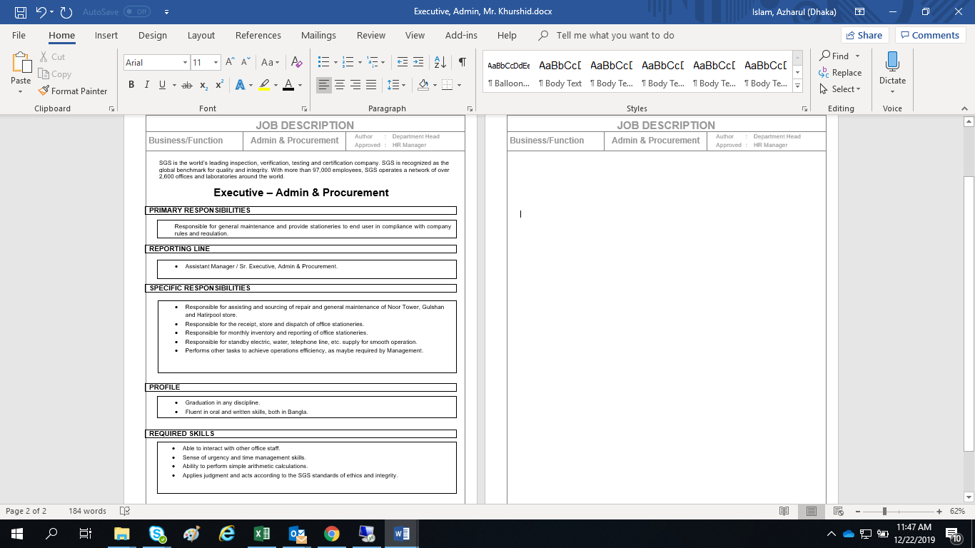
This JD of SGS actually comes from the job analysis. If we give concentration in these JD here is a Senior Inspector/ Inspector Duties and responsibilities are maintained clearly. The firstly mentioned the primary responsibility in here just basically describe the regular task for the ultimate goal achieve. Like as an Inspector in here a primary activity is to ensure business revenue and profitability with a long term successful performance. Then comes the reporting line like where the employee needs to report or inform for any kind of work. From the next box is a Specific responsibility. In this the task will be more specific like as- where he has to go, whom to communicate, time management to whom track regularly etc. On the profile these are the summary of the task like education, experience as a whole what actually expected to perform the job. Then comes the last required skills which are basically to complete the task they need to capable to go through some task .It can be also focus on the KSA of an employee. The basic difference in profile and required skill is profile is a whole scenario of an employee such as the academic background required skills is nothing just like to perform the job some specific condition he/she have some knowledge.
In a nutshell , first SGS find out where the resources need and according to this report Job description is more specific information about the employee task which information is basically origin from the job analysis or position analysis part.
3.5 The impact on talent management through job analysis process
Attracting high worth employee in this competitive is not a cup of tea. Talent management is managing the ability, competencies of an employee in the organization. It is not restricted with in the selection but also nurture them to put stay on the organization. But basically, talent acquisition starts with the recruitment in SGS. And to find out the right fit job candidate Job description is important which comes from Job analysis.
There are two type requisitions occur in SGS. The strategic sub unit (SBU) send a recruitment requisition form to the human resource department. The entry level or the replacement it should be mentioned in the form. This form is basically describing few points:
- Required Number of Candidates.
- Why the candidate is needed
- Justification for the new candidate.
- What types of task the new resource will be performed.
So, From the Sub unit they give the form to the headquarters to the Human Resource team to find the right skills candidate needed according to the information for the certain position. When the vacancy should be closed also written this RRF form. And the RRF need an approval from the HR manager and the Directors body. After the approval, the action is to make it publicize the announcement.

Figure- SGS Bangladesh limited Recruitment Requisition
However, in these Publication process SGS don’t go for and advertisement job announcement. But on the early time they give announcement through newspaper job site. And now they recruit employee through externally or internally.

External process:
- They basically go for the online job portal such as bdjobs, and the university career council for fresher.

Figure- External process

- To perform low weightage task, like Messenger, Teaboy, Random Sample Collector, etc., (known as Sibson) they give the announcement to the third party or the vendor. Their vendors are Dynamic Resources, Pro-edge Associates Ltd, Iqbal guard system. And the internal manager gives the announcement in mail of the organization employee. And from the internal source can received out the candidate if fit for the job.
Internal process: In the internal process HRM mail to the all user for recruit employee.

Figure-Internal process

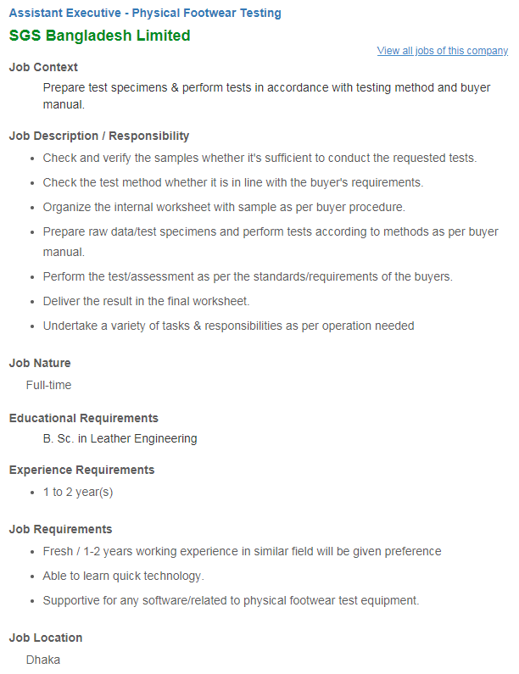
After meet up the deadline, the talent acquisition team collected CV from the sources and lists the application according to the work requirements. For the fresh graduates position they go for written, verbal test, english, simple math and the critical thinking. And some time they organize group discussion for the applicants at an observable test. All are sitting together and discuss on a topic. There is a jury board who observe the action of the candidate and decide that who are more accountable for the vacant job. From the group, the members of the discussion board evaluate their leadership quality, communication, presentation, knowledge of work, appearance, Manner, confidence. How they cope up in pressure etc. And then the selected one are goes for interview from them they recruit. For the midlevel its go direct to the interview session. And the high level of employee process goes through the head hunter.

Figure- Entry Level position

Figure- Higher level position

Recently the employees of SGS Bangladesh are 650 Staff. They also took contractual basis employee for a short time. Each SGS Bangladesh Ltd administrative site has a specific job description and a golden sheet that includes Job description information authority, general responsibilities, requirements and skills for a specific job, Key Performance Indicators (KPIs). According to the task potential candidates should be recruited based on their job descriptions and goals.
3.4 Flow chart of Job analysis process that manage talent Acquisition at the SGS Bangladesh

3.5 The impact on organizational development through job analysis process by talent management
That is very clear that the Job analysis is a preliminary stage that helps to hire the relevant workforce for the organization. For the development of the organization Talent management is must which is ensuring by the human resource management. In the previous flowchart we have been seen how Job analysis process of SGS Bangladesh Ltd Talent acquisition maintained inside the organization. Here in these parts discuss about how job analysis process in talent acquisition bring organizational development.

- Creating Future leader- For creating future leader job analysis help to find out the talent management an effective issue. Because for upcoming future is uncertain preparing a future post employee is more important otherwise some time work is in hamper for do not creating any selection for the post.
- Future talent - The talent management are always appreciating the future oriented talent. To find out the future talent job analysis could also helpful equipment for the HR team.
- Recruitment Capacity- Recruitment is a curtail things for any company. SGS professionals have been renowned for researching and recruit. HR professionals know the best market to drive the job.
- Creating business sense- The CEO and other executive’s wants profits in money numbers and HR team provide these number. Human resource team ensure how companies can improve their work and also ensure the quality.
- Strategic Planning- HR team are responsible for the analysis and their maximum flow to work. And also responsible to the head. The human resources department creates to provide a work life balance.
3.8 Job analysis outcome job evaluation impact on SGS Bangladesh
Job evaluation is basically the output of job analysis process like as job description. But there is some specification. Job evaluation is assessing with jobs not the people. In a short term job description is determining the value of the job. On the basement of job description and job specification relative value can be determined. For framing compensation or pay grade structure evaluation is helpful process.
Pay structure is also known as the salary structure which is calculated through job evaluation.
SGS Bangladesh Limited follows the type of broad graded structure pay.
There are several basic steps that SGS conduct for develop the job evaluation process.
They are given below-Figure- Steps of developing job evaluation

Chapter 4



Recommendation and conclusion

4.1 Recommendation
After analysis this report Find out that job analysis is directly or indirectly related with organization part. And at SGS Bangladesh limited job analysis plays an important role from the recruit the employee to talent management and most importantly in organization development inside the organization,
In these parts of this report, I would give some suggestion which might be helpful for SGS which I found during my internship period it might help to improve their productivity.

- The work pressure to the SGS Bangladesh Limited employee. Moreover, each employee has to perform their specific task that has to give their target but most of the time they have to perform two or one employees work. To reduce this problem SGS Bangladesh should recruit employee. Over burden work should be minimized.
- Employee engagement is a most important thing for the employee. Cultural program should be more frequent related to the task. Because, sometime took more attention through employee engagement program otherwise employee feel bored or don’t want to give attention.
- SGS employees are very much sincere about their task. But there can be change in working schedule. They could flexible their working hour for the employee.
- Recruitment layer should be vaster. Because from these they could minimize cost selecting an appropriate candidate.

- In SGS, employees engage to perform lot of task under pressure. Though company has much First Aid (Trained & Certified) and enlisted hospital for emergency support but a scope found to appoint doctor in case of emergency situation.

4.2 Conclusion

SGS Bangladesh is a market leading Service Company in Bangladesh. The big portion comes from the garments industries. Like all other companies SGS Bangladesh Limited has also some strength and weakness. Like all other companies, the SGS Bangladesh has its strengths and weaknesses. For the Inspection, Testing, Verification, Certification these will be their service. SGS is a successful market leading business in Bangladesh but organization may need more staff. SGS employees are continuously giving their hard and soul to make a successful in the field of business. SGS always try to fight to reduce their weakness and treat because they believe when employee is satisfied; they reach the preferred position in the market. As an established company they believe in practice of human resource in the office premises. So, SGS believe Job analysis process should be highly considered to be improved for better talent management and organizational development.

References
- https://www.bing.com/images/search?q=sgs+bangldesh&form=HDRSC2&first=1&cw=1424&ch=787
- (https://www.sgsgroup.com.bd/)
- (https://www.sgsgroup.com.bd/-/media/global/documents/brochures/group-profiles/sgs-group-profile)
- (https://www.sgsgroup.com.bd/en/our-company/about-sgs/sgs-in-brief)
- (https://www.sgsgroup.com.bd/en/our-company/about-sgs/sgs-in-brief)
- (https://www.sgsgroup.com.bd/-/media/global/documents/brochures/business-principles/sgs-corporation)
- (https://www.sgs.com/en/our-company/about-sgs/board-and-committees)
- http://www.whatishumanresource.com/job-evaluation

