Cattle Farming and Meat Industry in Bangladesh: An Analysis

Tarif Zaman

This Project report is submitted to School of Businesses & Economics, United International University as a partial requirement for the fulfillment of Bachelor of Business Administration Degree requirement

Cattle Farming and Meat Industry in Bangladesh: An Analysis

Submitted by
Tarif Zaman
ID: 111 151 321
Major in Marketing
School of Business & Economics
United International University

Supervised by
Dr. Kawsar Ahmmed
Professor & Deputy Director
BBA and BBA in AIS Program
School of Business & Economics
United International University

Date of Submission: September 1, 2020

Letter of Transmittal

23rd August, 2020
Prof. Dr. Kawsar Ahmmed
School of Business & Economics
United International University, Dhaka

Subject: Submission of project report on “Cattle Farming and Meat Industry in Bangladesh: An Analysis”

Dear Sir,
With due respect I like to state that project on “Cattle Farming and Meat Industry in Bangladesh: An Analysis ” asked by you to prepare is completed and ready for your viewing. I am glad to submit it as a part of completion of the requirement for project course with you.

I have tried my best to put up a good report with as much information as I could gather during the time allotted for writing this paper. I am begging for any kind of mistake.
Thank you, for your kind support and help through the course.
I shall be highly encouraged if you are kind enough to receive the report.
Sincerely,
Tarif Zaman
111 151 321
Bachelor of Business Administration
United International University

Acknowledgement
First of all, I would take the opportunity to express my heartfelt gratitude to Allah for making me accomplish the project within the designated time. This project is a part of my academic course.

This is high time I express my cordial thanks to our honorable course instructor Dr. Kawsar Ahmed (Professor of Marketing & Deputy Director, Bachelor of Business Administration, United International University) for assigning such an effective task. Without co-operation and support of him, it wouldn’t be possible to prepare a resourceful paper. I am thankful to him for all the times I consulted him and for being constantly patient in guiding us throughout the whole term paper. This has enabled me to make a comparison between theoretical knowledge and practical applications of it. Finally, thanks to everyone who was putting their efforts into completion of the task.

Executive Summary
The aim of this project report is to analyze the present scenario of cattle farming and meat industry in Bangladesh.
Among the industries contributing for the economic development of Bangladesh, cattle farming and meat industry is becoming an important sector for GDP. This sector is developing rapidly and now it is in the edge of becoming self-sufficient. Due to the financial attraction, bright future of the industry, choosing this sector as employment by the young generation, increasing demand of Bangladeshi meat in overseas countries, and more importantly, Bangladesh government initiative have accelerated the growth of this industry.

Analysis of this sector reveals that Government and research institutes are doing as much as they can to maintain standard in cattle and milk. Bangladesh Bank has circulated instructions for easy loan for those interested to this sector. Different breeds of bulls and milking cow are adding up. Artificial insemination is reaching out to rural areas. Meat exporting is increasing as local demands are being fulfilled. Some companies are doing well with a good quality and maintaining international standards. So, there is a hope one day meat exporting will be as good as our Readymade Garments sector of Bangladesh.

In contrast to these positive sides, some drawbacks are making the growth speed slow of this industry. One of the challenges is meat import. Meat import is one of the worst drawbacks for our country and this industry. Analysis shows that low quality meat is coming in which is harmful for both our health and economy. Therefore, for the betterment of this industry, it is necessary to undertake various strategies and implement those within shortest possible time to overcome those challenges and convert them as opportunities.

Keywords: Cattle farming, Beef Fating, Dairy Industry, Artificial insemination, Meat export, Bangladesh

Contents
Letter of Transmittal 1
Acknowledgement 2
Executive Summary 3
Chapter One: Introduction 5
Cattle farming in Bangladesh: an Introduction 6
Current situation in Dairy Farming 7
Industry Scenario 8
Bangladesh Livestock Research Institute (BLRI) 8
American Dairy Limited 9
Chapter Two: Dairy Sector in Bangladesh 12
Introduction 13
Bangladesh Dairy 16
Milk-Vita 16
Bangladesh Government Initiative 18
Low-Cost Loan for Dairy Farmers 18
Breed Improvement 19
Feeds and Fodder Management 19
Dairy Development 20
Meat industry 23
Chapter Three: Challenges & Opportunities 32
Introduction 33
Cattle Industry 33
Dairy Industry 33
Meat Industry 33
Future of Cattle Farming Industry 34
Artificial Insemination – AI 34
BRAC Artificial Insemination 37
Conclusion 38
Reference 40

Chapter One: Introduction

Cattle farming in Bangladesh: an Introduction

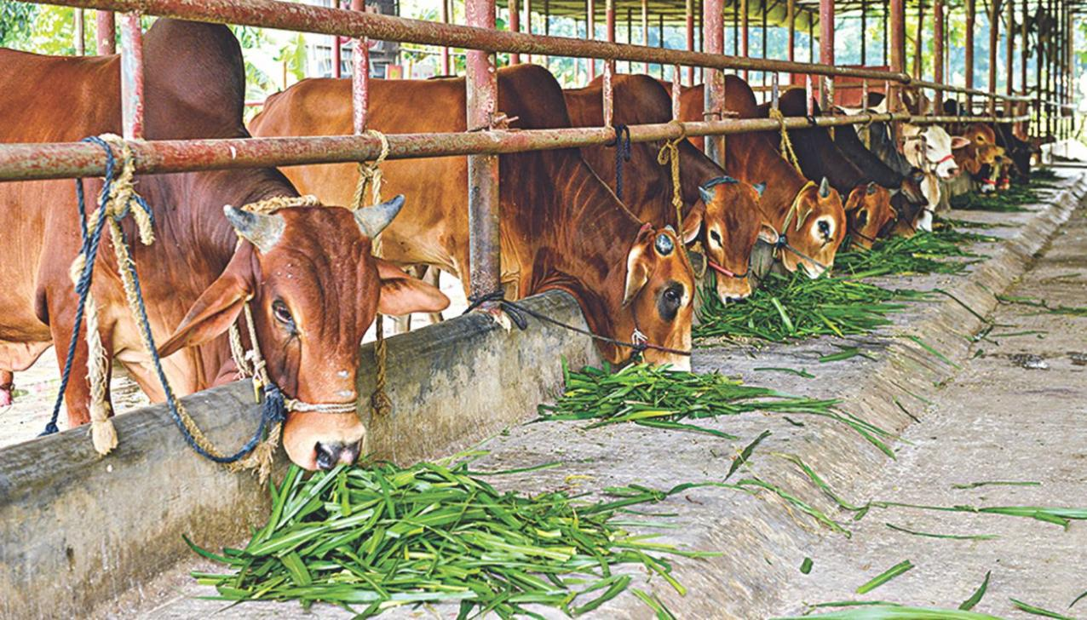
Bangladesh is an agricultural country. About 87 percentages of people are involved in it. A big part is cattle farming. It is one of the immerging sectors in Bangladesh right now. The number of people involvement is growing day by day. Once there was a thought that only people from rural area are involved in farming. But now a day’s more educated and people with the knowledge about cattle farming coming into the business and doing well especially young generation.
A big part of our daily portion of protein and nutrition comes from meat and milk. Currently Bangladesh is going in a process where its vision is towards self-sufficiency.
As meat and milk is in our daily food chart so the demand is growing higher day by day. With our environment condition it is very much sweet able for cattle farming.
According to Bangladesh Economic review 2019, a basic need of meat is 120gm per day and around 72.97 lakhs metric ton annually.
Another part of demand comes from our religious view. Halal food is preferable as the majority numbers of people are Muslim in Bangladesh. And there is Eid-ul-Azha, where Muslim people sacrifice cattle or goat for the satisfaction of Allah. From a survey of department of livestock services (DLS) almost 5 million sacrificial animal in 2019 and the number is to grow high in future.

Current situation in Dairy Farming

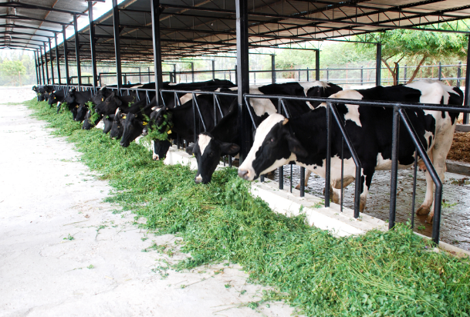

Bangladesh is in a position were improvements are coming in dairy sector. But regarding that still Bangladesh is shortage in supply of milk with the growing population and demand. According to the experts in dairy sector, it is high time to take necessary steps to upgrade local breed of cow with artificial incrimination and cross breed cow. Many big companies are going in joint venture with foreign companies to improve the breeding system in Bangladesh dairy farming and milk industry.

Industry Scenario

Bangladesh Livestock Research Institute (BLRI)
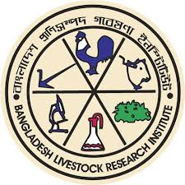
BLRI is the only Government research institute in Bangladesh regarding livestock with head office situated in Savar. It’s been working for since 1984 for the development of breeding and improvement of different cattle breed regarding milk quantity and quality. At present over 80 scientists are working in different sectors for the development in different areas.
BLRI is reaching out to the rural area in Bangladesh for the improvement of milking and fattening bull. Although they have limited manpower but trying much as they can. In last decade milking cow breed are improved as new lineup is added to the national greed.
For a developing country like Bangladesh becoming self-sufficient in milk is must for public health. And BLRI is there to keep it up for the future.
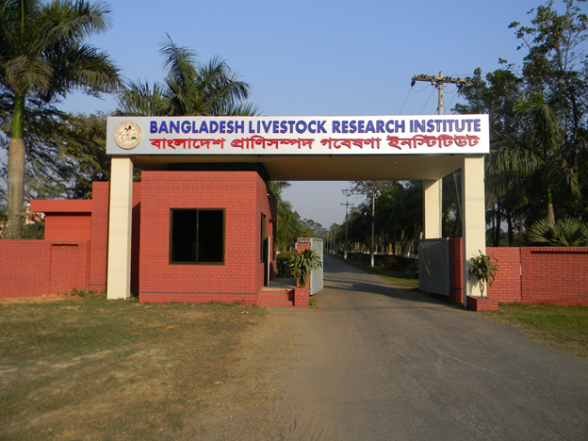

American Dairy Limited
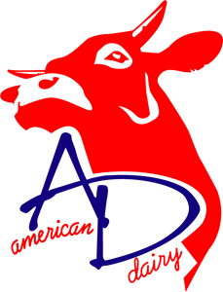
The ADL-Biotech Research and Development Unit founded in 2010 as one of the new dimensions of American Dairy limited. ADL-Biotech Research and Development Unit is a corporate entity of ADL located at Gazipur, Bangladesh.
The ADL-Biotech works with an upward generative growth of open cattle resources on Bangladesh to maximize the industrial as well as the natural efficiency of animals to produce a successful cattle farming practice. By origin, the ADL-Biotech Unit intends at increasing farmers’ in Bangladesh.
Nursing animals with respect and kindness are components of every dairy farmer’s heritage. Put, no dairy farmer can thrive success without healthy and strong cows. Farmers acknowledge that sound animal well-being practices attend to the return of high-quality, safe, and wholesome milk. Recently, Farmers are also investigating ways to develop the comfort of their animals.
Dairy cows are actual the element of the farm, and they handled as such. Managing a healthy and convenient herd of cows is concern number one. Dairy cows take daily on-site eye check from veterinarians, and the operators serve to confirm their cows’ comfort.
ADL dairy farms emphasize bedding composed of white sand that executes for a clean and comfortable area where the cows can relax. Extended barns give cover from the sun, and the combination of fans and sprinkler arrangements creates a refreshing mist.
ADL dairy farms also produce certain cows have their hooves trimmed, something they describe a “cow pedicure.” Cows have an all-day entrance to freshwater, and their specialist of animal nutritionist formulates portions to ensure a cow receives exactly what it necessitates to perform at its best and deliver nutritious milk.

Mission:
The mission of the American Dairy Limited (ADL) is to discover, develop and disseminate knowledge that improves the quality of milk and the efficiency and profitability of its production around Bangladesh.
To achieve this mission there are several wings of ADL, like-
- Dairy breeding head
- Breeding bull station for genetic improvement
- HYV fodder cultivation
- Milk processing unit
- Veterinary and animal husbandry training center
- Goat breeding farm
- ADL consultancy service for new entrepreneur who wish to start large scale dairy farm operation by mechanization.

Products:
- Pasteurized Milk
Pasteurization is a method that removes toxic bacteria by boiling milk to a precise heat for a fixed period.
- Yogurt
Yogurt is made applying a culture of Lactobacillus delbrueckii subsp., Streptococcus thermopiles and bulgaricus bacteria.
- Sweet Dahi

- Help the metabolism of milk protein.
- Improve block and resist digestive stretch infections.
- Moderating cholesterol.
- The vitamins B12 and Riboflavin.

- Ghee
Ghee produced through an uncomplicated method of steaming milk butterfat through evaporating bonded liquid and hold 99.99 % milk fat.

- High Genetic merit semen straw
High Genetic merit semen straw is necessary for Animal fitness, sufficient nutrition, cow supervision, temperature detection, A.I. system, a quality management plan for intentions.
- Beef Cattle
Male calves of the dairy herd are raised distinctly under an accelerated feeding arrangement for retailing high-quality cows for Eid UL Azha every year.

Chapter Two: Dairy Sector in Bangladesh

Introduction

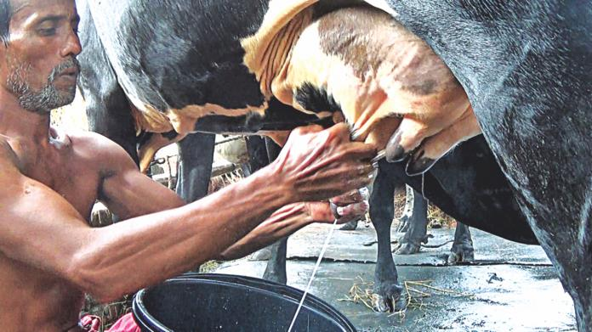
Dairy farming is the most ancient occupation established in the rural area in Bangladesh. With the growing demand day by day more are coming in this sector.
From collecting milk early in the morning and selling it in local market, Bangladesh has moved to a certain level were modern day dairy farming technology are being use to collect milk, preserve those and sell.
There was a time when every household in village had two or three milking cow as part of producing milk and selling for some extra income for the family. Now a days we can see many big companies are coming is the act to provide milk in huge quantity and keeping top quality.
So, as factor milk is one of the top levels for human health, and becoming self-sufficient in it is must. This is developing very first as more educated people are coming and technology grows.
According to Bangladesh Standards and Testing Institution (BSTI) Currently there are 14 big companies are associated with providing packaged milk to the people.
Among them some of the top companies that are available in the market are given below:
Company Name | Year of Establishment | Mother company
Milk Vita | 1977 | Bangladesh government
Igloo dairy | 2004 | Abdul monem ltd.
Farm Fresh | - | Akij Group
Aftab Milk | - | Aftab Group
Ultra Milk | - | PT Ultrajaya Milk Industry & Trading CO Tbk
Aarong Dairy | 1998 | BRAC Dairy & Food Project
Pran Dairy | - | Pran-RFL
Irish ( আইরান ) | - | Danish Dairy
Pura Milk ( পিউরা মিল্ক ) | - | Ichamoti Dairy and Food Products

A study accompanied to investigate the dairy farming of Bangladesh from an industrial perspective. Primary data obtained from smallholder dairy fields relating to survey questionnaires. A Cobb-Douglas product functions and multiplied regression models calculated to analyze farm milk productivity and the gross margin of the dairy farms. Surveyed dairy farms had on a proportion of 3.07 milking cows containing 0.37 domestic and 2.70 crossbred cows. The average productivity of milk was 7.80 liter per cow per day, in which indigenous cow produced 1.9 1iter per day, and crossbred cow milk produced 6.48 liter per cow per day. The investigation determined that the average regular milk production dairy farms:
Size of dairy farms | Average daily milk production
Small | 5.45 liter
Medium | 32.50 liter
Large | 59.83 liter

The average monthly income and expense of milk stock were US$ 79 and US$ 21 per cow, following in the average net income of US$ 58 per cow per month. Both quantitative calculation and t-test outcomes showed a positive statistically significant relationship in farm size and milk productivity with gross margin.
The research conclusions also crossbred cows are generating higher financial advantages to the dairy farmers contrasted to the indigenous cows. Despite existing smallholder and maintenance, dairy farming presents the potential for enhancing revenues to scale, and consequently, there is a field for further extension of the sector.

Bangladesh Dairy
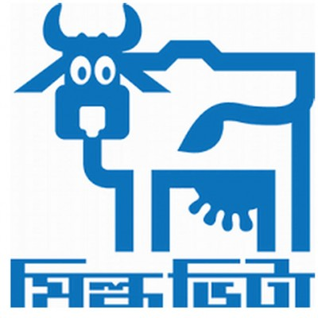

Milk-Vita
In 1946, Late M. Muklesur Rahman Pioneer of Dairying in Bangladesh established a dairy manufactory with a capability of 2000 liters per day at Lahirimohanpur, Sirajgonj (Pabna). The aim was to impart milk products to Calcutta (India) as a part of the Indian subcontinent that period of time mostly because of the easy rail communication system from Pabna to Calcutta.
In 1952, a privet company named Eastern Milk Products LTD. Purchased this dairy from the original owner after the separation of India and Pakistan.
In 1965, Eastern Milk Producers Co-operative Union limited (EMCUL), the first milk producers cooperative was formed through Government patronization.
In (1973-1978), special steps were taken by the independent Government of Bangladesh for the poverty alleviation and to enhance the milk production in the country.
In 1977, organization changed their name to Bangladesh Milk Producers’ Co-operative Union Ltd. keeping its brands name of the product as Milk-Vita
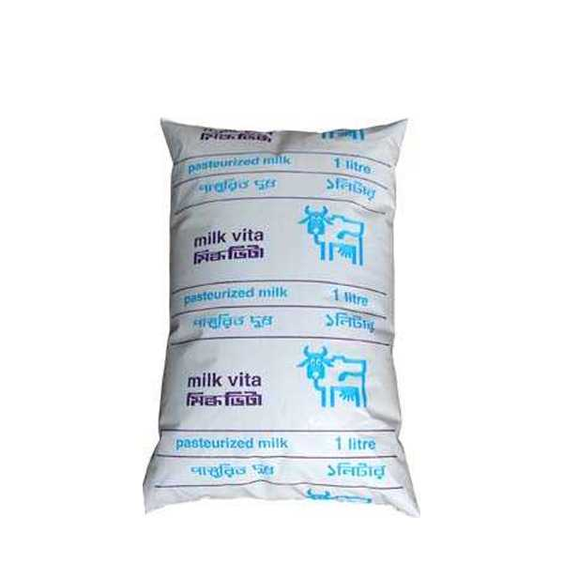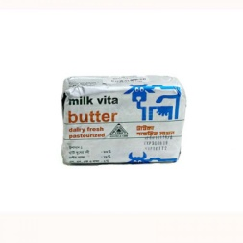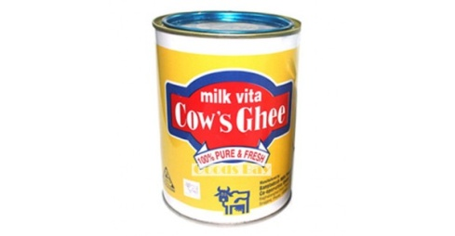

Milk vita is making necessary steps to accomplish the need of the milk and milk goods of city residents by managing milk from far away regions of the country. Currently, milk vita runs in six milk storehouse cities of the country,
- Tangail
- Manikganj
- Tekehat
- Baghabari ghat
- Rangpur
- Srinagar
It manages milk within channels authorized by its central initial co-operative communities. BMPCUL is the fundamental unit of 345 initial milk farmers and has a group of about 40,000 milk-producing producer members.
- To become a part of a rural central membership, producers have to maintain a milking cow and have to purchase a share of TK 10.00 and pay TK 1.00 as an entrance fee.
- To become active membership, a producer has to provide at least 150 liters of milk in a year.

Bangladesh Government Initiative
As the population is growing the demand is incising for milk and meat. Bangladesh government has taken many steps to help the rural farmers and large scale investors in cattle farming sector. Some of those are given below:

Low-Cost Loan for Dairy Farmers
Bankers will grant to dairy producers borrowing Tk 200 crore refinancing capital from Bangladesh Bank’s with an interest rate of 5%.The central bank established the fund in June 2017, to promote dairy producers and lower consumption milk powder import declarations.
This is the part of boosting the growth of milk production and meat. Farmers are now more secure in their business as Government and banks also stand beside them. There is a huge demand in country and around the world. Increased production would mean more for us and lees imported from other country.Need for processing and storing milk to increase the milk processing business and assist broaden into milk goods such as butter, ghee and cheese is very high. These things have an enormous market in domestic business and abroad.
Bangladesh Government spends approximately Tk 4,000 crore a year to ship powder milk to satisfy the deficiency. The refinance plant will provide at least 10,000 farmers to receive affordable loans. Following this scheme, producers will receive a loan within Tk 50,000 and Tk
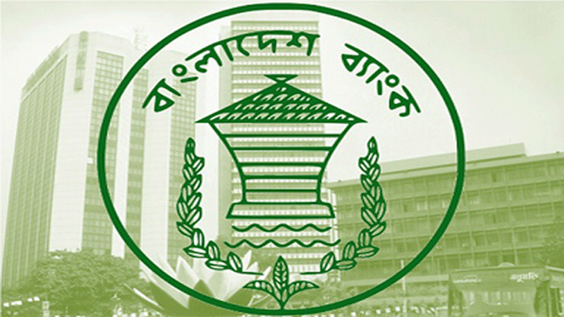
2 lakh from banks, which they have to refund within four and a half years.
Producers can borrow Tk 50,000 for one cow able generating within a culmination of three months and take a maximum of Tk 2 lakhs for four cows for the milk product. Application for purchasing the domestic breeds would get preference.
Bangladesh Bank is closely monitoring this sector as highly important one. As a country Bangladesh economy is depending on agriculture and farming. Cattle sector is a huge part of that.

Breed Improvement
BLRI is constantly working to improve the breeding system of cattle and their fattening process. In breed semen of Brahman bull are distributed in rural areas. With a high growth rate this project is appreciated by the farmers.
Vaccination service is more improved now a day. As Foot-and-Mouth disease FMD is one of the most common and dangerous for this sector. Vaccination is going door to door to prevent casualties.

Feeds and Fodder Management
AEZ 12, AEZ 15, AEZ 30 some of the high quality grazing grass are introduced among the farmers. This have high protein and fast growth system.
About 44% of the dry matter, 26% of the crude protein and 17% of the energy requirements are met by the available feed resources. For a healthy cow almost 5 kg/day needed but naturally all are not available. So, high potential grass is most needed.

Dairy Development
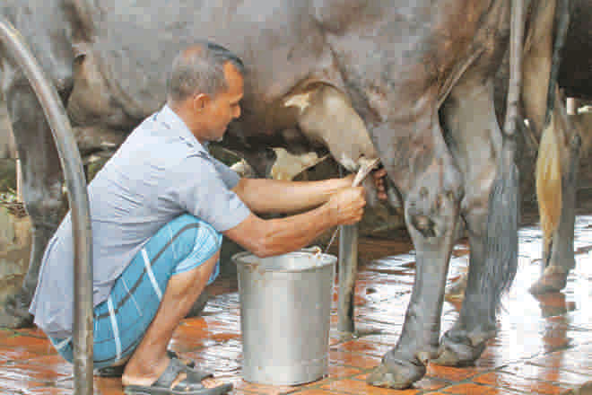

The possibility of the extension of large-scale dairy is inadequate in Bangladesh due to the insufficiency of land. However, the possible growth of smallholder dairy is huge. Over the latest few years, small-scale dairy agriculture has developed.
Now a day’s dairy farming and cattle fattening is becoming a major sector for self employment. Young and educated generation are taking interest in this sector. Many Government and non government companies are coming forward to help them. Vital changes appeared with the assistance of credit, supplies, veterinary assistance, and the requirement of a self-insurance system.
Small-scale dairy agriculture affords vocation for the more deprived portions of the population. Except from the traditional employment dairy is creating new and women are also part of that.
For rural people it is important to have alternative income generating opportunities and dairy and cattle fattening is leading. Smallholder dairy thus increases the field for the poor with confined entrance to land to increase their earnings. Dairy animals can act a significant role in household meal preservation, through increased revenue and nutrition of low-income societies.
Dairy plantation in Bangladesh is influenced by myriads of constraints. And those are:
- Poor knowledge and technological abilities of smallholder dairy producers.
- Lack of feeds and fodder.
- Inadequate quality of feed.
- Common appearance of diseases.
- Insufficient coverage if veterinary co-operation
- Scanty of diagnostic types of equipment.
- Absence of credit support.
- Poor milk collection and processing abilities.
- Inexpensive price at the selection point.
- Absence of insurance coverage.
- Deficiency of market knowledge.
- Shortness of suitable breeds.
- Deficiency of governing body.

Some most important system of the structure is needed toward the development of dairy in Bangladesh. The structured framework that can be adopted by both big and small scale farmers is very necessary.
- United dairy development (milk vita model) has to expend in possible regions of the country. Collect milk from rural areas in daily basis and set a price to match the expense and marginal profit.
- Successful pro-poor diagrams for community-based smallholder dairy expansion including relevant contact agriculture plans would be replicated.
- Smallholder dairy agriculture, combined with crop and fish agriculture should be developed and encouraged.
- Processing and retailing of milk and milk products should be preferred according to supply chain based production.
- A national dairy development board should be authorized as a regulative organization to support dairy improvement projects.
- “National dairy research institute” should be founded to carry out analysis in different viewpoints of dairying.

Meat industry

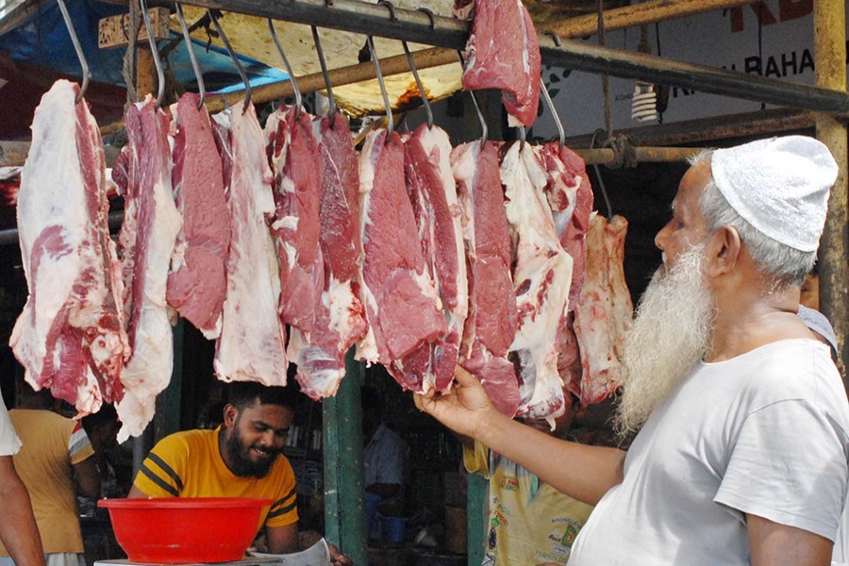
Bangladesh is in the era of being self-sufficient in beef meat production. As number of Farm and Agro based business are growing. Young and educated people are coming in as a pioneer.

Beef Meat export companies in Bangladesh
Name | Year of establishment | Country / region
Bengal Meat | 2006 | Bangladesh / Dhaka
Crunchy Sphere | 2010 | Bangladesh / Chittagong
Anik Trading Corporation | 1997 | Bangladesh /Dhaka
Halal Meat Pvt. Ltd. | 2007 | Bangladesh / Dhaka
Tanvir enterprise | 2001 | Bangladesh / Dhaka
Deshi Meat | 2013 | Bangladesh / Dhaka

Meat Export
To determine the full privileges of globalization and business liberalization, Bangladesh must notably increase its export goods to complete product standard terms of importing countries and get current knowledge on several markets.
Bangladesh is sign Agreement on Agriculture (AOA) under the WTO (World Trade Organization). The AOA gives a structure for the long-term betterment of the farming business including livestock. In some parts Bangladesh is trying to meet the recommended safety and quality standard for livestock products. Responsibilities and systems included in the AOA link to four features;
- Agreement on market access,
- Agreement on domestic support,
- Agreement on export competition/subsidy
- Agreement on SPS (sanitary and phytosanitary) measures.
Meat export could be another big sector to earn foreign exchange for Bangladesh after RMG sector. In Middle East and in Muslim countries there is a huge demand of Halal and safe beef meat. Government should take incentives to help companies to export meat. Creating new market place is most important for this sector. To export meat companies must follow the international standards and guidelines. There are some obstacles in following proper standards and international guideline;
- Poor veterinary services,
- Shortage of experienced human resources,
- Deficiency of diagnostic abilities,
- Insufficiency of financial assistance,
- poor of disease monitoring and monitoring of animal health,
- Lack of update food legislation and
- Lack of an upgraded national food export and certification application.
Largest export-oriented industries are small and medium-size with the bounded capability to initiate market research, buy-in technologies and settle, stock and method business information.
Extra major challenges correlate to satisfying employment and environmental standards, developing plans and packaging and obtaining and utilizing current data on customer preference and trends in global businesses.
Several initiatives have neither the in-house ability to collect the essential trade-related data nor the systems to obtain such knowledge. A management framework for worldwide trade administrators for shipping meat;
- Focal features would be fixed up in the DLS (Department of Livestock Services) and the MoFL (Ministry of Fisheries and Livestock) to trade with the foreign and local sales arrangements and secure implementation of information and necessities;
- Training would be given to the administrators in the DLS, MoFL and livestock-related activities to allow them to completely appreciate and trade efficiently with foreign and local business contracts;
- Terms of trade related professional support for the DLS, MoFL and individual exporters would be charged and needed support would be granted;
- The contents of DLS would be extended through institutional improvement to address SPS (Sanitary and Phytosanitary Measures) and HACCP (Hazard Analysis and Critical Control Point) obligations;
- An Internet-based intelligence system must practice facilitating worldwide market networking for livestock products;
- MIS (Management Information Systems) must practice in the DLS and MoFL for global trade management of livestock goods; and
- Private sector participation should assure all exercises of global trade management.

Meat Production
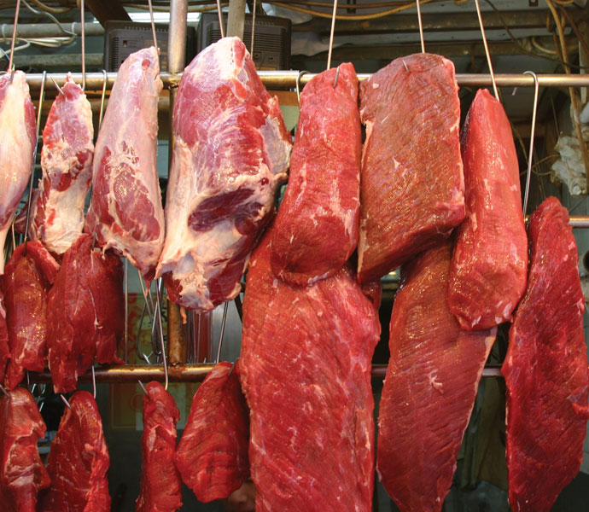
Approximately 3.5 million cattle are killed yearly in Bangladesh of which 40 percent which imported through cross-border sales. Nearly 15 million goats are killed annually regularly of regional origin. Of the cumulative carnage of cattle and goats, almost 40 percent performed in Eid-ul-Azha. This number is growing day by day.
As a first growing country with huge population meat is the way to nutrition.Meat production is estimated to have high income-generating potential but meets limitations such as;
- Deficiency of appropriate breeds.
- Awareness gaps of producers.
- Scarcity of proper veterinary service
- Poor quality feeds.
Most beef is retailed under the unsatisfactory hygienic situation in both agricultural and metropolitan zones. Implementation of law reporting to slaughtering or beef review is limited. There is usually:
- Poor pre-slaughter state.
- Inadequate hygiene.
- Poor management of discharge of waste substances.
- The under rate in Disposal of offal.
There should a structure founded for quality beef production. The structure provided below;
- Animal Slaughter Act and Animal Feed Act would be established and implemented in order to better sanitary production of quality beef.
- Processors would be trained on accurate systems of butchering processing and storage procedures.
- Improvement of cow breeds for enhanced productivity at the farm level.
- Improvement of slow and progressing linkage policy to promote the growth of existing cattle fattening practice into private businesses.
- Privet area should be promoted to practice mechanized slaughterhouses with the latent flying structure around consequential towns.

Meat Import
Bangladesh is an underdeveloped country. Where it has to depend on importing lots of things and exporting is main source of earning foreign revenue.
In this situation, there comes the issue of importing beef meat from varies countries due to recent price hike of beef meat in local market. Day by day interest in importing beef meat is increasing.
In 2016, meat imports of Bangladesh were 2058 thousand US dollars. The number of meat import in Bangladesh fluctuated in recent years. A collected data of meat import in value and change in percentage is given below:
Date ( Year ) | Value ( US dollars ) | Change (%)
2016 | 2058 | 5.86 %
2015 | 1944 | -23.28 %
2014 | 2534 | -30.59 %
2013 | 3651 | 41.95 %
2012 | 2572 | 106.26 %
2011 | 1247 | 40.11 %
2010 | 890 | -32.78 %
2009 | 1324 | 159.61 %
2008 | 510 | -36.09 %
2007 | 798 | 19.10 %
2006 | 670 | -18.89 %
2005 | 826

For a country like Bangladesh, This incising number is alarming. As an agricultural country the number of people involve with the cattle farming is huge. More and more educated people are getting involved with this day by day. With proper knowledge and use new age methods they are making cattle farming more promising and steps towards self-sufficient in beef meat production from Bangladesh.
Although it is mostly illegal to import beef meat but some of the over enthusiastic businessman are eagerly waiting for the permission to import beef meat. A part of Bangladesh Garments Manufacturing and Export Association is strongly suggesting the beep meat import from African country to increase the export of garments product in that region. Although Bangladesh Government didn’t approved any final dissension but the people connected with cattle farming and cattle fattening industry are strongly against this. This type of import system will directly affect farmers of rural area and they won’t get the price they deserve. Effects of beef meat import will be a burden for long run in the economy as country may depend fully on import which is worst situation for an under-developing country like Bangladesh.
Worldwide in 2018, 72% beef meat import is done by fifteen rich countries. Those are:
- United State of America
- China
- Japan
- South Korea
- Italy
- Netherlands
- Hong Kong
- Germany
- France
- Russia
- Great Britain
- Egypt
- Chile
- Taiwan
Country like Bangladesh doesn’t belong to that list as most of the Asian countries are sweet able for cattle farming. So there is a hardly any need of beef meat import.

As a country, were meat is in top of any food menu price is high. Meat is 32 percent more expensive than the global average cost. Insufficient domestic production is considered as the major cause behind in the days. It rises and some businessmen are strongly wanted there should be beef meat import from countries like Brazil and India.
Customer needs to pay about TK 500-550 or about $7 for each kg of beef meat around the country where as the international average price is $5 (about TK 400) per Kg, according to the World Bank (WB) Commodities Price Data published every month. In this condition, from the Federation of Bangladesh Chamber of Commerce and Industry (FBCCI) suggestions came that the Government should ship meat from India to attend the country's protein requirement that prevailed unfulfilled because of the expensive red beef in regional markets. FBCCI even proposed that Bangladesh Government Should import beef meat from African countries to increase the export of readymade garments goods.

Impact of meat import
- Illegally imported
- Unhygienic
- Unemployment
- Economy
- Not being halal

According to the Department of Livestock Services, a law came in act from 2015 known as “Bangladesh Animal and Animal Product Quarantine Act 2015 “. And it says,
If anyone wants to import animal or animal products then one must updated and reported to the authorized officer of the department about the procedures 15 days ahead of importing.
But currently imports are done illegally. Thousands of gem beef meat is being imported without any legal authorization. There is no clearance that the imported meet is healthy or not. For many the questions always remain that weather the imported meat is halal or not. In recent time not beef but also buffalo meat is being imported. According Chittagong customs almost five to six lakhs kgs of rotten beef and buffalo meat imported every month. This meats are not tested which can cause vital diseases through consuming them. In many ways buffalo meats are sold to consumers as beef meat which is totally against the Act of Consumer Rights. Some of the illegally meat importers also import preserved meat that has already expired its date. That is another unlawful act. As imported meat from India in a way cheaper then local meat, many restaurants in capital are using those. This consumption of unhygienic food will lead to long term diseases. In recent times May legal action has been taken against this. Still outdated imported meat is found in the market.
When a product is imported then the production of that product will decries and the people depending on that sector will lose interest in producing. Same goes for the farmers and investors in this sector. Farmers who are involved with cattle fattening will be harmed deeply causing leaving this profession. And if meat is constantly going on than in long run Bangladesh may fully depend on import meat. This kind of situation may cause full sector to collapse. Many small farmers take bank loan to establish a cattle fattening farm. If the meat import increases then those farmers won’t get proper price. Market wouldn’t have the same meat demand as before. People will go for less costlier imported meat. This will lead to a negative impact in our rural economy. As a result many people will lose their livelihood. Almost four crore people are directly or indirectly involved with cattle farming sector. Unemployment rate will go high in long run. Depending on imported meat affect all of them. People taking loans on easy term based on agricultural background will face difficulties in repaying them.

Chapter Three: Challenges & Opportunities

Introduction
Every sector has some challenges and opportunities. From perspective of cattle industry biggest challenge is food cost. Day by day food cost is getting higher. In rural areas farmers can’t maintain a good quality fating bulls or dairy cow because of increased price. Illegal import of beef meat is also challenge in local market.
Different opportunities are also available in this sector. Most promising is self employment. In a stage of self-sufficient Bangladesh can export meat of milk product to earn which is good for GDP.

Cattle Industry
- Government should take steps to improve the breading system in rural area.
- Develop a monitoring team for assessment in price of cattle food.
- Reach out to the farmers of new generation to step up in this sector.
- Government loan system should be with more easy process.

Dairy Industry
- Make milk plant more available throughout the country.
- Make a proper pricing chart for collecting milk from the farmers.

Meat Industry
- To become self-sufficient in meat more high profile breed should be added to the national greed.
- Meat import should be totally forbidden for the industry and public health issue.

Future of Cattle Farming Industry

Artificial Insemination – AI
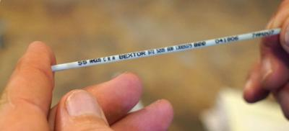
The livestock sector has an enormous role in securing food preservation, nutrition, and overall socio-economic growth. Its increase in GDP is 2.51% with 3.39% the growth rate. Still, after suffering many challenges limitations, the livestock sector is progressing.
Since 2008 in live stock sector has been advancing quality bull genes into the nationwide. This is helping in producing calf with healthy life cycle. Fast growth and cow with more milk producing ability is result of AI.
As through the government reports, in approximately 50% regions of the country, artificial insemination (AI) has moved considerably successfully not only in big projects but also in door to door of rural farmers.
Also in 2008 Bangladesh Livestock Research Institute (BLRI) introduces high quality Brahman Bull semen to the farmers. Its Beef Cattle Development Project, which has rotated out at least 48 districts, manages Brahman bull semen shipped from the United States to produce local cows. The effect is healthier, fastest-growing livestock, and is well-suited to higher quality milk and meat stock.
The Ai research center of Savar is progressing onwards with precise procedures and goals. The Ai research center has an individual AI system, semen testing, and packaging and preservation capability. The state of the art practice also involves strict bio-safety measures. Besides the facilities, the center also has the technologies for monitoring the quality, growth rate, and fitness of the semen and other.
BLRI proposed to producers for free semen; the in-service has so far provided around 10,000 Brahman hybrid calves national. The start of the outline was back in 2014, beginning 120 artificially bred Brahman Hybierd cattle in Bagerhat produced in Mollahat Upazila.
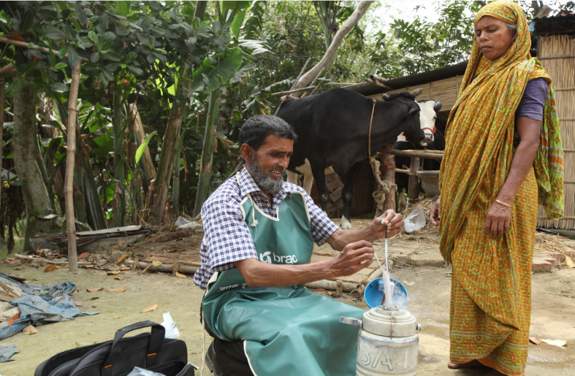
Different privet companies are providing this AI service to the farmers.
- Bangladesh Livestock Research Institute (BLRI)
- American Dairy Limited
- BRAC Artificial Insemination

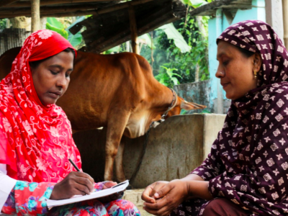
They go from home to home to make farmers aware of the advantages of artificial insemination. The outcome of AI program is very effective. When farmers agree, they provide the insemination of their bulls. The introduction of Brahman cow into the internal herd intended to attend national meat and milk demands.

BRAC Artificial Insemination
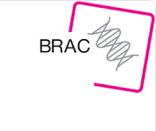
BRAC Artificial Insemination started in 1987 as a partnering initiative with the management of Bangladesh to implement the rural poor with the approach to better quality breeds of heifers. While BRAC presented calves as assets to the rural people, the situation was not excellent as those cows could provide an aggregate of 1.25 liters of milk per day (Survey of BRAC Research Department). This significance of productivity did not help the target groups to create a decent income. BRAC decided that breeding higher-yielding dairy heifers would improve this problem. At this time in the past, the government alone had passage to high-quality bulls frozen semen, and the rural people made seldom capable of implementing artificial insemination by that semen. Therefore, a collective effort by BRAC and the government workers toward the area to train a chosen number of people on how to regulate artificial insemination provided a head start to the project. Therefore, 130 people proposed to be trained as artificial insemination specialists and till now, BRAC has trained 2,141 artificial insemination specialists successfully. Some are waiting to start their project in agricultural areas.
In 1998, BRAC officially split its efforts from the government and worked with several other organizations to further its development works. Till 2007 it has a developing phase and by 2007, the artificial insemination developing programmed became self-sufficient and BRAC finally set a self-governing artificial insemination social enterprise.
BRAC Artificial insemination has one bull station in Shambhugonj, Mymensingh, Bangladesh. When it was first built, it held 35 bulls along with growing. Today it holds 73 bulls and 19 Black Bengal goats BRAC is the pioneer of private owned large-sized bull and buck frozen semen collection, processing, preservation, and distribution center in Bangladesh. No government and private companies are in goat frozen semen production, processing, and administration. Momentarily, from the bull station, all varieties of frozen semen get assigned to depots. BRAC Artificial Insemination has 70 CCA(stations) throughout Bangladesh. Here, artificial insemination operators buy semen for average BDT 140. Then they charge the farmers BDT 205-250 for the semen and their assistance. Artificial insemination operators not only inseminate the farmer's heifers but also guide farmers to take care of their heifers on overall fitness (water supplementation, feeding for proper nourishment, housing, management, disease prevention, and cattle breed selection).
If a farmer's heifer goes into heat, the farmers call artificial insemination workers and the specialist inseminate the cow within 12 to 18 hours for proper conception. Farmers eventually benefit from both male and female calves. High-quality breeds of male calves grow more quickly and larger than average male calves, making them a better source of beef. If the cow births a female calf, this calf will eventually grow into a high-yielding cow. For making profitable business on dairying the one calf in one year is essential. AI operators are devoted to informing the farmers in that regard.
Today, BRAC Artificial Insemination includes 61 districts across Bangladesh and has inseminated a total of around 1.64 million in 2015. The districts covered also add to the BRAC Dairy and Food Project. BRAC Artificial Insemination contributes to the success of BRAC Dairy, helping to feed the demand for milk in Bangladesh.

Conclusion
As fact this industry is growing day by day. More and more people are coming in. There should more lone support for the new farmers and investors. This will encourage building a farming system which is self-sufficient for Bangladesh.
Government research center should be adapting to the new technology to reach out to the rural people. New breeds of cattle and milking cow should be introduced to the farmers. To meet the need of country new fattening breed should also be included. AI system should be available though out the country.
Once Bangladesh reach self-sufficient stage beef meat can be export to other countries as a new part of earning remittance. Until then there should be totally ban on importing meat.

Reference
Bangladesh Livestock Research Institute (BLRI)
Website: http://www.blri.gov.bd
Bangladesh Livestock Department
Website: http://www.dls.gov.bd/
BRAC (BRAC Artificial Insemination)
Website: http://www.brac.net
American Dairy Limited (ADL)
Website: http://www.adl.farm
The Daily Star
Website: https://www.thedailystar.net
Bangladesh Import Export Bureau
Website: http://www.ccie.gov.bd
Bengal Meat
Website: http://bengalmeat.com
Bangladesh Dairy Farmer Association (BDFA)

