EFFECT OF HOME DISTANCE ON CGPA

Submitted By
Mumtahina Mim
ID: 121 142 001
Department of Economics
Summer 2018

A Guided Research Paper
Submitted to United International University
As a fulfilment of the requirement of the degree
Bachelor of Science in Economics

Supervisor: Sumaiya Binte Kabir
Lecturer
Department of Economics
United International University (UIU)

Acknowledgement
First of all, all credit goes to Almighty Allah. I am really grateful to my university that it has created such an opportunity of research which always enriches our knowledge and wisdom. Secondly, I would like to express my gratitude to my research supervisor Sumaiya Binte Kabir. She is a very co-operative, friendly & humble person. Without her co-operation it would be impossible for me to complete my thesis. Because as a student, I did not have much idea about how to carry on research and make thesis paper based on it. My ma’am helped me throughout this tough journey wholeheartedly. I faced many challenges and sought help from her over and over again but I never saw her to be disturbed. These are the things that encouraged me a lot to stay focused in my journey of making this thesis paper. So it might be less if I thank her. Rather I would always want that every student be blessed with a teacher like her of such a rich personality.

TABLE OF CONTENTS
Contents | Page number
- 1. Introduction | 1
- 2. Literature review | 2-3
- 3. Objective of the study | 4
- 4. Methodology | 5-6
5.Descriptive Analysis | 7-13
6. Estimation of result | 14-15
7. Conclusion and Recommendations | 16
8. Reference | 17

LIST OF TABLES
Tables |  | Page number
Table 1: Regression Analysis |  | 14
Table2: Male-Female percentage | 7
Table 3: Results of home distance from university | 8
Table 4: Results of students CGPA | 8
Table 5: Vehicle Availability | 10
Table 6: Study in daily | 11
Table 7: Attendance per week | 12

LIST OF CHART
Chart | Page number
1. Pie chart of time needed to reach | 10
2. Bar chart of time spent in traffic jam | 10
3. Bar chart of Vehicle Availability | 10
4. pie chart of group study | 11
5. Bar chart of spent time in university | 12
6. Pie chart of part time job | 13

Abstract
This paper is based on primary data which was collected from the university students to see the relationship between the effects of home distance and CGPA. The primary data is also used for the ordinary least square estimation that shows the relationship of the student’s CGPA with study hour, group study, part time job and class attendance. We used gender as a dummy variable to see how gender plays a role in obtaining good CGPA. This study notes that no significant relationship exists between CGPA and home distance in the context of UIU but this study reveals a positive relationship between CGPA and study hour. Also after adding dummy variable we see that female students obtain higher CGPA than male student.

EFFECT OF HOME DISTANCE ON CGPA
1. INTRODUCTION

The number of students in private university is increasing day by day. But there are no residential facilities in private universities. Students come from different places to attend the classes. Obviously they expect to attain a good CGPA. But not always they can achieve their desired result. In this thesis paper I described the reasons that may cause these failures. They face various types of challenges in the way of achieving their desired result. Home distance is one of the main factor. Commuter students get less time to study than residential students. Because in this city traffic is a common barrier. University students waste 3-4 hours of time in travelling which consumes a big part of the day. As a result they get tired after reaching home which affects their study and CGPA. So we say that home distance is an important factor for CGPA. Besides home distance, availability of vehicle in the area also plays a great role in CGPA. So availability of vehicle is also a factor. Shortage of vehicle causes a student fall in trouble in the way of arriving to the university. As a result many students keep waiting or adopt walking as a media to come to university. So at the end of the day it kills their valuable time and energy which they could spend in studying. Part time job is another factor of affecting CGPA. Because of part time job a student can’t concentrate on his study properly. This also affects CGPA. Class attendance and group study plays a big role in the result.
If home distance is more then attendance becomes less for a student. On the other hand students are not willing to stay in university for group study if their residence is far away from university. Above all, all the factors have more or less connection with home distance either it has direct or indirect relation.

2. LITERATURE REVIEW

This research required an investigation of the key variables affecting a student’s academic achievement with home distance. Significant research has been conducted on the various elements affecting a student’s academic performance in order to understand what leads to student success. One of the major measurements of student’s performance is the student’s credit grade point average (CGPA). This is the primary outcome measure for this study. Our goal is to assess the positive or negative effect that variables such as study hour, group study hour, class attendance, part time job, gender, home distance of student.
This paper summarizes some of those papers below:

the literature has been carried out to find out the related to student’s good result.. In a study, Dayıoğlu and Türüt-Aşık (2007) say Survey was made to identify whether gender differences play any vital role at Middle East Technical University. It is said that smaller number of female students outperformed their male counterparts. Young and Fisler (2000) carried reseat in SAT-M exam. In this survey they observed that boys get good GPA than girls because of socioeconomic aspects existing between them.
Personal and school characteristics on Graduate Record Examinations (GRE) were analyzed by Stricker and Rock (1995). The analyst revealed that the education level of parents is the most effective variable. Beside this institutional expertise also influence on the exam scores.
Urien (2003) discover 3 factors affecting academic performance of students one is personal characteristics, second is family background and third is study discipline. Fertig and Schmidt (2002) showed us that there is a positive relationship between students’ verbal performances and employed mother and father from unbroken family structure.
Factors like ethnicity, sex,family income and social economic environment can make a differences in the graduate point average which was reported by Betts and Morell (1998)
Smith and Naylor (2004) showed the of the students characteristics on the university performance. They identified that student with a higher CGPA from university completed high school from private school is probably 5.9 percent higher than a student who graduates from public school. Horowitz and Spector (2004) reported that the students who graduate from religious high school show higher performance than the students who graduate from private and public high schools. Cohn et al. (2004) examined the effect of socio-economic and demographic factors on student performance in South Carolina University and found out that white students gets higher scores than non-white
Durden (1981) and Romer (1993) opined that less attendance reduces the CGPA. Wolaver (2002) explain in a study that alcohol consumption by student acts as an important determinants for less CGPA. Clifton et al. (2004) stated that the pedagogical environment and the psychosocial dispositions affect the students’ academic success.
(Bozick, 2007) stated that student playing more attention in job can hardly concentrates on studies so it has a concern of student CGPA. The factor be like part-time job, full time job etc. have impact on student academic career. (O'Toole et al., 1999) stated single students face less limitations related to their family life that’s why being single was found to contribute to student retention rather than attrition.
Financial support coming from student earning or not have an impact on the persistence. It is defined as critical factors. (Tinto, 1999) and Astin (1984) emphasized on student persistence level. (Tinto, 1999) described in integration model that students engagement level impacts both how student apart to schools people and environment.it is also connected to success of a student.
Guerrero (2010), in an analysis of factors that influenced student retention at a southwestern university, identified several factors that influenced students’ continuing commitment to remaining enrolled in college. Among the factors identified, part-time status of students was found to have a significant relationship with the possibility of dropping out of college. Guerrero reported that students who attended part-time were nearly 230% more likely to drop out than were full-time students. Students who attend part-time may do so because they cannot afford to attend fulltime; and students attending part-time are by definition off-campus residents, because most colleges and universities allow only full-time students to live on campus. This literature review has identified a number of factors that can influence the likelihood of a commuter student CGPA.

3. OBJECTIVE OF THE STUDY

- To find out the relationship between home distance and CGPA.
- To find out the factors behind higher CGPA.
- To find out the factors behind lower CGPA.
- To find out the effects of home distance on male student’s and female student’s CGPA.
- To find out how part time job effect on CGPA.
- To see the relationship between study hour and CGPA.

4. METHODOLOGY OF THE STUDY

This paper determines to find if there are any influence of home distance that affects CGPA. I want to measure how home distance affects CGPA and how much it can affect. The methodology of this paper is conducted by quantitative analysis.

Types of data:

This study is based on primary data which was collected from UIU students belonging from 1st to 12th semester. A survey questionnaire was prepared and provided to the students. Data was collected both online and offline. All data was accumulated from 106 students on a random basis.

Selected variables for quantitative variables:

This paper focuses on students CGPA. To understand the variation of CGPA we use home distance, study hour, traffic jam, part time job, group study, class attendance as independent variables where home distance is main independent variable and our dependent variable is CGPA that helped us to do this quantitative analysis.

Model Specification

To measure the effect of home distance on CGPA first we run a liner regression and estimate using ordinary least square estimation. In this model our dependent variable is CGPA and independent variables are trimester, average distance, time for travel, traffic, study hour in a day, study hour in university, days per week in university and total GPA.
Our linear regression function is:
cgpa = α₁+ Σ β_{i}x_{i} + u_{i}

Where xi = are trimester, average distance, time for travel, traffic, study hour in a day, study hour in university, days per week in university and total GPA.
And u_{i} is error term
Then we tried to find out how gender plays a role in obtaining good CGPA. We used gender as a dummy variable to see the impact. Our model is:
cgpa = β₁+: β₂D_{i} + u_{i}
Where D=1 if male and 0 if female

Limitations of the research:

1. The descriptive analysis didn’t discuss the role of other variables than distance in obtaining high CGPA. The correlation ship between CGPA and other variables were not shown.
2. Taking three criteria such as low CGPA, good CGPA and high CGPA an order probit or multinomial logit model can be done in future given a large random sample.

- DESCRIPTIVE ANALYSIS

I am going to observe the effect of home distance on CGPA where I collected 106 (where male is 49 and female is 57) primary data from UIU students. In this survey, I asked different types of questions to the students. I want to add that students from 1st to 12th semester took part in this survey.
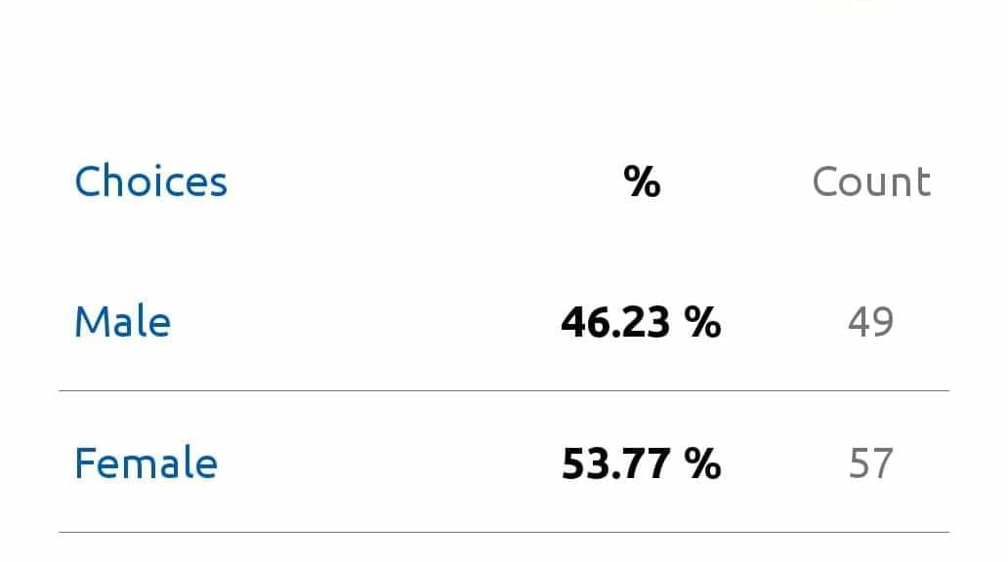
Table 2: Male-Female percentage
Participants spontaneously responded and filled up the form. Finally, I summarized the result.

- Relationship between Home Distance and CGPA:

First of all, I wanted to know the distance between the home and university of students which I compared with student’s CGPA.
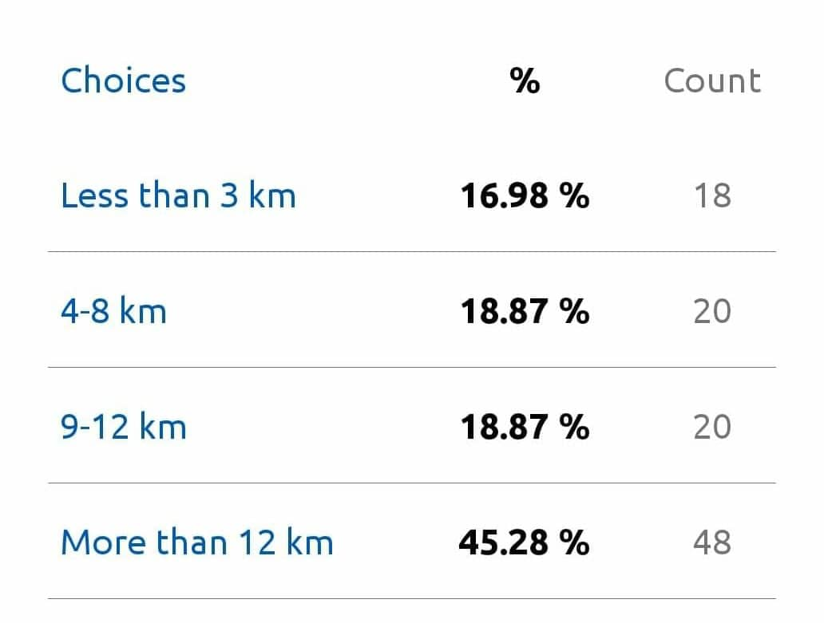
Table 3: results of home distance from university

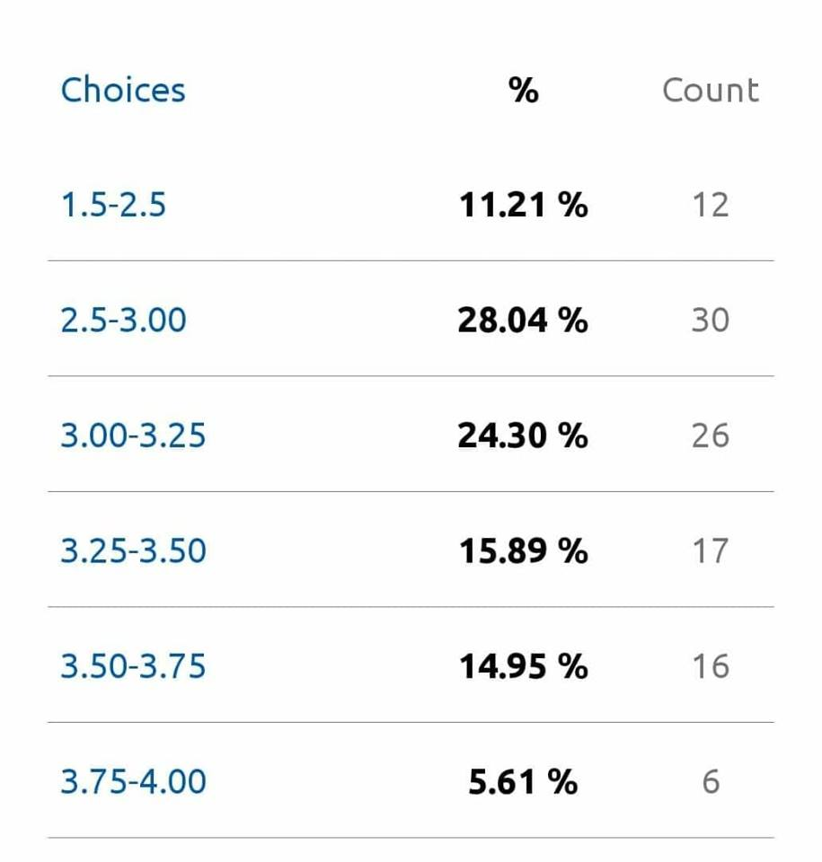
Table 4: results of students CGPA
In this survey we found that 18 students residence is located less than 3 km among 106 students who don’t belong in CGPA ranging from 1.5-2.5 and 6 students belong CGPA ranging from 2.5-3.00 which consists 33%. In addition to this, 4 students among 18 belong CGPA ranging from 3.00-3.25 and 3 students belong CGPA ranging from 3.25-3.50 and 3 students CGPA ranges from 3.50-3.75.Lastly, 3.75-4.00 CGPA is achieved by 2 students.
In this survey, we found that 20 students residence is located 4-8 km among 106 students. Among them 3 students belong to CGPA ranging from 1.5-2.5 and 6 students belong to CGPA ranging from 2.5-3.00. In addition to this, 5 students among 20 belong to CGPA ranging from 3.00-3.25 and 4 students belong CGPA ranging from 3.25-3.50. And 2 students CGPA ranges from 3.50-3.75.No students belong CGPA 3.75 & above.
In this survey, we found that 20 students residence is located 9-12 km among 106 students. Among them 1 student belong to CGPA ranging from 1.5-2.5. And 8 students belong to CGPA ranging from 2.5-3.00. In addition to this, 5 students among 20 belong to CGPA ranging from 3.00-3.25 and 3 students belong to CGPA ranging from 3.25-3.50. And 3 students CGPA ranges from 3.50-3.75.No students belong to CGPA 3.75 & above.

In this survey, we found that 48 students residence is located more than 12 km among 106 students. Among them 8 students belong to CGPA ranging from 1.5-2.5. And 10 students belong to CGPA ranging from 2.5-3.00. In addition to this, 11 students among 48 belong to CGPA ranging from 3.00-3.25 and 7 students belong to CGPA ranging from 3.25-3.50. And 8 students CGPA ranges from 3.50-3.75.4 students belong to CGPA 3.75 & above.
So we can consider seeing this explanation students having distance more than 12 km from university form the majority of students. 20 students have home distance of 4-8 km and 9-12km from university and the number of students living less than 3km is very minor.
Now I am interpreting the table of CGPA.
12 students have CGPA 1.5-2.5. Among them 8 students have distance more than 12 km,1 student has 9-12km and 3 students have 4-8km distance. The majority students consisting 30 belong CGPA 2.5-3.00 where students having distance less than 3km and 4-8km are 6 students each. The students having distance from 9-12km is 8 and more 12km is 21. Total no of student having CGPA 3.00-3.25 is 26 where 4students have less than 3km distance ,5 students each belong 9-12 km & 4-8km. 12 students belong more than 12km distance.
17 students have CGPA 3.25-3.50. Among them 7 students have distance more than 12 km,3 students have 9-12km and 4 students have 4-8km distance.3 students have distance less than 3km.
16 students have CGPA 3.50-3.75. Among them 8 students have distance more than 12 km,3 students have 9-12km and 2 students have 4-8km distance.3 students have distance less than 3km. 6 students have CGPA 3.25-3.50. Among them 4 students have distance more than 12 km & 2 students have distance less than 3km. no students belong in 4-8 km & 9-12 km.
So we say that, 33% students having distance less than 3 km belong to CGPA 2.50-3.00 which consists the majority of percentage.
30% students having distance of 4-8 km belong to CGPA 2.50-3.00 which consists the majority of percentage.
40% students having distance 9-12 km belong to CGPA 2.50-3.00 which consists the majority of percentage.
23% students having distance more than 12km belong to CGPA 3.00-3.25 which consists the majority of percentage.
Now I can say, the majority of students belong to CGPA 2.50-3.00 from any distance among the total no of 106 students. Rather we found that the students coming from more than 12 km achieved good result
- Relationship between Time needed to reach university, Vehicle Availability, Traffic jam with CGPA:

Besides this, a number of factors are responsible for the effect of CGPA of students like how much time they need to reach university and how much time they spend in traffic jam because these also impact on CGPA.
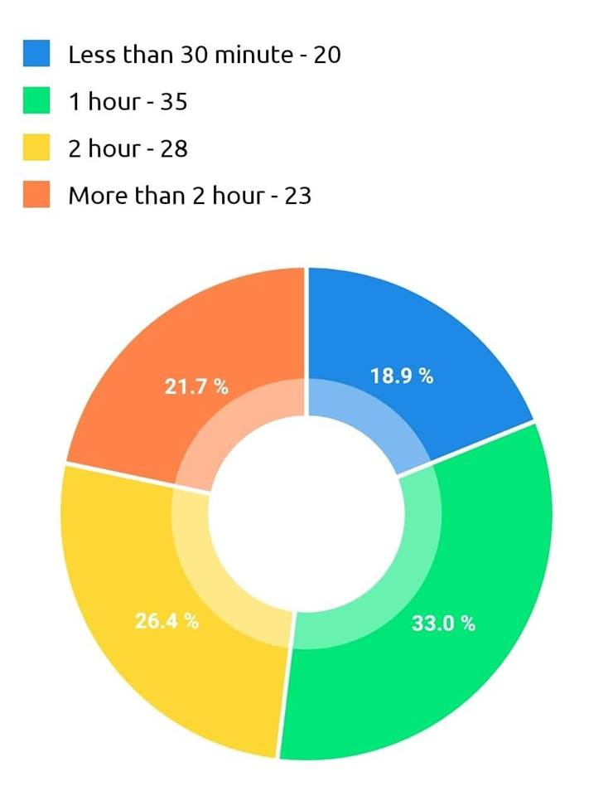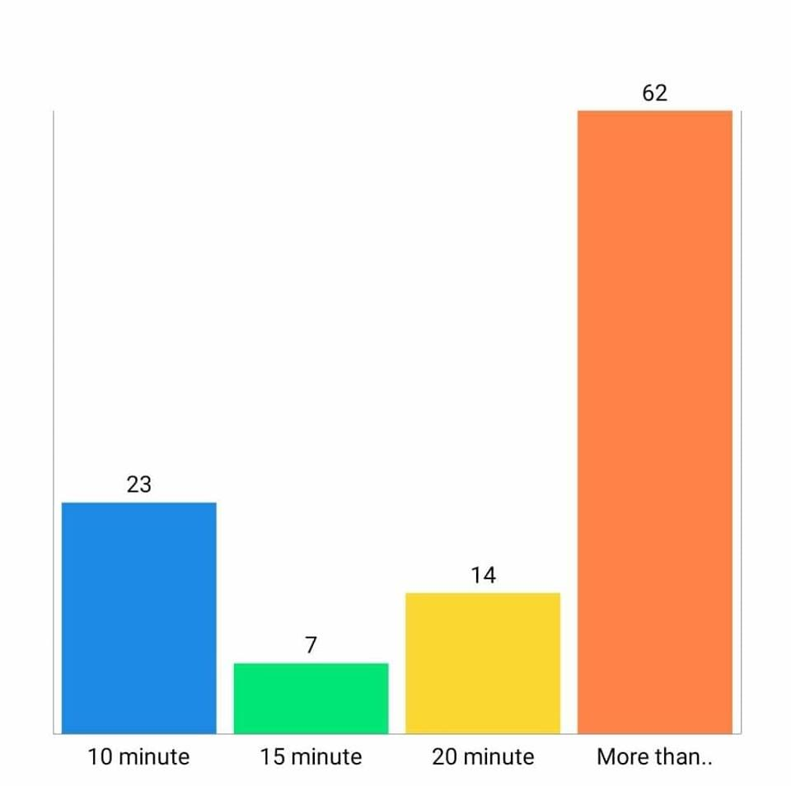
Pie chart of time needed to reach Bar chart of time spent in traffic jam
In the pie chart we see, 33% students take 1 hour to reach in the university & 26.4% students take 2 hours, 21.7% students take more than 2 hours and 18.9% students take less than 30 minutes to reach the university.
From the bar chart, we find that, 23 students spend 10 minutes, 7 students spend 15 minutes, 14 students spend 20 minutes in traffic jam.62 students spend more than 25 minutes in traffic jam among 106 students which consists the majority which is harmful for CGPA.
University vehicle is also important factor for class attendance that can affect our CGPA. In our survey, we see 50% students have direct vehicle for university and 50% don’t have.
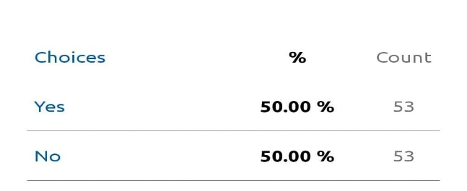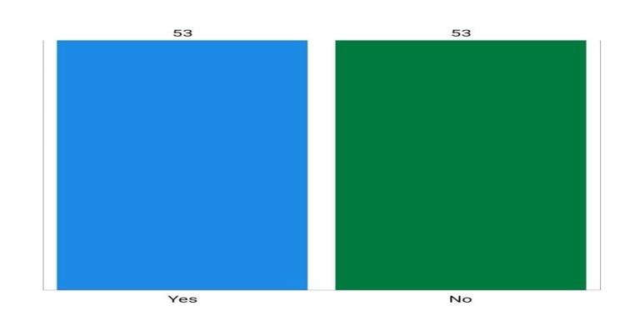
Table 5: Vehicle Availability Bar chart of Vehicle Availability

- Relationship between Study and Group Study with CGPA:
For achieving better CGPA daily studying and group study play also important role. Because without study we cannot achieve good CGPA whatever the home distance is.
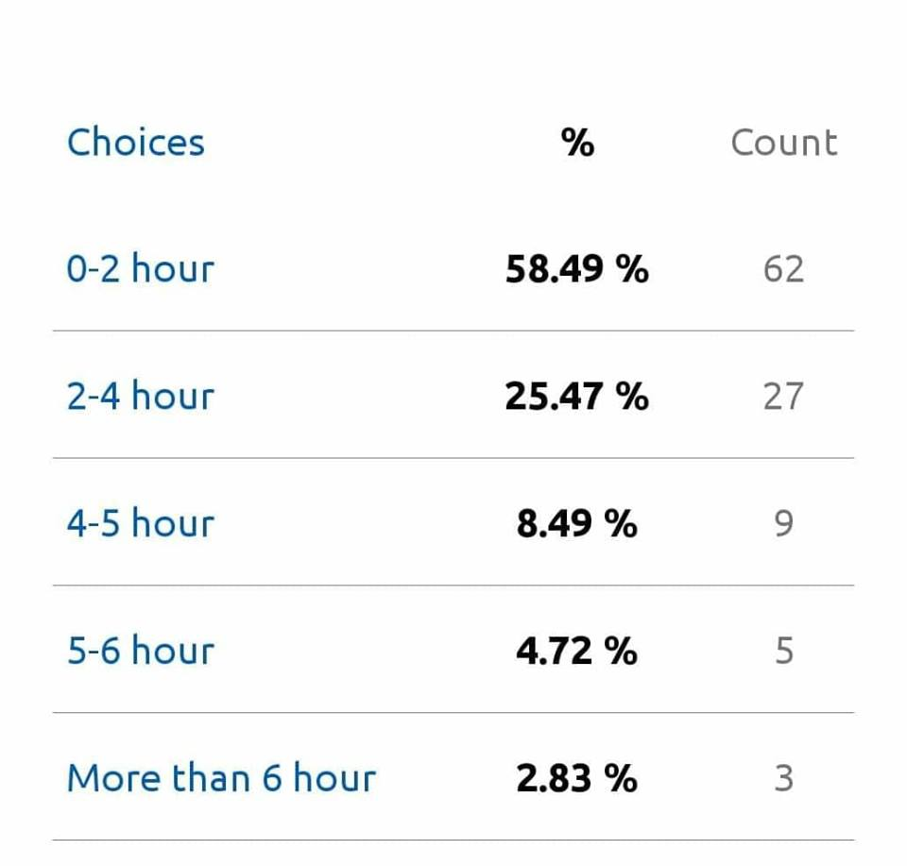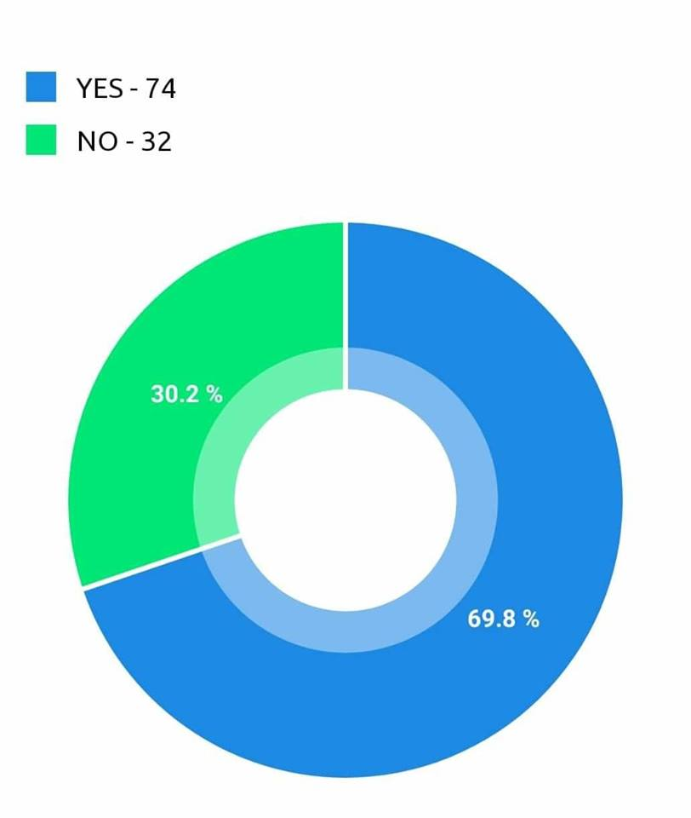
Table 6: study in daily pie chart of group study
In this table, we see 58.49% students study for (0-2) hours, 25.47% students study for 2-4 hours, 8.49% students study for (4-5) hours, 4.72% students study for (5-6) hours, 2.83% students study for more than 6 hours.
From the pie chart, we find that 74 students take part in group study and 32 students don’t participate.
So it is clear that, studying daily and group study are important for good CGPA.

- Relationship between Spent time in university & Attendance per week with CGPA:
Apart from this, time spending time in university and attendance in a week are also vital for good CGPA.
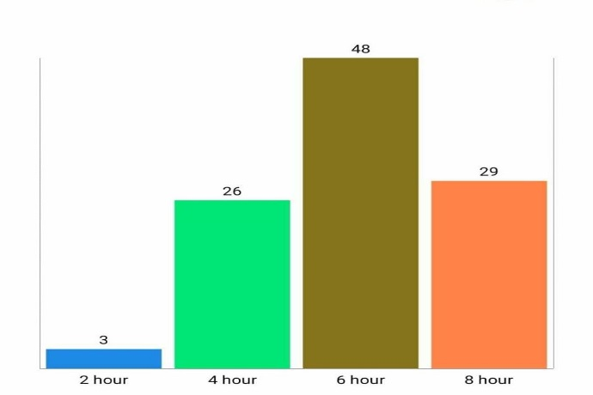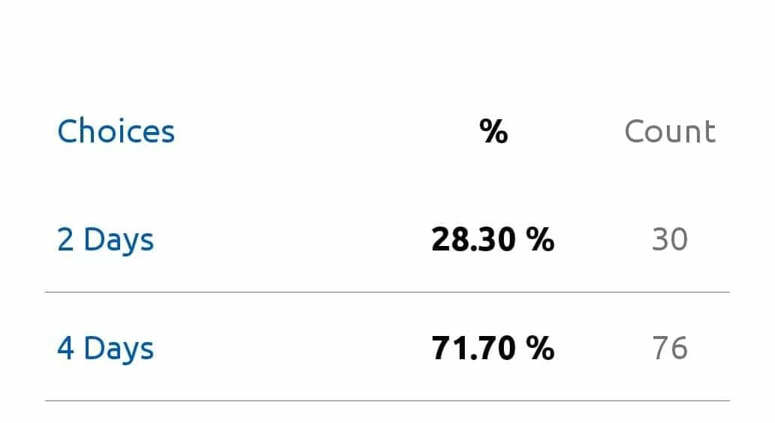

Bar chart of spent time in university Table 7: Attendance per week

From the bar chart we see 3 students spend 2 hours, 26 students spend 4 hours, 48 students spend 6 hours, 29 students spend 8 hours.
From the attendance stats, we find that 28.30% students attend 2 days per week and 71.70% students attend 4 days per week.
So staying in university without class/study is harmful for CGPA. On the other hand, attending the class regularly is good for CGPA.

- Relationship between Engaging in part time job with CGPA
Engaging in part time job is also a determining factor for CGPA. Because who are engaged in part time job can hardly manage time for studying. So, students take part in part time job very less as per pie chart.
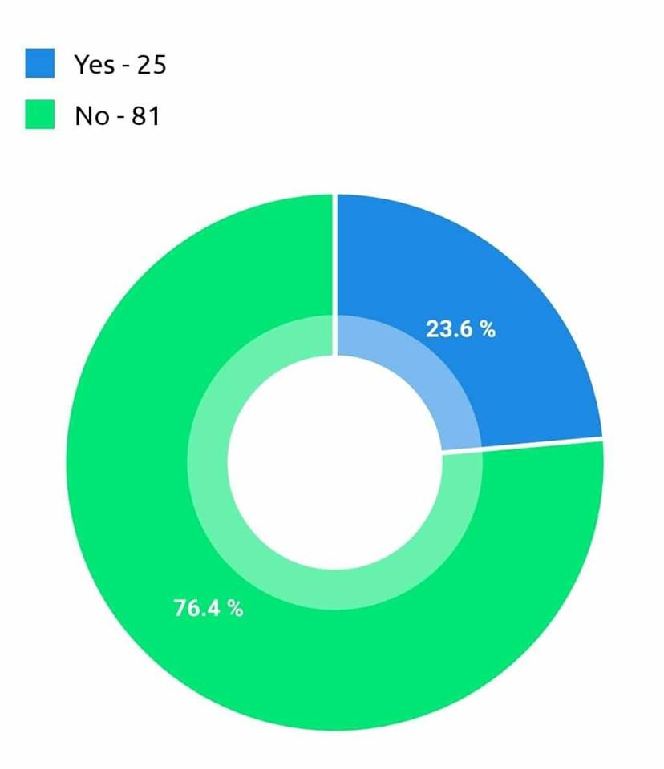
Pie chart of part time job

From this pie chart, 23.6% are engaged in part time job and 76.4% are not engaged.
In this case study we discover that, there is no major connection of home distance with CGPA. And this connection is relative. Lots of factors play vital role in CGPA except home distance.

- ESTIMATION RESULTS

The exact result of this research from the estimation described step by step.

First model:

Table 1: Regression Analysis
CGPA | Coef. | Std. Err. | t | P>t
Independent variables
trimester | -0.00704 | 0.019104 | -0.37 | 0.713
average distance | 0.199263 | 0.182121 | 1.09 | 0.277
time for travel | 0.125365 | 0.169108 | 0.74 | 0.461
traffic | -0.01347 | 0.174046 | -0.08 | 0.938
study hour in a day | 0.283058 | 0.182231 | 1.55 | 0.124
study hour in university | 0.530161 | 0.264073 | 2.01 | 0.048
days per week in university | 0.172824** | 0.424858 | 0.41 | 0.685
Total GPA | 0.002266 | 0.012906 | 0.18 | 0.861
constant | 0.413633 | 1.382304 | 0.3 | 0.766

** means significant at 5% level
P value is the lowest level of significance at which null hypothesis can be rejected. In our study null hypothesis is that the parameter is not significant. If P value is greater than level of significance we say accept the null hypothesis. From table 1 we can see for independent variable, study hour in university, the coefficient value is positive and it’s 0.53 and p value is .048 which is less than .05(5 % level of significance) , so this variable is significant at 5% level of significance. The coefficient value is positive which means if study hour increases, on an average CGPA will increase.
And like our descriptive analysis we see from table 1 that average distance has no significant impact on CGPA. Only university study hour has significant impact.

Second Model:
For second model our estimated equation is:
c͡pga = 4.017 -.6093Di
t = (.2404797)*** (.3536986)*
Values in parenthesis are standard error and ***, * means significant at 1% and 5% level of significance.
From this equation we can say on average female students obtain higher CGPA than male students. On an average female CGPA is 4.017 and male CGPA is (4.017-.609 = 3.4)

CGPA Range | CGPA weight
1.50-2.50 | 1
2.50-3.00 | 2
2.50-3.00 | 3
3.00-3.25 | 4
3.25-3.50 | 5
3.50-3.75 | 6
3.75-4.00 | 7

The regression was run using weight as data is given in range not actual value, the average weight of CGPA for females are 4.1 so it falls in to range of CGPA 3.00 to 3.25 and for males it falls in lower range.

Conclusion

In a word my study shows home distance plays a minor role on a student’s CGPA. We discussed lots of factor besides CGPA but except the factor study hour none of the factors had direct impact on CGPA. So, how much time students spend on studying in university has a positive impact on gaining CGPA and on average female students are doing well in exams than male students. Distance has no significant impact on obtaining good CGPA. The result of the thesis is obtained based on UIU students but if we survey in other private universities we expect to find more or less the same result. So we say that for good CGPA studying is the first and foremost duty of a student. Beside home studying student should also take part in group studies to achieve a better CGPA. Apart from studying, class attendance and being attentive to the class lecture is also necessary. As private universities are not residential therefore students from different places have to improve their study habit to attain a good CGPA .There is no alternative to that.

- REFERENCE

1.Danielle Nelson, S. V. (n.d.). Retrieved from https://files.eric.ed.gov/fulltext/EJ1088600.pdf

