
United International University
Internship Report
On
Financial Performance Analysis of Commercial Bank of Ceylon, Bangladesh

Submitted To
Muhammad Enamul Haque
Assistant Professor
School of Business & Economics
United International University

Submitted By
Tanzin Binta Ahamed Arpa
Id: 111 161 139

Date of Submission
16 June, 2020

Internship Report
On
Financial Performance Analysis of Commercial Bank of Ceylon, Bangladesh



LETTER OF TRANSMITTAL

16 June, 2020
Muhammad Enamul Haque
Assistant Professor
United International University
Satarkul, Badda, Madani Avenue
Dhaka

Subject: Financial Performance Analysis of Commercial Bank of Ceylon, Bangladesh

Dear Sir,
May I feel proud to submit my intern report titled “Financial Performance Analysis of Commercial Bank of Ceylon” to you. I have completed my internship in Commercial Bank of Ceylon, Dhanmondi Branch.
It was a three-month internship opportunity for me obtaining practical knowledge about functioning of banking operations to finish my report. I applied ratio analysis tool to measure the financial performances of Bank of Ceylon. To do this, necessary financial statements data are collected from internal sources as the bank is not stock exchange.
I tried my level best to analyze the bank’s performances with your guidelines. I would be obligated to receive your remarks given the constraints about the information I faced in preparing the report.

Sincerely yours
Tanzin Binta Ahamed Arpa
ID: 111 161 139

ACKNOWLEDGEMENT

At first, I would to express my gratitude to Almighty Allah who has given me opportunity to go through the total process of Internship and to write a report in this regard.
I have the real pleasure to acknowledge my gratitude to Muhammad Enamul Haque sir Assistant Professor of United International University He provided me full support and cooperation relevant to prepare this report during my entire intern period. Without his proper mentorship it would not have been possible for me to finish my report.
I also like to be grateful to commercial bank of Ceylon PLC authority for providing me necessary information from their portal in preparing this report. I extend my heart rendering appreciation and gratitude to the each and every body who assisted me in this regard.
Finally, I would have my humble thanks to all of my family members who gave me all kinds of supports to complete my internship program.

EXECUTIVE SUMMARY

The objective of the report is to measure performance analysis of Commercial Bank of Ceylon Bangladesh (CBC) over the financial statement data from 2015 to 2018. Ratio analysis technique has been used to do it. The financial ratio analysis shows that how efficiently and effectively the Commercial Bank of Ceylon is managing its operations. Bank of Ceylon’s performances are measured in terms of different aspects of businesses like profitability, efficiency, solvency, etc. In profitability analysis, return on assets and return on equity ratios seemed to be reasonably stable over the analysis period. The Asset turnover ratio does not change so much but financial expense ratio increased in recent period. This indicates that bank fails to maintain its operating efficiency. If we look at the solvency dimension of CBC, it is observed that bank’s amount of borrowing increased slightly but the capacity to pay the debt obligations remains stable. Commercial Bank of Ceylon’s liquidity position has been improved over the years and looked good. The conclusion can be made that Ceylon’s overall performances found stable.

Table of Content

Introduction 1
- Product and servives 3
- Functionns of the bank 3

Analysis of Financial Performances 4
Financial Ratio Analysis……………………………………………………………………………………………………………..5
- Current ratio 5
- Quick Ratio 6
- Debt Equity Ratio 7
- Debt Ratio 8
- Cash Ratio 9
- Total Asset Turnover Ratio 10
- Profit margin Ratio 11
- ROA Ratio 12
- ROE Ratio 13
- ROI Ratio 14
- Net Working Capital to Total Asset Ratio 15
- Equity Multiplier Ratio 16
- Long Term Debt Ratio 17
- Times Interest Earned Ratio 19
- Cash Coverage Ratio 20
- Fixed Asset Turnover Ratio 21
- Financial Expense Ratio 22
- Debt to Asset Ratio 23
- Operating Margin Ratio 24
- ROCE Ratio 25
- Net Working Capital Turnover ratio 26
Conclusion 27
Bibliography 28
Appendix 29
- Corporate profile of CBC 33

Introduction

Introduction

Banks in today’s modern economy plays a significant role in channeling funds from surplus units to deficit units which ultimately contribute to economic growth. A bank is a financial institution which mainly deals with money where the main concern is customer. Because of its transitional role, banking systems occupies a vital place in a country’s economy. It confirms distribution and re-allocation of assets and keeps up the motion of economic activities. It assembles asset for the entrepreneur’s and government agencies. The banking segment plays a vital role in whole financial system of Bangladesh. As a BBA graduate, I have genuine interest in financial control planning transaction and risk analysis which are particularly important for developing the career in banking sector. I wanted to conduct a practical orientation in a reputed bank for fulfilling the requirements of the 12 weeks internship program. The main purpose was to gain the practical knowledge of the real-world banking situation. Bearing this in mind I got the opportunity for three months internship program in Commercial Bank of Ceylon’s corporate branch which is one of the leading foreign banks in Bangladesh having reputation for upgraded growth and achievement. In order to complete the internship program, Human resource Division (HRD) of Commercial Bank of Ceylon PLC placed me to Dhanmondi branch at Green road, BEPZA complex.
The overall topic of the report has been selected to enlighten my practical knowledge on general banking. Commercial Bank has on record over 90 years of incomparable development and accomplishment. It is one of the leading commercial banks in Sri Lanka with 250 branches and 625 ATMs. The bank has operations in Bangladesh and Maldives. Commercial Bank Of Ceylon PLC Bangladesh has been rated the best bank in Sri Lanka by the global Finance in 14 consecutive years. Having made a distinctive mark in innovative predominance perceived as pioneer’s has maintained its cultural identity while providing a range of products and services.
It has become the leaders in private banking in Sri Lanka and one of the leading foreign banks in Bangladesh. CBC established in 2003 in Bangladesh. Over the period of last 15 years of operation, CBC has expanded its branch network of 11 branches, 2 specified OBU sections in at Gulshan, Dhaka and Chittagong (CEPZ) and 6 SME centers four in Dhaka and rwo in Chittagong. Dhaka braches are Bangshal Road, progati Sharani brach, Shantinagar branch and Tongi branch. In Chittagong the branches are in Jubilee Road and CDA Avenue. Unique products and services, superior services quality and efficient and customized solutions to the requirements of corporate and personal banking customers are hallmarks of the successful stride of CBC in Bangladesh. Commercial Bank has been rated ‘AAA’ Triple A Long Term by CRISL for the 5th consecutive years in 2014.The rating AAA by CRISL was based on bank’s asset quality, capital adequacy, financial, operating efficiency and risk management. By analyzing the financial ratio analysis from the balance sheet of CBC from 2015 to 2018 we can see that the overall ratios are stable which means they are not that different in each year which is good for a company.

Product and Services of CBC

Savings Account | Regular Savings Account  Bonus Savings Account  Shamriddhi Savings Account  FreeCorm Servings Account  DPS (Dream Planner Savings)  DotCom Savings Account  Ananya Savings Account
Deposits | Dollar smart Fixed Deposit  Money Market Account  Fixed Deposit
Current Accounts | FreeCorm Current Account  Regular Current Account
ATM Card | Credit Card  Debit Card
Loans | Home Loan  Personal Loan  Festival Loan  Auto Loan  Loan against Trust Receipt  Medium Term Loan  Short Term Loan  Overdraft
Services | Safe Deposit Locker Services  Evening Banking  Online Banking  Student Remittance  Holiday Banking  ATM services

Thee key functions of the bank can be identified as follows:

- Front desk or customer service account opening section
- Clearing Section
- Cash section
- Accounts section
- Loan distribution

Analysis of Financial Performances

Financial Ratio Analysis

Ratio analysis is treated as widely accepted technique of measuring performances of any organization. In the report, I applied ration analysis and tried to focus Ceylon’s performances in terms of different aspects of its day-to-day activities.

Current ratio

2015 | 1.414
2016 | 1.384
2017 | 1.427
2018 | 1.444

Interpretation
Current ratio is liquidity ratio to know the company’s ability to pay the short term obligation due within a one year. If the current asset is greater than current liabilities then it will be desirable for the company. If current asset is equals to current liabilities then it will be just enough for pay the short term obligation for the company and if the current asset is less than current liabilities then the company will not have enough money to pay the short term obligation.
In commercial Bank of Ceylon PLC the four years I have mentioned in every year the bank had more current asset than current liabilities. From all the years in 2018 the current ratio is highest than all ratios. So we can say in 2018 the current asset was highest which 1.444 is so the year of 2018 had the highest desirability to pay the short term loans. And lastly we can see that in 2016 the current ratio is the lowest which 1.384 than the other years is so in this year the bank did pay the short term loan with few difference of desirability.

Quick Ratio

2015 | 0.3755
2016 | 0.3131
2017 | 0.2971
2018 | 0.3369

Interpretation
Quick ratio is an indicator of a company’s short term liquidity position and measures the company’s short term obligation with the most liquid asset. It is also known as acid test. If the quick ratio is higher than the company may keep too much cash on hand or it may create problem to collecting its accounts receivable.
In commercial bank of Ceylon PLC in 2015 the quick ratio is the highest than all other years which is 37.55%. So in 2015 the bank more cash to collect account receivable. And in 2017 the bank has less quick ratio which was 29.71%. So this year the bank may have more inventory than the asset which could create problem to collect account receivable.

Debt Equity Ratio

2015 | 4.2855
2016 | 4.0000
2017 | 4.7051
2018 | 5.1746

Interpretation
The total debt ratio is calculated by dividing the company’s total liabilities by its shareholders equity which were available on the balance sheet of the company’s financial statement. A higher debt ratio indicates a levered firm which is quite preferable for a company that is stable with significant cash flow generation. But not preferable when the company is declining. On the other hand lower debt equity ratio indicates a firm less levered and closer to being fully equity financed. The ratio is used to identify the company’s financial leverage. Lower debt ratio means low risk on loan default. It decreased the probability of bankruptcy.
As we can see the ratios of CBC the ratio is lower in 2016 which is 4.00 rather than other years so in this year the bank have low risk of financial leverage which decrease the probability of bankruptcy. And in 2018 the ratio is highest is 5.1746 which create the industry average. So in this year there was a difficulty of securing additional funding and have more loan risk rather than other years.

Debt Ratio

2015 | 0.8017
2016 | 0.8034
2017 | 0.8246
2018 | 0.8387

Interpretation
The debt ratio is the financial leverage ratio that measures the portion of the company’s resources that is funded by debt. We calculate the debt ratio by dividing the total liabilities to the total asset. A company with high debt ratio known as “leveraged” firm. Company having lower debt ratio is known as conservative companies. High debt ratio means a company maybe putting itself into risk default on its loan if the interest rates are rise suddenly. If the company ratio is more than 100% or 1.00 than the company will be at financial risk.
In commercial Bank of Ceylon PLC we see the in the four year we choose we get the entire ratio less than 1.00 which is less than 100%. So CBC in this four year did not face any risk default on its loan. In 2015 there was lowest ratio which is 0.8017 so this year the bank gets the most of its benefits rather than other yeas. And in 2018 the ratio is a bit high which is 0.8387 a bit riskier than the other years ratio so this year the bank was more leveraged than the other years.

Cash Ratio

2015 | 0.0778
2016 | 0.0881
2017 | 0.0952
2018 | 0.1967

Interpretation
The cash ratio is the measurement of the company’s liquidity. It tells the value of current asset soon turned into a cash and what percentage of the company’s current liabilities this cash and near cash asset would cover. The cash ratio is calculated by cash & cash equivalent divided by the current liabilities. I the cash ratio is equals to 1.00 it means the current liabilities are the same as the cash & cash equivalent pay off those debts. If the cash ratio is less than 1.00 then there will br more liabilities than there will be insufficient cash which can pay off short term debt which is not good for the company. If the cash ratio is greater than 1 than there will be more cash than the company have the ability to pay short term debt with remaining cash which is good for the firm.
In Commercial Bank of Ceylon we can see that in the 4 years the ratios are less than 1.00 so there were more liabilities than cash so they can pay the short term debt but they don’t have the remaining cash after that. In 2015 there was a lowest cash ratio which was 0.0778 so in this year the bank had the lowest ability to pay the short term debts and in 2018 there was a highest ratio which is 0.1967 highest than all other ratios so this year the bank had the highest cash to pay the short term debts.

Total Asset Turnover Ratio

2015 | 0.0565
2016 | 0.0434
2017 | 0.0432
2018 | 0.0476

Interpretation
The total asset measures the value of company sales or revenues relative to the value of its assets. The total asset turnover ratio measures by the total sales divided to the total asset. The total asset turnover can be used as an indicator of the efficiency with which a company is using its assets to generate revenue. The highest asset turnover indicates the higher efficiency to generate the revenue. So in Commercial bank of Ceylon in all the four years 2015 has the highest turnover ratio which is 5.65% so in this year the bank had the highest efficiency to generate revenue. The lowest asset turnover ratio indicates the lower efficiency to generate the revenue. So in CBC it had the lowest efficiency in 2017 which is 4.32%. So this year the bank generate the lowest revenue thn all the four years.

Profit margin Ratio

2015 | 85.99
2016 | 82.08
2017 | 83.97
2018 | 78.66

Interpretation
Profit margin is calculated by net income divided by net sales. Profit margin is called profitability ratio to which company actively makes money. It represents what type of percentage of sales has turned into profit. If the sales increases profit margin also increases this is good for the company.
In Commercial Bank of Ceylon PLC the profit margin is highest in 2015 which is 85.99% it means this year the bank had most sales than the other years. In 2016 and 2017 the profit margin was near to 2018 which are 82.08% and 83.7% so these years also have good amount of selling to generate profit. But in 2018 the ratio is quite lower which is 78.66% than the other years so in this year the bank had profit with less sales than the other years. So Commercial Bank of Ceylon PLC was most profitable in 2015 and less profitable in 2018.

ROA Ratio

2015 | 0.0485
2016 | 0.0356
2017 | 0.0363
2018 | 0.0374

Interpretation
Return on asset is a profitability ratio how much profit a company can generate from its asset. It measures the efficiency the company has earning from its economic resources or assets. If the return on asset is higher, the more the company is efficient. It is calculated by net income divided by average total asset.
In Commercial Bank of Ceylon PLC we can see that the return on asset is highest in 2015 which is 4.85% so this year the bank had the most economic resources or assets to generate the profit so this year the bank was most efficient than the other years. In other years the bank get generate less ass which is very near to each other.

ROE Ratio

2015 | 0.245
2016 | 0.182
2017 | 0.207
2018 | 0.233

Interpretation
Return on equity is a profitability ratio to know how much we can generate profit from its shareholder’s equity. It is calculated by dividing the net income with the shareholders equity. It is considered as return on net asset.
Commercial bank of Ceylon PLC had the highest ratio in 2015 which is 24.55% and the lowest ratio in 2016 which is 18.2%. So in 2015 CBC generate the highest shareholders equity and for that total asset also increased in that year that’s why profit also increased in this year. In 2016 the ratio is lowest that’s why shareholders equity is less in this year total asset also got decreased and that’s why profit get also decreased in this year.

ROI Ratio

2015 | 0.272
2016 | 0.273
2017 | 0.311
2018 | 0.462

Interpretation
Return on Investment (ROI) is a financial ratio calculated to know the benefits that the investor are received from its investment cost. It is commonly measured by the net income divided by the capital cost of the investment. The higher the ratio the greater benefit earned.
In Commercial Bank of Ceylon PLC we can see that in 2018 the ratio is greater than all other years. In 2018 the ratio is 46.2% so this year the bank had earned the most from its investment cost. And in 2015 the ratio is the lowest than all other years which is 27.2% so this year the bank had the lower earnings from its investment cost.

Net Working Capital to Total Asset Ratio

2015 | 19.82%
2016 | 19.65%
2017 | 17.53%
2018 | 16.12%

Interpretation
Net working capital to total asset ratio is a liquidity ratio that expresses the net current asset or working capital of a company in a percentage of its total asset. It is calculated by net working capital divided by net total asset. If net working capital to total asset increases it shows the company ability to match its accounts payable obligation over time. A lower net working capital to total asset shows the serious cash flow difficulties in which they are unable to pay the payments to its suppliers and creditors.
In commercial bank of Ceylon we can see that there was a highest ratio which is 19.82% in 2015 so in this year the bank had the ability to overcome the obligations over time. The lowest ratio in 2018 which is 16.12% it means in this year the bank has some difficulties for payment than the other years.

Equity Multiplier Ratio

2015 | 5.043
2016 | 5.087
2017 | 5.702
2018 | 6.202

Interpretation
Equity Multiplier is financial leverage ratio that measures the amount of firm’s assets that are financed by its shareholders by comparing total asset with total shareholders’ equity. In here lower equity multiplier is more preferable the higher ratio because companies with lower ratio are less depends on its debt financing and don’t have high debt servicing cost.
In commercial bank of Ceylon in the four years all ratio are quite near to each other. But in 2018 the ratio was a bit higher which is 6.202 so this year the bank had more financial debt and didn’t have high debt servicing cost than the other years but not that much.

Long Term Debt Ratio

2015 | 0.122
2016 | 0.114
2017 | 0.097
2018 | 0.078

Interpretation
Long term debt ratio is financial leverage ratio measuring the proportion of long term debt used to finance the assets of a business. It is calculated by long term debt divided by total asset. A higher long term debt ratio requires the company to have positive and steady revenue to prevent to prevent raising alarm regarding solvency. Higher ratio has the ability to pay the debts easily.
In commercial bank of Ceylon PLC in the four years the bank have higher ratio in 2015 which is 0.122 so this year the bank had the positive and steady revenue and can easily paid the debt. In 2018 the ratio was the lowest which is 0.078 so this year the bank had face few difficulties to pay the debt.

Times Interest Earned Ratio

2015 | 1.78
2016 | 1.62
2017 | 2.07
2018 | 1.53

Interpretation
The time interest earned ratio is also known as interest coverage ratio. It shows that how much earning a company can spent to pay its future interest cost. It is calculated by EBIT divided by interest expense. To calculate this ratio it sometimes create problem because many company doesn’t have the accurate EBIT so sometimes the answer of the ratio may not have correct.
In commercial bank of Ceylon the bank had the highest time interest earned ratio in 2017 which is 2.07 so that year the bank had the more ability to pay the future interest cost. In 2016 the bank had less ratio so this year the bank had less ability to pay the future interest cost.

Cash Coverage Ratio

2015 | 0.078
2016 | 0.088
2017 | 0.095
2018 | 0.197

Interpretation
The cash coverage ratio has the ability to pay out the current debt which examines the organizations cash and cash equivalent. It is also known as cash ratio. Cash coverage ratio is calculated by cash & cash equivalent divided by the current liabilities. A cash coverage ratio is more than 1% is positive scenario it means the company can cover its current debt using cash alone.
In commercial bank of Ceylon between four years only in 2018 the cash coverage ratio is more than 1% which is 1.97% so this year the bank had the ability to pay its current debt by using the cash. And other three years have the ratio which I less than 1% it means the bank in this years had less short term asset that why the face difficulties to pay the current debt by using its cash.

Fixed Asset Turnover Ratio

2015 | 45.26
2016 | 42.44
2017 | 26.78
2018 | 23.64

Interpretation
Fixed asset turnover ratio is a efficiency ratio that indicates how well a company can uses fixed asset to generate sales. Fixed asset turnover ratio is calculated by net sales divided by net fixed asset. A higher fixed asset ratio implies more effective utilization of investment into fixed asset to generate revenue.
In commercial bank of Ceylon the highest fixed asset ratio is highest in 2015 which is 45.26% it means this year the bank had more effective utilization of investment in fixed asset to generate revenue. In 2018 the ratio is lowest which 23.64% is so this year the bank had not that much investment in fixed asset to generate revenue.

Financial Expense Ratio

2015 | 0.0950
2016 | 0.1383
2017 | 0.1261
2018 | 0.2244

Interpretation
The financial expense ratio is an expense ratio which is a way for potential investor to quickly see how fast the investor portfolio runs. It shows how much fund asset goes to the administrative expense. It is calculated by operating expense divided by average value of fund asset or total investment. The lower the expense it will good for the company.
In commercial bank of Ceylon the lowest ratio occurs in 2015 which is 0.095 so this year the risk was low to handling the portfolio. On the other hand the highest ratio occur in 2018 which is 0.2244 so this year there was more risk to manage portfolio than the other years.

Debt to Asset Ratio

2015 | 0.1221
2016 | 0.1143
2017 | 0.0973
2018 | 0.0786

Interpretation
Debt to asset ratio indicates what proportion the company’s assets are being financed with debt rather than equity. This ratio is derived by dividing the total debt by the aggregate of total asset. The ratio is being used by the investors to ensure that the company is solvent and will be able to meet its current and future obligation and the potential to generate the healthy return on investment
In commercial bank of Ceylon the highest ratio is in 2015 which is 12.21% so this year the bank has more risk of the loan reject. The lowest ratio occurs in 2018 which is 7.86% so this year the bank had less risk of loan request. As all the ratios are more than 1% it means in this four years the bank had more debt than asset.

Operating Margin Ratio

2015 | 3.8662
2016 | 2.9724
2017 | 3.4688
2018 | 3.0624

Interpretation
Operating margin ratio indicates how much profit a company has after the variable costs. Which are wages, raw materials etc. it also shows how efficiency the company control the cost and expenses associated with business operations? It is calculated by operating income divided by total revenue. A higher operating margin has greater potential to derive profit and create cushion against any increase of cost.
In commercial bank of Ceylon we can see that all the ratios in the four years are near to each other but in 2015 the ratio is 3.86 so in this year the bank had more profit to protect its increase of cost. In 2016 the ratio is lowest which 2.97 is so this year the productivity was lot and the profit also get reduced.

ROCE Ratio

2015 | 0.1218
2016 | 0.0851
2017 | 0.0861
2018 | 0.0887

Interpretation
Return on capital employed or ROCE is a profitability ratio that measures how efficiently a company can generate profit from its capital employed by comparing net operating profit to capital employed. A higher ratio in here is much preferable because it means more profit generate by each capital employed.
In commercial bank of Ceylon the bank had the highest ratio in 2015 which is 12.19% so this year the bank had more profit generated to each capital employed. In 2016 the ratio was lowest which 8.51% this ratio is near to other two years so this year the bank had less profit generated by each capital employed.

Net Working Capital Turnover ratio

2015 | 0.2849
2016 | 0.2211
2017 | 0.2466
2018 | 0.2955

Interpretation
Net working capital turnover ratio shows that how efficiently the company can use its working capital in the business. It signifies that how well the company can generate it sales from its working capital. It is calculated by net sales divided by net working capital. A higher working capital indicates that the company may generate more revenue. When the current asset is higher than the current liabilities it means there is a positive working capital.
In commercial bank of Ceylon the net working capital ratio in all four years are near to each other it means all year the bank generate same amount of revenue. But in 2018 the ratio is bit higher than other years which are 29.55% so this year the bank generates more revenue. In all the four years the total current asset is higher than total current liabilities in commercial bank of Ceylon so in this four year the bank had positive net working capital turnover ratio.

Conclusion

Financial ratio analysis is very useful tool accepted among financial analysts and other users of financial statements to exhibit the performances of banks. It also allows management to understand its strengths and weaknesses and to initiate possible corrective actions. I already mentioned that to measure the performances of Commercial Bank of Ceylon, ratio analysis has been done in the report. Different aspects of bank operations are assessed using ration analysis. From profitability dimension, we can see that the profit margin of the Bank has improved.so the percentage of every profit ratio are stable in each year. Asset turnover ratio does not change so much but financial expense ratio increased in recent period. This indicates that bank fails to maintain its operating efficiency. If we look at the solvency dimension of CBC, it is observed that bank’s amount of borrowing increased slightly but capacity to pay the debt obligations remain stable. Commercial Bank of Ceylon’s liquidity position has been improved over the years and looked good. The conclusion can be made that Ceylon’s overall performances found stable.

Bibliography

- (2017). Auditor reort and financial statement. Gulshan-2, Dhaka-1212.
- (2018). Auditors Report and financial statement
- Bangladesh bank. (2019-2020). Retrieved from https://www.bb.org.bd/
- combbank. (2020). Retrieved from https://www.combank.net/
- (2015). Commercial Bank of Ceylon PLC - Bangladesh Operations. Dhaka-1010
- (2016). Commercial Bank of Ceylon PLC - Bangladesh Operations. Gulshan 2, Dhaka 1212.
- Online banking. (2020). Retrieved from https://www.combank.net.bd/en/

Appendix

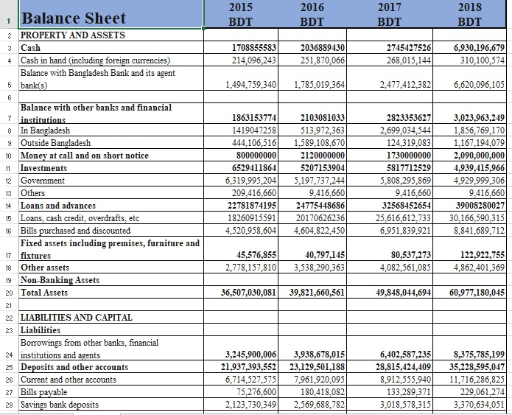

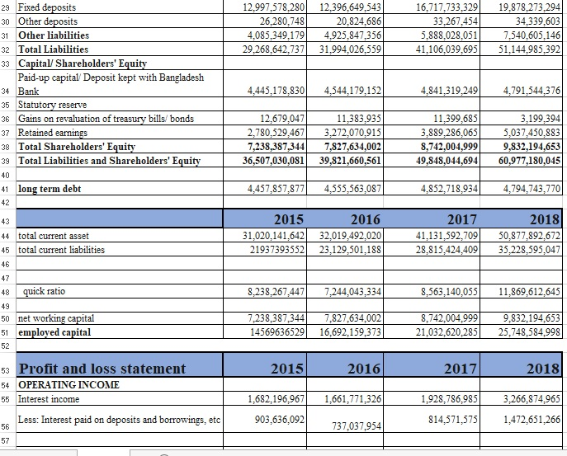
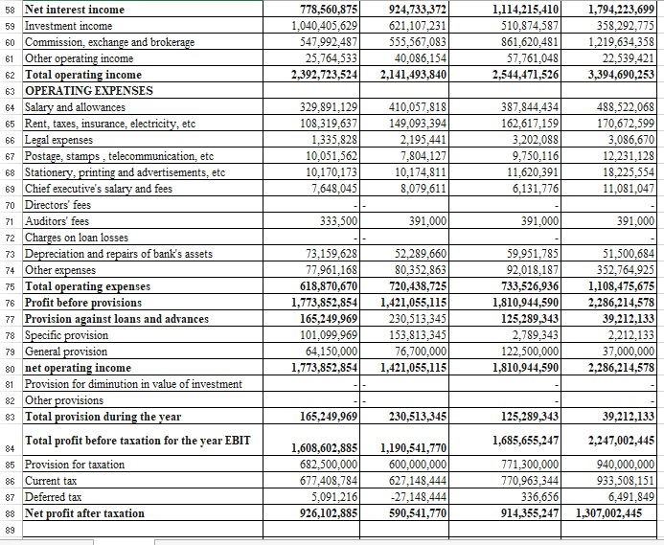
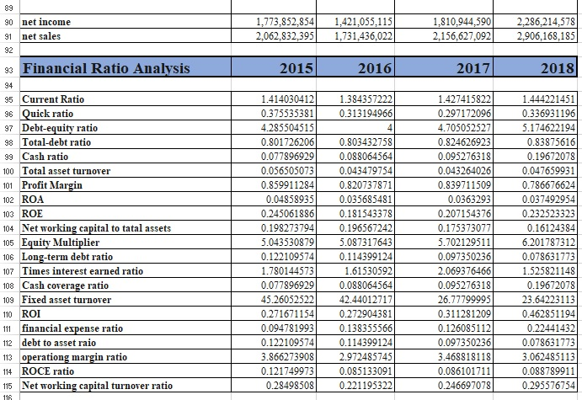

Corporate profile of CBC

Name of the Company: Commercial Bank of Ceylon PLC Bangladesh
Chairman: K G DD Dheerasinghe
Deputy Chairman: M P Jayawardena
Managing Director: Jegan Durairatnam
Legal Status: Public Limited Company
Year of Incorporation: 2003
Head office: Hadi Tower, road: 50, Kemal Ataturk Avenue, Gulshan 2, And Dhaka 1212
Line of Business: Banking
No of Branches: 11
No of ATM Booth: 4
No of SME centers; 2
Logo: 

