United International University

Report on:
Talent Acquisition of ARLA Foods Bangladesh Limited

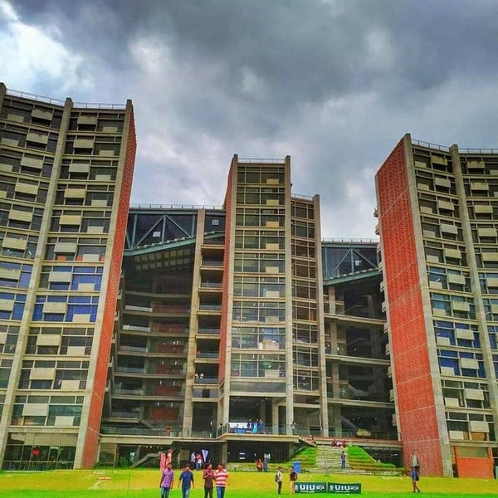

Submitted By,
Nusrat Nasreen
ID- 111 181 034
Dept – Bachelors in Business Administration

Submitted To,
Ishrat Sultana
Assistant Professor, SOBE
United International University

Date of Submission: 11th June 2023

Acknowledgement
I show my outmost gratitude to Almighty Allah to allow me the strength & capability to complete this internship report with his good grace.
I would like to convey my heartiest appreciation to my honorable supervisor Ishrat Sultana Ma’am, who guided me through the report completion process. This report would not have been prospected without her valuable guidance and support.
While working with the report based on the knowledge bound topic like Talent Acquisition Process of ARLA Foods Bangladesh Limited, I get the chance to enhance my real life knowledge through active participation & observation by working to the MNC Arla Foods Bangladesh- Recruitment & HR operations Team. The research and practice for the completion of this report added a whole new stage to level of knowledge for me. The information of the entire report is the learning outcome of my three months working experience and research through different studies and websites. I have tried my best to pull out my true potential and demonstrate an informative report.
I convey my deepest appreciation to Mr.Ali Ahsan Khan, Head of HR, Arla Foods Bangladesh Limited & my Line manager Arif Hossain- Talent Acquisition & HR operations whom have given me their generous guidance & shared valuable insights. I am hopeful that the experience I have gained here will be helpful for my future career growth. I am grateful to all the employees of Arla Foods Bangladesh ltd for their assistance, support and cooperation during my internship period.

Letter of Transmittal
11th June 2023
Ishrat Sultana
Assistant Professor
School of Business & Economics
United International University
Subject: Submission of the report titled “Talent Acquisition of ARLA Foods Bangladesh Limited”

Dear Ma’am,
With due high respect, I would like to state that I have finished the report on “Talent Acquisition of ARLA Foods Bangladesh Limited” which has been prepared as a requirement to complete my under graduation academic journey of the BBA program.
I got the opportunity to work as a Human Resource Intern at ARLA Foods Bangladesh Limited. In this report, I have tried my best to portray my learning essentials and experiences during the internship period. The report carries a significant value of my learning outcome.
Therefore, I cordially submit the internship report for your kind consideration & assessment. I would be very grateful to you if you kindly give your precious judgment on my effort. I will be obliged to respond any query you may have regarding this report.

Sincerely,
Nusrat Nasreen
ID- 111 181 034
Major- HRM & Marketing
Dept- BBA
Table of Contents
Acknowledgement 2
Letter of Transmittal 3
Executive Summary 6
Chapter-1 1
Introduction 1
1.1 Background of the Report 1
1.2 Objective of the Report 1
1.3 Research Method 1
1.4 Sources of Data 2
1.5 Scope of the Report 2
1.6 Limitations of the Report 2
Chapter 2 3
Literature Review 3
2.1Human Resource functions in an organization 3
2.2 Talent Acquisition in Human Resource Management 4
2.3 Training & Development of Human Resource Management 4
2.4 Compensation & Payroll System in Human Resource Management 5
2.5 Performance Management System in Human Resource Management 6
2.6 Importance of Human Resource Management 7
2.7 Impact of Human Resource Management 8
2.8 Human Resource Policies for organizational development 8
Chapter 3 10
Company Overview 10
3.1 Brief History of ARLA Foods 10
3.1.1 Global 10
3.1.2 Local 11
3.2 Vision 12
3.3 Mission 12
3.4 Purpose & Values 12
3.5 Tagline 12
3.6 SWOT Analysis of ARLA Foods Bangladesh 13
3.7 Location of ARLA Foods Bangladesh Limited 13
3.8 Milestones/Achievements of ARLA Foods Bangladesh 14
3.8 Brands & Products 15
Chapter 4 18
HR Functions of ARLA Foods Bangladesh Limited 18
HR Planning of ARLA Foods Bangladesh Limited 21
Chapter 5 25
Analysis of Data & Findings 25
5.1 Job Description 25
5.2 Talent Acquisition of ARLA Foods Bangladesh Limited 27
5.2.1 Recruiting Process 27
5.2.2 Assessment Process (First Step) 28
PI (Predictive Index) Test 28
Segment 1- Behavioral Test 28
Segment 2- Cognitive Test 29
5.2.3 Interviewing (Second Step) 29
5.2.4 Making Final Selection (Third Step) 30
5.2.5 Medical Checkup 30
5.2.6 On-boarding 31
5.2.7 Inductions For employee engagement 32
5.3 My Recruitment details during Internship 33
Chapter 6 34
Covid Impact on Overall HR practices at ARLA Foods Bangladesh Limited 34
6.1 Positive changes 35
6.2 Drawbacks/Challenges 36
Chapter 7 39
Recommendations 39
Conclusion 41
Chapter 7 42
References 42
Bibliography 42
Chapter 8 45
Appendix 45
Questionnaire 45
Pictures of ARLA Foods Bangladesh 46
Celebrating workforce Diversity 47
Documentation 48
Job Description 49
Employer Branding & Job Fair activities 52
Employee Engagement Activity 54

Executive Summary

Talent Acquisition is an essential part for any effective & profitable business. Any successful business must invest in talent acquisition. In today’s business world, innovative recruitment practice is increasingly being adopted by organizations in order to find candidates with appropriate competencies & skill sets for their company. It involves finding, recruiting, and employing capable people to take on important positions inside an organization. In this procedure, the job requirements are assessed, candidates are found, they are screened, and job offers are negotiated. A diverse, competent, and engaged staff should be prioritized in talent acquisition efforts, which should be adapted to the specific needs of the company. Talent recruiting is becoming an increasingly important area of focus and as a result organizations should place a greater emphasize on this aspect of their talent acquisition strategy. In this report, we explored this topic by addressing approaches & tactics of talent acquisition with the concept of talent management & HR system.
This internship report is concentrated on ARLA Foods Bangladesh Limited for the purpose of conducting research on the company. This report is focused on the skills being learned and experiences being encountered throughout the internship. A combination of primary & secondary source of data has been used to compile this study. Arla foods Bangladesh’s human resource policy & talent management strategies to attract & retain top talent are outlined in this paper. At first, a comprehensive background of Arla Foods Bangladesh has been presented. Here, the company’s brief significant history both global & local, their emergence has been given. The report has outlined the company’s management style, goals, and vision, mission, objective & core values. Their milestones, offering products & overview of their human resource department is also been presented. Then in the finding part, a descriptive overview of their talent acquisition system has been portrayed. Here, the job role, job description, recruitment process such as assessment, interview, final selection, onboarding, after on boarding activities, recruitment details everything has been described. A section on Covid pandemic affects has also been visualized. The work role and actions adopted are being in focus here. And lastly before concluding, a recommendation part where all the feedbacks and improvements are provided. To emphasize the relationship between HR function and talent acquisition, the internship report is being accompanying the portrayal of the overall strategies of Arla Foods Bangladesh limited.

Chapter-1

Introduction

1.1 Background of the Report
As a part of the completion for the Bachelor of Business Administration degree (BBA) offered by United International University, students must have to complete a (3 credit) internship requirement. Based on the learning during the three months internship period, we have to prepare a report which is associated with professional inheritance along with academic learning.
So here, I have tried to portray the best possible essentials of first-hand knowledge I have gained during my internship period with ARLA Foods Bangladesh Ltd. This report titled,” Talent Acquisition of ARLA Foods Bangladesh Limited” focuses on the overall human resource operations, policies and talent attraction programs of ARLA Foods Bangladesh Ltd.

1.2 Objective of the Report
This report has been prepared to demonstrate an insightful knowledge about Talent Acquisition process of the company. In this report, I have described the internship program experience in Human Resource department. By identifying the HR operations & policies provided by ARLA Foods Bangladesh Ltd to their employees and analyzing their planning strategies & actions is the key focus of this report. Putting focus on the talent attraction process and evaluating their potential prospects this report has been made with utmost sincerity.

1.3 Research Method
The study exhibits on exploratory research method. As the analyses emphasizes on the organization’s ability to attract and retain top talents, both qualitative and quantitative methods have been used for compiling the results & decisions.
Through the in-depth discussion with the company’s internal recruiter, a qualitative approach has been implied to understand the strategies, process and implementation of the organizations talent management system. And a quantitative method has been used by collecting feedbacks from the employees working in various departments in Arla Foods HO (Head office).

1.4 Sources of Data
The collection of data for this report has been derived from various sources and the entire report is the reflection of practical experience.
- Primary Data: Primary sources for the collection of data’s include close observation of working with the recruitment team, in person interview with the HR personnel, daily log of activities for the overall HR & Administration system, first hand participation of talent attraction programs.
- Secondary Data: Secondary sources include company’s website (Arla.net.com), internal documents & database, different websites & journals from internet.
The overall result for preparing this report is the compilation of both primary & secondary data.

1.5 Scope of the Report
The knowledge and propositions which has been presented on this report is being acquired during the internship period. Additionally for better understanding of the reader, ARLA Foods Bangladesh ltd’s brief history & overviews are given. In this report, the details of Job description and responsibilities which I have experienced while working with the organization’s HR team have been shared. The organizations overall policies, culture, norms, procedure & tools are also discussed. Some real life opinions and views on human resource operation, talent attraction programs, and talent management tactics are being shared. The main section of this report covers, technical & professional gatherings which is the detailed result of the internship tenure.

1.6 Limitations of the Report
The following limitations were found while preparing the report.
- Some of the data collection from the organization was challenging as the organization is highly confidential in maintaining their particulars.
- As employees had hectic schedule, collecting responses from individuals was quite challenging.
- Due to some lack of cross-functional activities, it was quite tough to gather appropriate data from different departments.

Chapter 2

Literature Review
Human Resource management is a broad concept of managing people who are the most essential component for an organization in order to ensure a smooth collaboration between job, culture & organizational purpose. According to Human Resource aspect a study research shows that, HR system and the execution of its successful implementation depends mostly on driving few strategic objectives such as combining employees’ knowledge, skills & ability alongside with company’s practices to attain the highest possible outcome for individuals. , (David P. Lepak, 18 September 2006 ) . Another study performs; high performance work system depends on employee involvement with working factors such as quality management program, extensive training, fostering appraisals, employee relation & customer satisfaction and many more. (Moody, 1994). In the late 1980’s the framework of HRM was drawned by a philosophy which states that, Human capital must be modulated as a overall process because When individuals are referred to as "human resources," they are placed in the same value category as materials, money, and technology. Resources are only valuable to the extent that they may be used to create socioeconomic value. (Taylor, 2014). A study research implies that, to develop a sustainable work environment the relationship between human resource & other functional departments plays as a channel and the integration of diversity makes it more innovative. (The central role of human resource management in the search for sustainable organizations, 11 Dec 2008)

2.1Human Resource functions in an organization
According to a study research, it has been stated that if the broader concept of Human resource activities can be categorized into specific orientation or function, organizations expense could be cut at a lesser amount to attain the best possible outcome. Functions like training & co-ordination, performance appraisal & evolution could make employees perform better. (lll, 2006) Human resource functions have naturally focused on the challenging talent concern raised by growth, including hiring and integrating a significant number of individuals, tapping into new talent pools, training current employees to provide the necessary new knowledge and skills, and attending to the demands for a rapid increase in leadership capability. (Mohrman, September, 2007) Another study performs identify that, Through the assignment of task in HR department like carefully selecting people for required task, train & guide them, give them proper inductions so that they can know the pros & cons, make them aware about policies & wellbeing will eventually decrease the degree of uncertainty & provide a mind map towards external factors. (P.Robbins, 2016)

2.2 Talent Acquisition in Human Resource Management
In human resource management, talent acquisition refers to the procedure of recruiting, identifying, assessing, and integrating new employees into a company. In a study research it has been stated that, finding, attracting, and hiring the most qualified applicants is the aim of talent acquisition in order to meet organizational objectives and promote a profitable and efficient work environment. This entails strategic hiring, employee on boarding, and orientation procedures that enable new hires to integrate into the team as fast and effectively as possible. (Tripathy, 2014) Another study research performed in Asia states that, To find and hire the best candidates for a position, the recruiting staff needs a concentrated awareness of the company's values, priorities, and goals. It also illustrates how significant e-recruitment is in order to maintain a globally connected society. The study's conclusions showed that online hiring offered several benefits, leading businesses to abandon more conventional hiring practices for the purpose of alternatives. The key benefits included time and money savings, easier access to applicants, increased recruiting process efficiency, enhanced communication between employers and prospective searchers and enhanced information security. (Tyagi, March 2012)

2.3 Training & Development of Human Resource Management
We know one of the key elements in managing a productive and profitable organization is training and development of human resource management. It is essential to an organization's ability to develop a solid and effective staff that can achieve its objectives as well as its goals. According to a study research it has been stated that, in order to succeed in the demanding industries and organizations of the modern world, people and organizations must both make significant investments in the development of their human capital. Despite the fact that training and development research has grown over the past 20 years, its applications has come under evaluation. Resources will be discarded, objectives won't be reached, and businesses will lose a competitive edge if research isn't conducted with sufficient developmental process. For aspects linked to employee learning, a diversified knowledge and data support must be attained in order to assure effective training and development. (Klimoski, 2007) Training and Development of Human Resource Management also help organizations provide insight views of compliance to the employees with all applicable policies, rules, and laws, including those related to, health and safety, labor law and equal employment opportunity. In another study research it shows that, Training strategies are utilized to instruct and advance information and skills to boost workers productivity. Methods of training are procedures used to acquire a particular set of abilities and results. There are many various kinds of training methods, and the best one to utilize depends on the circumstances, available resources, and desired outcomes. On-the-job training, apprenticeships, e-learning, simulations, work rotation, and role-playing are a few examples of training techniques. Each style of training has benefits and drawbacks of its own. The most effective training strategies are ones that are made specifically for both the company and individuals. (Latham, 2012) So, organizations should facilitate training to guarantee that all employees have the most recent information and skills needed to carry out their duties successfully and efficiently which will allow the company to maintain its competitive position in the market.

2.4 Compensation & Payroll System in Human Resource Management
We know an essential component of human resource management is the compensation and payroll system which is used to efficiently and accurately pay employees for their services. According to the HR professionals it has been claimed that, A well-designed compensation system helps the HR department effectively manage its budget in addition to ensuring that employees are receiving adequate benefits. The system also aids in keeping track of payroll data including leave documents and payments, and deductions. This data is crucial for maintaining an accurate employee file that HR can use to decide whether to give increases, incentives, or other recognitions. The technology can also rapidly and easily update payroll data and assist in managing leave allowances. HR managers can make sure employees are paid appropriately and on time with the aid of a comprehensive incentive & payroll system. (Jerry M.Newman, 2014) (T Welbourne) A study states that, in order to establish fair and legal compensation for the organization's employees, the proper compensation and payroll systems should take consideration of both regional and national laws as well as the current situation of the market. It is important to undertake regular reviews of pay scales in order to keep them relevant and to recognize employees achievements. (Widener, 2006) Policies related to incentives, additional hours, and paid leave should all be part of a successful compensation and payroll system. These regulations should also include issues like unfair sick leave reimbursement, resignation pay, taxes, and remittance Organizations must also continue fulfilling their obligations to all applicable federal, state, and local laws and regulations, including those governing labor law systems. Policies that emphasize interpersonal interaction with employees should be part of well-designed compensation and payroll systems. This involves seeking out employee feedback on the system, providing employees to receive credible and comprehensive compensation information, and ensuring that workers have access to all possible payment methods. (Thomas P. Flannery, 2002) Additionally, Employers can keep track of employee pay as well as how much an employee makes during a specific tax fiscal year by employing an advance payroll system. This data is essential for effectively budgeting, tracking the contributions of employees to company earnings, guaranteeing compliance with the rules of employee incentives, and estimating payroll taxes. Additionally, by enabling the distribution of consistent paychecks and the raising of alarms for fluctuations in compensation, a complete compensation and payroll system may assist assure employee satisfaction with their salary and incentives. So in order to sum up, a good Human Resource Management plan requires the careful execution of a payroll and compensation system.

2.5 Performance Management System in Human Resource Management
We know, Performance management system help HR to create policies, procedures, & systems that ensure employees reach desired goals connected to company objectives. In order to encourage and enhance employee performance, a performance management system (PMS) is a tool used in human resource management. It is intended to assist staff members in comprehending the precise goals associated with their jobs and how they fit into those goals, as well as in tracking their progress in reaching those goals. In addition to motivating staff and assisting management in creating measurements and plans to enhance employee performance and productivity, PMS also promotes communication and teamwork among team members. It works well to raise employee productivity, promote teamwork, and acknowledge individual successes within an organization. Through the use of a performance management system, human resource management can create policies, procedures, and systems to guarantee that employees can reach their desired goals, which are connected to company objectives. (Dale Tweedie, 2019) In a study research it has been claimed that, to develop good performance inside the firm, performance management involves evaluating employee performance and giving useful feedback. Typically, this process entails creating performance-related goals, monitoring progress toward those goals on a regular basis, giving staff feedback, and taking corrective measures as necessary. Giving employees the support and resources they need to succeed in the workplace is the overarching purpose of performance management. Processes for performance management often involve activities like job evaluations, behavioral tests, and skill-driven feedback sessions and should be customized to the specific goals and culture of a business. Organizations can recognize employees for their accomplishments and make sure that everyone is pursuing the same organizational objectives by putting in place an efficient performance management procedure. (St-Onge, 2012) (Mishra, 2012) So, Therefore, it is crucial for firms to have a performance management plan in place as it helps to increase productivity as well as achievement across all levels. Additionally, it offers a chance to assess and track performance as well as support staff as they develop, enhance, and advance in their positions. Performance management additionally pushes workers to enhance their levels of commitment and involvement while also fostering a positive work environment. It is one of the most crucial tools available for managing workers well and making sure an organization runs smoothly.

2.6 Importance of Human Resource Management
We know today’s business world becomes really dynamic & complex. According to a study based on multinational context, it has been showed that effective human resource management in an organization could help to attain at most eighty seven percent more competitive advantage than those organizations which had less implication of it .So it is crucial to identify and develop the human resources that are required to carry out an international or global strategy. (Dowling, 2004) Another study performs, the systemic aspect of human resource management, the influence of framework on HR policies and practices, the necessity of collaborating in managing human resources, the complexity of managing human resources in firms, the difficulty of developing concepts and frameworks that provide new and useful observation, the value of addressing the concerns of various stakeholders will shape to a bigger outcome for organizations. (Jackson, 2005) According to a research of 21st century, it can be defined that Human Resource Management is connected to employee benefits because enthusiastic, highly engaged employees are likely to create more effective, productive work that in overall, contributes to the success of the organization. So for that human resource plays a very vital role in order to attract & retain employees by providing wellbeing & compensation which will eventually decrease company’s expense & turnover rate. (Hassan Danial Aslam)

2.7 Impact of Human Resource Management
A survey which was conducted on a group of 2200 people from U.S workforce has claimed that, Business performance should be influenced by organizational structure to the extent that talented and engaged employees are effectively involved in choosing what work is conducted and how this work is accomplished. The group of people from similar work field has stated that, the functions of human resource management plays an important role and impact the most for engagement of employees as excellent team based production and employee training, incentives and extensive job design is being generated from their section. (Huselid) Research indicates that many businesses are granting their HR departments the authority to move beyond their typical administrative duties and become a strategic partner. This new role necessitates the implementation of a systematic approach, in order to ensure that HR systems and operational and strategic initiatives are in sync, and that there is a stronger relationship between HR and line managers. This, in turn, will lead to better work output for the company. (Gerhart) A primary area of study in this area has showed how human resource management affects performance. A wave of research showing a beneficial relationship between human resource administration (HRM) and performance have given those who have long argued for a unique strategy for managing human capital optimism. (Guest, 18 Feb,2011) A study from England projects on impact that, Employee satisfaction and motivation to contribute to a company's accomplishment are fostered by good HR procedures. A business's competitive advantage can be increased by training, knowledge, and skills. By assisting employees with training, education, and development, effective firms emphasize this positive impact of HR. (Kamal Birdi, 2008)

2.8 Human Resource Policies for organizational development
It has been demonstrated through the results of a survey of 300 commercial personnel in Asia that there is a positive correlation between organizational effectiveness and human resource policies. Particularly, it was observed that employee decision-making is the primary influence of human resource policy on organizational performance. Therefore, further alterations and advancements to the HR-controlled structures and procedures are necessary components of organizational development, including initiatives such as talent management, diversity, and employee wellness. (Alkalha, 2012) Human resource management, quality development & career progress could be divinely possible only if the corporate policies are well enough to bring the most outcomes from every department. The three developments for every company which are organizational, individual & process can be structured through valuable components & standard policy making. (A.Swanson, 1995) A developmental study demonstrated that the highest value would be achieved if strategies, systems, and procedures were implemented to expand and strengthen frameworks, promoting organizational effectiveness. It highlighted a number of features that distinguish organizational development from other methods of achieving organizational change and improvement, such as management consulting, fresh ideas, idea management, and operations management. This also underlines the distinction between organizational development, change management, and organization change, which can be accomplished through an effective HR system. (Worley, 2014)
Human resource has come across a more highway and it is on a verge of constant change & revolutionary impact on today’s business world. Previously Human Resource tools were more associated with only hiring & firing but to carry out in today’s dynamic business culture it has to be more than few functions between these two only. (Bernardin, 2009) In conclusion, Human Resource Management is a complex and ever-evolving field that requires a deep understanding of the various aspects of management, from recruiting and hiring to training and development and many more. Human Resource Management is an important component of any successful business. It is responsible for the recruitment, development, and retention of employees, as well as the management of employee benefits and the development of policies and procedures. (David A. DeCenzo, 2016) It is clear from the literature review that Human Resource Management must be approached strategically in order to ensure the most effective and successful outcome. Understanding the importance of HRM and how to effectively utilize it can help organizations maximize their performance and provide a competitive advantage.

Chapter 3

Company Overview

3.1 Brief History of ARLA Foods

3.1.1 Global
ARLA Foods is the Danish-Swedish co-operative dairy firm which has started their journey in the late 1880’s and currently operating at more than 140 countries with their multinational dimensional performance. Being the 5th largest dairy producer in the world, ARLA is owned by 12,500 farmers from 7 different countries associated with a business strategy to build shared dairy production facilities. Initially they started off as a Swiss dairy firm aligned with some shared production facilities with the Danish dairy firm MD Foods but later on at April 17th 2000 the Swedish dairy cooperative ARLA and Danish dairy business MD Foods merged and became ARLA Foods. The corporate headquarter of ARLA is located in Denmark.
With the Agenda of “From Grass to Glass" ARLA has launched their brand “DANO” in the categories of powder milk. ARLA is the mother company of DANO. Alongside with the milk powder categories they also produce cheese, butters & spreads in their production line. The worldwide famous cheese brands Arla, Lurpak, Castello is their variations. ARLA Foods also produces milk-based components such as minerals, lactose, phospholipids, nutritional milk protein.
ARLA have successfully operated their significant international footprint in the MENA (Middle East North Africa) & SEA (South East Asia) region. The MENA region involves Bahrain, Iraq, Lebanon, KSA and few more. And the SEA region covers Bangladesh, Indonesia, Japan, Korea, Malaysia & Philippines in addition to their home markets Germany, Sweden & Denmark. From a research it has been found that, in the year of 2022 ARLA Foods revenue increased to almost 3.4 billion Euros in, its highest level ever.
For more than a century, ARLA Foods has been a pioneer in dairy innovation and production all over the world. The business started as a small-scale Danish dairy cooperative and has since developed into one of the top ten dairy corporations worldwide. ARLA Foods has expanded its footprint globally while maintaining a focus on the safety, quality and its purity of its goods during its global expansion. Today, ARLA Foods sells its goods in more than its start off periods and has operations in more than 15 different nations. ARLA Foods has established the benchmark for quality, safety, and ecological responsibility in the dairy business via its dedication to sustainability and innovation.

3.1.2 Local
ARLA Foods Bangladesh is a leading organization in the FMCG industry of Bangladesh. The powdered milk brand DANO was the first ARLA Foods product offered in Bangladesh, launched when the company was known as MD Foods. ARLA Foods Bangladesh limited has officially started their journey in Bangladesh on 2013, before that Bangladeshi importers used to import h’ Arla’s DANO milk powder from Denmark. Even before the liberation war, from the year of 1961 to 1970 Bangladesh was aligned with Arla through importing and in the year of 1973 Arla’s first importer MD Foods opened a corporate office in Dhaka from where all their market activities, sales, promotional operations would have been monitored.
For making the business more corresponding, a letter of credit has been issued on 1994 from Bangladesh to Denmark. After that in the year of 1998, a packaging plant in Gazipur has been established in order to package imported DANO powdered milk with outmost quality maintained packaging machineries. The products of ARLA Foods had been imported under MD Foods till 2011 and after that in the year of 2013 ARLA Foods Bangladesh limited create its own identity through building its separate division with their sustainable dairy consumption business strategy.
Since entering Bangladesh for the first time in 2013, ARLA Foods Bangladesh has advanced significantly. The business has made great progress toward making its customers more nutritious and satisfied since it was a small, local business and is now among Bangladesh's top dairy brands. The company has launched a number of innovations and methods in its quest to make nutritious dairy products affordable for everyone, including an on-demand service and a wide selection of blended dairy flavors. Future-focused, ARLA Foods Bangladesh is dedicated to providing its clients with high-quality dairy products that will satisfy households all throughout the nation.

3.2 Vision
“Creating the future of dairy to bring health and inspiration to the world naturally”

3.3 Mission
“To secure the highest value for our farmer’s milk while creating opportunities for their growth”

3.4 Purpose & Values
ARLA Foods has always been consistent with their value proposition & Purpose. Their three driving essentials are-
- Lead
- Sense
- Create
Lead: This is a priority for Arla because it implies taking leadership and setting the example for what needs to be done by acknowledging ones authority. The strategy is to always engage sincerely, look for leadership possibilities, and see the best possible outcomes in self, organizations, and relationships with everyone.
Sense: According to Arla, a perception of their own people, of their consumers, and of the larger society varies significantly. So for that Being honest, having a positive view, being able to see one's own potential, being organized, and having relationships are all significant in order to safeguard a better commitment.
Create: Arla understands the challenges of learning the new skills and developing inventive approaches for obtaining information, products, and market connections. The key to achieving this objective is to maximize the potential of workforce, business, and alliances. So they committed to their create module.
Besides these three essentials Arla also encourages their Diversity-Inclusion policy.

3.5 Tagline
“Create the future, Grow with ARLA”
Explanation: ARLA Foods Bangladesh Limited is dedicated to assisting its employees in all areas of their lives. According to this, a lot of resources are committed to ensuring that their team has everything necessary for success. One can achieve those by exercising their full potential. This phrase is extremely important to the organization's employer branding efforts which portrayed commitments to both the employees as well as the company.

3.6 SWOT Analysis of ARLA Foods Bangladesh
Strength – Arla has a number of features that enable it to thrive in the business world including strong manufacturer, remarkable expansion efforts, efficient capital expenditure and return, a strong vendor network, effective marketing strategies, automation of tasks, and a highly-skilled workforce with solid training programs. Additionally, it has a successful history of acquiring other businesses in order to support its activities and build a reliable network.
Weakness- Arla needs to focus on financial planning, demand forecasting, investing in new technologies and offering a wider range of products to remain competitive against its opponents. By doing so, Arla can create a more efficient and successful business
Opportunities- Recent consumer trends in the market provide a potential opportunity for Arla to explore new revenue sources and products. This offers a great chance for Arla to utilize an independent pricing strategy and challenge rivals with their own advantages. Additionally, Arla has invested significantly in an online platform (ARLA website) allowing them to reach new customers and better serve existing customers using big data analysis. This market development can also help secure Arla's competitive advantage.
Threats- Changing legislation, increased competition, a lack of innovation, a lack of qualified labor, and replication of low-quality products are some of the threats facing Arla's activities globally. Furthermore, changes in currency rates might have a big impact on its sales.

3.7 Location of ARLA Foods Bangladesh Limited
ARLA Foods Bangladesh’s corporate office is located in Dhaka. The location of their corporate Head office & Packaging Plant Factory is given below-
Corporate Head Office- Cotton House, House-2, Road 113/A, Gulshan-2, Dhaka-1212.There are 188 employees currently working in head office.
Packaging Plant Factory- Gazipur, Kona Bari, Industrial Area. In order to repacking the imported powdered milk this packaging factory was established back on 1998 & started its operation from the year of 2000.
Distribution Houses- Other than that, there are 128 sales distribution houses covering all 64 districts under 10 regions which are:
- Dhaka metro 1
- Dhaka metro 2
- Dhaka north
- Dhaka south
- Bogura
- Sylhet
- Chittagong
- Barishal
- Cumilla
- Khulna

3.8 Milestones/Achievements of ARLA Foods Bangladesh
ARLA Foods Bangladesh is one of the leading dairy companies in the country and has achieved many milestones and accomplishments since its establishment in 2008. The company has won numerous awards and accolades for its quality products and innovative strategies. Some of the significant milestones and achievements of ARLA Foods Bangladesh include:
- Awarded ‘Green Label’ certification from Bangladesh Standards and Testing Institution in 2015 for its quality products.
- Established the first ever dairy school in Bangladesh in 2020 with the aim to create a pool of trained and skilled manpower in the dairy industry.
- Launched Bangladesh’s first ultra-high temperature (UHT) milk in 2019.
- Became the first dairy company in Bangladesh to receive certification from the Global Food Safety Initiative (GFSI) in 2021.
- Developing a comprehensive Corporate Social Responsibility program including activation such as DANO Daily Pusty: Affordable nutrition, satisfying taste in 2021.
- Executed 1600 Lost Time in Accident-Free Days (LTF) till 2022.
- Achieved Best brand award 8th time in a row in the FMCG industry & gained commward for best campaign implementation in the year of 2021.
-Receiving numerous awards for their commitment to quality and sustainability, achieved the highest certification “Best Quality Award” from Bangladesh Standards and Testing Institution (BSTI) .
- Successfully implemented the project of ARLA PRO with a vision of bringing the exceptional dairy products for kitchen professionals.
-Achieved the highest certification for its products from the Bangladesh Milk Producers Association (BMPA) in the year 2018.
- For their exclusive work culture & environment ARLA Foods Bangladesh achieved “Best Employer Brand Award” in the year 2018 & 2019.
- During Covid Pandemic their growth has been persisted for choosing right distribution strategy & their sales has been increased in total up to 37%.

3.8 Brands & Products
By ensuring the positions of best brand award consecutively 8 times in a row ARLA Foods Bangladesh advocate their sustainable dairy consumption commitment towards its stakeholders. With the purpose of manufacturing & providing the highest quality dairy products ARLA Foods are committed to deliver its variation in dairy section.

Currently their market offering in the dairy industry is given below-
Product Name | Type | Description | Product
DANO Daily Pushti | Powder Milk | This Fat-filled skimmed milk comes with a variation of sachet,100g,200g,500g & 1kg packet. This is one of their popular & high volume sales product. | 
DANO Growth Shakti | Powder Milk | This is their first launched powder milk in Bangladesh combined with double calcium,vitamin-D & milk fat. This product is available on 250g & 500g quantity. | 
DANO Power | Powder Milk | This premium full cream milk powder comes with a variation of 200g,400g,500g & 1 Kg’s packet. | 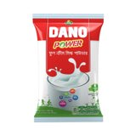
ARLA UHT Milk | Liquid Milk | ARLA’s organic UHT milk enriched with calcium,vitamins,protein  and many more essentials. For the purpose of serving different aged people the UHT Milk is being produced into 3 variations which are full cream, lactose free & UHT low fat. | 
Lurpak | Butter | This is one of the supreme popular butter brand comes with salted & unsalted flavor. | 
Castello | Cheese | With an essence of traditional cheese flavor this premium priced product comes with different variations like blue cheese, cheddar cheese, white cheese, havardy, black pepper and many more. |   

These are the products offered by ARLA in the dairy industry.

Chapter 4

HR Functions of ARLA Foods Bangladesh Limited
The term “Human Resource Management” refers to a process where an organization finds the best suitable individual for their company and trains them accordingly so that they can perform their best to achieve organizations goals & mission. ‘Human’ is the most essential component for any organization to perform a smooth collaborative operations. So in order to utilize it more effectively & efficiently every organization ensures the significance of this department.
The human resources department of ARLA Foods Bangladesh is dynamic and functional, and this department reinforces the company's values and identity in its employees as well as manifests the corporate culture through viewpoints. The HR team's primary concerns in this context are figuring out the company's hiring needs, filling open positions with qualified candidates, conducting in-depth interviews, and making recruitment decisions. The next step involves on boarding, keeping employees, maximizing their potential and meeting company requirements through training and development, managing the factory's human resource needs, resolving HR-related issues, and working toward the final approval or during the period of employment termination.
ARLA Foods Bangladesh is being operated by the following HR Functions-
- Talent Acquisition & Recruitment- The Talent Acquisition team is dedicated to find the most talented and capable individuals to join the company. The team involves experienced HR professionals who understand the importance of finding the right candidate for the required job. They use a combination of innovative recruiting strategies and cutting-edge technologies to source and attract the best talent such as ARLA MENA region team dedicates their potential search of talents through online platforms and from that they shortlists the most suitable ones. The team is committed to providing professional and efficient recruitment process and delivering quality candidates for each role.
- Training & Co-ordination- The Training & Coordination Team is associated with professionals who are committed to providing their employees with the best possible work experience. They are responsible for the overall management and coordination of all training activities and initiatives. The team works closely with the business managers to assess the training needs of the organization and develop appropriate training plans. A full training calendar is being prepared in the beginning of fiscal year & revised on half yearly basis. In the beginning of each fiscal year, employees set their key objectives on the success factor software which has been revised by their line manager and based on that training professionals set the module. They also ensure that the training content is relevant, up to date and easy to understand. The team also provides ongoing support to employees through monitoring and evaluation of training programs, providing feedback, and providing guidance for improvement.
- Compensation management & Payroll- Compensation Management & Payroll Team is specifically associated with a group of professionals who are dedicatedly responsible for providing accurate and timely payroll services to all Arla Foods Bangladesh employees. They ensure that all employees receive their salaries and benefits in a timely and accurate manner. They use HRIS software to calculate salaries and ensure that payments are made by the 26th of each month. They also manage the administration of all bonus and incentive programs within the organization. In addition, this team oversees the management of bonus and incentive programs and provides advice and support to workers regarding their pay, such as provident fund policies, gratuities, and insurance coverage.
- Expatriate Management- As Arla Foods is a multinational company, there are relocated employees for their work purpose. So, their expatriate management function is committed to ensuring process with employment regulations while also providing expatriate staff with a competitive and advantageous package. This includes a salary that is competitive, adequate insurance coverage, and relocation support. Also this team is associated for handling the guest employees. Additionally, Arla Foods Bangladesh is dedicated to creating a secure work environment and regularly reviews and evaluates all expatriate management operations. The team constantly looks over the coordination of travel activities, visa-processing, HOD’s accommodation facilities. To ensure expatriates can successfully adapt to their new environment and make the most of their experience, the organization also provides full support through maintaining highest standard quality.
- Employer Branding – Arla is always committed to provide a secure and encouraging work atmosphere for its employees, Arla Foods Bangladesh has become a leading employer brand in the Bangladeshi employment sector. To ensure employees have the best possible work experience, the company has implemented different strategies, employee engagement programs such as celebrating different cultural festivals at workplace, flexible work schedules, and a wealth of additional benefits. In order to let the job seekers know about their work culture, they have also opened a page in social site named “Life At Arla”. Besides that, they arranged different talent attraction programs like career fairs & also arrange seminars & roadshows. Consequently, Arla Foods Bangladesh has been successful in developing a workplace where employees feel valued, respected, and motivated to reach their full potential, leading to a positive employer brand and the ability to attract and retain the best talent.
- Factory HR- The factory HR team works hard to ensure that every employee has a secure and fulfilling workplace. They strive to uphold the dignity of each employee and foster a culture of fairness and consistency in their rules and practices. In addition, they provide attractive benefits such as competitive pay and quality health care. The HR team works closely with all departments to ensure that the company's objectives are met and that everyone enjoys a positive and safe working environment.
- Administration- This department oversees the day-to-day operations of the company, including budgeting, financial planning, regular administrative costing, feast planning and other administrative tasks. The Administration Department also works closely with the company’s Human Resources and IT departments to ensure that all personnel are properly and efficiently managed, and that the company meets its financial and legal obligations. This department is essential to Arla Foods success, as it not only provides the necessary support for the company’s business operations but also ensures that the company is compliant with all applicable rules and regulations.

HR Planning of ARLA Foods Bangladesh Limited
We Know, Human Resource planning refers to a system where predicting the hiring needs of a company and making sure the right people are in the right places at the right times is the main concern. It is a constant process for both long-term and short-term workforce demands including identifying tactics for attracting and keeping top personnel, preparing backup plans to handle unpredictable hiring needs and coming up with tactics to make the most of workers productive time.
The purpose of this section is to assess ARLA Foods Bangladesh's HR planning and offer suggestions for future improvements. One of the top dairy producers in the world, Arla Foods sells milk and dairy products in more than 120 nations. throughout addition to other nations, the company is well-represented throughout Europe, the Middle East, and North Africa. As part of its aim for worldwide expansion, Arla Foods has recently increased its presence in Bangladesh and other emerging markets.
With a vision of implementing an inclusive & diversified HR procedure ARLA Foods Bangladesh follows the following steps for a successful HR planning process-
- Arrange a meeting with the directors of the business and key employees to determine the company's vision.
- Discuss the initial ideas with them while using pre-planned questions to help for getting the core ideas.
- Set up a meeting with the key personnel to go over the organization's core values.
- Establish five important company principles, give each one a thorough definition, create value indicators, and then take one last look to ensure that none of the core values fall into the area of future goals.
- They develop important HR strategies and a vision that is align with business objectives. They design an appropriate organizational structure to back up the business idea. Effective workforce planning will guarantee the most efficient use of resources. With a focus on the key deliverables for the future year they create an HR operational strategy.
- After that, an initial presentation has been organized where they identify mistakes, fill in the coordinating gaps, and integrating the HR system with the company strategy and objectives. The goal of HR evaluations is to guarantee that the company's current HR procedures are working effectively.
- Also, Examining relevant facts and figures, discuss the findings with top-level executives, holding a group discussion to recognize significant matters, identify the key problems, propose solutions for progress, and prioritize urgent issues has been discussed in the meeting.
- As, Planning for HR aids in developing and implementing development and succession strategies for employees and management. By doing this, the company can make sure they have enough lead time to advance current staff to senior roles. With the use of human resource planning, managers regularly evaluate the skills and flaws of their employees as well as their standards of behavior before taking action to change the situation.
- Then Create training and development module plan to make sure that employees have the skills and knowledge needed to contribute to the success of the company.
- Further they observe and assess employee performance, highlighting areas that need improvement and as necessary offering feedback and guidance. Also, Prepare for, detect and deal with any potential management-employee dispute. In order to maintain a standard work plan strategy they assured all current labor laws, rules, and procedures to guarantee consistency across the entire organization.
- And lastly, by creating a dimensional roll-out strategy with an auditorial follow-up after six month Arla Foods Bangladesh ensures the their HR planning process.

The flow of authority of HR team & the chain of reporting commands for individuals assigned task is given below-

The daily operations of the company are managed by the Executive Management Team (EMT) of ARLA Foods Bangladesh Limited, which also makes sure that the global executive team, the global Chief Executive Officer (CEO), the board of Directors, and the board of Representatives are kept informed about all significant matters. The EMTs are supervised by a Managing Director (MD), and each department's head of department is also a member of the group. The senior managers/managers, who are responsible to assistant managers, senior executives, or executives, come after the HODs.

A visual representation of the organizations overall management hierarchy is given below-

Head of Sales (Central)
Head of Sales (East & West)

Head of Finance
Head of Marketing
Head of Human Resources
Head of Supply Chain
Head of Operations
Managing Director/MD (Peter Hallberg)
Head of Corporate Affairs

Chapter 5

Analysis of Data & Findings

5.1 Job Description
There are many opportunities for interns at ARLA Foods Bangladesh Limited to understand their culture and gain knowledge from first-hand experiences, and they are treated just like so as regular employees. They are given all the responsibilities and benefits given to normal employees, feel included in decision-making, and help to shape the workplace culture alongside with coworkers who are important to the business success. As a result, interns at this organization can gain experience in the workforce while being compensated for their time. Additionally it’s an opportunity for interns to learn while doing. So interns required to assist with tasks that would typically be performed by a full-time staff varied from department to department. At Arla, the office hours starts at 9.00 am and ends on 5.30 pm and employees required to start & end their working time according to this schedule.
There were numerous learning opportunities that have been experienced and observed as a Talent Acquisition & HR operations intern under the HR team in Arla. Some of the significant learnings that has been experienced at ARLA are as follows-
- The main objective of the Talent Acquisition position is to create and maintain a pool of resumes from various relevant sources.
- ARLA Foods Bangladesh Limited gathers resumes from many different sources, such as corporate websites, employee recommendations, online job boards, HR agencies, executive recruitment firms, social media sites like LinkedIn and BD Jobs, Facebook and more.
- The company has strong working connections with a wide range of organizations that might provide a reliable supply of resumes for its pool.
- In addition to gathering resumes, the role also encompasses sorting through them in accordance with a number of criteria, including the applicant's professional history, education, academic qualifications, education outcomes, academic institution, areas of expertise, and the desired position.
- The role requires more than just collecting resumes because each step of the whole acquisition process reflect & affects organizations source & credibility for hiring talents.
During my internship the role required to screening almost five thousand CV’s and created robust talent pipeline for some vacant positions. By the supervision of line manager Arif Hossain & HR executive Farjana Islam Esha all of the tasks have been conducted. And the designated departmental activities that have been conducted are as follows -
1. Assisting in recruitment process like interview planning & scheduling
2. Making phone calls to candidates (both global & local)
3. CV screening from potential sources & preparing CV summary,
4. On boarding activities like inductions arrange for new joiners.
5. Maintained Applicant tracking database (ATS) & updated employee database files.
The role requires assisting in support of ARLA MENA region team (Global) in talent acquisition like coordinated PI (Predictive Index) test, interview planning & scheduling for global candidates, made screening calls and others. After that some employer branding task was also included in order to attract & retain potential candidates for the organization. During the internship period different talent attraction programs has been executed like Arla has coordinated four career fair (Dhaka University Career fair 2023, AUST National Job Fair 2022, AIUB Job Fair 2022 & Daffodil Job Utsob), in past four months.
Beside this, the role also requires to planning their Monthly content for their career page “Life at ARLA” & deal with vendors was also a part of this task. There was also a global hunt for candidates for positions at Arla Foods and the talent acquisition team assisted in conducting the precise examinations and interviews needed to choose the top applicants.
Another part was, the role requires overseeing few training modules based on employees’ dialogue objective, calibration input by managers in their success factor site & developmental objective. Through task & development, training calendar was being prepared. And lastly some contribution in the Administration department like Town Hall festivals in order to celebrate Arla’s success was associated by HR team.

5.2 Talent Acquisition of ARLA Foods Bangladesh Limited
ARLA Foods Bangladesh has a strong talent acquisition strategy that focuses on attracting, engaging and retaining the best talent in the market. The company has implemented a talent acquisition process that includes recruitment from potential sources, onboarding and development of new employees. It also emphasizes recruiting a diverse workforce and fostering an environment at work that promotes cooperation and innovation. In addition, ARLA Foods Bangladesh is dedicated to offering its employees flexible working hours, attractive benefit plans, and competitive pay.
With a human resources team that is both highly qualified and experienced, ARLA is dedicated to finding and bringing on new hires that will add value to the organization. ARLA uses a variety of methods and tactics, including specialized assessment exams, standardized interviews, and performance simulations to ensure that the hiring process is fair and efficient. Additionally, ARLA operates numerous programs and initiatives designed to attract top personnel in a variety of industries, including IT and finance. Through these programs, ARLA has established trusting relationships with a network of possible new hires to whom they regularly seek out to make sure they are hiring the most suitable candidates.

5.2.1 Recruiting Process
ARLA Foods is always looking for the best talent to join their team. Their recruitment process is designed to ensure a smooth and efficient engagement between the company and job seekers.
ARLA Foods Bangladesh Limited begins its recruitment process by searching for potential talent from a variety of reliable sources. These include popular job websites such as LinkedIn, BDJobs, and social media career pages and groups. They also look for applicants at top-rated universities through their career clubs and talent attraction programs such as career fairs, roadshows, and seminars. Moreover, they also accept resumes through internal references. Then, the relevant departments prepare a job description and search for the best match with the required skills, knowledge, and experience.
Furthermore, the Talent Acquisition Manager at Arla Foods MENA region, Poonam Gaude, has created a robust recruitment process that includes headhunting and examining criteria such as academic results of CGPA 3.00 and above, participation in extracurricular activities, and exposure to technical skills ( For example- packaging plant engineers, IT engineers must be familiar with software like Auto CAD, Power BI etc.) . Candidates who meet these requirements will be given priority in the recruitment process.
The hiring procedure at ARLA Foods Bangladesh Limited is thorough and successful. The hiring requirements are meticulously reviewed and analyzed to identify the abilities and competences required for the applied employment post before any recruitment process gets started. To ensure that only the best qualified candidates are recruited for the position, the selection process is comprehensive and includes several steps.

5.2.2 Assessment Process (First Step)

PI (Predictive Index) Test
The initial step in the recruitment process is the PI (Predictive Index) test. Candidates who are shortlisted for the designated post have to attend this online PI test within 7 days from the delivered date of assessment link. This assessment is divided into two segments-

Segment 1- Behavioral Test
First is the behavioral test through which if the candidate is suitable enough for the organizations culture fit or not is being decided. There would have 6/7 questions for this test and no specific time limit for the completion of this test. But the candidates must have to complete the test within one sitting. Based on the candidates answer four segments about their culture fit has been given. There is no right or wrong answer for this test. Each question specifies characteristic & behavior of an individual.
The objective assessment of a person's behavioral abilities that behavioral tests offer enables recruiters to assess an applicant's "personality traits." These assessments cover a wide range of topics including aptitude, attitude, communication, handling stressful situations and other areas that help their business better understand the person, pinpoint his or her natural talents and shortcomings and increase job satisfaction. So ARLA Foods Bangladesh acclaimed, this assessment offer useful information to them which they can utilize to boost organizational performance and help their business to make better hiring decisions.

Segment 2- Cognitive Test
Second is the cognitive test. In order to assess logical reasoning & depth of knowledge this test has been taken. There would have 50 questions allotted in this segment and the candidates have to complete the test within 12 minutes. There is no negative marking for wrong answers and the questions would appear sequentially one after another.
These two assessments would have taken through online platform and two separate links has been shared with candidates in order to take the test.
Globally in MENA region usually after the PI test a case has been shared with candidates through email and they have to prepare a presentation on it. And during the interview date candidates get 15 minutes time to present their case study with the interviewers. Usually this case study type presentation has been generated for high profile candidates.
Cognitive tests are widely used at ARLA Foods Bangladesh Limited to evaluate prospective team members before making employment decisions. According to their thinking, these tests which assess a person's capacity for reasoning can be used to determine traits like problem-solving skill, capacity for logic and reasoning, and general intelligence. This assists them in determining whether a certain applicant is a good fit for the designated team or not. Their cognitive tests are also used to assess and track the performance of their present workforce. This makes sure that each team operates at their best potential and helps them to identify areas where employees might require more training.

5.2.3 Interviewing (Second Step)
After passing the PI test an initial interview has been conducted on the Head office which is located in Gulshan, Dhaka. The interview was set with the HR line manager & the required department’s manager. In the interview date, the PI tests results & candidates CV’s has been moderated through crosschecking during the interview time. Total duration for each interview is allocated for 40 to 50 minutes. And once the interview has been done, HR line manager compiles a top sheet in which key competencies of candidates, their weaknesses, their potentials and many more like why this could be an eligible employee for the designated post has been noted.
Arla Foods Bangladesh Limited conducts a thorough and rigorous interviewing procedure. It starts with a thorough assessment of the candidate's CV and followed by a number of preliminary screenings which includes in-person interviews for those who advance through the preliminary stages. Before being chosen for the post, the candidates who successfully complete the processes will move on to a final round of interviews. The organization considers the candidate's soft skills, cultural fit, and understanding of the specific job throughout the interview process. Arla Foods may administer demanding psychometric and aptitude tests for more complicated positions. This makes it easier for the business to discover the best candidate for each position.

5.2.4 Making Final Selection (Third Step)
And lastly candidates who have passed the first phase of interview get a call for the final round of interview. This interview has been taken by HOD’s (Head of Department). HRBP (Human Resource Business Partner) & HOD of the designated department was on the board room for taking the final round. Top sheet is being presented to the interviewers and why this candidate should be beneficial for the company’s overall growth, an overdraft has been shared with the interviewers.
At ARLA Foods Bangladesh Limited, they are aware of how critical it is to choose the best individuals at the end. So for that, actively participate in ensuring that they select the job candidates who are most suited for the position. Reviewing every CV, interviewing every applicant, and thoroughly investigating their backgrounds. They also use a number of other techniques including psychometric testing, evaluating each applicant's team fit, and keeping track of the performance of those employed after training. They want to make sure that anybody whom they choose will be the best fit for the position and capable of performing it successfully.

5.2.5 Medical Checkup
If a candidate passes the third step which is final for the recruitment, a full body medical checkup is being done and after the evaluation being satisfactory, the candidates can be hired only.
ARLA Foods Bangladesh Limited take their employees health and safety on a serious accountability. In order to make sure that their employees are in good health to do their tasks to the best of their abilities, Arla Foods offered free medical examinations to a select group of individuals. General physical examinations and tests for a range of illnesses and disorders will both be part of the checkups. The medical staff will maintain the utmost confidentiality about all test findings, only disclosing them to the HR department as required. They want to reassure their employees that these examinations are done with the concern of their health in mind and only for their betterment.

5.2.6 On-boarding
On the day of new joiners on boarding after final selection, the admin team issues ID cards, business cards, and gifts to welcome them into the organization. They also answer any IT-related queries the new hires may have. Moreover, the team strives to create a friendly and welcoming environment for the new employees on their first day. Additionally, they create organizational announcements to introduce the new staff and assist the line manager in other writing activities that might have required. They also put together the employee document file, gathering pertinent information about the new hires.
In order to create a successful, advantageous, and enriching working environment, ARLA Foods Bangladesh Limited recognizes the value of the on-boarding process. They have an adequate procedure in place to make sure that each candidate that is chosen gets the orientation, training, and tools which they need to be proficient in the organization.
The on boarding tailoring process of individual candidates is listed below-
- A complete overview and orientation to the company that includes familiarization with its key principles, goals, values, and culture.
- A thorough explanation of the position's goals, reporting structure, primary responsibilities, and skills required of the applicant.
- A robust tour of all ARLA Foods Bangladesh Limited situations including introductions to team members, vendors, and other employees.
- A complete review of all ARLA Foods Bangladesh Limited policies and procedures, including those regarding attendance rules, dress codes, and safety procedures.
- Interactions in which the candidate is introduced to the team and given objectives by their direct supervisor.
- An extensive job description and a list of expectations for the candidate to meet during the initial three months of employment.

5.2.7 Inductions For employee engagement
A successful new joiner’s induction is essential for any organization. ARLA Foods Bangladesh also avails it for their new joiners. It helps new employees feel welcome and quickly get up to speed on culture, processes, and roles. It also gives the organization a chance to set expectations and make sure new joiners hit the ground running. Usually on the first week of joining all inductions have been given to a new joiners. A comprehensive overview of the organization, job function, collaboration, policies, and standards should be included in a successful induction process. It should also involve plenty of opportunities for the new joiner to meet their colleagues, ask questions, and get to know their new workplace.
At ARLA Foods Bangladesh, the new joiner’s induction process is designed to ensure that all new employees receive the support and guidance they need. The process starts with a comprehensive induction program designed to introduce the new joiner to the company, its mission and values, the job role and team dynamics. Following this, the new joiner is invited to join in-depth training sessions and receive ongoing support from colleagues and managers. Throughout the process, new joiners are encouraged to ask questions and receive feedback from their supervisors and colleagues.
ARLA Foods Bangladesh Limited are very concerned about their induction procedures for chosen candidates. They make every effort to give each applicant the induction they require in order to succeed and become a valuable team member. They make sure that each induction is customized to the needs of the candidate, covering everything from corporate overviews to technical and social instruction. To make sure that the candidate's integration into the organization is as transparent as possible and that they have the abilities needed to contribute significantly to ARLA Foods Bangladesh Limited, also head office employees and project teams will collaborate.

5.3 My Recruitment details during Internship
During my three months internship period, I have worked on several recruitment batches. The batch here is referring to as the total people allotted for a certain position in Arla. Each batch contains usually six/seven people. The details have been given below-
Designation / Department | Grade | Batches
1.Territory Officer | Executive | 6 Batch
2.Key Accounts &  E-Commerce | Executive | 2 Batch
3.Production Manager | Manager | 1 Batch
4.Assistant Manager  (Operations & Maintenance) | Manager | 1 Batch
5.Corporate Finance (Contractual) | Contractual | 1 Batch
6.Human Resource ( Intern) | Intern | 1 Batch
7.Regional Packaging Lead(For ARLA Global-MENA) | Manager | 3 Batch
8.Key Account Manager (ARLA Global- MENA) | Manager | 3 Batch
9.Project Manager (ARLA Global- MENA) | Manager | 2 Batch
10.Digital Media Specialist (ARLA Global- MENA) | Executive | 4 Batch

Chapter 6

Covid Impact on Overall HR practices at ARLA Foods Bangladesh Limited
The Covid-19 pandemic has had a major impact on the overall HR practices at ARLA Foods Bangladesh Limited. This pandemic enormously shifted ARLA Foods Bangladesh Limited's entire HR policies both positively and unfavorably. The rapid move from traditional in-person working methods to remote working has had the most distinct influence on HR procedures. This required rethinking, redesigning, and remote implementation of many regular HR strategies and procedures, including training, on boarding, evaluation, and payment. The in-person meetings and team-building exercises that were frequently used to foster the formation of teams are nearly gone. It is now more challenging to find and hire new talent because the epidemic has forced elimination of direct interviews, job fairs, and other recruitment events. Companies now have to find, screen, and interact with candidates through digital channels like social media, online job boards, and interactive interviews. Also the training modules have changed due to the versatile structure of work method.
For ARLA Foods Bangladesh Limited, the move to online process has brought both benefits and difficulties. On the one hand, using digital recruitment speeds up the hiring process and expands the talent pool. Technology has made it more challenging to evaluate employee’s qualifications and personalities and to develop connections with them. The business has employed a specialized team to conduct video conferences with each team in addition to investing in an artificial intelligence-based human resource infrastructure to automate the process in order to ensure successful HR operations.
However, the epidemic has also given management and HR professionals the opportunity to reconsider the function of HR within the company. It has brought attention to the necessity of being adaptable as well as flexible in order to cope with such quick and unexpected changes. Additionally, it has allowed the personnel in Human Resources to think creatively.

6.1 Positive changes
- Inheritance of Virtual Working Method-. To ensure that everyone in the organization is adhering to the same standards and guidelines and to ensure consistency in output and performance ARLA Foods Bangladesh had build processes and systems. This includes utilizing the same tools for online communication for example Arla uses Microsoft teams for their internal employees communication, creating and enforcing rules for online conferences, and creating online task and progress monitoring systems(they uses success factor website for evaluation). Also they ensure a higher level of productivity and efficiency across all digital offices by making sure that virtual working procedures are consistent.
- Adaptation of Advance technologies- To automate the operations and for the purpose of ensuring top quality services to their employees, ARLA Foods Bangladesh Limited has implemented cutting-edge technology like artificial intelligence and machine learning, such as the success factor website. ARLA's HR procedures have been more effective as a result of the communication between colleagues and their supervisors being enhanced through the use of virtual meetings and workshops. This enables better decision-making and teamwork. ARLA Foods Bangladesh Limited has considerably advanced in technology to manage the every-day tasks of its HR team in the context of the pandemic and increased flexibility.
- More access to learning resources & Development opportunity: ARLA employees now have more access to learning materials including online courses and webinars through the development of digital technologies and platforms. ARLA developed a website named AMBA since pandemic time where online recorded trainings and different courses has been provided. They emphasizes on establishing a more inclusive and diverse workplace by giving individuals from different backgrounds access to resources and opportunity.
- Social Media Activation- The organization has also made use of social media engagement channel of possibilities to reach a wider range of prospects and improve its chances of reaching its target market & potentials in an efficient way.
- Implementation of Favorable HR policies: A number of advantageous policies have been put in place by ARLA Foods Bangladesh Limited to enable its employees to maintain a balance between both their professional and personal lives. This involves offering employees with flexible work schedules, work from home options and the tools & devices they need to continue producing when they're working from home. They also emphasize on decision-making for both the system and policy levels to guarantee that the organization complies with local laws and regulations.
- Cost-Effective Budgeting - Due to the worldwide outbreak, ARLA Foods Bangladesh Limited had to modify its budget for hiring, which led to a switch to more affordable hiring practices. Due to the paper-free work & less consumption of electric usage at office they have cut down their operating cost & also the pay scale of each employees remained as same as before pandemic. The organization has also developed web-based, cost-effective HR systems.
- Creating Mental & Physical Health Awareness: Now the organization is more concern & pay greater attention to the physical and emotional health of employees by providing flexible working hours and encouraging regular breaks. Arla Foods Bangladesh have also counsel their employees by providing follow up through specific consultants & for employee engagement and their physical wellness, 2/3 indoor games has been provided so that employees can rejoice themselves between their work time . it will be beneficial for both their mental & physical health. Also weekly gym classes are available for their betterment of health.
- Insightful Approaches - The Company has also made educated individuals by using data-driven insights to gain insight into how well employees performed. This makes it easier to moderate the top talent. . A higher priority on utilizing data and metrics to track the success of various HR initiatives.

6.2 Drawbacks/Challenges
- Increased uncertainty and volatility in the job market caused by the pandemic has made it difficult for ARLA Foods Bangladesh Limited to accurately predict the needs of the organization and plan its strategic process. The Covid-19 epidemic has seriously disrupted ARLA Foods Bangladesh Limited's HR procedures. In terms of how the organization will manage its people, it has raised challenges and instability. ARLA Foods Bangladesh Limited was aware of the difficulty it would have face in retaining job stability for its employees, protecting their welfare, and providing an effortless shift to remote working as the epidemic continues to change the work dynamics. So for that they have prepared to undertake a number of HR measures like from expanding schedule flexibility to offering access to a variety of resources. In order to make sure that its policies are in accordance with HR best practices and the shifting nature of the global workforce, it has also started a review of its procedures. Each HR function has to address the issue with flexibility and intelligence while preserving a secure and effective working environment for all employees in the face of the increased unpredictability and volatility brought on by the pandemic.
- Challenges in prediction-Because the pandemic was unpredictable, it was difficult to anticipate how Covid-19 might affect ARLA Foods Bangladesh Limited's overall HR policies. The possible consequences of covid on their organizational processes, such as personnel, hiring, training, and communications, were uncertain and might differ. With the introduction of remote working, the process of sourcing and interviewing potential candidates has become more challenging as the human touch has been removed from the process. The pandemic's implications on monetary resources, managing distant work, making adjustments to current trends in HR practice, and employees' psychological wellbeing are additional issues that needed to be addressed.
- Hindrance in Grasp- The Covid-19 pandemic has created major challenges to ARLA Foods Bangladesh Limited's HR procedures. The pandemic has disrupted the operation of several essential HR services. Like, Social distancing norms have hindered face-to-face meetings with employees. Additionally, there has been an unusually high demand for immediate assistance from the organization which had put a heavy burden on the HR department. The HR team has found it challenging to adjust to the shifting dynamics of job market needs and preferences. The administration of the HR department is further complicated by rising employee levels of disorientation and misunderstanding. Due to resource shortages brought on by the pandemic, the organization has also had severe effects on HR procedures.
- Productivity disruption- Adjusting to the new normal of remote work has been a challenge for HR function who have had to create new strategies for modify and restructure the employees. This required the relocation of numerous personnel within the company or perhaps their termination. And also the government's strict regulations and restrictions make it challenging for them to maintain a safe workplace. In order to stop the virus from spreading in the office, a greater amount of time has been spent working remotely or from home. As a result, there were fewer accessible productive hours overall which has decreased output as a whole.
- The interdependence of functions- As a result of work from home during pandemic, it is now more difficult for HR personnel to coordinate with other departments and engage new hires to the organization for processes to ensure efficient workforce. Since it has significantly restricted interaction between administrators and their employees which prevents flow of information and data exchange, this has interfered with efficient HR management.
- Difficulty in maintaining customer engagement & relationship- The pandemic has increased the competition in market, making it more difficult for HR function to identify and target customer resulting in a shift towards virtual reach. The pandemic has made it more difficult for ARLA Foods Bangladesh Limited to build and maintain relationships with potential clients of B2B, leading to a decrease in the number of meetings. This pandemic has changed how Arla establish and maintain client connections from being unable to meet with clients in person to switching to virtual meetings. By using social media platforms to tell customers about product updates, deals, and other significant news, ARLA Foods Bangladesh Limited has been able to substantially change its approach to client involvement. The company has also been able to connect with customers through web seminars which helps inform clients about the goods and services they provide.

Chapter 7

Recommendations
ARLA Foods Bangladesh is committed to provide a sustainable & incorporated work environment for its employees & by ensuring high quality nutritious dairy product to its consumers it has gained a respectful market position in the dairy industry of Bangladesh.
Although there are some areas and fields that can be improved and focused on to create advancement in the talent acquisition of Arla Foods Bangladesh. According to the analysis and findings that have been perceived, some recommendations can be made that are given below-
- Increasing the engagement of cross-functional activities- To increase the engagement of cross functional activities, regular cross-functional team meetings can be arranged to discuss recruitment, on boarding and other related topics. Utilization of technology to streamline communications and collaboration between team members can also be implemented. Team members can be encouraged to share best practices and ideas with one another. In addition to that, a culture of knowledge sharing and continuous improvement should be practiced within the organization.
- Enhanced use of technologies: Utilization of technologies is a predominant part of any given organization. Efficient and relevant software or systems can be designed and improved in the recruitment process such as- while screening the CVs and sorting out those in the basis of a certain criteria developed by Arla. With the enhanced use of the computerized system and certain software, the recruitment process will be efficient and prompt.
- Modification of PI test: According to the observation of the PI (Predictive Index) process, if a candidate is unable to fit the certain criteria & eligibility set by ARLA , he/she will be banned for 2 years to further apply for certain position. This can be discouraging and speculative for the candidates who are earnest. It is a big opportunity loss for the hunt of sincere candidates for the company as well.
- Company policies & employment law: Company policy of Arla should be applied to all facets of the recruitment process, including job postings, interviewing, and hiring. Employment law should ensure that their recruitment process is fair and transparent by outlining clear criteria for job postings and interviewing and providing job seekers with the information they need to make informed decisions. Arla should also create an environment where candidates feel comfortable expressing themselves and are given equal consideration regardless of their identities.
- Strengthening the ratio of female recruitment: Strengthening the ratio of female recruitment is an important step to increase diversity in the workplace. It is essential to create an inclusive work culture where everyone especially women are valued and empowered. This can be achieved through initiatives such as setting targets for female recruitment, providing flexible working arrangements, running mentorship programs and ensuring equal pay for equal work. Additionally, providing employee development and training opportunities for female employees can help to attract and retain talented female candidates.
So, these are the recommendations and suggestions that have been ascertained from the analysis and findings of Arla Foods Bangladesh. Arla may consider these recommendations to implement for further betterment in the overall recruitment process.

Conclusion
ARLA Foods Bangladesh is always entitled with a goal-oriented vision with an integrated process of developing, managing, recruiting, planning & overseeing the whole talent management system. Their holistic approach and contribution have been making a big significant impact on the evolving market in a great manner. ARLA Foods Bangladesh has been providing a wide range of dairy products, such as milk, cheese, butter, and other dairy products. It has a strong presence in the local market and is committed to delivering high quality products to its customers. ARLA Foods Bangladesh is always committed to producing safe, natural and nutritious products that will meet the highest standards of quality and safety. The company has been able to maintain such brand influence and presence as a result of efficient and systematized recruitment process consistently.
The Talent Acquisition Department of ARLA is an essential component of the organization's success. With the right recruitment strategies in place, they are able to attract and retain the best talent available. They remain competitive due to their dedication to development and process improvement. In order to help ARLA find and keep the best personnel, their talent acquisition team is committed to utilizing their knowledge. They are able to give the business the edge they need to flourish in the market because of their commitment and dedication. They have a strong and committed pool of resources with a diversity of backgrounds and opinions, and they are able to consistently meet the needs of internal and external stakeholders of ARLA Foods Bangladesh. To guarantee a great result, they also work with highly qualified individuals and subject matter experts. They uses the best possible practices, which is generated to meet the demands of their prospects.
A company's competitive and vibrant human resources department is its most valuable division. Despite all the obstacles, HR professionals nevertheless make an attempt to positively influence organizational growth. The continuing sourcing of the production process, interpersonal relations, and information technology by companies in other regions in addition to global organizations, has had a huge positive economic impact on local businesses across the country. As in other nations, Bangladeshi HR professionals must be aware of both their own commitment to the objectives of the firm and the external environment.
As the saying goes that, the opinions of employees are three times more accurate than those of the CEO when it comes to discussing the optimal approach of talent management. A trustworthy & safe work system cannot be constructed without employee generated content. And somewhat company’s reputation is involved with all these essentials. Throughout the whole talent acquisition & management system the employee advocacy has also helped the company expand steadily. Considering these aspects, ARLA Foods Bangladesh is an FMCG sector leader in management & reputation. It is certain that ARLA Foods Bangladesh as one of the world’s leading organization which emphasizes on top-notch HR practices, attracting top talents, retain current workforce through strategies and soon they’ll become a leader in setting standards.

Chapter 7

References

Bibliography
(n.d.).
A.Swanson, R. (1995). Human Resource Development:Performance is the Key.
Alkalha, Z. S. (2012). Investigating the Effects of Human Resource Policies on Organizational Performance. European Journal of Economics, Finance and Administrative Sciences.
Bernardin, H. J. (2009). Human Resource Management.
Dale Tweedie, D. W.-B. (2019). How Does Performance Management Affect Workers? Beyond Human Resource Management and Its Critique. International Journal of Management Reviews.
David A. DeCenzo, S. P. (2016). Fundamentals of Human Resource Management.
David P. Lepak, H. L. (18 September 2006 ). A Conceptual Review of Human Resource Management Systems in Strategic Human Resource Management Research. Research in Personnel and Human Resources Management.
Dowling, P. (2004). International Human Resource Management : Managing People in a Multinational Context: Managing People in a Multinational Context. Thomson.
Gerhart, B. B. (n.d.). THE IMPACT OF HUMAN RESOURCE MANAGEMENT ON ORGANIZATIONAL PERFORMANCE:PROGRESS & PROSPECTS.
Guest, D. E. (18 Feb,2011). Human Resource Management & Performance:a review and research agenda. The International Jornal of Human Resource Management.
Hassan Danial Aslam, M. A. (n.d.). Importance of Human Resource Management in 21st Century: A Theoretical Perspective. International Journal of Human Resource Studies.
Huselid, J. T. (n.d.). THE IMPACT OF HUMAN RESOURCE MANAGEMENT PRACTICES ON PERCEPTIONS OF ORGANIZATIONAL PERFORMANCE.
Jackson, R. S. (2005). A Quarter-Century Review of Human Resource Management in the U.S.: The Growth in Importance of the International Perspective. A Quarter-Century Review of Human Resource Management in the U.S.: The Growth in Importance of the International Perspective.
Jerry M.Newman, G. T. (2014). Compensation. Carolyn Milkovich.
Kamal Birdi, C. C. (2008). THE IMPACT OF HUMAN RESOURCE AND OPERATIONAL MANAGEMENT PRACTICES ON COMPANY PRODUCTIVITY : A LONGITUDINAL STUDY.
Klimoski, G. C. (2007). Training and development of human resources at work. USA: Human Resource Management Review.
Latham, G. P. (2012). Human Resource Training & Development. Washington.
lll, E. E. (2006). Achieving Strategic Excellence. Stanford Business Books.
Mishra, D. C. (2012). Performance management benefits organizations and their employees.
Mohrman, S. A. (September, 2007). Designing Organizations for Growth: The Human Resource Contribution.
Moody, A. L. (1994). Human Resource Management and Organizational Performance. Human Resource Management and Organizational Performance.
P.Robbins, D. A. (2016). Fundamentals of Human Resource Management. WILEY.
St-Onge, V. Y. (2012). Performance management effectiveness: practices or context? The International Journal of Human Resource Management.
T Welbourne, L. G.-M. (n.d.). Compensation Strategies in a Global Context.
Taylor, M. A. (2014). ARMSTRONG’S HANDBOOK OF HUMAN RESOURCE MANAGEMENT PRACTICE.
The central role of human resource management in the search for sustainable organizations. (11 Dec 2008). The central role of human resource management in the search for sustainable organizations.
Thomas P. Flannery, D. A. (2002). People, performance, & pay: Dynamic compensation for changing organizations.
Tripathy, M. S. (2014). Talent Acquisition a Key Factor to Overcome New Age Challenges and Opportunities for Human Resource Management. Journal of Business and Management.
Tyagi, A. (March 2012). Effective Talent Acquisition Through E-RecruitmentT: A Study. Noida, Uttar Pradesh, India.
Widener, S. K. (2006). Human capital, pay structure, and the use of performance measures in bonus compensation.
Worley, T. G. (2014). Organizationl Development & Change.

Chapter 8

Appendix

Questionnaire
- Describe about the recruitment & selection process of your organization. Do you think the process as scientific & Unbiased?
- What are the functions of talent acquisition process in ARLA Foods Bangladesh limited?
- What are the measures taken for talent management system?
- What talent acquisition and retention techniques does your company implement?
- Do you think the HRIS selection process of ARLA Foods selects only capable candidates who are skillful & sufficient for the specific job role?
- What is the application for talent acquisition process?
- What programs has your company put in place to make sure that new hire on boarding goes smoothly?
- Describe the Human Resource planning process of your company.
- How has your organization responded to the covid 19 pandemic in terms of talent acquisition? Explain both positive aspects & challenges.
- Give your opinion on shaping the overall HR process & describe the challenges you face during performing the role?
- What actions your company ensures so that employees can work with all their potentials?
- How the employee performance is related mostly with talent acquisition & hiring process?
- Does the PI (Predictive Index) text is fully software automated & what type of criteria’s has been standardized for an eligible candidate?
- Additionally put some feedbacks & recommendation according to your observation.

Pictures of ARLA Foods Bangladesh

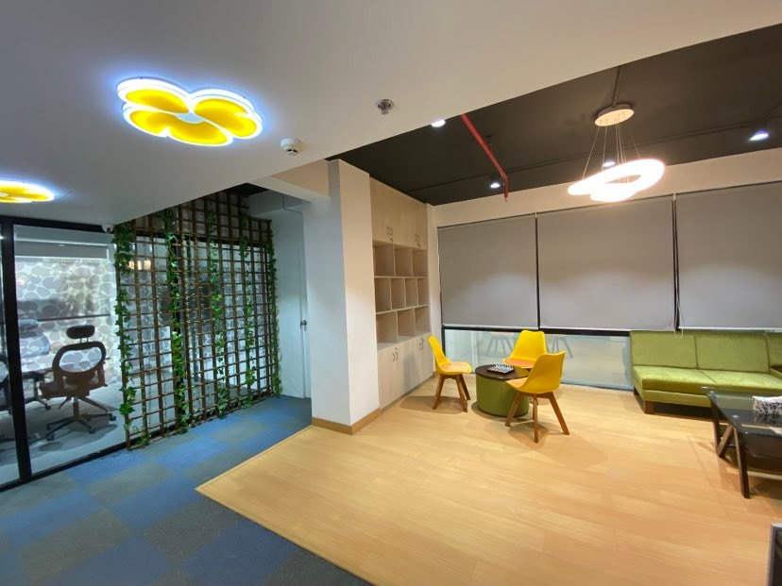
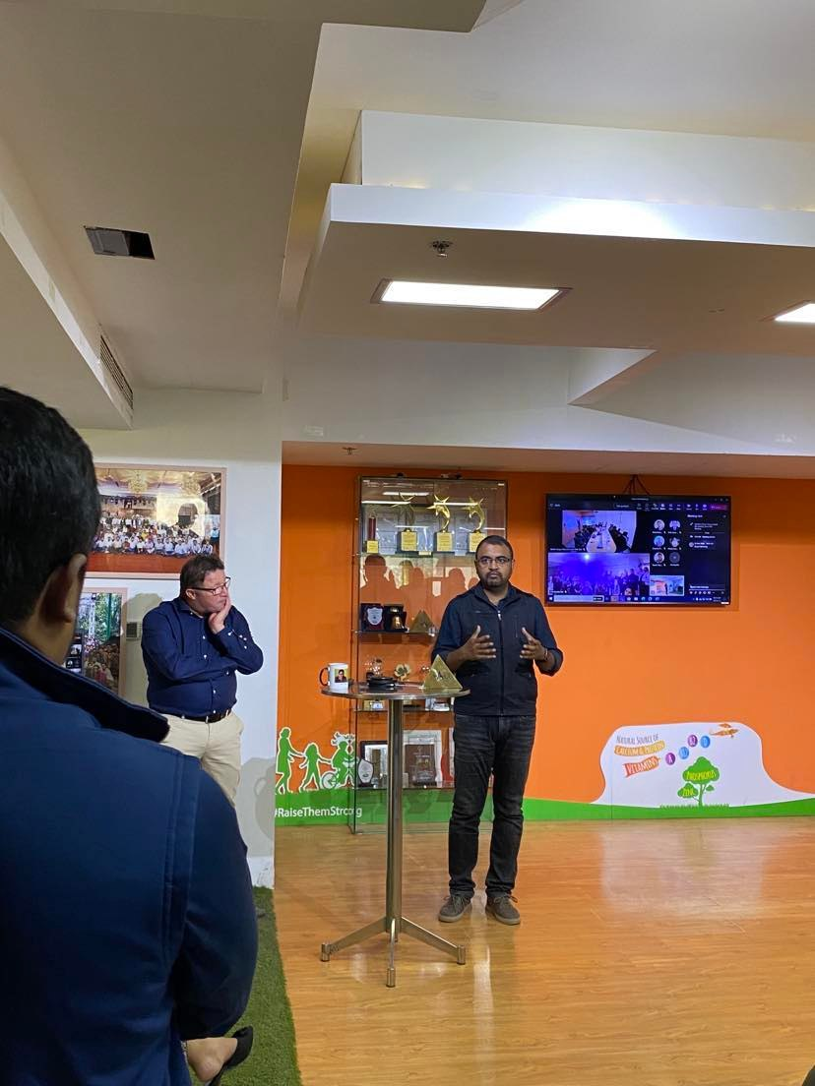
Figure: ARLA Foods Bangladesh’s Head office

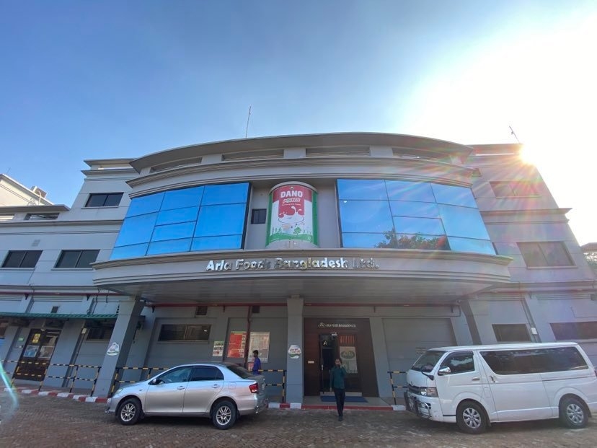
Figure: ARLA Foods Bangladesh’s packaging plant factory

Celebrating workforce Diversity



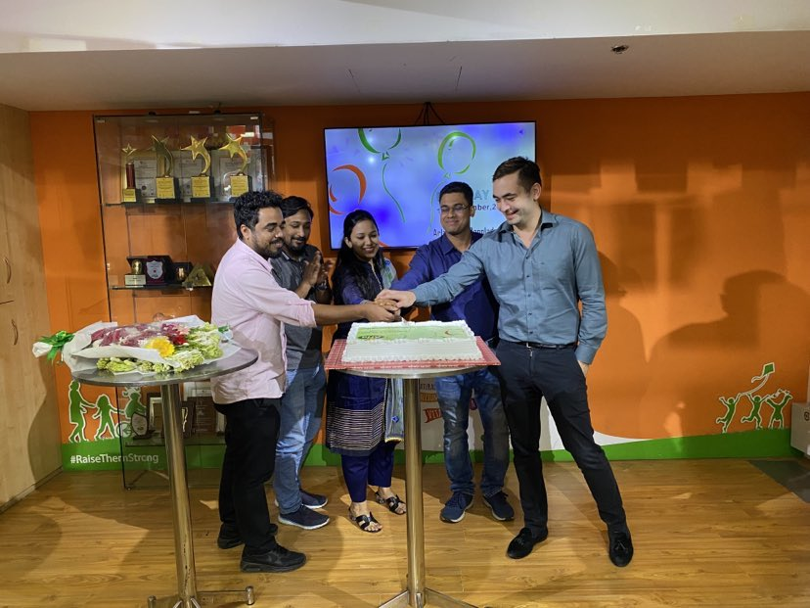

Figure: Employees celebrating sales target achievement success.

Documentation

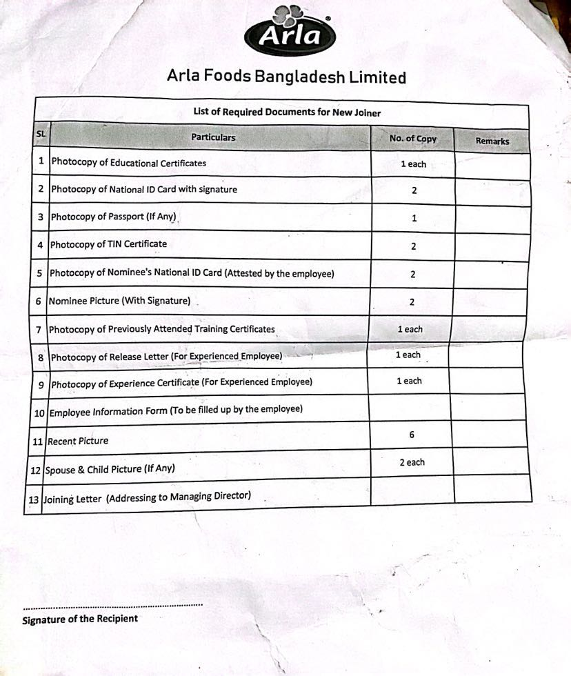

Figure: List of required documents for new joiners.

Job Description

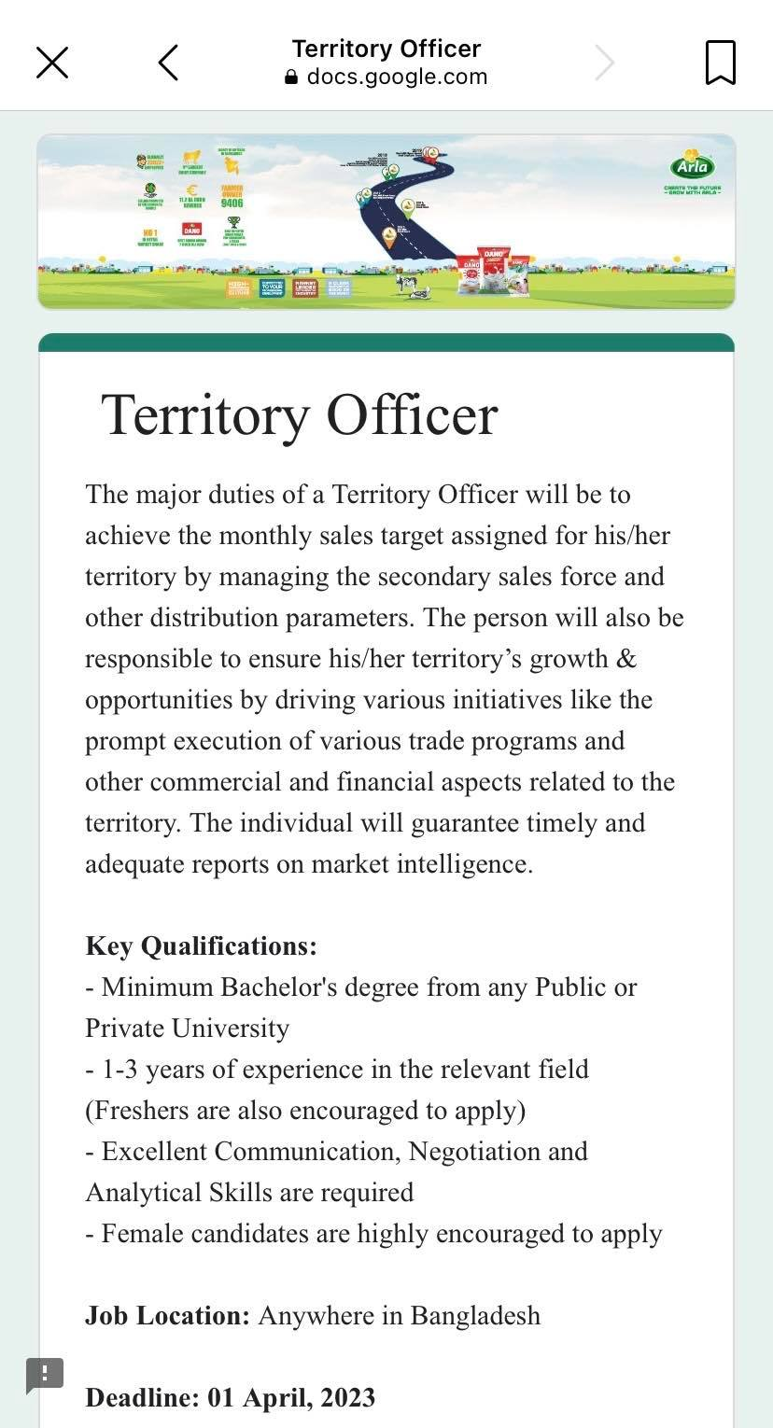
Figure: Job Description for the role of Territory Officer.
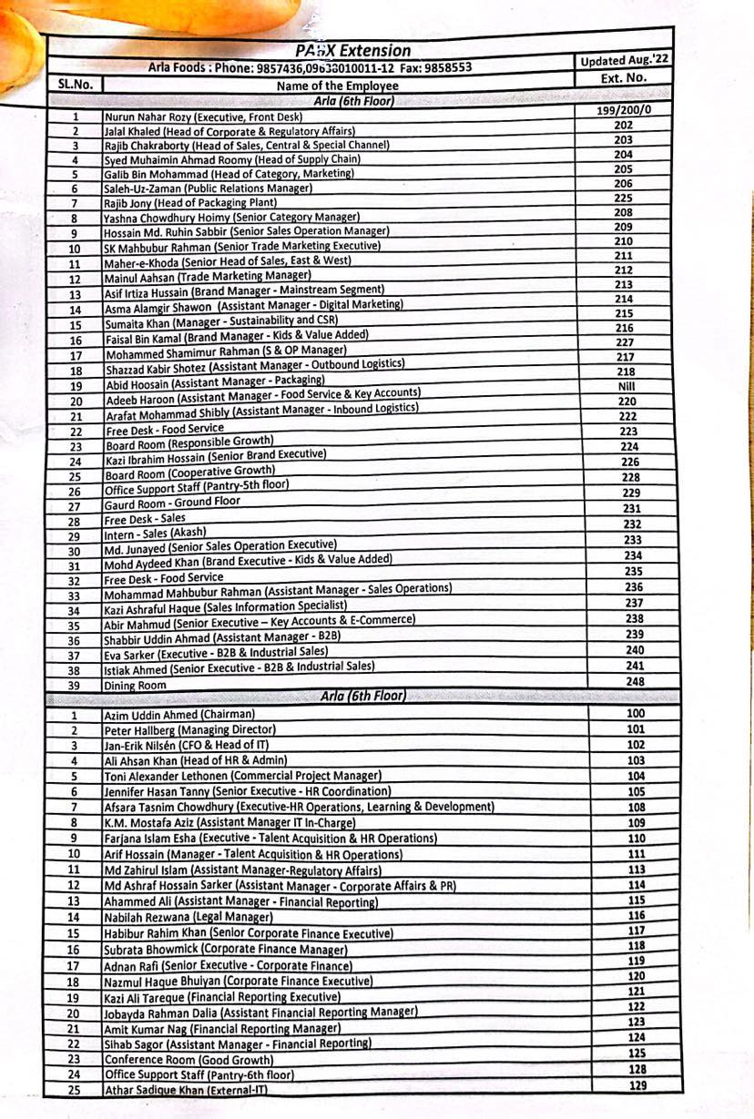
Figure: Enlisted employees of ARLA Foods Bangladesh’s Head Office.

Employer Branding & Job Fair activities

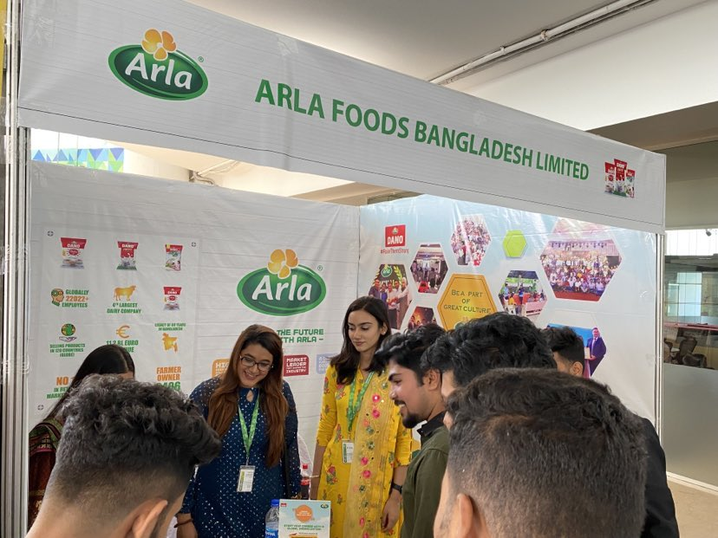
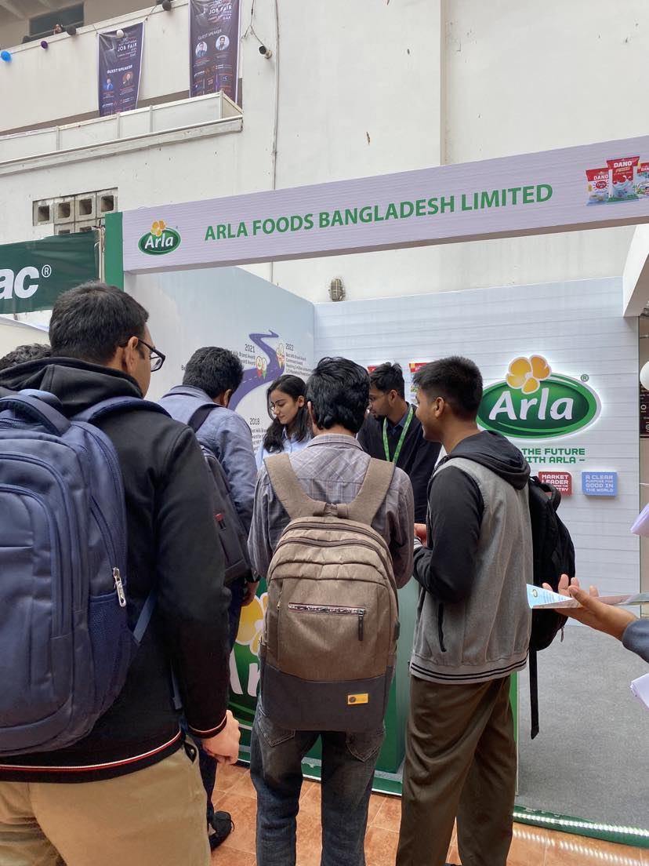
Figure: Career Fair Participation & Employer Branding
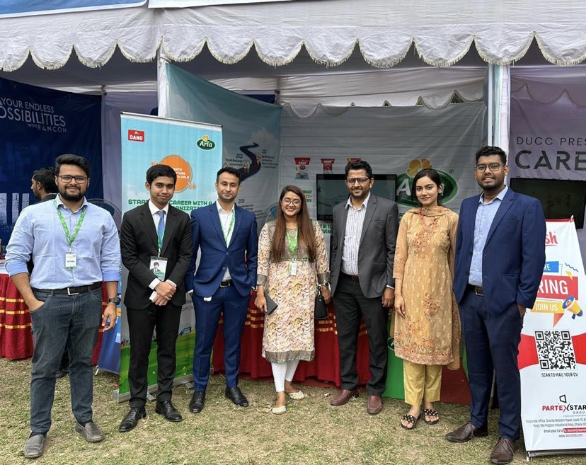
Figure: Dhaka University Career Fair
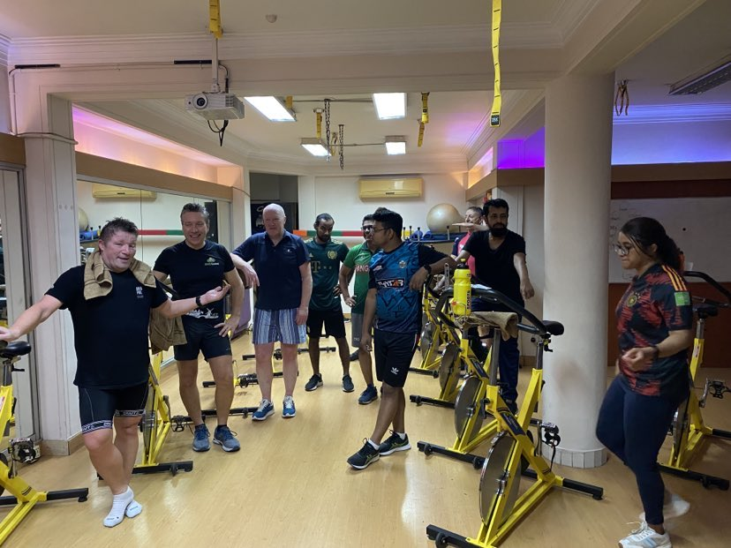
Figure: Weekly Gym Session for employees’ Healthcare benefit.

Employee Engagement Activity

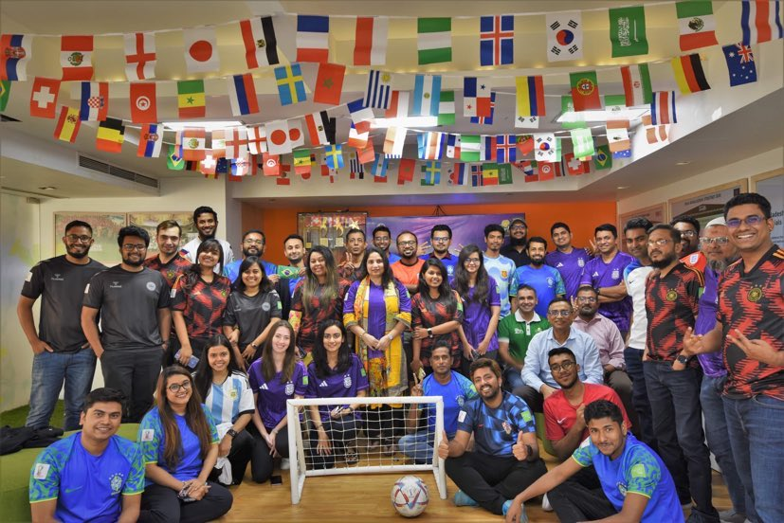
Figure: Employee engagement activity during world cup

