Internship
Report on:
Ad-Din Hospital



Report On:
Ad-Din Hospital

Submitted To:
Mosabbir Ahmad
Assistant Professor
School of Business & Economics
United International University

Submitted By:
Sadia Maisha Mahi
Program: BBA
ID: 111192020

Major in Finance

Date of submission
17th September, 2023
United International University
Letter of Transmittal

September 17, 2023

Mosabbir Ahmad.
Assistant Professor
School of Business & Economics
United International University

Subject: Submission of Internship Report

Dear Sir,
I am pleased to announce that I am Sadia Maisha Mahi, a student at United International University, have effectively concluded a four-month internship at Ad Din Foundation, under your guidance and supervision. I conducted thorough research and analysis to compile this report for my reporting purposes. I have taken all possible measures to create an error-free report; I apologize in advance for any kind of mistakes that may have occurred. I hope you will consider any errors with kindness.
I would be honored by your acceptance and any expression of gratitude. I welcome any questions you may have and reserve the right to respond.

Thank you,
Sincerely Yours,

Sadia Maisha Mahi
111192020

Student Declaration
I am Sadia Maisha Mahi and my ID number is 111192020. I am a regular student at the School of Business and Economics, United International University; I am pursuing major in Finance. I wish to affirm that the internship report on Ad-Din Hospital is a product of my independent effort. I assure that this work is original and has not been previously submitted to meet any academic degree prerequisites.

Acknowledgement
I wish to convey my utmost gratitude to everyone who aided me in the accomplishment of my report. Firstly, I deeply appreciate the Almighty Allah for bestowing upon me the strength and patience necessary to successfully conclude this endeavor.
Furthermore, I would like to express my sincere thanks to all the staff members who played a pivotal role in gathering data and sharing their insights through the Ad-Din Foundation questionnaire. Their contributions proved to be of immeasurable worth in finalizing this report.
Lastly, I would like to offer special acknowledgment to my supervisor, Mosabbir Ahmad, Assistant Professor at the School of Business & Economics, United International University. From the project's inception to its culmination, she provided unwavering guidance and support. Her extensive assistance and invaluable suggestions were indispensable, and without her, the completion of this undertaking would not have been possible.

Table of Contents
Executive Summary vi
Chapter one: Introduction 1
1.1 Background of Report: 2
1.2 Scope of the Report: 2
1.3 Objective of Report: 2
1.4 Methodology: 2
1.5 Limitation: 3
Chapter Two: Company Overview 4
2.1 Company Profile: 5
2.2Mission: 5
2.3 Vision: 6
2.4 Institute of Ad din Foundation 6
2.4.1 Hospitals of Ad Din Foundation: 6
2.4.2 Medical College of Ad din Foundation 8
2.4.3Nursing Institute of Ad din Foundation 9
2.4.4 School Under Ad Din Foundation 10
2.5Ad Din Pharmaceuticals 11
Chapter Three: Challenges of Ad din hospital 12
3.1 Problems Faced by Ad-Din Hospital: 13
3.1.1 Infrastructure and Facilities: 13
3.1.2 Equipment and Technology: 13
3.1.3 Human Resources: 14
3.1.4 Financial Constraints: 14
3.1.5 Patient Overcrowding: 14
3.1.6 Administrative Inefficiencies: 14
3.1.7 Regulatory Compliance: 15
3.1.8 Patient Satisfaction and Experience: 15
3.1.9 Technological Integration: 15
3.1.10 Lack of Community Engagement: 15
Chapter four: Industry Analysis 16
4.1 Ad-Din Hospital: 17
4.1.1 Facilities: 17
4.1.2 Challenges: 20
4.2 Squire Hospital: 20
4.2.1 Facilities: 20
4.2.2 Challenges: 21
4.3 Holy Family Hospital: 21
4.3.1 Facilities: 22
4.3.2 Challenges: 22
Chapter five: Financial Guideline of Ad din Foundation 24
5.1 Introduction: 25
5.2 Cash Receipts 25
5.3 Cash Disbursement: 25
5.4 Accounts Payable: 25
5.5 Payroll: 26
5.6 Imp rest Cash: 26
5.7 Advances: 27
5.8 Prepayments & Security Deposits: 27
5.9 Investment: 27
5.10 General Ledger: 28
5.11 Accounting Activities: 28
5.12 Operating Activities: 28
Chapter Six: Internship Experience 29
6.1 Job Responsibility 30
6.1.1 Specific Job Duty: 30
6.1.2 Critical Observation 30
2.2 Functions of the Department: Reporting and Financial Statements: 31
2.3 Accounts Payable (Money Out): 31
2.3 Accounts Receivable and Revenue Tracking (Money In): 31
2.4 Inventory 32
2.5 Taxes: 32
Chapter Seven: Recommendation & Conclusion 33
Recommendation: 34
Conclusion: 36
Bibliography 37

Executive Summary

In this report, the financial activities and challenges of Ad-Din Foundation, a prominent healthcare institution in Bangladesh were examined. The main objective was to identify and analyze the financial activities of the organization. The report also aimed to share the author's internship experience, understand industry challenges, and explore the activities of the Accounts and Finance department. The methodology included data collection through informal interviews with management, supervisors, and peers, as well as secondary sources such as the organization's official website, internet, reports, and relevant journals and books.
Ad-Din Foundation was established in 1980 with a primary focus on aiding the disadvantaged majority in Bangladesh. The organization has since expanded its reach by establishing hospitals, medical colleges, nursing institutes, and medical technology institutes across various regions of the country. The report highlighted the challenges faced by Ad-Din Hospital, including infrastructure and facilities, equipment and technology, human resources, financial constraints, patient overcrowding, administrative inefficiencies, regulatory compliance, patient satisfaction, technological integration, and lack of community engagement.
A comparison was making between Ad-Din Hospital and its nearest competitors, Squire Hospital and Holy Family Hospital. Each hospital's facilities, strengths, weaknesses, and challenges were analyzed providing insights into their respective positions in the healthcare industry.
The report also provided a financial guideline for Ad-Din Foundation, outlining procedures for cash receipts, cash disbursements, accounts payable, payroll, cash, advances, prepayments and security deposits, investments, general ledger, and other accounting activities.
The internship experience at Ad-Din Foundation was highlighted including job responsibilities such as assisting with research, data entry, and maintaining financial records. The functions of the Accounting and Finance department, including reporting, financial controls, payroll administration, accounts payable and receivable, inventory management, internal reporting, and taxes were explained.
In conclusion, the report provided valuable insights into Ad-Din Foundation's financial activities and challenges, as well as the author's internship experience. The financial guideline and department functions outlined in the report offer a comprehensive overview of the organization's financial operations. Overall, the report contributes to a deeper understanding of the healthcare industry in Bangladesh and the role of Ad-Din Foundation within it.

Chapter one: Introduction

1.1 Background of Report:

As a requirement for the completion of a Bachelor of Business Administration degree, I am Submitting this report to the School of Business & Economics at United International University. This submission is an integral component of my internship program and encompasses insights gleaned throughout the duration of the internship period.

1.2 Scope of the Report:

The report will focus on the financial activities, foundations, and challenge of Ad-Din Foundation.

1.3 Objective of Report:

Main Objective: The main objectives of this report is to identify Ad-Din foundations financial activities.
Specific Objective:
- To share internship experience.
- To know industry challenge.
- To know Accounts and finance department activities.
- To fulfill the Degree requirement.

1.4 Methodology:

- Topic Selection: I have selected this topic, which has received approval from my esteemed supervisor, Mosabbir Ahmad, an Assistant Professor at the School of Business and Economics, United International University.
- Process Data Collection: Using a basic random sampling technique, I gathered data by informal interview with my peer and my supervisor
- Method of data collection: For the execution of this project, I employed both primary and secondary data, encompassing the two distinct methods of data collection.
Primary Data: informal interview with management, Supervisor and my peer

Secondary Data: Some sources are listed below-
- Official website of Organization
- Internet
- Different report
- Relevant journal and book

1.5 Limitation:

All progress is constrained by limitations, and I encountered several limitations while preparing this project effectively. The following are the primary limitations that had the greatest impact:
- Not all employees were cooperative in furnishing information.
- The secondary sources of data proved to be insufficient.
- Limited prior experience in conducting research.

Chapter Two: Company Overview

2.1 Company Profile:

Ad-Din Foundation was established in 1980 with the primary objective of aiding the disadvantaged majority in Bangladesh. Its inaugural endeavour cantered on erecting an orphanage in Jessore. Over the span of 37 years, Ad-Din has broadened its reach by executing a variety of initiatives across different regions of the nation.
At present, Ad-Din oversees a multitude of ongoing initiatives. These encompass hospitals located in Dhaka, Keranigonj, Jessore, Kushtia, Khulna, and Postogola. Additionally, medical colleges have been established in Dhaka, Jessore, Keranigonj, and Khulna, while nursing colleges operate in Dhaka. Moreover, nursing institutes can be found in Dhaka, Jessore, and Kushtia. Further enhancing its scope, a medical technology institute operates in Jessore. The organization also operates mobile eye clinics, a project focusing on maternal and child health, and an initiative dedicated to preventing and addressing obstetric fistulae. Notably, Ad-Din administers an integrated health and microfinance program that incorporates health insurance.
The Ad-Din hospitals were instituted to provide economical, top-tier medical care and have since gained renown as hubs of excellence. They are lauded for their calibre, affordability, and patient-centric approach.
Endorsement from the Ministry of Health and Family Welfare of the People’s Republic of Bangladesh was secured for various institutions. Notably, Ad-Din Women’s Medical College (AWMC) in Dhaka gained approval in 2008, Ad-Din Sakina Medical College (ASMC) in Jessore in 2012, Bashundhara Ad-Din Medical College (BAMC) in Keranigonj, Dhaka in 2013, and Ad-Din Akij Medical College (AAMC) in Khulna in 2013. Ad-Din’s commitment to furnishing exceptional educational facilities is evident, complemented by a dedicated cadre of faculty members, many of whom are experts in their respective domains. Leveraging its available resources, Ad-Din remains dedicated to producing remarkable medical graduates who excel not only in clinical practice but also in their social responsibility. (Foundation, n.d.).

2.2Mission:

The primary goal of the Hospital is to create proficient physicians who meet the standards set by the Bangladesh Medical and Dental Council (BMDC) in terms of knowledge, skills, and professional conduct. These physicians are expected to deliver exceptional medical care, committed to continuous learning throughout their lives. Our graduates are prepared to excel in diverse settings, taking on leadership roles within the national healthcare system. Additionally, they play a vital role in fulfilling the healthcare and research needs of the country.

2.3 Vision:

The Hospital's aspiration is to achieve recognition on both national and international stages, lauded for its exceptional education and its capacity to cultivate graduate physicians who possess vital knowledge, skills, and a strong sense of professionalism. These physicians are expected to adeptly sustain their service and embark on careers dedicated to advancing health promotion, disease prevention, treatment, and medical research within the nation.

2.4 Institute of Ad din Foundation

The Ad-Din Foundation operates multiple institutes, including 8 hospitals, 4 medical colleges, 4 nursing colleges, and 3 schools. Additionally, they are involved with Ad-Din Pharmaceuticals and Ad-Din Welfare

2.4.1 Hospitals of Ad Din Foundation:

- Ad-Din Medical College Hospital Dhaka, 2 Bara Maghbazar, Dhaka-1217
- Ad-Din Sakina Medical College Hospital, 15 Rail Road, Jessore
- Ad-Din Hospital Kushtia, 19/1 Chand Mohammad Sarak Thanapara, Kushtia
- Ad-Din Eye Hospital Chanchra, Dalmil Jessore
- Ad-Din Barrister Rafiq-Ul-Huq Hospital 23/1 Postogola, Balurmath Jurain, Dhaka
- Ad-Din Akij Medical College Hospital Boyra, Khulna
- Basundhara ad-Din Medical College Hospital Plot No. 556/A, Block-C, Bashundhara Riverview Residential Project.
- Ad-Din Children Hospital, Poridarshan Banglo Sarak Karbala, Jessore.
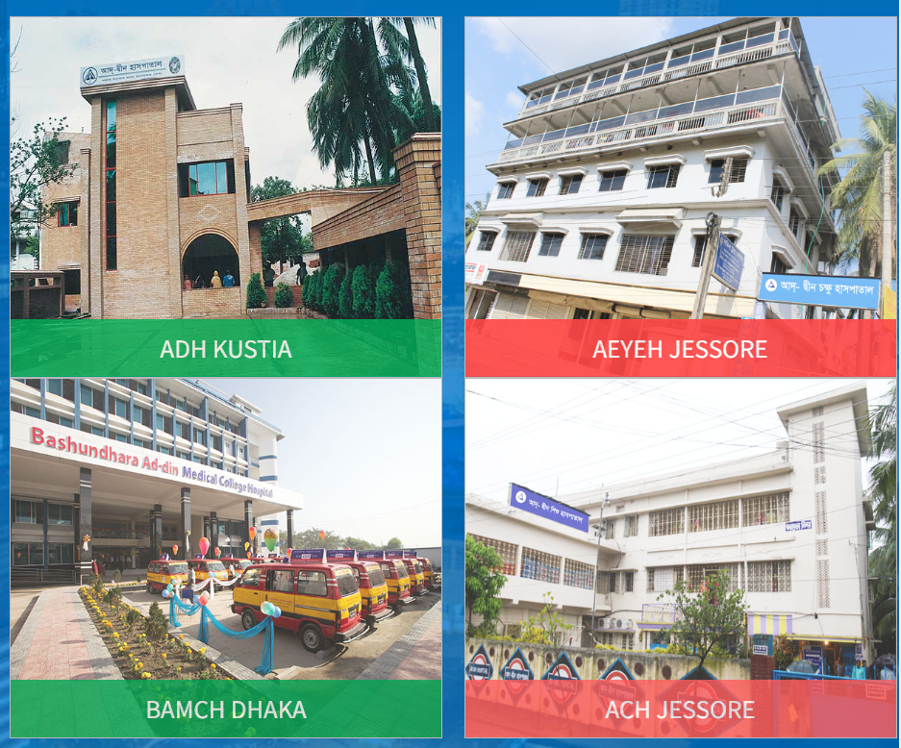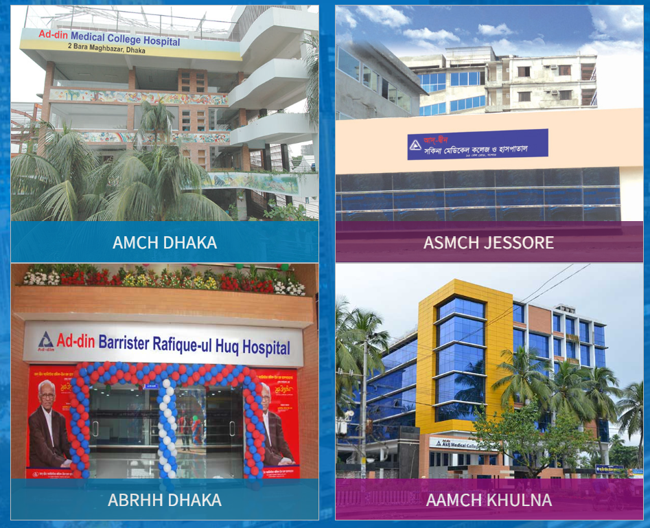
All Hospital

2.4.2 Medical College of Ad din Foundation

- Ad-Din Women’s Medical College (AWMC) Dhaka
- Basundhara Ad-Din Medical College (BAMC) Dhaka
- Ad-Din Akij Medical College (AAMC) Boyra, Khulna
- Ad-Din Sakina Medical College (ASMC) Pulerhat, Jessore

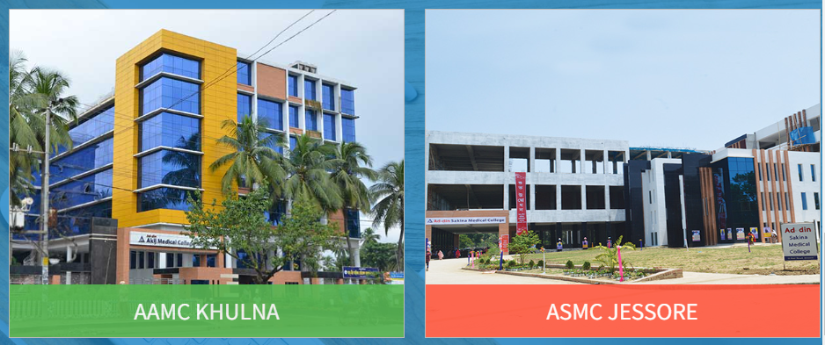
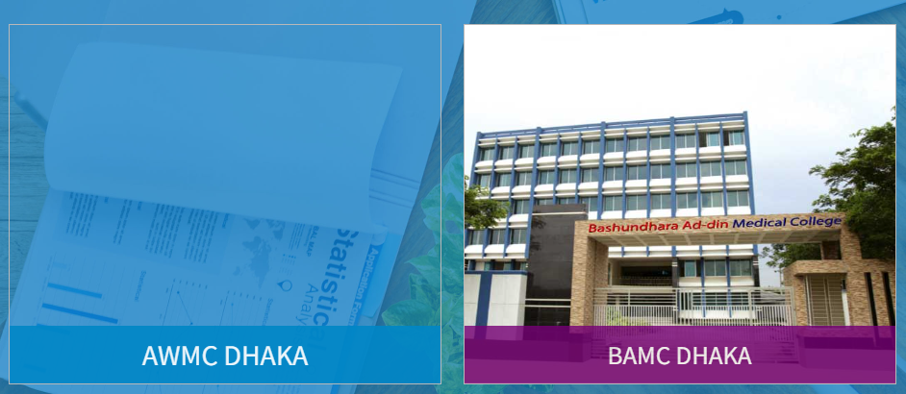

2.4.3Nursing Institute of Ad din Foundation

- Fatema Nursing Institute 2 Bara Maghbazar, Dhaka
- Ad-Din Nursing Institute Pulerhat, Jessore
- Safina Nursing Institute Kushtia ,38/1 Chand Mohammad Sarak Thanapara, Kushtia
- B. Sc. Nursing Institute, Ad-Din Women Medical College Dhaka

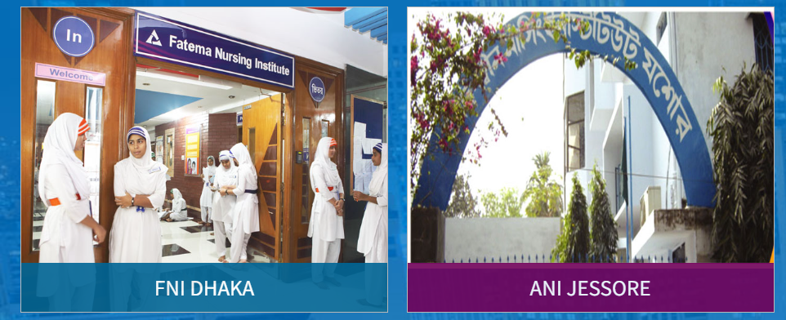

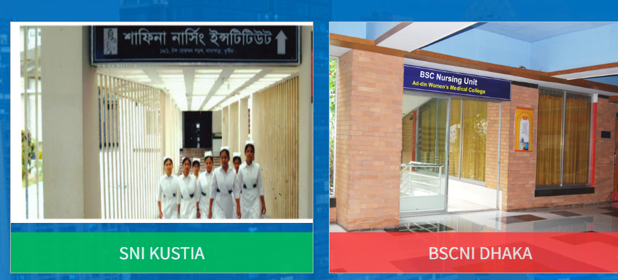

2.4.4 School Under Ad Din Foundation

- AD-DIN SHISHU KISHOR NIKETON Jhikor Gasa, Navaron, Jessore.
- Akij Collegiate School Navaron, Jessore
- Sakhina Girls School Brandipara, Jessore

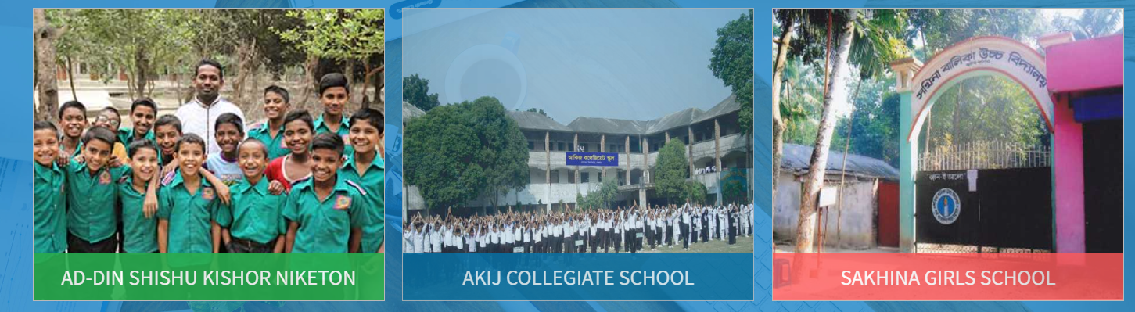

2.5Ad Din Pharmaceuticals

Ad-Din Pharmaceuticals Ltd., initially known as Jess Chemical and Pharmaceutical Works Private Limited when it was established in 1996, was formed with the overarching goal of improving healthcare quality. In 2007, the company underwent a name change to become Ad-Din Pharmaceuticals Limited and concurrently established its manufacturing facility at the BSCIC Industrial Estate in Jessore. The company's ultimate ambition is to rapidly established itself as a leading research-cantered pharmaceutical firm on a global scale. Notably, Ad-Din Pharmaceuticals has already initiated measures to broaden its presence in international markets, solidifying agreements with renowned pharmaceutical enterprises. Furthermore, the company is on the brink of initiating fundamental research endeavours. Central to its mission, Ad-Din Pharmaceuticals is dedicated to furnishing high-quality medications at accessible prices, with the aspiration of benefiting a wide spectrum of individuals.

Chapter Three: Challenges of Ad din hospital

3.1 Problems Faced by Ad-Din Hospital:

Ad-Din Hospital, a distinguished healthcare establishment recognized for its unwavering dedication to delivering exceptional medical services, has encountered a range of difficulties and concerns that have influenced its functioning, patient welfare, and overall efficiency. Through this exhaustive examination, we will explore the intricate particulars of the adversities confronted by Ad-Din Hospital, with the intention of offering a comprehensive comprehension of the intricate aspects of these issues.

3.1.1 Infrastructure and Facilities:

Ad-Din Hospital confronts a central hurdle concerning its infrastructure and amenities. The institution might grapple with antiquated structures, limited space, and inadequate resources to meet the demands of an expanding patient base. These deficient facilities not only impede the hospital's ability to house patients effectively but also undermine the calibre of healthcare delivered. The absence of proper room for specialized departments like intensive care units, operating theatres, and diagnostic facilities could result in delayed or compromised patient treatments.

3.1.2 Equipment and Technology:

The Ad-Din Hospital encounters a significant challenge in the form of outdated medical equipment and technology. Contemporary healthcare systems depend extensively on cutting-edge equipment to ensure precise diagnoses, successful treatments, and improved patient results. The presence of obsolete or insufficient equipment can result in incorrect diagnoses, extended treatment periods, and a reduction in overall patient confidence. Moreover, the lack of a robust electronic health records system might hinder seamless information exchange among medical staff within the hospital.

3.1.3 Human Resources:

Managing human resources poses a intricate dilemma within every healthcare establishment, and Ad-Din Hospital is no different. The deficiency of proficient medical experts, encompassing physicians, nurses, and technicians, has the potential to burden the hospital's capacity to offer punctual and all-encompassing medical attention. Furthermore, upholding adept personnel becomes a challenge in light of obstacles like insufficient recompense, burdensome workloads, and a scarcity of prospects for professional growth.

3.1.4 Financial Constraints:

Numerous healthcare establishments encounter financial limitations, and Ad-Din Hospital is no exception to these hurdles. Ensuring high-quality healthcare services demands significant financial commitments for infrastructure, equipment, personnel salaries, and continual operational expenses. Insufficient funding can result in compromises in patient care, postponed upgrades, and challenges in recruiting top-notch medical experts.

3.1.5 Patient Overcrowding:

The issue of patient overcrowding remains prevalent in numerous hospitals, and Ad-Din Hospital is no exception to this challenge. The hospital is renowned for delivering exceptional care, which frequently results in a greater influx of patients than the facility can effectively accommodate. This overcrowding contributes to prolonged waiting periods, compromised patient confidentiality, and an elevated potential for the spread of infections. Furthermore, it places a strain on the hospital's available resources, consequently affecting the overall quality of care that can be deliver.

3.1.6 Administrative Inefficiencies:

The overall effectiveness of the hospital can be significantly influence by administrative inefficiencies. Delays, confusion, and errors in patient care can arise from insufficient communication between departments, absence of standardized processes, and inefficient resource allocation. To maintain seamless operations, it is crucial to enhance communication channels and optimize workflows for better administrative functioning.

3.1.7 Regulatory Compliance:

Just like any other medical facility, Ad-Din Hospital is required to follow rigorous regulatory norms and directives to guarantee the well-being of patients and the excellence of their medical treatment. Manoeuvring through intricate regulations and securing adherence can present difficulties and consume considerable time. Neglecting to meet these regulatory prerequisites can lead to legal complications, penalties, and harm to the hospital's reputation.

3.1.8 Patient Satisfaction and Experience:

Patient contentment and perception stand as pivotal gauges of a hospital's prosperity. Unfulfilled patient anticipations, extended wait durations, deficient communication, and insufficient post-treatment follow-through possess the potential to precipitate a drop in patient contentment. Consequently, this could affect the hospital's standing and its ability to maintain patient loyalty.

3.1.9 Technological Integration:

Incorporating technology into healthcare systems is vital to enhance patient care, optimize workflows, and boost overall efficiency. Ad-Din Hospital could encounter obstacles when embracing and integrating novel technologies like electronic health records, telemedicine platforms, and data analytics tools. Inadequate technological integration may impede the seamless exchange of information, effective decision-making, and efficient patient management.

3.1.10 Lack of Community Engagement:

Healthcare organizations that are successful typically involve themselves with the communities they serve. They do this to increase knowledge about health, provide programs that prevent illnesses, and guarantee that medical assistance is within everyone's reach. Ad-Din Hospital might encounter obstacles when trying to effectively connected with its local community. This could result in limited awareness about the services they offer and a deficiency in initiatives for preventive healthcare.

Chapter four: Industry Analysis

Healthcare institutions play a crucial role in providing medical services to the community. Ad-Din Hospital, Squire Hospital, and Holy Family Hospital are three prominent healthcare facilities, each with its own set of facilities and challenges. This comparison aims to delve into the details of these hospitals, analyzing their strengths, weaknesses, and the healthcare landscape they operate within.

4.1 Ad-Din Hospital:

Ad-Din Hospital, a prestigious healthcare institution, has garnered renowned for its all-encompassing medical services, cutting-edge facilities, and unwavering dedication to patient well-being. Founded with the mission of making high-quality healthcare accessible to all strata of society, the hospital has emerged as a symbol of excellence in the realm of medical care. This comprehensive depiction will delve into the array of amenities extended by Ad-Din Hospital, spotlighting its pivotal divisions, state-of-the-art technologies, patient-centric ethos, and meaningful contributions to the community.

4.1.1 Facilities:

4.1.1.1 Extensive Medical Divisions:

Ad-Din Hospital boasts an extensive array of specialized medical divisions designed to address a diverse spectrum of healthcare requirements. These divisions are staffed by adept and experienced healthcare experts, guaranteeing the highest caliber of medical attention. Noteworthy departments encompass:
Cardiology: The cardiology division proffers a spectrum of services, ranging from non-invasive diagnostic assessments to intricate interventional procedures. The deployment of advanced equipment, such as echocardiography apparatus, cardiac catheterization laboratories, and state-of-the-art monitoring systems, enables precise diagnosis and efficacious treatment.
Oncology: The oncology division is outfitted to administer comprehensive cancer care, spanning chemotherapy, radiation therapy, and surgical interventions. A multidisciplinary methodology ensures seamless collaboration among oncologists, surgeons, radiologists, and support staff, facilitating holistic patient management.
Orthopedics: The orthopedic division at Ad-Din Hospital is dedicated to musculoskeletal well-being, proffering remedies for fractures, joint replacements, spinal disorders, and sports-related injuries. Advanced imaging technologies like MRI and CT scans facilitates pinpoint diagnosis.
Gynecology and Obstetrics: Furnished with contemporary labor and delivery suites, the hospital provides a secure and congenial milieu for childbirth. This division encompasses prenatal care, high-risk pregnancies, and gynecological surgeries.
Neurology: Neurological maladies are diagnosed and managed through state-of-the-art technologies such as EEG and MRI scans. The hospital's neurology division addresses conditions like epilepsy, stroke, and neurodegenerative ailments.

4.1.1.2 Leading-Edge Technologies:

Ad-Din Hospital stands at the vanguard of medical technology, harnessing advanced apparatus to augment diagnostics and interventions. This encompasses:
Diagnostic Imaging: The hospital's arsenal encompasses high-resolution imaging modalities, spanning MRI, CT scans, X-rays, and ultrasound equipment, facilitating precise and timely diagnoses.
Minimally Invasive Surgery: Contemporary operation theaters facilitate minimally invasive procedures, curbing patient discomfort and expediting recovery periods. Routine practices encompass laparoscopic surgery, endoscopy, and arthroscopy.
Critical Care Units: Ad-Din Hospital features well-equipped intensive care units (ICUs) complete with advanced patient monitoring systems, ventilators, and life-saving apparatus for critical cases.

4.1.1.3 Patient-Centric Philosophy:

A hallmark of Ad-Din Hospital is its unwavering patient-centric approach, where every facet of care is meticulously crafted to prioritize patient well-being and comfort:
Patient Education: The hospital underscores patient education, empowering individuals with insights into their conditions, treatment alternatives, and preventive measures. Informed patients are better equipped to engage in decisions about their health.
Comfort-Oriented Facilities: Patient wards are meticulously design to blend comfort and hygiene. Private Chambers are available for patients necessitating isolation or specialized care.
Multilingual Support: The hospital offers language interpretation services to cater to a diverse patient demography, ensuring effective communication between healthcare providers and patients.
Emotional Assistance: Recognizing the emotional toll of illnesses, the hospital extends counseling services and support groups to aid patients and their families in coping with psychological challenges.

4.1.1.5 Community Engagement and Influence:

Ad-Din Hospital extends its impact beyond its physical confines through community engagement and philanthropic endeavors (Tajmim, 2019):
Health Camps: The hospital orchestrates health camps in underserved regions, providing complimentary check-ups, vaccinations, and awareness initiatives to enhance community health.
Charitable Initiatives: Ad-Din Hospital extends subsidized or cost-free medical services to underprivileged individuals, guaranteeing that financial constraints do not obstruct access to essential healthcare.
Medical Training and Research: The hospital assumes the role of an educational nucleus, offering medical training programs for healthcare professionals and spearheading medical research to advance healthcare practices.

4.1.1.6 Emergency and Trauma Care:

Ad-Din Hospital excels in emergency and trauma care, housing a dedicated division operating around the clock:
Trauma Response Team: The hospital maintains a specialized trauma response team composed of adept physicians, surgeons, nurses, and paramedics who swiftly attend to critical cases.
Emergency Division: Outfitted with resuscitation zones, diagnostic tools, and the capacity for emergency surgery, this division guarantees swift and effective interventions during crises.

4.1.2 Challenges:

4.1.2.1 Financial Constraints:

Relying heavily on subsidies and donations, Ad-Din Hospital struggles with financial stability, which can impact the quality of infrastructure and medical equipment.

4.1.2.2 Limited Technological Advancements:

Due to budget limitations, the hospital might lack access to state-of-the-art medical technology, potentially affecting diagnosis and treatment options.

4.1.2.3 Overcrowding:

High patient volume, coupled with limited resources, can lead to overcrowding and longer waiting times, affecting patient experience.

4.2 Squire Hospital:

Squire Hospital is a contemporary private healthcare institution renowned for its Advance technology and exceptional healthcare standards. Operating within an affluent market, it confronts a unique spectrum of advantages and challenges (Squire, 2023).

4.2.1 Facilities:

4.2.1.1 Advance Medical Equipment:

Squire Hospital makes substantial investments in state-of-the-art medical technology, encompassing advanced diagnostic imaging, robotic surgical systems, and precision medicine tools.

4.2.1.2 Specialized Departments:

The hospital proudly hosts specialized departments and centers of excellence dedicated to fields such as cardiology, oncology, and neurology. This specialization magnetizes patients seeking the highest caliber of medical care.

4.2.1.3 Upscale Amenities:

Patients at Squire Hospital revel in an elevated level of comfort, with amenities including private accommodations, gourmet dining, and personalized concierge services.

4.2.1.4 Highly Trained Personnel:

The hospital places a strong emphasis on continuous staff training, assuring that its healthcare professionals remain well-versed in the latest treatments and techniques.

4.2.2 Challenges:

4.2.2.1 high Costs:

The incorporation of advanced technology and opulent amenities comes at a premium, rendering Squire Hospital's services inaccessible to a considerable portion of the population.

4.2.2.2 Disparities in Access:

Given its premium pricing, the hospital may inadvertently contribute to healthcare inequalities, limiting access primarily to those with the financial means to afford it.

4.2.2.3 Profit-Centric Focus:

The hospital's private nature may incentivize a profit-oriented approach, potentially jeopardizing patient care in the pursuit of financial gains.

4.3 Holy Family Hospital:

Operated by a religious institution, the Holy Family Hospital strives to deliver comprehensive healthcare while staying true to its ethical and religious principles. Its offerings are a distinctive amalgamation of services and hurdles that align with its core mission (Family, 2023).

4.3.1 Facilities:

4.3.1.1 Ethical and Spiritual Care:

Central to the Holy Family Hospital's mission is the provision of care that adheres to both ethical and religious values, a feature that particularly appeals to patients seeking such specialized services.

4.3.1.2 Engagement with the Community:

The hospital actively engages in community welfare initiatives, conducting complimentary medical camps, educational programs on health, and extending support to marginalized groups.

4.3.1.3 Diverse Medical Offerings:

Within the Holy Family Hospital, an extensive array of medical services covering various specialties is available, rendering it a dependable healthcare choice within its community.
4.3.1.4 A Holistic Approach:
Going beyond medical interventions, the hospital places emphasis on the spiritual and emotional well-being of patients, a focus that strikes a chord with certain individuals.

4.3.2 Challenges:

4.3.2.1 Religious Constraints:

The hospital's unwavering commitment to religious values might result in constraints on certain medical procedures or treatments conflicting with these values.

4.3.2.2 Allocation of Resources:

Similar to any other institution, Holy Family Hospital could encounter limitations in resources, impacting the caliber and accessibility of medical services extended.

4.3.2.3 Inclusivity Considerations:

While the hospital's religious emphasis could be attractive to some, it might inadvertently exclude those who don't share identical beliefs or values.

Ad-Din Hospital, Squire Hospital, and Holy Family Hospital epitomize d instinct facets of the healthcare domain. Each hospital presents a unique array of facilities and challenges tailored to different segments of the populace. Ad-Din Hospital's dedication to affordability and community involvement caters to the underserved, whereas Squire Hospital's cutting-edge technology and specialized care allure individuals seeking premium medical services. For those who prioritize ethical and religious values, Holy Family Hospital's focal point strikes a chord. It is imperative to acknowledge the wide spectrum of institutions within the healthcare industry, with each playing a crucial role in tending to the manifold healthcare requisites of society.

Chapter five: Financial Guideline of Ad din Foundation

5.1 Introduction:

This manual serves as a comprehensive guide for the operational procedures within the Finance and Accounts department of our organization. Its primary purpose is to establish a framework for robust internal accounting controls. Throughout this manual, illustrative examples of essential documentation are included to facilitate the department's objectives. It is essential to emphasize that this manual is intend solely as a tool to aid and complement management's involvement, rather than replace it.
5.2 Cash Receipts:
Cash receipts are recorded through the company's official money receipts. Within the corporate Finance and Accounts department, each deposit must be meticulously entered into a manual collection register. Following this entry, the receipts are forwarded to the relevant revenue section for reconciliation against revenue records. The collection register serves as the source for generating cash collection reports.

5.3 Cash Disbursement:
The management should exercise strict control over cash disbursements, given its highly liquid nature. Basic control measures for cash disbursements include:
- Approval of payment vouchers by management.
- Mandating that all payments, particularly vendor disbursements, be made via checks.
- Restricting check signatories to top management and authorized senior staff.
- Prohibiting the preparation of checks without prior approval through payment vouchers. Cash disbursement typically covers accounts payable, recurring expenses, payroll, and impress cash.

5.4 Accounts Payable:

- Invoices for payment must receive written approval from an authorized individual, typically indicated by their initial on the invoice after a thorough review.
- Manual check generation may be required.
- The check must be accompanied by supporting documents, often referred to as vouchers, including:
- Purchase orders
- Receiving reports
- Invoices
- A money receipt should be obtained upon making the payment.
- Applicable source tax should be deducted, if necessary.
Recurring expenses are of various types, including monthly and occasional expenses, each with specific guidelines for payment:
(i) Monthly expenses should be paid based on submitted invoices/bills, ensuring timely remittance to designated deposit centers to avoid service disruption.
(ii) Occasional expenses incurred for specific purposes must adhere to these steps:
- Completion of an expense report in a timely manner
- Attachment of receipts to the expense report prior to submission
- Inclusion of date, time, and business purpose
- Staff sign-off and date on the expense report before submission to the Finance and Accounts department
- Approval of the expense report by the appropriate authority before disbursement or adjustment of any advances made.

5.5 Payroll:
Staff salaries should align with the terms outlined in their employment agreements with the company.

5.6 Imp rest Cash:

- The imp rest cash fund is a revolving fund maintained at a fixed amount to cover minor cash expenditures such as conveyance, entertainment, and minor office supplies. Key procedures for managing the imp rest cash fund include:
- Initial establishment of the imp rest fund account, providing adequate funds to the responsible individual for a specified duration.
- Prompt submission of expenditure vouchers to the corporate office after the designated period.
- Processing of vouchers by the Finance and Accounts department and submission for approval.
- Resolution of any discrepancies identified during voucher examination.
- Availability of the approved voucher amount to the concerned party after posting to the relevant account.

5.7 Advances:

Unavoidable advances, such as those to vendors or employees on humanitarian grounds, require prior approval from top management. The department should take necessary measures to recover advances as agreed upon.

5.8 Prepayments & Security Deposits:

Prepayments for rental offices should align with management-approved agreements and adjusted accordingly. Security deposits for services like business telephone and customs should be made via check, with approval from management. The Finance and Accounts department is responsible for ensuring their return at the designated period and proper accounting.

5.9 Investment:

Managing investments involves complex policies but includes the following key controls:
- Implementation of investment decisions by the Finance and Accounts department.
- Current policy, placing funds in fixed deposit reserves with banks and government-issued savings certificates.
- Investment execution upon board of directors' decisions.
- Accounting for interest earnings upon investment maturity.

5.10 General Ledger:

The general ledger (G/L) serves as the central repository for all accounting activities during an accounting period. Given its pivotal role, the following controls are essential:
- All journal entries must be approved by a designated authority prior to posting.
- A validation sheet is used to verify the accuracy of journal entries.
- Department heads conduct reviews of month-end financial statements.

5.11 Accounting Activities:

The summarization of monthly activities are accomplished through journal entries. Various accounting activities giving rise to journal entries include:
- Cash activities, including receipts, payments, sales, and credit collections.
- Individual entry of all receipts, whether cash or check, into respective revenue centres.
- Individual posting to the relevant accounts upon each payment.

5.12 Operating Activities:

Operating activities encompass several facets, including:
- Recording accounts payable for recurring expenses (e.g., Direct costs, General costs, Salary, Rent) on a cash basis.
- Treating credit sales as accounts receivable and posting monthly journal entries accordingly.
- Handling payroll, posting payable accounts for salary at month-end.
- Calculating depreciation on fixed assets, with journal entries reflected in the reporting software.
- Ensuring proper accounting for prepaid/advanced accounts during payment/adjustment.
- Supporting any additional journal entries with appropriate documentation, as needed.

Chapter Six: Internship Experience

6.1 Job Responsibility

I consider myself fortunate to have had the opportunity to intern at Ad Din Foundation, one of the premier private sector organizations in Bangladesh's healthcare industry. During my internship, I was stationed at 2 Bara Moghbazar under the guidance of Mr. Asadul Islam FCA, the Head of Division. I worked diligently within the Accounting and Finance department, assuming significant responsibilities and acquiring valuable knowledge.

6.1.1 Specific Job Duty:

My time at Ad Din Foundation was a tremendous learning experience. I actively contributed to the company's success by diligently fulfilling my duties. These included:
- Providing support in research, organizing documents, entering data, and ensuring the precision of financial records.
- Utilizing bookkeeping software (ASP) for financial tasks.
- Collaborating with the Accounting team to compile and analyse data, track information, and support the company's financial endeavours.
- Undertaking additional tasks and projects to deepen my understanding of accounting and office operations.
- Verifying employee logbooks and salary sheets.
- Preparing monthly close reports.
- Scrutinizing vouchers.
- Managing the company's advertising schedule.
- Conducting monthly statement reviews and analyses.
- Facilitating the opening of bank accounts for the company's Chairman, Vice Chairman, and Managing Directors.

6.1.2 Critical Observation

Working at Ad Din Foundation has not only been enticing due to its prestigious reputation but also because of its exceptional working environment. This organization stands out not only within its industry but also throughout Bangladesh. The workplace encourages open communication and free interaction among employees. The friendly atmosphere fosters a culture where everyone is comfortable providing suggestions and innovative ideas to streamline work processes.

2.2 Functions of the Department: Reporting and Financial Statements:

The heart of the Accounting and Finance department at Ad Din Foundation lies in collecting data meticulously using SAP accounting software. This data is then used to prepare essential financial reports for budgeting, forecasting, and decision-making processes. Additionally, these reports play a crucial role in communicating with investors, banks, and other professionals vital to the company's growth.
Financial Controls, including reconciliations, responsibility division, and adherence to GAAP accounting standards, are rigorously implemented to ensure compliance and prevent fraud and theft. The Controller's role is pivotal in establishing error-free procedures for managing these processes.
Payroll administration is another critical function, ensuring accurate and timely payments to all employees, including bonuses, commissions, and benefits. The department also monitors employee time-off, vacations, sick days, and handles tax assessments and payments, union dues, and other withholdings.

2.3 Accounts Payable (Money Out):

Maintaining strong vendor relationships and ensuring timely payments is a vital role in the Accounting department. The department actively seeks opportunities to save money, such as identifying discounts or incentives for prompt payments. Each payable is recorded as a liability, and payment schedules are managed efficiently to minimize late payment charges.

2.3 Accounts Receivable and Revenue Tracking (Money In):

The Accounting department is responsible for tracking and accounting for receivables, including outstanding invoices and necessary collection actions. It creates and tracks invoices, ensuring timely customer payments through friendly reminders. Each receivable is recorded as an asset.

2.4 Inventory

The Accounting department closely monitors Ad Din Foundation's inventory, balancing the cost of inventory against revenues over specific periods to maintain healthy cash flow. Striking a balance between satisfying customer demands and managing expenses is crucial.
Internal reporting is a key function, with cost accounting staff calculating product, service, customer, and region profitability to help management make informed decisions and improve financial results.

2.5 Taxes:

Ad Din Foundation's specialized group of accountants estimate taxable income and periodically remit income tax payments to the government based on these estimates. This ensures compliance with tax regulations and responsible financial management.

Chapter Seven: Recommendation & Conclusion

Recommendation:

Given a comprehensive understanding of Ad Din Foundation's financial operations and insights gathered during the internship experience, several suggestions can be put forth to optimize financial management and bolster operational efficiency. These proposals revolve around enhancing internal controls, integrating technology, and refining strategic financial planning.

Strengthen Internal Controls: To guarantee precision, responsibility, and transparency in financial operations, Ad Din Foundation should institute robust internal controls. This involves devising standardized protocols for inputting, validating, and authorizing financial transactions. By doing so, the risk of errors, fraudulent activities, and inconsistencies can be mitigated, thereby bolstering the credibility of financial reporting. Consistent audits and reconciliations need to be carried out to promptly detect and rectify any disparities.

Embrace Technological Integration: The incorporation of advanced accounting and enterprise resource planning (ERP) software, harmonized with the organization's functions, holds the potential to greatly streamline financial procedures. This technology can automate routine responsibilities like payroll management and account payables, minimizing manual errors and liberating valuable human resources for more strategic undertakings. An electronic document management system can enhance the efficiency of record keeping and retrieval, endorsing an organized and paperless work milieu.

Enhance Budgeting and Projection: The adoption of a robust budgeting and forecasting system can facilitate improved resource allocation, risk evaluation, and objective setting. By scrutinizing historical financial data and market trends, Ad Din Foundation can craft precise and realistic budgets, facilitating superior financial strategizing and decision-making. Consistent juxtaposition of real financial performance with budgeted figures will aid in identifying areas for enhancement and potential avenues for cost reduction.

Optimize Cash Flow Management: Effective management of cash flow is pivotal for the sustenance of operations and fulfilling financial commitments. The organization should institute a mechanism for predicting cash flow, foreseeing periods of surplus and deficit. Through identifying potential cash shortages, Ad Din Foundation can proactively organize financing or regulate expenditures accordingly, mitigating the risk of liquidity challenges.

Invest in Financial Literacy and Training: Empowering staff members from various departments with a fundamental grasp of financial principles and practices is essential. Organizing workshops and training sessions to elevate their financial acumen will enable them to make informed choices in alignment with the organization's financial objectives. This collective awareness fosters a culture of responsibility and judicious financial management throughout the organization.

Monitor Key Performance Indicators (KPIs): Construct and track KPIs that offer insights into financial well-being and operational effectiveness. Metrics such as turnover of accounts receivable, inventory turnover and the ratio of operating cash flow furnish a clear perspective on the organization's financial performance. Consistent monitoring of these indicators empowers management to promptly intervene and make necessary adjustments.

Cultivate Continuous Improvement: Establishing a culture of perpetual enhancement involves motivating employees to identify bottlenecks, inefficiencies, and areas primed for optimization. Regular feedback loops and interdisciplinary collaboration can yield innovative solutions that augment operational efficiency while curbing expenses.

By putting these suggestions into practice, Ad Din Foundation can enhance its financial management practices, ensuring long-term viability, judicious resource allocation, and the capacity to deliver exceptional healthcare services to its community. These actions will not only solidify the organization's financial bedrock but also underscore its dedication to excellence and innovation.

Conclusion:

While Ad-Din Hospital remains dedicated to delivering top-notch medical services, it faces a gamut of obstacles spanning across infrastructure, human resources, financial aspects, patient care, and administrative functions. Tackling these hurdles mandates, a thorough and synchronized endeavour, encompassing enhancements in infrastructure, technological investments, adept human resource administration, and effective patient engagement tactics. By acknowledging these concerns and actively striving for their solutions, Ad-Din Hospital can persist in offering exceptional healthcare and contributing positively to the health and welfare of both its patients and the community it serves. Along with these challenges, Ad-Din Hospital shines as a guiding light for comprehensive healthcare provision, presenting cutting-edge medical technologies, specialized divisions, and a patient-centric methodology. Its dedication to engaging with the community and providing charitable assistance cements its standing as an establishment devoted to overall wellness. Through the fusion of medical proficiency and empathy, Ad-Din Hospital consistently leaves a deep imprint on the individuals it serves and the larger society at large.

My understanding of financial and accounting difficulties has substantially increased since I joined the Ad Din Foundation as an intern. My report preparation hampered, though, by data shortages. I was not given access to all the information because the data from the Finance and Accounting department is extremely private. To make up for this, I used web sources my professional experience working at AD Din, and my academic knowledge to make paper. Consequently, I only used a limited amount of data to support my findings. Despite this difficulty, I found my internship experience to be a worthwhile learning opportunity and I am eager to use the knowledge I have learned to further my career

Bibliography
Family, H. (2023, 08 26). Profile. Retrieved from https://holyfamily.com.bd/
Foundation, A. D. (n.d.). Retrieved from https://ad-din.org/
Squire. (2023). Center Of Excellence . Retrieved from Squire Hospital: https://www.squarehospital.com/
Tajmim, T. (2019, 09 23). Health. Retrieved from The Business Standard : https://www.tbsnews.net/bangladesh/health/ad-din-hospital-flag-bearer-normal-child-delivery

Appendix

