Measuring Consumer-Based Brand Equity of Pathao Limited

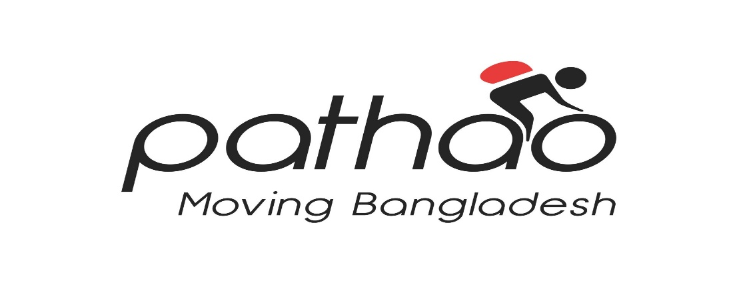
Prepared By
Tanjila Mirza
ID: 111 143 121
BBA Program
United International University

Supervised By
Dr. Md. Shariful Alam
Associate Professor
School of Business and economics
United International University

Date of Submission: 29th January, 2019


Letter of Acknowledgement

At the beginning of this report, I love to thank my Almighty Allah that I can successfully complete all the courses and come to this end stage of my BBA program.

First, I want to thank my respected faculty as well as my project supervisor, Dr. Md. Shariful Alam, Associate Professor, United International University, to allow me to work on my preferred company which is highly growing day by day in Bangladesh. Both the written or verbal support I have got were very important for me. It was not possible to complete the report for me without the guidance and support given by him.

I would like to express my sincere gratitude to Md. Muntasim Zawad, Communication and content specialist of Pathao Ltd. for giving me the articles related to my report and various important links of Pathao news. I would like to thank Mrs. Anurekha Chowdhury, MTO, Pathao Limited for helping me when I was having any difficulties.

At last but not the least, I would like to express my gratitude to all the respondents for giving a quick reaction to their response and seriously considering my survey question paper. All their valuable feedback helped me collect and finish my project report.

Letter of Transmittal
29th January, 2019

Dr. Md. Shariful Alam
Associate Professor
School of Business and economics
United International University

Subject: Submission of Project Report on Measuring Consumer-Based Brand Equity of Pathao Ltd.

Dear Sir,

I am highly glad to submitting you my project report on “Measuring consumer-based Band Equity of Pathao Ltd. Brand equity is driven by the quality of customer experience, including branding and marketing of the company. It is created from the consumer feelings and directly impacts on their behavior; Because of Brand equity customers buy expensive services and products even though the products or services get medium reviews.
All the supports and guidelines proved very important for me that were given by you during my project report. I am highly appreciate for your acceptance of the topic which goes perfectly with my major area.
I want to add that this report is made by me and all the data are taken from valid source of Pathao Ltd. The report steps provided by you were found highly relevant and were followed while preparing this report carefully.
I would be highly appreciate if you accept my project report and oblige thereby.

Sincerely yours,
Tanjila Mirza
ID: 111 143 121
BBA Program
United International University

Abstract

Pathao Ltd. began its journey in Bangladesh in 2015 with its own group of cycles and motorcycles. It started as a delivery service provider for various Bangladeshi e-commerce services, including the Daraz, a group of Alibaba (later changed in Rocket Internet). Later, in 2016, Pathao began using bicycle sharing services in mid-2016 and successfully registered more than 100,000 drivers and about 1 million users in March 2018 across the country. According to the Pathao CEO Pathao currently has a group of 50,000 bicycles and it has a brand value of more than $100 million as of June 2018.

The performance of the brand is not simple but it is possible to measure and provide value for branding activity, marketing, and the quality of overall customer experience. Without measuring the consumer-based survey of Pathao Ltd, it is impossible to understand whether different marketing efforts are contributing to its equity.

In this Project report, the effort has been provided to find out the consumer based brand equity of Pathao Ltd. through a survey on university level students of Bangladesh. In chapter 1, basic information of this project report is shared followed by the objectives and methodologies of the report in chapter 2 and 3. Chapter 4 is to clear basic ideas of some technical terms and chapter 5 is concentrated on the Pathao Ltd. The main part of the report is chapter 6 where the findings of the survey is being discussed.

Finally, some recommendations are shared of Pathao Ltd. based on the findings of the survey analysis. Hopefully, all the recommendations help Pathao Ltd. to improve its brand in coming days.

Keywords: Pathao Ltd. , Ride sharing, E-commerce, Brand equity, Customer loyalty

Abbreviations

BBA-Bachelor of Business administration
CEO- Chief Executive officer
UIU- United International University
BRTA- Bangladesh Road Transport Authority
VAT- Value Added Tax
CSR- Corporate Social Responsibilities.
App- Application
E-Commerce – Electronics Commerce

Table of Content
Chapter one
1.1 Introduction to the topic in hand 2
1.2 A brief introduction of the ride-sharing and parcel delivery sector 2
1.3 Rational of the study 3
1.5 Background of the study 3
1.5 Limitations of the study 3
Chapter Two
2.1 Objectives of the Study: 6
2.2 Methodology of the Study: 6
a. Data design 6
b. Data collection process: 6
Chapter Three
3. Literature Review: 9
3.1 Brand Equity 9
3.1.1 Brand Identity 9
3.1.2 Brand Awareness 9
3.1.3 Brand Personality 10
3.1.4 Brand Loyalty 10
3.2 Importance of measuring brand equity 11
Chapter Four
4.1 Organizational Profile: Pathao 14
4.2 Mission 14
4.3 Vision 14
4.4 Values 14
4.5 Types of Services 15
4.6 Major Competitors 15
4.7 A SWOT Analysis on Pathao 16
Chapter Five
5. Findings and Analysis of the Survey 19
Chapter Six
6.1 Recommendations 26
6.2 Conclusion 27
7. References 28

Chapter One
Introduction
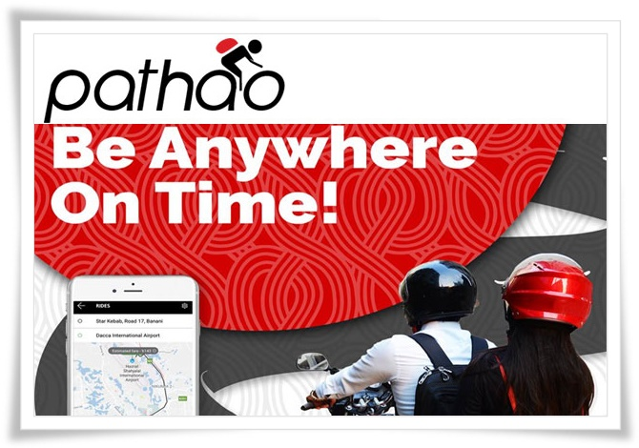

1.1 Introduction to the topic in hand
Pathao Ltd. began its journey in Bangladesh as a delivery service in 2015 with his own group of cycles and motorcycles. It started as a delivery service provider for various Bangladeshi e-commerce services, including the Daraz, a group of Alibaba (later changed in Rocket Internet). Later, in 2016, Pathao began using bicycle sharing services in mid-2016 and successfully registered more than 100,000 drivers and about 1 million users in March 2018 across the country. According to the Pathao CEO, Hussain M. Elius, Pathao currently has a group of 50,000 bicycles and it has a brand value of more than $100 million as of June 2018.

Brand’s Equity or Value refers to the additional value that a customer attributes to the brand that is distinctive compared to all other brands available in the market. Additionally, Brand Equity means the consumer awareness, consumer perception, and a client's loyalty to the brand. In summary, the equity of the brand is the goodwill that a brand has gained over time.

The marketers basically follow the consumer-based survey approach in which they understand a consumer's reaction to the brand that can be reflected in the frequency of purchase. It focuses on the consumer's perception that is, what they have felt, read, thought about, expected in the brand and how much the brand has helped meet their need.

1.2 A brief introduction of the ride-sharing and parcel delivery sector
The city ride-sharing has become a popular and impressive event for most residents of the city. The impact of bicycling is noticeable in 2017, in terms of 50% growth in bicycle sales. The unexpected recognition of ride-sharing is mainly directed to pick up and drop off services to the consumer's door. It is not easy before to find a car/bike in emergency hours and the city-dwellers were never before got help from other public for transportation unless the person were not a taxi driver. From another point of view, the growth of purchasing power of the middle-class families, creating space to enrich the ride-sharing and parcel delivery sectors. And this incident is no longer limited to the megacity boundary such as Dhaka city; it has spread rapidly in other parts of the country. These Ride-sharing sectors create employment opportunities for more than 40,000 people, claiming this sector's commitment to economic prosperity. However, due to the recent announcement of 5% VAT on ride-sharing, the service will become expensive, the higher authorities will take action seriously and evaluate how the new regulations will affect the beginning of sharing of millions of passengers and local travel.

1.3 Rational of the study
In our educational system we still believe in memorizing theories and writing them on our test sheets like a machine. However, United International University (UIU) allows us to get the feel of the practical world outside the book theories with the internship and project program. The students who follow a project program of at least three months to experience and observe what is happening in the practical world of business and try to incorporate their knowledge and learnings, and prepare his/her project report according to their major area. In this report, I have shared my last three month’s observations of Pathao Ltd. In this project report, I have tried to find out the consumer-based brand equity of Pathao Ltd Bangladesh. I had prepared a survey questionnaire, and surveyed some university students through Google docs to measure their satisfaction level. This report can be used to conduct more in-depth investigations or to learn about Pathao's marketing and branding activities. Finally, this report can be useful for students and trainees to improve their knowledge on Pathao in the upcoming days.

1.5 Background of the study
All of the students of United International University have to go through either Internship program or Project program to acquire the Bachelor of Business Administration (BBA) degree. In Internship program, students have to work in any organization and after three months of working inside an organization they have to prepare a report based on their internship experience under the supervision of any of our respected faculty. On the other hand, in a project program, it is not necessary to work inside a organization rather students have to observe any organization, sector or any industry of Bangladesh and select a title based on his major area, also under in the supervision of respected faculty. I selected my project topic “Measuring Consumer-Based Brand Equity of Pathao Limited”. Pathao Limited is highly growing company who provides parcel and ride-sharing services in Bangladesh. It started its journey as a ride-sharing company in 2016, and now in January, 2019, within 2 years there are hardly any person can be found who does not know pathao and its services. So measuring its brand equity will be a valuable one.

1.5 Limitations of the study

During the last three months of my project program, I realized that it is not easy to perform all the work of my project report. A lot of difficulties were encounter while surveying on such a popular ride-sharing company. Several mixed and biased reaction I have observed while evaluating Pathao Limited. Some of these limitations are listed below:

- Short time period: The three months of this project program is not enough to perform such an extensive study.
- Confidentiality: A lot of business confidentiality are requested to me by the Pathao officials to disclose.
- Lack of information: As Pathao is a new company with an innovative business, there are very few information available and people are not also very aware of overall ride-sharing process. All these creates problems while collecting my Data.

Chapter Two
Objectives and Methodology

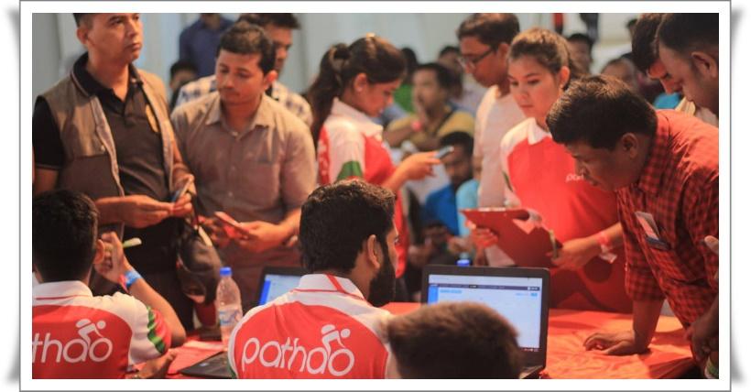

2.1 Objectives of the Study:
Objectives are set of information from what a reader of this report can directly get the essence of this report. Moreover, the objectives portrays goals for what the report is conducted and what are the goals for what the report is prepared. The objectives of my report can be shared into two sections. They are:

- Primary Objectives
The primary objective of making this project report is to achieve the Bachelor of Business Admiration (BBA) degree from United International University, as it is a pre-requirement.

- Specific objectives
These objectives are more important than, that of primary objectives. It displays the Specific and more accurate goals of this project report. The specific objectives are:
- To share an overview of Pathao Ltd.
- To analyze the concept of Brand Equity.
- To analyze the consumer based Brand equity of Pathao Ltd.
- To find-out the findings and share some suggestions to improve Pathao Ltd.

2.2 Methodology of the Study:
  - Data design - I have gathered the information of consumer-based brand equity of Pathao by directly face to face communication with the university level students. I have prepared a questionnaire on Google Forms and then invited students of various institution to fill up the survey through social media sites such as Facebook, Google and so on.

  - Data collection process: I have collected theoretical information for my project report from various sources. These sources are divided into two parts. They are:
- Primary Sources:
- Face to face communication with Pathao trainers and riders.
- From personal delivery and ride sharing experiences.
- Through Survey questionnaire.
- Secondary Sources:
- From the online websites of Pathao.
- From various blogs and articles on Pathao.
- From Daily newspaper.

  - Sample design: The users of Pathao in Dhaka city is huge. I had targeted to take 100 responses from the university level students who lives in Dhaka city, surprisingly responded 125. I am going to present the 125 responds in the analysis and findings part.

  - Analytical tools: The major analytical tools used to create the survey and to collect the responses is Google Form. However, charts and some other data have shown using MS Word and MS Excel.

Chapter Three
Literature Review
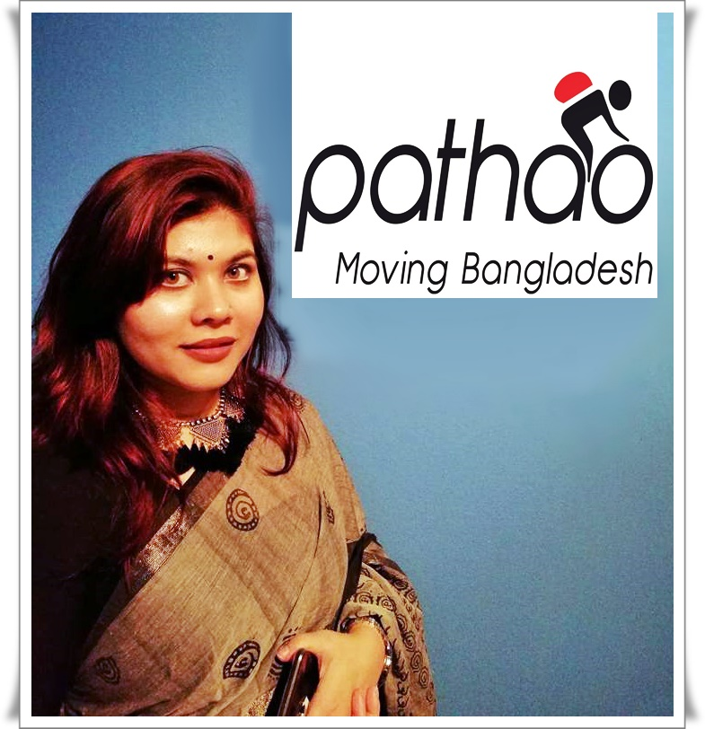

3. Literature Review:
Literature review is to theoretical discussion of the study. Its primary purpose is to share the theoretical concepts. In this chapter, I would like to clear basic ideas of some technical terms to the reader of the report such as:

3.1 Brand Equity
The Brand Equity is a set of assets and liabilities related to the brand and symbol that are added or subtracted from the value provided by a product or service. The concept is used to determine the value of a brand, based on the assumption that established and reputable brands are more successful. The link between "Equity" and concepts of "Brand" has drastically altered the marketing function, which has allowed it to go beyond strategic tactics and get a seat at the executive table.

The Management of Brand Equity

3.1.1 Brand Identity
According to Lake (2009), brand identity is the message that the customer receives from the product, the person or the thing. The brand identity will combine the recognition of the product. For example, a roadside survey was conducted asking city residents to reveal the main product that sounds when they hear the word, Bose? Constantly, it was the earphones. It's obvious that Bose built the brand identity for its earphones.

The identity of the brand must be a constant message from its group of spectators. In the case that a part of the identity is a specific tone, the consistency of the nuance is fundamental to maintain the identity of the product. The identity must correspond to the image anticipated by society in general.
(Source: Laura Lake, 2009, "Consumer Behavior for Dummies," Available at: https://www.thebalancesmb.com/brand-identity-and-marketing-2295442)

3.1.2 Brand Awareness
According to Aaker (2009), the brand awareness is the possibility that customers know the valuable life and accessibility of the product. This is how much buyers precisely connect the brand with the explicit product. It is estimated by the extent of the specialty showcase that has past learning of the brand. Brand recognition incorporates both brand recognition and brand evacuation. The recognition of the brand is the capacity of the buyer to perceive the learning of the past brand when the stamp is asked for or when it is demonstrated that an explicit brand, ie purchasers can plainly recognize the check that has been seen or heard beforehand. Despite the fact that the evacuation of the stamp speaks to the customer's capability to recover a check from his memory when he is doled out the classification/class of the product, this classification or buy situation must address the issues as a flag. As such, it implies that shoppers should effectively recuperate birth and memory when they have a file or they can recollect the explicit brand when the product class is referenced. All in all, it is less demanding to perceive a sign than to recover it from memory.
(Source: David A. Aaker, 2009, Professor Emeritus of Marketing Strategy, Haas School of Business, Book Name: Managing brand equity)

3.1.3 Brand Personality
According to Gelder (2003), the brand personality states to a brand's personification. Basically, it is included in a set of features or human traits or a brand. When brand personality is created, characteristics like human beings, such as care, creativity, trust, unique, direct, rebel, dishonest, etc which is part of brand features.

Moreover, the brand personality refers brand behavior or ways to communicate with users. Human characteristics refers to those represented by the behavior of the brand (for example, employees) as well as packaging, advertising etc. When brand image or brand identity is expressed as a human feature, then speaks of a brand's personality.

(Source: S Van Gelder, 2003, Book Name: Global brand strategy: unlocking brand potential across countries, cultures & markets)

3.1.4 Brand Loyalty
According to Grace and Chia-Chi (2009), brand loyalty is a marketing term that demonstrates the buyer's responsibility to redeem or continue to use the brand. This can be demonstrated by the regenerated purchase of a product, benefit or other positive behavior, such as a positive verbal statement. This brand idea shows images and images of a product or service. Brands can have the ability to attract buyers and give them an enthusiastic connection. The beliefs and mental patterns of the buyers are the brands, which influence the way they will see the brands with which they interact. The encounter with the brand occurs when buyers buy or search for products for the buyer. For example, when you come into contact with brands, encounters involving relationship, play and feeling are included. The deeper these feelings are deeply rooted and social in the individual, the more the continuous buying behavior will be important. When contact is established, a mental thought will occur, followed by a decision to buy or not to buy. This may require continuous buying behavior, which requires the initiation of brand loyalty. Brand loyalty is not linked to continuous buying behavior, there is deeper mental thinking since an individual constantly buys branded products. Brand loyalty can be quickly termed a "will to act" to maintain partnerships with a specific brand. In a survey of approximately 200 distributors, 68% said they thought the "loyalty" measure was exceptionally useful.
(Source: Lin, Grace T.R.; Chia-Chi, S. (2009). "Factors influencing satisfaction and loyalty in online shopping: An integrated model". Online Information Review. 33 (3): 458–475)

3.2 Importance of measuring brand equity
Brand individuals, small business owners, and big companies have become one of the most valuable success stories. The question and delusion that most companies find is their brand equity. Measuring brand equity, sometimes called brand value, is a term used in marketing to identify brand knowledge measurement.

The reasons for measuring brand fairness include market share, consumer perception and acceptance, profit margin and all words, phrases, coins, jingles which customers can easily recognize.

The factors of quality, performance, respect, value, reliability, longevity, and trust brand impact that consumers decide to purchase. All these factors can be realistic or may be felt by customers' minds. However, more consumers are willing to pay the premium for big brands.

Real product brands are much easier than measuring service-based brands. It is very easy to compare the two types of smartphones. Will cover the label and allow people to recognize the best smartphone, whether they will reveal whether there is a brand's underlying value or perceived value. It is not possible to compare two competing ride-sharing companies by hiding the label. For this type of company, additional measures will be needed to measure brand value.

It is important to understand that it consists more than a brand logo. It is characterized by its image, its perception, and its name. It is more important with the advent and popularity of social networks. Each publication, tweets, and commentary helps to build or reduce a brand. Avatars, professional pages, photos, etc. It is strategically selected and used effectively. In fact, if a brand is called "earned money," it can be used as an indicator to measure the quality of a brand.

The winning method basically means that people of different social networking sites and prospective consumers are positive about your brand. This is not just a brand value indicative, it is a necessary measurement of the brand's online presence.

Finally, the objective is not only to measure the value of a brand, but also to increase and protect it. The best way to learn and determine the indicators to measure your brand value.

Chapter Four
Organizational Overview of Pathao

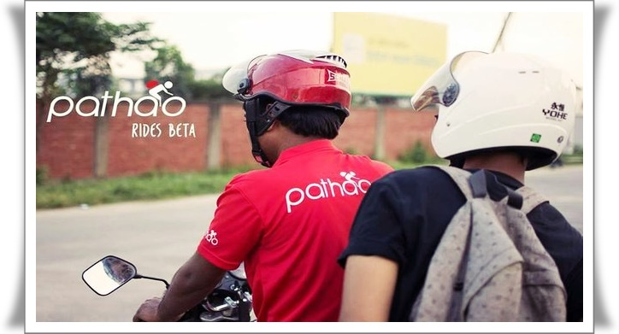

4.1 Organizational Profile: Pathao
Pathao Ltd. began its journey in Bangladesh as a delivery service in 2015 with his own group of cycles and motorcycles. It started as a delivery service provider for various Bangladeshi e-commerce services, including the Daraz, a group of Alibaba (later changed in Rocket Internet). Later, in 2016, Pathao began using bicycle sharing services in mid-2016 and successfully registered more than 100,000 drivers and about 1 million users in March 2018 across the country. According to the Pathao CEO, Hussain M. Elius, Pathao currently has a group of 50,000 bicycles and it has a brand value of more than $100 million as of June 2018.

4.2 Mission
‘Moving Bangladesh’ is the mission statement for Pathao. It is emerging concrete explanations to address the country's main structural challenges. Afterward the setting up of e-commerce distribution company in Bangladesh, Pathao is now being developed on on-transport services. Utilizing an energetic motorcycle team, Pathao’s mission is to provide solutions using technology power to change all the districts of Bangladesh.

4.3 Vision
The current vision of Pathao is ‘One app, all solutions’. Pathao is trying to provide solutions to several inside problems of Bangladesh. The company is currently providing their several delivery and ride sharing services to only Dhaka and Chittagong city. Their vision is to provide Bangladeshi people a hassle free transportation services and spread their business not only all over Bangladesh but also in the global market, as there are very few competitor exist in international market.

4.4 Values
At Pathao, everything begins with the clients and riders. The organization values the majority of its accomplices with sheer regard and significance. This spearheading soul comes to back to its enterprising roots, motivating cooperation, development and particularly straightforwardness over the majority of its stages. The Pathao might be neutralized inside the accompanying focuses:

- Leaders area unit fully grown, not made.
- Everyone matters.
- Never stop learning.
- Keep moving and continue to grow.
- The Empathy and kindness.
- Everyone builds.

4.5 Types of Services
According to the Pathao online website, Pathao provides five kinds of services. They are:

Chart 1: Services of Pathao

4.6 Major Competitors

Chart 2: The Major Competitors of Pathao

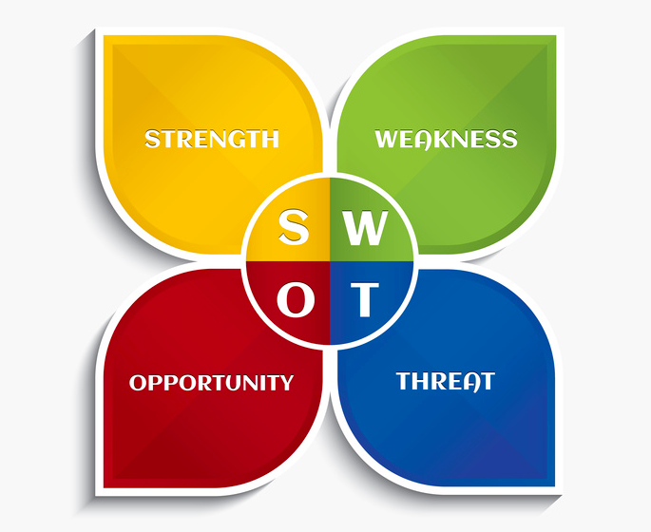
4.7 A SWOT Analysis on Pathao
Chart 3: SWOT Analysis
- Strength:

- Weakness:

- Opportunities

- Threats

Chapter Five
Findings and Analysis of the Survey

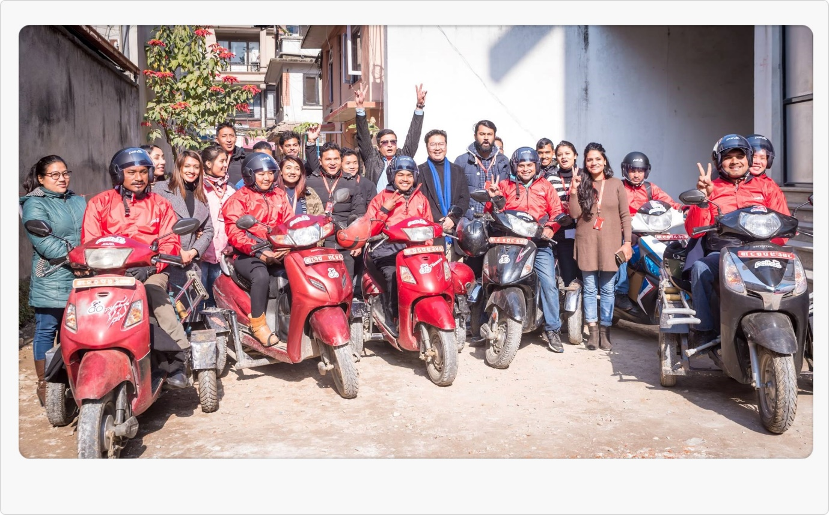

5. Findings and Analysis of the Survey

The measurement of consumer based brand equity of Pathao has been done using a consumer survey through Google Form. Total 125 students of different university who provided responses. The responses are going to show below using Pie / Bar charts under each questions so that it might help to understand the brand equity of Pathao.

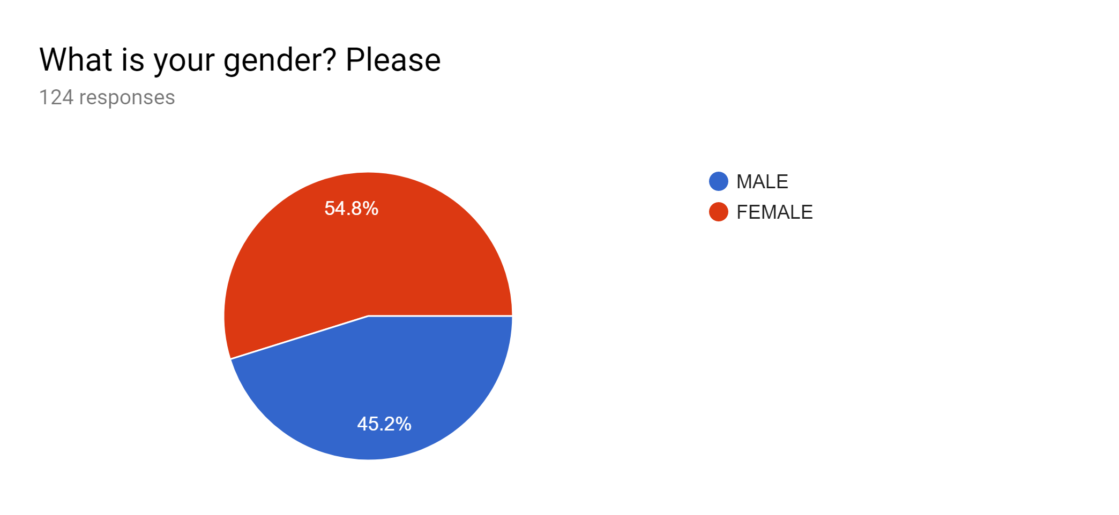

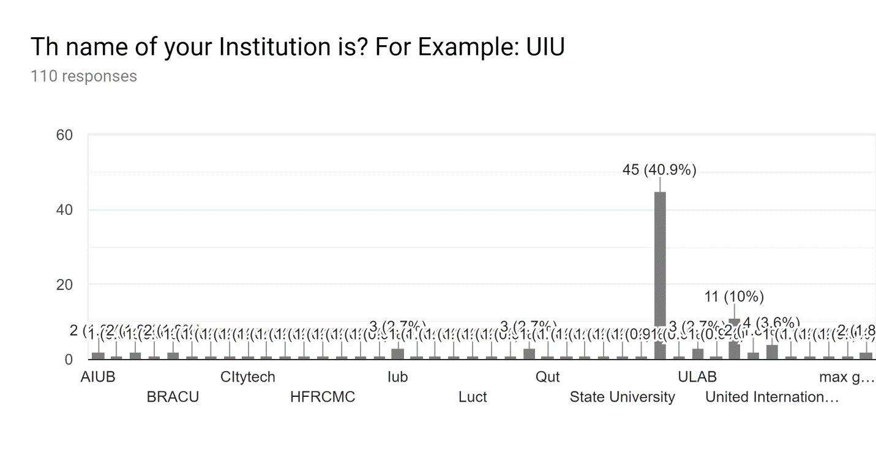
Interpretation: Total 124 students answered the question, where 68 students were female and 56 students were male. All the students are from Dhaka City.
Interpretation: The students were from different university and institution that are being shared the bar chart above. The majority (40.9%) of the students were from the United International University which was in total 45 students among these 110 students who responded in this question.

General Information on Pathao, Bangladesh

In this section, I have tried to acknowledge whether my respondents are aware of Pathao or not. The Questions are given below:
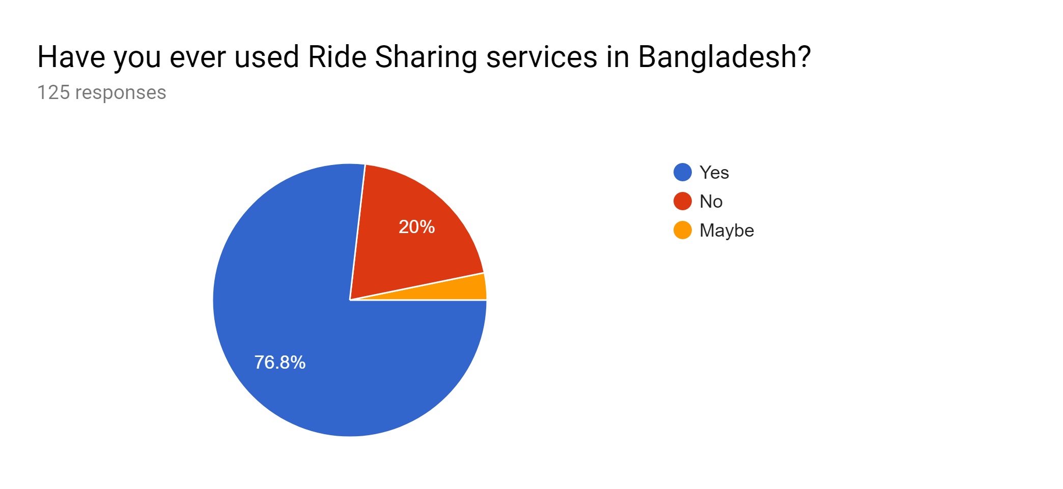
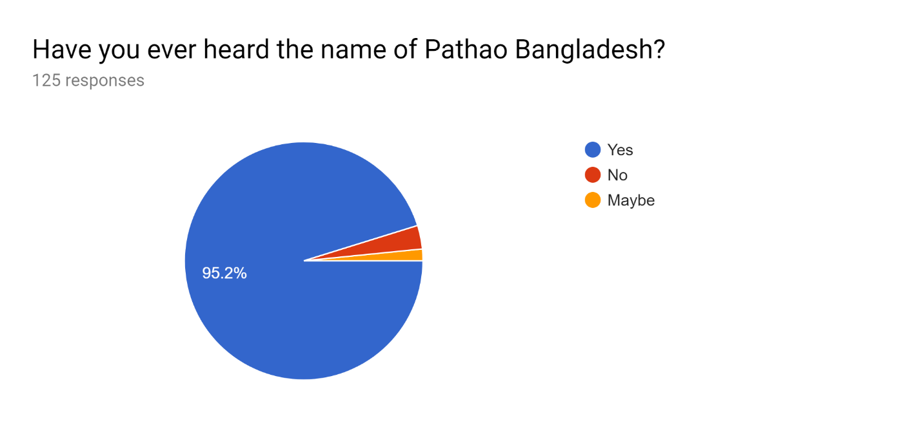
Interpretation: The pie chart above shared that among 125 respondents, 76.8% of the students or 96 students used the ride sharing services. 25 students or 20% of the students never have taken such services yet.
Interpretation: From the 125 students who responded the question, 119 (95.2%) students replied that they have heard the name of Pathao and 4 (2%) students are there who never heard the name of Pathao.
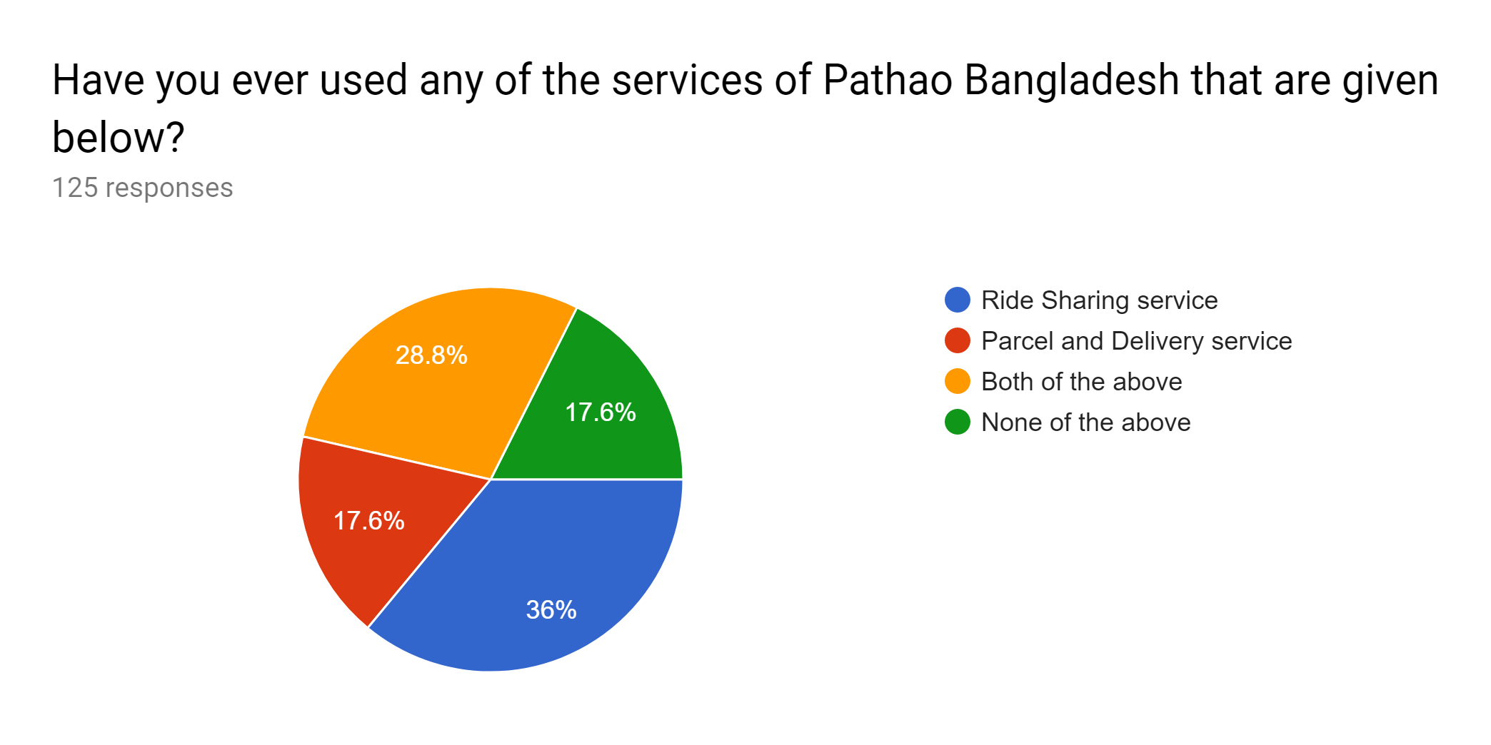
Interpretation: 125 students answered the question above and the reply were equal and mixed. Most of the students, around 36% students only used the ride sharing services of Pathao, 17.6% have used Parcel and delivery services and 17.6% students are here who used both of the services of Pathao. So, the graph shows that the usage percentage of Pathao is far high than none of the above option of the question.

Specific Information on Measuring Brand Equity of Pathao, Bangladesh
In this section I have asked few specific questions using Likert scale to the students to get some concentrated information of Pathao. The findings are sharing below:
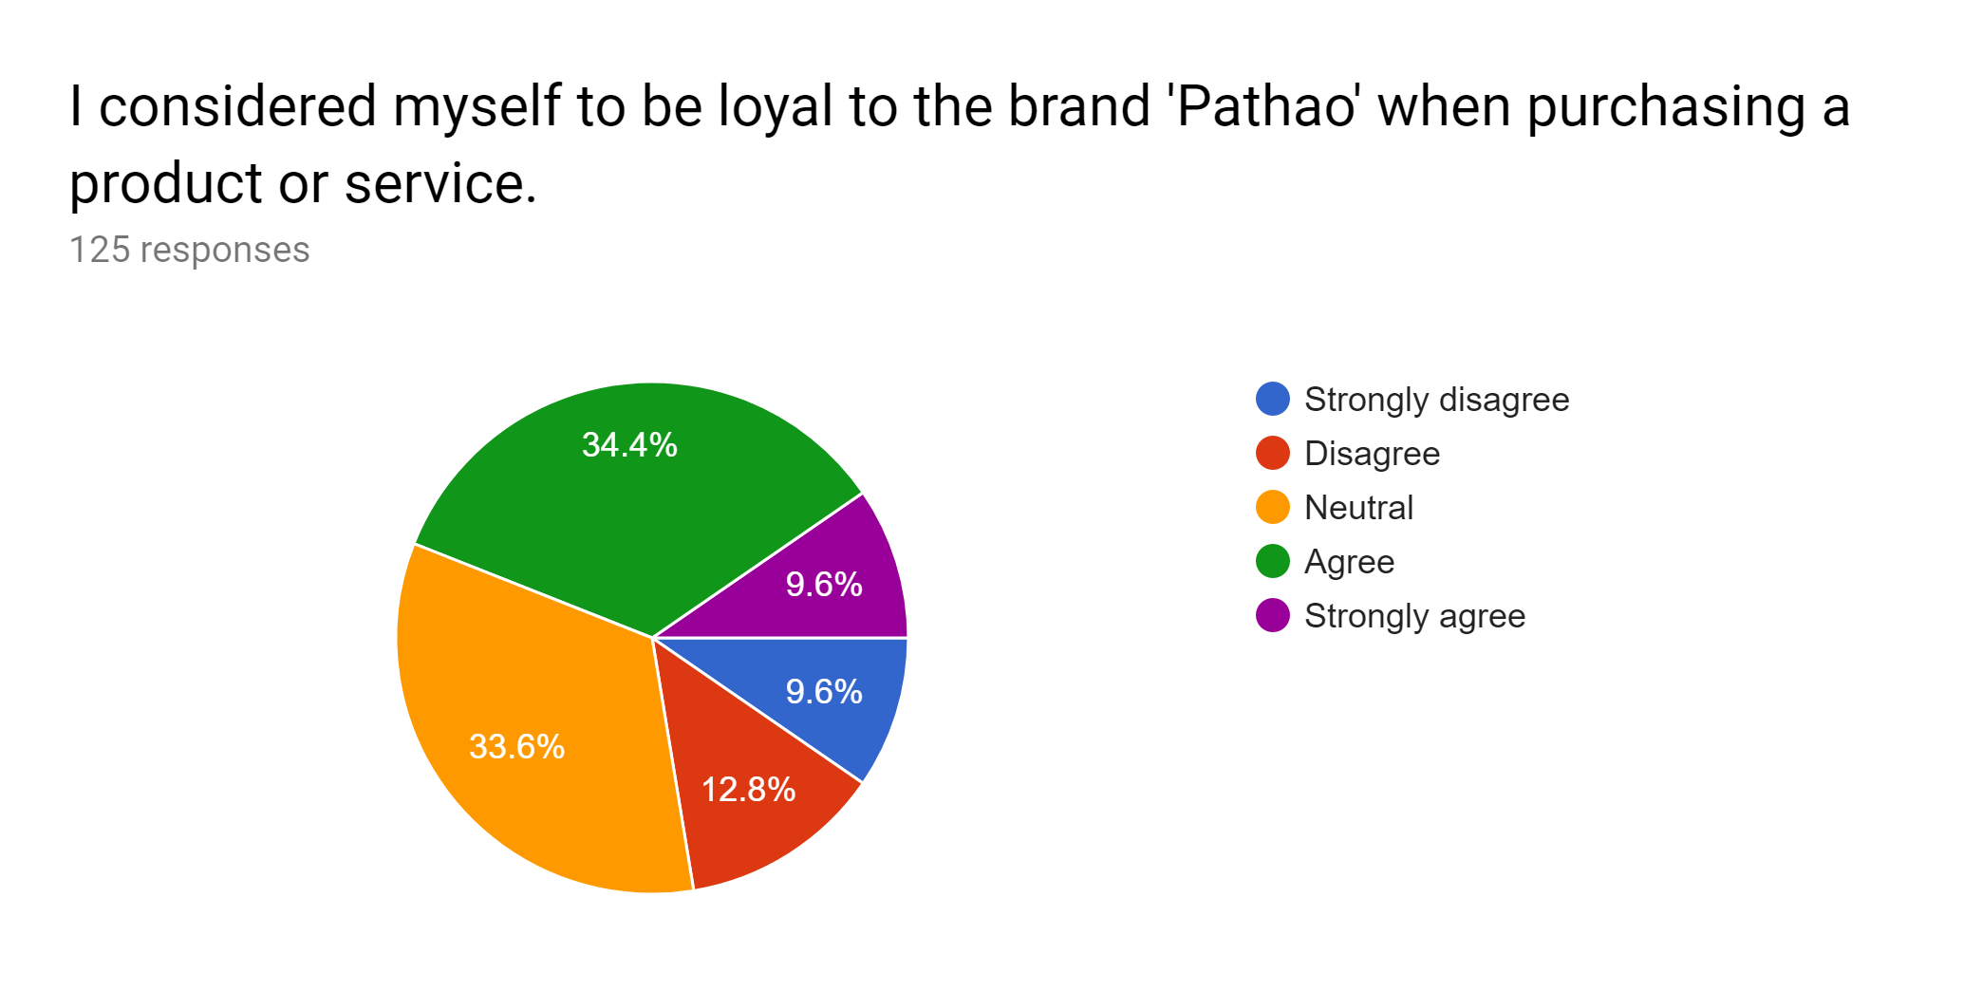
Interpretation: Among 125 students, 43 (34.4%) students are agreed, 42 (33.6%) were neutral, and 12 students were strongly agreed with the statement given above. Though there are few of 28 who strongly agreed (12) or disagreed (16). But still the majority of the students consider themselves to be loyal with the Pathao brand.
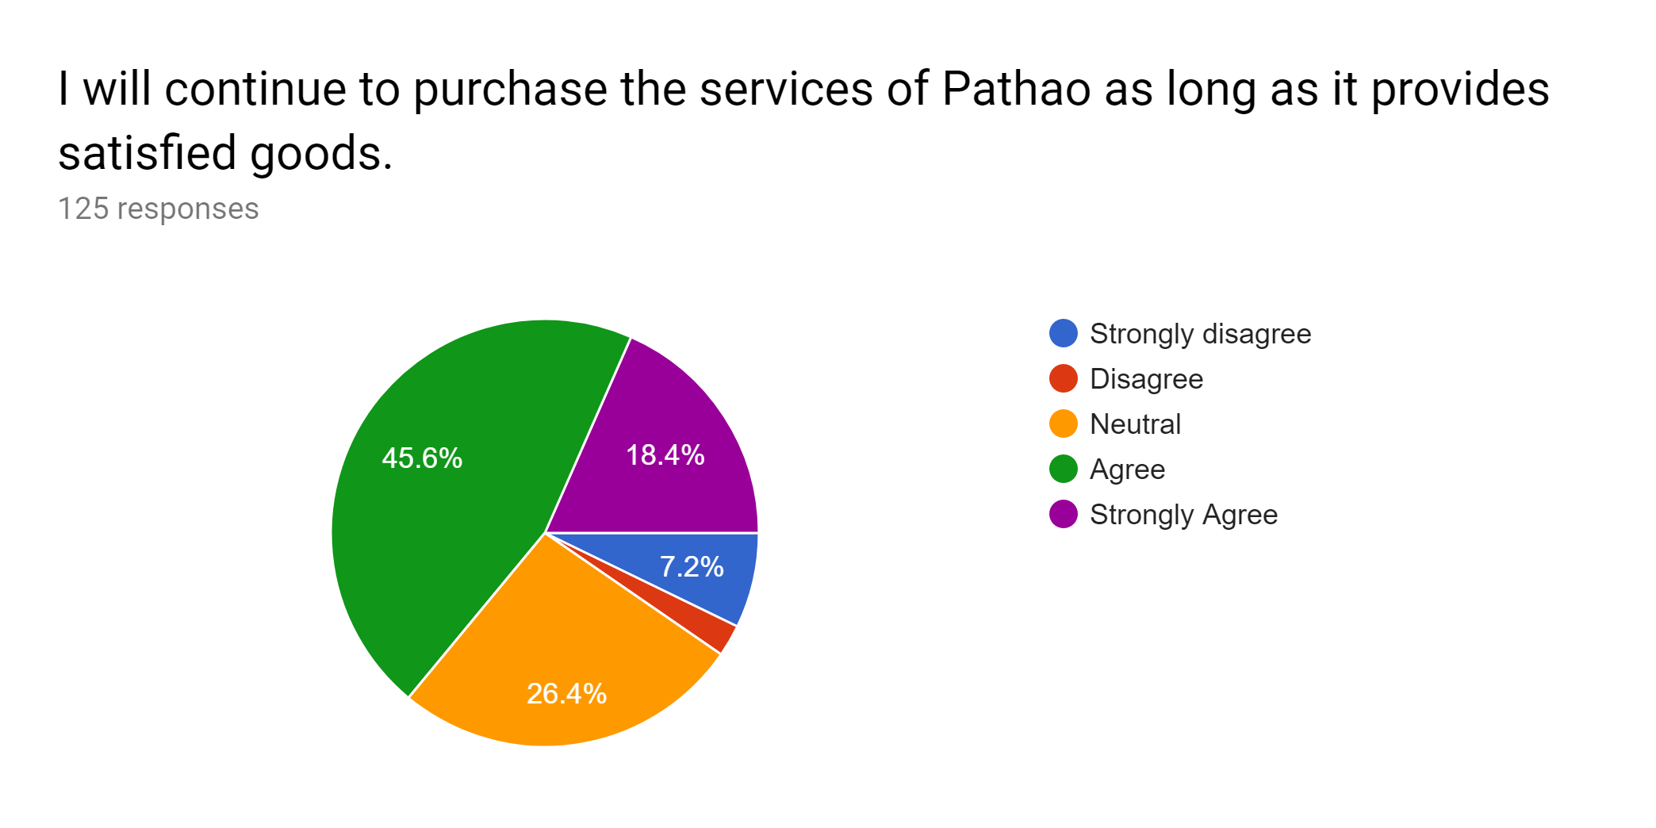
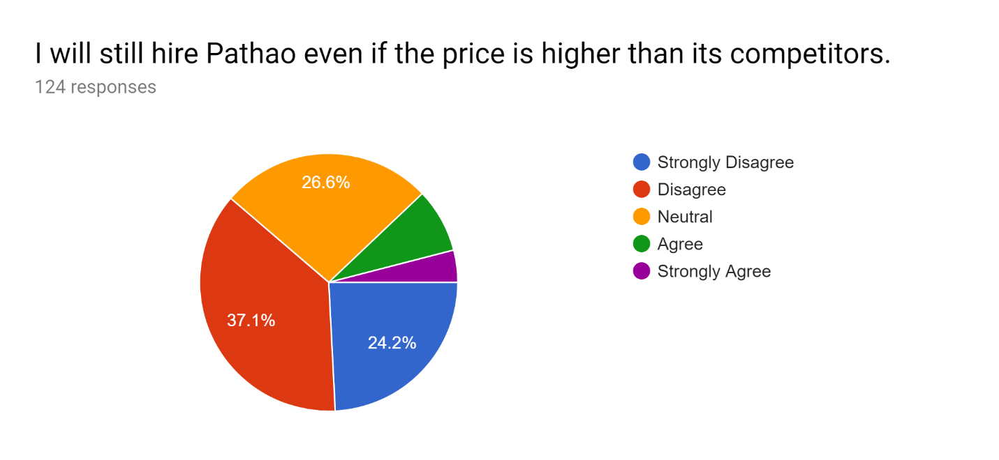
Interpretation: Among 125 responses of the above statement, the majority of 45.6% or 57 students who were agreed and 18.4% or 23 students were strongly agreed to the statement above. Though there were few neutral, disagreed, and strongly disagreed students exist in the graph but they were very low in terms of the agreed students.

Interpretation: This statement answered by 124 students and among them the majority of the students disagreed or strongly disagreed with the statement above that if the price of the services goes high compare to the price of other competitors of Pathao, the students will not hire Pathao anymore.

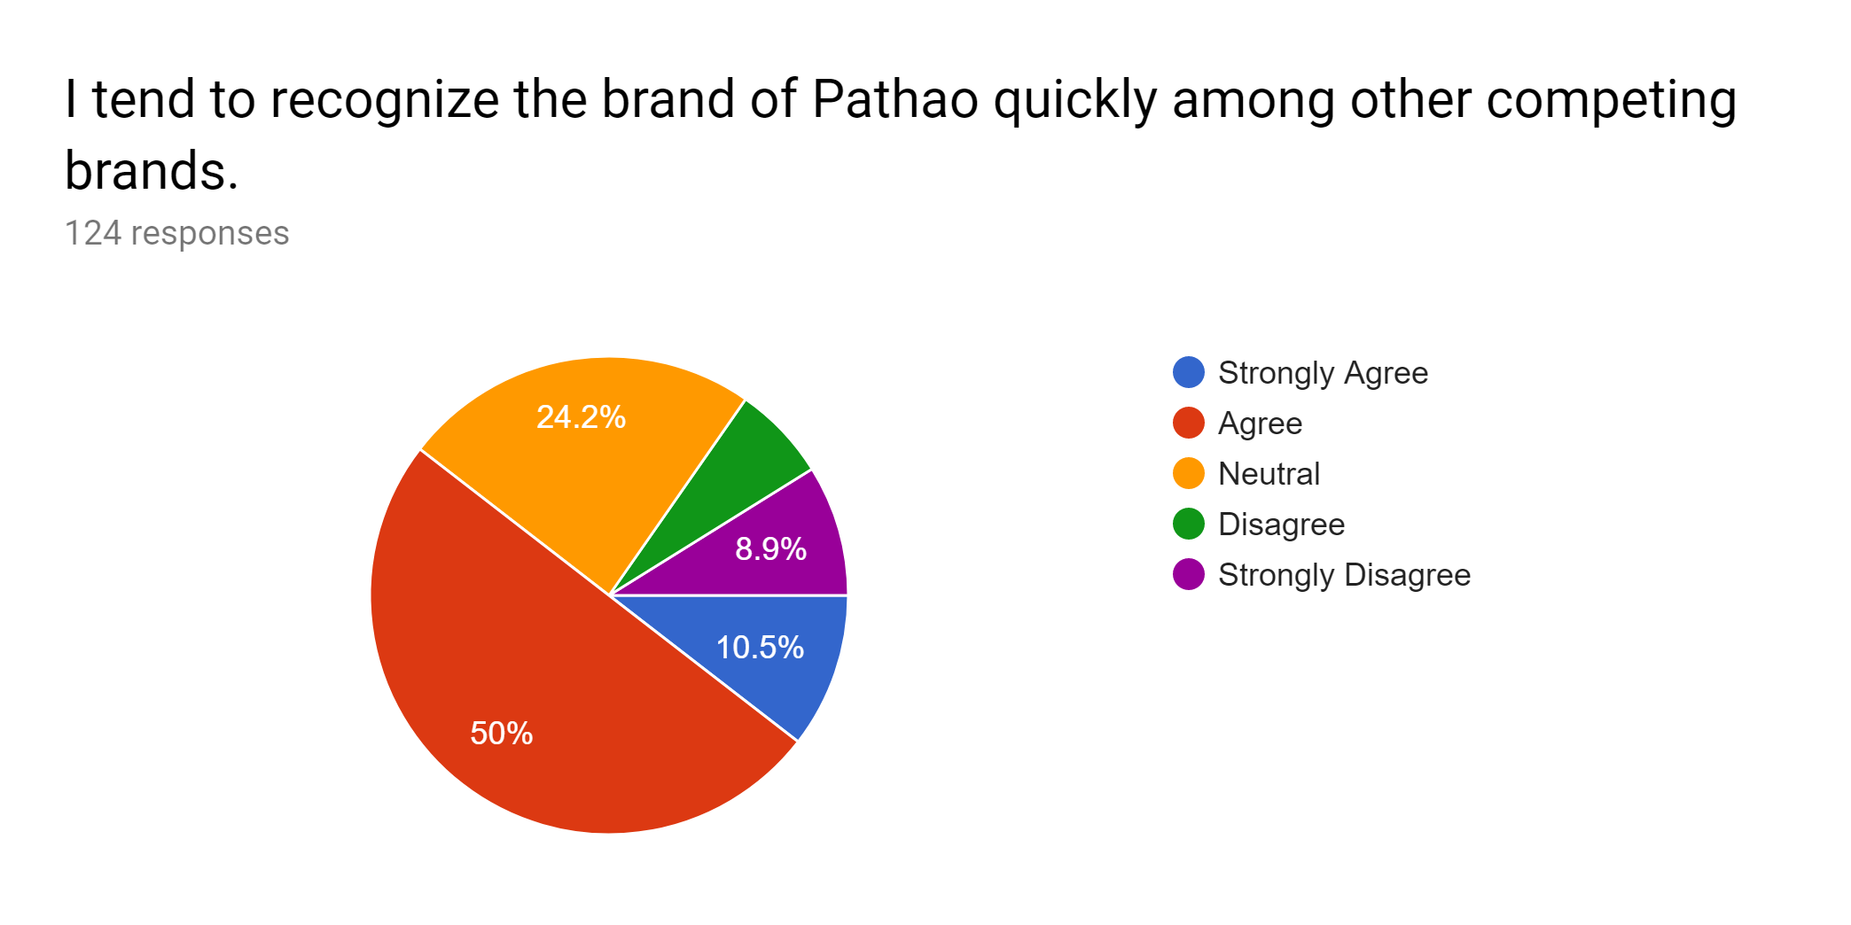
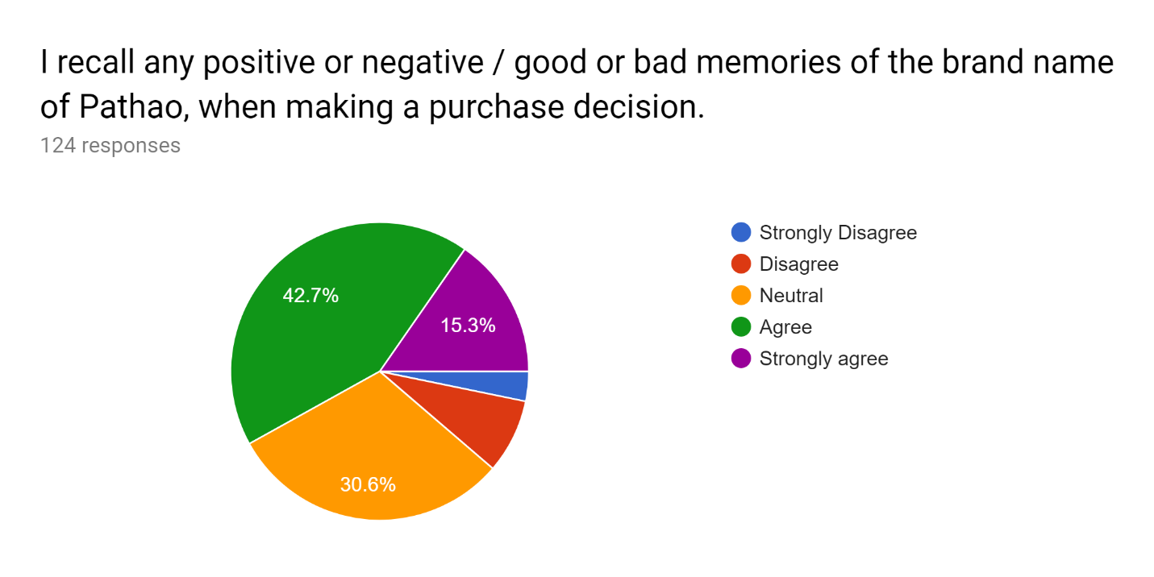
Interpretation: 124 students shared their opinion on the statement above and 50% means 62 students strongly agreed and 13 students were strongly agreed. They replied that they tend to recognize Pathao quickly whenever they see Pathao logo among other competing brands.
Interpretation: 124 students answered the statement and 42.7 or 53 students were agreed, 15.3% or 19 students were strongly agreed that they recall the positive and negative memories when they purchase any products or services of Pathao. Though there are 30.6% of the students replied neutral and very few are here who disagreed with the statement.

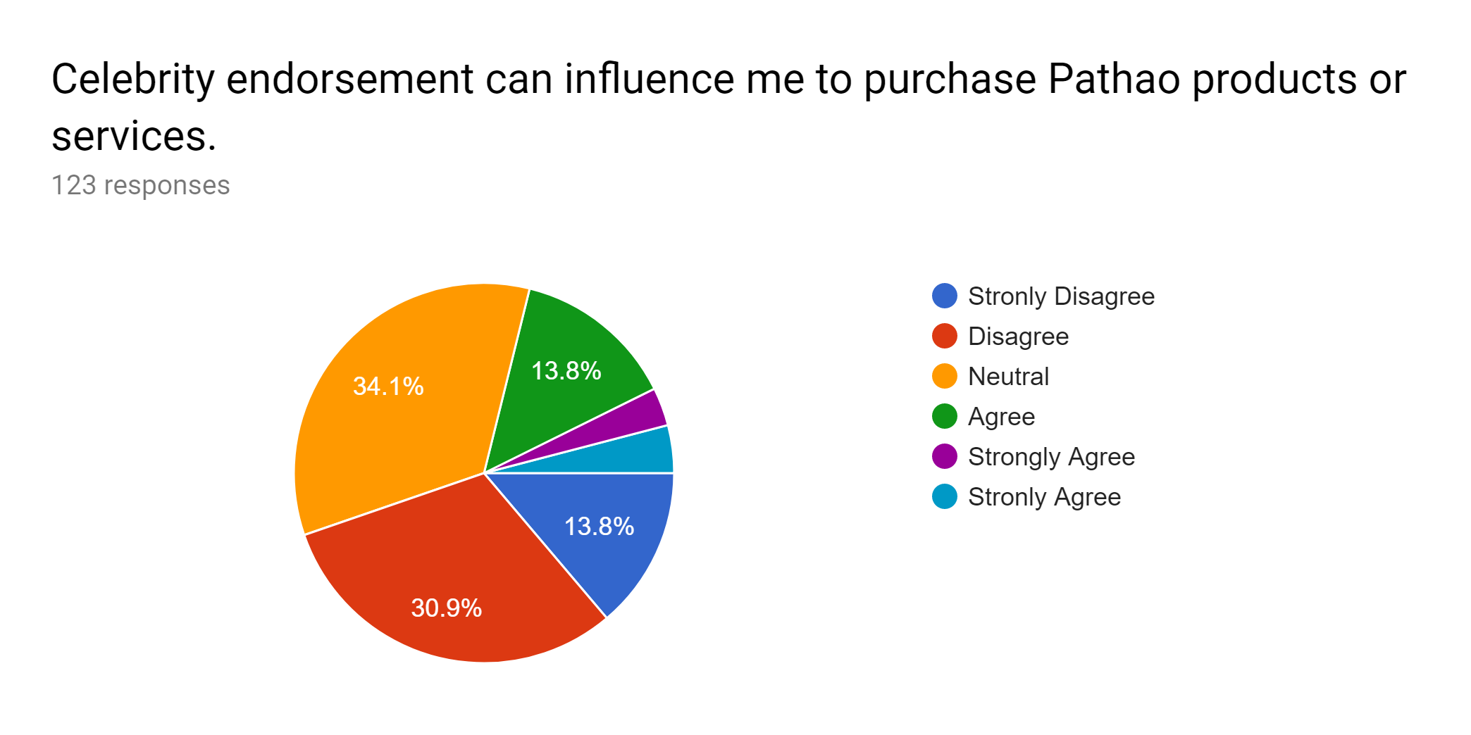
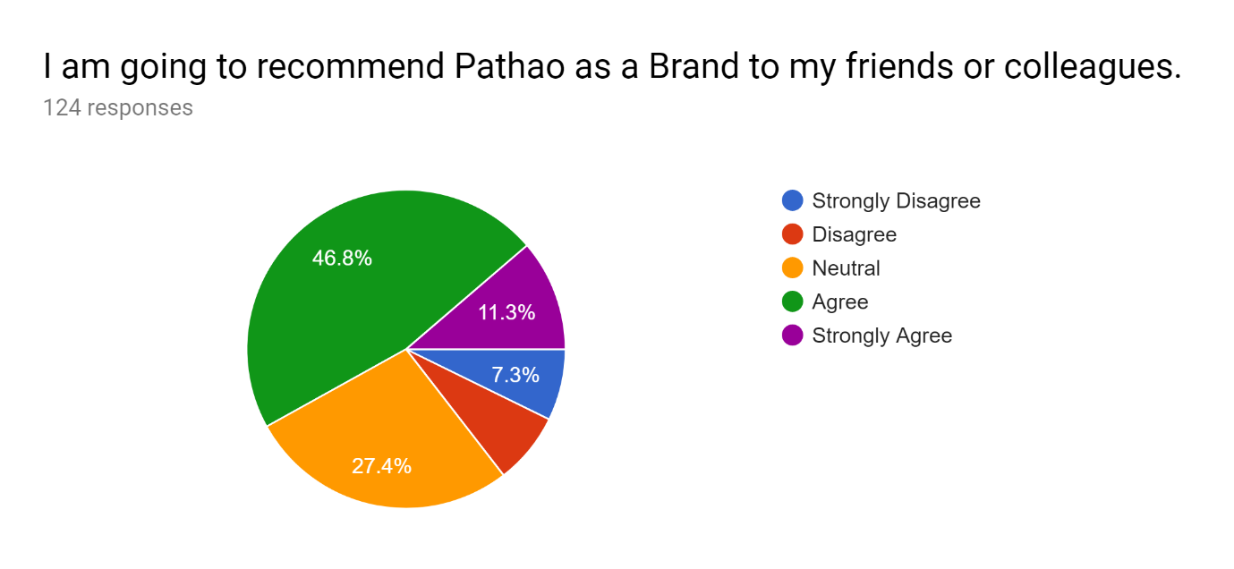
Interpretation: Among 123 responses of the statement above the majority of the students were neutral. 30.9% or 30 students were disagreed, 13.8% of the students agreed, 7.4% or 9 students strongly agreed with the statement. So, it can be said that Pathao should not use celebrity endorsement to promote their brand rather they need to focus on their riders and maintain safety to the consumers.
Interpretation: Among the 124 respondents, 58 or 46.8% of the students were agreed and 14 or 11.3% of the students were strongly agreed that they will recommend Pathao to their friends and colleagues. A very few students either disagreed or strongly disagreed with the statement above. As the percentage of disagreed students (7.3% + 7.3%) were very low than the agreed percentage, it can be conclude that Pathao is still a favorable brand in Bangladesh.

Chapter 6
Recommendations and Conclusion

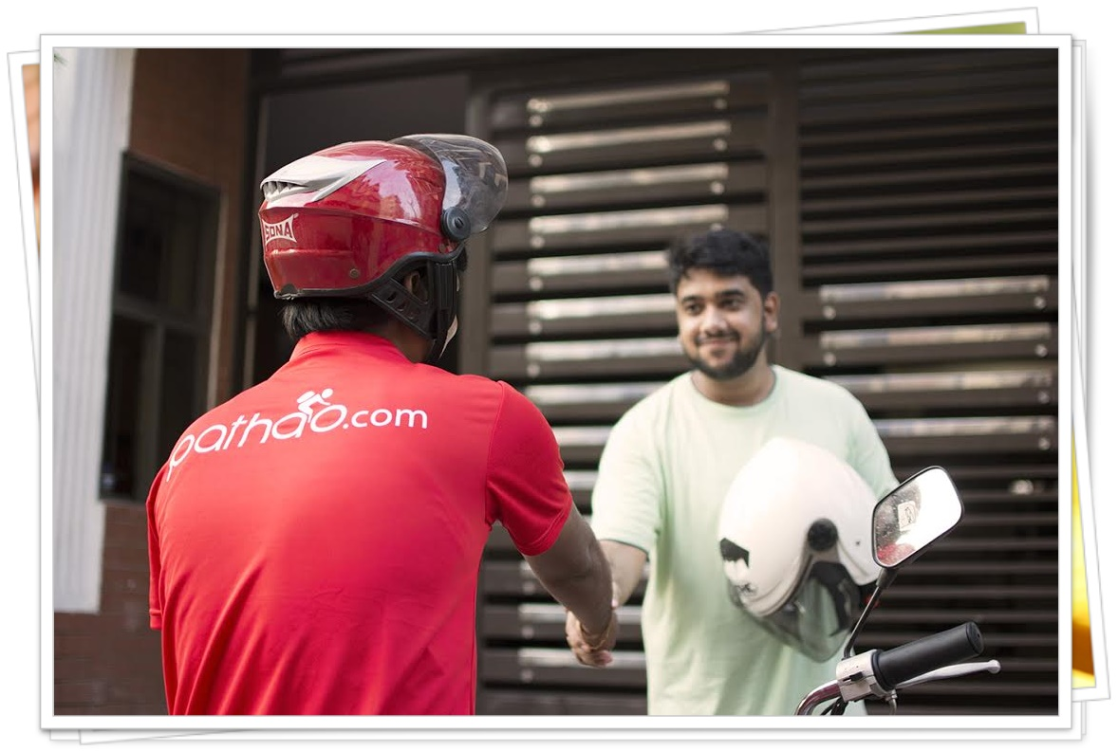

6.1 Recommendations
After analyzing and findings of the survey, it is clear now that Pathao holds a good delivery and ride sharing service brand of Bangladesh. The company needs to concentrate more on their brand equity and deliver more satisfactory services and awareness to their consumers. In this chapter, I would like to share some suggestions to Pathao for the betterment of their consumer-based brand equity.
- First of all, we have already seen that there are few students who still didn’t heard of Pathao as they do not use the services Pathao is currently providing. So, Pathao needs to increase their services to reach all the consumers demand. It will help Pathao to increase the awareness of the Brand.
- Pathao should increase the service quality and safety to its consumer.
- As we can see the students mostly replied that if Pathao increase its service price than its competitors, they will not hire Pathao services anymore. Pathao need to be cautious on its pricing strategy to improve its brand value.
- Pathao should train their riders to improve its consumer satisfaction and need to reduce the accident rate as consumers mostly recall the bad memories while purchasing any products or services.
- According to the survey, Pathao should not invest much on the celebrity promotion rather they need to improve its service quality and pricing strategy.
- Pathao can contract with the universities that are far apart from Dhaka city such as United International University and can provide bus and food facilities to the faculties and students of such universities.
- Pathao can advertise road safety awareness to its consumer though Television, Newspaper and Social media sites.

6.2 Conclusion
The value or equity of the brand is very important for the marketing of consumer products and services. The brand equity facilitates the extension of the brand and the functionality of the brand, because loyal customers are ready to accept brand extensions. There are methods to measure the value of the brand value, but measuring the brand value based on the consumer is very difficult. I have tried to present a survey to measure brand value based on the customer. The breadth of brand equity based on the customer has been improved on the basis of performance, value, loyalty and commitment.

E-commerce has a bright future in Bangladesh economy. Pathao can play an integral part of by its technological advancement if it can create strong brand equity inside the consumers mind.
Without satisfying the consumers, no brand can sustain for long time. Pathao should improve its lacking quickly and create the brand awareness among the consumers of Bangladesh.

The project report shows that Pathao is in a favorable brand value to the consumers of Bangladesh. Though the brand position is not highly strong among the consumers, Pathao needs to concentrate more on various infrastructural problems, more innovative services, and reduction of the accident rates. Moreover, Pathao ought to practice competitive pricing strategy and provide high quality, safety and security for its valuable consumers of Bangladesh to become a stronger brand among its competitors in Bangladesh.

7. References
(1) Abdullah Wasif, 2018, Article name: Using Pathao Rides, Available at: https://pathao. zendesk.com /hc/en-us/articles/115003522614-Using-Pathao-Rides.
(2) Pathao Reviews, 2019, Available at: https://www.glassdoor.com /Reviews/Pathao-Reviews-E1758349.htm
(3) Branding future startup: Pathao, 2018, Articles available at: https://futurestartup .com/tag/pathao/
(4) BRTA. (2017). Registered Motor Vehicle Statistics. [Online] Available: http://www.brta.gov.bd/newsite/en/dhaka-metro-up-to-june-2016/
(5) Laura Lake, 2009, "Consumer Behavior for Dummies," Available at: https://www.thebalancesmb.com/brand-identity-and-marketing-2295442
(6) David A. Aaker, 2009, Professor Emeritus of Marketing Strategy, Haas School of Business, Book Name: Managing brand equity
(7) S Van Gelder, 2003, Book Name: Global brand strategy: unlocking brand potential across countries, cultures & markets
(8)Lin, Grace T.R.; Chia-Chi, S. (2009). "Factors influencing satisfaction and loyalty in online shopping: An integrated model". Online Information Review. 33 (3): 458–475
(9) SD ASIA (2016) Pathao Aims To Solve Two Major Problems in Bangladesh [Online] Available: https://sdasia.co/2016/12/15/pathao-aims-to-solve-two-major-problems-in-bangladesh/
(10) Ullah, G.W. and Islam, A., 2017. A Case Study on Pathao: Technology Based Solution to Dhaka’s Traffic Congestion Problem. Case Studies in Business and Management, 4(2), p.100.

Appendix
Survey Questionnaire
