Payroll Management System in Python: A Study on payroll management

Payroll Management System in Python: A Study on payroll management

Submitted to:
Ahmed Imran Kabir
Lecturer
Management Information Systems (MIS)

Submitted by:
Amena Akter Mishu
ID: 111 172 002
Bachelor of Business Administration (MIS)

School of Business and Economics
United International University

Date of submission: 28th March, 2023

Letter of Transmittal

Date: 28th March, 2023
Ahmed Imran Kabir
Lecturer
School of Business & Economics
United International University
United City, Madani Avenue, Dhaka-1212

Subject: Submission of report on "Payroll Management System in Python: A study on payroll management".

Dear Sir,

This is to let you know that I tried to give my best to thoroughly research the selected topic which is "Payroll Management System in Python: A study on payroll management". As part of the university's requirements for my bachelor's degree, I conducted this project report. And also, I tried to generate a great outcome of this project report by studying various paper from different sources.
I am expecting you will have the generosity to accept this project report and provide me helpful critique regarding my effort.

Sincerely Yours,
Amena Akter Mishu
ID: 111 172 002
Signature: 
Date: 28th March, 2023

Certification of Similarity Index

Declaration of the Student

I, hereby state that the project report which is titled “Payroll Management System in Python: A study on payroll management” is genuinely made by me to fulfil the credit requirement for the degree of Bachelor of Business Administration. I tried to complete the project report according to the guideline of the university standard.
This report is not made by duplicating any data or information from any available sources. The information which I took from other paper from “Google scholar” I clearly mentioned their name and details and also cited them properly. The project report has not been submitted to any other university/educational institute.
This is the bona fide work of my own hard work and time which I invest to bring the best outcome to match the project requirements.

Amena Akter Mishu
ID: 111 172 002

Acknowledgment

First of all, I would like to thank Allah (S.W.T) for granting me such a scope to complete the project appropriately. I am glad to express my heartfelt gratitude to my project supervisor, Ahmed Imran Kabir sir who gave me the space to choose my project topic according to my preference and guided me for completing the task within time. Then I want to give thanks to the teaching assistant of our MIS department who have guided me to the entire project and helped me to understand the task according to the topic which I have selected for my project.
And finally, I would like to give thanks to all of those who have contributed to my project directly/indirectly an bring it to the completion of the project.

Abstract

The “payroll system” indicates of paying the existing employees, depositing their taxes while maintaining the transactional records of the employees.
To assure the accurate computation & disbursement of salaries of the employees more effectively the “payroll management system in python” is used by many companies around the world. The system can make calculation of the salaries, tax deductions, or bonuses by its own to sort out the payment related issues from the recorded database. Which can allow the existing employees, payroll management as well as auditors to monitor and work effectively. Basically, to overcome the manual system issues related with the management (Not paying appropriately) it has been used by many organizations now a days.
[Keywords: payroll system, payroll management system, python, manual system, payment]

Table of Content
Contents
Letter of Transmittal 3
Certification of Similarity Index 4
Declaration of the Student 5
Acknowledgment 6
Abstract 7
CHAPTER I: INTRODUCTION 10
1.1 Background of the Study 10
1.2 Statement of the Problem 11
1.3 Objective of the Study 11
1.4 Conceptual Framework and Research Hypotheses 11
1.5 Motivation of the Study 12
1.6 Scope and Limitation of the Study 13
1.7 Definition of Key Terms 13
CHAPTER II: LITERATURE REVIEW 14
2.1 Descriptive Form 14
2.2 Summary Form 19
CHAPTER III: METHODOLOGY 20
CHAPTER IV: FINDINGS AND RECOMMENDATIONS 24
CHAPTER V: CONCLUDING REMARKS 25
Reference 26
Appendix 28

CHAPTER I: INTRODUCTION

1.1 Background of the Study
In the era of 14th century people feel the need of keeping a record to make it feasible for the business to pay the employees. Then the “Athenians” brought a system for managing the pay, where the business used to keep details information of financial transaction. During the Industrial revolution the “payroll” acknowledged to the businesspeople, which is now widely known by all of us. And until 1950s the payroll management was only done manually.
In general, “payroll system” can be defined as paying the employees of the organization while maintain a record of the transaction and taxes. The process can be complete by manually by a person or the authority or else it can be done by automated system. Where the manual process can be less effective and automated system can be more appropriate and accurate.
It is necessary to maintain payroll management for every institution because payroll management system helps to keep record of the employee (employee hours, salaries, and taxes) accurately for paying them on time with proper information and to pay accurately.
Undoubtedly, payroll management is a foremost part for the human resource where payroll management system includes a series of procedures which has to be go through a well-organized pay method by adding bonuses, deducting taxes & so on to find the net salary of an employee.
To bring the changes and make it more appropriate the payroll management system software was introduced after the 1950s century. Where the automated system can keep track the record of the employees and can make pay for the employees according to their record.

1.2 Statement of the Problem

The major problem of payroll management is not keeping the record of the employee accurately and not giving proper entry of the information. Which embrace not processing accurate information, not classifying employees properly and lastly not paying on time. Hence, to solve the issue it is important to give this a conclusion. And by using some ways and developing system can make it better in some ways. The primary objective of the study is to understand the topic and issue related with this and to analyze overall procedure to accomplish a positive result.

1.3 Objective of the Study

The report objective is to identify the gap between payroll management with the system. Therefore, it involves the mentioned facts which stated below:
- Taking forward a literature review on payroll management system, error occurring in the process, automated system used in payroll management and to make the study meaningful.
- Examining the result of the literature review to identify the issues with payroll management and the overall system related to it.
- Developing advice based on the analysis conclusion.

1.4 Conceptual Framework and Research Hypotheses

Research Hypotheses:

H₀: Automated System is more efficiency than manual system.
H₁: Automated System is not efficient than manual system.

Conceptual Framework:

Data Input
Data Integration
Collect
Data
GAP Found
Literature Review

Analysing Data
Negative
Positive

H₀

H₁

1.5 Motivation of the Study

I conducted this study and researched into the topic as deeply as I could for a few reasons. The main motivation for completing this project was a keen interest to study an exciting topic which is related with organization aspect. Besides it will help me to complete my credit requirement as well by submitting the project. Learning about this topic will enhance my knowledge and I can differentiate the problem regarding the issue and can make assumption to bring solution too. Again, the topic will create a field for me to learn uses of python regarding the relevant situation.

1.6 Scope and Limitation of the Study

There are several restrictions on this study. The primary restriction is to collect or find real data related with the payroll management from the organization. To manage/collect relevant data to research on this topic is challenging task. I had to use some secondary sources in order to gather data such as- previously tested data which is available to reach out and use for the project.
Therefore, to analyze the data and get the result I had to make use of those sources. Only the number of data related to the topic to make a conclusion was required to collect. This was a little complicated and difficult as payroll management system is related with employee pay. The data are sensitive as it is related with the pay system.
Also, a particular time frame has been determined for this project's data gathering. Apart from hard data, there might be some non-subjective data as well.
Finally, we may have the chance to improve the payroll system in a more sophisticated way soon in order to improve efficiency.

1.7 Definition of Key Terms

PPP - Payroll Protection Program
IPPIS- Integrated Payroll Personnel Information System
SLPA- Sri Lanka Ports Authority
ADP- Automatic Data Processing

CHAPTER II: LITERATURE REVIEW

2.1 Descriptive Form

A groundwork conducted by Mahajan, K., Shukla, S., & Soni, N. (2015) on Reviewing of Computerized Payroll System. Where the paper discusses the benefits of using an automated payroll management system. It has been said in the paper that the system allows for multiple user access with different levels of authorization, to keep track of employee data and monthly pay information etc. which minimizes human errors in payroll calculations.

Sudarsono, B. G., Fransiscus, H. H., Bernanda, D. Y., & Andry, J. F. (2020) research on the Adopting SCRUM Framework in a Software Development of Payroll Information System. The article tried to discuss about the problem of manual payroll processing and its impact on the performance of an organization. To solve the problem, a payroll system app was developed using the SCRUM method. Where the system aims to improve the efficiency of the payroll process to enhance the performance of the organization.
A study conducted by Barrios, J. M., Minnis, M., Minnis, W. C., & Sijthoff, J. (2020) on Assessing the Payroll Protection Program. The paper discusses about the Payroll Protection Program (PPP), which was introduced as part of the Coronavirus Aid, Relief, and Economic Security (CARES) for providing funds for small businesses during the COVID-19 pandemic. In the paper the authors used publicly available payroll data to estimate the potential magnitude of PPP requests.
An interpretation was shown by Dumancic, S., Meert, W., Goethals, S., Stuyckens, T., Huygen, J., & Denies, K. (2021, May) on automated reasoning and learning for automated payroll management. This article highlights the difficulty of predicting the financial impact of payroll policy because of the complex tax law. So, the authors propose a solution that involves integrating machine learning to make the process more efficient. Which was successfully deployed by a social insurance fund where the goal is to automatically explore potential payroll policies.
Banyen, K., & Nasamu, M. (2015) research demonstrate the challenges in managing government payroll system. Where the study evaluated the mechanized voucher system of payroll management in Ghana to identify the major challenges of delays, errors and corruption. A survey of 200 stakeholders was conducted for the investigation of the challenges and to find solutions for improving payroll management in Ghana.
A study by Kaur, P., & Grover, D. (2012) on computer-based payroll system implementation for E-Governance. This article mainly discusses the benefits of a computer-based payroll system for organizations for their employee payroll scheduling and planning. The system made it easier for users to walk through the payroll process and to minimize human calculation errors.
A study conducted by Thite, M., & Sandhu, K. (2014) on the critical success factors of payroll system. The article discusses the importance of a well-designed payroll system for organization where the research highlights the need for change management methodologies in payroll projects so that it will be effective and efficient at the same time.
A groundwork was conducted by Mahardika, D. E. K., & Siregar, M. U. (2018) on the design and development of web-based employee payroll. The article highlights the importance of implementing computerized systems in various fields to improve the organizational service quality. It says the payroll information system help to optimize the payroll process for organization with many workers. The article specifically focuses on the implementation of a payroll information system to improve the efficiency and effectiveness of the payroll process.
UDO, I. (2012) discusses about the design and implementation of automated payroll system. Where the article emphasizes on the importance of adopting a computerized payroll system in all accounting departments in order to reduce fraud, corruption and errors. The discussion says the system will not only saves time and improves accuracy but also it will enhance the economic growth of organizations by providing accurate payment to workers.
Palladan, A. A., & Palladan, N. Y. (2018) researched the employee’s views on payroll computerization and its impact. The study reveals that computerized payroll systems can increase accuracy, job enrichment, and can made timely payment of employee. Which can directly enhance the employee productivity. The paper highlights the adverse effects of manual payment systems. Which brings lack of accuracy and inaccurate calculation of employee allowances that leads to uncertainty employee morale.
Research made by Rusly, F. H., Ahmi, A., Yakimin, Y., Talib, A., & Rosli, K. (2019) on the global perspective of payroll system patent. The article emphasizes the advantages of automating payroll processes. Which can minimize human errors & increase data security. As technology is developing day by day, the computerized payroll systems are becoming important for efficient human resource management and payroll system as well.
Uyanah, A. A., Jimmy, U. W., & Ita, O. U. (2021) conducted a study on a critical appraisal of integrated payroll system. Here, the article discusses the fraudulent practices in the Nigerian Public Sector (payroll fraud, irregular payment of salaries etc.). Where the Integrated Payroll Personnel Information System (IPPIS) is identified as a mechanism to ensure regular payment of salaries. And the study recommends that the government need to highlight the issues to enhance the effectiveness of IPPIS.
The research was undertaken by Singh, M., Singh, P., Singh, R., Singh, S., & Gupta, S. (2017) on leave and payroll management. Where the study says the leave and payroll management is crucial for any organization as it can affect the payment of the employee. The paper included that; the current systems are manual & inefficient which takes a lot of time & effort. To improve the process- a web application is proposed for payroll management system which can reduce the manual calculation errors and make the existing system faster and more productive.
Lokugama, K. J. (2021). developed knowledge on Management Information System in context of human resource and payroll system. The paper discusses on Sri Lanka Ports Authority (SLPA), which is one of the economically important semi-government organizations in Sri Lanka. It has a major problem with managing human resources and making estimates for future fund allocation and investment. The research shared information about their complications on developing a tailor-made software package for payroll calculations, estimations, and HR functions.
Bello, M. I. (2022) researched the potentials of blockchain technology for payroll system. This paper examines the problems of payroll systems in developing countries and the capabilities of block chain to solve the issue. Where the study shows, Blockchain technology can be used effectively to solve the issues of payroll and increase the effectiveness of payroll systems. The technology can prevent financial manipulation, frauds and it can increase the security of electronic payment systems as well.
Alfiandi, F., & Kertahadi, N. F. N. (2014) investigated the implementation of payroll accounting system. Where the study aims to improve the internal control system and to provide the alternative problem-solving methods. The paper suggested to add more specific information related to income tax & a complete flowchart of the payroll system. The implementation of a payroll accounting system can help managing payment transactions, ensuring that employees can receive their pay according to their performance.
Cajner, T., Crane, L. D., Decker, R., Hamins-Puertolas, A., Kurz, C. J., & Radler, T. (2018) performed research on payroll processor microdata to measure the labor market activities. The paper examines the effectiveness of private high-frequency payroll microdata from Automatic Data Processing (ADP) to forecast the labor market condition. A set of aggregate employment indexes were mentioned in the paper where ADP payroll microdata can provide high-frequency information on the labor market. The indexes can predict the labor market movements with both real-time and non-real-time indexes.
Srinath, K. R. (2017) conducted a study based on payroll audit. Where the paper reveals that a high percentage of errors occurs in the payroll system because of employees overriding controls to meet payroll deadlines. In the paper, the errors were classified into four categories: no action taken, incorrect entry, department error, and system failure. Mainly, the high error rate was a result of there being no procedures manual to standardize payroll practices.
Research made by de Freitas, M. M., Codesso, M., & Augusto, A. L. R. (2020) on the implementation of continuous audit on the Brazilian navy payroll, where the author discusses about the third party database which is used to improve the audit work. The paper shows the real challenges/ situation and also the real looking perspective on internal audit based on payroll and the overall improvement on basis of Brazilian navy payroll.
A groundwork conducted by Yusuf, Z., Nawawi, A., & Salin, A. S. A. P. (2020) where the paper is focused to make analysis on payroll personnel of payroll system and to measure the control process of current payroll management system and made the analysis on basis of survey. The findings say there’s a certain risk associate with the payroll system because of the weak internal control system.
Moyes, G. D., & Hasan, I. (1996) performed research on an empirical analysis on fraud detection likelihood. The study made survey on two types of auditor- first internal and external auditor and secondly government entities. Where the fraud detected through the analysis on the period of four cycles which includes acquisition and payment, payroll and personnel and sales collection.
Gruber, J. (1997) shows in his research with evidence on the incidence of payroll taxation. Where the data has been taken from manufacturing firms. & the before and after privatization made changes which reduced the burden of payroll taxes of many firms in Chile. The finding was focused on measuring error of firm level wages that is related with the payroll and taxes.
Research made by Hamermesh, D. S. (1979) on new estimates on the incidence of the payroll tax, where the study is concentrated on the workers earrings which is mostly affected because of the share of taxes paid by the employees. The nature of data shows the dynamic process of tax shifting and how quickly the taxes of payroll shift on employees.
Anderson, P. M., & Meyer, B. D. (2000) made research on the effect of unemployment insurance payroll tax on wages where they made a natural experiment on the tax incidence and the effects causes with it. The findings says that the average tax rates are largely paid by the workers with lower income.

2.2 Summary Form

Attribute | Definition | Scholars
Payroll Information System | Payroll information  System can be defined as a system which can keep a record of the existing employees  (personnel data, pay slips,  allowances, tax, leave etc.) and use them in a way to manage the payroll more effectively. | Sudarsono, B. G., Fransiscus, H. H., Bernanda, D. Y., & Andry, J. F. (2020).
Computerized Payroll | When the process changes from manual to computerized system which enhance the effectivity of payroll system, is known as computerized payroll. | Mahajan, K., Shukla, S., & Soni, N. (2015).
Employee Record | It indicates to keep record of the information about employee such as name and address, level, type of pay and deduction etc. in a system or manually. | UDO, I. (2012).
Block chain Technology | Block chain is the electronic database which can store records, events and transactions and it can set rules on updating the information. | Bello, M. I. (2022).
payroll accounting system | Payroll accounting system can be defined as a set of computations and payment methods for employee pay/salaries. | Alfiandi, F., & Kertahadi, N. F. N. (2014).

CHAPTER III: METHODOLOGY

Any piece of information is known as data. And data is useful in every sphere in life. The data which is used in the project is collected partially (Name, Number of employees on a team) from the previous workplace where I was doing my internship. Because the data related with payroll management is sensitive data for which any organization is not willing to provide or give access to their data related to it. So, I use data partially from my previous working sector. Which helped me to process my further workings for my project. Where I have taken the name and designation accurately from previous working place and the salary which is related to pay is made on assumption and the salary was not dependable on hourly basis.
First of all, I have tried use those data to create a code to run on a system which will allow to type a name of the employee and it will show all the information regarding the wages, tax, pay etc.
The code was developed on python programming language. By using IDLE 3.11.2 I have executed the code to show the final result/outcome. And with the help of available sources and tutorials the code was developed and used in this project.
In the given picture of the code, I have taken two classes which are- “Employee” and “Payroll Management”. Where the employee will represent the data related to an employee such as- employee id, name, number, working hours in a day, hourly rate and so on. Again, the payroll system will manage a list of employees which will further allows to add new employees or to remove employees from the existing database as well as calculating the payroll.
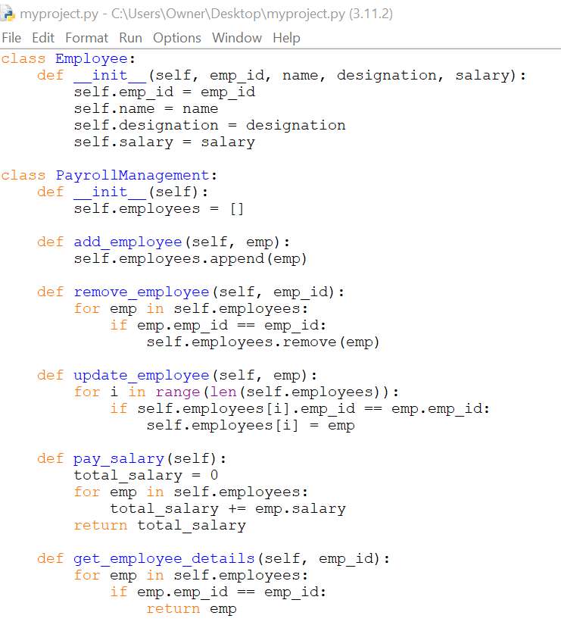
The picture shows the two elements of the classes. Class- Employee and payroll Management. Where the two classes hold two different types of role to execute the code.
After creating the two classes I have added few employees name as object & added salary amount for those employees and to show the total pay of the employee. To made it I have to get the source code to build the code and use it properly. The code I used here and in the first phrase is available in some sources. I have to made some modification in the code such as adding data for the employees which was taken from previous workplace and designation. I have added eight number of employees in the record to identify/get details about them later. After creating the employee object, I have to “add” these data or else the code will not show any result for any queries.
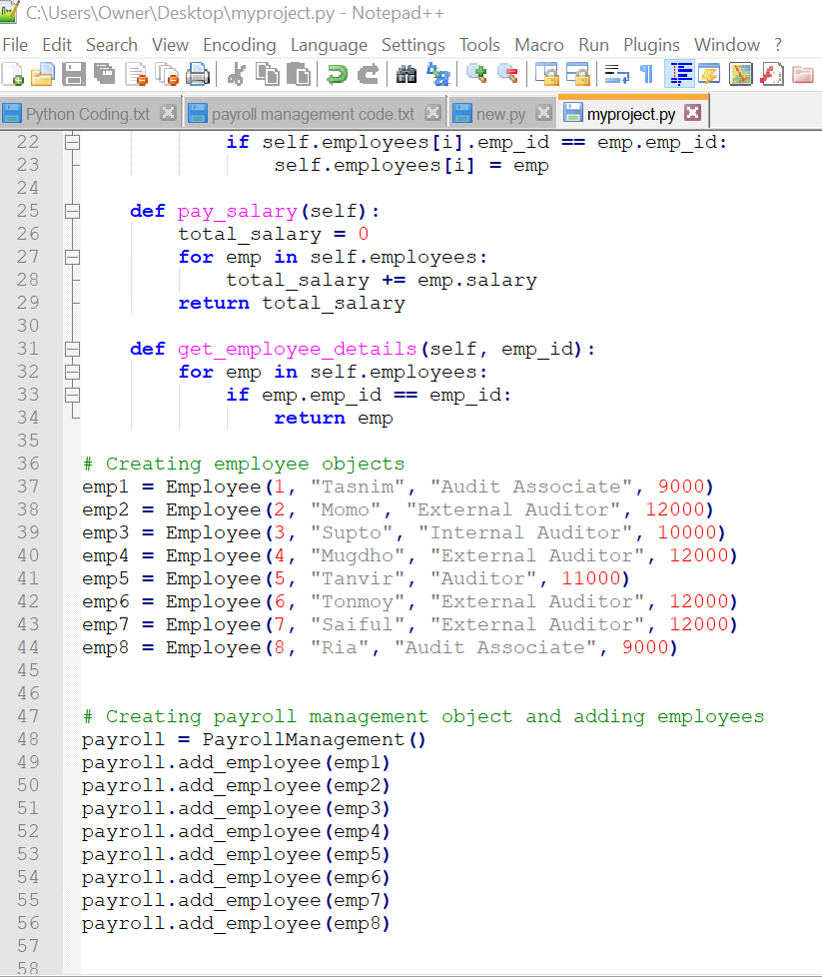
Now finally the code are ready to give or show result on basis of queries. Here, first I tried to make query on having details about “employee 2”. And to do such act I wrote the following query and regarding the query it shows the result given in the picture.
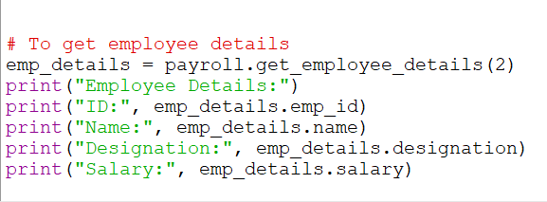

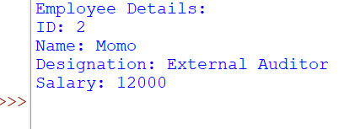

And to get the total pay of any employee I have wrote the following code and got the final result shown in the picture. Where it was shown the result for the employee 2 as I have made query for the second employee total pay.
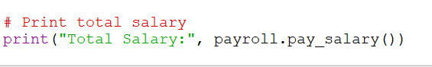

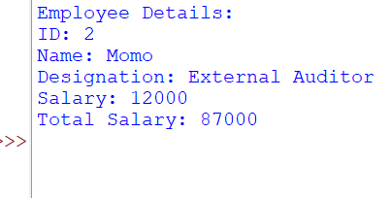
By using more function, I can add and remove any new or existing employee from the database which can be useful for later.

CHAPTER IV: FINDINGS AND RECOMMENDATIONS

The findings the appropriate record of data will create efficiency in payroll management. And doing it manually can create less effectivity within the organization. So the organization can use automated payroll management system where they will keep record of the employee appropriately and whenever needed they can also get the information or data related to any particular employee. Also when any new employee will join the system can create a new entry for the employee and also when any employee will leave then the system can remove the data of the employee to make the system more effective.
I have only created the system for a team which includes a group of eight people. The salary was fixed for the employee for the month. And the team payroll system was created by using the python programming language in IDLE version 3.11.2 to execute the code and give it to a final result.
It is recommended for the organization or any company to adopt the automated payroll system to make it more effective and efficient. Doing the payroll system manually could create more error and would be less effective for the organization.

CHAPTER V: CONCLUDING REMARKS

In conclusion I can say that the payroll management system by using python can be efficient and also effective tool for managing the information of the employee and calculating the pay as well. The process simplifies the track record of the employee which can allow the HR professionals to be more focused on the other important work. And with the ability of adding and removing any employee, their details, wages/salary the system provides a comprehensive solution to manage payroll. The code which is used in the project is ease to customize to meet the specific needs for the organizational group/team.

Reference

Mahajan, K., Shukla, S., & Soni, N. (2015). A Review of Computerized Payroll System. International journal of advanced research in computer and communication engineering.
Sudarsono, B. G., Fransiscus, H. H., Bernanda, D. Y., & Andry, J. F. (2020). Adopting scrum framework in a software development of payroll information system. International Journal of Advanced Trends in Computer Science and Engineering.
Barrios, J. M., Minnis, M., Minnis, W. C., & Sijthoff, J. (2020). Assessing the payroll protection program: A framework and preliminary results.
Dumancic, S., Meert, W., Goethals, S., Stuyckens, T., Huygen, J., & Denies, K. (2021, May). Automated reasoning and learning for automated payroll management.
Banyen, K., & Nasamu, M. (2015). Challenges in Managing Government Payroll Systems in Ghana: The Way Forward. Asian Academic Research Journal of Social Science & Humanities.
Kaur, P., & Grover, D. (2012). Computer based payroll system implementation for E-governance at Punjab agricultural university. International Journal of Engineering Research and Development.
Thite, M., & Sandhu, K. (2014). Where is my pay? Critical success factors of a payroll system–A system life cycle approach. Australasian Journal of Information Systems.
Mahardika, D. E. K., & Siregar, M. U. (2018). Design and Development of Web Based Employee Payroll Information System Using Codeigniter Framework and Extreme Programming Method. International Journal on Informatics for Development.
UDO, I. (2012). DESIGN AND IMPLEMENTATION OF AN AUTOMATED PAYROLL SYSTEM.
Palladan, A. A., & Palladan, N. Y. (2018). Employees Views on Payroll Computerization and Its Impact on Their Productivity: A Grounded Theory Approach. Arabian Journal of Business and Management Review.
Rusly, F. H., Ahmi, A., Yakimin, Y., Talib, A., & Rosli, K. (2019). Global perspective on payroll system patent and research: A bibliometric performance. International Journal of Recent Technology and Engineering.
Uyanah, A. A., Jimmy, U. W., & Ita, O. U. (2021). Government policies and performance of the public sector: a critical appraisal of integrated payroll and personnel information system (IPPIS) policy. International Journal of Public Administration and Management Research.
Singh, M., Singh, P., Singh, R., Singh, S., & Gupta, S. (2017). Leave and payroll management system. IOSR Journal Of Computer Engineering (IOSR-JCE).
Lokugama, K. J. (2021). Management Information System-Human Resource & Payroll System for Sri Lanka Ports Authority.
Bello, M. I. (2022). Potentials of Blockchain Technology for Payroll Systems.
Alfiandi, F., & Kertahadi, N. F. N. (2014). The implementation of payroll accounting system as an effort to improve the system of internal control (a study at Pdam Kota Malang).
Cajner, T., Crane, L. D., Decker, R., Hamins-Puertolas, A., Kurz, C. J., & Radler, T. (2018). Using payroll processor microdata to measure aggregate labor market activity.
Srinath, K. R. (2017). Python–the fastest growing programming language. International Research Journal of Engineering and Technology.
de Freitas, M. M., Codesso, M., & Augusto, A. L. R. (2020). Implementation of continuous audit on the Brazilian navy payroll. Journal of Emerging Technologies in Accounting.
Yusuf, Z., Nawawi, A., & Salin, A. S. A. P. (2020). The effectiveness of payroll system in the public sector to prevent fraud. Journal of Financial Crime, (ahead-of-print).
Moyes, G. D., & Hasan, I. (1996). An empirical analysis of fraud detection likelihood. Managerial Auditing Journal.
Gruber, J. (1997). The incidence of payroll taxation: evidence from Chile. Journal of labor economics.
Hamermesh, D. S. (1979). New estimates of the incidence of the payroll tax. Southern Economic Journal.
Anderson, P. M., & Meyer, B. D. (2000). The effects of the unemployment insurance payroll tax on wages, employment, claims and denials. Journal of public Economics.

Appendix

Python codes used in the project:
class Employee:
def __init__(self, emp_id, name, designation, salary):
self.emp_id = emp_id
self.name = name
self.designation = designation
self.salary = salary

class PayrollManagement:
def __init__(self):
self.employees = []

def add_employee(self, emp):
self.employees.append(emp)

def remove_employee(self, emp_id):
for emp in self.employees:
if emp.emp_id == emp_id:
self.employees.remove(emp)

def update_employee(self, emp):
for i in range(len(self.employees)):
if self.employees[i].emp_id == emp.emp_id:
self.employees[i] = emp

def pay_salary(self):
total_salary = 0
for emp in self.employees:
total_salary += emp.salary
return total_salary

def get_employee_details(self, emp_id):
for emp in self.employees:
if emp.emp_id == emp_id:
return emp

# Creating employee objects
emp1 = Employee(1, "Tasnim", "Audit Associate", 9000)
emp2 = Employee(2, "Momo", "External Auditor", 12000)
emp3 = Employee(3, "Supto", "Internal Auditor", 10000)
emp4 = Employee(4, "Mugdho", "External Auditor", 12000)
emp5 = Employee(5, "Tanvir", "Auditor", 11000)
emp6 = Employee(6, "Tonmoy", "External Auditor", 12000)
emp7 = Employee(7, "Saiful", "External Auditor", 12000)
emp8 = Employee(8, "Ria", "Audit Associate", 9000)

# Creating payroll management object and adding employees
payroll = PayrollManagement()
payroll.add_employee(emp1)
payroll.add_employee(emp2)
payroll.add_employee(emp3)
payroll.add_employee(emp4)
payroll.add_employee(emp5)
payroll.add_employee(emp6)
payroll.add_employee(emp7)
payroll.add_employee(emp8)

# To get employee details
emp_details = payroll.get_employee_details(2)
print("Employee Details:")
print("ID:", emp_details.emp_id)
print("Name:", emp_details.name)
print("Designation:", emp_details.designation)
print("Salary:", emp_details.salary)

# Print total salary
print("Total Salary:", payroll.pay_salary())

