INTERNSHIP REPORT
ON
The Effect of Performance Appraisal System on Compensation Management Practices – A Study on NEXT VENTURES


INTERNSHIP REPORT
On
The Effect of Performance Appraisal System on Compensation Management Practices – A Study on NEXT VENTURES
Submitted To
Md. Kazimul Hoque
Assistant Professor
School of Business and Economics
United International University
Submitted By
Mobashwera Ansari
ID – 111 172 009
School of Business and Economics
BBA Program, Major in HRM
United International University
Date of Submission: May 26, 2022


UNITED INTERNATIONAL UNIVERSITY

Letter of Transmittal
May 26, 2022
Md. Kazimul Hoque
Assistant Professor,
School of Business and Economics
United International University
Subject: Submission of Internship Report on “The Effect of Performance Appraisal System on Compensation Management Practices: A Study on NEXT VENTURES"
Dear Sir,
I am submitting my internship report, which is titled “The Effect of Performance Appraisal System on Compensation Management Practices: A Study on NEXT VENTURES" for your consideration which is a prerequisite for the Bachelor of Business Administration degree, and it contributes toward the degree completion requirement.
I hope, this report will fulfill your requirements and expectations. I would be grateful if you would accept my internship report with valuable consideration.

Mobashwera Ansari
ID – 111 172 009
BBA Program, Major in HRM
School of Business and Economics
United International University

Declaration of the Student
I, Mobashwera Ansari, hereby declare that the intern report is my original work, except for quotations and citations that have been properly acknowledged. The report on “The Effect of Performance Appraisal System on Compensation Management Practices: A Study on NEXT VENTURES" has been prepared for my internship program. I also declare that this report has not been submitted previously or concurrently for any other degree at United International University or other institutions.

Mobashwera Ansari
ID – 111 172 009
BBA Program, Major in HRM
School of Business and Economics
United International University

Acknowledgement
My heartfelt gratitude goes out to Allah for giving me the strength and capacity to complete and submit my internship report on time.
I would also like to express my gratitude to Md. Kazimul Hoque, Assistant Professor, School of Business and Economics, United International University for all of his valuable guidelines and instructions on my academic path so far. Without his assistance, and involvement, I would not have been able to complete the report on time while still ensuring that it was accurate. In addition, I am grateful that I had the opportunity to complete my internship program under his supervision.
In conclusion, I would like to express my gratitude to all of the employees of NEXT VENTURES, and in particular the HR teams, for their time and effort spent participating in the interview sessions and survey.

Table of the Contents

Executive Summary vi
Chapter 01: Introduction
1.1 Introduction of the Report 2
1.2 Objectives of the Report 2
1.2.1 General Objective 2
1.2.2 Specific Objectives 3
1.3 Methodology of the Report 3
1.3.1 Primary Sources 3
1.3.2 Secondary Sources 3
1.3.3 Data Analysis Plan 3
1.4 Scope of the Report 4
1.5 Limitation of the Report 4
Chapter 02: Literature Review
2.1 Performance Appraisal 6
2.2 Effective Performance Appraisal 7
2.3 Different Components of Performance Appraisal 8
2.4 Performance to Compensation 10
Chapter 03: Organization Profile
3.1 Take a Look at NEXT VENTURE 13
3.1.1 Mission 13
3.1.2 Vision 13
3.1.3 Tagline/Slogan 13
3.1.4 Passion 13
3.1.5 Team Work 14
3.2 Products and Services 14
3.3 Organization Chart 15
3.4 Departmental Activities 15
3.5 SWOT Analysis 16

Chapter 04: Analysis and Findings
PART A: Analysis of Performance Appraisal System and Compensation Management Practices of NEXT VENTURES 19
4.1 Performance Appraisal System at NEXT VENTURES 19
4.1.1 Objectives of Evaluation Employees’ Performance 19
4.2 Following Performance Appraisal Methods at NEXT VENTURES 20
4.3 Criteria for Performance Rating System 20
4.4 Performance Development Plan at NEXT VENTURES 21
4.5 Key Performance Indicator (KPIs) 23
4.6 Compensation Policy at NEXT VENTURES 23
4.7 Procedure and Method of Compensation 24
4.8 Pay Rises for All Employees 24
4.9 Promotion 24
4.10 Bonus and Incentive Program 25
PART B: Analysis of Employees’ Statement Regarding PAS and Compensation at NEXT VENTURES 26
4.11 Demographic Characteristics 26
4.11.1 Respondents of Gender 26
4.11.2 Job Position 27
4.11.3 Service Tenure 27
4.12 Analysis of Survey Data 28
4.13 Findings of the Study 41
Chapter 05: Recommendations and Conclusion
5.1 Recommendations 43
5.2 Conclusion 43
References 45
Questionnaire 46

Executive Summary
An employee's work performance is evaluated on a regular basis through performance ratings. Performance appraisals are often used by organizations to provide employees feedback on their work and to justify decisions like compensation increments, promotions, and in certain situations, terminations. Even though performance reviews may be conducted at any time, the majority of employers prefer to do it on a quarterly, semi-annual, or yearly basis. Performance evaluations can serve a variety of purposes for businesses, including determining which employees are the most deserving of pay raises and promotions, determining which employees have the most potential for growth within the company, analyzing employee strengths and weaknesses, and providing employees with useful objections to support in their professional development.
NEXT VENTURES, this software and IT firm also places a significant emphasis on the functions performed by the department of human resources. The HRD is primarily responsible for supervising, managing, and asserting power over the organization's employees and other members of the workforce. The tasks of the department include selection and recruitment, training and performance evaluation, talent acquisition, compensation and benefits, ensuring the health and safety of employees, and planning that may assist the company in achieving its objectives. The main purpose of preparing the report is to study on their performance appraisal systems and to identify what challenges they are facing to implement effective performance appraisal system that impact on their compensation management practices.
For analyzing the topic of the study, both qualitative and quantitative data have been used. Significant factors including recommendations and essential understandings have been provided also this report. These aspects were determined based on the results of the analysis. And at the end of the report is brought to a close with the presentation of the conclusion.
Keywords: HRM, Performance Appraisal System, Compensation Management, NEXT VENTURES.

CHAPTER 01
INTRODUCTION

Introduction of the Report
Individuals and organizations alike benefit from performance appraisals. Individual and organizational performances are both focused at being maximized in order to increase profitability for the company as a whole. It's a good opportunity for employees to concentrate on their daily tasks and objectives, find and fix any difficulties they may have, and set themselves up for success in the future.
Employees are evaluated on their achievements and performance during the retrospection portion of the evaluation. It is a tremendous motivator to show appreciation for an employee's efforts. As a result, employees' behavior may be changed and their performance can be boosted. With an annual performance evaluation, supervisors and subordinates have an excellent opportunity to identify and agree on their respective training and development requirements. Performance and future professional goals will be connected to these demands.
Recruitment activities may be evaluated for their effectiveness based on appraisal data. After a performance appraisal system has been implemented and a methodical strategy for job evaluation has been established, the process of compensation may go forward with its various components. As a result, the significance of addressing the appropriate and systematic adaptation of performance appraisal is significant, and it needs to be a component of each and every organization as the results have addressed. The main purpose of the report is to study on how performance appraisal system can affect on a NEXT VENTURES’s compensation management practices.

Objectives of the Report
The following is a list of the study's various objectives, which have been formally defined:

General Objective
The submission of a report that has been prepared based on the subject matter of the study, which is the performance appraisal system and compensation management practices of NEXT VENTURES, is the primary objective of the study. This report will concentrate on how performance appraisal system can affect on compensation management practices at NEXT VENTURES.

Specific Objectives
- To analyze the performance appraisal systems of NEXT VENTURES.
- To analyze the compensation policies and management practices of NEXT VENTURES.
- To find out the factors of performance appraisal systems of NEXT VENTURES that can affect on their compensation management practices.
- To provide recommendations that can help to HR manager to develop the present performance appraisal system at NEXT VENTURES.

Methodology of the Report
This study and the report have been analyzed based on the IT firm of NEXT VENTURES in Bangladesh. For analyzing the topic of the study and collecting data, both qualitative and quantitative methods have been used. For the purpose of information collection, we used the following two methods:

Primary Sources
- Discussion and conversation with the employees of NEXT VENTURES.
- Conducting a survey over 25 employees of NEXT VENTURES.
- A thorough overview of the progress of human resources (HR) departments of NEXT VENTURES

Secondary Sources

Articles, journals and books which are related the concept of the topic.

Internal report and HR documents of the NEXT VENTURES.

Data Analysis Plan
In order to conduct research on the topic, a questionnaire with I Statements has been prepared. The questionnaire, which was built with five likert ratings and there are 25 Statements on it that, was developed as a method of acquiring data. Pie charts have been used for analyzing the data of the survey.
And the survey was carried out at NEXT VENTURES, where a total of 25 employees participated in the survey. Descriptive method has been used for analyzing the survey data of the report.

Scope of the Report
The report's analysis and study may be helpful for academic comparison as well as for formulating policy making. The findings of the study could provide HR professionals and management at NEXT VENTURES with useful information for developing effective Performance Appraisal Systems. The recommendations for succession management included in the paper might be useful to NEXT VENTURES to develop the human resource department (HRD), ensure enough employee numbers are maintained, and implement efficient training programs and performance appraisal systems, work-life balances, and pay policies.

Limitation of the Report
For completing the internship report, the procedure of gathering information and data have some limitations. The following are a few of them:
- A few individuals from the firm were participating in the survey, and from what I could see, they were a little confused by it. Employees are unwilling to fill out the survey because they are concerned about the responses they will get from their coworkers and superiors.
- The largest portion of participants did not complete the survey in full, stating lack of time as their major reason.
- As a result of the limitations and constraints imposed by the organization, it was challenging to gather comprehensive information.

CHAPTER 02
LITERATURE REVIEW
Literature Review
Previous research on the subject matter addressed by this study is outlined in this section. In line with the study's objectives, the following sections were further divided into sub-sections:

Performance Appraisal
In order for employees to improve their performance at work, an evaluation system that facilitates communication between managers and employees and results in continuous periodic feedback is required. At the same time, employees feel they are involved not only in their daily practice by reporting performance relates as well to the company's main objectives are also involved. So, an effective performance evaluation system that is both transparent and equitable may be the result of having a well-structured feedback and development plan for shortcomings as well as a reward system for achieving performance standards (Laura Werber, 2012).
A performance evaluation is an organized, formal dialogue between a supervisor and subordinate. Employees' job performance is often examined on a regular basis in an interview setting in order to uncover areas for growth and development, as well as flaws that need to be addressed and broader perspectives on one's future career prospects (Rao, 1985). The appraisal process will be seen as accurate and fair by workers if these elements are met. They will also be more open to the appraiser's suggestions and more likely to make changes in their behavior (Rao, 1985).
These advantages are reflected in both individual and organizational performance evaluations. Its goal is to maximize both individual and organizational performance, which in turn increases the profitability of the company. As a means of identifying and correcting current issues, as well as encouraging greater future performance, appraisals are a vital tool. An employee's success and performance are evaluated during the retrospection portion of the evaluation process so that any gaps may be detected. The impact of performance assessment may be divided into three categories:
- Employee motivation and satisfaction: When an employee's efforts are recognized, it serves as a potent motivator. The correction of employee behavior and the improvement of employee performance may thus be accomplished in the appropriate manner (Mohammed, 2020).
- The performance appraisal process provides an ideal chance for a supervisor and subordinate to identify and agree on the unique training and development requirements of each other. It will be necessary to relate these requirements to performance results and future career objectives (Fink, 1999).
- Recruiting: Appraisal data may be used to track the effectiveness of an organization's recruitment efforts (Mohammed, 2020).
After a performance evaluation process and a methodical strategy for work evaluation have been implemented, the process of compensation, with all of its numerous components, may then be carried out in an efficient manner. This will allow the process to be as effective as possible (Rao, 1985). Managers now must advise, encourage, and lead their employees on a daily basis as human resources grow. In many firms, an effective assessment system has been proven to be the greatest approach to boost employee enthusiasm and productivity.

Effective Performance Appraisal
The firm as a whole as well as the employees who get performance reviews benefit from the positive effects of these reviews. In order for these evaluations to fulfill their function in an effective manner, they need to be reliable and consistent. They should pay attention to the surrounding environment, the employee, and the employee's job description. Any subjectivity and personal characteristics that are not relevant to the task should be eliminated from the evaluation. In order for an organization to be efficient, it has to have "a primary objective, a strong framework, time managing, and motivated employees who are all working together to get the task done" (Fink, 1999). Employees' needs and aspirations may be communicated both downward from high management to lower levels, making communication a crucial part of any assessment system. When an employee is being evaluated, a lack of communication may be seen as an endorsement of the individual's existing performance, which may have a detrimental impact on the employee's standing in the workplace. On the other hand, the manager has the constitutional authority to step in and make adjustments at any level of performance in order to ensure that the company and its employees are satisfied with the results (Deborah F. Boice, 1997).

Different Components of Performance Appraisal
The ultimate strategy should be selected and put into action in a manner that is appropriate to the nature of the firm, taking into consideration whether it is a service provider, distributor, producer, or manufacturer. For instance, a manufacturing or industrial setting might benefit from several evaluations. Work standards are the greatest choice for non-exempt or blue-collar employees since they are based on typical worker productivity rates. For each industrial process, line balance and production rates are determined using statistical data analysis and simulation analysis. So the worker is given a list of objectives based on management criteria. Because rating scales are simple, fast, and utilize specified elements on a predetermined scale level, they should be used for administrative workers as well (Mohammed, 2020).
Furthermore, performance appraisal is a formally conducted event that occurs on a regular basis, usually once or twice a year, and establishes specific evaluation criteria. It is a quantitative evaluation of the performance of the workers in which the findings should be communicated (DeNisi, 2006). As a result, the company has a variety of methods at its disposal for assessing its personnel, including the ranking approach, the narrative method, the 360-degree method, and so on. Sequential activities should be carried out in the most efficient manner feasible throughout the performance. For example, the HR department's benefit and administration officer sends a remark to the manager to initiate the evaluation process. If this is done annually, the date should be in the first part of the year. To make the process simpler, the employee's complete file is submitted to the (B&A) officer. The manager will then evaluates, remark, and deliver the document to HR. This data is analyzed and reported to HRMs and the company's or business unit's GM, who is advised of any difficulties. The last step of the process is the (B&A) officer calculating the employee's annual bonus and submitting the results to both HRM and the GM. A professional in training and development will also get a copy of the employee's ongoing development. After Human Resources Management has given their approval, they will inform the General Manager and then submit the decision to payroll so that the appropriate pay adjustment may be made. An example of this procedure is shown in the Figure 1.1 (below).
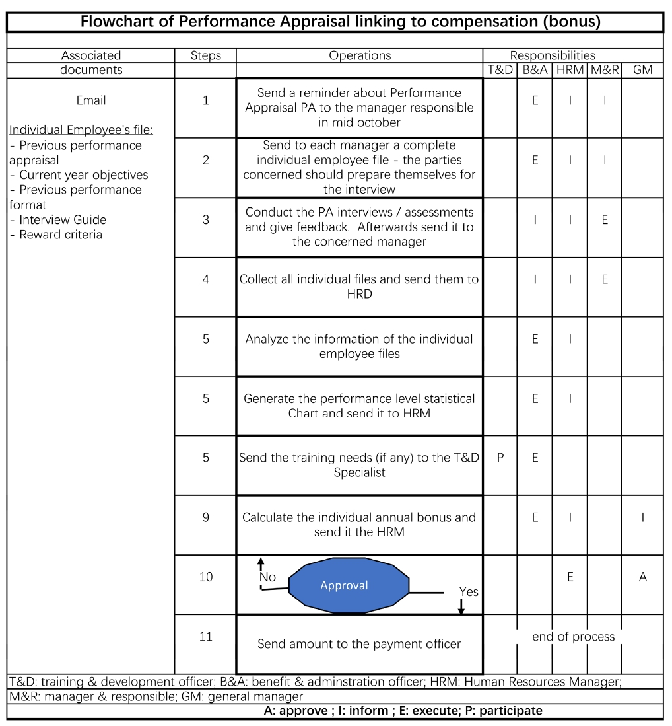
Figure1.1: Flowchart of Performance Appraisal System linking to Compensation
An evaluation of an employee's performance may take a wide variety of forms, each of which makes the program to a certain type of operation, management philosophy, or industry. Some firms utilize a ranking system in which employees are ranked from highest to lowest. Managers can apply this approach when making evaluative judgments, such as who gets a raise, who gets promoted, and who will get the honor of employee of the month. This method may also disclose a worker's standing inside the organization by using a fundamental comparison with the rest of the company's personnel. In another setting, managers write brief essays on their employees' flaws, abilities, and deeds. Finally, a 360 degree appraisal measures a worker's performance in relation to both internal and external clients, such as managers and consumers. This popular yet time-consuming method measures a human's talents and activities. They can then work with a T&D officer or a training programme to address their weaknesses. This method also reduces subjectivity and bias (DeNisi, 2006).

Performance to Compensation
Employees are compensated for their efforts via remuneration. An organization's survival and expansion are dependent on it. Financial and non-financial rewards are available.
In Maslow's hierarchy of needs, an employee's monetary pay is referred to as the extrinsic needs. This compensation may take the form of a basic salary, bonuses, and other benefits. Maslow's theory of "intrinsic desires," in which a person finds satisfaction in their work either from the nature of the task itself or from the setting in which it is performed, rather than from the financial benefit often referred to as "compensation" (Chen, Ford, & Farris, 1999).
According to (Lazear, 2018), the pay rate and other forms of payment have a direct effect on the performance of an employee. To phrase it another way, economic activity and the component of GDP that relates to employment are linked in this manner. To be successful, the firm has to keep its qualified professionals, bring in new ones, and motivate those it already has. The benefits package should include not just health insurance but also paid time off for employees and their families as well as welfare support for their children's education (Murray, 2002). It will be clear to the employees that the organization is concerned about their health and welfare. In addition to this, it provides a clearer communications channel for employees to express their grievances. If an employee gets a flawed incentive, then the levels of motivation and productivity will decrease, and the employee will feel that the effort put in at work is not being appreciated. This is because performance is linked to reward, and because this is a sensitive topic for everyone (Hearn, 2012).
For an effective compensation plan, the pay system has to be connected with the purpose, vision, and strategic plan of the business. The compensation structure of an organization must always include elements such as job evaluation (which may take the form of a point-based system, which is prevalent in many businesses), a detailed job description, and performance ratings. In an organizational context, it is important to keep an eye out for opportunities for continuous improvement.

CHAPTER 03
ORGANIZATION PROFILE

Take a Look at NEXT VENTURE
"NEXT Ventures" is a Bangladesh-based digital business firm with operations in the United States, the United Arab Emirates, and the United Kingdom. For a worldwide audience, they seek to provide extraordinary experiences and innovative solutions. NEXT Ventures has already served more than 20,000 customers from more than 100 countries with their various products and services. NEXT Ventures has previously been successful in launching a number of digital enterprises, particularly in the financial technology area. Fintech is constantly being remained by the brilliant minds at NEXT Ventures in order to provide their clients with access to a wide variety of new opportunities.
Employees
100+
Countries
100+
Office
5+
Clients
20K

Mission
- The mission of the NEXT VENTURES is to include their company in the Fortune 500 Company and simultaneously make the highest contribution to the country’s economy through employment and brining remittance in the country.

Vision
"To be the Most Accepted Solutions Provider via Simplicity," that is the vision of NEXT VENTURES.

Tagline/Slogan
“Building towards the Future and Ready to be the Next”

Passion
Their life's work is to generate high - quality software and e-commerce solution strategy. They develop new products and services that help businesses succeed. When it comes to project management, they know how important it is to put together the proper combination of experience, talents, and disciplines.

Team Work
They strongly believe that achieving one's goals is only possible with the help of one's peers. There isn't a door in their station. They jot down their thoughts while they talk. They engage into heated debates and ignite the idea bulb together in order to come up with creative solutions to difficult challenges. It's difficult to escape their feelings from one other in a cubicle or glass. The way they're creating future-proof solutions is this way.

Products and Services
The founder and CEO of Abdullah Jeyaed started his business journey from 2010. But as a company, NEXT VENTURES started its’ journey in January 2016. Currently, there are three ventures like Blaze Tech, eCOMcHEF, Money Back FX, FINALYTICS, Founded Next, Growth Alliance and Livtual under NEXT VENTURES.
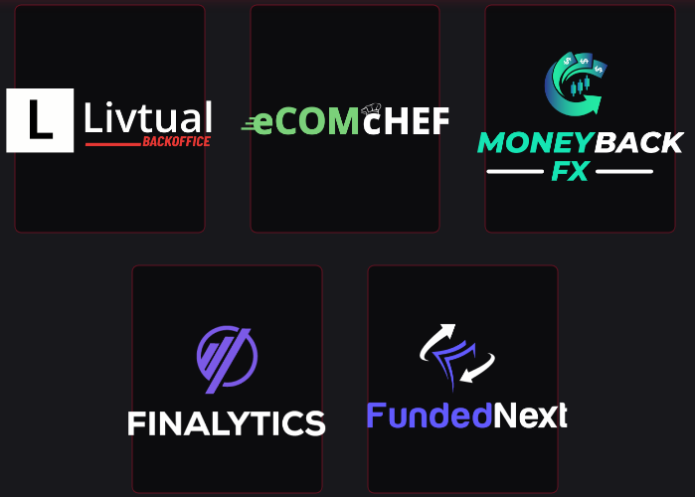
- Blaze Tech offers lead generation and marketing services.
- Product research with Face book ad formula and bespoke eCom solutions are all part of eCOMcHEF’s all-in-one solution platform.
- Livtual provides online HR staffing services.
- Access to Growth Alliance's exclusive tools and training materials offers a one-stop shop for traders.
- Funded Next is a proprietary trading organization with cutting-edge technology that aims to provide the most effective financing programs to traders all over the world.
- Money Back FX is a Forex trading account rebate service that pays you for every transaction you make.

Organization Chart
Organizational order, stability, and transparency are all maintained by NEXT VENTURES via a horizontal form of the company's structure. Every employee's productivity and commitment to their job may rise as a result of fostering an environment that values excellence and encourages friendliness among coworkers.
Managing Director
Department Head
Out Sourcing
HRD
Customer
Relationship
Hardware
Business
Development
Accounts & Finance

Senior Officer

Executive

Figure 3.1: Organization Chart of NEXT VENTURES

Departmental Activities

- Accounts and Finance Department:
Within this division, employees supply all of NEXT VENTURES with the accounting and financial assistance it requires. This department works on a variety of concerns, such as charging all of the other departments for their work, keeping records of inventories, calculating salaries for staff, preparing financial statements, and so on. Finance is another area which NEXT VENTURES is focusing on. Among the responsibilities of the finance department include keeping track of the company's financial records and accounts, preparing yearly budgets, allocating various forms of compensation to employees and management, and handling all of the business' revenues and expenditures.
- Hardware and IT Department:
NEXT VENTURES is a company that offers services by using the most recent technological advancements. Therefore, it demands for continuous assistance in information technology. The information technology department is responsible for monitoring the technical components of the company and ensuring that the network and electronic equipment are properly maintained.
- Out Sourcing Department:
Many divisions at NEXT VENTURES are focused on July, however the outsourcing department handles more TPA tasks than July does. There are several distinct TPAs that work with the outsourcing department, and each of these TPAs provides a different service to the outsourcing department. There are now nine TPA clients in the department.
- Business Development:
The business development team is the first department to interact with new customers. The New Business and Installation section maintains the accuracy and appropriateness of all corporate database information. NEXT VENTURE's out sourcing department is the primary source of information for customers.
- HR Development:
The department of human resources also plays an important role in the company. Overseeing, managing, and controlling the organization's human resources are the primary responsibilities of the human resource manager. The department's responsibilities include selection and recruiting, training and assessment of performance, talent acquisition, remuneration and benefits, guarantee of workers' health and safety, and planning that may help the business achieve its goals.

SWOT Analysis
As the name suggests, SWOT analysis is all about comparing and analyzing an organization's strengths, weaknesses, opportunities, and threats. The primary goal of this analysis is to identify a firm's most essential strategies for operating in a competitive environment and to design a business model that best fits the entire environment and circumstance in which the company works. As a result, companies may better manage their limited resources and, if necessary, adjust their business models in response to changes in their external environment.
The following is a SWOT analysis of NEXT VENTURES, divided into its strengths, opportunities, weaknesses, and threats:
- Strengths
- NEXT VENTURES's biggest strength is the collective intelligence of the whole group. Their team consists of innovative, result-oriented, and highly qualified digital marketing, IT, software and Web development specialists with a wide range of knowledge in a number of sectors.
- In addition to the coordination among their specially picked IT and digital marketing specialists, they provide services that are quantified, result-driven, and driven by industry best practices.
- Strong networking system.

- Weakness
- Because NEXT VENTURES is a relatively new IT and digital marketing company in Bangladesh, it will likely be a while before it can break into the industry and gain acceptance, especially among high-profile clients.
- Probabilities of innovation that is comparatively small.

- Opportunities
- Regulations from the government that is flexible.
- Strong capacity for future development.

- Threats
- The establishment by the government of business policies or regulations.
- A slow pace of overall infrastructure development in relation to new company creation.

CHAPTER 04
ANALYSIS AND FINDINGS

PART A: Analysis of Performance Appraisal System and Compensation Management Practices of NEXT VENTURES

Performance Appraisal System at NEXT VENTURES
An evaluation of an employee's performance and dedication to the company is called a performance appraisal. Use the results of an annual review of the performance of the employees to support salary raises and bonuses as well as termination decisions. Despite the fact that companies may do performance evaluations at any time, they are most often conducted once a year, twice a year, or once a quarter.
The Human Resources Department of NEXT VENTURES evaluates employee performance with the support of each department's head. Managers at Flora Telecom Ltd evaluate the performance of their employees and compare it to the organization's objectives and goals. Managers determine which points of view should be incorporated in order to boost employee productivity. Every department's managers are responsible for motivating and motivating their workforce to achieve excellent outcomes.

Objectives of Evaluation Employees’ Performance
The following are the purposes for which the evaluation is being conducted at NEXT VENTURES:
- To analyze and identify the gaps between the actual and expected levels of performance.
- To establish links that develops between the management and the employees.
- To provide personnel with feedback based mostly on their performance outcomes.
- To provide direction and encourage the growth of insight among underperformers.
- In order to determine and identify the individual's needs in terms of training and growth.
- In order to encourage personnel to do their jobs.
- To establish and evaluate the progress toward objectives.
- To identify the employees' strengths and weaknesses in order to determine their training and development requirements.
- To evaluate an employee in order to determine compensation packages, salary structure, incentives, etc.

Following Performance Appraisal Methods at NEXT VENTURES
The following is a list of the performance evaluation methods that are used by NEXT VENTURES:
- The raters of NEXT VENTURES uses the raking technique to rate all of the personnel in a group according to their individual performance. There are two ranks: the highest rated performer and the lowest ranked one. When all employees are performing in a comparable manner, the rater rates the employees based on their performance levels. As a result of this method, it is easier to discern between the positive and negative performers.
- Sometimes, the rater of NEXT VENTURES uses graphic rating scale method in order to conduct the evaluation of the performance. A Likert scale is used by the rater in this approach for the purpose of assigning positions to personnel, with categories including "poor," "fair," "average," "good," and "outstanding."
- In order to acquire 360-degree input for an assessment, an employee's circle of influence, which includes supervisors, coworkers, customers, and direct reports, is employed at NEXT VENTURES. Bias in performance evaluations may be eliminated by using this method, which also provides an accurate evaluation of an employee's competence.

Criteria for Performance Rating System
The criteria are used to provide ratings to the employees. The following is an example of a sample for NEXT VENTURES’ performance rating system:
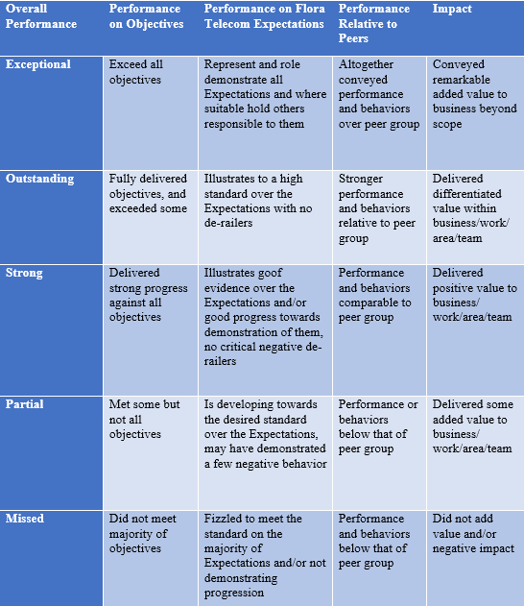
Table 4.1: Criteria of Performance Rating System

Performance Development Plan at NEXT VENTURES
NEXT VENTURES conducts a performance development plan (PDP) evaluation of employee performance and sets annual goals based on the PDP. Employers may use this PDP to evaluate their employees' overall performance, which is a good determinant of the effectiveness and productivity of the company's products and services. NEXT VENTURES does PDP every other year and every two years.
- Mid Year Review: To establish long- or short-term plans and approaches for the benefit of the organization, all managers or supervisors gather together with their collaborators. Additionally, there is evidence to support this claim.

- Yearly Review: The annual review takes place in December of each year. Group discussions are conducted with the Managing Director (MD) and members of the management team during the annual review. The whole performance of the company is examined in that debate. In addition, the performance of the personnel is also taken into consideration. Whether or whether the organization's goals have been reached or how the organization has met the employee's satisfaction is also observed.
A total of seven components make up the performance development plan (PDP) which are listed below:
Part A: Performance Design and Objectives
It clearly explains the most significant consequences and provides for five criteria of evaluation. Employees may use these five criteria to determine the degree of expectation from their supervisors by ensuring that their actions are specific, measurable, action-oriented, realistic, and time-based.
Part B: Leadership Essentials
It places an emphasis on the relevance of leadership, which is the factor that enables NEXT VENTURES to accomplish its aims and objectives.
Part C: Periodic Review
It gets repaired at different times during the year. It primarily enables the workers to improve themselves in order to accomplish the goals that have been established by their managers. In addition to that, it opens the door for them to be altered in the event that this becomes required.
Part D: Annual Review
The month of December is assigned for it. The supervisor first overlooks the implications that follow from Part A and Part B, but eventually comes around to evaluating them. Following that, each and every consequence is dissected and described in the Part-D section. The choice about an employee's salary, however, is contingent upon the comprehensive assessment of that employee's performance.
Part E: Development Plan
In this area, personnel focus on improving their KSA in order to make their job more efficient and also to better prepare themselves for the next days.
Part F: Development Plan Periodical Review
The evaluation of the progress made according to the development plan takes place on many occasions during the period of the year.
Part G: Developmental Annual Review
The review is carried out once a year at this location, and its significance cannot be overstated due to the fact that it enables clients to take part in the evaluation process.

Key Performance Indicator (KPIs)
A Key Performance Indicator (KPI) measures how well and efficiently an employee contributes to the achievement of a company's most important business goals and objectives. Every business has its own set of KPIs. Each company has its own unique set of KPIs, and they should reflect that NEXT VENTURES, like many other organizations, employs several KPIs to measure their success in accomplishing their goals. Like-
- The absence rate
- The rate of Employee productivity
- Employee satisfaction index
- Employee engagement index
- Employee innovation index
- Internal promotional rate
- Quality of hiring
- Turnover rate
- Training effectiveness etc.

Compensation Policy at NEXT VENTURES
The Managing Director of NEXT VENTURES will review and approve funds for total compensation, including cost of living adjustments, base wages, and bonus pay, as part of the yearly budgeting process. All individual employment must be competitively evaluated and verified every two years by the Managing Director in collaboration with the HR department. This will be done at least once each year. Adjustments for pay equality are made in an open, transparent, and transparent way.
The department of human resources has been tasked with ensuring that the whole compensation program is administered in a method that is both consistent and unbiased (HR). NEXT VENTURES makes it apparent that it maintains the right to update, modifies, or eliminates any of the elements included in this compensation policy at any time without prior notice.

Procedure and Method of Compensation
NEXT VENTURES employs a variety of techniques and procedures for calculating remuneration, including a basic base salary, as well as incentives for excellent performance, overtime pay incentives, and profit sharing.

Pay Rises for All Employees
NEXT VENTURES gives a yearly percentage adjustment for inflation on June 1st of each year. This was compiled by the department of labor's bureau of labor statistics and then sent to every employee. The following are the requirements for pay rises:
- The recruiting manager may order a compensation rise of between 5 and 8 percent, with the least being 5 percent and the highest being 8 percent. The pay rate has to be equal to or more than the minimum of the new range or grade, but it cannot be lower than the maximum. In terms of the wage range, it is anticipated that the majority of salaries would congregate around the grade midpoint, which serves as a measurement of the market rate.
- In the event that exceptional circumstances arise, the HR manager may submit a request to the Managing Director for an exception to the above limits in order to get approval for an increase that is more than what is specified there. The letter making the request will be sent on to each of the HR manager as well as the Managing Director.

Promotion
Promoted positions are those that have been elevated in terms of compensation, grade or non-graded status. Accountant to Senior Accountant is another example of career progression. When a qualified candidate applies for a position or when the department decides to promote someone within, a promotion is considered to have occurred. Organizational demands, money availability, and the permission of the managing director are all factors that must be taken into consideration before a promotion may take place.

Bonus and Incentive Program
NEXT VENTURES has a bonus policy and system in place that recognizes and rewards excellent performance and substantial contributions to the organization. At the order of management, a one-time payment of a discretionary bonus is provided in the form of a single amount. It does not contribute to an increase in the minimum wage and is distributed twice a year.

PART B: Analysis of Employees’ Statement Regarding PAS and Compensation at NEXT VENTURES

Demographic Characteristics
The numbers of 25 employees of NEXT VENTURES were participated on conducting this survey. So,
- The Sample size (n) = is 25.

Respondents of Gender

Figure 4.1: Respondents of Gender
There were 68% male and 32% female taking parts in the survey (see figure 4.1). Therefore, it may be stated that the respondents of male is greater than female on this survey.

Job Position

Figure 4.2: Job Position of Respondents
Figure 4.2 shows that of the 25 employees who took part in the survey, 17 employees held the position of Entry level (60 %); 6 employees held the position of Midlevel (24 %); and 4 employees held the position of Top level (16%).

Service Tenure

Figure 4.3: Service Tenure of Respondents
Figure 4.3 shows that of the 25 employees who took part in the survey, 10 employees have 0 to 1 year job experience (40 %); 11 employees have 2 to 4 years job experience (44 %); and 4 employees have 5 to 7 years job experience at NEXT VENTURES (16%).

Analysis of Survey Data
The primary objective of the study that is detailed in this report is to get an understanding of the ways in which the factors of Performance Appraisal System may have an effect on the compensation management practices at NEXT VENTURES in Bangladesh. In order to conduct research on the topic, a questionnaire with I Statements has been prepared. The questionnaire, which was built with five likert ratings and there are 25 Statements on it that, was developed as a method of acquiring data. Pie charts have been used for analyzing the data of the survey.
Statement 01: I am satisfied with the current performance appraisal procedures within the organization.

Figure 4.4
According to the statistics shown above Figure 4.4, the current performance appraisal systems of the organization are not effective for all employees due to not having sufficient resources and tools.

Statement 02: When it comes to evaluate performance of the employees, the raters of the organization are not biased and I am satisfied with this.

Figure 4.5
In some situation, the raters of the organization are biased during the evaluation of employees’ performance.
Statement 03: I enjoy the organization’s culture.

Figure 4.6
All the employees of the organization enjoy the culture and environment of the organization because organization offers them entertainment facilities and indoor game facilities.

Statement 04: I can share my job tasks with another.

Figure 4.7
Organization needs to focus on create flexible workplaces for their employees because some females’ employees are dissatisfied with over pressure in the organization.
Statement 05: I like to participate in the process of contributing my ideas and opinions at work within the organization.

Figure 4.8
All the employees can participate in the process of contributing their ideas and opinions at work within the organization.

Statement 06: I feel comfortable with the organization’s “Peer Review” system for assessing employee performance.

Figure 4.9
Organization has not qualified or expert reviewers. And there are instances when different viewpoints come into conflict with one another.
Statement 07: I trust my manager about the appraisal results which are discussed and concluded drawn during appraisal development interview.

Figure 4.10
During the appraisal progress session, the supervisor discusses the outcomes of the evaluation and drew conclusions from the employees of the organization and most the employees trust their supervisor at their workplace.
Statement 08: I have a good understanding of informal structures and processes within the organization.

Figure 4.11
Most of the employees agreed that they do have no good understanding of informal structures and processes within the organization because of lack of communication with the top management.
Statement 09: I always feel comfortable to share my feedback to my supervisor.

Figure 4.12
The supervisors of the organization are friendly and cooperative with their all employees and all the employees feel comfortable to share their feedback to the supervisor.

Statement 10: I feel my manager gives value to my opinions and listens honestly.

Figure 4.13
Most of the employees agreed that due to lack of communication with the top management, they feel their manager gives value to their opinions and listens honestly.
Statement 11: I receive enough recognition at my work.

Figure 4.14
Some employees feel that recognition programs are biased and that management provides favorable treatment to certain employees.
Statement 12: I feel that I am recognized relatively for my contribution to team efforts.

Figure 4.15
All the employees feel that they are recognized relatively for their contribution to team efforts because they engage into heated debates and ignite the idea bulb together in order to come up with creative solutions to difficult challenges.
Statement 13: I am satisfied with the present benefits that the organization offers, above my salary.

Figure 4.16
The majority of employees are dissatisfied with the current salary structures and benefits program within the organization, their thought is that the organization does not provide a fair salary on the basis of their skills and experiences.

Statement 14: I am satisfied with the present compensation policies and benefits.

Figure 4.17
The exiting compensation policies and benefits of the organization are not suitable for employees because the incentive programs and overtime benefits are not applicable for all employees.
Statement 15: I am satisfied with the performance-based advancement approach.

Figure 4.18
All the employees think that performance based advancement approach benefits them to get fair compensation programs from the organization.
Statement 16: The organization conducts a comprehensive annual feedback session in order to assess its employees' performance and I am satisfied with it.

Figure 4.19
The organization conducts a comprehensive annual feedback session in order to assess its employees' performance and the entire employees are satisfied with it.
Statement 17: I feel comfortable with the HRIS system, which is used for performance appraisal, is maintained on a regular basis by the organization.

Figure 4.20
The majority of employees are disagreed on this statement because; organization doesn’t use effective HRIS system for measuring and recoding employees’ working performance data.

Statement 18: I am satisfied with the estimated key performance indicator (KPI) which is adequate for all levels of the organization's employees.

Figure 4.21
The most of the employees are disagreed on this statement because; organization doesn’t focus on actual KPI indicators for evaluating the performance of the employees. They said, organization measures everything that walks and moves and this assumption may conflict with the employees and the HR supervisor and also may affect on employees’ job satisfaction, performance and promotions or rewards.
Statement 19: I feel comfortable with the BARS method which is beneficial for assessing the overall performance of the workforce.

Figure 4.22
Most of the employees feel comfortable with the BARS method which is beneficial for assessing the overall performance of the workforce but currently organization doesn’t use this method properly.
Statement 20: I feel comfortable with other performance assessment approaches (such as the Graphical Rating Scale and 360-degree feedback) which are also employed and followed by the organization, depending on the circumstances and the individual.

Figure 4.23
All the employees feel comfortable with other performance assessment approaches (such as the Graphical Rating Scale and 360-degree feedback) which are also employed and followed by the organization, depending on the circumstances and the individual.
Statement 21: I am satisfied with the predetermined time frame (duration/period) which is established by the organization and it is appropriate for assessing the performance of all employees.

Figure 4.24
The organization follows at periodic intervals, conduct a feedback evaluation interview with each subordinate in order to review his or her appraisal and to set objectives for the upcoming time period.
Statement 22: I am satisfied with the organization's incentive payment system which meets all of its requirements.

Figure 4.25
The exiting incentive programs are not meets all of its requirements. Because high performers get single or double incentives on the other hand, average performance doesn’t get any incentives.
Statement 23: The "Employee Focused Pay" strategy is employed by the organization to choose the highest performers, and it is deemed satisfactory for me.

Figure 4.26
All the employees are satisfactory the "Employee Focused Pay" strategy which is employed by the organization to choose the highest performers because it gives motivation them to increase their productivity for the organization.
Statement 24: I feel comfortable with the compensation objective of the organization which is related to the overall success of the organization.

Figure 4.27
The compensation objective of the organization which is related to the overall success of the organization is good but sometimes lack of management system, some employees don’t feel comfortable.
Statement 25: Individual incentives (or commissions) are made available to employees who achieve certain performance targets and I am satisfied on it.

Figure 4.28
Organization developed individual incentives (or commissions) programs for its’ all employees who achieve certain performance targets and all the employees are satisfied with it.

Findings of the Study
Several of the findings will be discussed in the following section; these findings are based on the impact that Performance Appraisal Systems of NEXT VENTURES that can effect on compensation management practices within the organization.
- Few male respondents agreed that sometimes the raters of the organization are biased during the evaluation of employees’ performance. For example, According to an employee of NEXT VENTURE, Named “XY”, when he struck a major agreement for the firm at the beginning of this year, he was well recognized. However, his performance has dropped in the last two months. Unfortunately, at XY's performance review, his manager only discussed the events of the last few months, failing to recognize the tremendous value of XY's work from earlier in the year and this bias impacted his annual bonus that year.
- Majority of respondents are dissatisfied with the peer review system because according to them, organization has not qualified or expert reviewers. And there are instances when different viewpoints come into conflict with one another.
- Majority of respondents are dissatisfied with the KPI system of the organization because they said, organization measures everything that walks and moves and these assumption may conflict with the employees and the HR supervisor and also may affect on employees’ job satisfaction, performance and promotions or rewards.
- Majority of respondents claimed that, top management makes the majority of the decisions on how performance appraisals are implemented and the results they produce; everyone else can only provide an opinion but cannot take the required measurements until top management gives the go-ahead.
- Due to lack of performance appraisal system in the organization, majority of respondents are dissatisfied with the current compensation policies and salary structure of the organization. Some employees get high salaries but some employees don’t get expected salaries from the organization. On the other hand some employees get incentives and bonuses but some of the employees are deprived from these.

CHAPTER 05
RECOMMENDATIONS & CONCLUSION

Recommendations
- In the case of reducing recency bias; the HR manager should develop a routine of obtaining feedback on overall performance statistics from employees at various periods. Need to send a request for feedback to their peers so he may get an idea of how well they performed. If that's the case, ask the manager for comments on the participant's engagement. At the end of the year, he'll have additional data points from all throughout the year.
- There are several challenges to implementing and sustaining an effective real-time peer review system. But peer feedback helps employees better understand their work and that of their coworkers, as well as how to improve it. As a result, they understand how to create use of one another's strengths and become more effective as a team. They can better express their thoughts and comments when they get feedback from their peers. So, organization should choose and select “peers” wisely.
- Organization should develop their KPI measuring model that will relate with the organizational succession planning, objectives and performance.
- The organization should, at periodic intervals, conduct a feedback evaluation interview with each subordinate in order to review his or her appraisal and to set objectives for the upcoming time period. Both the raters and the rated individuals need to prepare for the meeting and be prepared to dispute about how the employee's prior performance compares to the objectives for the term. The rater should put the employee at ease and emphasize that the interview is not a penalty session, but rather a time to review prior work in order to enhance the individual's future performance, level of satisfaction, and personal growth. It is the responsibility of the rater to request that the rate do his or her own evaluation on a periodic basis and to promote the rate's participation in both self-review and evaluation. The last part of the interview should focus on the employee's future professional and personal aspirations, as well as the ways in which the superior may assist the employee in attaining organizational objectives.

Conclusion
The evaluation of an employee's performance is a component of the management of human resources that allows the company to measure the degree to which its employees are meeting the requirements of their employment. The majority of management personnel are the ones who participate in this activity, since its purpose is to determine their areas of weakness and strength, as well as possibilities for growth and skill development. After performing the study of the report, it is quite challenging to offer a comprehensive commentary when one has such a limited amount of time available. According to the findings of the survey analysis, it can say that the evaluation system that NEXT VENTURES uses is a contemporary one that has been thoroughly developed, despite the fact that there is some space for improvement here and there. The organization as a whole has conflicting views; some employees of NEXT NEVTURES believe the system is very well run, while others believe it might need some work. The raters are of the opinion that the system is very well managed. If care is taken of the grey areas of the system, which have been found by study, the system will be defensible, the employees who work at NEXT VENTURES will be more satisfied, and eventually they will contribute more effectively to the achievement of the company's objective as well as it can help to implement effective compensation management practice within the organization.

References

Chen, C., Ford, C., & Farris, G. (1999). Rewards [personnel motivation. IEEE Potentials, 18, 10-12.
Deborah F. Boice, B. H. (1997). Designing effective performance appraisal systems. Work Study, Vol. 46 No. 6, 197-201.
DeNisi, A. S. (2006). Performance Appraisal, Performance Management and Improving Individual Performance: A Motivational Framework. Management and Organization Review, 2, 253-277.
Fink, C. O. (1999). Creating Effective Performance Appraisals. Industrial Management, 41, 18-23.
Hearn, S. (2012). The Crucial Link between Performance and Reward. Strategic HR Review, 11, 39-40.
Laura Werber, L. D. (2012). Assessment Criterion G: Process for Performance Appraisal Feedback. An Assessment of the Civilian Acquisition Workforce Personnel Demonstration Project, 41-44.
Lazear, E. P. (2018). Compensation and Incentives in the Workplace. The Journal of Economic Perspectives, Volume 32, 195-214. .
Mohammed, A. A. (2020). Review Paper on University Teachers Performance Appraisal. Open Access Library Journal, 7, 1-18.
Murray, S. (2002). Marrying Performance with Reward. Financial Times.
Rao, T. V. (1985). Performance Appraisal Theory and Practice. New Delhi: Vikas Publishing House.

Questionnaire
Google Form Link:
https://docs.google.com/forms/d/e/1FAIpQLSdJGWN3z3vd36uLbWJK-_QExErmYIPFK3uOu9-eDLVGqBO3EA/viewform?usp=sf_link
The Effect of Performance Appraisal System on Compensation Management Practices – A Study on NEXT VENTURES
Dear respected respondent,
The following questionnaire is to collect information from the employees of NEXT VENTURES about Performance Appraisal Systems within the organization. The information provided will only be used for academic research purposes.
Employee’ Name:
Gender | Male |  |  |  | Female
Position | Entry Level |  | Mid Level |  |  | Top Level
Service Tenure | 0-1 years | 2-4years |  | 5-7 years |  | 8years and above

Statement |  | Strongly  Disagree  (1) | Disagree  (2) | Neutral  (3) | Agree  (4) | Strongly  Agree  (5)
01. | I am satisfied with the current performance appraisal procedures within the organization.
02. | When it comes to evaluate performance of the employees, the raters of the organization are not biased and I am satisfied with this.
03. | I enjoy the organization’s culture.
04. | I can share my job tasks with another.
05. | I like to participate in the process of contributing my ideas and opinions at work within the organization.
06. | I feel comfortable with the organization’s “Peer Review” system for assessing employee performance.
07. | I trust my manager about the appraisal results which are discussed and concluded drawn during appraisal development interview.
08. | I have a good understanding of informal structures and processes within the organization.
09. | I always feel comfortable to share my feedback to my supervisor.
10. | I feel my manager gives value to my opinions and listens honestly.
11. | I receive enough recognition at my work.
12. | I feel that I am recognized relatively for my contribution to team efforts.
13. | I am satisfied with the present benefits that the corporate offers, above my salary.
14. | I am satisfied with the present compensation policies and benefits.
15. | I am satisfied with the performance-based advancement approach.
16. | The organization conducts a comprehensive annual feedback session in order to assess its employees' performance and I am satisfied with it.
17. | I feel comfortable with the HRIS system, which is used for performance appraisal, is maintained on a regular basis by the organization.
18. | I am satisfied with the estimated key performance indicator (KPI) which is adequate for all levels of the organization's employees.
19. | I feel comfortable with the BARS method which is beneficial for assessing the overall performance of the workforce.
20. | I feel comfortable with other performance assessment approaches (such as the Graphical Rating Scale and 360-degree feedback) which are also employed and followed by the organization, depending on the circumstances and the individual.
21. | I am satisfied with the predetermined time frame (duration/period) which is established by the organization and it is appropriate for assessing the performance of all employees.
22. | I am satisfied with the organization's incentive payment system which meets all of its requirements.
23. | The "Employee Focused Pay" strategy is employed by the organization to choose the highest performers, and it is deemed satisfactory for me.
24. | I feel comfortable with the compensation objective of the organization which is related to the overall success of the organization.
25. | Individual incentives (or commissions) are made available to employees who achieve certain performance targets and I am satisfied on it.

DeNisi, A. S. (2006). Performance Appraisal, Performance Management and Improving Individual Performance: A Motivational Framework. Management and Organization Review, 2, 253-277.

