HOSPITAL MANAGEMENT SYSTEM
(Android Application)

JINAT AFSANA TINNY
Student Id: 012123036

A Project
in
The Department
of
Computer Science and Engineering

Presented in Partial Fulfillment of the Requirements
For the Degree of Master of Science in Computer Science and Engineering
United International University
Dhaka, Bangladesh
January 2018
© Jinat Afsana Tinny, 2018

Approval Certificate

This project titled "Hospital Management System” submitted by Jinat Afsana Tinny, Student ID: 012123036, has been accepted as Satisfactory in fulfillment of the requirement for the degree of Master of Science in Computer Science and Engineering on 13-01-2018.

Board of Examiners

……………………………… Supervisor
Dr. Mohammad Nurul Huda
Professor & MSCSE Coordinator

Department of Computer Science & Engineering (CSE)
United International University (UIU)
Dhaka-1209, Bangladesh.

………………………………. … Examiner
Mr. Mohammad Mamun Elahi
Asst. Professor & CCNA Program Coordinator

Department of Computer Science & Engineering (CSE)
United International University (UIU)
Dhaka-1209, Bangladesh.

………………………………………… Ex-Officio
Dr. Mohammad Nurul Huda
Professor & MSCSE Coordinator

Department of Computer Science & Engineering (CSE)
United International University (UIU)
Dhaka-1209, Bangladesh.

i

Declaration

This is to certify that the work entitled “Hospital Management System" is the outcome of the research carried out by me under the supervision of Dr. Mohammad Nurul Huda, Professor and MSCSE Coordinator.

………………………………..
Jinat Afsana Tinny
Student ID: 012123036
Department of Computer Science and Engineering

In my capacity as supervisor of the candidate’s project, I certify that the above statements are true to the best of my knowledge.

…………………………………………..
Dr. Mohammad Nurul Huda
Professor and MSCSE Coordinator

ii

Abstract

By using Hospital Management system - Android application, it will be very easy to maintain Hospital Management. Its functionality is very easy and anyone can use it to manage Hospital Management. Its functionality is designed according to the basic demands of user. It provides much functionality among them there are Super admin management, Sub admin management, Consulting Doctor management, Investigating Doctor management, Pharmacists management and Patients management.

iii

Acknowledgement

I would like to start by expressing my deepest gratitude to the Almighty Allah for giving me the ability and the strength to finish the task successfully.

This project titled “Hospital Management System-Android Application” has been prepared to fulfill the requirement of MSCSE degree. I am very much fortunate that I have received sincere guidance, supervision and co-operation from various persons.

I would like to express my heartiest gratitude to my supervisor, Dr. Mohammad Nurul Huda, Associate Professor and MSCSE Coordinator, United International University, for his continuous guidance, encouragement, and patience, and for giving me the opportunity to do this work. His valuable suggestions and strict guidance made it possible to prepare a well-organized thesis report.

Finally, my deepest gratitude and love to my parents, friends for their support, encouragement, and endless love.

iv

Table of Contents

Title Page No.
DECLARATION .ii

ABSTRACT iii

ACKNOWLEDGEMENT………………………………………………………………..iv

CHAPTER 1

Introduction 1

CHAPTER 2

Hospital Management System (Android Application)

2.1 Different Types of User Modules 2

2.2 Super Admin 1 ……………………………………………………………………………………2-3

2.3 Add Patients (New patient registration)……………………………………………….4

2.4 Emergency service …………………………………………………………………....5

2.5 All admissions ….……………………………………………………………………..6

2.6 New notice ……………………………………………………………………………7

2.7 All appointment requests ……………………………………………………………..7

2.8 Sub Admin…………………………………………………………………………….8

2.9 Doctor-2 (Consulting doctor Module) ………………………………………………10

2.10. Doctor-3 (welcome to investigating doctor Module -1) …………………………..11

2.11. Patients Module ………………………………………………………………………..11

2.12. Payments …………………………………………………………………………..12

2.13. Pharmacist list……………………………………………………………………...14

CHAPTER 3

DATABASE DESIGN SCHEMA

Tables & All Attributes For MySQL ……………………………………………………15

3.1 Eclipse IDE: Development Tool …………………………………………………….15

v

3.2 JAVA for Android Coding ………………………………………………………………15

3.3 Code Sample #1: Handling Activity Data Using JAVA……………………………..16

3.4 XML For Interface/Screen layout Design …………………………………………..17

3.5 Code Sample #2: Layout Design in XML Format…………………………………...17

3.6 JSON Parsing For Data Interchange ………………………………………………...18

3.7 Code Sample #3: JSON Parser Creation For Network Data Transfer……………….18

3.8 Code Sample #4: Reading JSON Data …………………...…………………………..19

3.9 Code Sample #5: Storing Data To Online Database Using API……………………..20

3.10 Android Manifest File : For App Configuration……………………………………20

3.11 Code Sample #6: Application Setting in Menifest.xml…………………………….21

3.12 PHP as Scripting Language………………………………………………………...21

3.13 Code Sample #7: Server Side Data Process Using PHP…………………………...22

3.14 Code Sample #8: Server Side JSON Data Creation………………………………..22

3.14 MySQL for database ……………………………………………………………….23

3.15 Any database design tool ……………….………………………………………….23

CHAPTER 4

Results……………………………………………………………………………………24

CHAPTER 5

Conclusion……………………………………………………………………………….25

References……………………………………………………………………………….26

vi

Figure No.

Figure 2.1-2.3

Figure 2.4-2.9

Figure 2.10

Figure 2.11-15

Figure 2.16

Figure 2.17-2.18

Figure 2.19

Figure 2.20

Figure 2.21

Figure 2.22

Figure 2.23

Figure 2.24

Figure 2.25

Figure 2.26-2.29

Figure 2.30-2.31

Figure 2.32-2.34

LIST OF FIGURES

Title

Super admin module

Sub admin module

Emergency Service

All admissions

New notice

All appointment request

Sub admin-1(My Status)

Specialist doctor 1

Admin notice

All admissions

Doctor-2 (Current Status)

Doctor-3 (Investigating doctor module 1)

Patients Module

Payments

Patient current status

Pharmacist list

Page No.

3

4-5

5

6

7

7

8

8

9

9

10

11

11

12-13

13

14

vii

Chapter 1
Introduction

Android is the working structure that powers more than one billion mobile phones and tablets. These devices make our lives so regular, each Android adjustment is named after a sweet. Regardless of the way that it's getting headings or despite cutting virtual characteristic item, every Android release makes something new things.

Android is an adaptable working structure (OS) in perspective of the Linux bit and right now made by Google. With a UI in perspective of direct control, Android is illustrated essentially for PDAs and tablet PCs, with specific UIs for TVs (Android TV), automobiles (Android Auto), and wrist watches (Android Wear). The OS uses touch inputs that unreservedly identify with authentic exercises, for example, swiping, tapping, crushing, and pivot pressing to control on-screen objects, and a virtual reassure. Despite being fundamentally expected for touchscreen input, it has in like manner been used as a piece of beguilement solaces, propelled cameras, standard PCs, and diverse equipment. Beginning at 2015, Android has the greatest presented base of each and every working structure, and is the most conspicuous compact working system in by a long shot the vast majority of countries; in various countries wherever all through the world, Android is the most celebrated tablet organize.

Chapter 2
Hospital Management System

Different Types of User Modules:

- Super Admin
- Sub Admin
- Consulting Doctor
- Investigating Doctor
- Pharmacists
- Patients

Consulting Doctors (Role-Type: 3): Cardiologists, Nephrologists, Surgery, Medicine, Orthopedics, Neurologists, Gynecologists, Eye, ENT, Skin, Psychiatrists, Dental, and Emergency Medical Officer.

Investigating Doctors (Role-Type: 4): Gastroenterologists, Hematologists, Radiologists, Pathologist, Neurologist, Cardiologists.

Other Users: Super Admin (Role-Type: 1), Sub Admin (Role-Type: 2), Pharmacist

(Role-Type: 5), Patients (Role-Type: 6).

All User Accounts Are Secured By Unique Username And Password.

Super Admin 1 – Super Admin has some modules:

- View All Patients List
- Register New Patient
- View Patient’s Prescriptions
- View Patient’s Investigations
- View Patient’s Current Status
- Update Patient’s Current Status
- View Patient’s Payment Status
- Create Patient’s payment Invoices
- Confirm Patient’s Payments
(All Payment Options: Outdoor Payment, Investigation Amount, Pharmacy Bill, Admission Charges, Discharge Amount, Extra Charges)
- View Patient’s Personal Information
- View All Financial Summary
- View All Staffs List
- Register New Staff
- Fire A Staff
- View Staff’s Personal Information
- View Emergency Services
- View All Current Admissions List
- View All Discharged Admissions List
- View Details of An Admission
- Register New Admission
- Discharge A Patient
- View All Transactions
- Publish Office Notice for Staffs
- View All Appointments Requests
- View Details of Appointment Requests
- Acknowledge An Appointment

Here Figure 2.1 to 2.3 are the screenshot of super admin module.

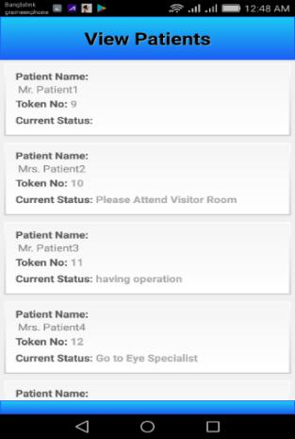
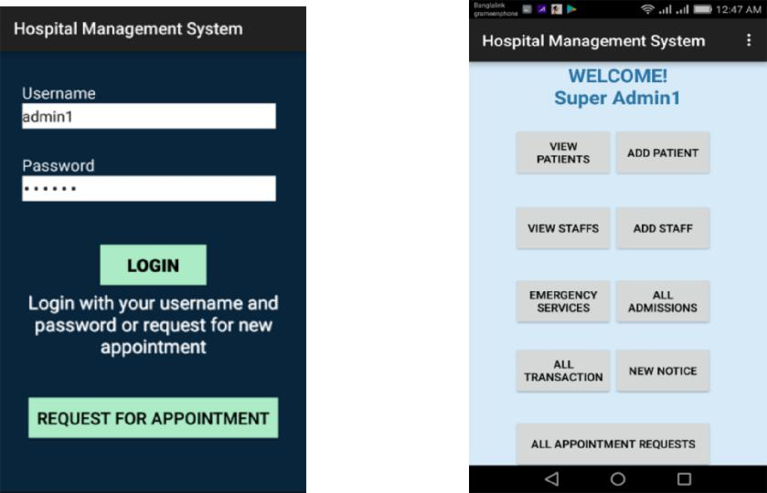

Figure: 2.1 Figure: 2.2 Figure: 2.3

Super Admin can access here using password (Figure 2.1). Then Super Admin can view all patients (Figure 2.3), staffs, emergency service condition, all transaction, all appointment requests, all admission and also can add new patients, staffs and give new notice (Figure 2.2).

Add Patients (New patient registration):

Sub Admin Module Can’t Publish office Notice and Fire Staffs. All Other Permissions and Options Are Same As Super Admin. (See Figure 2.4 and 2.7)
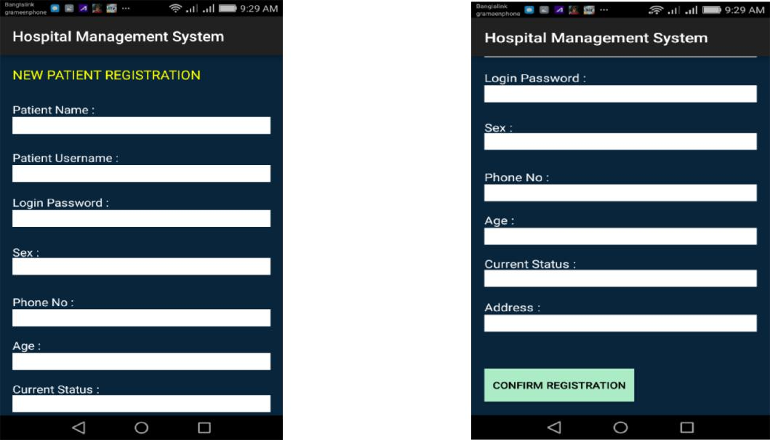

Figure: 2.4 Figure: 2.5

They can view their staffs. (Figure: 2.6-2.7)
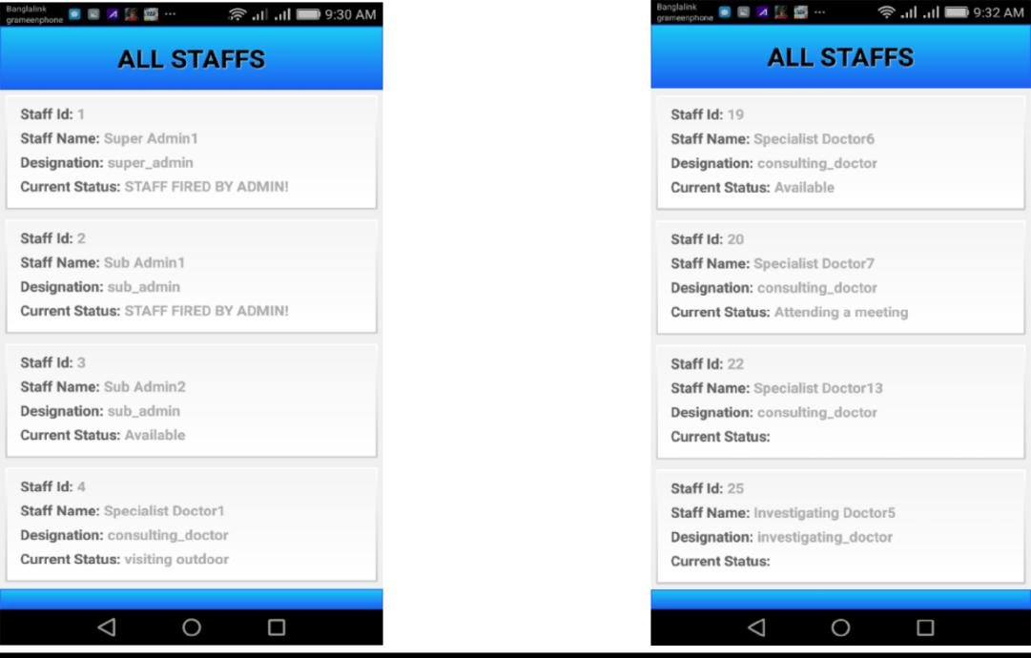

Figure: 2.6 Figure: 2.7

They can add staffs (new staff registration) here. (Figure: 2.8-2.9). They have to input their name, user name, login password, sex, phone number, age, specialty for registration.
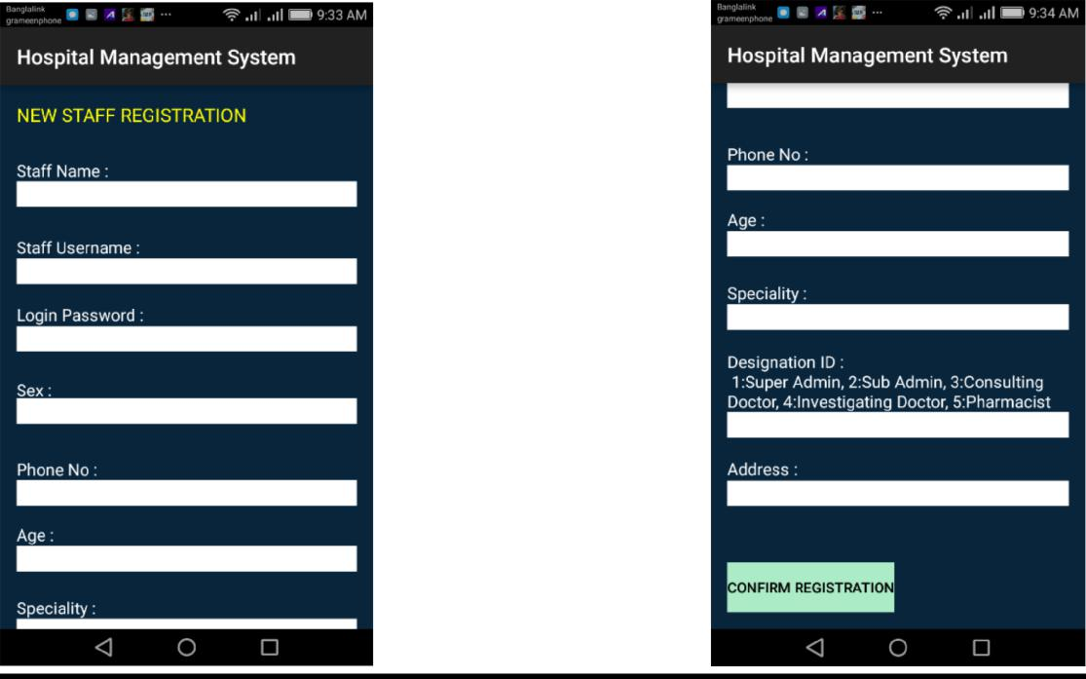

Figure: 2.8 Figure: 2.9

Emergency service:

Emergency service has Ambulance service, important contacts and other services. (Figure 2.10)
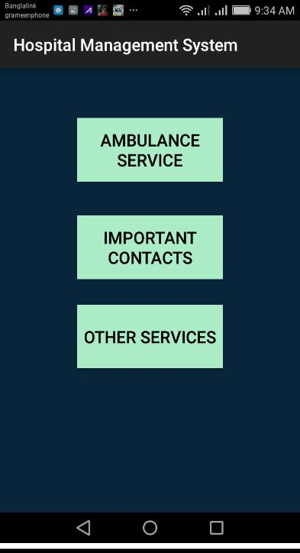

Figure: 2.10
Here are some all admissions screenshots. (Figure: 2.11-2.15). Here they can view current admissions, admit a new patient, discharge a patient and also view admission history. By putting patient Id, doctor Id, ward Number, Cabin number they confirm a new patient admission (Figure 2.13).

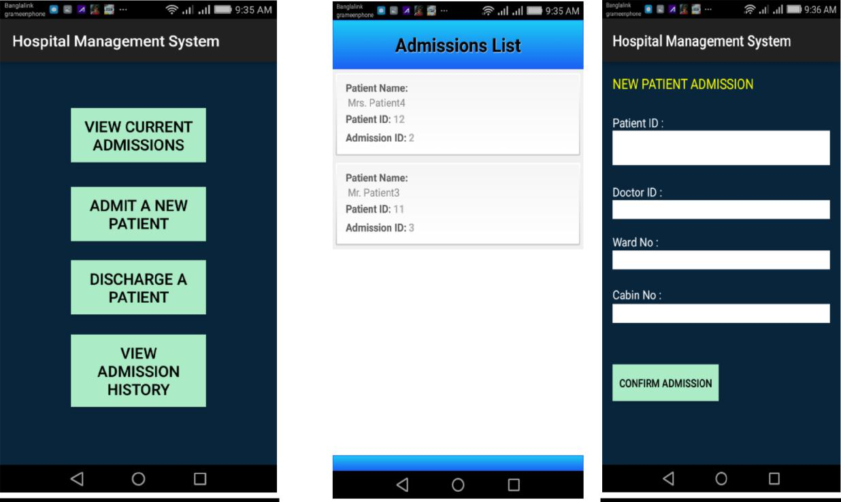

Figure: 2.11 Figure: 2.12 Figure: 2.13

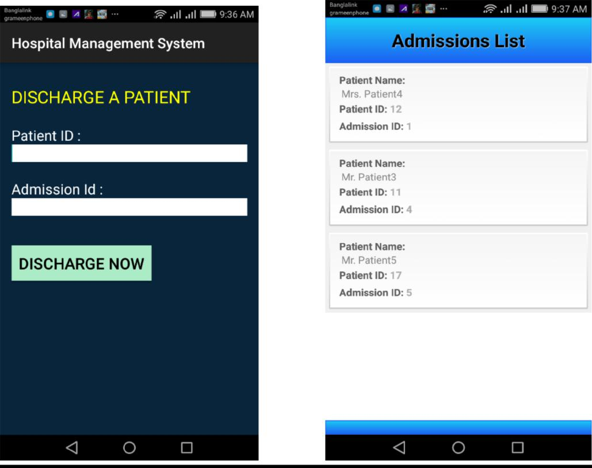

Figure: 2.14 Figure: 2.15
They can write new notice here and submit. (Figure 2.16)

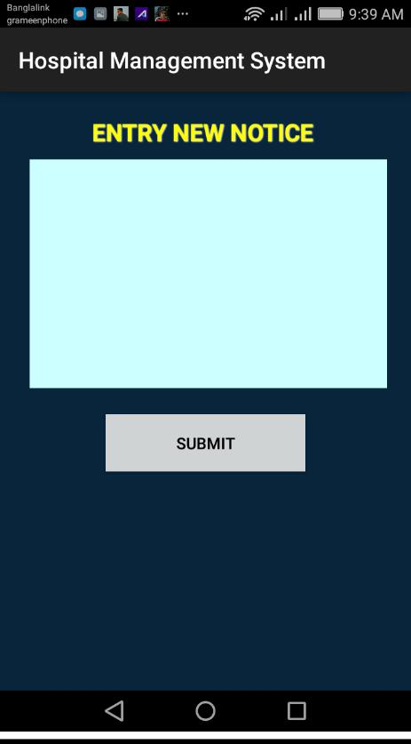

Figure: 2.16

Here are all appointment requests. Here we can see their appointment Id, Patient name, Request date, Current status. (Figure 2.17 - 2.18)

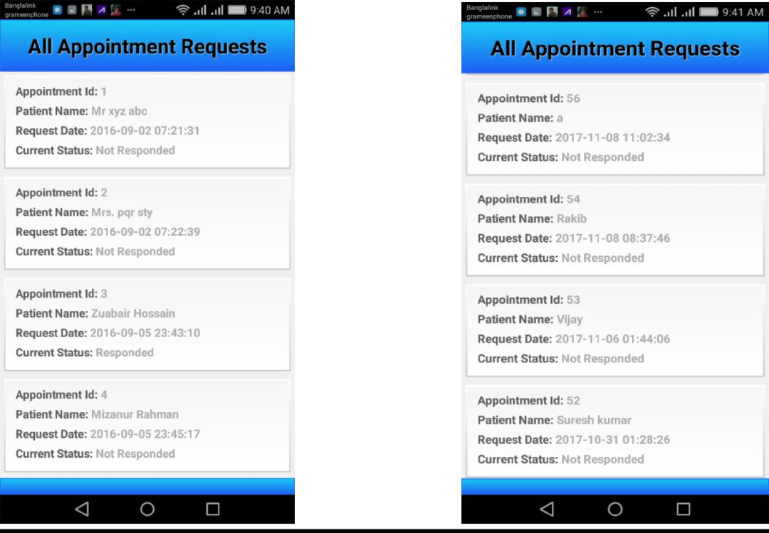

Figure: 2.17 Figure: 2.18

Sub admin-1(My Status): (Figure 2.19). Here we can see Staff fired by admin.

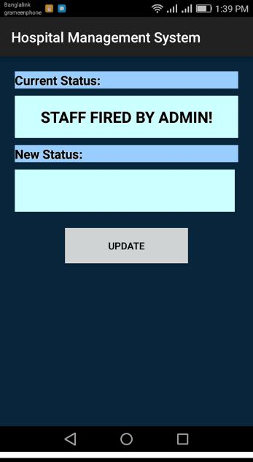

Figure: 2.19

Welcome to specialist doctor-1

Here are some options like View all patients, my current status, admin notice, all admission (Figure 2.25).

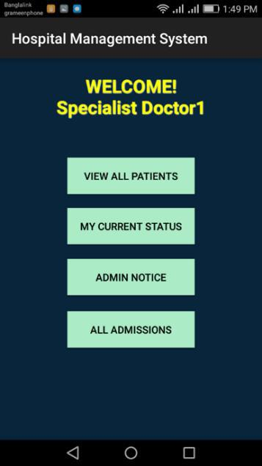

Figure: 2.20

Admin notice:

Admin can give any notice here for all. (Figure 2.21)

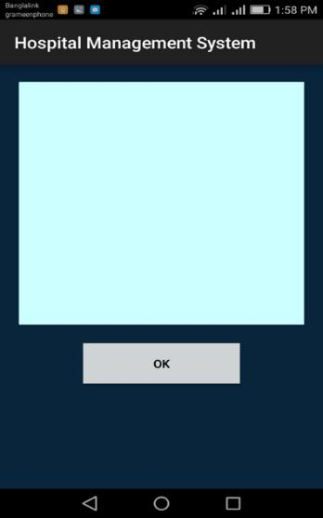

Figure: 2.21

All admissions:

Here they can View current admission, View admission history and Admission under me. (Figure 2.22)

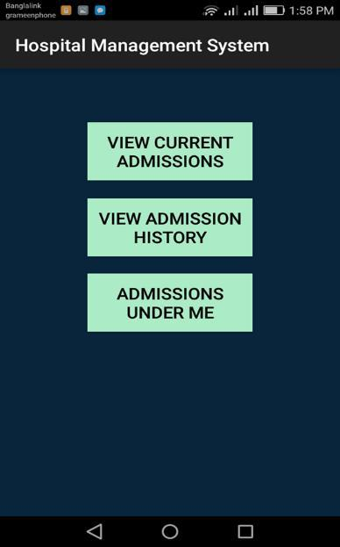

Figure: 2.22

Doctor 2 - Consulting Doctor Module:

- View All Patients List
- View Patient’s Prescriptions
- Add A New Prescription
- View Patient’s Investigations
- View Patient’s Current Status
- Update Patient’s Current Status
- View Own Status
- Update Own Status
- View Office Notice By Admin
- View All Current Admissions List
- View All Discharged Admissions List
- View All Admissions Under Respective doctor
- View Details of An Admission

Here the doctor’s current status is ‘Brain Surgery at OT-3’. Here doctor can update their status too. (Figure 2.23)

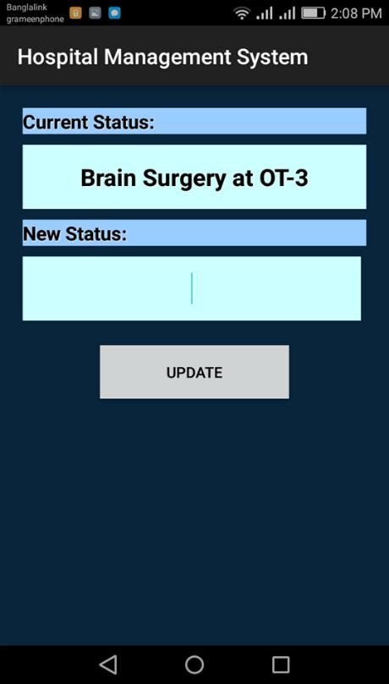

Figure: 2.23
Doctor-3

(Welcome to investigating doctor Module -1)
Investigating doctor can view All Patients List, Patient’s Prescriptions, Generate Investigation Report, View Patient’s Investigations, View Patient’s Current Status, Update Patient’s Current Status, View Own Status, Update Own Status, View Office Notice By Admin. (Figure 2.24)

Here current status is ‘Investigating patient4’.

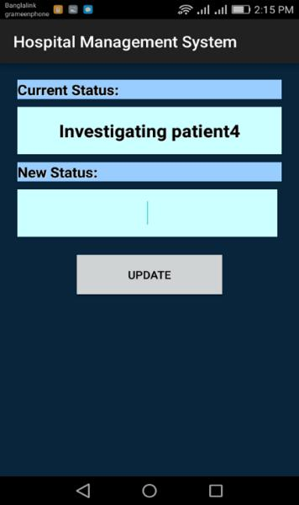

Figure: 2.24
Patients Module:
Patients can request for an appointment view all prescriptions, all investigations, current status/task, all payment sections, payment invoices, payment status. (Figure 2.30)

Patients list - Patient-1

- Prescription
- Current status
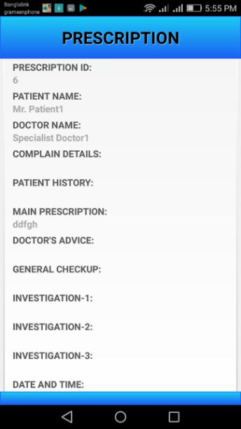
- Investigations
- Payments

Figure: 2.25
Payments:

Here are some options as outdoor payment, investigation amount, pharmacy bill, admission charges, discharge amount, extra charges. (Figure 2.26)

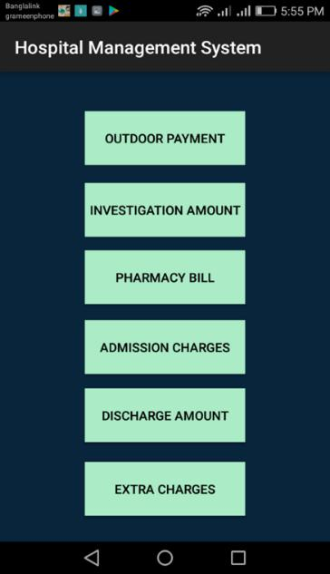

Figure: 2.26

Here payments show pharmacy bill as ‘Patient with Token No:10 has already paid Pharmacy Bill BDT 1400 on 2016-9-10 at 09:5853, Transaction Id: 9’ (Figure 2.27) and ‘Patient with Token No: 11 is required to pay Outdoor Amount BDT 250 due 2016-09-09 at 19:19:07, Transaction Id: 11’ (Figure 2.28).

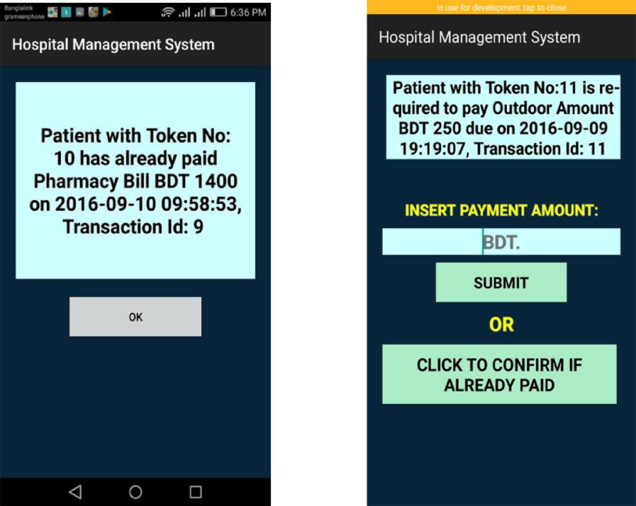

Figure 2.27 Figure 2.28

Here outdoor payments show that ‘Patient with Token No: 10 is required to pay outdoor amount BDT 350 due on 2016-09-09 at 10:01:32, transaction Id: 4’ (Figure 2.29).

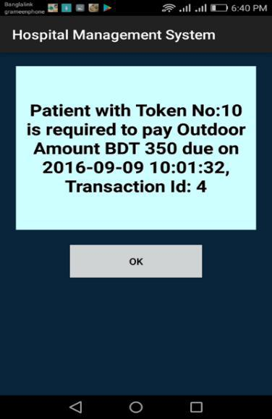

Figure: 2.29

Here Patient 3 current status is ‘having operation’ (Figure: 2.30) and Patient 4 current status is ‘Go to Eye Specialist’ (Figure 2.31).

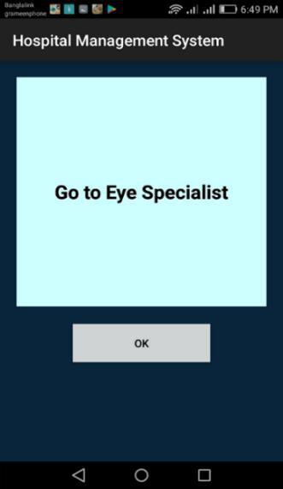
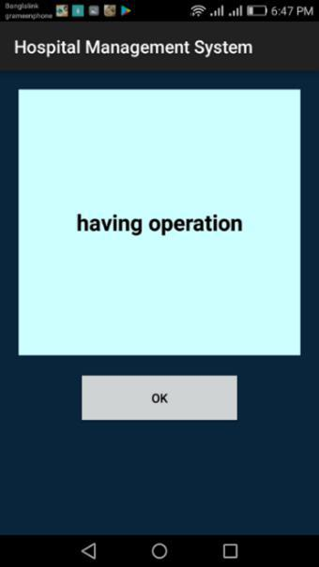

Figure: 2.30 Figure: 2.31

Pharmacist list

Pharmacist can view all patients, my current status and admin notice. (Figure 2.32)

Here pharm 1 show their current status is ‘serving visitors’(Figure2.33) and pharm 2 show their current status is ‘active’(Figure2.34)

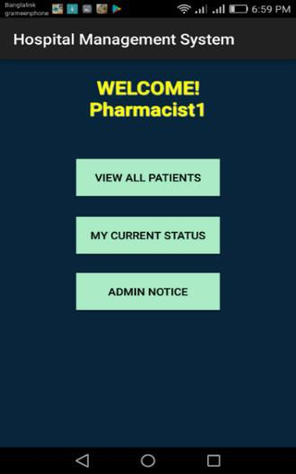

Figure: 2.32

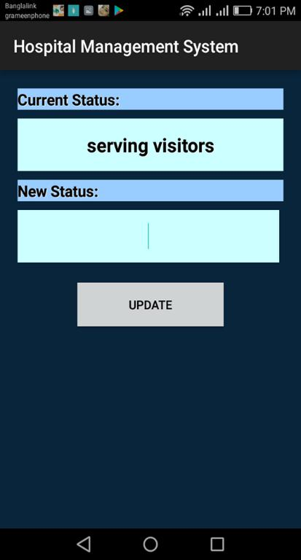
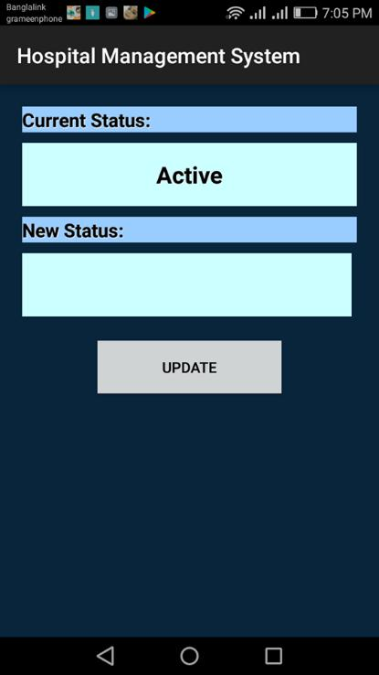

Figure 2.33 Figure 2.34

Chapter 3
Database Design Schema

Tables & All Attributes For MySQL
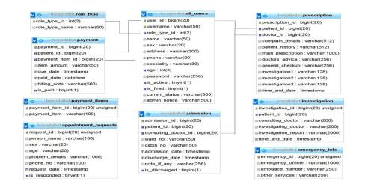

1. Eclipse IDE: Development Tool:

Eclipse is a coordinated improvement condition (IDE) utilized as a part of PC programming, and it is the most broadly utilized Java IDE. Eclipse is composed for the most part in Java and its essential utilize is for creating Java applications, however it might likewise be utilized to create applications in other programming dialects. Eclipse contains a base workspace and an extensible module framework for redoing the earth.

2. JAVA for Android Coding:

Java is a programming dialect explicitly intended for use in the circulated condition of the web. It is the most prominent programming dialect for Android cell phone applications and is among the most supported for edge gadget and web of things improvement.

Code Sample #1: Handling Activity Data Using JAVA

investigation.setOnClickListener(new View.OnClickListener() { @Override

public void onClick(View v) {
Intent i = new Intent

("com.admit.hospitalapp.PPAYMENTSTATUSACTIVITY"); i.putExtra(PATIENT_IDT, patient_id); i.putExtra(PAYMENT_ITEM, "2");
startActivity(i);
}
});

pharmacy.setOnClickListener(new View.OnClickListener() { @Override

public void onClick(View v) {
Intent i = new Intent

("com.admit.hospitalapp.PPAYMENTSTATUSACTIVITY"); i.putExtra(PATIENT_IDT, patient_id); i.putExtra(PAYMENT_ITEM, "3");
startActivity(i);

}
});

admission.setOnClickListener(new View.OnClickListener() { @Override

public void onClick(View v) {
Intent i = new Intent

("com.admit.hospitalapp.PPAYMENTSTATUSACTIVITY"); i.putExtra(PATIENT_IDT, patient_id); i.putExtra(PAYMENT_ITEM, "4");
startActivity(i);

}

});

discharge.setOnClickListener(new View.OnClickListener() { @Override

public void onClick(View v) {
Intent i = new Intent

("com.admit.hospitalapp.PPAYMENTSTATUSACTIVITY"); i.putExtra(PATIENT_IDT, patient_id); i.putExtra(PAYMENT_ITEM, "5");
startActivity(i);

}
});

3. XML For Interface/Screen layout Design

XML UI is a Java and XML structure for building rich customer, work area and versatile applications. The system can spare a significant part of the code ordinarily expected to construct an application with subsequent funds being developed time, support costs and henceforth brings about more noteworthy dependability.

Code Sample #2: Layout Design in XML Format

<ScrollView xmlns:android="http://schemas.android.com/apk/res/android"
android:id="@+id/scroll"
android:layout_width="match_parent"
android:layout_height="fill_parent">

<RelativeLayout
android:layout_width="match_parent"
android:layout_height="match_parent"
android:paddingLeft="@dimen/activity_horizontal_margin"
android:paddingRight="@dimen/activity_horizontal_margin"
android:background="#08253c” >
<Button
android:id="@+id/Buttonpp4"
android:layout_width="175dp"
android:layout_height="60dp"
android:layout_below="@+id/Buttonpp3"
android:layout_centerHorizontal="true"
android:layout_marginTop="18dp"
android:text="Admission Charges"
android:textColor="#000"
android:background="#abebc6"/>

<Button
android:id="@+id/Buttonpp5" android:layout_width="175dp" android:layout_height="60dp" android:layout_alignLeft="@+id/Buttonpp4" android:layout_below="@+id/Buttonpp4" android:layout_marginTop="16dp" android:text="Discharge Amount" android:textColor="#000" android:background="#abebc6"/>

</RelativeLayout>
</ScrollView>

4. JSON Parsing For Data Interchange:

The JSON.parse() technique parses a JSON string, building the JavaScript esteem or question depicted by the string.

JSON is a content configuration that encourages organized information trade between all programming dialects. JSON is grammar of props, sections, colons, and commas that is helpful in numerous specific circumstances, profiles, and applications.

Code Sample #3: JSON Parser Creation For Network Data Transfer

public class JSONParser {

static InputStream is = null;
static JSONObject jObj = null;
static String json = "";

// constructor
public JSONParser() {

}

public JSONObject getJSONFromUrl(final String url) {

- Making HTTP request
- try {

} catch (Exception e) {
}
}

public JSONObject makeHttpRequest(String url, String method,
List<NameValuePair> params) {

//Making HTTP request try {

} catch (Exception e) {
}

}
}

Code Sample #4: Reading JSON Data From Online Database

(Fetching Patient Information)

private ProgressDialog pDialog;

// JSON parser class
JSONParser jsonParser = new JSONParser();

private static final String PERSON_INFO_URL = "http://www.myweb.in/hospitallogin/personal_info.php";

private static final String TAG_SUCCESS = "success"; private static final String TAG_MESSAGE = "message";

class FetchStatus extends AsyncTask<String, String, String> {

@Override
protected void onPreExecute() {
super.onPreExecute();

pDialog = new ProgressDialog(PatientInfoActivity.this);
pDialog.setMessage("Fetching Details...");
pDialog.setIndeterminate(false);
pDialog.setCancelable(true); pDialog.show();
}

@Override

protected String doInBackground(String... args) { try {

- Building Parameters
- getting product details by making HTTP request
- check your log for json response
- save user data
} catch (Exception e) {
}
protected void onPostExecute(String s) {

super.onPostExecute(s);
person_details.setText(s);
pDialog.dismiss();

}

Code Sample #5: Storing Data To Online Database Using API

Adding New Patient)

// Progress Dialog
private ProgressDialog pDialog;

// JSON parser class
JSONParser jsonParser = new JSONParser();

class AdmissionPatient extends AsyncTask<String, String, String>{ @Override

protected void onPreExecute() {
super.onPreExecute();

pDialog = new ProgressDialog(PatientInfoActivity.this); pDialog.setMessage("Fetching Details..."); pDialog.setIndeterminate(false); pDialog.setCancelable(true); pDialog.show();

}

protected String doInBackground(String... args) { try {

- Building Parameters
- getting product details by making HTTP request
- check your log for json response
- save user data
} catch (Exception e) {
}
protected void onPostExecute(String s) {

super.onPostExecute(s);
person_details.setText(s);

pDialog.dismiss();

}
}

5. Android Manifest File: For App Configuration:

Every single application must have an AndroidManifest.xml document in its root registry. The show document gives basic data about your application to the Android framework, which the framework must have before it can run any of the application's code.

Code Sample #6: Application Setting in Menifest.xml

<?xml version="1.0" encoding="utf-8"?>
<manifest xmlns:android="http://schemas.android.com/apk/res/android"
package="com.admit.hospitalapp"
android:versionCode="1"
android:versionName="1.0" >

<uses-sdk
android:minSdkVersion="8"
android:targetSdkVersion="22" />

<uses-permission android:name="android.permission.INTERNET"/>

<application
android:allowBackup="true"
android:icon="@drawable/ic_launcher"
android:label="@string/app_name"
android:theme="@style/AppTheme" >

<activity
android:name=".HSplash"
android:label="@string/app_name"
android:screenOrientation="portrait" >

<intent-filter>
<action android:name="android.intent.action.MAIN" />

<category android:name="android.intent.category.LAUNCHER" />
</intent-filter>
</activity>

<activity
android:name=".HospitalActivity"
android:label="@string/app_name"
android:screenOrientation="portrait" >
<intent-filter>

<action

android:name="com.admit.hospitalapp.HOSPITALACTIVITY" /> <category android:name="android.intent.category.DEFAULT" />
</intent-filter>
</activity>
</application>
</manifest>

6.PHP as Scripting Language:

PHP is a comprehensively valuable scripting lingo. It is especially suited to server-side web change, in which case PHP generally continues running on a web server, any PHP code in a requested record is executed by the PHP runtime.

Code Sample #7: Server Side Data Process Using PHP

<?php

//load and connect to MySQL database stuff
require("config.inc.php");

if (!empty($_POST)) {

//gets user's info based off of a username.

$query = "UPDATE payment SET is_paid = 1, paid_date = NOW() WHERE patient_id = :patient_id AND payment_item_id = :payment_item_id";

$query_params = array(

':patient_id' => $_POST['userid'], ':payment_item_id' => $_POST['itemid']

);

try {
$stmt = $db->prepare($query);
$result = $stmt->execute($query_params);
}
catch (PDOException $ex) {
//For testing, you could use a die and message.
//die("Failed to run query: " . $ex->getMessage());

//or just use this use this one to product JSON data:
$response["success"] = 0;

$response["message"] = "Database Error1. Please Try Again!"; die(json_encode($response));

}

$response["success"] = 1;

$response["message"] = "Payment Confirmed"; die(json_encode($response));

} else { ?>

Code Sample #8: Server Side JSON Data Creation

(For Patient Details)

{
"success": 1,

"message": "Patient List Available!",
"posts": [
{
"patient_id": "9",
"patient_name": "Mr. Patient1",
"status_id": ""
},
{
"patient_id": "10",
"patient_name": "Mrs. Patient2",
"status_id": "Please Attend Visitor Room"
},

{
"patient_id": "11",
"patient_name": "Mr. Patient3",
"status_id": "having operation"
},
{
"patient_id": "18",
"patient_name": "Miss. Patient6",
"status_id": "Visit Room 12"
},
{
"patient_id": "21",
"patient_name": "Mr. Patient7",
"status_id": "Please come tomorrow"
}
}
}

- MySQL for database:

MySQL is an open source social database administration framework in light of Structured Query Language (SQL).LAMP is a Web advancement stage that utilizations Linux as the working framework, Apache as the Web server, MySQL as the social database administration framework and PHP as the question arranged scripting dialect.

- Any database design tool like : starUML

StarUML is an open source programming displaying device it underpins Unified Modeling Language. It depends on UML rendition 1.4, gives eleven unique sorts of chart and it acknowledges UML 2.0 documentation. It effectively underpins the MDA (Model Driven Architecture) approach by supporting the UML profile idea and permitting to create code for various dialects.

Chapter 4
Results

Results and findings of the project are noticeable. All the modules are working as expected. Patients are able to take appointment, get registered using a token, proceed to doctor for prescription followed by investigations, get admissions, purchase medicines from pharmacy, pay all types of hospital bills and so on. Doctors can follow the patients, submit prescriptions, investigations and assign admissions. Pharmacists and other staffs are also able to use the App to perform their duties. Admin and Sub Admins can look after all the patient’s procedures, admissions, investigations, payments & transactions and also manage the hospital employees.

Chapter 5

Conclusion

By using this application, it will be very easy to maintain full hospital management. Its functionality is very easy and anyone can use it.

Future Scope

- Add user image as profile photo.

- Set an emergency number so that I can call on emergency time using sensor.

- More user friendly interface.

References

1.Book reference: Java The Complete Reference-Herbert Schildt

2.Web reference: https://www.tutorialspoint.com/android/

3.BASIS Institute of Technology & Management (BITM) course of Mobile Applications Development.

