

The Islamic Banking Industry of Bangladesh & Social Islami Bank Limited: An Internship Experience Perspective

Supervised by:
Md Mohan Uddin, Ph.D.
Professor
School of Business & Economics
United International University

Submitted by:
Junayed Ahamed Soumik
ID: 111-163-139
Bachelor of Business Administration (BBA)
School of Business and Economics (SoBE)
United International University

Date of Submission: 1st May, 2021

ACKNOWLEDGEMENT
All praises to the Almighty Creator, who has conferred his kindness upon me by giving me the chance, time, courage, and strength to carry out and finish the task within the time limit. I would like to express thanks to those who have contributed to it a lot.
I sincerely acknowledge my debt and special gratitude to the instructor, Md Mohan Uddin, Ph.D. Professor, School of Business & Economics (SoBE), United International University, for his careful supervision and eccentric guidelines for the Internship report throughout several consultations as my supervisor. The continuous discussion between me and my supervisor has let me put a heartfelt effort to produce this report. He has indebted us with his flawless advice and support and of course to allow us to work on such an exceptional project from where we have learned abundant things. His consistent accessibility for discussing problems and ideas and encouragement with support have contributed much to the report.
I am also grateful to Shaheen Mahmood (my organizational supervisor), Mr. Istiak Mahmud (FAVP and Trade In-charge), Mr. Showeb Mohammad (Officer), and also other bank officers for offering me the relevant information for my report and their useful cooperation, guidelines, advice and continued support throughout the internship period. During my internship period, I was closely associated with them. They made my internship delightful and convenient. To end with, I must not miss the chance of articulating my earnest appreciation to some of my friends, who shared and inspired me all the time.

LETTER OF TRANSMITTAL
1st May 2021
To,
Md Mohan Uddin, Ph.D.
Professor,
School of Business and Economics
United International University
Subject: Submission of Internship Report
Dear Sir,
I am delighted to present my Internship report regarded as” The Islamic Banking Industry of Bangladesh & Social Islami Bank Limited: An Internship Experience Perspective” to you, my supervisor for the Internship as assigned by the university authority. I have given my absolute best to form this report with the necessary details, figures, and suggested proposition. In writing this report, I have charted the guidelines that you have specified to me and I have also applied related concepts that I have learned throughout my under graduation phase. Moreover, I also collected information from the selected organization to find a resemblance to theoretical learning. However, some information and references have been taken from different sources to facilitate my report. I attempted all possible steps to complete the report in due time and I wholeheartedly desire that this report will meet the expectations. My honest effort was put into giving this report a neat shape to make it as revealing and detailed as possible. If you face any problem reading any part of my report or need any assistance, feel free to contact me (Email: jsoumik163139@bba.uiu.ac.bd, Cell no. 01674645987). Finally, I would love to express once again my gratitude for your compassionate thoughts and kind consideration.
Sincerely Yours,
Junayed Ahamed Soumik
ID: 111-163-139

EXECUTIVE SUMMARY
This report is based on a three-month internship experience which was a partial requirement for the completion of Bachelor of Business Administration (BBA) from United International University (UIU). The purpose of the report is to give a clear idea about the Islamic Banking Industry of Bangladesh. This report will depict the corporate structure of SIBL from an intern perspective. SIBL was incorporated on 5 July 1995 and from 22 November to provide its customer with elite service facilities and thus meet the demand for banking services started its operation throughout Bangladesh. It will show how SIBL in a very short period became an industrial conglomerate following its operation based on the Sharia-based principle.
The first chapter enhances the evolution of Islamic Banking industries and it facilitates the background of the report which conveys the key differences between Islamic banking and conventional banks. It also shows some key features such as the objective, significance of the report to initiate the reader to understand more thoroughly.
The second chapter is an in-depth analysis of the Islamic Banking Institution of Bangladesh. If we get a fixed amount of interest in the conventional bank, which is also known as RIBA, we get a certain share of total profits in the Islamic bank. After evaluating the size, trend, maturity, and number of banks it classifies the growing nature of the Islamic Banking industries in Bangladesh. Porter’s Five Sources model suggests the vitality of the economical factor for this particular industry. Comparative analysis shows the strength of the buyer and supplier power present in the industry. The intensity among the rivals is increasing as the industry is emerging with a high exit barrier. It also suggests some challenges and opportunities that the industry likely to face in near future.
The third chapter is to break down SIBL into different pieces. This chapter will particularly highlight the current situation, the product offering, and customers' perspectives of SIBL. After analyzing its annual report this chapter will focus on the rising trend of its business growth. It assures the increasing number of deposits, investment services, total capital, and total assets SIBL has achieved over the period. These chapters also focus on the availability of the SIBL product and the function of its operation to meet its objective. After doing SWOT analysis it figures out as the honesty of the employees, the religious sentiment of people, and adequate funds are the key factor behind their strength. Weakness suggests SIBL requires more employees and up-to-date equipment for its operation.SIBL has a huge opportunity to grow by retaining its massive customer and providing them with efficient services. Implementation of Islamic banking structure from the conventional one is the major threat in coming years. These chapters also include some strategies from the intern point of view that SIBL might adapt to become the market leader of the industry.
Also, Chapter four includes my entire experience as an intern, which was very fascinating. It briefly describes my job responsibilities and how I enhanced my competencies at Social Islami Bank Ltd.
Finally, chapter five will demonstrate the recommendation based on my evaluation of the performance of the bank from a different dimension. It also mentioned some recommendations for my self-development.
This report is modulated to discover the present scenario of the Islamic Banking industry in Bangladesh. Considering SIBL as the model of the report enhances the challenges and opportunities this particular industry faces in the current market.

Table of Contents
CHAPTER-1| INTRODUCTION 2
1.1. BACKGROUND 2
1.2. OBJECTIVES OF THE STUDY 6
1.3. SIGNIFICANCE OF THE STUDY 7
CHAPTER-2 | ANALYSIS OF THE INDUSTRY 10
2.1. SPECIFICATION OF THE INDUSTRY 10
2.2. SIZE, TREND, AND MATURITY OF THE INDUSTRY 11
2.3. SEASONALITY 21
2.4. EXTERNAL ECONOMIC FACTORS 21
2.5. TECHNOLOGICAL FACTORS 22
2.6. POLITICAL, LEGAL, AND REGULATORY FACTORS 23
2.7. BARRIERS TO ENTRY 23
2.8. SUPPLIER POWER 24
2.9. BUYER POWER 24
2.10. THREAT OF SUBSTITUTES 25
2.11. INDUSTRY RIVALRY 25
2.12. CHALLENGES AND OPPORTUNITIES 26
CHAPTER-3 |ANALYSIS OF THE ORGANIZATION 30
3.1. OVERVIEW AND HISTORY 30
3.2. TREND AND GROWTH 34
3.3. CUSTOMER MIX 39
3.4. PRODUCT AND SERVICE 40
3.5. OPERATION 43
3.6. SWOT ANALYSIS 44
3.7. STEPS/STRATEGIES TO MEET THE CHALLENGES AND OPPORTUNITIES 46
CHAPTER-4| INTERNSHIP EXPERIENCE 48
4.1. POSITION, DUTIES, AND RESPONSIBILITIES 48
4.2. TRAINING 48
4.3. CONTRIBUTION TO DEPARTMENTAL FUNCTIONS 49
4.4. EVALUATION OF INTERNSHIP PERFORMANCE 49
4.5. SKILLS APPLIED 50
4.6. NEW SKILLS DEVELOPED 51
4.7. APPLICATION OF ACADEMIC KNOWLEDGE 51
CHAPTER-5| RECOMMENDATIONS 53
5.1. RECOMMENDATIONS FOR IMPROVING DEPARTMENTAL OPERATIONS 53
5.2. RECOMMENDATIONS FOR IMPROVING SELF-PERFORMANCE 53
CHAPTER-6| CONCLUSION 56
CHAPTER-7| REFERENCES: 58

List of Figures
Figure 1 Mobilization of deposits of Islami banks 15
Figure 2 Types of deposits 16
Figure 3 Investment amount of Islamic banking windows and branches 17
Figure 4 Excess liquidity of Islamic Banks over two periods 18
Figure 5 Share of Remittance of Islamic Banks 18
Figure 6 Share of remittances by Conventional and Islamic Bank 19
Figure 7 Logo of SIBL 32
Figure 8 Core values of SIBL 32
Figure 9 Organogram of SIBL 34
Figure 10 Deposit over the years of SIBL 35
Figure 11 Investment of SIBL over the years 35
Figure 12 FX business of SIBL over the last 5 years 36
Figure 13 Profit after tax of SIBL over the last 5 years 36
Figure 14 Paid-up capital of SIBL over the last 5 years 37
Figure 15 Total asset amount of SIBL over the last 5 years 38
Figure 16 Total capital amount of SIBL over the last 5 years 38
Figure 17 Number of Branches of SIBL over the last 5 years 39
Figure 18 Number of employees of SIBL over the last 5 years 39
Figure 19 SWOT analysis of SIBL 44

List of Tables
Table 1 Difference between Riba and profit 3
Table 2 Difference between Islamic bank and Conventional bank 5
Table 3 Activities of Islamic Banking in Bangladesh, April-June 2019 13
Table 4 Number of Islamic banks in Bangladesh 20
Table 5 Products of the respective SIBL departments 41
Table 6 Performance evaluation of SIBL 50



CHAPTER-1| INTRODUCTION

BACKGROUND
Over the last few decades, the accelerated and viable growth of Islamic banks in the global economy has shown the iconic status of Islamic banking as a demanding substitute to the interest-based capitalist financial system. The Islamic finance industry has grown significantly in the past decade, increasing at 10-12 percent per year.
The foundation of the Islamic Development Bank situated in 1975 had an abrupt manipulation for the development of Islamic Banking worldwide. Regardless of Muslim and non-Muslim nations much Islamic banking and monetary organizations have been set up worldwide since the foundation of IDB. Over a short span of time the Islamic monetary industry has quickly elongated around the world. At present, around 300 Islamic banks and monetary foundations (IFIs) have been working following Islamic Shariah with all-out joined resources surpassing the US $2 trillion above 75 nations. This quick development has acquired significant consideration in global monetary circles where different market members have perceived their promising possibilities.
In parallel with the accelerated international expansion of Islamic banking, Bangladesh has encountered amazing development in Islamic banking following massive consumer availability for the structure. Islamic Banking has started its operation in Bangladesh in from1983. This banking industry has approximately around 20% of the market share. Despite its rapid progression, this industry still shows great promises for advancement in the future as Bangladesh with a real growth economy is a Muslim-based populated country.
Profit VS interest:
Firstly, we need to recognize the variations between profit and interest to grab a clear perspective about the Islamic Banking Industry. Islamic bank shares a certain percentage with its borrower, on the contrary, the non-Islamic bank charges a fee on the loan they provide. Interest, also known as RIBA is prohibited (Haraam) in Islamic tradition. Riba represents a surge or addition of access. As per Islamic Shariah's terminology, Riba is any overcompensation without proper regard for the time value of money. Conventional Bank has the tradition to fix the interest rate at the beginning of the year and it does not change unless there is a financial distress situation in the economy. But profit, alternatively, is entirely different from interest. The bank invests the money of its depositor as its assets into a business and earns profit, then shares a few percentages of that profit to the depositors. Profit compare to the interest rate is not fixed despite it also been established at the beginning of the year. This could alter if the bank is earning more and perhaps less. It varies on the stability of the bank. The Islamic Bank in Bangladesh as well provides the shared profits that have already been decided at the outset of the year in compliance with the rules of the Bangladesh Bank. However, once in a while it affects its percentage because of its efficiency gains. This is a significant distinction between profit and interest. Conventional Bank runs to earn profit where else Islamic Bank believe in sharing the profit and loss. The differences are shown below in Table 1.
Table 1 Difference between Riba and profit
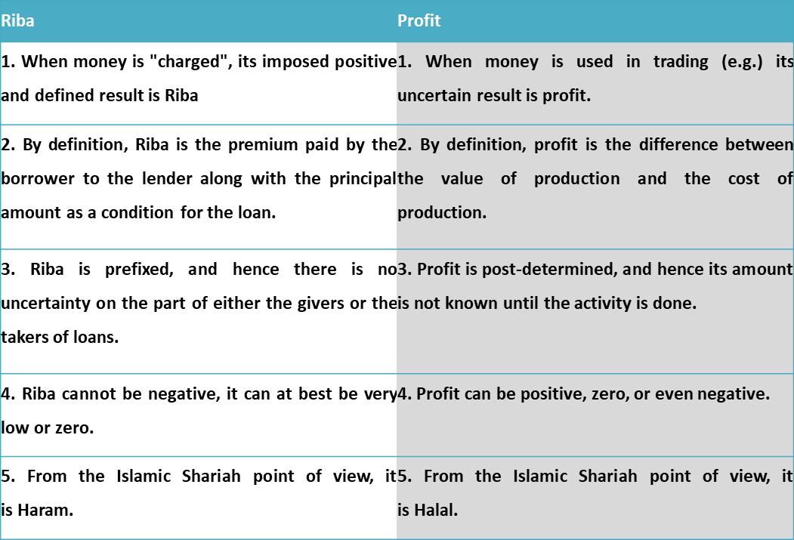
Mudarabah is the basis of modern Islamic banking on a two-tier basis
Mudaraba is a sort of a deal where one entity provides capital to another entity for investment. This kind of partnership forms to enhance enterprising abilities, so that can start its project suitable and provide works for labor.
Benefits coming from the investment are shared at a certain rate. Also, the capital provider of the investment doesn't have any power over the business. There are two-tier of mudaraba as follows;
First level: In the first level, depositors invest in the bank by putting cash as well as agreeing to transmit benefits in it. The bank becomes the administrator of assets while the contributor becomes the supplier of capital in this situation.
Second level: In the second level, Entrepreneurs take financial support from the bank for aiding their organizations on the basis that the dividend earned by their business will be divided between the bank and the entrepreneurs to the extent that was agreed upon, however, if any loss arises then the bank will fully bear it. Unlike the previous first level, in this level, the bank becomes the supplier of capital while the entrepreneur becomes the director.
Islam defines that an individual can expect to appreciate his income through the usage of his fund if he is willing to face challenges as well as the possibility of loss from it Islam says an individual can only obtain a true share of profit when he's willing to expose his fund on the probability of the loss, not by only earning through applicable interest rate given by the conventional bank on the deposit of funds.
Although certain individuals tend to erroneously believe that cost of capital of the Islamic banking system is equivalent to zero interest rate. Which is not true the only comparison is that non-Islamic bank operates with a predefined fixed rate on the other hand Islamic banking structure harness on sharing the profit with its contributor.
Conventional and Islamic banking
Conventional banking maintains a two-sided relationship with its contributor. On one side they coercively maintain the relationship with their lender and on the other side, they keep their depositor of the fund. In both cases, interest is applicable, as it defines as the opportunity cost of the money. Islam, on the contrary, does not charge any pre-determined fee on the money they provide to its borrowers. Therefore, Islamic banks are not supposed to take any advantage in the events of the misfortune of the lender.
When cash is loaned based on a pre-determined rate, it occurs more than not that it tends to lead to something like oppression. The main Islamic rule fundamental in these types of transactions is "Deal not unjustly, and ye shall not be dealt with unjustly" [2:279].
Non-Islamic banking in the Islamic context is therefore not dependent on the relationship between the debtor and the creditor. Islam also believes there should be no incentive without challenge on any financial transactions. This principle applies both to workers and employers. Since labor is not earning anything unless they are employed exactly in the same way there should be no reward on the fund unless it is subjected to risk Based on these two standards the Islamic banking framework has been constructed. As a result, financial relations in Islam have been collaborative. Nowadays even many other scholars are set to believe the traditional banking model should shift its structure to Profit and loss sharing. This implies that a pre-determined rate should be substituted by a changeable rate of return based on the contemporary stability of the economy. These two standards: (a) a profit and loss sharing structure, and (b) investment (loans and advances in the conventional sense) provide satisfaction for both shareholders and also advantage for the wider population. All in all sets a distinctive feature for the Islamic banking industry. For the interest of the readers, the differences between the Islamic Bank and Conventional Bank are demonstrated in the following Table 2:

Table 2 Difference between Islamic bank and Conventional bank
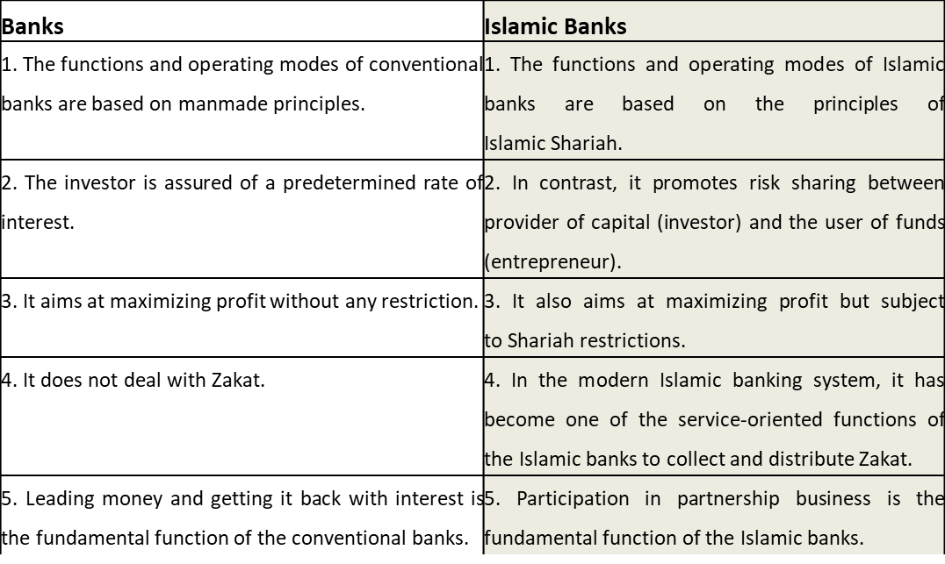
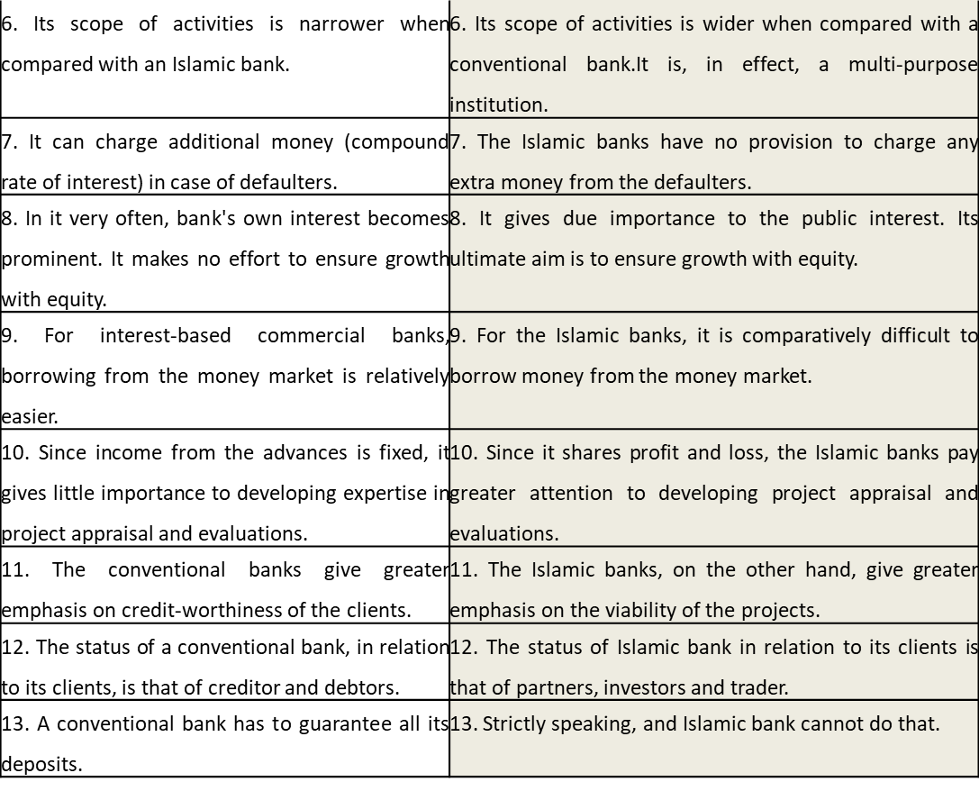.

OBJECTIVES OF THE STUDY
The objective of the report is as follows:
- Overview of the Islamic Banking Industry of Bangladesh
- Comparison between Islamic Banking Industry and Non-Islamic banking industry
- Overview of SIBL
- To gather knowledge about the functions and transactions of different departments of the bank
- Demonstration of Bank operation
- Performance of the SIBL over the period
- Comparative analysis of SIBL
- Islamic Banking Activity of SIBL

SIGNIFICANCE OF THE STUDY
This report is prepared after 12 weeks long internship program, as a part of the Bachelor of Business Administration (BBA) course requirement, to familiarize the students with the organization environment in real life. It will comprise of the analysis of the Islamic Banking industry of Bangladesh, analysis of the SIBL, and my internship experience. The reader will get about the difference between conventional banking and Islamic Banking. This report also enhances the function, market position, and procedure of the Islamic Banking Industry of Bangladesh particularly SIBL. This report contains vast amounts of data from authentic sources so that banks can use for their future reference endeavor.
The test was to interpret the theoretical knowledge into a practical experience, which was difficult for me being only an intern. This report will also help another student grasp and establish detailed knowledge on the responsibility of the job, the idea about the practical business world, and compare the real-life scenario with the lessons that have been learned during the academic years. This report also provides present information and market scenario of Islamic Banking Industry particularly SIBL which may be helpful for the policymakers, industrialist, and individual business person.
LIMITATIONS OF THE REPORT
It is included that the gathering of correct data and information is troublesome because the greatest data is classified. A large portion of the data has been taken from Secondary sources. It was exceptionally hard to get genuine data for me as a result of classification. Adequate records, productions, archives were not accessible as the organization website wasn’t ingenious. This requirement limits the extent of the genuine investigation. In light of time limitations, I couldn't invest adequate energy to make an inside and out examination. Because of time restriction, huge numbers of the viewpoints couldn't be examined in the report and I needed more time to prepare for my satisfaction. Each association has its mystery that isn't uncovered to other people. While gathering information they didn't unveil much data for authoritative classification. Despite the untiring effort, there are still some shortcomings prevailing in the report. There was a lack of practical experience and capabilities in the real world. Sample of references such as articles, journals, various links was rare to find, and even when it was found, it was difficult to take whole data and information due to the suspicion of directly copying. Lastly, couldn’t gather information by personally visiting companies due to the pandemic (Covid-19).
Despite these limitations, I tried my preeminent to accumulate the required data and information that have been analyzed in the following sections.
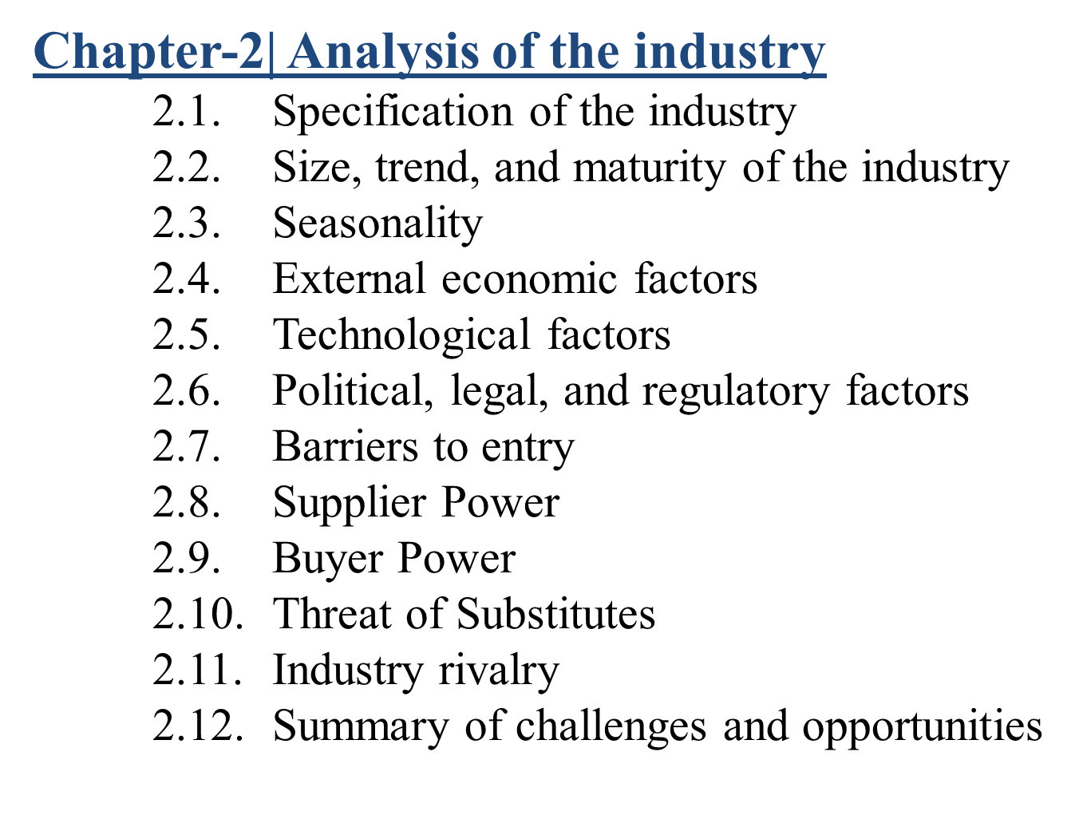

CHAPTER-2 | ANALYSIS OF THE INDUSTRY

2.1. SPECIFICATION OF THE INDUSTRY
The idea of Islamic Bank, as defined by the General Secretariat of the OIC, is as per the following. "The Islamic Bank should have a status, rules, and techniques explicitly express its obligation to the guideline of Islamic Shariah and to restrict the receipt and payment of interest n any of its tasks. As aforementioned statement describe that Islamic banking as a financial intermediary’s framework that tries to ignore interest in any of its transactions and operates in such a way as to help meet the goal of the Islamic economy. This banking industry gives assurance on guaranteeing equity and fairness to the community. As it runs through the Islamic Principles of profit-sharing and loss-sharing transactions it is known as PLS bank.
The emergence of Islamic Based Bank in Bangladesh
In August 1974, Bangladesh signed the Charter of the Islamic Development Bank and engaged itself in reorganizing the Islamic Shariah's economic and financial system. In January of 1981, The Government of Bangladesh has placed great emphasis on the expansion of banking operations. Mostly in a couple of years following independence, there was a gigantic increase in volume and size of bank branches and the growth of banking business. Government strategy is acting as a stimulus on the advancement of the industry. Therefore, Bangladesh's banking sector now contains Bangladesh Bank (BB) because of the establishment and 51 commercial banks comprising four nationalized commercial banks (NCBs), five government-owned specialized banks, 13 foreign commercial banks, and 29 domestic private banks. Of the 51 local and foreign banks, six are Islamic and the rests are conventional banks. The six Islamic banks functioning within the private sector are Islami Bank Bangladesh Limited, Social Islami Bank Limited, Al-Arafah Islami Bank Limited, Al-Baraka Bank Bangladesh Limited, Shamil Bank of Bahrain E.C., and Shahjalal Bank Limited. Shamil Bank of Bahrain E.C. (previously observed as Faysal Islamic Bank of Bahrain E.C.) may well be an overseas bank and is that the biggest Islamic bank within the globe. It opened a branch in Bangladesh in 1998. Additionally to those Islamic banks, two other private banks—Prime Bank Limited and Dhaka Bank Limited—have opened two Islamic banking branches and an Islamic banking counter, correspondingly, to covenant with the Islamic banking business parallel to their conventional interest-based banking operations since the inauguration of the banks in 1995. Also, four Islamic insurance companies (Islamic Insurance Bangladesh Limited, Islamic Commercial Insurance Limited, Takaful insurance firm Limited, and far East Islamic insurance company Limited) are functioning as Islamic financial institutions in Bangladesh.
Functions of Shariah Board
The primary purpose of the Shariah Committee of the Shariah Board is to guide the Bank's jurisdiction to prepare the manpower of the Bank so that they can operate the Bank upon on the principles of Shariah. They also regulate the functions of the bank, whether they comply with the norms. They introduce audits/inspections of Islamic Bank branches with the assistance of Bank Officers and respond audits/inspection reports to the Board of Directors with their responses to ensure Shariah's compliance. They shall also retrieve information/data from their banks and other Islamic banks of the country and shall organize for the preservation of information/data for a uniform decision. The authorization of the Shariah Council is obligatory on the authority of Islamic Banks before the launch of any new product on Shariah constitutionality. The Board likewise coordinates time-to-time seminars/workshops on Islamic banking to strengthen the awareness and insight of Islamic bankers and scholars of Islamic banking

.

SIZE, TREND, AND MATURITY OF THE INDUSTRY
Banks
After independence, the financial business in Bangladesh began its excursion with 6 Nationalized Commercialized banks, 3 State-owned Specialized banks, and 9 Foreign Banks. The entrance of private banks during the 1980s boosts a huge development into its industry. Presently, banks in Bangladesh are fundamental of two kinds:
- Scheduled Banks: The list of banks that follow the guidelines of the Bangladesh Bank Order,1972.
- Non-Schedule Banks: These banks cannot perform all the operations of scheduled banks. They are established for special and objective for certain operations.
60 schedule banks in Bangladesh work under full control and oversight of Bangladesh Bank which is engaged to do as such through Bangladesh Bank Order, 1972 and Bank Company Act, 1991. Schedules Banks are characterized into the accompanying types:
State-Owned Commercial Banks (SOCBs): 6 SOCBs are fully or majorly owned by the Government of Bangladesh.
Specialized Banks (SDBs): 3 specific banks are presently working which were set up for explicit targets like farming or growth of industries. These banks are likewise completely or significantly possessed by the Government of Bangladesh.
Private Commercial Banks (PCBs): 42 private business banks are significantly possessed by people/private entities. PCBs can be classified into two groups:
Conventional PCBs: 33 they are currently working in the business. They play out the financial capacities in conventional structures for example interest-based schemes.
Islami Shariah based PCBs: There are 8 Islami Shariah-based PCBs in Bangladesh and they execute banking exercises as per Islami Shariah-based standards for example Profit Loss Sharing (PLS) model.
Foreign Commercial Banks (FCBs): 9 FCBs are working in Bangladesh as the parts of the banks which are joined abroad.
There are presently 5 non-scheduled banks in Bangladesh which are:
- Ansar VDP Unnayan Bank,
- Karmashangosthan Bank,
- Grameen Bank,
- Jubilee Bank,
- Palli Sanchay Bank
FIs
Non-Bank Financial Institutions (FIs) are those kinds of monetary organizations that are managed under the Financial Institution Act, 1993 and constrained by Bangladesh Bank. Presently, 34 FIs are working in Bangladesh. Out of the aggregate, 2 are completely government-owned, 1 is the auxiliary of a SOCB, 15 were started by private domestic initiator, and 15 were started by joint endeavor activity. Significant sources of assets of FIs are Term Deposit (at any rate three months tenure), Credit Facility from Banks and other FIs,

Call Money just as Bond and Securitization. The significant contrast among banks and FIs are as per the following:
- FIs can't give checks, pay orders, or request drafts.
- FIs can't receive demand deposits,
- FIs can't be associated with foreign exchange trade financing,
- FIs can direct their business activities with differentiated financing modes like partnered financing, connect financing, rent financing, securitization instruments, the private position of equity, and so forth.

Table 3 Activities of Islamic Banking in Bangladesh, April-June 2019
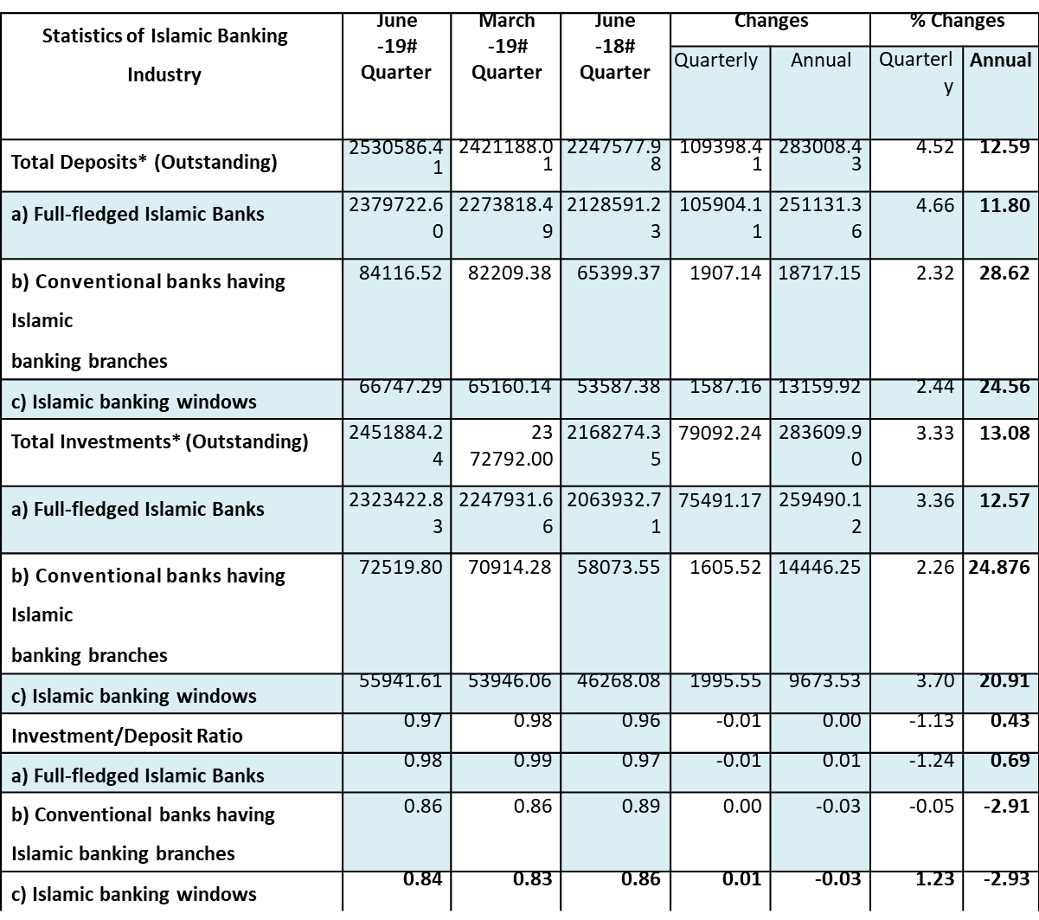

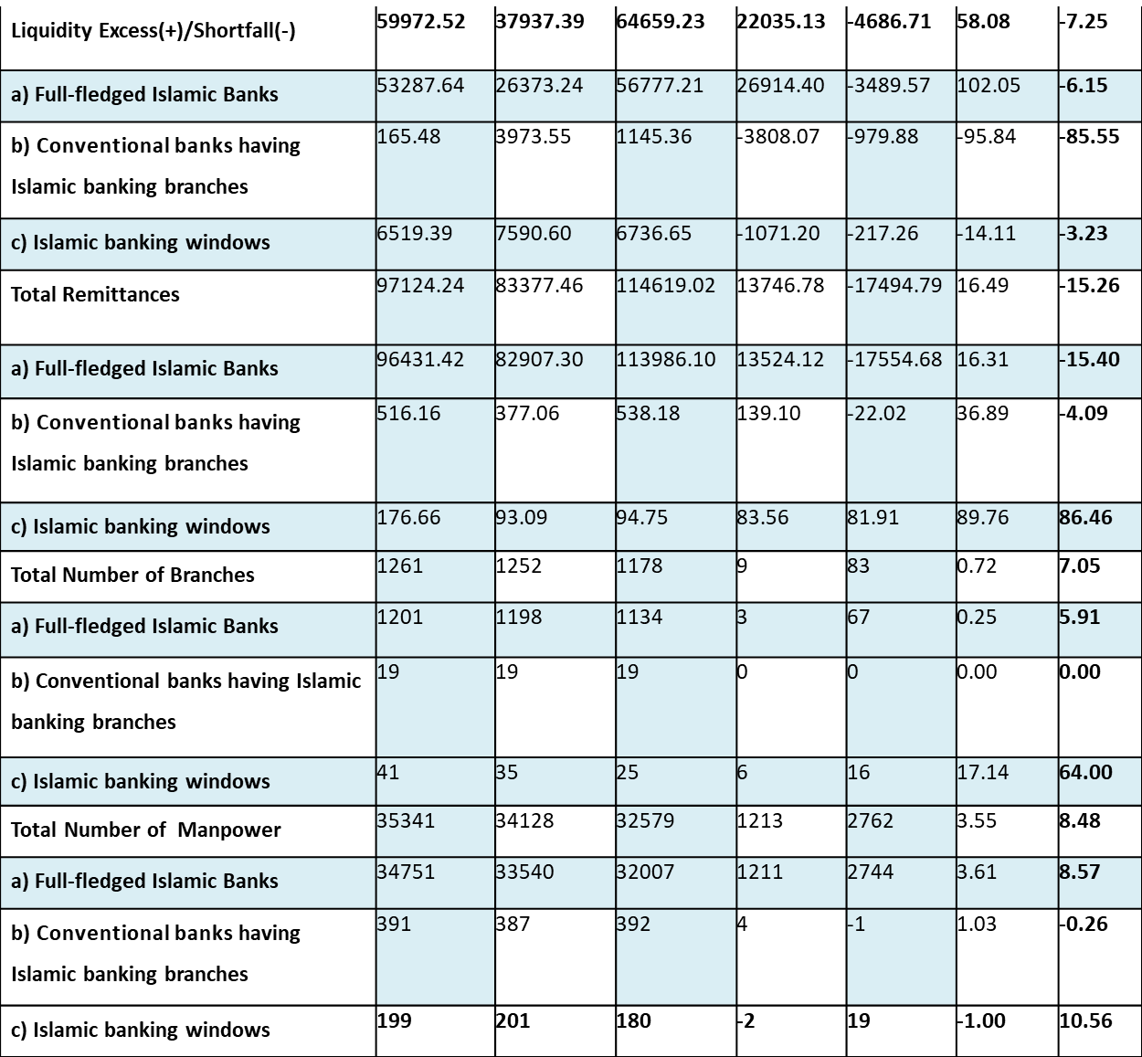
Table 3 demonstrate by the end of April-June -19 the total deposit of the Islamic banking industry increased BDT 109398.41 million from BDT million or by 4.52% compared to the previous quarter BDT 2530586.41 million furthermore, by BDT 283008.43 million or by 12.59% contrasted with relating quarter of a year ago.
By the end of April- June 19 total investment of the Islamic banking sector rises by 79092.24 million or by 3.33% and by BDT 283609.90 million or by 13.08% thought about to the past quarter and same quarter of the precedent year. The total Investment of the quarter ends at BDT 2451884.24 million. In comparison to the conventional bank, the investment deposits ratio of the current quarter, March-19 and June-18 stood at .96, .98, and.96 respectively.
During April-June 19, the Islamic banking sector significantly increases its excess liquidity ratio at BDT 2451884.24 million from BDT 59972.52 million correspondent to the previous quarter and the same quarter of the last year.
At the end of the April-June 2019 quarter, the total remittances propelled by the Islamic banking sector was Tk. 97124.24 million. However, compared to the first quarter of 2019, it was 16.49% or Tk. 13746.78 million higher. Moreover, the second quarter was higher by Tk. 17494.79 million or 15.26% compared to the second quarter of 2018.
Upon reviewing, at the end of the quarter, the number of Islamic banking sector reached 1261, which includes Islamic branches and windows of conventional commercial banks. In the previous quarter, it was 1252. In addition, it was 1178 the previous year in this same quarter.
Mobilizations of Deposit
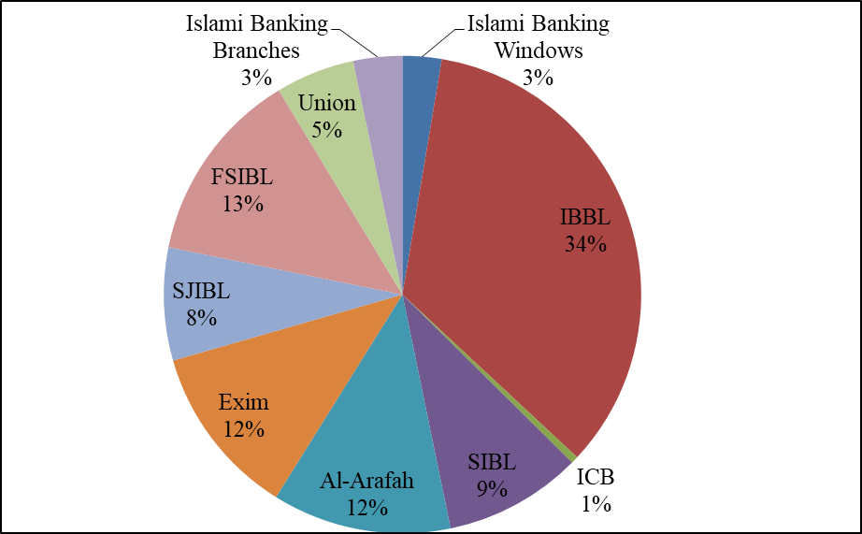
Figure 1 Mobilization of deposits of Islami banks
Figure 1 illustrates, at the end of April-June 2019, the total deposit of this industry amounted to be increased by 4.52% compare to the previous quarter. The total deposit of BDT 2530586.41 is the sum of the demand deposit of BDT 29294850 and the time deposit of BDT 223763792 mil. The total deposit is 13% more than the respective quarter of last year. Over the period under assessment, the share of total Islamic banking mode stood to be 23.77% among all the banks.
At the end of June 19, the amount of 8 completely shariah-based Islamic banking’s deposits amount is BDT 2379722.60 mil. This amount holds significantly 94.04% of the industry’s deposit.
At the end of June, Islami Bank Bank Bangladesh Ltd ensure the highest share of deposit(34.30%). Islamic Bank Limited and Islamic Banking Windows have the least deposit respectively with .48 and 2.64%. Other banks such as Exim Bank Ltd (11.66%), First Security Islami Bank Ltd. (13.15%), Al-Arafah Islami Bank Ltd. (12.12%), EXIM Bank Ltd. (11.66%), Social Islami Bank Ltd. (9.35%), Shahjalal Islami Bank Ltd. (7.64%), Union Bank Limited (5.35%), Islamic banking branches (3.32%), have a significant contribution on deposits.

Types of Deposits
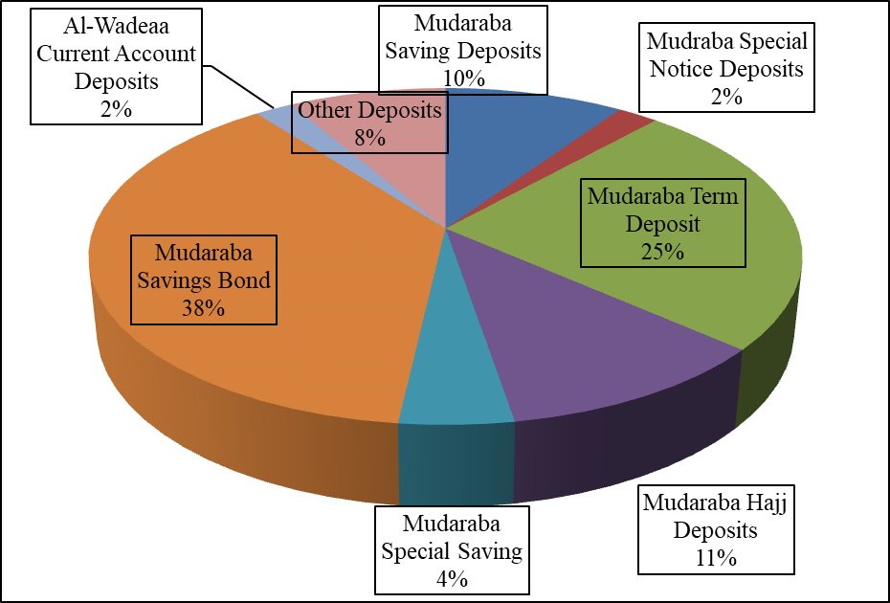
Figure 2 Types of deposits
Figure 2 depicts that, Mudaraba Term Deposits tend to be most favorable from all the other types of deposits with 47.85%. Mudaraba Savings Deposits (MSD) (18.37%), Mudaraba Special Savings (pension/profit) Deposits (8.57%), Mudaraba Special Notice Deposits Al- Wadeeah Current Account Deposits (3.95%), Mudaraba Hajj Deposits (0.21%), (4.21%), Mudaraba Savings Bond (0.73%) and Other Deposits (16.11%), etc.
Investments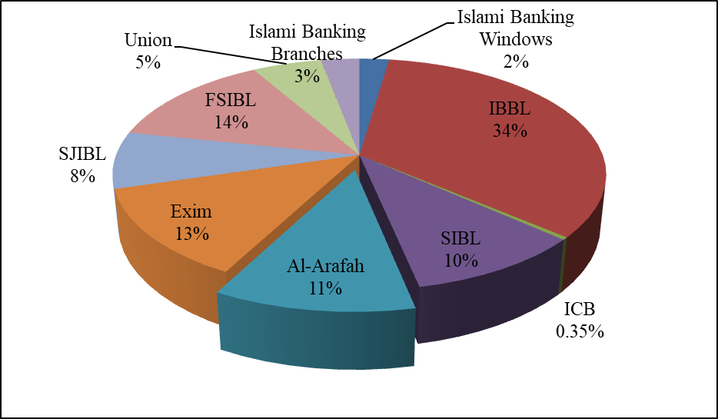
Figure 3 Investment amount of Islamic banking windows and branches
From Figure 3 it can be seen that, at the end of June-19, there was a significant rise by 3.33% and 13% compared to the precedent quarter and similar quarter of the previous year respectively. The total investment of this year is amounted to be BDT 2451884.24 which is 24.26% among all banks. The contribution of completely shariah-based Islamic banking is 94.76%, 2.96% from the conventional banks’ Islamic banking branches, and the rest 2.28% from the conventional banks’ Islamic banking windows in total investments
At the end of the quarter, Islami Bank Bangladesh made the highest investment (34%) among all the Islamic banks. The Islamic Bank Ltd. struggle to properly utilize their asset in terms of investment (.35%). Other Bank had moderate investment, Security Islami Bank Ltd. (13.41%), EXIM Bank Ltd. (12.62%), Al-Arafah Islami Bank Ltd. (11.06%), Social Islami Bank Ltd. (10.06%), Shahjalal Islami Bank Ltd. (7.93%), Union Bank Ltd. (5.33%).

Liquidity
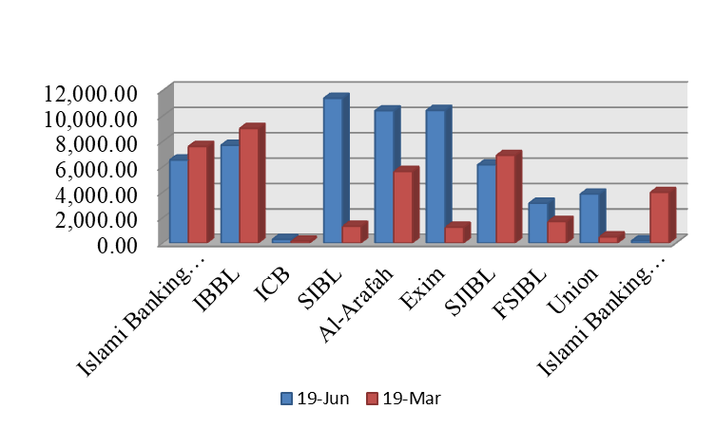
Figure 4 Excess liquidity of Islamic Banks over two periods
Figure 4 demonstrates that, at the end of June-19, the liquidity state amounted to BDT 59972.52 million of the industry. This figure is higher in contrast to the precedent quarter as well as the same quarter of the last year by 58.08% and 7.25% respectively. Among all Islamic banks, the amount of BDT 165.48 mill, BDT 6519.39 mil, and 53287.64 million represented by Non-Islamic bank's Islamic branches, Islamic windows of traditional ones, and 8 full-fledged Islamic Bank respectively. Erupting liquidity state during this period was mainly contributed by Social Islami Bank, Exim Bank, and Bank Asia
Remittances Mobilized by the Islamic Banking Sector
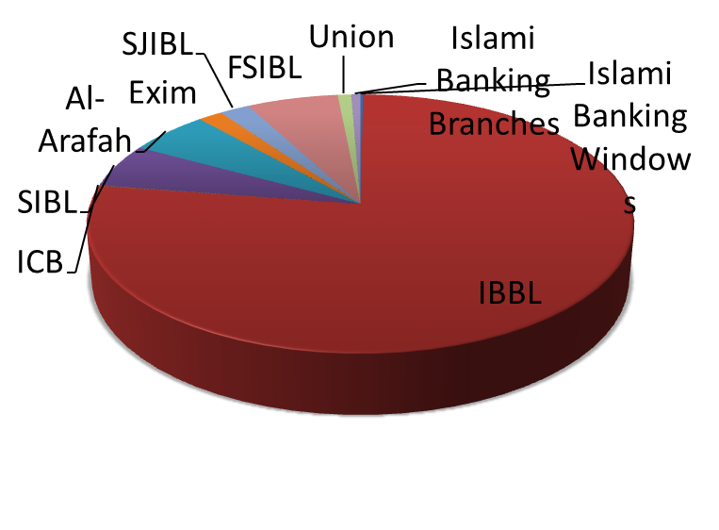
Figure 5 Share of Remittance of Islamic Banks

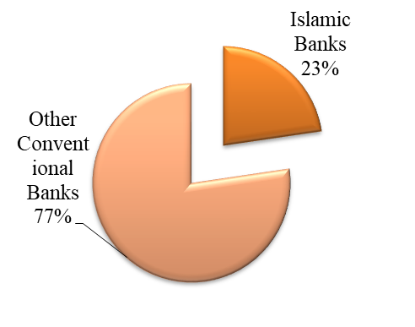
Figure 6 Share of remittances by Conventional and Islamic Bank
Figure 5 shows that remittance towards the end of June-19, the Islamic financial industry assembled the sum of BDT 9712124.24 mil. Significant arise by17% from previous quarter indicating this industry is indeed boosting and gathering foreign remittance collection of our country. Although, assuming the pandemic situation all over the world, is lower by 15.26% from the previous year's adjacent quarter. After the assessment for June, At the end of the assessment During this period specifically, Islami Bank Bangladesh dominated regarding foreign remittance collection with a significant number of 77.26% of the overall industry. Other banks of the industry are steady regarding this matter with ICB Islamic Bank (0.03%), EXIM Bank Ltd. (1.65%), Social Islami Bank Ltd (5.56%), Islamic financial windows (0.18%), Union Bank Ltd (0.92%), Shahjalal Islami Bank (2.08%), First Security Islami Bank Ltd (6.27%), Al-Arafah Islami Bank Ltd. (5.52%), and Islamic financial parts of customary banks (0.53%).
Figure 6 demonstrate the share of remittance collected amount stood 25.27% of all the Islamic bank in the industry. Rest were contributed by Non-Islamic financing institutions, especially by the conventional ones.
During the first quarter, this industry had plunged to a level of 22.67% of the inflow of remittance collection compare to the entire financial industry. Although during the quarter of June-19 the collection significantly arises to 25.27% which is the depiction of the fundamental arise of foreign remittance collection in most recent years
.Expansions of Branches
At the end of the quarter upon review, the number of branches of the Islamic banking sector, which includes Islamic branches and windows has reached 1261. In the previous quarter, it was 1252 and in the last year’s same quarter it was 1178. During the April-June 2019 quarter, eight fully functioning Islamic banks had 1201 branches, seven conventional banks had 41 Islamic banking windows, nine conventional commercial banks had 19 Islamic banking branches. At the end of the quarter after reviewing, among all the scheduled banks, the share of total bank branches of Islamic bank was 12.13%. The following Table 4 shows the numbers of Islamic banks:
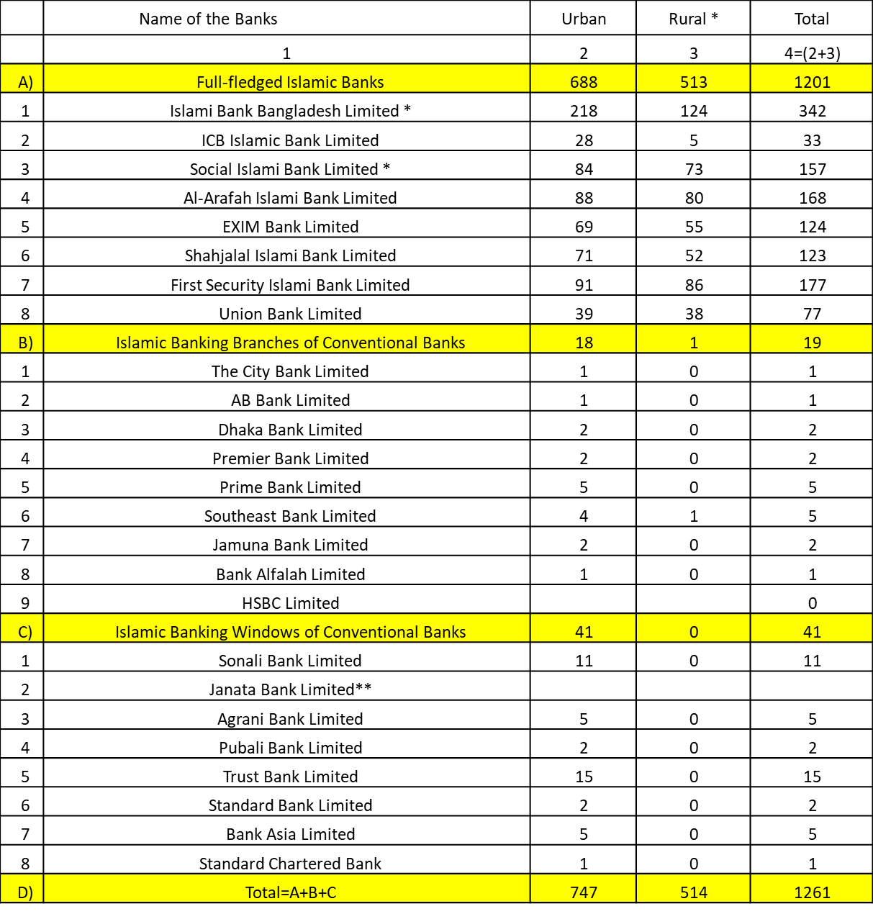
Table 4 Number of Islamic banks in Bangladesh

SEASONALITY
Seasonality is defined as periodic trends in supply/demand, organizational performance, and money-related exchange. This growth is comprehensively taking place on a yearly premise, in conjunction with territorial weather patterns, the launch of economic information, or the festivity of various occasions. Seasonality is a significant aspect to be addressed once financing selections have been made. Seasonality is a critical viewpoint to be tended to once financing determinations have been made. At whatever point left unregulated, the expanded shakiness and disturbance of the market because of these patterns will raise the threat of the cash, value, or commodities of the markets. The harmony estimation of monetary forms, values, and products typically alludes to the season. For example, the mid-year months (June-August) are viewed as the most noteworthy liberation season for occasions in Eid. Taxation is also an aspect of the demand for banking services and could be an aspect ideally suited to seasonal increase inactivity, which will keep going until the 30 November tax point in time after June.
The seasonal pattern of the SIBL is a period of yearly low in late January and February is subsequently trailed by a surge in loans that starts in March and through May it rises sharply furthermore it rises more by the end of June. Beyond June the pattern for its business remains marginally down, and from September to January, the demand for its business remains slightly stable. The factor that drives the seasonal pattern of the business is interest rates, demand for investment services and Tax repayment. When interest rates hit the bottom of the chart most of the company is allured to financing services.

EXTERNAL ECONOMIC FACTORS
Gross Domestic Product: Islamic banking advancement had a positive effect on financial development in terms of the GDP-per-capita growth rate. All things considered, outcomes acquired through the polynomial and semi-parametric approach appeared to the relationship between Islamic budgetary improvement and financial development. Islamic banking could be a modern budgetary framework that must entirely comply with Islamic Sharia controls. The point is to lift individuals out of financial trouble and destitution, build up financial morals in understanding with fabric and otherworldly values, and channel investment funds into beneficial divisions.
Inflation: Islamic banks are essentially influenced by vulnerability at pre-determined rates. Particularly, that swelling instability encompasses a negative, though; the uncertainty related to the genuinely intrigued rate contains a noteworthy positive effect on the dissolvability of Islamic banks. In any case, both sorts of vulnerability have a measurably inconsequential impact on the monetary execution of both routine and Islamic banks in Bangladesh. Giving noteworthiness prove on the bank-specific observational determinants makes difference bank directors make strides their banks' budgetary execution and dissolvability.
The economic reasoning for disposing of Riba
Due to equity, productivity, steadiness, and development Riba (interest) structure should be disposed of for the overall enhancement of the economy. The contentions for procedural reasonableness as follows:
- Equality of risk is shared between industrial and commercial as well as entrepreneur and proprietor of the capital
- Removing a fixed return by a proportionate portion of genuine profits would offer a superior profit for capital regardless of whether the profits are high or low and whether the costs are simulative, stable, or deflationary.
- The cash would produce more abundance for its proprietors just if its efficiency in financial exercises prompts the making of significant value-added.
The assumptions for the productive portion of capital are as per the following:
- Loan money, in contrast to the statement of risk capital, seems to convey the most financially sound borrowers and not innately the most proficient and viable endeavors.
- Profit-sharing structures adjust the interests of providers and capital clients leading to a combined emphasis on performance.
- This model additionally offers local area soundness between different classes, the impetuses of which are frequently equivocal and conflicting inside the conventional ones.

TECHNOLOGICAL FACTORS
In the evolving era of technologies, Technology plays a vital part in Islamic banks of the innovation of technologies consumers now remotely can handle their accounts. Numerous bank is offering different types of application to their client so that they can handle their account remotely. Bank from one end and client from another can examine cheques simultaneously. Debit cards are also evolving now instead of swiping the cards can be embedded into the charging machine and transaction occurs ” tap choice”- where transaction of debit occurs even without requiring a pin. These progressions make it simpler for the client to make buys without required interruption from banks. Clients can also pay their different bills with the help of a mobile app from the bank account.
Banks are also taking advantage of innovation and installing new technologies in their work environment. For instance, executives from different branches are participating in online meetings with the hand of technological advancement. It replaces the need for in-person meetings. Nowadays banks are moreover utilizing SMS and the Internet as the major source of advancements and giving incredible utility to their clients. Progression of technological innovation has offered 24X7 keeping money indeed giving speedier and secured benefits.

POLITICAL, LEGAL, AND REGULATORY FACTORS
Political impact includes a splendid part within the banking and financial services. Islamic banks are utilized to have incredible impact and control. But the government has propelled an elevated level of controls to scrutinize the budgetary teach. It is since they secure a remarkable sum of reserve funds from the public. In this manner, banks ought to comply with the laws of the government. Critics and financial related examiners say that pointless government association isn't great for the performance of banks. On the other hand, nearby and the government has continuously been included within the undertakings of the banks until the end of time. Distinctive nations have diverse laws and directions for the banking industry, and they unexpectedly affect the banking-related industry. Indeed even though banks contribute a part towards work, and they have to confront the labor laws.

BARRIERS TO ENTRY
In Bangladesh, the Islamic banking industry is still in a growing stage. So, the danger of likely new entrants is extremely high. Generally, an organization that exists already tries to set entry of barriers to discourage potential contenders to enter their industry. Some factors that create barriers for new entrants in an industry. The factors are loyalty towards the brand, the learning curve effect, economies of scale, absolute cost, and regulations by the Government. The loyalty of the customers in the Islamic Banking Industry is fairly clear, if one holds an account in any of the banks of this industry, they don’t prefer to open an account in any other conventional banks. This makes hindrances for new entrances. Because of the spread environment of the industry, no bank gets an absolute cost advantage. Availability of the effect of learning curve also the scale of economy is evident for the majority of the bank in the industry. Since most of the banks working for a long time now, they have been able to open branches everywhere and also accumulate experiences for operating it successfully. Government guideline is very steady towards the development and activity of new banks which leads to a lower threat for new entrants. New entrants come into the market with the possibility of a better quality of product at a lower price and contribution resources. To prevent new entrants to enter the industry, existing firms need to focus on and awareness of the present and coming situation of the industry.

SUPPLIER POWER
Depositors are considered to be a key supplier of funds for the Islamic banking industry. Directors also act as sources of funds for the banks. Here the few factors that demonstrate the strength of the suppliers:
1 Number of Supplier:
In the economy of Bangladesh, most individuals prefer to reserve funds and so banks are always found with an excess of the fund. So, in the banking industry bargaining power of suppliers is low.
2 Threat of forwarding Integration:
At times banks might face danger from the supplier of the fund too. Large organizations possess threats for banks by forming another bank to store their funds. Bank generates cash by investing other money. Therefore, this can prompt an intensive rivalry for the bank while the acquisition of funds. So, banks should give preference for better customer service while completing their day-to-day activities.

BUYER POWER
When it comes to the banking industry, buyers are those customers who take a loan from the bank. The following factors are known as the bargaining power of those buyers:
- The number of Loan Applicants:
In the economy of Bangladesh, there are not sufficient candidates for business loans. For lots of variables, investment is also not expanding. Hence, banks are using their inactive cash by providing mostly personal loans. The reduced number of loan applicants increasing the business rivalry among the banks.
- Switching Cost:
Switching cost in the banking industry is extremely small. So if the lenders do not get find suitable terms and conditions for their loan they can effectively switch one bank to another as most of the banks providing at the same pre-determined interest rate. Competitiveness among the banks is high as the lenders are easily changing one bank to another in search of lower interest rates or for many other reasons.
- The threat of Backward Integration
At times big companies create intimidation for banks. They possess a fear of forming another bank from which they can borrow money at a much lower rate. As a result, this industry is a constant pressure for backward integration from the enormous company of the country.

THREAT OF SUBSTITUTES
The risk of substitute items has expanded within the industry of banking. The industry has started to propose specialized money-related facilities which were customary as they were accessible from banks as the company’s exterior. Paid ahead of time charge cards, and online loan specialists offer a huge number of choices that fetched and other major banks an impressive sum of income. Banks have activities that incorporate a division that centers on little trade lending. Moreover, it can build up unused claim advanced wallet benefits.

INDUSTRY RIVALRY
As the number of banks is emerging day by day it is increasing the intensity of rivalry among the organizations. To sustain and grow in this situation each of the banks attempting to gain a competitive advantage over their rival's banks. In this stiff competitive environment, banks are trying to stand alone by offering attractive packages and offers to their customers. The bank is also spending on market research to gain a clear insight into the service they provide to their clients
The factors that influenced these rivalries are given below:
Competitive Structure of the Banking Sector:
Our banking industry has attributes of a lower entry barrier and the same kind of product offering which is known as fragmented in nature. Price is the only factor that distinguishes one bank from another as all operate through pre-determined interest rates. . A horrendous price war usually starts after the entrance of a new competitor typically leads to a circumstance of overabundance limit. Our banking industry ought to face enormous prices within several years. In general, a divided industry builds rivalry, and it likewise pushes down by and large industrial profitability.
Demand Conditions:
Overall demand for the banking industry is increasing at an agreeable rate. The increase in demand means less rivalry as one bank is selling more without removing the market share of the other. But it is not quite certain the pattern for demand will remain the same over the year.
Exit Barriers
Exit barriers are economic, strategic, and emotional factors. High exit barriers mean companies are locked in unprofitable circumstances. For many people bank has become a sensitive connection of their regular daily lives. So, many banks are still running despite facing consistent loss over the years. Few banks are large to the extent that closing any of them will hurt the entire economy as it will create an impact on foreign and domestic trade. Hence, Exit barriers for our banking industry are extremely high.

CHALLENGES AND OPPORTUNITIES
Challenges
Since its establishment, the Islamic Banking structure has been embraced by everyone in general, yet it still has many obstacles to overcome until it can assert to be an organization accomplished of addressing the needs of global business markets. During my research on the differentiation of conventional banking from Islamic banking, I classified some challenges for Islamic banking as shown below-
- The lack of the Islamic money market, the inadequate skilled personnel, the lack of legal supervisory framework, and the lack of link institutions are some of the illustration restrictions on the practice of Islamic banking.
- The risk for people of sharing the loss from Mudaraba deposits.
- Also, some of the investment customers, including Muslims, do not have any Shariah knowledge, particularly concerning Riba, permissible, and prohibition, etc. in financial transactions. Unfortunately, it has become a difficult task, excluding the general understanding of Shariah and making clients understand the concept of Islamic principles of halal and haram.
- It is a challenging task as the majority of the people of the country even Muslim does not have sound knowledge of Shariah Knowledge
- Traditional Bank operates on pre-determined fixed rate wheels the rate of return of Islamic varies from time to time.
- As a result of the implementation of restricted methods of investment, Bai-Murabaha Bai-Muajjal has not still been able to point out the differences to the general public.
Opportunities
To retain and evolve the system including its moral and value-added system, the Islamic framework must seek to address the opportunities which disrupt the general flow of their development and sustainability. However, the opportunities may be as follows:-
- It has greater potential as people of the country have trust and dependability on them.
- It can build socio-economic infrastructure and employment opportunities
- Eliminate inequalities and ensure justice in the economy
- It involves a critical evaluation by the Islamic Banks as to whether they are controlled by the Shariah Council and by the skilled individuals who are rehearsing Muslims.
- The ambition, drive, far-sightedness, and unwavering endeavors of the individuals who have been correlated with the system may give it an incredible lift and momentum.
- Staff should be adequately trained
- The assessment and management of Central Bank and its enormous Islamic banking training course both domestically and overseas should be equivalently aware of the different operating strategies
- People should be persuaded and acknowledged to justify the actual essence and instruction of Islamic banking. They should identify the core contrast between Islamic and Non-Islamic banking.
- For the rapid growth and development of the structure, it requires a legal and regulatory framework and also link institution need to be addressed

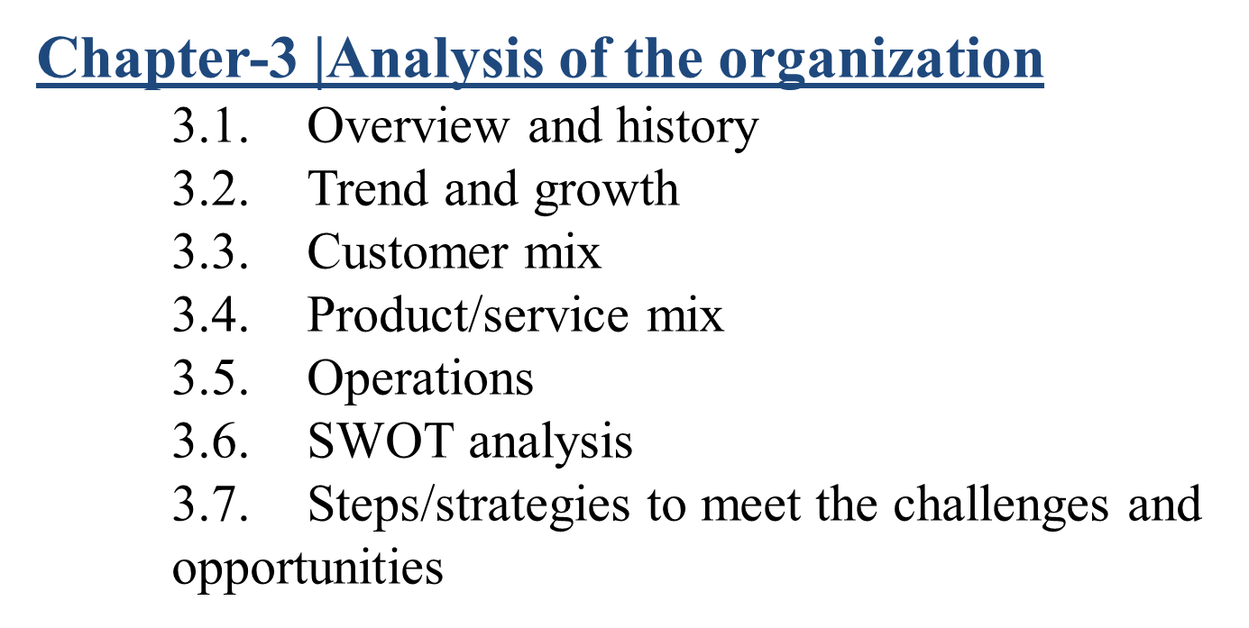

CHAPTER-3 |ANALYSIS OF THE ORGANIZATION

OVERVIEW AND HISTORY
Social Islami Bank Limited (SIBL) has been a financial institution service of the 2nd gen based on the "Shariah" concept since 22 November 1995. . SIBL comprised of:
- SIBL Limited Securities.
- Investment SIBL Limited.
SIBL operating intently with its esteemed customer and stakeholders to provide them with the one-stop services, get right of entry to the very modern-day usage of technology Its unmatched client services has created them alone within the industry. They tend to build long-term business partnerships with our consumers serving them to grow profitable. SIBL serves across the nation with a whopping 3125 employees working in 161 branches also 50 sub-branches. They also have 156 Agent Banking outlets and they are providing services to secluded zones in the country. The financial sector is an economic barometer of a country. SIBL being the pioneer in the business has been endowed with the responsibility of the county’s agricultural, commercial and industrial development for the sake of the overall growth of the economy. They create local income opportunities while discouraging inner migration, also, they empower and refine families that are in poor condition. To increase the overall productivity of the country SIBL extensively provides monetary services for the import and export sector of the business. In terms of the non-formal corporate area, this bank would be giving Waqf certificates and managing as well as developing Waqf and Mosque properties and trust reserves. In terms of formal corporate area, the bank offers varieties of banking administrations, e.g., financing exchanges, different sorts of deposits and investments accounts, giving the letter of assurance, health projects, opening LOC, sorting the bills which affect the foreign and domestic exchanges, etc. In this way with these bank helps the possibilities in the business area has expanded like never before.
Social Islami Bank Limited has restored its push to comfort its organization with more situated zones involving SME banking and Argo-money, with attention on looking for substitute dispersion stages for SMS banking and portable settlement installment frameworks and at last acquainting them with disseminating SIBL administrations to clients' doorsteps. To improve its market, SIBL has just presented web banking and dispatched some new items. The schemes of SIBL are
- Sonali Din.
- Shukher Thikana.
- Sabuj Chhaya.
- Sabuj Shayanho.
- Subarnalata Subornalekha.
- Sanchita.
And the service is Zameel ATM Debit Card.
Social Islami Bank Ltd (SIBL) was founded the year 1995 as an open constrained organization which is occupied with Shariah-based business keeping money in the nation and its normal way of doing things are essentially not exactly equivalent to other standard banks. This is the second-era pioneer Social Islami Bank in this nation giving web-based saving money offices to its clients. It registered under the Companies Act with its registered under the Company Act with its registered office 7-8, Motijheel C/A, and Dhaka, Bangladesh. At the time of incorporation, the authorized capital and the paid-up capital of SIBL were respectively TK 10000 and 7031.42 million.
Vision of SIBL
- Working together for a caring society.
Mission of SIBL
- High-quality financial services using new technologies.
- Establishing a banking model for three sectors.
- Quick, reliable, and fulfilling customer service.
- Innovative Islamic banking products introduction
- Adjusted and feasible development procedure.
- Ideal profit for investors' value
- To recruit and maintain human capital of high quality
- Empowering real poor families and building jobs for local wages.
- Offering help for social welfare associations via assembling assets and social administrations.
Motto/Slogan of SIBL
The slogan of SIBL Bank is "Utkorsho obiram". These two words are Bengali words that represent “Journey towards Excellence” on the organization


Figure 7 Logo of SIBL

Core Values of SIBL
Figure 8 Core values of SIBL

- Honesty:
SIBL’s honesty policy is derived from the core manual. They strictly follow this in all of their services.
- Transparency:
To build trust, SIBL follows the transparency decree, and they abide by this rule.
- Efficiency:
Perfectly doing any job entails efficiency. SIBL opts for delivering service with satisfaction.
- Accountability:
Being responsible for any action and removing mistrust is a way of being accountable and SIBL always tries to be accountable for it.
- Religiousness:
Along with improving economic prosperity, SIBL boosts ethics by religious perspective.
- Innovation:
SIBL tries to be innovative towards its customers and keep an open mind towards any progression of life.
- Flexibility:
To get greater satisfaction and understanding from the customer's flexibility plays a crucial role. SIBL always opts for the quality of its services.
- Security:
SIBL ensures that customers feel secure with their services and trust them fully.
- Technology:
SIBL progresses with the latest technological advancement to give their customers the easiest and efficient way to complete any functions.

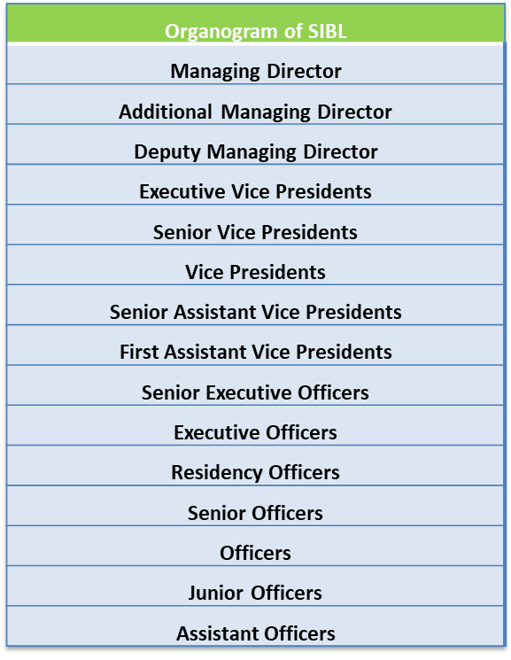
Figure 9 Organogram of SIBL
Figure 9 illustrates the organogram structure of SIBL. It represents the hierarchical relationship between the employees. It’s a chain of command that starts with the managing director at the top and ends with the assistant officer at the bottom

TREND AND GROWTH
There are several important figures to show the impact of trend and growth of SIBL it will be described as below:
Business Growth:
Deposits

Figure 10 Deposit over the years of SIBL
As we can see from figure 10, deposits of SIBL proportionally increased over the years. From 2015 to 2018 deposits of SIBL increased proportionally around 20%. It illustrates that around those periods SIBL was able to attract new and retain customers. SIBL was able to attract new cash and new customers to its services. Therefore, the bank likely had more cash to lend which increase their earnings. Despite the fact, a loan is an asset for the bank, on the other hand, deposits are liabilities as the bank pay its financing cost to borrow money from the customer, though this cost is at a much lower rate than the bank are earned from the interest of the loan. In 2019 bank was only able to increase 8% deposits from the precedent year.
Investment:

Figure 11 Investment of SIBL over the years
Investment is the process in which banks finance other businesses for their transaction. Bank as an agent earned income through commission. So, as we can see from figure 11, over the years from 2015 to 2019 there is a growth of around 121% for the bank through its investment activity. Hence, it means the bank is generating more money by purchasing an asset for others
FX_Business:

Figure 12 FX business of SIBL over the last 5 years
Figure 12 shows the FX department of the bank where it handles the foreign exchanges (also known as FX) market it is a worldwide market to exchange national currencies against one and another. Banks encourage ex exchanges for customers and participate in speculative transactions from their trading desks. As banks operate as dealers for clients, the spread of bids reflects the bank's profits. Speculation of currency sales is carried out to benefit from currency fluctuations. The aforementioned figure 12 illustrates, from 2015 to 2019 Bank has maintained a consistent hike in its FX operation.

Profit after Tax:

Figure 13 Profit after tax of SIBL over the last 5 years
The net operating profit after tax (NOPAT) is a financial measure that depicts what the bank accomplished through its core operation. As we can see from the graph, albeit of the positive trend but NOPAT for SIBL fluctuated over the years. From figure 13 above we can see that, in 2016 and 2017 NOPAT for the bank hike around 8.9% and 10.6% respectively from its precedent years. Although from 2017 to 2018 bank simulate a massive drop of 36% in its NOPAT. During the year 2019 bank was able to manage its resources efficiently and pick up its NOPAT by around 8.8% from the previous year.

Entity Growth
Paid Up Capital:

Figure 14 Paid-up capital of SIBL over the last 5 years
Paid-up capital is a benefit for the investors from their portion of the stock that is valued in cash. Paid-up capital is generated after the company explores its shares on the primary market to sells its share directly to its investor, typically through an initial public offering (IPO). The amount of paid-up capital of a company is the degree to which it relies on equity funding to finance its operations. Figure 14 demonstrates the Paid-up capital of SIBL is steady, only in the year 2019 and 2017 there was a hike of 10% and 5% respectively,
Total Asset

Figure 15 Total asset amount of SIBL over the last 5 years
As figure 15 illustrate the total asset of the bank increased spontaneously by 17.15%, 26.42%, 21.36%, and 11.20% in the years of 2016, 2017, 2018, and 2019 respectively from its precedent years. Usually, expanding assets are an indication that the bank is growing, yet everybody can identify with the way that there is considerably more in the background than simply taking a gander at the assets. The objective is to decide how the asset growth of an organization is financed.

Total Capital:

Figure 16 Total capital amount of SIBL over the last 5 years
Bank capital is an incentive to its investor and a primary reflection between its asset and liability. The purpose of the capital on the reserve is to deal with a specific measure of distress, before being in danger of getting insolvent. As the above figure 16 is positively skewed it indicates banks always maintain its asset over liabilities in case of facing certain contingencies
Total number of Branch and No. of employees:

Figure 17 Number of Branches of SIBL over the last 5 years

Figure 18 Number of employees of SIBL over the last 5 years
From figure 17 it can be seen that over the years SIBL consistently increases its number of branches to reach out to more customers and from figure 18 it is shown that they have expanded the number of employees to provide more efficient customer provide service.

CUSTOMER MIX
Customer perception about the interest rate and profit:
The view of interest rate and profit for the clients can be changing from individual to individual. Below the potential customers of SIBL has been mentioned:
Individuals who follow Islamic rules strictly: The clients with highly Islamic oriented mind believe accepting interest is prohibited find the result of speculation at Islamic banking model as a benefit for their business. To eliminate the possibility of doing a haram majority of the customers of SIBL continue their banking functions with them. Due to the absence of interest, the client with highly Islamic values believes consider Interest as haram and outcome from the Islamic banks as a profit of the business. SIBL follows both the rules and regulations governed by the central bank of Bangladesh and also the Islamic business law known as Fiqh-ul-muamalat. SIBL acknowledges the nature time value of money and recognizes the value of money decreases with time. So they adjust this constraint by spending on a project which has possible to expand by itself (in size, in progress, and so on). This model of business of SIBL can be attractive to the client with highly Islamic values.
Individuals who prioritize remittance flexibility: The remittance facility in SIBL is formable. Much flexibility is given to the customers banking with SIBL for remittance purposes.
Individuals supporting CSR: SIBL is well known for its various CSR activities, thus, the people who support the wellbeing of different communities and environment, in general, prefer banking with SIBL.
Individuals who prefer joint account facilities: People who encourage investment in the Islamic Bank address interest rates as non-conventional business profit following the Islamic Guideline. A type of account where the account holder needs to share the profit of the investment from the account with Social Islamic Bank Ltd. (SIBL). The credit terms of this account 1, 3, 6, 12, 24 months period.

PRODUCT AND SERVICE
SIBL a business bank be liable for all conventional financial administrations, comprising a great diversity of savings and investment schemes products, foreign exchange, and ancillary services, with the arrangement of cutting edge innovation and expert administration. The accompanying table 5 contains various results of the individual SIBL offices.
Table 5 Products of the respective SIBL departments
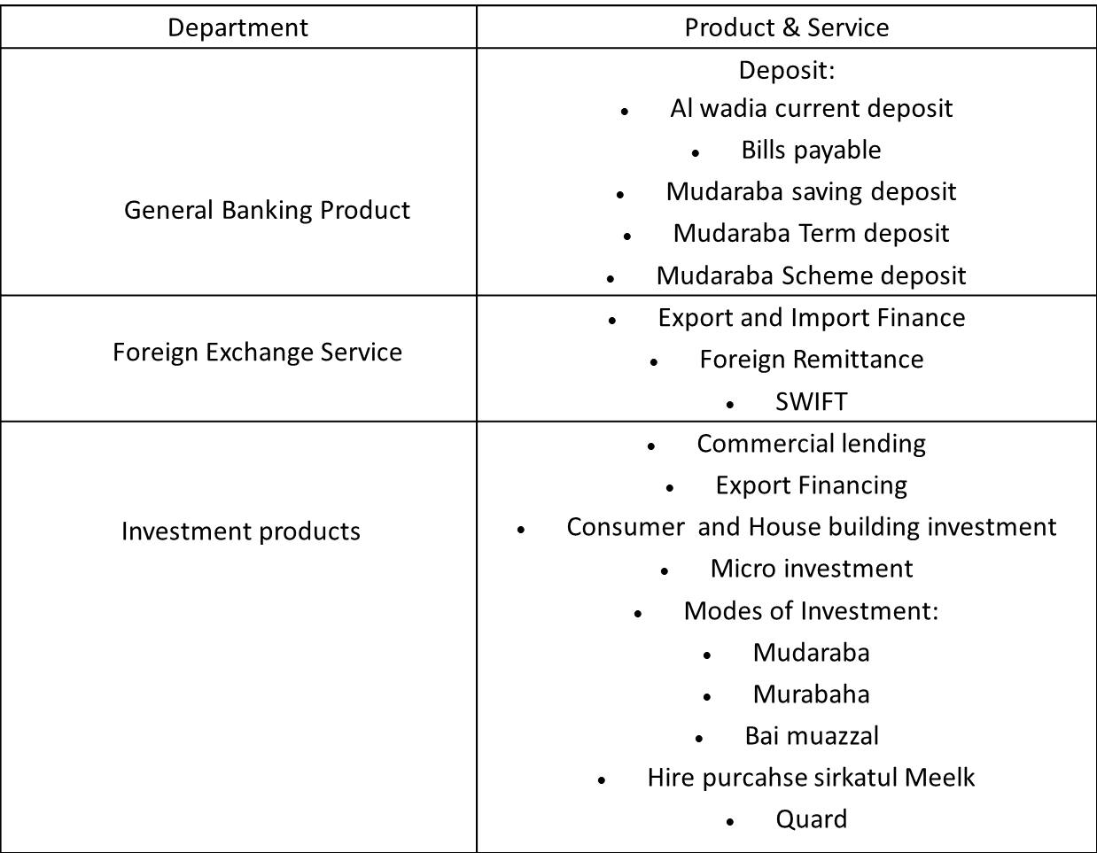

Types of Deposit and other account offered to meet customer need-
Mudaraba Saving Deposit:
The money of the account can be transferred from one client to another by the means of the institution. To open the account one introducer is mandated. One individual or multiple people can jointly open this account. The depositor can only withdraw money either twice a week or 4 times a month.
Mudaraba Term Deposit
A type of account in which the profit from investment is agreed upon to be share with the bank, the credit terms of this account 1, 3, 6, 12, 24 months period.
Al Wadiah Current Deposit
Bank has the permission to use the money for investment from the account but at its own risk. The owner of the account bare neither risk nor any return from the investment done from the account. It is a current account that can be only open with proper instruction regulated by the bank and the minimum amount deposited by the depositor.
Mudaraba Deposit Scheme
There are several schemes the bank provides to satisfy some of them is as follows:
- Mudaraba Pension Saving Deposit: This deposit scheme can be opened by anyone above the age of 18 years old and whose mental condition is sound. There are several monthly savings rates, e.g., Tk. 100, Tk. 400, Tk. 500 and Tk. 1000. In this account, money can be deposited by the owner at a fixed rate every month until it reaches its maturity. Upon reaching its maturity the depositor gets a fair amount of money back including profit. Either the depositor can withdraw the whole amount at a time or take it out monthly until it reaches the designated time.
- Mudaraba Hajj Saving Deposit: In this scheme, the account holder is known as Sahib-e-mal and the bank will be a Mudarib. The time of this type of scheme ranges from 1 to 20 years. To open this account an introducer must be present. While opening the account any sum of installment can be chosen. Although the owner of the account can facilitate the profit before reaching maturity as per the rule of Al-Wadiah's current account. However, unless the account is at least six months old, no profit will be given in that case.
- Mudaraba Lakhopoti Deposit Scheme: A type of account where the owner by choosing any of the following monthly savings’ amount; Tk. 470, Tk. 1280, Tk. 2380, Tk. 3830 can open the account. This scheme’s duration can range from 2,3,5 or 1o years. Unless the account is closed within 6 months, the owner can consume the profit even before the maturity as per the rule of the Mudraba Saving Account. If the depositor continues the scheme for 1 year, then they have the benefit to take loan up to 80% of the deposited amount from the bank
Other types of services they provide are as follows:
- Online Banking
- ATM Service
- Online Banking

OPERATION
Overall Operational Goal
The important goals from an operational perspective as follows;
- SIBL wants to create better opportunities to eliminate poverty and more income opportunities for the deprived people of the nations and enhance the upcoming generation of already privileged ones.
- Contributing to the economy will bring harmony and provide social protection for the general public.
Objective of SIBL
The primary objective of SIBL is to maximize profit through consumer loyalty. SIBL has confirmed the most profit by delivering the most effective and enhanced client service together with other corporate products mentioned below:
- Providing clients with the simplest quality facilities and outcomes
- To continue with the elevated expectation of corporate and business ethics
- To be the utmost productive bank in terms of the applying of technology
- To contribute towards the event of capital
- Aiming for maintainable profit and well-adjusted growth
- To worth and regard the clients and continue the agreeable banker-customer relationship
- To accomplish and continue the leading domestic market position in both client and company finance area.

SWOT ANALYSIS
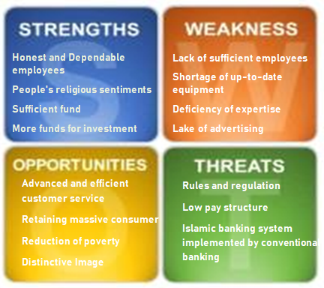
Figure 19 SWOT analysis of SIBL
STRENGTH
Honest and Dependable employees: All employees of the SIBL are reliable and trustworthy. They have constantly committed themselves to the customers for better client service.
People's religious sentiments. Bangladesh is a Muslim nation country and most of the people consider interest as a Haram. Therefore they prefer to choose an Islamic bank over a conventional one. SIBL being one of the leading banks of the structure always provide service maintaining Shariah-based principle as well as the laws and regulation governed by the central banks.
Sufficient fund: Social Islami Bank Ltd. has sufficient funds. That is the reason; they don’t need to go outside and borrow money from external sources such as the central bank or several others from the industry.
Availability of investment financing: SIBL always reserves adequate funds so they can provide finance on investment services. SIBL maintain their investment services quite highly productive to gain a competitive advantage over any other bank in the industry.
WEAKNESS
Lack of sufficient employees: SIBL has a limited number of employees compared to its operations. They don’t have enough employees to provide services to their clients. It sometimes aggravates the client and distorts the images of SIBL.
Shortage of innovations tools: SIBL SIBL is still not up-to-date with the ever-evolving technological advancement. Nowadays there is a continuous progression of technological innovation but SIBL doesn’t prefer to go with the flow of this advancement. As a result, they often refer as back-dated and it not only bothers customer but also bring constraint on the productivity of employees.
Lack of competent employees: To sustain and survive in this highly competitive industry SIBL require highly competent employees. The client of the business terms their employees in deficiency of skill compared to other banks in the industry. SIBL requires to appropriately train them and provide a workshop to uplift their skills.
Lake of promoting strategy: SIBL has a lack of advertising campaign compared to other banks.

OPPORTUNITY
Advanced and efficient service: To comply with the competitive environment bank has to match and execute its customer more efficiently with the help of technological advancement.
Retaining massive consumers: SIBL has an enormous chance to seize most of the consumers by enhancing its banking services all across the country as the majority of people of Bangladesh religious minded.
Reduction of poverty: SIBL has a huge potential that could save the country’s vulnerable communities from being borrowing funds that charge higher interest rates.
Distinctive Image: SIBL already created a brand value of being a trustworthy bank. By using that value SIBL can attract more customers as people already believe their money will be protected under the hand of SIBL.
THREATS
Rules and Regulations: Some of the traditional rules and regulations established by the central bank deviate from the structure of the Islamic principle of Islamic banks. So they need to confront different issues to work their exercises as per the Islamic Shariah.
Low pay structure: Now several of the Banks are recruiting fresh-faced expertise and skills people with great salaries where SIBL could not afford to employ a competent workforce because of the low pay structure.
Islamic banking system implemented by conventional banking: Due to the rise of demand for the Islamic banking system, some of the conventional banks already implement the structure. There are more others to follow. Hence it will increase the competition for SIBL.

STEPS/STRATEGIES TO MEET THE CHALLENGES AND OPPORTUNITIES
Despite the fact Social Islami Bank Ltd. (SIBL) is operating well but does have some vital challenges to overcome which are recommended below:
- It's a modern banking time. Every financial institution has been effectively leveraging innovative technologies. So, SIBL should use these technological innovations to maintain pace with the evolving time.
- SIBL should seek to employ skilled executives which can turn the bank ahead.
- Investment application by SIBL should be smoother than any other conventional bank.
- SIBL could perhaps consider its investment schemes more alluring to high-return projects.
- SIBL should anticipate the use of rural possibilities both in productivity and investment basis in the light of present socio-economic situations in Bangladesh. Powerful responsibilities and strengthening through experimentation and the introduction of effective concepts are the effective forms to do this.
- SIBL should be received public attention to promoting the image of Shariah-based banks as PLS (profit-loss-sharing) banks.
- SIBL can spread its range of financing by concentrating on the Shariah investment framework among bank officers; employers and clients through strength training, workshops.
- SIBL should implement different financial modes as per the evolving requirements of consumers by carrying out extensive research and study.

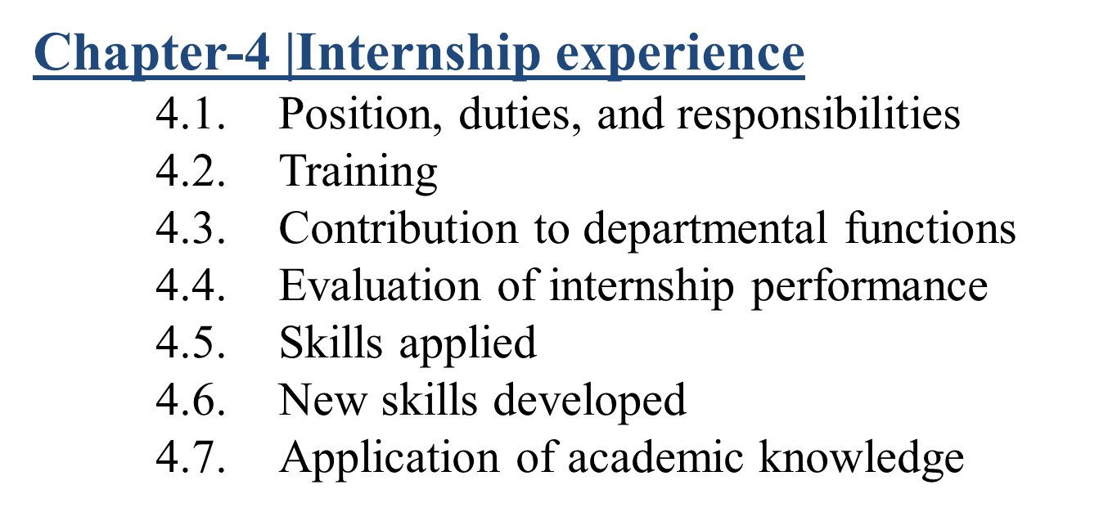

CHAPTER-4| INTERNSHIP EXPERIENCE
  - POSITION, DUTIES, AND RESPONSIBILITIES
The internship program helps students understand the organizational processes and to cope with the environments as professional staff. To accomplish my graduation from the United International University, I did my internship at the Social Islami Bank (SIBL, Dhanmondi branch). . I worked there as an intern for 3 months under the Foreign Trade Department. My core duty was to assist Mr. Shaheen Mahmood, Senior executive officer accountable for the Department and all the officers of Foreign Trade and Exchange.
My main responsibilities of the work as follows:
- Entry the data of transaction in registers
- Updating the values of the trade-in server and register
- Construction L/C issue statement form
- Compliance with officers in their regular activity.
- Assist clients with Exp and Imp files
- Maintaining the serial numbers of cheques
- Filters of cheque and vouchers
- Maintenance of Customer
- Enlisting some documents
- Working with L/C related paper

TRAINING
The internship program is supposed to be a 'job learning program,' so there isn't any conventional training granted by the bank for the internship, but all the officials of the branch were adequately kind to quickly advise me the strategy for the allocated work. The Social Islami Bank has been one of every of the simplest banks and it's a powerful market position. I used to be extremely fortunate enough to possess an internship position there. Right from the start of my three-month internship period, I used to be given some instructions and circulars to research the key operations of the bank. They always addressed every single question I asked and removed all my ambiguities. Entire departments are helpful personally. Across the full of my entire internship period, I’ve got had the chance to understand such a lot of individuals and also learn to speak with various individuals and the way to cope with different contexts. Therefore, I could say that the complete period of three months was an educational program on my behalf of me.

CONTRIBUTION TO DEPARTMENTAL FUNCTIONS
The main roles and responsibilities were to upload daily transactions online in Bangladesh Bank to capture the annual export and import data of Bangladesh. So if those data were uploaded accurately, within the database as indicated by its code, it'll be recorded within the Bangladesh Bank online system. This plays a big role because with this, the govt. of the nation are going to be able to ascertain what quantity export and import have been done annually.

EVALUATION OF INTERNSHIP PERFORMANCE
I was not an experienced employee nor been prepared officially but I had to figure with other experienced officers of the bank. I won't term my experience as "Work" rather it'll be more suitable as "Training". I’ve got given my complete specialization in my work, and my work has indeed been admired by everyone, they lauded me as a tough worker and punctual. They often motivated me, despite my few errors. Be that because it may, whatever I did I’ve got gained a good deal of acknowledgment from the Branch Manager also as branch authorities for my truthfulness and basic knowledge about banking and management and my quick learning capacity. I’d state that these 3 months help to construct a build between my educational background and useful corporate world.
Table 6 Performance evaluation of SIBL
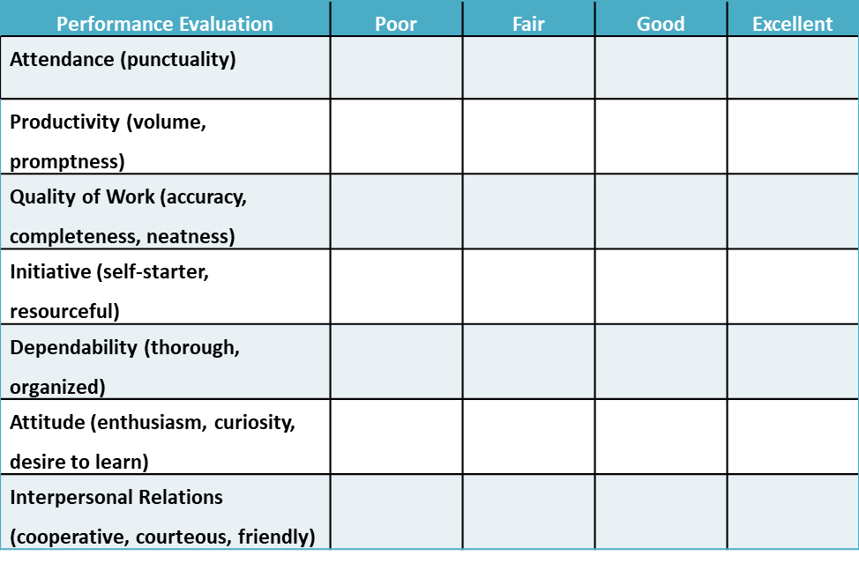
In table 6, my supervisor listed me with good attendance, Quality of Work, initiative, and interpersonal skills he was also marked as excellent productivity, attitude, and dependability. I am pretty satisfied with my evaluation and looking for a way to overcome my flaws.

SKILLS APPLIED
From the internship experience in the Social Islami Bank Ltd. I have picked up a fair number of skills. To mention a few, how the supervisors systematically execute work and cautiously. Below are given some of the new skills which I learned from my experience working at SIBL:
- I have learned to communicate with customers effectively from this internship experience. Each customer is an individual who needs various sorts of services and help. I have learned to provide those specific needs to those customers.
- I have developed the practice of working 8 hours a day, which is the general custom of any corporate culture. So, from here I gained the knowledge of how a corporation runs on time.
- I also learned how to continue the affiliation with supervisors and also the customers for the long term. This is a crucial part of any corporate life and bears significance for adjusting there.
- I have learned to concentrate better from this internship experience. As I had to finish work within a stipulated time, so I had to give my full concentration on it.
- I learned how the individual branches of any corporation play a big role in the overall banking industry.
- I have developed the skill to cooperate with my colleagues from working as an intern at SIBL.
- Working as an intern at SIBL has boosted my confidence to complete any work properly.

NEW SKILLS DEVELOPED
Each experience results in a path of innovation. Throughout my entire internship period, I’ve got countless new aptitudes that will act as building blocks to my future. Before going into the bank, I’ve got little understanding of the bank, and now I’ve got a good deal of information on the bank which will result in a stronger future. My senior officers and therefore the Deputy Manager were so helpful and that they empower me all the time which helped me to assemble countless new abilities.
In three months of my internship with Social Islami Bank, Dhanmondi branch, I had the motivation to know housekeeping, file management, client trading, financial reporting, new computer tricks, business correspondence, etc. I realize that this type of professional development will assist me within the near career path, irrespective of as an employee or an entrepreneur. With the rules of my senior officers, I could house my shortcoming that may certainly help in my near future.

APPLICATION OF ACADEMIC KNOWLEDGE
During my academic period, I had acquired knowledge of banking, management, finance, accounting, etc. sector, which assisted in my practical training during the internship period. I had to adjust to branch officials on the opening, closing, issuing of cheques, cash management, processing of loans, and documentation that required basic banking knowledge. On the opening day of the month, we had to manually calculate the interest of a number of the deposit and loan accounts on a sample basis that required financial knowledge. To touch the instruction one has to have management knowledge. Accounting knowledge could be a must to figure and understand banking operations.

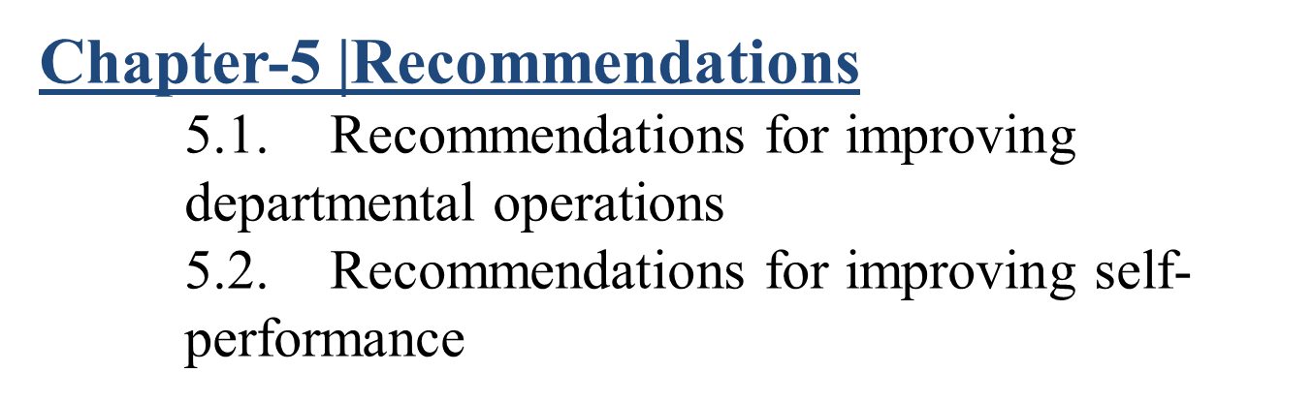

CHAPTER-5| RECOMMENDATIONS

RECOMMENDATIONS FOR IMPROVING DEPARTMENTAL OPERATIONS
Despite being one of the best Islamic Banking organizations in the country, SIBL faces some obstacles to overcome to meet its true objectives. To sustain and compete as the best of the industry, here are some recommendations SIBLmay prompt to adapt:
- As one of the dynamic banks, SIBL should increase its attention to each of the departments.
- Due to technological advancement, SIBL requires installing the latest PC and an adequate number of laptops for legitimate operation.
- SIBL need to strengthen their marketing activities to grab more customers.
- The management needs to focus on the promotion of the bank around its operations. For checking and reviewing of this current status of all the divisions for apart from their errors.
- SIBL requires to designate customer profit officer’s overall branches. They solve customers’ problems, reply to the request of customers, etc.
- S SIBL should distinct its services embracing technological innovation and diversified products.
- To accomplish the target, a bank should shape up and follow satisfactory methods, enhances, and strategies for assessing the quality and also the adequacy of loan provision and reserve.
- To upgrade the image of the bank and to expect social responsibility, the bank needs to interact with numerous social programs sort of an allowance to improve however worthy students, strengthening of the youngsters in degrading financial condition, Campaign against dowry and alternative social diabolical, etc.
- They should move frontward the harmonization among the branches and Head Office.
- Dynamism and rapidity must be enhanced on the performance of its operation.

RECOMMENDATIONS FOR IMPROVING SELF-PERFORMANCE
As I was working beside experienced officials I had to find a few varieties which I was obscure about and I should progress myself in those areas:
- Swift clarification of instruction into work thanks to the absenteeism of correct banking information.
- Practical presentation in accounting associate degreed finance as customers bestowed a couple of unstructured money statements for an advance proposition and from those unstructured financial as bank officers I had to decide on useable resources.
- Coping up with Organizational Environment as banking culture varies intensely from the real culture being told around. Working in SIBL has made a difference for me to begin understanding how banking culture works as I have received top-notch encounters from working in SIBL



CHAPTER-6| CONCLUSION

In the starting, the world wasn't familiar with Islamic banking. Earlier only the interest-based capitalist system was understood. The Islamic industry began to emerge with the distinguishing characteristics of a free system of interest. The central focus around that the Islamic industry consisted is that the straight takeoff from interest. Muslims around the world highly acknowledging this form of the banking system as it gives them reliability and trustworthiness although a somewhat confusing structure specifically to non-Muslim facing some challenges. If they can change some of their activities then they might get permission and recognition to operate in non-Muslim countries as well. Slowly but gradually the interest-free banking system began to emerge in Bangladesh as well. These adjusted-system components are all in place, now with the government's support with legal regulation, it has the potentiality to contribute more towards the economy of the country. Transforming some traditional banking into Islamic branches in Bangladesh indicates the great promise of the interest-free rate structure.
Banking organizations have become one of the most essential sectors of the economy. Banks now provide a variety of services to the people in general. All sorts of industries in the country are getting elevated with the helping of banking organizations. Likewise, SIBL is also showing progression with its effective method of operation. Taken, all things into consideration, it will firmly be aforementioned that the SIBL action program is coordinated towards the expansion of a very interactive economy beyond the far side demand and supply laws of goods and services. The Social Islamic Bank's family empowering credit program is gaining ground at a grassroots level in our country. Within the SIBL structure, credit expresses a whole lot of life and is directly connected to the social context and cultural context following Islamic law. There’s a superior chance of constructing provisions for social subsidies. De-secularization of credit might prompt the re-writing of the latest economies. Thus, it's felt that the link between credit and social objectives and assignments can have comprehensive abstract implications for the look of another construct of the latest theories of financial gain, output, and employment. SIBL offers services customized to the actual desires of the shoppers among the region of exchange, comers, and business, apart from the domestic network. Whereas services like Debit Cards, ATMs, and SWIFT payment systems area unit already in place, the Bank plans to implement the online integrated industry with all advanced delivery channels within the future. SIBL is always grateful to the government and Central Bank for showing them the upcoming prospect. It also never forget to show gratitude to esteemed customers and loyal employees. To become a market leader and accomplished the difficult task ahead it always looks forward to dynamic participation from the people associated with them.

CHAPTER-7| REFERENCES:

- Alias. (2015), M. (2015). Impaired Financing Determinants of Islamic Banks in Malaysia. Impaired Financing Determinants of Islamic Banks in Malaysia. Information Management and Business Review. Doi: 7. 17-25. 10.22610/number.v7i3.1149.
- EMI Calculator. (n.d.). Retrieved January 15, 2021, from https://www.siblbd.com/mudaraba-lakhopothi-deposit-scheme
- Islamic_banking_some_conceptual_issues. (n.d.). Retrieved January 15, 2021, from https://www.islamibankbd.com/abtIBBL/cis_islamic_banking_some_conceptual_issues.php
- Maverick, J. (2020, August 28). Analyzing Porter's Five Forces on JPMorgan. Retrieved January 15, 2021, from https://www.investopedia.com/articles/markets/020916/analyzing-porters-five-forces-jpmorgan-chase-jpm.asp
- Mudaraba-deposit-pension-scheme. (n.d.). Retrieved January 15, 2021, from https://www.siblbd.com/mudaraba-deposit-pension-scheme
- Mudaraba-education-savings-scheme. (n.d.). Retrieved January 15, 2021, from https://www.siblbd.com/mudaraba-education-savings-scheme
- Sanchita-special-deposit-scheme. (n.d.). Retrieved January 15, 2021, from https://www.siblbd.com//sanchita-special-deposit-scheme
- Sharma, G. (2012, April 19). Pestel analysis: Banking sector. Retrieved January 15, 2021, from https://www.slideshare.net/Gstheproud007/pestel-analysis-banking-sector
- Www.bb.org.bd. (n.d.). Retrieved January 15, 2021, from https://www.bb.org.bd/fnansys/bankfi.php#:~:text=Scheduled%20Banks%3A%20The%20banks%20that,but%20are%20not%20Scheduled%20Banks.
- Www.islamic-banking.com. (n.d.). Retrieved January 01, 2021, from https://www.islamic-banking.com/explore/islamic-finance/islamic-banking
- SIBL profile. (n.d.). Retrieved January 18, 2021, from https://www.siblbd.com/about/profile
- Developments of Islamic Banking in Bangladesh*. (n.d.). Retrieved January 18, 2021, from https://www.bb.org.bd/pub/quaterly/islamic_banking/apr_jun_2019.pdf

