Internship Report on
General Banking at the Gulshan Branch of
Mutual Trust Bank PLC (MTB)



Internship Report on
General Banking at the Gulshan Branch of
Mutual Trust Bank PLC (MTB)

Submitted by:
Khondoker Jobayer Islam Ratul
ID: 111201005
Bachelor of Business Administration

Supervised by:
Dr. Md. Shariful Alam
Professor
School of Business and Economics
United International University



Date of submission: Aug 10, 2025

Declaration

I have completed my three-month internship at Mutual Trust Bank PLC (MTB), Gulshan Branch, and prepared a report titled “Internship Report on General Banking at the Gulshan Branch of Mutual Trust Bank PLC (MTB)” which is original and has not been submitted to any other institution for academic certificates, diplomas, or degrees.

There is no violation of copyright in the report I have presented, and no portion of this report is based on any previous assignments I have done, whether for a degree.

Sincerely,

Khondoker Jobayer Islam Ratul
ID: 111 201 005
Bachelor of Business Administration
United International University

Letter of Transmission

Date: Aug 10, 2025
Dr. Md. Shariful Alam
Professor
School of Business and Economics
United International University
Subject: Application for permission to submit Internship Report.
Respected sir,
I am glad to inform you that I have completed my internship report on General Banking at Mutual Trust Bank Plc. I am delighted to submit this report to you. It will undoubtedly be helpful to my future goals and assist me in completing the Bachelor of Business Administration.
During my internship at Mutual Trust Bank, I have fully utilized the opportunity. Writing this report has given me valuable knowledge that will help me significantly in my academic and professional goals. Because of this, my understanding of banking operations has expanded. To write a proper report, I put in a lot of effort.
Please accept my sincere gratitude for the opportunity you've given me to write this report. Writing this report is an excellent way to put everything I learned in the BBA program into practice, and I'm glad I had the opportunity to do so. I would be happy to answer any questions you may have.
Sincerely Yours,
Khondoker Jobayer Islam Ratul
ID- 111 201 005
Bachelor of Business Administration
United International University

Acknowledgement

First of all, I am grateful to Almighty Allah for helping me complete my report on time.
Fulfillment of anything requires support from several sources. I am lucky to have sincere guidance and supervision from several people.
I want to thank Md. Nazim Uddin, MTB Gulshan branch (Customer Service Manager), for attentively reviewing the report and giving me helpful suggestions to finish the report.
Additionally, I would want to express my gratitude to Md. Nazmul Islam, who is in charge of branch operations, and Farzana Afroz, who is the customer service officer at the MTB branch in Gulshan. They gave me an extensive explanation of what MTB does on a daily basis. Everyone else who helped me out when I was an intern, from other officials to other students, has my eternal gratitude. Their cooperation was really helpful to me. Thanks to the details they gave me, I was able to complete all of the assignments.
Then, I would like to thank my respected professor, Dr. Md. Shariful Alam, who is a professor at United International University's School of Business and Economics, for regularly giving me comments and guidance on my report. By providing me guidance, he helps me make this course as perfect as possible. It would be hard for me to finish this report without his helpful advice and assistance.
To each and every one of you, I am forever thankful. I hope you will find this report appreciated.

Executive Summary

The financial sector in Bangladesh is rapidly modernizing, with banking becoming more interconnected and accessible to all departments, making it faster and more convenient.

Mutual Trust Bank Plc, a third-generation private bank in Bangladesh, began operations in 1999 and operates from its Corporate Head Office in Dhaka, managing its financial operations through 158 branches and sub-branch facilities.

This report provides an overview of MTB Gulshan Branch, which includes General Banking and the Advance Department, and its operational environment.
In this report, I also detail my three-month internship at MTB Gulshan Branch, outlining my responsibilities and valuable lessons learned from my supervisor, coworkers, and colleagues, as well as the valuable lessons I gained during my time there.
I have detailed my experience working with real clients and the challenges I faced during my three months at an organization, five days a week. I have also expressed my understanding of the difference between my expectations and the reality of working for an organization.
Table of Contents
Declaration i
Letter of Transmission ii
Acknowledgement iii
Executive Summary iv
CHAPTER:1 1
INTRODUCTION 1
1.1 Introduction: 2
1.2 Significance and Background of the Report: 3
1.3 Objectives: 4
CHAPTER: 2 5
ORGANIZATION’S BACKGROUND AND OVERVIEW 5
2.1 Organization Details: 6
2.2 Background of MTB: 7
2.3 Vision of MTB: 7
2.4 Mission of MTB: 8
2.5 Commitment: 8
2.6 Philosophy of the Bank: 8
2.7 Objectives of MTB: 8
2.8 Functions: 9
CHAPTER: 3 10
PRODUCT AND SERVICE 10
3.1 Services and Products: 11
3.2 MTB Gulshan Branch: 12
CHAPTER: 4 13
EMPLOYEES, DEPARTMENT, AND MANAGEMENT 13
Employees and Departments: 14
4.1 Department of General Banking 14
4.2 Department of Credit and Foreign Exchange: 14
4.3 Department of Cash: 14
Management of MTB: 14
4.4 Planning: 15
4.5 Organizing: 15
4.6 Staffing: 15
4.7 Directing and Controlling: 15
CHAPTER: 5 16
INTERNSHIP ACTIVITIES AND EXPERIENCES 16
Internship Activities: 17
5.1 Actual Task: 17
5.2 Responsibilities: 17
5.2.1 Opening Accounts: 17
5.2.2 Receive Cheque Requisition: 20
5.2.3 Issue Pay Order: 20
5.2.4 CDD Project: 22
EXPERIENCES: 22
5.3 Filing: 22
5.4 Voucher Sorting: 24
5.4.1 Voucher types: 24
5.4.2 Management of Voucher: 24
5.4.3 Purpose of Voucher Management: 24
5.5 Others: 25
CHAPTER: 6 26
LEARNING AND OBSERVATION 26
Learned from Internship: 27
6.1 Technical Skill: 27
6.2 Analytical Skill: 27
6.3 Communication skills: 27
6.4 Personal development: 27
6.5 Observations: 28
CHAPTER: 7 29
RECOMMENDATIONS AND CONCLUSION 29
Conclusion: 30
Recommendations: 30
References 32
Appendices: 33

CHAPTER:1

INTRODUCTION

1.1 Introduction:
In a general sense, “Bank” refers to a financial entity that manages financial transactions. It is an economic entity that focuses mainly on generating revenue through the exchange of credit and cash investments.
The bank can influence the money supply through investment and lending. Different kinds of banks exist in Bangladesh, including central banks, cooperative banks, commercial banks, savings banks, investment banks, and merchant banks. Still, the term "bank" is typically used to refer to a "Commercial Bank."
A commercial bank is a financial institution that accepts deposits from customers, utilizes these deposits in the form of loans and investments to meet the financial requirements of businesses and other segments of society, and repays and withdraws funds on demand.
To fulfill the requirements of United International University's Bachelor of Business Administration program, I have been required to submit an internship report detailing my time spent interning at Mutual Trust Bank PLC (MTB). The report also includes details regarding the operations and management of Mutual Trust Bank. The data I gathered throughout my internship will be the basis of my report. This job experience is a great way to put what I have learned in the classroom into practice. Through my internship at Mutual Trust Bank PLC, I gained valuable knowledge in the banking and financial services business.

1.2 Significance and Background of the Report:
An internship is a formal arrangement between an organization and a university that allows students like us to gain practical experience in a professional environment through a short-term assignment. It prepares us for future employment by bridging the gap between what we learn in the classroom and what we'll face on the job.
Internship, with the course code "INT 4399," is an important part of United International University's Bachelor of Business Administration degree. In order to pass this course, all students are required to get an internship with a prestigious company. While there, they will learn valuable skills and get experience that will help them in their future careers.
This course is required of all students at United International University, even though it is not required in all universities in Bangladesh. It is worth 3 credits out of 123 for completion of the BBA Program. It must be covered within 3 months under a supervisor assigned by the Directorate of Career Counselling and Student Affairs.
I required this course to finish my BBA program, and I was a last-semester student. I was an employee at the Gulshan Branch for about three months, beginning on March 2, 2025, and ending on May 28, 2025, in the General Banking Division. My study for the task focused on Mutual Trust Bank Plc's "General Banking" division.
I've learned new skills from this internship course that I may use in the future at work. These skills increased my job opportunities and improved my resume. I have studied and performed the tasks and responsibilities that professionals carry out on a daily basis as a result of this course. In addition, I got familiar with the office setting and followed the established procedures.

1.3 Objectives:
My report's primary goals are to:

- Provide a quick overview of Mutual Trust Bank Plc (MTB), its staff, and its customers.
- To discuss my achievements and contributions to the Bank.
- To discuss my interactions with coworkers and bosses.
- To discuss the difficulties I encountered.
- To discuss how expectations and reality differ from one another.
- To discuss how an internship has impacted my career goals.
- To discuss what I would change if I had to repeat my internship program.

CHAPTER: 2

ORGANIZATION’S BACKGROUND AND OVERVIEW

2.1 Organization Details:

NAME | MUTUAL TRUST BANK PLC
Head Office | MTB Centre, 26 Gulshan Avenue, Plot-5, Block SE (D, Dhaka 1212)
Status | Public Limited Company
Number of Branches & Sub-Branches | 120&38
Present Chairman | Rashed Ahmed Chowdhury
Shareholders | Shareholders 11
Manpower | 2703 Employee
Website | https://www.mutualtrustbank.com/

2.2 Background of MTB:
The Companies Act of 1994 made MTB a public company limited by shares on September 29, 1999. Its authorized capital is 38,000,000, which is split into 38,000,000 ordinary shares of Tk. 10 each. MTB is allowed to do all kinds of banking business.
Foreign exchange transactions and other financial services are among the many commercial banking operations carried out by MTB. The bank's main priorities during the first two years of existence were expanding its client base and providing individualized customer care.
MTB conducts the following categories of banking business:
- All commercial banking operations, including those related to the money market.
- Putting money into merchant banking operations.
- Investing in business operations.
- Financial intermediary services.
- Capitalists, promoters, financiers, and other
- Associated financial services.

2.3 Vision of MTB:
Mutual Trust Bank’s vision is based on a philosophy known as MTBV:
• Best-performing bank in Bangladesh.
• Bank of choice.
• World-class bank.

2.4 Mission of MTB:
MTB aims to be the most prestigious financial institution in the country, recognized for its dynamic, innovative, and client-centric approach, providing a wide range of services for excellence and substantial economic value.

2.5 Commitment:
- Shareholders: Use an ethical and effective business approach to generate long-term financial benefit for our shareholders.
- Community: Dedicated to improving society by promoting job growth, supporting neighborhood initiatives and gatherings, and acting as a responsible corporate citizen.
- Clients: Provide our clients with advanced service by providing an extensive range of products and making every effort to meet their banking requirements.
- Employees: We rely on our employees' natural merits and value our partnership as members of this prestigious financial organization.

2.6 Philosophy of the Bank:
Our mission is to provide trustworthy and honest services to our clients so that we can become a trusted financial institution in the country.

2.7 Objectives of MTB:
The primary objective of Mutual Trust Bank Plc (MTB) was to provide an interest-free banking system in the financial market. Apart from that, the bank started its operation in the country intending to realize the following objectives:
- To get rid of the idea of a debtor-creditor connection that traditional banks have, and instead build a partnership with clients.
- To set up a banking system that helps people.
- To get people to save money and put it into productive areas.
- To put money into something that shares both the profits and the risks.
- To take deposits and share the profits and losses.
- To make jobs available by putting funds into promising economic areas.
- To make banking services available to the poor, defenseless, and low-income persons in society so that they can improve their quality of life.
- To help build a society by spreading money fairly.
- To make trade and business fair in the country.
- To help the country's economy grow by providing services.

2.8 Functions:
Mutual Trust Bank Plc Functions:
- Maintaining online deposit accounts.
- Engaging in foreign exchange operations.
- Expanding banking services.
- Engaging in social welfare initiatives.

CHAPTER: 3

PRODUCT AND SERVICE

3.1 Services and Products:
Mutual Trust Bank's Services and Products Overview
Offers various accounts, including:
- individual,
- joint,
- Special Notice Deposit, and
- current accounts.
Provides various schemes including:
- MTB Monthly Savings,
- MTB Millionaire Plan,
- MTB Kotipoti Plan,
- MTB Fixed Deposit,
- MTB Monthly Benefit Plan,
- MTB Double Saver,
- MTB Angona General, Premium, and Fixed Deposit.
Offers Yaqeen Deposits including:
- Al Wadeah Current Deposit,
- Mudaraba Saving Deposit,
- Mudaraba Term Deposit Receive, and
- Mudaraba Short Notice Deposit.
Provides online banking services including:
- MTB Internet Banking,
- MTB Smart Banking App,
- MTB SMS Banking, and
- MTB Smart IVR.
Offers loan, debit, credit, prepaid cards, and pay order transactions.

3.2 MTB Gulshan Branch:
20 Gulshan Avenue, Dhaka 1212
Phone: 88 02-9882473, 88 02- 8837840
Fax: 88 02-8832343
Email: gulshan.br@mutualtrustbank.com

I have completed my internship at MTB's Gulshan Branch, a clean and well-maintained corporate building. The facility offers good security, quick back office service, and friendly staff, with over 27-28 employees, ensuring a comfortable experience.

CHAPTER: 4

EMPLOYEES, DEPARTMENT, AND MANAGEMENT

Employees and Departments:
MTB has three departments. They are the “Cash Department”, the “General Banking Department”, and the “Foreign Exchange and Credit Department”.

4.1 Department of General Banking
General Banking, known as "The Heart of Banking," involves daily tasks like money procedures, account opening, closing, foreign remittance, and bills, functioning like the blood of the bank.

4.2 Department of Credit and Foreign Exchange:
The foreign exchange department is the bank's international division. In this department, work related to export, import, and remittance occurs. It makes a connection and bonding between the exporter and the importer by providing them with various services.

The credit department works with CIB to process loans on behalf of clients, preparing documentation for approval to the Head Office. They offer various loan types, including car, home, and business loans, after obtaining approval from the head office.

4.3 Department of Cash:
The primary responsibility of this department is to manage financial matters for its clients. This section allows individuals to deposit their funds by filling out a deposit form. Cash withdrawals are also conducted in this section. Individuals are permitted to withdraw funds from this department after submitting the appropriate check. Additionally, this department contains a billing section where the officer is responsible for the receipt of government bills and other types of bills.

Management of MTB:
Management is crucial for financial and non-financial organizations, planning, organizing, staffing, directing, and controlling resources. Mutual Trust Bank's management practice covers various aspects, enabling the organization to achieve its goals.

4.4 Planning:
Mutual Trust Bank's planning division is responsible for overall planning, ensuring alignment with corporate goals, with each branch creating a plan based on corporate-level objectives.

4.5 Organizing:
Mutual Trust Bank is structured based on its business locations, with branches as separate entities responsible for their performance, and each branch is functionally organized within it.

4.6 Staffing:
Mutual Trust Bank employs two recruitment methods: management program (MTO) and non-management level positions, such as Assistant Officer.

4.7 Directing and Controlling:
Mutual Trust Bank's works are designed to allow superior monitoring of subordinates through comfortable seating arrangements in offices, budgeting, rewarding, and punishing as control mechanisms.

CHAPTER: 5

INTERNSHIP ACTIVITIES AND EXPERIENCES

Internship Activities:

5.1 Actual Task:
During my internship at Mutual Trust Bank Plc. (MTB) At the Gulshan Branch, I was assigned to make observations within the General Banking Department. I fulfilled several responsibilities, including account opening, voucher management and organization, as well as the management of cards and cheque books.
Initially, I worked with Nayeema Nusrat, one of the employees at the front desk, for a few days.
I mostly performed duties and observed the guidelines and regulations of the "General Banking Department."

5.2 Responsibilities:
I was responsible for various tasks within the GB division of Mutual Trust Bank PLC (Gulshan Branch), starting at 10:00 a.m. and ending at 5:00 p.m., sometimes working until 6-7:00 pm. They performed various types of tasks during this time.

5.2.1 Opening Accounts:

General banking's most critical concern is account opening. Nayeema Nusrat, Farzana Afroz, and Kazi Anwarul Azim supervise this section at the MTB Gulshan Branch. This is the initial phase of the bank's service delivery process for customers. It is crucial to understand the bank's intended audience prior to opening an account. It is also crucial to figure out the reasons behind the customer's desire to open an account at this branch. It is quite difficult to disclose the customer's motivation for opening an account. The purpose of opening the account for a specific customer can be easily figured out by an experienced and intelligent account opening officer.
Mutual Trust Bank Plc (MTB) provides different account types for its target population, including Current Accounts, Savings Accounts, and Fixed Term Deposit Accounts (FDR).
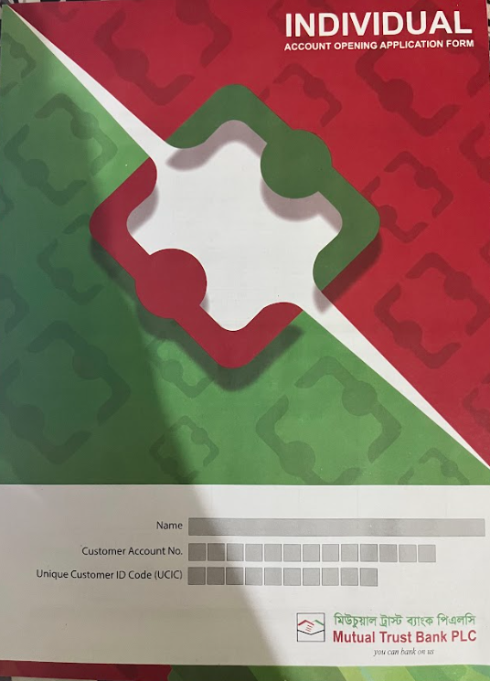
The individual and institutional customers require an account, and my duty is to provide high-quality services and maintain long-term customer relationships to a standard.
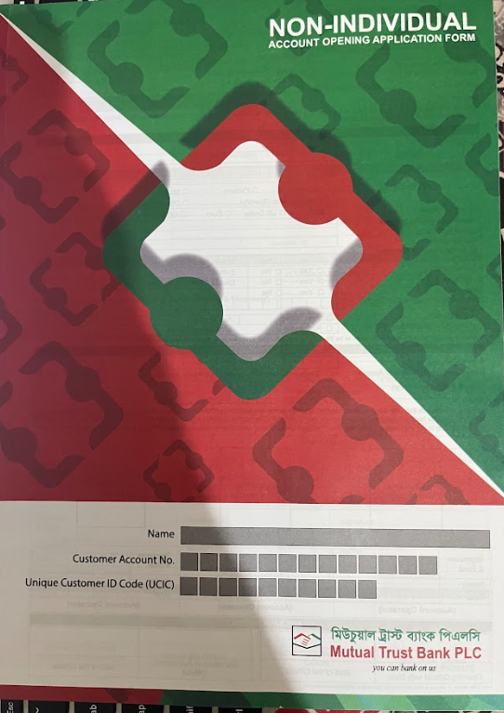

Account Opening Form

5.2.2 Receive Cheque Requisition:

Rawnak Jahan manages this section where customers submit cheque requisitions for new cheque books, with each book containing a specific number of pages. These requisitions are received daily and sent to the head office via Rakib Hossain. Once ready, the books are sent to the branch via courier.
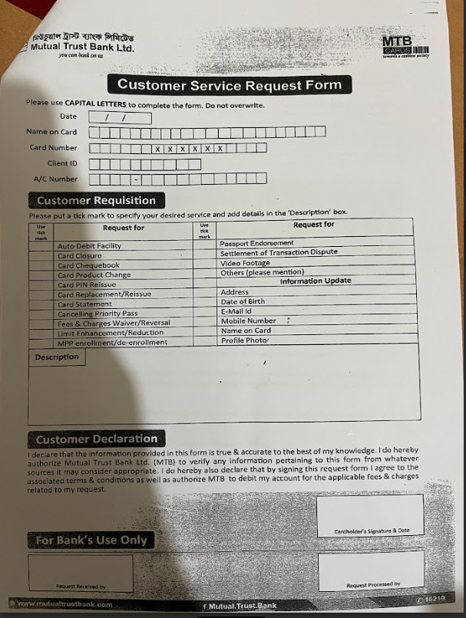

Customer Service Request Form

5.2.3 Issue Pay Order:

This section is supervised by Nayeema Nusrat, and in her absence, by Sabah Naureen. A pay order has been issued to facilitate the customer who wants to transfer funds using a cheque instead of cash. It minimizes the risk related to carrying cash. I have often helped consumers during the procedure.
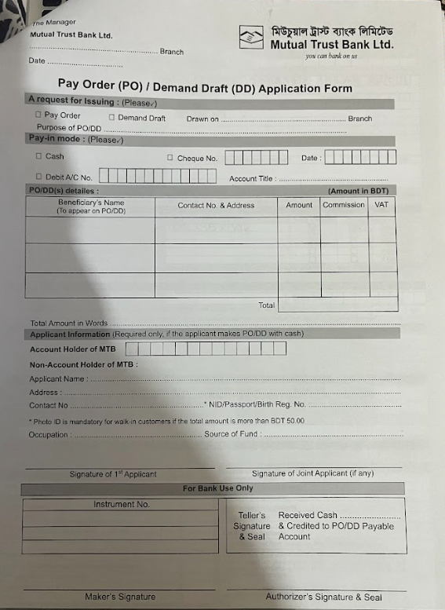

Pay Order Application Form

5.2.4 CDD Project:

The Bangladesh Bank has assigned every bank in the country to the "CDD Project," which focuses on Customer Due Diligence. The project involves promoting E-KYC (Know Your Customer), which allows for quick customer onboarding by verifying customer identity digitally. This saves time and eases the process for both clients and service providers, while also reducing institutional costs. If technical issues arise, traditional KYC approaches should be used for natural individuals.
Officers at MTBL were assigned specific targets to complete the Know Your Customer (KYC) process for accounts under the Customer Due Diligence (CDD) Project, as directed by manager Sir Mezbah Uddin Chowdhury. I helped achieve these targets by creating a list of pending and completed accounts.

EXPERIENCES:

5.3 Filing:
Several documents must be kept for the branch's records and monthly audits. These include TP, KYC, update statements, monthly transaction profile reviews, and more. Every day after work, I helped several officers fill out documents like this.
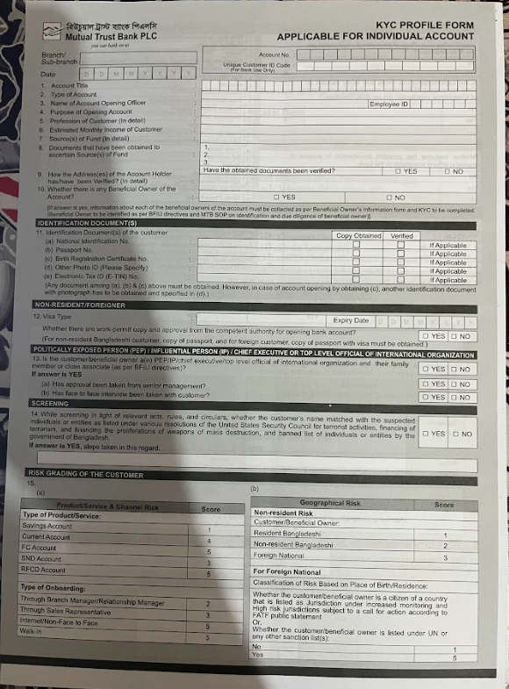

KYC Form

5.4 Voucher Sorting:
Voucher sorting is a systematic process used to compile various types of transaction-related vouchers, such as fund transfers, cheques, RTGS, BEFTN, and debit installments, daily.

Voucher types:

- Cash voucher
- Clearing voucher,
- Transfer voucher.

Management of Voucher:

- Collect and sort vouchers.
- Print daily transaction report.
- Verify vouchers for seal and marking.
- Matching vouchers with the transaction report.
- Correcting any mismatches or errors.
- Attach the voucher to the report.
- Creating the voucher top sheet.
- Sending for preservation after the signatures.

Purpose of Voucher Management:

- Shortening daily vouchers.
- Verifying daily transactions
- Correcting errors if identified.
- Ensure voucher seal and marking.
- Preserve the voucher for future use and audit evidence.

5.5 Others:
Some other responsibilities that I have done are-
• Creating credit card forms.
• Calling clients for cheque books and cards.
• Handling inward and outward entries.
• Sorting and completing previous vouchers (2025).
• Preparing Excel sheets for cheque books and cards.

CHAPTER: 6

LEARNING AND OBSERVATION

Learned from Internship:
The internship at Mutual Trust Bank has provided me with valuable skills that will enhance my professional career, allowing me to understand how the bank cultivates competencies for those aspiring to work in a professional environment.

6.1 Technical Skill:
During my internship, I enhanced my technical skills by using Microsoft Office applications and operating the bank's software, "MTB SMART BANKING."

6.2 Analytical Skill:
Analytical skills are crucial in the corporate sector, particularly in banking. Despite facing challenges in analyzing large amounts of data and working across departments, and completing multiple tasks multiple times, these skills have improved my ability to handle any situation effectively.

6.3 Communication skills:
Through my internship program, I developed practical communication skills in the corporate sector by interacting with clients from various departments. This experience improved my formal communication skills and demonstrated my interpersonal abilities. I was able to handle busy officers and clients waiting in designated areas, utilizing my interpersonal skills to manage their needs and establish connections with clients across departments. Overall, my internship program helped me improve my communication and interpersonal skills.

6.4 Personal development:
After completing an internship, I learned effective time management through working in various departments at a bank. I learned to multitask, handling accounts, clearance, foreign, and investment tasks. Initially, completing a voucher took 1-1.5 hours, but now it takes 15-20 minutes.

6.5 Observations:
Working at Mutual Trust Bank was an interesting experience. Lovely and talented individuals work there. The things I've observed are:
- Work is never left up to the next day until it has to be.
- Better operating systems and an intranet could speed up the work process.
- Employees are motivated when they know they're doing a good job.
- A lot of people are always coming to this branch, so a lot of transactions happen there. For this reason, the workers are kept very busy all day.
- The tasks at work are always given to and shared among all employees.
- Each worker is responsible for a certain set of tasks. He or she takes care of those duties all day long. In this way, it is also easy to give out tasks.
- One more thing: I saw everyone help each other out a lot.
- The busy days of the week for work are Sunday and Thursday.

CHAPTER: 7

RECOMMENDATIONS AND CONCLUSION

Recommendations:
I recommend Mutual Trust Bank update its system due to its slow performance, causing inconvenience for employees and customers. The outdated system often leaves employees working late, and the server system has user restrictions, causing delays for others. Interns are working from 10:00 a.m. to 5:00 p.m., but may be left behind due to work pressure. The author suggests that interns should be let go on time. The bank's network system needs improvement, with the mobile network not functioning properly inside the office. Wi-Fi should be provided for bank officers. The branch network and ATM locations need expansion, as there are few customers at the ATMs. Overall, I believe that Mutual Trust Bank should focus on improving its system and addressing the issues faced by its employees.

Conclusion:
MTB's main competitive advantage is its online banking capabilities, which all banks are striving to improve.

MTB's employees are highly motivated and cooperative with customers, colleagues, interns, and visitors, mainly due to the benefits provided.

This report explores practical dealings in handling various types of banking activities in each department.

The internship was a valuable experience, transforming my initial fear and confusion about corporate life into excitement. It allowed me to meet new people, gain knowledge, and develop skills through my time at the bank.

Moreover, the internship provided me some valuable knowledge of corporate life, rules, and regulations, allowing me to work in a real-world bank and address common issues, extend my academic expertise beyond academics, and influence my career choice.

References
http://www.bangladeshbank.org.bd/
https://www.bb.org.bd/en/index.php
https://www.mutualtrustbank.com/
https://www.mutualtrustbank.com/investor-relations/annual-report/
Khan, N. H. (2019). General Banking. Dhaka.
Mission and Vision. (n.d.). Retrieved 2022, from https://www.mutualtrustbank.com/about-us/missionvision/?fbclid=IwAR1XG0NWkCGyD2PLjmAgdimEDddhtwU3yFYb-I8A01H4DqLKnkqLvyQ2-ME

Appendices:
