Internship Report
On

The Primary Purpose of the bank is to provide services to farmers and agricultural industry in Bangladesh

HR Forecasting Process and Staffing Strategy of Bangladesh KRISHI Bank



Internship Report
HR Forecasting Process and Staffing Strategy of Bangladesh KRISHI Bank
Course code: INT 4399

Submitted To
Nasrin Akter
Assistant Professor
School of Business and Economics
United International University

Submitted By
Salman Rahatin
ID: 111 161 306
School of Business and Economics
BBA Program, Major in Human Resource Management
United International University

Date of Submission
October 03, 2021


Letter of Transmittal
October 03, 2021
Nasrin Akter
Assistant Professor,
Department of School of Business and Economics
United International University.
Subject: Submission of Internship Report
Dear Mam,
I would like to submit my internship report on “Human Resource Forecasting Process and Staffing Strategy of Bangladesh KRISHI Bank”, which I have prepared as a prerequisite for completing the United International University's BBA program and the INT course 4399. I have attempted to follow each and every guideline you suggested while working on the report. Working in this new business has been a really eye-opening experience, and I have thoroughly enjoyed my internship with the HR team of Bangladesh KRISHI Bank. The teams have also extended their cooperation where necessary. I have done my best to prepare this report informative.
I would also want to express my gratitude for your continued guidelines and supports. It would be my great pleasure to provide you with any further information you want in order to analyze the internship report.
Since, I am a fresher in a real job life experience, I am requesting to you accept my report as general consideration if there are any errors in the report.
Sincerely,
Salman Rahatin
ID: 111 161 306
Program: BBA
Major in Human Resource Management

Declaration of the Student
I am Salman Rahatin, student of United International University of Bachelor of Business Administration, major in Human Resource Management. I do hereby declare that the Project on “HR Forecasting process and the Staffing Strategy of Bangladesh KRISHI Bank” is original piece of work that has never previously been submitted for a degree or conformity assessment.
I also hereby declare that this report work is solely done by me, under the supervisor of Nasrin Akter, Assistant Professor of School of Business & Economics at United International University. This internship report is completed for the fulfillment of my undergrad degree, BBA Major in Human Resource Management from United International University.
Salman Rahatin
ID: 111 161 306
Program: BBA
Major in Human Resource Management

Acknowledgment
An internship program is a very important and vital means of obtaining practical knowledge because a student's knowledge is incomplete until he or she has learned and gained both theoretical and practical information,
I cannot claim full credit for my original study completion. Many people helped me to complete my report on time by providing me with helpful information, guidance, and direction. But first and foremost, I want to express my gratitude to Almighty Allah for giving me the strength and peace of mind to complete the task on time.
Secondly, I would like to convey my deepest thanks to my academic supervisor, Nasrin Akter, Assistant Professor, School of Business Economics, United International University, for her time, assistance, and advice in completing my internship report.
Then, Md. Towhidul Haque, Assistant General Manager, ICT department, Bangladesh KRISHI Bank, has given me with a great deal of knowledge, relevant material, and, most significantly, has cooperated with me to guarantee the successful completion of this study. I am very grateful to him.
Finally, I'd like to express my gratitude to Bangladesh KRISHI Bank, its management, and particularly the HR colleagues, for their valuable support in compiling this difficult research, study and analysis with essential facts and data.

Table of Content

Executive Summary vi
Chapter 01: Introduction
1.1 Introduction of the report 2
1.2 Origin of the report 2
1.3 Objective of the study 2
1.3.1 Primary Objective 2
1.3.2 Specific Objective 3
1.4 Scope of the report 3
1.5 Limitation of the report 3
1.6 Methodology of the study 4
Chapter 02: Literature Review
2.1 HR Forecasting 6
2.2 How to do an HR Forecast 6
2.3 Benefits of HR Forecasting 7
2.4 Benefits of HR Strategy 8
2.5 How HR Forecasting affect HR Strategy 9
Chapter 03: Industry and Organization Preview
PART A: Banking Industry
3.1 Banking Industry (2020-2021) 11
3.1.1 Transformation to the Digital System 11
3.1.2 Online Banking Services 12
3.1.3 Work from Home and Virtual Activities 12
3.1.4 Layoffs of Bank Employees 13
3.1.5 Employees’ Salary Cuts 13
PART B: Bangladesh KRISHI Bank
3.2 Overview of Bangladesh KRISHI Bank 14
3.3 Mission 16
3.4 Vision 16
3.5 Core Values 16
3.6 Objectives 16
3.7 Management of Bangladesh KRISHI Bank 17
3.8 Structure of ICT Department 18
Chapter 04: Analysis and Findings
Data Analysis and Presentation Plan 20
PART A: HR Foracsting Process
4.1 HR Forecasting Process of BKB 21
4.2 Categories of HR Forecasting Activities 21
4.3 Key Personnel Analyses Conducted by HR Forecasters 22
4.4 HR Forecasting by Time Horizon 24
4.5 Forecasting in Demand 25
4.6 Forecasting in Supply 27
4.6.1 Internal Supply 27
4.6.2 External Supply 28
4.7 Using the Supply of Inside and Outside Candidates 28
PART B: Recuritment and Selection Process
4.8 Approach of Recruitment Process 30
4.9 Selection Process of BKB 32
4.9.1 Characteristics to look on during the recruitment stages 35
PART C: Findings
4.10 HR Forecasting 37
4.11 The Strengths of Recruitment and Selection Process of BKB 37
4.12 The Weakness of Recruitment and Selection Process of BKB 38
Chapter 05: Recommendation and Conclusion
5.1 Recommendation 40
5.2 Conclusion 40
References 42
Appendix 43
Interview Questionnaire 45

Executive Summary
One of the most effective ways to prepare your company for the future is to forecast human resource requirements. HR forecasting skills will be in high demand at any company, large or small, to help them plan for the future following a particularly turbulent year. HR forecasting is all about predicting demand and supply, whether it's in terms of employee numbers, skills, or office space. On the other hand, an organization's recruitment and selection method is required in order to attract an effective workforce since it will determine the company's success and have an impact on the overall operation. Employees are one of an organization's most important assets.
I have selected this topic and this report has been split into various components. As an intern at BKB, I did my absolute best to learn about their HR Forecasting Process, Recruitment and Selection process in a short of internship period.
The study begins with an overview of the “Bangladesh KRISHI Bank (BKB),” including its mission, vision scope, and limitations. The report then moves on to the first section, which is the introduction. The Bank is governed by the Government of the People's Republic of Bangladesh's policies and principles. Then after, I continue to concentrate on the report "HR Forecasting Process for the ICT department of BKB, which details the various stages. I have tried to find out the policy and program of a HR surplus and HR shortage of BKB. During the pandemic situation, on the ICT department they have more shortage of manpower and for this they are going to recruitment and selection activities. In the Recruitment and Selection process the first step is to create a personnel request and submit it to the Human Resources Department. Following clearance, the advertising is placed in at least two national newspapers. The next stages are to schedule a written exam, conduct interviews, and lastly have a physical assessment. A more detailed explanation of the best candidate selection process has been provided in this report, as well as the HR department's role in identifying the most qualified personnel. SWOT analysis of recruitment and selection procedure of BKB has been included in this report. And on the analysis of the study, I have provided some recommendations for improving about these activities. After studying this analysis, it is clear that an effective, competent, and active involvement in the HR Forecasting process, Recruitment and Selection process drives an organization to the height of achievement.

CHAPTER 01
INTRODUCTION

Introduction of the report
The most important activity in HR planning is an organization's HR Forecasting process. HR Forecasting is concerned with keeping track of internal changes implemented by the organization’s managers and employees and the core of the HR planning process is determining the net requirement for employees by assessing the demand for and supply of human resources today and in the future. Effective forecasting reduces HR expenditure while also increasing the organization's flexibility and ensuring that the organization's needs take priority over other concerns. On the other hand, the most important human resource planning activities are an organization's recruiting and selection procedures. The main objective of recruitment is to make a massive enough pool of candidates and select the best candidates. Effective recruitment is necessary because a sufficient number of competent applicants are required to ensure that the selection process can be completed effectively. Bangladesh KRISHI Bank is our country's largest well-known agricultural bank, with nearly 335 of its 1031 branches online, 361 of which are automated. Since, I am a BBA student, major area in Human Resource Management and I am doing my internship program in Bangladesh KRISHI Bank in ICT department. In my internship report, I have tried to cover their HR forecasting process, activities and their recruitment and selection process for ICT department.

Origin of the report
The Internship report is being prepared in order to do study on the “HR Forecasting Process and the Staffing Strategy of Bangladesh KRISHI Bank (ICT Department).” To complete the BBA program at United International University, It is required to perform internship report. Nasrin Akter, Assistant Professor of School of Business Economics at United International University oversaw and led the guideline and report preparation, and I am grateful to her for delegating this assignment to me.

Objective of the study
There are two types of objectives: primary and specific, as mentioned below.

Primary Objective
The primary objective of this report is to get a clear understanding about the Human Resource Forecasting Process and the Staffing Strategy for ICT department of Bangladesh KRISHI Bank.

Specific Objective
- To get an overview of Bangladesh KRISHI Bank in agricultural industry.
- To accrue knowledge about banking activities and the HR department of Bangladesh KRISHI Bank.
- To know about the HR forecasting methods and processes of Bangladesh KRISHI Bank.
- To find out how Bangladesh KRISHI Bank combines employee efficiency for their ICT department.
- To determine how Bangladesh KRISHI Bank plans job descriptions and job analysis for a large of pool candidates.
- To know about the recruitment and selection process of Bangladesh KRISHI Bank.
- To make some recommendations as well as suggestions to help the HRD of Bangladesh KRISHI Bank to improve its performance.

Scope of the report
The establishment of a large industry necessitates a significant amount of capital. Financing large-scale industries is exceptionally hard for a developing country like Bangladesh. It is not easy to practices and implements a proper Human Resource Forecasting, planning and staffing strategy.

Limitation of the report
The main limitation is the pandemic Covid-19. As there are many employees were affected in covid-19 in the bank which made the working environment unsafe for me to do my internship properly. So, during my internship, I shifted my internship from home and sometimes at office in last month of my internship journey.
Another main limitation was difficulty in conducting survey. Since Bangladesh KRISHI Bank is a stated owned bank, some of the employees are not proper interact with Interns. So, the topic was studied and analyzed on the basis of open ended question through interview. Beside some other limitations are listed below:
- Some data can't be provided because of confidential and other banking commitments.
- The colleagues of ICT department had not given so much time on my interview sessions.

Methodology of the study
This research and the internship report were based on academic theoretical knowledge, studying relevant HR Forecasting and Recruitment and Selection Process literature, reports, focus groups with senior colleagues of ICT department of BKB, and other qualitative data collection techniques.
Here's a brief overview of how I gathered data and conducted research for this report:
Type of the data: This report has been prepared based on primary & secondary data which are described below:
- Primary Data: Hand on experiences like taking interviews from the Assistant General Manager, HR Manager, discussions and communications with senior colleagues on ICT department of BKB, and direct observations and practical working experiences on overall HR related activities were used to collect data.
- Secondary Data: Various articles, documents, HR Planning, forecasting, Recruitment and Selection Process’ reports, online publications, & various websites were used to collect the data.
Data Source: How data is interpreted and evaluated is described by the technique. I was able to get the material after going through the many databases that supported me in preparing my report. There are two parts to the foundation.
- Primary Sources of collecting the data: The following are some of the methods and sources used to collect the data such information:
  - Face to face conversations with the Assistant General Manager of ICT department at BKB.
  - Conducting an interview session with a structured interview questionnaire.
  - Group discussions with senior colleagues on ICT departments of BKB.
  - Experiences on HR related activities.
- Secondary Sources of collecting the data:
  - Articles, annual reports which are related to the HRP, Forecasting Process of Manpower in Banking Industry and Recruitment and Selection process of candidates.
  - Official Websites of Bangladesh KRISHI Bank.
  - Internal Reports of Bangladesh KRISHI Bank.

CHAPTER 02
LITERATURE REVIEW

HR Forecasting
One of the most effective ways to prepare your company for the future is to forecast human resource requirements. HR forecasting skills will be in high demand at any company, large or small, to help them plan for the future following a particularly turbulent year. HR forecasting is all about predicting demand and supply, whether it's in terms of employee numbers, skills, or office space. In HR, this entails calculating the skills, equipment, and resources required to meet needs of the employees while also meeting business objectives. HR forecasting over a long period of time allows HR departments to analyze changes in past data, performed up supply forecasting, and adjust strategy to prepare for the future.
This forecasting approach is also known as time series analysis. Businesses can estimate future human resource needs by anticipating both internal and external demands. Training and development to enhance current personnel are the most common outcomes of a human resource projection. More detailed HR predictions, such as workforce forecasts, are also possible. These specialized workforce forecasts can assist in determining which areas of the business may require additional personnel.

How to do an HR Forecast
The very first stage in human resource planning is to conduct a current-state review. To fully comprehend the current internal supply chain, human resources managers must accurately inventory existing members of employees, their competence, and any other human resource inventory. This information, combined with organization's future growth and forecasting methods, can be used to generate a forecasting plan that can help determine what resources will be required in the coming years.
The following are some of the most basic forecasting techniques:
- Annual sales figures or production projections
- Numerical calculations are used to make quantitative assessments.
- Qualitative evaluations based on cultural match up or particular skills evaluations
Consider a department with 10 team members that is currently using a quantitative method based on production estimates. To meet expectations, the team will need to grow by 5 employees if it expects to increase output by 50%. Team members may require up skilling in soft skills or change management to be best prepared to deal with changes in working practices, based on a qualitative assessment made by a manager.
These are simple examples, but they provide some insight into the preparations that should be made in advance of an anticipated increase in demand. When looking at larger organizations, workforce forecasting will place a strong emphasis on supply of workers. Any forecasting results will then be shared with the HR department, learning and development teams, and talent management teams, who will be able to use the forecast results to create a future strategic plan.

Benefits of HR Forecasting
There are 5 major reasons whether you should evaluate HR supply and demand on a regular basis in your organization, all of which have a positive impact on your company's performance, finances, and satisfaction of employees.
- HR forecasting helps in the growth of businesses
Human resource forecasting enables you to ensure that your teams have the necessary skills, techniques, and employees to increase output, productivity, reach objectives, and drive business growth. According to Sierra-Cedar, businesses that conduct HR forecasting as part of ongoing workforce planning see a 10% increase in business outcomes on average compared to businesses that do not.
- Effective forecasting helps in the formulation of appropriate budgets
Human resource forecasting allows businesses to effectively budget for increased human resource supply, reducing the risk of budget surpluses, staff shortages, and project excessive spending.
- Forecasting enables in the management of change
Employees may find change management to be one of the most difficult fields of study to gain knowledge, but by accurately forecasting transformation through forecasting, management teams can adequately prepare their teams and arrange their workforce for inbound change.
- Human resource requirements can enable in the identification of potential challenges
When used as part of workforce forecasting, qualitative assessment can often expose weak points in employee specific skills. Development teams can train and develop or retrain employees to help them improve their performance and meet new or changing demands by identifying these weak points and implementing changes in working practices.
- Employee satisfaction can be improved by conducting regular HR reviews
Businesses that regularly assess their workforce's needs ensure that all employees not only have everything they need to do their jobs well, but also that they be got to hear. This is one of the most important factors to consider when determining employee satisfaction.

Benefits of HR Strategy
In Human Resources, the HR Strategy serves as a defining factor. Employees enjoy working when they understand the purpose of their efforts. Not only the day's objective, however, if they understand the overall concept, they will be able to support it and develop their own improvements on a daily basis. Managers may anticipate improved services in a certain time range and can be patient.
The development of an HR strategy provides a good opportunity to analyze the current condition of Human Resources in the organization. As the team develops the analysis of the HR Processes, assesses the processes, and delivers the internal HR SWOT analysis, the HR Manager gets a complete view of the HR Function in the organization.
The HR Manager, on the other hand, might enlist the most numerous internal customers to assist in the initial HR analysis preparation. Internal customers generally like being included and having a say in the final outcome since they see the HR internals and may anticipate witnessing effective implementation in their teams.
The HR Strategy may bring the HR team together when everyone is appreciated and workers are required to obey the rules of the game. Nobody can be more valuable; all ideas must be captured and analyzed at team meetings so that employees can understand how essential they are. It can be consequential effects, but HR Strategy requires the assistance of the HR Team, this is a big advantage of the effective collaboration.
The HR Strategy should continually be discussed to managers from all departments within the organization so that they may offer valuable input during the development process. HR Managers should accept suggestions, and the main message should be thoroughly integrated into the HR Strategy so that managers know their efforts were not in useless.
Managers from other departments may contribute to the HR Strategy since they engage with their employees on a regular basis and can get valuable ideas and suggestions from them. Employees in the organization interact with many people from outside the organization on a regular basis, and they usually talk about their jobs, with HR Policies and Procedures being a popular topic of conversation.

How HR Forecasting affect HR Strategy

HR forecasting and analysis can assist you in anticipating turnover due to retirement or market competitiveness. It can also assist you in determining how changes in strategic plan will affect your workforce, such as the development of a new product, keeps changing in target audience, as well as the implementation of new employment or industrial laws. By keeping track of which employees are transferring, retiring, or being asked to leave, human resource forecasting helps you prevent long-term gaps in your staffing requirement. By using information, the Human Resource Managers decide whether or not to fill these vacancies with internal workers or to begin a fast recruitment effort.

CHAPTER 03
INDUSTRY SCENRIO
AND
OVERVIEW OF THE ORGANZITION

Banking Industry (2020-2021)

At present, the negative effects of Covid-19 are evident and lasting in the world and domestic economy. In this context, the role of commercial banks and state-owned banks in Bangladesh needs to be made more dynamic. The central bank also has a role to play here. The central bank needs to take a tougher stance. Despite the outbreak of the Corona epidemic in 2020 and the imposition of 9 per cent interest rate on loans, some of the public-private sector banks have continued to make a profit. As in previous years, banks will be able to declare dividends at the expected rate for their shareholders in 2020.

Even in the midst of this epidemic, Bangladesh's GDP grew by 5.2% where the World Bank and the IMF estimated that the GDP growth rate would be 1.6% and 2% respectively.

The amount of wage earner remittances has increased by 39% as compared to FY 2020-2021.

In the last half of April 2021, the Foreign Exchange Reserve stood at. 44.95 billion, which is about 25% more than in April 2020.

The inflation rate was 5.48% which was in line with the estimated budget of the last financial year.

The ongoing epidemic has helped identify technical weaknesses in the country's banking sector. Digital-based services play an important role in reducing the amount of risk in e-commerce and credit card business by modernizing the call center and providing 24/7 services to review transactions and reduce customer daily complaints.

Transformation to the Digital System
Although in the pandemic condition of COVID 19, the country's economy, particularly the financial sector, has suffered a great deal. When Corona began, because of social distance, direct transactions to the company have been limited. Banks need the digital banking to expand so that clients may transact from safe distances and there is an enormous potential for digital transactions to increase.
People are drawn to digital transactions during the pandemic circumstances and its influence on COVID 19. Banks have currently created several online banking services for the convenience of different bankers. Some banks in the country have made it possible to establish protected deposit products, quickly transfer money online, open bank accounts, and make purchases online.

Online Banking Services
Several banks have launched new applications for house collecting the money to distributors from different local and global firms. This means dealers may apply to the app if they need a loan and the money goes gone if the loan is accepted.
Standard Chartered Bank conducted block chain transactions for the first time in the country in order to promote import-export activity. Recently, letters of credit (LC) have been issued effectively using Contour Block Chain Network. Note that the block chain is an automated way to finish the transaction procedure within a short time. The digital payment method 'Cashless Pay' has been implemented by Eastern Bank on the Paper Fly home delivery network for online shopping. Instead of cash, online orders will be paid digitally when the products reach the purchasers' gates. With the aid of MasterCard, Paperfly confirms this service. There is no sales point (POS) for this equipment. In addition, Bangla QR Payment was started by the Bank.
Dhaka Bank has launched following phases to enable transactions to take place from home. In the banking industry in Bangladesh, two of these services are new. The bank opened a location at home in June last year. The Bank will provide ATM cards and check books at home free of charge after creating an online account.

Work from Home and Virtual Activities
Corona demonstrated the banks how technology can help training courses, workshops meetings, and so on, while keeping a safe distance. Actually, virtual meetings had been held, but their reach was limited. The annual general meetings (AGMs) of banks during the coronation period include board meetings and management meetings. There was not much online training introduced in the country before Corona. However, workshops, the training of personnel are conducted in a virtual way during this pandemic time. Virtual meetings are being done virtually every day at different banks. Due to virtual meetings rooms are not required for rent, use of services, hospitality, travel etc. As an outcome, banks try saving time and money in training. More trainees can also be brought into training around the same time. Online trainings, Virtual meetings, virtual seminars, among other things, have become quite popular all around the world during this COVID 19 pandemic situation. To minimize the danger of corona infection and to continue banking activities, several workers have set up virtual offices from home. Senior authorities, on the other hand, have distributed data via an e-filing system and are communicating with their subordinates via technology.

Layoffs of Bank Employees
During the Coronation period, the largest number of layoffs took place in private banks, which is the first in the history of the bank. Many of the world's major financial firms have declared thousands of layoffs. Several banks in Bangladesh, including the private sector South East, The City Bank, and AB Bank, have laid off around 500 people. Sometimes there are whispers of layoffs in the banks of the country, but so many people have not been laid off at once before. The takeaway from Corona is that bank personnel must be knowledgeable in banking as well as other areas in order to deal with such unfavorable situations.

Employees’ Salary Cuts
No private bank has ever heard of reducing its wage allotment in the background of Bangladesh Bank. The banks raised their workers' pay allowances at various times due to fierce rivalry among the banks. However, no one imagined the wage could ever be cut. Following the outbreak, a number of private banks have cut salaries in order to reduce expenses. The impact of COVID 19 taught the bankers the mindset of accepting a circumstance, such as a reduction in bank employees' pay allowance.
To decrease the danger of corona infection, banks are now concentrating on the development of cutting-edge technology, intelligent systems, and computer vision technologies.

Overview of Bangladesh KRISHI Bank

Bangladesh Krishi Bank (BKB) that is entirely controlled by the government. “Krishi” is a Word that meaning “Agriculture.” BKB has made a significant contribution to the agriculture industry since its establishment. BKB also offers commercial banking services. Credit Transfer Arrangement makes it simple for those working overseas to transfer money home.
The main occupation of the Bangladeshi people is "Krishi," or "Agriculture." Agriculture, which provides a substantial percentage of GDP, employs about 85 percent of the people directly or indirectly. Bangladesh Krishi Bank (BKB) was created under the Bangladesh Krishi Bank Act.Bangladesh Krishi Bank (BKB) was established in 1973 by President's Order No. 27 of 1973. The Banking Company Act of 1991 governs the company. Krishi Bank is where the company's headquarters are situated.Dhaka-1000, Bangladesh, Bhaban, 83-85 Motijheel Commercial Area. BKB's main goal is to give loans to farmers in order to help them expand their businesses. The Bank operates under the policies and principles of the Government of the People's Republic of Bangladesh. BKB's authorised capital is Tk. 15,000 million (Taka 15,000 million) and its paid up capital is Tk. 9,000 million (Taka 9,000 million), both of which are completely paid by the government. Since 1977, the Bank has been operating commercially to create more loan able funds from idle rural and urban deposits and invest them for the improvement of our economy. The Bank's functions are carried out through its 987 branches (with the exception of the Rajshahi Division). It has 16 authorized dealer (foreign exchange) branches. For careful monitoring of branch activities, the Bank has 9 Divisional, 29 Chief Regional, and 24 Regional offices on the ground. The bank also has 63 field level audit offices, 9 at Divisional and 54 at Regional levels, as part of its internal control and compliance system, to ensure smooth operations. It operates out of seven corporate offices in Khulna, Chittagong, Agrabad, Sylhet, Karwan Bazar, Banani, and Narayanganj. The Bank has four divisions led by General Managers, 37 departments, and a Training Institute led by Deputy General Managers at its Head Office. A General Manager leads BKB's local principal office. As of 30 June 2015, the Bank's workforce strength was 10444, compared to the permitted strength of 15442.
- Trends and Growth
The features and evolution of the agricultural sector are varied across the world, and finance is a significant problem in the agricultural sector's progress. In many developing countries, agriculture is a vital part of the economy. Better access to financial services, among other things, is required to strengthen this industry. In developing countries, the majority of people lives in rural regions and work in agriculture. Agriculture is the economic pillar of many countries, and other sectors like as manufacturing, trade, and governmental and private services are heavily reliant on it. Agriculture initially meets the subsistence requirements of families. Any money earned from the surplus can be used to meet other pressing requirements. The surplus is sold on the open market to fulfill domestic food crop demand. Cotton, peanuts, coffee, tea, jute, tobacco, vanilla, and other cash crops are primarily directed at export markets. Raising livestock such as goats, chickens, and sheep for milk, meat, eggs, draught animals, leather, or religious or cultural rights is another important agricultural activity. Agricultural exports are a key source of foreign money for a number of nations. Public sector jobs, as well as those in commerce and other services, are heavily reliant on the primary sector. Cotton, for example, contributes considerably to export earnings in Mali, employs almost 3.5 million people, and provides major money in rural regions, allowing for investments in physical and social infrastructure. Despite the agricultural industry's significant contribution to the economy, the rural sector in developing nations has little resources to accomplish its goals. Agricultural financing should be incorporated as much as feasible into a broader development strategy that includes assistance for agricultural production, agricultural product marketing, managerial capacity development, environmental protection, and risk management. "Krishi" is the most common employment in Bangladesh. Krishi is a Bengali term that roughly translates to "agriculture." Agriculture employs around 85 percent of the people, either directly or indirectly. Agriculture is the single largest generating sector of the economy, accounting for around 30% of the country's GDP and employing roughly 60% of the workforce. This sector's success has a significant influence on important macroeconomic goals such as job creation, poverty reduction, human resource development, and food security. As a result, the country's appropriate growth cannot be imagined without the correct development of its agricultural sector. In this regard, the financial system plays a critical role in the growth of the agricultural industry. The banking sector, as a whole, plays a critical role in the economic growth of a developing country like Bangladesh. In reality, a bank serves as the economic structure's heart, and the capital it provides serves as the blood. As previously said, agriculture dominates Bangladesh's economy; thus, if financial assistance is not supplied to the agricultural sector, the country's growth will be delayed. The bank's loan facility serves as an incentive for the producer to enhance production.

Mission
In providing high - quality banking services to the people of the country's doorsteps and offering agricultural loans, Small and medium-sized enterprises (SMEs) and agro-based enterprises for food self-sufficiency and poverty reduction.

Vision
To establish food self-sufficiency and enhance the rural economy, financial facilities must be provided.

Core Values
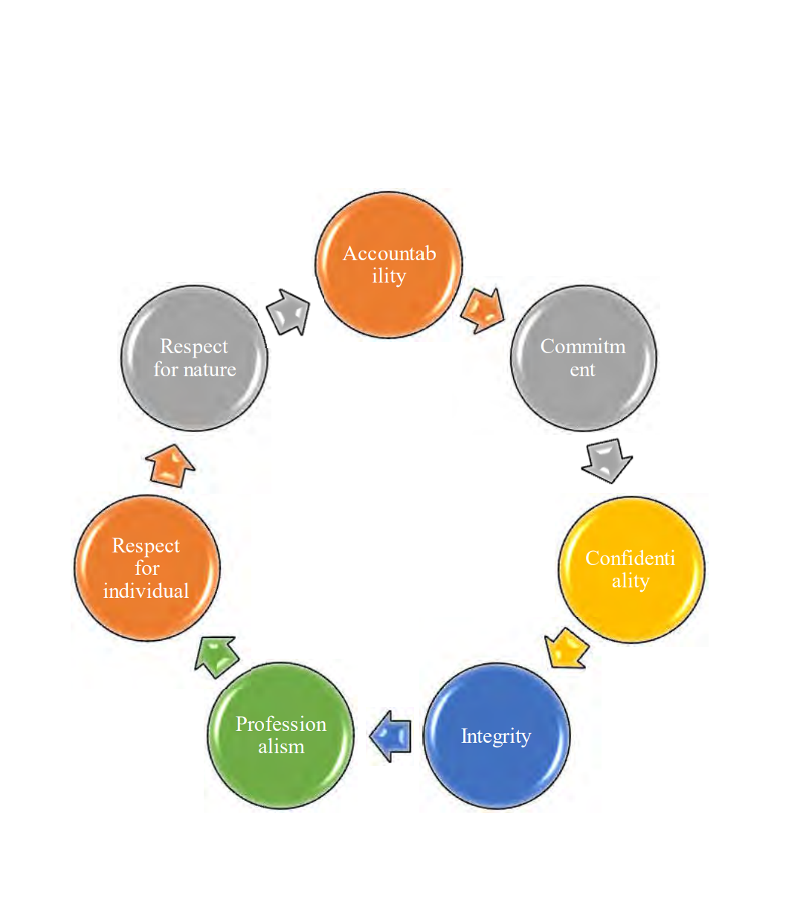

Objectives
The major goal of BKB is to provide credit facilities to farmers for the growth of agriculture, such as crop production, fish culture, animal husbandry, and so on, as well as entrepreneurs involved in the development of agro-based and cottage industries. They are always attempting to give assistance for the expansion and development of the country's agriculture industry. First and foremost, they encourage savings, mostly among the urban and rural middle and lower middle classes. Furthermore, these banks encourage investment in various agricultural, industrial, and commercial sectors. They either directly invest or provide loans to investors. They are constantly supporting underprivileged individuals in becoming self-sufficient by providing them with micro - credit.

Management of Bangladesh KRISHI Bank
The Board of Directors is the management at the highest level and consists of teams formed in 1972 by the Bangladesh Bank's Nationalization Order. The Bank is governed by an 11-member Board of Directors. The Chairman is in charge of the Board. The Chairman of the Board is usually an experienced professional/ex-professional with a high level of acceptance and rapport. The Directors are selected by the government and represent both the public and private sectors. The Chief Executive Officer of the Bank is the Managing Director. He is a government-appointed official. The Bank has two Deputy Managing Directors, each of whom is chosen by the government. The bank has 14 General Manager Positions. The government appoints them as well.
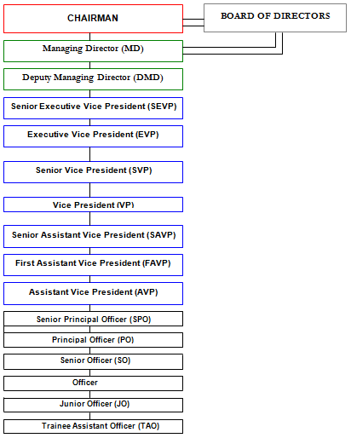
Figure: Organogram of Bangladesh KRISHI Bank

Structure of ICT Department

ATM Data Center
CBS
Core Banking Solution

Hard Ware
NOC
Network Operation Centre

HRD of BKB

Administration of ICT

Assistant General Manager (AGM)

Deputy General Manager (DGM)

Figure: Hierarchy System of ICT department of Bangladesh KRISHI Bank

CHAPTER 04
ANALYSIS AND FINDINGS

Data Analysis and Presentation Plan
On this chapter, for analyzing the topic, I have prepared an open ended questionnaire for conducting interview with my HR manager, Assistant manager of ICT department and other colleagues of ICT department of Bangladesh KRISHI Bank (Principle Branch).
I have not included any numerical figures in my internship report since the following report is a descriptive kind report. The report focuses on a practical case. I mainly used verbal analysis with some diagrams and modules to describe HR Forecasting Process for ICT department, Recruitment and Selection Process of Bangladesh KRISHI Bank. And on the basis of analysis of the topic, I have also included major findings part. These analysis and findings part have been divided into 3 parts which are:
- Part A: HR Forecasting Process for ICT department,
- Part B: Recruitment and Selection Process of Bangladesh KRISHI Bank.
- Part C: Findings.

PART A
HR Forecasting

HR Forecasting Process of BKB
HR forecasts continue at the centre of the HR planning process and could be identified by assessing demand and supply of human resources now and for the future as determination of the total requirement for personnel. I would like the Bangladesh KRISHI Bank’s HR forecast to assist me know about their bank's demand and supply, and how they estimate for their future recruitments. We can find a comprehensive sense of how many personnel they need across the year from this forecasting of Human Resources on their ICT department. It really provides us a good understanding of a bank's requirement. As we operate in a government bank, one of our country's renowned banks, we made this human resource forecast to organize human resources. This is also the case. The human resources department has conducted this HR forecasting process. Professional human resources have Bangladesh KRISHI Bank under the authority of Bangladesh Bank for all this tasks.

Categories of HR Forecasting Activities
- Transaction-based forecasting
It forecasts that the internal change introduced by the performance of the organization will be monitored. As I am working on Bangladesh KRISHI Bank, transaction-based forecasts are generally maintained in this bank for ICT department. ICT Administration and the HRD of Bangladesh KRISHI Bank replace their employees internally on their different branches. They transform their employees from the branch to the branch. This internal transaction is conducted out by the advantage of the bank. Sometimes the best employee is transferred to the head office of Bangladesh KRISHI Bank.
- Event-based forecasting
The forecast relates to external environment changes. Bangladesh KRISHI Bank always has a connection to outside forces. All this relates to the bank, as the economic, labor market, geography, business sector, and commercial sector. This is why some event-based forecasting was made by the Bangladesh KRISHI Bank. Sometimes this transfer is also requested by personnel. Like, if our country's political situation gets worse, then the city of Bangladesh feels that its personnel in Dhaka are transferring to the safer area. If banks' business conditions improve, management would like additional employees to be transferred to the branches of commercial banks. I visited various branches of Bangladesh KRISHI Bank. I have found that the number of employees in trade sectors is more numerous than other industries. As Motijheel's workforce, it is greater than the other branches of Bangladesh KRISHI Bank. They do so with the forecast of the event for their ICT department.
- Process-based forecasting
Forecasting that is not centered on a particular internal organizational event, but rather on the flow or sequencing of numerous work activities. Normally, the Bangladesh KRISHI Bank does not use process-based forecasting for their ICT department. These personnel are generally cast on the basis of processes.

Figure: Following categories of HR Forecasting Activities for ICT Department of BKB

Key Personnel Analyses Conducted by HR Forecasters
- Specialist/technical/professional personnel
A significant emphasis area of the forecasts is employees who have professional degrees which are highly sought after or require long training in order to get skills. They need to pay special attention to the salary comparison plan, in order to meet and manage industry standards in order to recruit and retain those who perform effectively. The ICT department of Bangladesh KRISHI Bank obtains the trainings and rewards that motivate it to make additional tasks to fulfill bank requirements from the ICT department of senior management such as Deputy General Manager (DGM), Assistant General Manager (AGM), Deputy Director and Admin.
- Employment-equity-designated group members
Designated group members are groups of Aboriginal descents, ladies, persons with disabilities and members of visible minorities which receive special consideration in the case of the Bank employees. Designated groups in the Bangladesh KRISHI Bank of ICT department get particular attention for some time just as female employees do. They have the opportunity and get allowances, compensation and accommodation facilities at times. For example, during pregnancy of the female employees, the Bangladesh KRISHI Bank provides a "Maternity Leave" to its female employees for 6 months at the time of pregnancy with the salary and the maternity benefits.
- Managerial and executive personnel
In order to succeed, every organization must ensure that its managers have the skills needed for success in its particular specialty. Managers (CEO, chairman, vice-chairs etc.) communicate on behalf of the organization with important environmental stakeholders and are accountable to define goals for the future direction of the organizations. Managers who function as the supervising layer of the executive authority at the operating level has the responsibility to teach, lead, train and develop employee behavior and to monitor the achievement of the executive group's objectives. I have seen that the senior management of the Bangladesh KRISHI Bank is properly qualified. They are highly trained to achieve the organization’s objective. The intermediate and senior managers are connected. They meet and set the organization’s objectives periodically. They hold a meeting for ICT department in every year. They posed the whole situation they were confronted with and decided on the next stage in their banking. I have seen in the Head office of Bangladesh KRISHI Bank that Deputy General Manager (DGM), AGM, Deputy Director of ICT, Admin of ICT and the Head of HRD of BKB is frequently monitoring the whole department and solving issues of ICT department’ employees. The every department of manager is also trying to tackle this branch's usual difficulties. In front of them the department managers strive to solve the problem and then pass it to the ICT Administration and Deputy Director of ICT of Bangladesh KRISHI Bank.
- Recruits
Training for the recruitment staff must always be provided by the bank. This instruction enhances their efficiency. The Bangladesh KRISHI Bank trains its recruitment staff. So train their staff to make the site more active and do their bank best. The Bangladesh KRISHI Bank has specific training for its staff. This training helps them achieve the highest level in the bank.

HR Forecasting by Time Horizon
The HRD and the Administration of ICT department of Bangladesh KRISHI Bank estimated the number of employees needed based on the time horizon. This relates to forecasting. That means they use prediction in their forecasting process as well. They also make some assumptions in order to forecast. As a result, they have completed their forecasting.
- Current forecasting
It is to fulfill an organization's immediate requirement. This forecast is distributed over a maximum period of one year. Current forecasts clearly exist at the Bangladesh KRISHI Bank. This current HR forecasting is mostly for specific recruitment purposes. Sometimes they recruit an expert at the Bangladesh KRISHI Bank for a certain time just like for 1 year. The highest level managers of the BKB are selected according to the present prediction. DGM, AGM, Deputy Director and Admin of ICT department are the example of it.

Figure: Time Horizon Forecasting For ICT Department of Bangladesh KRISHI Bank
- Short Run Forecasting
This forecast is for a period of between one and two years. Every year, Bangladesh KRISHI Bank hires a probationary officer for their ICT department on their different wings like NOC, Hard ware, CBS and ATM Services. These officers are placed on probation for a period of time. After completion of the probation period, they are considered regular employees of the ICT department of Bangladesh KRISHI Bank. However, the time they work as probationers is a type of short-term forecasting.
- Medium Run Forecasting
It takes between three and five years. In Bangladesh KRISHI Bank, officers and senior officers have been trained in medium-term forecasting. They have an agreement with their officer that after the probationary period they have to service for this bank till five years. All their division officers of ICT department, employees are taken on this medium run forecasting.
- Long Run Forecasting
Long-term forecasting includes more than five years. All mid-level officers of ICT department at Bangladesh KRISHI Bank are hired for the long term. The managers of ICT department are responsible for achieving the bank's objectives. If they try to switch numerous times, the bank will fail to meet its target. That is why they hire all of their managers and mid-level managers for the long term.

Forecasting in Demand
A key element of Human Resource Planning is forecasting the number and sort of people required to meet objectives of the organization. Because we live in an open system, a number of organizational elements such as competitive strategy, technology, structure, and productivity can impact labor demand. Bangladesh KRISHI Bank recognizes their need for personnel based on various assumptions and often statistically. They basically forecasting their requirements of Human Resources based on:
- Morality
- Retirement
- Transfer
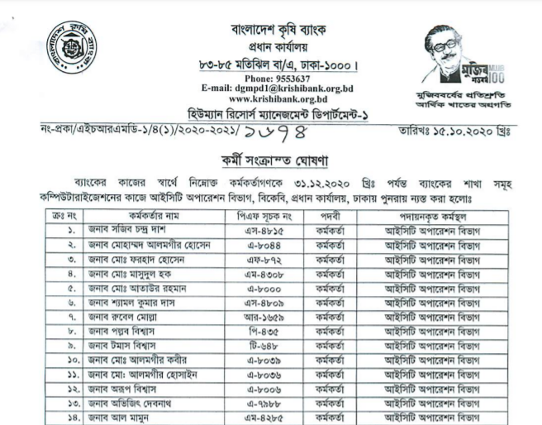
From the Human Resource Department 01 of BKB, above the employees are transferred on various branches of BKB on the ICT department for the purpose of working of banking activities.
Employees will sometimes transfer from one branch to another for the purpose of banking services. As a result, in this circumstance, the national bank makes an employee demand. For this reason, HR demand is important for BKB's ICT department in this regard. Every year, they hire more than 50 people for the ICT department. According to the recent information from HRD of BKB, during this COVID 19 from 2020 to 2021, for the ICT department the ratio of forecasting HR demand is:

Post and Designation of ICT Department | Demanded Position
Top Level Employees | 5%
Middle Level Employees | 25%
Officers | 30%
General Categories of Employees | 40%

Forecasting in Supply
The ICT department of Bangladesh KRISHI Bank their work with HR supplies in order to meet their complete demand for employees in their bank. They employ various methods to increase the efficiency of HR supply. Once a company has predicted its future personnel needs, the next stage is to determine where those needs may be fulfilled. As a result, it must assess if there are sufficient numbers and types of personnel, as well as how many are qualified for the possible roles. Thus, supply analysis entails procurement planning: who, where, how and when to hire. There are both internal and external sources of supply.

Internal Supply
During this pandemic situation, Bangladesh KRISHI Bank first seeks to fill all open positions with internal personnel. This is done through promotion or based on their performance.
- Staffing tables/manning charts
Staffing tables are created by Bangladesh KRISHI Bank for their ICT department. This gives them a good idea of who they have operating for the bank.
- Skill inventories
This section includes information on each employee's education, previous job experience, computer skills, IT knowledge and so forth for the ICT department. Bangladesh KRISHI Bank conducts an annual poll of its employees to assess their educational attainment. They gained an understanding of their employees' abilities as a result of this of the employees of ICT department.

- Replacement chart
For the ICT department, Bangladesh KRISHI Bank does not use this internal supply method.

External Supply
After fulfilling their internal need for the ICT department, the BKB considers external supplies. This external supply is more complicated than the internal source. The BKB seeks to fulfill their requirements through internal supply for the ICT department. When their bank needs additional and skilled human resources for the ICT department, they use their external supply. During this pandemic situation and for opening new branches, BKB goes to external supply sources for fulfilling their HR demands of the ICT department.

Using the Supply of Inside and Outside Candidates
- Requirement for ICT Department
HR DEMAND = EXTARNAL SUPPLY + INTERNAL SUPPLY
- Percentage of Supply
For the ICT department, the bank first attempts to hire by using internal sources from various branches of BKB. But during this pandemic situation they received only 20% of their employees from internal supply. During this pandemic situation for the number of available post of ICT department, they need a number of human resources from internal sources.
- Programs of Human Resources
Bangladesh KRISHI Bank never has a shortage of human resources. They always have a surplus of HR personnel in their bank. They constantly have a surplus of candidates for their open positions.
But during this COVID 19 pandemic situation and lockdown (2020-2021), due the postpone job circular and recruitment process; on the ICT department they have more shortage of the manpower.
HR DEFICIT= HR DEMAND > HR INTERNAL SUPPLY
And for minimizing this HR deficit for the ICT department, from 2021, they are using Hiring Freeze technique.

- Hiring Freeze Technique for Reducing HR Deficit
All newly hired workers at a Bangladesh KRISHI Bank are subjected to a prohibition period. They do this to increase the efficiency of their employees and to provide them with adequate training. During this time, they also observed employee attitudes toward the bank and devotion to the job. Actually, this time has been set aside to analyze them.

PART B
Recruitment and Selection Process of BKB

Approach of Recruitment Process
To forecast future manpower demand, the Human Resource Department of Bangladesh KRISHI Bank typically allocates a general form to all other divisions including and branches ICT department at the start of the year. Based on the information obtained from these forms, BKB's HRD forecasts the year's human resource requirements. Long-term human resource forecasting is not done at BKB. This estimation chart indicates that the number of bank branches and manpower in various years.
The recruiting goals of BKB are to attract and keep competent personnel who would succeed in their professions. The bank would not only look for competent individuals, but also for those who are willing to work for the bank for a fair period of time.
- Types of Recruitment in BKB
Bangladesh KRISHI Bank practices two methods of recruitment for their all divisions including ICT department.

Figure: Types of Recruitment in BKB
- Yearly recruitment is conducted in accordance with the HR plan each year.
- Recruitment based on need, this is done when an opportunity occurs spontaneously.

- Sources and Methods of Recruitment
The HR Division will be in responsible of recruiting, and the overall plan will be based on the Yearly Strategic Framework of manpower. Short-listing the candidates could perhaps, however, be the responsibility and mandate of the different business division requiring the profiles. For entry-level positions, skill-based recruitment will be used. As a result, the campus recruitment strategy must correlate with the placement season at the various universities targeted for recruitment. The HRD of Bangladesh KRISHI Bank needs to identify a set of campuses based on the courses offered there, any previous experience candidates from these campuses have had, and the bank's current needs of the ICT department.
External Sources
- Various universities and campuses
- Competitors and other organizations
- Unsolicited applicants
The HR Division of Bangladesh KRISHI Bank will have to make a decision for ICt department about external recruitment sources based on factors such as –
- Available spread of candidates
- The financial impact
- Requirement of Times
And the External methods of recruitment for ICT department are:

Figure: External methods of recruitment for ICT department in BKB
- Requirements of ICT Candidates
Bangladesh KRISHI Bank requires a certain degree of candidates for the ICT department, which must be specified in the system. Candidates' backgrounds might range from recent graduates to seasoned professionals from Science Background. Bangladesh KRISHI Bank establishes a competency level for entry-level employees based on which they can select applicants.
- For Entry Level Position of ICT Department: Bangladesh KRISHI Bank prefer applicants for the post of with minimum four years Undergraduate degree of CSE, EEE, Electric and Communication from any public university or Private University candidates are given a lot of significance at BKB for ICT department. Candidates for the SSC and HSC must have a first-class division, with no third-class divisions permitted. And Age not over 30 years.

Selection Process of BKB
As a staff function, the HRD of Bangladesh KRISHI Bank will handle and manage all issues involving to recruitment and selection process for the ICT department. In the case of selection via press advertisement, the following steps may be taken to systematize the selection procedure by the HRD of BKB:
- Receipt of Applications
This is the first step in becoming a participant of BKB. Candidates send their CVs either in response to a specific job posting or in response to any suitable position. Job applications are collected by the HR department for each job vacancy for the ICT department. Applicants are given at least three weeks to respond to newspaper advertisements. Every job vacancy is closed for applications after a certain amount of time has passed. Applicants are now required to complete online application forms.
- Sorting out of Applications
The next step is to prepare shorting list the CVs, which is usually handled by the HR department and the administration of ICT department of BKB. However, the HR division may transfer this procedure to the appropriate divisions to save time (for which the selection is being conducted). In order to employ experienced bankers, CVs might be filtered from a pile of unsolicited CVs. One alternative is to look for qualified and experienced bankers in other organizations. Potential applicants are contacted and invited to an interview after they have been identified.
The following are the steps of the selection process in detail:
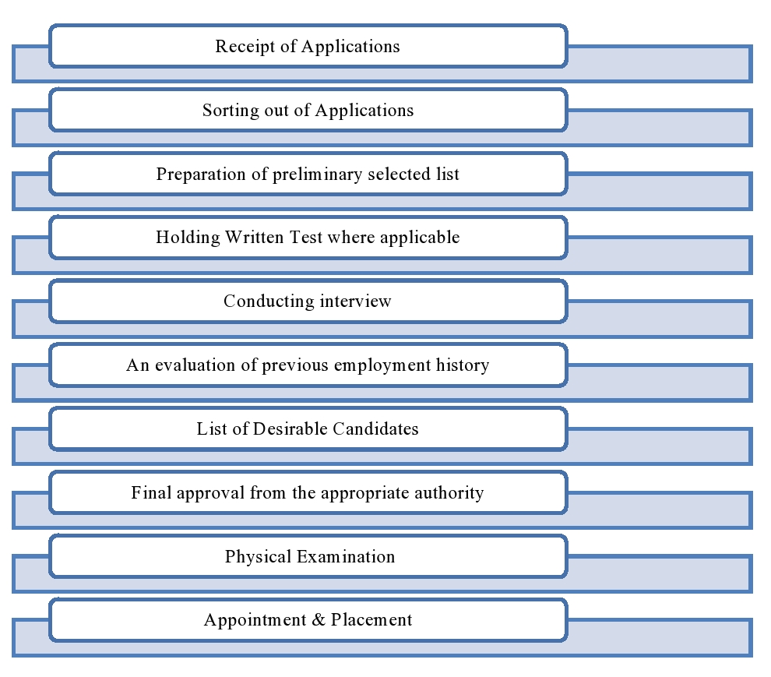
Figure: Selection Process of Bangladesh KRISHI Bank for ICT and both of all division
- Informing Candidates
For entry level positions after the applications have been sorted through and a preliminary list has been created, candidates are contacted and invited to a written exam or an interview for experienced bankers for mid level or senior level posts. For written exams, the bank sends out admit cards via online before the exam.
- Written Tests
Typically, the employment exam is a competency test that evaluates a candidate's language, mathematics, and intellectual adaptability, among some other things. The HRD of BKB contact details with IBA/BIBM to design and conduct the bank's recruitment tests. To construct the test question paper, the HRD of BKB provides them with the preferred academic qualification as well as the names of the vacant positions.
Content for the written test (100 marks) should be as follows:
- Capability to write in both English and Bangla
- Arithmetic in general
- Test of General Knowledge and Intelligence
- Bank management may organize the test, or it may be outsourced (IBA/BIBM/Others).
- For officer and staff posts, 40 percent and 50 percent marks will qualify a candidate to appear in an interview/viva, respectively.
- Interview
The interviews are done in a panel setting and the interview panel consists of the DGMs, AGM and the Head of HR. Those top levels like AGM, ICT Consultants and executive level managers are present even in the selection of fresh graduates for the Probationary Officer post of ICT department. The interview panel also includes people who are not affiliated with the Bangladesh Bank or the Finance Ministry. In most cases, only one interview is held to select a candidate for a position. In most situations, a candidate for a post is chosen after only one interview. When it comes to recruiting experienced bankers, though, many interviews may be necessary.
- Final Approval by Competent Authority
The management committee determines who will be selected after interviewing and evaluating the interviewees. Each new hire receives a 'Offer Letter' once the final decision has been made. When a candidate accepts an offer, they are issued a "Appointment Letter."
- Physical Examination
After receiving their appointment letters, candidates have one month to join. Physical examinations must first be completed by the candidates. If the results of these physical tests are satisfactory, the candidate is entitled to join the bank.
- Joining and Placement
To be considered for existing members, the candidate must present the results of the medical tests, as well as any other needed papers and academic credentials, after the physical examination. After completing the formal joining and placement process, the candidates are now employees of Bangladesh KRISHI Bank.

Characteristics to look on during the recruitment stages
The following characteristics must be looked for at various stages of the recruitment process for ICT department includes all the wings or divisions:
- Network Operation Center (NOC)
- Hardware
- Computer Business System (CBS)
- ATM or Data Center
Data collection techniques | Look for the following characteristics
Screening preliminary | Age, academic qualifications, and previous performance are all factors to consider.
Problem Solving Test | Transformation on Technical systems by Banking knowledge
In-depth interview | Knowledge about various operating system like UNIX, Windows, Linux, Network System, Hardware, Web and app application, CBS, System Design and Web Development etc.
Obtaining biographical information from sources | No negative reports on past performance those are unfavorable.
Personal judgment | Overall ability and competence to adapt into the job position and the institution
- Appointment
Classification of the post
Employees of the bank will be classified as shown in the illustration above. Any change or addition to the classification and designation must be approved by the board first. A bank employee, other than an officer appointed to a specific category of position, must remain in that category. Provided, however, that he meets any conditions imposed in this regard, the competent authority may appoint him to a different category of post.
Nationality
No person shall be appointed to any position in the bank's service unless he is a Bangladeshi citizen. Provided, however, that in exceptional circumstances, the board may waive this condition if the condition relating to foreign national employment in Bangladesh is met.
Age
At the time of direct recruitment as a Probationary Officer, a candidate must be between the ages of twenty and thirty (except for cottas applicants) and not less than eighteen years old and be at least thirty years old at the time of direct recruitment as a probationary employee other than an officer in the Bank's service. Provide that in exceptional circumstances, the board may relax the upper age limit for reasons that must be documented in writing.
Physical Fitness
No person shall be appointed to the bank's service unless the bank's Medical Officer or another medical authority designated by the bank has declared him physically fit.

Part C
Findings

HR Forecasting
- The human resources department Bangladesh KRISHI Bank conducted this HR forecasting process.
- Bangladesh KRISHI Bank involves in Transaction Based HR Forecasting and Event Based HR Forecasting activities for the ICT department but BKB generally goes to Process Based Forecasting activities.
- Bangladesh KRISHI Bank never has a shortage of human resources. They always have a surplus of HR personnel in their bank. But during the impact of COVID 19, on the ICT department they have more shortage of the manpower. And for minimizing this HR deficit for the ICT department, from 2021, they are using Hiring Freeze technique for external sources.

The Strengths of Recruitment and Selection Process of BKB
- BKB's management is concerned with the quality of its services as well as the quality of its human resources.
- HR department and ICT administration department are playing in the decision making of HR planning programs for the ICT department of BKB.
- The recruitment and selection process is completely fair and legal. Everyone in the Human Resources Division is honest and impartial, which fosters an environment of accountability.
- Internal growth fosters a connection between employees and the organization. Furthermore, internal growth has improved the HR Division's recruitment and selection efficiency because it now has a better understanding of the applicants' knowledge, skills, abilities, and other qualifications.
- BKB's recruitment and selection process focuses more on who fits the institution than who fits the job. As a result, it has developed a distinct organizational culture, and the entire HR Division ensures a friendly and caring working environment.

The Weakness of Recruitment and Selection Process of BKB
- The procedure of recruitment and selection is not computerized in Bangladesh KRISHI Bank. In the case of predict and analyze recruitment and selection requirements, Statistical analysis such as regression analysis and correlation analysis are not applied to more precisely.
- In recruitment and selection, quantitative methods are not used to determine utility. And there is no feedback system in place to determine the system's efficiency and correct its flaws.
- There is no research to back up the effectiveness of the recruitment tests.
- BKB does not always properly check references, which could cause a serious problem for the organization.
- During the pandemic situation, in the case of selection process of candidates, other banks are following virtual interview and online exams but Bangladesh KRISHI Bank, they does not follow this virtual procedures in their selection process.

CHAPTER 05
RECOMMENDATION AND CONCLUSION

Recommendation
I worked in the ICT department at BKB and noticed that, despite being one of the most well-known banks in our country, its HR division is not very active for the ICT department. I looked on the internet and found that other banks around the world are more active than our Bangladeshi banks. So our banking sector is going through something similar. Several suggestions for improving the existing HR Forecasting, recruitment and selection policy and procedure are listed below:

Bangladesh KRISHI Bank does not make extensive use of technological tools for manpower and HR forecasting. They ended up going about their business as usual when it came to recruiting. They could be more efficient in their banking and hiring if they used those tools. This will strengthen their HRD. I think so; they require a strong HR division to improve the effectiveness of their forecasting. As a result of manpower and forecasting, they will get a good idea of how many people BKB will require throughout the year. As a result, it is essential for them to have a strong and more technically based HR division for manpower planning and forecasting demand supply.
- The procedure of recruitment and selection is not computerized in BKB. To make this process easier, banks should utilize human resources management software to simplify this recruitment and selection process.
- BKB needs to be transparent about its efforts to recruit from outside sources, such as a job fair, BD jobs, Online Advertisement. In addition, they should evaluate the virtual recruitment procedure during this pandemic situation.

Conclusion
It was a perfect experience on the HR activities of Bangladesh KRISHI Bank. Employees and trainees / trainers who made the place have learned to learn and learn as employees. This experience improved my confidence in the HR area, and I have tried to address. In terms of my career development, it has given me more confidence, fostered a strong positive attitude, and taught me how to work as a team player in a group setting. The primary goal of an internship is for students to apply their theoretical knowledge in the form of real-life work experience collection and practices. I am grateful to the entire HR team of BKB for their exceptional assistance in making my work experience truly rewarding. I've learned a lot about my skills and human resources level, especially in this section. After this internship ended, I learned the significance of the HR Manager, Training Executive, HR Senior Supervisor, and HR Senior Assistant roles in human resources.
Bangladesh KRISHI Bank should establish a Human Resources department to manage the organization's workforce and to keep track of the employees' working hours. Although Bangladesh KRISHI Bank is doing well in their field of expertise, they still need to focus on their workforce and follow the recommendations, which they should do as they grow in the future. From the foregoing discussion, it is possible to conclude that because human resource planning and staffing strategy is a constantly practiced issue, it plays a significant role in an organization's overall performance. If an organization wants to reap the full benefits of human resource management, it must adhere to all sections of HRM. I think that if the HRD of BKB should implement a new policy regarding HR Forecasting of manpower, recruitment, and selection based on job analysis, we hope that Bangladesh KRISHI Bank will be a market leader in the agricultural sector with skilled employees in order to meet the modern goal.

References

Dr. Janes O. Samwel, P. (2018). Human Resource Planning as an Important Practice to Anticipate Future Human Resource Requirements of the Organization – Literature review. International Journal of Research in Business Studies and Management, 24-30. Retrieved from https://www.businessmanagementideas.com/human-resource-planning/importance-of-human-resource-planning/19973
HR Supply Forecasting - succession analysis - Markov Analysis. (n.d.). Retrieved from Human Resource Management: https://www.whatishumanresource.com/hr-supply-forecasting
Monica Belcourt, K. J. (2017-2018). Strategic Human Resource Planning. 5e. Global Edition: Nelson Education Ltd.
Morrow, M. K. (2020, December 04). Demand Forecasting Techniques Used in Human Resource Planning. Retrieved from Altametrcis: https://altametrics.com/en/demand-forecasting/demand-forecasting-techniques-in-human-resource-planning.html
Recruitment Process. (n.d.). Retrieved from HR Help Board: https://www.hrhelpboard.com/recruitment/recruitment-process.htm
Sutanto, E. M. (2000). Forecasting:The Key to Successful Human Resource Management. Indonesia: Petra Christian University.
Techniques for Human Resource Forecasting. (n.d.). Retrieved from Toppr: https://www.toppr.com/guides/business-management-and-entrpreneurship/human-resource-management/human-resource-forecasting/
Upadhyay, I. (2020, November 09). Selection Process in Human Resource Management: 9 Easy Steps to follow. Retrieved from Jigsaw: https://www.jigsawacademy.com/blogs/hr-analytics/selection-process/
What Is HR Forecasting? (n.d.). Retrieved from ROVVA: https://www.rovva.com/en-gb/blog/growing/what-is-hr-forecasting

Appendix
Job Advertisement of Bangladesh KRISHI Bank for ICT Department
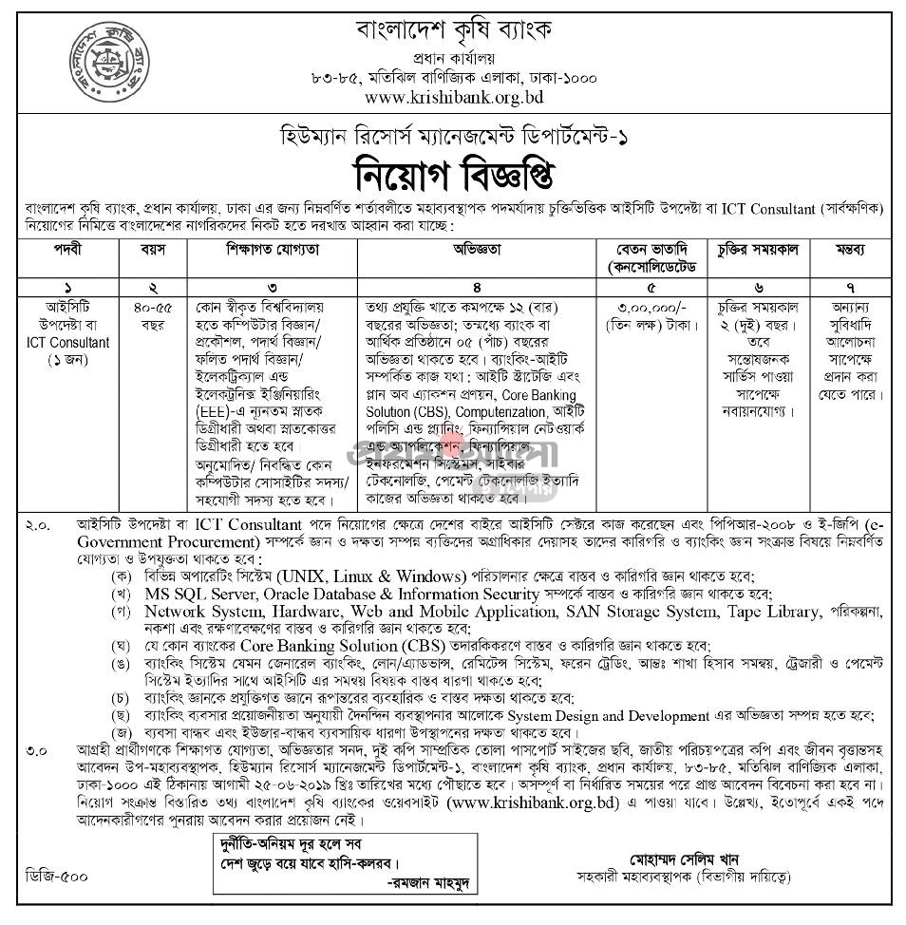

Appointment Letter for Internship Program on ICT Department of BKB
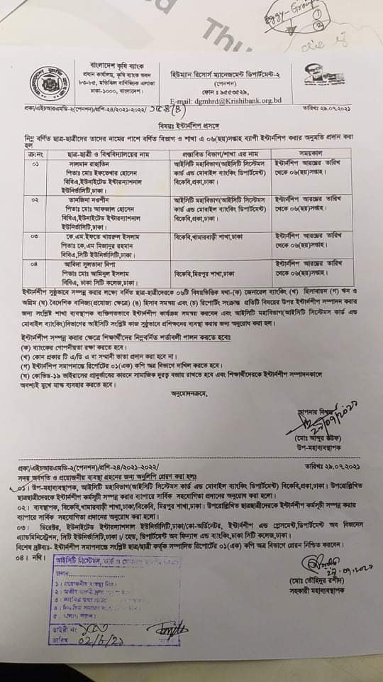

Interview Questionnaire
