Internship Report


Internship Report
On
Effects on Customer Relationship Management: A Digital Marketing Perspective on Asiatic Mindshare Ltd.

Submitted To:
S.M. Asif-Ur-Rahman
Assistant Professor
School of Business & Economics
United International University

Submitted By:
Mohd. Ashraful Alam
ID: 111-131-245

Date of Submission
16-04-2018
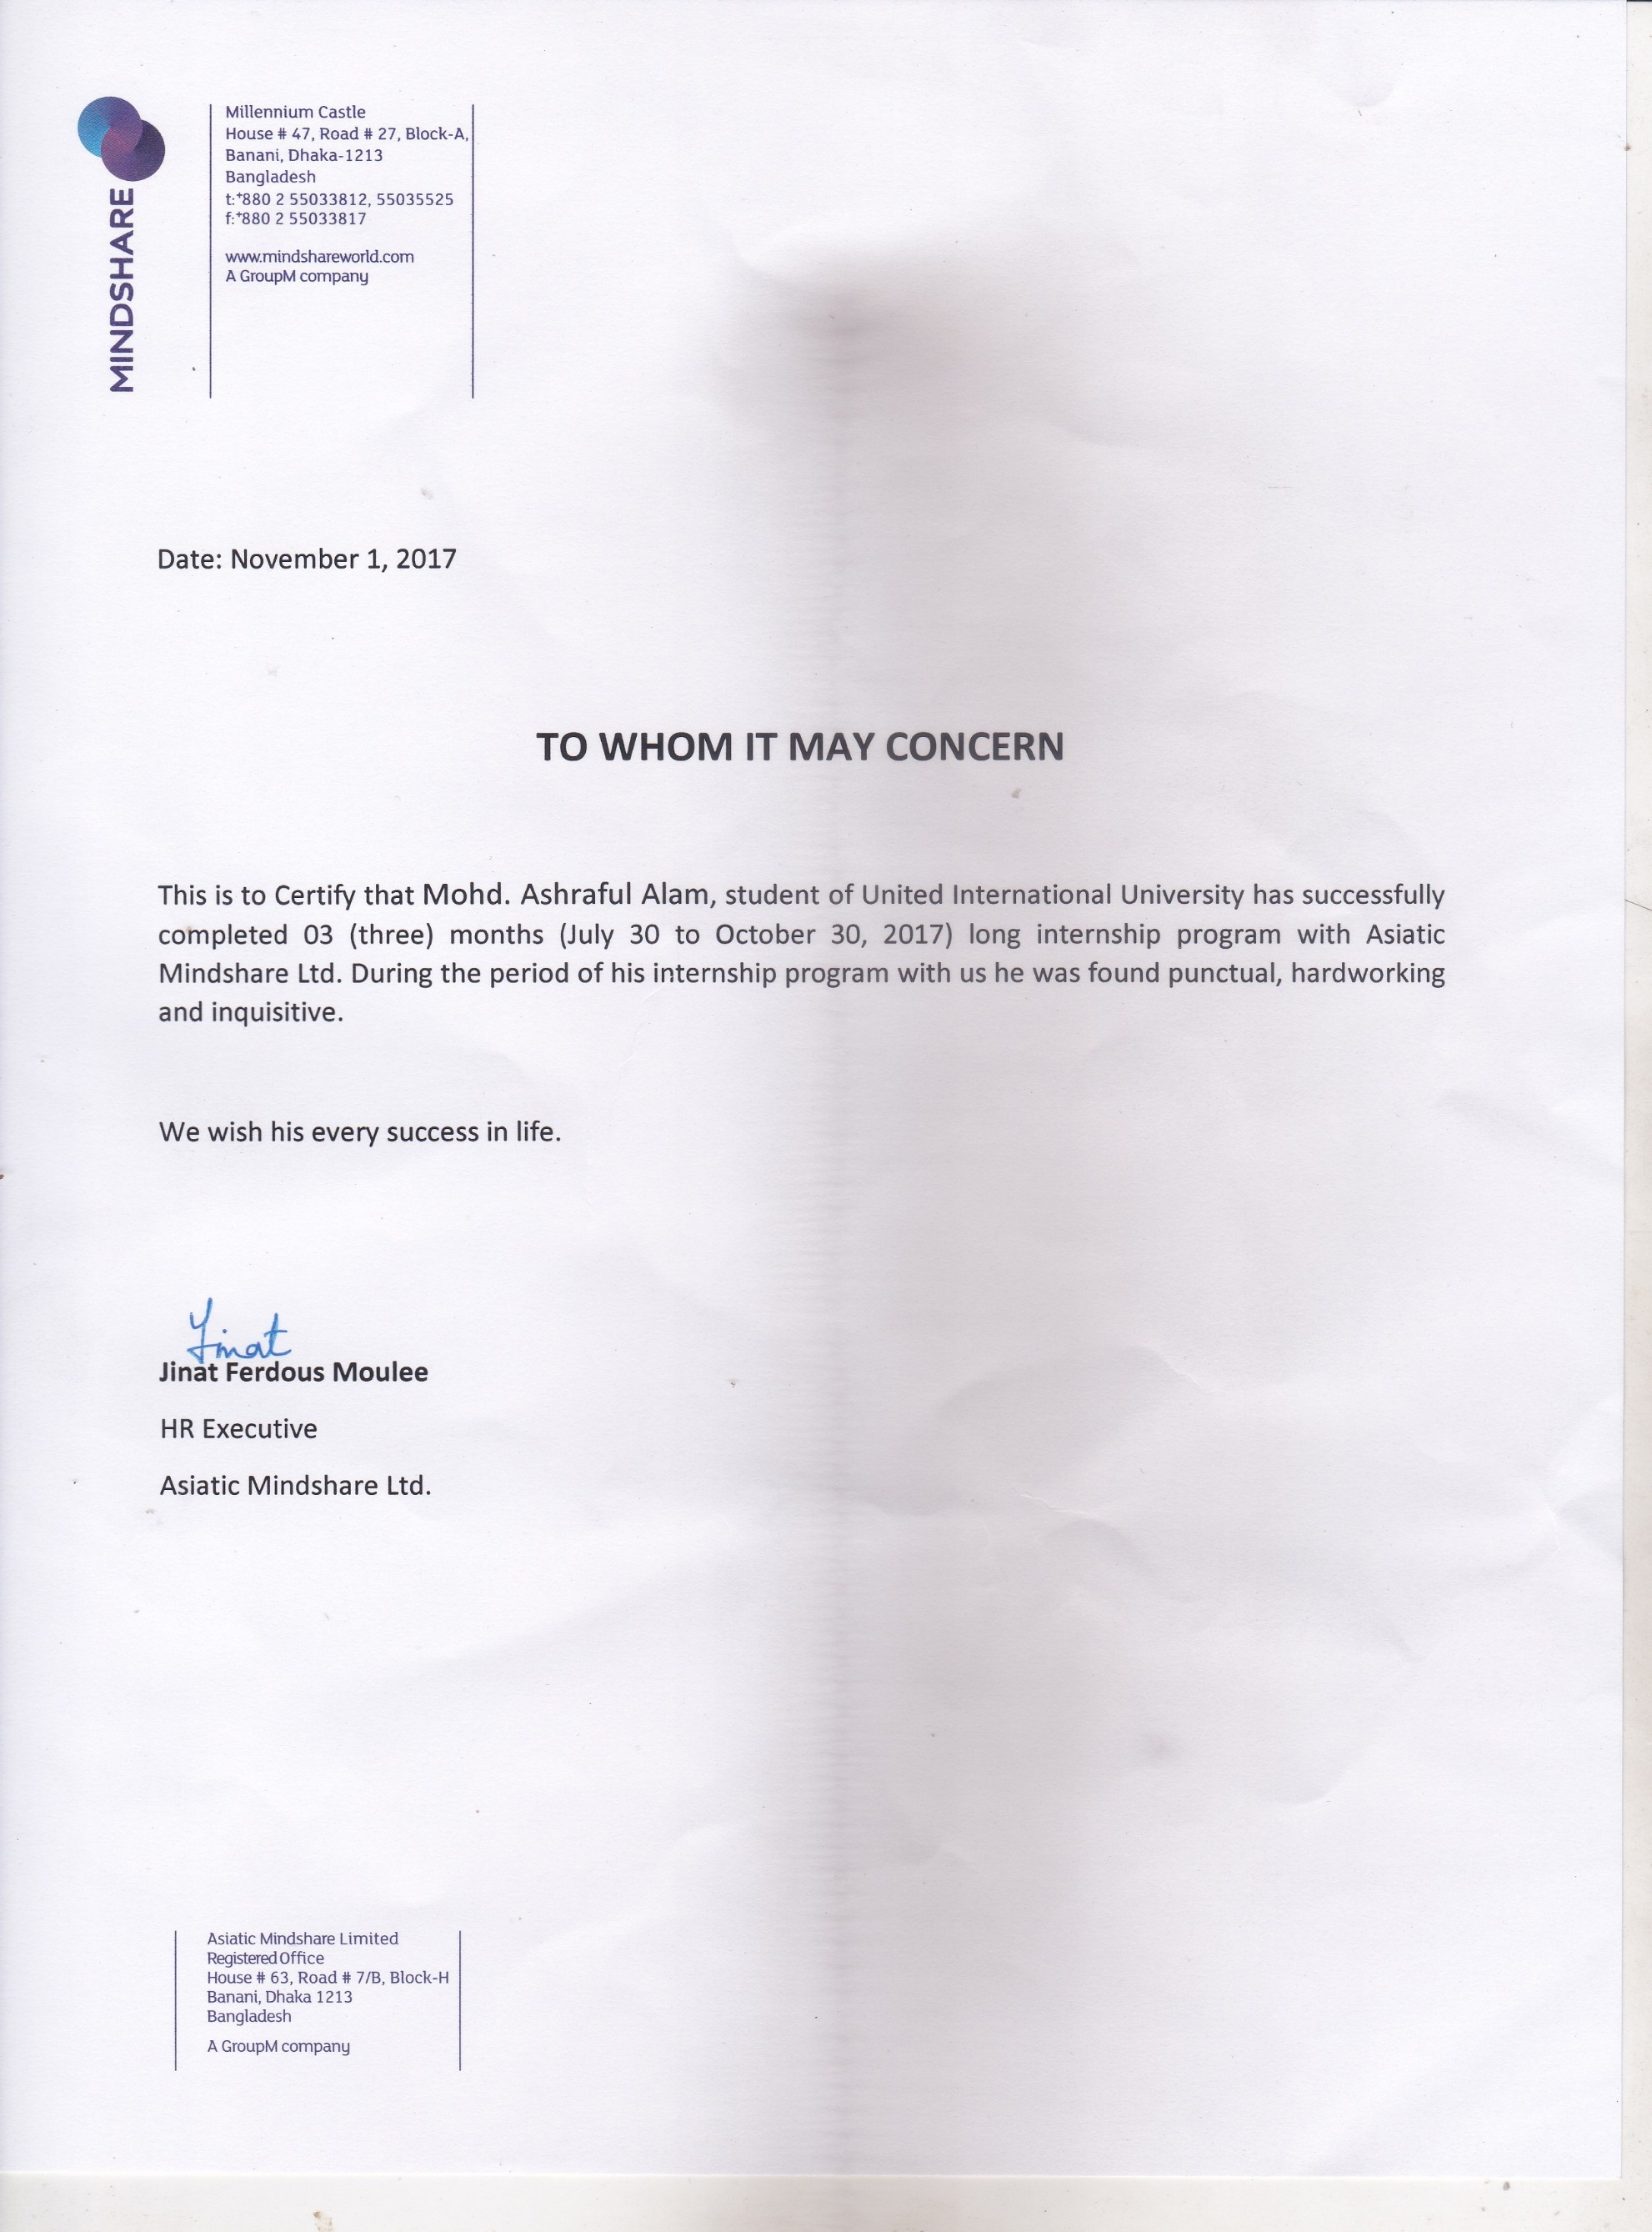
Letter of Transmittal
10th April, 2018
S.M. Asif-Ur-Rahman
Assistant Professor
School of Business & Economics
United International University

Subject: Submission of Internship Report

Dear Sir,
I have completed this report as part of my internship program. The report has been compiled as per your requirements. It gives me immense pleasure to tell you that working on this internship report has given me a wide range of experience. The report is based on the "Effects on Customer Relationship Management: A Digital Marketing Perspective on Asiatic Mindshare LTD" as well as the knowledge, experiences and the skills that I have acquired during my period of internship in that organization. I am submitting this report with the hope that it may fill up to your satisfaction.
However, I would be glad if you enlighten me with your thoughts and views regarding the report. In addition, if you wish to enquire about any of the aspects of the report, I would be glad to answer your queries.

Sincerely,

Mohd. Ashraful Alam
111-131-245
Contents
I. Introduction 1
A. Origin 1
B. Background 3
C. Literature Review: 7
D. Purpose Statement: 7
E. Scope and limitation: 8
F. Methodology: 8
1. Research type: 8
2. Data Type: 9
3. Sample size: 9
4. Sampling technique: 10
5. Data collection method: 10
6. Data Analysis: 10
7. Data presentation method: 10
II. Findings & Analysis 10
A. Question-wise analysis 10
III. Suggestion & Recommendation 21
IV. Conclusion 23
V. References & Bibliography A
VI. Questionnaire B
VII. Appendix C

Figure 1: Gender 12
Figure 2: Profession 13
Figure 3: Which social media you use most? 14
Figure 4: What's your main purpose of using social media? 15
Figure 5: Social media is trust worthy for buying or selling products or service 16
Figure 6: Digital marketing completely changed your shopping behavior 16
Figure 7: How often you purchase products or services from online? 17
Figure 8: How is your overall experience after purchasing product or services from social media? 18
Figure 9: When you have query regarding products or services from social media, how do you resolve it? 19
Figure 10: If you ask any query to the organization, how they responded? 20

Executive Summary

This internship report emphasizes the work activity I have gained as an Intern in the Digital Services department of Asiatic Mindshare Ltd. In this report, I have consolidated my experience at Asiatic Mindshare LTD especially in query management and campaign management work. I also have presented details about my 3 months’ work experience along with a comprehensive description where I had to work with different international and local brands and analysis the effects of customer relationship management through digital marketing tools. It reflects my works at Asiatic Mindshare. Since its beginning in 2001 in Bangladesh, Asiatic Mindshare LTD has always been serving quality service. It has become one of the renowned and biggest media buying agencies in the country within short time. In this report, I have included a list of their clients and brands they are managing. Later, I discussed few campaigns where I was part of the team and some creative done by Asiatic Mindshare’s creative department under my department’s supervision where I was also followed-up. Then, I discussed the project on "Effects on Customer Relationship Management: A Digital Marketing Perspective on Asiatic Mindshare LTD" where different new findings came out. The project’s objective is to understand how customer relationship management of different brands is affected by social media based on the digital marketing perspective. This report will serve interesting information for the marketers and people can know about the current experience of customers for online shopping. Asiatic Mindshare LTD has a great internship program. Agency employees have to work strong for uplifting a brand and its value. If agency- client gap can be reduced, it may ease the tasks for both the parties. Digital marketing communication is still a new aspect which is not practiced widely till the date. More investments and research in digital media are needed which may result in a better visibility of the brands and make the advertising and marketing atmosphere more useful which may attract people for purchasing.

Introduction

Origin

Organization overview: Asiatic Mindshare Ltd
Mindshare recites generally to the expansion of consumer awareness or popularity which is one of the main objectives of advertising and promotion. When one thinks of a product type or category, they generally think of a limited number of brand names. The objective of Mindshare is to build a brand as being one of the best kinds of a given product or service and to even have the brand name become a synonym for the product or service offered
Mindshare seeks out the opportunity in this change, bringing together a diversity of talent, colliding people with different skills and perspectives, with one ambition: To Invent the Future of Media for our Clients. In doing so mindshare helps them build future commercial and cultural success. (Mindshare, 2015)

Clients

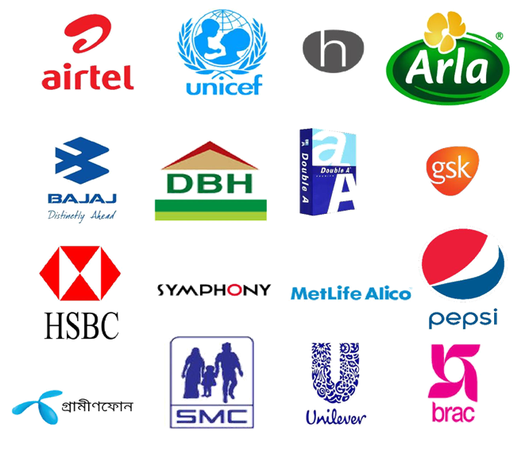

Literature Review:

For a variety of purposes, many companies use the concept of CRM, such as to gain customer and customer retention. Along with tangible benefits, CRM also provides intangible benefits, for example, customer loyalty, customer trust, and service quality. Another strategy is to build brand equity and good reputation. In this era of modern technology form of CRM is changed. As digital marketing emerged in the world, many things have changed. The way of thinking towards products and services by customers have changed greatly. The purchasing behavior along with expectation and demand is also shifting from reality to virtual.
It is still to find what and how a customer thinks of their relationship with the business itself. The impact of customer mind is very crucial to a business success. To retain a customer in a business, a solid and proper relationship has to be built. It should be interactive and efficient to both ends.
Organizations are maintaining customer relationship management for years. Though there is still the traditional form available in the market, more new CRM strategies are being taken to compete in the digital marketing era. It is stated by international best-selling author and digital expert Erik Qualman that 93% buying decisions are influenced by social media. This revolutionary change gave a new shape to traditional CRM and its components. (Qualman, 2016)
In our studies, it is to discover that how CRM is affected by a digital marketing perspective. The survey is mainly focused on social media used by people.

Purpose Statement:

The purpose of this study to find the effects on Customer Relationship Management from a digital marketing perspective.

Scope and limitation:

This study will help marketers to find how is the current experience of customers and their relationship with companies. It may also help to plan their strategy of CRM more accurately and efficient.
During the three months of the internship session, many limitations created obstacles. Some of the limitations in making the report are following-

1. While collecting primary data, it was really tough to get proper information from respondents as they were not feeling comfortable. It is hard to tell if the provided information is correct or not.
2. It is quite impossible to observe the whole company and its activities and obtain a fruitful output. It would huge amount of time which was not available for this study.
3. The internship proposal is implemented based on few secondary data which were inefficient and somewhat unreliable.
4. Due to confidentiality conditions within the company, it was not reasonable to gather more information that could present the report more informative from all aspects.

Methodology:

Research type:

The research is survey based. The study will be both mixtures of quantitative along with the qualitative part. A basic overview of the data collected and used to make this report are described below-

Data Type:

This report is based both on primary and secondary data.
Primary Data: The survey questionnaire contained a total of 10 question that encompassed the objective of the research.
Secondary Data:
- Asiatic Mindshare Ltd. Internal documents and publications.
- Newspaper, Journals, Articles, and Websites.

Sample size:

For this research project, I have selected a sample size of 107 from the population.

Sampling technique:

Non-probability technique was followed for selecting the sample of this survey study.

Data collection method:

Due to time constraint, I used "Google Forms" to collect and analyze the data on the social media. A weblink for the survey questionnaire was given to the respondents to fill up. The respondents were chosen randomly and they do not belong to same demographic group.

Data Analysis:

Data analysis is the system of efficiently applying sensible and measurable systems to portray, join and recap and assess learning. This is one of the vital elements of research. I adjudicated to collect both quantitative data and qualitative data. "Google Forms" has a powerful database system and tool that generates charts and automatically make the analysis from the input. It eased my effort for analyzing data. These were helpful in my research as it was a descriptive research. Besides, it also helped me for doing tasks like sorting, filtering, formulas for equations, percentage etc.

Data presentation method:

“Google Forms” helped for doing tasks like sorting, filtering, formulas for equations, percentage etc. The pie charts, bars etc. were presented with the help of “Google Forms.”

Findings & Analysis

Question-wise analysis

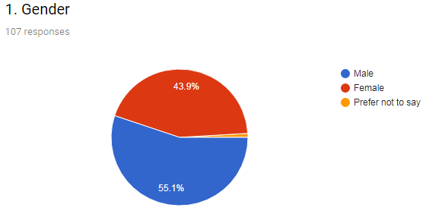
Figure 1: Gender

The first question of the survey was about their gender. From this question, it was discovered which part of the sample size in terms of gender is using social media the more. From the study, it was affirmed there was 43.9% (47) female and 55.1% (59) male respondents. This interprets that there are more male users than female in terms of social media. Though the differentiation is insignificant, this data will help organizations to determine their strategy more accurately. The pie chart in Figure 1 illustrates the first question responses.

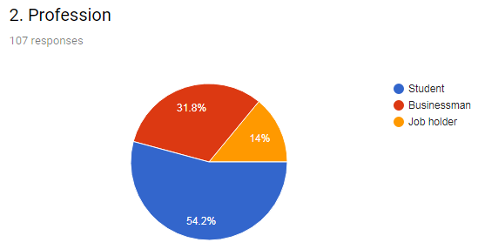
Figure 2: Profession

The second question asked to the respondents was about their profession. Among 107 people, the majority of them were students (58). There were also 34 businessmen and 15 job holders. This illustrates that the students spend time on social media in most of the cases. Though the young generation is the major audience of social media, people from different age groups are also joining different platforms. The pie chart in Figure 2 illustrates the second question responses.

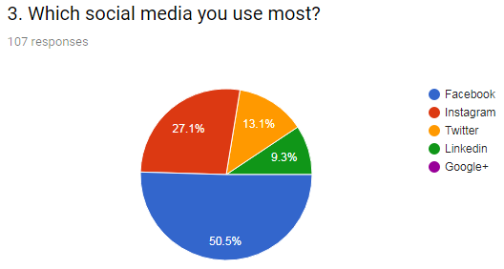
Figure 3: Which social media you use most?

The third question was about which social media platform was the most popular among the respondents. It was expected that Facebook would be the most used social media which covers 50.5% respondents. In our country, Instagram is the second most used social media covering 27.1%. Other platforms like Twitter, LinkedIn, Google+ covered very insignificant portion. These platforms are emerging along with other platforms like Pinterest, Tumblr, YouTube, Flickr etc. The pie chart in Figure 3 illustrates the third question responses.

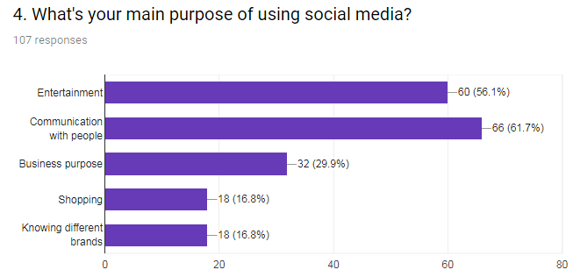
Figure 4: What's your main purpose of using social media?

The fourth question asked to the respondents was about their main reason behind using social media. There could be many reasons, but the most 5 popular reasons were given to choose from. Respondents were allowed to choose more than one option from this question. The most common two reasons found in the survey were Communication with people and Entertainment. These two are the reasons why social media were introduced at first. Interestingly, only 18 of them think they use social media for shopping purpose. More than 29% people use social media for their business purpose. The bar chart in Figure 4 gives an overview of the fourth question responses.

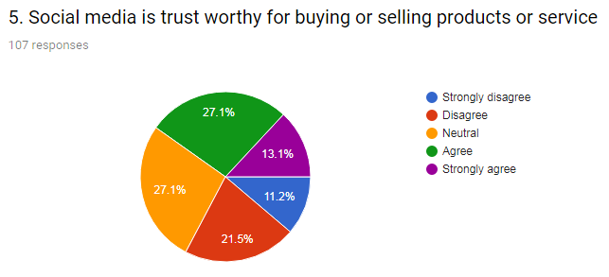
Figure 5: Social media is trust worthy for buying or selling products or service

The 5th question was about a statement that whether they believe social media is trust worthy for buying or selling products or service or not. 29 respondents were in neutral position for this position. According to this survey, there is a mixture of feeling of trust among the respondents. More people agreed to this statement than the people who did not agree with this statement. The pie chart in Figure 5 illustrates the fifth question responses.

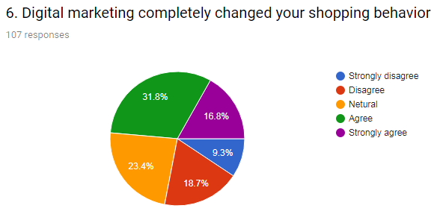
Figure 6: Digital marketing completely changed your shopping behavior

The sixth question asked to the respondents was also about a statement that whether they believe digital marketing completely changed their shopping behavior or not. 52 people agreed with this statement. On the other hand, 30 people don’t believe their shopping behavior is changed due to digital marketing. 25 people responded that they are in neutral position regarding this. The pie chart in Figure 6 illustrates the 6th question responses.

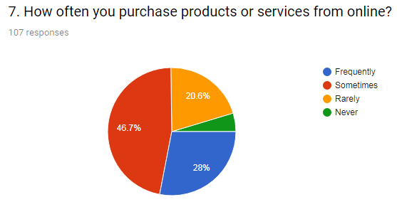
Figure 7: How often you purchase products or services from online?

The seventh question was about their purchasing frequency of product or service from different social media platforms. 30 people said they purchase frequently from social media. 50 of them said they purchase sometimes. Only 22 of them said they purchase rarely from social media platforms. The pie chart in Figure 7 illustrates the 7th question responses.

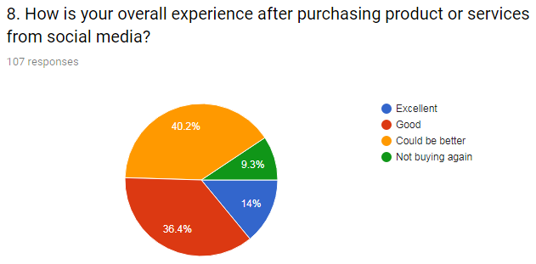
Figure 8: How is your overall experience after purchasing product or services from social media?

The eighth question is about respondents’ experience about their purchasing product or service from social media. Majority of the respondents (54) were satisfied with their experience. Other 43 people think there is room for improvement regarding this. 10 people had such a bad experience with the social media platform that they will not consider buying from online again. The pie chart in Figure 8 give a breakdown of the 8th question responses.

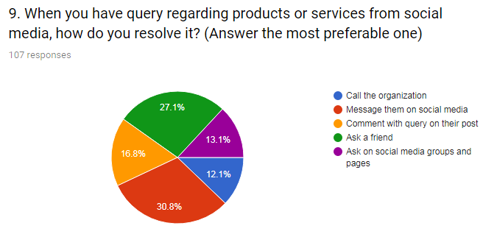
Figure 9: When you have query regarding products or services from social media, how do you resolve it?

The ninth question is about their query regarding product or service and how it was resolved it. They were asked to choose only one option which was most preferable to them. The most popular option to them is to send message to them privately. The 2nd most popular was asking a friend about the query and 29 people preferred it most. The least popular option was asking on social media groups and pages. The pie chart in Figure 9 give a breakdown of the 9th question responses.

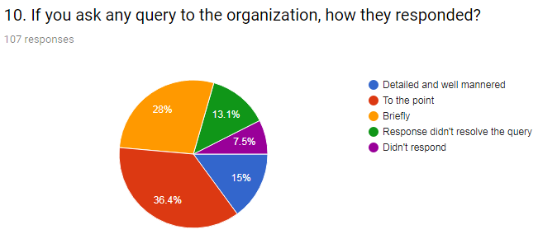
Figure 10: If you ask any query to the organization, how they responded?

The tenth question was about the response from organization about queries. Majority of them (85) think the response for resolving their issues were satisfactory. Other 22 people was not satisfied at all with the responses. Some of them even claimed there was no response.
The pie chart in Figure 10 give a breakdown of the 10th question responses.

Suggestion & Recommendation

According to the analysis and findings of the survey, there are few recommendations for the marketers which are advised to follow:

1. Marketers should make their strategy of advertisement on social media according to audience's gender.
2. People from different fields of professions have different types of needs. Their preference for purchasing from social media can differ according to their income level. Marketers should be aware of their target market on social media and their profession.
3. Though Facebook is the most popular social media till date, other social media are also playing a significant role in terms of targeting audiences. According to our survey, Instagram is the second most popular social media which should be also a matter concern for the marketers.
4. People use social media mainly for entertainment and communicating with others. Marketers should focus on this and make public relation more effective. Entertaining customers along with maintaining relationship with them can benefit a marketer by creating a prominent effect in their mind.
5. People are still having trust issues with online shopping which leads to questioning their quality and relationship with customers. There is a huge gap of expectations of customers and products and services. Marketers should work on appropriate communication and approach to the customers.
6. There are many people left in the society who are not active users of social media or at least they do not buy products and services from online. Maintaining relationship with this group is a challenge of a modern marketer and s/he should prioritize it.
7. Marketers should find out what are the experiences of customers from customers' perspective. They should try to locate what are their actual demands and where is the actual gap. They should work on their weaknesses and make them their strengths.
8. Responding to customers' query should be topmost priority of any organization. It creates a positive impact on customers mind. The medium of connecting customers and organization should be more user-friendly.
9. Though there are 83.14 million internet users in Bangladesh, most of them do not purchase from online. As this is very efficient in every manner and more people are starting to use social media for purchasing products or services, organizations should be aware of their customer relationship management. (Commission, 2018)

References & Bibliography

Kotler, P., & Armstrong, G. (1991). Principles of marketing. Englewood Cliffs, N.J.: Prentice Hall.
Kotler, P., & Keller, K. (2012). Marketing management. Boston [Mass.]: Pearson.
Miller, R., & Washington, K. (2014-2015). Consumer marketing.
Alam, M. A. (2018, April). Effects on Customer Relationship Management. Retrieved from Google Forms: https://goo.gl/forms/6oERoSoU7IgQigur1
Asiatic360. (2018). Mindshare. Retrieved from Asiatic360: http://www.asiatic360.net/mindshare/
Commission, B. T. (2018, February). Internet Subscribers of Bangladesh. Retrieved from BTRC: http://www.btrc.gov.bd/content/internet-subscribers-bangladesh-february-2018
Interactive, I. (2018). Social Media Query Management Dashboard . Retrieved from Smashboard Beta: https://smashboard.co/
Mindshare. (2015, February 05). MindshareWW. Retrieved from YouTube: https://www.youtube.com/watch?v=_ne5NBwP1jg
Qualman, E. (2016, November 14). Erik Qualman. Retrieved from YouTube: https://www.youtube.com/watch?v=odoYOuvwjDE
Symphony, M. (2017). Symphony Mobile. Retrieved from Facebook: https://www.facebook.com/symphonymobile/
Wikipedia. (2018). Mindshare (firm). Retrieved from Wikipedia: https://en.wikipedia.org/wiki/Mindshare_(firm)
WPP. (2018). Our Companies: Mindshare. Retrieved from WPP: http://www.wpp.com/wpp/companies/mindshare/

Questionnaire

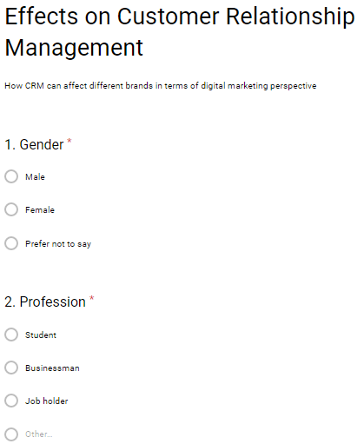
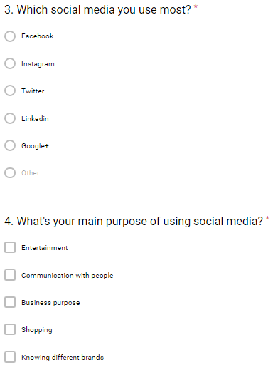
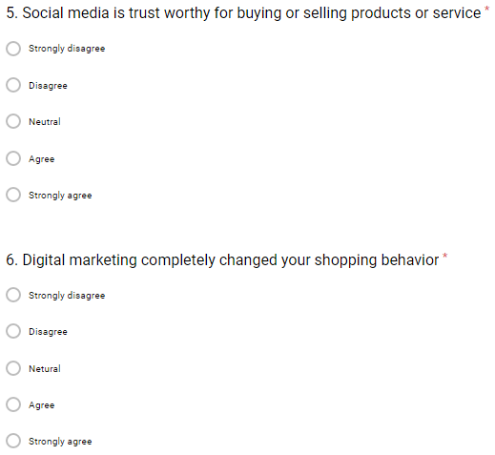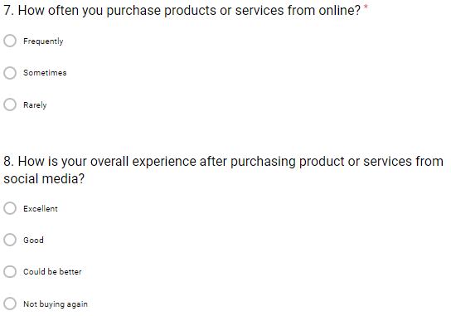
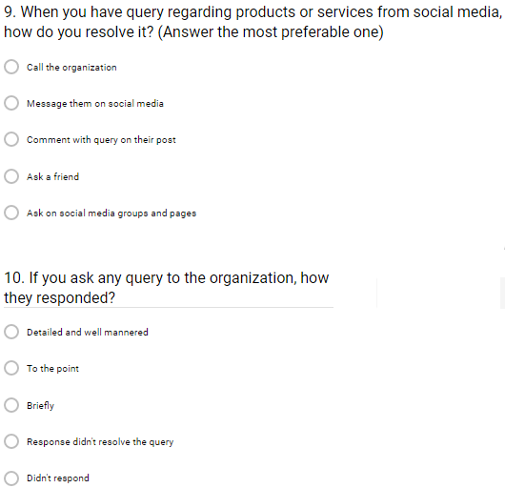
(Alam, 2018)

Appendix
Job Description

Task and responsibilities:
During these 3 months of my internship program, one of my main tasks was to prepare weekly reports on the social media (Facebook) activity of the brands- Symphony mobile and Helio. These reports included the overall performance of each of the brands based on Facebook pages. The report included total number of queries, resolved queries, customer reviews and feedbacks. I was also a part of team for different campaigns including-
Smartphone & Tab Expo: This offer was about flat 5% discount on every handset and tab purchased at the event which was located in BICC from 3-5 August, 2017. This campaign was applicable for both smartphone brand by Edisson Group. It was very successful. (Symphony, 2017).


Symphony Eid Offer: This offer included foreign tour, free handset and free recharge up to Tk. 1000 on daily basis. This offer was available till the day before Eid. It was applicable for both Symphony and Helio brands. (Symphony, 2017)

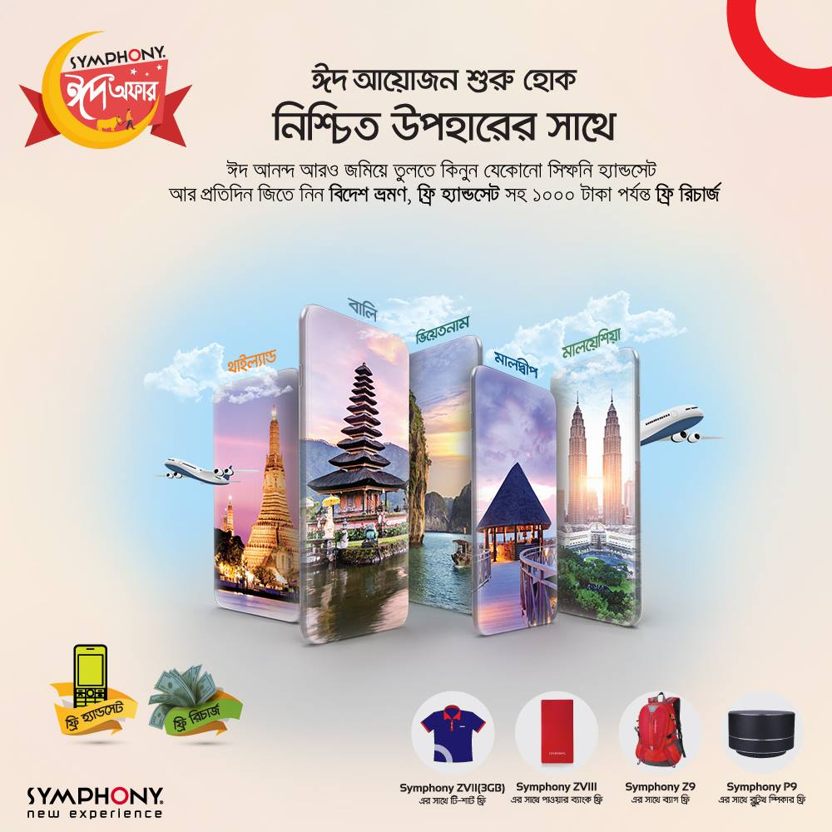

Various Mobile Operator offers: Mobile operators like Grameenphone, Robi, Banglalink etc. collaborated with Symphony to provide various offers for purchasing handsets and tabs. (Symphony, 2017)
Launching of new handsets and tabs: New handsets with various price ranges were introduced in the market in these three months. Various campaigns were executed for these. (Symphony, 2017)

