

Internship Report
On
Evaluation of the Marketing Mix Elements of Kazi Farms
Course Code: INT-4399
Submitted To
Muhammad Hasan Al-Mamun
Assistant Professor
School of Business & Economics
United International University
Submitted By
Md. Jubair Nasif
ID- 111-151-243
Program: BBA
School of Business & Economics

Evaluation of the Marketing Mix Elements of Kazi Farms
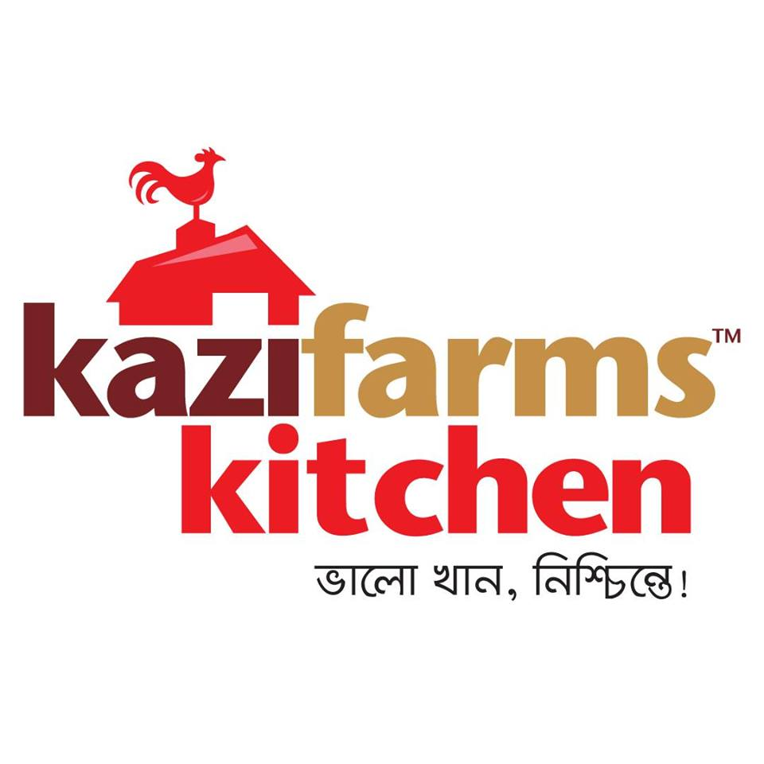

Letter of Transmittal
September 28th, 2019

To
Muhammad Hasan Al - Mamun
Assistant Professor
School of Business and Economics
United International University

Sub: Submission of Internship Report

Dear Sir,
Here is my internship report on “Evaluation of the Marketing Mix Elements of Kazi Farms”. I am submitting this report as the part of my internship in Kazi Farms Group. While preparing this report, I tried my level best to follow your guidelines and also took help and suggestions from my organizational supervisor Md. Somrat Joardar, Executive – Talent Acquisition, Human Resource Department. The entire report is based on my practical experiences in the Kazi Farms Group’s Corporate Head Office. I have tried my level best to include almost everything what I have learned during the internship. I shall be highly encouraged and obliged if you would be kind enough to receive this report. If you have any further query concerning any additional information, I would be very pleased to let you know.

Thanking you.
Sincerely yours,
_____________
Md. Jubair Nasif
ID-111-0151-243
BBA Program, School of Business and Economics
United International University

Acknowledgement

At the very beginning, I would like to express my gratitude to Almighty Allah for making me able to complete my internship and my graduation. Then I must express my deep gratitude to my University supervisor Muhammad Hasan Al-Mamun Assistant Professor, UIU for his guidance and suggestions in finishing the internship program successfully. I would like to place my gratitude to the HR of Kazi Farms Group for giving me the opportunity to complete my internship in their esteemed organization.

I would also like to thank my host organization supervisor Md.Somrat Joardar, Executive– Talent Acquisition, Human Resource Department, who has helped me to learn many new things during my internship program.

During the preparation of the project work I got huge supports from my co-workers, friends, my supervisor, who gave their ideas and time in the process of completing the report. To be true to myself I must say that without their help it would be very hard for me to go through the entire process. I am thankful to all of them.

Executive Summary
The report is the partial requirement for the Bachelor of Business Administration program. The report is actually based on my three months internship at Kazi Farms. I was hired by Kazi farm Group to participate in three months internship program. I was able to learn both theoretical and practical knowledge during this three-month internship project.
In this report I discussed about by internship learning in the kazi farms group. Mainly I discuss about their trading system, their performance valuation and how was their working environment etc. But the main focal point of this report was concentrated on the evaluation of the services marketing mix fo Kazi Farms. Details of the each of the following elements were presented with due critical evaluation.
Their products include ready to cook products, fast foods, ice-creams and consumer edible. Price of their products is competitive considering the quality they provide. Their distribution strategy is mainly based on franchising, the owner the shop being the franchisee and Kazi Farm being the franchiser. Their promotional efforts include promoting through leaflets, brochures and short catalogs distributed in the stores and/or put inside the newspapers with help of the Hawkers of different areas.
By following the service dominant logic of marketing, three more elements of service marketing mix were also evaluated with the same critical evaluations. They have a separate HR department managing the employee aspects of service marketing mix. But they are yet to develop a strategic initiative to manage the customer aspects in details. They can hire service landscape designer to develop the right kind of physical evidence.
With the better management of all 7Ps of marketing mix, Kazi Farm is expected to flourish in terms of sales, profits, and customer engagement.

Key Word: Marketing Mix

TABLE OF CONTENTS

Chapter name | Contents | Page No
Chapter -1 | Introduction | 1
1.1 | Organizational Profile | 2
1.2 | Data Collection Methods | 2
1.3 | General Information of Kazi Farms Group | 2-5
Chapter-2 | The Organization | 6
2.1 | Mission, Vision and Goal | 6
2.2 | Organizational Structure | 6-7
2,3 | Background of the organization study | 7
2.4 | Objective of the organization study | 8
2.5 | Managing the people aspect of the organization | 8
2.6 | Departmental activities | 8-11
Chapter- 3 | Company Analysis | 12
3.1 | SWOT analysis of kazi farms group | 12-13
3.2 | The Five force model of kazi farms group | 13-15
3.3 | Marketing analysis of kazi farms | 15
3.3.01 | Marketing Segmentation of kazi farms | 15-16
3.3.02 | Targeting | 17
3.3.03 | Positioning Strategy | 17
3.3.04 | Marketing Mix (7Ps) for Kazi farms | 17-19
Chapter- 4 | Findings and Analyzing | 20
4.1 | Findings | 20-21
4.2 | Analyzing | 21
Chapter-5 | Conclusion | 22
 | Intern Role and Responsibility | 23
 | My experience during internship | 23
 | My role during internship | 23
 | References | 24

Chapter: 1
Introduction
  - Organizational Profile
Kazi Farms Overview of the Organization
Kazi Farms is known as one of the leading poultry farms in our country. The Company starts its business almost 23 years ago. The company established in 1996. At first, they imported eggs later on that year they start their own parent firms. In 2004 production begins in their main (GP) firms. The Company actually Continues with its latest products and services, Considering Consumer and Clients perspective.
The Company actually maintains their client trust and they actually maintain a very good customer policy. Because all income class is their customer and the company build a strong model so called communication network and customer service network to retain their customer and also attract new customer.
In 2006 the company has able to build the country’s most advanced poultry feed mill. In addition to producing breeder feed to meet the companies own requirements. Kazi firms is the largest grant parent company of Cobb- Van tress USA for Cobb 500 which is know best broiler in the world.
They have also a smaller number of grand-parents of the popular Ross Broiler from Aiagen USA. The frame have word most popular layer breed. They are the first exporter of hatching eggs day one chickens from Bangladesh
The Company have over 70 broiler firm in Bangladesh. Such as, Grand-Parent (GP) farms, layer farms, hatcheries, feed mills and sales offices. The firm actually maintains a very well hygiene and nutrition system to take care chickens. They actually maintain this with their company scientist, biochemist and controlling their firm environment.
The company actually committed to take a lead in countries farming sector. So on that reason they actually focusing good and innovative technology and services. It also ensure creation higher value for its requested customer and shareholders.
The firm is trying with their own best to provide the services to the customer doorsteps. They are trying their best to bring more people in farming sector in rural Bangladesh and become benefitted. Every year the company spends 2% in research and development sector. Kazi firm continuously invest into its biggest assets the “Marketing & Sales” department will drive forward with its mission “to be the best performing farm in the country”

  - Data collection methods:
There are two main sources that I collect all the information. They are
- Primary source:

- Adequate practical knowledge during my job responsibility
- I always talk with my supervisor about the company and also my job responsibility.
- I talk with AGM and also tank Marketing head and operation department during my report period.
- Understand and learn a lots about communicate with different vendor and update employee profile.

- Secondary source

- Visiting Kazi farms website
- Read Various journal that publish information about kazi farms
- Reading Marketing books and tools

1.3 General information of kazi Farms Group:

Company Name: Kazi Farms Group
Type: Private Company
Industry: Poultry & Hatchery
Foundation: 1996
Founders: Kazi Zahedul Hasan
Kazi Shahidul Hasan
Owners: Kazi Zahedul Hasan
Employee: 11000
Corporate Office: Ahmed kazi tower, House- 35, Road-02, Dhanmondi, Dhaka 1205
Telephone: + 880-2-9612290-93, 9612184
Fax number: +880-2-9612185
IP No: +09613606060
Email address: info@kazifarms.com

Current Products and services of Kazi Farms Group, Kazi Foods Industries and Kazi Media Limited is:

Kazi firm broiler parent chicks and broiler chicks
Kazi farm have the best broiler in Bangladesh. With the franchisee from Cobb-Vantress USA , they actually collect best broiler in the world. Both Cobe 500 parent and chicks are consider best performing broiler in the country’s domestic market and customer are actually paying premium price over it.

Layer chicks and table eggs
One of the oldest poultry breeding company is hi-line international. It is also leading breeders of Kazi farms Group. They are also the distributor for Hy-Line brown and white layers. This sector also the produce largest commercial table eggs in Bangladesh.

Kazi Poultry Feeds
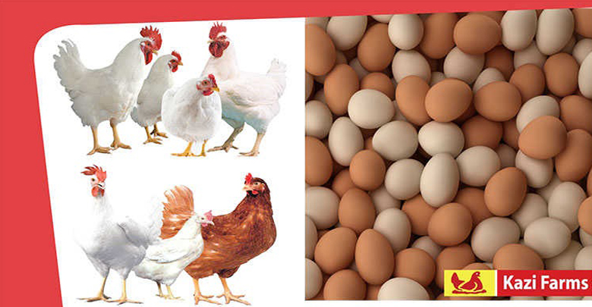
In 2006 Kazi farm company expanded their business into poultry feed sector. But a very short period of time kazi feeds becomes market leader in poultry feed sector. The feed mill actually produce a large number of poultry feed. Approximately 90% of poultry feed produce by kazi firms in domestic market. The Gajaria feed mill actually do it very efficiently. With the help of Switzerland Buhler company actually providing the better result in feed sector. The main focus is quality control. Kazi firm actually collect raw poultry feed material and grinding them with insuring quality. So it actually provides better result in domestic market.

Bellissimo Ice-Cream
The Ice Cream Company is a subsidiary company of Kazi farm group. The main mantra of that company is to made local premium product. The Bellissimo ice cream is rich with premium and high quality. Because the made of that ice cream process is very hygienic and Wally maintains quality. The company wants to offer largest Varity and also wants to introduce new flavor. The companies spend a lot in their marketing and product packaging and desiring sector. “Sakib Al Hasan” is the current brand ambassador of Bellissimo Ice-Cream.

Zaa n Zee Ice Cream
Another latest introduction to kazi farms new venture is Zaa n Zee ice cream. This is a new a new company and offers promising product to the customers within a cheap price. The main vision of that company is to capture 50% of the local market within next five years.

Kazi Farms Kitchen
Kazi farms kitchen is the pioneer of frozen food sector in Bangladesh. A large number and Varity product actually sold in their tagline and brand name. Kazi farms kitchen actually followed international standard in processing frozen food. They have 45+ different varieties of frozen food item and 60+ outlets. The main tagline of that company is eat better. They have a very good quality control unit and they want to become number one in frozen food sector in Bangladesh within next five years.The company spend a lot in their research and development sector. I talk with Company GM “Eftakher Ahmed sir” and he told me they actually invest a lot in advertising, Packaging and also online marketing. He also ensures me that response is very positive among all ages people. So they are investing a lot in this sector and also invest a lot in their research and development sector.

Kazi Media Limited Deepto TV
Deepto television is the concern of kazi farms group. Generally kazi farm is very much focus on agricultural sector. Deepto tv actually promoting and contributing agricultural sector. They are promoting agriculture, entertainment and regular television news. Their main focus is agricultural sector and daily drama series. They mainly collect agricultural news rural Bangladesh.
Deepto tv started its commercial transmission on November 18, 2015

Associates and other Sister Concerns of Kazi Farms Group
- Central women’s university – Known as the first private university for women established in 1993 in Dhaka.
- Sysnova information System Ltd. (IT based company located in Dhanmondi) mainly focused on software making and monitoring various organization software system.
- Kazi Food Industry- Located in Ashulia . Some of its popular brand is Bellissimo, ZaNZee and Kazi Firms Kitchen
- Kazi Zahirul Haque College – Located in (Gopinathpur, Gopalganj) established in 2016.
Chapter 2
The Organization

2.1 Mission Vision Goal

Mission:
The main philosophy is to provide consumer quality food in affordable price.

Vision:
The company’s main vision is to become number one trusted company in Bangladesh.

Goal: The Company’s main goal is to find more opportunity in poultry sector.

2.2 Organizational Structure:

Kazi farm is one of the biggest industries in Bangladesh. Currently they are following “hierarchical structural model” for their business. This is one of the popular forms that modern business actually applied.

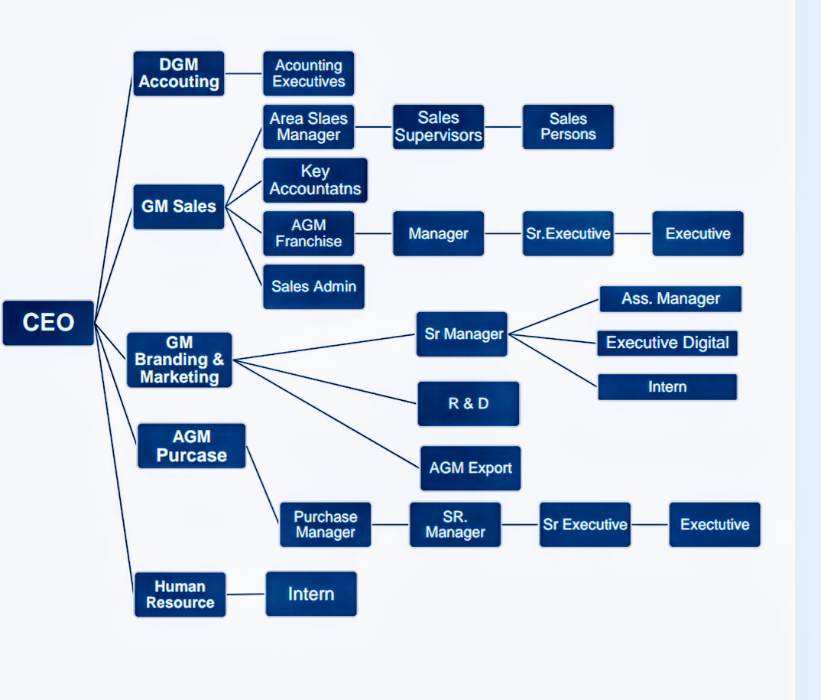

2.3 Background of the organization study:
Kazi farm is known one of the leading companies in Bangladesh. Their Golden footprint in the poultry firm, frozen food sector, information technology, ice cream and television sector is very much promising.
The company’s market share is based on 35% day one old chicks and 30% broiler feeds. To conducting the whole business, they need a huge and processing manpower.
If kazi firm use their manpower properly they actually get competitive advantage over competitor. They actually maintain their employee well and they are tiring their best to provide various kinds of training base on their performance. To maintain 11000 employees is not an easy task. So, they are actually subsidies the department to increase their performance.
Now a days kazi farms actually following peters five force model and more focus on succession planning and and talent resource management to achive their goals.

2.4 Objective of the organization study:
The main objective of the study is how they actually manage internal market practices inside the organization. What was their Talent resource and how marketers are attracting by their product. And if there any suggestion needed based on the report I will love to provide later on the report part.

2.5Managing the people aspect of the organization:
For managing people kazi farms actually focus various things. Like,
- They actually provide extra bonus those who work inside the firm.
- GM, AGM and Doctor in poultry firm gets 22 thousand taka extra for accommodation
- Sometimes kazi firm provide furniture those who worked inside the firm
- They maintain a strong Communication tools because it’s a continuous firming process
- If a worker worked 2 months inside the firm they paid 50% bonus based on their salary
- Sales team actually focuses regular sales and if they full fill their target they actually get extra benefits based on their performance.
- HR team actually monitoring all the workers and they provide various terms of bonus like KPI, yearly increment so worker gets satisfied.
2.6 Departmental activities:

I actually intern in HR sector but I’m doing the report based managing the people on service marketing sector. Kazi farm actually very creative in marketing sector and they actually showed very much creativity when they actually focused on department activities. The Following Chart is showing how the activities are planned and executes in the company

- Focus on managing current marketing plan and what are required and also focused on upcoming event
- Executing head of operation and CEOs Plan
- Supervising promotional activities based on product
- Creating promotional budget for all the department
- Mantling a positive communicational environment with vendor stakeholder and agencies

- GM Marketing

- Regular inspection poultry sector with the help of talent management.
- More focus about promotional plans like,
ATL, BTL plan etc.
- Focus on raw material supply and demand
- Follow the current trends and if any lacking found than informed it to the CEO and GM
- Maintain quality with brand value.

- Sr. Manager

- Maintaining all the documents that are related to sales and marketing.
- Design product, monitoring product quality also focused on pricing strategy.
- Much more focused on future growth.
- Monitoring and controlling the sales department and if any changes required take corrective action in a short period of time.
- Attract new marketers.

- AGM Sales and Marketing

- The main job for the assistant manager is to manage the distributor.
- They are liable to manage distributor
- Manage indoor and outdoor promotional activities
- They also involved purchase requisition and invoices

- Assistant manager

- Product development is a continuous process and the R&D department is continuously developing quality of the
Product.
- The company invest 2% to 3% of its annual revenue for product development.
- They are liable also analyzing the competitive advantage.
- They ensure various features of product for different market
- Planning continuously for upcoming product.

- R&D

- Prepare promotional campaigning like University events host concert and also become brand partner.
- Focus on brand segmentation.
- Digital campaigning.
- Attract new market.
- Continuously communicating with the marketers and features new promotional idea

- Executive digital

Chapter 3
Company Analysis

3.1 SWOT Analysis of kazi farms group:
Kazi farm is one of the leading organizations in Bangladesh. They have several sector so there is some limitation and also have some strengths. The SWOT analysis of kazi farm is given below:-
Strengths of Kazi Farms Group:
- Market leader in Poultry sector: Kazi farm is recognized number one in the poultry sector in Bangladesh. They have dealers every district and sub district. Around 70% of chick’s product by kazi farm in domestic market and approximately 60% of chicken feeds produced by kazi firms.
- Pioneer in frozen food industry: The venture of kazi foods and kitchen are tiring to become number one in the frozen food sector. They have 70+ outlets and tiring to open more. In recent years they are investing more on this sector.
- Advanced ice cream sector: They actually used advanced technology for their two sub brands Belessimo and zaaNzee. Belessimo is premium propduct and zaaNzee is tiring to capture the new market around Bangladesh.

Weakness of Kazi Farms group:
- Always maintaining chickens production is very difficult
- According to their plant size their production is low
- The launching of new media sector Deepto TV is not profitable
- Lack of utilizing brand image.
- They are not effective enough to increase their productivity
- There are lots of competitors so it does very hard compete in the competitive market.
- Lack of talent resources

Opportunity of Kazi Farms Group:
- Market growth rate is high: The market growth rate is very high. Because Poultry sector is one of the sector where company always tries to focus and capitalize. The frozen food item is also playing a good role to capitalize the market in last 5 years 90% growth is recorded in frozen food sector.
- Selling eggs: Kazi farms sell its eggs to number of small hatcheries. Those other farms won’t do it often. So it’s a plus point for new market opportunities
- Quality of breed: For their breading production they actually used quality breeder so its provide competitive advantages.
- Frozen food sector: Now a day’s frozen food sector become very popular. Because people are very busy. They don’t have enough time. So they are capturing very much of it.

Threats of Kazi Farms Group:
- Huge competition: There are lots of competitions with other company. So pricing strategy is a key fact. They need to identify what other thinks about their company and their current market product.
- New company entrance: The threats of new company entrance are very high in Bangladesh. The company needs to cope up with that.
- Rules and regulation: The government rules and regulation is also a common barrier for the firm.

3.2 The five force model of kazi farms group:

Porters five force model actually help many industry to develop their own strategy for many ways. Different firm have different perspective. Due to the emergence in many farming company in Bangladesh, there actually have a competitive environment. To maintaining a competitive environment the farming sector the porters five force model will be:-

- Threats of new entrance: The main business of kazi firm is poultry industry. Now a days the poultry sector in Bangladesh looks like very interesting. Because there are a lots of local and multinational company are tiring to open poultry industry. The market share majority is kazi farms hand. But the firm not only looks for the present they also need to look for the future.

- Bargaining power of supplier: There are two types of major supplier that are involved in kazi firm business model
- Worker
- Supply chain management

So the company needs to utilize it very efficiently. Because suppliers are very much liable for production. The supplier needs to focus required market demand. The supply chain management does a good job for utilizing it.

- Bargaining Power of buyers: Buyers are called sometimes immediate customer but they are not the ultimate customer. Buyers have the high bargaining power that supplier are find it very hard to make a profit on it. Poultry industry has lots of buyers. Now a day’s many hotels restaurant are love to buying frozen foods

- Threats of substitutes: Substitutes are those, who actually produce similar product and service with the same types of customer. Substitutes have the ability to switch one customer group to another company. Kazi farm sells chickens, eggs Frozen foods so other company also take all those things to their business model and create their own brand and sell all those item in their new brand logo

- Competitive rivalry: The main competitor that kazi farm have CP, Index, Aftab and Agro industry. Because they have the same customer group.

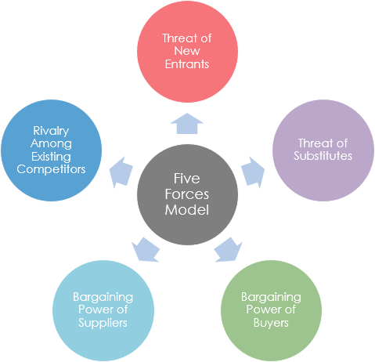

3.3 Market Analysis of Kazi farms:
Market is a place where two or more party gets together and exchange goods and services In this part I would love to discuss some core marketing term that actually used by kazi firm in their marketing point of view like Marketing Mix, Segmentation, Targeting & Positioning

3.3.01 Market segmentation of kazi farms:
Segmentation is a process where market is divided in few gropes. It’s actually helps a company where they actually needs to focus, The main purpose is doing segmentation is that the content have superior market values. The main advantages that we actually get such as,
- To identify the actual demand and supply
- What will be the relative promotional tools
- What kinds of marketing tools that we are actually using
- For the economic prespetive segmentation is done to reduce cost
There are four types of market segmentation that actually used by the marketers. They are,

Demographic Segmentation:
Generally they target all age groups .Actually most simple and the widest type of market segment is demographic segment. The segmentation actually do based on people requirement. Like tits sometimes vary country to county or district to district. Sometimes it’s depend based on age group, income, family, Religion and nationality
Kazi farm focus this segment such as:
- Age group (Ice cream and frozen food). Age group 12 to 60
- Both Male & Female
- Income based on product choice

Psychographic Segmentation:
Depends on people behavior and choice. Like frozen food actually chosen by those who don’t have enough time to cook. Sometimes life style also plays a vital role in psychographic segmentation.

Geographic segmentation:
Generally this kind of segmentation is done by based on geographical. This divided the market one country to another country. Sometimes there might me a minor change into their product placement. Kazi firm is not a fully export oriented company. They are only folly the religion perspective.

Behavioral segmentation:
This segment is actually done by certain behavioral process. This segment actually focuses on usage rate and also decision marketing pattern.
For example Young people always prefer Dove soap. But most of the sportsperson will prefer Lifebuoy soap.
Kazi farm actually don’t use this segment. But this segment has four main ideas
- Purchase/Usage occasion
- Loyalty Status
- Usage rate
- Buyer Readiness
3.3.02 Targeting:
They mainly target all ages of people because they have product verity and they are producing daily based product. So their target audience is very large and they are very much focus on it. They are mainly concern about halal food. They mainly target all income group, Ages, Class people.

3.3.03 Positioning Strategy:
Positioning strategy actually focused by the brand value and what consumer think about their product. Kazi farm have a good brand value. By the tagline of sub brand each sector are doing very well. They are using tagline by the brand positioning.
The tagline of kazi farm kitchen is “Good health for everyone”
The tagline of kazi food is “Eat Better”
Each of the sectors has unique promotional tools based on product positioning.

3.3.04 Marketing Mix (7ps) for kazi farms:
Marketing mix is the most famous and widely used marketing tools. It is one of the famous marketing term. The marketing mix are called 4ps. But if we focus on service marketing perspectives there are 7ps. The marketing mix is the contribution of Product, price, place, promotion, and the addition of process, people and physical evidence.
(Kotler and Armstrong 2010)

Product:
Product is the basic element for marketing. A Kazi farm offers a verity of product in various sectors. Such as,
- Chickens
- Eggs
- Ice cream
- Frozen Food
- Entertainment

Price:
Price is something which actually exchange for offerings. The main goal for kazi farm is to reduce cost and improve manufacturing and offers variety of product to the all types of consumer. The price actually done by Kazi firm is Cost based pricing and sometimes also value based pricing

Place:
Place is something where marketers done all its selling activities to capture target audience. Kazi firm have sellers in all district around the country. They have 451 own Truck and pick up vans to take their product one side to another side in the country. They have distribution center all around the country.

Promotion:
Promotion is something which actually knowing the product. On the promotional activities the company actually targets their potential customer. Promotion includes all the tools that marketers actually involve in their marketing communication. Kazi firm use various marketing tools for promotion. Such as,
- Online marketing
- Television advertisement
- Newspaper advertisement
- Billboard
- University campaigning
- Providing sponsorship to various sports

Process:
Process is something which actually done by to get the result. There are several things which might use in process. Such as,
- Business Process
- Business Process management
- Business process modeling
- Process costing
Kazi farms actually use all those terms very efficiently to conduct business.

People:
People are the most important element in marketing mix. People play an important role in service delivery. Kazi farms and kitchen actually perform this task very beginning. They are actually conduct transactional marketing and also plays an important role in customer relationship.
Physical evidence:
Physical evidence is called real evidence or material evidence. The process actually helps to provide judgment based on the product. Kazi farm actually perform this task very well in their marketing mix strategy.

Chapter 4
Key Findings and Evaluations

4.1 Key Findings:
In my three months of internship process I worked with the HR department of kazi farm group head office. There I learn lots of thinks how an organization is run. How they manage the people. How they take immediate response. There are few things that I notice in their working process such as,
Recruiting new employee process: The Company mainly recruits new employees based on their academic background and work experience. They have a strike guideline while hiring new employee. The HR department work hard to evaluate each and every candidate. Recruiting is a tuff process. The Companies success mainly depends on this. The future of the company depends on new people so they need to be very selective.
How they made every month salary: Salary is made my HR department. They worked hard to calculate every employee salary based on their job. They mainly focus on each and every factor like entre and excite time employee working hour while preparing salary.
Provide bonus: Kazi farms mainly provide bonus based on their work performance. If an employee attends regularly office he or she gets one day extra bonus also they provide overtime bonus. They also measure performance based on KPI while making salary. There are two fixed Eid bonus and many working condition bonous.
Manage employee details in database: Kazi farms use their own database system. They have unique system, where they actually upload all employee information and also managed those information based on serial wise. They have unique IT department and they made all those database system
There are also few other factors which I would like to include in finding sector. Such as,
- The HR Department worked very hard. I think it’s the most busy sector into the office
- They handle huge pressure like managing employee. I think it is one of the tuff processes to manage employee. But kazi farm did it very well based on their work activities.
- In their recruitment process they check every document and also cross check to find is the document is legal or not
- The whole HR department has strong relationship to their employee.
- The companies fixed asset to net worth ratio shows that the company is dominating in the market.
- Day by day labor cost is increasing and also the cost of hatching is increasing. But the company tries its best to do it properly.
- Now a days the company is much more focus in their frozen food sector. They thought this market will grow very rapidly.
- In last year survey the company actually provide 60% to 70% efficiency rate. The company thought they can improve it.
- The company is much more focused in automated technology. They thought it actually maintain hygienic system.
- Kazi farm want to export their product in foreign market. Specialty they are tries to export frozen food item. They have the capability to export frozen food item. After the end of 2019 they will focus export market.
- The Company tries its best to produce its perishable product based on their market condition

  - Evaluations:
Based on my observation there are lots of things need to be improved. Like
- Database management is very slow: Every day their server goes down 4/5 times. So, it took so much time to update information. Because their server misbehave every day. My suggestion will be maintain this server based on employee requirement. It’s very hard to work in a slow database management system.
- Insufficient space: There are lots of files approximately 11 thousand. So it’s very difficult to manage them all because of insufficient space. In the office there are not enough room for all those file. They need to create more space to take care all those file
- Personal Communication system: They need to build up a personal communication system to perform their task easily. They need to cope up with all managerial activities because it is very standard system for the employees.
- Redesign Web Browser: They need to redesign their website. Because it’s getting too old.

Chapter 5
Conclusion
Conclusion:
In this study I learn lots of new and creative think. A multinational company is unknown for me. But I learn lots of things to work there. I learn lots of things about kazi farms, kazi foods and kazi media. Actually my point of view all those sector are very promising. I basically learn the organization culture in my study. How they manage employee how they invent new venture that’s very interesting for me. I learn their marketing strategy, Business model and also marketing mix. I think near future I can apply them very creatively
I hope this study will help readers to know the overview of kazi farms.

Intern Role and Responsibility

My Experience during internship:
I was Working HR department in the head office of kazi farms group during my internship. As a new comer they give me lots of freedom. They are very friendly. There are various task that I actually perform during my three months internship period.
I saw there are three major teams in kazi farm HR department. They are,
- Operation team: They perform parole activities, Policy making, Conducting exit interview, managing files, Update current employee files, Check employs personal documents etc.
- Development team: They actually monitor employee, manage succession plan for the employee, provide adequate training also monitor employee behavior.

- Recruitment team: They actually manage all recruitment activities. Like, making interview paper, take interviewer exam, create database for new interviewer, check mail, manage database, take phone calls also manage activity performance.

My Role during Internship period:
My job role during internship period was exciting. Like,
    - Updating employee basic information.
    - Updating files.
    - Manage phone calls and inform senior manager.
    - File processing for interviewer.
    - Re- Organizing employee file based on joining date.
    - Checking the reference and also send mails.
    - Helping other employs when they are loaded with work

References

Kazifarms.com. (2018). :: Kazi Farms Group ::. [online] Available at: http://www.kazifarms.com/ [Accessed 10 May 2018].
Eva, t. (2015). Talent Management: A Key to Success in Any Organization -Perspective from Bangladesh, volume 3(12).
Recruiting Resources: How to Recruit and Hire Better. (2018). Talent Acquisition vs. Talent Management vs. HR: an FAQ guide.
En.wikipedia.org. (2018). Succession planning.
Hamid, M., Rahman, M., Ahmed, S. and Hossain, K. (2016). Status of Poultry Industry in Bangladesh and the Role of Private Sector for its Development. Asian Journal of Poultry Science, 11(1), pp.1-13.
Bea-bd.org. (2018). [online] Available at: http://www.bea-bd.org/site/images/pdf/084.pdf
Wilska, E. (2015). Determinants of effective talent management. Journal of Positive Management, 5(4), p.77.
Fitzgerald M (2014), Talent and Talent Management Insights, NHS Leadership Academy.
Bugg, k. (2015). Best Practices for Talent Acquisition in 21st -Century Academic Libraries. 29(4).
Kowalewski, S. (2011). Succession planning: evidence from “best companies in New York. 4(2).
Henson, M and Eskenazi, J. (2005). Workforce planning: The key to true staff forecasting and strategic staffing.
Shaefer, B. (2007, July). Succession planning: identifying and developing talent for the future.
Estedadi, E. (2015). The importance of succession planning in organizations. 2(3).
McConnell CR. Succession planning: valuable process or pointless exercise? Health Care Manag. 2006;25(1):91–98
Rothwell, W. (2001). Effective succession planning. New York: American Management Association. Rothwell, W. J. (2005). Effective Succession Planning: Ensuring Leadership Continuity and Building Talent from Within (3rd ed.). New York: American Management Association.

