AN INTERNSHIP REPORT ON


"Customer Perception regarding Ricebran oil in Bangladesh : A case on Aci Nutrilife Ricebran oil"

25th August 2019
UNITED INTERNATIONAL UNIVERSITY
DHAKA, BANGLADESH
An Internship Report On
"Customer Perception regarding Rice bran oil in Bangladesh: A case on ACI Nutrilife Rice bran oil"
SUPERVISED BY
S.M. ASIF-UR-RAHMAN
ASSISTANT PROFESSOR,
SCHOOL OF BUSINESS AND ECONOMICS
UNITED INTERNATIONAL UNIVERSITY

SUBMITTED BY
MD. EFTHAKHAR-BIN- ALAM
ID: 111 133 147
BBA PROGRAM
UNITED INTERNATIONAL UNIVERSITY

UNITED INTERNATIONAL UNIVERSITY


Letter of Transmittal

To
S.M. Asif-Ur-Rahman
Associate Professor,
School of Business and Economics
United International University
Subject: Submission of Internship report.
Dear Sir,
It is a great opportunity for me to inform you that I have recently completed my internship program from ACI Bangladesh Limited. Meanwhile I was performing my internship responsibilities as an intern, I have also prepared my internship report on the title that is "Customer Perception regarding Rice bran oil in Bangladesh: A case on ACI Nutrilife Rice bran oil".
At the time of preparing this report, I adhere to your guidelines and rules, in addition to the data that I can collect from the ACI Consumer Brand Office. This report was completed within five months of my internship at the ACI Pure, consumer brand office. This internship report gives me the opportunity to introduce myself practically to the company, to the market and to the people working there. It also gave me the goal of analyzing markets, data preparation, performing survey through questionnaire to prepare this report.
I would like to offer my heartfelt thanks to you for your valuable time, direction and support. I have tried my best to complete the report correctly and I would be highly grateful if you accept this report and oblige thereby.
Sincerely yours,
Md. Efthakhar-Bin- Alam
Id: 111 133 147
BBA Program
United International University

Acknowledgement
First of all, I am grateful to the Almighty ALLAH and my Parents for giving me the patience, strength, and courage to carry out this colossal 4 years of BBA Program from United International University and help me to finally complete it.
I love to express my deepest gratitude to all the people who provided data with the likelihood of finalizing this report. Special thanks to our esteemed Sr. Asif-Ur-Rahman, Associate Professor, School of Business and Economics, United International University whose teaching method, encouragement and suggestions motivated me to start the report.
My appreciation and my gratitude also go to my supervisor, Moinur Rahman, Business Manager who guided me to access your field marketing and the opportunity to complete my internship program in his Market Auditing department. Md Moinur Rahman also guided me to extend my internship program and helped me to set up this report and provided necessary information.
In addition, I would also like to show my gratitude to Hyder Waliur Rahman, Brand Manager, ACI Consumer Edible Oil, for his motivational speeches and support. Without their help, it could not be possible to allocate all the information for this report.
Furthermore, I am also grateful to Abdullah-Al-Tayseer, food oils product manager at ACI Bangladesh Limited, who supported me while my older brother made me feel at home. Without cooperation and mutual support, it would not be possible to carry out all the tasks.
Finally, I sincerely thank the Authority of United International University for organizing this student internship program. This really makes students able to perform official tasks before entering the corporate world.

Executive Summary
As a graduate business student in a marketing program, we need field experience before we graduate. An internship is a good time to live a real experience. This is the reason, the report is part of the BBA program. I had the experience of visiting many markets in Dhaka. I interviewed resellers and distributors. I asked them how much stock they had. Noting all the comment in my diary, which my supervisor gave me, I had prepared an Excel spreadsheet during the market tour and then sent it back to him. In addition, I had created a survey on consumer perceptions of rice bran oil and according to my supervisor's suggestion, I chose the title of my report that was "Customer Perception regarding Rice bran oil in Bangladesh: A case on ACI Nutrilife Rice bran oil". My internal ACI supervisor Md. Moinur Rahman has also supported me and participated in the market research program with consumers and wholesalers (distributors) during their market visits. There is a survey performed on the consumer's perception of rice bran oil as the main objective of this survey is to understand consumer perceptions of rice bran oil in Bangladesh.

The report is consist of five brief chapters. The first chapter provides the general idea of the internship report. It also includes the main objectives and difficulties that we have faced while preparing the report. The second chapter is a brief discussion of the related literature so that any reader of the report can get the true essence of the report. The fourth chapter is a short briefing of the ACI Company. The most important chapter is analysis and findings chapter where the ACI rice bran oil concept is discussed and the questionnaire responses that I had collected through survey are analyzed and interpreted there to understand the perceptions of customer who purchases edible oil.

Finally, the report concludes with some recommendation, such as ACI should concentrate more on its promotion and consumer awareness of rice bran oil and also some other suggestions according to my academic knowledge so that this product line of ACI can reach more customer in the upcoming days.

Keywords

Internship report | Questionnaire Survey
United International University – UIU | Bachelor of Business administration - BBA
Marketing Report | 100 customer Reponses
Consumer / customer perception | SBU – Strategic Business Unit
ACI Edible oil | ACI Nutrilife Rice Bran Oil

Table of Contents
Chapter one: Introduction of the study
1.1 Background of the Study 2
1.2 Significance of the study 2
1.3 Objectives of the study 3
1.4 Study Methodologies 3
1.4.1 Data Collection Procedures: 3
1.4.2 Sampling plan 4
1.5 Limitations 4
Chapter two: Literature Review
2.1 Perception 6
2.2 Customer Perception 6
2.3 Ways to measure customer perception 6
Chapter three: Company profile
3.1 Company overview 9
3.1.1 Vision 9
3.1.2 Mission 10
3.1.3 Value 10
3.2 The Strategic Business Units of ACI 11
Chapter four: Analysis and Findings
4.1 General discussion of the Rice Bran Oil of ACI. 13
4.1.1 Research and development: 13
4.1.2 Market Presence: 13
4.1.3 Available in three types: 14
4.2 Consumer perception survey of ACI Nutrilife Rice Bran Oil. 14
Chapter five: Recommendations and conlusion
5.1 Recommendations 20
5.2 Conclusion 21
Reference 22
Appendix 23

Chapter One –
Introduction of the study


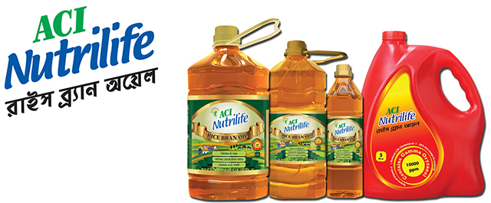

Background of the Study
At the end semester of BBA program, internship or projects are the pre-requirements for students to achieve the BBA degree from United International University. Each student who chooses internship program, has to join in an organization as intern from at least three months to learn practical job responsibilities under the supervision of an instructor. Meanwhile performing his/her internship responsibilities students have to prepare their internship report based on their selected topic and according to their field of study.
As a graduate student in business administration in the marketing program, we need fieldwork experience before completing our degree. An internship is a good time to live a real experience. So this report is part of my BBA program. I have accumulated the experience of visiting many markets in Dhaka. I interviewed retailers and distributors. I asked them how much stock they had. Taking note of his comments in my diary, which my supervisor gave me, then I prepare an Excel sheet on the market visit and send it to my supervisor. In addition, I created a survey on consumers' perceptions of rice bran oil.
According to the suggestions of my supervisor, I selected my report title which is "Customer Perception regarding Rice bran oil in Bangladesh: A case on ACI Nutrilife Rice bran oil". The topic was also get support from my internal supervisor of ACI named Md. Moinur Rahman, Business Manager of the ACI consumer brand who was assigned to a market research program with retailers and wholesalers (distributors) during market visits. In this report, most of the data of retailers and wholesalers of the city of Dhaka is provided. There is also the consumer's perception of rice bran oil. The main objective of this survey is to know the perception of consumers regarding rice bran oil in Bangladesh.

Significance of the study
The report significance is very high as the report is prepared on a highly popular consumer brand of Bangladesh. After reading this report, the reader will understand the consumer's perception of rice bran oil in Bangladesh. In addition, it includes the competitors of ACI nutrilife rice bran oil. In addition, the reader can learn about survey questionnaire and how to conduct a well-structured survey to get the consumer perception. University faculties as well the students can compare their theoretical learning with my practical learning. The competitor of rice bran oil can also find this report useful as there are actually very few information available in online on ACI Rice Bran Oil.

Objectives of the study
The objectives of the report refers to the goals that are desired to conduct in this study. The study objectives are several and can be separated into two parts: The Primary and specific objectives.
- The Primary objective of the Study: The submission of internship report is mandatory work to achieve the BBA degree from United International University. Therefore, to attain the degree, I am preparing the report.
- The specific objectives: There are four major purposes for preparing this report. They are listed below:
- To analyze the ACI company.
- To conceptualize the customer perception.
- To analyze the customer perception regarding ACI Nutrilife Rice Bran Oil by preparing a questionnaire.
- To recommend suggestions based on the analysis.

Study Methodologies
1.4.1 Data Collection Procedures: This is a descriptive report and this report is prepared with relevant qualitative data. Most of the data in this report are primary and less is secondary data.
I. Primary sources:
  - Through face to face communication with consumer as well as the personnel of ACI.
  - Key information collected by the consultant and the supervisor.
  - Significant field visit with the concern of the respective supervisor.
  - Campaign for park visits and direct conversation with consumers.
  - The Google online survey form.
ii. Secondary sources:
  - Secondary information are collected from several web sites and relevant blogs.
  - Few secondary information are collected from the websites of ACI.

1.4.2 Sampling plan
- Time period and data collection: 6th November 2018 to 6th August 2019.
- Sampling procedure: Nonprobability convenience sampling technique is used.
- Population: Random consumers who buy Edible Oil in Dhaka city.
- Sample size: 100 customers are randomly selected.
- Sampling procedure: Nonprobability convenience sampling technique is used.
- Sampling frame: ACI consumer brand sales database.
- Sampling elements: 100 consumer survey.
- Survey questionnaire formulation: Prepared through Google Forms and collected data through face to face interview and through social media sites such as Facebook, Twitter, WhatsApp, and IMO and so on.

1.5 Limitations
The limitations of the study are the design or methodology characteristics that influenced or impacted the interpretation of the results of our study. The limitations are:
- Rude behavior of some retailer.
- Short period of time.
- Confidentiality issues of some information.
- Lack of interest of some consumer for survey.

Chapter Two - Literature Review



2.1 Perception
In humans, perception is the process by which sensory stimulation translates into organized experience. This experience, or perception, is the common product of stimulation and of the process itself. The relationships found between various types of stimulation (for example, light waves and sound waves) and their associated perceptions suggest inferences that can be made on the properties of the perceptual process; Perceptual theories can be developed on the basis of these inferences. Since the process of perception is not public or directly observable (with the exception of the perceiver, whose perceptions occur directly inexperience), the validity of theories of perception can only be verified indirectly. That is, predictions derived from theory are compared with appropriate empirical data, often through experimental investigations.

2.2 Customer Perception
In marketing, customer perception is an idea that tells us what customers think about a brand or company or its offers. They can be perceptions, tendencies, expectations, feelings, obstacles, or negative or positive experiences of the client.
When one understands the idea of customer perception, he or she may understand that this is probably the most important factor that determines the success of an organization, product or any particular brand. The way in which a brand or organization is found also plays an important role in this regard. The characteristics of a brand and its personality play an important role.
For example, we can see if we look at Apple where most of its customers have made the company in a positive way. In fact, there are big Apple fans. The reason is that the company has always been innovative and provides products with good results that create connections with its customers. Apple is one of the most successful brands in the world.

2.3 Ways to measure customer perception
Brand perception helps identify the position of a product or service and, therefore, the effectiveness of a company's advertising and marketing. There are general strategies that measure the link between brands and specific concepts. They are divided into two main categories: Sorting and Scaling. Sorting strategies allow companies to know if there is a single association. On the other hand, Scaling techniques allow us to determine whether there is an association between the brand and an attribute with the strength of the relationship.
The customer survey is a scaling strategy that can help strengthen a company's brand image. It allows you to effectively capture customer feedback and effectively measure brand perception and how it measures global brand strategy.
Customer satisfaction surveys (CSAT) allow companies to measure their customers' feelings after purchasing or using a product. The CSAT can be run after a visit to the store, a conversation with customer service, or a purchase. After physical transactions, CSAT can be done online with free tools such as survey monkeys or a pen and conventional paper. It's also a good idea to encourage survey customers to attract more respondents. The very popular method of conducting a customer survey is through Google Forms.
Another very important tool of collecting customer perception of a product is product survey. Product survey is a brand tool that measures the satisfaction and adherence of products. Product surveys are a great way to create unique and creative ideas for customers that can make a valuable contribution to a company's brand strategy. Product reviews are also ideal for customers who have been using the brand for a long time.
Social media listening has also became a very important tool of collecting customer perception. Instagram, Twitter, Facebook, and other social media tools do not only mean publishing content regularly but also keeping track of impressions and customer sharing. As an excellent scaling technique, its true value lies in learning how customers look for your brand using hashtags, specific mentions, and keywords, so you can align your brand with them.

Chapter Three –
Company Overview of ACI

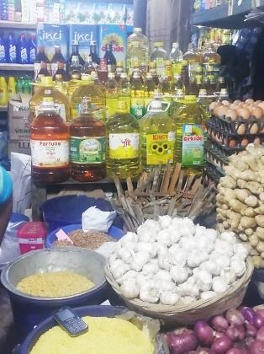
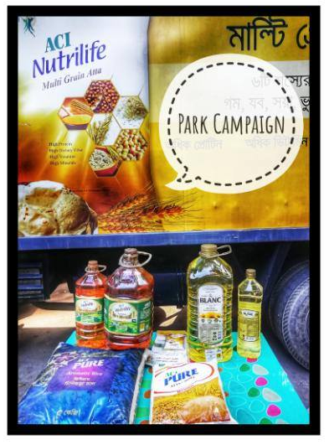
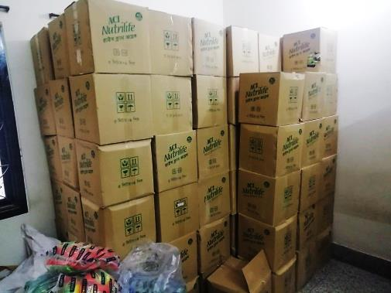

3.1 Company overview
ACI Bangladesh Manufacturers Limited was a subsidiary of an international multinational ICI and a public limited company listed on the Dhaka Stock Exchange. In 1992, ICI plc sold its interest after the purchase by management. ICI Bangladesh Manufacturers Limited changed the name of the company to Advanced Chemical Industries (ACI) Limited. ACI Formulations Limited, a subsidiary of ACI, has become a government business organization through direct registration.
The purposes of ACI are to achieve acceptance, respect, efficiency, and expectations of the organization's clients. ACI adheres to the quality management system standards to guarantee product quality and achieve customer satisfaction. Even the ICA is often. Recognized as a member of the Global Growth Society community by the ICA World Economic Forum. (Company: ACI Limited Bangladesh)
ACI has now became one of the largest local companies in Bangladesh. It brings together different activity groups: agribusiness, pharmaceuticals, and consumer brands. ACI is the first company in Bangladesh to receive the ISO9001 quality management system in 1995 and the ISO14001 certification in the environmental management system in 2000. ACI is a joint-stock company listed on DSE and CST. In addition, the company has a wide list of international partners and trade agreement partners. Today, ACI is one of the fastest-growing companies in Bangladesh.
ICA was renamed 1992. However, ACI's history dates back to 12 years, when Imperial Chemical Industries Inc. (ICI) joined the UK, and four companies were named British Dysartes Corporation, Novel Industries Limited, United Alkali and Bruner Mond Company limited. From that time period, ICI PLC has operated globally as an MNC. During the beginning period, ICI began to operate in the Indian subcontinent, called ICI (India) Limited. After India and Pakistan were separated into 5 inches, the name of of the office of Karachi which was ICI (India) Co., Ltd. was changed to ICI (Pakistan) Co., Ltd.

3.1.1 Vision
ACI have several visions. The vision of ACI are listed below:
- To achieve a high level of productivity in all operations through the efficient and effective use of resources, the adoption of appropriate technologies and alignment with our key competences.
- ACI is trying to achieve a leading position in each of its business sectors.
- The company wants to promote an environment where employees can learn and grow personally.
- To provide high quality and consistent products and services that guarantee good value for our customers.
- Want to develop staff by encouraging responsibility and rewarding innovation.
- Want to establish a strong relationship with the community and promote greater environmental responsibility in the area of ​​impact.
- Encourage and help to improve the quality of services provided to its suppliers and distributors.

3.1.2 Mission
The mission statement of ACI mission is to enrich people's living standards by applying technologies, knowledge, and skills in a responsible manner. ACI is committed to providing customers with the highest level of satisfaction with world-class products through innovative processes, and capable staff.

3.1.3 Value
The values of ACI are shown in the chart below:

Chart: Values of ACI

3.2 The Strategic Business Units of ACI
ACI has four major strategic business unit (SBU). While knowing about its products we have to aware of it. The SBU’s of ACI are:

Chart: Strategic business unit of ACI

Chapter Four: Findings and Analysis



4.1 General discussion of the Rice Bran Oil of ACI.
ACI Nutrilife Rice Bran Oil: ACI Edible Oils Limited started the process of commercializing consumer packaged cooking oil with well-known national brands such as ACI Pure and ACI Nutrilife in Bangladesh in 2012. Since its creation, ACI Edible Oils Limited has been committed to serving the best consumer goods to the customers of Bangladesh.
The lifestyle and foods we love every day make it wise not only to have the right amount of oil but also to ensure the best possible quality use. ACI Nutrilife Rice Bran Oil is the "healthiest food oil in the world" that contains vitamins, antioxidants, nutrients, and fats without trans-fat. In 2002, ACI Nutrilife began its journey from Rice Bran Oil, as part of a broader launch program.

4.1.1 Research and development: ACI Nutrilife is committed to improving people's life and health. In addition to maintaining its unmatched quality, ACI Nutrilife regularly publishes and distributes Dr. Nutrilife newsletters that provide expert health advice. Through this newsletter, ACI helps its target group to fight diseases like diabetes, cardiovascular disease, and colon cancer.

4.1.2 Market Presence: ACI Nutrilife currently leads the market in rice bran oil with over 20% share. It has grown since its founding in 2012 at exceptional rates.
Here are 10 advantages you can enjoy from a 100% refined ACI nutrilife rice bran oil:
    - Tocotrienols and Phytosterols: Contains anti-cancer properties.
    - Vitamin E: helps balance the nervous system.
    - Balanced PFAA / MUFA ratio: clear blood vessels.
    - Lowers bad LDL cholesterol.
    - Balanced fatty acids: balanced nutrition, balanced health.
    - Originals: improves HDL / LDL ratios.
    - Squalene: improves skin tone and delays the formation of wrinkle.
    - Ferulic acid: stimulates hormonal excretion, promotes health.
    - Low oil absorption: healthy foods.
    - Natural antioxidants: protection against diseases.
Source: Joint FAO / WHO Food Standards Program, Codex Committee on Fats and Oils, 18th Session, United Kingdom, 3-7 February. 2003.

4.1.3 Available in three types:
- Premium 5 liter HDPE cans
- PET bottle 1 liter 2 liter, 5 liters,
- The food in is 8 liters

4.2 Consumer perception survey of ACI Nutrilife Rice Bran Oil.
Most companies rely on the responses and comments of their customers to determine if the product or service they offer is satisfactory in today's digital world. In these situations, the Forms survey tools such as Google, LinkedIn, Facebook, WordPress and the best of all other social media channels are developed and used to measure customer responses and opinions. In addition, customer comments and opinions give entrepreneurs and marketing experts a clear vision of what they can use to improve their brand, services products, and the overall customer experience.
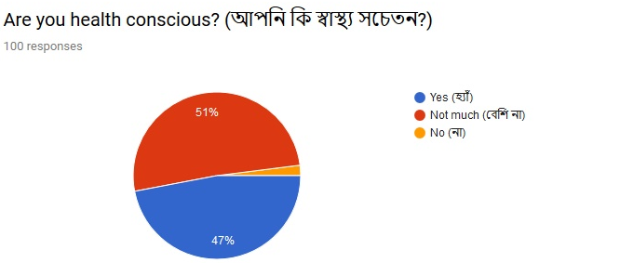
The best critics of the ACI brand, products and services are its customers. Knowing what he liked and hated his experience with ACI, the company can identify weaknesses or positive aspects of its products and/or services. As a result, ACI can correct its weak points and improve them even before they destroy the business. Here, are the survey responses that I have prepared on Google From and collected information for ACI Nutrilife Rice Bran Oil from 100 random customers. The questionnaire of the survey is added in the Appendix part of the report. An interpretation is also given in below of each response so that any reader of the report can easily understand the meaning of the pie charts.
Interpretation:
Among 100 random customers, 51% (51) have response that they are not much health conscious and 47% (47) replied that they care about their health. Only 2% are there, who replied that they are not aware of their health.
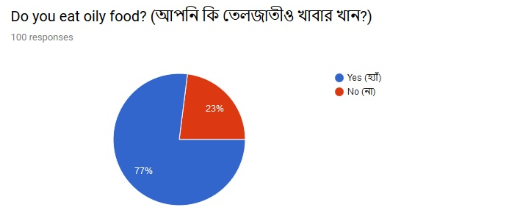
Interpretation:
Among 100 random customers, 77% responded “yes” means they eat oily foods and on the other hand, 23% customers said they do not eat any oily food.
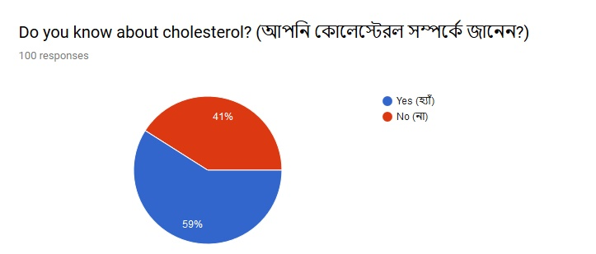
Interpretation:
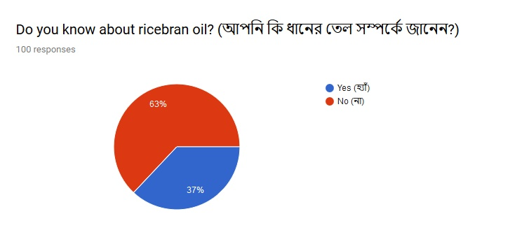
From 100 customers replied in this question, 59% are aware about cholesterol and 41% (41) people don’t have any idea of cholesterol.
Interpretation:
Among 100 consumers, 63% replied they know about the rice bran oil and there are 37% of the customers, who have no idea of rice bran oil.
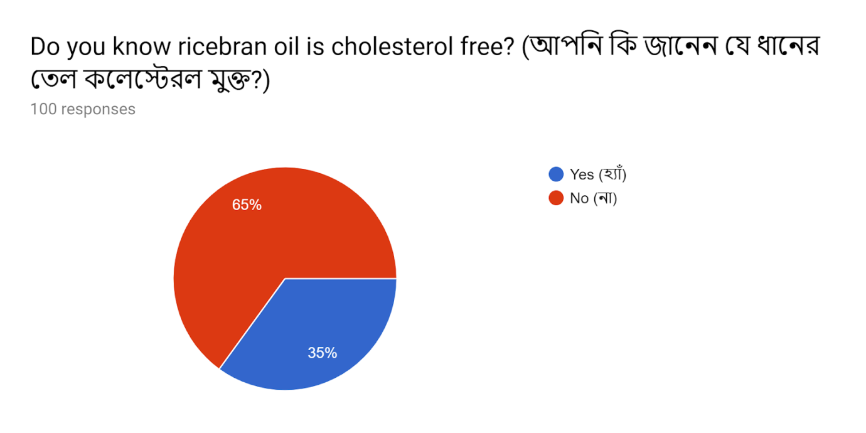
Interpretation:
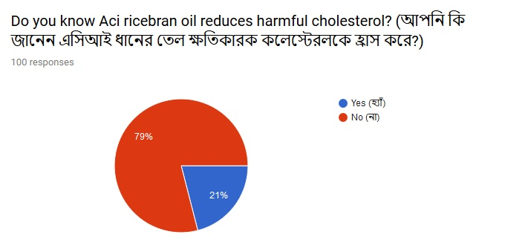
Among the consumers who responded in this question, 65% (65) know that rice bran oil is cholesterol free and on the other hand 35% (35) consumers don’t know about it.
Interpretation:
Among 100 responses of consumer, 79% (79) have replied that they know the ACI Nutrilife rice bran oil reduces harmful cholesterol. There are also 21% (21) consumers who don’t know neither ACI rice bran oil nor its benefits.
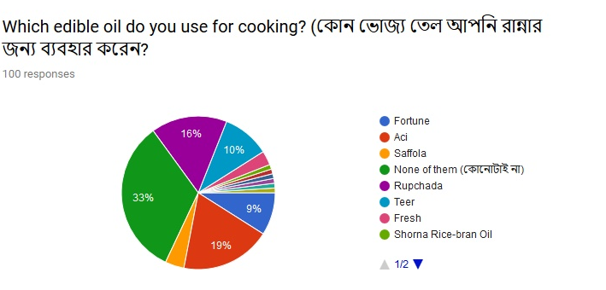
Interpretation:
Several responses had come in this question on several types. Among 100 customers responded in this question, 33% have said that they doesn’t use any of the brand’s oil mentioned in the option. 19% are using the ACI Nutrilife rice bran oil, 16% are using Rupchada soybean oil, and 10% are using TEER Soybean oil. And rest of other are using few other soybean oil of different brands.
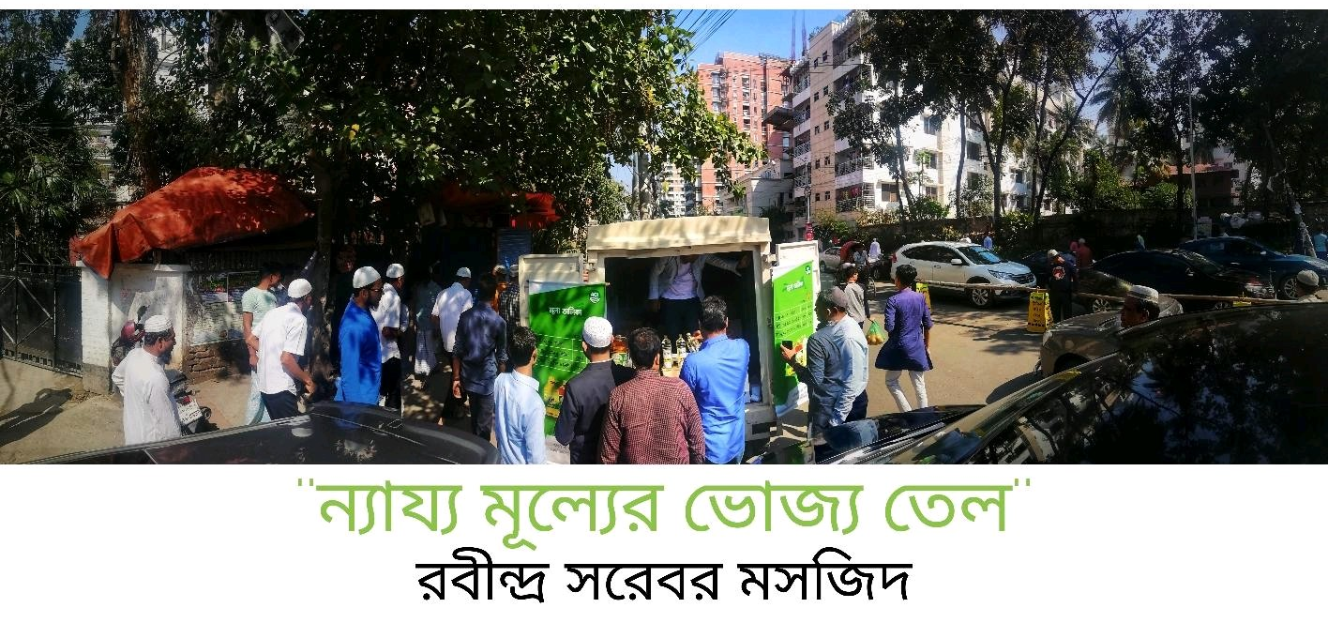

Chapter Five: Recommendations and Conclusion

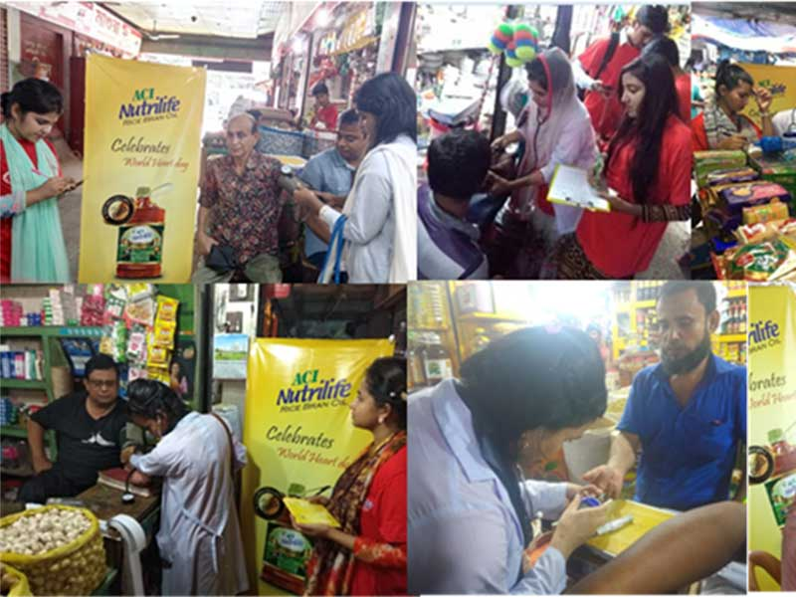

5.1 Recommendations
From the survey responses, we have already know that the consumer who use oil in their daily household chores are aware about the brand of ACI as well as about the ACI Nutrilife rice bran oil, but very few of them are actually using it. Most of them are using oils of different manufacturers. Therefore, in this chapter, I would like to recommend few suggestion to the ACI brand according to my academic knowledge so that they can take few initiative to increase the knowledge of rice bran oil in consumers and maximize their sales.

- The most effective aspect of social networks is that they work quickly and are easy to use. It allows brands to connect quickly with their consumers via one of their platforms. Consumers are now also turning to Twitter or Facebook to share their experiences and expect to receive a response from their favorite businesses within 24 to 48 hours. Therefore, ACI's Nutrilife rice bran oil must establish a relationship with its loyal consumers on social networks and must response to their queries quickly.

- Promotional activates can be performed highlighting all the facts and benefits of ACI Nutrilife Rice Bran Oil.

- ACI may choose to distribute the material for ACI Nutrilife rice bran oil at fairs, shop windows, car park or in any other densely populated area.

- Customer service must not only be responsive, but ACI must also inform its customers of its brand of ACI Nutrilife rice bran oil. For example, share information that rice bran oils are better than soybean oil, because most of the time we have discovered that soybean oil is a defective oil palm or a mixture of oil. Therefore, it is better to switch to rice bran oil.

- An excellent way to increase sales of the product of the market is to ensure that sales are highly recognized for the quality of the brand's products. For example, if the consumer buys low-grade oil and the seller offers ACI Nutrilife rice bran oil sharing the benefits, the seller improves the customer's perception and awareness of his health.

- Informative and fresh content is one of the main elements that attract potential customers and new visitors. ACI can update its content by posting a blog that presents the latest business news, key technical paper findings and news topics about ACI and its products. The new content will also help the ACI website to appear in the search engines.

5.2 Conclusion
ACI Edible Oils Limited is committed to providing the best consumer products to improve the lives and health of the people of Bangladesh. However, after analyzing consumers' perception of rice bran oil, we found that most Bangladeshi consumers were unaware of the availability of Nutrilife rice bran oil in the market. It was also noted that the initiatives taken by ACI Edible Oil are not sufficiently satisfying to promote the knowledge of the standards to benefit brands and consumers. As a result, a lot of advertising in rural areas, on the street or in the media can inform people about ACI Nutrilife Rice Bran Oil.
The purpose of the Internship Report is to analyze consumer perceptions about ACI Nutrilife Rice Bran Oil and after analyzing 100 customer responses, it is clear that the products in this category are not going well, as consumers will not generally be able to buy this rice bran oil compared to other competitors' soybean oil. Therefore, ACI consumer brand is required to provide a high concentration in the particular product line.

Reference
(1) Product information are taken from websites of ACI Edible OIL. Available at: https://www.aci-bd.com/sub_edible_oil.php
(2) Company information are taken from the websites of ACI Consumer Brand. Available at: https://www.aci-bd.com/consumer.php

(3) Rice bran oil raises hopes for cuts in imports. Article from Daily star. Published on 8th March 2015. Available at: https://www.thedailystar.net/rice-bran-oil-raises-hopes-for-cuts-in-imports-58889.
(4) ACI sells household brands to US firm for Tk 250.54cr. (2016, August 5). Available at: Http:/ www. thedailystar.net/business/aci‐sells‐household‐brands‐us‐firm‐tk‐25054cr‐79282.
(5) Wee, C. S., Ariff, M.S.B.M., Zakuan, N. and Tajuddin, M. N. M. (2016). Consumer perception, purchase intention and real buying behavior of organic food products. Review of Business Research and Integrative Economics, 3 (2), 378-397.
(6) Yap, M.C., Tong, D.Y.K. and Lai, K.P. (2012). Consumer perception and impressions of international supermarkets of the brand's products. International Journal of Social Sciences and Humanities, 3 (1), 271-280.
(7) Alam, M. S., & Faruqui, M. F. (2017). Effect of product knowledge on Consumer Brand Preference: A Case Study on ACI EDIBLE OIL of Bangladeshi Consumers. 2(3), 56–65.

Appendix
- Questionnaire
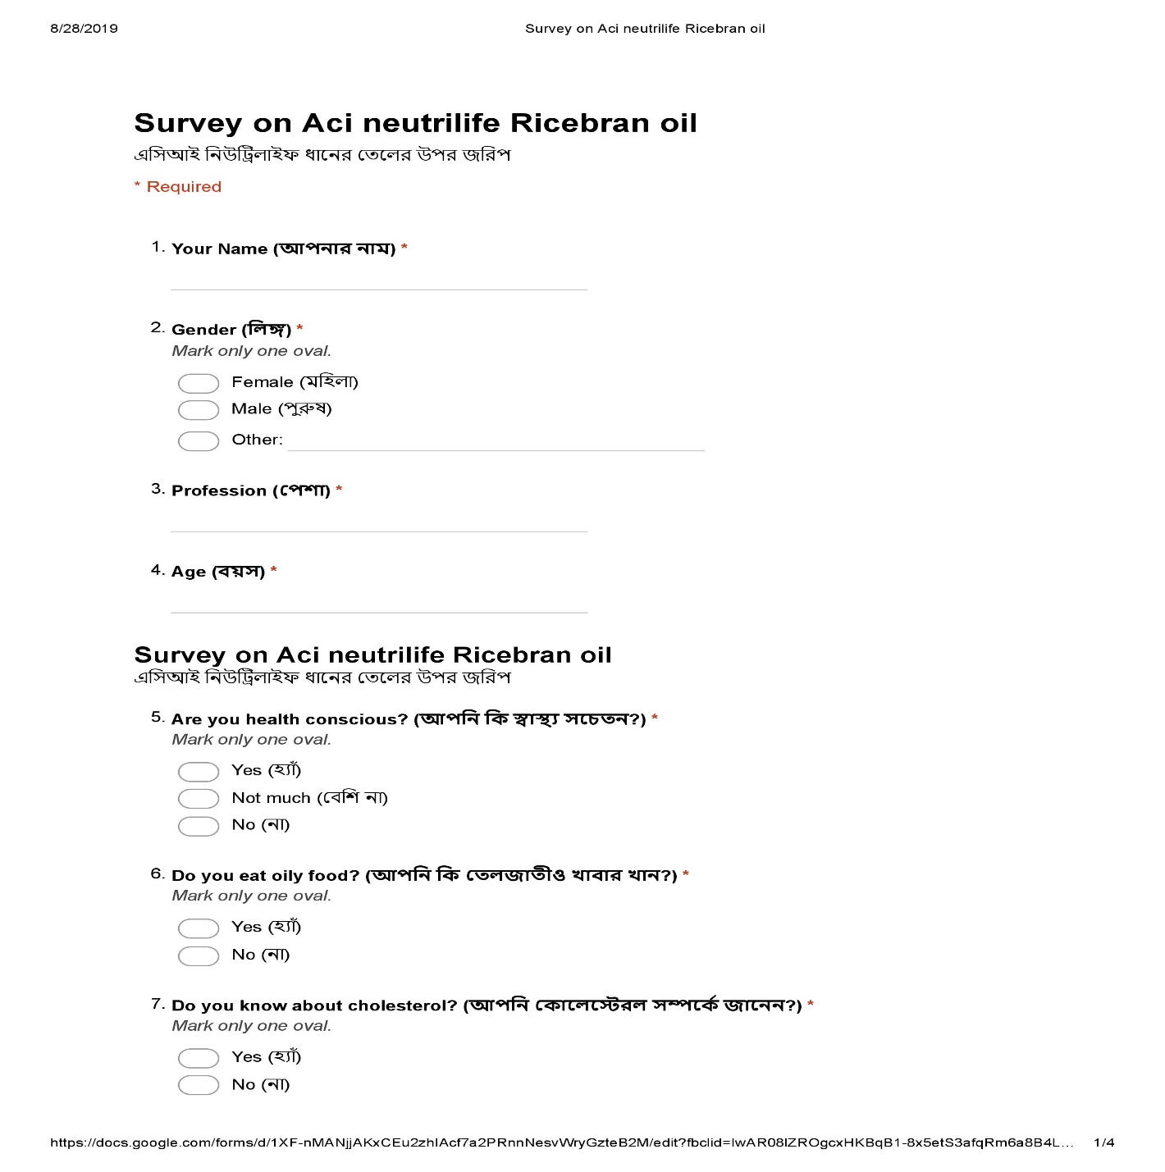
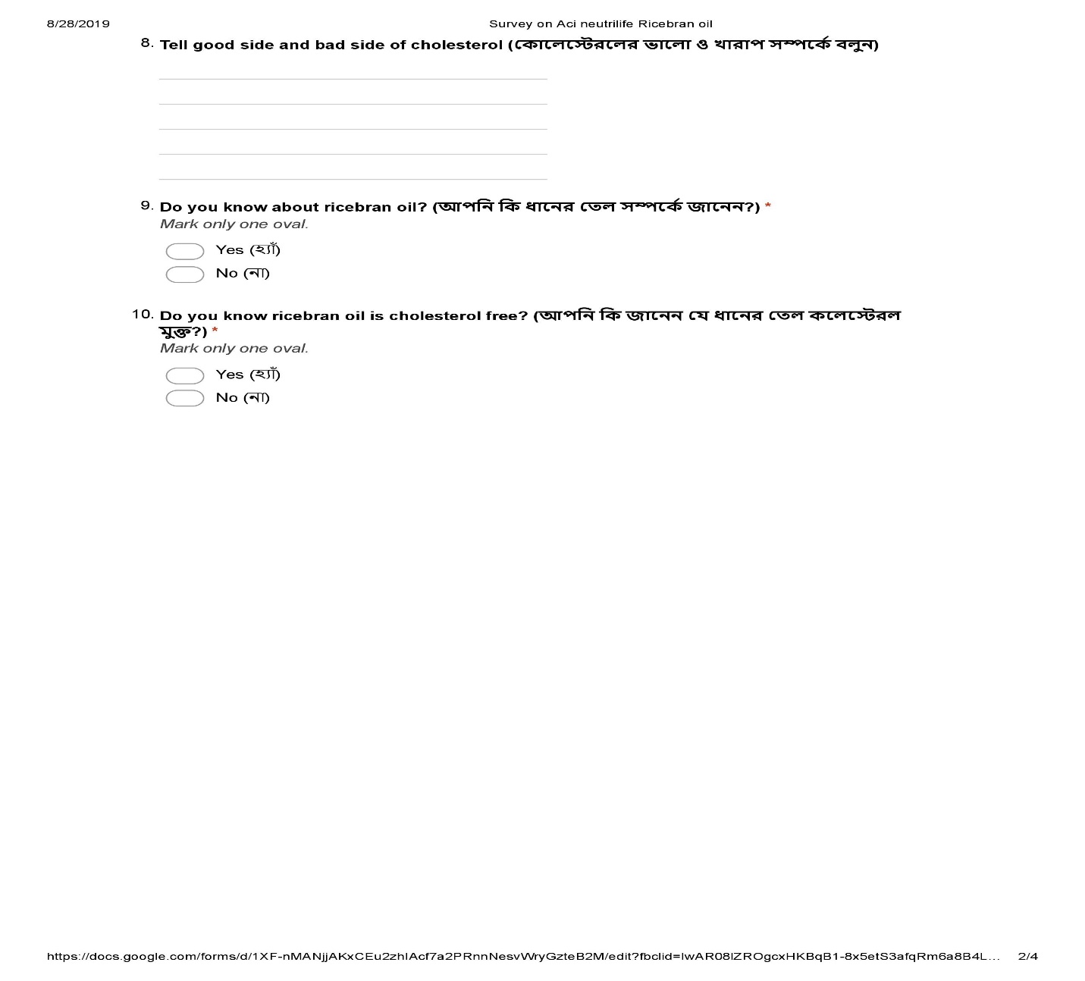
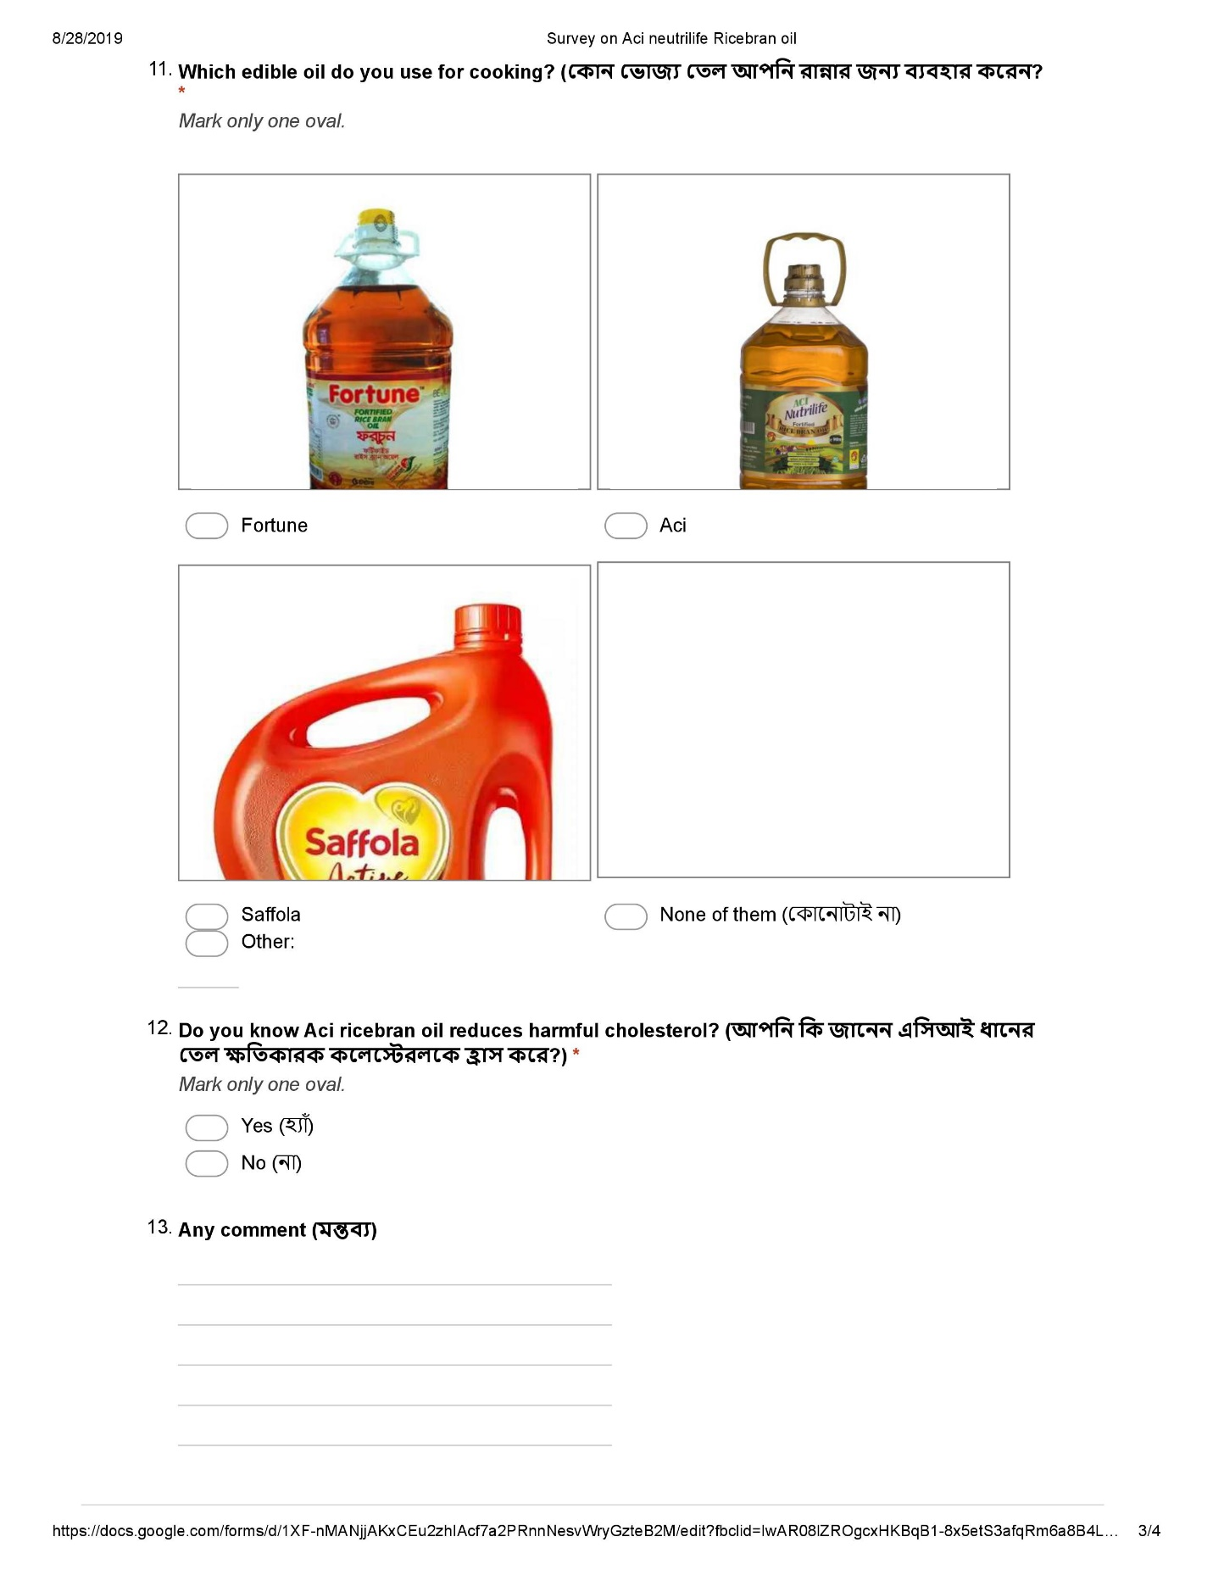
All responses in a chart

Your Name (আপনার নাম) | Age (বয়স) | Profession (পেশা) | Are you health conscious? (আপনি কি স্বাস্থ্য সচেতন?) | Do you eat oily food? (আপনি কি তেলজাতীও খাবার খান?) | Do you know about cholesterol? (আপনি কোলেস্টেরল সম্পর্কে জানেন?) | Do you know about ricebran oil? (আপনি কি ধানের তেল সম্পর্কে জানেন?) | Do you know ricebran oil is cholesterol free? (আপনি কি জানেন যে ধানের তেল কলেস্টেরল মুক্ত?) | Which edible oil do you use for cooking? (কোন ভোজ্য তেল আপনি রান্নার জন্য ব্যবহার করেন? | Do you know Aci ricebran oil reduces harmful cholesterol? (আপনি কি জানেন এসিআই ধানের তেল ক্ষতিকারক কলেস্টেরলকে হ্রাস করে?)
Samin Yasar | 39 | Service Holder | Yes (হ্যাঁ) | No (না) | Yes (হ্যাঁ) | No (না) | No (না) | None of them | No (না)
Nusrat | 25 | Marketing Intern | Not much (বেশি না) | Yes (হ্যাঁ) | Yes (হ্যাঁ) | Yes (হ্যাঁ) | Yes (হ্যাঁ) | shorna | Yes (হ্যাঁ)
Afia | 24 | Student | Not much (বেশি না) | Yes (হ্যাঁ) | No (না) | Yes (হ্যাঁ) | Yes (হ্যাঁ) | None of them (কোনোটাই না) | No (না)
Nitol | 24 | Student | Yes (হ্যাঁ) | Yes (হ্যাঁ) | Yes (হ্যাঁ) | Yes (হ্যাঁ) | Yes (হ্যাঁ) | None of them (কোনোটাই না) | Yes (হ্যাঁ)
S M Mushfiq | 26 | Student | Yes (হ্যাঁ) | Yes (হ্যাঁ) | Yes (হ্যাঁ) | Yes (হ্যাঁ) | Yes (হ্যাঁ) | Shorna Rice-bran Oil | No (না)
MD. ASHRAF SIKDER | 28 | FRONT OFFICE EXECUTIVE OF AMBASSADOR RESIDENCY | Yes (হ্যাঁ) | Yes (হ্যাঁ) | Yes (হ্যাঁ) | No (না) | No (না) | Aci | No (না)
Md Mahmudul hasan | 23 | Service holder | Yes (হ্যাঁ) | No (না) | No (না) | No (না) | No (না) | None of them (কোনোটাই না) | No (না)
Sadia | 25 | service holder | Not much (বেশি না) | Yes (হ্যাঁ) | Yes (হ্যাঁ) | Yes (হ্যাঁ) | No (না) | None of them (কোনোটাই না) | No (না)
Sara Hoque | 24 | Student | Not much (বেশি না) | No (না) | Yes (হ্যাঁ) | Yes (হ্যাঁ) | Yes (হ্যাঁ) | None of them (কোনোটাই না) | No (না)
Fozilatunnesa | 46 | House wife | Yes (হ্যাঁ) | No (না) | Yes (হ্যাঁ) | Yes (হ্যাঁ) | Yes (হ্যাঁ) | Aci | Yes (হ্যাঁ)
Irtefa waseek | 22 | Studemt | Not much (বেশি না) | No (না) | Yes (হ্যাঁ) | No (না) | No (না) | Aci | No (না)
Ishrak Rahman | 25 | Student | Yes (হ্যাঁ) | Yes (হ্যাঁ) | Yes (হ্যাঁ) | Yes (হ্যাঁ) | No (না) | None of them (কোনোটাই না) | No (না)
Md. Abu Zafor Shojib | 30 | Private Job | Not much (বেশি না) | Yes (হ্যাঁ) | Yes (হ্যাঁ) | No (না) | No (না) | Teer | No (না)
Nusrat | Marketing Intern | Student | Not much (বেশি না) | Yes (হ্যাঁ) | Yes (হ্যাঁ) | Yes (হ্যাঁ) | Yes (হ্যাঁ) | shorn | Yes (হ্যাঁ)
Jinia Rahman Jui | 23 | Employment | Not much (বেশি না) | Yes (হ্যাঁ) | Yes (হ্যাঁ) | No (না) | No (না) | Teer | No (না)
Sanjida | 24 | Student | Yes (হ্যাঁ) | No (না) | Yes (হ্যাঁ) | No (না) | No (না) | None of them (কোনোটাই না) | No (না)
Aslam | 22 | Studdent | Not much (বেশি না) | Yes (হ্যাঁ) | Yes (হ্যাঁ) | No (না) | No (না) | None of them (কোনোটাই না) | No (না)
Tanzia Hossain Zinia | 24 | Student | Yes (হ্যাঁ) | Yes (হ্যাঁ) | Yes (হ্যাঁ) | Yes (হ্যাঁ) | Yes (হ্যাঁ) | Olitalia sunflower oil. | Yes (হ্যাঁ)
John Doe | 23 | Student | Not much (বেশি না) | Yes (হ্যাঁ) | Yes (হ্যাঁ) | Yes (হ্যাঁ) | Yes (হ্যাঁ) | Aci | No (না)
Rakib | 24 | Entrepreneur | Not much (বেশি না) | Yes (হ্যাঁ) | No (না) | No (না) | No (না) | Aci | No (না)
Atik | 27 | Business | Yes (হ্যাঁ) | Yes (হ্যাঁ) | Yes (হ্যাঁ) | No (না) | No (না) | None of them (কোনোটাই না) | No (না)
Antu | 24 | Student | Not much (বেশি না) | Yes (হ্যাঁ) | Yes (হ্যাঁ) | No (না) | No (না) | Rupchada | No (না)
Raj | 26 | Job Holder | Yes (হ্যাঁ) | Yes (হ্যাঁ) | No (না) | No (না) | No (না) | Teer | No (না)
Yashir salman | 24 | student | Yes (হ্যাঁ) | Yes (হ্যাঁ) | Yes (হ্যাঁ) | Yes (হ্যাঁ) | Yes (হ্যাঁ) | None of them (কোনোটাই না) | Yes (হ্যাঁ)
Nesar Ahmad | 25 | Business | Not much (বেশি না) | Yes (হ্যাঁ) | Yes (হ্যাঁ) | Yes (হ্যাঁ) | Yes (হ্যাঁ) | None of them (কোনোটাই না) | No (না)
Shanchay | 25+ | Student | Not much (বেশি না) | Yes (হ্যাঁ) | Yes (হ্যাঁ) | No (না) | No (না) | Aci | No (না)
Md. Abu Naser | 27 | Students | Not much (বেশি না) | Yes (হ্যাঁ) | Yes (হ্যাঁ) | No (না) | No (না) | None of them (কোনোটাই না) | No (না)
Syed Muhimeen Ahmed | 24 | Student | Yes (হ্যাঁ) | Yes (হ্যাঁ) | Yes (হ্যাঁ) | Yes (হ্যাঁ) | No (না) | None of them (কোনোটাই না) | No (না)
Tanmoy Mahmud | 29 | Graphic Designer | Not much (বেশি না) | Yes (হ্যাঁ) | No (না) | No (না) | Yes (হ্যাঁ) | None of them (কোনোটাই না) | No (না)
Minar | 28 | Job Holder | Yes (হ্যাঁ) | Yes (হ্যাঁ) | Yes (হ্যাঁ) | No (না) | No (না) | None of them (কোনোটাই না) | No (না)
rashed | 24 | student | Not much (বেশি না) | Yes (হ্যাঁ) | Yes (হ্যাঁ) | Yes (হ্যাঁ) | Yes (হ্যাঁ) | None of them (কোনোটাই না) | No (না)
Chisti | 23 | Student | Not much (বেশি না) | Yes (হ্যাঁ) | Yes (হ্যাঁ) | No (না) | No (না) | Aci | No (না)
Md. Omor Faruk | 26 | Service | Not much (বেশি না) | No (না) | Yes (হ্যাঁ) | No (না) | No (না) | Saffola | No (না)
Rizwazul | 25 | Businesman | Not much (বেশি না) | Yes (হ্যাঁ) | Yes (হ্যাঁ) | Yes (হ্যাঁ) | No (না) | None of them (কোনোটাই না) | No (না)
Moon | 23 | Student | Not much (বেশি না) | Yes (হ্যাঁ) | Yes (হ্যাঁ) | No (না) | No (না) | None of them (কোনোটাই না) | No (না)
Zarin tasnim | 25 | Student | Yes (হ্যাঁ) | No (না) | Yes (হ্যাঁ) | Yes (হ্যাঁ) | Yes (হ্যাঁ) | Aci | Yes (হ্যাঁ)
Md.Mahfuzur | 20 | Student | Yes (হ্যাঁ) | Yes (হ্যাঁ) | Yes (হ্যাঁ) | No (না) | No (না) | Aci | No (না)
Nowrin | 28 | Service holder | Not much (বেশি না) | Yes (হ্যাঁ) | Yes (হ্যাঁ) | No (না) | Yes (হ্যাঁ) | None of them (কোনোটাই না) | Yes (হ্যাঁ)
Nazmul huda | 24 | Student | Not much (বেশি না) | Yes (হ্যাঁ) | No (না) | Yes (হ্যাঁ) | No (না) | Fortune | No (না)
Shuvo | 25 | Student | Yes (হ্যাঁ) | Yes (হ্যাঁ) | No (না) | No (না) | No (না) | None of them (কোনোটাই না) | No (না)
Md. Efthekhar-Bin-Alam | 25 | Student | Not much (বেশি না) | Yes (হ্যাঁ) | Yes (হ্যাঁ) | Yes (হ্যাঁ) | Yes (হ্যাঁ) | Teer | Yes (হ্যাঁ)
Md. Efthekhar-Bin-Alam | 25 | Student | Not much (বেশি না) | Yes (হ্যাঁ) | Yes (হ্যাঁ) | Yes (হ্যাঁ) | Yes (হ্যাঁ) | Teer | Yes (হ্যাঁ)
Afsana | 24 | unemployed | Not much (বেশি না) | Yes (হ্যাঁ) | Yes (হ্যাঁ) | No (না) | No (না) | None of them (কোনোটাই না) | No (না)
Alauddin Salam | 26 | Job | Yes (হ্যাঁ) | Yes (হ্যাঁ) | Yes (হ্যাঁ) | No (না) | No (না) | Aci | No (না)
Hosnayara Hossain | 18 | Student | Yes (হ্যাঁ) | Yes (হ্যাঁ) | No (না) | No (না) | No (না) | None of them (কোনোটাই না) | No (না)
Sheikh sadi | 27 | Student | Not much (বেশি না) | Yes (হ্যাঁ) | Yes (হ্যাঁ) | No (না) | No (না) | Fortune | No (না)
Azmine Iktider | 22 | Student | Yes (হ্যাঁ) | Yes (হ্যাঁ) | No (না) | No (না) | No (না) | Rupchada | No (না)
Md Mushfiqur Rahman | 27 | Student | Yes (হ্যাঁ) | No (না) | Yes (হ্যাঁ) | Yes (হ্যাঁ) | Yes (হ্যাঁ) | Aci | No (না)
Seefat Akram | 28 | Student | Yes (হ্যাঁ) | Yes (হ্যাঁ) | Yes (হ্যাঁ) | No (না) | No (না) | USA er CRISCO Vegetable Oil | No (না)
Rafiqul Islam | 28 | Engineer | Yes (হ্যাঁ) | No (না) | Yes (হ্যাঁ) | Yes (হ্যাঁ) | No (না) | None of them (কোনোটাই না) | No (না)
Aumi | 24 | Businessman | Yes (হ্যাঁ) | Yes (হ্যাঁ) | Yes (হ্যাঁ) | No (না) | No (না) | Saffola | No (না)
Ishtiaq Ahmed | 18 | Job | No (না) | Yes (হ্যাঁ) | No (না) | No (না) | No (না) | Doesn’t matter, all the f**ks are the same | No (না)
Nabil Ahsan | 27 | Student | Not much (বেশি না) | Yes (হ্যাঁ) | No (না) | No (না) | No (না) | TEER | No (না)
Sharif | 25 | Student | Not much (বেশি না) | Yes (হ্যাঁ) | Yes (হ্যাঁ) | Yes (হ্যাঁ) | Yes (হ্যাঁ) | Fortune | Yes (হ্যাঁ)
Annesha | 23 | Doctor | Yes (হ্যাঁ) | Yes (হ্যাঁ) | Yes (হ্যাঁ) | No (না) | No (না) | None of them (কোনোটাই না) | No (না)
Annesha | 23 | Doctor | Yes (হ্যাঁ) | Yes (হ্যাঁ) | Yes (হ্যাঁ) | No (না) | No (না) | None of them (কোনোটাই না) | No (না)
নিষাদ আদনান | 23 | ছাত্র | Yes (হ্যাঁ) | Yes (হ্যাঁ) | Yes (হ্যাঁ) | No (না) | No (না) | None of them (কোনোটাই না) | No (না)
Azmine Iktider | 22 | Student | Yes (হ্যাঁ) | Yes (হ্যাঁ) | No (না) | No (না) | No (না) | Rupchada | No (না)
Nasreen | 36 | House wife | Not much (বেশি না) | Yes (হ্যাঁ) | Yes (হ্যাঁ) | No (না) | No (না) | None of them (কোনোটাই না) | No (না)
Nahar | 32 | Housewife | Not much (বেশি না) | Yes (হ্যাঁ) | Yes (হ্যাঁ) | Yes (হ্যাঁ) | Yes (হ্যাঁ) | Rupchada | No (না)
Runa | 35 | Housewife | Yes (হ্যাঁ) | No (না) | Yes (হ্যাঁ) | Yes (হ্যাঁ) | Yes (হ্যাঁ) | None of them (কোনোটাই না) | No (না)
Nusrat Jahan Akhter | 24 | Student | No (না) | Yes (হ্যাঁ) | Yes (হ্যাঁ) | Yes (হ্যাঁ) | Yes (হ্যাঁ) | Saffola | Yes (হ্যাঁ)
Rajib | 22 | Student | Not much (বেশি না) | Yes (হ্যাঁ) | Yes (হ্যাঁ) | No (না) | No (না) | None of them (কোনোটাই না) | No (না)
Razzaq | 24 | Student | Not much (বেশি না) | Yes (হ্যাঁ) | No (না) | No (না) | No (না) | Teer | No (না)
Anam Hossain | 25 | Student | Not much (বেশি না) | Yes (হ্যাঁ) | Yes (হ্যাঁ) | Yes (হ্যাঁ) | Yes (হ্যাঁ) | Teer | No (না)
Ruffe Mohammad Khan | 25 | Student | Not much (বেশি না) | Yes (হ্যাঁ) | Yes (হ্যাঁ) | Yes (হ্যাঁ) | Yes (হ্যাঁ) | None of them (কোনোটাই না) | No (না)
Rabbi | 26 | Businessman | Not much (বেশি না) | Yes (হ্যাঁ) | Yes (হ্যাঁ) | Yes (হ্যাঁ) | Yes (হ্যাঁ) | Aci | Yes (হ্যাঁ)
Sunny | 26 | Businessman | Not much (বেশি না) | Yes (হ্যাঁ) | Yes (হ্যাঁ) | No (না) | No (না) | Rupchada | No (না)
Abir khondokar | 25 | Student | Not much (বেশি না) | Yes (হ্যাঁ) | No (না) | No (না) | No (না) | Teer | No (না)
Rizvi | 24 | Student | Not much (বেশি না) | Yes (হ্যাঁ) | Yes (হ্যাঁ) | No (না) | No (না) | None of them (কোনোটাই না) | No (না)
Sojib | 28 | Service holder | Yes (হ্যাঁ) | Yes (হ্যাঁ) | Yes (হ্যাঁ) | Yes (হ্যাঁ) | Yes (হ্যাঁ) | Fortune | No (না)
Kazi Shafiqul Islam Rummon | 30 | Service holder | Not much (বেশি না) | Yes (হ্যাঁ) | No (না) | No (না) | No (না) | Teer | No (না)
Afsana Mumu | 23 | Student | Not much (বেশি না) | Yes (হ্যাঁ) | Yes (হ্যাঁ) | No (না) | No (না) | Rupchada | No (না)
Rafeed Rahman | 24 | Student | Not much (বেশি না) | Yes (হ্যাঁ) | Yes (হ্যাঁ) | Yes (হ্যাঁ) | Yes (হ্যাঁ) | Aci | Yes (হ্যাঁ)
Shabiha Siddika | 29 | Teacher | Not much (বেশি না) | Yes (হ্যাঁ) | Yes (হ্যাঁ) | No (না) | No (না) | Teer | No (না)
Rushna Ferdous | 25 | Student | Not much (বেশি না) | Yes (হ্যাঁ) | No (না) | No (না) | No (না) | Rupchada | No (না)
Haseeb Nabi Rana | 24 | Student | Yes (হ্যাঁ) | No (না) | Yes (হ্যাঁ) | Yes (হ্যাঁ) | Yes (হ্যাঁ) | None of them (কোনোটাই না) | No (না)
Kazi Raju | 30 | Service holder | Not much (বেশি না) | Yes (হ্যাঁ) | No (না) | No (না) | No (না) | Teer | No (না)
Ashraf Emon | 22 | Student | Not much (বেশি না) | Yes (হ্যাঁ) | No (না) | No (না) | No (না) | Rupchada | No (না)
Faisal Hossain | 25 | Service holder | Not much (বেশি না) | Yes (হ্যাঁ) | Yes (হ্যাঁ) | No (না) | No (না) | Teer | No (না)
zabun nesa | 50 | Housewife | Yes (হ্যাঁ) | Yes (হ্যাঁ) | No (না) | Yes (হ্যাঁ) | Yes (হ্যাঁ) | Rupchada | No (না)
Jannatul Nur Resmi | 26 | Housewife | Yes (হ্যাঁ) | No (না) | No (না) | No (না) | No (না) | Rupchada | Yes (হ্যাঁ)
Abu Taher Chowdhury | 55 | Business man | Not much (বেশি না) | No (না) | No (না) | Yes (হ্যাঁ) | Yes (হ্যাঁ) | Rupchada | Yes (হ্যাঁ)
Salauddin Chowdhury | 40 | business man | Yes (হ্যাঁ) | No (না) | No (না) | Yes (হ্যাঁ) | Yes (হ্যাঁ) | Fortune | Yes (হ্যাঁ)
Laila Bilkis | 22 | student | Yes (হ্যাঁ) | Yes (হ্যাঁ) | No (না) | No (না) | Yes (হ্যাঁ) | Aci | Yes (হ্যাঁ)
Laila Bilkis | 22 | student | Yes (হ্যাঁ) | Yes (হ্যাঁ) | No (না) | No (না) | Yes (হ্যাঁ) | Aci | Yes (হ্যাঁ)
Laila Bilkis | 22 | student | Yes (হ্যাঁ) | Yes (হ্যাঁ) | No (না) | No (না) | Yes (হ্যাঁ) | Aci | Yes (হ্যাঁ)
Asaduzzaman Asad | 25 | student | Not much (বেশি না) | Yes (হ্যাঁ) | No (না) | Yes (হ্যাঁ) | Yes (হ্যাঁ) | Rupchada | Yes (হ্যাঁ)
Asaduzzaman Asad | 25 | student | Not much (বেশি না) | Yes (হ্যাঁ) | No (না) | Yes (হ্যাঁ) | Yes (হ্যাঁ) | Rupchada | Yes (হ্যাঁ)
Rubina Nazmun Nahar | 35 | Housewife | Yes (হ্যাঁ) | Yes (হ্যাঁ) | No (না) | Yes (হ্যাঁ) | Yes (হ্যাঁ) | Fortune | No (না)
Raisul Islam Akash | 24 | musian | Not much (বেশি না) | No (না) | No (না) | No (না) | No (না) | Rupchada | No (না)
Tojammel Huque Toja | 23 | student | Yes (হ্যাঁ) | No (না) | No (না) | No (না) | No (না) | Saffola | No (না)
Tarif Tamjid | 29 | Doctor | Yes (হ্যাঁ) | No (না) | Yes (হ্যাঁ) | Yes (হ্যাঁ) | No (না) | Fortune | No (না)
Tarif Tamjid | 25 | student | Not much (বেশি না) | No (না) | No (না) | No (না) | No (না) | Aci | Yes (হ্যাঁ)
Nusrat Jahan Tanzia | 25 | Bekar | Not much (বেশি না) | Yes (হ্যাঁ) | No (না) | No (না) | No (না) | Aci | No (না)
Md Shahjahan Chowdhury | 26 | Student | Yes (হ্যাঁ) | Yes (হ্যাঁ) | No (না) | No (না) | No (না) | Rupchada | No (না)
Nahian Intisher | 28 | employee | Yes (হ্যাঁ) | Yes (হ্যাঁ) | No (না) | No (না) | No (না) | Fresh | No (না)
Mahir Chowdhury | 24 | Student | Yes (হ্যাঁ) | No (না) | No (না) | No (না) | No (না) | Fortune | No (না)
Rezaa Ars | 25 | Student | Yes (হ্যাঁ) | No (না) | No (না) | No (না) | No (না) | Fresh | No (না)
Md Hasib Khan | 27 | nothing | Yes (হ্যাঁ) | No (না) | No (না) | No (না) | No (না) | Rupchada | No (না)
Md Mostakim | 26 | bekar | Yes (হ্যাঁ) | No (না) | No (না) | No (না) | No (না) | Fresh | No (না)
Muhammad Riaz | 30 | employee | Yes (হ্যাঁ) | Yes (হ্যাঁ) | No (না) | Yes (হ্যাঁ) | Yes (হ্যাঁ) | Aci | Yes (হ্যাঁ)
R.s. Refat | 26 | Student | Yes (হ্যাঁ) | No (না) | No (না) | No (না) | No (না) | Fortune | No (না)

