Internship Report
On
Business Development Process of Susthotaa

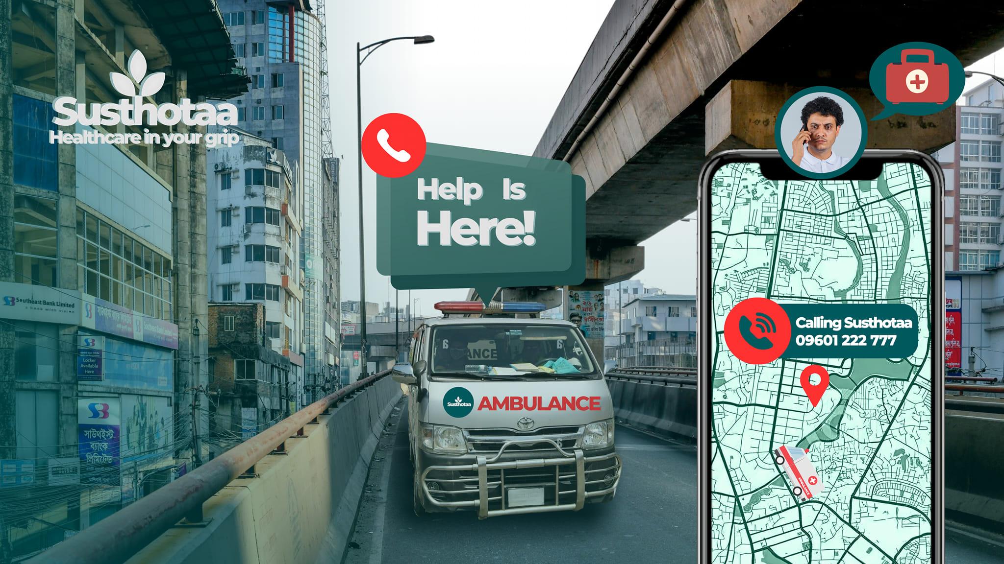

This report is submitted to the School of Businesses & Economics, United International University as a partial requirement for the fulfillment of Bachelor of Business Administration Degree.



Internship Report
On
Business Development Process of Susthotaa

Submitted by
Md Ashiqur Rahman
Program: BBA
ID: 111201154
School of Business and Economics
United International University

Submitted to
Muhammad Hasan Al-Mamun
Assistant Professor
School of Business and Economics
United International University

Date of submission: December 29, 2024

Acknowledgement

I would also like to thank all those who have made this a really great and enriching experience for me/ Let me take this opportunity first and foremost to give a hearty vote of thanks to Susthotaa - the leading health tech startup in Bangladesh - for giving an opportunity to work as an intern for three months in their Business Development program. I learned from my internship many things about how complex the healthcare facilitating organization is, and how Susthotaa is implementing futuristic ideas to recreate it.

I would like to express my deepest gratitude to my supervisor and my coworkers at Susthotaa for the supports, encouragement, and guidance provided during the internship period. Their wisdom, constructive feedback, and readiness to share have greatly helped me in my professional and personal development.

My academic institution, my faculty advisor Muhammad Hasan Al-Mamun sir, and everyone else who encouraged me and assisted me in pursuing the internship are very much appreciated. Their advice has greatly influenced my learning.

I want, last but not least, to express my deep appreciation to my family for the love, supports, and encouragement throughout this journey. It is through their confidence in me that courage was always given and inspiration to invest all in everything that is done. Thank you all.
.

Letter of Transmittal
December 29, 2024
Muhammad Hasan Al-Mamun
Associate Professor
School of Business and Economics
United International University

Subject: Submission of the report on “Business development Process of Susthotaa.”

Dear Sir,

It is an immense pleasure for me to submit the report on the successful completion of my internship on the business development process of Susthotaa. During the internship, I was placed in the Business Development division. I have worked hard and tried my best to follow all the instructions provided by my supervisor to complete the required tasks and thereby write the report in the way it is now.

I tried to follow the rules as well as the supervisor's instructions from my organization. While writing this report, I was able to learn about a number of topics like communication, marketing, and sales strategies. I am pleased to discuss any significant issues raised in the report.

I would like to express my deep gratitude for all your useful advice and constant attention during my internship and, when necessary, during the research preparation process. Thank you.

Sincerely,
________________________
Md Ashiqur Rahman
ID: 111201154
Program: BBA
School of Business and Economics
United International University

Executive Summary

This internship report deals with the business development process of Susthotaa, a Health-Tech company making huge strides in the healthcare industry of Bangladesh. The report throws light on Susthotaa's strategy for providing all-inclusive medical services, including worldwide medical treatments, diagnostic lab testing, and ambulance services. In this regard, during my internship, I had the opportunity to work closely with the team as a business development intern and assist in many facets of their expansion plan. Susthotaa, established in 2024, is committed to enhancing the standard and accessibility of healthcare through creative ideas. Its offerings are intended to cater to the increasing needs in telemedicine, emergency medical care, and medical tourism within and outside the country. Business development in general, especially the development of the ambulance service and international patient care, was a core of my internship.
At Susthotaa, I was assigned with the responsibility of business development, especially for the Ambulance Services, by visiting hospitals and interfacing with doctors. I was also involved in generating leads related to international medical treatments through the engagement of probable clients on social media platforms. In addition, the role involved me assisting in operational activities, documentation, and reporting.
The findings of the report provide deep insight into analyzing the business development strategies in practice by the company at present, including both pros and cons. As much as Susthotaa has been doing fantastically well, the study also points out where the company can improve its digital presence, optimize internal processes, and enhance customer acquisition and retention strategies.
Conclusions are drawn in the report regarding the improvement of Susthotaa's standing within the health sector. Development and optimization of digital marketing, increased follow-ups with clients, stronger collaboration with hospitals outside the country, and financial investment in employees are amongst several recommendations for improvements to Susthotaa. In the final analysis, this internship at Susthotaa has been a wholesome learning experience where I applied my knowledge in a practical scenario.

Keywords: Business Development Process, Susthotaa
Table of Contents
Acknowledgement 3
Letter of Transmittal 4
Executive Summary 5
Chapter 01 8
Introduction 8
Chapter 02 11
Company Overview & Competitive Analysis 11
2.1 Company Overview 12
2.1.1 Services Offered by Susthotaa 12
2.1.2 Key Strengths 14
2.1.3 Values and Mission 16
2.1.4 Vision for the Future 16
2.1.5 Susthotaa: A Lifeline for Critical Moments 16
2.2 Competitive Analysis 18
2.2.1 Competitor’s Overview 18
2.2.2 Analysis of Competitors 19
2.2.3 Susthotaa’s Competitive Positioning 20
2.2.4 Competitive Edge 21
2.2.5 Opportunities and Threats 22
2.2.6 Path Forward 23
Chapter 03 24
Objectives & Methodology of the Study 24
3.0 Objectives of the Study 25
3.1 Primary Objectives 25
3.2 Secondary Objectives 25
3.2 Methodology of the Study 26
3.2.1 Primary Data 26
3.2.2 Secondary Data 27
Chapter 04 28
Findings of the Study 28
4.1 Findings of the Study: 29
1. Client Acquisition Process 29
2. Lead Generation for International Medical Treatment 30
3. Operational Support and Documentation 32
4. Promotional Techniques and Their Effectiveness 33
5. General Thoughts and Insights 34
Chapter 05 35
Recommendation & Conclusions 35
5.1 Recommendations 36
5.2 Conclusions 41
References 42

Chapter 01

Introduction

Health facilities from reliable sources are no longer a luxury but also one of the dire needs of modern busy lifestyles when accidents may occur at any moment. Susthotaa is a Health-Tech firm in redesigning the way healthcare services are sought and delivered across Bangladesh. The purpose of the study is to give a comprehensive review of Susthotaa's business practices, tactics, and innovations that set it apart from other companies in the healthcare sector.

This report, therefore, sets out to explore and understand how Susthotaa blends compassion and innovation in giving its customers a seamless health experience. The study indicates the business development process that has so far been adopted by the organization in addressing the increasing demand for quality, easily accessible products.

This internship allowed me to closely observe the working of Susthotaa, know about its various difficulties, and appreciate how much it has improved the health department of Bangladesh. These go into this report, together with some suggestions for its growth plans and services.

Founded in 2024, Susthotaa had one ambitious goal: making healthcare services as simple and accessible as ordering food or a cab on the internet. With its main office in Baridhara, Dhaka, this business is swiftly setting its mark in Bangladesh's health technology vertical.
Susthotaa was founded upon the pillars of compassion, accessibility, and creativity, thus providing a 360-degree health experience through diverse programs with an aim of supporting people during their difficult periods. This is Susthotaa's offerings.

- Emergency Ambulance Services: The backbone of its operations, Susthotaa maintains a fleet of more than 400 AC ambulances, including 55 ICU ambulances and 100 freezing ambulances, strategically positioned to ensure rapid response times-usually within 20-25 minutes.

- International Medical Treatment and Telemedicine: In contrast, Susthotaa facilitates these patients who avail themselves of advanced medical treatments aboard via Malaysia, Singapore, Thailand, and India.
But where Susthotaa outshines is in making sure that everybody has easy access to health services. Susthotaa addresses this by collaborating with more than 170 hospitals all over the world, and also by introducing a call center that is open around the clock and user-friendly mobile applications.

It has a simple but striking mission statement: "To deliver an exceptional one-stop healthcare experience with compassion." The objective is to build an integrated high-value healthcare system that contributes to the goals of healthier communities and lifestyles in Bangladesh and beyond.
Susthotaa's strong infrastructure and creative approach are its main advantages. For instance:

- It has one of the most robust networks for air ambulance and dead body cargo services in the nation.
- More than ten locations dispersed throughout Bangladesh, assistance is always accessible.
- The company also offers a unique combination of medical tourism services, including follow-up care assistance, lodging, and medical visas for patients traveling abroad.

Susthotaa is way beyond a health technology company; it is a life support for people and their families in their most distressing times, while keeping its guiding principles of compassion, excellence, accessibility, and honesty intact.
The purpose of the study is to distill the core of the operations of Susthotaa and its influence on the healthcare sector, apart from providing insights on how its business development methods might be further improved for growth and scalability.

Chapter 02

Company Overview & Competitive Analysis

Susthotaa is a health-tech company, founded in 2024, pioneering in healthcare services such as medical tourism, telemedicine, and ambulance support in Bangladesh. Undoubtedly, the full-on approach differentiates it; however, the enrichment of customer experience and strengthening of digital presence is quite mandatory in this highly competitive business.

2.1 Company Overview

Susthotaa is a health-tech company whose work relates to the growing demand for effective, accessible, and available healthcare in Bangladesh. In fact, since its day of incorporation in 2024, Susthotaa had pledged to generate a well-rounded health-care atmosphere-where caring and technology amalgamated. Starting its function from Baridhara, Dhaka, within short intervals of time, it grows rapid as a reliable brand across their operation in the facilitation of emergency medical services, diagnostics, and overseas treatments.

The objective of Susthotaa, though simple, is profound: a complete health experience. Driven by this objective are its efforts toward building an ecosystem that contributes to healthier lifestyles and stronger communities. Susthotaa changes the game in the health sector of Bangladesh with its creative approach, wide network, and persistent commitment.

2.1.1 Services Offered by Susthotaa

With services intended for each phase of a patient's medical journey, Susthotaa works as a one-stop healthcare service provider. Its portfolio consists of:

- Emergency Ambulance Services:
The backbone of operations for Susthotaa is its fleet of ambulances. With more than 400 air-conditioned ambulances, of which 100 are freezing ambulances and 55 are intensive care unit ambulances, the organization is prepared for all types of crises. Its efficient fleet, which is very crucial in saving lives, ensures response times of only 20 to 25 minutes.
Susthotaa is well equipped with air ambulances, and dead body transports alongside the road ambulances. This will definitely help to bridge the gaps in the nation's health care by assuring that emergency medical transportation reaches even the most inaccessible areas.
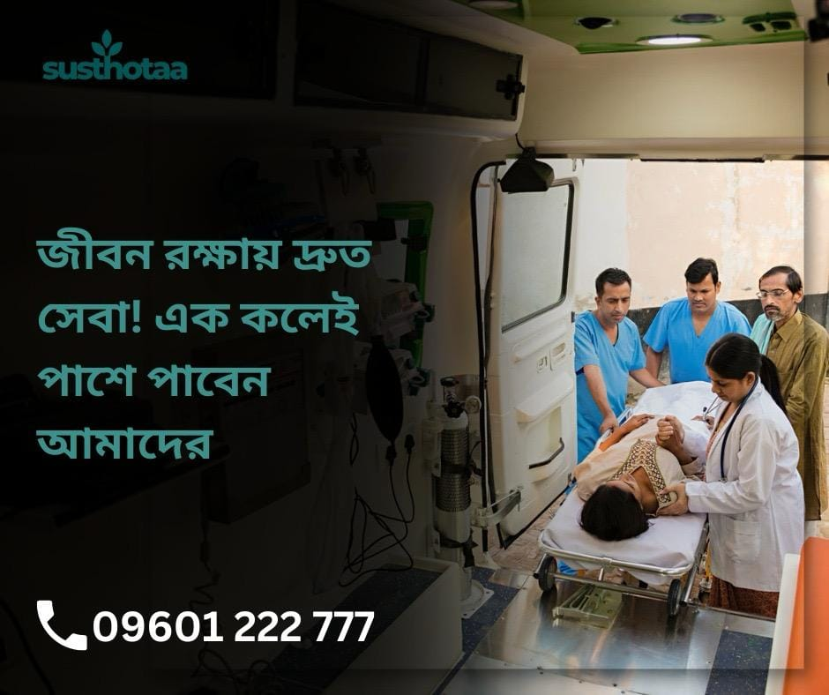

- International Medical Treatment and Telemedicine
Susthotaa is vital in the linking of patients to leading-edge medical institutions abroad. The organization offers smooth treatment experiences abroad through direct cooperation with hospitals in Malaysia, Singapore, Thailand, and India. It offers patients and their families aid with medical visas, treatment planning, airport transportation, lodging, and even sightseeing packages.

Another important side involves telemedicine, meaning for instance, that patients might get advice from top-level doctors without leaving their home.
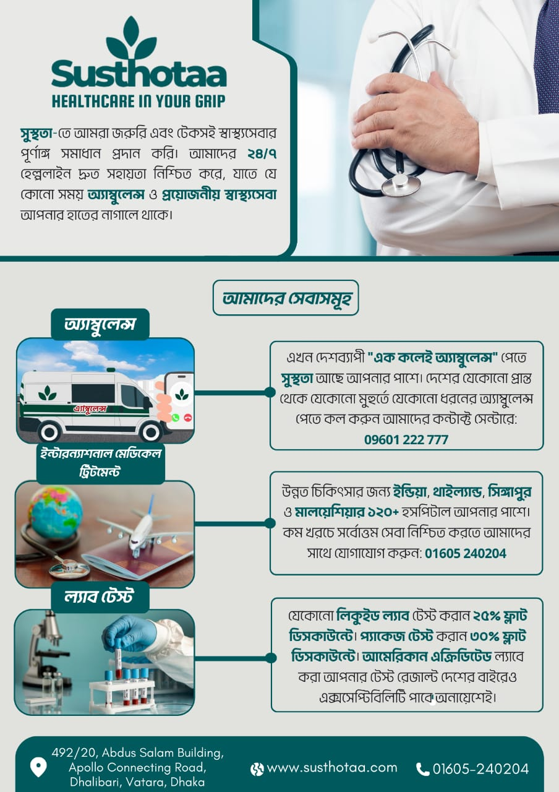

2.1.2 Key Strengths

Susthotaa is different from all other healthcare providers because of its unique blend of advanced technology, humane treatment, and business alliances. Some of the key advantages of the business are as follows:

- Wide Network and Accessibility
With over 10 locations in the country and alliances with more than 170 hospitals across the world, Susthotaa has established a wide network where help is always around. It assures access to services anytime, anywhere through the website, mobile application, or through the call center that works day and night.

- Cutting-Edge Facilities
Susthotaa enjoys the best medical facilities, including one of the strongest air ambulance and freight transportation networks in the country. Its focus on state-of-the-art technologies and logistics ensures timely and reliable services for the patients.

- Medical Tourism Competency
Susthotaa leads medical tourism in Bangladesh through the facilitation of the patient's every need outside the country. It claims to provide an 'end-to-end' service starting from visa assistance to follow-ups post-treatment, thus making treatment and travel one single, smooth experience, combining quality health care.

- Compassionate and Skilled Workforce
Susthotaa proudly boasts its team of highly qualified medical and non-medical specialists: from paramedics and diagnostic technicians to telemedicine consultants to ambulance drivers. All have proved to be committed with a mission of offering compassionate superior care.

- Solutions Driven by Technology
The website and the mobile app of the company facilitate easier scheduling of diagnostic tests, reservations for ambulances, and telemedicine use. Susthotaa ensures ease of use as expected by modern-day patients through the use of technology.

2.1.3 Values and Mission

Its mission, "To deliver an exceptional one-stop healthcare experience with compassion," reflects the organization’s dedication to creating a positive impact on the lives of its patients. Four basic tenets form the bedrock of operations at Susthotaa:
- Compassion: Leading with empathy, dignity, and respect in every interaction with patients and their families.
- Excellence: Innovating relentlessly to offer better care and services.
- Accessibility: Ensuring that no one is deprived of healthcare because of situations beyond their control.
- Integrity: Ensuring truthfulness, openness, and moral conduct in all aspects of its business operations.

The organization's mission, "To deliver an exceptional one-stop healthcare experience with compassion," indicates the commitment toward bringing change in the lives of its patients.

2.1.4 Vision for the Future

Susthotaa seeks a boundary-less healthcare system and strives to make quality medical services accessible to all. With a culture of continuous innovation and expanded reach, the company looks to set new standards in healthcare excellence not only within Bangladesh but beyond its shores.

2.1.5 Susthotaa: A Lifeline for Critical Moments
Susthotaa is not just a medical treatment center but a lifeline for the patient and the family members. Whether it's offering emergency services with unparalleled speed, coordinating foreign treatments involving complex processes, or simply being there during trying times with much-needed care, the organization stands as an embodiment of hope and dependability.
Susthotaa revolutionizes healthcare in Bangladesh by including an innovative and kind touch. It stands for proof that this is what could happen when human empathy and technology blend. Throughout growth and change, their commitment has continued to be centered on healthier lives and stronger communities.
In the years to come, Susthotaa's story will surely spur a revolution in healthcare, proving that high-quality treatment given with compassion can change lives and create a better, healthier future for all.
Susthotaa is more than a health technology firm; it's actually a lifeline to those patients in the most desperate part of their lives. Combining creativity and compassion, the organization is modernizing the face of Bangladesh's healthcare. Susthotaa remains steadfast to the commitment of improving lives and communities both at home and abroad as it undergoes further development and growth.

2.2 Competitive Analysis
Susthotaa operates in the lively and fiercely competitive healthcare industry of Bangladesh, where several organizations jostle for shares of the many different patient needs. Thus, in such a case, Susthotaa needs to understand the competitive scenario to be able to identity its strengths, potentials, and areas of improvement. The given report depicts the standing of Susthotaa in the market through highlighting its key competitors and their offerings, and through which Susthotaa differentiates itself from.

2.2.1 Competitor’s Overview
The two major competitors of Susthotaa are MediAider and HealthPort, both of which are well-known companies in the field of medicine. Each competitor has created a unique market segment and offers unique services. We can get a better idea about the competitive advantages of Susthotaa by examining the pros and cons of each of them.
Competitor | Key Services | Strengths | Weaknesses
HealthPort | International Medical Sevice, diagnostic testing, telemedicine | Nationwide availability, integrated service portfolio, robust digital platform | High pricing for premium services; slower emergency response times
MediAider | Emergency services, medical consultancy, health monitoring | Specialization in health monitoring and consultancy; strong hospital affiliations | Limited ambulance fleet; less focus on medical tourism
Sheba.xyz | Ambulance booking, home services | Technology-driven platform with wide accessibility | Limited to service booking; lacks broader healthcare solutions
Red Crescent Ambulance | Ambulance services | Reliable and long-established network | Limited service scope beyond ambulance provision
MedTour Bangladesh | Medical tourism | Focused on international treatment with strong hospital partnerships | Restricted to medical travel; lacks localized patient support
Doctorola | Telemedicine and doctor appointments | Easy-to-use app for connecting with doctors | Limited involvement in emergency or diagnostic services

2.2.2 Analysis of Competitors
HealthPort: HealthPort has emerged as a significant player with a wide range of healthcare-related services. The fact that they can offer emergency care, telemedicine, and diagnostic testing under one roof has been able to create a distinctive value proposition for them. Simultaneously, the middle- and lower-income groups find them less approachable because of their pricing strategy. Secondly, their emergency response times might be a drawback when considering Susthotaa's network of quick and swift service.
MediAider: MediAider has been focusing much on medical consulting and health monitoring, and is good at post-treatment management and preventive healthcare. With such solid ties with the hospitals, they have a competitive advantage in the specialty treatments. But Susthotaa can very well capture that market share because of their fewer number of fleet of ambulances and less focus on foreign medical tourism.
Sheba.xyz: Sheba.xyz is a highly technologically advanced platform that has specialized in accessibility and service booking. While their website is popular, easy to use, and serves its purpose for booking services, it leaves gaps in the larger healthcare ecosystem.
Red Crescent Ambulance: Red Crescent has a long history in the ambulance industry and is reputable. However, they lack Susthotaa's all-encompassing solutions due to their limited concentration on ambulance services.
MedTour Bangladesh: Known for making international treatment experiences smooth, MedTour Bangladesh specializes in medical tourism. Despite this, they only offer medical travel services; Susthotaa offers comprehensive healthcare solutions.
Doctorola: Doctorola does stand out for patients seeking to consult doctors through its app-based strategy for telemedicine. Besides, their involvement in supporting diagnoses and emergency services is the smallest, which restricts the overall market influence they would have.

2.2.3 Susthotaa’s Competitive Positioning
Susthotaa is differentiated in the healthcare sector by its broad-based integrated service offerings. Its innovative methodology offers an integrated healthcare experience that melds state-of-the-art technology, humane treatment, and business alliances. The key factors impacting the competitive position of Susthotaa are given below.

Strengths:
- Holistic Healthcare Ecosystem: Susthotaa is a single platform that integrates worldwide medical care, telemedicine, diagnostic testing, and ambulance services, which most of its competitors are not. This approach gives the patients a seamless experience right from the beginning to the end of their medical journey.
- Technological Integration: The website of Susthotaa and its mobile app make it very easy to book services, track them, and even consult telemedically.
- Rapid Emergency Response: While the competitors, like HealthPort, assure response times of only 20 to 25 minutes, Susthotaa has more than 400 ambulances, including intensive care units and freezer units.
- Global Partnerships: Susthotaa can promise a medical tourism experience unmatched due to its partnerships with more than 170 hospitals in Malaysia, Singapore, Thailand, and India.
- Affordable Accessibility: Susthotaa offers reasonably priced services that are transparently invoiced to make them more accessible to a customer.
Weaknesses:
- Brand Awareness: Shusthotaa is still growing its reputation and brand trust since it is a relatively new organization, founded in the year 2024.
- Physical Presence: Shusthotaa while having a strong and integrated digital infrastructure, has less physical sites compared to competitors like HealthPort, for example.

2.2.4 Competitive Edge
It has differentiated itself from competitors due to a few USPs, namely:
- Comprehensive Services: Susthotaa offers unmatched, end-to-end healthcare solutions-right from emergency response to follow-ups post-treatment.
- Innovative Telemedicine Solutions: Innovative telemedicine solutions: Susthotaa has crossed the gaps in accessibility of services and expertise through its telemedicine network, connecting patients with specialists around the globe.
- Global Reach: Susthotaa has been a pioneer in medical tourism because of their wide-ranging alliances with topmost hospitals abroad.
- Transparency in Pricing: In terms of affordability and with the facility for flexible payment schedules, Susthotaa option can be viable for many different demographics.
- Compassion Factor: Susthotaa strikes a note of empathy with its consumers by incorporating the use of empathy and patient care.


2.2.5 Opportunities and Threats
Opportunities:
- Increasing Demand due to Greater Need for Accessible Healthcare: People are increasingly seeking Susthotaa's services because of growing awareness about health-related issues.
- Digital Transformation: Due to the higher penetration of smartphones and internet connectivity, Susthotaa stands at a very great opportunity to increase its reach through its website and app.
- Expanding Medical Tourism: Susthotaa boasts excellent standing in ensuring leverage through its alliances and industry experience to facilitate demand for medical care from overseas patients.

Threats:
- Established Competitors: To illustrate, MediAider and HealthPort have so much infrastructure and brand popularity that Susthotaa's incursion is seriously tampered with.
- Economic Instability: Fluctuations in the economy may affect the ability of consumers to afford medical care.
- Regulatory Challenges: Meeting the standards of international medical travel would add to the managerial burden.

2.2.6 Path Forward
In the same breath, Susthotaa is in a vantage position to dominate the industry with concentrated advantages and mitigated disadvantages. Susthotaa can set new benchmarks for excellence in health services by leveraging technology acumen, expanding physical reach, and continuing to render empathetic care. These apart, investments in brand and marketing programs will bolster corporate reputation and enhance confidence among patients. Thus, Susthotaa-with its innovative strategy and commitment to access-can be hugely transformative in healthcare, both in Bangladesh and beyond.

Chapter 03

Objectives & Methodology of the Study

This study will provide an overall understanding of the business development process of Susthotaa by integrating primary and secondary data. The results will be comprehensive, precise, and actionable because of a blend of real-world experience with additional research.

3.0 Objectives of the Study
Before undertaking this internship report, certain objectives were drawn to guide the research and ensure an exhaustive analysis of the business development process at Susthotaa. These objectives are divided into two types: broad and specific.

3.1 Primary Objectives
- This internship report focuses on the completion of the required measures for the Bachelor of Business Administration at United International University.
- It is an attempt by the intern to close the gap that exists between professional practices and academic learning through direct observation and assessment of the practical implementation of strategies undertaken for business growth.
- This report tends to evaluate and analyze Susthotaa's business development process and apply theoretical knowledge learned throughout the BBA course to practical life.

3.2 Secondary Objectives
- Understand the full insight into Susthotaa business development processes, comprising lead generation, client gathering, and service promotion.
- To understand Susthotaa's medical facilitation and ambulance services, facilitation services globally
- To assess the effectiveness of different marketing strategies that have been used to secure tie-ups with medical centers and other healthcare facilities.
- To identify potential lapses in the current strategy and provide feasible recommendations towards its improvement.
- Learn how the business works regarding the operational work process; the work process includes documentation, reporting regularly, and communicating with clients.

3.2 Methodology of the Study
A structured approach was followed for this study, amalgamating information from credible external sources with ideas from the real-world internship experience. Data collected during the internship were carefully analyzed, and relevant secondary sources were integrated in developing the report.

3.2.1 Primary Data
The main source of data in this research involved my active participation in business development initiatives, observation of day-to-day activities in Susthotaa, and personal interviews with key staff members. Core tools used for the collection of data included the following:
- Field Visits to Hospitals: I have visited several hospitals to promote and offer Susthotaa's services, with a major focus on ambulance support. I got to have a personal look at how the market was responding.
- Interactions with Supervisors and Colleagues: Routine interaction with my supervisor, senior executives, and other members of the team assisted in my understanding of the processes of business development, plans of departments, and their challenges.
- Customer Engagement: I have engaged with potential clients through direct interaction via private messaging, calls, and Facebook groups for lead development of foreign medical treatment. These interactions yielded qualitative insights into the needs and expectations of the client.
- Documentation and Reporting: The operational activities and business development initiatives of the project were represented through structured data from daily tasks and observation reporting.
- Own Experience: By engaging myself actively in lead generation and operation-related work, I could identify the key factors in Susthotaa's company development process.

3.2.2 Secondary Data
Apart from the primary data, a wide range of secondary data has been used for supportive arguments.
- Susthotaa’s Official Website and Promotional Materials: In which infrastructural information regarding services, vision, and mission of the organization is stated.
- Market Research and Competitor Analysis: Information obtained from Internet sources, including publications, industry reports, and web portals, on Susthotaa's standing in comparison with its competitors.
- Company Documents and Reports: Susthotaa reports, marketing plans, and internal documents provided background information that helped in understanding the business development undertaken.
- Digital Tools and Platforms: Social media platforms such as Facebook allowed me to communicate my lead generation effort with my prospective client.

Chapter 04

Findings of the Study

This section details specific deductions that have been made based on observations and experiences during my internship period with Shusthotaa. One of the most important focuses of my internship has been business development. Active participation in a variety of tasks allowed me to acquire an in-depth understanding of how Shusthotaa tries to attract clients, expand service provision, and maintain efficiency of operation. The conclusions here will be drawn from secondary data obtained from discussions with clients, managers, and colleagues, in addition to my personal involvement.

4.1 Findings of the Study:

1. Client Acquisition Process
Customer acquisition was one of the major strategies in developing Susthotaa. During my internship, I got to see a few client-attracting tactics implemented in reality, especially in the hospitals and health facilities. The idea was to link up the promoting of the Susthotaa ambulance services along with overseas medical treatment support.

a. Hospital Visits and Service Promotion
I actively participated in introducing the services of Susthotaa in several hospitals all over Dhaka during my first month there. Basically, the visits were targeted to promote the ambulance services offered by Susthotaa, such as air ambulance service, ICU-equipped ambulances, and AC ambulances. Such services would be very appealing to hospitals looking to offer some added help to their emergency rooms.
These visits have made me realize that most of the hospitals are unaware of the services that Susthotaa has to offer. The team has adopted a thoughtful strategy of having meetings with the CEOs, department heads, and senior officials of hospitals, including the medical directors. It had to be presented as an efficient and reliable service provider that can manage emergencies related to medical transportation with ease.
The focus on relationship building with key decision-makers at the hospitals was critical. The company highlighted that there would be a reliable business partner for acute medical transports in hospitals since the operations would ensure efficiency in quick transportation and latest medical apparatus on board ambulance. A number of key hospitals were pleased with the initiative, but would consider alternative business partners, showing concerns about their costs and ability to deliver their services well.

b. Challenges Encountered in Hospital Outreach
Even though some were receptive and showed interest in Susthotaa's services, a number of obstacles hampered the process:
- Awareness: Most of the hospitals were unaware of the various services that Susthotaa provides. The range of services, particularly specific services such as air ambulances or even telemedicine consultations for foreign medical treatment, are least known among them.
- Price Sensitivity: Many hospitals frequently voiced concerns over costs. They were generally hesitant to switch providers or add services until they had confidence the price would be reasonable and supported by the value of services provided.
- Competition: The presence of hospitals with their own ambulance fleets besides established ambulance service providers was tough competition for Susthotaa. Positioning Susthotaa as a different service provider who could offer a high degree of value in terms of quality was the challenge.
Despite these challenges, the visits and meetings finally resulted in the forging of ties with several hospitals. This, in fact, proved quite an experience as to the importance of emphasizing service quality, clear communication, and persistence in gaining new customers.

2. Lead Generation for International Medical Treatment
Besides, Susthotaa provides foreign medical treatment services, which include facilitating easy medical treatments for people in places like Singapore, Malaysia, Thailand, and India. I was responsible for creating leads for this service during my internship. This involved identifying prospective customers in online forums and converting them into paying clients.

a. Using Facebook Groups to Create Leads
My other duty was participating in online communities, particularly Facebook groups, where members would continually update their statuses with information on their medical treatments or solicit suggestions on healthcare options. These groups mainly comprised individuals who look for less expensive medical healthcare for complex illnesses abroad. I joined the relevant discussions and shared information on possible overseas treatment options of Susthotaa.
The following are the activities that were included in the engagement process:
- Commenting on Relevant Posts: I shared the offerings at Susthotaa and how we could help people who were seeking medical care abroad.
- Private Messaging: I personally messaged the ones commenting on the blogs to show interest in knowing more about the services after their comments. I gave them comprehensive information on the medical procedures, assistance with getting a visa, and the whole process of getting medical treatment abroad.
Many of those interested in getting treatment abroad also continued the discussion-an indication that this one-to-one approach was effective, since I was able to get their trust and a large amount of leads by providing individualistic care and answering their queries.

b. Following Up with Phone Calls
I also made follow-on calls to the prospective clients where, after introducing myself, I would further discuss their needs and the services Susthotaa could offer like:
- I answered whatever queries they might have with respect to the available medical services and treatments during these calls.
- It was more customized, elaborating how Susthotaa's products could be adjusted to their specific needs.
- Assured possible clients of the quality in services that Susthotaa-affiliated medical facilities and specialists abroad would provide.
Even though not all leads immediately turned into clients, I came to learn that follow-ups, quick response, and the provision of customized support enhanced the possibility of conversion manifold.

3. Operational Support and Documentation
Operational support to the staff was another important aspect of my internship. This included record-keeping, assisting in scheduling, and reporting daily. Documentation plays a very important role in the business development process, and it helps in monitoring performance and provides valuable insights into customer engagement.

a. Bookkeeping and Daily Reporting
I had to keep detailed records of the things I did daily, from the number of leads generated to the number of meetings held and what follow-ups were done. These reports helped track development and ensured timely completion of each assignment assigned. Some of those reports included:
- Reports quantity of fresh leads and queries received.
- Status of current discussions with clients and hospitals.
- Follow-up notes describing the next step in the process for each lead conversion into a client.
These were reports meant for the senior management team, which were targeted at keeping it updated on the developments in ensuring that Business Development is focused on meeting the company's objectives.

b. Challenges in Documentation
One of the challenges I had to put up with in the documentation process was to ensure that all data was duly collected and categorized. Sometimes there was this rush to complete tasks in which it became easy to overlook important aspects or even small details. I learned from this how very important paying attention to detail in operational tasks is. A good workflow, follow-through, and ultimately meeting corporate goals all rely on good documentation.

4. Promotional Techniques and Their Effectiveness
Susthotaa's promotional strategies involved lead generation and awareness regarding the services. I marked their strengths and weaknesses according to these tactics.

a. Advantages of Marketing Techniques
- Diversified Service Offerings: Susthotaa was uniquely positioned in the marketplace, with a broad service portfolio comprising air ambulances, critical care ambulances, and international medical treatment assistance. The different products allowed Susthotaa to cater to a wide range of customers seeking its services, both those for whom it provided medical treatment abroad and others for healthcare transportation services within the country.
- Client Contacting Directly: Susthotaa approached clients personally through calls and even on social networking sites for personal meetings. Creating credibility for Susthotaa helped it establish a better reputation as an efficient service provider
- Follow-Up and Relationship Building: Susthotaa was able to keep itself in the eyes of prospective customers and nurture leads due to the follow-up procedure. Frequent updating and communication helped solidify relationships and maintained client interest.

b. Difficulties with Promotional Techniques
- Limited Online Presence: While Susthotaa has a decent online presence, there is much room for improvement in its digital marketing and content promotion. Support through a fuller web presence-a web presence that contains paid advertising and content marketing-may allow Susthotaa to increase its readership base and create greater awareness about its brand.
- Sales Techniques: The team was good with the customers, but could do better in areas like overcoming objections and closing the sale. Training them in such areas of sales techniques would enhance the lead-to-customer conversion rate of the team.

5. General Thoughts and Insights
I had the chance to obtain important knowledge about Susthotaa's daily operations throughout my internship. The significance of cooperation and teamwork in the business development process was one of the main lessons learned. In order to accomplish shared objectives, Susthotaa's team collaborated closely and placed a high value on communication.
The second common theme throughout my internship with this organization was its emphasis on providing quality services. Various management and employee contacts with the clients indicated that it offers nothing but the best available services. The things that distinguish Susthotaa from the competition include an ability to innovate, offer customized services, and change with the times.
The outcome of this internship study highlights the business development process at Susthotaa in terms of its strengths and weaknesses. By focusing on customer acquisition, lead generation, operational effectiveness, and promotional tactics, Susthotaa is well-placed to continue growing and delivering excellent healthcare services. However, there are areas that may need attention, especially with regard to improving the online visibility of the business and refining sales tactics. The internship at Susthotaa gave me a broad understanding of the business development process and its importance in the success of a service-based company.

Chapter 05

Recommendations & Conclusions

This report offers practical recommendations on the findings. It will fuel growth at Susthotaa due to a strong focus on innovation, client satisfaction and continuous improvement.

5.1 Recommendations
My observations and research during the internship in Susthotaa led me to highlight a number of areas whereby the organization should optimize business development initiatives, enhance clients' engagement, and rationalize operations. The recommendations highlighted below might also help Susthotaa reach bigger outreach and efficiently grow her services.

1. Strengthen Online Presence and Marketing Campaigns
In today's fast-moving digital world, a good online presence means everything for acquiring new and retaining old customers. Irrespective of the fact that Susthotaa has been using social media, she still can do better.
Recommendations:
- Invest in Digital Marketing: Susthotaa should invest more in digital marketing strategies such as SEO, PPC advertising, and content marketing. Success stories shared, interesting content posted on social media, and useful healthcare tips provided will help the company establish itself as an authority in the field and create awareness.
- Create Informative Content: Utilize informative content such as blogs, videos, and infographics to make Susthotaa aware of all its services and benefits provided by air ambulances, ICU-equipped ambulances, and even international medical treatment. It allows your company to engage more viewers and gain the trust of potential customers.

2. Leverage Customer Testimonials and Success Stories
People are very much likely to trust a service when they actually see how other people have benefited from it. As of now, Susthotaa seems to lack publicly available endorsements and success stories from their clients.

Recommendations:
- Testimonials Compilation and Display: I would recommend Susthotaa to collect several testimonials from their satisfied clients who have gone for treatment or ambulance services abroad. These can be showcased through marketing materials, the website, and social media of the company. Real experiences inspire credibility and emotional connection.
- Case Studies: Create detailed case studies that highlight great customer experiences; these will help build trust. These case studies need to indicate the challenges that clients had, how the services provided by Susthotaa solved those challenges, and the successful results thereafter.

3. Improve Your Follow-Up and Sales Strategies
Although the staff is doing a great job in follow-ups with clients, there is definitely room for improvement as far as the conversion of leads to paying customers is concerned. Some leads tend to wane after initial engagement due to a lot of hesitancy or lack of faith in the decision-making process.
Suggestions:
- Sales Training for Staff: Susthotaa should consider adding more sales training for the business development staff. There would be a greater chance of converting leads into long-term customers if attention was given to strategies on how to handle objections, how to close a sale more effectively, and how to maintain relationships with clients post-sale.
- Enhance Lead Nurturing: While the team is doing a great job of follow-up, implementing a more structured lead nurturing process would yield better conversions. Set up automated email campaigns to deliver more information or special offers to prospective customers who show interest yet don't sign up.

4. Expand Collaborations with Medical Facilities and Hospitals
A major role in Susthotaa's business strategy is the collaboration of the company with medical institutions. While the business has already made good strides in building relationships with hospitals, more interaction and strategic alliances can help in building its market reach.
Recommendations:
- Establish Long-Term Partnerships: Susthotaa should establish long-term partnerships with the hospitals rather than just offering a one-time service. This can be done by giving special discounts to the hospitals, ensuring that at any moment in time ambulances are available if there is an emergency, and helping the hospitals to reduce the red tape in order to speed up the processes involving emergency transportation.
- Gain Better Exposure in Healthcare Networks: Through medical or healthcare conferences, workshops, and even sponsorships of events, visibility of Susthotaa is more than likely to increase within the health sector. Such a potential opportunity offers an enormous avenue to get associated with many medical facilities and doctors that provide this business with more avenues of capturing long-term deals.

5. Enhance specialization, service coverage
Although the services currently offered by Susthotaa have been quite varied, there is considerable scope for further specialization so that the business can fully meet all of its clients' needs.
Recommendations:
- Diversify Offered Services: Consider value addition to the existing service by including other services like telemedicine-based medical consultations, home healthcare assistance, or specialized medical transports of patients with specific needs. This might attract even more customers and enable Susthotaa to cater toward niche markets, such as elderly care or care for persons with disabilities.
- Prior on Niche Markets: Susthotaa can focus on niche areas like the care and movement of patients in remote regions or for specific diseases. For example, cancer patients require regular treatment; similarly, other patients can have their own needs. This allows the company to distinguish itself from competitors and appeal to customers with special needs.

6. Improvement in Communications and Customer Service
Customer satisfaction requires perfection in customer service. Though the customer service of Susthotaa is generally good, yet it can always be improved and made more efficient.
Recommendations:
- Supportive Staffs: Each support staff should be assigned for each service area, say for example, ambulance services, international treatment, etc. The client will have to waste less time in sorting through questions, and the communication would be more effective with personalized touch.
- Strengthen the Communication Channels: A set of communication channels can be embedded at this point, such as mobile apps and live chat on the website. Even an automated reservation-tracking system would do. Susthotaa should make communication more approachable to customers to manage them more effectively and reduce their response time.

7. Improve Employee Training and Development
The personnel from Susthotaa have thus proved to be informed and devoted. Their professional skill acquisition, however, could still be refined and continuously developed and updated according to the latest knowledge of business and health service innovations.
Suggestions:
- Invest in ongoing training: In-service training on healthcare regulations, customer service, and technology advancement - general and medical equipment specific - will keep the workers informed and interested in their occupation. This also enhances overall quality in the services being given to the customers.
- Encourage Performance: Morale and retention among employees can be further improved by recognizing and praising staff members for a job well done, such as converting clients or offering great customer service. A well-designed incentive program may lead to a positive and more competitive workplace environment.

8. Enhanced Operational Efficiency
The backbone of every successful service-oriented organization is sound operations. While Susthotaa is a well-run business, developing internal processes can lead to enhanced customer satisfaction and service performance outcomes.

Recommendations:
- Simplify the process of booking and scheduling Ambulance Services: The efficiency in the booking and scheduling process of the ambulance services can be improved. Consider the usage of more advanced software programs which allow for automated scheduling, real-time tracking, and easier communication with the clients.
- Improvement in Departmental Coordination: Delays can be reduced, and quality of service improved by strengthening the operational, business development, and customer service teams' communication. This could be done by clearly defining their roles and responsibilities, holding regular team meetings, and being better equipped with project management tools.
The above recommendations are targeted toward improving the overall marketing, operational, and commercial development plans of Susthotaa. Susthotaa can further grow and have a competitive advantage in the market by focusing on building strong digital marketing campaigns, long-term customer relationships, refining sales strategies, and internal process improvements. Once these enhancements are in place, the business will be in a position to offer even better services, grow its clientele, and finally achieve success in the long term.

5.2 Conclusions

As this report concludes, it is obvious that Susthotaa has established itself as a reliable and essential service provider in the healthcare industry, particularly with its foreign medical treatment offers and specialist ambulance services. During my internship, I got to closely follow and participate in business growth initiatives inside the company, which bettered my understanding of the subtleties associated with working in the healthcare industry.

At Susthotaa, I was able to see the commitment of the team to provide the best services to their consumers. Yet, there are many more ways in which the business can work out its market position. Susthotaa will be able to continue its growth and reach more needy people with its services by reinforcing its alliances, enhancing its digital marketing efforts, and intensifying sales and follow-ups. Smoother and more efficient for both the team and the clients, this could also be achieved by an improvement in customer service, funding staff training, and smoothing internal procedures.

Recommendations of the report are based on developing a long-term, customer-oriented strategy with an emphasis on some of the development areas identified as necessary to help Susthotaa continue to improve its competitive advantage and better its position within the healthcare industry.

This internship turned out to be a priceless learning experience. I had been able to fill up the knowledge gap between mere theoretical and practical aspects of it: I learned about business growth firsthand, and comprehended how different tactics are used in practical situations. I believe that the report's findings and recommendations would go a long way for the company in further scaling newer heights with its already enviable service.

In other words, innovation, customer happiness, and continuous improvement will be what further enhances the operations and increases the circle of influence for Susthotaa. With the right strategy and commitment, Susthotaa can keep leading in the healthcare service provision sector and ensure more people get the attention and care they need.

References

- https://www.susthotaa.com/
- https://web.facebook.com/bd.susthotaa
- https://healthport.com.bd/?fbclid=IwY2xjawHZz51leHRuA2FlbQIxMAABHan__4lXjGDlCs7v1NgLYdgAGvk2HA-XQPUUo3Fw-0J0aJ4s_vG7ou32Jg_aem__6ikhp5tdFOrrtddRYtuuw

