Internship Report
On
Operational Analysis of the Distribution Management System of Data Path Ltd.

Submitted to:
Mr. Muhammad Enamul Haque
Associate Professor,
School of Business and Economics
United International University

Submitted by:
Kazi Hamed Asadullah
ID: 111 211 042
BBA (Finance)



School of Business and Economics
United International University

Date of submission: July 15, 2026
Letter of Transmittal

July 15, 2026
Mr. Muhammad Enamul Haque
Associate Professor, School of Business & Economics
United International University
Madani Avenue, Dhaka 1212
Subject: Letter of Transmittal.
Dear Sir,
It is my great pleasure to present an Internship Report on the title “Operational Analysis of the Distribution Management System of Data Path Ltd." for the fulfillment of the requirement of Bachelor of Business Administration (BBA) degree majoring in Finance at United International University (UIU).
I have attended Data Path Ltd. for three months as an Intern in the Distribution Team from July 14, 2025 to October 14, 2025. This internship allowed me to acquire hands-on experience in the administration of retirement plans, especially with the processing of 401(k) distributions request. I also gained knowledge on verifying participant eligibility, review of documentation, regulatory compliance and professional communication with clients.
I have tried my best to blend the theories I have throughout my academic studies with the experiences that I've had in the workplace when preparing this report. I think this report accurately reflects how 401(k) distribution management functions in practice and the valuable learning experience I had when I was an intern. I have made sincere efforts to present the information accurately, objectively and in line with the guidelines given by the university.
I would like to thank you for all your guidance and valuable suggestions and encouragement throughout the preparation of this report. This internship report has been completed with your support to a great degree.
I hope this report does not disappoint and I hope it exceeds your expectations. This report would be appreciated if you would please accept it and give your valuable comments.
Sincerely yours,
Kazi Hamed Asadullah
ID: 111 211 042

Certification of Similarity Index

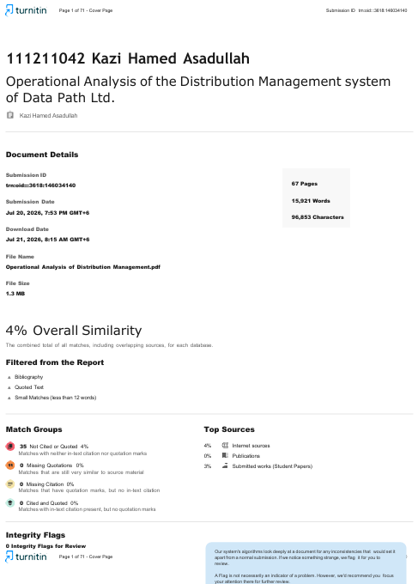

Declaration of the Student

I hereby declare that the internship report titled “Operational Analysis of the Distribution Management System of Data Path Ltd.” has been prepared as a partial fulfillment of the requirements for the degree of Bachelor of Business Administration (BBA), Major in Finance, at United International University (UIU). This report has been prepared and submitted by me, Kazi Hamed Asadullah, under the supervision of Mr. Muhammad Enamul Haque, Associate Professor, School of Business & Economics, United International University.
I also state that this report is my own work and is based on my analysis, observations and practical learning, which is gained within a 3-month internship at Data Path Ltd. All the findings presented, discussion included in this report are a result of my practical experience in the Distribution Team and information I have collected from the company procedures, publicly available sources and academic reports.
I certify that all information, data, figures and references have been properly acknowledged with academic integrity guidelines. No part of this report is to be copied in any form without proper acknowledgment.
I also affirm that this internship report is not submitted for any degree or academic qualification to any other University or institute, either partially or in full.

Acknowledgement

I would like to thank first the Almighty Allah for giving me the strength and opportunity to complete my internship and prepare this report.
I would like to thank my academic supervisor Mr. Muhammad Enamul Haque, Associate Professor, School of Business and Economics, United International University (UIU) for his invaluable guidance, constructive suggestions, constant encouragement and unconditional support throughout my internship and preparing this report. It was the advice and supervision he gave that helped greatly in the successful completion of this work.
I am also deeply grateful to United International University (UIU) and all the respected faculty members of the School of Business and Economics for equipping me with the academic knowledge, analytical skills, and professional values that have greatly contributed to both my personal and professional development.
I also wish to thank Data Path Ltd. for allowing me to do my internship in the Distribution Team. This experience helped me to acquire hands-on experience in administering retirement plans and put into practice the concepts I learned in school.
Lastly, I would like to thank my colleagues, team members and everyone I met or interacted with related to my internship in some way or another who made it a valuable learning experience for me. They were very helpful with cooperation, support and encouragement.
Executive Summary

This internship report, titled “Operational Analysis of the Distribution Management System of Data Path Ltd.”, has been prepared as a partial fulfillment of the requirements for the degree of Bachelor of Business Administration (BBA), Major in Finance, at United International University (UIU). This report is based on the practical experience gained when I perform my internship at Data Path Ltd. from July 14, 2025 to October 14, 2025, where I was an intern within the Distribution Team.
The main purpose of this report is to provide a description of the distribution of requests in U.S. 401(k) retirement plans and an evaluation of the efficiency of Data Path Ltd. in performing these duties. This report describes all aspects of the distribution management process, from applicant eligibility verification to document auditing and compliance with Internal Revenue Service (IRS) regulations, reaching out to stakeholders and plan administrators, and processing of various types of distribution requests such as hardship withdrawals, in-service withdrawals, termination distributions, rollover distributions, Required Minimum Distributions (RMDs), and participant loans. Here I have also talked about my responsibilities and experiences as an intern on the Distribution team and the practical knowledge I acquired and the skills I developed during my internship.
Several financial analyses based on estimated data of operating performance of distribution processing have been included in the report in order to gain insight into the performance of distribution processing in terms of finances. The analysis includes revenue analysis, gross profit margin analysis, cost-to-revenue ratio analysis, revenue growth ratio analysis, gross profit growth ratio analysis, contribution margin analysis, break-even analysis, revenue per distribution analysis, revenue per client analysis and estimated cost structure per distribution analysis. The results of the analysis indicate that the volume of distribution and revenue has increased steadily from 2021 to 2025, which demonstrates the growth and performance of the business.
During my internship, I had an opportunity to apply the knowledge which I gained during my studies at the university. Here are some of the skills that I acquired from the internship that benefited me: analytical thinking, communication skills, problem solving, time management, attention to detail, and an understanding of retirement plan administration.
Overall, this internship was a great learning experience which helped me gain knowledge of both academic and real-life experience and made me ready for a future career in finance and retirement plan administration.
Table of Contents
CHAPTER I: INTRODUCTION 1
1.1 Background of the Report 2
1.2 Objectives of the Report 2
1.3 Motivation of the Report 3
1.4 Scope of the Report 4
1.5 Limitations of the Report 5
1.5 Definition of Key Terms 6
CHAPTER II: COMPANY PREVIEW 9
2.1 Company Analysis 10
2.2 Industry Analysis 17
CHAPTER III: INTERNSHIP EXPERIENCE 20
3.1 Internship Position 21
3.2 Duties and Responsibilities 21
3.3 Training Received 22
3.4 Contribution to Departmental Functions 24
3.5 Internship Experience Evaluation. 24
3.6 Skills Applied During Internship: 25
3.7 Application of Academic Knowledge 26
CHAPTER IV: FINANCIAL ANALYSIS of DISTRIBUTION MANAGEMENT 29
4.1 Overview of Distribution 30
4.2 Importance of Distribution Management 30
4.3 Types of Distribution 30
4.4 Revenue Generated from Distribution Operations: 32
4.5 Operational Costs of Distribution Management: 36
4.7 Break-even Analysis: 42
CHAPTER V: CONCLUSIONS & KEY FACTS 50
5.1 Recommendations for Improving Departmental Operations 51
5.2 Key Understanding 52
5.3 Conclusion: 53
REFERENCE: 54

List of Figures

Figure 01: Estimated Number of Retirement Plans Administered
Figure 02: Revenue Growth Ratio
Figure 03: Revenue per Distribution
Figure 04: Estimated Cost Structure per Distribution
Figure 05: Gross Profit Margin
Figure 06: Cost-to-Revenue Ratio
Figure 07: Revenue Growth Ratio
Figure 08: Gross Profit Growth Ratio
Figure 09: Contribution Margin
Figure 10: The Contribution Margin Ratio (CMR)
Figure 11: The Break-even Revenue Analysis
Figure 12: Revenue per Client
List of Table

Table 01: 6year grade Vesting Schedule
Table 02: Illustration of Vesting Calculation
Table 03: Estimated Revenue from Distribution
Table 04: The Revenue Growth Ratio
Table 05: Estimated Operational Costs of Distribution Management
Table 06: Gross Profit Margin
Table 07: Cost-to-Revenue Ratio
Table 08: Gross Profit Growth Ratio
Table 09: Break-even analysis
Table 10: The Contribution Margin Ratio (CMR)
Table 11: The Break-even Revenue Analysis
Table 12: Revenue per Client

List of Acronyms & Abbreviations
Acronym / Abbreviation Full Form
401(k) Section 401(k) Retirement Savings Plan
ACP Actual Contribution Percentage
ADP Actual Deferral Percentage
BPO Business Process Outsourcing
CRS Compliance Recordkeeping System
IRA Individual Retirement Account
IRS Internal Revenue Service
KPI Key Performance Indicator
RMD Required Minimum Distribution
TPA Third-Party Administrator
NRA Normal Retirement Age
SSN Social Security Number
TIN Taxpayer Identification Number
DOH Date of Hire
DOT Date of Termination

CHAPTER I: INTRODUCTION

1.1 Background of the Report
Internship forms an integral part of the Bachelor of Business Administration (BBA) program and enables the students to make the connection between theory and application in the business world. The internship programs provide students with exposure to actual business settings, enhance their professional skills and offer them insight into the process or practices of an organization that can't be obtained simply by attending class.
This report is a partial fulfilment of the degree of Bachelor of Business Administration (BBA) at United International University (UIU). The report is based on practical experience gained in the Distribution Team, Data Path Ltd. from July 14, 2025 to October 14, 2025.
Data Path Ltd. is a top business process outsourcing (BPO) provider for retirement plan administration services to U.S. clients. It offers a range of retirement plan administration services such as compliance testing, annual administration, and recordkeeping support and distribution management. One of these functions, distribution management, is particularly important to ensure that retirement plan participants receive distributions in a timely manner and in compliance with the Internal Revenue Service (IRS) regulations and plan provisions.
For the internship, I had the opportunity to work in the Distribution Team doing hardship withdrawals, in-service withdrawals, termination distributions, rollover distributions, and Required Minimum Distributions (RMDs).
This report discusses the processes for distributing 401(k) plans, and the issues Data Path Ltd. has been able to address in order to effectively distribute participant requests without violating the law or regulations.

1.2 Objectives of the Report
Primary Objective
This internship report is primarily aimed at analyzing the working procedures of 401(k) distribution management of Data Path Ltd. based on the knowledge and experience acquired during the internship period. The intent of this report is to provide a comprehensive review of the administration, processing and tracking of requests for distribution of retirement plans and how the policies and needs of clients are being met and Internal Revenue Service (IRS) regulations are being followed. It also is designed to demonstrate the application of theory acquired in the school environment to a professional retirement plan administration environment.

Secondary Objectives
The other purpose of this report is to provide a comprehensive view of Data Path Ltd., the history of the company, the work they do and their role as a Third Party Administrator (TPA) in the retirement services industry. The report also aims to learn more about the structure, roles and processes of the distribution team, as well as the processes for handling different types of 401(k) distributions (such as hardship, in-service, termination, rollover and RMD). The report also aims to explore the implications for IRS rules and compliance for retirement plan administration and the impact that these rules have on distribution processing accuracy and efficiency. Furthermore, the report presents the obstacles to the normal operation of distribution administration, such as lack of information for participants, the regulatory framework, and communication delays with clients and participants. Finally, it offers recommendable actions that can be taken to optimize the operational efficiency and quality of services, compliance processes and client satisfaction during the internship experience.

1.3 Motivation of the Report
The objectives of preparing this Internship report are to fulfill the academic requirements and to meet the professional development objectives. The internship experience at Data Path Ltd. proved to be a valuable and enriching experience for the final year of the BBA Programme with Finance and Fin-Tech major student, as it was a good learning opportunity to gain exposure to real time application of the Finance and Fin-Tech concepts in the business world.
As part of my internship, I was provided with the opportunity to apply my theory concepts gained from courses such as Principal of Finance, Fin-Tech, Operations Management, Management Information Systems, and managerial finance in tasks I performed in the real work environment. This experience further developed my knowledge of retirement plan administration and my analytical, problem solving, communication and decision-making skills. As a profession, retirement plan administration is very specialized, compliance oriented, and requires accuracy, confidentiality, critical thinking and knowledge of regulatory requirements.
I personally reviewed all different types of distributions (hardship, in-service, termination, rollover, RMD, loan and refinancing loan) for 401(k) distributions as an intern in the Distribution Team. The responsibilities resulted in hands-on experience of client communications, document verification, eligibility checks, Internal Revenue Service (IRS) guidelines and individual retirement plan provisions. The internship also highlighted the need for accuracy and efficiency in the retirement transaction processing as it can impact the retirement benefits of the participant and compliance.
The second motivation of the report writing is to capture and analyses the acquired knowledge and skills that were gained through internship. This report looks at the operational workflow of the Distribution Team, how the distribution team is organized, operational difficulties faced during the distribution process, and the steps taken to guarantee that services are delivered on time, accurately and compliant. The report also emphasizes the importance of cooperation between various stakeholders, process standardization, and the use of technology to enhance operational efficiency and customer satisfaction.
In addition, this report will demonstrate the significance of Data Path Ltd. as a Third-Party Administrator (TPA) to the retirement services industry. Retirement plan administration services provide a comprehensive array of services to employers, financial advisors and retirement plan participants to administer their retirement plans, including services to process distribution requests. The report illustrates the value of good retirement plan administration practices in safeguarding participants' interests and ensuring retirement plans maintain their integrity.
Finally, this report is a professional learning experience I gained and competencies I developed in the internship experience. The internship not only fulfilled the educational requirement of the program, but it also provided me with a thorough review of retirement plan distribution management and brought the academic component of the program to life to provide a solid foundation for a career in finance, retirement services and financial technology.

1.4 Scope of the Report
This internship report focuses on the day-to-day operations of the Distribution Team of Data Path Ltd. and highlights the administration and processing of 401(k) retirement plan distributions. The report provides an overview of Data Path Ltd.'s business operations, organizational structure, and how the company supports clients across the United States by providing retirement plan administration services as a Third-Party Administrator (TPA). It covers the workflow of the Distribution Team and how different types of distribution participant requests are reviewed, verified and processed, while complying with the plan provisions and Internal Revenue Service (IRS) regulations.
In addition, the report reviews the process used to process different types of distribution requests such as hardship withdrawals, in-service withdrawals, termination distributions, loan rollovers, Required Minimum Distributions (RMDs), participant loans, and loan refinancing requests.
The report also covers Data Path Ltd.’s internal control and quality assurance procedures to protect the accuracy, consistency and promptness of submission of distribution requests. For business growth and operational performance, an estimate of the financial analysis of the distribution processing function where applicable, based on the available operational data, is included in the report.
Finally, the report discusses the skills developed during the internship which include analytical, problem solving, communication, team working, time management and administration of retirement plans skills. The information in this report is based on actual observations, practical experiences and training, conversations with supervisors and colleagues, and information publicly available about retirement plan administration procedures and policies.

1.5 Limitations of the Report
I have worked hard to make this report thorough and informative, but there were a number of limitations during the internship and in preparing the report.
The first restriction was the length of the internship placement. The internship was only for three months and provided me with much needed hands-on experience in the field, but it was not enough to observe all kinds of transactions of retirement plans as well as all the long-term activities.
A second limitation was that Data Path Ltd. had a confidentiality clause. I have not been able to include any confidential business data, any client or participant-specific information, or any internal procedures and/or financial records in this report since this type of information is used by the company concerning its sensitive client and participant data. As a result of this, some of the financial analyses and operational discussions are based on estimated information and general observations for academic purposes only. The retirement plan industry is also well-regulated and intricate. It is subject to various rules and regulations from the Internal Revenue Service (IRS), the Employee Retirement Income Security Act (ERISA), and others. Because of the nature of this internship, this report concentrates primarily on the operation of distribution management and only briefly discusses a number of legal and regulatory issues in detail.
Another constraint was time. During this internship, I was unable to conduct any further research, gather additional primary data, or even compare Data Path Ltd. with other organizations within the retirement services industry due to the limited time available for this internship.
Additionally, some of the financial analyses contained in this report are based on reasonable assumptions, as I was not able to access the company's complete financial statements and actual cost information. These assumptions were made solely to demonstrate financial analysis techniques and have been clearly mentioned wherever necessary. However, I have no doubt that every effort has been made to ensure that this report is accurate in terms of what I experienced at Data Path Ltd. and what I actually learned there. I believe the report provides insight into how 401(k) distribution management works and what I learned during my internship.

1.5 Definition of Key Terms
In the internship report, there are various terms that are important throughout the report. These terms are provided to assist readers to better understand how retirement plan administration works and the distribution management process at Data Path Ltd.
401(k) Plan
In the United States, a 401(k) plan is an employer-sponsored retirement savings plan. It enables employees to put aside a part of their salary to save for their retirement via payroll deduction. Depending on the plan, the employee may contribute a "pre-tax" amount or a "Roth" (after-tax) amount. There are also many employers that make matching payments or profit-sharing payments to supplement employees' retirement savings.
Third-Party Administrator (TPA)
A Third-Party Administrator (TPA) is a firm that administers a retirement plan for a company. A TPA handles administrative duties like keeping participant records, handling contributions, distributions, participant loans, etc. and preparing compliance reports and providing customer support. Data Path Ltd. acts as a Third-Party Administrator to employers assisting them in the administration of their retirement plans and in compliance with IRS and other regulatory requirements.
Types of Distribution
A distribution refers to the withdrawal of funds from a participant's retirement account when certain eligibility requirements are met. Examples of distributions are:
- Termination Distribution: Withdrawal after the participant separates from employment.
- Partial Termination Distribution: Withdrawal of only a portion of the participant's vested account balance following termination of employment.
- In-Service Withdrawal: Withdrawal permitted while the participant is still employed, subject to the provisions of the retirement plan.
- Hardship Withdrawal: Withdrawal allowed to satisfy an immediate and heavy financial need as defined by IRS regulations and the plan document.
- Rollover Distribution: Transfer of retirement funds to another qualified retirement plan or Individual Retirement Account (IRA) without creating a taxable event.
- Required Minimum Distribution (RMD): The minimum amount that eligible participants or beneficiaries must withdraw annually after reaching the applicable age specified by the IRS.
- Loan Distribution: A loan taken by the participant against their vested retirement account balance, subject to plan rules and IRS limits.
- Loan Refinance: A process that replaces or restructures an existing retirement plan loan, subject to the provisions of the retirement plan.
Vesting
Vesting – refers to the legal ownership of the employer-contributed money in a retirement plan that the participant has. Participant salary deferrals are usually 100% vested immediately, but employer matching or profit-sharing contributions can become vested over time depending upon the vesting terms in the plan. If a participant loses their job prior to full vesting, they may lose the unvested portion of their employer's plan contributions.
Vesting Schedule
A "vesting schedule" is the period set forth in the retirement plan that indicates how much each participant owns with respect to the percentage of years of service completed. Typically, vesting periods are either a cliff vesting model (whereby employees are vested all at once after they've served a certain year or period) or a graded model (where the ownership of the shares is gradually vested over a number of years). The vesting schedule has a direct impact on the amount that a participant receives when the plan is distributed.
Example of a Graded Vesting Schedule: When a plan follows 6year grade vesting schedule
Table 01: 6year grade Vesting Schedule
Years of Service | Vested Percentage
Less than 2 years | 0%
2 years | 20%
3 years | 40%
4 years | 60%
5 years | 80%
6 years or more | 100%
Vesting Calculation Example
Suppose a participant terminates employment after completing 4 years of service.
- Employer Contribution (ER Source): USD 20,000
- Vesting Percentage: 60%
Calculation:
Vested Amount = Employer Contribution × Vesting Percentage
= USD 20,000 × 60%
= USD 12,000
Non-Vested Amount = Employer Contribution − Vested Amount
= USD 20,000 − USD 12,000
= USD 8,000
The participant therefore gets USD 12,000 from the employer contribution account, and the rest, USD 8,000, is lost based on the retirement plan's vesting schedule.
Illustration
Table 02: Illustration of Vesting Calculation
Description | Amount (USD)
Employer Contribution | 20,000
Vesting Percentage | 60%
Vested Amount | 12,000
Non-Vested (Forfeited) Amount | 8,000
Employee salary deferrals (employee contributions) are always 100% vested and are not subject to the vesting schedule. Vesting rules typically only apply to employer contributions, like employer matching and profit-sharing contributions.
Participant
A participant is an individual who is eligible to participate in a retirement plan and has an account in the retirement plan. Participants can fund their accounts with salary deferral contributions, (if applicable) accept employer contributions, view their account balances, apply for distributions and/ or loans if eligible and designate beneficiaries for their retirement accounts.
Plan Sponsor
A plan sponsor is the employer, business entity or organization that creates, maintains and administers a retirement plan for their employees. The plan sponsor must decide on the design of the plan, approve any plan amendments, comply with applicable plan regulations, pay the employer contribution, if required, and provide services with Third Party Administrators (TPAs), record-keepers, and investment advisors.

CHAPTER II: COMPANY PREVIEW

2.1 Company Analysis

2.1.1 Overview of Data Path Ltd.
Data Path Ltd. is one of today's premier business process outsourcing (BPO) providers for retirement plan administration solutions to clients across the United States. The company offers full administrative services for employer sponsored retirement plans, especially 401(k) plans, assisting employers to stay compliant with regulatory needs and to deliver effective solutions to plan participants.

Established in 1988, Data Path Ltd. is known for its high-quality retirement plan administration processes, professionals and technology. The company has a wide array of clients, such as small businesses, businesses with medium-sized operations, retirement plan advisors and third-party administrators.

The company has several specialized departments that support each other in the efficient administration of retirement plans. These departments include Annual Administration, Compliance Testing, Distribution Processing, Recordkeeping Support, Conversion Services, Quality Assurance, and Client Services.

The internship was undertaken in the Distribution Team, which is vital to processing requests for participant distributions and ensuring adherence to the Internal Revenue Service (IRS) regulations, plan provisions and client needs.

Data Path Ltd. is one of the recognized service providers in the retirement administration outsourcing industry, having invested in technology, employee development and operational excellence all the time.

History and Growth
Data Path Ltd. was established to provide retirement plan administration services for organizations in the United States. With the evolution of retirement plans, due to the new rules and growing needs of participants, many organizations began to seek professional companies to administer their retirement plans. This presented an opportunity for Data Path Ltd. to expand and increase their services.
Over the years, the company has increased its number of clients, employees, and service offerings to meet the growing demand. Data path has further invested in employee training, the adoption of modern technology and process optimization to deliver quality, accurate and efficient services. Demand for outsourcing retirement plan administration has surged, the growth of the U.S. retirement services industry, a robust client base, and ongoing enhancements to its business model have helped drive the company's growth. Today, Data Path Ltd. administers thousands of retirement plans and offers retirement plan administration services to clients in a variety of industries throughout the United States.
Growth in Number of Clients:
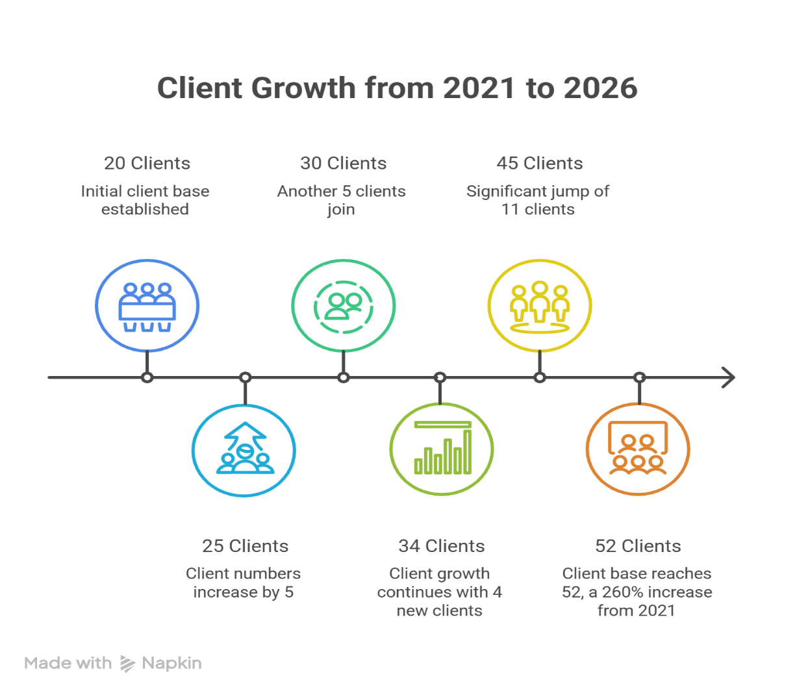

The Company’s client count has been steadily increasing from 2021 to 2026, indicating its growing presence in the retirement plan administration market. There was a 25% rise in the number of clients, from 20 in 2021 to 25 in 2022. In 2023, the client base grew to 30, followed by 34 clients in 2024. The largest growth was in 2025, with the number of clients rising to 45, indicating the company's success in gaining new clients and strengthening its client partnerships with retirement plan sponsors. Currently there are 52 clients (up 160% from 2021) of Data Path Ltd.

The steady increase in clients is an indicator of Data Path Ltd.'s proven ability to deliver consistent retirement plan administration services and to build market share. Another reason for the high volume and service revenue of distribution processing in the same period could be the increasing number of clients. Overall, the trend suggests that the company has been in a state of constant growth, development and expansion of their business activities, capabilities and services to their clients.
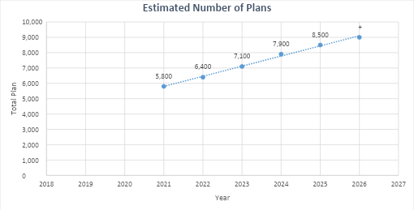
Figure 01: Estimated Number of Retirement Plans Administered by Data Path Ltd. (2021–2026)
The number of retirement plans of Data Path Ltd. administers has increased over the last six years. The total plan estimates rose from 5,800 in 2021 to 9,000 in 2026, representing the overall increase of approximately 55.17% of plans. The upturn is attributed to the administration company's continued growth in the retirement plan administration space and its ability to acquire and retain retirement plan sponsors. The steady expansion of plan volume also suggests an increase in the capacity, technology and client services that are available. As more plans become administrators, Data path probably has its foot on the better foot to be successful in the market and are assisting more U.S. participants.

2.1.2 Vision, Mission, and Core Values
Vision
Data Path Ltd.'s vision is to be the world leader in retirement plan administration services through innovative solutions, technology and client focus. The firm strives to set industry benchmarks by operating efficiently, complying with regulations and continually finding new ways to innovate, and building long-term relationships with clients, financial advisors and retirement plan participants. Data path's dedication to embrace new technologies and best business processes will continue to strengthen its position as a trusted partner in the global retirement services industry.
Mission
Data Path Ltd.'s purpose is to provide top class, accurate, compliant and technology-based retirement plan administration solutions which will ease retirement plan administration for employers, financial institutions and retirement plan participants. The company is committed to delivering excellent customer service, meeting the highest regulatory requirements and continually innovates and digitalizes to boost its efficiency. Data path aims to add value to their clients by building a successful long-term retirement plan and offering them reliable retirement administration solutions that enhance the client's retirement plan participation journey.
Core Values
These values are the cornerstone of Data Path Ltd.'s culture and are reflected in its operations, decision making and service excellence:
- Accountability
- Excellence
- Collaboration
- Innovation
- Customer Focus
- Continuous Learning
- Respect
- Professionalism
- Quality

Customer Mix

Data Path Ltd. has several different types of customer in the U.S. retirement services industry. It has three main customer groups: Third Party Administrators (TPAs), plan sponsors, and financial advisors, retirement plan participants, and business partners. A diversified customer base ensures that the company is not relying on a single customer segment and helps sustain its business growth.

The company's largest customer group is Third-Party Administrators (TPAs). Currently Data path administers more than 50 TPA firms throughout the United States. The company supports these clients in retirement plan administration, compliance testing, recordkeeping support, and distribution processing and plan administration. Outsourcing these things to Data path will allow TPAs to become more efficient and concentrate more on their clients.

In addition, Data path holds a special relationship with plan sponsors, assisting employers in the administration of their retirement plans and in compliance with IRS and ERISA regulations. The company also serves financial advisors and retirement consultants with reliable administrative services, assisting them in better handling their retirement plans.

While not direct customers, retirement plan participants benefit from Data path's services through the accurate and timely processing of various requests for distributions, such as hardship withdrawals, in-service withdrawals, terminations, rollover distributions, Required Minimum Distributions (RMDs), participant loans, and loan refinancing requests.

Data path also has great relationships with several top record keepers and financial institutions, including John Hancock, Principal, MassMutual, Fidelity, American Funds and Empower. These arrangements enable the company to provide efficient and reliable services for administration of the plan. The company's mix of customers is diversified, and this diversification enhances its position in the market and supports the growth of the company.

Product & Service Mix

Data Path Ltd. provides a variety of retirement plan administration services for TPAs, plan sponsors, financial advisors, and retirement plan participants. The firm brings together seasoned experts, cutting-edge technology and regulatory expertise to deliver accurate, efficient and compliant retirement plans solutions.

The company's primary business is the administration of retirement plans. This encompasses the administration of participant eligibility, employer and employee contributions, vesting, employer matching, loan administration, compliance monitoring and any other day-to-day retirement plan activities. Data path also offers distribution processing services, which involves screening and processing hardship withdrawals, in-service withdrawals, termination distribution, rollover distribution, Required Minimum Distributions (RMDs), participant loans, refinancing of participant loans, and death benefit distributions, as well as complying with plan rules and IRS regulations.

One other significant service is compliance testing. The company conducts ADP/ACP testing, Top-Heavy testing, Coverage testing and other compliance testing to make sure retirement plans comply with IRS and ERISA regulations. Data path also performs year end plan administration annually at the end of each year, which involves year-end review, participant census validation, contribution calculations, plan reconciliations and updating plan documents.

The company also offers a recordkeeping support service, including maintaining participant accounts, processing contributions and reconciling transactions and close working with major record keepers. Data path also can help clients file tax reports and regulatory documents, such as Form 5500, Form 1099-R and Form 5330. The company also provides continuous client support to answer inquiries, address administrative questions and help clients with retirement plan operations.

Each of these services is offered through a single platform, easing retirement plan administration, enhancing the effectiveness of plan operations, assuring regulatory compliance and ensuring excellent service to plan participants and retirement plan clients.

2.1.3 SWOT Analysis
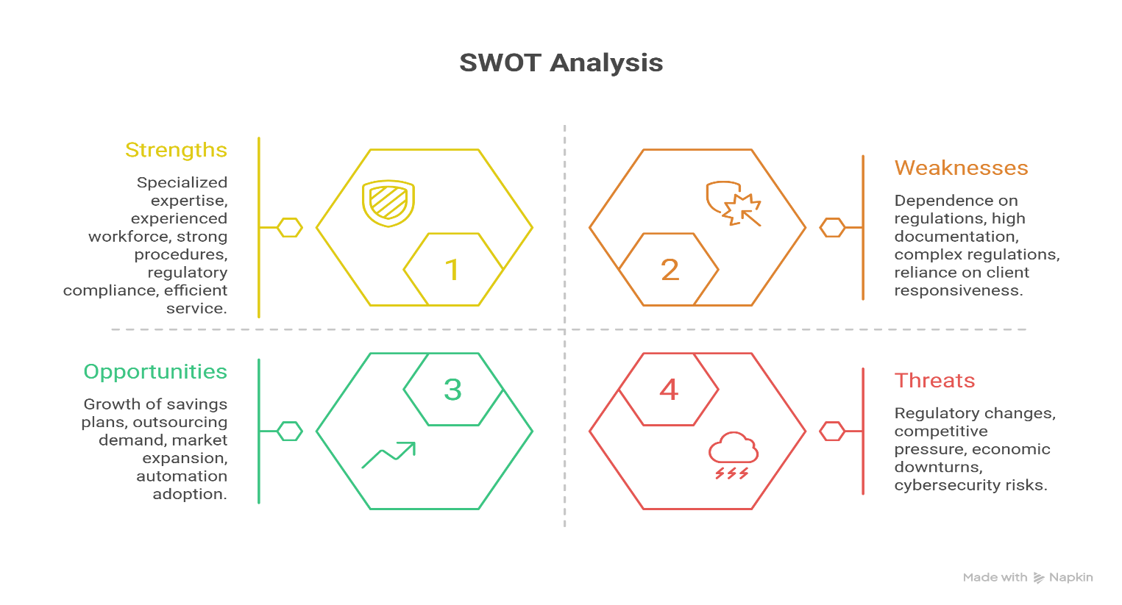
Strengths
Specialized Expertise in Retirement Plan Administration
Data Path Ltd.'s main assets are its niche expertise and experience in retirement plan administration. The company has long experience in serving retirement plans and has gained significant retirement plan management experience, particularly with regard to 401(k) plans and other retirement plan types. It has a team of employees who understand IRS regulations, retirement plan rules, and industry best practices. This knowledge enables the company to handle retirement plan transactions correctly, keep its compliance with the law and provide reliable services to its clients.
Experienced Workforce
Data Path Ltd. has a skilled and experienced team of employees that are important in the success of the company. Staff are provided with periodic training and develop hands-on experience in dealing with various retirement plan activities. They possess knowledge, teamwork, and attention to detail to minimize processing errors, enhance operational efficiency and deliver quality service to their clients. Additional benefits of an experienced team include their ability to respond to evolving client needs and regulatory changes more efficiently.
Weaknesses
Dependence on Regulatory Environment
The retirement plan administration industry is highly regulated by organizations such as the Internal Revenue Service (IRS) and the Department of Labor (DOL). Data Path Ltd. shall amend its procedures, systems and employee training when the laws or tax requirements governing retirement change. Additional resources, time and effort are needed to keep up with these frequent changes, and this will impact operational efficiency temporarily.
High Documentation Requirements
There must be full and accurate documentation of the retirement plan transactions before they are processed. Staff will thoroughly examine participant forms, documentation, tax withholding forms, signatures and other necessary data. Without the proper documentation or information being correct, the request cannot be processed. Consequently, the processing period can be longer, and you may not be as satisfied with the results.
Opportunities
Rising Demand for Outsourcing
A growing number of employers in the U.S. are opting not to administer their retirement plans in-house. The trend brings in great opportunities for Data Path Ltd. to gain new clients and grow its business. More employers are creating retirement plans for their workers, and more experienced retirement administration service providers are likely to continue to be in demand.
Automation and Digital Transformation
In the financial services sector, advanced technology, automation and artificial intelligence are rapidly growing. Data Path Ltd. can further enhance its operational efficiency through adoption of more automation in workflows, document verification systems, and data analysis. These technologies can cut down on some of the manual tasks, speed up processing time, cut down on errors, and better the overall quality of customer service.
Threats
Regulatory Changes
Data Path Ltd. may face operational difficulties as a result of changes in retirement plan laws, tax laws or compliance regulations. The company has to keep track of the changes in the regulations and update their processes to keep track of it. Non-compliance with the new regulations may lead to fines, higher operating expenses, and loss of customer trust.
Cybersecurity Risks
Data Path Ltd. handles a large amount of confidential financial and personal information related to retirement plan participants. With cyber threats on the rise across the globe, safeguarding sensitive data is a significant challenge. To ensure the security of the company's operations and the trust of its clients, the company needs to keep investing in robust cybersecurity systems, data protection measures, and strengthening employee awareness.

2.2 Industry Analysis

2.2.1 Specification of the Industry
Data Path Ltd. Is a company that comes into contact with retirement plan administration and Business Process outsourcing. Their expertise lies in assisting companies in their employer-sponsored retirement plans, such as a 401(k) plan in the USA. Data Path Ltd. carries out a variety of tasks to support these businesses such as managing retirement plans, ensuring adherence to regulations, record keeping, and conducting reports. The retirement plan administration industry is composed of services, information technology, legal and customer support. Everything that is done is to ensure that the retirement plans are executed appropriately and efficiently. Lots of rules come from the Internal Revenue Service and the Employee Retirement Income Security Act, companies such as Data Path Ltd. Should be extremely cautious and adhere to all rules.

2.2.2 Industry Size, Trend and Maturity
One of the sectors of the financial services industry in the United States is the retirement services industry. Many people have a retirement plan established through their employment, and there is a need for companies that can assist them. Although this industry is already relatively large, it continues to increase as there are more individuals saving for retirement and more companies seeking assistance in their retirement program. A lot of technology, such as digital record keeping and automation, are also being employed to make industry easier and more efficient. There are also lots of rules that companies are expected to adhere to and they require assistance from the professionals who know exactly what to do.
External Economic Factors
The economic health of the retirement plan administration industry may be influenced by the economy. Things like inflation, interest rates and how well the job market is doing can all impact retirement plans. During an upturn of the economy, more people are working and earning, which means they can contribute more towards retirement savings. If the economy doesn't look so hot, individuals might not be able to contribute the amount of money to their plans, and they may even have to withdraw funds. The performance of retirement plans can also be influenced by the stock market, making it more complex for companies offering retirement plans.
Technological Factors
Technology plays a significant role for companies that assist with retirement plans. At Data Path Ltd. they have a number of technologies that make things more efficient and they provide better service, such as automated systems and secure digital communication tools. The use of new technologies, such as intelligence and automation, is assisting companies to minimize mistakes and accomplish things more quickly. They are also assisting companies in decision-making and information protection for peoples. This is very important for companies that utilize retirement plans, given that they should preserve people’s information safely and observe all the regulations.
Barriers to Entry
It is not easy for new companies to get into the retirement plan administration industry. They must be well-versed in the rules and regulations for retirement plans. They should have good systems and technology to maintain people’s information safe. They need to be able to establish trust with their clientele as well as demonstrate their capability in servicing the client. This can be a time-consuming process and for small businesses to be able to compete with established players such as Data Path Ltd.
Supplier Power
The companies that supply technology and other services to the retirement plan administration industry do not have a lot of power. There are different companies that provide these services so the companies that help with retirement plans have a lot of choices. This means that the suppliers have to compete with each other to get business, which keeps prices low and service quality high.
Buyer Power
The companies that buy services from the retirement plan administration industry have a to high amount of power. There are different companies that provide these services so the buyers have a lot of choices. They can choose the company that provides the service has the most expertise and charges the lowest price. This means that the companies that help with retirement plans have to be very good at what they do and provide service in order to keep their clients.
Threat of Substitutes
There is not a threat of substitutes in the retirement plan administration industry. Retirement plans are complicated and have to follow a lot of rules so it is not easy for other companies to provide the services. While technology is getting better and better it is not likely to replace the expertise and service that companies like Data Path Ltd. Provide. However technology may be able to do some of the tasks, which could change the way that companies work.
Industry Rivalry
The retirement plan administration industry is very competitive. There are companies that provide these services and they all compete with each other to get business. They compete on things like service quality, expertise, technology and price. To be successful companies have to be very good, at what they do and provide service.

CHAPTER III: INTERNSHIP EXPERIENCE

3.1 Internship Position
I completed my internship at Data Path Ltd. from July 14, 2025 to October 14, 2025 as part of my BBA degree from United International University (UIU). In this timeframe, I served as an Intern within the Distribution Team, which is one of the many important operational teams at the company that manages the distribution of all participant requests for employer-sponsored retirement plans in the United States.
The Distribution Team is essential to the accurate, efficient and IRS compliant processing of participant distribution requests, while also addressing participant's specific needs. The department considers a variety of distribution types, ensures that participants meet the requirements of a distribution, reviews documentation supporting the distribution, communicates with clients and plan administrators, and interfaces with other departments to help process distribution in a timely manner.
This experience in this department gave me good hands-on experience in the U.S. retirement plan administration industry. During the internship, I had an opportunity to apply knowledge in reviewing retirement plan transactions, plan provisions, contributing to regulatory compliance, and discussing missing information and processing with the client. Such practice enabled me to match the theoretical knowledge with practical implementation in order to gain experience and develop relevant competencies.

3.2 Duties and Responsibilities
I was an intern at Data Path Ltd., where I had a wealth of experience in all areas of operations related to distribution administration for retirement plans. My main job responsibilities included reviewing requests from participants, checking eligibility, verifying documentation and maintaining regulatory compliance, and assisting with the smooth delivery of 401(k) distribution transactions. This hands-on experience in retirement plan cases was invaluable and provided me firsthand insight into the retirement services industry and retirement rules and processes in the United States.
3.2.1 Distribution Request Processing
One of the biggest responsibilities I had as an intern was reviewing and accepting a variety of participant distribution requests including Hardship, In-service, Termination, Rollover, Required Minimum Distribution (RMD) requests, Death Benefit requests, Participant Loans and Loan refinancing requests. My job was to review the forms submitted by participants to verify that they were eligible for the plan based on the provisions of the plan and IRS guidelines, verify the sources of funds for an account, confirm the instructions for payments, review tax withholding elections, verify missing and/or incorrect information, and ensure the information was complete prior to processing payments. I also communicated with plan administrators and clients for further clarification and/or documentation when needed to ensure that transactions were processed correctly and in compliance with the rules of the plan.
3.2.2 Documentation Review and Eligibility Verification process
One of the other significant roles was to check participant documentation and confirm eligibility criteria prior to transactions being processed. Ensured that distribution request documents, supporting documents, beneficiary information, instructions for payment, tax withholding elections, and participant signatures and other required documents are complete and accurate. Also, I looked at the participant eligibility restrictions, plan funding sources, account balances, age, active/inactive, and their percentages. These exercises helped to reduce processing errors and meet retirement plan requirements.
3.2.3 Client Communication
An integral component of my internship was communicating with clients and internal stakeholders. Communicated with the plan administrator, client representatives, financial advisor, record-keeper, internal staff frequently to request missing information, confirm instructions to participants, provide follow-up on missing documentation, correct processing issues, and update information on pending requests. These duties reinforced my professional communication skills, as well as problem solving and client service skills.
3.2.4 Task and Workflow Management
Also had the opportunity to work with the Distribution Team on day to day operations. My job was to monitor project assignments, monitor progress on project assignments, update project assignments, monitor pending requests, follow up on pending requests, and assist in managing workload to ensure requests of participants are done correctly and on time to the service. It was very helpful in enhancing my organizational skills, time management and knowledge of coordinating the workflow in a professional business environment.
Overall, the internship at Data Path Ltd. was a great opportunity to gain first-hand experience in retirement plan administration and greatly improved my analytical skills, regulatory expertise, communication skills, attention to detail and professionalism. The internship enabled me to apply my theoretical learning in the financial operations and also provided me practical experience to better prepare me for a successful career in financial and retirement plan administration.

3.3 Training Received
I was hired as an intern with Data Path Ltd. to take part in the company's structured training program and gain an understanding of the daily operations, retirement plan administration procedures and working environment of the company. The training was a mix of theory and demonstrations, which allowed me to get a grasp of the technical and regulatory requirements surrounding retirement plan administration, prior to dealing with real-life participant requests.
The first training was on the basics of a 401(k)-retirement plan. I gained an understanding of the basic structure of employer sponsored retirement plans, the basic terminology of retirement plans, participant/plan sponsor responsibilities, and different types of distribution requests, concepts of vesting, and the overall process of retirement plan administration. This training gave an understanding of the operational surroundings and services offered by Data Path Ltd.
I also got in-depth training on the distribution request processing workflow. This training covered the entire process of distributing participant requests, hardship withdrawal, in-service withdrawal, termination distribution, rollover distributions, Required Minimum Distributions (RMDs), participant loans, refinancing loans, and death benefit distributions. I was taught to review requests by participants for their submission, verify eligibility, review their supporting documentation, identify missing information, and ensure that each request met applicable provisions of the plan and company procedures for processing.
Retirement plan administration was highly regulated, making compliance and regulatory training a significant part of plan administration. Aware of Internal Revenue Service (IRS) provisions, retirement plan requirements, eligibility for distributions, withholding tax requirements, documentation requirements, and compliance with the Internal Revenue Service. In general, this training provided me with a new understanding of the importance of accuracy, confidentiality and the need to comply with rules and regulations in all aspects of retirement plan administration.

3.4 Contribution to Departmental Functions
I was involved within the day to day running of the Distribution Team. I gained the knowledge and skills needed to support the team during the various operations carried out, to ensure proper and timely execution of the requests of the participants.
One of my biggest roles was to take care of the distribution requests for the participants. Checked supporting documentation, identified missing documents/inconsistencies, and ensured requests were processed and met processing requirements before moving forward. The ability to detect missing information early in the process helped minimize processing delays and streamline the workflow.
In addition, I had some responsibility for documentation to ensure that the information was accurate and compliant to retirement plan requirements. I collaborated closely with IRS to review documents and verify participant eligibility and work to reduce processing errors and to ensure requests are consistent with plan provisions and IRS rules and regulations. In the department, quality and accuracy of work was guaranteed due to my attention to detail.
I also had a regular exchange with team members on the requirements that were due, ongoing or outstanding documentation, and the status of the project as well as being able to help monitor the tasks assigned to me. The activities facilitated the team process management and ensured that participant requests were fulfilled within the agreed service times.
In general, my role contributed to the Distribution Team's operational targets in several ways, including helping to increase the accuracy of the documentation, minimizing processing time, ensuring the flow of the work, and encouraging adherence to regulatory requirements. This experience gave me a chance to contribute to the department, build my analytical skills, problem solving skills, teamwork skills and confidence as a professional in the real world of business.

3.5 Internship Experience Evaluation
Overall, my internship at Data Path Ltd. was a very enlightening experience for me both academically and professionally. It gave me a chance to put my knowledge from my BBA studies to the test in the real world of business while gaining a greater perspective of retirement plan administration and financial service operations.
The internship experience proved to be highly beneficial due to several practical experiences gained. I found my working with real Participant Distribution Requests to be well helpful in understanding the administration of retirement plans in the United States and how the regulations are applied in day-to-day operations. First-hand experience in examining participant requests, verifying documentation, making sure it is compliant with IRS rules and regulations, and assisting with the timely handling of retirement plan transactions.
The internship also has been a great asset in my professional development. I developed my confidence, communication skills, problem solving and decision making through collaborative and professional working. I'd been consistently reminded to keep learning by interacting with supervisors and team members, and about the significance of working in a team, being responsible and accurate in financial services.
Moreover, the internship provided me with a great amount of knowledge about the industry. I gained a thorough understanding of the concepts of retirement planning, administration of 401(k) plans, processing distribution procedures, regulatory compliance, and the responsibilities of the Third-Party Administrator (TPA). It was a hands-on experience that added to my learning and deepened my passion for working in the financial services sector.
Overall, the internship was a great experience to have the opportunity to see what it is like to be a working professional. It gave me a better understanding of business operations, helped me to develop my technical and interpersonal skills, and guided me to make a smooth shift from academia to a professional job.

3.6 Skills Applied During Internship
During my internship at Data Path Ltd., I was able to practically use the theoretical knowledge and skills I learnt in school at United International University. The internship has proved to be a valuable opportunity, as I gained firsthand experience in the field and honed several skills that are important to a finance and retirement plan administrator. The following are skills that were used in the internship.
Analytical Skills
One of the most important skills that I used throughout the internship is analytical ability. My day-to-day tasks included the following: Reviewing participant info, verifying eligibility, checking supporting information, looking for missing and/or inconsistent information, and determining any possible violations of the program before processing a distribution request. These activities improved my financial and operational data analysis skills, decision making and regulatory compliance.

Communication Skills
Good communication was a key component of my job. Frequently contacted plan administrators, plan representatives, financial advisors, record-keepers, and internal staff to seek clarification and provide status, request missing information, and address issues pertaining to plan processing.

Time Management and Organizational Skills
In the Distribution Team, it was important to efficiently use time as several participant requests needed to be studied and acted upon within a limited time for service. I learned to identify task priority based on the urgency, daily task scheduling, tracking of outstanding projects and follow-up of pending requirements, and I learned to complete tasks efficiently and accurately without compromising my productivity.
Attention to Detail
A high level of accuracy and precision is required in administering retirement plans. During the internship, I analyzed the information available for every participant, their account balance, their vesting percentages, their distribution, and instructions on how to make the payments, beneficiary information, withholding tax elections and supporting documentation. This attention to detail helped minimize processing errors and to be sure that company procedures and IRS rules were followed.
Problem-Solving Skills
Often requests were not documented or required further clarification before they could be processed. Honed problem-solving abilities; found discrepancies; came up with the needed corrective actions; communicated with clients to get missing information; helped efficiently resolve processing problems whilst maintaining service quality.
Regulatory Compliance Awareness
During my internship, I had a better understanding of the regulatory components of retirement plan administration. While reviewing requests, I ensured that each request was legal and operational and leveraged tax, IRS, plan provisions, tax withholding, documentation and internal compliance requirements.
Overall, Skill Development
To conclude, I acquired many new skills and ideas in my internship which I could use in the classroom and helped me to reinforce my analytical, communication, problem-solving skills, time management, organizational, detail-oriented and regulatory compliance skills.

3.7 Application of Academic Knowledge
During my internship with Data Path Ltd. one of the most beneficial experiences I had was to get the opportunity to utilize the theoretical knowledge that I had learned in my Bachelor of Business Administration (BBA) studies from United International University and put it to practical use in a real business setting. This internship allowed me to apply information from many business disciplines during my everyday tasks and learn about the use of concepts and theories in a business environment. Below are the main fields of my academic knowledge which I applied.
Application of Finance Knowledge
During my internship, I was able to utilize many financial concepts as a Finance major. As I was going through the requests from participants, I gained first-hand experience with retirement planning, investment accounts, withholding taxes, Required Minimum Distributions (RMDs), rollover transactions, and wealth building strategies. I also learned much about how employer-provided retirement plan benefits help lower retirement plan participants' risk of a lack of retirement savings and how the various distribution options affect their retirement savings and tax obligations. This firsthand exposure served to deepen my knowledge of financial planning and retirement management beyond that imparted in school.
Application of Business Communication
The skills I acquired in Business Communication classes were very useful in my job. A large portion of my work consisted of the ability to communicate with Plan Administrators, clients, financial advisors, and internal team members, which required a large amount of time preparing professional e-mail correspondence, seeking missing information, clarifying instructions to participants, and reporting back regarding requests in progress. Effective written communication and business etiquette and professional correspondence skills helped me to communicate clearly and foster good business relationships.
Application of Business Law
The Business Law courses taught me the ins and outs of compliance, contracts, and ethics in business. In my internship, I used this knowledge when examining retirement plan documents, making sure they adhere to the Internal Revenue Service (IRS) regulations, plan provisions, company policies, and processing participant requests for retirement plan distributions. I gained an understanding of the legal aspects of retirement plan administration which gave me an appreciation for compliance, confidentiality and accuracy in financial services.
Application of Operations Management
The concepts of Operations Management were directly applied to the work schedule of the Distribution Team. The department has established standard operating procedures to guarantee efficient and accurate processing of requests for the participant. While reviewing distribution requests, monitoring assigned tasks, keeping track of documentation pending, and helping with maintaining operational efficiency, I used workflow management, process efficiency, task prioritization, quality control, and continuous improvement concepts in my internship. The ideas enabled me to understand how systematic processes give rise to productivity and quality of services.

The overall application of academic knowledge.
My internship experience at Data Path Ltd. was a very good experience overall because it was a chance for me to apply academic theory and knowledge to real practice. The experience provided application of concepts learned from Finance, Business Communication, Business Law and Operations Management to real business problems and technical skills and professional competence. The hands-on experience greatly contributed to my knowledge of retirement plan administration and helped me make a successful career in the financial services field.

CHAPTER IV: FINANCIAL ANALYSIS of DISTRIBUTION MANAGEMENT

4.1 Overview of Distribution
A 401(k) distribution is taking money from a participant's 401(k) plan in accordance with the terms of the plan and Internal Revenue Service (IRS) rules. A participant can be eligible to receive a distribution upon retirement, leaving a job, when the participant has financial hardship, upon becoming disabled, or upon death, or at the normal retirement age. The type of distribution will vary depending on the participant's situation and the provisions of the retirement plan. There are some key things that need to be done before a distribution can be processed. Some of the most common ones are checking eligibility, verifying documents, calculating the eligible amount of distribution, verifying if there will be any taxes withheld, obtaining necessary approvals, and making sure that the payment is accurate and secure. Because retirement plans are intended to assist people in saving for their future, every distribution should be carefully administered and in compliance with the provisions of the retirement plan and the Internal Revenue Code.

4.2 Importance of Distribution Management
Distribution management involves the review, verification and processing of retirement plan withdrawal requests made by participants. It is one of the most critical uses of retirement plan administration since it guarantees that distributions are made properly, effectively and in accordance with the plan rules and government laws and regulations. A successful distribution management process will involve verifying eligibility of the participants, processing of the supporting documents, reviewing compliance with the IRS regulations and plan provisions, avoiding unauthorized or fraudulent transactions, safeguarding the retirement savings of the participants and timely and accurate processing of payments. The Distribution Team at Data Path Ltd. takes care of the entire distribution process. The team reads through the requests from participants, verifies eligibility, checks supporting paperwork, conveys with participants, plan administrators, financial counselors, and record-keepers if more information is required, and makes sure each request is handled following IRS rules and company procedures. The team's well-defined process and emphasis on accuracy, compliance and customer service maximize efficiency and provide quality service to clients and retirement plan participants.

4.3 Types of Distribution
A distribution is the removal or transfer of funds from a participant's retirement account, once certain eligibility criteria are met by the retirement plan and Internal Revenue Service (IRS). Depending on the situation of the participant, there are different types of distributions. A Termination Distribution is provided when a participant leaves or separates from employment. If a participant elects to withdraw only part of the vested portion of their account balance upon leaving the job, it's referred to as a Partial Termination Distribution.
An In-Service Withdrawal is a withdrawal of funds from a retirement plan when the participant is an active participant and also still working for the employer. A Hardship Withdrawal is allowed only when the participant has an immediate and serious financial need, as defined by IRS regulations. such as certain medical expenses, education costs or to prevent the home from being lost. A Roloff Distribution is a transfer from one qualified retirement plan to another qualified retirement plan or to an Individual Retirement Account (IRA), which is made without paying taxes at the time of the transfer.
There is another significant distribution called the Required Minimum Distribution (RMD). The lowest amount that a participant or beneficiary can remove from the plan annually after turning the age set by the IRS. The participants can also use a Loan Distribution to borrow money from their retirement account, as long as the rules of the retirement plan and IRS limits permit this. Loan Refinance (Refinance an existing retirement plan loan with new terms) – A participant who wishes to change or replace an existing retirement plan loan with a new loan is allowed to do so under the retirement plan.

4.4 Revenue Generated from Distribution Operations
Certain eligible distribution events for participants allow them to withdraw funds from their 401(k) accounts, such as termination, partial termination, in-service withdrawal, hardship withdrawal, loan, and loan refinance. There is a fee of USD 120 for each distribution request payable to the Third-Party Administrator (TPA). Data Path Ltd. is TPA and is responsible for handling and also processing these distribution demands.
Data Path Ltd.'s distribution requests have increased in the last five years. The company processed 22,000 distributions in 2021, 27,000 in 2022, 30,500 in 2023, 35,000 in 2024, and 51,000 in 2025. The regular rise in distribution volume can prove to be a clear sign of the business expansion and a growing base of clients, which will lead to increased revenue from their distribution processing services.
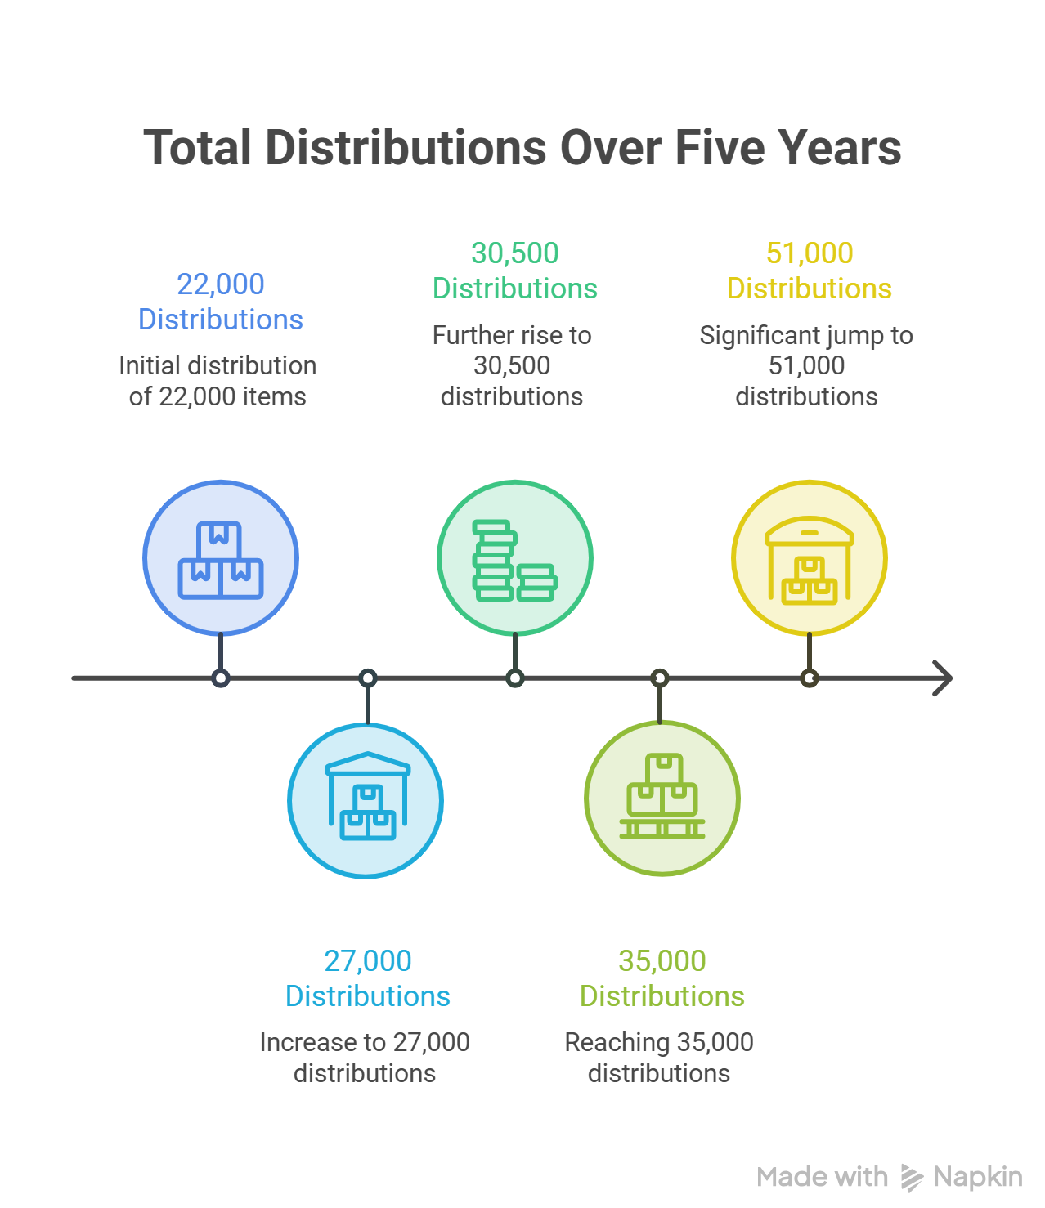

Estimated Revenue from Distribution Processing
Estimated Revenue from Distribution Processing is the total amount of money earned as a result of processing participant distribution requests over a particular time interval. It is the sum of all distribution requests multiplied by processing fee per distribution. This analysis can be used to gauge the revenue generating potential of the Distribution Team and the contribution of revenue from distribution processing to the organization.
The estimated annual revenue from distribution processing has been calculated for 2021-2025 to assess Data Path Ltd.'s financial performance on its distribution processing operations. Based on the number of participant distribution requests processed per year and the processing fee that applies per distribution. During 2021 and 2022, the processing fee was USD 90 per distribution, which increased to USD 100 in 2023, USD 115 in 2024, and USD 120 in 2025. The estimated revenue analysis can help determine how the distribution processing business of the company has grown and the impact on the company's finances of the growth in processing volume and service fees.
Table 03: Estimated Revenue from Distribution
Year | 2021 | 2022 | 2023 | 2024 | 2025
Fee per Distribution (USD) | 90 | 90 | 100 | 115 | 120
Estimated Revenue | 1.98 M | 2.43 M | 3.05 M | 4.03 M | 6.12 M

It is estimated that distribution processing revenue has consistently been increasing over the 5-year period and has shown a strong growth. The estimated revenue for 2021 was USD 1.98 million, whereas it was estimated to be USD 6.12 million in 2025, which is over three times the amount of 2021. This increase is caused by the rise of number of distribution requests the participants are requesting and the progressive rise of processing fee for each distribution. Revenue has increased primarily due to an increase in volume of distribution requests during 2021–2023. The growth in revenue for 2024 and 2025 was greater because processing volumes grew and the services fees also increased. The dramatic rise in 2025 is a reflection of the company's major growth in its distribution processing business, reflecting the rising need for retirement plan administration services. The overall estimated revenue analysis indicates that Data Path Ltd. notably bolstered its revenue capabilities in the face of ongoing business expansion, effective operational execution, and intelligent pricing strategy modifications. This steady revenue growth shows that the company has a larger client base. It also reflects increased processing power and the Distribution Team's role in generating overall revenue.

Revenue Growth
The Revenue Growth Ratio shows how more money a company makes from one year to the next. This is a deal because it tells us if a company is getting bigger and doing better. The Revenue Growth Ratio is like a report card, for a company’s health. It looks at how the company is doing and if it is growing in the market. The Revenue Growth Ratio is very important because it shows if a company is making money and if its business is working well.
To see how well Data Path Ltd.’s distribution processing business is doing we looked at the Revenue Growth Ratio. This is based on how money they make from distribution processing each year. We wanted to know how more money they made each year compared to the last one. This tells us if Data Path Ltd. Is getting bigger and doing better and if they can make money over time. If the Revenue Growth Ratio, for Data Path Ltd. Is going up it usually means they are doing a job more people want their services and they are getting better at making money.
Table 04: The Revenue Growth Ratio
Year | 2021 | 2022 | 2023 | 2024 | 2025
Growth | 22.73% | 25.51% | 31.97% | 52.05%

Estimated revenue generated through distribution processing shows consistency and high growth trends throughout the five years. In 2021, the estimated revenue obtained through distribution processing is USD 1.98 million for Data Path Ltd. In 2022, the estimated revenue increased to USD 2.43 million, showing an increase of 22.73% compared to the previous year. Continued growth was seen in 2023, where the estimated revenue is USD 3.05 million, showing a 25.51% increase.
In 2024, the financial performance was further improved through an estimated revenue of USD 4.02 million showing a growth of 31.97%. The highest revenue increase was observed in 2025 when the estimated revenue increased to USD 6.12 million, showing an increase of 52.05%.

Figure 02: Revenue Growth Ratio

Altogether, the consistent growth of the revenue suggests a lot of growth of the business in terms of expanding activities. Such increases may have been achieved due to an increase in the number of distribution processes requested, gradual increase in fees charged, increase in the number of customers, operational efficiencies, and more. The growth in the revenue clearly illustrates how Data path has grown as far as its operations are concerned.
Revenue per Distribution
Revenue per Distribution measures the average money we earn from each distribution request. It helps us see if our pricing strategy is effective and how much we make from each distribution deal. The Revenue per Distribution indicator examines the revenue generated from every distribution request we handle. This helps companies understand their pricing strategies and make informed decisions. We use it to evaluate the revenue earned from each distribution transaction.
The Revenue per Distribution analysis reveals that the average revenue from each distribution request increased gradually over time. In 2021 and 2022, Data Path Ltd. earned an average of USD 90 per distribution. This was due to the processing fee they charged during those years.

Figure 03: Revenue per Distribution
The average revenue from each distribution request was USD 100 in 2023. It was USD 115 in 2024. In 2025 the average revenue per distribution was USD 120. The company made these changes to the processing fee over time.
The fact that the revenue from each distribution request went up consistently shows that Data Path Ltd. was able to make pricing adjustments work. The company was still able to get distribution requests even with the changes. This helped the company make money overall. It also helped the Distribution Team at Data Path Ltd. Do better financially.
The Revenue per Distribution going up shows that Data Path Ltd. Can make money because they are good at pricing and their business is growing. The Revenue, per Distribution is a measure of how well Data Path Ltd. Can make money from what they do.

4.5 Operational Costs of Distribution Management
Since the real operational cost data of Data Path Ltd. is private information and not available for academic purposes, a set of reasonable assumptions have been made to estimate the cost of processing for the purpose of financial analysis. It is assumed that the distribution processing fee was USD 90 per transaction in 2021 and 2022, with an estimated processing cost of USD 55 per distribution. In 2023, the processing fee increased to USD 100, while the estimated processing cost was USD 60. In 2024, the processing fee rose to USD 115, with an estimated processing cost of USD 69. Finally, in 2025, the processing fee increased to USD 120 per distribution, with an estimated processing cost of USD 70. Based on these assumptions, the following ratio analysis has been prepared to evaluate Data Path Ltd.'s estimated financial performance and operational efficiency. The calculations presented are intended solely for academic purposes and do not represent the company's actual financial information.
Table 05: Estimated Operational Costs of Distribution Management
Year | 2021 | 2022 | 2023 | 2024 | 2025
Fee per Distribution (USD) | 90 | 90 | 100 | 115 | 120
Estimated Cost per Distribution (USD) | 55 | 55 | 60 | 69 | 70
Total Distributions | 22,000 | 27,000 | 30,500 | 35,000 | 51,000
Estimated Revenue | 1.98 M | 2.43 M | 3.05 M | 4.03 M | 6.12 M
Estimated Cost | 1.21 M | 1.49 M | 1.83 M | 2.42 M | 3.57 M
Estimated Gross Profit | 0.77 M | 0.95 M | 1.22 M | 1.61 M | 2.55 M

Estimated Cost Structure per Distribution
Estimated Cost Structure per Distribution is the distribution of the estimated processing cost across the primary cost components needed to process a single request for distribution for a retirement plan. It gives a broad perspective of the distribution of the overall processing cost among business activities and assists in assessing the cost structure and efficiency of the business.
Data Path Ltd. does not publish the actual cost in which it incurs per distribution request, so an estimated cost structure has been derived for academic purposes only, depending on the nature of the retirement plan administration services. Major operational costs included in estimating processing costs for review of participant requests, verification of eligibility, regulatory compliance, communications with clients, technological infrastructure and day-to-day operations. The cost components are not given in monetary terms, but rather as percentages of the total estimated processing cost to show the relative contribution of each cost component.

Figure 04: Estimated Cost Structure per Distribution
The estimated cost structure shows that processing cost is mostly driven by Employee Salary & Benefits (40%) of the total processing cost per distribution. That's indicative of the amount of manual work involved in retirement plan administration, where he or she needs to be able to review requests, ensure eligibility, stay current on regulatory requirements, and accurately process distributions. The remaining costs are divided among technology and software (15%), administrative and office (13%), quality review and compliance (12%), communication and client support (8%), training and professional development (5%) and general overhead allocation (7%). All of these costs are necessary to efficiently provide processing services within the distribution channel and to ensure accuracy, regulatory compliance and high quality customer service. The estimated cost structure is realistic in terms of the costs incurred in processing distributions from retirement plans and provides a basis for the financial ratio analyses presented in this report.
4.6 Profitability Ratio Analysis
Gross Profit Margin
Gross Profit Margin represents the percentage of revenue remaining after the direct costs of providing services are deducted, which indicates the operational profitability of the company.
Gross Profit Margin = (Gross Profit ÷ Revenue) × 100
Table 06: Gross Profit Margin
Year | 2021 | 2022 | 2023 | 2024 | 2025
Gross Profit Margin | 38.89% | 38.89% | 40.00% | 40.00% | 41.67%
The Gross Profit Margin of Data Path Ltd. was stable and increased gradually over the five-year period. The gross profit margin stood at 38.89% in 2021 and 2022, which means that the company retained nearly 39 cents as gross profit from every USD 1 of revenue after considering the estimated processing costs. The margin increased to 40.00% in 2023 and 2024, reflecting better cost management and higher profitability driven by the rise in processing fees.
The gross profit margin was at its highest in 2025 at 41.67%. That means the company was able to keep about 42 cents of gross profit for every USD 1 in revenue generated, indicating improved operational efficiency and enhanced profitability. Overall, the increase in the gross profit margin shows that Data Path Ltd. was successful in controlling its processing costs and increasing its service fees, resulting in better financial performance during the period.

Figure 05: Gross Profit Margin
Cost-to-Revenue Ratio
The Cost-to-Revenue Ratio measures what percentage of total revenue is used up by operating or processing costs.
Formula: Cost-to-Revenue Ratio (%) = (Total Cost ÷ Total Revenue) × 100
Table 07: Cost-to-Revenue Ratio
Year | 2021 | 2022 | 2023 | 2024 | 2025
Cost-to-Revenue Ratio | 61.11% | 61.11% | 60.00% | 60.00% | 58.33%
Cost-to-Revenue Ratio is the ratio of total revenue to the estimated processing costs. The ratio has been 61.11% in 2021 and 2022, which means Data Path Ltd. spent around 61 cents per USD1 of revenue it generated. The ratio decreased slightly in 2023 and 2024, at 60.00%, showing that cost efficiency is improving a bit with smaller amount of revenue being spent on processing costs. In 2025, the company posted its lowest-ever Cost-to-Revenue Ratio, at 58.33% where only about 58 cents was spent on estimated processing costs for every USD 1 generated in revenue. The overall declining Cost-to-Revenue Ratio indicates better operational efficiencies and cost management. It implies that over the five-year period Data Path Ltd. could maintain its profitability, even as its service fees rose, which in turn led to greater utilization of resources and lower processing costs.

Figure 06: Cost-to-Revenue Ratio
Revenue Growth Ratio
The Revenue Growth Ratio is the percent change in revenue compared to the prior year.
Formula: Revenue Growth (%) = [(Current Year Revenue − Previous Year Revenue) ÷ Previous Year Revenue] × 100
Year | 2021 | 2022 | 2023 | 2024 | 2025
Growth | – | 22.73% | 25.51% | 31.97% | 52.05%
The Revenue Growth Ratio shows that Data Path Ltd. had steady and significant revenue growth over the period of study. The estimated revenue growth from USD 1.98 million in 2021 to USD 2.43 million in 2022 is 22.73%. Revenue has also been steadily increasing in 2023, at USD 3.05M, 25.51% higher than 2022. In 2024, the company's revenue was estimated at USD 4.03 million, marking a 31.97% increase from the previous year. The highest growth was seen in 2025, as revenues jumped by 52.05% to around USD 6.12 million from 2024. In general, the revenue has been growing over the previous 5 years, so Data Path Ltd. clearly managed to go through a process of expansion in their business operations over that time. The strong growth is due to an increase in distribution requests handled, distribution processing fees increasing on a periodic basis, a growing number of clients, and increased operational efficiency. The company's revenue also experienced a significant increase in 2025, reflecting its robust market position and the potential for greater revenue generation from its retirement plan administration services.

Figure 07: Revenue Growth Ratio
Gross Profit Growth Ratio
Gross Profit Growth Ratio is the percentage increase or decrease in gross profit from last year.
Formula: Gross Profit Growth (%) = [Current Year Gross Profit − Previous Year Gross Profit) ÷ Previous Year Gross Profit] × 100
Table 08: Gross Profit Growth Ratio
Year | 2021 | 2022 | 2023 | 2024 | 2025
Growth | – | 22.73% | 29.10% | 31.97% | 58.39%
The Gross Profit Growth Ratio shows that Data Path Ltd.'s profitability increased steadily for the 5 years. Gross profit increased from USD 770,000 in 2021 to USD 945,000 in 2022, representing a 22.73% growth. Profitability continued to improve in 2023 (+29.10%) and 2024 (+31.97%). The highest growth was seen in 2025, with a gross profit of USD 2.55 million, an increase of 58.39% from the previous year. The upward trend indicates that Data Path Ltd. successfully improved their profitability by boosting revenues and managing their expenses effectively.
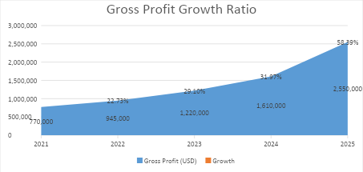
Figure 08: Gross Profit Growth Ratio

4.7 Break-even Analysis
When we do a break- analysis we are trying to figure out how much we need to sell to cover our costs. This is a way for companies to see when they will start making money. A break- analysis is a tool that helps companies find the point where the money they make is equal to the money they spend.
At this point the company is not making a profit. It is not losing money either. The break- analysis helps companies see if they can really make money from their business. It tells them the minimum amount of money they need to make to pay for everything. This is important for companies to know if their business is an idea and if it will make money. Break- analysis is about finding the balance between the money that comes in and the money that goes out.

Assumption of the Analysis
This analysis is based on financial assumptions which are reasonable and consist of information, which is not, and has not been made, public. Financial assumptions are reasonable and information which is not and has not been made public is utilized in this analysis. The fixed operating cost of the Distribution Department is assumed to be USD 500,000 per year. In addition, the assumptions of the processing cost per distribution are USD 55 if the processing cost is USD 90, USD 60 if the processing cost is USD 100, USD 69 if the processing cost is USD 115, and USD 70 if the processing cost is USD 120. The assumptions are merely for academic purposes and are not intended to reflect the actual financial information of Data Path Ltd.
A break-even analysis has been performed for Data Path Ltd. to assess the financial sustainability of their distribution processing activities, based on their estimated revenue, processing costs and fixed operating costs. The analysis determines the minimum revenue needed to cover up all estimated running expenses and the company estimates annual revenue is compared with minimum revenue. The outcomes give an indication to how much revenue the department can produce above the breakeven level and shows the overall efficiency and profitability of the department.
Table 09: Break-even analysis
Particulars | 2021 | 2022 | 2023 | 2024 | 2025
Fee Per distribution | 90 | 90 | 100 | 115 | 120
Estimated Processing Cost | 55 | 55 | 60 | 69 | 70
Contribution Margin | 35 | 35 | 40 | 46 | 50
Contribution  Margin Ratio | 38.89% | 38.89% | 40.00% | 40.00% | 41.67%
Assumed Fixed Operating Cost (In million) | 0.50 M | 0.50 M | 0.50 M | 0.50 M | 0.50 M
Break-even Revenue  (In million) | 1.29 M | 1.29 M | 1.25 M | 1.25 M | 1.20 M
Actual Revenue  (In million) | 1.98 M | 2.43 M | 3.05 M | 4.03 M | 6.12 M
Revenue Above Break-even | 54% | 89% | 144% | 222% | 410%

Contribution Margin Analysis
Contribution Margin Analysis is a tool used to help us understand how much money is left over once we have paid out the costs that vary with our sales. This can help us determine the profitability of each item we sell and the amount that each item contributes toward covering the fixed costs. For a company like Data Path Ltd. That's what the services Contribution Margin Analysis helps you to determine whether each service you offer is profitable or not. It also assists decision makers to consider the amount that can be charged, the cost control and how to improve the functionality of the company. Contribution Margin Analysis is important for companies, like Data Path Ltd. It aids them in comprehending the impact of each service on their Contribution Margin.
Formula here we use: Contribution Margin=Fee−Cost

Figure 09: Contribution Margin
The contribution margin kept going up from $35 per distribution in 2021 to $50 in 2025.
This way we were making cash for our overheads or more profit with each distribution we processed. The contribution margin is significant because it indicates our money after we have covered our variable costs. Our pricing decisions and cost management are working well. That’s why we're seeing this upward trend, in contribution margin.
That contribution margin performance has been steady is wonderful. The contribution margin allows us to pay the fixed operating costs and to boost profitability. We can make money from each distribution.
Contribution Margin Ratio
The Contribution Margin Ratio (CMR) is defined as a financial ratio that represents the amount of money from sales revenue remaining after subtracting variable costs. It determines what percentage of sales revenue covers fixed costs and provides the company with profit. A higher contribution margin ratio reflects greater operational efficiency and profitability.
Contribution Margin Ratio= (Fee−Cost)​/Fee ×100
Table 10: The Contribution Margin Ratio (CMR)
Particulars | 2021 | 2022 | 2023 | 2024 | 2025
Fee Per distribution | 90 | 90 | 100 | 115 | 120
Estimated Processing Cost | 55 | 55 | 60 | 69 | 70
Contribution Margin | 35 | 35 | 40 | 46 | 50
Contribution  Margin Ratio | 38.89% | 38.89% | 40.00% | 40.00% | 41.67%

The Contribution Margin Ratio of Data Path Ltd. has moved up steadily and consistently over the past 5-years. The company had 38.89% of its revenues left after deducting the estimated variable processing costs in both 2021 and 2022. This means that USD 0.39 was left to cover the fixed operating costs and generate profit for every USD 1.00 in distribution processing revenue.

Figure 10: The Contribution Margin Ratio (CMR)
The Company's Contribution Margin Ratio rose to 40.00% in 2023, improving the Company's pricing strategy and cost management. This enhancement remained in 2024 despite the volume of processing, showing consistency of operation. The proportion rose again to 41.67% in 2025, which is the highest seen during the study period. This translates to approximately USD 0.42 out of each USD 1.00 in revenues generated to recover costs and enhance profitability.
The non-significant rise in the Contribution Margin Ratio over time indicates that Data Path Ltd. was able to generate higher distribution processing fees, while holding constant estimated processing costs, thereby making its operations more efficient. Therefore, the financial gains to the firm's profit were higher in both the distribution channels. It has also risen indicating that the company is in a better position financially, meaning that it is more cost efficient and able to sustain set costs of operating the company and future expansion. In summary, the trend of rising Contribution Margin Ratio indicates Data Path Ltd.'s capacity to enhance its financial sustainability and make more profit from their distribution processing activities.

Break-even Revenue
Break-even Revenue is the revenue required to generate by a company to equal its total fixed and variable costs. The break-even point is the point at which total revenue is equal to total costs, so there is no profit or loss. This is a key financial metric to assess business sustainability, cost recovery and performance.
To see if Data Path Ltd. Can afford to keep running their distribution processing operations we need to figure out the break- revenue. We did this by using the estimated contribution margin ratio and guessing that the fixed operating cost per year is USD 500,000. This calculation tells us the minimum amount of money Data Path Ltd. Needs to make so that they can pay all their operating costs without making a profit or a loss. We did this calculation for each year. The results are, below.
Table 11: The Break-even Revenue Analysis
Particulars | 2021 | 2022 | 2023 | 2024 | 2025
Contribution Margin Ratio | 38.89% | 38.89% | 40.00% | 40.00% | 41.67%
Assumed Fixed Operating Cost (In million) | 0.50 M | 0.50 M | 0.50 M | 0.50 M | 0.50 M
Break-even Revenue  (In million) | 1.29 M | 1.29 M | 1.25 M | 1.25 M | 1.20 M
Actual Revenue  (In million) | 1.98 M | 2.43 M | 3.05 M | 4.03 M | 6.12 M
Revenue Above Break-even | 54% | 89% | 144% | 222% | 410%

The Break-even Revenue Analysis shows that Data Path Ltd. can produce a revenue greater than the minimum required to cover the fixed operating costs. The company's contribution margin ratio steadily increased from 38.89% in 2021 to 41.67% in 2025, meanwhile the company's assumed fixed operating cost remained USD 500,000 throughout the five years. The increase in the contribution margin ratio represents a greater efficiency in converting revenue into contribution to fixed costs and profit for Data path.

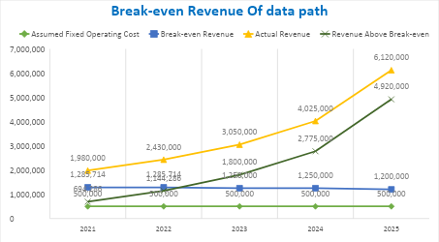
Figure 11: The Break-even Revenue Analysis
As a result of the increasing contribution margin ratio, the company's break-even revenue requirement declined from USD 1,285,714 in 2021–2022 to USD 1,250,000 in 2023–2024, and further to USD 1,200,000 in 2025. This decline indicates that Data path's fixed operating expenses declined, owing to more efficient operations and cost management.
In all year’s actual revenues have always been greater than the break-even revenues. The business has grown significantly with a steady revenue increase from USD 1,980,000 in the year 2021 to USD 6,120,000 in 2025. As a result, revenues over breakeven also jumped significantly, from USD 694,286 in 2021 to USD 4,920,000 in 2025. This means that year by year the firm increased the amount of its operating surpluses.
In conclusion, the analysis shows that Data Path Ltd. was financially stable during the period under study. The steady rise in revenue, along with the growth in contribution margin ratio and the decline in break-even revenue, shows improved operational efficiency and a good profitability. The gap is increasing and shows that the real revenue is increasing in relation to break-even revenue, thus the Company's business risks are decreasing and its ability to support future growth is improving.

Revenue per Client
Revenue per Client is a financial performance measure that quantifies the average revenue per client over a given time. It is used to assess the company's potential of deriving maximum revenue from the clients and it indicates the success of client relationship management and service delivery.
The Revenue per Client ratio was determined to assess the company's ability to generate revenue from its increasing client base between 2021 and 2025. This analysis calculates the average revenue generated by each client for the year, by dividing total annual distribution processing revenue by the total number of active clients. It gives you a look at the profitability of your clients; how efficient your business is and how you could boost revenue by attracting new clients and or improving your service.
Table 12: Revenue per Client
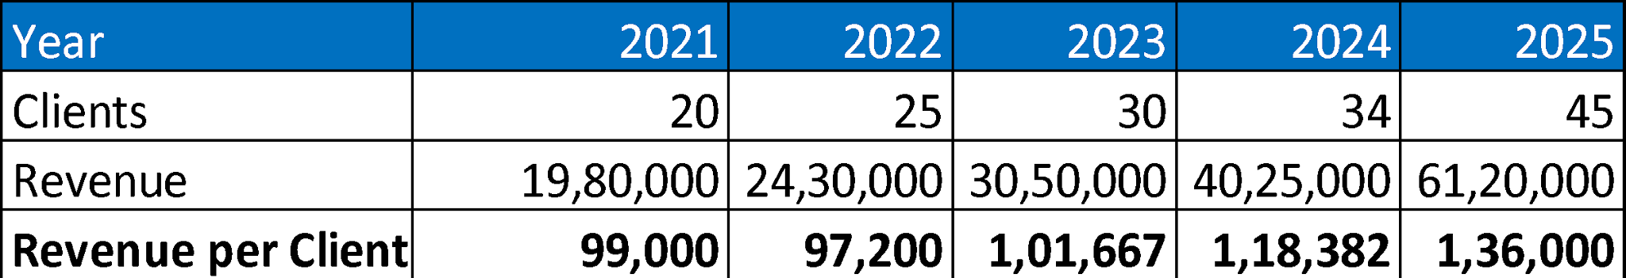

Based on the Revenue per Client analysis, Data Path Ltd. has seen a significant improvement in its ability to generate revenue per client from its customers over the past five years. The average revenue per client in the company was USD 99,000 in 2021. This was slightly lower, at USD 97,200, in 2022, reflecting a relatively higher growth in clients than in revenue, but the company's revenue bounced back in the next few years.
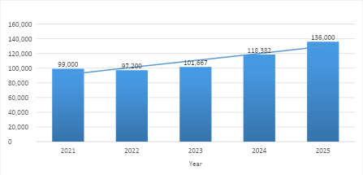

Figure 12: Revenue per Client
From 2023 onward, Revenue per Client increased steadily, reaching USD 101,667 in 2023, USD 118,382 in 2024, and USD 136,000 in 2025. The upward trend suggests that Data Path Ltd. is not only successful in securing new business but also increasing its revenue per customer. This growth can be explained by increased demand for distribution processing, fee structure increases, relationship-building and relationship management, and operational efficiency.
It concludes that Data Path Ltd. improved its revenue generation capacity by increasing its client base, overall. The increase in this indicator is a sign of the company's performance and good management of clients, which contributes to sustainable growth and profitability of the company in the long term.

CHAPTER V: CONCLUSIONS & KEY FACTS

5.1 Recommendations for Improving Departmental Operations
During my time at Data Path Ltd., in the Distribution Team I found there were several areas that the team could improve in order to be more efficient and provide better service. The overall distribution process is already effective, but some enhancements may be possible to enhance the process speed, accuracy, and distribution efficiency.
One of the critical recommendations is to use the automation system more in the day-to-day operations. Additional automation to verify documents, validate participant eligibility and track tasks could further reduce manual work and process errors, while many are currently automated by various systems. It would also enable employees to get things done faster, and boost productivity.
Another area for improvement is client communication. Required documents or responses from clients or plan administrators are often not submitted on time, causing many distribution requests to be delayed. Standard email templates, automatic reminder emails, and regular follow-up communication could help to speed up response rates and avoid unnecessary delays in processing.
The company will also benefit from creating a centralized employee knowledge base. Having IRS regulations, plan rules, standard operating procedures (SOPs), and common processing scenarios all on one platform would aid employees in locating information. This will help create uniformity in decision making and minimize the time required to address processing problems.
Regular training programs should also continue to be provided for employees. The rules of the retirement plan and IRS regulations are subject to change, and ongoing training would assist employees in keeping up to date on any changes in the rules or regulations from an IRS or company perspective, as well as best practices in the industry. This would enhance the accuracy of the processing and compliance as well.
Further, the department could improve its performance monitoring through the frequent measurement of Key Performance Indicators (KPIs) like average processing time, turnaround time, documentation accuracy, error rate etc. The ability to track these indicators would enable management to detect issues in the operation early and make appropriate adjustments in order to enhance the operation.
Finally, Data Path Ltd. could make greater use of operational data for decision-making. Processing trends analysis, frequent issues with documentation, changes in workload throughout the year, and common questions asked by the participants would assist management in planning resources more effectively, improving the management of the workflow, and providing better service. The implementation of these recommendations would further enhance the Distribution Team's performance and contribute to the company's long-term success and customer satisfaction.

5.2 Key Understanding
The experience at Data Path Ltd. provided a wealth of knowledge on how U.S. retirement plan administration works and is regulated. As a member of the Distribution Team, I gained experience in reviewing, approving and processing participant distributions for a wide variety of reasons, including, but not limited to, hardship, in-service, termination, rollover and distributions for required minimum distributions (RMDs), participant loans, refinancing participant loans and distributions for death benefit distributions, in accordance with IRS regulations and plan provisions.
Also, the internship helped me understand how vital Third Party Administrators (TPAs) are for plan administrators when it comes to making their plan effective. I found that success of distribution processing was not only the technical expertise, but the review of all documentation, ensuring adherence to regulation, communicating and collaborating, and paying attention to detail.
Moreover, I learned to use the theories that I have been taught in the classes such as Finance, Business Communication, Business Law, Operations Management and MIS in solving real problems. This enhanced my analytical thinking, problem solving abilities and professional communication, time management, organization, and professionalism in the workplace.
Overall the internship was a great experience to get first-hand experience in the field and get a glimpse of what my future career will entail in future retirement plan administration and finance.

5.3 Conclusion
This internship at Data Path Ltd. was an invaluable learning experience, and has had an impact on my academic, professional and personal growth. Working in the Distribution Team was key to understanding what it is like to be on the ground with distribution administration for retirement plans and provided me with a greater understanding of the challenges faced when distributing 401(k) plan proceeds in a highly regulated environment.
During the internship, I actively participated in answering requests from the participants, verifying the eligibility of the participants, verifying the information given in the documentations, ensuring regulatory compliance, communicating with the client etc., and helping in the everyday business. They helped me further develop a number of important industry skills: problem-solving, attention to detail, analysis, communication and teamwork and time management.
The elements that are necessary to build a high-performing retirement plan distribution management system—strong processes, compliance with regulations, top-notch technology and compelling communications with all stakeholders—are all essential components of the recipe for success. Data Path Ltd. has successfully built an operational structure and a client-centric approach that provide accurate, timely and compliant retirement plan administration services.
Finally, the internship has achieved the desired learning outcomes and has given me the opportunity to learn, practice and acquire new knowledge from the industry. Overall, my internship has reinforced my interest and passion for contributing to my profession and has been instrumental in reviving my career aspirations in financial services, retirement plan administration and finance.

REFERENCE:
- https://www.dol.gov/
- https://www.data-path.net/
- https://www.data-path.net/bpo-services/
- https://en.wikipedia.org/wiki/Employee_Retirement_Income_Security_Act_of_197 4?utm_source
- https://en.wikipedia.org/wiki/Pension_Protection_Act_of_2006?utm_source
- https://www.irs.gov

