Internship Report
On
Agent Management of an Online Marketing Organization:
A Case Study on DARAZ.COM.BD

Submitted To
Muhammad Hasan Al-Mamun
Assistant Professor
School of Business & Economics
United International University

Submitted By
Tansushila
ID Number: 111 141 295
BBA Program
School of Business & Economics
United International University

Date of Submission:


Letter of Transmittal

8th July, 2018
Muhammad Hasan Al-Mamun
Assistant Professor
School of Business & Economics
United International University

Subject: Submission of Internship Report.

Dear Sir,
I am submitting my internship report titled “Agent Management of an Online Marketing Organization: A Case Study on DARAZ.COM.BD” as a requirement for the completion of the internship program of the BBA program at United International University under the School of Business and Economics.

It was a great prospect for me to gain knowledge in such a professional environment through the internship program. It has been a learning experience for me and I have tried to reflect my learning in the report. The report provides illustrations of the experiences that I have gathered during my 3 months internship period.

I would like to take this opportunity to thank you for all the supports and guidelines that you have provided, which I hope to continue getting in the future.

Sincerely,

Tansushila
ID Number: 111 141 295
BBA Program
School of Business & Economics
United International University

Acknowledgement

All the praises are for the almighty, ALLAH who bestowed me with the ability & potential to complete this Internship report. I also pay our gratitude to the almighty for enabling me to complete this report within due course of time.
For the making of this report, I would like to convey my sincere thanks to Md. Zubaer Siddique, Head Of D-Force, sales Department. Monica Kabir, Senior executive, D-Force, Sales Department of Daraz Bangladesh Ltd. While I was working in this company, I was attached to the team led by them. They have given me their valuable time and full supports while carrying out the steps that were required to make this report. Also, they have given me the access to ask for any resources that I may require while preparing the internship report.
I take this opportunity to record my deep sense of gratitude and appreciation to our teacher Muhammad Hasan Al-Mamun, Assistant Professor of School of Business and Economics,United International University,for his constant encouragement and inspiring guidance with his wisedom.

Executive Summary

Every year we are noticing a significant growth of internet users. Now e-business have become very popular among people. For most of the people in Bangladesh, Amazon, Alibaba. Flipkart are not alien concepts. We have many e-commerce ventures, such as click BD, bikroy.com, ekhanei.com, daraz.com.bd, Kaymu, foodpanda, Hungry naki etc. Daraz Bangladesh is the pioneer of E-commerce industry in Bangladesh who has brought a new era in the shopping trend. It has opened so many opportunities for business along with new trends for the customers. They try to follow the effective internet projects from other advanced countries like United States and replicate their tactics in developing markets. Daraz Bangladesh Limited is rigorously providing B2C type on selling which no other E-Commerce portal does in Bangladesh. Daraz was launched in late September 2013 and has become the 4th e-commerce site after OLX, Ekhanei and ClickBD.
As I did my internship under D-Force Sales consultant Department as Intern at Daraz Bangladesh therefore throughout this report I have tried to bring the some facts regarding the D-force sales consultant program, how it works and also tried to find the agent acquisition through D-force of Daraz Bangladesh. I have given details of my job descriptions where I mentioned how D-force sales consultant program which is based on agent acquisition of Daraz Bangladesh runs, which software they use while working and different methods of working. I have described the analyses on Daraz Bangladesh. There I tried to put the steps how an agent can enroll in D-force through website. However, I have tried to describe my research on Daraz Bangladesh and findings, interpretation of my research and recommendations on Daraz Bangladesh.
In addition, in recommendations part I tried to mention the suggestions of the consumers which I found from my survey. Throughout the report I tried to find out how D-force sales consultant program manage their agent acquisition from Daraz Bangladesh, their current service conditions for agents, where they should perform better and so on. It’s now extremely essential to anticipate and forecast the needs and demands of the agents and fulfill them accordingly to increase the market growth and market share as well.
Key Words: e-commerce, agent-management

Table of Contents:
Company Background and Industry Perspectives 7
COMPANY OVERVIEW 9
Brief Profile of Daraz- Bangladesh 9
Features 10
MISSION, VISION, OBJECTS & CORPORATE DIVISION OF DARAZ 11
Mission 11
Vision 11
Objectives: 11
DETAILS OF THE PRODUCT LINE & SERVICES 12
OPERATION DETAILS 14
CORPORATE SOCIAL RESPONSIBILITY (CSR) 16
➢ Campus workshop: 16
➢Daraz Future Leadership Training Program: 16
Agent Management on the perspective of Daraz.com.bd 17
Difference about D-Force 18
How to participate in D-Force 19
How to Place order by use agent id 21
Future Plan of D-Force Improvisation and implementation 29
Scope 32
Methodology 32
Limitations 33
Conclusions 36
References: 37



Company Background and Industry Perspectives

Bangladesh is a growing country in the world. It brings achievement in the diverse sectors like RMG, Education, and Medicine etc. But the biggest success has been come from the ICT sector. E-commerce refers to the buying and selling of products or services over electronic network combining a range of process such as Electronic Data Interchange, Electronic mail, World Wide Web, Internet Applications and Network Applications. Everyday e-commerce is improving the efficiency and effectiveness of business, government and nonprofit organizations.
Some years back in our country we never thought to buy anything without physically touching or watching. We couldn’t even imagine that we are ordering something just based on some photo and information, that thing is brought by someone else to our home and then we are receiving that product. But at recent time the surroundings have been changed extremely. This happened because of the progress of technology along with the new idea, e-Commerce.
E-commerce refers to the buying and selling of products or services over electronic network merging a series of process like Electronic Data Exchange, Electronic mail, World Wide Web, Internet Applications and Network Applications. E-commerce was presented 50 years ago and keeps on developing with new technologies, innovations, and a great many administrations entering the online market every year Everyday e-commerce is improving the efficiency and effectiveness of business, government and nonprofit organizations. At today’s date, people lack time. They try to save it as much as possible and that’s where e-commerce shows its charisma by saving both the most significant things which is time and money. From an online marketplace people can buy and sell their products rather than visiting physical market.
Daraz Bangladesh is the forerunner of E-commerce business in Bangladesh who has brought a new era in the shopping trend. It has opened so many opportunities for business along with new trend for the customers. Daraz is becoming the leading online marketplace for Bangladesh. Here, in Bangladesh, people only knew about Amazon business model where buyers meet sellers and exchange goods. Amazon business model is introduced by Daraz in Bangladesh. They try to follow the effective internet projects from other advanced countries like United States and replicate their tactics in developing markets. Daraz Bangladesh Limited is rigorously providing B2C type on selling which no other E-Commerce portal does in Bangladesh. Daraz was launched in late September 2013 and has become the 4th e-commerce site after OLX, Ekhanei and ClickBD.
Rocket Internet is the mother company of Daraz. They started their journey in 1999 and now they have 120+ market driving projects in 50+ countries. In late 2014, Samwer Siblings regarded Rocket Internet as a multi-billion-dollar association. The associations politely appraised worth billion euros was around 8 in April 2015.
Rocket Internet.
"We build companies” is the mission of Rocket internet. Rocket Web GMBH is world's one of the fasted creating startup wander incubation center. This Association was set up by three kin known as Samwer Siblings. The association's Head quarter is masterminded in Berlin, Germany. They contract people over the world who have the conceivable outcomes as like as a specialist. They have meanders in more than 50 countries. Rocket generally target making countries who has creating markets like Bangladesh, Cambodia.
It has some ventures. These are:
➢ Kaymu – Online Shop
➢ Food Panda – Online Food shop
➢ Carmudi – Online Car shop
➢ Lamudi– Online Real State
➢ Jovago – Online Hotel Booking service
➢ Everjobs - Online Job Site (Companies, 2017)

COMPANY OVERVIEW

Brief Profile of Daraz- Bangladesh:
It is viewed as that Bangladesh is a developing on the ecommerce industry where famous organizations, for example, EBay, Amazon, Flipkart has not been presented in Bangladesh and meanwhile, Daraz accepted the open door to catch this tremendous market. In most recent 5 years, Rocket Internet presented eleven organizations in Bangladesh and those are in like manner –
Carmudi, Wadi, Javago, Printvenue. Vendito.com, Easy Taxi, Lamudi, Lyke, Zenrooms, Kaymu and Daraz. Later, it had been launched more businesses.
"Daraz" is Urdu word which means "Drawer" and as an overall driving e-retail market, it confidently boosted its operation in Bangladesh as Daraz.com.bd. Practically at the remainder of the middle of 2013, it went to the market as a fourth internet business webpage after OLX, Ekhanei and ClickBD however bearing its business operation to acquire the nation's main web based shopping point. (Chowdhury, 2016)
it has a verified official fb page with 10 million followers (Daraz Online Shopping, 2018). People who using Facebook, can see the new offers in it. It is just like a digital marketing policy to get more customers. There is an interesting thing that Daraz is one of the online marketplaces which keeps their eyes on the SEO. So, when a customer searches on Google like “the biggest or best ecommerce sites”, the name of Daraz comes first.
Daraz has many products in its website. From the baby diapers, Daraz provides fashionable clothes, electronic products, furniture, masher bazar, books, home decorations, bags, watches, accessories, sports & fitness items etc.
Daraz gives many promotional offers to the customers. These offers are given after end of each weeks or any occasions, campaigns etc. To grab these offers, customers place orders more & more time. Even if one customer places order using his/her different email to get offers.
Like other countries, Daraz provides a shopping experience that is incomparable in Bangladesh. Daraz attempts to offer the most modish, adapted and protected online shopping experience with a wide scope of brands such as Yellow, Noir, Symphony, The Body Shop, Huawei, Samsung, Walton, Aranya, 6 Degree Mobile, ShadaKalo, Apple, LG, Fastrack, MAC, Nikon, Ecstasy, Panasonic, Doors etc. are just a few of the global and local leading brands who have already set up e-stores with Daraz.com.bd with excellent sales reviews. (Smartphones, 2018)
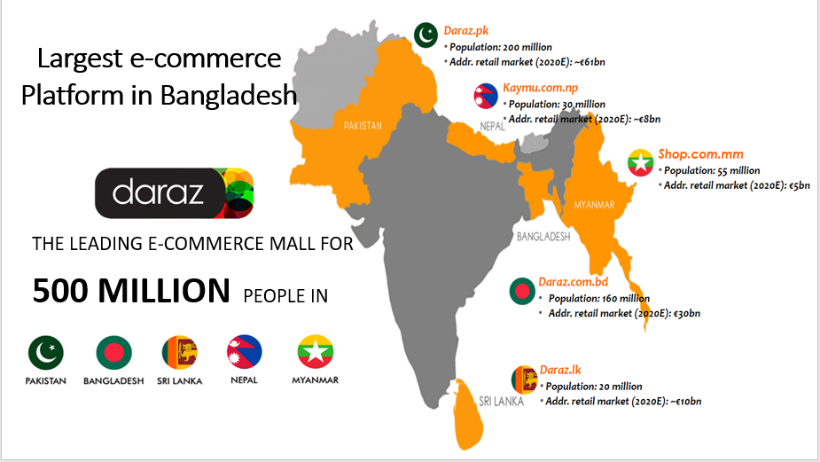

Features:
Daraz is an online shopping destination where fashion lovers can get-
➢ Extensive assortment of electronics, fashion, home appliances, kid’s items,
➢ Delivery directly to consumers home or office at convenient time,
➢ Offers unrestricted returns and various imbursement options as well as cash on delivery,
➢ With reasonable prices and quality products, Daraz allows an overwhelming experience,
➢ Super suitable guarantee from the sellers,
➢ Escalating the product range to include the latest gadgets, fashion styles and new classifications,
➢ Payment method is cash on delivery by assigned rider along with a wider range of options are also available during receiving end,
➢ Port wallet (online payment), bKash, Rocket, Swipe on delivery etc. are the services what customers can use to buy products,
➢ Delivery is door-to-door and handled by trusted logistics partners-AIGX

MISSION, VISION, OBJECTS & CORPORATE DIVISION OF DARAZ

Mission:
To take over all the clients is the Mission of Daraz. To accomplish this mission, Daraz gives many attractive offers to the clients. So, customers become happy getting many offers and buy products with lowest prices.

the missions are-
- To provide an enjoyable shopping experience for Consumers and to grow together with our Sellers

- It will continue building a vast loyal customer base by having the broadest selection of products, unbeatable prices, 100% reliable fulfillment and relentless focus on customer experience.

- For its’ Sellers, it will continue to provide a differentiated value-added service to support scalability, growth and integrated business solutions.

- Daraz Bangladesh will achieve the mission by focusing on their core values and hiring, coaching and retaining the best people in the industry through a strong company culture.

- Daraz Bangladesh is committed to a strong ESG program and creating long-term growth and job opportunities in all of our markets by pioneering the e-commerce development.

Vision:
The vision of Daraz Bangladesh is to be a leader in the ecommerce industry providing best products with lowest prices. The Vision statement of Daraz is “To be the most reliable marketplace and offering the best services to our customers: Consumers and sellers”

Objectives:
Daraz wants to provide the best quality products at the most competitive price. Daraz believes to introduce the latest and demanding products for its customers. The objectives of Daraz Bangladesh are to reach everywhere in Bangladesh to grab the most market share, provide every necessary product to its consumers and include most significant brands and sellers in Bangladesh.

Corporate divisions and departments:

The biggest online shopping marketplace, Daraz Bangladesh, has some departments. Most of the departments are in the head office, Banani. There is an interesting thing that there has no separate cabins or rooms for the departments except the CS & Accounts department. The Managing director of Daraz sets meeting with all the departmental heads to know the current situations of company and give some instructions to them. The chart of these departments is given bellow:

DETAILS OF THE PRODUCT LINE & SERVICES

Daraz Online Shopping is a market place where buyers and sellers meet. Daraz gives superior collection of products to its clients. From Fashion to GM (General Merchandising) all is available on Daraz. Customers can visit their website www.daraz.com.bd and choose their preferable products without any hassle and products will be delivered within a few days. The products lines of Daraz are given below:
Baby section:
Baby diapers, baby feeds, baby clothes, baby toys etc are included in this category.
Men’s fashion:
Western clothes: T-shirts, Shirts etc, Religious clothes: Panjabi, Dhuti. Formal suits, Casual clothes, Shoes, wallets, body spay etc are included in this category
Watches:
All kinds of watches of Different Popular Brands such as Casio, Titans, Break watch, Time Zone etc are available for the customers. So, a customer can buy these products in an affordable price.
Women’s fashion:
Sharee, Kurti, Long kameez, Short kameez, Fatua, Lehenga, Shoes, Shirts/T-shirts, bags perfume etc. are included in this category.
Cosmetics:
There are a lot of cosmetics for the girls. There is a full of packages for them. On the other hand, there is special combo offers for them.
Electronic products:
Air coolers, Air conditioners, Televisions, Mp3 players, Hybrid camera, Digital camera, Laptops, DVDs, Home theater, DSLR camera, Lenses, Power banks, Smart watches etc.
Mobiles & accessories:
Daraz has corporate Deal with Xiaomi,Nokia, Samsung, Oppo, Apple, Micromax, Symphony, Asus, HTC, Huawei, Infinix etc. So, a client can find 100% original and authentic products from Daraz. On the other hand, the prices of these phones are lowest from the local markets. Same things are for the mobile accessories. So, customers place orders more and more to buy these products.
Home appliance:
Vacuum cleaner, Refrigerator, Cooking appliance, Blender, Beverage appliance, Furniture, Bed sheet etc are included in this category
Sports & fitness:
football accessories, cricket accessories, tennis items, treadmills, by-cycle, bumbles etc. are included in this category
Deal under 999 Taka:
Under this group, a customer can buy products which are below 999 Taka. It is a great benefit for clients. Most of time, customers prefer this division to purchase products.
Grocery Item
It is another special offer for the customers. A customer gets all the products like shampoos, face washes, soups, soaps, chal, dal, baby dippers, chola, dates, combo of these products etc.

(Daraz Group. (n.d.). Daraz BD, 2016)

OPERATION DETAILS

Rocket Internet is the parent company of Daraz which has certificate of E-commerce association of Bangladesh (e-Cab). Daraz is working as a middle man but has corporate deals with the many sellers, business firms or corporates. After agreement, Daraz sells those products and give all the services to the customers. The followings are given below:
➢ B2B contact:
Daraz gives opportunity to the business firms to do business with them. Maximum time, companies want to join with Daraz. After the contract, they sell their products through the website of Daraz. So, the products of the firms are selling in a huge number via dara.com.bd.
➢Content writing:
After completing all kind of system with the vendor, following couple of working days dealer give his or her item list with a cost to the merchant operation director (Business Engineer). At that point business engineer gives that rundown to the Substance Advancement group for transferring the items in the Daraz's e-commerce site.
➢ Marketing:
The marketing policy of Daraz is very strong. Daraz is doing digital marketing. They give advertisement in Google, Facebook, Instagram, Affiliate marketing etc. They come in the live streaming to get in touch with customer. Daraz gives many promotional offers to the customers so that the sales of Daraz increase continuously.

➢ CS verification:
After placing orders, CS team receives those orders in the build-in website of Daraz named Order Management System (OMS). Then they verify & confirm those orders. (Figure:1)
➢ Product collection:
As an intermediary online marketplace, Daraz doesn’t store products into their warehouse. After getting customer confirmation, Daraz sources those products from the sellers. Then sellers send those products to our hub. But there are some products which are stored already in the hub of Daraz. The quantity of these products is very low.

➢ Delivery:
The outbound team of Daraz delivers the products to the customers who placed orders after the packaging of the products. It takes up to 5 working days to deliver products within Dhaka city. But outside the Dhaka, a customer gets products within 10 working days (highest).
➢ Return policy:
The return policy of Daraz is quite good than other e-commerce sites. A customer can get 7 days after receiving the products. If there is any fault, they can inform to the Daraz about the problems of products. Then the rider of Daraz come to return those products. (Figure: 2, Figure: 3)
➢ Refund policy:
After reaching products to at warehouse, QC is checked of products. If the complain of the customer is valid, then customer gets refund via bKash or portwallet or as a refund voucher. (Figure:4)
➢ Review:
Daraz has a review team who takes the review of the products from the customers. Most of the times, customer gives positive reviews but sometimes Daraz gets negative reviews.
➢ Payment systems:
There are multiple ways of payment systems in Daraz. Daraz follows some payment procedures like Cash on delivery, bKash, Rocket, Mobile payment, Swipe on delivery, Online payments with visa card, credit card, master card and amex card of city bank.
➢ Service Blueprint:
Through the service blueprint, anyone can get the complete idea about the operation of the company.

CORPORATE SOCIAL RESPONSIBILITY (CSR)

The largest e-commerce Daraz is not only selling products to the customers but also, they try to contribute in the society. As the part of the CSR, Daraz takes many initiatives. These are briefly Explained below:

➢ Campus workshop:
Daraz is doing workshops in the different universities. Basically, these workshops are based on the Corporate cultures. So, it helps to the students to prepare themselves for the corporate world.

➢Daraz Future Leadership Training Program:

Daraz tries to make some leaders from our society. So, Daraz organizes a program for students of universities where they have to solve some case studies with different issues. On the basis of good ideas, the team of students win that competition. It helps them to know about the corporate world. It also helps them to be a leader in their life.

Agent Management on the perspective of Daraz.com.bd

Agent acquisition means acquire people or encourage any person to work on behalf of a company most of the time to attend a sales presentation for a time-share program on the basis of certain amount of commission.
- All acquisition agents and their representatives, shall register with the commission and furnish such information as provided by commission regulation. The application for registration shall be accompanied by cost or free of cost.
- The commission has the authority to assess civil penalties, or to suspend or revoke the registration of an acquisition agent, for any activity. The commission also has the authority to promulgate rules and guidelines for the training and conduct of acquisition agents.
(customer service center , 2017)
Daraz Bangladesh started a new program named D-force. D-Force is a sales consultant program where they acquire agents to sell product from their websites. D-Force is an alternative sales channel of 2000+ agents.
Daraz is the largest e-commerce marketplace in Bangladesh. Where there is genuine product, cash on delivery facility, best customer service and product back saving benefit within 7 Days.

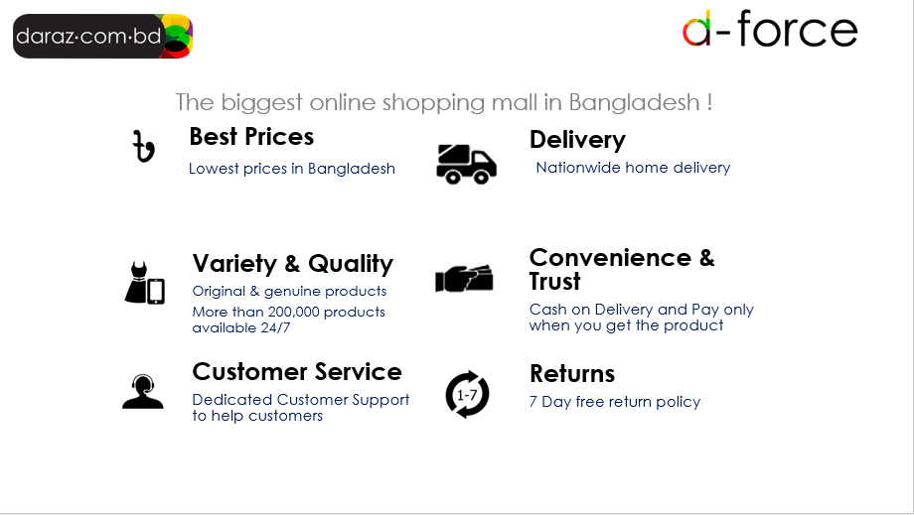

D-Force is a selling branch of Daraz. This is such a program where If you register, you can earn money by selling products from Daraz Bangladesh Ltd .

Difference about D-Force

Zero Investment:

Agents do no have to pay any initial cost or they dosen’t need any previous experience to participate in D-Force sales channel.

Quality Training:
Agents can get the skills to sell more. Daraz provide them a standard training and knowledge about sales.
Be your Own Boss:
Agents can work at their own will and manage their team by their own. Daraz doesn’t provide any target or time limit. They can work at their own convenient time and Way.

Boost your CV:
Agents who will work for daraz they will Get a real hands-on experience about sales and communication. It will help them in their job life.

Participating in the D-Force program, you will receive a variety of benefits:

- As a D-Force Sales Consultant, the more sales you get from Daraz, the more commission you get.

- You do not need any investment to sell products from Daraz.

- You own your boss.

- Daraz has a huge supply of goods from which customers can sell any product according to the demand.

- You can order from Daraz at any time because the Daraz website is effective 24 hours.

- The countrywide product delivery network is available in Daraz.

- Delivering the delivery of goods to the customer and collecting the payment

Who can be an agent’s buyer?

- You will be able to sell products from your family and friends by courting them
- Customers who do not have internet access or who are not used to making online shopping, can also sell them
- Under no circumstances can the products of Daraz be merged and cannot be resold in retail stores

How to participate in D-Force:

Step 1 : Open your mobile / tab / PC / Laptop browser, type www.daraz.com.bd.

Step2 : Click on the "Your account" option on the homepage of the Debate website and sign up with the correct email address and phone number

Step 3: After signing up, click the "go a sales consultant" option at the bottom or next door of the door's homepage

step 4 : Whichever registration form comes, fill it up properly. After that, a link to a training video will be shared from your email. Click the link to watch the video.

Step 5: After watching the video, verify the number with mobile number

Step 6: After completing the registration process on your mobile number in this last step an SMS will be sent.
Then you can start selling as a D-force agent.

(Daraz life, 2018)

What amount of commission can you get?

Usually, Daraz Bangladesh Ltd will give a Price based commission on the each product price.
Commissions will be available only if the price of each product is 500 Taka or more. Commissions are not paid when the product is priced below 500 Taka. But it is added to the sales point that helps in changing the agent level.

Level change structure and Commission structure are given below:

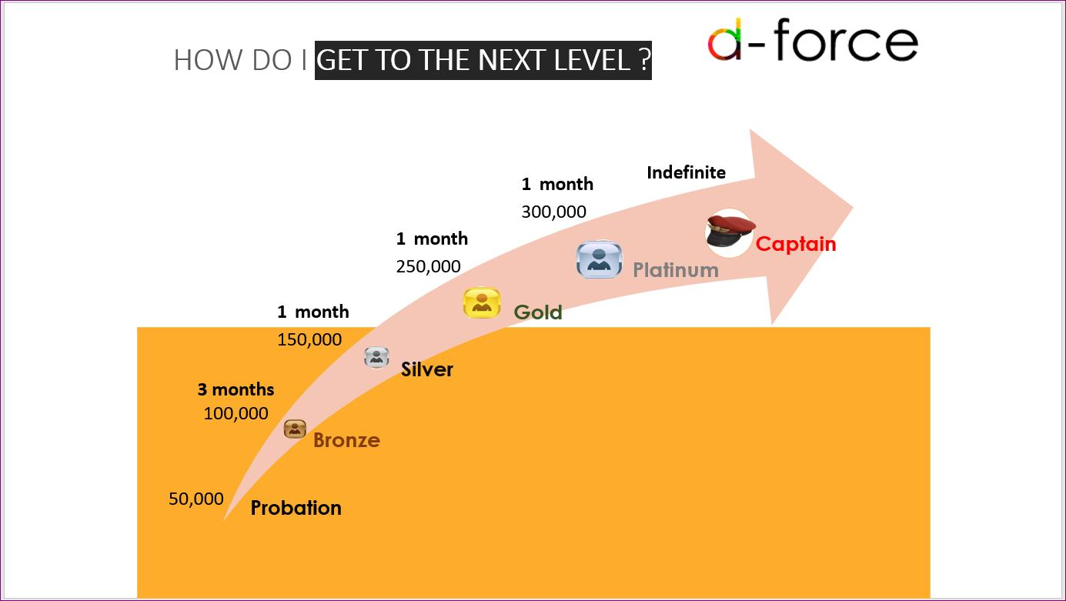

There are six level for agents those are Probation, Bronze, Silver, Gold, Platinum & Captain. They get different amount of commission on the basis of different level of same amount of order.

- In probation level agents have to sell 50000 Taka in total sale. After that he will go in bronze level. There is no staying period in probation level.

- In Bronze level agents have to sell 100000 take and staying period are minimum 3 months. Apart from that agent can take their own time. There is no bindings in highest time. After fulfilling this condition agents level will be change into silver level.

- If anyone filled the condition of Bronze level he/she will enter in silver level where he has to sell 150000 lakh taka and staying period is 1 month.
- After silver an agent will enter in gold level where he/she has to sell 250000 lakh Taka .
and staying period is 1 month here as well.
- When an agent complete the condition of gold level he/she will enter in platinum level. To cross the platinum level agents need to sell 300000 taka and staying period is 1 month.
- When an agent cross the platinum level then he/she gets commission under captain level.
Where there is no limit of sell and there is no staying period. This is the last level of commission structure. Agents gets highest commission in this level

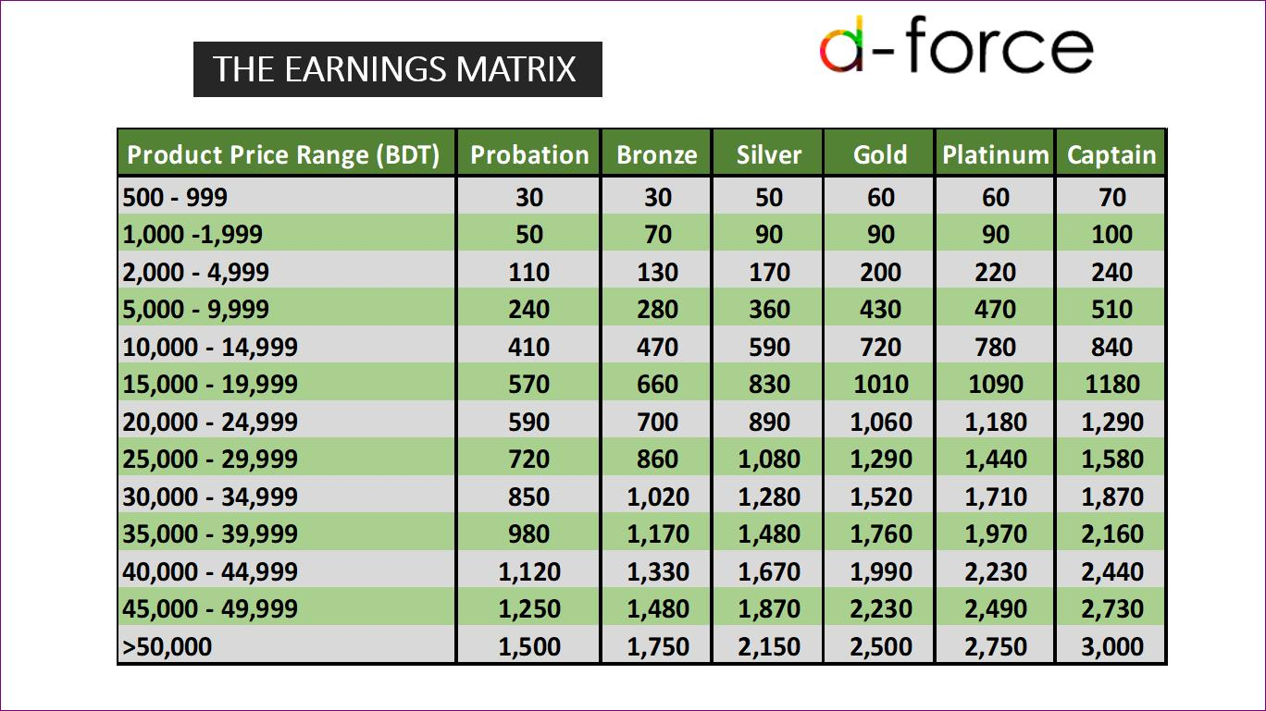

How to Place order by use agent id:
- First of all select your desktop or phone's browser option, Then type www.daraz.com.bd

- Always ensure that your email ID is not logged in to Daraz's website before Because if you are logged in then order will not be placed as an agent order.

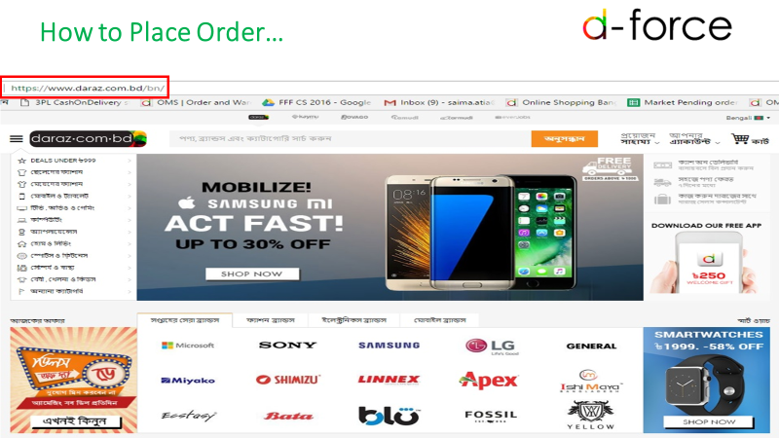

Then, browse the category option

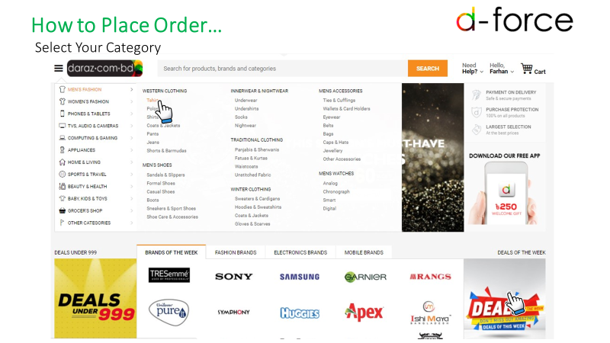

After that, select your desirable product and check the description of the product properly. So that you can know the features and materials details of the product.

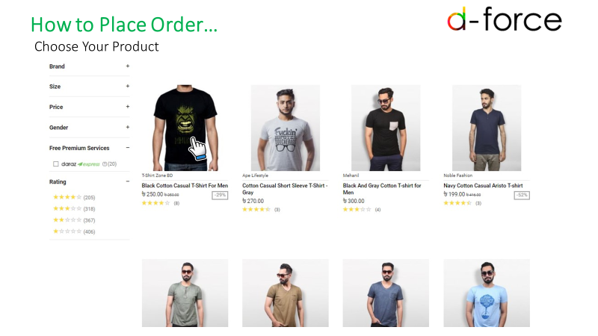

After selecting the product click on the buy now option

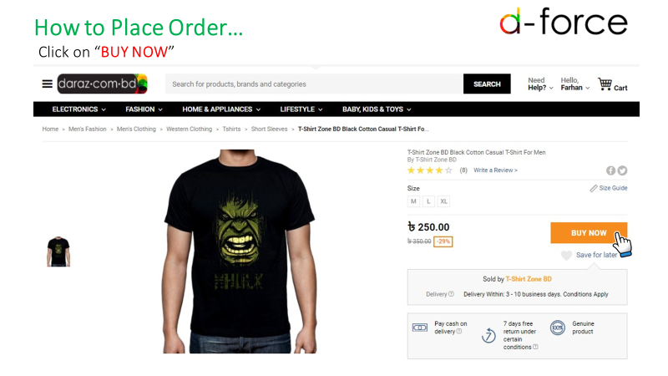

Then click on the cart option on the top of the right side in the website.

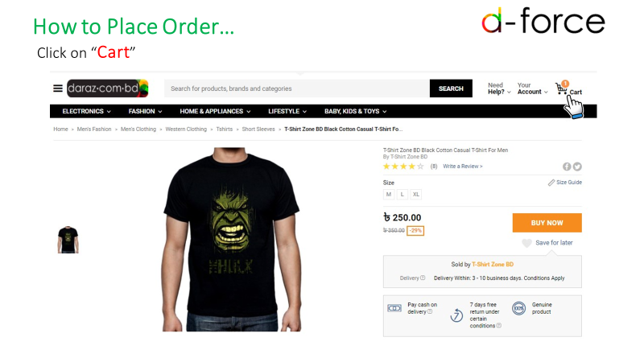

Then check the details of the product price and quantity. Then click the proceed to check out option.

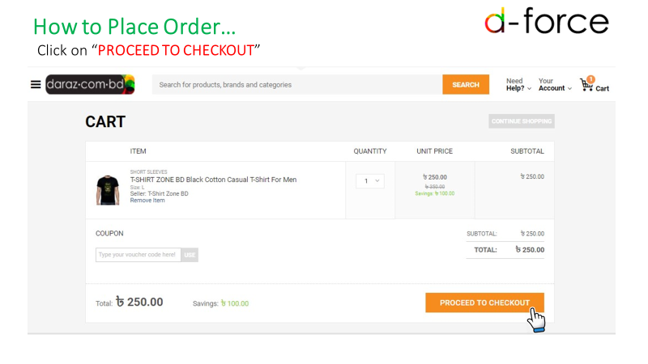

Type your registered agent email address with ul# and email address without any space.
Suppose, Type ul#faisaluddin@gmail.com. Then click proceed option.

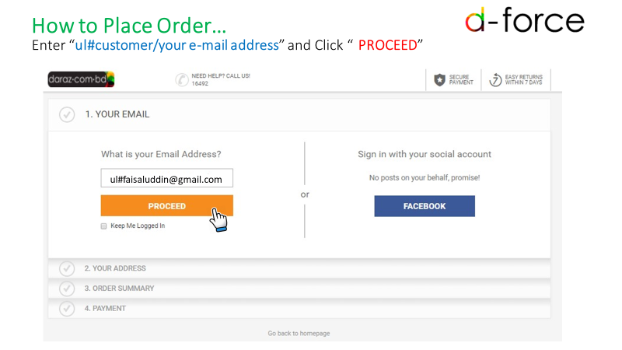
Type in the password field of the agent email address and type daraz account password
For example, the agent email address that has been used here is faisaluddin@gmail.com
And this account's password is 123456
So in the password room type faisaluddin@gmail.com, with comma, 123456 has been typed, then click on the proceed.

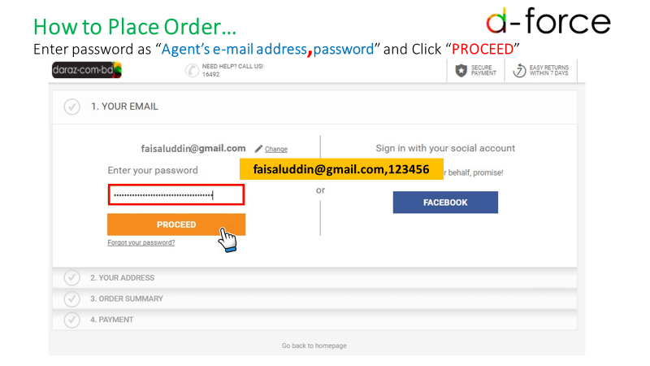

Then click on the 'validate' option for the greeting pop up

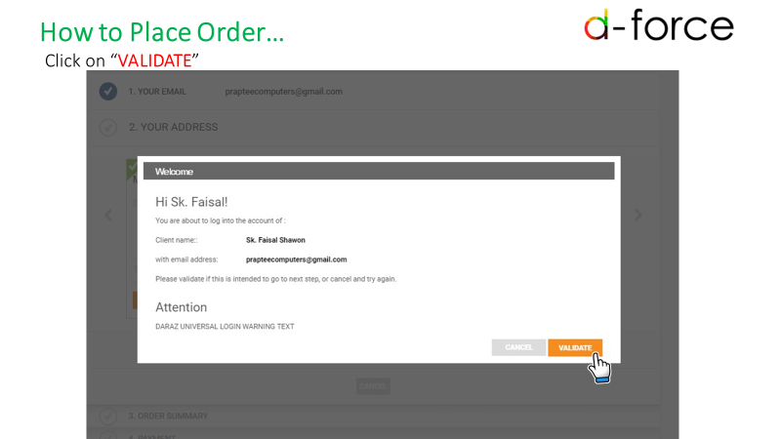

After that, fill up the information that the customer is ordering for. Then click on the terms and conditions option and click on check and place order

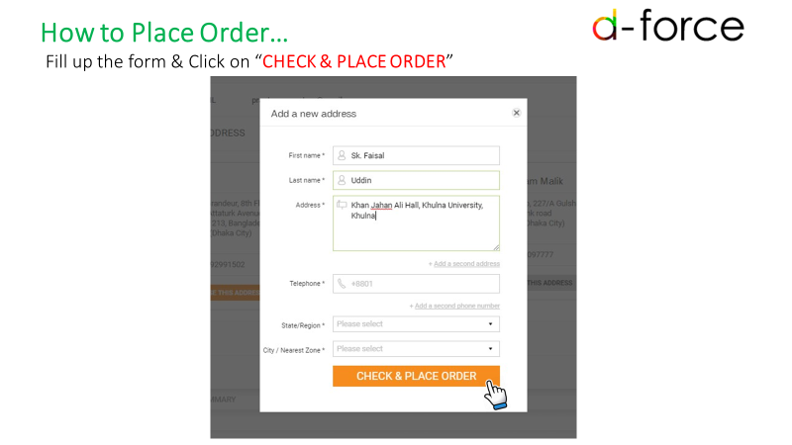

Click on the check and place order in the product summary check.

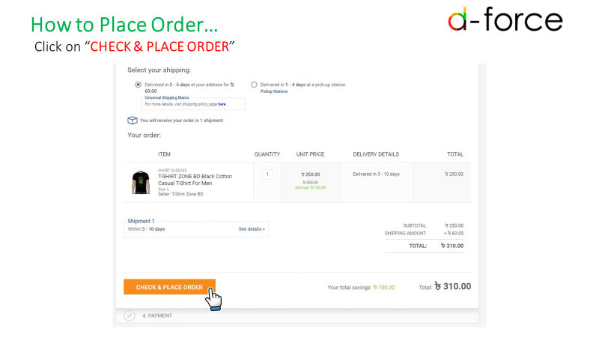

Then select your preferred payment option, then click on confirm order, your order will be successfully place.
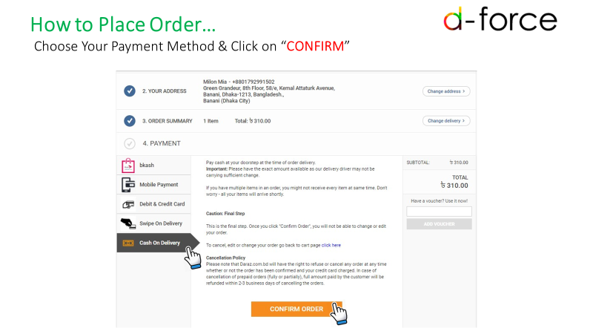

Then keep the order number in order to track the status of the product, to re-order place,ollow the steps again
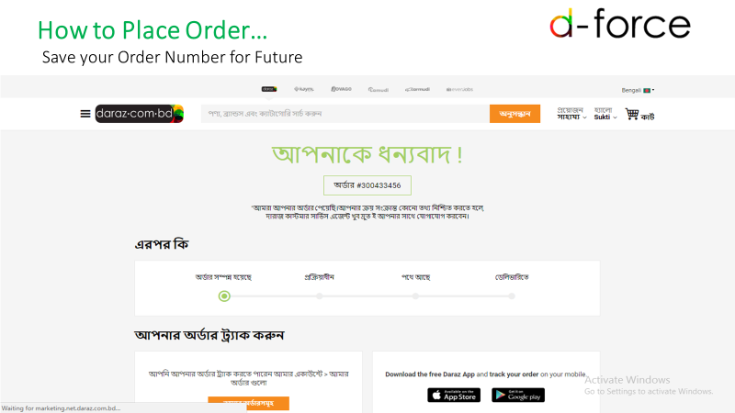

Support from Daraz To Agents:
1.Daraz clear all the regular & timely payments to agents
2. Daraz Bangladesh Ltd provide Regular Trainings to Enhance agents Skills
3.Daraz.com.bd provide printed flyers & brochures for sales support to their valuable agents.
4. Daraz Bangladesh have a D-Force FB page and newsletter to keep agents informed of all deals and offers from daraz.com.bd.



Future Plan of D-Force Improvisation and implementation
Methodologies to Implement:
Three basic channels can be used as follows:
1. Customer Acquisition through Agent Base (New)
  - Increase in number of customers acquired by agents
2. Membership offers for customers (New)
  - Increase in number of members who shop from Daraz

3. Sales through Agent Base (Existing)
  - Increase in agent acquisition

1. Customer Acquisition Through Agents
- Incentive can be reformulated for agents. They will receive commission based on the no. of new customers acquired
- The commission structure for new agent acquisition is as follows:
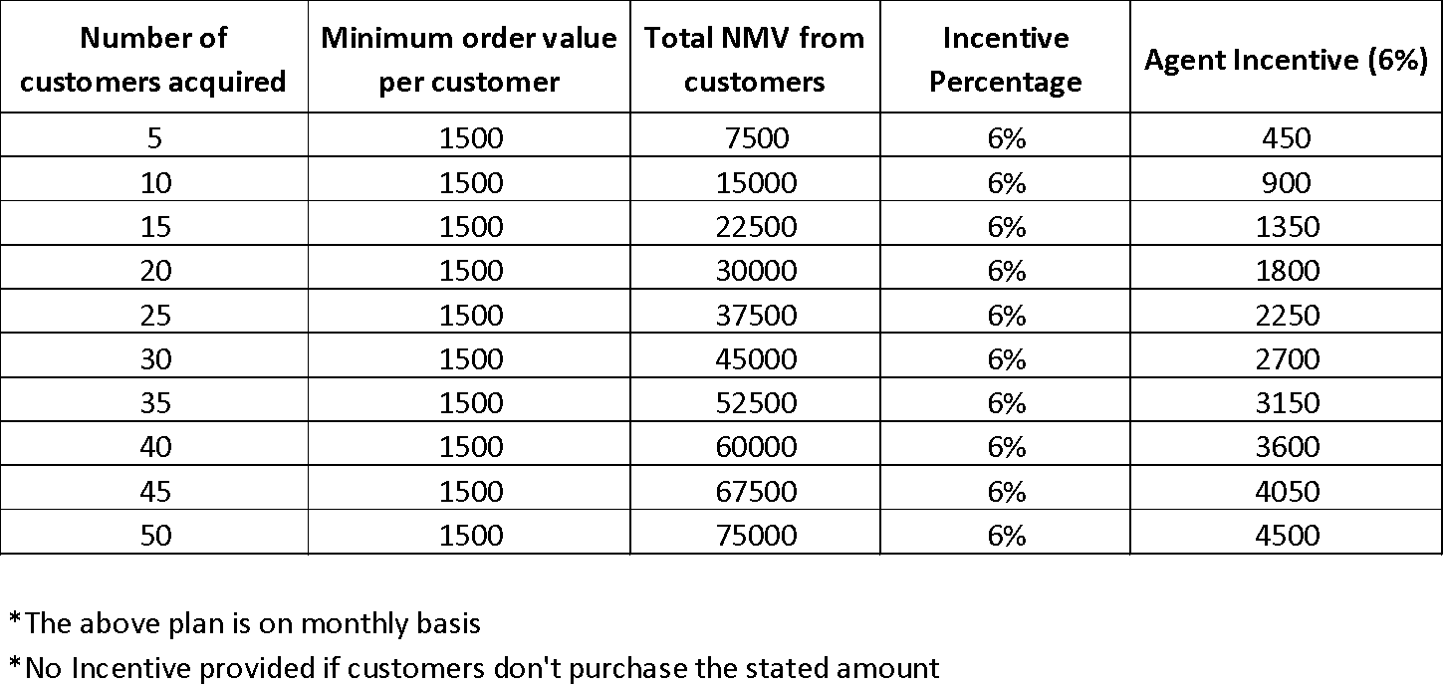

- Customer Acquisition Through Agents (Continued)

Keeping track of customers through agents
Agents will notify every time they acquire a new customer. A database of all customers under each agent will be maintained.
Customer sales data can further be tracked through sales cube for incentive calculation.
2. Membership Offers for Customers
- Membership Plan can be launched for customers which will be communicated through D-Force.
- For each purchase made worth TK 1000 (cart value), customers will receive 1 point (Each point being worth TK 80). Discount can be availed as vouchers only when customers reach 50 point limit.
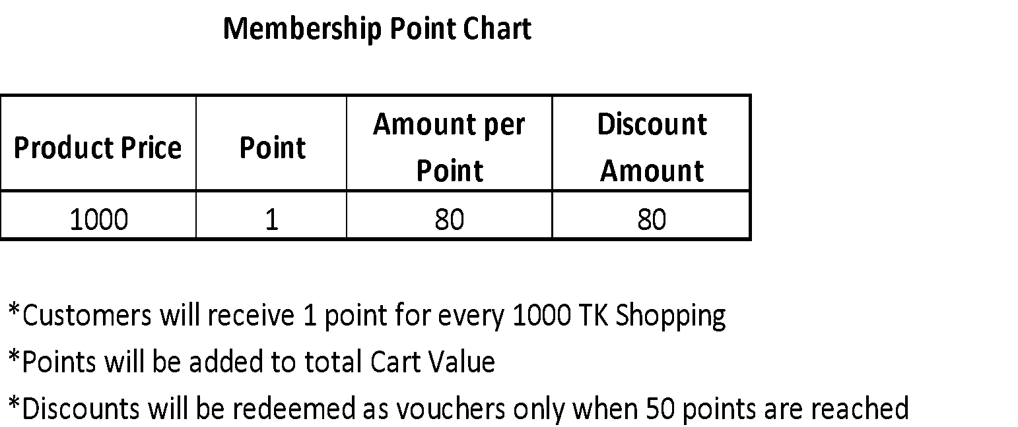
3. Sales Through Agent Base
- Why Agent Base is important in Bangladesh perspective:
Out of 160 M people in Bangladesh, only 84 M people use Internet. Out of these, 2 M people shop online. Only 3.75 Lakh people out of these are customers of Daraz.
Agents can be used to obtain orders from the remaining 76 M people who don’t have access to Internet.
- Number of agents should be increased. This can be done in 2 ways:
1. Online (Primary)
2. Offline (Secondary)
3. Sales Through Agent Base (Continued)
- Online (80%)
  - Registrations can be increased through newsletter mails, SMS, Facebook posts in closed groups, advertisement in Website homepage.
- Offline (20%)
  - Through campaigns, events, and seminars in various target areas.

Scope

This report entitled is “Agent Management of an Online Marketing Organization”. Basically, In this report I have tried to accumulate all the resources that I have learnt from the last three months of my internship period, primary and secondary sources of information. I have collected data from journals, newspapers, websites, reports, team meetings, company data base, daily records and study material provided by executives of the company. For primary sources of information, interview of executives of the company will be considered.

Methodology

I have basically worked for a particular department so I did have to collect data from different sources. I have collected data from two sources.
Primary Sources of Data
- Practical Desk Work
- Conversation with the employees.
- Personal work experience on seller management team and sales team
- Interview with Monica Kabir, Senior executive of D-Force.
Secondary Sources of Data
- Daraz Bangladesh Ltd website
- Daraz.com.bd/blog website
- Software: Salesforce, Bob,OMS
- Different Publications
- E-commerce associations of Bangladesh (eCab)

Limitations

Limitations for agents:
There is some limitation for the agent acquisition of daraz Bangladesh Ltd. The limitations are which company is still facing.
There is some limitation for agent acquisition process.
- Sometimes it’s hard to convince people to do the job. As it is a job which need to do in free time. So the people who do job already in a company or in other staff they do not find it convenience for them. But the people who get interested they are not enough educate in online shopping or internet use. So there create a limitation.
- The payment structure to the agents are in a monthly basis. Like once agents order any products the agent will get the payment after a month and all the payment will be given to the agent in a single transaction. So the agents have to wait whole month to get the commission. sometimes they get disappoint when they didn’t get the commission on time.
However, these limitations might be overcome gradually once Daraz is well known and an established name throughout Bangladesh.
E-commerce is almost a new term in Bangladesh and has introduced it very recently so there are having few pure c-commerce company in Bangladesh. Even, the E-commerce association of Bangladesh has established after the entrance of Kaymu.com.bd in Bangladesh. There are few online sites in Bangladesh but their business model is different from others. I have tried to find out all the information’s during my internship period but still there is some lacking’s because of having some limitations.

The limitations for myself are given below:
- Having less time of my internship course.
- I was allowing accessing little software. Example: I was able to use sales force and bob but I was not able to use seller center because of their permission.
- Some of the information and meeting was confidential so I was not allowed to attend those.
Recommendations

- Daraz Bangladesh needs to improve delivery system to deliver the product timely. They are facing troubles with the delivery of the products due to late deliver. Moreover, they should increase pickup station in rural area. Rural people are not placing the order from daraz because daraz is not deliver product in village area. So to increase sales and customer base daraz should acquire a strong control over the delivery system.
- Daraz Bangladesh Ltd need to improve their 24/7 online customer service over the phone call or live chat option cause the trends in Bangladesh is changing and customers are in need of ordering product at night most of the time cause the targeted group of people are usually busy at the office time. Customer get irritated when they have to wait in que for so long time.
- Daraz Bangladesh needs to judge the product quality which is delivering from the sellers to customer. Daraz has huge complain about its product quality from the customers.
- More product details should be available on the product list. Sometimes products are uploading without having more details. So, Agents are not ordering that types of products.
- Product price should be judged with other sellers and needs to fix a price level cause sometimes sellers are offering price more than double which has a negative customer review on the brand name.
- Daraz Bangladesh has to promote it site properly like using television, electronics media and print media cause most of the time customer are not aware about Daraz Bangladesh name even sometimes sellers are not also aware about Daraz Bangladesh name.
- Daraz Bangladesh has to observe the market trend properly and needs to promote its Facebook page rather promoting its product on a daily basis cause if Daraz Bangladesh page gets more customer engagement or likes then when Daraz Bangladesh will upload any products then easily a potential customer can get notified about it and need not to promote its site on a regular basis by using sponsored advertisements.
- The employee of Daraz Bangladesh needs to build a cooperative mindset and needs to think about the company benefit in long run.

Conclusions

Daraz Bangladesh has seen potential prospect in the Bangladeshi e-commerce market. This is the high time for this company to develop a huge customer. There are lots of e-commerce companies establishing their market now-a-days so it will be hard to compete if Daraz Bangladesh cannot control over the market. Daraz has lots of problems and at the same time it has lots of opportunities if Daraz can hire the best people and can solve the current problems. Daraz Bangladesh can observe its competitors sometimes to overcome its problems and get the direction how they control their customer cause in online most of the things are open and transparent so easily any other company can get it.
It gives them an awesome ordeal which they can use, all things considered. They generally keep up great connection with both their sellers and clients. The client care is dependably there to help client with any issue. After all these regardless it hasn't quit advancing, it keeps on conveying to something new to the blend. While working with the D-Force Team, Daraz Bangladesh Limited, I encountered the work procedure of multinational organization, which is a major accomplishment for me. My employment obligations alongside different exercises have built up my handy learning and gave me a stunning background. Daraz has a brilliant future. In this paper, I attempted to blend my insight, individuals', academic articles and my academic knowledge that I have gained throughout my undergraduate life through different academic courses and practical experiences as well. Daraz Bangladesh is still growing and it has huge opportunity to improve more and more as they have potentials and resources. They need to ensure that they give the best support of the client, customers and agents as well. In online business there is immense open door in Bangladesh. Simply need to work legitimately and guarantee customers fulfillment. This is a booming sector in Bangladesh and I personally believe that Daraz Bangladesh will reach at the apex of the online business sector very soon.

References:
customer service center . (2017, July 3). Retrieved from tdcihelp.zendesk.com: https://tdcihelp.zendesk.com/hc/en-us/articles/115008000787-What-is-an-acquisition-agent-What-duties-require-an-acquisition-agent-license-
Daraz Group. (n.d.). Daraz BD. (2016, December 13). Retrieved from Daraz BD. Retrieved: https://www.daraz.com.bd/
Daraz Life. (n.d.). Retrieved from Daraz.com.bd: https://www.daraz.com.bd/blog/2018/06/05/how-to-be-dforce-agent/
Daraz life. (2018, June 5). Retrieved from Daraz.com.bd: https://www.daraz.com.bd/blog/2018/06/05/how-to-be-dforce-agent/

