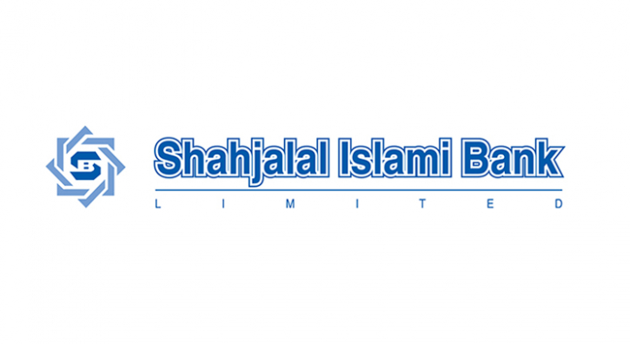


Internship Report
On
Analysis of General Banking Operations of Shahjalal Islami Bank Limited

Submitted to
Dr. Mofijul Hoq Masum, ACMA
Associate Professor - AIS
School of Business and Economics
United International University

Submitted by
Name- Tasnim Matin Meem
ID- 111 171 048
BBA, School of Business and Economics
United International University

Date of Submission – September 26, 2023

Letter of Submission

September 25th, 2023
Dr. Mofijul Hoq Masum
Associate Professor - AIS
United International University
Subject: Submission of Internship report on “Analysis of General Banking Operations of Shahjalal Islami Bank Limited.”
Dear Sir,
I am happy to inform you that I have completed internship program at Shahjalal Islami Bank Ltd. I like to submit the Internship Report on “Analysis of General Banking operations of Shahjalal Islami Bank Limited.”
I put my utmost effort to follow your instructions and complete the report as thoroughly and meaningfully as I could within the time provided. I have made a concerted effort to read relevant papers and records in order to prepare my internship report. Please forgive for any mistakes I may have made.
I'd also want to express my gratitude for all of your encouraging words, feedbacks and recommendations. If you have any questions, I would be delighted to answer them.
Sincerely Yours,
Tasnim Matin Meem
ID: 111 171 048
BBA
United International University

Acknowledgement

At First, I would like to thank Allah for his for grace that allowed me to complete this report. I would also like to express my sincere gratitude to Dr. Mofijul Hoq Masum, supervisor of my internship, for his constant support and guidance.
I am extremely grateful to Shahjalal Islami Limited for granting me with such an incredible internship experience. I’m immensely thankful to Mr. MD. Mazharul Haque, Branch Manager of the Panthapath Branch, Mr. MD Iqbal Hossain Deputy Manager, General Banking In-charge Mr. Nizam Uddin also my supervisor Ms. Kaniz Fatema Irin, Their guidance has been priceless in helping me develop valuable professional skills and knowledge.

Abstract

Banking industry is the most significant sector in every country as it serves as the backbone of the economy. This industry contributes to a country's economic development. The banking industry is expanding at a rapid pace, making its operations more efficient and convenient. I have chosen to produce a report on Shahjalal Islami Bank Limited (SJIBL) as per the internship and BBA program requirements. For the internship report, I concentrated on SJIBL's general banking sector. SJIBL is one of the leading banks of Bangladesh that operates both domestically and globally. A comprehensive examination of the general banking system is undertaken centered on the bank's current offerings and its client’s level of satisfaction with those banking services. The introduction of the study gives background information about Shahjalal Islami Bank Ltd. Their managing system, workings of several divisions is all discussed in depth afterwards. This report then addresses the restrictions and consequent issues, as well as proposed remedies. The first section of the report is an introduction section that describes the subject of the study, its origin and context, methodology, and limitations. The second section of the study focuses on Shahjalal Islamic Bank Limited, including their vision, goal, and objectives, as well as their policies, fundamental principles, brand commitments, and their organizational framework. The next section of the paper presents an overview of the global Islamic banking movement, including Bangladesh. The organization's normal banking operations are detailed in the section report that follows, along with growth analysis and SWOT analysis of the bank.

Key word
Shahjalal Islami Bank, Islamic Banking, General Banking, Customer Service, Bank Account.

Table of Contents

Letter of Submission iii
Acknowledgement iv
Abstract v
List of Table vii
List of Figure vii
Chapter- 1: The Organization 1
1.1 The Study’s Background 1
1.2 Overview of Shahjalal Islami Bank 2
1.3 Vision & Mission 2
1.4 Organizational profile of SJIBL 3
1.5 Purpose of SJIBL 6
1.6 Techniques of SJIBL 6
1.7 Group pledges of SJIBL 6
1.8 Objective of the study 7
1.9 Limitation of the Study 7
Chapter- 2: Methodology of this study 8
2.1 Data Design 8
2.1.1 Primary or major data source 8
2.1.2 Secondary or Additional data sources 8
2.2 Research and data collection: 9
Chapter- 3 Literature Review 11
3.1 Islamic Banking 11
3.2 Objective of Islamic Bank 12
3.3 The fundamental principles of Islamic banking 12
3.4 Islamic banking movement throughout the world 13
3.5 Islamic banking movement in Bangladesh 14
3.6 Research on Islamic Bank Bangladesh: 15
Chapter- 4 General banking activities of SJIBL 17
4.1 General Banking 17
4.2 Types of Bank Account 17
4.3 Activities of Cash Section 21
4.4 Clearing department activities: 23
4.5 Remittance section: 24
4.6 Cheque Book Issue: 25
4.7 SJIBL card services 29
4.8 SMS Banking and Online Banking 31
Chapter- 5 Banking Services Analysis and Findings of SJIBL 32
5.1 General Banking services of SJIBL 32
5.2 Deposit mix Analysis 32
5.3 Growth Analysis: 33
5.4 SWOT Analysis of SJIBL 35
5.4 Major Findings or Problems 38
Chapter-6 Recommendations& Conclusion 39
6.1 Recommendations 39
6.2 Conclusion 40
References 41
Internship Completion Certificate lii

List of Table
Table 1 Usage Limit Of Visa Debit Card 31
Table 2 Deposit mix of SJIBL (In million) 34

List of Figure

Figure 1Cheque 24
Figure 2 Commission of Telegraphic Transfer (TT) 26
Figure 3Commission of Demand Draft (DD) 27
Figure 4Monthly deposit scheme (MDS) 27
Figure 5 Hajj Deposit Scheme 28
Figure 6Monthly Income Scheme 29
Figure 7 Mudaraba Double Money plan 29
Figure 8 Mudaraba Multiple deposit scheme 29
Figure 9 Deposits of five years 34
Figure 10 Trend of regulatory capital 35
Figure 11 Growth of investment 35
Figure 12 Growth of Operating Income 36

Chapter- 1: The Organization

Most people and businesses in today's world rely on banking for their regular financial transactions since it is secure, dependable, rapid, and safe. It is impossible to exaggerate the importance of banks as one of the main economic drivers of a nation's prosperity. There are 61 banks that remain on the maintained list under the Bangladesh Bank order, 1972 also there are 5 banks that are not included in the list are present in Bangladesh at the moment. The responsibilities given to scheduled banks cannot all be completed by these institutions.
It is obvious that it is difficult for any sort of bank to reach its aim and particular clientele without suffering strong rivalry when there are more than 60 active banks and many financial organizations occupying such a limited market. Banks fiercely compete with one another to establish their superiority to their clients by offering alluring investment returns, interest rates lower than others for borrowers, innovative and tailored packages, and quicker client service. The major objective of banks is to meet customer needs and expectations in order to grow their base of devoted clients.

1.1 The Study’s Background

After concluding all the academic requirements for the United International University's undergraduate (BBA) degree, you must participate in an internship program for at least 90 days with a reputable company. I decided on Shahjalal Islami Bank to finish my internship program. I chose Shahjalal Islami Bank since it was in my own interest to understand how a bank manages and conducts its general banking activities. To complete the criteria for my graduation from United International University, I conducted this study. Taking into account of my actual work experience over three months in this department, I think this study topic is a good choice. Nearly most of the usual financial services offered by other commercial banks in Bangladesh were almost entirely available at the branch where I worked. Anyone interested in learning more about the current banking processes utilized by Shahjalal Islami Bank and those seeking professions in the banking business may find this in-depth study to be helpful. “Analysis general banking operation of Shahjalal Islami Bank Limited.”

1.2 Overview of Shahjalal Islami Bank

Banks are becoming a vital component of everyday life. People are far more reliant on bankers for transfers of money. Banks are improving their customer service in order to thrive in a market that is cutthroat.
Shahjalal Islami Bank Limited adheres to Islamic Shari’ah. SJIBL is named in honor of the saint Hazrat Shahjalal (R), dedicated his life to promoting world peace and helping people. SJIBL was established as a public limited bank under the Companies Act of 1994 on the year of 2001 Shahjalal Islami Bank Ltd began its banking activities on May 10th. Because of its actions, it has attained a remarkable position in a short period of time and has also become a treat for other institutions.
Shahjalal Islami Bank has always prioritized customer satisfaction; the bank is run by a team that has received extensive training. They believe that satisfied clients are the finest brand ambassadors. SJIBL offers numerous services to both residential and commercial customers, spanning all sectors of society, in accordance with the legislation of the central bank.

1.3 Vision & Mission
Vision of SJIBL
“Most admirable brand of Shari’ah banking & investment in Bangladesh ensuring sustainable value for all our stakeholders embodied with human development based on morality and ethics.”
Mission of SJIBL
“Setting high standards of integrity, inclusive and innovative banking. Sustainable value for all stakeholders. Continuous development of professionals and system up gradation to face the challenges and drive for excellence.” ( (SJIBL, 2021)

1.4 Organizational profile of SJIBL

Shahjalal Islami Bank LTD made its debut in the banking sector to high anticipation. It's been operating as a banking institution for more than 20 years. Through the construction of additional branches in prime locations both inside and outside of Dhaka over the past 20 years, SJIBL has increased the range of products and services it offers. It is an institution that does not charge interest because it follows Islamic Shari'ah and because it is an Islamic bank. This bank is continually growing as a consequence of its objectives, excellent outcomes, and organizational structure. Client-specific customer request letters, personal and professional banking activities, debit cards, credit cards also ATM cards, DPS, FDR, payment orders, instant packaging, investment banking, and corporate banking are just a few of the many elements that make up this banking. SJIBL's primary sections are ordinary finance, business, and foreign exchange, with other units and departments working under these divisions.
It aspires to be the top commercial bank in Bangladesh by sticking to Shari’ah, providing excellent service, and updating its professional personnel.

Organogram of SJIBL
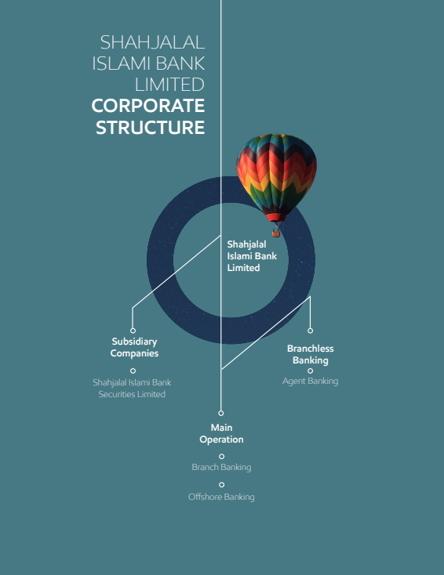

1.5 Purpose of SJIBL

- Contribute to long-term economic development
- Maintaining a Shari’ah-based banking system with no interest
- Contributing to the reduction of poverty and unemployment.
- maximizing the exploitation of existing assets
- Objective To be the greatest and leading entity in Bangladesh in terms of resources and earnings

1.6 Techniques of SJIBL

- Increasing consumer confidence and satisfaction.
- Capital expansion
- Managing all operations of the bank in the most effective way
- Fulfilling client demands and regularly keeping tracks of the customer satisfaction level of the service provided.
- To deliver good service to clients, policies, method, and practicing must have been investigated
- Focusing on staff development to effectively recognize client needs.
- Establish a welcoming workplace culture to diversify your portfolio throughout the wholesale and retail marketplaces.
- Market with wide trading face lifting
- Offering easiest answer for complex business circumstances.
- Taking advantage of those who are still unaware of how banks operate.

1.7 Group pledges of SJIBL

- People- Believe in long-term relationships that provide more value
- Process- The method or methodology by which we conduct ourselves
- Prosperity- The goal of creating appropriate value addition for all stakeholders

1.8 Objective of the study

The report will contain details on the bank's general banking operations, its multiple programs, interest rates and also a basic analysis of SJIBL’s present position among the private banks in Bangladesh
The main objectives of this study are-
Broad Objective
The objective of this study is to successfully finish the internship requirement of my BBA program and acquire practical knowledge about general banking operations of Shahjalal Islami Bank Limited.
Specific Objective-
- To learn the operations of Islamic banking system.
- To understand the general banking operation of SJIBL.
- To examine the general banking services provided by SJIBL such as account opening management, transaction processing etc.
- To analyze the banking activities and finding out the bank’s strengths and problem areas where this bank can improve.

1.9 Limitations of the Study

During my internship of three months in Shahjalal Islami Bank Limited I faced some problems to gather information for the report which could be labeled as limitation of the study
- Limited duration of my internship (3 months) is quite challenging to gather substantial amount of information.
- The presence of confidentiality constraint hindered the information collection process.
- Sufficient information regarding this report was not present.
- Reluctance of individuals (clients, employees, stakeholders) to share their insights further hampered data collection.

Chapter- 2: Methodology of this study

I used the knowledge and skills I acquired throughout my three-month internship to produce this report. Most of the required data r for this study was gathered from the clients directly, also from the employees, and other stakeholders to get accurate information. Many unprocessed data were obtained throughout the course of these three months, and I made every effort to transform them into knowledge that would be useful for this report.
To produce my intern report, I will mostly depend on my experience working in various Shahjalal Islami Bank Limited divisions. Additionally, I'll utilize certain official papers that I got from the office. Books, articles and other relevant materials that focuses on the banking sector helped to add more value to this report and deepen my understanding of this industry and make this more informative.

2.1 Data Design

Proper data design is crucial to ensure that the data analysis is efficient and helpful to the decision making process.

2.1.1 Primary or major data source
- First hand observation of the activities
- Office records and papers,
- Conversations with bank employees and others
- Informal discussions with bank clients.

2.1.2 Secondary or Additional data sources
- Shahjalal Islami Bank's official webpage
- Online journals and records
- SJIBL's annual statements
- Bangladesh Bank's website and SJIBL-published circulars, Books on the subject many bloggings, articles, and journal information
- Rate sheet of bank
- The Progress reports
- Various statements of fact in web

2.2 Research and data collection:

- Gather relevant data and information on the banking industry, including market size, growth rate, key players, and industry trends.
- Obtain financial data and information on the specific bank(s) of interest, including balance sheets, income statements, and cash flow statements.
- Use reputable sources such as annual reports, industry reports, and financial databases

Chapter- 3 Literature Review

3.1 Islamic Banking
The act of executing financial transactions in conformity with Shari'ah (Islamic law), sometimes referred to as Islamic banking, Islamic finance, or Shari'ah-compliant finance. Two fundamental principles of Islamic banking are the distribution of profits and losses as well as the prohibition on lenders and investors earning and paying interest. Through equity participation, which calls for a borrower to give the bank a portion of their income rather than paying interest, Islamic banks are able to generate revenue. (Tarver, 2022).
In the early 1970s, Islamic banking started to gain popularity as a useful and effective method of financial intermediation. This became notably clear when King Abdul Aziz University in Makkah, Saudi Arabia, hosted the First International Conference on Islamic Economics. Islamic banking's success as a useful technique for carrying out financial intermediation between surplus and deficit economic units was further cemented by the establishment of the first commercial Islamic bank, Dubai Islamic Bank (DIB), in the United Arab Emirates, followed by the International Islamic Development Bank (IDB), located in Jeddah, Saudi Arabia, and a large number of other private and semi-private commercial Islamic banks in nations like Egypt, Sudan, Kuwait, and Bahrain. (Munawar Iqbal, 2005).
The contribution of Islamic banks has substantially aided the nation's economic development, inclusive growth, and efforts to fight poverty. Both the acceptance of this tactic and its market share are steadily rising. With an 18% market share, Malaysian Islamic banking has earned a reputation as the world's center for Shari'ah banking. Due to the limited amount of Islamic banking products offered, the United Kingdom and Singapore are working to promote Islamic banking in emerging economies by easing financial regulations. (Mannan, 2014)
Islamic banking has been practiced in this country for thirty years. Today, one-fifth of all banking in the country is handled via this financial system. Among all Islamic banks globally, Bangladesh is rated No. 12 in terms of asset value. When financial inclusion and the kind of distribution, rather than the volume of assets, are taken into consideration, the situation for Islamic banking in Bangladesh is typically favorable.

3.2 Objective of Islamic Bank
Islamic banks use this wealth for the sake of society since they hold the belief that all wealth and property are the property of Allah. Profit and loss are totally reliant on investment, and Islamic banks always adhere to Islamic rules and regulations. The consumer is responsible for covering any losses if they come from the investment. Islam has forbidden interest, it is viewed as haram or riba and banks which operates under Islamic law hold this view.
According to an Islamic bank, upholding the Shari’ah would aid the country by eradicating poverty, fostering employment, building socioeconomic infrastructure, and establishing a just economy.

3.3 The fundamental principles of Islamic banking

Islamic banks must adhere to the rules of Shari’ah law, which includes a set of obligations for business transactions and the hadith—the true traditions. Islamic banks serve Muslim clients' requirements, but they are not run as places of worship. Instead, they adhere to Islamic law, which has an impact on how the financial system operates. (Imam, 2010). According to (El-Gamal & Islahi, 2006), four factors are unique to Islamic banking which are discussed below.
The restriction on interest (Riba), which distinguishes Islamic banking from conventional banking, is the main distinction. Islam forbids riba in all of its manifestations because it is a type of exploitation and goes against the idea of justice. As a result, Shari’ah law prohibits determining a loan's favorable return in advance as a reward for patiently waiting. Since riba is seen to be an improper appropriation of other people's property, it is seen as being detrimental to growth. The temporal worth of money is acknowledged in Islam, although it can only be experienced in a real transaction. In a lease arrangement, for instance, if the time value of money is a significant factor in the agreed-upon rate, longer leases are frequently anticipated to yield greater returns.
Speculation is prohibited by Islamic banking because it forbids maysir (games of chance) and gharar (chance). Increasing one's riches through speculation is thought to be more fortunate than doing so through worthwhile work. However, it's not always apparent where conjecture ends and actual work begins. Although the term "maysir" refers to unnecessary risks that are not a part of daily life, such as visiting a casino, entrepreneurship might be seen as a form of gambling. On the other side, danger that cannot be avoided is accepted. Gharar contracts, or contracts of doubt or uncertainty, are forbidden in Islamic finance. This relates to circumstances like starting a business endeavor without enough knowledge or accepting too much risk. The idea, which is related to asymmetric information, seeks to reduce the likelihood of misunderstanding and conflicts between contracting parties.
It is against the law for Islamic banks to support haram (illegal) operations. They are only permitted to finance halal (lawful) activities under their code of conduct. This implies that they are unable to lend to businesses or people engaged in ventures that are seen to have a detrimental effect on society, like gambling, or that are prohibited by Islamic law, such funding the development of an alcoholic beverage manufacturing facility.
Islamic banks are expected to donate a portion of their income to zakat, which helps the community. Muslims believe that for a society to work, there must be justice and equality of opportunity, and one method to achieve this is by redistributing money to ensure that the poor have access to a minimal standard of life. One of the five pillars of Islam is the practice of zakat, which entails contributing 2.5 percent of one's holdings as a sort of almsgiving. Islamic banks set up zakat funds to gather money given to religious organizations in nations where zakat is not taxed by the government. (Ministry of Finance, 2020-2021)

3.4 Islamic banking movement throughout the world
Two significant occurrences in the 20th century helped the Islamic financial system expand. First, small-scale tests in remote Egyptian communities showed that Islamic banking was feasible. Since then, the Middle East has given rise to a sizable business that has extended to places like Asia, the Americas, sub-Saharan Africa, Indonesia, Malaysia, and even sub-Saharan Africa. The Islamic Development Bank (IDB), which was founded in Jeddah in 1975, provided top-down assistance for the growth of Islamic banking by concentrating expertise. An in-depth knowledge of Shari’ah law was initially required for the implementation of Islamic banking. In response to the need for Islamic banking, Islamic scholars tackled this problem, and in the early years, straightforward implementation techniques were developed and universally accepted. Recent years have witnessed a rapid increase in innovation, particularly in instruments like sukuks (Islamic bonds). Another recent institutional development that has facilitated the growth of Islamic banking is the creation of the Islamic Financial Service Board (IFSB) in 2002, which is tasked with developing prudential standards for Islamic banks. (Kangni & Imam, 2010).
Beginning in the 1980s, Malaysia became well-known in the Islamic world because to official support that viewed Islamic finance as a base for development. The government played a major role in Bank Islam Malaysia Berhad's establishment as the country's first Islamic bank in 1983. Similar to this, Bahrain has been looking for a niche in Islamic finance that would allow it to build on its thriving banking business and establish itself as a prominent financial center. The whole banking systems of Saudi Arabia, Iran, Pakistan, and Sudan were first converted to Islamic banking. However, they recently abandoned this tactic and have adopted hybrid systems that combine conventional and Islamic banks (Imam, 2010). In recent years, as Islamic banking has accelerated in expansion, the industry has reached outside its traditional bounds into countries with substantial Islamic populations, such as the United Kingdom. With more than 400 million Muslims, Africa has also experienced an increase in Islamic finance. While figures vary, it is estimated that the Islamic finance sector would reach US$5.9 trillion by 2026 from its current US$3.95 trillion size (Puri-Mirza, Total value of Islamic finance assets worldwide from 2012 to 2021 with a projection for 2026, 2023). More than 400 Islamic banks now provide financial services to clients worldwide, both Muslims and non-Muslims, in an effort to boost the economy (Puri-Mirza, Number of Islamic banks worldwide in 2019, 2022).

3.5 Islamic banking movement in Bangladesh

The establishment of Islamic Bank Bangladesh Limited in 1983 signaled the start of Islamic banking in Bangladesh. Al Baraka Bank Ltd., the second Islamic bank in the country, was established in 1997. In 1996, two more banks—Al-Arafah Islami Bank Ltd. and Social Investment Bank Ltd.—began carrying out banking activities in accordance with Islamic Shari’ah after receiving authorization to do so. Shahjalal Islami Bank Limited began operations in May 2001. Later, two conventional banks, First Security Bank and Export-Import Bank Ltd. (EXIM Bank), through the conversion process to become Islamic banks; EXIM Bank began operating as an Islamic bank in 2004. (Hossan, 22). Currently, Bangladesh has 10 fully operating Islamic banks with 1569 branches. According to Bangladesh Bank, there are 39 Islamic banking locations dispersed among eight traditional commercial banks. (Hossan, 22).
194 Islamic banking windows are available in Bangladesh's 13 traditional commercial banks, which offer Islamic financial services. Furthermore, Mutual Trust Bank Limited will begin providing Islamic Financial Services through the authorized windows as of May 2021. The City Bank also introduced its upgraded Islamic banking service, branded as City Islamic, in December 2021. ( (Hossan, 22). By the end of June 2021, the country's Islamic banking sector would account for 27.26 percent of deposits, or BDT 3 crore 26 lakhs 94 thousand 300 Crore (BDT 3, 27, 94, 300, 00), and 27.55 percent of investments, according to predictions from Bangladesh Bank. Additionally, from April to June 2021, BDT 20, 03,900,000 in total remittances—or 38.24% of all remittances to Bangladesh—were made through Islamic banking. About 43,909 individuals work in Bangladesh's Islamic industry. (Hossan, 22).

3.6 Research on Islamic Bank Bangladesh:
Hasan (1999) provided a comprehensive discussion of the fundamental concepts behind interest-free banking and utilized examples from Bangladesh, a developing nation with a majority-Muslim population, to support his arguments. Based on increases in deposits, investments, profit, foreign commerce, remittances, and the growth of branch networks between 1983 and 1994, the research evaluated the performance of Islamic Bank Bangladesh Limited (IBBL). IBBL's performance was compared in the study to that of other private banks over the same time period. (Ahmad & Hassan, 2007).
In order to examine the growth trends for the investments and deposits made by the Islamic bank Bangladesh Limited between 1983 and 1994, Alam (2000) conducted research. According to the report, the Al-wadia and Mudaraba modes were where the IBBL mobilized deposits the most. According to research, the bank mostly used the Quard E Hasana, Bai-Muajjal, Musharaka, and Murabaha methods of investing. The bank places a special emphasis on the Murabaha, Bai-Muajjal, and other associated kinds of investment among its many working modes. Only 3% of investments were made using the Musharaka and Quard E Hasana modes, while none were made using the Mudaraba form. (Alam, 2000). Six Islamic banks that were listed on the Chittagong Stock Exchange (CSE) and the Dhaka Stock Exchange (DSE) in 2014 had their performance examined by Ibrahim. The research evaluated the performance of the banks using information from their annual reports, taking into account variables such as deposits, investments, foreign remittances, profits per share (EPS), dividend declaration, dividend payout ratio, price earnings ratio, and net asset value (NAV). The study found that Islamic banks fared well based on these parameters. (Ibrahim, 2014). Mahmud's (2010) research focuses on a thorough analysis of the 2000–2005 operations of Bangladesh's conventional and Islamic banking systems. The study's objectives were developed using a number of widely used measures, including basic business metrics, profitability ratios, management soundness, and social profitability. The study found two important functional distinctions between conventional and Islamic banking, despite the fact that both have had a considerable influence on Bangladesh's economy. While conventional banks follow trading and investing procedures, Islamic banks follow borrowing and lending ones. In contrast to conventional banks, Islamic banks never provide or accept interest in exchange for deposits or advances. Instead, they operate using profit rather than using interest as a pricing mechanism. The study discovered that Islamic banks outperformed traditional banks. (Mahmud, 2010) .
In their 2014 study, Sadekin et al. looked at five Islamic banks in Bangladesh and how they operate, grow, and expand. The number of branches, the number of employees, the total amount of deposits and investments, the total amount of remittances, the net income, and the earnings per share from 2008 to 2012 were the seven variables included in the study. Eight trend equations for various Islamic bank operations were examined. The analysis found that the trend value of branches, employees, deposits, and net income was positive for each of the selected institutions. The square of the correlation coefficient (r2) for branches, deposits, and net income was found to be larger than 0.5 when all trend equations were also analyzed. This suggests that Bangladesh's Islamic banks have a highly promising future. (Sadekin, 2014).

Chapter- 4 General banking activities of SJIBL

4.1 General Banking
This is the segment that deals with customers directly. This is the starting point for all banking activity. Financial services are yet another phrase for general banking. It consists of the following sections:
- Account opening,
- Cash Section
- Clearing Section,
- Remittance.

4.2 Types of Bank Account
To become a bank client, one must first create a bank account. The first step in establishing a connection between a bank and a consumer is to create an account. There are several procedures that one must do in order to create an account; these stages or regulations are maintained by banks in order to protect themselves against fraud and forgery.
Type of accounts
- Mudaraba Savings Deposit (MSD) Account:
MSDs are often opened by mid-income individuals to save money while simultaneously getting returns from their savings. Individuals, organizations, and institutions are urged to create an MSD account.
- Profit payment: Shahjalal Islami Bank Ltd. provides a 7% income on Mudaraba Saving Deposit accounts. The bank declares profits between June and December.
- Opening a savings account: To start an MSD account, the necessary papers are required:
- A brief introduction
- Two copies of a passport-sized picture
- A copy of your national identification card.
- Detailed information about the candidate and applicant
- Restrictions
- Only two withdrawals per week are permitted.
- A previous notice of 7 days must be given, and the withdrawal amount cannot be more than 25% of the deposited funds (no more than 25,000 taka).
- To open an account, a minimum deposit of 2000tk is needed.
- Inability for overdrawn I MSD

- Al -Wadiah Current Deposit (ACD):
ACD accounts are often established by businesses, individuals, manufacturers, importers, and exporters. This account necessitates an investment of 5000 taka to be opened.
- Benefits:
- Everyday transaction is feasible, meaning that funds may be withdrawn at any moment.
- Bank statements are available upon request at any time.
- Bank offers a free checkbook
- Since the bank would bear the whole cost of any losses incurred as a consequence of the investment, depositors may feel confident using this account
Documents required to create an account:
- For personal use-

- A introduction letter , a passport photocopy, if available; a certificate of employment or commissioner;
- TIN certificate,
- Passport-size two photographs

- For a single-person business

- Two copies of the owner's passport-size photos
- The TIN certificates
- A photocopy of the business license
- A copy of the introducer letter or passport.

- For Partnership Businesses
- Trade License photocopy
- Identities and telephone numbers of all partners
- Photocopied Deed done by partners
- All partner’s passports photocopy
- The TIN certificates
- Registration Certificate of the company

- For private and public limited liability companies

- Certified memorandum copies and articles of incorporation
- A copy of the firm's incorporation certificate
- In the event of a public limited company, the certification of commencement must be supplied.
- The phone numbers and names of all directors
- Copies of trade licenses
- A list of authorized members who are involved in account opening and operations must be provided.
- Two passport-sized photos of approved members
- A copy of their TIN certificate

- Mudaraba Term Deposit Receipt (MTDR) Account:
Consumer may deposit of a given amount of money for a specific time like 90, 120, or 360 days and withdraw it before to the maturity date; if the customer does so, they will get a profit. Additionally, if the consumer does not cancel it after the first renewal, it will renew itself. The customer is also responsible for any losses incurred by the bank from the investment. All governmental fees must be paid by account holders. An authorized nominee may take possession of the funds in the accountholder's absence. Profitability as of right now is 9%.

Account opening procedure: The following information must be submitted on the bank's form by the customer: Name of the customer, their present and permanent addresses, NID number, their date of birth, profession, info about the introducer, nominee’s name and address, signatures of the nominee and account opener, and first deposit. Also required is extra paperwork, including
- Copy of the account opener's and nominee's NID
- Two passport-sized photos of both the account opener’s and nominee’s
A down payment of at least 2000 taka is necessary for the initial deposit. The applicant's account will be computerized after the first deposit, and the computer will provide the customer a special account number. The applicant has the option of ordering a checkbook with 10 or 50 pages. The applicant may then use the check book to deposit and withdraw money.
- Mudaraba Short Notice Deposit Account (MSND):
This kind is account is more suitable for large division and organization since it provides greater profit than a savings account. However, one restriction applies: the customer must maintain their money for at least six months in order to reap the benefits.
Profit Share: The profit from this kind of account is applied twice a year, often in June and December. If a customer withdraws money without prior warning, no profit will be made.

4.3 Activities of Cash Section

The cash department, sometimes known as that of the bank's blood, is the most sensitive and crucial part of the institution. The cash division is generally concerned with the receipt and payment of cash to the customer. The cash department has the following registers:
Procedure for obtaining cash:
We all know that bank activities cannot be carried out without cash. Money or cash is deposited in the bank by depositors of various sorts. Officers collect deposits from customers, count the funds, input them into computers, and sign the deposit slip. Cash may be received from customers in the following ways:
- Deposits for various sorts of schemes
- A variety of bills, including remittance of electronic, telephone, and gas, water bills etc.

Payment Method of Cash:
The bank must give cash to the customer if they present the bank instruments with proper authorization. Those instruments are-
- Pay slips of Savings account,
- Cheques, pay orders,
- Demand drafts, and TT

Cash Transfer:
A requisition slip is required for cash transfer, and that slip will be confirmed by the manager before being delivered to the main office for remittance. There are two kinds of monetary transfers:
- Incoming funds:
- Counting the gathered cash;
- Preparing a simple credit voucher;
- Preparing an IBCA; and
- Finally recording the event in the cash register.
- Outgoing cash:
- Cash must be requested over the phone, and
- Simple debit voucher must be prepared with the signature of authorized officials.

Cash Balance:
The officers must check the balance at the conclusion of the transfer.
- Grand sum of cash collected
- Total cash payment
- Counting the day's closing account balance and that would be the next day’s opening balance.
- Recalculate it on the computer
- Count the entire cash
- Record the balance in the register; and
- Document it with denominations.
Situation of the cash department:
The placement of the cash department is quite important since many individuals enter the bank to deposit or withdraw money. It should be stored in a secure place at the Panthapath branch, which is situated on the left side of the building and has a vault behind it.
Counter Limit:
The cash counter also has a limit, and everything must be completed inside it. Limit of SJIBL Panthapath branch counters per corer. Only the amount allowed may be given to the cashier; any more funds must be placed in the safe.
Sorting Cash:
Cash offers must be arranged after the transfer according to the different denominations of notes, such as 1000, 500, 100, 50, 20, 10, 5, 2, and so on. One bundle has ten packets with identical sounds, whereas one packet contains 100 similar notes.

4.4 Clearing department activities
Accepts and transmits demand drafts, pay orders, and cheques on behalf of the client bank. Two departments are involved in clearing activities:
Inward clearing:
Inward clearing refers to a check that is received from another bank inside the clearing area. The following are the bank's procedures:
- Entrance must be submitted at Inward Registration; demand draft/pay order, and check obtained from the office
- Cancellation of tools; Authorized officer provide sign aspect register Recognized instruments are delivered through IBCA to the local workplace, and returned memos with justification are forwarded to the office in question.

Outward register:
When a customer deposits a DD, PO, or a cheque in another banks clearance region, this is referred to it as outward. The bank's procedures are as follows:
- A receipt for an instrument from another bank
- Verification is required for Brach's name, date, signature, and total in both words and numbers.
- The crossing seal and clearing seal must be checked before entry is made at the outward register.
- The clearing house should prepare the schedule and transmit it to the office.
Transfer delivery is categorized into two sorts.
Inward Transfer Delivery: Inward transfer delivery is the term used to describe when something arrives at our branch. Following are the steps:
- When the instrument arrives at the branch, it is received and verified.
- Checking to make sure if the serial number of the instrument's signature matches the item on the incoming transfer record book voucher.
Outward Transfer Delivery: Outward transfer delivery refers to the act of sending an instrument to another bank for money collection. This is how it's done:
- Getting an IBAC and paying the client.
- Getting the instrument sent by another branch.
- Writing an entry in the outbound transfer delivery register book.

4.5 Remittance section activities

Shahjalal Islami Bank Limited offers this service which is also known as an intra-bank fund/money transfer, refers to a client's transfer of funds between locations. Remittance Managements System (RMS+) is the bank owned software that helps to pay abroad remittances over the counter rapidly, and it is used in every branches. Due to its unique ability to send a confirmation message to the recipient's or sender's mobile phone, this web-based software provides digital services to expatriates. SJIBL uses the Bangladeshi automated clearing house to handle the clearing component.
Shahjalal Islami Bank Limited's operations include the following:
- Telegraphic Transfer (TT): This is a rapid service method that allows money to be transferred quickly by telegraphic transmission. A client may obtain money on demand because the sending branch or bank requests payment from another branch or bank, but only valued customers can use this service. In the event of a money bank emergency, utilize the phone. The use of testing code ensures protection.

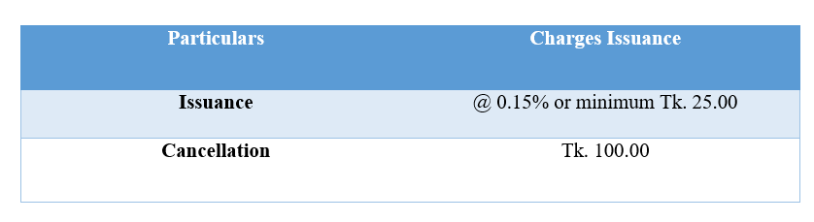
Figure 2 Commission of Telegraphic Transfer (TT)

- Demand Draft (DD): A customer must fill out a form if they want to receive money through DD. That form must be filled properly with applicant’s information, payee’s information ,draft number, branch name where the DD will be drawn, and amount.DD is a negotiable document that may be crossed or not, depending on the customer. Before making a payment to a paying branch, check to see whether the cheque is forged. Carrying money is increasingly dangerous these days, which is why individuals prefer to transfer money through DD. To use this service, the customer must pay a commission.

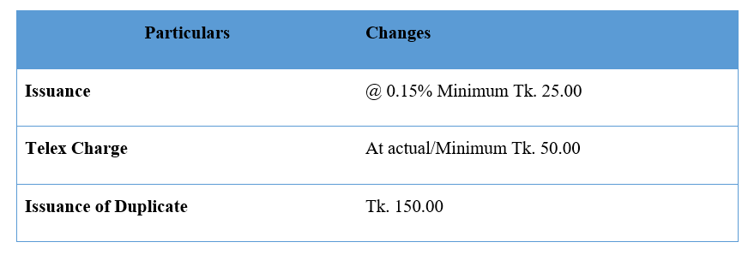

Figure 3Commission of Demand Draft (DD)

Pay order (PO): The client may get funds from the issuing bank. Only pay orders issued by the issuing bank may be encased. Banks withdraw funds in advance in order to issue a pay order. Because it cannot be crossed, it is not a negotiable instrument.

4.6 Cheque Book Issue

Is there a person maintains a bank account, he or she may withdraw money using a cheque book. It is the most convenient and secured method of transferring money from one location to another. A demand slip may be used to issue a cheque book. The institution will verify that slip, and following verification, the bank's central office will issue a check book. When a check book arrives at the branch, it must be noted in the register book as well as the branch seal must be placed on the cheque book page. When a consumer visits the bank to pick up a check, he or she must sign the register book. The officer will then input this information into the computer to confirm that the client has in fact received the check book.

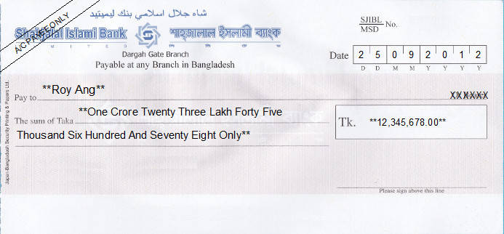
Figure 1Cheque

Duplicate Cheque Book:
The consumer could reapply for their cheque book if they lose it. When a customer reports that their cheque book has been missing, the bank cancels the order of payment for that book series in the ledger. Additionally, they must provide a GD copy to the bank. The bank will then be permitted to provide the consumer a brand-new checkbook.
Return of check: A cheque book might be reverted for the following reasons:
- If a customer chooses to end an account, they are required to return the checkbook.
- If there is insufficient money in the bank, the payment must be stopped.
- If the clearing house tax disc is missing, the payment must be stopped.
- If the required date is incorrect or missing, the officer's signature is missing.
These steps are typical banking procedure, and checks and vouchers are physically and digitally recorded. The bank's internet servers are used for this operation. Walk-in consumers must complete an application which includes client’s information, photos, nominee’s information, and income source, the reason for the account, and signature verification, in order to open an account. These data are also recorded into the bank’s server later by a staff member.

4.7 Different type of scheme

Shahjalal Bank offers a variety of Shari’ah-based schemes that benefit both the bank and the consumer.

- MDS (Monthly Deposit Scheme):
The creditor will get a guaranteed sum of profit each month, making it a highly appealing arrangement. If the money is removed within a year, no profit will be granted. If indeed the account holder is not present, the nominee may benefit from the account. The creditor will get a profit based on the table below.

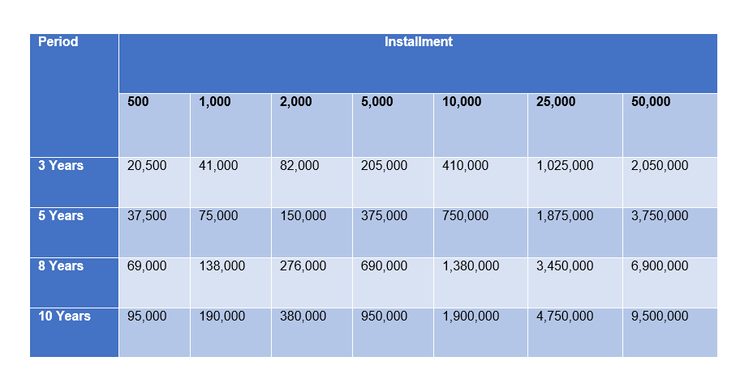Figure 4Monthly deposit scheme (MDS)

- Hajj Savings System:
According to this plan, money may be transmitted in amounts ranging from one year to 25 years in order to complete the Hajj.
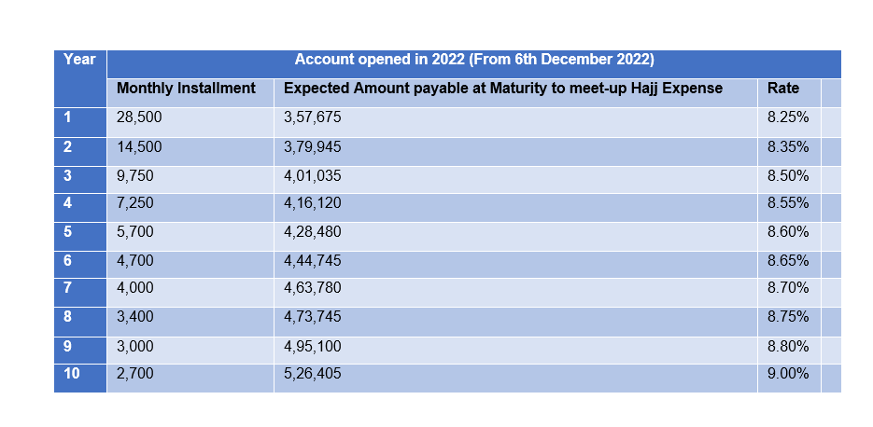
Figure 5 Hajj Deposit Scheme
- Monthly Income Plan:
Jobholders find this program especially alluring since they may benefit greatly by investing just a little amount. An applicant will get 750 taka per month if they deposit one million taka. Depending on the saving rate, an account holder will gain by closing the account. The approved applicant may use the whole benefit in the absence of the account owner.
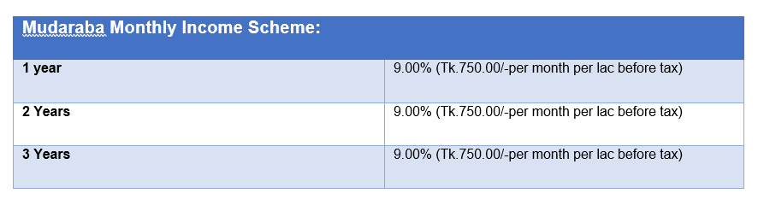
Figure 6Monthly Income Scheme

- Mudaraba Double Money Plan:
In this entirely Shari’ah-based scheme, a consumer may get double revenue. For a period of eight years, a depositor may make more than $10,000 in deposits; after that time, they may withdraw twice that amount. All forms of government taxes must be paid by account holders.


Figure 7 Mudaraba Double Money plan

- Mudaraba Multiple Deposit Scheme:

It is very important to save money to build up capital. Saving is said to be the backbone of development. This is a 13-year deposit strategy that triples your money due to the high profit rate. This sort of strategy encourages individuals to save more money for the country's growth.

Figure 8 Mudaraba Multiple deposit scheme

4.7 SJIBL card services

SJIBL ATM Service:
SJIBL Limited is comprised of NPSB, Q-Cash network, also VISA ATM. Clients can receive 24 hours cash withdrawal services by using the 130 own ATMs and over 5000 shared ATM booths that’s situated across the country. SJIBL very recently began trading.
The yearly charge for a Charge for debit card is Taka 400 (VAT included), replacement or reissue card fee is also Taka 400.
ATM Booth: To provide clients with 24-hour service, SJIBL has built 130 ATM booths around the nation. An ATM booth may be used to execute transactions by a VISA cardholder with ease.
SJIBL is planning to open extra booths in order to provide better service.

Debit Card Service:
The purchase of products and services takes on a new dimension thanks to the Visa card. Carrying a lot of cash might be risky, but the visa card can cut down on that risk. The following two goods are being introduced to serve customers:
- SJIBL VISA Debit Card: The customer's ACD and MSD accounts may be used as collateral for a debit card. Customers may use ATMs at whatever time they want, and they will get message in their phone if they selected the messaging option after using an ATM at their desired location verifying the amount available in their bank.
- SJIBL VISA Prepaid Card (Local): Even those who do not have this banks account can use it. All merchant locations with the Visa brand, including ATMs, accept this card.
- SJIBL VISA Prepaid Card (International): This card is available to all clients and allows them to pay in US dollars against their travel limit, creating a lien on their account of fixed credit.
- SJIBL Dual Visa Debit Card: With this card, one doesn’t have to two cards for domestic and international transactions. Customers may shop both locally and internationally.
- SJIBL VISA Gift Card: Customers are really drawn to this card. It works similarly to a gift card and is universally usable. Customers may customize this card to suit their tastes.

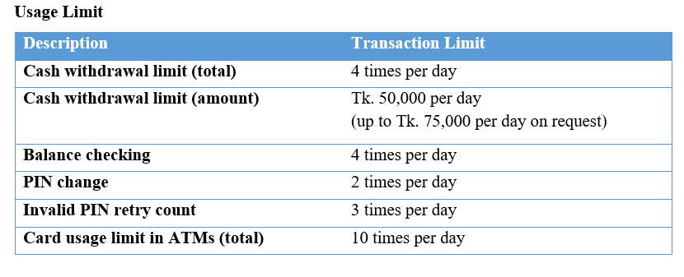
Table 1 Usage Limit of Visa Debit Card

4.8 SMS Banking and Online Banking
The 48 SJIBL branches that are now a part of the Online ABB network as of February 16, 2023, according to the SJIBL website and the most recent update.
- SMS Banking is available at all 48 branches.
- A network of automation presently connects all 48 branches at home.
- The 48th branch is capable of using RTGS.
Internet banking anywhere at SJIBL branch: All branches are linked by a wide area network. Because all of the branches are linked, a customer may get certain services and conduct financial transactions from any branch. This method also allows for quick financial transfers. Because of the financial transfer, the IT department's responsibility is to maintain the safety system. Shahjalal Islami Bank uses all latest technology to deliver better service to its customers.
SMS Service: People are depending on technology more and more. People lack the time to visit the bank to examine their accounts, hence why SJIBL has launched a Sms to provide this service to its registered clients. Clients get information on their transactions through SMS.

Chapter- 5 General Banking Services Analysis and Findings of SJIBL

General Banking services of SJIBL
General Banking consists of four activities. They are-
- Account opening and managing
- Cash receipt and payment
- Clearing accounts and
- Remittance
Account opening and managing is one of the main activities of SJIBL. Depositing money through account opening plays a crucial role in supporting banks growth and operations. These deposits allows the bank to lend money to other customers, invest in new opportunities and offer services. Customers can securely store their funds while bank can utilize and support its operations. It is a mutually beneficial relationship.

5.2 Deposit mix Analysis

Account type | 2017 | 2018 | 2019 | 2020 | 2021
Al Wadia Current Deposit | 7,416.18 | 8,182.56 | 9,952.29 | 34,433.46 | 39,179.68
Mudaraba Saving Deposit | 18,280.59 | 20,792.17 | 24,751.90 | 30,316.57 | 36,326.44
Mudaraba Term Deposit | 64,248.15 | 79,408.03 | 82,587.97 | 81,508.51 | 74,469.38
Mudaraba Short Term Deposit | 4,956.74 | 9,060.35 | 10,444.27 | 13,641.48 | 18,959.58
Mudaraba Schemes Deposits | 37,121.57 | 42,374.50 | 52,493.67 | 54,653.87 | 44,336.94
Others | 13,359.25 | 17,043.90 | 23,154.05 | 3,889.06 | 4,016.97
Total | 145,382.48 | 176,861.51 | 203,384.15 | 218,442.95 | 217,288.99

Table 2 Deposit mix of SJIBL (In million)

Figure 9 Deposits of five years
The Table and figure shows that the deposit from the mix steadily rose significantly from the year 2017. While 2021 got slightly less deposit compare to 2020, we can still say that SJIBL has a strong position with their accounts management.

5.3 Growth Analysis:

Shahjalal Islami Bank Limited has great potential to grow more in the banking area. This bank is expanding its market share significantly. The graph below allows us to keep track of its development.
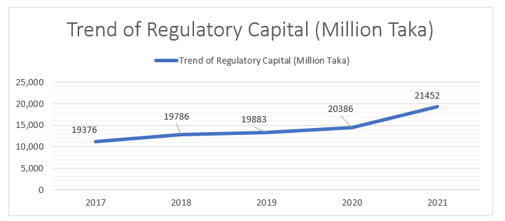

Figure 10 Trend of regulatory capital

This diagram makes it quite evident that trend capital is on the increase and growing.
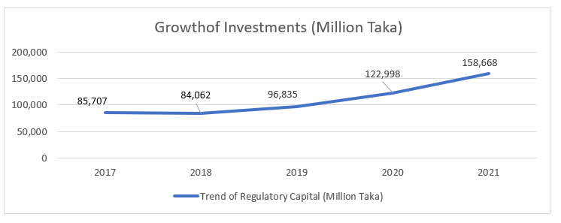

Figure 11 Growth of investment
According to the graph above, the investment rate fell in 2018, but it started to climb again in 2019 and is rising continuously.

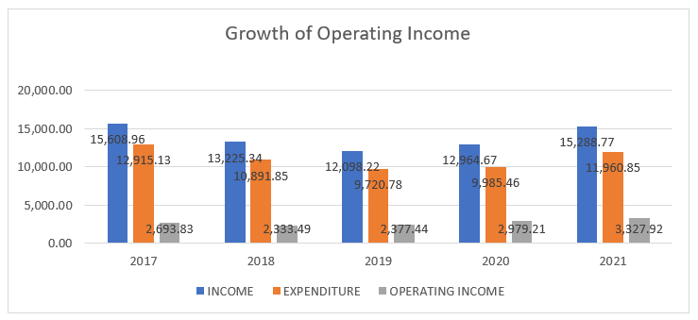

Figure 12 Growth of Operating Income
SJIBL's operational earning keep fluctuating, but it has been rising since 2016, thus it is sufficient.

5.4 SWOT Analysis of SJIBL
It is a conventional method. SWOT analysis is useful for providing a fast overview of an organization. We can quickly learn about in an organization's strengths, weaknesses, opportunities, and dangers. This study assists a firm in overcoming its weaknesses and preparing for future difficulties. SJIBL’s SWOT that I could decipher are-

- Strength:

- A well-informed workforce: The SJIBL human resource management staff is prepared to handle difficult circumstances. The growth of its employees is a top priority. The top management is aware that motivated personnel may complete and meet client requests, resulting in the unequivocal success of the company. SJIBL has improved as a workplace for its employees as a result of this empowering environment. Customers of various levels may get services from them.
- Solid corporate identification: SJIBL provides financial services on a nationwide scale, solidifying the company's reputation among clients. The SJIBL is gaining ground on its rivals in the banking industry because to its insignia. Additionally, SJIBL dominates the retail banking sector.
- Strong inter-team connections: The most valuable asset for any company is its workforce. The SJIBL workforce has a close link and a strong sense of commitment to and belonging to the organization.
- Cooperative and friendly environment: At Shahjalal Islamic Bank Limited, there isn't a distinct executive dining room. To debate their ideas, all of the executives and officers assemble around a table in the cafeteria. The SJIBL's members are allowed to speak their views at any time. Each of them is experiencing freedom. The fact that all of an employee's duties are distributed to other team members to maintain good customer service in the event of a missing or absent employee at the branch is another excellent thing I saw there.
- Satisfactory online banking: One may conduct financial transactions via internet banking from any place. SJIBL provides consumers with IT services that are appropriate for them. SJIBL has a strong security system to ensure that customers may conduct online transactions without worry.
- Interest-free bank: The majority of Bangladeshis are Muslims; therefore, interest is forbidden in Islam. Shahjalal Bank is an interest-free bank, which makes it a good choice for Muslims.

- Weakness:

- Inadequate marketing and advertising: Shahjalal Islami Bank Limited have yet to implement a marketing and advertising plan that includes TV commercials, mass media, banner advertisements, and social media. They do not organize any marketing campaigns to advertise their services.
- Slow machinery exchange: Due to their hectic schedule, some consumers want quick service. When a variety of equipment, such as a printer, photocopier, scanner, or MICR machine, take a long time to process, it is a loss of time for both the client and the branch, and we all know that time is money.
- Hasty service: Some branches may not give token service to customers. Each branch handles a variety of transactions, including deposits and cheque clearing. Because they don't keep track of tokens, customers are sometimes forced to wait for an extended period of time, and sometimes they break the sequence, causing other customers to grow irate.
- Credit concentration risk: Banks face credit concentration risk since certain customers do not pay their installments on time, and it is often impossible to collect money from them after issuing the final notice.
- Larger fees: I've seen that they occasionally charge higher fees than other banks, which generates a bad impression among clients. For example, if a bank statement exceeds 5 pages, they charge an additional cost.

- Opportunity :

- Fixed Deposits, Deposit Pension Scheme’s demand is high : Customers always purchase by taking out a loan with no hidden fees, and the bank gives certain special offers on cards like discounts and buy one get one free deal. Customers are encouraged to save money since the FDR and DPS interest rates have increased above those of other institutions. Customers get loans for their enterprises as well as themselves in order to buy a house, a car, or to handle a short-term need.
- A large number of branches: SJIBL has 137 locations in Bangladesh to effectively serve customers. Additionally, it provides SME banking and online banking services.
- National network: SJIBL's main objective is to grow their business and operations throughout the whole nation, which is why they provide a variety of products and services. By offering consumers a reliable network service, their main goal is to increase their reputation and take the top spot.
- Getting more investments through customer satisfaction: Increasing customer satisfaction leads to increased investment.

- Threats:

- The number of competitors: As the banking business expands, clients have more options for switching. On the other side, rivals may attempt to replicate it.
- Crisis of: Liquidity: This happens in the market. They can't manage funds to breach their limit on occasion or financially.
- State Legislation: Because it is an Islamic bank, the law differs somewhat from that of other banks.
- Objective fulfillment: Each branch must meet its allocated target; if they fail to do so, the branch will be penalized.
- Turmoil in the market: Because the market fluctuates constantly, SJIBL should plan accordingly to be in control.

5.4 Major Findings or Problems

During my Internship in Shahjalal Islami Bank Limited Panthapath Branch I noticed some problems that needs to be addressed so that this branch can work more efficiently.

- Not enough workforce: Many people visit the Panthapath branch to do business, however owing to a personnel shortage; the branch is unable to give prompt service to its patrons, which is the cause of unhappiness. As a consequence of this dissatisfaction, word of mouth is being spread, which harms the bank's reputation.

- Lack of Seating Arrangement: There isn’t enough room for customers to sit at this branch. Due to this, customers has to stand for a long time and wait to get service, especially during the rush hour. It causes inconvenience and discomfort for the customers.

- Lack of good Online Service: Panthapath branch faced online technical issues like server downtime few times which hindered customers to do their banking. It turned out to be inconvenience for the customers as they had to wait a long time to get their service.

- Lack of a token system: Panthapath branch does not use a token system, due to this it is difficult to figure out who gets the service first, causing unhappiness.

Chapter-6 Recommendations& Conclusion

6.1 Recommendations
As an intern with barely three months experience, I have very little time to provide recommendations. According to my observations, I propose the following:
- Hire more Employees: Optimize staffing levels to ensure that there are enough employees available during peak hours to handle customer traffic. This will also help improve customer service. The bank should ensure that the employees are properly trained so that they can work fast and without any error during the rush hour.
- Seating Arrangement: To address this problem, the branch need to assess the current seating arrangement and see if it’s possible to add more seating to accommodate more customers. They can rearrange the layout for this or implement a system where customer can schedule appointments to lessen the waiting time. This can help to improve overall customer satisfaction.
- Improve internet service: Provide customers with online or mobile banking options to allow them to perform transactions remotely, reducing the need to visit the branch in person. Upgrading software can also be a good solution as new software can get the work done faster.
- Implement Token System: Even though this branch is quite small but a huge number of customers comes to get service every day so it can get quite busy. A token system in this branch can provide a structural queuing system and streamline customer service. Customer can take a token upon arrival which would help maintain order and reduce the wait times. It also allows customers to have a seat and wait comfortably until their token is called.

6.2 Conclusion
One of Bangladesh's most promising Shari’ah-based banks is Shahjalal Islami Bank. This bank establishes a new standard for other banks to follow. They have a good position in this competitive market. If we assess its performance, we may conclude that its drive and potential are the reasons for obtaining this position. SJIBL is able to acquire more customers because of its strong customer relationships and outstanding service.
Working at Shahjalal Islami Bank Limited (Panthapath Branch) gave me a lot of satisfaction. During my three-month internship, I have seen a significant contrast between theoretical knowledge and real work. Real work is practical labor. I acquired a range of abilities throughout the course of these three months. I have learned how to face customers and how to behave professionally. I am aware of how a banker does business. The SJIBL has a number of operational guidelines; my report mainly emphasizes on this banks general banking and it help me understand the bank’s plan. I learned throughout my internship that this bank is successful because all of its divisions are flawlessly interconnected and its energetic officials are doing their jobs well. The popularity of this bank is growing as a consequence of its Shari’ah based services. Shahjalal Islami Bank, is making an effort to improve society by doing charitable works while following the Quran and Sunnah .Their major goal is to provide better service to clients rather than to make a profit.
With the way SJIBL is expanding its offerings, it might eventually overtake the competition. Each bank offers unique benefits and drawbacks. According to my observations, SJIBL should prioritize its customers, which necessitates personnel training. The bank treats its customers with greater sensitivity. If SJIBL does not constantly upgrade, it will be unable to compete since the banking industry is always evolving and demanding. SJIBL's major objective is always to provide excellent service rather than quantity, which is why they prioritize customers above business.

References
Annual Report of SJIBL 2021, 2020,2019, 2018,2017
Ahmad, A. U., & Hassan, M. K. (2007). Regulation and Performance of Islamic Banking in Bangladesh. Thunderbird International Business Review, Vol. 49(2) 251–277.
Alam, M. N. (2000). Islamic Banking in Bangladesh-A Case Study of IBBL. International Journal of Islamic Financial Services, Vol.1 No.4.
Ali, M. a. (1995). Islamic Banking: Principles and Operational Methodology".
(2021). Annual Report SJIBL. Bangladesh: SJIBI.
El-Gamal, M. A., & Islahi, A. A. (2006). Islamic Finance: Law, Economics and Practice. Journal of King Abdulaziz University-Islamic Economics.
Hossan, S. (22, March 25). Development of Islamic Banking in Bangladesh: Current Status, Challenges and Prospects. Retrieved from Business Inspection: https://businessinspection.com.bd/development-of-islamic-banking/
Ibrahim, M. .. (2014). Investigating the Performances of Islamic Banks in Bangladesh”’ . Asian Social Science, Vol.10. No.22, pp.165-180.
Imam, P. a. (2010). Islamic Banking How Has it Diffused? International Monetary Fund; Volume 2010: Issue 195, 30.
Kangni, K., & Imam, P. (2010). Islamic Banking: How Has it Spread? International Monetary Fund, 112-137.
Khan, R. S. (2017). Internship report on productivity and possibality analysis of shahjalal islami bank. Dhaka, Bangladesh: SlideShare.
Mahmud, A. A. (2010). A Comparative Study on Performance evaluation of Conventional Banks and Islamic Banks in Bangladesh with Special Reference to Islami Bank Bangladesh Limited,. Journal of Economics, 18(5), 25-44.
Mannan, M. (2014). Islamic Banking in Bangladesh: Progress and Potentials.
Ministry of Finance. (2020-2021). Activities of Banking, insurance and financial organization. Retrieved from www.mof.gov.bd
Munawar Iqbal, P. M. (2005). Thirty Years of Islamic Banking;History, Performance and Prospects. Palgrave Macmillan Studies in Banking and Financial Institutions (SBFI).
Puri-Mirza, A. (2022, Sep 12). Number of Islamic banks worldwide in 2019. Retrieved from Statista: https://www.statista.com/statistics/1090895/worldwide-number-of-islamic-banks-by-type/
Puri-Mirza, A. (2023, Jan 19). Total value of Islamic finance assets worldwide from 2012 to 2021 with a projection for 2026. Retrieved from Statista: https://www.statista.com/statistics/1090815/worldwide-value-of-islamic-finance-assets/
Sadekin, M. N. (2014). Performance Appraisal of Selected Islamic Banks in Bangladesh. Journal of Economics and Sustainable Development, 5(14), 165-175.
Shahjalal Islami Bank Limited. (2017). Credit Management of Shahjalal Islami Bank Limited. Retrieved from https://assignmentpoint.com/credit-management-of-shahjalal-islami-bank-limited/
SJIBL. (2021, 1 1). SJIBL. Retrieved from SJIBL: https://www.sjiblbd.com/
Sjiblbd.com. (2023). SJIBL ATM Location. Retrieved from Sjiblbd.com: https://sjiblbd.com/ATM_Locator.php
Tarver, E. (2022, March 15). Islamic Banking and Finance Definition : History and Example. Retrieved from Investopedia.com: https://www.investopedia.com/terms/i/islamicbanking.asp

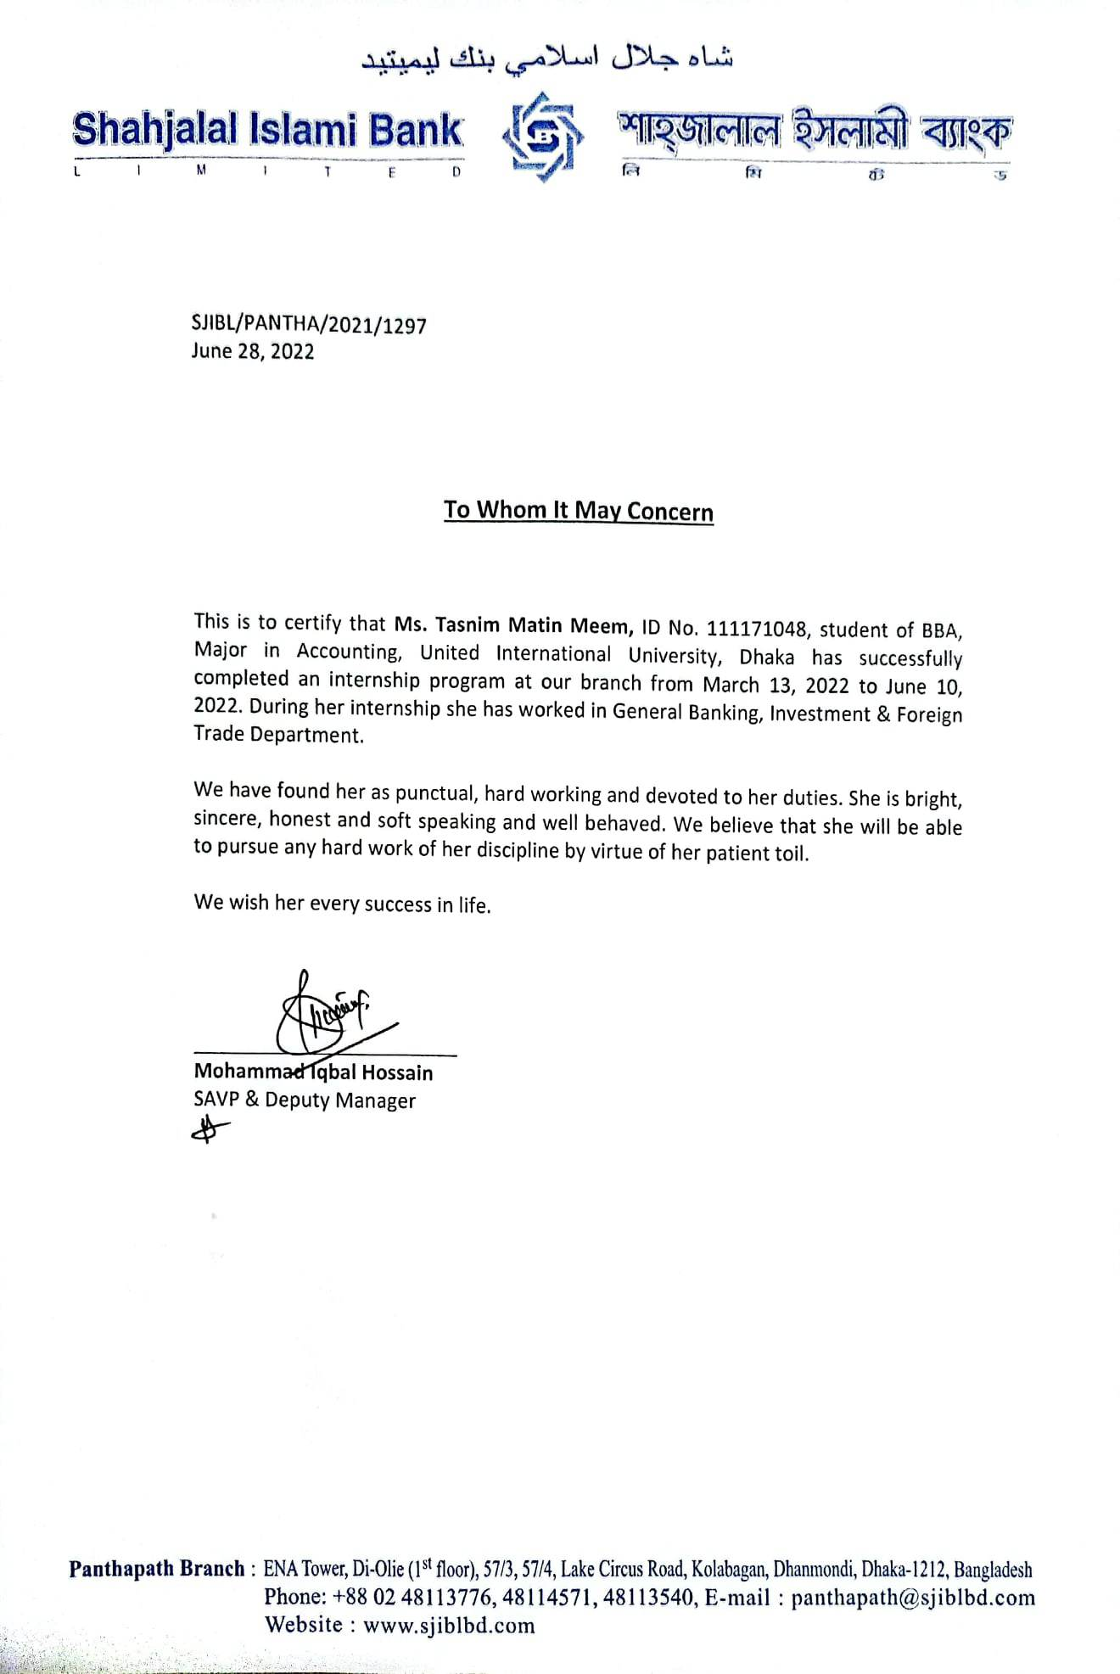
Internship Completion Certificate

