Appraisal of Employee Performance during Pandemic Situation: A Study on C.P. Bangladesh Co. Ltd

Name: Rahat Ahmad
ID No: 111-181-140
Major: HRM
Program: BBA



School of Business & Economics
United International University

27 January 2022
Letter of transmittal
27th January 2022
To,
Prof. Dr. F. A. Sobhani
School of Business and Economics
United International University (UIU)
Subject: Submission of Internship report on “Appraisal of employee performance during the pandemic situation of C.P. Bangladesh Co. Ltd”.
Dear Sir,
I have the integrity to present my internship report on the internship titled “Appraisal of employee performance during the pandemic situation of C.P. Bangladesh Co. Ltd”. The time expended on this document has been very rewarding for me as I have been talented to gain information and knowledge connected to the HR department which I trust will be of excessive help in my upcoming expert life.
I have undertaken my best and tried my level foremost according to your specification that you imparted to me. This internship report contains and holds of my internship experience about the pandemic situation of C.P. Bangladesh Co. Ltd based on their HRM sector or HR department as the report assigned with the appraisal of Employee performance that is the core and major criteria of HR department. I would be very appreciative if you follow up this report as well as receive it, and I would also be very delightful to express the appreciativeness for your kind attention and reviewing as well as reading my report as well.
With an open heart, I am very hopefully that my analysis of internship report will assist you to know and get about the details idea of the appraisal of employee performance during pandemic situation of C.P. Bangladesh Co. Ltd. I am also confidently that you will consider this report and think about the mistakes that may appear in this internship report despite my best efforts.

Rahat Ahmad
ID: 111-181-140
School of Business and Economics
United International University
Declaration

I, the undersigned, hereby declare that I have completed my internship report/project under the supervision of Dr. Farid A. Sobhani, Professor, School of business and economics, United International University (UIU), Dhaka, Bangladesh.
I have finalized an internship report titled on “Appraisal of employee performance during the pandemic situation in C.P Bangladesh co. Ltd.” That is my own work.
Neither part of this internship report is imitated from elsewhere nor submitted before for any academic qualification, certification, diploma and degree to any other university.

Sincerely Yours,

Name: Rahat Ahmad
ID: 111-181-140
Program: BBA
School of Business & Economics
United International University (UIU)

Acknowledgements
At first, I would like to thanks Almighty Allah for his bless I have successfully completed my internship report. Without his bless and support it would be very difficult for me to carry on the completion of entire internship report.
After that, in practically the successful completion of the internship report is the ultimate result of the support and contribution from the number of people as they all have given their valuable time, efforts, and most importantly their practical opinion and suggestion that helped me to gain the knowledge in order to make a complete internship report according to the guideline.
This internship has allowed me to gain practical knowledge that I hope will be useful for my future work in the future.
In particular, as the guideline and direction was supervised and monitored by the Prof. Dr. F. A. Sobhani, I would like to thank my supervisor Prof. Dr. F. A. Sobhani, for serving me the knowledge and direction in order to complete my internship issue “Appraisal of employee performance during the time of pandemic situation of C.P Bangladesh. Co. Ltd.
I would like to thank very specially to,
- Mr. Suchat Suntipada, The president of C.P Bangladesh Co. Ltd
- Mohammad Oli Ullah, The general manager of C.P Bangladesh Co .Ltd
- Md. Zakir Hossain, The HR manager of C.P Bangladesh Co .Ltd
- Abdullah Al Mamun, Md Ashraful Haq and so on the staff of the HR division.
These all the member of the human resource field directly or indirectly provided me the instruction and knowledge that were associated with the HR made my report so accordingly that might be the completion of a successful internship report.
In the end, my deepest appreciation goes to my classmates and friends for supporting, motivating as well as giving their opinion during the making and preparation of the internship report.

Executive summary
C.P group is consisted as an entirely foreign owned multinational company. As a private company it was established in 1921 in Bangkok, Thailand. After that, in 1999, they converted to public company with their corporate vision kitchen of the world and gained strategy to be a world class food producer by providing healthy, hygienic and testy foods to customer. In 1998, they started business in Bangladesh and registered as the name of (CPB) C.P Bangladesh co. Ltd. In the reason of being an agriculture country, CPB targeted expanding agri-business, food business, and develop people CSR activities. The company has already established its operation in different area of the entire country.
Furthermore, the aim of my internship report is to identify the appraisal of employee performance during the pandemic situation in C.P Bangladesh co. Ltd. My internship experience in this organization has been deal with the HR manager and staff under the Human Resource Division of C.P. Bangladesh Co. Ltd.
Before the pandemic, the Company always takes care of their employees by providing proper regulations.
But during the pandemic situation, they face a new genre of experiences. They were totally puzzled how to deal with employee performance, how to appraisal performance, how to replace the older version of appraisal with the new ones .In order to appraisal the employee performance they have followed totally a newer level of appraisal methods that were never seen before. They have always encountered with different training programs, performance appraisal and job evaluations for strengthen the effectiveness and efficiencies.

Table of Contents
Introduction 1
1.1 Background of the study 1
1.2 Objectives of the study 1
1.3 Methodology 2
1.4 Scope and Limitations 2
1.5 Significance of the study 3
Corporate Profile 4
2.1 Overview and history 4
2.2 A brief view of Company’s profile 5
2.3 Trend and growth 6
2.4 Customer mix 7
2.5 Product/service mix 8
2.6 Operations 11
2.7 HR Department 14
2.8 SWOT analysis 15
Findings and Analysis 17
3.1 Findings and analysis 17
3.2 Findings and analysis 18
3.3 Findings and analysis 19
3.3.1 The traditional performance appraisal methods 19
3.3.2 The modern methods of performance appraisal 20
3.4 Findings and analysis 21
3.4.1 Virtual appraisal process 21
3.5 Findings and analysis 23
3.5.1 Appraisal methods review before the pandemic 23
3.5.2 Appraisal methods review after the pandemic 24
Conclusions and recommendations 26
4.1 Major findings of the study 26
4.2 Recommendations for improvements 27
4.3 Concluding remarks 28
Appendix 29
References 30

Chapter-1

Introduction

1.1 Background of the study

Bangladesh is located in the north-eastern part of south Asia and basically it is so called an agricultural country despite the fact Bangladesh is now going to be a developed nation in 2041 Mission Digital Bangladesh. As a result, Multinational org. and companies emerge the prime location of establishing their business as well as setting and targeting their business mission and vision. So, almost hundred of multinational companies have already established their business in Bangladesh and running their business so profoundly around the country. Amongst them, C.P. Bangladesh Co. Ltd. is one of the leading and well-known as well as may considered most prominent multinational companies in Bangladesh. They are doing major contribution in the field of feed, farm, food in Bangladesh and expanding and developing these sectors very rapidly. Educated people and job seekers are getting opportunities to establish their career in multinational company like C.P. Bangladesh Co. Ltd.

1.2 Objectives of the study

The key objectives of this internship report are:
- To describe the impact of Covid-19 in business environment around the world.
- To introduce and describe the organization’s HR policies, procedures, especially the systems or methods of appraisal employee performance as well as in details of HRM department.
- To experience and recognize the new methods of appraisal employee performance those are practically performed during the time of Covid-19.
- To differentiate before and after appraisal methods of the company as well as the consequences of those methods before the pandemic and after the pandemic.
- To propose suggestions, instruction, knowledge and recommendation for the practitioners and management that may help further to gain the experience of best practices of HRM in the organization.

1.3 Methodology

This internship report is made of and prepared based on using primary and secondary data resources.
- Primary Data was collected by observing the process and procedures of appraisal methods of employee performance during the pandemic situation; by interviewing with employee via zoom online platform, Smartphone or even through meeting with them while a short term intern in HR division of C.P. Bangladesh Co. Ltd.
- Secondary data was collected from organization’s employers, staffs, employees, documents, magazines, articles, company’s website and relevant books so on.

1.4 Scope and Limitations

The main limitations that I encountered in the time of my internship period and in the course of preparing and making the report are as follows:
- Because of Covid-19 pandemic situation, a big amount of research was not possible.
- Gathering a big amount of information was not possible in the reason of time constraint.
- The management seems very busy adapting a new era of business environment.
- By virtually collecting the information was a little bit difficult as it has never been experience before.
- A Fewer information in company’s website. Thus, all requirements can’t be included.
- Collecting the relevant data and documents were very difficult because of the organization’s restrictions imposed by the government.

1.5 Significance of the study

In present world, every organization and every company want to gain a positive image and also be constantly evolved. The present time is not highly modest but also competitive too. The Covid-19 situation has been created a new era of business environment that was never seen before in our modern time. Every corner and area of the businesses has been profoundly affected. As a result, the organizations have been faced by the irrespective of scope, knowledge, environment, skills and market alignment, marketing advertisements. From the perspective of the HRM, the HR division and department have faced very challenging movement as they were not used to the pandemic situation and also they were not taught in their academic and practical life as well. Therefore, to overcome these limits and to adapt a new era of business environment, it is essential to make and maintain a proper guideline as well as create a strong and positive relationship between staff and their establishments.

Chapter-2

Corporate profile

2.1 Overview and history

The C.P. is known as the Charoen Pokphand group is recognized and considered Thailand’s biggest private company as well as one of the largest and well-known multinational groups. Their registered Corporate Head quarter is situated in Thailand.
At present, C.P groups are operating and conducting their business in 30 countries around the world and more than almost 400,000 employees and staffs those are working worldwide for this company. C.P. Ltd. has founded and established in 1921. Based on their establishment in Thailand and knowing as a private limited organization, then in 1998, they have commenced their journey in Bangladesh. The combined operations of C.P. Bangladesh Co. Ltd. are basically the pure raw materials that are sourcing for, animal breeding and farming, animal feed production and distribution, the raw meat processing and the manufacture of the meat products for example ready-to-eat cooked meat.
Around 86 years ago, the founders of C.P.Company named Mr. Ek Chor and Mr. Siew Whooy established a tiny seed shop which was named ‘Chia Tai Cheung’ in Bangkok’s Yaowaratarea, also known as China Town.
Later on, C.P group begun their journey by producing of animal feed and, after that they started livestock farming and processing as well as marketing & distribution its businesses, and later they enlarged into a fully integrated agri-business that seemed from seed to feed- to farm to food.
In 1978 C.P. Ltd registered under the name Charoen Pokphand Feed mill Company Limited to production and distribution animal feed in Thailand. In 1994 they converted from private company to public limited company.
By means of ethical and moral beliefs and practices, C.P group has been producing and manufacturing quality foods and services since its establishment. They are not only to help the ultimate or rising growing demand but also to do business with professional having the organized growing of the Thai society and environment.
Based on subsidiaries, they are involved with agro-industry, food, distribution and marketing. They have achieved well-establishment in Thailand as well as globally & internationally. It is basically known as agro-industry and food businesses that adds poultry and farming, swine and shrimps. They also offer plant protection products, seeds and composts for example; they offer corns seeds and vegetables, pet foods for dogs and cats, fishes and others animal as well. Their marketing and distribution strategy basically based on network installation combined with fixed line, subscription based digital platform such as 4g mobile phone, internet, and television & media coverage so on.
The company is announced and titled as “Charoen Pokphand Foods public Company Limited” in 1999 in order to show the C.P’s vision of becoming to be the Kitchen of the World.
Their main focuses of the business is to be the world class food producer. In the year 2002, they financed in United Kingdom, Republic of China. In 2004 they invested in Turkey .And in 2006, they also invested in Russia. After that, from 2005 to 2012 they have invested a big amount of finance and business capital in Malaysia, Philippines, India, and Taiwan etc.

2.2 A brief view of Company’s profile

Name of the company | C.P Bangladesh Co., Ltd.
Head-quarter | Bangkok, Thailand
Vision | Kitchen of the world
Year of formation  and establishment | 1921
Operation started in Bangladesh | 1998
Business category | Agro-business and food
Registered office | House 28, Alaol Avenue, uttara-6, Dhaka-1230, Bangladesh.
Company’s  website | www.cpgroupglobal.com  www.cpbangladesh.com

2.3 Trend and growth

The business strategies and policies of C.P. group seem very unique and comprehensive. The corporate vision and organization vision of the C.P. group is to kitchen of the world that refers to become a globally famous company that is committed to engage the qualities of food as well as nutritious, hygienic and safe. In the reason of gaining the faith and trust of societies in domestically and globally, C.P. group strongly concerns and thinks about its commitment and promises to develop the livelihood and well-being of the people as well as targets to active its portion in reinforcing the growth as well as the sustainability of the country’s economy, society and environment.
The main focuses or the main/major objective of their organization as follows:
- To expand and broaden business all over the world.
- To focus how to bring forth high quality product at very decent prices.
- To ensure the highest level safety depending on environmental friendliness and social responsibility.
- To raise the market share as well as increase the profit maximization.
- To become a leader of the agro-business in the world as well in Bangladesh.
The C.P. group is following “3-benefits” principle and a strong commitment towards it.
- Benefit to the people.
- Benefit to the company.
- Benefit to the country.
To ensure the benefit of the people of those societies in which people live, to ensure the benefit of the company that is consisted of employee, shareholders and executives, and finally to ensure the benefit in all country in where company has invested in.
Their company’s growth basically stands over some core values and strong criteria. These are as follows:
- Three benefit to its sustainability: people, society & country.
- Simplification: focuses on innovation and technology.
- Speed and quality: In order to survive, sustainability growth, speed and quality is considered to be the key factors.
- Adapt to change/transform: Because of enormous challenges surrounding the business environment, company needs to accept the challenges very cautiously.
- Innovativeness: In order to become an innovative organization, company needs to create best product and services for the consumers.
- Integrity & Honesty: It refers to follow the relevant rules and code of ethics.

2.4 Customer mix

It refers to the segmentation of the customer based on their lifetime value or experiences that reflect engaging better potential customer for future. C.P. group has been doing their business based on customer interest and demand. C.P groups always maintain and follow the estimation of the customer mix. All over the world they are following different types of customer valuation regarding some facts such as people choices, cultural varieties, business environment etc.

Since C.P. Bangladesh Co .Ltd or C.P group is a multinational company as well as produces and manufactures the varieties of product with different sector such as feed, food, breed farm etc, their customer varies from one to another. If we consider their biggest banner “CP Five Star” related to fried, spicy chicken and fast food as well; their customer loyalty depends on the past transaction and life time value in order to estimate the future loyalty of the customer to purchase the same products and items. Furthermore, other sectors of this C.P. group also face the same situation and follow the same criteria so as to estimate the customer mix accordingly.
The Products variation of C.P. foods seems to be a good example of customer mix. All over in the world in where C.P. established its businesses has received varieties of customer mix.


In addition, C.P. groups internationally and domestically also focuses on driving customer life time value by thinking about what is not required to sell an item rather than keep the customer for future purchases.

2.5 Product/service mix

The product mix can be referred to be the portfolio of the product that is offered by a firm. It is consisted of product line having varieties of the products by which the consumer can think or use together similar product and items. Here we can see dimension of the product lines; as follows:
- Width- the number of the product line offered by a company.
- Length- the number of product in a firm product mix.
- Depth- the variation of product line.
- Consistency-the relationship between the product lines.
Thus, C.P. group have the multi-product variation as they are a multinational company. Their business operation varies according to their business sector and operation. But basically their product line can be categorized; they are offering 3 types of product/services in Bangladesh. These are as follows:
Types of  Products line (C.P Bangladesh Ltd.) | Types of  product line  consists of | Example based on  C.P Bangladesh Ltd.
Feed production | Livestock line | - Considering the supreme and superior company to produce and make different types of feed. (4 factories across the country)
Feed production | Aquatic line | - Considering the leading company of producing & distributing shrimp and fish feed.
Farm business  (Broiler, Hatchery, &Breeder) | Livestock line | - Producing broiler chicken layer, duck, piglet, eggs etc& considering the leading company as well.  - Producing and farming quality full shrimp to ensure the best shrimp production sector for us.
Farm business  (Broiler, Hatchery, &Breeder) | Aquatic line
Food production |  | - C.P Bangladesh is well known and most famous for their ready-to-cook food or ready-made food.  - Their most popular food brand name is C.P five stars.  - More than 300 outlets are surrounding across the country and in future they also trying to expanding their business rest of the part in Bangladesh.



2.6 Operations

Since 1998 C.P Bangladesh Ltd has expanding their business across the country. At present, they have more than 500 outlets including approximately 9000 thousands employees and staffs those are working and staying in the integral part of this company.
The business operation of C.P groups in Bangladesh
Food business | - It is considered the big part of C.P group.  - Producing “ready-to-cook/eat” food.  - More than 300 outlets around the country.
Feed production  business | - Producing broiler , layer, cattle feed  - More than 6 farms and factories.
Health production  of animal | - Producing animal’s medicine that prevent animal from diseases.  - Dealer of medicine brand from Germany, Netherland etc.
Seed &  Organic fertilizer business | - Producing eco-friendly fertilizer.  - Established in 2005-06
Hatchery business | - More than 10 hatcheries.  - Producing chicks’ layer and broiler.
Breeder farm business | - Around 25 breeder farm across the country  - Delivers and supplies the eggs from one region to another region across the country.
Aqua-culture business | - 3 fish hatcheries  - Producing (Sinking fish feed, Tilapia fish & floating fish feed)
Integration business | - 15 broiler & layer firm.  - More than 20 sales outlets across the country.

All over in Bangladesh, especially Dhaka and Chittagong are considered the prime location of their business in which they conducting their major operations and producing product such as food business, agro business and feed animal business etc.

C.P Farm Business, Aqua business


Location: Chandra, Gazipur, Bangladesh.

2.7 HR Department

The following diagram is the HR department Hierarchy of C.P group that is designed and mostly followed in everywhere in regional branches and country around the world.

2.8 SWOT analysis

It is basically a framework by which a company can identify and analysis its internal strength and weakness and external opportunities and threats.

C.P group has a lot of variation over its business strategic plan. As they have conducted their business all over the world, the variation of the SWOT can be addressed differently as well .The consequences or analysis result of SWOT in Thailand will not be similar to the Bangladesh.
From Bangladesh perspective, The SWOT analysis can be described based on its business environment or the surrounding atmosphere of the business environment in which CP has been conducting their business since 1998 in Bangladesh.
- Strength: C.P Bangladesh is working with a vision and their vision implies to reach all the kitchens across the country. Having this vision and with having international fame or recognition, they could reach their goals and targets very quickly if they could afford or maintain as well gather a big amount of share in order to gain the capital for running the business in Bangladesh in future.
- Weakness: The major weakness of C.P Bangladesh can be referred to the shortage of raw materials or the chaos of the supply chain procedures. As they have the vision to reach across country; it could be very difficult to maintain the same procedures of the supply chain management.
- Opportunities: One of major opportunities is that C.P Bangladesh can arrange their production’s raw materials, labor, very cheaper compared to the other countries. And also being international reorganization they have achieved competitive advantages that help them to spread their business across the country and also to set them for planning new business strategy based on their surrounding environment in Bangladesh. As an international company or multinational company, C.P group has enormous financial support, advanced management policies, HR hierarchy included staff, managers, employees, marketing distribution policies, organization rules and regulations. Therefore, their opportunity, no doubt, would be better compared to their business competitors.
- Threats: Now-a-days business is so common in every nation of the world. Each and every multinational company is trying to set up their business very accordingly across the world. As business era is passing now so rapidly, as each and every company has got the same opportunity for example, better transportation system, internet system, better management and HR function, marketing, distribution and everything have the equal right, business competitor is arising so rapidly in which every multinational company are trying their best to gain the market position so that they can alone handle or occupy the market. This tendency makes the business world so competition that no one wants to give up their trying to be the best ones. So, C.P Bangladesh is also facing the threats that are implies if they want to do their business so long they must think about their competitors threats. Market is not only ruling by the C.P Bangladesh, their competitors are always trying to push back them and want to replace them so strongly.

Chapter-3

Findings and Analysis

3.1 Findings and analysis

The world is passing now one of the worst times in the history. We have not seen any pandemic or epidemic in our modern time or even modern civilization cannot think such incident even in their dreams. But in reality, we are facing it. Since 2019 when the Covid-19 was first found in Wuhan, Republic of China, we everyone thought it might be an epidemic or a new diseases that might be curable but later the consequences of the Covid-19 just destroyed and shattered the world economy, demolished our way of livings, pulled down our way of thinking, crashed our way of communication, ruined our regular system of transportation and most importantly Covid-19 damaged as well as wrecked our business world so profoundly that we are still struggling and trying to find out the way how to recover this great loss, how to adapt with a new environment that the world never seen it before. As the business world have been greatly damaged by the pandemic, the business world or its component such as the multinational companies are now adapting or focusing a new era of the communication, business strategy, management system, distribution and advertisement process. It is not only the result of any particular company; it has been practicing all over the world.
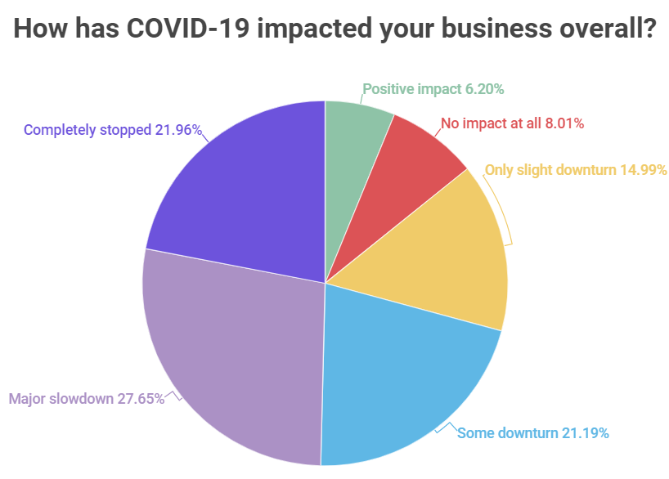Survey of 18 countries in Asia-Pacific region (2020-21)
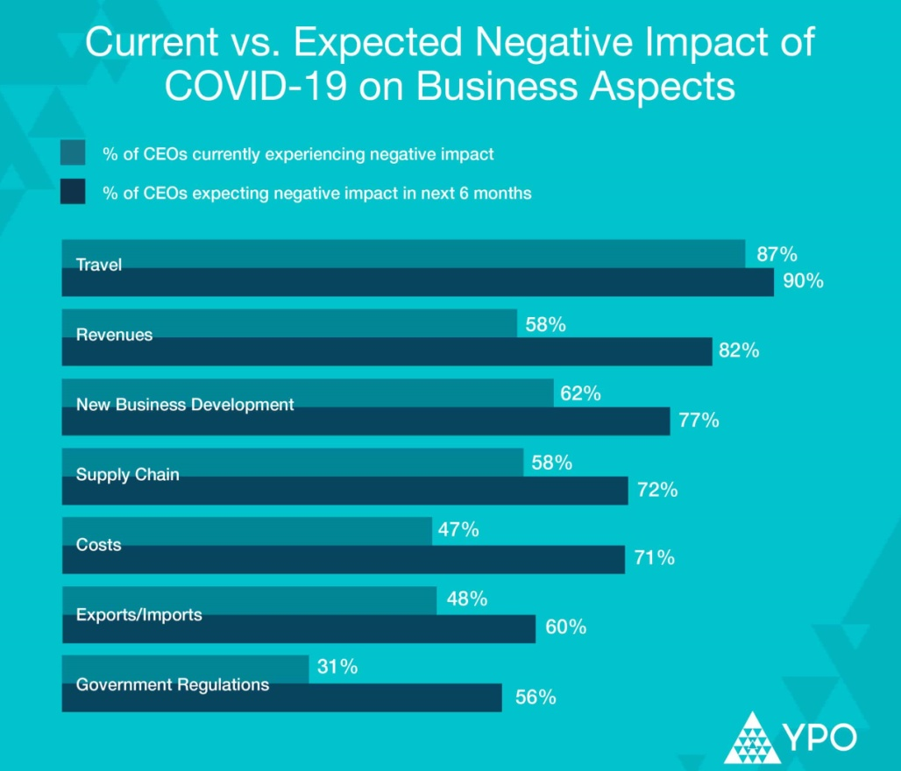(Global survey on the business impact of Covid-19 Number of respondents 2,750+ from 110 countries) Year- 2021

3.2 Findings and analysis

At the time of my internship period in C.P. Bangladesh Co. Ltd, I was trying participate their HR division or HR department in order to gain the practical experiences what would they do especially how would they appraisal their employee’s performance during the pandemic or Covid-19 times.
At the beginning, I was trying to find out what or how they actually appraisal their employee’s performance before the pandemic or covid-19. In order to gain this information, I talked with the HR manager of C.P. Bangladesh Co. Ltd. and then I also meet and interviewed C.P’s HR staff, employees and many more HRM related person whose are associated with C.P. Bangladesh Co. Ltd. Indeed, it was very difficult to meet or get an interview of the key figure of the company such as Company’s general manager, or country’s head of HR manager because of the wide spreading fear of Covid-19 and most noticeable, Government restriction over the company’s rules and regulation during the time of Covid-19.
In general, the HR department of C.P. Bangladesh Co. Ltd leads and supports the managers or staffs who typically conduct employee appraisal processes in order to assess how well employees are engaged with their work as well as what will be the better chances of their success. However, with the rapid advancement of HR technology available, the traditional methods seems outdated appraisal methods because of not providing the quality and standard of results that are needed for an organization to go up its success.

3.3 Findings and analysis

3.3.1 The traditional performance appraisal methods

Basically they were following the traditional appraisal methods in order to appraisal their employee’s performance. They were used to it; in addition, they were also following the modern appraisal methods as well but some specific requirements. But during the time of pandemic, they have been puzzled about what methods should be used to appraisal their employee’s performance. As a result, they have used or appraised their employee’s performance based on the needs of different situation they have faced throughout the pandemic period.
When traditional performance appraisal methods has been used at the beginning of the pandemic situation:
- 40% of the HR managers and leaders assumed that their annual performance reviews would not be an accurate appraisal for employee’s work.
- 40 to 50% of the employees and workers would leave their jobs if the employers would fail to provide the necessary guideline according to the employee’s performance.
- Around 50 to 60% HR manager, staff thought that their traditional methods would not be an effective way of appraisal the performance of the employees that would be engaging virtually in future.

3.3.2 The modern methods of performance appraisal

When modern performance appraisal methods have been used in the middle of the pandemic situation or after the failing of the traditional methods:

- HR managers and leaders received almost 70% feedback from their employees that showed they received around 10%greater positivity than they had assumed (60%) on their modern performance appraisal methods.
- They followed the modern methods that have received the turnover rates 20% lower than their pervious feedback of the traditional appraisal methods.
- Almost 70% of employees preferred that they are suitable and fit in the modern appraisal methods as they have the opportunity to feedback quickly.

3.4 Findings and analysis

After the spreading of covid-19, it is true that all over the world almost 90% of the organizations have gone through a paradigm shift over their management system, Training and development, recruiting and selection process as well as their performance appraisal methods/process so as to fit it with their changes that this pandemic has brought in our lives.
Nevertheless in can be noted that, performance appraisal process are conducted in every year or yearly as it estimates the employee’s overall growth as well as it also shows the differentiation between the high-average-low performing employee based on a yearly salary and promotion. Aside from, due to the covid-19, it can be noted other major shifts that have now been implemented in most of the organization.
During the time of pandemic C.P Bangladesh Co. Ltd has been frequently following these appraisal methods or tools in order to maintain appraisal employee’s performance criteria.
3.4.1 Virtual appraisal process
After covid-19 spreading all over the world and also lockdown imposed all over the world, especially in Bangladesh, around the country, C.P Bangladesh Co. Ltd has substantially picked out virtual appraisal process. Here are some characteristics or features that can be included or explained through virtual appraisal process.
a. Continuous and 360 Feedback

- Real-time and ongoing feedback- Ongoing feedback can be referred as regularly provided feedback and also an important part to keeping employees engaged.
- Seamless check-in meetings software and meeting tool templates- C.P. Bangladesh Co. Ltd has been engaged a very good feedback via meeting tool templates that seems very constant and make seamlessly.
- Multi-rater and 360-degree feedback tools- C.P were engaged to get feedback from multiple sources which seemed an effective feedback technique to them. For example, SpriggHR is a well-known example of Multi-Rater/360 Feedback tool that ensures input from many sources.
- SpriggHR- It is known as HR software that is used to help companies with performance appraisal and talent management of employees. It is very simple very intuitive, and flexible. Performance appraisal or Management platform, It offers very modern and advanced effective performance appraisal tools that help HR staffs assign the metrics about employees’ performance and also help them to encourages the continuousness of appraisal discussions as well as managing the frequency of reviews conduced.

b. The same rating and bonuses

- It is very true and no one can ignore the fact that all over the every company has been faced a tough blow in the reason of the Covid-19. Therefore, C.P. Bangladesh Co .Ltd, in the beginning, has faced a huge potential loss but later on adapting to the appraisal process in which all the employees are given the same rating and bonuses may lead to good images amongst the employees.
- It may be considered the adjustment with the cloud tools; virtual learning and other virtual processes seemed to be a major challenge for employees of C.P. Bangladesh Co. Ltd. As they are very armature considering the using of these tools for the first time, therefore, their performance must be following these matters very spontaneously.
- As a result, C.P. employers have been evaluated the challenges that employees faced in the reason of the sudden change in their work environment or business circumstances before starting to assess their progress and improvement.
c. Growth equal to Appraisal

- Although most of the companies have been suffered a huge loss because of the pandemic, there are also some companies that achieved a rapid growth in their business. If we think about C.P. Bangladesh Co. Ltd we see that they have witnessed a rapid growth during the pandemic because of their HR department dedication and most importantly they succeeded to retain the employees very profoundly. They also reward its employees adequately through conducting the appraisal process.

- While every organization and industry have had their own set of challenges in the pandemic, C.P. Bangladesh Co. Ltd has conducted its appraisal process enough timely, fair and transparently as a result it helped them to retain the employees that have been working hard through the thick and thin. It also helps in developing goodwill in the market, which is extremely helpful in the longer run.

3.5 Findings and analysis

3.5.1 Appraisal methods review before the pandemic

In order to calculate or estimate the entire scenario of the appraisal methods of employee performance, we have to differentiate the both situation or the before and after situation of the pandemic. If we review the pre-pandemic or before the pandemic era, we have found that the appraisal methods of the C.P. Bangladesh Co. Ltd has been systematically applied according to their HR polices and strategies which were implied on their employee performance measurement. They actually focused on the traditional appraisal methods before the pandemic; their HR staff and authorities were used to those HR appraisal methods.
In addition, sometimes they also used modern appraisal methods based on their needs, and if we consider their advantages and disadvantages of using the traditional methods, we can say:
Advantages | Disadvantages
1. This appraisal methods were organized based on company’s strategy and policies, so it was pre-planned and determined. | 1.Some noticeable disadvantages of the traditional appraisal methods can be example:  The contrast error, The rater bias error, The central tendency error, the sampling errors , the primary and regency error etc
2. HR leader and staff were used to using the traditional methods because it is known and recognized to all.
 | 2. From C.P. Bangladesh Co. Ltd perspective, they feel obliged to appraise traditional methods because every company does the same.
3. Traditional appraisal methods were well-justified and acceptable.
4. Traditional methods was academically proven and practically used by most of the companies around the world.
5. From C.P. Bangladesh Co. Ltd perspective, their HR authorities, leaders, staff, employees, employers all of them were very familiar and received a great amount of satisfaction through the part of the traditional appraisal methods.

And, if we consider their advantages and disadvantages of using the modern methods before the pandemic, we can say:
Advantages | Disadvantages
1. Through modern appraisal methods, an organization can quickly correct employee’s deficiencies as well as instant feedback can improve employees’ performance. | 1. Some major disadvantages of the modern appraisal methods: The prone to biasness, the severity and leniency error, the generalization of the tendency error.
2. Company’s employee’s development as well as employee’s growth can be done through modern appraisal methods compared to the traditional appraisal methods.
3. From C.P. Bangladesh Co. Ltd perspective, they have used or approached modern methods some specific area in which they have received positive affects and great satisfaction from the employees.

3.5.2 Appraisal methods review after the pandemic

And after the pandemic or during the pandemic situation, most of the time C.P. Bangladesh Co. Ltd has been used some new genre of appraisal methods which were never seen before by any HR staff, employee and employers as well. C.P’s HR department always maintained their employee’s performance by regarding the fact their employee’s are being conducted through a new era of business environment. Millions of people around the world or worldwide are working from home during the Covid-19 period. As a result, they stay far from their offices, make home setups and circumstances as well as face various responsibilities at home. C.P. Bangladesh Co. Ltd considered what they value and took this opportunity to reflect on the challenges associated with the Covid-19 on employee's performance. Therefore, we can circulate or estimate the advantages and disadvantages of using the new genre of appraisal methods based on their employee’s performance measurement criteria at the time of Covid-19 or pandemic.

Chapter-4

Conclusions and Recommendations

4.1 Major Findings of the Study

- C.P Bangladesh Co. Ltd has a great and well-planned human resource management team as well as well-structured HR division in which they have conducted every part of the HR requirements very accordingly. Their HR officers, manager and staff play the key responsibility for building the effective and efficient appraisal methods as well as employee’s work force for the organizations during the time of Covid-19 and world-wide pandemic.
- The company made a well-structured appraisal platform that indicates to its competitors that the company is using its manpower not only in a cost efficient way but also determining and measuring their employee’s performance by virtually.
- Aside from the pandemic restriction, they have given lots of training program which is associated with the virtual platform such as online cloud Zoom meeting, Google meeting etc.
- Despite the pandemic situation, every employee and employers are friendly and helpful to each others.
- Despite the pandemic situation, company’s employee, employers and higher authorities relationship seems quite good.
- Despite the pandemic situation, they always tried to maintain good working environment, health and safety procedure following the WHO direction that is certified globally all over the world.
- They have tried their best to engage their employees virtually and technologically in order to gain the benefits of their employee’s performance for their future project.
- Based on my internship experiences and also from my observation it can be said that C. P. Bangladesh Co. Ltd. has not properly maintained all the criteria that are needed to include into the virtual platform of the appraisal methods as it seemed new to the all and also they could not fulfill some requirements properly such as an effective motivation, smart salary and bonuses they just fulfilled the basic needs of their employees.

4.2 Recommendations for improvements

After completing internship program, I have gathered some practical knowledge about the Human Resource practices in C.P. Bangladesh Co. Ltd. I have come up with some recommendations which will be helpful for the organizations future improvement.
- C.P. Bangladesh Co. Ltd. must be concentrated more on employee performance evaluation carefully before appointing employee.
- HR departments and respected department should be judge and analyze more on employee’s expectations, and think about their willingness, interest of the job, working knowledge and capability, respect and loyalty on organization etc during viva interview.
- They must be focus on its employee’s satisfaction in order to get the result that employees can always be motivated and loyal of the company and reduce absenteeism.
- Because of not knowing properly about their HR business policies to the employees, they should change their marketing and HR strategy.
- They have to improve their compensation system and also provide other facilities like transport, food facilities, canteen facilities etc.
- They have to maintain proper job security of employees. They should introduce provident fund and regularity of promotion system.
- The company can engage in benchmarking process with other competitors and can acquire and take on the best practices to continuous improvement of appraisal the employee’s performance process and for improving internal activities for better management of the organization.

4.3 Concluding remarks

C.P Bangladesh Co. Ltd is considered the leading and most prominent multinational company in Bangladesh. It is very well-known company gained its popularity over agro- business field in Bangladesh. In agro-business field, they are improving their business era day by day. C.P group has adapted many adjunct and expansion policies all over the country by providing and supplying worthy quality product to consumer satisfaction in accord with their demand and option and choices.

HRM are considered one of the most important factor that shows the requirement of continuing improvement and development that adds value to the organization. At C.P Bangladesh Co Ltd, the HR department is very vast and extensive which deal with the overall management process. During the time of pandemic or Covid-19 situation, they always give their preference to employees and support them how to deal with a new business environment. They also teach, educate and motivate them so as to take over the challenges that are faced during the time of Covid-19. They also strengthen and broaden employee’s capabilities so as to increase their ethical behavior, professional skills, self respect, respect to others and social responsibility. The employers of the company as well as the management especially the HR authority are very serious and cautious about choosing or determining the appraisal methods of employee’s performance. Based on my internship experiences, I can say that I have learnt and seen a new genre of HR practices that I have not learnt in my academic career as Covid-19 has totally changed our academic perspective but whatever I leant basically it is the ultimate knowledge of HR practices. Moreover, I am very please and satisfied with engaging and working the Human Recourse Division of C.P Bangladesh Co. Ltd.

With an open heart, I truly believe that my internship experience of C.P Bangladesh Co. Ltd will help me in build up my future career successfully.

Appendix
Questionnaire
Topic: Appraisal of employee’s performance during pandemic situation in C.P. Bangladesh Co. Ltd.
Dear Sir,
I am a student from United International University (UIU). I am going to conduct a survey on “Appraisal of employee performance during the pandemic situation” in C.P. Bangladesh Co. Ltd.
*Please note that the information provided by you will be kept highly confidential and will be used by our group only for the purpose of our survey. Your precious answer and comments will be very helpful for us.
Name
Gender
Designation

Answer the following questions (1=Strongly Agree, 2=Agree, 3=Neutral, 4=Disagree, 5= strongly disagree);
Questions | Options
 | 1 2 3 4 5
1. I feel like I belong to this institution.
2. The nature of the work and business environment of this organization give the opportunity to maintain my professional life as well as personal life.
3. The nature of the work is challenging and rewarding.
4. The HR department of the organization is well-planned and organized.
5. HR leaders and managers are always very friendly and supportive.
6. Company’s HR polices and strategies seem very accurate and flexible.
7. My HR superior are very professional and expert as well as skilled in HRM area.
8. During the pandemic situation, Company’s HR division handled the situation very strategically.
9. During the pandemic situation, Company’s HR division imposed some new appraisal methods that are very helpful to employees.
10. During the pandemic situation, Company faced a new era of business environment but corporate management very strategically handled the situation.
11. The new form of appraisal methods seems very comfortable and fair towards the employees.
12. Continuous 360 degree feedback and SpriggHR seem new form HR performance evolutions that are very advanced and better.
13. Company’s HR leader, manager had predicted for its HR appraisal that might be accurate in practical performance of the employee’s performance.

References
- Dev, T. (2009). Performance Appraisal and Management, Excel Books India.
- Kevin, M. (2018). Performance Appraisal and Management, SAGE Publications.
- Anstey, ED. (2017). Staff Appraisal and Development. Taylor & Francis.
- Miah,M.K & Islam M.S (2021, August 30). Workplace technology and alternative work arrangement during and post-Covid-19. The Financial Express. Retrieved Fromhttps://thefinancialexpress.com.bd/views/workplace-technology-and-alternative-work-arrangement-during-and-post-covid-19-1630339220
- Falcone, P. (2020). Amending Your Performance Review Template for the COVID-19 Pandemic. Retrieved https://www.shrm.org/resourcesandtools/hr-topics/people-managers/pages/amending-performance-review-templates-.aspx
- https://www.cpbangladesh.com/
- Miah, M.K (2020, June 4). OP-ED: Human resource management during a pandemic. DhakaTribune. Retrieved https://archive.dhakatribune.com/opinion/op-ed/2020/06/04/human-resource-management-during-a-pandemic

