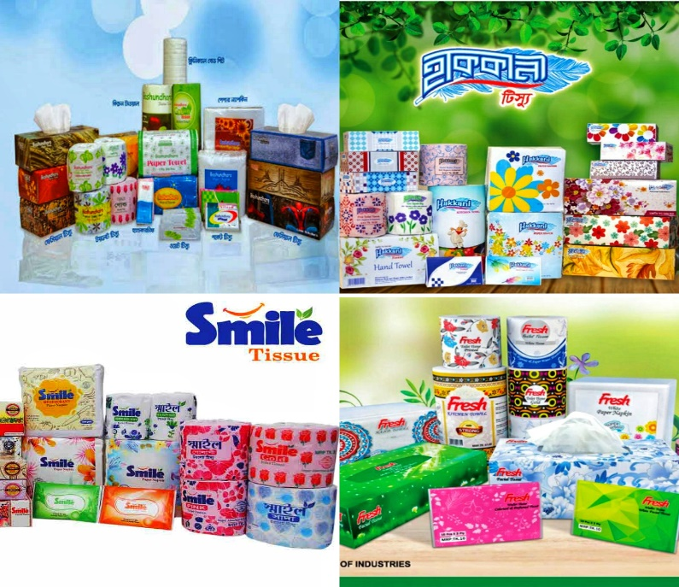
Analysis of Fast-moving Consumer Product Market: A Study on Tissue Industry in Bangladesh

Md. Abid Hasan Prodhan

This project report is submitted to the School of Businesses & Economics, United International University as a partial requirement for the fulfillment of Bachelor of Business Administration Degree
Analysis of Fast-moving Consumer Product Market: A Study on Tissue Industry in Bangladesh

Submitted By:
Md. Abid Hasan Prodhan
ID: 111 163 134
Dept: Bachelor of Business Administration

Supervised by:
Kawsar Ahmmed. PhD
Professor
School of Business and Economics
United International University

Date of Submission: 21/12/2021

Letter of Transmittal

21-Dec-21
Kawsar Ahmmed. PhD
Professor
School of Business and Economics
United International University
Subject: Submission of the project report on Analysis of Fast-moving Consumer Product Market: A Study on Tissue Industry in Bangladesh

Dear Sir,
With due respect, We wish to inform you that it was a matter of great pleasure as well as learning to prepare this report on the topic “Analysis of Fast-moving Consumer Product Market: A Study on Tissue Industry in Bangladesh” which was allotted to me as a huge need of completing the "Bachelor of Business Administration" program at United International University given by you.
I have endeavored my best to make them work as indicated by I assure you that this work was prepared in accordance with the requirements that you have guided and my measurement of comprehension and capacity. Also, I am fabulously keen on the open door that you offered me to convey my capacity and I am confident that this experience will help me in future for performing real life scenario.I vivaciously accept that you will like the work that I have done. Any challenges or imperfections may arise on account of my learning viewpoints. I will wholeheartedly perceive any proposal or evaluation concerning my report.
I have tried our best to avoid any deficiencies and I hope that will meet your expectations.
Best regards,Sincerely Yours,

-------------------------------
Md. Abid Hasan Prodhan
ID: 111 163 134

Acknowledgment
Firstly, I want to pay appreciation to the Almighty Allah for presenting to me this far and allowing me to complete this project. Then I would like to express my thanks to people who helped me to complete this project with their valuable time and efforts. It was not possible at all to prepare this project without the assistance and encouragement of those peoples.Except their enthusiastic administration, guidance, and support I may not have made progress in this project. I owed a lot of appreciation throughout the last month for the arrangement of this report.

The report title named " Analysis of Fast-moving Consumer Product Market: A Study on Tissue Industry in Bangladesh'' has been set up to satisfy the requirements of completing the Bachelor of Business Administration (BBA) program at the School of Business & Economics, United International University. I'm blessed that I have gotten earnest guidance, collaboration, and management from many individuals while setting up this report. In particular, I want to offer the heartiest gratitude to our honorable faculty "Kawsar Ahmmad, PhD" for helping me to set up this project, because without his commitment this report would not have been conceivable and would not have been an effective compilation. Nevertheless my sincere endeavors, there might be a few deficiencies in this report. I apologize for any unexpected errors.

Executive Summary
The main purpose of this study is to learn about effective marketing approaches. I have chosen the topic based on my knowledge and reasonable information gathered from the internet which is titled “Analysis of Fast-moving Consumer Product Market: A Study on Tissue Industry in Bangladesh”.
Tissue is one of the biggest and Fast-Moving Consumer Goods (FMCG) industries in Bangladesh. It is mostly consumed by households and restaurants for various needs.
The study is conducted based on several issues divided into some chapters including i) Overview - which includes the methods, limitations, and objectives of the report, ii) Industry overview- it includes the organizational overview of the tissue industry, iii) Literature Review- it includes attributes explanation, iv) Analysis & Findings and Discussion - here I analyzed the tissue market industries brand loyalty along with other attributes and also surveyed my report topic. Then according to the analysis, I tried to explain what is happening in the current tissue market, and based on these, some recommendations are forwarded along with the conclusion.

In brief, this project paper gives in-depth analysis and understanding of the current tissue market scenario of Bangladesh. Conclusively, I have attempted to apply my theoretical and valuable information on branding and its various angles to set up the report and to explain the issues regarding benefitting brand loyalty and how to improve it. After completing this whole report, it is clear that the whole tissue market is in a good condition though there are so many scopes for improvement.

Keywords: Tissue products, packaging, product quality, brand loyalty, customer satisfaction,

Contents
Letter of Transmittal 3
Acknowledgment 4
Executive Summary 5
Chapter -1 3
Introduction 3
Introduction 4
(1.1) Origin of the study: 4
(1.2) Objectives of the report: 5
(1.3) Methodology: 5
(1.4) Scope of the study: 5
(1.5) Limitation: 5
Chapter-2 7
“Tissue Industry: An Overview” 7
Introduction 8
(2.1) An Overview: Tissue Industry 8
Chapter – 3 10
Literature Review 10
(3.1) Brand Loyalty 11
Product Attributes 11
Product price 11
Retailers Recommendations 11
Sales Promotions 11
Media Advertisements 11
Packaging & family size 12
Product Quality 12
(3.2) A summary of some studies in FMCGs: 12
Chapter-4 14
Analysis, Findings and Recommendations 14
(4.1) Findings 15
Short Description: 15
(4.2) Recommendations: 32
(4.3) Conclusion: 34
References 36
(6.2) Appendix: 37
Survey Questionnaires 37

Chapter -1

Introduction

Introduction
Tissue papers are broadly utilized for freshness and hygiene purposes. Increasing consciousness concerning individual concern and cleanliness improves the acceptance of tissue paper-based sanitary items. Manufacturers are concentrating on the production of various colored and formed tissue products that draw customers to purchase these kinds of tissue products. Tissue paper making is absolutely the most challenging method within the paper industry, including very moderate base density paper being dehydrated in shorter than a second at heats up and operating over a series of creping, rewinding, and converting steps to create a ﬁnished packaged stock of tissue products. In the late '90s and the first decade of the '20s only the privileged personalities were using the tissue commodity at that age; furthermore that’s why that particular business remained bounded. Nevertheless, by significant advancement of our country, this business has grown extensively while consumed by the vast majority. And therefore to match with these market requirements many organizations built their own facility. Nowadays in the market there exist many local brands of tissue in the industry of Bangladesh. The application of tissue is curved among the peoples of the country, gratitude to the developing health awareness amongst the people. And along with that as the salary equilibrium of our nation is increasing, the market along with it is also rising. Though our income level has increased, there is a tremendous difference among several societies. As a consequence, tissue consumption is however moderate compared to its potential.

(1.1) Origin of the study:
For completing all the credits of the "Bachelor of Business Administration (BBA)" program, writing up this project report was entrusted to me by "Md. Kawsar Ahmmed" from UIU Business School, United International University. And, it has been developed from the data that I have collected from the internet and more information sent by my honorable faculty. After collecting all the necessary data and doing a survey on 105 people I have come up with a report on, “An overview of the tissue industry of Bangladesh" which report has been set up under the kind supervision of Academic Supervisor, Md. Kawsar Ahmmed from United International University .

(1.2) Objectives of the report:
The general objective of this research was to investigate the factors influencing brand loyalty in the tissue market of Bangladesh. The specific objectives were to determine whether brand performance, marketing strategies, customer satisfaction, and perceived product quality influence brand loyalty. A survey of one hundred and five respondents was used. The research adopted a descriptive design with qualitative and quantitative techniques. The study recommends future studies to be done on values, skills, and attitudes of customers on brand loyalty. Each work is finished with a target to accomplish. This report is made dependent on two center objectives, where the essential goals portray the need of breaking down all the data gathering them for the report for the learning of the “An Overview of the “Tissue Industry” in Bangladesh”. What's more, the Secondary goal means to gather significant data from potential ways giving a more clear view of the organization.

(1.3) Methodology:
In this entire report, a specific technique as an efficient approach has been followed to complete the report which is experienced sequentially followed by a few parts. Firstly, in the example of the assurance of the topic, I discussed it with my respectable administrator and lastly chose the subject “An overview of the Tissue industry Of Bangladesh”. The wellsprings of information were both essential and optional information chosen for the report. Fundamental information was gathered from online websites and also many were provided by the administrator. Then again other optional information was gathered for the most part from the organization's site and different sites too and from reading material, papers, and the organization's yearly reports and from some other recently done reports. Along these lines, it worked out together.

(1.4) Scope of the study:
Every one of my encounters all through these Academic years helped me a great deal to prepare this report regarding the tissue industry of Bangladesh. I found out about its condition, morals, societies, and various practices in the industry.

(1.5) Limitation:
Despite understanding the aggregate of the difficulties while setting up this report, I have put my whole effort into making my report fruitful. Other than all the aides and smooth work there were a few constraints and spines where I felt challenged in the finishing of the report. It was very challenging to accumulate all the data as some appeared to be reluctant to give the data and lacked enough data on the internet. Moreover, it was a slow process. Within this limited time, it was impossible to accumulate and understand a ton from closer about the whole overview of the tissue industry of a Country. So collectively, time limitation, absence of enough data because of limited private information available online wherever a portion of the significant limitation while doing the report.

Chapter-2

“Tissue Industry: An Overview”

Introduction
Tissue paper making is absolutely the most challenging method within the paper industry, including very moderate base density paper as below as 12gsm being created at rates as carrying out as 2000m/min; being dehydrated in shorter than a second at heats up to 625 degrees C and operating over a series of creping, rewinding, and converting steps to create a ﬁnished packaged stock of tissue products.

(2.1) An Overview: Tissue Industry
At the beginning of the '80s Kollel Industries Limited emerged as a converting ecosystem to begin as a tissue business enterprise by the Fay International which is based in the United Kingdom and entered it in the Bangladesh market. And later on, In the early '20s, Bashundhara Group started its primary manufacturing factory in Bangladesh .Meghna Pulp & Paper Mills Ltd along with East Asia Group, and several following groups. And at the end of 2017, the country already owns 10 tissue-producing companies on its own.
In the late '90s and the first decade of the '20s only the privileged personalities were using the tissue commodity at that age; furthermore that’s why that particular business remained bounded. Nevertheless, by significant advancement of our country, this business has grown extensively while consumed by the vast majority. And therefore to match with these market requirements many organizations built their own facility. On the other hand, few organizations are involved with converting systems through assembling tissue jumbo rolls from various sources which may be local or imported based upon trade taxes and many other scenario.After 2004 Private Brand continues expanding the business to enter the place of established brand name upon Bangladesh tissue industry. Presently Bangladesh possesses Thirteen Tissue Manufacturing Plant and likewise Fifteen tissue Regenerating Plant. From which are Bashundhara Tissue, Fresh Tissue, Hakkani Tissue, Superstar (SSG), Bangla Tissue, Kasper Tissue, Sonali, Jononi, Fay, Safe, Nice, and Planet tissue etc.
Nowadays in the market there exist many local brands of tissue in the industry of Bangladesh. Those local companies execute a powerful function to manufacture tissue paper in Bangladesh. The largest of the local producers are producing excellent attributes of Tissue paper objects by their brands. Where various kinds of tissue can be seen for example :Facial Tissue, Toilet Tissue, Kitchen Towel, Napkin Paper, wallet tissue.Clinical Bedsheet, Shower tissue, Hand clean tissue. shower cap tissue, Makeup remover Tissue, etc are frequently growing popular in Bangladesh.
In the tissue paper industry, the size of the market becomes multiplied within a decade in Bangladesh by the favor of urbanization, increasing per head earnings, moreover rising health consciousness amongst people. Several years back the market size of the tissue was reached at around Tk 500 crores from approximately Tk 250 crore in 2008, Which was according to data of Bashundhara Paper Mills, Who is the business leader in the tissue section along with the greatest amid exporters of the tissue commodity. The application of tissue is curved among the peoples of the country, gratitude to the developing health awareness amongst the people. And along with that as the salary equilibrium of our nation is increasing, the market along it is also rising.
Bangladesh annual tissue production capability held 84,000 tonnes in 2018-19, followed by 30,000 tonnes in 2016-17. As we possess vast possibilities in the tissue market along with its interest in the abroad markets is similarly increasing. So, every local tissue generator is extending product generating capability. On the other hand, in the domestic tissue market, Bashundhara's market percentage is approximately Seventy-five percent and some Five percent of tissue is shipped. The remaining requirement is fulfilled by Meghna Pulp & Paper Mills, East-Asia Group, including some different producers. Meghna Pulp's market percentage increased in the last six months.
Bangladesh becomes not solely self-reliant in the tissue section also exporting the tissue commodity to more further than Thirty nations where monthly 300-400 Metric tons together with the United Kingdom, Australia, Bahrain, The United States of Arab Emirates, China, India, including Bhutan. Regional generators have continued exporting tissue commodities since 2004. In the first two quarters of 2018-19, nearly 1,238 tonnes of tissue properties were shipped, bringing Tk 10.22 crore. The export profits stood at Tk 12.20 crore, Tk 10 crore, Tk 13.19 crore, and Tk 12.47 crore in the earlier times sequentially. Despite the increase in production including shipping, Bangladesh's per head tissue uses is yet quite moderate contrasted over its companion nations where Per capital tissue consumption was 4.1kg in Bangladesh in 2018, opposed to 13kg in India, 19kg in Sri Lanka,33kg in Vietnam, 7kg in Pakistan and 9kg in Cambodia. More concisely less than Ten percent of individuals consume tissue in Bangladesh. Though our income level has increased, there is a tremendous difference among several societies.As a consequence, tissue consumption is however moderate contrasted to its potential.

Chapter – 3

Literature Review

(3.1) Brand Loyalty
Brand loyalty is the persuaded corporation where customers connect to a particular product or brand. Customers who display brand loyalty are often dedicated to a product or brand, which is proved by their repetition of purchases despite rivals' attempts to attract them elsewhere. Organizations frequently pay great sums of cash in customer service and marketing to produce and sustain brand loyalty concerning an accepted product.

Product Attributes
Product attributes signify the distinguished other products. Attributes include something similar in size, appearance, flavoring, packaging type, and distinct characteristics that are related to the section. From a customer point of view, those attributes are something that determines the payment factors and controls the final buying conclusion.

Product price
Product Pricing can be defined as building value for a product. Most of the time product price takes place while a company determines how much a consumer needs to repay toward a product. The product cost that's placed through the pricing process is what the customer will spend for this product.

Retailers Recommendations
For Retailers, There is always some essential way to progress. Which is, They need to develop sales and decrease expenses to increase profitability. Both of the purposes are identical but how they accomplish specific milestones may differ. Retailer Recommendation plays a very important role here. By the retailer recommendation, customers, most of the time buy their preferred things of a particular brand which improves the sales of the brand as well as increase the profitability of the retailer.

Sales Promotions
Sales Promotion may be defined as a method that makes short-term promotions to improve the demand also the following sellouts for that product. The sales promotions are intended to target and increase buying behavior to accomplish specific purposes.

Media Advertisements
Media Advertising is a mechanism through which an advertisement is passed to the people. It may convey information, stories, or details about the product that is meant to be advertised. It is a very communicative approach to influence the customers and invite them to purchase the product. Advertising can actually be defined as a parallel universe because it is the most influential mechanism through which anything in our brain, concepts, and thoughts, can be imagined and introduced with the environment, and most importantly to the target customers. If the appropriate style of advertising is determined, anything can be sold easily.

Packaging & family size
Packaging is the process of implanting or defending products for delivery, selling, and usage. Packaging also indicates the method of designing and manufacturing products. Where family size may be indicated to describe the entire number of people holding a family unit, where it may count as follows like quantities of kids and quantities of grown-ups in the family. This difference is necessary as family size may be a crucial element to the consumption of a particular product.

Product Quality
Product Quality is the combination of all the features and attributes of a product that provide its capability to satisfy the customer's demands and conditions. This basically means the capacity of the product to accomplish whatever the end-user desires and looks in return for the price they pay. Quality is actually the promise made by the producer to the customer. A product is recognized as a quality product totally while it satisfies those several standards concerning its functioning for the customer.

(3.2) A summary of some studies in FMCGs:
1. To fight with these complications the marketers need to craft creative marketing strategies for which marketer must explore the perceptions of the customers who look for parameters in selecting any brand of FMCG.
2. Product education, packaging, availability, affordability, and quality of products are the most important variables for customers while purchasing FMCG.
3. FMCGs consumption is merely driven by some factors, like feelings, motivation, lifestyle, opinions, culture, personality, social class, reference group, family, opinion leaders, culture/belief.
4. Social class, reference group, family have positive and significant impact on Company fast moving products; while culture/belief negative and significant impact on turnover of fast moving goods.
5. Four factors is important which are:- manufacturers production standard, managerial efficiency, promotional capability, and customer solution capability were liable on retailer’s behalf in the FMCG sector in Bangladesh
6. Factors like destination marketing with reference to feature, uniqueness, appearance, and trademark as a weight for advertising and above all destination development in stakeholders collaboration perspective work well.
7. Motivation and attitudes have positive and significant impact on turnover of fast moving goods while personality and learning have a negative and significant impact on turnover of fast moving goods.
8. FMCG companies are not only selling their product in the market but also adopting a 360-degree strategy to gain customers and market share.
9. New entrants in the FMCG market can select Television to create brand awareness among the consumer and maintain with Quality product
10. Promotions and offers have considerable impact on larger households and young adults to buy FMCG products. At the same time where they are buying generic products, they nourish aspiration value for branded products which remains restricted due to lack of money.
11. Retailers Recommendations,Sales Promotion, Product Attribute, LifeStyle and Product Quality plays a significant role in the FMCGs purchase decision in rural areas of Bangladesh.
12. By educating the retailers or shopkeepers more as the rural consumers ask retailers recommendations while purchasing any FMCG brands due to their low level of education and brand awareness can increase the sales.

Chapter-4

Analysis, Findings and Recommendations

(4.1) Findings
To get An Overview of the “Tissue Industry” in Bangladesh, twenty-two after-mentioned variables occurred beneath eight explicit sections. At that very moment, there was an attempt to summarise an understanding of the circumstances along with tissue market perception about the future and recent scale of usage.

Short Description:
Above 105 respondents answered through an online survey. The numbers of the respondents participating in the study were men 56.6% and 4o.6% were women and another 2.8% prefer not to say.Of these, 77.2% between 16-25 years of old, 22.0% between 26-36 years of old.Regarding family size the vast quantity goes to the small or nuclear family members ,there can be viewed so less amount of large or joint family members living now a days.
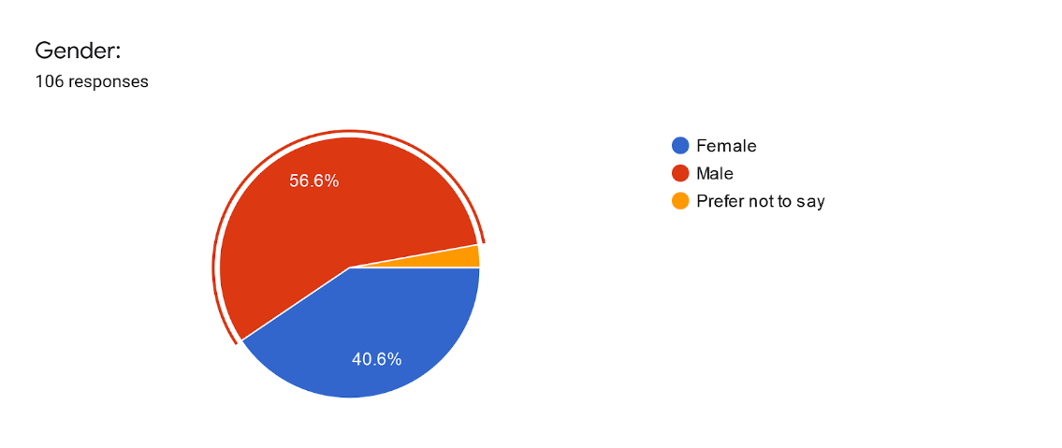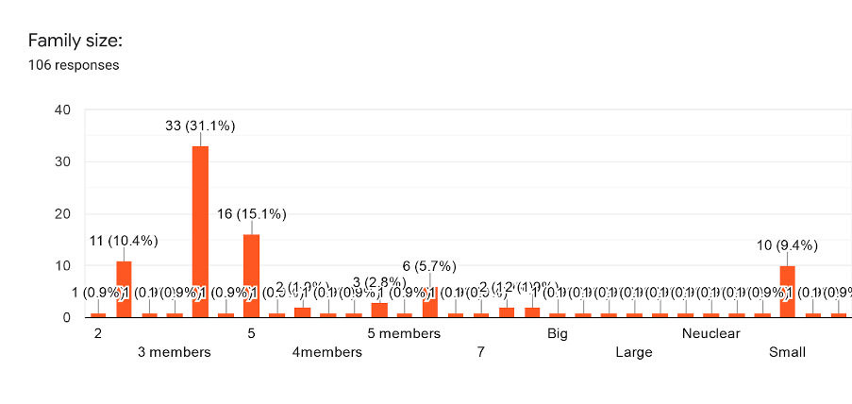

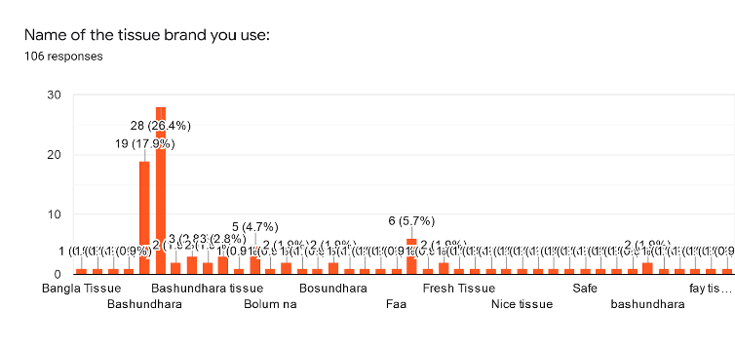

Brand Loyalty: I always buy this tissue brand
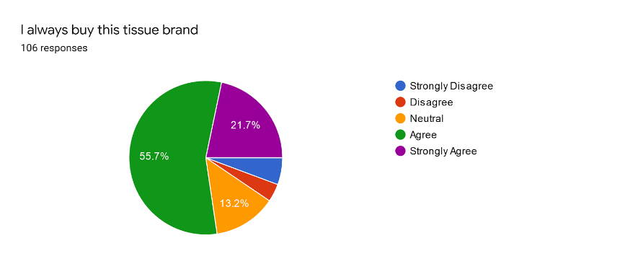
In presence of other tissue brands, I like this brand most
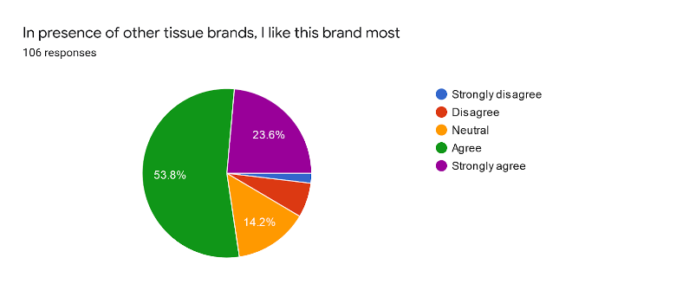
when I need to buy tissue, I buy this brand
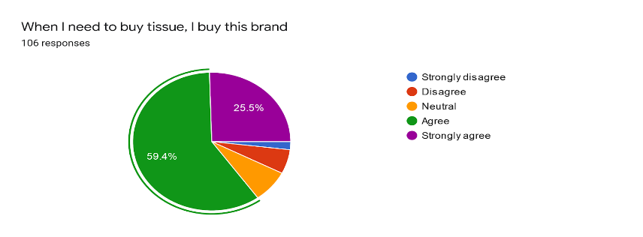
Product Attributes: Size of this tissue brand is suitable for me
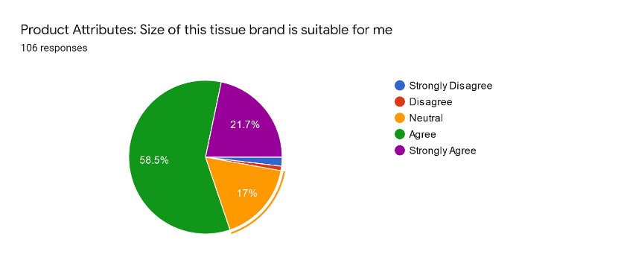

This tissue brand is suitable to meet one’s requirement
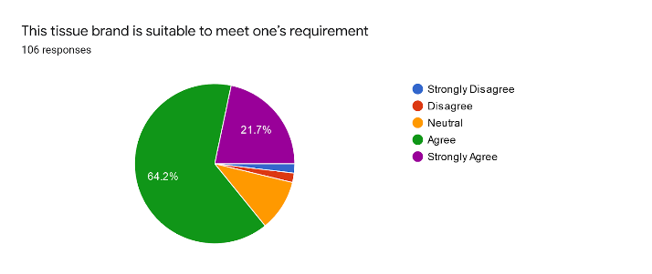
Good fragrance attracts people to buy this tissue brand
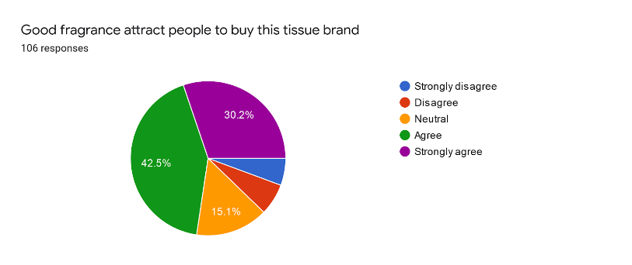
Product price: Price of this tissue brand is reasonable for me
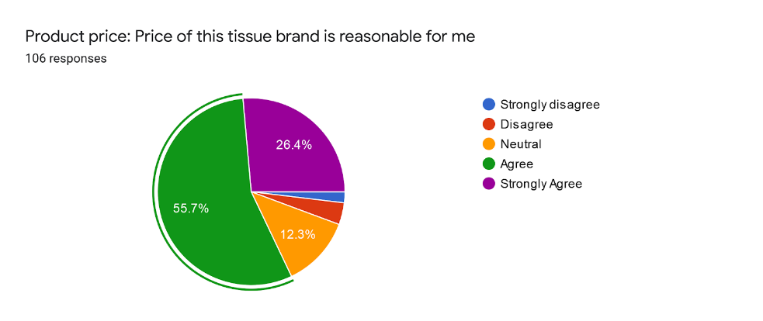
Price of this tissue brand is value for money
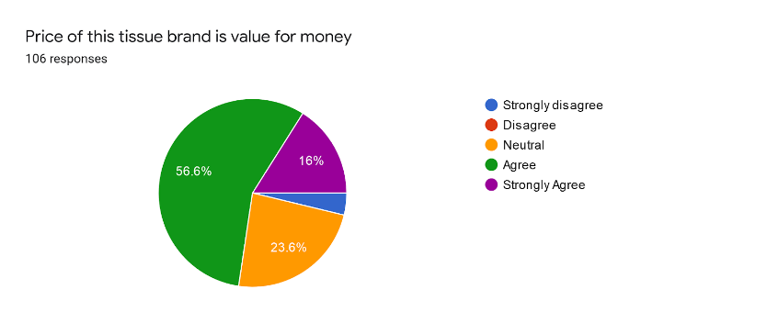
Price of this tissue brand is affordable
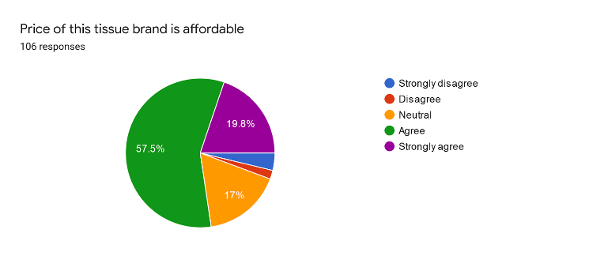
Retailers Recommendations: Retailer recommends this tissue brand if consumer asks for
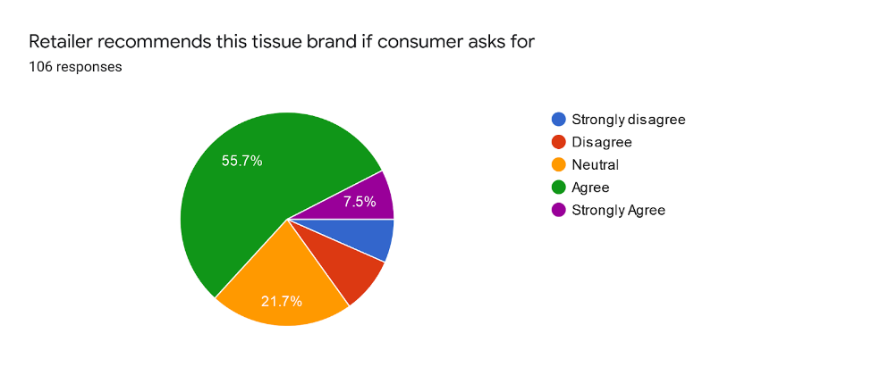
Friends and other recommend this tissue brand if consumer ask for
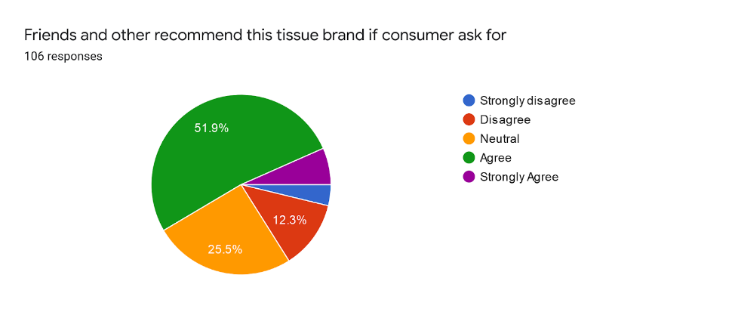
This tissue brand is available everywhere
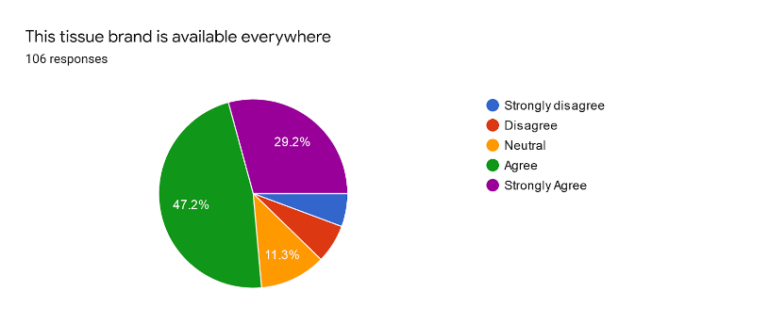

Sales Promotions: This tissue brand adds new ingredients from time to time
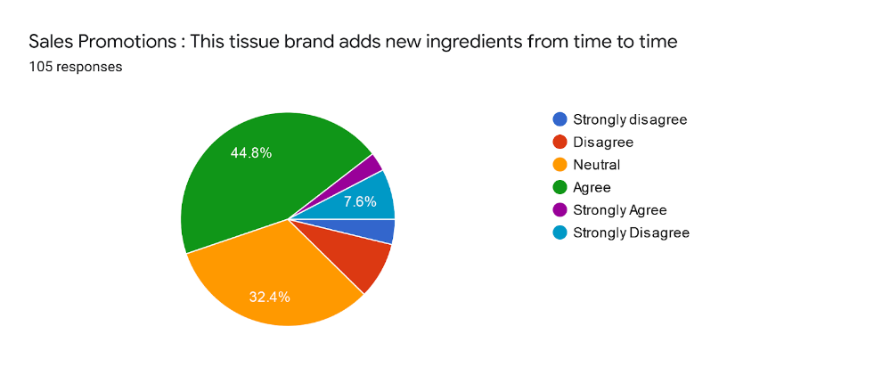
This tissue brand uses billboards and newspaper to promote
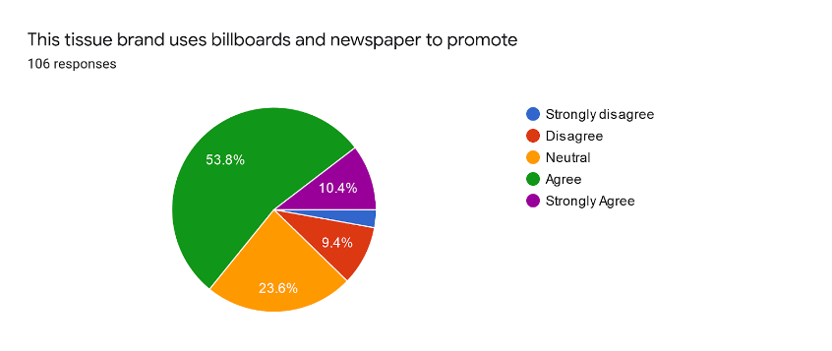
This tissue brand uses discounts and offers to attract consumer
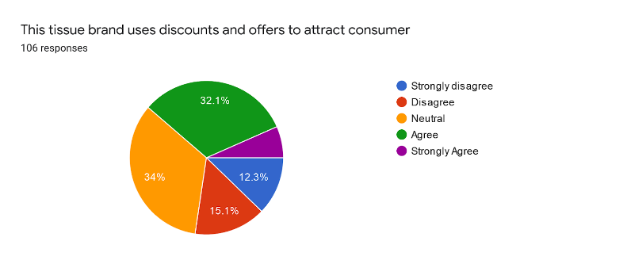

Media Advertisements: This tissue brand uses radio advertisements for promotion
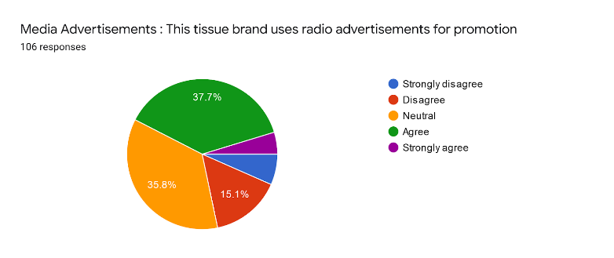
This tissue brand uses celebrity endorsement for promotion
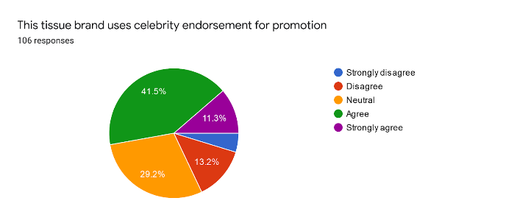
This tissue brand uses TV advertisements
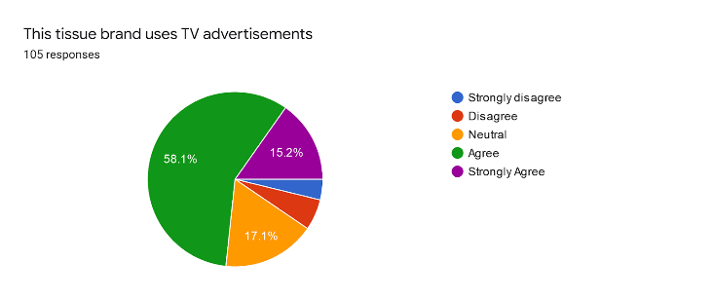
Packaging & family size: This tissue brand markets attractive family size
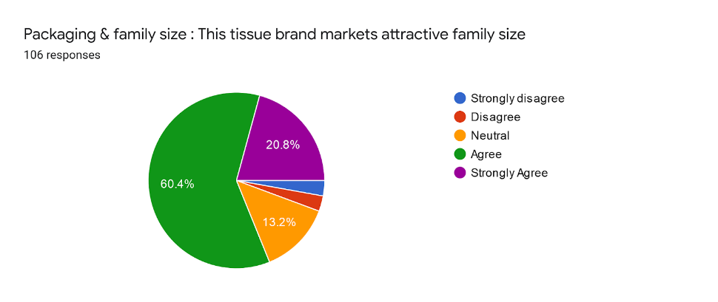
Packaging of this tissue brand is attractive for me
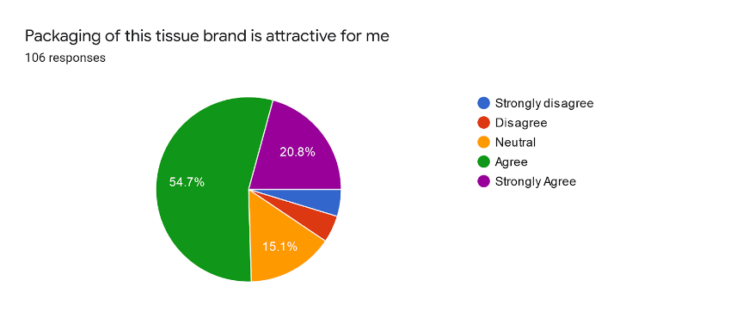
Product Quality: This tissue brand maintains high quality
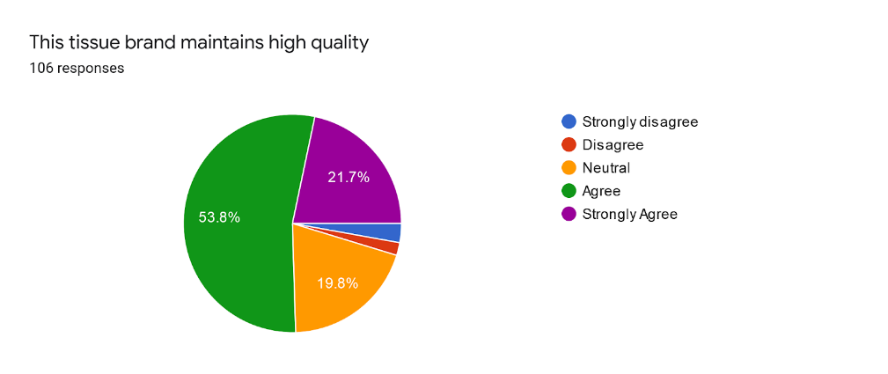
This tissue brand does not use any ingredient(s) that goes against consumers’ believe

Brand loyalty is the allegiance that a customer displays towards a particular brand and that might be shown through renewing the shopping in a proper cycle of time. Sometimes brand loyalty also can be reflected in such a way by telling the people around that particular brand where there are so many constraints and advertisements produced through the different competing brands. Mostly brand loyalty depends on the customer’s active responses over the acceptance and usage of a product which may translate as customer satisfaction. It is already very clear that through brand loyalty customers can communicate their satisfaction of the product they buy and use.
Here the average of the variables of the Brand loyalty has been scored around 3.92 Which indicates that the current brand loyalty of the tissue market in Bangladesh is positive as because 4 indicates to the Agree and 5 to the Strongly Agree.As the average score from the 105 participants has been 3.92 thus we can say that it is in a near of agreed axis.Though this is not enough and more attributes have to enforced to increase the Brand loyalty. But from the average it can be established that most of the customers always buy from a preferred tissue brand and In presence of other tissue brands, they like their brand most.It also indicates that when they need to buy tissue they buy that particular brand unhesitantly.From the chart it can be easily seen that most of the spikes for the all three variables are around the four number circle where very few passes the five number circle though few were in the one,two and three number circles.
From the brand loyalty chart we can see that most of the spikes are passing or touching the number four axis bar which indicates that most of the answer were positive though few answer were from disagree/Strongly disagree and neutral bar still the positivity is greater here.So from the variable of average chart it can prove that brand loyalty holds a great deal here in the tissue market industry of Bangladesh though more improvements also needed.

Relationship between Product Attributes and Brand Loyalty:
Product Attributes have a powerful influence toward brand loyalty. Physical attributes like size by which it is determined that how much I have paid and how much in size I had got whether it satisfies my vision or not, appearance reflects the fact that when I see the product or purchase the product whether it is appealing to me or not, whether I got interested or not after seeing it which ultimately brought brand loyalty to that particular brand because I love the appearance of that product, flavoring is also very crucial to bring brand loyalty to a particular brand because as a human being we all are attracted to various kind of good flavors/fragrance, packaging type, and distinct characteristics have a more effective association with brand loyalty because some time exceed all the previous characteristics by only distinct characteristics a product can bring all the brand loyalty from the customers because of some specials features which most of the customers search in term of their monetary value they spend for that particular product by which customer satisfaction easily can be gained which holds a interfering connection among product attributes and brand loyalty and by which it can easily proves that how valuable products attributes to keep up the customer satisfaction implies for the company’s involvement among its customer and for maintaining their Brand loyalty.
Here the average of the variables of the Products Attributes has been scored around 3.95 which has also scored the highest among the all variables.From the average it can be said that product attributes of the tissue market is positive as the average tends to go to the side of agree which means customers are much more satisfied with the tissue products attributes. So it can easily emphasis that the size of the preferred tissue brand is suitable for many of the customers and its easily is suitable to meet one’s requirement also those brands come up with a good fragrance to attract people which lead to buy those tissue brand undoubtedly.
From the chart it can be easily seen that half of the spikes for the all three variables are around the four number circle where a great number touch the five number circle though few were in the one,two and three number circles.

Relationship between Product prices and Brand Loyalty:
Nowadays as the advertising cost and raw materials price has been dramatically increased so the marketers are increasingly turning to pricing and price-related promotions as a means of influencing purchase decisions about the consumers.Thus understanding how consumers respond to price is very important at the same time they also believe that consumer segments will differ in their sensitivity to price changes. Loyalty holds a significant distinguishing variable and a fundamental component of a brand loyalty.Most of the time consumers who are loyal to a brand will be insensitive to the brand’s price. Sometimes it also is called that relationship between brand loyalty and product price sensitivity is repetitious or attached but most of the time it depends on the purchase decision. But sometimes it can be reasoned like price always may not hold influential involvement among brand loyalty.Though when a brand can get loyalty from various others aspect of the product then the price does not initiate the great trigger rather customer doesn’t look at the price.So brand loyalty and price relationship depends on the factors what type of products you are offering and still how much you are charging them for that particular product and whether it surplus the price range of this related field also a matter of consideration.So the relationship between Product prices and brand loyalty is very complicated. Sometimes it is dependable and sometimes undependable which actually matters, though it can be said that it has a positive relationship with the price and Brand Loyalty.
Here the average of the variables of the Products price has been scored around 3.90. By which it can be shown that product price of the tissue market is almost near positive to the using customers as the average score has been gone to the side of agree axis which means Price of the tissue brands are reasonable for the customers where the customers also thinks that their preferred brand price of the tissue is also carry value for money and most importantly they think that the price of those tissue brands are affordable.
From the chart we can see that most of the spikes for the all three variables are around the four number circle where a fews were in the numbers of five circles .Here we can observe that very fews were in the one,two and three number circles.

Relationship between Retailers Recommendations and Brand Loyalty:
Brand loyalty is a terminology applied to represent the tendency that customers must attach among the product displaying signs they know and believe which explains continuous selling and improved profitability. By the retailer recommendation customers most of the time buy their preferred things of a particular brand which improves the sales of the brand as well as increases the profitability of the retailer.When a customer come to the retailer and ask for a product that retailer recommend a particular brand then that brand may always lies in the customers heart also when someone near of him like friends,colleagues or family members ask that person which brand to buy then that person will also recommend that particular brands which was retailer recommendation to him.So it can be easily state that there is a very crucial relationship between Retailers Recommendations and Brand Loyalty.When the retailer recommendation increase automatically the brand loyalty goes on a positive axis.

Here the average of the variables of the Retailers Recommendations has been scored around 3.61.By which it can be easily state that retailers recommendations of the tissue market is in near of the positive trend rather it is pretty much in middle of the positive and neutral axis where customers are not that much aware of the retailers recommendations so the average score has been gone to the middle of agree and neutral axis. Which indicates that retailer does not recommends tissue brand that much if consumer asks for also they don’t suggest actively to the friends and other this tissue brand if consumer ask for and sometimes the preferred tissue brand is not available everywhere thus they can not buy frequently.
From the chart we can see that most of the spikes for the all three variables are around the four number circle where a fews were in the numbers of five circles .Here we can observe that very fews were in the one,two and three number circles.

Relationship between Sales Promotion and Brand Loyalty:
Sales promotions can act as a reinforcing tool or decrease the behavior of brand loyalty. Customers usually prefer promotion, where their response is likely as a reward to purchase an unspecified brand. So here Sales promotions function as a last-minute influencing medium to help the customer up until that time of buying and by which it can positively impact brand loyalty. There will always be loyalty to particular brands and that trades promotions which may provide ongoing prosperity for marketing purposes if there is a proper knowledge of the customer. So it has been already stated that sales promotion affects customer brand loyalty where it functions as an auxiliary method designed to arouse immediate response. So here Sales promotion works as an influencer which relationship with brand loyalty is very important because when a brand will reduce their sales promotion it will automatically lower the brand loyalty of that particular brand whereas When The sales promotion will be in a broader quantity it will automatically increase the number of brand loyalty.

Here the average of the variables of the Sales Promotion has been scored around 3.28 by which it can be stated that the current tissue companies are not adopting sales promotion for that the variable average is 3.28 which is almost near to neutral to the participants that means most of the customer of the tissue markets are unknown to the fact of sales promotion by which brand loyalty fails from this aspects.So in this aspects the tissue brands does not adds new ingredients that much from time to time though they uses billboards and newspaper to promote which is clearly not enough to grab the proper attention and finally tissue brands does not uses discounts and offers frequently to attract consumer and increase brand loyalty.

From the below chart we can see that most of the spikes for the all three variables hits the number three and two circle where also can been seen that fews were in the numbers four circle but still it does not improve the situation.Much attention needed in this criteria.

Relationship between Media Advertising and Brand Loyalty:
Nowadays, analyzing the aggressive circumstances of markets, earning loyalty through branding is one of the essential scopes for Companies who develop their brand and create a position of the brand in the memories of customers. Which will eventually develop trustworthy importance to the product and will be acknowledged as a business identification. Media Advertising has a concrete influence on brand loyalty. Because this customer is receiving extra awareness of representation, quality, and attributes that are associated with the brand name. Whereas customers are also receiving about the equilibrium between low price and product quality. Here this understanding has developed through media advertisements between the customers and the brand, furthermore, if the frequency of this relationship is powerful then eventually appears to heighten the degree of loyalty for the brand. Brands always tend to decide what type of media advertisements should be aired as it performs an essential function in customer preference, and brands are analyzing methods of whence to attract customers and how to sustain their concentration which later on creates awareness and fastens constant positive vision in the memories of customers and magnify brand loyalty through this Media Advertising. Media Advertising is the simplest method of interacting and growing Brand Loyalty and it appears while the customers turn into fully satisfied. So from the above discussion it can be easily said that media advertising is an essential factor of brand loyalty.

Here the average of the variables of the Media Advertisements has been scored around 3.45 which indicates that it is .45 less in value from neutral and .55 shorter from the Agreed axis which says that tissue industry is lacking of proper media advertisements.Here tissue brands uses radio advertisements for promotion but very few tissue brands uses celebrity endorsement for promotion though most of them uses TV advertisements to promote their desired tissue product and reach to their desired customers.

Here from the chart it can be seen that few passes the agree axis and tried to touch the Strongly agree bar where also a great numbers of response were at agree bar but here in this variables most of the responses are existing at three and two which are Neutral and Disagree So the scope and efforts of Media advertisements must have to improve so that they can score more positively and increase the brand loyalty.

Relationship between Packaging & family size and Brand Loyalty:
Packaging is a significant mechanism to preserve, defend and transfer the product and it additionally supports the product as a convenient and satisfactory medium of promoting. Packaging is the most crucial component of the product and also functions as a selling advertisement. To define the relationship between packaging and brand loyalty we must understand that packaging holds an important impression on brand loyalty. A graded packaging will appear in reducing price and later it will utilize to improve the consumption of products. Packaging magnifies happiness and stimulation and exhibits that packaging design holds an important influence on customer engagement in phases of a brand. Packaging is the origin of marketing that accommodates forming a connection between usage and ownership. Packaging form applied to advertise the product and distinguish the product from its opponents thus packaging influences customer brand loyalty. Along with that family size produced a positive connection with brand loyalty.

Here the average of the variables of the Packaging & family size has been scored around 3.88 which shows that packaging & family size is in a positive manner to its usage customers. Packaging of the tissue brands are attractive for the consuming customers and also the tissue brands market attractive family size products for which they have got a positive score in the brand loyalty.
From the Packaging & family size chart it can be observed that most of the spikes are on the number four circle bar also many answer are on the number five circle which which indicates that most of the answer were positive though very few answer were from disagree/Strongly disagree and neutral bar still the positivity is greater here.So from the variable of average chart it can prove that Packaging & family size holds a great deal of brand loyalty here in the tissue market industry of Bangladesh though more improvements also needed.

Relationship between Product Quality and Brand Loyalty:
There is a solid link between product quality including consumer satisfaction wherever the product holds the great quality is positively parallelled along with customer satisfaction which later on turns into brand loyalty. Product quality is a significant feature for the company's survival. Quality can affect customers to build powerful associations with companies by establishing customer expectancies correctly. Brand loyalty can be described as behavioral loyalty which is evaluated by buying behavior who nevertheless proactively buying and later on continue making purchases.Another attitudinal loyalty is evaluated by customer attitudes through the brand where customers hold a great choice and dedication to that particular brand. Loyalty is a mixture of customer satisfaction and customer's continued purchase behavior. Customers who are pleased with products may improve their approaches to promote the preferred brand which may include delivering concrete comments regarding products, recommending the brand to others, remaining loyal to the brand products, and spending for products at a premium cost.
Here the average of the variables of the product quality has been scored around 3.75.By which it can be observed that product quality of the tissue market is almost near positive to the using customers as the average score has gone to the side of agree circle line which was four. It means that the tissue brands maintains high quality and always tries to upto the mark and they never use any ingredients that goes against consumers’ belief or health.Thats why the variable average score was positive to the brand loyalty.

From the chart we can see that most of the spikes for the all three variables are around the four number circle where only a fews were in the numbers of five circle .Also we can observe that fews were in the one,two and three number cirles.Here in this attributes their is a scope of improvement so that the answer of the user reach up to the brand loyalty axis and more positively.

(4.2) Recommendations:

To deal with the issues that tissue companies are facing at various levels, here are some recommendations to change a few of their policies and thrash the situation and make upgrades in increasing brand loyalty and other needed aspects.

Brand loyalty in the current tissue market of Bangladesh is positive .Many of the customers buys from a preferred tissue brand and In presence of other tissue brands, they like their brand most.But still it maybe a reason of the unavailability of many tissue brands everywhere.Or maybe even biasness for a particular brand because of using the same brand for very long.As a result of that many customers may not want to tryout new or any other existing brand.So brands should established a proper supply system by which they can ensure that their product is getting every corner of the country so those are available to the people who uses them

Though the products attributes of the tissue market are positive .But still they need to focus on some criteria .They should try to bring out a more designed packaging system so they attract the customers along with a very good fragrance which will give the surety of customers satisfactions with the tissue products attributes.

Due to products price of the tissue brands are reasonable for the customers where the customers also thinks that their preferred brand price of the tissue is also carry value for money and most importantly they think that the price of those tissue brands are affordable sp companies don’t have to worry here rather they should focus on the Sales Promotion where most of the customer of the tissue markets are unknown to the fact of sales promotion by which brand loyalty fails from this aspects.So in this aspects the tissue brands in the light of promotion and branding they can adds new ingredients in a broader value from time to promote and increase the brands. Tissue brands also may use discounts and offers frequently to attract consumers and increase brand loyalty.

The Retailers Recommendations of the current tissue market of Bangladesh customers are not that much aware of the retailers recommendations which means if consumer asks for a good tissue brand they don’t suggest actively to the consumers.So here the tissue brands are suggested that they can cut a deal with the retailer so the retailer easily suggest the brands.

Media Advertisements is lacking of proper advertisements in the current tissue market sector which means all the brands are not aware of the benefit they can from media advertisement.Though tissue brands uses radio advertisements for promotion and very few tissue brands uses celebrity endorsement for promotion.So here all the existing brands should pay more attention to the media advertisement.
Product quality of the tissue brands maintains high quality and always tries to upto the mark and they never use any ingredients that goes against consumers’ belief or health.But in spite of this their is also a very broader scope of improvise because in future the market of whole industry will be much more larger so many new competition may arise so more powerful branding with more good product quality must be bring on to become the market leader of the tissue industry.
In the light of above discussions brands at first can apply to upgrade the packaging which may be more attractive along with perfumed flavored. Next, they must focus on their advertisement sectors as most of the users are not completely aware of all the brands which are currently available in Bangladesh.Various kinds of advertisements activities are available in the existing market.

The digitalized reviewing technique can also work as marketing by which many more will get to know about the brand along with its pros and cons. Whether that brand is value for money or not will come at daylight by this system which will ensure customer satisfaction and by which brand loyalty automatically will follow.

Finally and most importantly Brands are sometimes can actively can join on the social activities where they maybe distribute free tissues to the poor or to the girls or maybe to the needed one.They can set up a promotional camp along with social activities or even sometimes can organize games for the childrens which also will increase the brand name as social activities is on of the most crucial things now a days to the companies to get recognition from the mass people.

(4.3) Conclusion:

The growing awareness of the citizens to maintain cleanliness and individual hygiene broadly within the urban areas is raising the requirement for tissue papers in public areas.A fastest-growing country like Bangladesh the customer market of tissue paper is undergoing more extensive exposure of interest which eventually enhances the requirement for tissue paper.Therefore,gradually increasing the demand of tissue paper.In comparison of the current market trend and 10 years back market trend there is a drastically change of the demand also now so many brands are also present in the market. Under these circumstance various types of tissues are being offered along with various types which is basically a good thing for the consumers.Similarly all the tissue brands are competing with each other by offering the best product at the best price and because of huge and broader market scape they also making profit by their tissue product.Data suggest that in future there will be more wider market for the tissue paper where many more types and quality will be required.From the survey analysis there is very broader scope of advancement along with promotional improvement. In Contrast Bangladesh as a developing country has grown as a huge market of tissue industry day by day and is currently making employment of many peoples so more closure from Government and private sector is much more needed.

References
Kotler, Philip, Jha Mithileswar et al. (2013) – Marketing Management (14th edition), Dorling Kindersley (India) Pvt. Ltd on license from Pearson Education SEA.
Schiffman, Leon G, Kanuk, Leslie Lazar and Kumar, S. Ramesh (2010) – Consumer Behavior (10 ^{th} edition) Dorling Kindersley Pvt. Ltd (India) on license from Pearson Education SEA.
https://www.thedailystar.net/business/news/tissue-paper-market-doubles-decade-1733473?fbclid=IwAR2EbZd6HEDm3bEekySFgYiuUCgPMWHL5OPkxEmB0Mo3UQkIK8KvijmdBFY
https://www.studocu.com/row/document/north-south-university/strategic-management/bosundhara-group-strategic-management/8258842
https://www.listofcompaniesin.com/bangladesh/tissue/
http://www.slideshare.net/vickybahl/valcon-window-tissue-paper-industry
https://www.studocu.com/row/document/north-south-university/strategic-management/bosundhara-group-strategic-management/8258842
http://www.assignmentpoint.com/business/marketing-business/presentation-on-bashundhara-tissue.html
http://dainikbazar.com.bd/product-category/beauty-health/personal-care/tissue-wipes/

(6.2) Appendix:

Survey Questionnaires

Rating options were:
1. Strongly disagree 2. Disagree 3.Neutral 4. Agree 5.Strongly Agree
Brand Loyalty
I always buy this tissue brand
In presence of other tissue brands, I like this brand most
When I need to buy tissue, I buy this brand

Product Attributes
Size of this tissue brand is suitable for me
This tissue brand is suitable to meet one’s requirement
Good fragrance attract people to buy this tissue brand
Product price
Price of this tissue brand is reasonable for me
Price of this tissue brand is value for money
Price of this tissue brand is affordable
Retailers Recommendations
Retailer recommends this tissue brand if consumer asks for
Friends and other recommend this tissue brand if consumer ask for
This tissue brand is available everywhere

Sales Promotions
This tissue brand adds new ingredients from time to time
This tissue brand uses billboards and newspaper to promote
This tissue brand uses discounts and offers to attract consumer
Media Advertisements
This tissue brand uses radio advertisements for promotion
This tissue brand uses celebrity endorsement for promotion
This tissue brand uses TV advertisements
Packaging & family size
This tissue brand markets attractive family size
Packaging of this tissue brand is attractive for me

Product Quality
This tissue brand maintains high quality
This tissue brand does not use any ingredient(s) that goes against consumers’ believe

