Internship Report
on
“Improving Employees KSA (Knowledge, Skills & Abilities) Through Training & Development”
Submitted to: MD. Kazimul Hoque Assistant Professor
United International University

Submitted by:

Munia Akter

ID: 111 161 282



School of Business and Economics

United International University

Date of Submission: January 3, 2023

Improving Employees KSA (Knowledge, Skills & Abilities) Through Training & Development

LETTER OF TRANSMITTAL

January 3, 2023
MD. Kazimul Hoque Assistant Professor
United International University

Subject: Submission of Internship Report on “Improving Employees KSA (Knowledge, Skills & Abilities) Through Training & Development”.

Dear Sir,

With due respect I am informing you that, I completed internship at Bangladesh Development Bank Limited and also prepared an internship report on the topic “Improving Employees KSA (Knowledge, Skills & Abilities) Through Training & Development”. I made proper analysis regarding the Human Resource of Bangladesh Development Bank Limited and its effectiveness in improving the knowledge, skills & abilities of the employees through training & development. I am willing to submit my report now. I have collected both primary and secondary data to make my report unique. The primary data of the report are collected by conducting personal interview with the company’s staffs and the secondary data of the report are collected from the official website and other websites, annual report and articles.
Finally, I have successfully prepared my internship report with my greatest effort and I expect that you will much satisfied to read my report. I, therefore hope that you would kind enough to grant my internship report. I appreciate your kind co-operation.

Sincerely yours, Munia Akter ID: 111 161 282

DECLARATION OF THE STUDENT

I, Munia Akter, declare that I have prepared the internship report based on the topic “Improving Employees KSA (Knowledge, Skills & Abilites) Through Training & Development”. I have made proper analysis regarding the Bangladesh Development Bank Limited (BDBL) and its Human Resources for preparing this report. I have learnt lots of things by preparing this report.
I have collected the primary and secondary data for the report. I ensure that this report is nicely prepared and it is a unique report of BBA program.

ACKNOWLEDGEMENT

Firstly, I would like to convey my heartiest gratitude to my internship supervisor Md. Kazimul Hoque, Assistant Professor, Department of Human Resource Management, United International University for helping me through the duration of my internship and serving as a mentor who incredibly understands. I am thankful for his assistance, guidance, scheduled meetings, and advice, all of which inspired me and helped me greatly in finishing my report.
I also want to thank Ishrat Jahan, Principle Officer of Bangladesh Development Bank and the entire Bangladesh Development Bank’s service operation team for providing me with such knowledge and support throughout my internship period.
Lastly, I would like to show gratitude to everyone who has offered me advice, support, and suggestions. Without all of these, I would not be able to prepare this report.

EXECUTIVE SUMMARY

Bangladesh Development Bank Limited (BDBL) is a state-owned commercial bank which is basically a public limited company incorporated on 16 November, 2009. The bank is fully owned by the Government of Bangladesh. The bank is established by the combination of the former BSB and BSRS. The bank has a high loan default rate in Bangladesh. At present, the bank has an extraordinary value and high profitability.
Bangladesh Development Bank Limited (BDBL) is a well renowned bank organization which has a greater value and has retained huge number of clients with their extraordinary banking services. The bank started its journey with some few products and services in 2009, but at present the bank has plenty of products and services by which they are running their business effectively. After starting business, initially the revenue and profit of the organization were very low. But gradually the rate of profit increased in every year.
The introduction part of the report is given in Chapter 1. The Chapter 2 introduces the literature review. The company profile is given in Chapter 3 where vision, mission, products & services, organogram etc. of the bank are provided. The Chapter 4 represents the analysis and findings part where the HR practices of the bank as well as the effectiveness of training and development in improving the employees' skills, knowledge & abilities are discussed elaborately. Some findings & observations of the bank are also provided in this chapter. Finally, in the last chapter, recommendations and conclusion are provided.
The Human Resource is a very significant factor in any business organization which influences highly on the achievement of the business goal. The HR of the Bangladesh Development Bank is very potential and effective which has a significant influence on the profitability of the organization. The staffs of the HR department are well knowledgeable and expert and able to maintain all of the HR functions efficiently. They provide effective and potential training to the organizational employees regarding the banking tasks and operations. They provide training for a long term to the employees in order to improve their skills, knowledge & abilities. After taking proper training from the organization, the employees become able to work efficiently toward the business objectives.
Bangladesh Development Bank Limited has a strong reputation currently and generates high revenue and profit in every year. The growth rate of the bank is improving gradually. The government is planning to invest more money in the organization and extend the business for it's future growth and development.

TABLE OF CONTENTS

Contents

LETTER OF TRANSMITTAL iii
DECLARATION OF THE STUDENT iv
ACKNOWLEDGEMENT v
EXECUTIVE SUMMARY vi
TABLE OF CONTENTS vii
CHAPTER 1: INTRODUCTION 1
  - Background of the Report 1
  - Objectives of the Report 1
    - Primary Objective 1
    - Secondary Objective 1
  - Scope & Limitations of the Report 2
    - Scope 2
    - Limitations 2
  - Methodology of the Report 2
    - Types of Data 2
    - Data Collection Process 3
    - Sample Size 3
    - Sampling Techniques 3
    - Area and Time of Research 3
CHAPTER 2: LITERATURE REVIEW 4
CHAPTER 3: COMPANY PROFILE 6
  - Vision 6
  - Mission 6
  - Strategic Priority 7
  - Products & Services 7
  - Organogram 8
  - Board of Directors 9
CHAPTER 4: ANALYSIS & FINDINGS 12
  - HR Practices of Bangladesh Development Bank 12
    - Roles of HR of BDBL 12
    - HRM Model of BDBL 13
  - Improving Employees KSA (Knowledge, Skills, Abilities) through Training & Development 14
  - Findings 18
CHAPTER 5: RECOMMENDATIONS & CONCLUSION 20
  - Recommendations 20
  - Conclusion 21
REFERENCES 23

CHAPTER 1: INTRODUCTION

Background of the Report

This internship report is on “Improving Employees KSA (Knowledge, Skills & Abilities) Through Training & Development”. Human Resource is an important sector of a business organization that highly impact on the value of the organization. The HR department actually focuses on the management of the employee related issues. There are plenty of HR roles and activities which they have to maintain effectively. One of the crucial HR roles is Training & Development. Through training & development, employees can gain knowledge regarding the operations and activities of the organizations. The knowledge, skills & abilities of the employees are improved through the training & development. At the modern world, information & technology significantly impacts on Human Resource. Through the digitalization, the Human Resource departments of business organizations provide proper training to the employees. In this report, a relevant discussion is presented about how the knowledge, skills & abilities of the employees are improved through the training & development.

Objectives of the Report

Primary Objective

The primary objective is to complete the BBA program and to obtain the BBA certificate from the United International University (UIU).

Secondary Objective

The specific objectives are given below:

- Understanding the overview and the organizational background of the Bangladesh Development Bank Limited.
- Understanding about how the bank is cooperating their clients and fulfilling the needs of their clients.
- Representing the company profile, vision, mission, objectives, organogram of the BDBL.

- Identifying the products & services and the operations of the Bangladesh Development Bank Limited particularly.
- Identifying the effectiveness of training & development in improving the KSA (Knowledge, Skills & Abilities) of the bank employees.
- Recommending some important aspects for the organizational improvement in future.

Scope & Limitations of the Report

Scope

In this report, primary and secondary data both are used for preparing the report. The Human Resource Department of the Bangladesh Development Bank Limited and the effectiveness of training & development in improving the KSA (Knowledge, Skills & Abilities) of the organization’s employees of Bangladesh Development Bank Limited are elaborately discussed here. I conducted personal interview with some knowledgeable officers of the Bangladesh Development Bank Limited for the primary data. The official website of the company and the other websites, the articles and the annual report of the bank are the secondary data.

Limitations

During preparing this internship report, I have to face some limitations. There are many privacies inside the organization for which I could not collect plenty of information of Bangladesh Development Bank Limited. The overview, background, products & services, operations etc. are given in the bank’s official website and the bank’s annual report. I have collected those data and provided in this report. But many important data & information related to their organization are not provided in their official website, annual report and other files & reports for their privacy. So, I could not get those data & information and provide in this report.

Methodology of the Report

Types of Data

There are two types of data which are basically needed in order to conduct a research, primary data and secondary data. The data and information which are collected by the researcher by doing proper analysis are called the primary data. The sources of primary data are questionnaire, survey, observation, interview etc. The data and information which are basically collected from various sources are called the secondary data. The sources of secondary data are books, newspapers, articles, websites, reports etc.

Data Collection Process

In order to prepare the research, both the primary data and the secondary data are collected. Here, primary data are taken by conducting personal interview with the staffs of Bangladesh Development Bank Limited. Many technical questions were asked to the different employees of the organization. After asking them questions, they provided their valuable opinions. By taking their opinions, finally the primary data have found and provided in this report. The secondary data are collected from the company’s official website, other websites, articles and the annual report of the Bangladesh Development Bank Limited.

Sample Size

In this research paper, 10 HR officers of Bangladesh Development Bank Limited are taken. Among those 10 employees, 5 employees are from the superior level of HR department and 5 employees are from the subordinate level of HR department.

Sampling Techniques

In this report, the random sampling method is applied for conducting the research. 10 HR officers are selected randomly. 5 officers are from the superior level of HR department and 5 employees from the subordinate level of HR department are randomly selected for preparing the research paper.

Area and Time of Research

This research paper is prepared based on the topic “Improving Employees KSA (Knowledge, Skills & Abilities) Through Training & Development”. The Human Resource (HR) of the Bangladesh Development Bank Limited and the effectiveness of training & development in improving the employees’ knowledge, skills & abilities of the bank are provided here. It has been taken almost 2 months for preparing this internship report through proper analysis.

CHAPTER 2: LITERATURE REVIEW

Training & development is a part of Human Resource. It is a very important role among the HRM roles. Human Resource Management is an essential part of the business organizations which influences highly at the achievement of the business objectives. It actually maintains the employee management activities and gives effort highly to effectively run the business operations with the organizational employees. After hiring the employees in a business organization, those employees are trained properly to work in the organization. The training program is conducted by the Human Resource. The HR department organizes the training program for the employees. They try to improve the knowledge, skills and abilities of the employees through effective training and development so that employees can work efficiently in the organization. Different methods of training are applied in the business organizations to provide effective training to the organizational employees. Some organizations run the training session for a long time in order to provide effective training to the employees. The top management of the organizations assign the potential and effective members in the HR department so that they can properly maintain the HR activities including recruitment, selection, training & development, performance evaluation, employee compensation, promotion & rewards etc. The employees always need to be motivated into the organization. The authority of the organizations should establish a good and friendly work environment in the organization and the Human Resource of the organization should provide promotion, rewards and benefits to the employees in order to motivate them into the organization. Information & technology significantly influence on Human Resource activities. The Human Resource of the business organizations can maintain their operations effectively by the technology. Effective training programs are operated through the technology. The HR officers can provide potential training to the organization’s employees by help of technology.
The functions and activities of the Human Resource (HR) are at the following:

- Recruitment and Selection
- Training and Development
- Performance Management
- Employee Compensation

- Employee Benefits
- Promotion & Rewards
- Performance Evaluation
- Total Quality Management

CHAPTER 3: COMPANY PROFILE

Bangladesh Development Bank Limited is owned by the Government of Bangladesh. The bank is basically a public limited company incorporated on 16 November, 2009. The Head Office of the bank is situated at BDBL Bhaban, 8, Rajuk Avenue, Dhaka-1000. The Authorized Capital of the bank is 1,000 crores Tk. and Paid-Up Capital is 600 crores Tk. The bank was started its journey on January 03, 2010. There are total 11 divisions and 35 departments at the Head Office of the bank. There are total 6 Zonal Offices, 50 Branch Offices and 5 AD Branches at the bank. The subsidiary companies of the bank are BDBL Securities Limited & BDBL Investment Services Limited.

Vision

Being an influential banking sector of the country, assisting the private organizations of the country and the other sectors for the economic development of the country. Besides this, launching new products and services for the customers in the commercial banking sector.

Mission

- Carrying on competition with the other banks and the financial institutions of the country
- Influencing on the economic development of the country by introducing new products and services
- Mobilizing deposits for the significant investment of the organization
- Extending branches in the urban and rural areas of the country
- Assigning effective employees for the company and increasing their skills through effective training and development
- Assuring effective accountability and assigning more employees
- Establishing standard rules, laws and policies for the organization
- Implementing new advanced technology in the organization
- Maximizing profit through effective resources and employees
- Increasing products and services in the organization based on the needs of the people.

Strategic Priority

- Investing in those industries which lend money in different sectors (agro-based industries, IT industries, power industries, transportation and infrastructure).
- Investing in those projects where raw materials, infrastructure facilities and utilities are available.
- Limiting the loan for the large projects between 2 crores Tk. to 15 crores Tk. and conducting a syndicated loan for the projects of above 15 crores Tk.
- Identifying the potential investors and inspiring them to invest money in the organization.
- Publishing financial outcomes of the company in a regular basis.
- Maintaining the SWOT (Strength, Weakness, Opportunity, Threat) analysis regularly to survive at the market.

Products & Services

The products & services of the Bangladesh Development Bank Limited are given at the below:

- Commercial Banking
  - Deposit Banking
  - Current Deposit
  - SND Account
  - Savings Deposit
  - Short Term Deposit
  - Fixed Deposit
  - Shikhha Sanchay Scheme
  - Chikitsha Sanchay Scheme
- Short & Long Term Loan
  - Cash credit (Hypothecation)
  - Cash credit (Pledge)
  - Working capital loan
  - Secured advances (Financial Obligation)

  - Over draft
  - Consumer loan
- SME Loan
  - CMSME loan
  - CMSME special packages
- Other Services
  - Online banking
  - Automated clearing house
  - Electronic fund transfer system
  - SMS banking
  - Demand draft
  - Payment order
  - Debit card
  - Credit card
  - Selling of bonds & savings certificate

Organogram

The organogram of Bangladesh Development Bank Limited is given below:

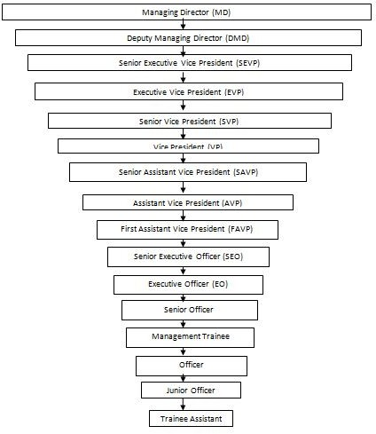

Figure 1: BDBL Organogram

Board of Directors

The board of directors of the Bangladesh Development Bank Limited is given at the below:

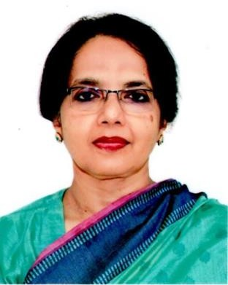

Shamima Nargis (Chairman)

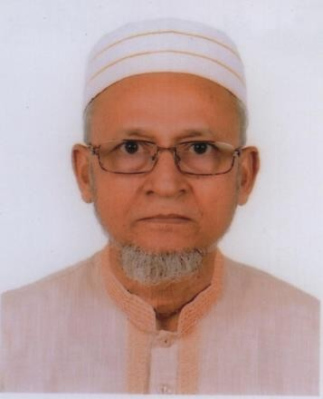

Md. Ekhlasur Rahman (Director) Md. Abu Hanif Khan (Director)

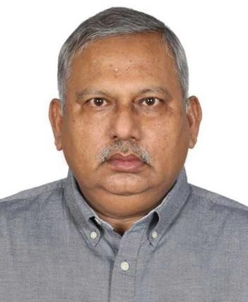

Subhash Chandra Sarker (Director) Quazi Shairul Hassan (Director)



Md. Azizur Rahman (Director) Md. Habibur Rahman Gazi (MD & CEO)

CHAPTER 4: ANALYSIS & FINDINGS

HR Practices of Bangladesh Development Bank

Human Resource Management is an essential part of the business organizations which actually get involves on the employee management tasks and activities toward the business objectives. The Human Resource creates influence on gaining the potential and competitive advantage of the organization. Developing and improving the employees’ skills and performance in the organizational activities and operations to gain the business goal is the main focus of the Human Resource. In a company, effective employees are hired for each position according to their skills, knowledge and abilities by the HR and they are provided effective training for operating the organizational works. Different rules and provisions the HR officers need to follow in the organization. The board of the organization establishes many policies, rules and regulations in the business organization. By following those regulations, the officers of the HR department operates their tasks and operations effectively. Labor is an important resource of the organization and it significantly contributes to the achievement of the business goal. So, the board of the organization assigns effective and potential employees in the HR department who can actually understand the employee management related issues and can maintain those activities properly. All of the tasks regarding the employee management from the employee recruitment to employee discharge are maintained by the HR. The activities and functions of the Human Resource are as follows:
- Recruitment and selection
- Training and development
- Performance management
- Employee relations
- Employee benefits
- Employee compensation
- Promotion & rewards
- Total quality management

The Human Resource of Bangladesh Development Bank Limited (BDBL) is described at the below:

Roles of HR of BDBL

Many roles and activities the HR of BDBL need to operate in the organization. Those are in the following:
- Attracting candidates
- Selecting candidates
- Performance evaluation
- Employee compensation
- Employee benefits
- Learning & development
- Promotion & rewards
- Total quality management

HRM Model of BDBL

The HRM model of Bangladesh Development Bank Limited (BDBL) is given at the below:
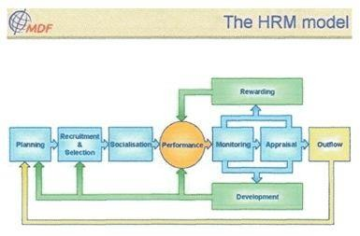
Figure 2: HRM Model

Improving Employees KSA (Knowledge, Skills, Abilities) through Training & Development
Training & development is a human resource activity which plays a great role in every organization. It is actually operated to teach the employees and personnel regarding the organization overview and the organizational functions. Employees become to properly understand about their roles and operations through the training & development. The HR department organizes the training program for the employees. In Bangladesh Development Bank Limited, the training program is arranged in a very formal way for the employees. The trainers specifically discuss about all of the organizational issues in the training session. Training is provided for a long time so that the employees can properly understand regarding the organizational operations and other issues. When new employees are hired in the organization, the training is conducted for a period of 3 months. The employees are informed regarding the general banking department initially, then the basic discussions regarding the other departments including cash department, credit department, foreign exchange department, accounts department, HR department. As the bank appoints huge employees in each circular, so the total number of employees are divided into some particular groups and training is conducted separately for each group. Different training methods are used in the organization which are given below:
- Orientation

The orientation program actually focuses on introducing the staffs and employees about the company background, the products and services, the divisions and departments, the provisions and rules, the board of directors, the organogram etc. The employees become to know about the organizational overview by this program.
- Socialization

Through the socialization program, the employees are able to know about the activities and operations of their particular positions. They need to know about their tasks and activities precisely to work in the organization. By this program they can properly understand regarding their roles and also the organizational norms, values, culture, behavior, dress code etc.
- On the Job Training

  - Coaching: By this method, the trainer explains about the each and every tasks of a particular position. The job responsibilities from the beginning to the end of the personnel are discussed through this method.
  - Under Study Methods: It is a method where a senior officer provides training to those subordinates who work under him. The superior shows the organizational functions practically to his subordinates. After that, they become to learn those functions.
  - Job Rotation: In job rotation, a new employee observes the operations clearly performed by the existing employees and try to understand. After understanding carefully, they perform those activities. They also get important guidelines and instructions from their pioneer to work effectively.
  - Apprenticeship Training: In the apprenticeship training, training is conducted by the productive works. The employees are able to acquire technical skills and knowledge from this method which is extremely required for their professional development. The employees become expert in their job environment by this method of training.
  - Job Instruction Training: This method is very potential for the employees where some steps of the job instructions are created and arranged sequentially for the employees. After that, based on those steps the instructions are given sequentially to the employees.
  - Committee Assignment: This method refers to establishing a committee with a particular number of employees in order to perform the organizational tasks. Different organizational tasks are assigned to them. They perform those tasks by conducting team work between them.
  - Special Meeting of the Staff: In an organization, many decisions are taken at different times to run the organization. Then, a special meeting is organized between the company staffs and the appropriate decision is taken at the meeting.
- Off the Job Training
  - Lecture Method: Lecture method is a method where the trainer explains everything to the employees by oral communication. The employees listen carefully those lectures and able to learn.
  - Conference Method: In the conference method, the employees conduct group discussions among themselves regarding several official issues to understand regarding the operations specifically.

  - Universities and College: Different colleges and universities organize professional classes for the professional workers. Different official tasks and activities are taught in those classes. The professional workers can attend those classes and learn lots of things.
  - Role Playing: In this method, the trainees are given many roles to perform together by the trainer. They perform those operations by working together and become to learn those activities.
  - Vestibule Training: Under this method, the trainer takes the trainees in a particular room where different organizational functions are operated. The trainer teaches the trainees by showing the functions practically and the trainees become to learn.
  - Workshops: Workshop is basically a conference where the executives of the organization meet together and discuss about different official issues and problems.
- Development

Through the development method, the skills and knowledge of the employees are developed according to the requirement. After gaining sufficient skills and knowledge the employees apply them in their organizational works. They gradually improve in their job with their skills and efficiencies and also get promotions and rewards.
After taking proper training from the company, the employees can learn and understand about the official tasks and activities clearly. Employees work physically and also work in the computer and software in the organization. The employees operate the banking activities including accounts opening, remittance, pay order, clearing, cash management, RTGS, BEFTN by applying those skills and knowledge they gain from the training session. Among the training methods above, socialization method is used for providing the knowledge of basic banking activities to the employees. On the job training method and off the job training method are used to teach the technical banking tasks to the employees.
For improving the employee performance, Bangladesh Development Bank Limited uses several methods which are as follows:

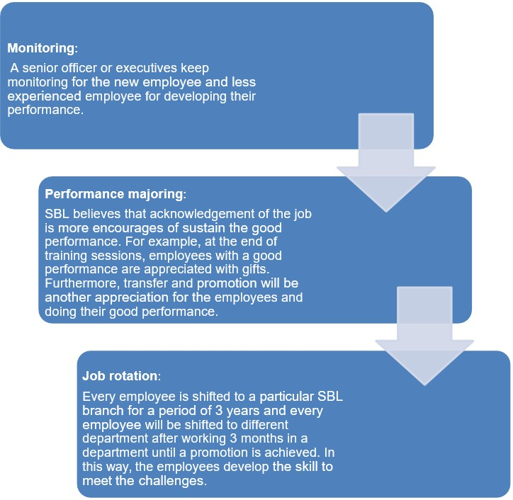

Figure 3: BDBL Development Process

Findings

I observed different problems in Bangladesh Development Bank Limited while doing internship. The findings & observations of the bank are given in the following:
- There are lack of resources in the Bangladesh Development Bank Limited. Because of insufficient resources in the company, BDBL face problems in conducting training for the new employees.
- Due to the technological problems and insufficient technology and machineries, the officers of the Bangladesh Development Bank Limited (BDBL) face problems in their works. The officers of the HR department also face difficulties due to this issue.
- Currently, there are lots of products and services in Bangladesh Development Bank Limited. But, sometimes few services can’t be provided to the clients for some technical issues. Then the clients become dissatisfied and the bank losses its reputation.
- Sometimes the bank can’t access to their server for conducting transactions when Bangladesh Bank disables their server. Then the bank highly suffers. They became unable to provide services to the clients.
- There is a lack of proper management in the organization. The management policies, laws, rules, regulations of the organization are not appropriate. The head of the organization has failed to publish standard management in the organization for the organizational operations and the employees. For the reason, the organizational operations are not maintaining in an effective way.
- The work environment of the bank is not good. There are so many employees inside the organization but the space of the organization is not much broad according to the number of employees. So, the work environment of the organization becomes too noisy. The staffs of the organization are not much friendly. That’s why the employees of the bank can’t frankly talk to each other for the operational issues.
- The Human Resource (HR) of the organization is not much effective as it needs to be. The head of the HR department along with the other officers of the HR department are not much efficient and expert to perform their operations and activities. They are unable to manage the employee management activities effectively.
- There are insufficient labor in the organization. Being a highly valuable organization, it needs excessive employees to perform the organizational operations and activities. But because of insufficient labor, the bank can’t maintain all of the operations effectively.

CHAPTER 5: RECOMMENDATIONS & CONCLUSION

Recommendations

In order to implement potential growth, Bangladesh Development Bank Limited should develop many things in their organization. They should take the following steps for their future growth & improvement:
- Bangladesh Development Bank Limited need to develop the deposit products. The deposit products need to be modified and diversified to create high value to the customers.
- The bank should launch better investment schemes in the organization for the clients. By this way, they can grow in their business and earn high profit.
- The business organizations of the country require capitals to operate their business. Banks provide loans to the organizations and take interest from them. Bangladesh Development Bank Limited should provide loans to the business organizations at less interest rate so that many business organizations become agree to take loans from them.
- The organization should implement proper management in their organization. The head of the organization should need to establish standard rules, laws, policies in their organization. The organization’s board should organize meeting with the staffs of the organization and make appropriate decision regarding the policies, laws and regulations.
- The organization needs to create a good work environment in the organization in order to motivate the employees into the organizational tasks. The office environment needs to be wide and massive. The managers of the organization need to be friendly & helpful to their subordinates so that the employees feel free to ask them anything related to the official activities.
- The head of the organization needs to bring more resources into the organization for operating the organizational tasks and activities. As there are lacks of sufficient resources in the bank, the bank needs to invest more money and buy more resources for the organization. Then, it will become easier for the employees to operate the tasks and activities effectively.

- There are many complicated processes in the bank. Clients have to face many difficulties while taking services from the bank. The procedures of the bank need to be simple so that the clients can easily make their transactions.
- The bank needs to make the HR division strong by hiring some effective people in that division. The HR division of the organization is weak and they are unable to maintain their tasks effectively. The organization should assign some expert employees at the HR division and provide them proper training to maintain their activities effectively.
- The Bank needs to increase the number of employees in the organization. Being a highly valuable organization, it needs huge number of employees to maintain the organizational operations effectively.

Conclusion

Bangladesh Development Bank Limited is maintaining standard systems and policies in their organization for implementing business growth and gaining the business goal. The officers and employees of the organization are well skilled and they are able to conduct the business operations properly. Though there are limited numbers of resources in the organization, the staffs of the organization can perfectly operate the business tasks and activities with those resources. The employees are provided well training while joining in the organization. So, they are able to show well performances while providing services to the clients and maintaining the organizational operations. The officers are not only good at work performance but also good in humanity. They are very helpful to their clients and they nicely cooperate them when they come to the bank for taking services. Their behaviour, attitude is always very positive. They always make attitude positively with the organizational members and the clients they serve. As there are different negative aspects in the organization which are discussed in the findings part, the Bangladesh Development Bank Limited is able to maintain the organizational works effectively with its labor and resources. The organization needs to take many necessary steps for the improvement of the organization which are given in the recommendation part. The owners of the organization need to invest more money in the organization and extend the organization by building more branches in the different areas. More resources should be purchased in the organization for operating the organizational tasks effectively in a short time. The office environment should always remain good

and friendly so that the employees can frankly talk to the subordinates regarding the office related issues. The bank need to hire more employees for their organization toward the achievement of the business goal. The board of the organization are planning to develop many strategies in the organization for the future growth. Being a valuable organization, it needs to be properly operated to gain the customer satisfaction. At present, the organization is running very effectively with its employees and resources. The board of the organization expects that the organization will accomplish more potential growth in future.

REFERENCES

https://www.bdbl.com.bd/

https://en.wikipedia.org/wiki/Bangladesh_Development_Bank

https://www.lawyersnjurists.com/article/overall-activities-of-bangladesh-development-bank- limited/#:~:text=As%20a%20development%20bank%2C%20BDBL,exchange%2 0and%20international%20trade%20financing
https://assignmentpoint.com/hrm-practices-banking-sector-of-bangladesh/

https://www.researchgate.net/publication/352990924_Human_Resource_Management_Practices
_in_Banking_Sector_of_Bangladesh_A_Critical_Review

https://www.aihr.com/blog/human-resources-roles/

https://www.researchgate.net/publication/333180261_The_Change_Of_Human_Resources_Role
_In_The_Banking_Digitalization_Era

https://www.lawyersnjurists.com/article/training-and-development-banking-sector-in- bangladesh/
https://www.academia.edu/35286367/Training_Development_Process

Bangladesh Development Bank Limited, Annual Report 2021 Bangladesh Development Bank Limited, Annual Report 2020

