Analysis of client management at the Octopi Digital Limited: An internship experience perspective

Shaikh Mohammad Haider Ali

The Report is submitted to the School of Business and Economics, United International University as a partial requirement for the degree fulfillment of Bachelor

Analysis of client management at the Octopi Digital Limited: An internship experience perspective

Submitted to:
Dr. Kawsar Ahmmed
Professor

Submitted By
Shaikh Mohammad Haider Ali
ID: 111173084
Major: Marketing
Registration Trimester: Summer 2024 (242)



School of Business and Economics
United International University

Date of Submission: March 6, 2025

Letter of Transmittal

06rd March 2025

Dr. Kawsar Ahmmed
Professor
School of Business and Economics
United International University
United City, Madani Ave, Dhaka 1212.

Subject: Submission of Internship Report

Dear Sir,
With due respect, I would like to submit the internship report title “Analysis of client management at the Octopi Digital Limited: An internship experience perspective” as an obligatory internship program requirement of the Bachelor of Business Administration.
I am so grateful to you for assigning this report and giving me the opportunity to gain the real life experience. This opportunity increases my knowledge regarding how the banking processes are done. This particular report will be discussing and focusing about Client Management At Octopi Digital Limited. While doing the report, I tried to connect the theoretical knowledge about service marketing with my practical experience.
I am extremely thankful to you for all your valuable guidance and constant attention. I hope that my work on this report will come up to the level of your expectation.

Sincerely yours,
Shaikh Mohammad Haider Ali
ID: 111173084
Marketing Major
School of Business and Economics
United International University

Corporate Evidence

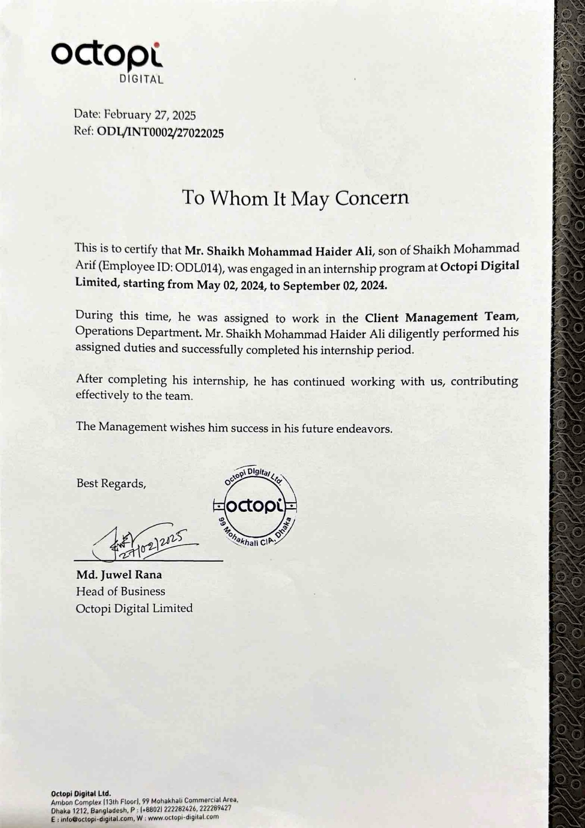

Acknowledgement

Firstly, I would like to thank Almighty Allah for giving me the strength to complete my internship successfully and prepare my internship report as per the requirements.
I convey my sincere gratitude to my honorable supervisor, Prof. Dr. Kawsar Ahmmed, United International University. Without his kind direction and proper guidance, this report would not have been a success. His supervision and guidance shaped every phase of the report so that it was completed perfectly.
I am thankful to all the managers and employees of the Octopi Digital Limited especially Juwel Rana, Head Of Business Of Octopi Digital, and Faridul Islam, Senior Executive In Admin Of Octopi Digital Limited. They helped me a lot to learn the work and gave me knowledge of each department. They also provide me with information and data regarding my final report.
Executive Summary

In B2B-focused digital marketing agencies, client management is one of the most important tools to bring success to the organization. It helps a business in client acquisition, retention, and organizational growth. The purpose of this report is to analyze the client management strategies of Octopi Digital Limited and identify the strengths and weaknesses so that I can find out the areas where organizations can improve their business relationships, service quality, and operational efficiency.
Based on the 4-month internship experience, this report highlighted theoretical knowledge with practical experience. The report covers an overview of the digital marketing industry, an analysis of Octopi Digital Limited’s operations, a study of its client management strategies, and recommendations for improvement.
Areas covered include client acquisition, retention, communication, conflict resolution, and execution monitoring. Also, opportunities for innovation, employee well-being, and expansion to new markets. The recommendations aim to make Octopi Digital Limited a sustainable and competitive agency.

Keywords: Digital Marketing, Octopi Digital Limited, Business Growth, Client Management Strategy, Client Satisfaction

FOR INTERNSHIP

Table of Contents
Letter of Transmittal iii
Acknowledgement v
Executive Summary vi
Chapter 1 1
Introduction and Digital Marketing Industry of Bangladesh 1
Primer 2
1.1 Objective 3
1.2 Motivation 4
1.3 Limitation 4
1.3 Specification of the Industry 6
1.4 Size, Trend, and Maturity of the Industry 7
1.6 Technological Factors 8
1.7 Political, Legal, and Regulatory Factors 9
1.8 Industry Rivalry 10
1.9 Key Challenges andOpportunities 11
Chapter 2 12
Analysis of Octopi Digital Limited 12
Introduction 13
2.1 Overview and History 13
2.2 Mission Statement 14
2.3 Premise andFacilities 15
2.4 Customer Mix 16
2.5 Product and Service Mix 17
2.6 Service Quality 18
2.7 SWOT Analysis 19
Chapter 3 21
Client Management at the Octopi Digital 21
3.1 Importance of Client Management and its strategies 22
3.2 Factors Considered in Client Management Strategy 24
3.3 Client Management Strategy Practices at the Octopi Digital Limited 26
Chapter 4 30
Internship Experience, Recommendation & Conclusion 30
4.1 Internship Experience 31
Recommendations 34
Conclusion 36
Reference 38

Chapter 1

Introduction and Digital Marketing Industry of Bangladesh

Primer

Bangladesh is witnessing a tremendous digital transformation, and digital marketing industry is playing a crucial role in this transformation. With rapid changes in technology and increased in internet using, digital marketing has become a major tool for business. With businesses going digital, businesses are targeting international markets. and this digital marketing has become one of the most in-demand services in the country. This is driven by the increasing number of internet users, rise of e-commerce, and the need for businesses establishing an efficient online presence.
There was a time when digital marketing in Bangladesh simply meant promoting your products and services through social media or Google ads We have come a long way since then and digital marketing here is an industry of its own involving SEO, content marketing, AI based automation, CRM integration, data analytics and so much more. Thus, the move from traditional to digital marketing does not have to be seen as a fashion but a need for the companies to stay alive and flourish in the globalized market.
For agencies focused on the USA market such as Octopi Digital Limited the move is a huge opportunity to generate foreign currency while allowing international businesses to expand their digital capabilities. The use of the global market is not only contributing to the foreign remittance of the country but is also a digital export generation for Bangladesh.

1.1 Objective
The main goal of this internship was to analyze the bridge and analyze the gap between theoretical knowledge and practical application of client management in real-time. During that internship period I aimed to gather the depth insights and understanding the of practical world business operations, client’s acquisition, retention strategies in a B2B focused digital marketing agency. The core objectives are,
- Practical Application of Theoretical Knowledge: The theoretical knowledge elaborates the understanding of the business, when we can see the actual application of theoretical knowledge in practically it gives the more depth understanding in real life.
- Understanding the way Octopi Digital performs client management: During the internship I was designated in Client Management department. The major objective was to learn and analyze the process Octopi Digital Limited follow to perform the client management activities and its strategies. It’s and deep understanding to manage and increase the client satisfaction.
- Analyze the problems Octopi Digital Limited facing in client management: Client management is a major concern for a digital marketing agency. My goal was to identify the challenges Octopi Digital Limited faces in managing their clients, meet client’s expectations and communication for the different time zone.
- Providing recommendations: After analyzing the problems that octopi digital limited facing during the client management framework, so that I can make a recommendation from my side about how to improve and minimize the problems which octopi digital limited is facing during the client management.

1.2 Motivation

Internship plays a vital role in career development. This is the first key to enter in career. I got motivations to:
- Finding the scope to apply theoretical knowledge in practical field: Internships allows by my own to gather the depth idea and understanding the theoretical application in real life. Internship gives the scope to see how the world is applying theoretical knowledge in practical life.
- Fulfilling an academic requirement to complete the bachelor degree: Internship is required to complete the bachelor degree. Internship is also a part of academic requirements. It’s containing 3 credits. Without internship degree is unfulfilled. I am also getting motivate to do internship as my other course to complete my academic requirement.
- To gather experience for future career growth: Internship is not only a part of academy, it’s also an opportunity to get experience in real life. To et chance in a well-known company, you need to have experience. Internship helps to get the experience for the future growth.

1.3 Limitation

Internship is valuable learning scope for everyone, but also it has some limitations that restricted to dive in the depth of the study.
- Time limitations: During the internship, everyone gets 3 to 4 months to complete the internship. But in this little time frame we can properly get knowledge I depth. As we have to experience a huge number of knowledge but the time frame is a barrier to go more depth in the study.
- Lack of relevant information: During the internship period we can not access in some confidential data for the agreements. These limitations made it more challenging to analyze and study the deeper in certain aspects. It’s made a barrier to gather the depth analysis of internship.
- Limited scope of operations: As the Octopi Digital Limited is still a small startup and the main focus is on the USA market, the scope of international clients and markets was limited. And for the startup company there was missing some major things which a big organization practices, which I missed to experience because of the limited scope of operations. But also that gave me an intensive opportunity to experience the operation with other regional clients.
After all that limitation, the internship provided me a solid foundation to gather the experience and depth understanding. It has given me scope to analyze and given me a instrument to enrich future career growth.

1.3 Specification of the Industry

Bangladesh Digital Marketing Industry has been growing up in economics from last decades. Both small and big businesses are now significantly investing in online marketing to target their audience better. The industry includes a broad offering of services, such as:
- Social Media Marketing (SMM): Conducting paid and organic campaigns on social media platforms such as Facebook, Instagram, LinkedIn, and YouTube for increasing brand visibility and driving customer interaction.
- Search Engine Optimization (SEO): Web optimization using techniques to improve search engine rankings, particularly with Google and other search engines, thereby increasing visibility.
- Pay Per Click (PPC): Running paid ad campaigns on Google Ads, Facebook Ads, etc., for leads and sales.
- Content Marketing: Writing relevant blogs, and making quality videos, infographics to inform and engage prospective customers.
- CRM Automation: Using AI-powered chatbots, automated email marketing and customer relationship management tools to help manage business processes.
- Web Design & Development Responsive, SEO-friendly, user-centered websites for businesses to create an online identity.
These services are ideal for clients of all sizes, from local businesses to international corporations seeking affordable, quality marketing services.

1.4 Size, Trend, and Maturity of the Industry
The digital marketing industry of Bangladesh is still buzzing with rapid growth but is fast maturing as more and more investments pouring in and technology is evolving. A few major trends impact the industry:
- Rapid internet penetration: More than 113 million internet users, it gives rise to the online audience. Digital marketing is now an essential part of a business strategy in Bangladesh.
- Social media with Big Potential: Facebook is the main social media platform used in digital marketing, followed by YouTube, LinkedIn, and Instagram. The video content & influencer marketing makes a great focus of businesses to arrest audience attentiveness.
- Growth of E-commerce: The rise of e-commerce platforms such as Daraz, AjkerDeal and Pickaboo has spurred on the need for digital marketing, as companies require targeted ads to reach customers.
- Artificial Intelligence and Automation: More companies are using AI-fueled marketing tools to better engage with customers, automate tasks, and improve campaign performance.
However, the industry is still new and many businesses are only just beginning to harness the power of digital marketing. That said, for established businesses like Octopi Digital Limited, the emphasis is on providing creative and outcome-focused solutions to maintain the competitive edge.

1.6 Technological Factors
Technology has reshaped the digital marketing landscape. Digital marketing is driven by technology, which evolves continuously and helps the industry. The way agencies work, thanks to new digital tools and platforms, has also been changed. The below are some focus areas for technological factors affecting the industry:
- Data Analytics & AI: Today businesses are dependent on the insights generated by AI to monitor consumer behavior, forecast trends and design marketing strategies accordingly. Analytics get Companies to Make Data Driven Decisions: Tools like Google Analytics, SEMrush, and HubSpot.
- Marketing Automation: Tools such as Go-High-Level, Mailchimp, ActiveCampaign, and HubSpot automatically run marketing functions, from email campaigns and social media posting to customer follow-ups, enhancing efficiency and engagement.
- Search Engine Algorithm Updates: Businesses must keep up with the latest SEO changes from Google to stay visible and relevant online.
- Rise of New Digital Platforms: Recent years have seen a growing use of platforms such as TikTok and WhatsApp Business for marketing, especially among younger audiences, though Facebook and Google are still the big players.
These advancements come with a multitude of benefits but also challenges. To remain in the game, agencies require constant updating of skills, systems for purchase of high-end tools, and modification to the rapidly developing rise of digital trends.

1.7 Political, Legal, and Regulatory Factors
Knowing the potentiality of the IT and digital marketing sector, the government of Bangladesh has already taken some steps to promote this. There are several important regulatory considerations impacting the industry, such as:
- Digital Bangladesh Vision 2021-2041: Government’s vision to turn into a digital economy which supported IT and digital services growth.
- Tax Incentives: The government provides tax exemptions on IT exports, encouraging digital service providers to cater to global clients.
- Data Privacy Laws: Bangladesh does not have a robust data privacy law such as GDPR but that same old question of data privacy is being debated on the move to implement GDPR like firm online consumer protection policy.
- Ad Policies: Social media platforms have ever-changing advertising rules, which agencies must stay on top of to avoid account hold or ad disapprovals
These regulations provide a framework for industry growth, and it is crucial for agencies to maintain awareness of legal requirements to help ensure a smooth engagement, especially with remote clients.

1.8 Industry Rivalry
Industry rivalry increases when the companies feel competitive pressure or find an find an opportunity to improve their position. Bangladesh is unique in the sense that the digital marketing industry is highly competitive. Although there are few regular digital marketing agencies, there is fierce competition from freelancers and smaller groups offering their services at lower costs. The major players in this space include:
- Freelancers on Platforms like Fiverr & Upwork: There are so many skilled people on this dedicated platform like Fiverr that also doing the digital marketing and providing a competitive price and flexibility from agencies.
- Local IT Companies & Agencies: Established IT companies are also offering digital marketing as a secondary service and are in the race for corporate clientele.
- Cost Challenges: Digital marketing services being rendered by Indian, Pakistani, Indonesian, & Philippines-based agencies have created intense competition, compelling Bangladeshi companies to introduce bingo services to remain competitive.
Octopi Digital Limited’s Unique Selling Proposition: Octopi Digital Limited is a full-service agency based that has client solutions under one roof with 30+ employees, whereas most of other agencies are made up of either freelancers or boutique small teams. This systematic approach, combined with ultimate pricing and a 7-day free trial strategy, acts as a magnet for international clients.

1.9 Key Challenges and Opportunities
Challenges:
- Infrastructure Problems: Lack of stable internet connection and advanced software tools can affect productivity.
- Frequent Changes to the Platforms: Google, Facebook, and LinkedIn make changes to their algorithms and platforms regularly, forcing constant adjustments.
- Global Business: If you want to outperform agencies/freelancers in other countries, you must provide better services.
Opportunities:
- International Demand: The USA, the UK and the western markets in general are in dire need of highly skilled digital marketing services, unlike any other field that offers humongous growth.
- Government Assistance: Tax benefits and a "Digital Bangladesh" ambition foster an environment for IT service exports.
- Incorporating AI & Automation: Agencies that initiate AI-based marketing strategies will be ahead of their competitors.

Chapter 2

Analysis of Octopi Digital Limited

Introduction
Solutions Octopi Digital Octopi Digital Limited is the fastest-growing digital marketing agency located in Bangladesh and the company falls under AZAL Group. It was founded in January 2025. Other agencies serve both local and USA clients, but Octopi Digital Limited is only for you if you are in the USA and need something top-notch like digital marketing, website design and development, video editing, CRM automation, and much more and providing services in B2B business model.

Its approximate premium service has a high client retention rate, which it has achieved by getting clients into the door with fairly inexpensive entry-level services and then upselling them on their premium solutions. Instead, by catering to international customers, the company is also bringing valuable foreign remittances to Bangladesh, helping the economy grow.

Octopi Digital Limited is now fast establishing itself as a big player in the digital marketing game with a team of over 30 staff strong combining its expertise, technology, and strategic business model to dominate the freelance and agency competition worldwide.

2.1 Overview and History
Octopi Digital Limited has been launched with a mission to connect the gap between affordable digital marketing services to quality execution. Recognizing a huge potential in the USA market where businesses keep facing challenges in finding low-cost and expert digital marketing partners, the agency decided to press significantly forth to capture the market.
The company started out small but has since evolved into an agency with an extensive array of digital services. At the heart of the company is a philosophy around:
- Offering complete digital solutions so that clients do not have to visit different service providers
- Enticing clients with competitive pricing, then winning them over as long-term customers with better service
Aren’t you sorry to be commenting on strange topics, cultural which you see by your role?
- Ensure strong team with skill sets to deal with international clients
Now Octopi Digital Limited has worked with small to large businesses throughout the USA, providing scalable digital solutions to boost brand visibility, customer engagement and increase revenue.

2.2 Mission Statement
Octopi Digital Limited mission is:
‘’To provide businesses around the world with state-of-the-art digital marketing solutions, helping them to grow, scale and succeed, in an ever-changing digital environment.’’
This mission embodies the company’s dedication to:
- Providing quality and results-oriented digital marketing solutions
- Long-term relationships with international clients
- Jointly with 3 hard workers like us, enhance Bangladesh's economy embedded with foreign currency.
- Developing a successful workplace that fosters employee growth and creativity
The company remains committed to this mission as it builds its client roster, diversifies its service offerings, and forts up as a trusted digital partner to businesses across the globe.

2.3 Premise and Facilities
Located in Bashundhara R/A, Dhaka, Bangladesh, Octopi Digital Limited works from a fully equipped office and provides a collaborative and productive work environment for its employees.
Amenities and Work Environment:
- A permanent own office space with is equipped with comfortable technology bay workstation
- Available lunch box along with transportation facilities to provide convenience to the employees
- Professional digital loading and high-speed internet.
- A collaborative and innovative work culture with a team that always lend you helping hands
Employee satisfaction ranks high in the organization and they take great pride in keeping their employees engaged and motivated. One of the primary reasons for the company’s rapid growth and employee retention is the positive work culture.

2.4 Customer Mix
Customer mix is the different types of customers that a business serves and categories on the basis of factors. Octopi Digital Limited works with a variety of clients across the United States from small businesses to large enterprises. It serves a variety of industries including:
- B2C brands seeking to sharpen and increase their sales
- Healthcare professionals and chiropractors engaging in marketing for clinics and wellness companies
- Agencies & leads generation and forced filter of a brand
- Content marketing and paid ad solutions for SaaS and tech startups
- Service-based businesses within your locality like restaurants, gyms, law firms, and consultants
Keeping a diverse range of clients, the firm also has a more consistent revenue flow and the opportunity to work on a wide variety of projects, enabling the firm to be more flexible to trends and needs in the market.

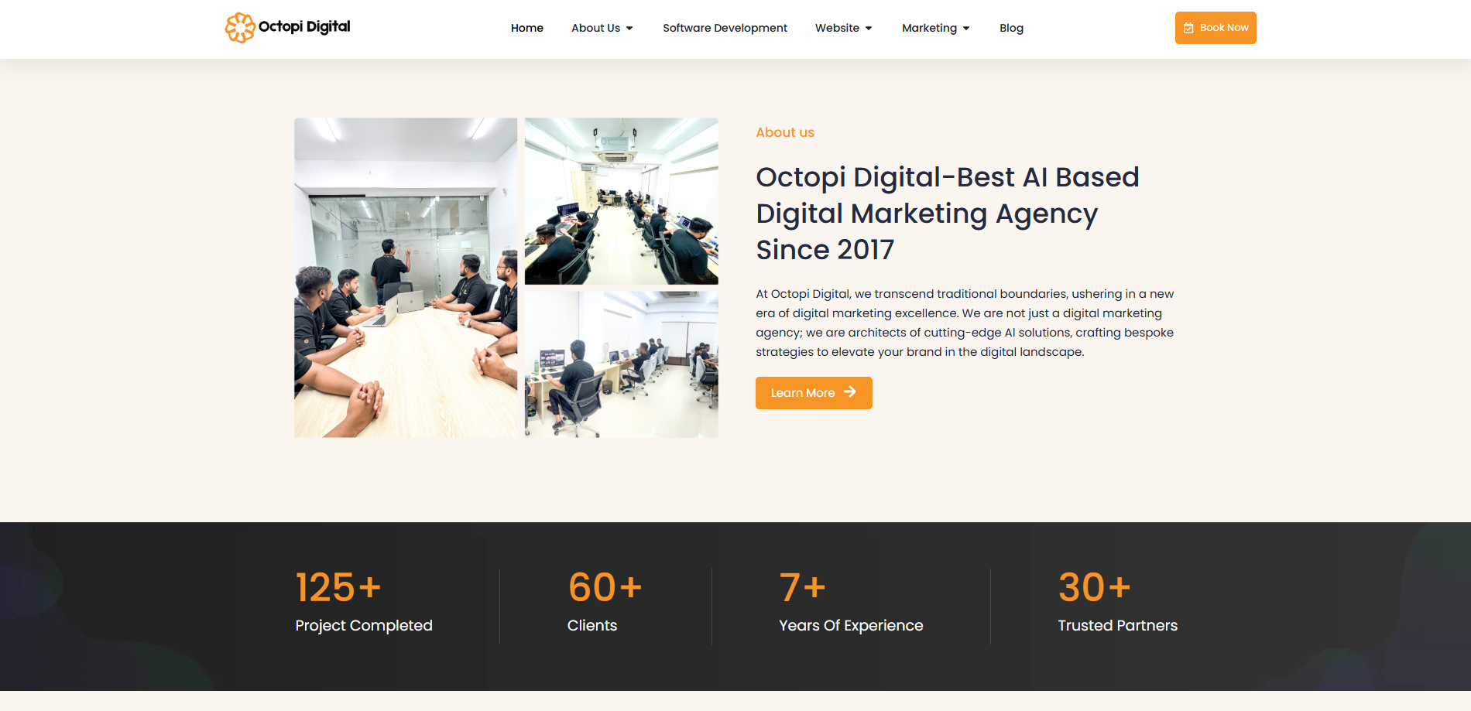

2.5 Product and Service Mix
From a one-stop solution to all your Digital & IT services.
Octopi Digital Limited: Core Services
- Social Media Marketing: Running campaigns on Facebook, Instagram, LinkedIn and TikTok to drive awareness and sales
- Pay-Per-Click (PPC) Advertising: Google Ads & Facebook Ads
- Search Engine Optimization (SEO): Enhance Google Rankings for Organic Reach & Visibility
- Website Design & Development: Creating responsive, SEO friendly, high-converting websites
- Graphic Design and Branding: Logos, social media creatives and promotional materials
- Video Editing and Production: Design all video ads, YouTube content and motion graphics
- CRM and Email Automation: Configuring email campaigns, chatbots, and CRM systems for improved customer engagement
This wide-ranging service portfolio enables the company to offer end-to-end digital marketing solutions, thereby eliminating the need for clients to seek additional services from external resources.
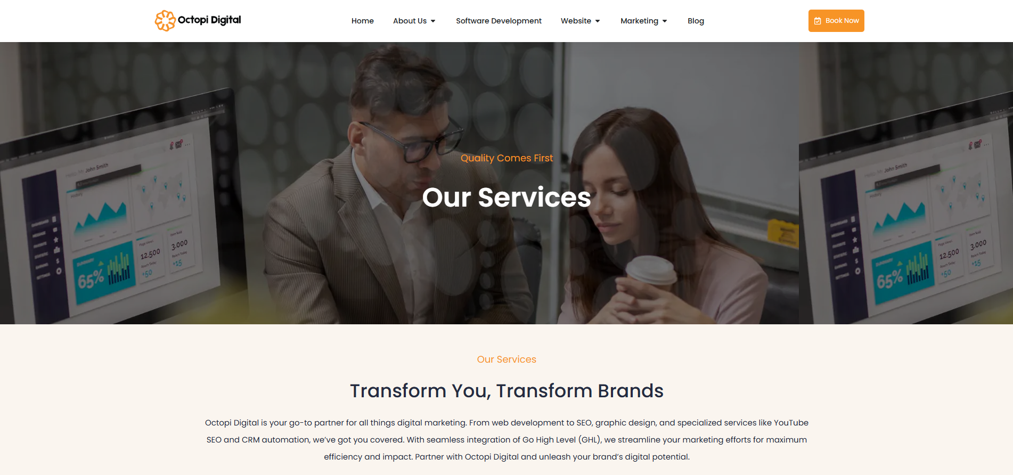

2.6 Service Quality
Octopi Digital Limited offer only the highest service quality, which is one of our greatest strengths in comparison to many competing products. The company focuses on:
- Executing return-on-investment-centered initiatives where each campaign is designed for maximum conversions and profitability
- Arranging a steady communication with transparency and a client-focused approach with ongoing support
- Providing a seven-day-free trial, which enables clients to get results beforehand, builds trust
- Data-backed decision making: utilizing analytics and AI tools to optimize strategies
These elements translate into a high client retention rate and strong word-of-mouth referrals, further building the company’s reputation.

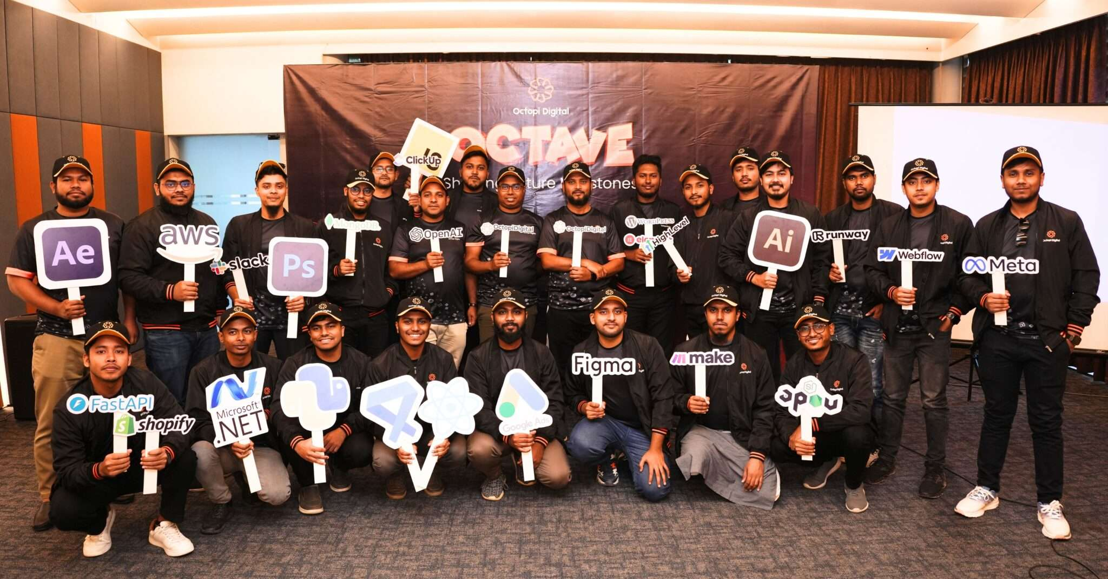

2.7 SWOT Analysis
A SWOT analysis is a technique to identify organizational strength, weakness, opportunities and threats. It’s helping a business to identify the strength and opportunities and minimize the weakness and threats. The SWOT analysis of Octopi Digital is analyzing below:

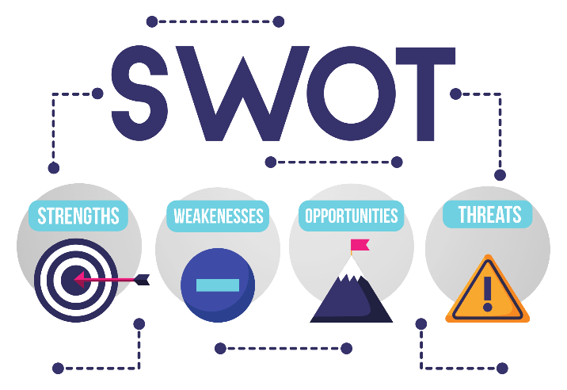

Strengths:
- Core business presence in US market
- One agency, many services
- Costs lower than other international agencies
- Experienced team with international client exposure
- High retention due to client-first approach
Weaknesses:
- Not established enough and have weak recognition versus old agencies
- Over-reliance on the USA market leading to lower geographical diversification
Opportunities:
- Growing need for AI-based marketing and automation
- Growth into the European and Australian markets
- Bangladesh’s digital economy is growing, resulting in access to workers with more skills
Threats:
- Fierce competition from freelancers and foreign agencies
- Regular updates to algorithms of social media partners that have an impact on marketing plans

2.8 Strategies to Meet Challenges and Opportunities
Strategy For Growth: To address weaknesses and threats, Octopi Digital Limited is doing the following:
- Increasing its customer base internationally by entering new markets apart from USA
- Merging AI-driven marketing automation to outstrip competitors
- Building a Stronger Brand Presence via Case Studies and Testimonials
- Training employees so your team stays ahead of the digital trends

Chapter 3

Client Management at the Octopi Digital

3.1 Importance of Client Management and its strategies

Client management strategies are most important part for serviced based companies, because in a service base companies there is no tangible products so there is option to experience a thing for the clients, in service-based clients retains for the better relationship, trust, credibility and client satisfaction. By implementing client management strategy an organization can take the right step to maximize the client satisfaction. The growth of a service-based companies depends on long term client relationship. Explaining the importance of client management strategies below,
- Building strong client relationship:
A proper strategy helps to establish trust and credibility. By maintaining proper communication, it helps to build a strong relationship with clients. Because when you are communicating with clients frequently, it makes them comfort and that creates a strong bonding with the clients which helps companies to achieve the long-term goal.

- Increasing client retention & loyalty:
When you are looking for acquiring new clients, it more expensive than existing clients. A well-organized client management strategy is made to increase the recuring projects and returning the clients continuously. Client management strategy helps to increase the loyalty among the clients. Its helps to increase the retention rate of clients.

- Enhancing customer satisfaction:
A structured clients management helps to ensure the client’s expectations are met properly. Timely reporting, updates, quality assurance provides can increase the higher client satisfaction and can increase the confidence about the company. That helps clients to take decision to return to that company with new projects.

- Maximizing revenue opportunities:
Maintaining good relationship with clients and understanding their need can identify upselling and cross-selling a business opportunity. Once clients trust to that service provider, they are always open to invest more in other services. Client management strategies help to create that trust among the clients to invest more in additional services.

- Efficient problem resolution:
No matter how efficient a company is but matters on how much they are organized to resolution a problem while it happens. Client management strategies help to make strategies on how to face an uncertain issue very smoothly. It helps to teach how to professionally addressed the issue and give resolution very smooth and perfectly. A positive reputation and misunderstanding can be prevented but quick response, flexible service adjustment and transparent communication.

- Improving Workflow and Efficiency:
Workflow and Efficiency A client management strategy in place means tasks are organized, deadlines are met and communication is clear between clients and teams. Client management strategy helps to reduces inefficiencies, minimizes errors and makes project execution smoother. A structured onboarding process, regular progress updates and quality checks helps to streamline.

- Strengthening Brand Reputation:
Reputations are also a major key for brands. While you are trying to position as a brand, company’s reputation must need thing to create positioning in client’s mind. While an organization has a proper client management strategy to keep up the client satisfaction and loyalty, it brings the good review, testimonial and refers to new clients and can contribute as word to mouth marketing to build your brand.

- Adapting to Market Needs and Trends:
Keeping up with Market Trends and Needs Regular client interactions means that company is up to date with market trends and evolving customer needs which creates more engagement with new clients and can helps to sustain the existing clients. By listening to client feedback and analyzing their needs a company can refine their strategies and improve can improve services. This helps a company to bring their steps ahead.

3.2 Factors Considered in Client Management Strategy

Structured approach to acquiring, retaining, and nurturing client relationships requires a successful client management strategy. Many factors play different vital roles to ensure the client satisfaction and willing to continue working that company. To develop an effective client management strategy, stating the factors below,
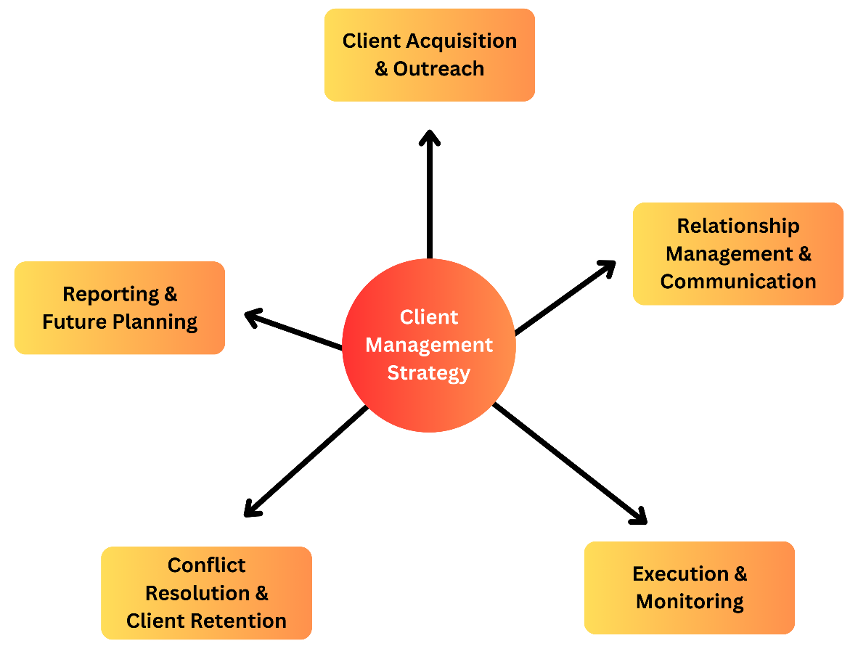

- Client Acquisition and Onboarding:
Client Acquisition and Onboarding is the foundation factors for client management strategy. In this factors company generate leads and turn those leads into the conversion. In service-based companies there need to be strong strategy to catch new clients, it helps to grow business and bring new clients which can create a stronger a company

- Relationship Management & Communication:
When a company looking for the Long-term success, relationship is the major key. Regular communication and check ins build the trust among the clients. Transparent communication without hide & seek helps to grow the trust and feel them do another project from the same company. Scheduling meetings, responding to queries quickly and actively listening to client concerns helps a positive working relationship. Open connections also allow businesses to adjust their strategy based on client feedback to continuous improvement.

- Execution & Monitoring:
High quality service requires a structured execution plan. When goes for the execution part, every task needs to be aligned according to the goal and must be organized properly. Frequently check for the changes and monitoring the execution leads to maintain the higher standard level of the execution. And also, regular monitoring can prevent from the mistakes because when monitoring regularly, if there is any issue then it's can be traced and fixed easily and that make the execution more quality.

- Conflict Resolution & Client Retention:
Problems and misunderstandings can happen in any business relationship so conflict resolution is part of client management. When conflict arrives, if the company can resolute it quickly and smoothly it helps to grow the confident among the clients. Without gaining clients confident, a company cannot achieve long-term goal. Managing the Businesses that focus on client retention through great service and responsiveness helps to build long term relationships and get repeat business from the clients.

- Reporting & Future Planning:
Giving reports to the clients with maintaining proper transparency in one of the major accountabilities for a company. Weekly and monthly reports help clients to analyze the performance and tends to trust. In a service-based company regular report is most needed. When clients get regular report, that creates positive view among to the eyes and this can help to plan for another project with that company. Without proper reporting clients cannot trust and they may suffer in suspense which can brings unsatisfaction to the clients.

3.3 Client Management Strategy Practices at the Octopi Digital Limited
Client management is not just about selling product, it’s about creating relationship and ensuring the satisfaction of client. Client management involves some key activities to helps to ensure client satisfaction, retention and business growth. The client management activities for Octopi Digital Limited are;

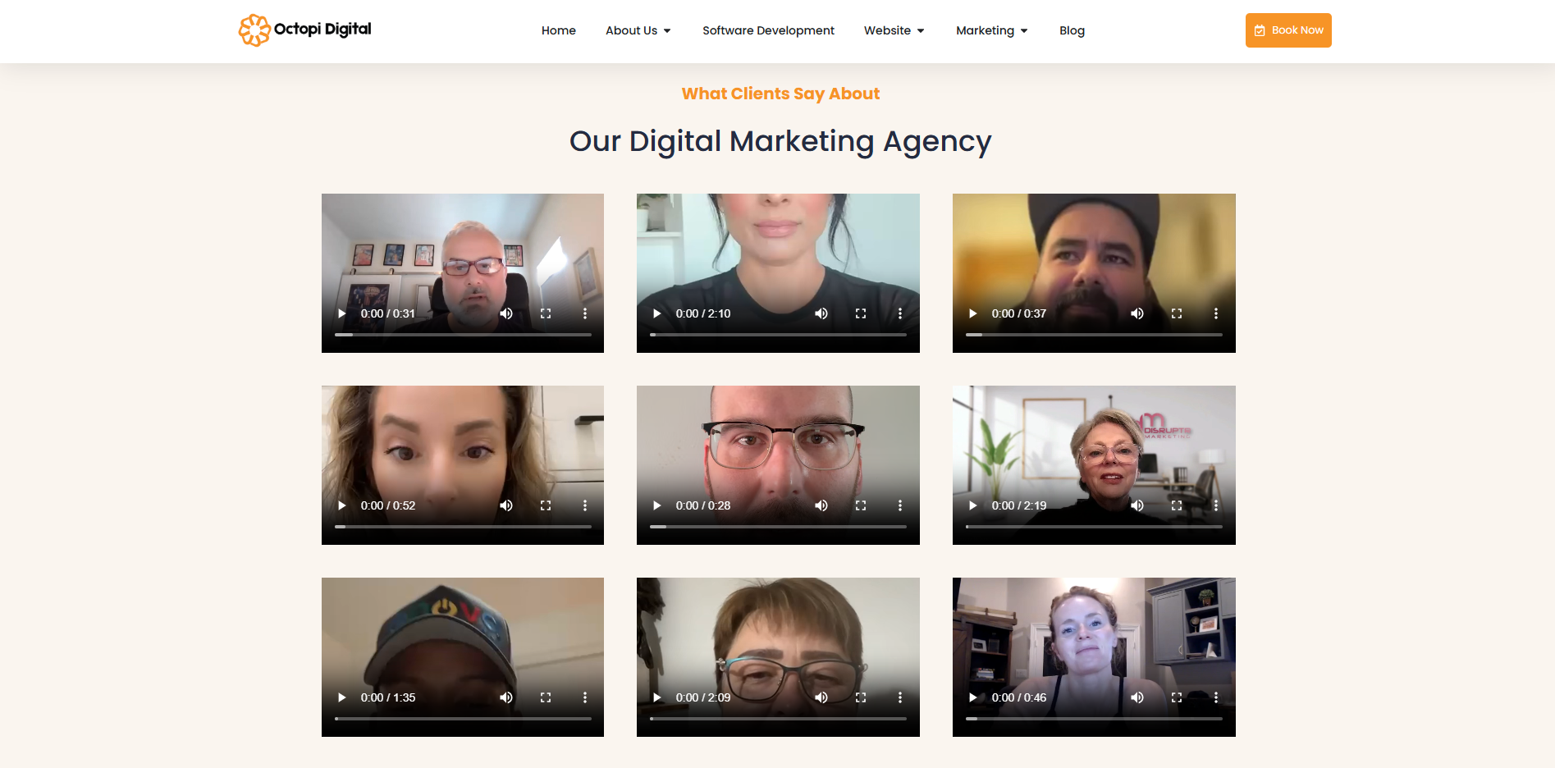

- Client acquisition & Outreach:
  - Lead generation / Outreach: Octopi Digital Limited do lead generation by 3 methods. One is from applying on Upwork and Fiverr jobs which requires some charges to apply, second one is by outreaching the companies through email and third one is referrals from existing clients.
  - Needs assessment: After getting a lead, a team work on analyzing the business of the clients and also do an assessment on what are the things that client needs. And also analyses the criteria client’s goal and expectations to evaluate.
  - Proposal & Contract signing: After evaluation the needs Octopi Digital Limited arrange a meeting on google meet or zoom meeting, then Octopi Digital Limited share our thoughts and fix a pricing for that job. After that they sent us the proposal and Octopi Digital Limited both sign into a contract which includes the details of the task, price and timeframe.
  - Onboard: On the onboarding process Octopi Digital Limited again have a meeting with clients, before that Octopi Digital Limited rearrange and make a list of required materials which Octopi Digital Limited need from clients such as logo, content, credentials, branding elements and other things. When client sent us those elements, Octopi Digital Limited pass all these elements to our execution team.

- Relationship Management & Communication:
  - Regular check-ins & meetings: During the execution period Octopi Digital Limited frequently contact with our clients and let them know about our upgrades and weekly Octopi Digital Limited arrange a meeting with clients to showcase the progress and takes feedbacks from client so that Octopi Digital Limited can fulfill their expectations and move forward smoothly
  - Reporting: When Octopi Digital Limited are finishing a check points, Octopi Digital Limited report to the clients that Octopi Digital Limited have completed that item, and also if Octopi Digital Limited face any problem or need any additional things, Octopi Digital Limited report to the client about that point and let them know how is it going or what else Octopi Digital Limited will need to move forward. All time Octopi Digital Limited try to be transparent which makes more reliability to clients.

- Execution & Monitoring:
  - Strategy implementation: At that part Octopi Digital Limited transfer the task to our operation team to execute according to the strategy. Octopi Digital Limited start the execution part here and in that point our 1st priority is to focus on the details. Because the most crucial part of a project. If someone is not focusing in every small detail it may cause bigger problem for us.
  - Quality check: Between the execution part Octopi Digital Limited assign our quality checker, who is responsible to check every details so that non of bugs or anything mislead the operation. During that time, Octopi Digital Limited make sure that our execution is going smoother and resulting the best quality result as client expected.

- Conflict Resolution & Client Retention:
  - Handling client concerns: Octopi Digital Limited cares about the customer experience, whenever any of the clients complains about anything, Octopi Digital Limited tries to get solution as soon as possible. Takes everything regarding the clients, take very seriously because when you are offering service as product then it customer experience is the first priority.
  - Flexible service adjustment: During the operation or after the operation, if client says that he wants to make a change then Octopi Digital Limited is always open to make adjustment according to the changes of clients need. Octopi Digital Limited concern about the retention of client. This is major priority to make happy the clients so that they come back again with new project and can gain their believe.

- Reporting & Future Planning:
  - Monthly and weekly reports: Octopi Digital Limited has 2 types of clients. One is the client with recurring task, and another one kind of clients are project basis. For the recuring clients Octopi Digital Limited frequently contact with clients and let clients now about the regular progress. Besides that, Octopi Digital Limited makes weekly and monthly reports for the clients to showcase the progress so that client can evaluate the progress and can give feedback so that Octopi Digital Limited can run the task more smoothly. And for the project basis clients Octopi Digital Limited frequently sent the updates to the clients and after the project done, they make a report about what has done and what they will need to know for the betterment in the future.
  - Review & Feedback session: According to the progress, Octopi Digital Limited arranges meetings frequently and showcases the progress. After showing the progress clients gives feedback which is very important for service-oriented company. Because without feedback no one the reach the client satisfaction. After getting feedback Octopi Digital Limited try to do according to the client’s feedback and ensure the 100% quality full result according the clients need.
  - Long term growth relationship: Octopi Digital Limited focuses on long term relationship with clients. Because of that Octopi Digital Limited always double check the quality of output to ensure the client satisfaction. In service companies’ client’s retention rate is everything. When you are serving a client with a task, if you can meet the client’s satisfaction level then definitely you will get another project from client, because in today’s world every business and individual need digital support and there is no end in digital marketing. So, maintaining customer relationship is major things for a digital marketing agency.

Chapter 4

Internship Experience, Recommendation & Conclusion

4.1 Internship Experience

The internship experience of mine was great. I was assigned to deal with the client. At first, I have to say that the working environment was very friendly in Octopi Digital Limited. There is an opportunity to learn multitasking. Octopi Digital Limited very much passionate to teach an employee properly. If you are hunger to learn, then this is the best choice to do internship in Octopi Digital Limited.

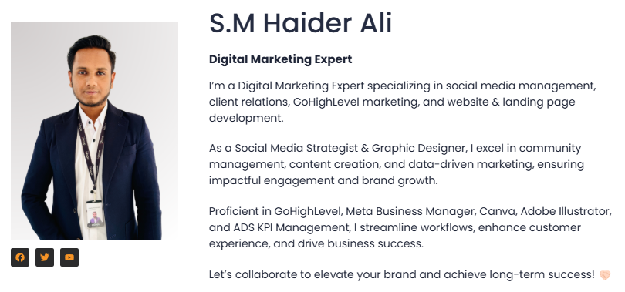

As I was assigned to manage and deal with clients. My first task was to research about the client, so that I can deal with them and can meet the taste of the client. To manage clients, I have to follow some steps. Explaining those below,
- Get lead: At first, we follow some strategy to get lead. When someone of our team get a lead, he arranges a meeting with client. Where me and manager seat on a meeting in google meet or zoom meeting for the first time.
- Arrange meeting with client: In the meeting manager introduce about the company and team with the clients and assign me to help the clients during the whole project
- Making bridge with client: At this moment I get connected with client, for better communication experience I always prefers to get connected in WhatsApp and I make a group with client and one from our operation team.
- Research: At the very first I research about the client more than his company because I believes that to meet the expectation of a client, I need to know more about the client than his company. It’s helps me to analyze the taste of the client. After that I research about the company.
- Analyze the need: In next I communicate with client about the task that what he actually needs. I do more questions to become clear, because if I am not clear about his need, I cannot deliver a quality full service. I always make notes with check points for us to analyze what will be the barrier to provide the service to clients. Then manager set and offer the price.
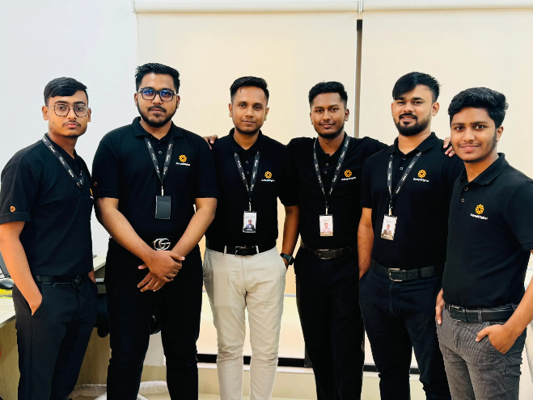
- Assign operation team: At that step I communicate with my operation team. We together check the points and make a list about what we can do, what elements we will be needed during that project, how much time it will take and what else we need from client. After that I arrange another meeting with client with my operation team and provides the information and asks clients for the requirements, we need from the client. Then client collects those elements and send to me and I send it to the operation team.
- Report to client: During the execution period I need to be communicated with client and frequently I sent the updates to the client about what we have done and what will we do next and also ask for somethings if we needed during the execution periods and takes feedbacks about the progress so that we can ensure that we are going right way. Also, during that time, I also arrange the meeting once in a week to showcase the progress and gets the feedbacks from client
- Deliver the project: When project is done, I have to ensure that every requirement from client has been fulfilled and nothing left. Then I have to arrange a delivery meeting with client and I present the project to client. After that if client ask for any changes, then I sent it to the execution team for the changes and if client says that it’s good then we are done with the project.
- Proposal for another project from the same client: During the execution process, I try to identify other gaps to get another opportunity with another projects. I research and make a proposal and give the proposal to the client that we can do that thing also, by this way we try to get into a recurring project and this is my main objective to build a relationship with the client. And during the delivery meeting I must place a proposal and make sure that client is getting the perfect service which he is looking for and that makes the client satisfy and happy and also that helps me to get another project from client. My aim is to get engage with daily task of that client so that we can take it into the long learn.
- Get touch with previous clients: Frequently I try to contact with previous clients and tries to get engage by asking about their days, health and family and try to ask if they need any other things from us. In every occasion I sent every client wishes, then sent them many promotional offers to get engage more and more. My aim is to engage with every client’s daily life.
During the internship I learned how to engage with clients, and serve the best service and meet their expectations. Our main focus is on every little details. Because when we can understand every detail of client’s need, we can satisfy client more. And also, that was a great experience to work with foreign clients, which taught me about their lifestyles, cultures and also their personality. As a marketing student that will helps me in every step in future.

Recommendations

Based on the overall analysis The Octopi Digital Limited has a very focused goal, and they have the strong aligned strategies according to their vision to achieve their organizational objective and goals. Octopi digital limited has the strong foundation to manage clients and employees. But also, according to my internship experience they can improve in some sectors, Such as:
- More focus on Long-term strategic partnership:
Octopi Digital Limited has a strong strategy for client management. But also, rather than just focusing on individual projects, they need to also focus on long-term growth strategy. Octopi Digital Limited should implement a strategy to create long-term service packages for clients and offering more personalized subscription packages, which will help to create a long-term partnership with clients and can transition from being a project-based service provider to a strategic partner. Creating subscription based digital marketing plans can positively impact on client retention and that consistency with impact to sustain growth.

- Innovation of a digital product:
Octopi Digital Limited is very much dedicated and expert in providing service. But only in service based, companies get conflict in long-term growth. As Octopi Digital Limited has a workforce with higher dedication, they can look for a digital product innovation. It will take time to create a product but once it is ready it will double up the company’s goal and can create sustainability for long-term. Only based on digital service, it is very much difficult to complete with others, that’s why I feel that Octopi Digital Limited need to think for product which can fulfil a customer’s actual need in digital world.

- Employees Motivation:
We know Octopi Digital Limited was founded last year and it is in an early stage, basically the 1st 2 years are very difficult for a startup company. In that period employees hard-working is must needed to grow the organization. As Octopi Digital Limited is totally focusing in USA market, but they are operating from Bangladesh. So, there is a huge time difference between those 2 countries. Employees in Octopi Digital Limited works from office in Bangladesh standard time and beside that they also need to work in the night when it is morning in USA. Between this hardworking period Octopi Digital Limited need to setup something to cheer up employees and increase the motivation. Octopi Digital Limited need to focus on the employees’ facilities and refreshment. Otherwise, some days later their performance may get down and that can cause poor quality of work and that can bring dissatisfaction of clients and can hamper to grow the business. Employee motivation is required for to achieve organizational goal. Octopi Digital Limited is very much focused on the operational part, they should be also focus on employee’s motivation because end of the day they are executing everything for the clients. Employee motivation can boost up the whole organizational growth.

- Expanding the business in other countries:
Octopi Digital Limited totally focusing on USA market. Octopi Digital Limited has created a good credibility among the clients. As Octopi Digital Limited operating business in USA from Bangladesh, they already know how to deal with foreign client and also has become experienced on it, so they also can focus on Europe sides. As Europe has same barriers as the USA market, Octopi Digital Limited will just face conflict with culture diversity and Law. But my believe is that if Octopi Digital Limited can run business, then they will also can run in Europe. That will unlock the opportunity to grow faster.

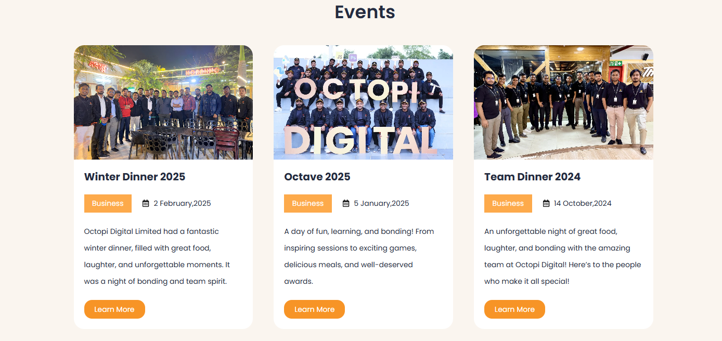

Conclusion

My internship journey has been a great journey in Octopi Digital Limited. It’s given me a depth understanding of Client Management, Digital Marketing and taught me to face the challenges and grabbing the opportunities that come with a B2B focused Digital Marketing Agency. I have witnessed the journey of how a structured client management strategy works a major role in maintaining the long-term relationship. During that period, I learned about how to ensure the client satisfaction and can ensure the business growth. The main concern of Octopi Digital Limited was providing the best quality service to the clients by maintaining transparency and continuously improving its process.

One of the big learning from this internship was that client management is not just about delivering quality full service, it’s about building trust, communication, credibility and long-term collaboration. I saw that how Octopi Digital Limited maintain and handle client acquisition, conflict resolution, execution, and retention with a strong strategic approach, making sure that every client interaction adds value. And also, I have identified where company can give more efforts and can bring more changes by developing digital products, expanding into new market and prioritizing more in employee motivation and well-being.

Octopi Digital Limited is a startup company. Now it is in the crucial growth phase. The dedication of the employees is incredible. Employees of Octopi Digital Limited are very much hardworking and dedicated on their works. Which playing vital roles in companies’ success. I believe, focusing on both client satisfaction and employee well-being can scale more faster and create a sustainable long-term impact. The experience in Octopi Digital Limited doesn’t only help me to grow professional skill, its also given me broader perspective in how a company operate and scale in competitive market.

I am incredibly grateful for the opportunity to work in Octopi Digital Limited. That period was a great experience to work with a passionate team. I believe Octopi Digital Limited can improve more in their strategical sides and also the innovation side and one day Octopi Digital Limited will be mark on the global stage.

Reference

- The Impact of Digital Marketing in Bangladesh – Retrieved on 2nd December 2024 from https://digital.implevista.com/the-impact-of-digital-marketing-in-bangladesh-in-2024/
- Technological Factors – Retrieved on 10th December 2024 from https://vajraglobal.com/blogs/impact-of-technology-on-digital-marketing/
- Company Information – Retrieved on 24th December 2024 from https://octopi-digital.com/
- Industry Rivalry - Retrieved on 10th January 2025 from https://learn.marsdd.com/article/industry-rivalry-and-competition-using-five-forces/#:~:text=Industry%20rivalry%20usually%20takes%20the,opportunity%20to%20improve%20their%20position.
- Customer Mix Idea - Retrieved on 15th January 2025 from https://www.mbaskool.com/business-concepts/marketing-and-strategy-terms/10952-customer-mix.html
- SWOT Analysis - Retrieved on 10th January 2025 from https://asana.com/resources/swot-analysis
- Why Client Management strategy – Retrieved on 25th February 2025 from https://nimbusweb.me/blog/client-management-key-strategies/
- How client Management strategy practiced - Retrieved on 25th February 2025 from https://www.corexta.com/the-client-management-strategies-for-business-and-professionals/

