Internship Report on
“Understanding Digital Advertising Through Bitspearhead Limited”

Tanzila Yeasmin Sara

This report is submitted to the School of Business and Economics, United International University, as a partial requirement for the degree fulfilment of Bachelor of Business Administration
Internship Report on
“Understanding Digital Advertising Through Bitspearhead Limited”

Submitted to:
Dr. Md. Shariful Alam
Professor and Deputy Director
BBA Program
School of Business and Economics

Submitted by:
Tanzila Yeasmin Sara
Id: 111 152 243
BBA

School of Business and Economics

United international university

Date of submission
April 3, 2023

Letter of Transmittal

April 3, 2023
Dr. Md. Shariful Alam
Professor
School of Business & Economics (SOBE),
United International University (UIU)
Subject: Submission of the report on “Understanding of Digital Advertising through Bitspearhead Limited”
Sir,
With all due respect, it is my great honor to provide my paper on "Understanding of Digital Advertising through Bitspearhead Limited." I'm presenting a report on my three-month internship at Bitspearhead Limited Bangladesh. I discovered a lot of new information about digital marketing while writing this report. The knowledge I have acquired is irreplaceable to me and will benefit me throughout my entire life. I put a lot of effort into writing this report, and I'm hoping it will help me fulfill my degree requirements.
So, I therefore pray and hope that you will help me with proper guidance to prepare this report.

Sincerely,
Tanzila Yeasmin Sara
ID: 111 152 243

Certification of similarity index

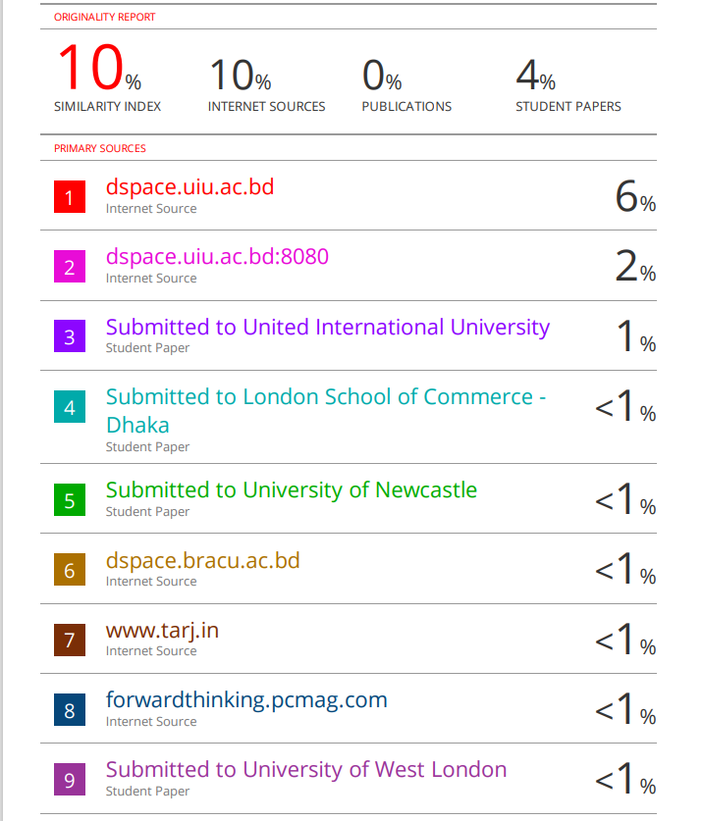

Declaration of the student

In the first place, I want to assure you that the internship report on "Understanding Digital Advertising Through Bitspearhead Limited" does not replicate prior research. To make this report as pertinent as possible, I have tried my hardest. I further guarantee that this report will not be presented to anybody and that it has never before been given to anyone for any other research purpose.


.. ......................................
Tanzila Yeasmin Sara
ID: 111 152 243
Program: BBA
School of Business & Economics (SOBE),
United International University (UIU)

Acknowledgement

I would like to take this opportunity to thank everyone who helped me to complete this paper on "Understanding of Digital Advertising through Bitspearhead Limited." I want to start by thanking the Almighty Allah, who is my creator, our sustainer, and my guardians, for his support up to this point. My profound gratitude goes out to Dr. Md. Shariful Alam, professor, in the United International University (UIU), Department of Bachelor of Business Administration, for his assistance during the first three months of my entry-level work. I truly appreciate Bitspearhead Limited's Head of Sales and Business Development allowing me to participate in the temporary employment program for their prestigious division. I want to express my gratitude to all UIU staff members, associates, and housing partners who inspired me to finish my report and offered sage advice, practical suggestions, and encouragement.

Executive summary

Bitspearhead Limited began its operations as an ad-tech in 2016 and has led significant innovation in the Bangladeshi digital space ever since. Bitspearhead primarily serves as a YAHOO! approved reseller. When dealing with brands, Bitspearhead mainly lets them know that they have direct ad space available on ESPN CRICinfo, POKKT, Yahoo, Sizmek DSP, IMO, Beauty-plus and Truecaller, Share-it, and Viber. As the company is a direct publisher in Bangladesh, there is no need for clients to place bids, resulting in stable prices. Additionally, the company offers prime inventory, such as pop-up ads on ESPN and Cricbuzz, which Google DSP cannot supply.Bitspearhead is renowned for having a competitive edge over all other advertising agencies and advertisers in Bangladesh because it is the country's sole reseller of international brands. In my report, I addressed the company's current operations, marketing mix strategy, and SWOT analysis. I attempted to use Porter's Five Forces model to illustrate the function and operations of the firm's segment in the Bangladeshi advertising business. Examining Bitspearhead Limited's current sales and business development operations and activities is the main objective of this study. An overview of the findings is provided at the end, along with a set of suggestions for improving departmental efficiency.

Table of contents for Internship
Table of Contents
Letter of transmittal 3
Certification of similarity index 4
Declaration of the student 4
Acknowledgement 5
Executive summary 6
Table of contents for Internship 7
List of Figures 9
List of Table
CHAPTER I: INTRODUCTION 10
I.1 Background of the Report 11
I.2 Objectives of the Report 11
I.3 Methodology of the Report 12
I.4 Scope and limitations of the Report 13
CHAPTER II: COMPANY AND INDUSTRY PREVIEW 14
2.1 Company Analysis 15
2.1.1 Overview and history 15
2.1.2 Trend and growth of Bitspearhead Limited 17
2.1.3 Customer mix 18
2.1.4 Product/Service mix of Bitspearhead Limited 18
2.1.5 Operations 24
2.1.6 SWOT analysis of Bitspearhead Limited 30
2.2 Industry analysis 32
2.2.1 Specification of the Digital marketing industry 32
2.2.2 Size, trend, and maturity of the Digital Marketing industry in Bangladesh 33
2.2.3 Competitive Analysis 35
2.2.1 Barriers to entry 35
2.2.2 Supplier Power 36
2.2.3 Buyer Power 36
2.2.4 Threat of Substitutes 36
2.2.5 Industry rivalry 37
CHAPTER IV: INTERNSHIP EXPERIECNE 38
4.1 Position, duties, and responsibilities 39
4.2 Training 41
4.3 Evaluation 42
4.4 Skills applied 42
4.5 New skills developed 43
4.6 Application of academic knowledge 43
CHAPTER V: CONCLUSIONS AND KEY FACTS 45
5.1 Recommendations for improving departmental operations 46
5.2 Conclusion 47
Reference 49
Appendix-A: 50

List of Figures

SL No. | Figures | Page No.
1 | Reach and Partners of Bitspearhead Limited | 12
2 | Organogram of Bitspearhead Limited | 17
3 | Current trend of Digital Marketing in Bangladesh | 18
4 | Yahoo Users in Bangladesh | 25
5 | Users of Sizmek DSP in Bangladesh | 27
6 | Users of ESPN CricInfo in Bangladesh | 27
7 | Users of IMO Messenger in Bangladesh | 28
8 | Users of LIKEE in Bangladesh | 29
9 | Users of POKKT in Bangladesh | 30
10 | Users of mCanvas in Bangladesh | 30
11 | SWOT Analysis of Bitspearhead Limited | 31
12 | Scenario of Digital Marketing in Bangladesh | 32
13 | Social media Statistics in Bangladesh | 33
14 | Porter’s five forces | 35

CHAPTER I: INTRODUCTION



Background of the Report

This internship report was created with the intention of facilitating every university graduate who participated in an internship program finish their BBA degree. Even though the internship experience is a curriculum assigned in the academic course outline, it differs significantly from other programs in that students must undergo an interview to work in a corporate environment as an intern. After finishing all courses, a student must endure a specific term of employment placement in a temporary workplace. Students will gain practical knowledge about the corporate world during their internship time; this knowledge is very different from theoretical understanding. The knowledge we learn in college is actually about a half step off from real-world application. An internship program, which lasts three to four months, is typically taken by students who are nearing the end of their BBA degrees. At Bitspearhead Limited, where I worked for 3 months from October 15 2020 to January 15 2021 as a sales and business development trainee, I developed practical knowledge of digital marketing and the Bangladeshi market's accelerated expansion.
I commenced working on the assignment titled "Understanding of advertising through Bitspearhead Limited" by Dr. Md. Shariful Alam, Professor at the United International University's school of business and economics.

Objectives of the Report

Broad Objective
The primary objective of preparing this internship report for accomplishing the BBA degree from the BBA Program of United International University as the internship programs are necessary preconditions for finishing the BBA program.
Specific Objectives
The secondary objectives of this report follows:
- To define the existing company overview of Bitspearhead Limited
- To highlight the current advertising industry for Bitsperhead Leveraging Digital
- To highlight the trend and growth of Digital Marketing in Bangladesh
- To identify issues or limitations of Bitspearhead Limited
- To propose some recommendations for improving departmental operations of Leveraging Digital

Methodology of the Report

To complete the present study both primary and secondary data have been collected which have been discussed below:
Primary Data
The primary sources used in this study were interactions with fellow employees and my performance of the regular additional responsibilities I received from the line manager at casual meetings and face-to-face interactions.
Secondary Data
For the secondary data, the official website of Bitspearhead Limited and its documents and booklets, online journals and articles on digital marketing, advertisements, trends and limitations of promotional methods in Bangladesh, online and operational papers of the partner brands of Bitspearhead including Cric Buzz Info, POKKT, Yahoo, and Simek have been used. In addition, the 2017 version of the academically cited book E Commerce by Laudon has been used for a range of information implications.

Scope and limitations of the Report

As the current research only concentrated on the reseller perspective and the digital marketing element for a specific time frame, it will be useful for future advertisers to enhance their operations. However, the report also had the potential scope to shed insight on Bangladeshi advertisers' concerns about the dominance of international brands over local ones.
The restrictions and limitations I had to adhere to while preparing the internship report include:
- It was challenging to cover every part of Bitspearhead's advertising efforts in the time allotted.
- Due to their confidentiality policy, the company was adamant about sharing some information even though the report contains a variety of company-related facts.
- The data that was gathered from the company's other employees might not be accurate for the time being.
- As I work there full-time, I have less time to gather the essential data while finishing my own tasks, which can be seen as a major restraint.

CHAPTER II: COMPANY AND INDUSTRY PREVIEW

Company Analysis

This section of the study will commence with a brief overview of Bitspearhead Limited, then evaluate the current market trend in Bangladesh, the firm's development through time, the management structure, and highlight current operations followed by a SWOT analysis.

Overview and history

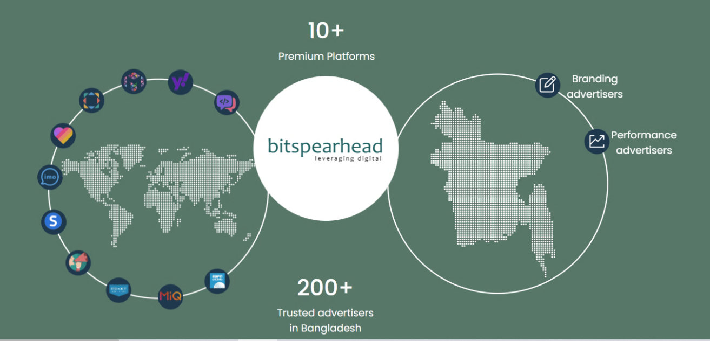
Bitspearhead Limited is predominantly an ad-tech company that began operations in 2016. The company's main goal is to establish novel approaches to building digital platforms by interacting with local and international businesses all over the world. In addition to increasing the return on Investment (ROI) of the brand's current digital spending in the Bangladeshi market
Fig 1: Reach and Partners of Bitspearhead Limited
Bitspearhead primarily strives to boost company image in gradual shift to end-consumers where it has also developed direct partnerships with a number of well-known international businesses, including Bigo which includes IMO and Likee, ESPN CRICinfo, Cricbuzz, Yahoo, MIQ, Beauty-plus, POKKT, Vidmate Sizmek, True Caller, Share-it, and Viver. The firm is also working as the official reseller of these global brands in Bangladesh. In alignment with an aim to introduce digital marketing solutions in the Bangladeshi market, the firm has also launched its first 3D advertisement technology on Live Cricket match in Bangladesh. Up to this point, the company has also successfully managed various advertising and marketing campaigns on a digital platform for both domestic and international brands, including Unilever, Marico, Samsung, Vivo, Huawei, Nestle, Coca-Cola, Sprite, Daraz, Banglalink, Shah Cement, Nagad etc.

Organogram of Bitspearhead Limited

Fig 2: Organogram of Bitspearhead Limited

Bitspearhead Limited is following the centralized organizational structure for their existing operations and functions.

Trend and growth of Bitspearhead Limited

As the aspects of digital marketing progress gradually in Bangladesh. The majority of businesses concentrate on leveraging digital platforms to market their goods. Because of the advantages of the niche targeting alternative in digital marketing, where advertisers may discover the right ROI, businesses like Bitspearhead are assured that they can run campaigns based on their own objectives, regular banner campaigns for ongoing brand awareness, lead generation campaigns for sell-based or precooking campaigns, and cost per activation or cost per sell campaigns for digital marketing. The company is actively acquiring its connection with POKKT, one of the emerging gaming platforms in Bangladesh that are currently becoming a trend in the market because of the user’s attitude and influential capability towards the platform.
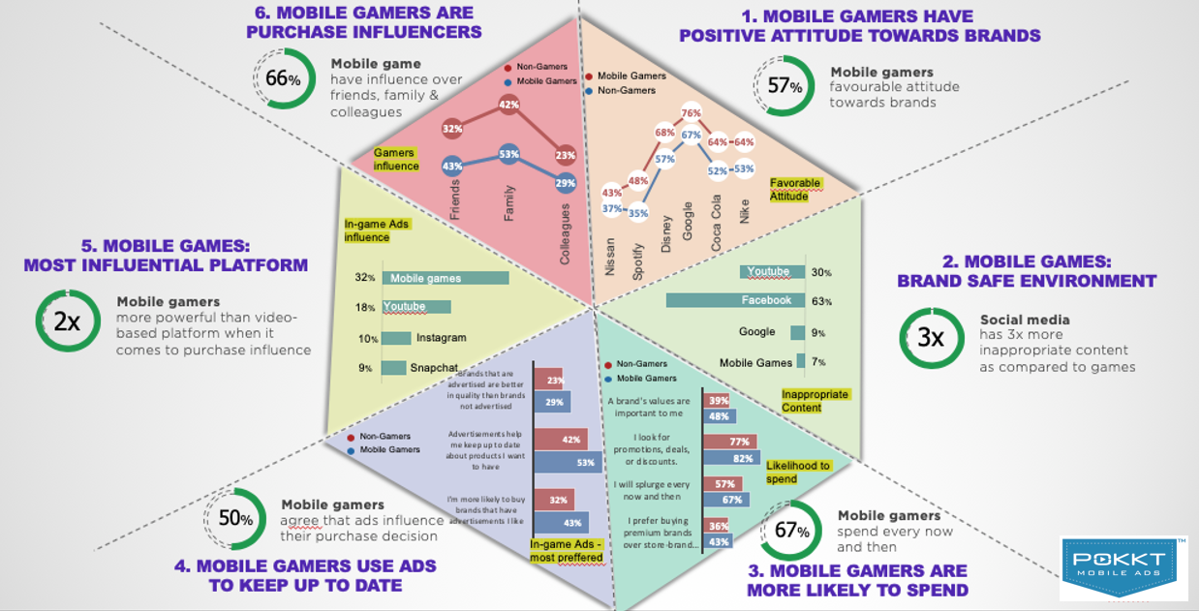
Fig 3: Current trend of Digital Marketing in Bangladesh

Customer mix

Customer mix primarily refers to the percentage of a given type of customer segment's overall sales that segment contributes to the company's sales. Bitspearhead's customer mix will reveal which client segments are served by the company. Additionally, it will show which client category is most crucial to the company in generating sales and which segment is trailing in the present market, (Customer mix, 2014).
As the key target market for Bitspearhead is the brands, which often rely on advertisers to produce advertising concepts and agencies for sustainability in the business. Bitspearhead has developed its business model on a B2B or Business to Brand basis. The company mainly offers and purchases advertising solutions for various brands based on their preferred promotional source and digital media platforms. As Bitspearhead is currently the principal reseller of the services to publish advertisements for numerous international brands, including ESPN Crickinfo, Crickbuzz, True Caller, Beauty Plus, IMO, Share-it, Verizon DSP, and Sizmek DSP, the brands that are currently looking for engagement campaign solutions and brand awareness solutions will constitute the majority of Bitspearhead's customer base. As the firm has worked with more than 200 reputable advertisers and more than 10 premium brands in Bangladesh, they are undoubtedly utilizing their distinct capacity and realistic implementation to be the industry's major competitive edge.

Product/Service mix of Bitspearhead Limited

The various components of services marketing that businesses utilize to spread their business and branding message to customers are combined to form the service marketing mix (“Service Marketing Mix”, 2020). The 4ps of the marketing mix, which are engaged in Bitspearhead's product marketing, will be thoroughly covered in this section of the study.
Product
Bitspearhead Limited is providing a number of digital solutions as a service; besides a product, however, the services are abstract and therefore cannot be estimated by the appearance, touch, or other characteristics of a consumable. To boost customer experience, it must be developed with the utmost caution and can be tailored to the user's demands to add a personalized experience. The services or products that the firm is currently offering to its clients include:
Advertising Support of Bitspearhead Limited:
- Messaging App Advertisement
- Mobile Gaming Advertisement
- Data Driven Influencer Marketing Solution
- Programmatic Advertisement
Content Support of Bitspearhead Limited:
- Rich Media
- Innovative interactive ads HTML creation
Tracking Support of Bitspearhead Limited:
- Tracking Solution for Brand Safety
The firm mostly place advertisements of their clients on their partnered platforms based on billing and different forms of CPM campaigns for the brands.
Price
Clients don't need to place bids for the platforms as the company serves as the direct publisher in Bangladesh. It also offers a fixed fee for advertising space as well as premium inventory like pop-up ads on ESPN and Cricbuzz, which Google DSP don’t offer for the clients. Since Bitspearhead doesn't charge brands or agencies a commission, the company primarily buys large quantities of advertising space from Yahoo, IMO, Share-it, True Caller, Beauty Plus, ESPN Circkinfo, and Crickbuzz before reselling it to bands and agencies for a higher price.
The company offers a fixed CPM rate and discourages customers from trying to sell below the margin, which would result in losses for Bitspearhead. The current pricing strategy of Bitspearhead services follows the following pricing:

Pricing for “ESPNcricinfo”
Properties | Billing Basis | Offer Cost
Leaderboard (Web) | CPM | $1.92
Overlay (Web) | CPM | $6.60
MPU (Web) | CPM | $1.92
Interstitial App and WAP) | CPM | $ 6.48
Standard Banner (App and WAP) | CPM | $1.92
MPU (App and WAP) | CPM | $1.92

Pricing for “IMO Messenger”
Properties | Billing Basis | Offer Cost
Native MPU (App) | CPM | $1.92

Pricing for “Yahoo”
Properties | Billing Basis | Offer Cost
Native | CPM | $0.06

Pricing for “Cricbuzz”
Properties | Billing Basis | Offer Cost
Standard Banner (App ad WAP) | CPM | $2.40
MPU (App ad WAP) | CPM | $2.88

Pricing for “ShareIT”
Properties | Billing Basis | Offer Cost
Home Page Banner (App) | CPM (Min $350) | $1.80
Radar Banner (App) | CPM (Min $350) | $1.56
Splash Screen (App Launch) | CPM (Min $350) | $2.16

Pricing for “BeautyPlus”
Properties | Billing Basis | Offer Cost
Top Banner (App) | CPM | $3.60
Splash Screen (App Launch) | CPM | $5.40

Pricing for “Truecaller”
Properties | Billing Basis | Minimum Budget
Roadblock | CPM | $4700
After call screen, call view and notifications | CPM | $4700

Pricing for “Verizon and Sizemek”
The rate of the services are mostly charged by the Verizon and Sizemek team which varies from brands to brands based on the campaigns which include:
- Cost per Lead Campaign
- Cost per View Campaign
- Cost per Click Campaign
- App installment Campaign

Place
The place Bitspearhead Limited chooses to perform its firm in can help or hinder their company effectiveness, thus the team is presently concentrating on determining how noticeable and regularly mentioned their existing setup would be by clients. The most frequent strategy that the firm uses for their employees to adopt in communicating with the potential clients or the brand managers and agencies include:
- Office Tours or Visits
Since establishing cordial relationship with publishers and clients is one of the company's core goals, a team or a particular from Bitspearhead typically visits the offices of publishers, agencies, or brands to speak with the respective marketing executives or the advertising agency professionals and address their concerns regarding the project. As currently every possible brands are on verge of creating their own brand awareness to the local market there, one of the main tasks that the employees try to encourage is gathering upcoming information, including pertinent contact information to interact with them in the future.
- Attending Seminars and other relevant events
The seminars and events hosted by various associations, sponsors, and organizations in Bangladesh give entrepreneurs the chance to showcase their products to the top players in the market and potential customers. In these situations, Bitspearhead frequently targets these events to connect with advertising agencies and marketers. Such occasions also assist the company in staying current with emerging market trends and digital advertising possible outcomes.
- Communicating via Phone
In order to go for the initial pitch, the company primarily responds to the marketing executives of the brand who are primarily responsible for managing the digital media buying via calling the provided number. As the business advertises benchmark to create partnership with potential buyer partners, recognize, generate, and develop marketing alternatives firmly rooted on reaching quantifiable project outcomes for the customers In the future, the firm prefers phone calls to inform clients about regular activities and impending meetings.
Promotion
The service industry typically faces intense rivalry in all market segments, making it necessary for businesses to invest heavily in marketing in order to effectively reach prospective clients. While direct marketing, web marketing, and advertising are the greatest ways to advertise Bitspearhead's service, a solid mix of communication channels is necessary to reach a wider audience. Because Bitspearhead's promotional efforts differ significantly from those of typical businesses, the company uses a variety of promotional strategies which include:
- Acquisition Strategy
The Bitspearhead employees act as the company's marketers, and either the whole team or a specific employee will frequently attend marketing-related events hosted by other businesses and agencies. This will assist the company establish connections with other potential advertisers and brand managers. Visitor's cards and pertinent contact information are the main tools for putting these plans into practice and extending the company's current operations to other brand managers and agency personnel.
- Retention Strategy
As part of its retention strategy, Bitspearhead frequently gives away presents, often in the form of branded or specially made goods from companies they are currently engaged with rather than actual commodities. These goodies are typically T-shirts, pens, pads, water bottles, and other items from the partner platforms. In addition, the business offers frequent and long-term customers discounted pricing on campaigns, which is also regarded as a component of the business's client retention efforts. In addition, the company frequently hosts events like welcoming parties for the end of festivals and arranges casual encounters with brand managers. The firm's primary retention strategy also includes participating in and attending their events to establish a lasting relationship.

Operations

In order to inform advertisers about the direct space that Bitspearhead is now providing on digital platforms like ESPN CRICinfo, Cricbuzz, IMO, Beauty-plus and True caller, Share-it, Viber, and Cricbuzz, it must communicate with them. Since the company is reselling the space directly, clients can purchase the space at their given fixed rate with a provided purchasing plan when the client approves it. The plan will include the necessary ad campaigns and other material linked to the completion of the campaign. Following the issuance of all campaign materials, the SVG (Seventy-Nine Media) in India, will reach with a publisher of Bitspearhead and ask them to post the client’s advertisement on their app or website in accordance with their preferences and requirements. The current operations of the firm involves several key platforms which include:
Yahoo and Verizon Media
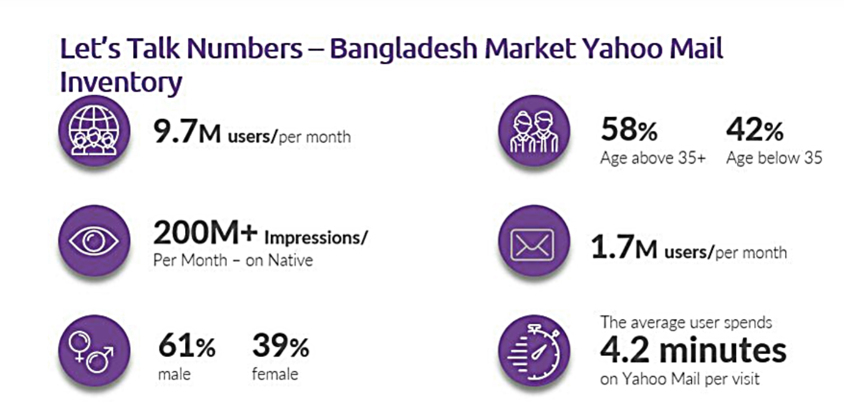
With 9.7 million users in Bangladesh and 200+ million impressions per month on native market, Yahoo is a leading worldwide media and technology firm that helps users interact with their interests. For the affiliates and brand managers, Yahoo ad tech had offered a full-stack platform designed to assist organizations expand and foster stronger ties spanning advertisements, searches, and multimedia. The organization presently uses Yahoo's Gemini to deliver leading edge optimizations and targeted advertising.
Fig 4: Yahoo Users in Bangladesh
Given that Verizon Media owns Yahoo, the company has changed its organizational structure to better position itself for the future of the market by focusing less on telecommunications and more on expanding its technology business.
Verizon Consumer, Verizon Media, and Verizon Business are the three business areas that the corporation largely streamlined. With the use of the combined data, Verizon DSP and Bitspearhead are able to make more data-driven decisions that will improve market outcomes. The company also provides native advertising on the Yahoo News site and on the pages of its various partners, including Adobe, Flicker, and Tumbler. Through Verizon DSP, Bitspearhead also offers a variety of campaign types, allowing users to bid on any ad space on any platform, including Google, Facebook, and others. Some of these campaigns include:
- Cost-per-click advertising campaign on the websites of Yahoo or its partners
- Cost-per-view advertising campaigns on platforms like Facebook, Google, and others, as well as on apps and websites, for bidding properties
- Cost per lead or sales campaign
- Cost per view of a video
- Cost per installation of app and app engagement

Sizmek DSP
Additionally, Bitspearhead will launch the Sizmek DSP service, which will provide AI-enabled bidding capabilities and allow businesses to purchase advertising space on any
platform, including Google, Facebook, and platforms running any Operating System (Windows, iOS, etc.). Sizmek tracker will be utilized to more precisely track the quantity of impressions, leads, and clicks. Additionally, brands are given access to the tracker service so they may correctly track customers, particularly to foster client-company communication.

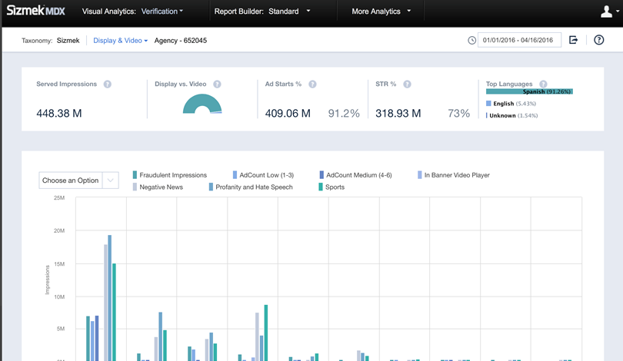

Fig 5: Users of Sizmek DSP in Bangladesh
ESPN Cricinfo
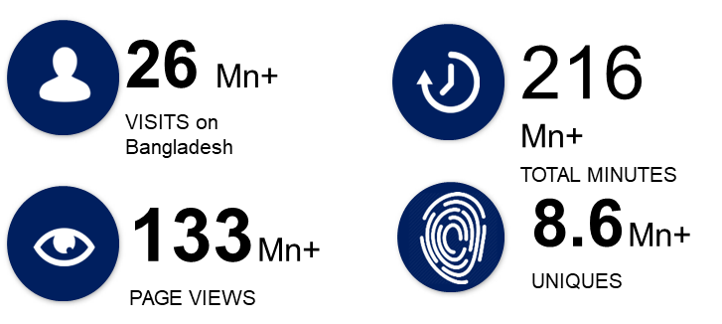

Fig 6: Users of ESPN CricInfo in Bangladesh
The company ESPNcricinfo ensures the maximum amount of Share of Voice through its recurring users who consume more than 264 Million minutes each month on its platform, which offers the finest brand visibility. Through 3D ads, GIFs, video ads, static ads, interactive games in JAVA format, and pop-up ads, Bitspearhead has reformed screen advertising.

IMO Messenger
IMO Messenger is now delivering over 15 Million unique users per month from and can provide over 30M+ impressions in a day, making it the top Messenger app in Bangladesh. Imo is for B & C segment of individuals focusing as it is extensively utilized in rural areas and people of average class where the users would use it for CPM, CPC, CPI, and CPT campaigns that they will be charged for every view.
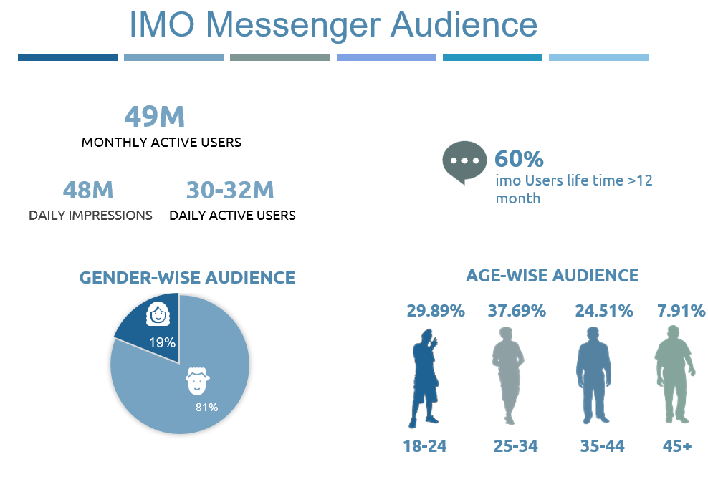

Fig 7: Users of IMO Messenger in Bangladesh

Share it and Beauty plus
Both Share it and Beauty Plus cater to a young audience, mostly made up of female users, and both apps currently offer static ad material for the sponsors.

Viber
Since Viber traffic in Bangladesh is significantly lower than in other states' markets, Bitspearhead is now offering CPM campaigns on both media types with static advertisements that solely contain images.
Likee
With a regular user MAU of 12M+ in the Bangladeshi market, Likee has expanded its commercial value thanks to its users' high engagement, involvement, and dissemination levels. As a result, it is currently the fourth most downloaded social media app globally in 2020. Through this platform, advertisers can influence young male and female consumers to support a brand.
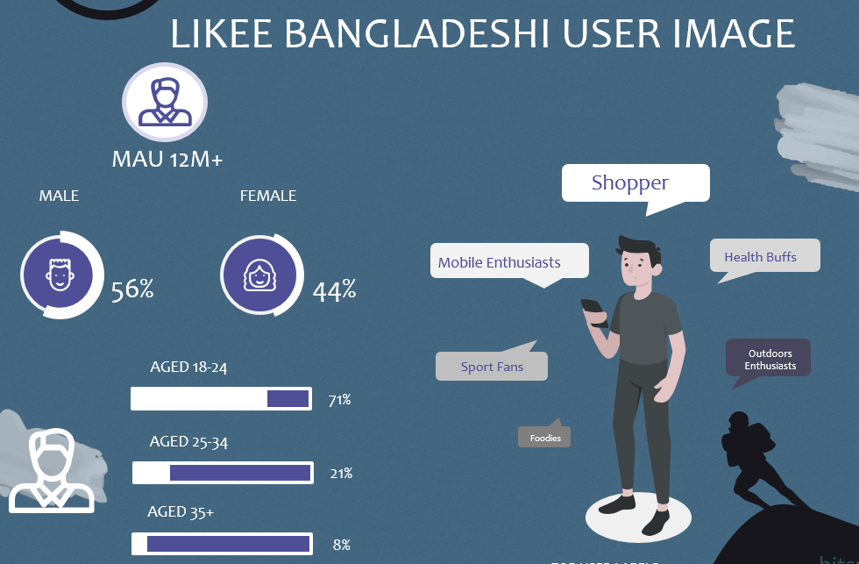

Fig 8: Users of LIKEE in Bangladesh

True caller
Bitspearhead offers full road block for 7 days on all True Caller ad units, allowing advertisers to supply in all ad properties by using the road block service for 7 days. Additionally, according to the needs of the brand, CPM campaigns, CPA consumer per action clicks, and additional fees for lead conversion are also available.

POKKT
Prominent mobile in-app and web advertising platform POKKT serves leading international companies across industries, assisting them in achieving a wide range of marketing goals. High engagement, full-screen only opt-in video ads
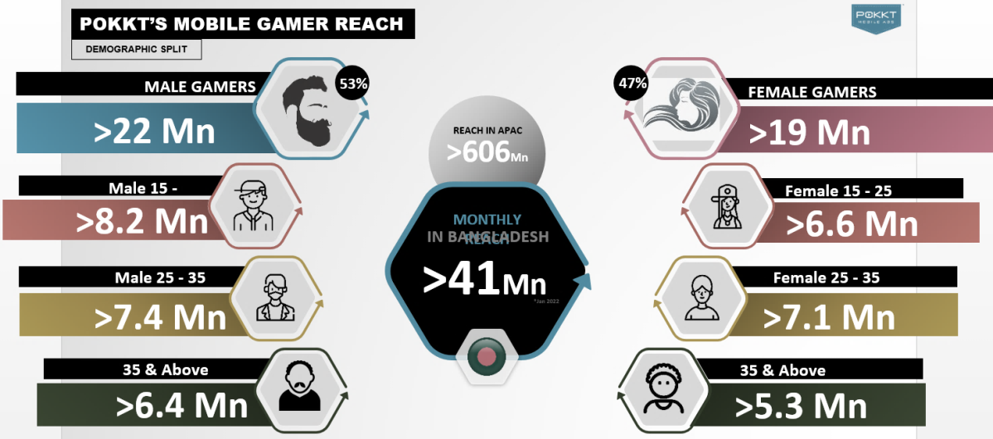

Fig 9: Users of POKKT in Bangladesh
mCanvas
mCanvas is predominantly a mobile branding firm that offers clients dramatic mobile advertising experiences by combining their brand's narrative with smartphone features and sensors via higher intensity display and video formats throughout upscale websites and mobile apps to create the advertising outcomes.
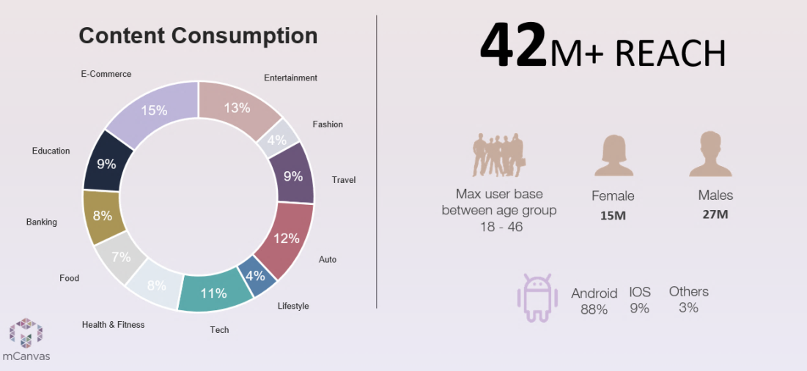

Fig 10: Users of mCanvas in Banglades

SWOT analysis of Bitspearhead Limited

In this section, a SWOT analysis on Bitspearhead Limited has been conducted to highlight the internal (strengths and weakness) and the external (opportunities and threats) factors of the company to strategize as a proactive approach.

Fig 11: SWOT Analysis of Bitspearhead Limited

Industry Analysis

Specification of the Digital marketing industry

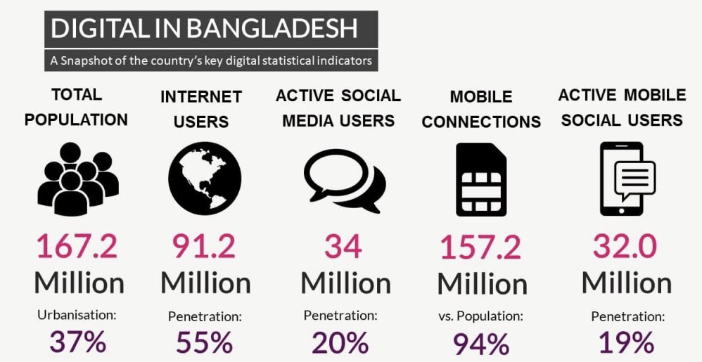
There is currently no easier marketing strategy than digital marketing to spread awareness for brand goods or services, given the rising number of Internet users in Bangladesh. If the businesses can conduct digital marketing properly, they will be able to quickly distribute the goods or services of any firm to the public. Through product promotion, marketing's primary goal is to educate consumers about the product. A creative marketer's duties in this situation would be to promote a service or product in an area where more people are passing by and remaining for longer periods of time, (Islam, 2020). It is beneficial to understand the differences between traditional marketing and digital marketing in today's technological age because traditional marketing is expensive while digital marketing may be carried out for a very low cost.

Fig 12: Scenario of Digital Marketing in Bangladesh (“How digital marketing”, 2021)
As per (Islam, 2020), digital marketing makes it possible to advertise products more quickly than with traditional marketing. Additionally, the number of social media users in Bangladesh increased by 3.0 million in 2020, showing that many different social media platforms, including Facebook, Twitter, Instagram, etc., are used as a way to spend the time. They use these social networks or social media to stay in touch with one another, as well as with numerous other businesses or people. Therefore, digital marketing is a massive medium for promoting the goods or services. The advertisers fail to take action by watching television advertisements, and traditional marketing platforms are unable to provide fast response and reports about who interacted with the advertisement. Digital marketing has made advertising more targeted and real-time based, allowing brand managers to choose the campaign time, audience time, and the interests of the individuals they are targeting for the campaign with precise targeting parameters. One of the well-publicized initiatives that entices brand managers to select the specified platform is ESPN's frequency restriction. In Bangladesh, young people's influence in the field of digital marketing has also risen steadily. Youth have more employment options now than ever before as the need for digital material rises. Additionally, the coronavirus epidemic has greatly accelerated this. The demand for tech-savvy digital marketers is continuously rising as Bangladesh continues to integrate modern technology into commercial operations, (“How digital marketing”, 2021).

Size, trend, and maturity of the Digital Marketing industry in Bangladesh

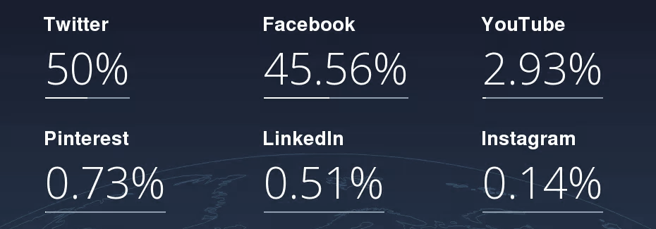
Businesses have always had to plan for their precise competitive advantage in the advertising market due to its intense competition. Firms won't be able to survive over the long term if they can't provide good quality service. The rivalry has been at its greatest point to earlier reach the targeted segment since market trends keep fluctuating and moving as a result of shifting consumer preferences

Fig 13: Social media Statistics in Bangladesh (Starcounter)
As per (Hasanat, Hoque, Anwar, Akter, & Hamid, 2020), an important and effective component of digital marketing is online product advertising. Managers of businesses can influence customers by advertising various products and services through internet promotions. On the other hand, because it limits the expense associated with the product's advertisement, online product marketing is also economical. Both consumers and producers save time and effort when using internet advertising. Through online marketing, people learn about a lot of things in a short amount of time. The Bangladeshi government is also providing financial aid to organizations planning to digitize their operations. For instance, there are now more travel apps, tourism portals, and online health services available in the nation. Due to the growing popularity of social media platforms, Bangladesh's markets have been receiving more attention and relevance. Business companies that operate in the Bangladeshi market have chosen to advertise their enterprises on websites like Facebook, YouTube, and others. Advertising agencies are pressuring brands to spend on Facebook and Google rather than publishing their advertisements on direct media purchasing platforms, leaving brands unable to resist and compelling them to spend inordinate amounts of money on these platforms.
To free its customers from the sway of expensive advertising on Facebook and Google and to give them a fresh perspective on advertising, Biitspearhead Limited has developed a number of products. These products use direct marketing techniques to provide customers a unique experience with advertising.
The e-commerce giants, such as eBay, Amazon, and Ali Baba, are benefiting greatly from the rise in mobile phone penetration. Both traditional stores and traditional industries are transitioning to ecommerce-based sales. By letting Google ad services on their apps, digital platforms like IMO, Viber, and True Caller make money. Digital marketing's characteristics are always evolving. Additionally, Bitspearhead has successfully managed a number of campaigns with leading companies in Bangladesh, including MindShare, All Group M Companies, Bitopi, Analyzen, Grey, Dentsu Aegis, StarCom, Samsung, Vivo, Huawei, Nestle, Coca-Cola, Sprite, Daraz, Bangla Link, Shah Cement, and Nagad.

Competitive Analysis

To better evaluate the level of industry competitiveness for Bitspearhead Limited and increase a company's long-term profitability, every sector of the economy can benefit from applying Michal E. Porter's model. A framework called "the forces" can be used to analyze a company's competitive environment. It is also widely used as a reference point for assessing the competitive forces that have an impact on various business sectors. Even these forces can be employed as a strategy guide for business to gain a competitive edge, (Scott, 2022).
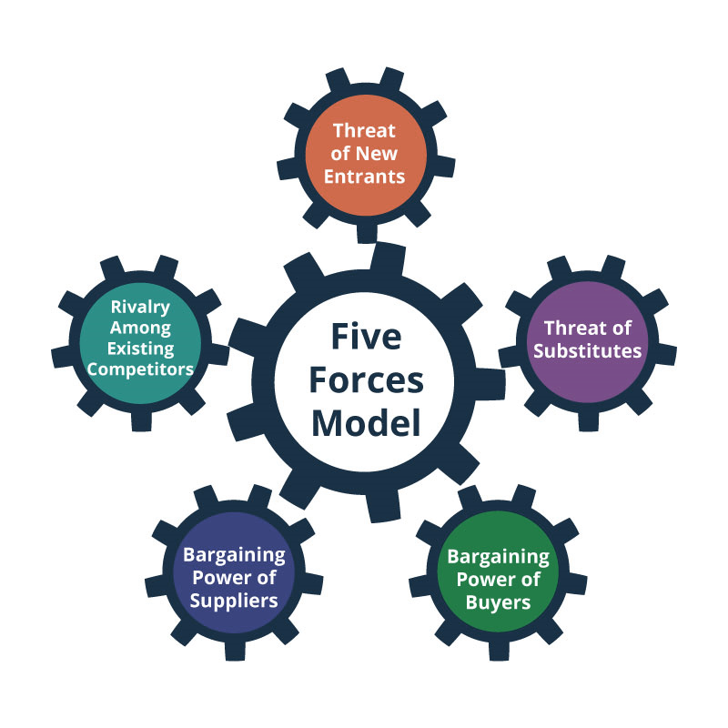

Fig 14: Porter’s five forces, (“Porter’s Five Forces”, 2021)

Barriers to entry

Due to the industry's tendency for market leaders to dominate, fresh entry from comparable companies may not have as much of an impact. On the other hand, monopolies sometimes benefit from government policy. Because of this, it can be challenging for new businesses to comply with regulations. But companies like Bitspearhead may be able to join the market more readily with the assistance of other significant global brands and exclusive operations, such as the sole reseller rights of the ad space of major brands, including Yahoo, Verizon, Imo, POKKT, and others.

Supplier Power

In terms of supplier power, the company has to face a higher supplier dominance for the operations. Since Bitspearhead is employed by SVG Media, they are forced to deal with intense negotiations, which involve paying extra VAT (estimated at 15% more than the amount allotted by the government) in order to engage with foreign publishers and advertisers. As a result, the profit margin is reduced. The SVG even has to offer free trials to clients in order to sustain long-term business and cover corporate expenses.

Buyer Power

As Bitspearhead competes with industry giants as well as other major international brands and publishers, customer negotiating power has grown to be a big benefit for business owners. Customers frequently want a free trial or a lower CPM for a test campaign, which causes the business to incur losses when launching new initiatives. For this industry, the purchasing power is also considered strong here.

Threat of Substitutes

As the advertising business in Bangladesh is expanding, there are other companies functioning for ATL or BTL who are substitute adversaries because Bitspearhead is focused specifically on online platforms. Due to the fact that they are digital platforms and may target the same customers through their targeting options whilst offering low and set rates to gain a competitive edge, the company has direct competitors or replacements such as Facebook, Google, Twitter, and LinkedIn. For this industry, the threat of substitutes is also considered high here.

Industry rivalry

Since Bitspearhead has only recently entered this market, they tend to have some direct competitors who, in some situations, can charge less than the company's suggested pricing plan and who can also directly compete together on price. Because of the transparency and competitiveness in the market, there is a greater chance that current clients will choose the competitors.

CHAPTER IV: INTERNSHIP EXPERIECNE

Position, duties, and responsibilities

Position: Specialists/Trainee, Sales and Business Development
During the 3 months Internship period, I worked as the specialist/trainee under Sales and Business Development of Bitspearhead Limited from October 15 2020 to January 15 2021. It was an immense pleasure to be offered the chance to complete an internship at Bitspearhead in the sales and business division. One can constantly learn something new about the advertisement market by working in sales and business development. The four months I spent on a work placement were jam-packed with educational opportunities. My communication skills and understanding of digital marketing have both advanced. Every day, I interacted with and helped a large number of brand managers. That made it much easier for me to bargain with the publishers. I feel incredibly confident in the interim. I also learned some important information about the advertising sector.
Duties
The duties that I were assigned during the internship period follows:
- To research and comprehend each internet platform that Bitspearhead is utilizing at the moment which include their current partners- IMO, Likee, ESPN, MIQ, POKKT, Yahoo, Verizon, & Sizmek.
- For the comprehension of the brands and their products, there was a constant need for knowledge improvement and effort, which included attending various workshops and training sessions.
- To devote a significant amount of time to mastering the company's existing procedures and operations, including attending all training sessions as determined by the reporting manager.
- Support for documenting relevant and necessary papers and reports in PowerPoint and Excel
- Keep publisher dashboards up to date
- Maintain positive interactions with clients and publishers by ensuring effective communication
- As the designated reporting manager, to participate in both online and offline sales calls.
- To support the sales team as needed

Responsibilities
During the job placement, I had to work both in the brand end for the local advertisers and at the publisher end for the foreign publishers to organize the ad campaigns according to the brand manager’s preferences. The responsibilities and tasks that were assigned during the internship period include:
- Presenting and closing pitches: I had to work individually, in both existing and new company and agencies with platforms like ESPN, Verizon, debate 360, IMO, POKKT, Likee for Business Insights, Digital Campaigns, Acquisitions, etc. to convey the pitch for the brand products to the affiliates and s to sell the ad space.
- Managing day-to-day operations of the department: I had to coordinate routine activities for alignment, this requirement involves key priority, goal formulation, process improvement, and teamwork advancement.
- Oversee campaign delivery and revenue recognition: Additionally, I was responsible for the campaign's planning, reporting, and the flagging of any at-risk income or upsell chances, all of which I had to submit to the project manager at the conclusion of the campaign.
- I had to locate revenue sources and create plans of action to generate extra income.
- I was responsible for ensuring and achieving the company's primary sales objectives, which include: revenue, reach, acquiring new clients, customer happiness, etc.
- Campaign planning and execution and reporting: I had to identify, develop, and implement marketing strategies based on delivering our clients with quantifiable business results in collaboration with our client partner.
- Ad placement planning: In order to expand an already-existing company alliance, I had to function as an external product consultant, teaching customers and agencies on product solutions and best practices.
- Maintaining a stable communication network with the parent companies to manage client relationships: In order to communicate and work together with the team of our partner publishers, I had to concentrate on establishing and managing relationships with important clients and agency partners (media, creative, marketing partners, etc.). This included setting up and managing meetings.

Training

The major source for learning about the practical aspects of the advertising sector in Bangladesh and for staying up to date on market trends, patterns, and developments was Bitspearhead Limited's training sessions and workshops. The organization used to hold a variety of workshops throughout the internship on how to grasp Bangladesh's present advertising market and how to match with potential customers. In order for the marketing team to assure appropriate platforms to publish the advertisement on and employ the appropriate ad space for the relevant brand, the training sessions also included trainings on grasping proper comprehension of a specific brand's products or services.
As a marketing intern, it was necessary for me to learn about and comprehend all the digital platforms, such as IMO, Likee, ESPN, MIQ, POKKT, Yahoo, Verizon, and Sizmek. This required ongoing persuasion for knowledge improvement, effort, and attendance at various seminars and training sessions, where 30% of total work time must be spent studying. I was also obliged to attend all training courses as determined by the reporting manager.The training sessions also featured workshops for new employees to enhance the negotiation and communication abilities along with the interpersonal skills. As an employee, I came as a recent graduate with less awareness of market trends and how to handle or pursue clients with closing the pitch. The training sessions were primarily created by the line managers to whom we were required to answer in order to improve our knowledge of the provided products or the publishers regarding the services we are currently providing to the market as the majority of them are foreign brands and have various operational outlines.

Evaluation

I hadn't been involved in every project that the company undertook for a limited amount of time, so my evaluation was primarily based on the duties that I had been given when I first started as a trainee in the sales and business development department. The business does not use any particular technique for evaluating its employees; instead, it bases evaluations exclusively on each employee's performance. According to my evaluation process, the managers to whom I was assigned to report mostly assessed my performance in terms of the number of clients I was able to reach throughout my internship.

Skills applied

My experience working in groups and meeting deadlines while taking academic courses supported me in developing these skills, which in turn helped me finish the tasks that my reporting manager had given me at the workplace. Additionally, understanding the marketing trends and corporate entities that Bitspearhead is currently providing was made easier by my academic background in marketing terminologies. Additionally, it allowed me to understand and learn about the new items during the brief time I had to develop ad campaigns to win over the brand managers. Additionally, I was able to negotiate with clients and respond to their inquiries with ease to prevent errors because of my ability to communicate effectively. Additionally, I was able to construct presentations about the provided brands to present and close pitches to the publishers to book their ad space on their platforms as well as databases to report to the manager because of my expertise of MS Office.

New skills developed

As a sales and business development trainee, my responsibilities included attending all training sessions as determined by my assigned project supervisor, preparing reports and documentation in Powerpoint and Excel, updating publisher screens, building strong bonds with publishers, and participating in both online and offline sales calls in accordance with the reporting manager's instructions. In addition to gaining theoretical information, these activities primarily assisted me in understanding the expertise of digital marketing in the context of the Bangladeshi market. Additionally, the training sessions assisted me in developing and advancing my skills in customer negotiation and understanding a product or service from the perspective of an advertising.
The marketing events that I had to attend as an employee also helped me learn about the current trends and growth of the sector and how to deal with the consumers and persuade them to buy the items that the company is serving. In addition to all of that, it enabled me to polish my communication and interpersonal skills and helped me acquire corporate etiquette. Some of the important skills I picked up throughout my internship and when writing the report include placing advertisements in accordance with client requirements, concluding deals with them through skillful negotiating, and reporting on the campaign's success.

Application of academic knowledge

Although every student is offered an internship experience to gain real-world experience in their field of study, my understanding of Bitspearhead's business operations was aided by my academic knowledge of digital marketing strategies, theories, and vocabulary. I was able to comprehend the needs and requirements of both the publisher and the client thanks to the company's value-based pricing model. To handle the upcoming obstacles, I used the Porter's Five Forces model to quickly analyze the key external influences driving the advertising sector. The company's customer mix analysis helped me to pinpoint a prospective target market, and the 4Ps of the marketing mix gave me a full understanding of the business's present operations and activities. Last but not least, the SWOT analysis assisted me in gaining understanding of the internal and external elements that could hinder or improve the firm's success.

CHAPTER V: CONCLUSIONS AND KEY FACTS

Recommendations for improving departmental operations

During the internship period, several drawbacks and issues of Bitspearhead Limited have been observed. For which some recommendations have been proposed to improve the departmental operations of the company and to sustain in the long run. The proposed recommendations include:
- Focusing on establishing an adequate HR department
An appropriate human resource department is required since Bitspearhead needs to oversee parent company management and client communication. This department is currently lacking and may occasionally cause conflicts or information to be withheld. To increase the effectiveness of their operations, the organization should hire people with the necessary expertise in the area.
- Recruit professionals on the advertisement field
As a strat-up firm, Bitspearhead Limited lacks a substantial number of advisors and staff members with adequate expertise of top management. As the business is now run as a third party firm, they should hire additional digital marketers to assess market trends and make appropriate judgments for the local ones.
- Upgrade the employee pay scale and benefit structure
Due to the company's weak HR operations, the salary scale structure also struggles, which ultimately discourages potential employees from applying. To increase their employee retention, the company should upgrade their compensation package based on the industry average scale.
- Practice a less rigid and decentralized chain of command
As Bitspearhead has only recently started operations, they are now operating under a more rigorous chain of command, which may be the cause of their creative ideas being lagging behind because they are not utilizing their best staff members for each project. In order to improve overall performance, the organization should encourage flexibility including both senior management and entry-level personnel.
- Minimize employee turnover rate
Employees frequently become dissatisfied with a similar set of competencies because there is no specific evaluation process or appraisal procedure employed in the company, which causes employees to leave the organization. For the employees to feel invested in the company, a suitable recognition program, comprehensive appraisal system, better remuneration package, and the formulation of attainable goals should all be designed.
- Organize more training sessions
Since Bitspearhead's team consists of fewer experts, additional workshops and training sessions on other technologies, competitor intelligence, etc., should be provided in addition to the fundamental training sessions and gaining expertise through promotional activities.

Conclusion

After reviewing the overall report, it can be concluded that, Bitspearhead Limited has demonstrated certain competitive advantages to maintain in the Bangladeshi market for the long term. Because of the danger posed by Facebook and Google's market domination to smaller direct publisher businesses like Bitspearpead, the company has developed Verizon DSP and Sizemek DSP in Bangladesh so that we could bid on all available digital ad inventory, just like Google DSP service. Due to the growing competitiveness in Bangladesh's advertising market and the dominance of major international platforms like Facebook and Google, start-up businesses there appear to be having difficulty differentiating themselves from the competition. Through the report, Bitspearhead's operations and expansion have been analyzed to show where the company falls short in terms of staff management and building a solid reputation as an employer. On the other hand, because the company is currently providing a fixed CPM rate to resell the advertising space for Bangladesh's most popular international platforms, they are able to attract the attention of potential brand managers and have completed several advertising campaigns with major players in the market like Shah Cement, Nagad, and Pran. If the organization employs the requisite employees and digital marketing expertise, they will be able to maintain a considerable market share while operating successfully for an extended period of time.

Reference

‌Chowdhury, U. (2021, February 6). Reasons to Invest in Digital Marketing in Bangladesh. Dcastalia Blog. https://dcastalia.com/blog/reasons-to-invest-in-digital-marketing-in-bangladesh/
‌ Customer Mix - Meaning & Definition. (2014, October 19). MBA Skool. Retrieved from https://www.mbaskool.com/business-concepts/marketing-and-strategy-terms/10952-customer-mix.html
Digital Marketing in Bangladesh. (2020, December 23). UNB. https://unb.com.bd/category/Bangladesh/digital-marketing-in-bangladesh/61680
‌ Hasanat, M. W., Hoque, A., Anwar, M., Akter, S., & Hamid, A. B. A. (2020). A Critical Review of Digital Marketing in Bangladesh. International Journal of Research in Social Sciences, 10(2), 35-42.
How Digital Marketing in Bangladesh is Changing the Online Marketing Scenario? (2021, July 16). Skyram Blog. https://www.skyramtechnologies.com/blog/how-digital-marketing-in-bangladesh-is-changing-the-online-marketing-scenario/
‌ Porter’s Five Forces Analysis: Assessing The Competitive Environment. (2021, March 29). Planium Pro. https://www.planiumpro.com/blog/porters-five-forces-analysis-assessing-the-competitive-environment/
‌ Scott, G. (2022, August 1). Porter’s 5 Forces Explained and How to Use the Model. Investopedia. https://www.investopedia.com/terms/p/porter.asp
Service Marketing Mix: Elements to Succeed in the Marketplace. (2014, May 27). Udemy Blog. https://blog.udemy.com/service-marketing-mix/

Official Website of Bitspearhead Limited: https://www.bitspearhead.com/#welcomeAppendix-A:

