
Internship Report On “General Banking Activities” of Sonali Bank Limited
Prepared for:
Dr. Seyama Sultana
Assistant Professor
School of Business and Economics
United International University

Prepared By:
Ajra Jabin
ID: 111 143 302
Department: BBA (Major in Marketing)

Submission date: 27th August, 2019

General Banking Activities of Sonali Bank Limited


Letter of Transmittal
27.08.2019
To,
Dr. Seyama Sultana
Assistant Professor
School of Business and Economics
United International University
Subject: Submission of the Internship Report on “General Banking Activities of Sonali Bank Ltd”.
Dear Madam,
In the following pages, I have presented a report titled “General Banking Activities of Sonali Bank Ltd”. This is the requirement of the BBA internship program. I consider myself very fortunate enough to have the opportunity to undergo the internship program of UIU under your valuable guidance. It was both a pleasure and a challenge as well for me to work under your supervision and I can never repay my indebtedness to you. It has been a very helpful and uplifting experience, as I have basically learnt a lot that wouldn’t have been possible otherwise. I have tried my level best to include all the relevant information to make the internship report informative and comprehensive.
Lastly, I would like to express my sincere appreciation and thanks to your help while preparing the report. I shall be delighted to respond to any queries that you may have in this regard.
Sincerely yours,

Ajra Jabin
ID: 111 143 302

Acknowledgement
At first, all the credits for completing this report go to Almighty Allah. By the grace of Almighty Allah and with the immense support from my supervisor Dr. Seyama Sultana, Assistant Professor, School of Business and Economics I have finished my internship report. I would like to show my gratitude to her for giving me all the essential instructions as well as support which enables me to feature extra price to my report. The report would not be completed without her advice, patience & necessary instruction. I would like to admit a few individuals for their assistance, motivation, and inspections in the accomplishment of my report. I am sincerely thankful to Mahbuba Hossain (Principal Officer) and, Sheikh Humaiyun Kabir(Officer) of Sonali Bank Ltd. They have continuously provided me all the useful information and documents which help me to complete the internship report successfully. Lastly, I want to express my love and greetings to United International University management as they have given me the scope.

Executive Summary
To get actual life experience and to have an understanding of work duties in any organization an internship Program plays an important role. The main title of the study and internship report is “General Banking Activities of Sonali Bank Ltd.”I organized this whole report based on the 3 months’ viable association and involvement with Sonali Bank Limited, Sat Masjid Road Branch. I started my Internship from 12th June 2019 which is a requirement of my BBA program. As a fresher, I get an opportunity to experience an actual banking system that was completely different from theoretical knowledge. Sonali Bank Ltd is certainly one of the biggest profitable and state-owned banks of Bangladesh. SBL has its branches all over in Bangladesh as well as has two branches abroad. The bank provides many services to its customers like locker service, ancillary services, special small loans, government treasury bonds and many more. Sonali Bank Ltd is doing its utmost to give better products and services to its customers.
In the beginning, I have given a short introduction to the report then mention its background, problems and rational. In the 2nd chapter, I have broadly discussed the overview of Sonali Bank Limited including management hierarchy, various products/services they offer to people. In the 3rd chapter, I have described my job responsibilities. Into the 4th chapter, I have viewed important issues of Sonali Bank Limited. And finally, in the very last part, I have given the conclusion and suggestions of the report. I have learned a lot regarding banking during my Internship Program. This real-life experience will be very beneficial and valuable to my career and future.

Contents
Letter of Transmittal ii
Acknowledgment iii
Executive Summary iv
CHAPTER-1(INTRODUCTION) vii
1.1 Introduction 1
1.2 Background of the Report 1
1.3 Problem statement: 1
1.4 Rational 2
CHAPTER- 2(INDUSTRY OVERVIEW AND COMPANY OVERVIEW) 3
2.1 Industry Overview 4
2.2 Competitors Analysis 4
2.3 Overview of Sonali Bank Limited 5
2.3.1 Corporate Profile of Sonali Bank Limited 6
2.3.2 Organogram Of Sonali Bank Limited 7
2.3.3 Management Hierarchy of Sonali Bank Limited 8
2.3.4 Board of Directors of SBL 9
2.3.5 Mission, Vision, and Slogan 10
2.3.6 Core values 11
2.3.7 Objectives of Sonali Bank Limited 11
2.3.8 Functions of Sonali Bank Limited 12
2.3.9 Core Business of Sonali Bank Limited 12
2.3.10 Other Business/Services of SBL 13
2.3.11 Islamic Banking of SBL 14
2.3.12 Corporate Social Responsibilities 15
CHAPTER- 3 (JOB RESPONSIBILITY) 16
3.1 Job Responsibility…………………..……………………………………………...……...17
3.2 My Job Responsibilities 17
CHAPTER-4 (VIEW COMPANY ISSUES) 18
4.1 Marketing Mix components Of Sonali Bank Limited 19
4.2 Sonali Bank Limited Promotional Mix Activities 21
4.3 Findings Of The Report 23
CHAPTER 5- (CONCLUSION AND RECOMMENDATION) 24
5.1 Conclusion 25
5.2 Recommendation 25
REFERENCES 26

CHAPTER-1(INTRODUCTION)

1.1 Introduction
The bank has been contributing to the economy over the years. It is an old institution that is flourishing our economy sector by providing all sorts of financial services. In today’s world, our lives are attached to the touch of banking services. Not only a bank provides the fund to people but also it contributes to constructing the economical basement of a nation largely. The Bank performs an essential role in our economic system. So it has a large importance in the contemporary lives of people. And that’s the reason why I choose the banking sector for the successful completion of my internship program.
An internship program is required for acquiring a BBA degree. Students of BBA program from United International University, Dhaka also require undertaking internship program. During this internship program, students are required to prepare a report on the respective organizations. As part of the program, I am proud to join with Sonali Bank Limited as Internee and selecting the topic “General Banking Activities of Sonali Bank Limited”. I was placed in Sonali Bank Limited, Sat Masjid Road Branch, for a period of three months. This internship is an orientation to the entire working activities of Sonali Bank Limited and a study on the General banking area. While working there, I had so many job responsibilities so in this report, I am presenting those works I have done. For my completion of 3 months internship program, I have prepared this report. I do highly appreciate this assignment and do hope that it will play a great role in building my future career.

1.2 Background of the Report
As a part of my graduation program, United International University has allowed me to explore the real world. For the accomplishment of my internship period, it is very much essential to summarize my whole leanings in the report. The report aims is to define and check all the areas of general activities whether the services are near the heart of people or not.

1.3 Problem Statement
Knowledge and learning turn more perfect when it is associated with theory and practice. In the case of business students, only curriculum activities are not enough for managing the real business situation; therefore, it is a requirement for completion of the BBA program to involve with a business organization and to prepare a report. Also, it is an opportunity for the students to know about the field of business through the internship program.
To fulfill this requirement I worked as an intern in Sonali Bank Limited for three months. For the internship, my preference is to know practically the activities of general banking studied on Sonali Bank Limited My assigned topic is “General banking activities of Sonali Bank Limited, job responsibilities, and important issues” which was assigned by my supervisor Dr. Seyama Sultana, Assistant professor, United International University.
On the base of working experience gathered through the internship period, I have tried to prepare the report with my level best to relate the theoretical knowledge with the practical work situation.

1.4 Rational
I am proposing this study for fulfilling the requirement of my graduation. I am proposing this topic based on my practical experiences as an intern of Sonali Bank Limited, Sat Masjid Road Branch, and Dhaka. As a student of business, I should be informed with the general banking activities, its relative functions and terms of use. This report is made of the mix of theoretical information and practical experiences that I gathered from my internship period. The internship program helps us to enlighten ourselves with the fresh and real experiences and provides us a scope to write those experiences and related information in a report. This report will satisfy those persons who want to build their career in the banking sector. They will get an overview of general banking activities after studying the report. Not only the students but also the report will help every individual for their research and academic purposes.

CHAPTER- 2(INDUSTRY OVERVIEW and COMPANY OVERVIEW)

2.1 Industry Overview
A bank is referred to a financial institution that collects deposits from various individuals and organizations and provides loans to those who need it. Although in the case of present banking it doesn’t signify merely the means of collecting and disbursing money to various entities. Rather it gives a variety of services to various entities to facilitate their business operations.
A bank classification is that “it is a monetary institution, which collects money from its clients as deposits and gives back money as loan to its borrowers.” According to a very well-known writer and economist “Bank is an institute which collets idle cash temporary from the public and lends to other public as per need”.
In Bangladesh, banking sectors are expanding their hand in different financial events day by day. At the same time the bank progressing more rapidly, easier along with the banking field is becoming more and wider. As the request for product and better services are rising banks are coming with different innovative ideas & products. To remain in the field of the banking sector and to become more competitive, all banking organizations Of Bangladesh are looking for greater service opportunities to provide their fellow clients. As an outcome, it has become crucial for each person to have some familiarity with the bank and banking procedures.

2.2 Competitors Analysis
Like other industries banking industries also competitive and profitable. In a growing industry, firms usually fight aggressively for a market share, which results in low profits. Bangladesh banking industry becoming stronger day-by-day and that’s why competition is becoming stronger also. Rivalry amongst present competitors of Bangladesh banking sector is extremely high. Despite having few fraudulence activities so many banks are doing well in the market, they are giving tough competition to the existing top-level banks. As the private bank sector is doing very well and providing new service schemes the competition between state-owned and private banks are getting intense. In economics, “competition” means something very different from what we have been seeing in the Bangladesh economy, particularly in banking. But somehow the competition in Bangladesh has contributed in terms of positive developments for the nation. As more banks are entering the banking market more services are offered by the banks. In economic theory, it’s saying that the competition only leads to positive gains for the whole economy under certain conditions. Those conditions or features are accurate information, transparency which can improve the banking sector.

2.3 Overview of Sonali Bank Limited
Sonali bank Ltd was established in 1972 under the Bangladesh banks (nationalisation) order. Before independence SBL was the national bank of Pakistan, premier bank and bank of Bahawalpur that located in East Pakistan until the 1971 Bangladesh liberation war. Sonali bank had a paid-up capital of thirty million taka when it was established. In 2001 it is authorized and paid- up capital is ten billion taka and nine billion taka respectively the bank’s reserve capital were sixty million taka in 1979 and TK 2.050 billion on 30 June 2000. In 2003, $250000 was stolen from the bank by cybercriminals using the swift international payments network. SBL 2016 signed a memorandum in 2016 of understanding with PayPal.
After the freedom of the state, in a short time SBL emerged as the principal also leading Nationalized Commercial Bank, via proclamation of the Banks' Nationalization Order 1972 (Presidential Order-26) liquidating the then National Bank of Pakistan, Premier Bank and also Bank of Bahawalpur. As a fully country-owned organization, the bank had been discharging its nation-building obligations by undertaking government entrusted extraordinary socio-economic schemes as well as money market affair of its own volition, covering all spheres of the economy. The bank has been transformed to a Public Ltd Company through getting 100% ownership of the government and started carrying out as Sonali Bank Limited from November 15, 2007, taking overall assets, liabilities and business of Sonali Bank Ltd. Later than after corporatization, the administration of the Bank has been given the necessary autonomy to make the bank competitive and to run its business effectively. Sonali Bank Limited is direct by a Board of Directors to be formed of 11(Eleven) members. SBL is direct by the Chief Executive Officer and Managing Director, who is a recognized Banker and a reputed expert. The corporate headquarter of SBL is located at Motijheel, Dhaka, Bangladesh, and the main commercial center of the capital.

2.3.1 Corporate Profile of Sonali Bank Limited
Name of the company | Sonali Bank Limited
Chairman | Mr. Ziaul Hasan Siddiqui
CEO & Managing Director | Mr. A,K,M Sajedur Rahman Khan
Company Secretary | Mr. Md. Hasanul Banna
Legal Status | Public Limited Company
Genesis | Emerged as Nationalised Commercial Bank in 1972, following the Bangladesh Bank
Date of Incorporation | 03 June, 2007
Date of Vendor's Agreement | 15 November, 2007
Office | 35-42, 44 Motijheel Commercial Areas, Registered Rangpur, Bangladesh
Authorized Capital | Taka 6000.00 Crore
Paid-up Capital | Taka 4130.00 Crore
Number of Employee | 18,167
Number of Branches | 1215
Phone-PABX | 9550426-31, 33, 34, 9552924
FAX | 88-02-9561410, 9552007
SWIFT | BSONBDDH
Website | www.sonalibank.com.bd
Email | itd@sonalibank.com.bd

2.3.2 Organogram of Sonali Bank Limited
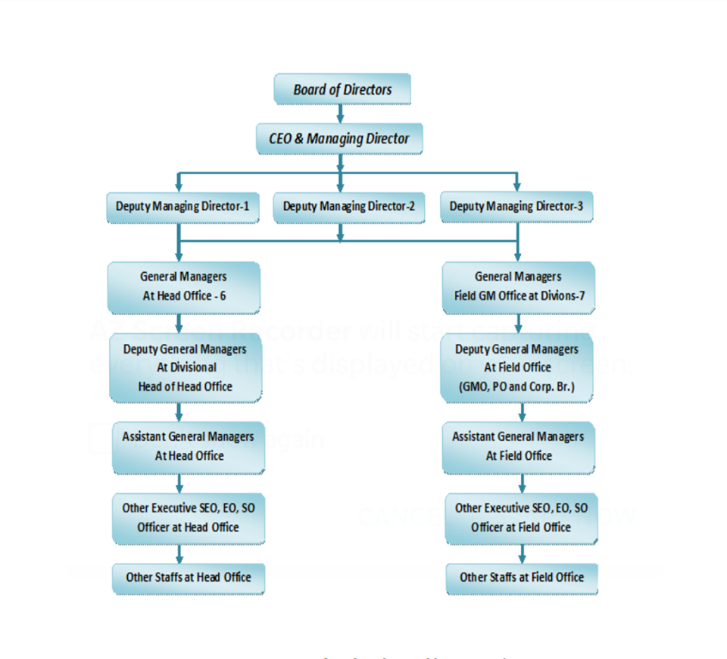

2.3.3 Management Hierarchy of Sonali Bank Limited

Chairman
↓
Board of Directors (BOD)
↓
Managing Directors (MD)
↓
Deputy Managing Directors (DMD)
↓
General Manager (GM)
↓
Deputy General Manager (DGM)
↓
Assistant General Manager (AGM)
↓
Senior Executive Officer (SEO)
↓
Executive Officer (EO)
↓
Officer

2.3.4 Board of Directors of SBL

SL No | Board Of Directors | Designation
1 | Mr. Ziaul Hasan Siddiqui | Chairman & Director
2 | Mr. Md. Fazlul Haque | Director
3 | Mr. A.K.M Kamrul Islam, FCA, FCS | Director
4 | Dr. Md. Nurul Alam Talukder | Director
5 | Mr. Ishtiaque Ahmed Chowdhury | Director
6 | Dr. Daulatunnaher Khanam | Director
7 | Mr. Md. Mofazzal Husain | Director
8 | Mr. Molla Abdul Wadud | Director
9 | Mr. A,K,M Sajedur Rahman Khan | Acting CEO & Managing Director

2.3.5 Mission, Vision, and Slogan

2.3.6 Core values
- Ethics: Every person needs to make sure to devote to the ethical practices of banking.
- Integrity: Protection and safeguard of customers’ interests is a vital element for societal trust.
- Objectivity: All individuals will have a specific objective in carrying out their duties.
- Innovation: New and innovative products are the needs of the time for which continuous action-oriented research is carried out.
- Transparency: Information is to be kept open for all so that stakeholders can have proper ideas about the bank’s activities.
- Accountability: All employees are responsible for their activities and will remain accountable to their respective superior for the accomplishment of tasks
- Excellence: Excellent performance and effectiveness are preconditions to ensure quality service to the large customer base of the bank.
- Commitment: Every employee is committed to working up to the expected level to ensure the satisfaction of valued customers.
- Self Reliance: Each employee will have an ownership attitude towards the bank and self- confidence in his work for the betterment of the bank.

2.3.7 Objectives of Sonali Bank Limited
Sonali Bank Ltd has many types of Objectives. Important objectives of Sonali Bank Ltd are as follows:
- To provide all types of banking services at the doorsteps of the clients.
- To participate in various social and development programs.
- To take part in the implementation of various policies and promises made by the government.
- Foster and encourage education and training.
- Work in collaboration with other foundations, Trust and associations.
- Produce employment.
- Control loan.
- Secure deposits.

2.3.8 Functions of Sonali Bank Limited
- Receiving of money on deposits.
- Conducting cash transition of customers who have a current account.
- Transfer of money.
- Collection of receipts.
- Acts as an advisor.
- Attending bill of exchange and draft of customers.
- Provide online services to the customers.
- They participate in the urban banking.
- Loan sanction.
- They arrange a part-time hypothesis for the university’s student.
- They give the primary teachers ‘wages as a representative of the government.
- Collecting different charges, interest dividends, rents, pension etc.
- They distribute pension to the retired workers.
- Distribute and collect the form of a passport.

2.3.9 Core Business of Sonali Bank Limited

- Corporate Banking  - Project Finance  - SME Finance  - Remittance  - Lease Finance  - Consumer Credit  - Money Market Operation | - Trade Finance  - Loan Syndication  - Foreign Exchange Dealing  - International Trade  - NGO Linkage Loan | - Investment  - Government Treasury Function  - Rural and Micro Credit  - Special Small Loan  - Capital Market Operation

2.3.10 Other Business/Services of SBL
- Ancillary services


- Government Treasury bond
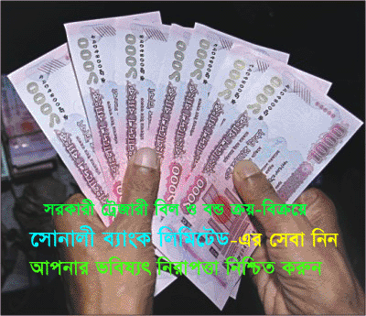
- A.T.M card
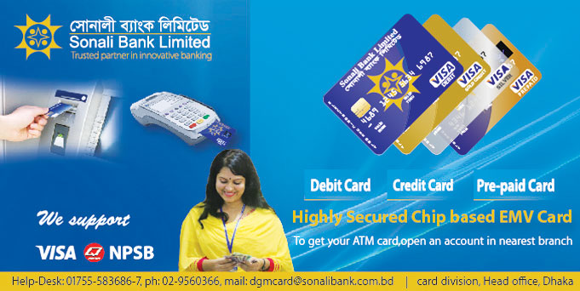
- Locker services


- Utility bills collection
- Merchant banking

2.3.11 Islamic Banking of SBL

SBL has started Islamic Banking Activities in consideration with increasing demand and expectation of religious Muslims. It’s completely based on Islamic Shariah. High profiled shariah supervisory committee comprises of reputed Islamic scholars, Economists and Bankers have been working for proper and fair Islamic banking activities.
Islamic Banking Services are:
- Deposit products-
- Al-Wadeeah Current Account (AWCA)
- Mudaraba Savings Account (MSA)
- Mudaraba Special Notice Deposit Account (MSNDA)
- Mudaraba Hajj Savings Account (MHSA)
- Mudaraba term Deposit Account (MTDA)
- Mudaraba Monthly Profit Scheme (MMPS)
- Mudaraba Sonali Monthly Deposit Scheme (SMDS)
- Investment products-
- Bai-Murabaha
- Bai-Muajjal
- Bai-Salam
- Hire purchase under Shirkatul Melk(HPSM)
- Bai-Istisna

2.3.12 Corporate Social Responsibilities
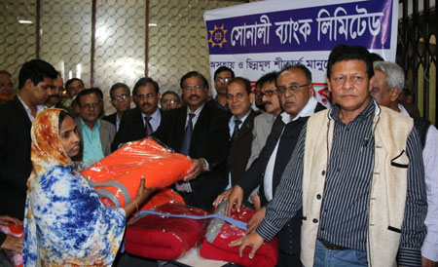
Sonali bank limited is committed to contribute towards social development of the country through its CSR activities. Through its foundation, the bank is trying to fulfill its CSR activities. Sonali Bank Limited Foundation work for education, information technology, disaster, and donation and so on. Important CSR activities of SBL given below-
- Help poor people live in slum areas.
- Helping in extending medical facilities.
- Provide blankets among the old affected people during winter.
- Grant, pay, rewards scholarship program for brilliant students.
- Provide food, clothes and medicine to the needy persons.
- Promote sports and culture.

CHAPTER- 3(JOB RESPONSIBILITY)

3.1 Job Responsibility
An Internship is an opportunity given by an employer to the potential employees to work at a firm for a fixed period of time. It is normally embraced by understudies and graduates hoping to increase their significant skills and involvement in a specific field. The duty of an intern changes with the working profile and the firm. Students can function as an assistant in marketing, finance, medical, HR, programming and many other different fields relying upon their instruction during their semester breaks. My major is marketing, so I have done my internship under the marketing department of Sonali Bank Ltd.

3.2 My Job Responsibilities
Throughout my three months working period, I have performed the following responsibilities-
- I have worked at the front desk for the time being. As all know front desk is one of the busiest sites of an organization so there I had many duties to fulfill. I was responsible for helping customers to fill up their new account opening form correctly. There I had other responsibilities like process checks book and to keep the record.
- Clearance department can be called as one of the sensitive sites of the bank and I have spent most of my time in that department there I have learned about clearing process of a check, reasons behind check gets rejected, time limit and so on their my duties were to registered data in the SBL clearing registration book, also help in sorting voucher.
- I have written demand drafts and issued paychecks.
- Acknowledge client’s presence, and immediately greet them.
- Show customers the way of service counter/desk.
- Stamped on checks and other documents.
- Provided customers any information they wanted to know.
- Did other related work assigned by the supervisor.

CHAPTER-4 (VIEW COMPANY ISSUES)

4.1 Marketing Mix components Of Sonali Bank Limited
Banking business is becoming competitive day by day. Each and every bank has own marketing activities. An innovative and effective marketing activity may help an institution to have a firm position in the market. Every organization has some marketing activities to attract their customers. If the organization wants to reach near the customer, it must set a goal or objectives. Also, it must focus on the target market and set the positioning as well. So, Sonali Bank Ltd has some 4 marketing mix components to attract their customers.

Next to let’s have a glimpse at the 4ps of Sonali Bank Ltd –
Product:
Product is something that can be offered to a market for attention, acquisition, use or consumption and that might satisfy a want or need. Levels of product may be of following-core, generic, expected, augmented and potential.
Today banks are diversifying their product to attract the customers and to cope with the changes of customer demand. Sonali Bank Ltd is also offering all kinds of products to the customers. It has huge numbers of products but still is just not sufficient. Though Sonali bank ltd is having very basic products, they are having large numbers of customers. To please them Sonali Bank Ltd has to attempt to diversify its products.
Price:
Price an amount charged for a particular product or a benefit. Though the price is not a dominant factor in the banking business, it may be an effective tool. Price plays both psychological and economic role in the banking industry.
Now on an instant let’s have a quick look at the initial amount of opening a bank account of Sonali Bank Ltd-
• FDR: For opening an FDR with Sonali bank a customer has to bear very few costs compared to other banks.
• Current Account: In SBL a customer is required TK.1000 to open a current account
• Savings Account: The initial amount required to open a savings account in Sonali bank is only TK.500. Which is very minute compared to other banks.
Service Charge: private banks service charge is a burden for a customer. However in this case, Sonali bank ltd seems to be extremely customer friendly. SBL does not force any service charge to the customer.
Placing or Distribution:
The place is an important factor because a perfect place and position may increase profitability. And SBL is having a competitive advantage in this. Numbers of branches of Sonali bank are huge. So it can attract a large number of customers. Private Banks are focusing only on urban areas. But Sonali bank is having its branch in urban as well as rural areas. SBL have total 1215 branches and these branches are situated considering place of locality, business, and affordability by people.
Promotion:
Promotion has turn into a vital part of new industries. Promotional activity means anything that will promote the bank to the people. Sonali Bank Ltd is not using advertising as an effective tool. It provides leaflets, a pamphlet to clients to make the clients come to know about their product and services.SBL does not give emphasis to on communication strategy as its competitors are doing.

4.2 Sonali Bank Limited Promotional Mix Activities

- Advertising:
Advertising is the best tool for promotion. The bank arranges publicity to get the attention of people like a businessman or different media. If the bank launches any new products or services, it advertises on different newspapers.

- Personal Selling:
Sonali Bank Ltd gives lots of focus on personal selling. The officers of every department try to provide the best service based on individual needs. They consider every client in the same way. If any new service comes, the officers encourage them to take the service and explain in detail about the service. The bank always tries to provide fast service to their clients. This is how the banks tried to maintain a good relation with their customers.
- Direct Marketing:
SBL do not practice direct marketing much. But if there is a serious need for this SBL officer perform it. But there is no specific department in SBL for direct marketing.

- Sales promotion:
Bank provides incentives to the customer to inspire the sales of bank service which called sales promotion. Sonali Bank Ltd often reduces their interest of loan and enhance the interest of deposit to attract customers.
- Public relation:
Basically, public relations refer to make a strong relationship with clients of the bank. Therefore, Sonali Bank Ltd focuses on building a good relationship with every individual of the existing and potential clients. They try to make a positive image in the minds of the clients. The bank invites their potential clients in June closings day and had lunch with them, the bank also joins in different corporate workshops to enhance their goodwill.

- Publicity:
Publicity is a promotional tool in which the organization does not pay for communication about its products and benefits this happens through a non-personal news article displayed in the media or delivered by a person in an interview or in a speech. Publicity is done mainly over and with community relations actions. Sonali Bank Ltd is very well-known on the market and its fame describes its advertising. Publicity for Sonali Bank Ltd also takes place during the launch of the annual sales reports is published.

4.3 Findings of the Report
During my 3 months internship, I have learned and also have gathered some crucial aspects relating to the bank which I feel more or less can be dominating the bank performance so here are my findings-
- The Sonali Bank Ltd has no accurate strategic plan for gaining long term goals.
- Employees bonding are not good enough.
- Lack of knowledge and use of modern tools and technology.
- Low remuneration Packages
- Absence of very strong marketing activities.
- SBL Helping to curb the unemployment problem.
- Many times SBL fail to provide customers loan.
- Employees are knowledgeable but not enough motivated.
- Most of the branches have no canteens and prayer room for its employees.
- In most of the branches there are only a few printing machines.
- Many branches of SBL have not enough space.

CHAPTER 5-(CONCLUSION AND RECOMMENDATION)

5.1Conclusion
Banking sectors of any country plays a vital role in its economy. Banks brought several positive changes in the world. So I am very happy to complete my report on a bank. Sonali bank Ltd plays a vital role to the economy and its well being by offering all convenient services. All organization has its positives and negative sites. The bank is certainly following traditional marketing strategies and it’s quite satisfying. But for the near future the bank should improve its marketing activities as well as strategies to attract more customers. As the management of SBL wants to reach the higher pick so it seems like in the near future the negative aspects will be eliminated.

5.2 Recommendation
Observing the findings I have given some recommendations. Those recommendations are written below-
- To provide better services SBL should increase using modern technology.
- They don’t have good sitting arrangement for their customers, so there is a need for good sitting arrangement.
- Their computer devices are monitored by headquarters, so SBL should provide few computer devices which are not monitored by headquarters to every branch.
- The Cash department needs to be more secured.
- SBL promotional activities are not strong enough so they should strengthen their promotional activities.
- Bank should introduce few new products.
- Few branches need to be renovated.
- For getting an effective performance server need to be repaired fast.
- Should Provide Air conditioner to all rural and urban branches.
- Need to increase the number of ATM booths.
- Need to add more product and service schemes.

REFERENCES
- Marketing Management, Philip Kotler; 11th Edition, Pearson, Inc.2003
- Principles of Marketing, Philip Kotler and Gary Armstrong, 15th edition, Pearson Education, In.2013
- McCarthy, Jerome E. (1975) Basic Marketing: A Managerial Approach, fifth edition, Richard D. Irwin, Inc.
- McGee, L.W. and Spiro, R.L., "The Marketing Concept in Perspective," Business Horizons, May–June, 1988
- Shimizu, Koichi (1989) "Advertising Theory and Strategies," (Japanese) first edition, Souseisha Book Company in Tokyo.
- Advertising and Promotion, George E.Belch & Michael A.Belch
- Kotler, P., Marketing Management, (Millennium Edition), Custom Edition for University of Phoenix, Prentice Hall, 2000,
Websites
- https://www.sonalibank.com.bd/index.php
- https://en.wikipedia.org/wiki/Marketing_mix
- https://www.academia.edu/13063352/General_Banking_Activities_of_Sonali_Bank_Limited

BIBLIOGRAPHY

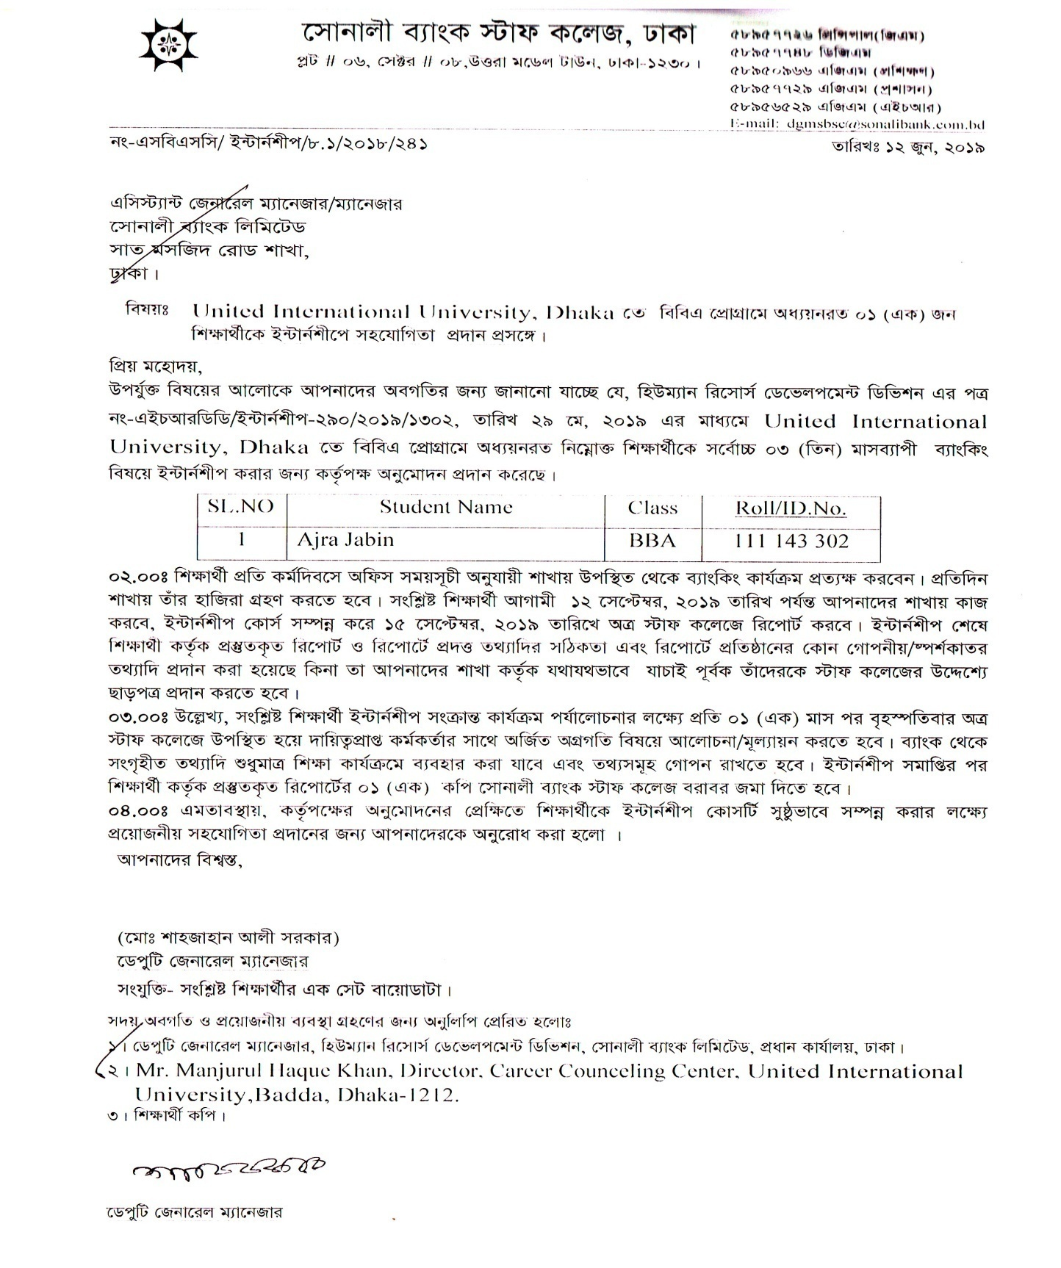

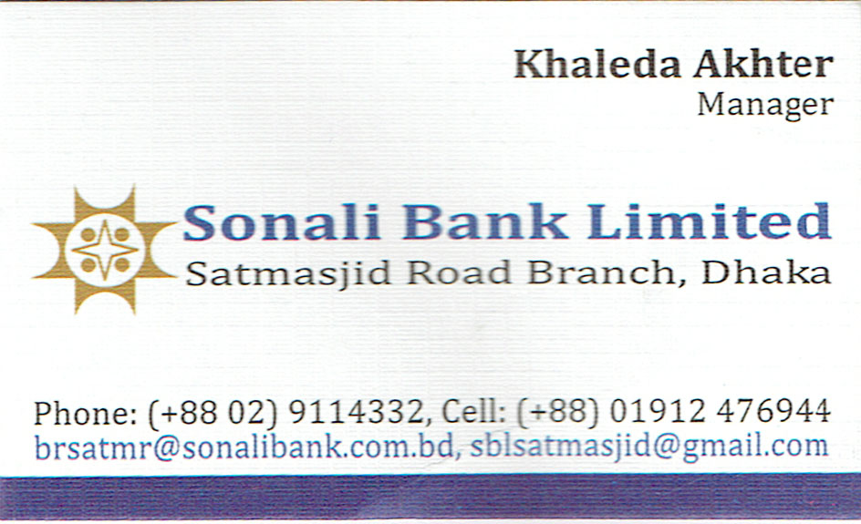
Visiting card

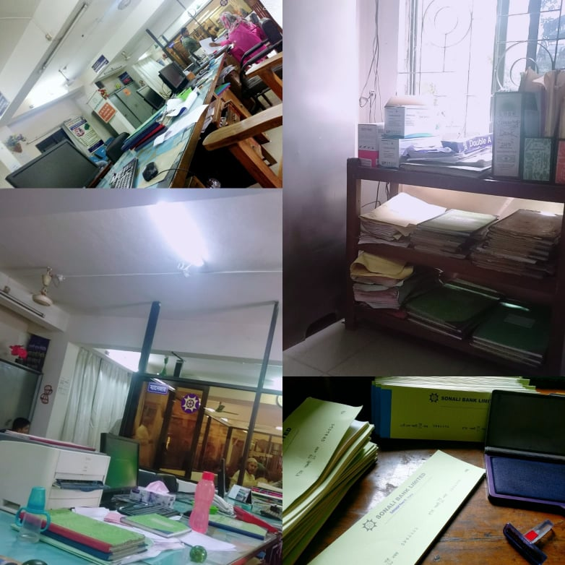
Inside Pictures of Sonali Bank Ltd Sat Masjid Road Branch

