Project Report

On

EXAMINIG THE IMPACT OF BRAND TRUST ON BRAND EQUITY:

A Study on Smart Phone Handsets Industry in Bangladesh

Project Report
On
EXAMINING THE IMPACT OF BRAND TRUST ON BRAND EQUITY
A Study on Smart Phone Handsets Industry in Bangladesh
Course Title: Project
Course Code: INT-4399
Submitted by
Name: Mg Kibria
ID: 111 142 236
School of Business and Economics
Program: BBA

Submitted to
Muhammad Hasan Al-Mamun
Assistant Professor
School of Business & Economics
United International University

Date of Submission: 31st October 2018

LETTER OF TRANSMITTAL
31st October 2018
Muhammad Hasan Al-Mamun
Assistant Professor
School of Business & Economics

Subject: Submission of Project Report on “Examining the Impact of Brand Trust on Brand Equity: A Study on Smart Phone Handsets Industry in Bangladesh”
Sir,
This is to inform you that, I have completed the project report which was a research for Examining the Impact of Brand Trust on Brand Equity: A Study on Smart Phone Handsets Industry in Bangladesh. It is pleasure for me to inform you that we I have completed my project report under your kind-hearted supervision.
In preparing this research paper, I tried my level best and worked sincerely & attentively to make it as well structured as possible. I hope that this will help me to know more about impact of brand trust on brand equity that with my real-life experiences. I would sincerely appreciate if you accept my project report and consider my work as good and unique.

Thank you,
Sincerely Yours,
Mg Kibria

--------------------------

ACKNOWLEDGEMENT

All praises are due to Almighty “ALLAH” who has enabled me to complete this project. This project is about “Examining the Impact of Brand Trust on Brand Equity: A Study on Smart Phone Handsets Industry in Bangladesh”.
I would like to express my sincere gratitude & appreciation to my project supervisor Assistant Professor Muhammad Hasan Al-Mamun. It would have not been possible for me to complete this report without his guidance and supervision. His continuous encouragement & supervision throughout the period of this study have been the greatest inducement for me & directly contributed to the accomplishment of the task.
Equally, I would also like to express sincere gratitude & indebtedness to the participants for their kind cooperation for participating in my survey for completing my project. It gave me the opportunity to work on such a project by using the practical information of the impact of brand trust on brand equity.

ABSTRACT

The study intended to examine the impact of the various facets of brand trust, brand reliability (BR) and brand intention (BI), on Overall Customer Satisfaction. The study also intended to measure their impact on Brand Loyalty and Brand Equity. Such impact of BR and BI on Overall Customer Satisfaction, Brand Loyalty, and Brand Equity was examined in the context of smartphone handsets industry in Bangladesh considering four brands currently available in Bangladesh: iPhones, Samsung, Symphony, and Walton.
The sampling technique adopted in the study was non-probabilistic in nature. Sample size was 120 and self-administered questionnaires were used to collect data using the appropriate instruments. Reliability of the constructs considered in the study was measured by using Cronbach Alpha values, which were found to be in the acceptable range.
It was found that both BR and BI have a significant impact on Overall Customer Satisfaction. The changes in the Overall Customer Satisfaction can be explained by the changes in both BR and BI by 71.40%. But BR was found to have more relative impact on Overall Customer satisfaction due higher beta value.
It was also found that both BR and BI have a significant impact on Brand Loyalty. The changes in the Brand Loyalty can be explained by the changes in both BR and BI by 51.50%. But BR was found to have more relative impact on Brand Loyalty due higher beta value.
Similarly, it was found that both BR and BI have a significant impact on Brand Equity. The changes in the Brand Equity can be explained by the changes in both BR and BI by 56.90%. But BR was found to have more relative impact on Brand Loyalty due higher beta value.
In a nutshell, both BR and BI were found to affect customer satisfaction, brand loyalty, and brand equity. But in all cases BR was found to have more relative impact than BI.
Key Words: Brand Trust, Customer Satisfaction, Brand Loyalty, Brand Equity

Table of Contents
LETTER OF TRANSMITTAL i
ACKNOWLEDGEMENT ii
ABSTRACT iii
1. Chapter-1: Introduction 1
1.1 Topic in Hand: 1
1.2 Context of the Study: 2
2. Chapter-2: Industry Perspectives 4
2.1 A Brief Evolution of the Industry: 4
2.2 Review of the Selected Brands: 9
3. Chapter-3: Literature Review 16
4. Chapter-4: Objectives and Methodology of the Report 20
4.1 Objectives of the Study 20
4.2 Methodology of the Study 21
5. Chapter-5: Findings of the Study 23
5.1 Sample Characteristics 23
5.2 Basic Descriptive Statistics 26
5.3 Reliability of Constructs Used 27
5.4 Interpretation of Cronbach Alpha Value for the Constructs of the Study 28
5.5 Evaluating the Relationships among Constructs 29
5.6 Evaluating the Impact of Brand Trust on Brand Equity 33
6. Chapter-6: Future Research Scope and Conclusion 36
6.1 Future Research Scope 36
6.2 Conclusion 36
REFERENCE 37

Chapter-1: Introduction

Topic in Hand:

Brand is the combination of sign, design, quality, symbol, color, packaging, logo, name, word and so on, of a particular product which is completely unique for differentiating from other product. Brand carries a unique identification of a particular product so that they can be differentiated from others. Actually, brand is the process of creating a brand name. Brand is used for the overall corporate or organizational identity as well as individual identity of a product or services or concept.
Brand is a trademark for a company or company’s particular product or service which makes them differentiated from their competitors and also make them unique to their targeted customers. Though brand is a trademark but it is a challenging task to create a brand because consumers need decision simplification and risk reduction for choosing a product or service. Moreover, a company face some difficulties for managing brand due to having insolent customers, increasing number of competitions, decreasing of traditional marketing tools replaced by new marketing tools and complex brand & product portfolio.
A company’s most important task is to build up customer’s trust over their brand which means creating brand trust to satisfy customer’s needs. As brand trust is the most important task, so marketers must have an acumen over their customers, brands; and the relationship between customers and brand. Brand trust is a combination of better service, good relationship between customers and salesperson or marketers, customer satisfaction, ability to come up with better product or service solution, bringing better features of a product, unique identity of the product or service and so on. According to Ambler (1992), “The consumer perspective towards brand can be explained as a promise which creates satisfaction through combination of different attributes resulted in a purchase of a product/service”. Customer trust a brand when all these things are carried by the brand. So, it can be said that brand trust is created when marketers fulfil the desire level of services or products or fulfil more than the desired level. Moreover, brand trust also come through communication. Marketers must come up with their brand by knowing their customers and their desired products or services as a result they must communicate with their customers for knowing them and their desired products and services. Also, communication will build up the brand trust by the salesperson when they express the features of the products or services to their customers. Furthermore, brand trust also comes through brand commitment which means delivering and serving which has been promised earlier.
Brand equity is known as the value of brand. Brand equity is defined through two different views and there are cognitive psychology and information economics. Cognitive psychology defines attributable perceptions driven by consumer’s awareness of brand features and association where brand equity lies. On the other hand, information economics states that brand name is the credible source to describe product’s quality, features and usability and generate price premiums as a form of return to branding investments. Basically, brand equity is very important to marketers and their goods and services for their consumers because they facilitate through brand extensions and brand introductions.
Brand trust is a component of brand equity which is a relational market-based asset due to creating relationship between brand and customers. As brand is a component of brand equity so it means brand trust on of the corner stone of brand equity. Brand equity defined as the consumer’s perception over a brand name through their commercial value, as a result it is referred as a relational market-based asset. Brand trust creates higher brand equity because whenever brand trust is created brand equity is also created at the same time. Brand equity adds value to the goods and services apparently. According to Yoo, Donthu and Lee, “Brand equity can be considered to be the difference between overall brand preference and multi-attributed preference based on objectively measured attribute levels and as an overall quality and choice intention”. If a company is trusted by their customers then they may have the substantial competitive and economics advantages provided by brand equity. Though brand equity is crucial strategically but it’s not easy to quantify because the concept of brand equity is disconnected between quantitative equity and qualitative equity. Quantitative equity defined as the numerical values like profit margin and market share whereas qualitative equity defined as the prestige and associations of interests. As there is a difference between quantitative equity and qualitative equity, most of the researchers use qualitative approach for doing their survey on brand to identify how and how much brand trust impact on brand equity. Brand equity also refers what customers ask or demand for to satisfy their needs. Marketers never create the brand rather their customers create the brand when they are attached with the products and services and have a greater trust on the brand as a result brand equity also arises whenever customers attached too much with the brand or trust the brand more and more.

Context of the Study:

Smartphone is the most unavoidable, important and helpful tool in this generation because of its mobile applications and performance which is varied based on the brand and its features, applications and operating system which are different from each brand. There are thousands of smartphones which are sold every day in the world.
Mobile applications are very important in the market and for the users due to its inclusion of internet, web browser and other operational tools. Mobile phone applications are facing some challenges due to having development with the availability of different platforms and the dedicated single platform tools. At first single platform concept came up with specific platform then it moved to cross-functional applicational development in which all applications can be developed simultaneously with various platforms.
In recent years all the mobile applications have been developed primarily for smartphones. Today’s all smartphones are operated by numerous and unique sensors. On the basis of each smartphone’s model and affordability it has become a powerful tool which includes a designed processor, a graphics chip, advanced connectivity and an inertial motion unit (IMU), with a 3D-accelerometer, gyroscope, compass, GPS, microphone, camera, proximity sensor, light sensor, temperature sensor, pressure sensor, etc. The sharp decline in the price of mobile equipment allows growth in emerging markets. Moreover, smartphones contain more technology such as a screen display, an audio system or a haptic feedback system that enables interaction with the user of the device. To combine and use all these functionalities, smartphones are able to run specific software, called “applications”. As smartphones are now operating numerous sensors and moving toward cross functional applicational development, so mobile application platform is divided in two major operating system and those are Android, which has Google Play Store and iPhone, which has AppStore. Applications are now being used for cost, health care, professionals’ involvement in app development, reminder mechanism and functionality etc. New smartphone models are being introduced at a rapid pace and participatory sensing due to be as qualified for their feasible performance in real-use conditions. Participatory sensing measurements are performed in uncontrolled environments and they yield sensor parameter deviation boundaries in real-use conditions. Such real-use parameters are used as the information about smartphone sensor quality which is known as great assistance to cross-platform mobile application developers.

Chapter-2: Industry Perspectives

A Brief Evolution of the Industry:

History shows that the communication technology was started almost 400 years ago because people started doing their business in a long time ago and they did their business through communication. In the past people did their business by making only face to face communication which was very difficult for every people because no one couldn’t make long distant communication due to having no opportunity to use any device or technology for communicating with others as a result they had to make face to face communication which took long days to meet and having the communication.
In 1867, the great Alexander Graham Bell came with solution by inventing “Telephone” which met the need of long distant communication for the very first time. Alexander Graham Bell communicated with Thomas A. Watson by the telephone which was the first ever communication through telephone. Ron Christianson from Cyber Telephone Museum stated that, “Alexander said to Watson, ‘Mr. Watson, come here. I want you’”. This, telephone was named as. “Gower-Bell” telephone. Gower-Bell was used in various countries like Spain, Japan and England as the first ever communication device.

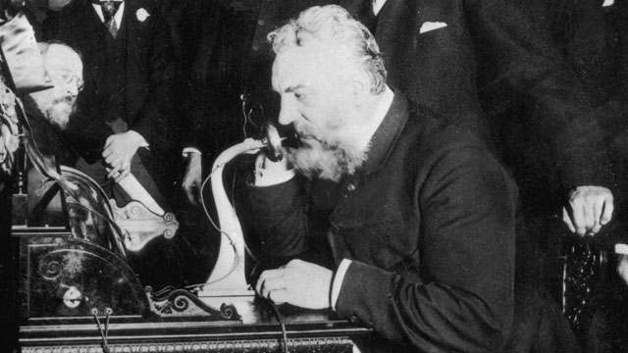
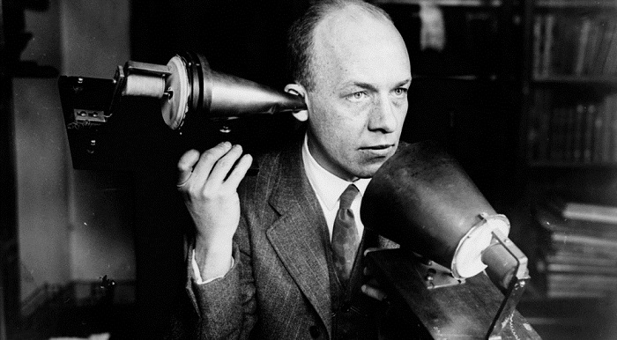
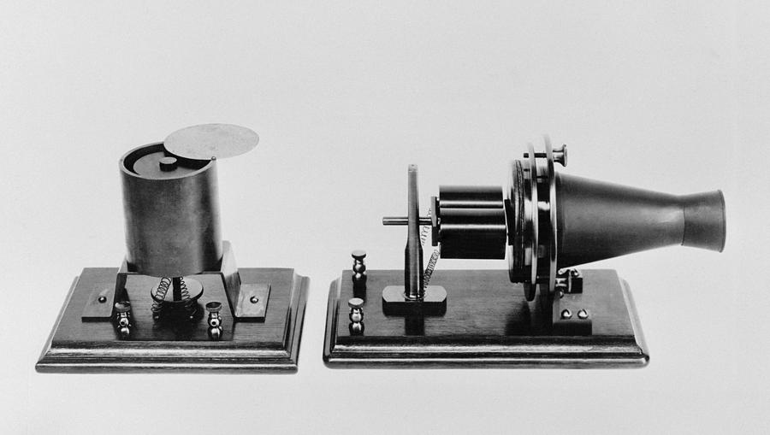
Gower-Bell telephone got its demand around the world and used in many hotels, office, institutions and cabinet’s houses etc. As. The demand increased ‘The Strowger Automatic Telephone Exchange Company’ came up with ten digits automatic wall telephone which was the first ever automatic rotary motion dialer telephone in 1899. Instead of The Strowger Automatic Telephone. Chicago Telephone Supply company introduced a curvy shaped telephone call ‘Potbelly’ in 1905, Stromberg-Carlson Telephone Mfg. Co. introduced a unique shaped telephone called ‘Oil Can’ in 1900 and S.H. Couch Company introduced a desk sets which were typically used to interoffice communications etc. Moreover, in 1920s in the military a telephone became much popular due to having noise cancellation technology and the telephone was called as ‘Magnavox anti-noise desk sets’ introduced by Magnavox Company. After 1920s rotary telephone began their journey since 1940 to 1960. Besides voice communication people found their need of video conversation. Therefore, fulfilling the need video was introduced in 1960s and in 1970s AT&T made their first ever videophone (Wikimedia Commons, visited at 11 pm on 2nd July 2018).
In the past 1980s AEG company came up with the first ever mobile phone by naming it, ‘AEF Telecar CD’ for the development of communication. This phone was responsible for uttering the words by back bearing the work.
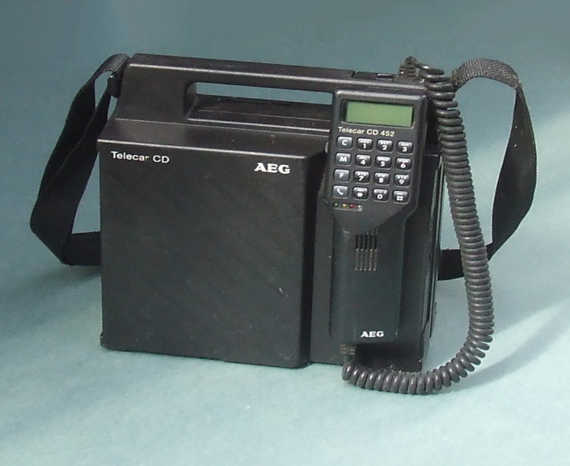

In 1983 Motorola company launched first ever commercial and wireless phone which was called ‘Motorola DynaTAC 8000X’. This phone was easily carried and less weight than other telephones in the past. Added with that Motorola also launched, ‘Motorola MicroTAC 9800x’ phone for some important persons in 1989. As, wireless phone was introduced by Motorola then in 1990 a typically cordless phone was launched also.
In development of communication, IBM company made one step further by launching first ever smart phone which called. ‘IBM Simon’ in 1994.
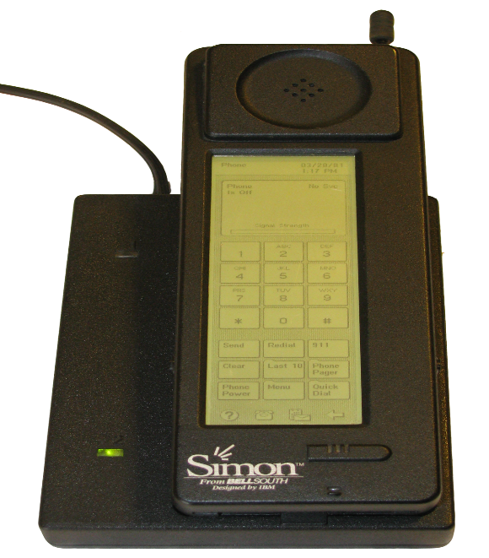

As IBM started the journey of smart phone, Nokia also launched smart phone named as ‘Nokia 8210’ in 1999. Nokia dominated the market by launching this wireless smart phone. In 1996, Motorola again cover the market by launching first flip phone named as, ‘Motorola StarTAC’. The craze and excitement of this phone was all over in the world. It was huge demanded mobile at that time in the global market. Japan always are one step ahead then other countries in case of technological development so they made an impact on mobile phone handset by launching first ever camera mobile phone named as, ‘Sharp J-SH04’ in 2000. In the modern age smart phone brought so much development in communication and mobile phone industry, T-Mobile company entered in the competition in market by giving a tough competition because they launched their smart phone handset which had the usability of Google’s Android Operating System which was known as, ‘T-Mobile G1’ in 2008.

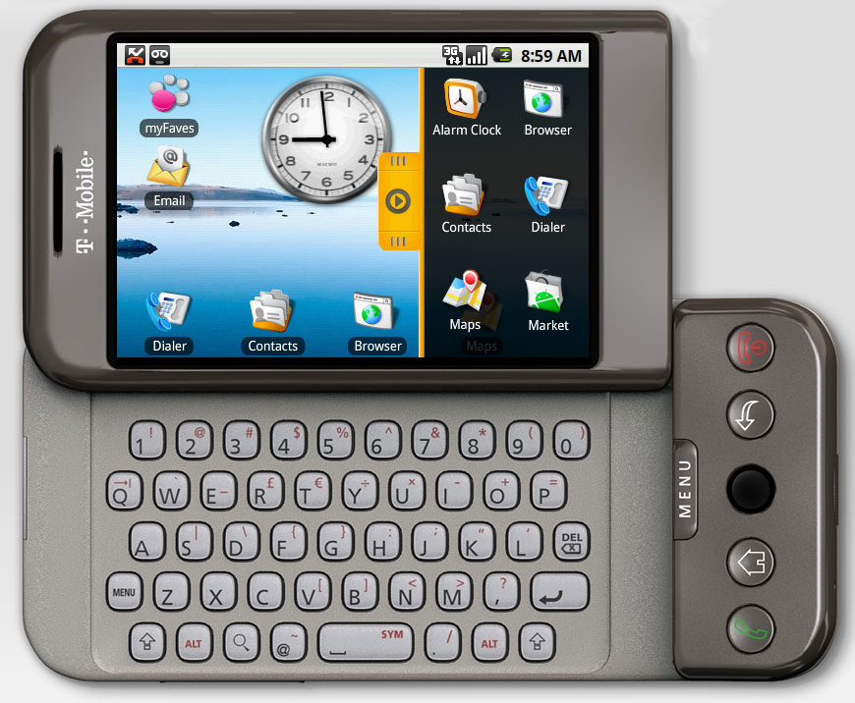

As the evolution of smart was going on, Motorola again come up with their innovation and this time they brought their first ever touched screen mobile phone named as ‘Blackberry Strom’ in 2008(‘RIM’). It impacted on global market with huge sell due to being their first ever touched screen phone in the market. Consumers were too much satisfied with the mobile because of its features, style and size and moreover people can use the mobile by touching it. There was no necessary to use the keypad when it can be used by touching.
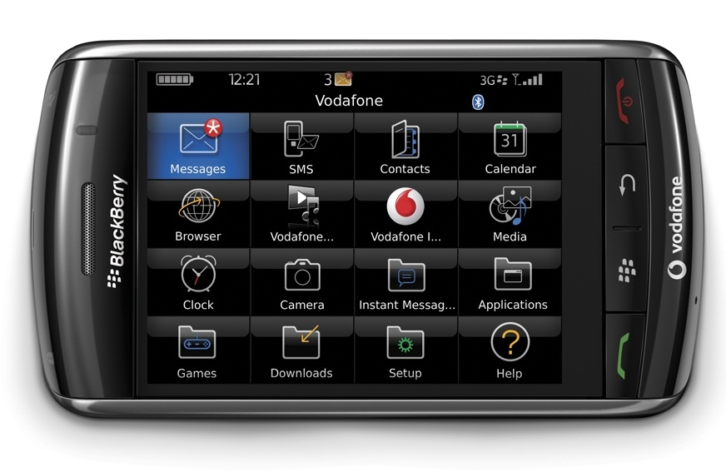
Though, blackberry was impacting in the market but in 2007 Apple company brought their first ever mobile phone or smart phone which in known by iPhone. iPhone changed people life by bringing some unique features such as browsing full webpages, triangulate positioning with Google Maps & easily downloading any applications. Though other smartphones were using Android Operating System but Apple used and still using IOS Operating System for their iPphone.

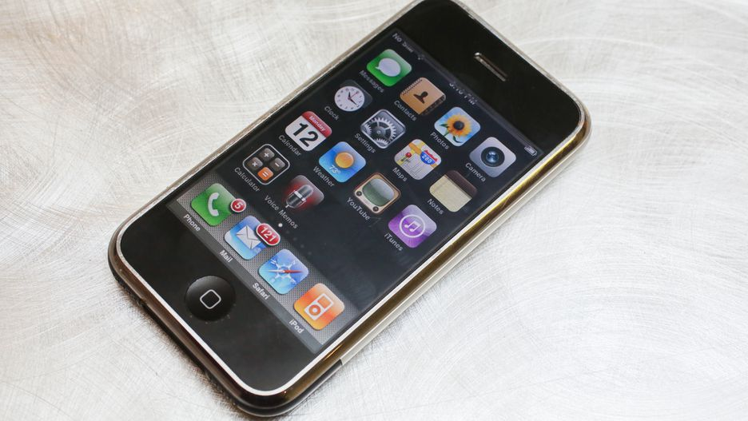
In 2007 Nokia moved to Windows from Java and launched first ever phone which was operated by windows operating system. This phone was named by Lumia 800 and operated by Windows 7. This phone had Microsoft’s “Metro” interface.
Now, in the overall market smart phone is dominating and there are lots of brand such as Apple, Samsung, LG, Nokia and Huwawei etc are competing each other to satisfy consumer’s needs in this modern age because in this age people cannot think about any work without their smart phone.

Review of the Selected Brands:

- Strong Brand:

- iPhone:

In early 2007 Steave Jobbs the founder and first CEO of Apple.inc came up with his innovation in smartphone industry by launching the finest smartphone “iPhone” which is incorporated with “iTunes” software. After launching it this smartphone has changed the world communications. Apples has sold about 1.2 Billion iPhones over the last decades so far. In the current age, iPhone is the most selling smartphone around the world. During the launch event of iPhone eleven years ago the inventor of iPhone and the CEO of Apple.inc Steave Jobbs stated that, “This is the one that started it all”. Basically, iPhone was an iPod as internet communicator and which was totally different from other competitors before launching in the market.

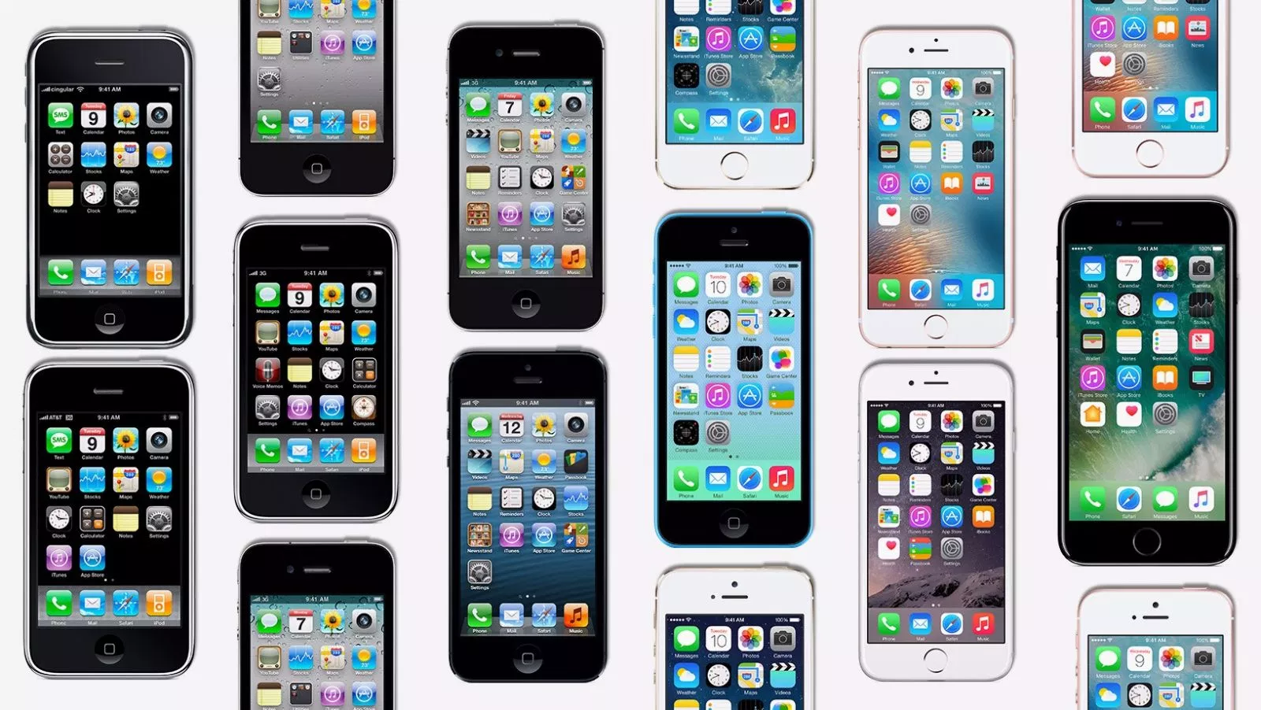

At the beginning year (2007) iPhone was a non-3G data and non-GPS smartphone. Second year of the introduction in the year 2008 iPhone introduced both 3G data and GPS for the smartphone. Though the iPhone-1 had plastic and aluminum body but iPhone-2 changed it and brought solid piece of curved plastic as the replacement of plastic and aluminum body to show it as a unique phone and good-looking smartphone then others. After introducing 3G data and GPS iPhone brought, iPhone 3GS in the second year after launching 3G data. Here the “S” of 3GS referred to standing for speed. The 3GS mobile phone added a minor hardware and software to refine over the 3G. According to the unscientific poll, iPhone’s finest and coolest looking phone was iPhone-4 which had glass backed device shattering on dropping it in a certain way and also it was the first ever iPhone which had front camera to take selfie. In addition to iPhone-4, iPhone-4s just only came up with voice assistance Siri and camera that could record a video about 1080p. Reuters and Yuya Shino stated that, “iPhone-5 launched which was taller than iPhone-4 and it was the first iPhone to support LTE, and the first to use Apple’s Lightning charging port, instead of the wide 30-pin connector that had been used on the iPhone to date and iPod before it”. Apple introduced another two different iPhone-5 and there were iPhone-5C and iPhone-5S. In one hand iPhone-5S introduced touchID finger print scanner and on the other hand 5C came up with plastic backed body since iPhone-3GS. In 2014 iPhone came up with their new two series 6 and 6 Plus. Both mobile were much larger than previous iPhones but the major difference between them were that the 6 plus had optical image stabilization on its rear-facing camera, and apps could be displayed in landscape on the larger device. Both phones were the first to feature Apple Pay. Some even considered it the pocket computer of their dreams (AP Photo/Damian Dovarganes, visited at 11:45 pm on 2nd July 2018). After that iPhone again introduced 6S and 6S Plus which was quite similar to 6S and 6S Plus but the difference was 6S added “3D Technology” which was used to select the menu by pressing the button hardly and 6S Plus was the first phone was rose in gold color which was taken all over the world. In the current time iPhone SE is the smaller iPhone and more affordable phone for using comparing with previous iPhones. The most criticized iPhone is iPhone-7 and 7 Plus due to adding incremental update over 6 and 6S. iPhone 7 and 7 Plus are the first iPhones without headphone jacks, the first without physical home buttons, and the first waterproof iPhones. Moreover, the 7 Plus also features two rear cameras that work in tandem to perceive depth and produce quite nifty portrait photos. iPhone 8 and 8 plus have come up with the strongest and smartest chip ever in smartphone history and also provide a unique feature which is wireless charging and durable glass designed. iPhone X is the latest series of iPhone which is unique smartphone due to adding features like responding to tap of anyone’s voice, tap and a glace, Apple believe that the vision is reality and easily people can say hello to the future by using iPhone X.
- Samsung:

Samsung Electronics launched their tele-communication Network in 1977 and then in 1983 it was introduced with mobile tele-communication business for making another future growth side of Samsung Group. After starting their tele-communication business Samsung innovate their first built-in car phone named as SC-100 in 1986 but Samsung failed in their beginning of their mobile phone business due to the poor quality of the phone. Though, they failed in the business but they didn’t withdraw their business which was decided by the head of the Wireless Development Team Ki Tae Lee and also Lee decided to buy ten ‘Motorola’ mobile phones for benchmarking. In 1988 after doing Research & Development, Samsung introduced their first ever mobile phone which was SH-100 in Korea and this mobile was first mobile ever produced in Korea.
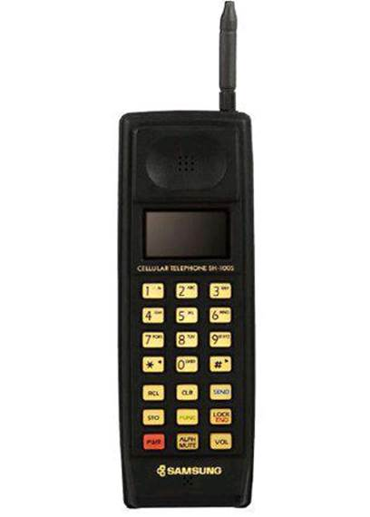
‘Samsung SH-100’

Samsung made their new management team in 1993 for the development of their mobile phones and to gathered around two hundred executives so that they could find out their all lacking which were needed to be improved. After forming new management Samsung introduced their new mobile phone SH-700 in 1993 which was much remarkable in the market as Samsung was competing their mobile phones with Motorola. As the new mobile was quite good in the mobile phone market so Samsung again introduced their new mobile phone SH-770 which was the upgraded version of SH-700 under the brand name “Anycall” in 1994. During their growing market Samsung Tele-Communication created their slogan which was, “Strong in Korean Topography” for giving tough competition in the market. As they created the slogan and planned to give tough competition in the market, they were succeeded by achieving their market share from 25.8% to 51.5% in 1994 whereas Motorola lost their market share from 52.5% to 41.2% 1994.
In the year between 1996 and 1998 Samsung had their Code Division Multiple Access (CDMA) era when they developed CDMA service and launched their first digital handset which was SCH-100 which had features like extra light and slim body and enabled clear voice communication. Samsung came up with some innovative features such as lightweight body, enhanced battery life, and the ability to capture delicate sounds in their new Personal Communication Service (PCS) mobile phone called SCH-1100 after being the leader in PCS and partnered with KTFreetel and Hansol PCS. Sanmsung targeted young generation by this phone because the mobile phone had those features which were liked by the young generation at that time. Samsung introduced their new slogan for PCS market to capture more market share and that was, “Strong in Small Sounds”. As Samsung developed CDMA service and brought PCS they achieved 57% market share in CDMA cellular market and 58% market share in PCS market in 1997.
In the year 1998 Samsung targeted to achieve Global System for Mobile (GSM) which was greater than CDMA as a result Samsung launched their first GSM mobile which was SGH-200 but this mobile couldn’t capture the market up to the mark then they again launch another GSM mobile which was SGH-600 which changed their whole market entry strategy and able to give tough competition to the “Big 3” means Nokia, Motorola and Erikson. As they gave tough competition to the Big 3 and captured their market share so they achieved the “Best Manufacturer” award twice by the Mobile News Awards.
As Samsung was growing their business and capturing the market they launched lots of their series such as SCH-800 which was able to send and read texts then launched their first colorful resolution mobile which was SCH-V300 in 2000 and in 2005 they launched their first tv streaming mobile which was SCH-B250. In addition to colorful resolution and tv streaming mobile phone, Samsung launched first ever 7 mega pixel and 10 mega pixel camera phone in 2005 and 2006. In 2008 Samsung launched first ever Omnia mobile phone and got the first position in US mobile phone market. In 2009 Samsung made Guinness World Record for building world largest mobile phone company, launched first ever solar powered mobile phone in India and created and launched their official application. Moreover, Samsung launched their first touched screen mobile in 2009 which was SCH-W850. Samsung came up with their new and unique phone series in 2010 named as Galaxy S which was able to stream any video, read any documents and capture high resolution images. In the year 2011 Samsung launched a bigger screen handset which was another series named as Galaxy Note which was and still able to do multitasking with S pen with one click.

- Weak Brand:

- Symphony:

Symphony mobile phone is one of the largest and famous mobile phone brands in Bangladesh. Symphony mobile phone company was founded by Edison Group of Companies by making partnership with SB Tel Enterprise Ltd in 2005 and started their business in 2008. Symphony was and still making continuous improvement, innovation and product diversification for their mobile phone and Edison Group is now holding an unchanged leading position in smart phone industry in Bangladesh through Symphony brand. Symphony brand has now started their new two business and there are Symphony accessories and Mobile phone applications.
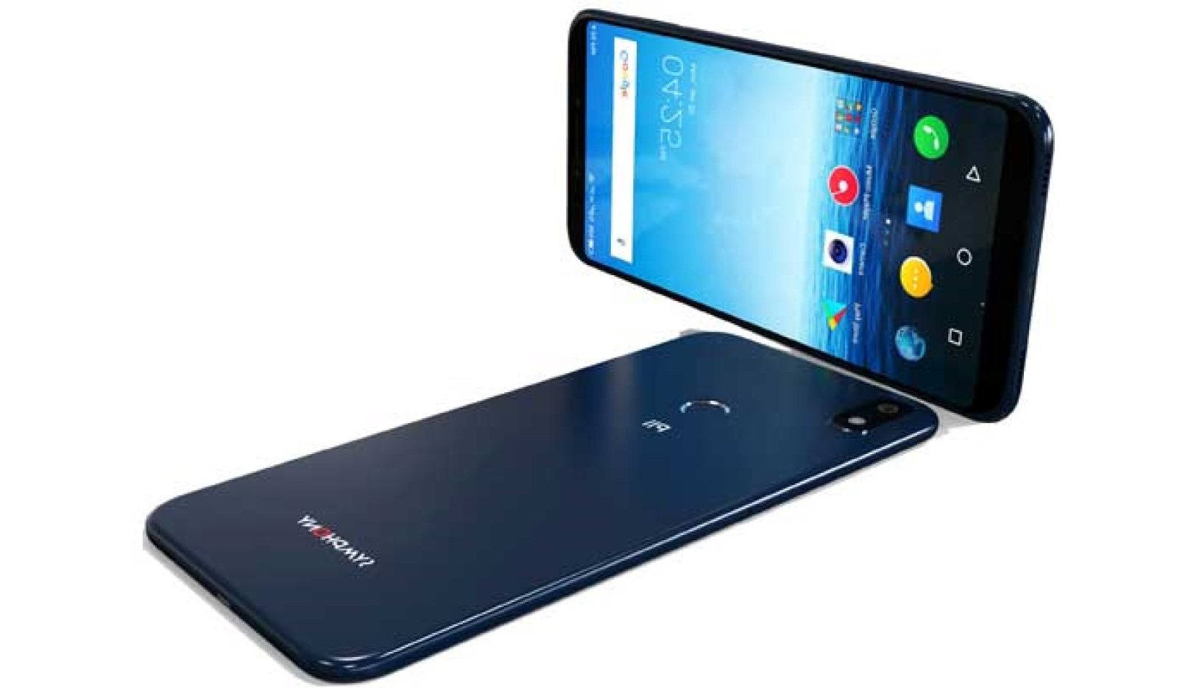

As Symphony is making their continuous improvement, innovation and product diversification for holding an unchanged leading position so they are ensuring their products availability and their ability to make the brand unique then others. In addition to ensuring ability to make the brand unique they are also ensuring ability of giving product solutions and updated features of each mobile phone. In 2010 Symphony became the number on 1 brand in the smart phone market in Bangladesh for their aggressive pricing strategy, contemporary features & styling, international quality builds a strong distribution network and after sales service have contributed to make Symphony Mobile the preferred choice of Bangladesh customers (‘SB Tel Enterprise Ltd, visited at 10 am on 3rd July 2018). The aim of Symphony is to provide outstanding customer service and giving product’s solutions.

- Walton:

S.M Nurul Alam Rezvi under the umbrella of R.B Group (Rezvi and Brothers) founded the Walton Group of Industries in 1977. Walton started their business through steels, textiles, electronics automobiles. In 2010 Walton introduced themselves in the smartphone industry and by then it became a renowned brand because of capturing holding market share about 12% with 7.96% annual growth and being 3rd ranked of the smartphone industry.
As Walton mobile has become a renowned brand so they have product diversification across Bangladesh and most interesting thing is they have also entered into the foreign market also. They have categorized their mobile phone handset into four different categories and there are-

- Smart Phone:
Walton currently is offering 39 different smart phones in our market such as Primo ZX3, Primo X4 Pro, Primo S6 Infinity, Primo RX6, Primo R5, Primo GM3, Primo GM7, Primo HM4i, Primo EF7, Primo F8, Primo H7, Primo F7S, Primo G8, Primo HM4+, Primo NF3, Primo NH3i, Primo S6 and Primo E8i etc.
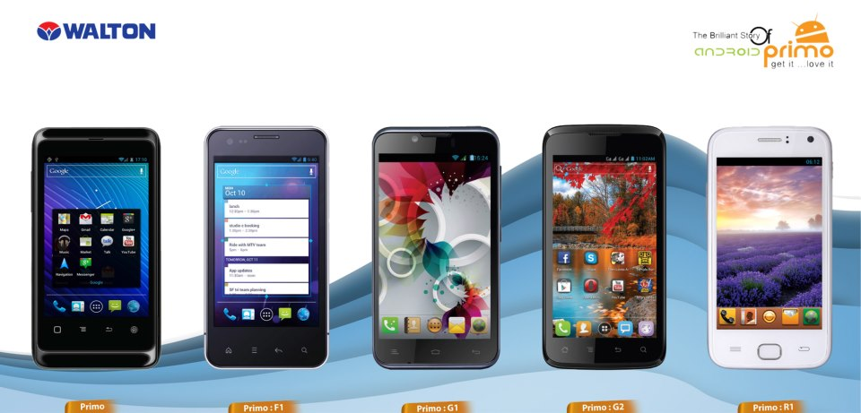

- Feature Phone:
Walton have 29 different feature phones and there are Olvio Q37, Q39, Olvio L6, Olvio MH16, Olvio MM17, Olvio MH15, Olvio L24, Olvio ML11, Olvio MM16, ML12, S32 and L9 etc.

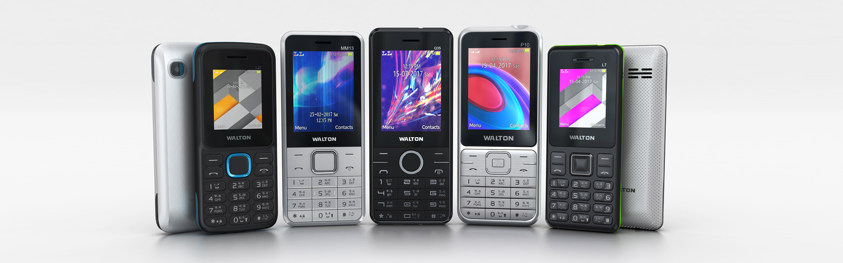

- Walpad:
Walton have launched 7 different walpad so far such as Walpad 10b, Walpad G3, Walpad 10x, Walpad 8x, Walpad C, Walpad G2 and Walpad G2i.

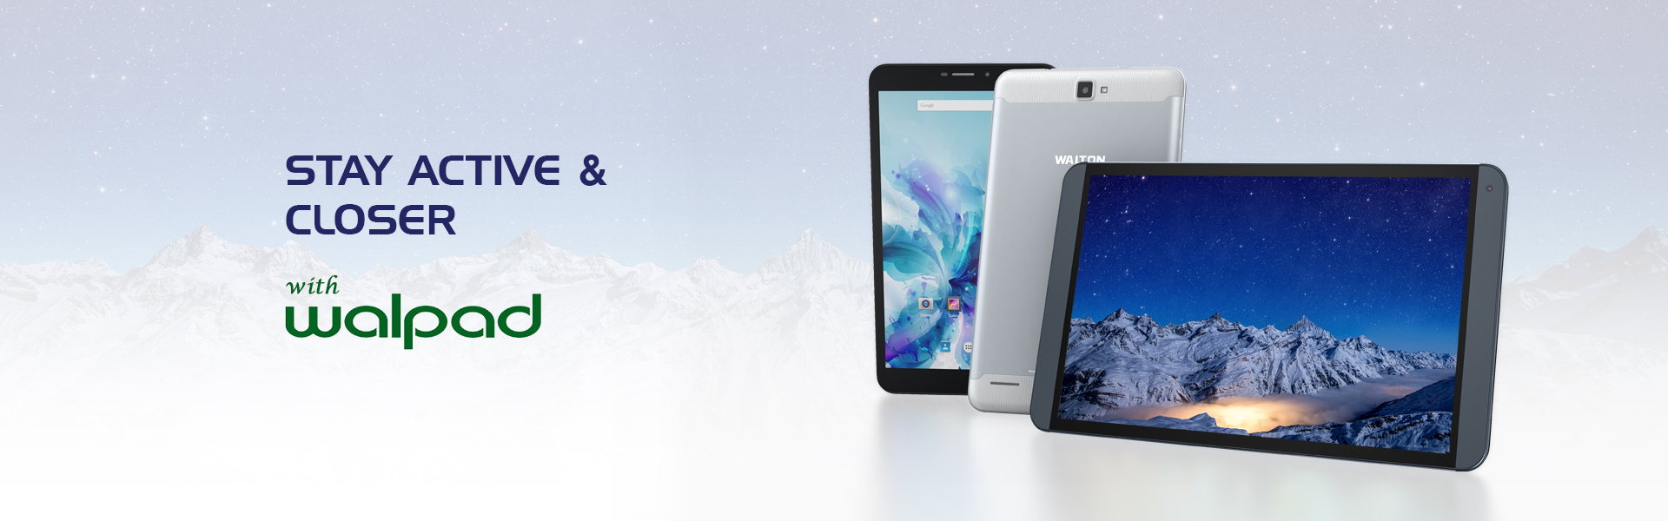

- Accessories:
Besides walpad, smart phone and feature phone Walton have also some accessories like earphone and power bank.
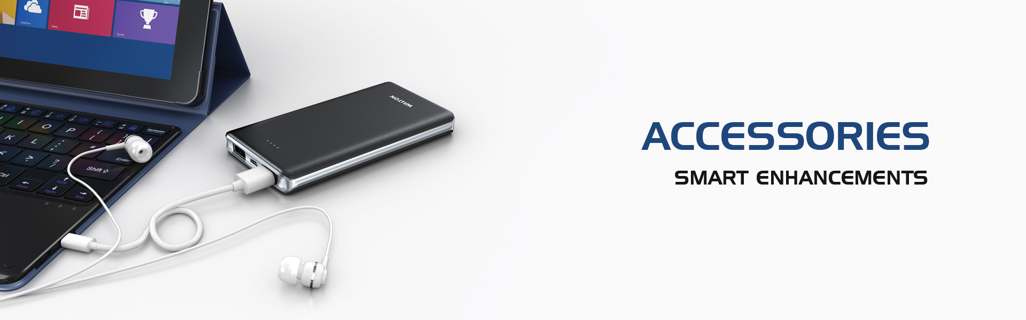

Chapter-3: Literature Review
An organization’s major goal is to build brand equity which will create competitive advantage for serving customers against the competitors. Moreover, brand equity helps an organization creates opportunity to stay in the market for long time to serve their customers. According to Falkenberg, Hooley and Srivastava, “Brand equity is a relational market-based asset because it exists outside the firm and resides in the relationships of final users with brands. At the same time, the emergence of relationship marketing as a dominant focus of both marketing theorists and practitioners suggests that trust is the main factor on which a relationship is based”. Actually, brand equity is the strength of creating superior value for customer to satisfy their needs in the market. According to, Hunt and Morgan (1995) said, “From a resource-based view of the firm, the sources of wealth creation are found in the resources endowment that enable the firm to efficiently and/or effectively produce a market offering that has value for some market segments”. According to Falkenberg (1996) also said, “By doing so, the firm achieves superior financial performance that is reflected in higher dividends and value of stocks”. Company’s long time staying in the market, company’s profit, decision making, marketing success and customer’s willingness to pay premium price are all affect brand equity.
Aaker (1991) defined brand equity as ‘’A set of brand assets and liabilities linked to a brand, its name and symbol, that adds to or subtracts from the value provided by a product or a service to a firm and/ or to that firm’s customers”. Brand equity consists four dimensions such as brand loyalty, brand awareness, brand image, and brand associations. According to Aaker (1991) defines all the dimensions in his theory and he stated that, “The attachment that a customer has to a brand”, brand awareness as “The ability for a buyer to recognize or recall that a brand is a member of a certain product category”, brand associations as “Anything linked in memory to a brand'', and brand image as “A set of brand associations, usually in some meaningful way”. Actually, brand equity is the net present value of the incremental cash flows through all these dimensions which helps to create brand name and set the brand into the customer’s mind. Brand equity encourages to enjoy high consumer preference, purchase intention, purchase, loyalty, and even higher stock returns whenever brand equity goes higher. Moreover, higher brand equity increases the credibility level of information for customers which is added with the product or services when it is provided to the customers.
Brand equity creates marketing asset for an organization by creating uniqueness in their product and services and also creating long time relationship with their customers. Therefore, consumer based-brand equity is needed so that company can build up their brand equity on the basis of consumer’s demand. Here, Consumer-Based Brand Equity refers to the analysis of the consumer’s cognitive and behavior through consumer survey as a result, marketers need to analysis consumer’s behavior and their cognitive approach before entering in to the market as a new comer or bringing new brand and product into the market. According to Aaker, “Brand equity provides value to customers by enhancing their interpretation and processing of information, confidence in the purchase decision, and satisfaction”. Value of an organization for efficiency and effectiveness of marketing programs, pricing, profit, brand extensions, trade leverage, and competitive advantage are all provided by brand equity. Besides, customer-based brand equity, firm-based brand equity defined itself as the representative for providing financial value which is created for the organization. Firm-Based Brand Equity helps to increase and manage market share, the brand premium company earns (over unbranded alternatives), the ability of the brand to sustain competition, imitation, and endure crisis etc. According to Srinivasan, “Firm-Based Brand Equity defined as the incremental profit per time period obtained by the brand in comparison to a brand with the same product and price but with minimal brand-building efforts”.
Brand trust is a cognitive component of behavior because brand trust refers to the consumer’s belief toward firms to satisfy their need anyhow and also refers to the strong relationship between consumers and marketers. Whereas, brand trust is difficult to build because competitors in the market will try to omit your product or services for the consumers as a result, consumers may not continue long term relationship when they get cheaper and more qualified product or services and most importantly consumers will break the relationship when they lose the trust they had with the firm. Therefore, marketers may face risk for losing consumers and loose the relationship with them. According to Deutsch (1973) defined brand trust as, “The confidence that one will find what is desired from another, rather than what is feared”. The concept of brand trust refers to the acceptance of customer’s both positive and negative impression toward the organization as a result brand trust belongs to relationship marketing concept. According to Ambler, “Brand trust is an affective (not a cognitive), analytical construct, which can even be a proxy for brand equity”.
There is a question arise why consumer lost their trust over a product or services provider? The reasons behind losing trust are, (1) product performance, in the sense that a person may not obtain the product intended; (2) financial risk, meaning a potential net loss of money20; and (3) time/convenience risk, incurred during online transactions (navigation, submission of orders and delays in receiving products). Brand trust plays a role as a mechanism for reducing customer’s perceive risk because trust is connected with customer’s perceived services and security. Customer’s trust goes higher when an organization provide the expected product or services to the customers which is superior and have attractive quality that satisfies customer’s needs or make customers delighted. Therefore, Zeithaml defines perceived service quality as, “The customer’s assessment of the overall excellence or superiority of the service”. If the service quality is excellent or superior then customers will continue the relationship with the marketers for long time. Brand predictability, brand competency, brand reputation, brand satisfaction and brand experience, all are connected with brand trust. Trust is created at that time when marketers commit to provide quality products or services to their customers to satisfy their needs and also create relationship between the customer and the firm. Lau & Lee have drawn a model which is known as, “ ‘Conceptual Model for Brand Loyalty’ that shows there are seven components such as, (1) brand predictability which refers to the ability of a brand to get anticipated by their consumers with full trust in every consumption so that they can predict the un expected things of the brand, (2) brand liking occurs due to the likeability of customers toward the brand also occurs through customer’s previous experience with the brand, (3) brand competence refers to the ability of a brand to overcome consumer’s problem and also fulfilling their needs, (4) brand reputation which depends on consumer’s opinion and also connected with credibility which the degree of trustworthiness of an information in a brand, (5) trust in the company refers to customer’s trust regarding the company’s provided services or delivered products which create and maintain relationship between organization and customers, (6) brand satisfaction which refers to the customer’s happiness with the delivered serviced or product which meets their satisfaction and encourage them to repurchase the service or product from the same brand & (7) brand experience which depends on customer’s usability of the brand, taste for the brand and attachment with the brand.

These seven components are combined to create brand trust and through all these components brand trust make impact on brand loyalty. Consumer belief that the brand has specific qualities that make it consistent, competent, honest, responsible and so on by considering brand trust as expectancy.
Relationship network is needed to be analyzed to examine the impact of brand trust on brand equity in which brand trust is set in the brand equity and it’s the both main priority and asset in the brand equity. In 1999 Garbarino and Johnson stated that, “Brand trust evolves from past experience and prior interaction because its development is portrayed most often as an individual’s experiential process of learning over time”. Therefore, it is said that brand trust impact on the brand equity by depending on the customer’s knowledge and experience with the brand because their experience with the brand and knowledge over the brand both increase and decrease the value of the brand. Brand experience directly impact on brand trust because it is the most important component of brand trust which make people belief to brand for repurchasing and stay for long time with brand that impact on brand trust as well as on the brand equity because brand experience may both increase and decrease the value of the brand which refers to the brand equity. To identify the connection between brand trust and brand equity, Chaudhuri, Holbrook, Delgado, Garbarino, Johnson, Lau and Lee all stated that, “Trust is the cardinal driver of loyalty because it creates exchange relationships that are highly valued”. Brand equity underlies on the ongoing process of maintaining a relationship between customer and brand. Basically, trust in transmitted by brand into the market when marketers cannot communicate with their customers directly as a result they try to communicate with them through trust which was built during the previous experience which creates the relationship between marketers and customers. Moreover, companies are also trying to build customer’s by satisfying their needs so that they can build a long-term relationship with them which will increase their credibility and brand equity. Beside firm, customers also want to build long-term relationship with the brand because changing brand may cost higher for the consumers and also create difficulties to experience a new brand. According to Sheth and Parvatiyar, “Consumers develop a relationship with the brand, which becomes a substitute for human contact between the organization and its customers”.
The ultimate purpose of maintaining trust for managing brand equity because trust is the main element which creates and holds relationship between company and customers for long time. So, it is proven that higher brand trust increases brand equity whereas lower brand trust decreases brand equity. Moreover, brand trust creates a lot of competitive advantage in the market and make them survive in the market for serving their customers for a long time. Furthermore, brand trust impact on brand equity both positively and negatively. Brand trust also make existing customers a credible source for the new customers, because existing customers trust the brand and spread positive view to the new customers because they are very much loyal with company. Moreover, these customers increase the value of the brand. Brand trust is highly associated with brand equity. Customers are trusted by the company whenever the company provides their expected product or services with premium price and higher quality which is superior than the competitors. Therefore, higher trust impact on the brand equity directly which the most important thing for the company. So, it is proven that brand trust directly impacts on the brand equity through relationship marketing.

Chapter-4: Objectives and Methodology of the Report

Objectives of the Study

Objectives of the study can be summarized below:
- To review the evolution of smartphone handset industry focusing on the important milestones over the years. Specific focus was also concentrated on the evolution and current scenario of the selected brands considered in the study: iPhone, Samsung, Symphony, and Walton.
- To make a review of the existing literature related to brand trust and brand equity. Detailed review of the brand trust will be made focusing on the two facets of brand trust, namely, brand reliability and brand intention. Relevant literature related to brand loyalty and overall customer satisfaction will also be included in the literature review section.
- To profile the respondents of the study including gender, education, average monthly family income, and profession.
- To examine the reliability of the constructs considered in the study: brand reliability (BR), brand intention (BI), brand loyalty (BL), Overall Customer Satisfaction, and Brand Equity. For the purpose of examining the reliability of these aforementioned constructs, Cronbach Alpha will be calculated for each of these constructs except Overall Customer Satisfaction, which is the only single-item measure used in this study.
- To explore the relationships among the constructs considered in the study. For this purpose, a lower diagonal correlation matrix will be developed and interpreted with due statistical underpinnings related to this study.
- To examine the impact of BR and BI on Overall Customer Satisfaction, a multiple regression analysis will be conducted assuming BR and BI as the independent variables and Overall Customer Satisfaction as the dependent variable. Coefficient of determination (R²) will be calculated and interpreted to measure the strength of association or the effect size. Beta values associated with independent variables will be interpreted to explain the relative contribution of each independent variable to the variation in the dependent variable.
- To examine the impact of BR and BI on Brand Loyalty, a multiple regression analysis will be conducted assuming BR and BI as the independent variables and Brand Loyalty as the dependent variable. Coefficient of determination (R²) will be calculated and interpreted to measure the strength of association or the effect size. Beta values associated with independent variables will be interpreted to explain the relative contribution of each independent variable to the variation in the dependent variable.
- To examine the impact of BR and BI on Brand Equity, a multiple regression analysis will be conducted assuming BR and BI as the independent variables and Brand Equity as the dependent variable. Coefficient of determination (R²) will be calculated and interpreted to measure the strength of association or the effect size. Beta values associated with independent variables will be interpreted to explain the relative contribution of each independent variable to the variation in the dependent variable.

Methodology of the Study

The methodology of the study can be explained in terms of the following aspects:
- Sampling Process and Sample Size: Non-probabilistic sampling technique was used in this study. More specifically, a convenient sampling technique was used. Sample size is 120. Data were mostly collected from the students. Others professions include service holders and business people.
- Instruments Used: The instrument used in the study is mainly derived from, “Does brand trust matter to brand equity; Elena Delgado-Ballester and Jose´ Luis Munuera-Alema´nMarketing Department, University of Murcia, Murcia, Spain”. The summary of the instrument used to collect the data is given below:

(The Impact of Brands Trust on Brand Equity)

Name (optional):

Phone Number (optional):

Gender: Male Female

Education: SSC or below HSC Bachelor Masters or equivalent professional degree or above

Profession: Student Service Holder Business Others

Average Monthly Family Income: 30,000 or below 30,000—60,000 60,000—90,000

90,000 –1,20,000 above 1,20,000

Please indicate your level of agreement with the following statements regarding the following statements. Where 1 = highly disagreed, 2 = disagreed, 3 = neutral, 4 = agreed, and 5 = highly agreed.

SN | Statements | 1 | 2 | 3 | 4 | 5
BR1 | X is a brand name that meets my expectations
BR2 | I feel confidence in X
BR3 | X never disappoints me
BR4 | X guarantees satisfaction
BI1 | X would be honest and sincere in addressing my concerns
BI2 | I could rely on iPhone to solve any problem with the product
BI3 | X would make any effort to satisfy me in case of a problem
BI4 | X would compensate me in some way for the problem with the product
BL1 | I consider myself to be loyal to X
BL2 | Only under extreme circumstances would I consider purchasing of this product different from X
BL3 | If the store was out of X, I would go somewhere else to buy some
BL4 | Even when another brand is on sale, I would prefer the brand X
BE1 | It makes sense to buy X instead of any other brand, even if they are the same
BE2 | Even if another brand has the same features as X, I would prefer to buy X
BE3 | If there is another brand as good as X, I prefer to buy X
BE4 | If another brand is not different from iPhone in any way, it seems smarter to purchase X

Please indicate the level of your overall satisfaction regarding X:
Very Dissatisfied. Dissatisfied. Neutral. Satisfied. Very Satisfied.

- Analyses to be Conducted: For the purpose of fulfilling the objectives, descriptive statistical analyses, Cronbach Alpha, Pearson’s Product Moment Correlation, and multiple regression analyses will be conducted.

Chapter-5: Findings of the Study

Sample Characteristics
There were 120 respondents as sample size and the sampling technique applied was non-probabilistic in nature. Characteristics of the sample used in this study can be summarized in the tables below:

- Gender:
 |  | Frequency | Percent | Valid Percent | Cumulative Percent
Valid | Male | 56 | 46.7 | 46.7 | 46.7
Valid | Female | 64 | 53.3 | 53.3 | 100.0
Valid | Total | 120 | 100.0 | 100.0

The sample size had a frequency of 56 male students and 64 female students. The female percentage was greater by 6.6 %, with a female percentage of 53.30 and a male percentage of 46.70.

- Education:

 |  | Frequency | Percent | Valid Percent | Cumulative Percent
Valid | HSC | 16 | 13.3 | 13.3 | 13.3
Valid | Bachelor | 92 | 76.7 | 76.7 | 90.0
Valid | Masters or equivalent | 12 | 10.0 | 10.0 | 100.0
Valid | Total | 120 | 100.0 | 100.0

Out of the randomly selected sample population, 13.3% is studying in HSC or Higher Secondary College. The percentage of sample pursuing their Bachelors is the highest, which is 76.7%. The rest 10% is in various stages of their Masters studies.

- Profession:
 |  | Frequency | Percent | Valid Percent | Cumulative Percent
Valid | Student | 100 | 83.3 | 83.3 | 83.3
Valid | Service Holder | 16 | 13.3 | 13.3 | 96.7
Valid | Business | 4 | 3.3 | 3.3 | 100.0
Valid | Total | 120 | 100.0 | 100.0

Maximum data was collected from the students through university premises which showed the greatest frequency of profession proved which didn’t surprise at all. The percentage of students in the study sample was 83.3, service holders ranked second with a percentage of 13.3 and people from other professions like business were of 3.3.

- Average Monthly Family Income:
 |  | Frequency | Percent | Valid Percent | Cumulative Percent
Valid | 30,000 or below | 8 | 6.7 | 6.7 | 6.7
Valid | 30,000 - 60,000 | 20 | 16.7 | 16.7 | 23.3
Valid | 60,000 - 90,000 | 24 | 20.0 | 20.0 | 43.3
Valid | 90,000 - 1.20,000 | 36 | 30.0 | 30.0 | 73.3
Valid | Above 1,20,000 | 32 | 26.7 | 26.7 | 100.0
Valid | Total | 120 | 100.0 | 100.0

The range of Taka 90,000- 120,000 was the second last range provided for this study and it proved to be the most common among the sample size. The aforementioned range had a percentage of 30.0, while the maximum range of Taka Above 120000 was the second most common, with a percentage value of 26.7. The other ranges had close percentages with the Taka 60,000-90,000 range having a percentage of 20.0, the Taka 30,000-60,000 range valuing 16.7 and the least percentage of 6.7 belonging to the lowest range of Taka 30000 or below.

Basic Descriptive Statistics

Basic descriptive statistics of the constructs used in the study can be summarized in the table given below:

 | N | Minimum | Maximum | Mean | Std. Deviation
Overall Satisfaction | 120 | 1.00 | 5.00 | 3.0083 | 1.15588
BR | 120 | 1.00 | 5.00 | 2.8313 | 1.02396
BI | 120 | 1.00 | 5.00 | 2.8792 | 1.03357
BL | 120 | 1.00 | 5.00 | 2.8542 | .94301
BE | 120 | 1.00 | 5.00 | 2.8812 | 1.09091
Valid N (listwise) | 120

Using the basic descriptive statistics (mainly mean and standard deviation), confidence interval for each construct was calculated assuming 95% level of confidence:
- Overall Customer Satisfaction:
While measuring the overall satisfaction level form the sample, the mean value calculated was 3.01, with a standard deviation of 1.15. The low value of standard deviation proves that the data points are quite close to the mean. The standard deviation of 1.15 along with a confidence interval of 95% provides the data range to be within 2.81 <Overall Customer Satisfaction<3.21.
- Brand Reliability (BR):
While measuring the brand reliability level form the sample, the mean value calculated was 2.83, with a standard deviation of 1.02. The low value of standard deviation proves that the data points are quite close to the mean. The standard deviation of 1.02 along with a confidence interval of 95% provides the data range to be within 2.65 <BR<3.01.

- Brand Intention (BI):
The measurement of brand intention level averaged to be 2.88 and the standard deviation calculated was 1.09. The validation for the result was found due to having low value for the standard deviation once again. A reliability construct will be done later on to be more confident of the sample data collected. The mean of 2.88 along with the standard deviation of 1.09 and confidence interval of 95% shows that the sample data spreads from 2.70<BI<3.06.

- Brand Loyalty:
The measurement of brand loyalty level averaged to be 2.85 and the standard deviation calculated was .94. A low value for the standard deviation is observed yet once again, providing validation for the results found. A reliability construct will be done later on to be more confident of the sample data collected. The mean of 2.85 along with the standard deviation of .94 and confidence interval of 95% shows that the sample data spreads from 2.67<BL<3.03.
- Brand Equity:
The measurement of brand equity level averaged to be 2.88 and the standard deviation calculated was 1.09. A low value for the standard deviation is observed yet once again, providing validation for the results found. A reliability construct will be done later on to be more confident of the sample data collected. The mean of 2.88 along with the standard deviation of 1.09 and confidence interval of 95% shows that the sample data spreads from 2.68<BE<3.08

Reliability of Constructs Used

Researchers (Introduction to SAS. UCLA: Statistical Consulting Group. from https://stats.idre.ucla.edu/sas/modules/sas-learning-moduleintroduction-to-the-features-of-sas/ (accessed August 22, 2016)) agree that “Cronbach’s alpha is a measure of internal consistency, that is, how closely related a set of items are as a group. It is considered to be a measure of scale reliability. A "high" value for alpha does not imply that the measure is one-dimensional. If, in addition to measuring internal consistency, you wish to provide evidence that the scale in question is one-dimensional, additional analyses can be performed. Exploratory factor analysis is one method of checking dimensionality. Technically speaking, Cronbach’s alpha is not a statistical test – it is a coefficient of reliability (or consistency).

A rule of thumb for interpreting alpha for dichotomous questions (i.e. questions with two possible answers) or Likert scale questions is:
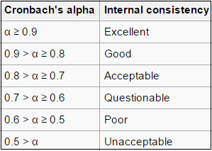

Interpretation of Cronbach Alpha Value for the Constructs of the Study
The Alpha value for constructing Brand Reliability (BR) was calculated to be .83 by the SPSS software. According to the rule of thumb of reliability coefficients an alpha value is 0.9 > α ≥ 0.8 which proves to have a good internal consistency. This good level of internal consistency validates the reliability of this construct used in the study.
The Alpha value for construct Brand Intention (BI) was shown to be .89 by the SPSS. This value, in line with the rule of thumb, falls under the level of “good” and so is proved to have suitable level of consistency with the study conducted.
The Alpha value for construct Brand Loyalty (BL) was shown to be .70 by the SPSS. This value, in line with the rule of thumb, which shows value 0.8 > α ≥ 0.7 that indicates the level of “acceptable” and so is proved to have suitable level of consistency with the study conducted.
The Alpha value for construct Brand Equity (BE) was shown to be .82 by the SPSS. This value, in line with the rule of thumb, which shows the value 0.9 > α ≥ 0.8 falls under the level of “good” and so is proved to have suitable level of consistency with the study conducted.

Evaluating the Relationships among Constructs

 |  | Overall Satisfaction | BR | BI | BL | BE
Overall Satisfaction | Pearson Correlation | 1 | .782(**) | .769(**) | .668(**) | .774(**)
Overall Satisfaction | Sig. (2-tailed) | . | .000 | .000 | .000 | .000
Overall Satisfaction | N | 120 | 120 | 120 | 120 | 120
BR | Pearson Correlation | .782(**) | 1 | .687(**) | .687(**) | .741(**)
BR | Sig. (2-tailed) | .000 | . | .000 | .000 | .000
BR | N | 120 | 120 | 120 | 120 | 120
BI | Pearson Correlation | .769(**) | .687(**) | 1 | .622(**) | .612(**)
BI | Sig. (2-tailed) | .000 | .000 | . | .000 | .000
BI | N | 120 | 120 | 120 | 120 | 120
BL | Pearson Correlation | .668(**) | .687(**) | .622(**) | 1 | .754(**)
BL | Sig. (2-tailed) | .000 | .000 | .000 | . | .000
BL | N | 120 | 120 | 120 | 120 | 120
BE | Pearson Correlation | .774(**) | .741(**) | .612(**) | .754(**) | 1
BE | Sig. (2-tailed) | .000 | .000 | .000 | .000 | .
BE | N | 120 | 120 | 120 | 120 | 120
** Correlation is significant at the 0.01 level (2-tailed).

The lower part of the diagonal matrix was used to determine the correlation between the constructs chosen for the study. In simpler words, this table illustrates whether the constructs affect each other and if they do then to what degree.
The constructs were used for this study were: (a) Overall Satisfaction, (b) Brand Reliability, denoted by BR on the table, (c) Brand Intention, denoted by BI, (d) Brand Loyalty, denoted by BL, and (e) Brand Equity, denoted by BE.

As evident from the table, the values are repeated twice as correlations are being repeated during analysis. To avoid confusion and make the hypothesis clear, only the lower part of the matrix is taken into consideration while inferring the correlation among the constructs. The division of the table has made it possible to exclude some irrelevant values, such as the correlation of Overall Satisfaction with Overall Satisfaction, BR with BR, BI with BI, BL with BL and BE with BE, which are apparently 1.

The relationship between the each and every construct are analyzed below:

- The correlation coefficient for Overall Satisfaction and Brand Reliability is 0.782(**). For survey scale type data this is pretty large. The numerical value of surveyed number in the sample responding to both items is 120. Correlation coefficient has p-value of .000. Technically it is not zero. SPSS does not give p-values to more than three decimal places.

The statistical hypothesis test for this p-value is:

H0: There is no significant relationship between Overall Satisfaction and Brand Reliability.
Ha: There is a statistically significant relationship between Overall Satisfaction and Brand Reliability.

As p < .01, the null of no relationship is rejected and it is concluded that the relationship is statistically significant.

- The correlation coefficient for Overall Satisfaction and Brand Intension is 0.769(**). For survey scale type data this is pretty large. The numerical value of surveyed number in the sample responding to both items is 120. Correlation coefficient has p-value of .000. Technically it is not zero. SPSS does not give p-values to more than three decimal places.

The statistical hypothesis test for this p-value is:

H0: There is no significant relationship between Overall Satisfaction and Intention.
Ha: There is a statistically significant relationship between Overall Satisfaction and Brand Intention.

As p < .01, the null of no relationship is rejected and it is concluded that the relationship is statistically significant.

- The correlation coefficient for Overall Satisfaction and Brand Loyalty is 0.668(**). For survey scale type data this is pretty large. The numerical value of surveyed number in the sample responding to both items is 120. Correlation coefficient has p-value of .000. Technically it is not zero. SPSS does not give p-values to more than three decimal places.

The statistical hypothesis test for this p-value is:

H0: There is no significant relationship between Overall Satisfaction and Brand Loyalty.
Ha: There is a statistically significant relationship between Overall Satisfaction and Brand Loyalty.

As p < .01, the null of no relationship is rejected and it is concluded that the relationship is statistically significant.

- The correlation coefficient for Overall Satisfaction and Brand Equity is 0.774(**). For survey scale type data this is pretty large. The numerical value of surveyed number in the sample responding to both items is 120. Correlation coefficient has p-value of .000. Technically it is not zero. SPSS does not give p-values to more than three decimal places.

The statistical hypothesis test for this p-value is:

H0: There is no significant relationship between Overall Satisfaction and Brand Equity.
Ha: There is a statistically significant relationship between Overall Satisfaction and Brand Equity.

As p < .01, the null of no relationship is rejected and it is concluded that the relationship is statistically significant.

- The correlation coefficient for Brand Reliability and Brand Intention is 0.687(**). For survey scale type data this is pretty large. The numerical value of surveyed number in the sample responding to both items is 120. Correlation coefficient has p-value of .000. Technically it is not zero. SPSS does not give p-values to more than three decimal places.

The statistical hypothesis test for this p-value is:

H0: There is no significant relationship between Brand Reliability and Brand Intention.
Ha: There is a statistically significant relationship between Brand Reliability and Intention.

As p < .01, the null of no relationship is rejected and it is concluded that the relationship is statistically significant.

- The correlation coefficient for Brand Reliability and Brand Loyalty is 0.687(**). The number of responding in the sample responding to both items is 120. Correlation coefficient has p-value of .000.

The statistical hypothesis test for this p-value is:

H0: There is no significant relationship between Brand Reliability and Brand Loyalty.
Ha: There is a statistically significant relationship between Brand Reliability and Brand Loyalty.

As p < .01, the null of no relationship is rejected and it is concluded that the relationship is statistically significant.

- The correlation coefficient for Brand Reliability and Brand Equity is 0.741(**). The numerical value of respondents in the sample answering to both items is 60. Correlation coefficient has p-value of .000.

The statistical hypothesis test for this p-value is:

H0: There is no significant relationship between Brand Reliability and Brand Equity.
Ha: There is a statistically significant relationship between Brand Reliability and Brand Equity.

As p < .01, the null of no relationship is rejected and it is concluded that the relationship is statistically significant.

- The correlation coefficient for Brand Intention and Brand Loyalty is 0.622(**). Total of 120 respondents answered both items. Correlation coefficient has p-value of .000.

The statistical hypothesis test for this p-value is:

H0: There is no significant relationship between Brand Intention and Brand Loyalty.
Ha: There is a statistically significant relationship between Brand Intention and Brand Loyalty.

As p < .01, the null of no relationship is rejected and it is concluded that the relationship is statistically significant.

- The correlation coefficient for Brand Intention and Brand Equity is 0.612(**). Total of 120 respondents answered both items. Correlation coefficient has p-value of .000.
The statistical hypothesis test for this p-value is:

H0: There is no significant relationship between Brand Intention and Brand Equity.
Ha: There is a statistically significant relationship between Brand Intention and Brand Equity.

As p < .01, the null of no relationship is rejected and it is concluded that the relationship is statistically significant.

- The correlation coefficient for Brand Loyalty and Brand Equity is 0.754(**). Total of 120 respondents answered both items. Correlation coefficient has p-value of .000.

The statistical hypothesis test for this p-value is:

H0: There is no significant relationship between Brand Loyalty and Brand Equity.
Ha: There is a statistically significant relationship between Brand Loyalty and Brand Equity.

As p < .01, the null of no relationship is rejected and it is concluded that the relationship is statistically significant

To be noted, all the correlation coefficient has the symbol (**) attached with it. This means correlation is significant at the 0.01 level (2-tailed). In simpler words, for the sample taken, 99% conformed to the correlation coefficients provided.

Evaluating the Impact of Brand Trust on Brand Equity

At first, for the purpose of evaluating the impact of the various facets of Brand Trust (brand reliability and brand intention) on Brand Equity, a multiple regression analysis was conducted. The result of the conducted multiple regression analysis can be presented in the table given below:

F = 77.367, Sig.= .000, R Squared = .569
Independent  Variable | B | Beta | t | Sig. value | Hypothesis Testing Result
Constant | .457 |  | 2.171 | .032
Brand Reliability | .647 | .608 | 7.281 | .000 | Significant Contribution
Brand Intention | .205 | .194 | 2.330 | .022 | Significant Contribution
Dependent Variable: BE = Brand Equity

Here F value is 77.367 with sig. = .000 (less than .05), the null hypothesis will be rejected. Now it can be concluded that both BR and BI significant affect the brand equity. Now the changes in Brand Equity can be explained by the changes in BR and BI by 56.90%, indicated by the value of R-squared = .569.

Beta values are the standardized coefficients. These coefficients are obtained when all the variables of the regression are standardized, including the dependent and all of the independent variables, and then regression is conducted. Through standardization of the variables before
running the regression, all of the variables have been put on the same scale, and so the magnitude of the coefficients has become comparable, to see which one has more of an effect.
Thus, the Beta value has been used to determine which of the independent variable has the most impact on brand equity, the dependent variable. From the Beta values produced by the SPSS, construct Brand Reliability (BR) has the highest value, which is .608.

The Beta value of construct brand intention (BI) is much lower than that of construct Brand Reliability (BR). Beta value for BI is .194, which shows that BI has smaller effect on equity than BR. The smaller value indicates weaker correlation between BI and Equity.

Secondly, for the purpose of evaluating the impact of the various facets of Brand Trust (brand reliability and brand intention) on Brand Loyalty, a multiple regression analysis was conducted. The result of the conducted multiple regression analysis can be presented in the table given below:

F = 62.069, Sig.= .000, R Squared = .515
Independent  Variable | B | Beta | t | Sig. value | Hypothesis Testing Result
Constant | .825 |  | 4.267 | .000
Brand Reliability | .452 | .491 | 5.540 | .000 | Significant Contribution
Brand Intention | .260 | .285 | 3.221 | .002 | Significant Contribution
Dependent Variable: BE = Brand Equity

Here F value is 62.069 with sig. = .000 (less than .05), the null hypothesis will be rejected. Now it can be concluded that both BR and BI significant affect the brand equity. Now the changes in
Brand Equity can be explained by the changes in BR and BI by 51.50%, indicated by the value of R-squared = .515.
Beta values are the standardized coefficients. These coefficients are obtained when all the variables of the regression are standardized, including the dependent and all of the independent variables, and then regression is conducted. Through standardization of the variables before running the regression, all of the variables have been put on the same scale, and so the magnitude of the coefficients has become comparable, to see which one has more of an effect.

Thus, the Beta value has been used to determine which of the independent variable has the most impact on brand equity, the dependent variable. From the Beta values produced by the SPSS, construct Brand Reliability (BR) has the highest value, which is .491.

The Beta value of construct brand intention (BI) is much lower than that of construct Brand Reliability (BR). Beta value for BI is .285, which shows that BI has smaller effect on equity than BR. The smaller value indicates weaker correlation between BI and Equity.

Finally, for the purpose of evaluating the impact of the various facets of Brand Trust (brand reliability and brand intention) on Brand Loyalty, a multiple regression analysis was conducted. The result of the conducted multiple regression analysis can be presented in the table given below:

F = 145.915, Sig.= .000, R Squared = .714
Independent  Variable | B | Beta | t | Sig. value | Hypothesis Testing Result
Constant | .058 |  | .319 | .750
Brand Reliability | .542 | .480 | 7.062 | .000 | Significant Contribution
Brand Intention | .491 | .439 | 6.457 | .000 | Significant Contribution
Dependent Variable: BE = Brand Equity

Here F value is 145.915 with sig. = .000 (less than .05), the null hypothesis will be rejected. Now it can be concluded that both BR and BI significant affect the brand equity. Now the changes in Brand Equity can be explained by the changes in BR and BI by 71.40%, indicated by the value of R-squared = .714.

Beta values are the standardized coefficients. These coefficients are obtained when all the variables of the regression are standardized, including the dependent and all of the independent variables, and then regression is conducted. Through standardization of the variables before running the regression, all of the variables have been put on the same scale, and so the magnitude of the coefficients has become comparable, to see which one has more of an effect.

Thus, the Beta value has been used to determine which of the independent variable has the most impact on brand equity, the dependent variable. From the Beta values produced by the SPSS, construct Brand Reliability (BR) has the highest value, which is .480.

The Beta value of construct brand intention (BI) is much lower than that of construct Brand Reliability (BR). Beta value for BI is .439, which shows that BI has smaller effect on equity than BR. The smaller value indicates weaker correlation between BI and Equity.

Chapter-6: Future Research Scope and Conclusion

Future Research Scope
There were lots of variety of respondents missed due to completing the survey without knowing the demographic elements such age, marital status, social background, and so on. Also, geographical location of the respondents.
The findings of the study showed that brand trust made a positive impact on brand equity. As, there were some varieties missed during the research so in the future I need to explore the varieties of the customers so that I can specifically identify impact of brand trust on the brand equity in a well-mannered way.
Moreover, future researches can also be conducted in various other contexts and industries. Future researches can also be conducted to examine the factors responsible for the formation of brand trust.

Conclusion
The reason behind the research was to examine the impact of brand trust on brand equity. To examine the impact, at first the facets of brand trust which are brand reliability and brand intention that needed to be identified and also needed to be analyzed so that the impact on the brand equity of brand trust can easily be identified. Then the constructs of the study which were, brand reliability, brand intention, brand loyalty, brand equity and overall customer satisfaction were analyzed and corelated to each other. After that, for the purpose of examining the reliability of these aforementioned constructs, Cronbach Alpha was calculated for each of these constructs except Overall Customer Satisfaction, which is the only single-item measure used in this study. At the end, multiple regression analysis was used to examining the impact of BR and BI on Overall Customer Satisfaction, on Brand Loyalty, and on Brand Equity. In a nutshell, both BR and BI were found to affect customer satisfaction, brand loyalty, and brand equity. But in all cases BR was found to have more relative impact than BI due to higher beta value.

REFERENCES

Aaker, D.A. (1991), Managing Brand Equity: Capitalizing on the Value of a Brand Name, Free Press, New York, NY.
Aaker, David A, V Kumar and Georges S. Day (2001).
Anton A Setyawan, Kussudiyarsana, Imronudinm, BRAND TRUST AND BRAND LOYALTY, AN EMPIRICAL STUDY IN INDONESIA CONSUMERS.
AP Photo/Damian Dovarganes, visited at 11:45 pm on 2nd July 2018.
Ambler, T. (1992). Need-to-Know-Marketing. Century Business, London
Ambler, T. (2003) Marketing and the Bottom Line: Creating the Measures of Success. London: Financial Times/Prentice Hall.
Ambler, T. & Barwise, P. (1998) The trouble with brand valuation. Journal of Brand
Management.
Baker, C., Nancarrow, C. & Tinson, J. (2005) The mind versus market share guide to brand
equity. International Journal of Market Research.
Elena Delgado-Ballester and Jose´ Luis Munuera-Alema´n, Does Brand Trust Matter on Brand Equity?
Falkenberg, A.W. (1996) Marketing and the wealth of firms. Journal of Macromarketing.
George Christodoulides (University of Birmingham) and Leslie de Chernatony (Università della Svizzera italiana, Lugano and Aston Business School),” Consumer-based brand equity conceptualisation and measurement”.
Hunt, S.D. & Morgan, R.M. (1995) The comparative advantage theory of competition. Journal of Marketing.
Keller, K. L. (1993). Conceptualizing, measuring, and managing customer-based brand equity. The Journal of Marketing.
Keller, K. L. (2001). Building customer-based brand equity: a blueprint for creating strong brands, Marketing Science Institute of Marketing.
Keller, K. L. (2003). Strategic Brand Management: Building, Measuring, and Managing Brand Equity (2nd ed.). Prentice-Hall, Upper Saddle River, NJ.
M.K. Agarwal, and V.R. Rao, An empirical comparison of consumer-based measures of brand equity. Marketing letters
Rai and Medha, 2013, Morgan and Hunt, 1994, Parasuramanetal., 1985.
Ron Christianson from Cyber Telephone Museum.
R.B Group Founder of Walton Group of Industries. 1977.
Reuters and Yuya Shino.
Steave Jobbs Founder of Apple.inc.
SB Tel Enterprise Ltd, visited at 10 am on 3rd July 2018
Srivastava R, Shocker AD. Brand equity: a perspective on its meaning and measurement. Working Paper Series, Report Number 91-124. Cambridge, MA: Marketing Science Institute, 1991.
Sullivan MW. How brand names affect the demand for twin automobiles. J Mark Res 1998;35(May):154 ±65.
Sheth JN and Parvatiyar, Are there differences in dissonance reduction behavior between
students and housewives? J Mark Res 1970;7(May):243± 5.
Wikimedia Commons, visited at 11 pm on 2nd July 2018.
Sciencedirect.com, visited at 7pm on 13th July 2018.
Journals.lww.com, visited at 7:20 pm 13th July 2018.
Emeraldinsight.com, visited at 11 pm 15th July 2018.
Mdpi.com, visited at 11:15 am 16th July 2018.
Visual.ly, visited at 9 pm on 18th July 2018.
QZ.com, visited at 10 pm o 18th July 2018.
Aytm.com, visited at 10:30 pm on 20th July 2018.
Forbes.org, visited at 11 pm on 20th July 2018.
Journals.ama.org. visited at 11:15 pm on 20th July 2018.
Waltonbd.com, visited at 10 am on 21st July 2018.
Apple.com, visited at 12 pm on 21st July 2018.
Scribd.com, visited at 1 pm, 1st August 2018.
Investopedia.com, visited at 7 pm 3rd August 2018.
Whatis.techtarget.com, visited at 9:30 pm 8th August 2018.
Yoo B, Donthu N, Lee S. An examination of selected marketing mix elements
and brand equity. J Acad Mark Sci 2000; 28(Spring):195± 211.
Zeithaml VA. Consumer perceptions of price, quality, and value.
means±end model and synthesis of evidence. J Mark 1988;52(July)
2 ±22.

