The Rise of Thematic Bonds, Bangladesh’s First Social Bond Issuance-An Internship Study at BRAC EPL Investment Limited

Azrun Nahar Promity

This report is submitted to the school of Business and Economics, United International University as a partial requirement for the degree fulfillment of Bachelor of Business Administration

The Rise of Thematic Bonds, Bangladesh’s First Social Bond Issuance-An Internship Study at BRAC EPL Investment Limited

Submitted to:
Name: Dr. Shakila Aziz
Designation: Associate Professor
SOBE, UIU

Submitted by:
Name: Azrun Nahar Promity
ID: 111221038
Major: Finance and Fintech


School of Business and Economics
United International University

Date of Submission: July 2026

Letter of transmittal
July 07, 2026
Dr. Shakila Aziz
School of Business and Economics
United international University
Subject: Submission of Internship Report on BRAC EPL Investment Limited
Dear Ma’am,
It is a great pleasure to present to you the Internship Report titled “The Rise of Thematic Bonds, Bangladesh's First Social Bond Issuance-An Internship Study at BRAC EPL Investment Limited” as a requirement for the completion of my Bachelor of Business Administration (BBA) degree in Finance and Fintech from United International University.
This report is focused on the practical experience that I gained in the Investment banking Sector, more specifically, in the emerging bond market, during my internship period at BRAC EPL Investments Limited, a Subsidiary of BRAC Bank, acting as one of the prominent merchant banks in Bangladesh. The report presents a detailed overview of the company’s Operations and performance, including an in-depth case study on BRAC Bank's Social Bond Transaction and its processing details. With that, it also introduces an insightful baseline of the concept of Thematic Bonds.
I made every effort to prepare this report with the highest level of accuracy and relevance. I sincerely hope it meets the required standard for my academic knowledge and demonstrates my participation in the practical applications of the business world.
Sincerely,
Name: Azrun Nahar Promity
ID: 111221038
Major: Finance and Fintech
School of business and Economics (SoBE)
United International University

Certification of Similarity Index

Declaration of the student

I, Azrun Nahar Promity, hereby declare that this Internship report is my original work, the result of my personal efforts, observations, and experience gained during my internship at BRAC EPL Investments Limited while completing my BBA degree at United International University.
This report does not contain materials previously written or published by a third party, except where they are fully cited and accurately referenced.
This report does not contain materials that have been submitted or accepted for any other degree or diploma at any other university or institution.
I have acknowledged all major sources of help. I understand that any violation of the University’s academic and ethical standards may lead to disciplinary action.


Corporate evidence

Acknowledgement
First and foremost, I would like to express my immense gratitude to my academic supervisor, Dr. Shakila Aziz, Associate Professor at the School of Business and Economics, United International University, for her mentorship, insightful feedback, and progressive encouragement throughout the preparation of this internship report. Her academic supervision, constructive criticism, and continuous support helped me to complete this report profoundly.
I would also like to extend my sincere appreciation to Mr. Anup Datta, Head of Investment Banking, BRAC EPL Investments Limited, for granting me the opportunity to undertake my internship in the Investment Banking Department. It was a privilege to gain practical exposure to the operations of a leading investment bank in Bangladesh.
My heartfelt gratitude goes to Mr. Zahidul Islam Tamim, Investment Analyst, Investment Banking Department, and Mr. Saiful Bari Talukdar, AVP, Investment Banking Department, BRAC EPL Investments Limited, whose mentorship and continuous support significantly enriched my learning experience.
I am equally grateful to all the officers and colleagues of the Investment Banking Department at BRAC EPL Investments Limited for their cooperation, encouragement, and cordial support throughout my internship. Their professionalism, collaborative spirit, and welcoming work environment made my internship a highly rewarding and memorable experience.
At Last, I would like to convey my sincere gratitude to United International University and BRAC EPL Investments Limited for providing me with this invaluable opportunity to integrate academic knowledge with practical experience. The internship has significantly broadened my understanding of investment banking, strengthened my analytical and professional competencies, and served as a vital milestone in my academic and career development.

Executive Summary
The internship report titled ‘The Rise of Thematic Bonds: Bangladesh’s First Social Bond Issuance -An Internship Study at BRAC EPL Investment Limited’ is a partial fulfillment of the study program of the Bachelor of Business Administration (BBA) program. The report includes practical learning experiences from a three-month-long internship in the Investment Banking Department of BRAC EPL Investment Limited, with an analytical study of the first Social Bond in Bangladesh, offering a glimpse into the sustainable finance market in Bangladesh and the Investment Banking operations at BRAC EPL Investment Limited.
The report represents an overview of BRAC EPL Investment Limited, including its organizational structure, industry position, Business operations, financial performance, and the functions of the Investment Banking Department. It also highlights the practical duties during the internship, such as working on Management Information System (MIS) databases, reviewing financial information, practicing financial modeling, supporting the bond team with documentation procedures, and other aspects of investment banking operations. These activities offered first-hand exposure to the roles of corporate finance and debt capital market services in practice, including operational, analytical, and regulatory elements.
Besides that, it focuses on the development of thematic bonds in Bangladesh by examining a detailed case study of the country's first Social Bond issue. The report outlines the history of thematic financing, the features of Social Bonds, the regulatory framework for their issuance, and the transaction process adopted by the lead arranger. The planning, documentation, compliance, coordination of stakeholders, and implementation of a groundbreaking debt capital market transaction are highlighted
Thematic bonds are a promising instrument to channel funds into socially beneficial projects, and to diversify the investments offered to domestic financial markets. The report highlights areas for improvement, including regulatory support, ESG reporting, investor awareness, market infrastructure, and ongoing engagement among issuers, regulators, and investment banks.
The findings demonstrate the relevance of investment banks in structuring innovative financial instruments, fulfilling regulatory requirements, and linking the issuer to the investor. BRAC EPL Investment Limited has played a key role in developing innovative capital market solutions by participating in the first-ever issuance of the Social Bond in Bangladesh.
Overall, this report showcases how practical internship experience can enhance academic education and give a first-hand glimpse into the economic landscape of financial markets, transaction execution, and sustainable finance. It also which highlights the growing importance of thematic bonds, a new financing mechanism that can support the long-term economic, social, and capital market development of Bangladesh.

Table of contents
Letter of transmittal iii
Certification of Similarity Index iv
Declaration of the student v
Corporate evidence vi
Acknowledgement vii
Executive Summary viii
Table of contents x
List of figures xii
List of tables xiii
List of acronyms and abbreviations xiv
Chapter 1: Introduction 1
1.1 Background of the Report 1
1.1.1 Concept and Importance of Thematic Bonds 1
1.1.2 Development of the Thematic Bond Market in Bangladesh 3
1.2 Objectives of the Report 3
1.3 Rationale of the Report 4
1.3.1 Understanding Investment Banking Practices 4
1.3.2 Assessment of the Social Subordinated Bond 4
1.3.3 Industry and Academic Perspective 5
1.3.4 Literature Contribution 5
1.3.5 Personal Learning and Practical Experience 5
1.4 Scope and Limitation of the Report 5
1.4.1 Scope 5
1.4.2 Limitation 5
1.5 The definition of key terms 6
Chapter 2 Company and Industry Profile 7
2.1 Company Analysis 7
2.1.1 Overview and History of BRAC EPL Investment Limited 7
2.1.2 Trend and Growth 7
2.1.3 Products and Services of BRAC EPL Investments Limited 8
2.1.3.1 Strategic Role of BRAC EPL Investments Limited 10
2.1.3.2 BRAC Bank's Social Bond 11
2.1.3.3 BRAC Bank Social Bond Framework: 11
2.1.4 SWOT Analysis 12
2.1.5 Financial Performance 16
2.1.6 Business Operations of BRAC EPL Investments Limited 19
2.2 Industry Analysis 21
2.2.1 Specification of the Industry 21
2.2.2 Size, Trend and Maturity of the Industry 22
2.2.3 Industry SWOT Analysis 23
Chapter 3 INTERNSHIP EXPERIENCE 25
3.1 Position, Duties, and Responsibilities 25
3.2 Training & Development 25
3.3 Contribution to Organization / Operations 26
3.4 Evaluation 26
3.5 Skills Applied 27
Chapter 4 Conclusions and Key Facts 28
4.1 Recommendations 28
4.2 Key Understanding 29
4.2.1 Social and Economic Impact of Social Bond 29
4.2.2 Challenges and Future Prospects 29
4.3 Conclusion 29
References 32
Appendix-A 33

List of figures

Figure 2.1: Revenue growth trend; overall Company Vs IBD 1
Figure 2.2: Social Bond advertisement 4
Figure 2.3: SIP features.....................................................................................................................10
Figure 2.4: BEIL SWOT analysis 12
Figure 2.5 gross profit margin 16
Figure 2.6: net profit margin 16
Figure 2.7: current ratio 17
Figure 2.8: debt to equity ratio 18
Figure 2.9: return on equity 18
Figure 2.10: Return on asset 19
Figure 2.11: BEIL Organogram 20
Figure 2.12: industry SWOT Analysis 23

List of tables

Table 1.1 Characteristics of Thematic Bonds 2
Table 1.1 Defination of key terms 6
Table 1.1 Industry Status 23

List of acronyms and abbreviations
- BBA: Bachelor of Business Administration
- BEIL: BRAC EPL Investments Limited
- BSEC: Bangladesh Securities and Exchange Commission
- CMSMEs: Cottage, Micro, Small and Medium Enterprises
- CSE: Chittagong Stock Exchange
- DCM: Debt Capital Market
- DSE: Dhaka Stock Exchange
- ECM: Equity Capital Market
- EPS: Earnings per Share
- EPSL: Equity Partners Securities Limited
- EPL: Equity Partners Limited
- ESG: Environmental, Social, and Governance
- FDI: Foreign Direct Investment
- GDP: Gross Domestic Product
- HR: Human Resources
- IBD: Investment Banking Department,
- ICMA: International Capital Market Association
- IM: Information Memorandum
- IPO: Initial Public Offering
- IT: Information Technology
- M&A: Mergers and Acquisitions
- MIS: Management Information System,
- MoU: Memorandum of Understanding
- NGOs: Non-Governmental Organizations
- PMD: Portfolio Management Department
- PPP: Public-Private Partnership
- PRC: Parliamentary Rights & Cards Limited
- ROA: Return on Assets,
- ROE: Return on Equity,
- RPGCL: Rupantarita Prakritik Gas Company Limited
- SBP: Social Bond Principles,
- SDG: Sustainable Development Goals
- SIP: Systematic Investment Plan
- SoBE / SOBE: School of Business and Economics
- SPO: Second Party Opinion
- UIU: United International University
- UNDP: United Nations Development Program

Chapter 1: Introduction

Background of the Report
The global financial framework has undergone a fundamental shift in the past two Decades. From the traditional domain of return-maximizing investors, the capital market is gradually being reshaped by the essentials of Environmental sustainability, social equity, and responsible governance, collectively known as ESG Finance. The evolution of a niche instrument of thematic bond transformed the capital market into a multi-trillion-dollar global asset class (The Daily Star, 2025).
Bangladesh is a country ranked among the world’s most climate-vulnerable economies and home to one of South Asia’s most dynamic capital markets. The adoption of thematic finance has been gradual but accelerating. In July 2023, the United Nations Development Program (UNDP) and the Bangladesh Securities and Exchange Commission (BSEC) signed a Memorandum of Understanding (MoU) to strengthen cooperation in the development of the ecosystem for the issuance of thematic bonds to achieve the Sustainable Development Goals (SDG) in Bangladesh (UNDP, 2023). NGOs like Sajida Foundation have actively developed thematic bonds like green bond, Orange bond, Social bond, etc. In 2025, BRAC Bank launched the first-ever social subordinate bond (BRAC, 2025).
This report documents and analyzes the initial development and impact of thematic bond through the lens of an internship at BRAC EPL Investment Limited’s Investment Banking Department. It examines the regulatory and structural framework governing the transaction, and draws professional lessons from the author’s direct participation in the process.

Concept and Importance of Thematic Bonds
Thematic bonds are debt securities issued to finance projects that address specific environmental, social, or sustainability-related objectives. Unlike conventional bonds, where proceeds may be used for general corporate purposes, thematic bonds require issuers to allocate funds to predefined eligible projects and to provide transparency regarding the use of proceeds.
The most common categories of thematic bonds include Green Bonds, Social Bonds, Sustainability Bonds, and Sustainability-Linked Bonds. These instruments have gained global popularity because they enable investors to align their portfolios with sustainable development goals while maintaining traditional fixed-income investment characteristics. (ICMA, 2020). Although thematic bonds may not provide a direct pricing advantage, they enable sovereign issuers to showcase their dedication to environmental, social, and sustainability-related priorities. (Hussain, F. I, 2022).
Table 1.1 Characteristics of Thematic Bonds
Characteristic | Social Bond | Green Bond | Orange Bond
Primary Objective | To finance or refinance projects that deliver positive social outcomes. | To finance projects addressing specific environmental benefits | To finance projects that promote gender equality and women –led business,
Use of Proceeds | Includes eligible social projects like CMSMEs, women-led enterprises, agriculture, healthcare, affordable housing, and education. | Focused on environmental sustainability and climate-vulnerable economic needs. | Exclusively for benefiting women entrepreneurs
Guidelines & Framework | ICMA Social Bond Principles (SBP). | ICMA Green Bond Principle (GBP) | IIX Orange Bond Principle (OPB)
Relevant UNSDGs | SDGs 1, 2, 3, 4, 8, 10, 11. | SDGs 6,7,11,12,13,14,15 | SDGs 5, partially 1,8,10.
Example in Bangladesh | BRAC Bank’s Social Subordinate bond | SAJIDA Foundation’s Green Bond | SAJIDA Foundation’s Orange Bond
From a development perspective, thematic bonds provide access to long-term capital for projects that generate positive societal outcomes. For developing economies such as Bangladesh, these instruments can help bridge financing gaps in sectors including healthcare, education, affordable housing, agriculture, and financial inclusion. The growing importance of thematic bonds also reflects a broader transition toward responsible investing, where investment decisions increasingly consider social and environmental impacts alongside financial performance.

Development of the Thematic Bond Market in Bangladesh
Bangladesh's financial system has traditionally been dominated by commercial banks. Although the country has experienced steady economic growth, the corporate bond market remains relatively underdeveloped compared to equity markets and bank financing.
Recognizing the need for alternative financing mechanisms, regulators have introduced reforms to promote bond market development. The Bangladesh Securities and Exchange Commission (BSEC) has played a pivotal role in encouraging innovative debt instruments, including thematic bonds. Simultaneously, growing interest from development agencies, institutional investors, and financial intermediaries has created momentum for sustainable finance initiatives.
The emergence of thematic bonds represents a significant advancement in Bangladesh's capital market. These instruments provide issuers with access to diversified funding sources while allowing investors to participate in projects that contribute to national development priorities. The approval and issuance of social and orange bonds indicate a growing willingness among market participants to embrace sustainable finance practices.
Despite this progress, the market remains in its early stages and faces challenges related to investor awareness, reporting standards, and market liquidity. Nevertheless, recent issuances demonstrate the potential for thematic bonds to become an important component of Bangladesh's future capital market development.

Objectives of the Report
The main aims of this internship report are:
- To document and evaluate the internship experience, including roles played, skills acquired, and professional competencies demonstrated, and to gain insight into the workings of investment banking in the frontier capital market.
- To explore the emerging thematic bond market in Bangladesh, its development, principles, and importance, particularly in the Social Bond market.
- To document the role of BRAC EPL Investment Limited as the Lead Arranger for BRAC Bank’s Social Bond issuance.
- To provide forward-looking suggestions to develop the thematic bond market in Bangladesh.

Rationale of the Report
One of the major challenges for Bangladesh is to grow the economy faster while addressing social inequity in access to credit, housing, and agricultural support. Existing development financing methods have been found to be inadequate to address this challenge. Capital market instruments, such as Social Bonds, are a novel link between private capital and public development goals. This could lead to a potential Solution to meet this challenge. According to Mr. Anup Datta, head of Investment Banking, BEIL, a successful issuance of Bangladesh’s First Social Bond was accomplished despite the absence of an established regulatory framework and other challenges involved in introducing a new thematic Bond to the local market. This report is relevant for several reasons as mentioned below:

Understanding Investment Banking Practices
The report examines the operations of BRAC EPL Investments Limited, particularly its Investment Banking Department’s operational activities, capital market services, and debt financing solutions. Moreover, it highlights how the company is contributing in the development of Bangladesh's bond market through innovative financial instruments.

Assessment of the Social Subordinated Bond
The report assesses the feasibility of Bangladesh's first Social Subordinated Bond issued by BRAC Bank PLC, with BRAC EPL Investments Limited serving as the Lead Arranger. It evaluates its importance and potential contribution to the development of Bangladesh's sustainable finance and debt capital market.

Industry and Academic Perspective
As part of the internship program, this report provides practical and academic insights into Bangladesh's investment banking industry and the emerging sustainable finance market. It is intended to benefit students, researchers, policymakers, and finance professionals seeking to understand investment banking practices and thematic bond issuances in Bangladesh.

Literature Contribution
The number of Research paper on Bangladesh's investment banking sector and thematic bonds, particularly Social Bonds is limited. This report contributes to the existing literature by documenting the issuance process, market significance, and the role of BRAC EPL Investments Limited in arranging Bangladesh's first Social Subordinated Bond, supported by industry data and strategic analysis.

Personal Learning and Practical Experience
The report reflects the practical learnings and professional experience gained during the internship period at the IBD of BRAC EPL Investments Limited. The experience helped to develop real world application of theoretical concepts in financial analysis, financial modeling, and investment banking operations,

Scope and Limitation of the Report

Scope
With an emphasis on its pioneering role in Bangladesh’s Capital market especially in the new bond market. This report offers a thorough assessment of BRAC EPL Investments Limited. Not only It analyses the organizations history, financial performance and Industry position but also shade lights on the creative strategic management of IBD in order to introduce exceptional capital instrument in the ecosystem of Bangladeshi capital market.

Limitation
- Some details of transactions, financial information, and internal communications have not been shared because they are confidential and fall outside the scope of the organization’s data confidentiality policy.
- The performance data due to the infancy of the thematic bond secondary market in Bangladesh.
- The report is the intern's view and experience and does not necessarily reflect the issuer's or investor's point of view.

The definition of key terms
Table 1.2 Definition of key terms
Term | Definition
Thematic Bond | A thematic bond is a fixed-income instrument that seeks to achieve environmental and social goals by allocating investments to projects that have been identified as environmentally or socially positive. 1.(Hussain F. I. ,2022)
Social Bond | A bond where proceeds are exclusively applied to finance or refinance social projects that deliver positive social outcomes, as defined by the ICMA Social Bond Principles. Refinance social projects that deliver positive social outcomes. Refinance social projects that deliver positive social outcomes, as defined by the ICMA Social Bond Principles (SBP, ICMA).
Second Party Opinion (SPO) | An independent assessment by a recognized external reviewer verifying that a bond’s framework aligns with relevant principles (e.g., ICMA SBP),
Lead Arranger | The financial institution is responsible for structuring, marketing, and coordinating the issuance of debt securities on behalf of the issuer.
ICMA Social Bond Principles | Voluntary process guidelines published by the International Capital Market Association promote integrity in the Social Bond market.
Use of Proceeds | The specific categories of projects or activities for which the bond’s capital is allocated.
Impact Reporting | Periodic disclosure by the issuer quantifying the social or environmental outcomes achieved by bond proceeds.

Company and Industry Profile

Company Analysis

Overview and History of BRAC EPL Investment Limited
BRAC EPL Investments Limited (BEIL) is a subsidiary of BRAC Bank acting as one of the prominent merchant banks in Bangladesh. The company's roots lie in Equity Partners Limited (EPL), a licensed merchant bank, formed in the early 2000s.
In August 2009, BRAC Bank took over the controlling interest in Equity Partners Limited (EPL) and its affiliate company, Equity Partners Securities Limited (EPSL) to increase its presence in the Bangladesh capital market. The acquisition has been a multi-phase process, where BRAC Bank first acquired 51% control of both entities. The bank more recently joined the brokerage business in 2011 by acquiring an additional 39% stake in the business, bringing the total 90%. After these mergers, the new companies have been known as BRAC EPL. The company is currently located at Mohakhali, Dhaka-1213.
Today, BRAC EPL Investments Limited offers a wide range of investment banking and merchant banking services such as issue management, corporate advisory, corporate finance, underwriting, and portfolio management. It also provides value-added financial solutions like wealth management services to both institutional and individual clients. BRAC EPL Investments Limited has strong parentage, abundant industry experience, and diversified financial services, which help develop the Bangladesh capital market and assist companies to access capital, invest, and grow into a sustainable future. BRAC EPL Investments Limited aims to provide innovative, pioneering and world-class sustainable investment banking solutions including creation of access to capital markets for individual investors and social enterprises.

Trend and Growth
The Bangladesh capital market has experienced tremendous expansion over the last ten years, and BRAC EPL has grown proportionately. Both the retail and institutional investors have increasingly started trading on the Dhaka Stock Exchange (DSE) and Chittagong Stock Exchange (CSE), which is comparatively small in comparison to the debt capital market, which has relatively fewer players compared to the size of the economy.
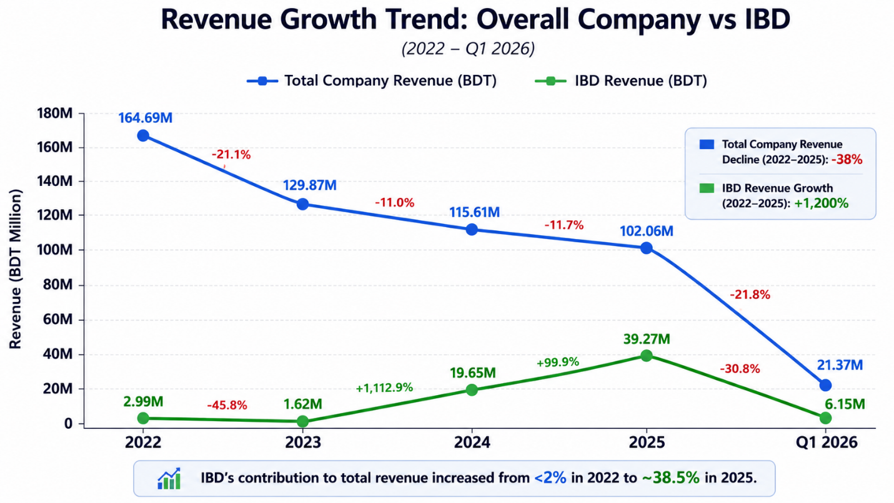
Figure 2.1: Revenue growth trend; overall Company Vs IBD

Products and Services of BRAC EPL Investments Limited
BRAC EPL Investments Limited is a full-service investment banker, portfolio manager, adviser, and wealth management firm that caters to the financing & investment requirements of corporate and individual investors.
Equity Capital Market: The organization helps companies raise equity capital in three ways such as Public Equity, Private Equity, and Quasi-Equity. They assist institutional issuers in obtaining long-term capital, expanding business operations, and maximizing capital structures, as well as connecting institutional issuers to potential investors.
Debt Capital Market: BRAC EPL offers financing solutions under the following instruments: Loan Syndication and Club Financing, Project Financing, Bond, and Regulatory Capital. These services provide businesses with access to significant financing, build infrastructure and expansion projects, and satisfy regulatory capital requirements cost-effectively.
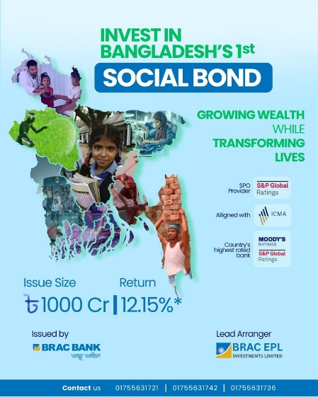
Figure 2.2: Social Bond advertisement
Source: BRAC EPL Investments Limited LinkedIn Post
Portfolio Management: BEIL offers Portfolio management service to both individual and institutional investors with products such as CAP Edge, Managed CAP Edge, and CAP Cash. Some major characteristics include diversified investment portfolios, active fund management, risk-adjusted returns, and liquidity management tailored to different investors' risk and financial goals.
Corporate Advisory: BRAC EPL provides financial advisory services for Mergers and Acquisitions (M&A), Distressed Companies Advisory, and Asset-Backed Securities. Examples of these services include corporate restructuring, business valuation, transaction execution, turnaround strategies, and alternative financing options.
Wealth Management: The wealth management section offers tailor-made investment solutions in the form of Progoti (Systematic Investment Plan - SIP), Shurokkha (Secured Investment), and Shomriddhi. Some of the key elements are disciplined wealth building, preserving wealth over time, consistent earnings, customized wealth building plans, and long-term portfolio development for individual investors.
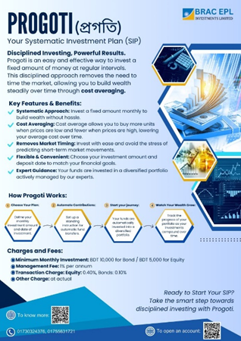
Figure 2.3: SIP features.
Source: BRAC EPL Investment limited LInkedIn Profile
To serve these varied products and services, BRAC EPL Investments Limited facilitates the development of the capital market and assists the clients to meet their financing, investment and wealth creation goals.

Strategic Role of BRAC EPL Investments Limited
BRAC EPL Investments Limited played a critical role acting as the Lead Arranger of the transaction, in facilitating the successful issuance of the bond. The firm's involvement extended beyond traditional advisory functions and encompassed multiple aspects of transaction execution. The organization contributed to structuring the bond, coordinating regulatory approvals, preparing transaction documentation, engaging with institutional investors, and ensuring compliance with applicable regulatory and market requirements. Such responsibilities required collaboration among various stakeholders, including regulators, trustees, credit rating agencies, legal advisors, and investors. The transaction highlights the growing importance of investment banks in developing Bangladesh's debt capital market. Through its advisory and arranging capabilities, BRAC EPL Investments helped bridge the gap between issuers seeking capital and investors seeking sustainable investment opportunities.

BRAC Bank's Social Bond
The issuance of BRAC Bank's Social Bond represents a landmark achievement in Bangladesh's financial sector. As the first social bond issued in the country, the transaction established a framework for integrating social impact objectives within capital market financing.
The bond was structured as a subordinated debt instrument with a total issue size of BDT 1,000 crore and a tenure of seven years. The issuance was designed not only to strengthen the bank's Tier-II capital base but also to channel financial resources toward sectors that generate measurable social benefits. Bond Framework Independently Vetted Second Party Opinion (SPO) by S&P Global Rating

BRAC Bank Social Bond Framework:
- Aligned with ICMA, Social Bond Principles, 2025
- Use of proceeds
- Process for project evaluation and selection
- Management of proceeds
- Reporting
A distinguishing feature of the bond is its alignment with internationally recognized Social Bond Principles (SBP). The proceeds are earmarked for eligible sectors including Cottage, Micro, Small and Medium Enterprises (CMSMEs), women-led enterprises, agriculture, healthcare, affordable housing, and other socially beneficial initiatives. The transaction reflects a strategic effort to combine commercial banking objectives with broader development goals. By linking capital market financing to social impact outcomes, BRAC Bank has demonstrated how financial institutions can contribute to inclusive economic growth while maintaining financial sustainability. The BRAC Bank Social Subordinated Bond was issued on 1 December 2025 and was fully subscribed by 22 April 2026, reflecting strong investor confidence and market acceptance. A total of 660 investors participated in the issuance, comprising 596 individual investors and 64 corporate investors. Notably, this was the first social bond in Bangladesh to be offered to retail investors, marking a significant milestone in the country's debt capital market. The overwhelming response demonstrated the growing interest in thematic bonds and highlighted the successful introduction of sustainable finance products to a broader investor base. The effortless completion of the issuance represented a significant achievement for both BRAC Bank PLC and BRAC EPL Investments Limited, reinforcing their leadership in innovative capital market solutions.

SWOT Analysis
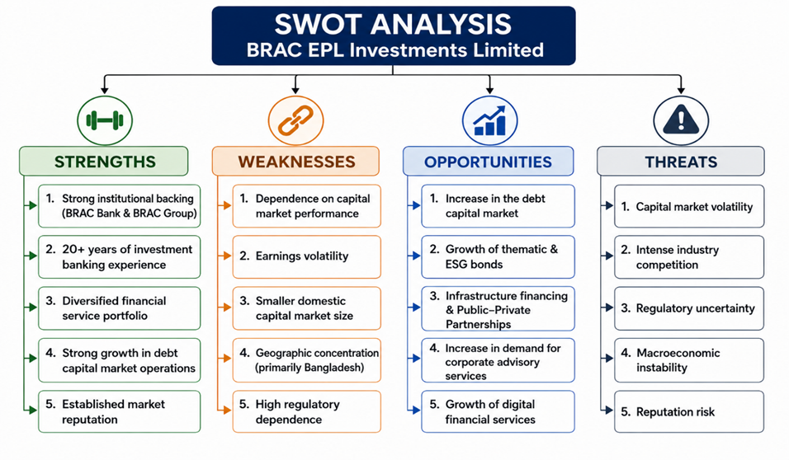
Figure2.4: BEIL SWOT analysis; source: created by Claude AI
The SWOT Analysis is a strategic planning tool used to assess an organization's Strengths, Weaknesses, Opportunities, and Threats. It provides detailed information on the competitive position of BRAC EPL Investments Limited, its internal capabilities, and the external business environment in Bangladesh's changing financial services sector.
- Strengths
Strong Institutional Backing: BRAC EPL Investments Limited has the financial strength and reputation of its parent entities, namely BRAC Bank PLC and BRAC Group. With such an institutional affiliation, the company earns more credibility and client trust and can book big corporate mandates from its domestic and international clientele.
Comprehensive investment banking experience: More than 20 years of experience and has built good, strong expertise in investment banking and merchant banking services for the firm. It has successfully completed many significant transactions, including Initial Public Offerings (IPOs), debt capital market transactions, mergers and acquisitions, cross-border advisory assignments, and more.
Diversified financial service portfolio: By providing a wide variety of financial services, such as equity capital market advisory, debt financing, corporate advisory, mergers and acquisitions, portfolio and wealth management, the organization created a divers portfolio. This approach helps the company lessen its reliance on a single revenue stream and provides clients with a range of financial services.
Strong growth in Debt Capital Market Operations: BRAC EPL Investments has shown outstanding performance in the debt capital market. Corporate demand is increasingly shifting toward alternative financing options, further bolstering the firm's position in Bangladesh's developing bond market.
Established Market Reputation: Their ability to execute complex financial transactions and provide high-quality services has earned it a reputation as one of the premier investment banks in Bangladesh. Its professional knowledge and market credibility make it a trusted advisor to corporate and institutional clients.
- Weaknesses
Dependence on Capital Market Performance: It is able to generate a major chunk of its revenue from investment banking, portfolio management and investment activities. This means that the capital markets have a direct impact on the number of transactions, advisory fees and investment returns.
Earnings Volatility: The financial condition of the company is vulnerable to adverse market conditions. Investment banking activity was cyclical, as evidenced by the adverse impact on profitability in 2024 due to lower capital market activity.
Smaller Domestic Capital Market Sizes: The capital market in Bangladesh is comparatively small compared to those of other countries in the region, including South East Asian countries and India. This restricts the number of transactions, the earning potential, and the firm's ability to engage in more varied investment banking transactions.
Geographic Concentration: Most of BRAC EPL Investments' activities take place in Bangladesh. It is not diversified internationally, and therefore, its operations are vulnerable to the economic risks of a particular country and have fewer opportunities for cross-border business expansion.
High Regulatory Dependence: The investment banking sector is heavily regulated by agencies such as the Bangladesh Securities and Exchange Commission (BSEC) and the Bangladesh Bank. There could be frequent changes in regulations that lead to additional expenses in compliance and ongoing operational adjustments.
- Opportunities
Increase in the Debt Capital Market: The debt capital market in Bangladesh is expected to have significant investment banking potential. With companies increasingly looking to alternatives to traditional bank financing, bond issuance and debt advisory services should also see significantly increased volume.
Growth of Thematic & ESG Bonds: New business opportunities emerge through the rising popularity of bonds such as Green, Social, Sustainability, and Sustainability-Linked. BRAC EPL Investments is well-equipped to take advantage of this trend by its experience in designing new and creative sustainable financing solutions.
Infrastructure Financing and Public-Private Partnerships: The in Bangladesh is likely to increase demand for project financing, syndicated loans, and Public-Private Partnership (PPP) advisory services. This will provide an opportunity to further develop the company's structured finance capacity.
Demand Increasing for Corporate Advisory Services: The rising number of M&A activity, FDI, business restructuring, and growth projects is expected to drive up the demand for valuation, capital raisings, and strategic advisory services.
Digital Financial Services: Financial services are rapidly becoming digital, and retail investors are taking the center stage, offering a promising avenue for digital wealth management, online investment platforms, and tailored financial advice.
- Threats
Capital Market Volatility: Lower investor confidence, reduced trading, and extended market slowdowns can all negatively impact IPO activity, investment banking business, portfolio management profits, and advisory fees.
Intense Industry Competition: They are facing stiff competition from the big financial institutions like IDLC Finance PLC, Lanka-Bangla Investments Limited, City Bank Capital Resources Limited, and EBL Investments Limited. Competition could drive down market share, pricing, and client acquisition.
Regulatory Uncertainty: The costs for compliance with evolving capital market requirements, underwriting guidelines, disclosure standards, and merchant banking policies could rise, and ongoing changes in business practices may be necessary.
Macroeconomic Instability: Inflation, high interest rates, exchange rate volatility, and a lack of investment in the private sector may affect a company's revenue by reducing its financial activity and decreasing demand for investment banking services.
Reputation Risk: Investment banking is closely tied to trust from clients and long-term relationships, so errors in operations, regulatory compliance, ethical issues, or failed transactions can have a significant impact on the firm's reputation and the trust of clients.

Financial Performance
- Gross Profit Margin

Figure 2.5 Gross profit margin; Source: annual report of BEIL 2023-2025
The Gross Profit Margin has shown extreme volatility, primarily driven by the cost of funds relative to interest income. The sharp decline in 2023–2024 occurred because direct expenses, mostly interest paid to banks like BRAC Bank PLC nearly consumed all operating revenue. The recovery in 2025 was fueled by the Investment Banking Department (IBD), which generates high-margin fee income with significantly lower direct costs compared to traditional margin lending.

- Net Profit Margin
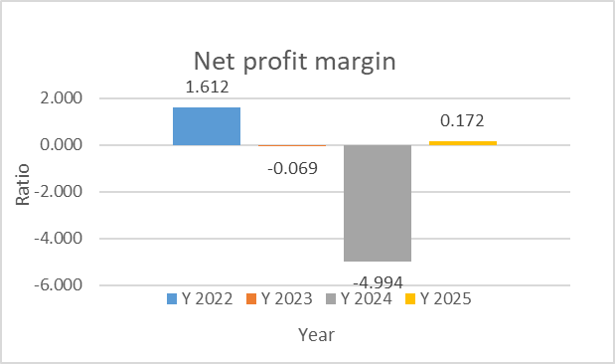
Figure 2.6: Net profit margin Source: annual report of BEIL 2023-2025
This ratio has been the most unstable, frequently detached from core operations due to external market factors and accounting adjustments. The massive negative margin in 2024 was caused by a combination of investment losses and a BDT 324.6 million deferred tax expense. Conversely, the 2025 profit margin was largely "artificial," as the company actually had an operating loss but was saved by a BDT 132.4 million tax credit.
- Current Ratio

Figure 2.7: Current ratio; Source: annual report of BEIL 2023-2025
BEIL has maintained a healthy short-term liquidity position, consistently keeping this ratio above 1.0.A ratio above 1.0 indicates that the company has sufficient current assets (like cash and customer loans) to cover its current liabilities such as bank overdrafts and customer deposits. However, the overall asset base is shrinking, current assets fell from BDT 2.03 billion in 2022 to BDT 1.18 billion in 2025, reflecting a general contraction in business volume.
- Debt-to-Equity Ratio

Figure 2.8: Debt to equity ratio; Source: annual report of BEIL 2023-2025

The company’s solvency has weakened over the last few years as its equity base was eroded by losses. The ratio rose from 1.03 in 2022 to 1.31 in 2025. Interpretation: An increasing ratio suggests that the company is becoming more reliant on debt relative to its own capital. While BEIL has aggressively reduced its bank overdrafts, the massive accumulated loss (BDT 2.29 billion) has depleted shareholder equity so significantly that the company's leverage remains high.
- Return on Equity (ROE)
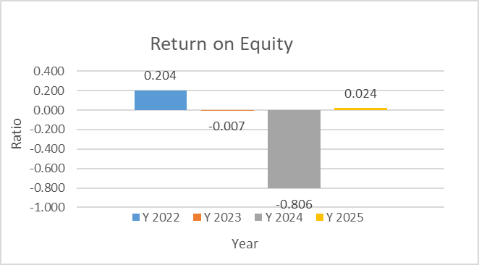
Figure 2.9: Return on equity Source: annual report of BEIL 2023-2025
ROE measures how effectively the company uses shareholder capital to generate profit. ROE was strong at 20.4% in 2022, crashed to -80.6% in 2024, and recovered slightly to 2.4% in 2025.The catastrophic ROE in 2024 highlights how the year's losses wiped out a significant portion of the owners' value. The return to a positive ROE in 2025 is a sign of stabilization, but at 2.4%, it remains well below the cost of capital, indicating that the company is not yet generating efficient returns for its parent, BRAC Bank.

- Return on Assets (ROA)

Figure 2.10: Return on Asset Source: annual report of BEIL 2023-2025
ROA indicates how efficiently the company is using its total asset base to generate earnings. The low ROA in 2025 (1.0%) suggests that even though the company is technically profitable again, its earnings are very thin relative to the BDT 1.69 billion in assets it manages. This reflects the ongoing struggle to find high-yielding business opportunities as interest income from customer loans continues to decline.

Business Operations of BRAC EPL Investments Limited
BRAC EPL Investments Limited (BEIL) functions as one of the leading merchant banks and investment management companies in Bangladesh, offering various services related to investment banking, portfolio management, and advice. There are two types of departments within BRAC EPL, namely revenue-generating and supporting departments that provide efficient operations and compliance.
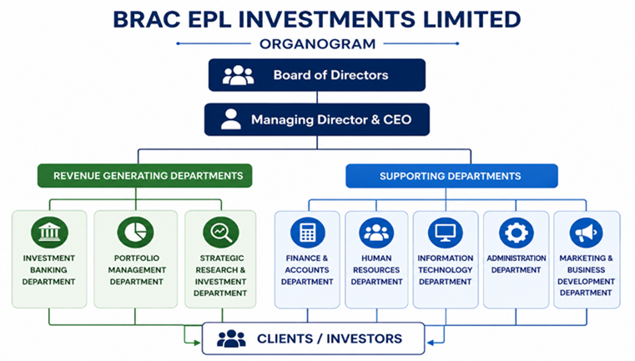
Figure 2.11: BEIL Organogram; source: Created by Notebook lm AI
- Revenue-Generating Departments
Investment Banking Department (IBD): Investment Banking Department (IBD) is one of the primary revenue-generating departments in BRAC EPL Investments Limited and acts as the core department that provides an array of financial solutions for corporate clients.
Portfolio Management Department (PMD): The Portfolio Management Department (PMD) manages investment portfolios for individual and institutional clients under discretionary and non-discretionary mandates. The department also manages corporate investment portfolios, trust funds, and provident and pension funds while maintaining regular communication with clients. Revenue is mainly earned through portfolio management and advisory fees.
Strategic Research & Investment Department: The Strategic Research & Investment Department supports the company's investment banking and portfolio management activities by conducting equity, industry and macroeconomic research. It develops investment strategies, prepares market outlook reports, and publishes research to support informed investment decisions. Although the department does not directly generate revenue, its research significantly contributes to client acquisition, portfolio performance, and successful execution of investment banking mandates.
- Supporting Departments
Finance & Accounts Department: The Finance & Accounts Department oversees financial reporting, budgeting, treasury operations, tax compliance, and regulatory reporting. It ensures sound financial management and provides accurate financial information for strategic decision-making.
Human Resources (HR) Department: The Human Resources Department manages recruitment, employee training, performance evaluation, compensation, and talent development to ensure the organization maintains a skilled and productive workforce
Information Technology (IT) Department: The IT Department provides technological infrastructure, cybersecurity, system maintenance, and Management Information System (MIS) support, ensuring the secure and efficient operation of business activities.
Administration Department: The Administration Department manages office operations, procurement, asset management, vendor coordination, and facility maintenance to ensure smooth day-to-day organizational functioning.
Marketing Department: The Marketing Department enhances the company's brand image and business development through client acquisition, corporate communications, promotional campaigns, digital marketing, and relationship management.

Industry Analysis
The investment banking and capital markets industry in Bangladesh is analyzed.

Specification of the Industry
The Investment Banking and Capital Markets Industry is a niche within the Financial Services Industry that includes services related to capital-building, corporate financing, investment management, and advice. Investment banks and merchant banks are intermediary institutions of the securities market that help corporations raise money in the form of equity or debt.
This industry is regulated by the Bangladesh Securities and Exchange Commission and includes merchant banks, investment banks, brokerage houses, asset management companies, stock exchanges, and other capital market intermediaries in Bangladesh. It is important to note that the industry is vital to the mobilization of long-term funding for businesses and to economic development by optimizing the allocation of financial resources.
Major Services Offered
- The book building and fixed price method of IPO Management is the most suitable
- Corporate Advisory Services
- Mergers and Acquisitions (M&A)
- The concept of debt financing and bond arrangement.
- Underwriting Services
- Portfolio Management
- Wealth Management
- Valuation and Financial Modeling
- Sustainable Finance Advisory (Green Bonds and Social Bonds)
Major Industry Participants
- Parliamentary Rights & Cards (PRC) Limited
- Lanka-Bangla Investments PLC
- IDLC Investments Limited
- EBL Investments Limited
The industry is moving towards a more diversified financial system with corporate bonds, capital market instruments, and alternative financing methods, moving away from the current financing structure, which is dominated by banks.

Size, Trend and Maturity of the Industry
Industry Size: The investment banking and capital markets sector is still very small in Bangladesh compared with the markets sector, which remains very small in Bangladesh compared with regional and global markets. The limited role of the capital market in overall economic financing is reflected in the stock market's capitalization value of about 6% of GDP, the bond market's capitalization value of about 6% of GDP, and the bond market's capitalization value of about 6.6% of GDP as of 2025. In contrast, commercial banks continue to play a dominant role in corporate financing, and there are significant opportunities to expand the capital markets as the country's economy grows.
Industry Trend: The sector is slowly growing as the need for varied financing options grows, and the continuous support of the regulatory body. Key trends include Debt Capital Markets (Increase in corporate bonds, subordinated bonds, Sukuk, and green and social bonds), Increase of Sustainable Finance (Growing focus on ESG-related investments and sustainable financing products), The growing need for corporate financing (Demand for investment banking advisory services, capital raising, and structured finance is rising due to industrialization and infrastructure development), Digital Transformation (Investment companies are leveraging digital platforms, data analytics, and tech-enabled wealth management solutions to enhance their processes and customer satisfaction).
Industry Maturity: Bangladesh's investment banking sector is at the growth phase in its life cycle. The market is relatively shallow, but it presents excellent prospects for long-term growth driven by continuous economic expansion, regulatory reforms, and the growing financing needs of corporations. The growth is also bolstered by the growth of the debt capital market and the rise of sustainable finance programs.
Table 2.1: Industry Status
Assessment Dimension | Current Status
Industry Size | Small to Medium
Market Development | Emerging
Capital Market Depth | Relatively Shallow
Bond Market Development | Developing
Growth Potential | High

Industry SWOT Analysis
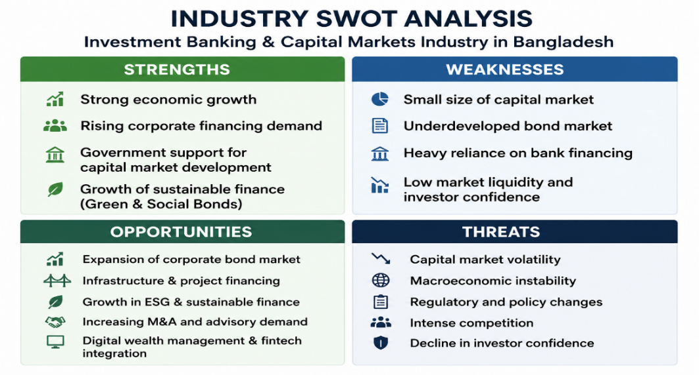
Figure 2.12: Industry SWOT Analysis; source: Created by Notebooklm AI
- Strengths
The capital markets and investment banking of Bangladesh have been able to derive a number of advantages owing to the continuous economic development of the country, rise in demand for corporate finance for a long period, as well as regulatory support to improve the capital market. Sustainable financing methods have further brought more opportunities for investment bankers.
- Weaknesses
Despite the industry being relatively small in size, it is significantly underdeveloped relative to other players in the region due to low market capitalization and underdeveloped corporate bonds market. The industry is also highly reliant on funding from commercial banks.
- Opportunities
There are substantial growth opportunities in expanding the corporate bonds market, financing infrastructure projects, mergers and acquisitions advisory services, and ESG investment products. Further digitalization of the industry and involvement of both institutional and retail investors are set to drive growth.
- Threats
The threats to the industry include fluctuations in the capital markets, economic uncertainties, regulatory changes, and cutthroat competition among merchant banks and other financial firms. This could lead to reduced investment activities, delayed financing processes, and impact profitability of the industry.

INTERNSHIP EXPERIENCE

Position, Duties, and Responsibilities
I completed a three-month full-time Academic Internship at BRAC EPL Investments Limited in the Investment Banking Department from 15 February to 14 May, mainly in the Bond Team. My duties were to create and process bond documents, keep subscription agreement forms, and arrange for the distribution of said documents to clients. Kept track of subscription activities, monitored the status of signed forms, maintained records of BO account openings, and created progress reports for supervisors.
I also created and kept vital records from clients, banks, and internal users. In addition, I helped the team with financial statement analysis, financial modeling, ratio analysis, and valuation. My duties also involved preparing presentations and supporting existing projects related to bond issuances and debt capital markets.

Training & Development
I interned and was formally and informally trained by supervisors and colleagues. The work culture was very supportive, allowing me to gain knowledge in investment banking that went beyond what was covered in the curriculum. Provided hands-on experience in the debt capital markets, bond issuance, client onboarding, subscription management, and transaction documentation. The best learning opportunity was through the internal processes of discussions and training sessions about process improvement. One training that focused on the ‘Cheaper, Better, Faster’ philosophy had me learn some workflow optimization techniques and the need to remove inefficiencies from operational processes. This knowledge enabled me to grasp the concept of continuous improvement and how it contributes to the productivity and quality of service provided by organizations.
I also had the opportunity to learn about portfolio management practices, servicing high-net-worth clients, and the creation of new financial products like Orange Bonds. Exposed to business development activities and client relationship management, attending client meetings and internal strategy discussions.

Contribution to Organization / Operations
As an intern, I helped with the bond-related business operation seamlessly by keeping the records in place and ensuring that the documents for subscription were processed in time. Support reports to supervisors. The activities were used to facilitate the smooth execution of the client's bond subscription and onboarding.
I also helped with analytical projects that the department did. Among the biggest things I did was to perform a financial statement analysis and prepare a presentation on RPGCL. Financial modeling, ratio analysis, and valuation techniques were used to assess the the company's potential for debt financing. Senior management reviewed my presentation, and it was subsequently used for preparing a meeting with the client.
Moreover, I assisted with projects concerning social bonds and the Information Memorandum (IM) of a Jamuna Bank bond issuance. In these positions, I helped the team with documentation, research, and information management functions that supported the team's ongoing transaction execution and business development.

Evaluation
This internship experience was highly rewarding and matched my academic studies and future career goals. The job was challenging, yet I was able to learn it and complete my tasks I needed from supervisors and colleagues. The organization was a place where people could learn and grow, as they worked together in a culture that valued collaboration and teamwork.
The last time I had a challenging situation was when we had around 200 subscription forms to process and distribute at the end of the issuance of a social bond. Effective coordination, organization and teamwork were required due to the high workload and time constraints.
The internship was an enriching experience, providing insights into various aspects of investment banking, including debt capital markets, financial analysis, and client management. The course helped me better understand the financial services sector and strengthened my desire to pursue a career in finance and investment banking.

Skills Applied
I used a variety of skills during the internship, ranging from technical and analytical skills to professional ones.
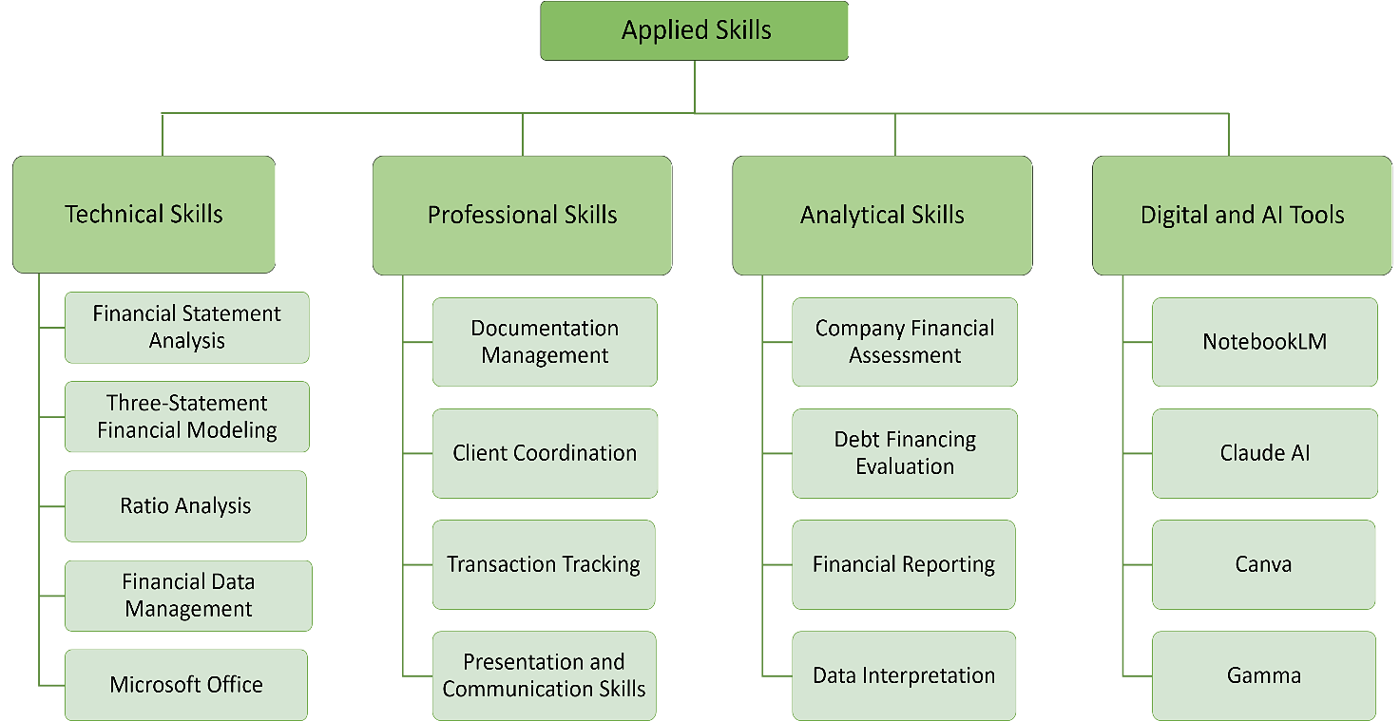
Figure 3.1: Overview of Different Skills Applied During the Internship
Source: created by Claude AI
Throughout the internship, I strengthened my ability to analyze financial information, prepare reports, and support business decision-making using practical data. Working with financial models, company assessments, and documentation improved both my technical expertise and problem-solving skills. Additionally, using AI-powered tools and digital platforms enhanced my productivity, research efficiency, and presentation quality. These experiences increased my confidence in handling professional responsibilities and collaborating effectively within a corporate environment.

Conclusions and Key Facts

Recommendations
Based on the findings of this internship study, the following recommendations are suggested:
- Expand Thematic Bond Offerings. Continue developing Green, Social, and Sustainability Bonds to strengthen leadership in sustainable finance.
- Strengthen Debt Capital Market Services. Increase focus on debt financing advisory as demand for corporate bond financing continues to grow.
- Enhance Investor Awareness: Conduct seminars and awareness programs to promote bond market participation and ESG investment opportunities.
- Invest in Digital Technologies. Adopt advanced digital tools to improve operational efficiency and client service.
- Strengthen ESG Expertise: Build specialized capabilities in ESG advisory and sustainable finance to meet emerging market demands.
- Diversify Revenue Sources Expand wealth management and corporate advisory services to reduce reliance on capital market fluctuations.
- Continue Employee Development: Provide regular training on financial modeling, regulations, ESG standards, and emerging financial products.
- Strengthen Risk Management and Compliance. Maintain robust governance and regulatory compliance to ensure sustainable business growth.
- Enhance Internship Programs Offer structured training and greater exposure to live transactions to develop future investment banking professionals.
- Promote Financial Innovation Continue introducing innovative capital market products to support Bangladesh's evolving financial sector.

Key Understanding

Social and Economic Impact of Social Bond

The significance of BRAC Bank's Social Bond extends beyond the financial sector. By directing capital toward underserved and socially important sectors, the bond has the potential to contribute to inclusive economic development. One of the primary beneficiaries is the CMSME sector, which represents a major source of employment and economic activity in Bangladesh. Improved access to financing can enhance business growth, job creation, and income generation.
Furthermore, financing for healthcare, affordable housing, and agricultural activities can improved living standards and social welfare outcomes. These sectors are particularly important in a developing economy where access to essential services remains uneven.

Challenges and Future Prospects
While the issuance represents a significant milestone, the future growth of thematic bonds in Bangladesh will depend on addressing several structural challenges. These include limited investor familiarity with thematic instruments, relatively high issuance and compliance costs, and the need for robust impact reporting mechanisms. Another challenge is the limited depth of the domestic corporate bond market, which may constrain liquidity and investor participation. Issuers must also maintain transparency regarding the allocation and impact of proceeds to preserve investor confidence.
Despite these challenges, future prospects remain promising. Increasing regulatory support, rising investor interest in sustainable finance, and growing awareness of ESG considerations are likely to create favorable conditions for market expansion. The successful issuance of BRAC Bank's Social Bond may encourage other financial institutions and corporations to explore similar financing mechanisms.

Conclusion
This internship at BRAC EPL Investment Limited has been an invaluable learning experience that successfully bridged academic knowledge with practical exposure to the investment banking industry. Over the three-month internship, I gained first-hand experience in investment banking operations through financial statement analysis, financial modeling, Data-management, due diligence support, documentation, and capital market activities. Working alongside experienced professionals enabled me to understand the complexity of financial transactions, the importance of regulatory compliance, and the critical role of collaboration in executing sophisticated financial instruments. A defining aspect of this internship was the opportunity to observe and contribute to the documentation and operational processes surrounding Bangladesh's first Social Bond issuance. The Social Bond framework aligns with internationally recognized principles and directs capital toward sectors such as women-owned enterprises, CMSMEs, agriculture, affordable housing, healthcare, and other socially beneficial initiatives, reflecting the growing importance of sustainable finance in Bangladesh's financial sector.
The internship also highlighted the strategic role of BRAC EPL Investment Limited as a leading investment bank in structuring and facilitating complex capital market transactions. The firm's expertise in advisory services, debt capital market solutions, regulatory coordination, and client relationship management demonstrates how investment banks create value beyond traditional financing by supporting economic development and financial innovation.
From a personal and professional perspective, this internship significantly enhanced my analytical, technical, and interpersonal competencies. I developed stronger financial analysis skills, improved proficiency in Excel-based financial modeling, strengthened my understanding of capital market regulations, and learned the importance of precision, confidentiality, teamwork, and effective communication in a professional environment.
Overall, this internship has strengthened my aspiration to pursue a career in investment banking and corporate finance. The experience has not only expanded my technical knowledge but also deepened my appreciation for sustainable finance as an emerging force in modern capital markets. As Bangladesh continues to diversify its financial instruments through innovative products such as Social Bonds and other thematic bonds, investment institutions like BRAC EPL Investment Limited will play a pivotal role in advancing inclusive economic growth and sustainable development. I believe the knowledge, skills, and professional values gained during this internship will serve as a strong foundation for my future career while enabling me to contribute meaningfully to the continued development of Bangladesh's financial services industry.

References
- Hussain, F. I. (2022). Thematic bonds to diversify fiscal sources. In The Sustainability of Asia’s Debt (pp. 409-425). Edward Elgar Publishing.
- Tirumala, R. D., & Tiwari, P. (2023). Diverse applications: thematic bonds catching up. In Advances in Infrastructure Finance (pp. 107-133). Singapore: Springer Nature Singapore.
- International Capital Market Association. (2025). Social Bond Principles (June 2025). https://www.icmagroup.org/assets/documents/Sustainable-finance/2025-updates/Social-Bond-Principles-SBP-June-2025.pdf
- BRAC Bank PLC. (2025). BRAC Bank launches first social bond in Bangladesh. https://www.bracbank.com/en/page/brac-bank-social-bond
- The Daily Star. (2025, May 26). Revitalizing Bangladesh's corporate bond market. https://www.thedailystar.net/business/news/revitalising-bangladeshs-corporate-bond-market-4156271
- Academy of Accounting and Financial Studies Journal. (2020). Bond market development in Bangladesh: Capacity building, challenges and policy initiatives. https://www.abacademies.org/abstract/bond-market-development-in-bangladesh-capacity-building-challenges-and-policy-initiatives-9445.html
- BRAC EPL Investments Limited. (2025). Annual report 2025. BRAC EPL Investments Limited.
- BRAC EPL Investments Limited. (2023). Annual report 2023. BRAC EPL Investments Limited.
- Datta, A. (2025, September 30). When we set out to launch the very first social bond in Bangladesh with BRAC Bank PLC, there were no clear rules to guide us, and no local ecosystem in place [LinkedIn post]. LinkedIn. https://www.linkedin.com/posts/anupdattadu_socialbond-sustainablefinance-impactinvestment-activity-7379525848690778112-guAB
- United Nations Development Programme. (2023, July 4). UNDP and BSEC join hands to develop SDG thematic bonds. https://www.undp.org/bangladesh/press-releases/undp-and-bsec-join-hands-develop-sdg-thematic-bonds

Appendix-A

Ratio | 2025 | 2024 | 2023 | 2022
Liquidity Ratios
Current Ratio | 1.41 | 1.39 | 1.53 | 1.51
Quick Ratio | 1.41 | 1.39 | 1.52 | 1.51
Profitability Ratios
Gross Profit Margin | 18.00% | 3.03% | 2.08% | 28.82%
Operating Profit Margin | (118.49%) | (199.28%) | (30.14%) | (62.47%)
Net Profit Margin | 17.15% | (499.36%) | (6.88%) | 161.20%
Return on Assets (ROA) | 1.03% | (34.46%) | (0.35%) | 10.03%
Return on Equity (ROE) | 2.39% | (80.62%) | (0.69%) | 20.38%
Efficiency Ratios
Total Asset Turnover | 0.06 | 0.07 | 0.05 | 0.06
Solvency Ratios
Debt-to-Equity Ratio | 1.31 | 1.34 | 0.95 | 1.03
Debt Ratio | 0.57 | 0.57 | 0.49 | 0.51
Interest Coverage Ratio | (0.54) | (1.26) | 0.67 | 2.37
Market Ratios
Earnings per Share (EPS) | 0.07 | (2.23) | (0.03) | 1.03

